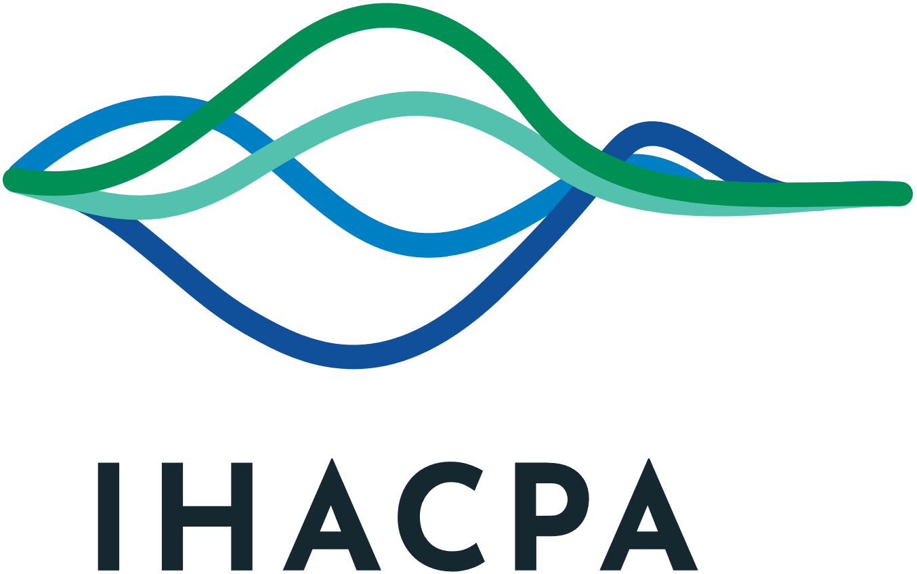
Information Publication Scheme (IPS) Agency Plan

Introduction
The Independent Health and Aged Care Pricing Authority (IHACPA) is an agency subject to the Freedom of Information Act 1982 (the FOI Act) and is required to comply with the Information Publication Scheme (IPS) requirements. This Information Publication Scheme (IPS) Agency Plan describes how IHACPA proposes to do this in accordance with section 8(1) of the FOI Act.
The IPS Agency Plan describes how IHACPA implements and administers its IPS entry in respect of its holdings, by addressing:
- establishing and administering IHACPA’s IPS entry
- structure of the IPS
- information required to be published under the IPS
- other information to be published under the IPS
- IPS compliance review.
IHACPA will continue to build and foster a culture in which proactive disclosure of its information holdings is embraced. This recognises that public sector information is a national resource managed for public purposes.

Purpose
The purpose of the IPS Agency Plan is to:
- assist IHACPA in planning and developing its contribution to the IPS
- facilitate public consultation about that contribution
- explain which information IHACPA proposes to publish, how and to whom the information will be published and how IHACPA will otherwise comply with the IPS requirements.

Objectives
The objectives of the IPS are to:
- ensure proper management of IHACPA’s IPS entry
- adopt best practice initiatives in implementing and administering IHACPA’s IPS entry
- proactively identify and publish all information required under section 8(2) of the FOI Act, including this IPS Agency Plan
- proactively identify and publish any other information to be published required under section 8(4)
- review and ensure on a regular basis that information published by IHACPA under the IPS is accurate, up-to-date and complete
- ensure that information published under the IPS is able to be discovered by the general public, is understandable, machine-readable, re-useable and transformable
- ensure online content satisfactory conforms with the Government’s Web Content Accessibility Guidelines (Version 2) (WCAG 2.2)
- assess the effectiveness of IHACPA’s implementation of the IPS through public feedback received on IHACPA’s IPS entry.

Establishing and administering IHACPA’s IPS entry
All Senior Executive Services (SES) Officers at IHACPA are accountable for ensuring that IHACPA complies with its IPS obligations.
SES Officers are responsible for ensuring:
- information required to be published is published as part of the data holdings (including operational information)
- the accuracy, currency and integrity of published information relevant to their responsibilities
- appropriate resources are dedicated to complying with IHACPA’s IPS obligation.
IHACPA’s FOI Officer oversees the administration and implementation of the IPS entry with assistance from the Director of Communications regarding access to information and website accessibility.
Each Branch is responsible for ensuring that documents approved for publishing to IHACPA’s website meet the minimum accessibility requirements. The Communications Branch has final responsibility for ensuring that all material published to IHACPA’s website is, as far as possible, accessible and conforms with the (Version 2) (WCAG 2.2).

Charges
IHACPA may charge a person for accessing any IPS document(s) which is voluminous or impracticable to publish online. These charges will be consistent with charges in the Freedom of Information (Charges) Regulations 2019 (which generally apply to access requests under Part III of the FOI Act) which will:
- represent the lowest reasonable cost
- reimburse IHACPA for specific reproduction costs or other specific incidental costs (s 8D(4)).
IHACPA encourages persons to print copies of required documents, if available for download on the IHACPA’s website.

Access charges
Format | Charge
Copy (other than a photocopy) | $4.40 per page
Photocopy | 10c per page
Document produced using a computer or other equipment readily available to retrieve stored information or a copy of a document in the form of a computer take or disk | An amount not exceeding the actual costs incurred in producing the document
Document requested to be delivered by post | An amount not exceeding the actual costs incurred for the delivery of the document

Structure of the IPS
A link to the IPS webpage is on the footer of the IHACPA’s website. The IPS entries are also published via links from the Homepage of IHACPA’s website.
To ensure that the IPS entry (and individual IPS documents) is easily discoverable, understandable and machine-readable, IHACPA has:
- wherever possible, provided online content in a format that can be searched, copied and transformed
- provided direct downloads from our website (where practicable to do so)
- provided links to other websites where the information is available
- provided a friendly navigation and easy to use search functionality on IHACPA’s website
- enabled the ability for feedback on the IPS to be made through the FOI section email: foi_ihacpa@ihacpa.gov.au
- put in place a process to enable copies of documents that are not accessible
- ensure that all documentations that are published under the IPS conform within (Version 2) (WCAG2.2), as much as reasonably possible as per outlined under Accessibility.

Accessibility
The majority of documents listed on the IPS section of IHACPA’s website will be converted into HTML where practical, in accordance with WCAG. A small number of exceptions might apply, such as Portable Document Format (PDF) of scanned documents.
Information published under the IPS can be supplied in accessible formats on request by emailing foi_ihacpa@ihacpa.gov.au

Information required to be published under the IPS
- IPS Agency Plan (s 8(2)(a)
- Who we are (ss 8(2)(b)
- Organisation chart (ss 8(2)(b)
- What we do (ss 8(2)(c)
- Statutory appointments (s8(2)(d)
- Our reports and responses to Parliament (ss 8(2)(e) and 8(2)(h))
- Consultation arrangements (s 8(2)(f))
- Routinely requested information in response to FOI requests and disclosure log (ss 8(2)(g) and 11C)
- How to contact the FOI Section
- Contact us (s 8(2)(i)).

Other information to be published
Taking into account the objectives of the FOI Act (s 8(4)), IHACPA will publish as much information as possible on its website to comply with the FOI Act and in the interests of full disclosure (in addition to the information published under section 8(2)).

Our priorities
Under section 8(4) of the FOI Act, IHACPA publishes information about the corporate and strategic plans of the agency
- IHACPA Work Program and Corporate Plan
- IHACPA Strategic Plan 2025-30
- Factsheets

Our finances
Under section 8(4) of the FOI Act, IHACPA publishes information about its finances, including information relating to procurement complaints, tendering and contracts. This information is available on the pages set out below.
- Australian Government’s AusTender site
- Reporting of contracts
- Procurement complaints
- Annual reports

Submissions

In the interest of transparency and with the respondent’s permission, IHACPA publishes public submissions to completed consultations. Certain information in submissions may be withheld from publication in some circumstances where they include information that may be commercially sensitive, raise individual privacy concerns or are factually contentious (that is, contains data, methodology or processes that are questionable).
- Past consultations

Other information
Under section 8(4) of the FOI Act other information such as determinations, frameworks, consultation papers, presentations, forms, fact sheets, publications, tools and videos that relate to IHACPA’s work are published on IHACPA’s website under
- Resources
- Consultation papers

IPS compliance review
IHACPA will review and revise this IPS Agency Plan at least bi-annually having regard to relevant guidelines issued by the Information Commissioner under section 93A of the FOI Act.
IHACPA is committed to transparency and open access to data, consistent with the objectives of the FOI Act, National Health Reform Act 2011 (NHR Act) and the Privacy Act 1988. However, publication practices must be balanced against IHACPA’s obligation to respect and maintain confidential, commercially valuable and personal information.
The public and stakeholders should remain confident that any personal or confidential information IHACPA possesses will be protected from release when it is appropriate to do so. IHACPA will seek the approval of from the owner of that information prior to publishing.

Accuracy and currency of published information
IHACPA’s IPS entry is required to be ‘accurate, up-to-date and complete’ (s 8B). IHACPA’s structure, statutory appointments, consultation arrangements, reports laid before Parliament and disclosure logs will be updated as soon as reasonably practicable after changes have been approved by the Chief Executive Officer to publish. Other information such as IHACPA determinations, frameworks and other key reports are published in accordance with the prescribed timeframes in the NHR Act.

Internal IPS information register
IHACPA’s internal information register identifies documents for publication and assists in reviewing IPS information for accuracy and currency.

Feedback
IHACPA welcomes feedback on its IPS. The FOI Officer will consider feedback, make recommendations for change to the Executive Committee and respond to individuals who offer feedback. Feedback or complaints about IHACPA’s IPS Agency Plan can be made:
By post:
FOI Officer
Independent Health and Aged Care Pricing Authority
PO BOX 483
DARLINGHURST NSW 1300
or by email: foi_ihacpa@ihacpa.gov.au
or by telephone: +61 2 8215 1100


Independent Health and Aged Care Pricing Authority
Eora Nation, Level 12, 1 Oxford Street
Sydney NSW 2000
Phone 02 8215 1100
Email enquiries.ihacpa@ihacpa.gov.au
www.ihacpa.gov.au

