
National Pricing Model 2026–27

Shadow risk adjustments for hospital acquired complications

Technical Specifications
March 2026
National Pricing Model 2026–27 – Shadow risk adjustments for hospital acquired complications – Technical Specifications – March 2026
© Independent Health and Aged Care Pricing Authority 2026
This publication is available for your use under a Creative Commons Attribution 4.0 International licence, with the exception of the Independent Health and Aged Care Pricing Authority logo, photographs, images, signatures and where otherwise stated. The full licence terms are available from the Creative Commons website.

Use of Independent Health and Aged Care Pricing Authority material under a Creative Commons Attribution 4.0 International licence requires you to attribute the work (but not in any way that suggests that the Independent Health and Aged Care Pricing Authority endorses you or your use of the work).
Independent Health and Aged Care Pricing Authority material used 'as supplied'.
Provided you have not modified or transformed Independent Health and Aged Care Pricing Authority material in any way including, for example, by changing Independent Health and Aged Care Pricing Authority text – then the Independent Health and Aged Care Pricing Authority prefers the following attribution:
Source: The Independent Health and Aged Care Pricing Authority

Contents
Table of acronyms and abbreviations 5
Glossary of terms 6
1. Introduction 7
1.1 Purpose 7
1.2 Background 7
2. Hospital Acquired Complication (HAC) 10
2.1 Definition of a HAC 10
2.2 List of HACs 10
2.3 Identification of HACs 11
3. Data preparation 13
3.1 Datasets 13
3.2 Data trimming 13
3.3 Distribution of HACs 17
4. HAC risk adjustment model 18
4.1 Overview 18
4.2 Model description 18
4.3 Risk factors 18
4.4 Assessment of model performance 23
5. Complexity groups, complexity points, complexity scores and complexity bounds 29
5.1 Complexity groups 29
5.2 Complexity points and complexity scores 30
5.3 Complexity bounds 31
6. Incremental cost of a HAC 33
6.1 Overview 33
6.2 Incremental cost model 33
6.3 Ad-hoc modifications to the incremental cost model 34
6.4 Incremental cost of HAC 35
7. Dampening factors and risk adjustments 37
7.1 Overview 37
7.2 How do the dampening factors work? 37
7.3 Calculating the dampening factors and risk adjustment values 38
8. Calculating HAC risk adjusted NWAU 40
8.1 Process to calculate HAC risk adjusted NWAU 40
8.2 Vignettes 41
Appendix A – Risk factor definitions 47
Appendix B – Developing the initial HAC risk adjustment model 50
Appendix C – Selection of and reassessment of risk factors 54
Appendix D – Model performance curves 57
ROC curves 57
PRC curves 60
Appendix E – Complexity points 63
Appendix F – Complexity bounds, dampening factors, risk adjustments and complexity profile distributions 75
Complexity profile distributions 77
Appendix G – Change tracker 85
Appendix H: HAC trajectory over time 86

Table of acronyms and abbreviations
Acronym/abbreviation | Description
ACHI | Australian Classification of Health Interventions
ACS | Australian Coding Standards
ACSQHC | Australian Commission on Safety and Quality in Health Care
ADRG | Adjacent diagnosis related group
APC | Admitted patient care
AR-DRG | Australian Refined Diagnosis Related Groups
CAC | Clinical Advisory Committee
COAG | Council of Australian Governments
COF | Condition onset flag
COPD | Chronic obstructive pulmonary disease
Commission | Australian Commission on Safety and Quality in Health Care
GWAU | Gross weighted activity unit
HACs | Hospital acquired complications
ICD-10-AM | International Statistical Classification of Diseases and Related Health Problems, Tenth Revision, Australian Modification
ICU | Intensive care unit
IHACPA | Independent Health and Aged Care Pricing Authority
MDC | Major diagnostic category
NEC | National efficient cost
NEP | National efficient price
NHCDC | National hospital cost data collection
NMDS | National minimum data set
NWAU | National weighted activity unit
PRC | Precision recall curves
ROC | Receiver operating characteristic
SEIFA | Socio economic indexes for areas

Glossary of terms
Term | Description
Complexity bound  Cut-off point | This refers to the threshold value which separate episodes within a single HAC into its complexity groups.
Complexity group | This refers to the grouping of episodes within a single HAC. HAC01-HAC04 and HAC06-14 have three complexity groups (low, moderate and high) while HAC15.02 has two complexity groups (low and high).
Complexity point | These are transformed logistic regression estimates for each risk factor variable.
Complexity score | This is the sum of complexity points for all risk factors relevant to a single HAC. Each episode of care can have up to 14 complexity scores, one for each HAC.
Condition onset flag | This flag is used to identify whether a diagnosis occurred during an episode of admitted care.
Dampening factor | This factor dampens the impact of the incremental cost adjustment, based on the complexity of an episode of care.
Funding adjustment  Funding reduction | The base price weight multiplied by the largest HAC risk adjustment value (relevant if it is a multi-HAC episode).
HAC risk adjusted NWAU | The NWAU of the episode of care minus the funding adjustment or funding reduction amount.
HAC risk adjustment | The incremental cost adjustment multiplied by the dampening factor.
HAC risk adjustment model | This predicts the likelihood of a specific HAC occurring within an episode of care. It consists of a series of logistic regression models, one for each HAC.
Incremental cost of HAC | This refers to the additional cost of a hospital admission due to a HAC.
Incremental cost model | This is a logistic regression model that uses AR-DRG and length of stay to predict the cost of non-HAC episodes.
Incremental cost adjustment | This refers to the incremental cost of a HAC as an adjustment value.
Risk factor | A variable which is associated with the likelihood of a specific HAC occurring within an episode of care.

Introduction

Purpose
This document has been produced as an accompaniment to the National Efficient Price 2026-27 (NEP26) Determination. It provides the technical specifications for how the Independent Health and Aged Care Pricing Authority (IHACPA) developed the hospital acquired complication (HAC) funding approach and risk adjustment methodology, which has been in effect since 1 July 2018. It also provides guidance to hospitals, local hospital networks (LHNs) and state and territory health authorities on how to apply these to hospital activity.
IHACPA develops the HAC funding approach based on the parameters specified under the Addendum to the National Health Reform Agreement (NHRA) 2020-26 and clause A63 of the Addendum to the NHRA 2026-31. According to clause A90 of the Addendum to the NHRA 2026–31, absolute pricing penalties for hospital acquired complications will not be applied to states and territories, and will instead be shadow priced, while the Australian Commission on Safety and Quality in Health Care (ACSQHC) undertakes a review of the safety and quality measures as outlined in clauses D51–D55. As such, IHACPA is shadow pricing the HACs funding approach and risk adjustment methodology for the National Efficient Price 2026-27 (NEP26) Determination.

Background
In April 2016, all Australian governments signed a Heads of Agreement that committed to improve Australians’ health outcomes and decrease avoidable demand for public hospital services through a series of reforms including the development and implementation of funding and pricing approaches for safety and quality.
The commitment by governments to pricing for safety and quality followed a four-year work program jointly undertaken by IHACPA and the Australian Commission on Safety and Quality in Health Care (the Commission) to undertake research and develop options for incorporating safety and quality into IHACPA’s annual Pricing Framework for Australian Public Hospital Services (the Pricing Framework). One of the outcomes of this collaboration was the development, through a clinician-led process, of an agreed Australian list of HACs.
In August 2016, IHACPA was given a direction by the then Commonwealth Minister for Health and Aged Care, acting under subsection 226(1) of the National Health Reform Act 2011 (the Act). IHACPA was directed to advise the Council of Australian Governments (COAG) Health Council of options on how funding and pricing could be used to improve patient outcomes across three key areas: sentinel events, HACs and avoidable hospital readmissions (AHRs).
On 30 November 2016, IHACPA provided advice to the COAG Health Council on options for integrating safety and quality into public hospital pricing and funding models. This was informed by feedback from the Consultation Paper on the Pricing Framework for Australian Public Hospital Services 2017-18.
In February 2017, the Commonwealth Minister for Health directed IHACPA to undertake implementation of three recommendations of the COAG Health Council relating to sentinel events, HACs and AHRs. IHACPA’s decisions in relation to this were set out in the Pricing Framework for Australian Public Hospital Services 2017-18.
In January 2026 the Addendum to the NHRA 2026-31 was agreed to by the National Cabinet. According to clause A90 of this Addendum, absolute pricing penalties for hospital acquired complications will not be applied to states and territories, and will instead be shadow priced, while the Commission is undertaking a review of the safety and quality measures as outlined in clauses D51–D55. As such, the HAC risk models are shadow priced for NEP26.
  - Risk adjustment for hospital acquired complications
Consistent with ministerial direction, IHACPA was to reduce the funding level for all HACs across every hospital to reflect the extra cost of a hospital admission with a complication by 1 July 2018, subject to the results of a shadow year from 1 July 2017.
In addition to this, IHACPA was required to develop a risk adjustment methodology that would consider different patient complexity levels or specialisation across jurisdictions and hospitals. The design of risk adjustment for safety and quality needed to balance two perspectives, namely that:
  - Hospitals which treat more high-risk patients should not be disadvantaged compared to hospitals which treat fewer such patients.
  - However, from the perspective of patients, high-risk patients want assurance that hospitals take all necessary action to manage their risks and mitigate the occurrence of any adverse events.
This meant that risk adjustment should account for the higher risks experienced by some patients. Pricing and funding approaches should balance the likelihood that some patients will be at higher risk of experiencing an adverse event while ensuring that all hospitals have ongoing responsibility to mitigate risks, to reduce and manage any negative impacts for all patients, and to improve safety and quality systemically.

  - Changes to HAC risk adjustment model for the Shadow NEP26
 | According to clause A90 of the Addendum to the NHRA 2026–31, absolute pricing penalties for hospital acquired complications will not be applied to states and territories, and will instead be shadow priced, while the Commission is undertaking a review of the safety and quality measures as outlined in clauses D51–D55. As such, IHACPA is shadow pricing the HACs funding approach and risk adjustment methodology for the National Efficient Price 2026-27 (NEP26) Determination.

For NEP26, the model has been completely re-fit using logistic regression backward selection. Testing for existing risk factors and new risk factors presented in Table 6a and Table 6b has been undertaken, and in consultation with stakeholders these have been reassessed for inclusion into each of the 14 HAC groups. This has been executed to ensure consistency of risk factors across HAC and AHR streams. As part of the evolving treatment of COVID-19 episodes in the complex health environment, the suspension of safety and quality adjustments for episodes flagged with COVID-19 was discontinued for NEP26 with COVID-19 instead tested as a new risk factor. The methodology used is presented in Appendix C. Moreover, the individual Charlson comorbidity conditions (instead of the Charlson Score) continue to be used as risk factors in the HAC risk adjustment model, where statistically significant.

Hospital Acquired Complication (HAC)

Definition of a HAC
A hospital acquired complication (HAC) refers to a complication for which clinical risk mitigation strategies may reduce (but not necessarily eliminate) the risk of that complication occurring.

List of HACs
In 2012, the Commission and IHACPA established a joint working group and over the years have refined and developed the current national list of HACs (the HAC list). The HACs list consists of 16 agreed, high-priority complications which clinicians, managers and others can work together to address and improve patient care.
The development of pricing for HACs in NEP26 has used the HAC list Version 3.2 as at September 2025. This list contains 16 HACs summarised in Table 1.

Table 1: List of hospital acquired complications (Version 3.2).
Number | Complication
1 | Pressure injury
2 | Falls resulting in fracture or intracranial injury
3 | Healthcare-associated infection
4 | Surgical complications requiring unplanned return to theatre
5 | Unplanned intensive care unit admission
6 | Respiratory complications
7 | Venous thromboembolism
8 | Renal failure
9 | Gastrointestinal bleeding
10 | Medication complications
11 | Delirium
12 | Incontinence
13 | Endocrine complications
14 | Cardiac complications
15 | Third and fourth degree perineal laceration during delivery
16 | Neonatal birth trauma

Identification of HACs
A HAC is identified using a combination of ICD-10-AM codes to identify the diagnosis and the condition onset flag (COF) to indicate that the diagnosis occurred during the episode of admitted patient care. Some HACs also require other codes to define the complication such as procedure and external cause codes. The latest specifications used to identify HACs, including exclusion criteria, is available on the Commission’s website. There are a few changes in moving from Version 3.1 to Version 3.2 provided by ACSQHC, which include the addition of code I97.84 to HAC04 and an update to the exclusion criteria for mental health cohorts which do not impact HAC counts. This occurred in May 2025. Subsequent to that in September 2025, there were ICD-10-AM Thirteenth Edition specific changes relating to the inclusion of all Y832X codes for HAC04. As well as updates to mental health codes for mental health cohorts which does not impact HAC count. For modelling HACs during NEP26, HACs were identified using ICD-10-AM/ACHI/ACS Twelfth edition.

Data preparation

Datasets
The development of the risk adjustment model and funding adjustments for HACs used hospital activity and cost data for admitted acute separations.
Three years of hospital activity data were used to develop the risk adjustment model, using the admitted patient care (APC) datasets for the 2021-22, 2022-23 and 2023-24 years. These datasets contain episode-level information about the hospital, patient and importantly, diagnoses and COF information which allowed for HAC identification.
Hospital cost data was used in the modelling to determine the incremental cost of a HAC. This data was sourced from the 2021-22, 2022-23 and 2023-24 National Hospital Cost Data Collection (NHCDC). These data sources are summarised in Table 2.

Table 2: Data used in the development of pricing for HACs.
Data source | Risk adjustment model | Incremental cost model
APC2122 | Yes | Yes
APC2223 | Yes | Yes
APC2324 | Yes | Yes
NHCDC2122 | No | Yes
NHCDC2223 | No | Yes
NHCDC2324 | No | Yes

Data trimming
There are two types of trimming applied to the datasets used to develop the risk adjustment model: hospital level and episode level trimming.

Hospital level trimming
To develop a robust risk adjustment model, the APC data was trimmed such that only records which were of a certain quality and reflective of hospital experience would be included in the modelling dataset. It was particularly important to only retain records from hospitals which had a high quality of COF reporting. This process was carried out at a hospital level.
Three rules were developed to identify whether a hospital would be trimmed:
  - Hospitals with fewer than 100 episodes were trimmed. This removed low-volume hospitals where it is not possible to determine the quality of COF reporting.
  - Hospitals where less than 1% of episodes contained conditions arising in the hospital (that is, where less than 1% of records had a COF = ‘1’ for any diagnosis). This removed hospitals deemed to have unusually few episodes with any condition arising during episode.
  - Hospitals where more than 10% of episodes had no reported COF (that is, where more than 10% of episodes only reported COF = ‘9’ for all diagnoses). This removed hospitals deemed to have poor quality COF reporting due to the high proportion of unknown condition onset statuses.

The number of hospitals trimmed is summarised in Table 3.

Table 3: Summary of hospitals (and associated episodes) trimmed for NEP26.
 | 2021-22 | 2022-23 | 2023-24
Total number of hospitals in dataset | 739 | 729 | 735
Number of hospitals trimmed from dataset | 211 | 208 | 219
Percentage of episodes trimmed from dataset | 1.6% | 3.2% | 3.0%

In addition to the standard hospital trimming process an adjustment was implemented in 2022-23 data to remove records identified in LHN108 in line with Jurisdictional Advice. This was due to data quality issues noted in cost data, and the decision to remove the relevant records in activity data. This change is reflected in Table 3 and Table 4 figures.

Episode level trimming
Records were also trimmed based on characteristics of the episode of care to improve the robustness of the risk adjustment model as some types of admissions would not be expected to receive a HAC. These trimmed records generally fell into three categories.
The first category involved trimming episodes considered to be outliers. This was after discussions with risk adjustment experts Professors Scott and Yong, who advised that including such episodes would disproportionately skew the risk adjustment model. These outlier episodes included:
  - Long-stay patients (patients with a length of stay greater than 200 days).
  - Patients over 95 years old.
  - Episodes where the patient died.
The second category involved trimming episodes where the admission characteristics could not lead to a HAC or that they were generally not representative of a HAC, as advised by the Commission. This category included:
  - Episodes classified as same-day dialysis, chemotherapy or radiotherapy, on the basis that these are high-volume, same-day episodes with very low HAC counts and have the potential to ‘wash’ out the analysis.
  - Episodes from rehabilitation, mothercraft, psychiatric, other non-acute and unpeered hospitals as these hospitals had a very low prevalence of HAC.
The final category involved trimming episodes considered out-of-scope for the purpose of developing the risk adjustment model and calculating the funding adjustments. This included:
  - Episodes not from activity based funding (ABF) public hospitals (that is, private or block-funded hospitals).
  - Episodes with error or ungroupable end classes.
Additionally, episodes with input errors were removed from the in-scope datasets. These include:
  - Episodes where the separation date is before the admission date.
  - Episodes where the admission date is before the birth date.
  - Episodes where the separation date is before the birth date.
  - Episodes with the default birth date of 1 January 1900.

Summary of trimmed records
Table 4 summarises the trimmed hospital activity records for NEP26.

Table 4: Breakdown of trimmed episodes for the 2021-22, 2022-23 and 2023-24 activity data.
 | Number of episodes
 | 2021-22 | 2022-23 | 2023-24
Total episodes before trimming | 6,787,446 | 7,067,482 | 7,408,128
Breakdown of trimmed episodes
Non-public hospitals | 163,576 | 128,339 | 139,420
Hospital level trimming
Stage 1: low volume | 4,532 | 4,657 | 4,681
Stage 2: COF = 1 less than 1% | 99,359 | 127,539 | 118,390
Stage 3: COF = 9 greater than 10% | 3,168 | 93,366 | 100,606
Jurisdictional Advice: Removal of Hospitals in LHN108 | 0 | 88,261 | 0
Episode level trimming
Error AR-DRGs | 991 | 938 | 1,179
Peer group | 2,375 | 1,653 | 1,701
Non-ABF hospital | 208,854 | 199,105 | 192,625
Same-day dialysis | 1,323,002 | 1,321,611 | 1,378,957
Same-day chemotherapy | 309,103 | 311,454 | 329,307
Patient over 95 | 21,060 | 21,908 | 24,133
Death | 35,316 | 35,114 | 33,897
Long stay patient | 162 | 193 | 190
Same-day radiotherapy | 3,397 | 3,485 | 3,742
Input error | 0 | 0 | 0
Total episodes remaining (untrimmed) | 4,612,551 | 4,729,859 | 5,079,300
% of episodes trimmed from public hospitals | 30.36% | 31.84% | 30.12%

Distribution of HACs
The number of episodes identified for each HAC is shown in Table 5. Episodes with multiple HACs have been counted more than once (in their respective HAC) and thus the total HAC episodes will be less than the sum of the individual HAC.

Table 5: Number of HACs identified in 2021-22, 2022-23 and 2023-24 activity data.
 | Number of episodes
 | 2021-22 | 2022-23 | 2023-24
Total episodes with a HAC | 88,411 | 89,355 | 92,419
Breakdown of episodes by HAC
1 Pressure Injury | 1,523 | 1,651 | 1,553
2 Falls resulting in fracture or intracranial injury | 1,557 | 1,652 | 1,733
3 Healthcare-associated infection | 34,318 | 35,573 | 36,882
4 Surgical complications requiring unplanned return to theatre | 14,226 | 14,342 | 15,456
5 Unplanned intensive care unit admission | n/a | n/a | n/a
6 Respiratory complications | 10,254 | 9,955 | 10,744
7 Venous thromboembolism | 3,032 | 3,113 | 3,158
8 Renal failure | 428 | 399 | 445
9 Gastrointestinal bleeding | 3,015 | 3,178 | 3,308
10 Medication complications | 2,221 | 2,172 | 2,097
11 Delirium | 15,006 | 15,027 | 15,138
12 Incontinence | 1,152 | 1,120 | 905
13 Endocrine complications | 9,739 | 9,586 | 9,705
14 Cardiac complications | 11,570 | 11,871 | 11,901
15 Third and fourth degree perineal laceration during delivery | 4,656 | 4,029 | 4,176
16 Neonatal birth trauma | 1,029 | 1,003 | 1,099

HAC risk adjustment model

Overview
IHACPA notes the need to balance the perspectives of both hospitals and patients when incorporating safety and quality into pricing. Hospitals that treat high-risk patients should not be disadvantaged compared to hospitals that treat fewer such patients. Likewise, high risk patients should have confidence that hospitals take all necessary actions to manage their risks and mitigate the occurrence of adverse events.
The equitable risk adjustment criterion used by IHACPA states that:
Pricing and funding approaches should balance the likelihood that some patients will be at higher risk of experiencing an adverse event while recognising that all hospitals have scope to improve safety and quality.

Appendix B contains details of the development leading up to the implementation of the HAC risk adjustment model in the national pricing model.

Model description
The HAC risk adjustment model consists of a series of logistic regression models, one for each HAC. The logistic regression models calculate a loading for each risk factor relevant to the HAC category. The model predictors (also referred to as ‘risk factors’) for each HAC are different and are detailed in the next section.

Risk factors
Table 6a and Table 6b outlines the individual risk factors used as predictors for each HAC logistic regression model.
The risk factors for all HACs for NEP26 have undergone a full re-evaluation using backward selection, where insignificant risk factors have been removed. Moreover, new risk factors have been tested for potential inclusion across all HAC models, including COVID-19 status. These new risk factors have been introduced to ensure consistency across AHR and HAC streams. The new risk factors tested are presented in Table 6b and the methodology used is outlined in Appendix C. Prior changes which occurred in NEP24 have remained. This included a change to replace the Charlson Score with its constituent individual comorbidity conditions as risk factors for all HACs except for HAC15.02 which did not use Charlson Score as a risk factor in the first place.
The risk factors for HAC15.02 Fourth degree perineal laceration during delivery remain as per their introduction in NEP20, with the additional testing and inclusions of new risk factors as outlined in Table 6b.
The process used to select the risk factors for each HAC is outlined in Appendix C. Risk factors which were previously considered but dropped are discussed in Appendix C. The underlying ICD-10-AM/ACHI/ACS codes used to flag various risk factors is outlined in Appendix A.

Table 6a: Risk factors considered for adoption for each HAC
Risk factors | 1. Pressure injury | 2. Falls resulting in fracture or intracranial injury | 3. Healthcare-associated infection | 4. Surgical complications requiring unplanned return to theatre | 6. Respiratory complications | 7. Venous thromboembolism | 8. Renal failure | 9. Gastrointestinal bleeding | 10. Medication complications | 11. Delirium | 12. Incontinence | 13. Endocrine complications | 14. Cardiac complications | 15.02 Fourth degree perineal laceration during delivery
Emergency admission status | ü | ü | ü | ü | ü | ü |  | ü | ü |  | ü | ü | ü | ü
Patient age | ü | ü | ü | ü | ü | ü |  | ü | ü | ü | ü | ü | ü | ü
Major diagnosis category 12 | ü | ü | ü | ü | ü | ü | ü | ü | ü | ü | ü | ü | ü
Intensive care unit status | ü | ü | ü | ü | ü | ü | ü | ü | ü | ü | ü | ü | ü
AR-DRG12 type | ü | ü | ü | ü | ü | ü | ü | ü | ü | ü | ü | ü | ü
Acute myocardial function |  |  | ü |  | ü |  |  | ü | ü | ü |  |  | ü
Congestive heart failure | ü | ü | ü | ü | ü | ü | ü | ü | ü | ü | ü | ü | ü
Peripheral vascular disease | ü | ü | ü | ü | ü | ü | ü | ü | ü | ü | ü | ü | ü
Cerebral vascular accident |  | ü | ü | ü | ü | ü |  | ü | ü | ü | ü | ü | ü
Dementia | ü |  | ü | ü |  | ü | ü | ü |  | ü | ü |  | ü
Pulmonary disease |  | ü | ü |  | ü |  |  | ü | ü
Connective tissue disorder | ü |  | ü | ü | ü | ü |  | ü | ü | ü | ü | ü | ü
Peptic ulcer | ü |  | ü |  |  | ü |  | ü | ü |  |  | ü | ü
Liver disease | ü | ü | ü | ü | ü | ü | ü | ü | ü | ü | ü | ü | ü
Diabetes | ü |  | ü | ü | ü | ü | ü | ü | ü | ü |  | ü | ü
Diabetes complications | ü | ü | ü | ü | ü | ü | ü | ü | ü | ü | ü | ü | ü
Paraplegia | ü | ü | ü | ü | ü | ü |  | ü | ü | ü | ü | ü | ü
Renal disease | ü | ü | ü | ü | ü |  | ü | ü | ü | ü |  | ü | ü
Cancer | ü | ü | ü | ü | ü | ü | ü | ü | ü | ü | ü | ü | ü
Metastatic cancer | ü |  | ü | ü | ü | ü | ü | ü | ü | ü |  |  | ü
Severe liver disease | ü | ü | ü | ü | ü |  | ü | ü | ü | ü |  |  | ü
Human Immunodeficiency Virus (HIV)
Sex | ü |  | ü |  | ü |  | ü |  |  | ü
Admission transfer status | ü | ü | ü | ü | ü | ü |  | ü | ü | ü | ü | ü
Fetal distress |  |  |  |  |  |  |  |  |  |  |  |  |  | ü
Instrument use |  |  |  |  |  |  |  |  |  |  |  |  |  | ü
Persistent posterior occiput presentation |  |  |  |  |  |  |  |  |  |  |  |  |  | ü
Young and mature aged primigravida |  |  |  |  |  |  |  |  |  |  |  |  |  | ü

Table 7b: Additional Risk factors considered for adoption for each HAC
Additional  Risk factors | 1. Pressure injury | 2. Falls resulting in fracture or intracranial injury | 3. Healthcare-associated infection | 4. Surgical complications requiring unplanned return to theatre | 6. Respiratory complications | 7. Venous thromboembolism | 8. Renal failure | 9. Gastrointestinal bleeding | 10. Medication complications | 11. Delirium | 12. Incontinence | 13. Endocrine complications | 14. Cardiac complications | 15.02 Fourth degree perineal laceration during delivery
COVID-19 Status | ü | ü | ü |  | ü | ü |  | ü |  | ü |  | ü
Obesity | ü |  | ü | ü | ü | ü | ü | ü | ü | ü |  | ü | ü
Cystic fibrosis
Schizophrenia |  |  | ü | ü |  |  | ü |  |  |  |  | ü | ü
Depression | ü |  | ü | ü | ü | ü |  | ü | ü | ü | ü | ü | ü
Disorder of intellectual development |  |  |  |  |  |  | ü |  |  | ü
Parkinson’s disease | ü | ü | ü |  | ü |  |  | ü | ü | ü |  | ü
Multiple sclerosis | ü |  | ü |  | ü |  |  |  |  | ü
Epilepsy | ü | ü | ü |  | ü |  |  |  | ü | ü |  | ü
Cerebral palsy | ü |  | ü | ü | ü |  |  | ü | ü |  |  | ü
Ischaemic heart disease | ü |  |  | ü | ü | ü |  |  |  | ü |  | ü
Chronic heart failure
Hypertension
Emphysema without mention of COPD
COPD
Asthma without mention of COPD
Bronchiectasis without mention of CF
Chronic Respiratory Failure
Crohn’s disease |  | ü | ü | ü | ü |  |  | ü |  |  |  |  | ü
Ulcerative colitis |  |  | ü |  |  | ü |  | ü
Chronic liver failure
Rheumatoid arthritis
Arthritis and osteoarthritis |  |  | ü | ü |  | ü |  | ü | ü | ü | ü | ü | ü
Systemic lupus erythematosus
Osteoporosis | ü | ü | ü | ü | ü | ü |  | ü | ü | ü |  | ü | ü
Chronic kidney disease
Spina bifida | ü |  | ü | ü |  |  |  |  |  |  | ü |  | ü
Down’s syndrome |  |  | ü |  | ü | ü |  |  | ü | ü |  | ü | ü
Low Length of Stay Flag | ü |  | ü | ü | ü | ü | ü | ü | ü | ü | ü | ü | ü
Mental Health | ü | ü | ü | ü | ü | ü | ü | ü | ü | ü | ü | ü | ü
Homelessness |  |  | ü
Post Transplant status |  | ü | ü | ü |  | ü |  | ü | ü | ü |  | ü | ü
Pacemaker status | ü |  | ü | ü |  |  | ü | ü | ü | ü |  |  | ü
Ventilator
Asthma | ü |  | ü |  | ü |  |  |  |  |  |  | ü
Malnutrition | ü | ü | ü | ü | ü | ü | ü | ü | ü | ü | ü | ü | ü
Drug Use | ü | ü | ü | ü | ü | ü | ü |  |  | ü | ü | ü | ü
Dystocia |  |  | ü | ü |  |  |  |  |  |  | ü | ü |  | ü

Assessment of model performance
IHACPA has generally used receiver operating characteristic (ROC) curves to measure the performance of the HAC risk adjustment model and early iterations of the readmissions risk adjustment model. However, ROC curve metrics alone may not clearly reflect significant changes in model performance where the number of episodes with no HACs is far greater than the number of episodes with at least one HAC. To account for this, IHACPA has computed precision recall curves (PRC), which are more informative that ROC curves on highly unbalanced data, alongside ROC curves in evaluating the HAC risk modelling.
Appendix D provides the ROC and PRC curves for each HAC in the HAC risk adjustment model.

4.4.1 Receiver operating characteristic curve
The ROC curve is an analytical method that can be used to evaluate a model’s ability to predict a binary outcome. In the context of the HAC risk adjustment model, we seek to evaluate the ability of this model to identify an episode with a HAC.
The ROC curve is a parametric plot of the true positive rate (TPR) versus the false positive rate (FPR) of the model where:
  - the TPR is the proportion of observations that are correctly predicted to be positive out of all positive observations; that is, how well does the model correctly predict the occurrence of a HAC in an episode.
  - the FPR is the proportion of observations that are incorrectly predicted to be positive out of all negative observations; that is, how often does the model incorrectly predict the occurrence of a HAC for episodes which don’t have a HAC.
The ROC graph plots both parameters against a theoretical threshold varied between 0 and 1 to illustrate the tradeoff between TPR and FPR at different threshold values.

Figure 1: Example of ROC curves
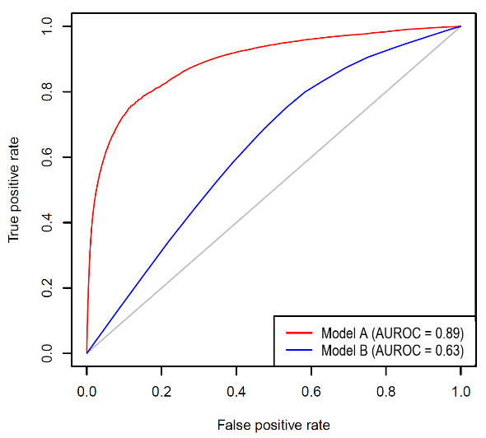
A sample ROC curve plot is provided in Figure 1. This example plot is for a general system, rather than the HAC model itself and is purely explanatory. A ROC curve lying on the diagonal line (grey line) is reflective of a model that performs no better than chance level (random guessing). The closer the ROC curve is to the upper lefthand corner, the better the model can discriminate between two outcomes (by maximising the TPR and minimising the FPR). With reference to Figure 1, it shows that Model A (red line) performs better than Model B (blue line). In the context of HAC risk adjustment model, this means that Model A is better at predicting the occurrence of a HAC in an admitted episode of care than Model B.
The area under the ROC curve (AUROC) provides an aggregate measure of the performance of the model across all the thresholds, and its value ranges between 0 and 1. A model that will predict 100% of categories wrong has an AUROC of 0.0 and a model which predicts all positive classes with 100% accuracy has an AUROC of 1.0. A model with an AUROC of 0.5 (also referred to as the baseline) is represented by the grey diagonal line in the graph. In Figure 1, Model A has a higher AUROC than Model B which indicates that the former model performs better than the latter model and this result is consistent with their respective ROC curves.
The issue with using the ROC curve to assess model performance on imbalanced data is that the rates (TPR and FPR) being compared have different denominators, the former’s denominator being the count of positive events and the latter’s denominator being the count of negative events. In the three years of data used in the HAC model, there are usually around 14 million negative events (i.e. episodes without a HAC). For each HAC group, the number of positive events (i.e. episodes with a HAC) are much lower, ranging from around 600 positive events for HAC15.02 to around 107,000 positive events for HAC03. Taking these figures into consideration and with reference to Figure 1, this effectively means that each incremental increase in the true positive rate (i.e. correctly identified HAC episodes) comes with an exponential increase in the false positive rate (i.e. number of incorrectly identified HAC episodes). Note that these figures are used for comparison of risk models only; in practice, risk models assign a probability and do not use thresholds to assign definite positive/negative outcomes.

4.4.2 Precision recall curve
The precision recall curve (PRC) is a complement to the ROC curve. It may give additional insight when evaluating model performance on imbalanced data.
The PRC curve is parametric plot of the precision and recall of the model where:
  - Precision is the number of true positives out of all the predicted positives, meaning the number of episodes which actually had a HAC out of those predicted to have had a HAC.
  - Recall is another name of the true positive rate and represents how successful the model is in identifying an episode with a HAC. That is, the number of HAC episodes that the model can successfully identify out of all the HAC episodes in the data set.
The PRC graph plots both parameters against a theoretical threshold varied between 0 and 1 to illustrate the tradeoff between precision and recall at different threshold values.

Figure 2: Example of PRC curve
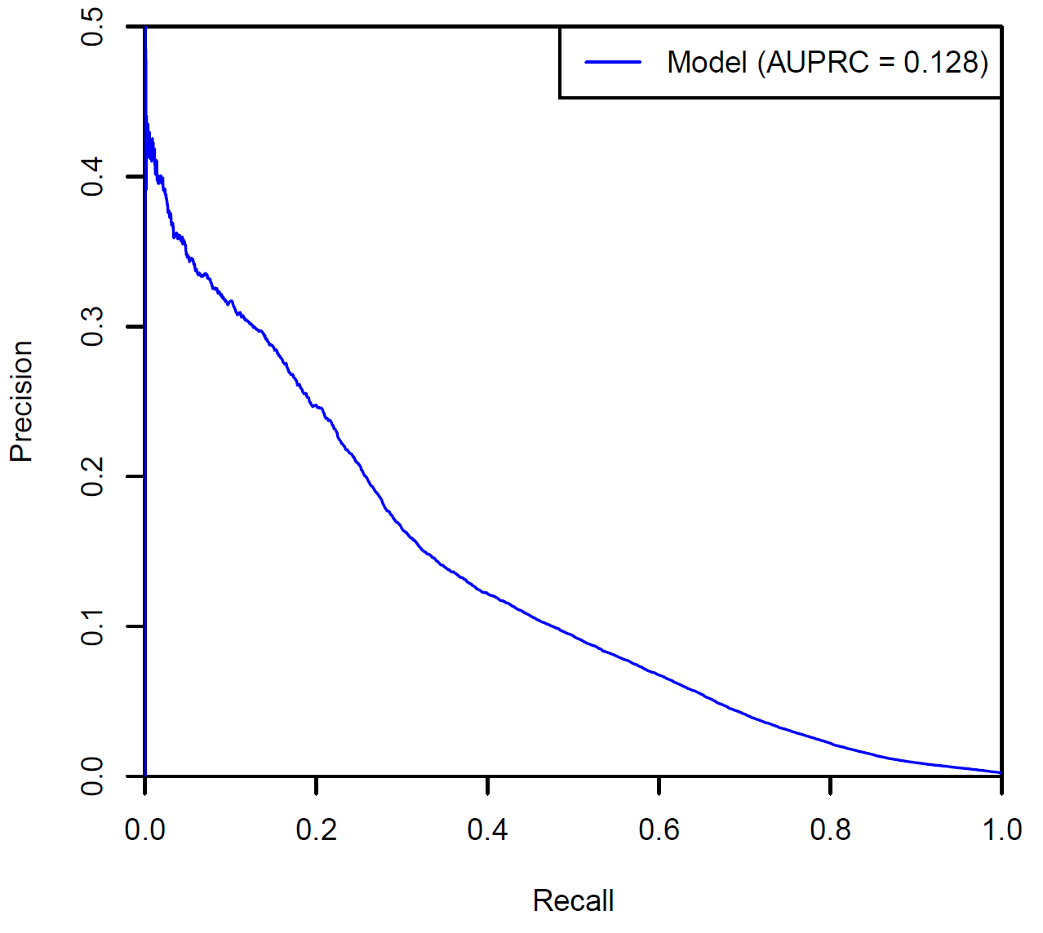
A sample PRC curve is provided in Figure 2. The closer the PRC curve is to the upper righthand corner, the better the model can discriminate between two outcomes (by maximising the precision and recall and thereby maximising the area under the curve).
The area under the PRC curve (AUPRC) provides an aggregate measure of the performance of the model across all thresholds. A higher AUPRC represents both high recall and high precision which is indicative of a better performing model. Generally, the AUPRC is considerably smaller in magnitude than the AUROC for the same model since the baseline is calculated as the proportion of positive observations over total observations which generally less than 0.5 in real-world datasets.

Complexity groups, complexity points, complexity scores and complexity bounds

Complexity groups
As noted in Section 1.3, the risk adjustment methodology of HACs is required to consider different patient complexity levels or specialisation across jurisdictions and hospitals. This is achieved through the creation of complexity groups for each HAC, with differing risk adjustments applied based on the complexity. Each HAC is split into three complexity groups (low, moderate and high). HAC15.02 only has two complexity groups (low and high). These complexity groups are set up such that patients at a higher risk of experiencing an adverse event are classified as ‘high complexity’ and attract a lower funding adjustment. Conversely, patients with a low risk of experiencing an adverse event are classified as ‘low complexity’ and attract a higher funding adjustment.
The assignment of complexity group is undertaken separately for each HAC flagged in the episode, since there are separate risk adjustment models for each HAC:
- A complexity score is calculated for each HAC in the episode based on the different risk factors relevant to that HAC.
- The complexity score is then compared to complexity bounds for that HAC to determine the complexity group for that HAC.
This effectively means that an episode can have up to 14 different complexity scores and complexity groups assigned, one for each HAC.

To enable the assignment of complexity group for each HAC in the episode, IHACPA undertakes the following key steps:
- Converts logistic regression estimates from the risk adjustment model into complexity points, which are summed together to calculate the complexity score for each HAC.
- Determines complexity bounds for each HAC, to enable assignment of a low, moderate or high complexity group for each HAC in the episode.

Complexity points and complexity scores
The logistic regression estimates for each risk factor variable coming out of the risk adjustment model (and the intercept term) are transformed into complexity points. See Appendix E for the complete breakdown of complexity points for each risk factor, for each HAC.
Table 8 provides an illustrative example of the conversion of estimates to complexity points for HAC02 (falls resulting in facture or intracranial injury). It shows that older patients are assigned a higher complexity points value.

Table 8: HAC02 – Falls resulting in fracture or intracranial injury – Patient age complexity points.
Parameters | Group | Estimate value | Complexity point value
Age group | 000 to 039 | 0 | 0
Age group | 040 to 049 | 0.7769 | 3.8847
Age group | 050 to 054 | 1.0856 | 5.4279
Age group | 055 to 059 | 1.3019 | 6.5096
Age group | 060 to 064 | 1.565 | 7.8252
Age group | 065 to 069 | 1.7194 | 8.597
Age group | 070 to 074 | 1.8896 | 9.4478
Age group | 075 to 079 | 2.1825 | 10.9127
Age group | 080 to 084 | 2.4461 | 12.2307
Age group | 085 to 089 | 2.6271 | 13.1355
Age group | 090 to 099 | 2.7417 | 13.7086

Based on the attributes of the episode, the complexity points for each risk factor variable are summed together to calculate the episode’s complexity score for that HAC. The complexity score is set up to fall between one and 100. One is set with reference to an extremely low-risk profile in the model (i.e. the lowest chance of acquiring that HAC), and 100 is set with reference to an extremely high-risk profile in the model. The complexity score is not an indication of the probability of a HAC occurring in an episode.
$$\text{Complexity Score = Sum of complexity points for each risk factor relevant to that HAC}$$

Refer to Section 8.2 for examples on how the complexity points are used to calculate the complexity scores.
Figure 3 shows the non-HAC and HAC complexity profiles for HAC10 (medication complications). The x-axis shows the complexity score values. The left y-axis displays the percentage of episodes with a specific complexity score value (relevant for the non-HAC and HAC distributions). The right y-axis lists probability values for the red line which shows the probability of a HAC at each complexity score value. In general, episodes with a HAC are assigned a higher complexity score compared to episodes without a HAC (non-HAC).

Figure 3: HAC10 – Medication complications – Complexity profile.

Complexity bounds
There are three complexity groupings of ‘low’, ‘moderate’ and ‘high’ for each HAC. This has been adopted to provide an optimal balance between complexities, risk homogeneity and sample size within each complexity group. Due to the small cohort for HAC15.02, only two complexity groupings of ‘low’ and ‘high’ have been adopted.
To assign a complexity group for each HAC in an episode of care, IHACPA determined complexity bounds (or cut-off points) to separate low and moderate complexity episodes, and moderate and high complexity episodes (or just low and high complexity for HAC15.02). The process to calculate the complexity bounds involved:
- Calculating the cumulative distribution of probability-weighted episodes with a HAC.
- Determining the complexity score which divides the cumulative distribution into three quantiles (or two quantiles for HAC15.02).
The complexity bounds represent the lowest complexity score required to be assigned to a complexity group.
Figure 4 shows the HAC10 (medication complications) complexity profile with its complexity bounds and corresponding average weighted probabilities for each complexity group. Refer to Appendix F for the non-HAC and HAC complexity profiles, including the complexity bounds and weighted probabilities, for all HAC categories.

Figure 4: HAC10 – Medication complications – Complexity bounds.
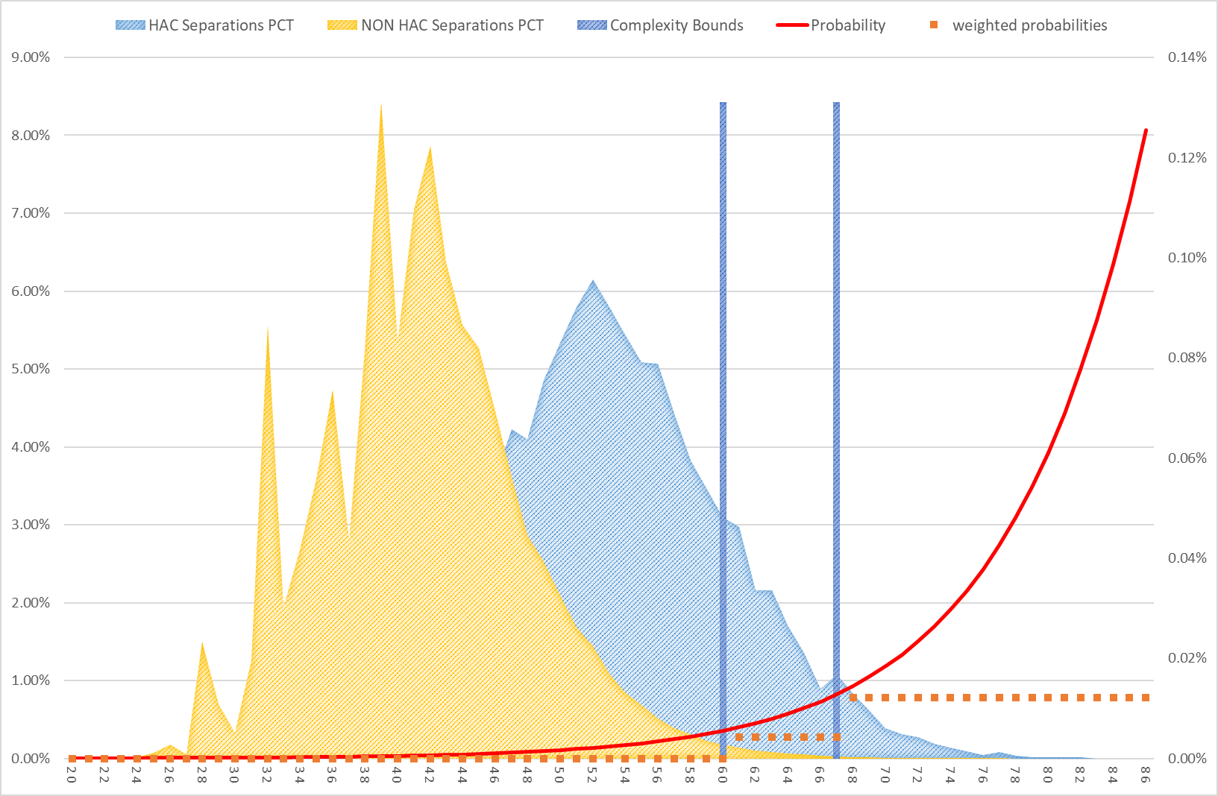

Example: How to assign complexity group based on complexity bounds

Complexity group | Complexity bounds
Low | 1
Moderate | 60
High | 67

This means that episodes with a complexity score:
- Greater than or equal to 67 are assigned to the high complexity group.
- Greater than or equal to 60, and less than 67, are assigned to the moderate complexity group.
- Less than 60 are assigned to the low complexity group.

Incremental cost of a HAC

Overview
The funding approach for HACs requires that the funding level for all HACs across every hospital be reduced to reflect the extra cost of a hospital admission with a complication. This additional cost may be the result of a more complex episode of stay or due to an increase in the length of stay than would have otherwise occurred.
Therefore, it is necessary to determine the value of only the incremental cost relating to the HAC and use this as the basis of the funding adjustment. There are several challenges to this:
- In episodes that contain a HAC, it is impossible to identify what components of the cost directly result from the HAC in the NHCDC data.
- The presence of a HAC may increase the length of stay, but it is impossible to determine the additional length of stay directly attributable to the HAC in the current data collections as there is no record of the date that the HAC occurred.
- The presence of a HAC may increase the complexity of an episode (resulting in a more complex AR-DRG) and this may confound analysis to determine the incremental cost and how an episode should be classified.
The following sections describe the methodology used to determine the incremental cost of a HAC.

Incremental cost model
The methodology used to determine the incremental cost of a HAC uses similar principles to that adopted for the national cost models, in that it uses linear regression to predict the cost of an episode. The incremental cost model uses the episode’s AR-DRG and length of stay as predictors since these characteristics represent the most significant drivers of cost. Other drivers of avoidable costs included in the national cost models such as remoteness and Indigenous status were not included to retain simplicity. These cost drivers may be considered in future refinements of the model.
Three years of activity and cost data were used for the incremental cost model and the model was fit using untrimmed episodes only. The approach taken to determining the incremental cost can be summarised in the following steps:
- A ‘best fit’ model was developed using a length of stay by AR-DRG linear regression to predict the cost of non-HAC episodes only. This model provides the best estimate for a cost of an episode with no HAC occurrence.
- The modelled parameters were then applied to HAC episodes (by AR-DRG and length of stay) to calculate a predicted cost for HAC episodes based on the non-HAC information. This is the cost predicted for the HAC episode with the same AR-DRG and length of stay, but assuming that the HAC was not present.
- A cost ratio was then calculated to compare actual in-scope cost to the predicted cost for the HAC episodes.
$$\text{Cost ratio} \text{=}\frac{\text{Actual in-scope cost}}{\text{Predicted cost}}$$
Under the hypothesis that a HAC leads to greater cost, it would be expected that the actual in scope cost of a HAC episode would be greater than what is predicted for a non-HAC episode with the same AR-DRG and length of stay. This would result in a cost ratio which is greater than 1.0 for HAC episodes.
This cost ratio forms the basis of the incremental cost calculation and was carried out for all HAC episodes in aggregate, as well as each HAC separately to determine whether the incremental cost varied between HACs.
This approach was considered appropriate because of its relative simplicity, using a ‘best fit’ model that accounts for the main drivers of cost. Several modifications were made the incremental cost model to improve the overall results of the model as described below.

Ad-hoc modifications to the incremental cost model

Low volume AR-DRGs and cost ratios less than 1
The overall HAC rates observed in the activity data are generally low and therefore, HAC episodes can be very volatile by AR-DRG. Some AR-DRGs also have a low volume of non-HAC episodes which results in greater instability in the modelled parameters coming out of the incremental cost model.
In some cases, the cost ratio of HAC episodes for some AR-DRGs are less than 1.0 despite HAC episodes being more costly than non-HAC episodes at the aggregate and HAC level. Some AR-DRGs have substantially more HAC episodes compared to non-HAC episodes, which increases variability in the cost ratio calculation. This is the case for some of the obstetrics AR-DRGs which in particular, impacts results for HAC 15.02 (fourth degree perineal laceration during delivery).
As a result, the decision was made to trim AR-DRGs where the cost ratio was below 1.0 and calculate the aggregate cost ratio for the HAC on the remaining AR-DRGs.

Treatment of HAC02 and HAC12
HAC02 (falls resulting in fracture or intracranial injury) and HAC12 (incontinence) have a very low number of HAC episodes, leading to less robust incremental cost calculations compared to other HACs. In particular, the incremental cost for HAC episodes in these two groups are very close to 1.0. This suggests that the actual in-scope cost of a HAC episode is almost equal to the predicted cost of the episode if it didn’t have a HAC, which is counterintuitive.
The decision was made to implement an alternative approach for HAC02 and HAC12, by using the regrouped AR-DRG in the incremental cost calculation. This regrouped AR-DRG is determined by grouping the episode’s AR-DRG after removing all HAC-triggering diagnosis and surgical codes (i.e. determining the episode’s AR-DRG as if the HAC did not occur). This approach acknowledges that the presence of a HAC has the potential to increase the complexity of the episode, thereby increasing the complexity of the episode’s AR-DRG. Using the original AR-DRG to apply the modelled parameters could result in the episode being compared to significantly more costly episodes in that AR-DRG for reasons other than the HAC.
This alternative approach applies the incremental cost model parameters based on the regrouped AR-DRG instead of the original AR-DRG. This results in a lower predicted cost, and all else being equal, a potentially higher cost ratio.
The argument could be made that the incremental cost model parameters should be applied based on regrouped AR-DRG for all HACs. However, current price weights for the AR-DRGs are developed using a mix of HAC and non-HAC episodes for that AR-DRG and accordingly, the funding adjustment should be calibrated using the same AR-DRG assignments.

Treatment of HAC15.02
When a fourth degree perineal laceration occurs during delivery (HAC15.02), the episode’s ADRG usually changes from O60 Vaginal Delivery to O02 Vaginal Delivery with GIs. Therefore, it is not appropriate to use the original AR-DRG to determine the predicted non-HAC cost of episodes with HAC15.02.
Therefore, the incremental cost model parameters are also applied based on the regrouped AR-DRG for HAC15.02, which results in a more accurate predicted cost and cost ratio.

Incremental cost of HAC
Table 9 summarises the final incremental cost of a HAC for each HAC and overall (across all HACs). The ad-hoc modifications detailed in Section 6.3 have been applied to these results.
The final incremental cost for each HAC is then converted into adjustment values using the formula:
$$\text{Adjustment =} \text{1} \text{-} \frac{\text{1}}{\text{1 +} \text{Incremental cost}}$$
These adjustment values form the basis for determining the reduction in funding due to a HAC.

Table 9: Incremental cost of a HAC and incremental cost adjustments by HAC (rounded to 1 decimal place).
Complication | Incremental cost | Incremental cost adjustment
All HACs | 9.6% | 8.8%
1 Pressure injury | 15.9% | 13.7%
2 Falls resulting in fracture or intracranial injury | 3.3% | 3.2%
3 Healthcare-associated infection | 9.2% | 8.4%
4 Surgical complications requiring unplanned return to theatre | 13.4% | 11.8%
5 Unplanned intensive care unit admission | n/a | n/a
6 Respiratory complications | 15.9% | 13.7%
7 Venous thromboembolism | 13.8% | 12.1%
8 Renal failure | 26.3% | 20.8%
9 Gastrointestinal bleeding | 10.7% | 9.6%
10 Medication complications | 10.4% | 9.5%
11 Delirium | 12.3% | 10.9%
12 Incontinence | 9.4% | 8.6%
13 Endocrine complications | 9.8% | 8.9%
14 Cardiac complications | 14.2% | 12.5%
15.01 Third degree perineal laceration during delivery | n/a | n/a
15.02 Fourth degree perineal laceration during delivery | 51.8% | 34.1%
16 Neonatal birth trauma | n/a | n/a

Dampening factors and risk adjustments

Overview
As discussed in Section 5.1, the funding approach for HACs is risk adjusted to consider different patient complexity levels or specialisation across jurisdictions and hospitals. This is achieved through the construction of dampening factors which vary depending on the episode’s complexity, or risk, of a particular HAC occurring.

How do the dampening factors work?
Dampening factors adjust the funding reduction for an episode containing a HAC based on the risk of that patient acquiring a HAC. Without dampening, episodes with higher complexity scores would be penalised the same amount for the same HAC as those episodes with a lower complexity score. This goes against the intent of the pricing for safety and quality. Dampening factors have been developed to adjust for these differences in risk among patient profiles for different hospitals.
Dampening factors are a set of percentage scores for each complexity group. The product of the dampening factors and incremental cost adjustment values (Table 9) determine the reduction in funding to an episode due to the presence of a HAC; the smaller the dampening factor applied, the smaller the reduction in NWAU. Table 10 provides an illustrative example.

Table 10: Example – Dampening factor calculations.
Complexity group | Incremental cost adjustment (a) | Dampening Factor (b) | Reduction in NWAU  (c) = (a) x (b)
Low | 10% | 100% | 10%
Moderate | 10% | 50% | 5%
High | 10% | 20% | 2%

Table 10 shows that by varying the dampening factor, episodes in the:
  - Low complexity group receives a 10% reduction in NWAU.
  - Moderate complexity group receives a 5% reduction in NWAU.
  - High complexity group receives a 2% reduction in NWAU.
The dampening factors allowing the funding approach for HACs to be risk-adjusted depending on the complexity of the episode.

Calculating the dampening factors and risk adjustment values
The dampening factors are derived by assessing the difference in the cost profiles between HAC and non-HAC cohorts in each complexity group within the same HAC. Figure 5 illustrates the cost profile for HAC10 (medical complications).

Figure 5: HAC10 Medical Complications - Cost profile analysis.
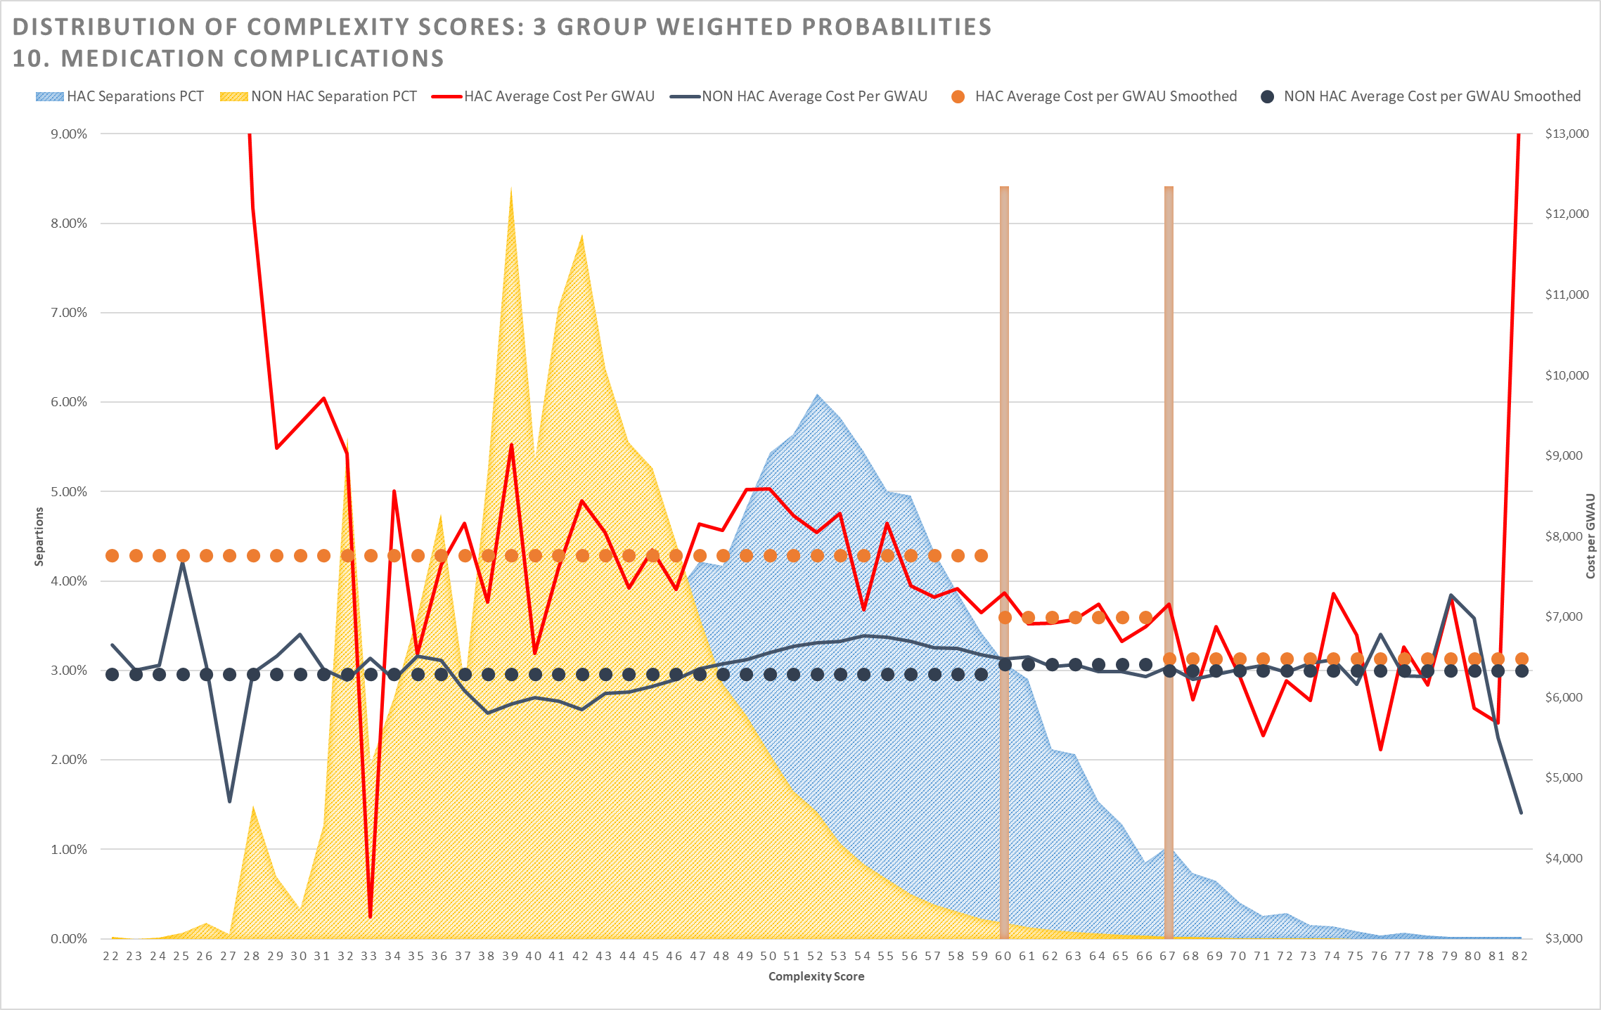
Figure 5 shows the cost differential between HAC and non-HAC cohorts. The red jagged line shows the average cost per GWAU for the HAC cohorts (the dotted horizontal orange lines represent the smoothed average cost within the complexity group). The corresponding lines in dark blue show the equivalent average cost per GWAU for the non-HAC cohorts. The GWAU has been calculated based on last year’s Determination.
It was observed that the differential between the HAC and non-HAC cohorts changes depending on the complexity group, and that this differential is reduced as the complexity increased (as demonstrated by the converging lines).
The differentials in the average cost per GWAU between HAC and non-HAC cohorts form the basis for determining the dampening factors in the following way:
  - Episodes belonging to the lowest complexity group receive no dampening, that is, these episodes receive the full funding adjustment (maximum reduction in NWAU) for that HAC.
  - The dampening factors for episodes in moderate or high complexity group are calculated by dividing the cost differential in that group by the cost differential in the lowest complexity group. That is, the cost differential in the lowest complexity group is used as a benchmark against which the moderate and high complexity groups are compared.
Formula to calculate dampening factors:

$$\text{Dampening factor = }\frac{\text{Difference between }{\text{X}}_{\text{HAC episodes}}\text{ and }{\text{X}}_{\text{Non-HAC episodes}}\text{ with Y complexity }}{\text{Difference between }{\text{X}}_{\text{HAC episodes}}\text{ and }{\text{X}}_{\text{Non-HAC episodes}}\text{ with low complexity}}$$

Where:
X = Average cost per GWAU
Y = Low, Moderate or High

Formula to calculate HAC risk adjustments:

$$\text{HAC risk adjustment} \text{=} \text{Incremental cost adjustment ×} \text{Dampening factor}$$

Table 11 shows the calculation of the dampening factors and HAC risk adjustments for HAC10 Medical Complications. The dampening factor is calculated by using the cost differential for the lowest complexity group as a benchmark. These are then multiplied by the incremental cost adjustment value for this HAC (refer to Table 9) to derive the final risk adjustment.

Table 11: Dampening factor and HAC risk adjustment calculation for HAC10 Medical Complications.
Complexity group | %$\frac{\text{HAC cost profile}}{\text{non-HAC cost profile}} \text{-} \text{1}$ | Dampening Factor | HAC risk adjustment
Low | $$\frac{\text{\$7,760}}{\text{\$6,290}}\text{ - 1 = 23.4\%}$$ | $$\frac{\text{23.4\%}}{\text{23.4\%}}\text{ = 1.0000}$$ | $$\text{1.0000 × 0.095 = 0.095}$$
Moderate | $$\frac{\text{\$6,997}}{\text{\$6,}\text{408}}\text{ - 1 = 9.2\%}$$ | $$\frac{\text{9.2\%}}{\text{23.4\%}}\text{ = 0.3937}$$ | $$\text{0.3937 × 0.095 = 0.037}$$
High | $$\frac{\text{\$6}\text{,}\text{481}}{\text{\$6,332}}\text{ - 1 = 2.4\%}$$ | $$\frac{\text{2.4\%}}{\text{23.4\%}}\text{ = 0.1009}$$ | $$\text{0.1009 × 0.095 = 0.01}$$

The magnitude of the dampening factors are derived from empirically observed cost differentials and as such, the dampening factors can vary between the different complexity and HACs.
The dampening factors and HAC risk adjustment values for the different HAC and complexity group combinations can be found at Appendix F.

Calculating HAC risk adjusted NWAU

Process to calculate HAC risk adjusted NWAU
 | The following steps are used to determine the HAC risk adjusted NWAU:
1. | For each HAC in an episode:  - Calculate a complexity score by summing the complexity points for each risk factor variable relevant to that HAC (Refer to Appendix E).  - Assign a complexity group by comparing the complexity score to that HAC’s complexity bounds (Refer to Appendix F).  - Determine the applicable risk adjustment based on the HAC and complexity group (Refer to Appendix F).
2. | If an episode contains more than one HAC, then the maximum adjustment is used in the next step to calculate the risk adjusted NWAU (regardless of the complexity of the HAC).
3. | Calculate the HAC adjusted NWAU as:  Adjusted NWAU = NWAU - base price weight × HAC risk adjustment factor

As discussed previously, it is possible for an episode to have multiple different complexity scores, each relating to a different HAC. Since each HAC has a different set of complexity bounds, it is possible for the same episode to be considered a low complexity group for one HAC and a moderate or high complexity for another HAC. Therefore, the final adjustment that is applied does not necessarily belong to the highest complexity, but rather the maximum adjustment value.
Table 12 presents an example of how the HAC risk adjustment factor is determined for an episode with more than one HAC. Even though the episode was considered as high complexity for HAC group Y, the adjustment for HAC group X was greater and therefore selected for the adjustment. This assessment is performed on an episode level for each HAC episode.

Table 12: Example calculation of adjustment factor for an episode with more than one HAC.
HACs present in the episode | Complexity score | Complexity group | HAC risk adjustment
HAC group X | 75 | Low | 13.5%
HAC group Y | 76 | High | 1.5%
Selected adjustment |  |  | 13.5%

The adjustments have been designed and calculated at an episode level allowing for aggregation to a jurisdiction, LHN or hospital level to determine the aggregate impact.

Vignettes
The following clinical examples demonstrate the application of the risk adjustment model and safety and quality adjustments to individual episodes.

Case 1: Falls resulting in fracture or intracranial injury – low risk
A 27 year old female patient was a booked admission to day-surgery for a cholecystectomy. She had no comorbid conditions. Following the surgery, she fell off the bed in the ward, hitting her head on the floor. A computed tomography (CT) scan showed a subdural haematoma. The patient remained in hospital for further treatment and surgery.

Table 13: Case one breakdown: HAC02 Falls resulting in fracture or intracranial injury.
Complexity score calculations
Risk factor breakdown | Complexity Score
Baseline | 27.4572
Age Group: 025 to 029 | 0.0000
Congestive heart failure: No | 0.0000
Peripheral vascular disease: No | 0.0000
Cerebral vascular accident: No | 0.0000
Pulmonary disease: No | 0.0000
Liver disease: No | 0.0000
Diabetes complications: No | 0.0000
Paraplegia: No | 0.0000
Cancer: No | 0.0000
Renal disease: No | 0.0000
Severe liver disease: No | 0.0000
DRG Type: Intervention | 3.0896
MDC: Diseases & Disorders of the Hepatobiliary System & Pancreas | -1.0780
Emergency admission: No | 0.0000
ICU Hours: No | 0.0000
Admission transfer status: No | 0.0000
COVID-19 Status : No | 0.0000
Parkinson’s disease: No | 0.0000
Epilepsy: No | 0.0000
Crohn's disease: No | 0.0000
Mental health: No | 0.0000
Post transplant status: No | 0.0000
Drug use: No | 0.0000
Malnutrition: No | 0.0000
Osteoporosis: No | 0.0000
Total | 29
Adjustment calculations
Complexity group | Low
Maximum adjustment | 3.2%
Dampening | 1.0000
Final adjustment | 3.2%

As illustrated from the above table, an episode in the ‘low risk’ category for this HAC is subject to a negative funding adjustment equivalent to 3.2% of the funding for this episode of care.

Case 2: Falls resulting in fracture or intracranial injury – moderate risk
The patient is a 73 year old male who was admitted through emergency for acute shortness of breath. The patient has a background of congestive heart failure, hypertension, peripheral vascular disease and type 2 diabetes managed with oral medication.
The patient was transferred to the ICU for non-invasive ventilation due to pneumonia before being transferred to the ward seven days later. While on the ward, the patient slipped and fell heavily while in the shower, resulting in a fracture of the lumbar vertebra L4-L5. The fracture was managed conservatively and the patient was discharged home 12 days following admission. The patient was also diagnosed with COVID-19 and malnutrition during her stay.

Table 14: Case two breakdown: HAC02 Falls resulting in fracture or intracranial injury.
Complexity score calculations
Risk factor breakdown | Complexity Score
Baseline | 27.4572
Age Group: 070 to 074 | 9.4478
Congestive heart failure: Yes | 1.8392
Peripheral vascular disease: Yes | 2.0288
Cerebral vascular accident: No | 0.0000
Pulmonary disease: No | 0.0000
Liver disease: No | 0.0000
Diabetes complications: No | 0.0000
Paraplegia: No | 0.0000
Renal disease: No | 0.0000
Cancer: No | 0.0000
Severe liver disease: No | 0.0000
DRG Type: Intervention | 3.0896
MDC: Diseases & Disorders of the Respiratory System | -1.4765
Emergency admission: Yes | 5.3373
ICU Hours: Yes | 2.3473
Admission transfer status: No | 0.0000
COVID-19 Status : Yes | 4.0065
Parkinson’s disease: No | 0.0000
Epilepsy: No | 0.0000
Crohn's disease: No | 0.0000
Mental health: No | 0.0000
Post transplant status: No | 0.0000
Drug use: No | 0.0000
Malnutrition: Yes | 5.6142
Osteoporosis: No | 0.0000
Total | 60
Adjustment calculations
Complexity group | Moderate
Maximum adjustment | 3.2%
Dampening | 0.4890
Final adjustment | 1.6%

As illustrated from the above table, an episode in the ‘moderate risk’ category for this HAC is subject to a negative funding adjustment equivalent to 1.6% of the funding for this episode of care.

Case 3: Falls resulting in fracture or intracranial injury – high risk
The patient is an 87 year old female who was admitted to hospital via the emergency department with a principal diagnosis of stroke. The patient has a background of severe liver disease, chronic renal failure, chronic obstructive pulmonary disease and type 2 diabetes managed with insulin.
The patient was treated conservatively. On the second day of her admission, she fell while trying to take herself to the bathroom unsupervised, which resulted in a fractured neck of femur. A total hip replacement was performed. The patient was discharged to her residential aged care accommodation 25 days following admission. During her admission, she also spent some time in an intensive care unit. The patient was also diagnosed with COVID-19 and malnutrition during her stay.

Table 15: Case three breakdown: HAC02 Falls resulting in fracture or intracranial injury.
Complexity score calculations
Risk factor breakdown | Complexity Score
Baseline | 27.4572
Age Group: 085 to 089 | 13.1355
Congestive heart failure: No | 0.0000
Peripheral vascular disease: No | 0.0000
Cerebral vascular accident: No | 0.0000
Pulmonary disease: Yes | 0.4668
Liver disease: No | 0.0000
Diabetes complications: No | 0.0000
Paraplegia: No | 0.0000
Renal disease: Yes | 1.7115
Cancer: No | 0.0000
Severe liver disease: Yes | 2.5591
DRG Type: Medical | 0.0000
MDC: Diseases & Disorders of the Nervous System | 1.5774
Emergency admission: Yes | 5.3373
ICU Hours: Yes | 2.3473
Admission transfer status: No | 0.0000
COVID-19 Status: Yes | 4.0065
Parkinson’s disease: No | 0.0000
Epilepsy: No | 0.0000
Crohn's disease: No | 0.0000
Mental health: No | 0.0000
Post transplant status: No | 0.0000
Drug use: No | 0.0000
Malnutrition: Yes | 5.6142
Osteoporosis: No | 0.0000
Total | 64
Adjustment calculations
Complexity group | High
Maximum adjustment | 3.2%
Dampening | 0.3106
Final adjustment | 1.0%

As illustrated from the above table, an episode in the ‘high risk’ category for this HAC is subject to a negative funding adjustment equivalent to 1.0% of the funding for this episode of care.

Appendix A – Risk factor definitions

Table 16: ICD-10-AM/ACHI/ACS Twelfth Edition codes used for to flag risk factors in the shadow period HAC risk adjustment model.
Risk factor | ICD-10-AM/ACHI/ACS codes
Acute myocardial infarction | I21-prefix I22-prefix
Congestive heart failure | I50-prefix I11.0-prefix I13.0-prefix I13.2-prefix U82.2
Peripheral vascular disease | I70-prefix I71-prefix I73-prefix
Cerebral vascular accident | I60-prefix to I66-prefix I67.0-prefix to I67.9-prefix I68.0-prefix to I68.2-prefix I68.8-prefix I69-prefix
Dementia | F03 F00.0 F00.1 F00.2 F00.9 F01.0 F01.1 F01.2 F01.3 F01.8 F01.9 F02.0 F02.1 F02.2 F02.3 F02.4 F02.8 (ICD-10-AM 10th and 11th edition only) F00.00 F00.01 F00.10 F00.11 F00.20 F00.21 F00.90 F00.91 F01.00 F01.01 F01.10 F01.11 F01.20 F01.21 F01.30 F01.31 F01.80 F01.81 F01.90 F01.91 F02.00 F02.01 F02.10 F02.11 F02.20 F02.21 F02.30 F02.31 F02.40 F02.41 F02.80 F02.81 F03.00 F03.01 (ICD-10-AM 12th edition only)/ U79.1
Pulmonary disease | J40-prefix to J47-prefix J60-prefix to J67-prefix U83.1 U83.2 U83.3 U83.4
Connective tissue disorder | M30-prefix to M36-prefix M05-prefix M06-prefix U86.1 U86.3
Peptic ulcer | K25-prefix to K28-prefix
Liver disease | K70.0-prefix to K70.3-prefix K70.9-prefix K71.0-prefix K71.2-prefix to K71.9-prefix K72.0-prefix K73-prefix to K75-prefix K76.0-prefix to K76.4-prefix K76.8-prefix K76.9-prefix B18-prefix
Diabetes | E10.8 E10.9 E11.8 E11.9 E13.8 E13.9 E14.8 E14.9-prefix
Diabetes complications | E10.0-prefix to E10.7-prefix E11.0-prefix to E11.7-prefix E13.0-prefix to E13.7-prefix E14.0-prefix to E14.7-prefix
Paraplegia | G81.0 G81.1 G81.9 G83.0 G83.1 G83.2 G83.3 G82.00 G82.02 G82.04 G82.06 G82.10 G82.12 G82.14 G82.16 G82.20 G82.22 G82.24 G82.26 G82.30 G82.32 G82.34 G82.36 G82.40 G82.42 G82.44 G82.46 G82.50 G82.52 G82.54 G82.56/ U80.5
Renal disease | N03-prefix N05.2-prefix to N05.6-prefix N07.2-prefix to N07.4-prefix N01-prefix N18.3-prefix to N18.5-prefix N18.9-prefix N19-prefix N25-prefix I12.0-prefix I13.1-prefix Z49.0-prefix to Z49.2-prefix U87.1
Cancer | C0-prefix to C3-prefix C40-prefix C41-prefix C43-prefix C45-prefix to C49-prefix C5-prefix C6-prefix C70-prefix to C76-prefix C80-prefix to C86-prefix C88.0-prefix C88.2-prefix to C88.4-prefix C88.7-prefix C88.9-prefix C90.0-prefix to C90.3-prefix C91.1-prefix C91.3-prefix to C91.9-prefix C92-prefix C93.0-prefix C93.1-prefix C93.3-prefix C93.7-prefix C93.9-prefix C94.0-prefix C94.2-prefix to C94.4-prefix C94.6-prefix C94.7-prefix C95.0-prefix C95.1-prefix C95.7-prefix C95.9-prefix D46-prefix D45
Metastatic cancer | C77-prefix to C79-prefix
Severe liver disease | K70.4-prefix K71.1-prefix K72.1-prefix K72.9-prefix K76.5-prefix to K76.7-prefix Z94.4-prefix U84.3
HIV | B20-prefix to B24-prefix R75-prefix Z21-prefix
Fetal distress (HAC15.02 only) | O68-prefix
Instrument use (HAC15.02 only) | 90468-00 90468-01 90468-02 90468-03 90468-04 90468-05 90468-06 90469-00 90469-01 90470-02 90470-04
Persistent posterior occiput presentation (HAC15.02 only) | O328-prefix O640-prefix
Young and mature aged primigravida (HAC15.02 only) | Z3551-prefix Z356-prefix
COVID-19 Status | U07.11 U07.2 U07.12
Obesity | E66.9 (ICD-10-AM 10th edition only) E66.90 E66.91 E66.92 E66.93 (ICD 10-AM 11th and 12th edition only)/ U78.1
Cystic fibrosis | E84/ U78.2
Schizophrenia | F20.0 F20.1 F20.2 F20.3 F20.4 F20.5 F20.6 F20.8 F20.9/ U79.2
Depression | F33.4 F33.8 F33.9 F32.00 F32.01 F32.10 F32.11 F32.20 F32.21 F32.30 F32.31 F32.80 F32.81 F32.90 F32.91/ U79.3
Disorder of intellectual development | F70.0 F70.1 F70.8 F70.9 F71.0 F71.1 F71.8 F71.9 F72.0 F72.1 F72.8 F72.9 F73.0 F73.1 F73.8 F73.9 F78.0 F78.1 F78.8 F78.9 F79.0 F79.1 F79.8 F79.9/ U79.4
Parkinson’s disease | G20/ U80.1
Multiple sclerosis | G35/ U80.2
Epilepsy | G40.00 G40.01 G40.10 G40.11 G40.20 G40.21 G40.30 G40.31 G40.40 G40.41 G40.50 G40.51 G40.60 G40.61 G40.70 G40.71 G40.80 G40.81 G40.90 G40.91/ U80.3
Cerebral palsy | G80.9 G80.00 G80.01 G80.02 G80.03 G80.09/ U80.4
Ischaemic heart disease | I25.9 I25.10 I25.11 I25.12 I25.13/ U82.1
Chronic heart failure | I50.0 I50.9/ U82.2
Hypertension | I10/ U82.3
Emphysema without mention of COPD | J43.9/ U83.1
COPD | J44.9/ U83.2
Asthma without mention of COPD | J45.0 J45.1 J45.8 J45.9/ U83.3
Bronchiectasis without mention of CF | J47/ U83.4
Chronic respiratory failure | J96.10 J96.11 J96.19/ U83.5
Crohn's disease | K50.9 K50.8 K50.1 K50.0/ U84.1
Ulcerative colitis | K51.0 K51.2 K51.3 K51.8 K51.9/ U84.2
Chronic liver failure | K72.1/ U84.3
Rheumatoid arthritis | M06.90 M06.91 M06.92 M06.93 M06.94 M06.95 M06.96 M06.97 M06.98 M06.99/ U86.1
Arthritis and osteoarthritis | M15.0 M16.0 M16.1 M17.0 M17.1 M18.0 M18.1 M13.90 M13.91 M13.92 M13.93 M13.94 M13.95 M13.96 M13.97 M13.98 M13.99 M19.01 M19.02 M19.03 M19.04 M19.07 M19.08 M19.09 M47.90 M47.91 M47.92 M47.93 M47.94 M47.95 M47.96 M47.97 M47.98 M47.99/ U86.2
Systemic lupus erythematosus | M32.0 M32.1 M32.8 M32.9/ U86.3
Osteoporosis | M81.90 M81.91 M81.92 M81.93 M81.94 M81.95 M81.96 M81.97 M81.98 M81.99/ U86.4
Chronic kidney disease | N18.3 N18.4 N18.5/ U87.1
Spina bifida | Q05.00 Q05.01 Q05.02 Q05.10 Q05.11 Q05.12 Q05.20 Q05.21 Q05.22 Q05.30 Q05.31 Q05.32 Q05.40 Q05.41 Q05.42 Q05.50 Q05.51 Q05.52 Q05.60 Q05.61 Q05.62 Q05.70 Q05.71 Q05.72 Q05.80 Q05.81 Q05.82 Q05.90 Q05.91 Q05.92/ U88.1
Down's syndrome | Q90.0 Q90.1 Q90.2 Q90.9/ U88.2
Mental health | F-prefix R45.81 U79-prefix
Homelessness | Z59.0-prefix
Post transplant status | Z94-prefix
Pacemaker status | Z95.0
Ventilator | Z99.1
Asthma | J45-prefix J46-prefix U83.3
Malnutrition | E40 E41 E42 E43 E44.0 E44.1 E45 E46
Drug use | F10-prefix to F19-prefix Z64.2-prefix Z72.2-prefix
Dystocia | P03.1 O66.0

Appendix B – Developing the initial HAC risk adjustment model
Determining the risk factors for the risk adjustment model
IHACPA undertook an extensive consultation process with the Commission, IHACPA’s CAC and jurisdictions to investigate potential risk factors for HACs.
Empirical evidence suggested that patient age was a strong predictor for the probability of a specific HAC occurring within an episode of care. Thus, the preliminary risk adjustment model developed in 2016 used patient age as the only risk factor (the age only model). This model was conceptually simple and easy to explain, however it did not appear to adequately adjust for specialist paediatric and tertiary hospitals. Further, it was believed that there may be other risk factors which could significantly impact the probability of a particular patient acquiring a HAC which should be also considered in the model. IHACPA sought consultation from the Commission and the CAC regarding risk factors that should be considered in a refined risk adjustment model.
Advice was sought in relation to the potential use of length of stay and presence of another HAC within the same episode as risk factors within the model. Advice from the CAC was that the lines of causation and correlation between these risk factors and HACs occurrence were blurred, and that it was not appropriate to include them within the model. For example, an episode with a higher length of stay has a higher exposure to risk receiving a HAC (correlation). However, conversely, the episode may have a longer length of stay due to a HAC occurring (causation). Risk factors deemed nonviable due to clinical advice were also removed.
The various risk factors investigated for the model and presented for consultation in the HAC Technical Specifications in July 2017 are provided in Table 17.

Table 17: List of potential risk factors investigated during initial model development.
HAC01-HAC14 risk factors | HAC-specific factors
Patient age | Liver disease (HAC04)
Sex | Heart failure (HAC07)
MDC | Myocardial infarction (HAC07)
AR-DRG type (medical, intervention) | Stroke with immobility (HAC07)
Intensive care unit status | Cardiovascular disease (HAC08)
Presence of another HAC | Malignancy (HAC08)
Patient Indigenous status | Mechanical ventilation (HAC09)
Patient remoteness | Parkinson’s disease (HAC13)
Patient SEIFA | Dementia (HAC13)
Admission transfer status
Chronic disease count
Highly specialised procedures
Emergency admission status
Length of stay
Charlson score

In early 2019, the Commission convened condition-specific HAC curation clinical advisory panels for delirium, pressure injuries, renal failure, cardiac complications, respiratory complications, third and fourth degree perineal lacerations and neonatal birth trauma.
The panels considered the pricing of perineal lacerations and neonatal birth trauma, neither of which were included for a funding adjustment in NEP18 or NEP19. This was due to difficulty in identifying suitable risk factors to construct a robust risk adjustment model.
The clinical review supported further investigation into a risk adjustment model for fourth degree perineal lacerations. HAC funding adjustment for fourth degree perineal lacerations was implemented from NEP20. They did not support a HAC funding adjustment for third degree perineal laceration or neonatal birth trauma.
Based on advice from the Commission, a unique set of risk factors were investigated for the HAC15.02 (fourth degree perineal laceration during delivery) risk model, as shown in Table 18. This includes the use of young and mature aged primigravida instead of primiparity due to the lack of consistent documentation in the latter category. The panel has recommended advocating for routine coding of parity. Another risk factor that was noted by the panel, but not included in the model due to lack of documentation, was mothers of Asian ethnicity.

Table 18: Risk factors investigated for HAC15.02.
HAC15-specific risk factors | Diagnosis (surgical) codes
Fetal distress | O680, O682, O683, O688, O689
Use of instruments | (9047002), (9047004), (9046800), (9046801), (9046802), (9046803), (9046804), (9046805), (9046900), (9046901) and (9046806) for ICD10AM v.10 and above.
Young and mature aged primigravida | Z3551, Z356
Persistent posterior occiput presentation | O328, O640

Determining the number of complexity groups for each HAC
A range of complexity groups were investigated to provide balance between having enough volume of data for each grouping, to ensure reasonable separation between the cut-off points for each group and to distinguish the distribution of complexity scores for HAC and non-HAC separations.
A range of options were tested, including two, three, five, eight and ten complexity groups. Three complexity groupings of ‘low’, ‘moderate’ and ‘high’ have been adopted to provide an optimal balance between complexities, risk homogeneity and sample size within each group. Due to the small cohort for HAC15.02, only two complexity groupings of ‘low’ and ‘high’ have been adopted.
Treatment of episodes with multiple HACs
IHACPA initially considered whether the presence of multiple HACs could be addressed through the funding approach. An additive funding approach was evaluated, where the funding adjustment for each HAC that occurred is deducted from the NWAU of an episode. This approach assumed that HACs occur independently, which is not the case and therefore found to overly penalise episodes with more than one HAC.
IHACPA then considered developing a model where the funding adjustment for episodes with multiple HACs would be scaled depending on the underlying correlation of one HAC to another. It was decided that the additional complexity of this approach was not warranted given the expected minimal funding impact.
Funding impacts have therefore been calculated using the HAC that results in the highest funding adjustment for an episode, with the additional costs of other HACs not considered in the funding adjustment.

Appendix C – Selection of and reassessment of risk factors
The HAC risk adjustment model consists of a series of logistic regression models, one for each HAC. Each logistic regression model predicts the likelihood of a specific HAC occurring within an episode of care using a set of risk factors specific to that HAC.
IHACPA has established a general process for assessing risk factors included in the risk adjustment model. The process involves:
  - (For new risk factors) A preliminary assessment to determine whether there is adequate volume of information to allow for their use.
  - Assessing the statistical performance of the risk factor in predicting the occurrence of a HAC.
  - Assessing the breakdown of classes within each significant risk factor.
  - Seeking clinical advice on the appropriateness of the proposed risk factor.

Testing risk factor significance
For NEP26 a revised stepwise selection methodology, backwards selection, is used to evaluate the risk factors included in the logistic regression model for each HAC.
The backwards selection methodology involves starting with a full model that considers all risk factors to be included in the model. Risk factors are then iteratively removed from the full model until all remaining variables are considered to have some significant contribution to the probability of predicting a HAC. Variables are removed from the model in an iterative approach where:
  - The starting model includes all candidate variables.
  - For each iteration, the p-value is calculated for every candidate variable currently in the model, to test the null hypothesis that ‘removing a specific risk factor does not significantly reduce model performance.’ The initial model includes all candidate risk factors.
  - For each iteration, the risk factor with the lowest chi-squared statistic that is not statistically significant (p-value less than 0.05) is removed from the model.
  - This process continues until all remaining variables meet the significance criteria (p-value less than 0.05) for retention in the model.
Risk factors identified in the above process must be tested as significant for all three latest NEP cycles which include NEP24, NEP25, and NEP26 before it is considered for implementation in NEP26.
As the risk factors for HAC15.02 are limited and based on clinical advice, all existing risk factors were retained for NEP26. In addition, the same framework as described above for all HACs was used for HAC15.02 to consider any additional risk factors for implementation in NEP26.
Individual parameter assessment
The individual parameter assessment examines the statistical performance of each class within the risk factors. Class refers to how the risk factor is split into different categories (e.g. the age risk factor has 20 classes). This step is undertaken to investigate any further improvements in the performance of logistic regression model for each HAC.
The classes within each risk factor were assessed under several criteria including:
  - The statistical significance of each parameter (0.05 threshold was adopted).
  - The statistical estimates of a class compared with subsequent classes (that is, if there are overlaps between confidence intervals indicating potential groupings of parameters).
  - Analysing trends in overall estimates within the risk factors and comparing them to clinical expectations.
  - Impact on model performance.
This process is undertaken in an iterative manner where various scenarios of different groupings of parameters are investigated.
Seeking clinical advice
IHACPA will seek the advice of the CAC on the selection, addition and removal of risk factors in the HAC risk adjustment model. This will generally be undertaken in two stages, firstly to propose risk factors for broad consideration and exploration and then subsequently, after statistical analysis, seek advice on any finalised updates to the risk model.
IHACPA has previously sought advice on the use of length of stay and the presence of another HAC within the same episode as risk factors within the model. Advice from CAC was that the lines of causation and correlation between these risk factors and HAC occurrence is blurred and it was not appropriate to include them in the model.
Other general considerations
Any changes to the risk factors in the HAC risk adjustment model should seek to optimise the statistical model performance and reduce the overall complexity of each logistic regression model. The following items should be considered when proposing changes to the risk factors:
  - Complexity of identification (for example, if there are any interaction effects between patient age and ICU status).
  - The consistency of the risk factor across each HAC model (that is, how prominent each risk factor is across the HAC logistic regression models).
  - The odds ratio for each of the parameters.
  - The impact on model performance if specific risk factors are added or removed.

Appendix D – Model performance curves
Refer to Section 4.4 for details on how to interpret these graphs.

ROC curves
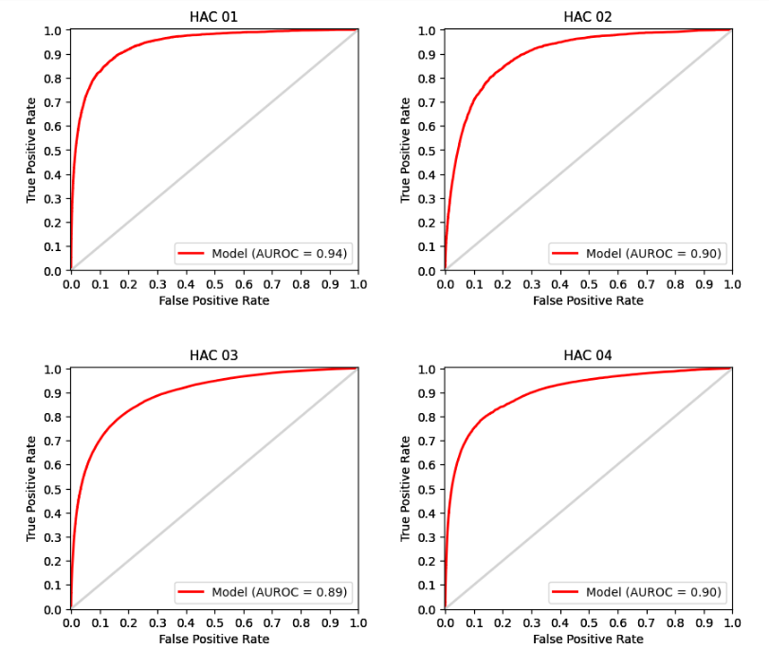
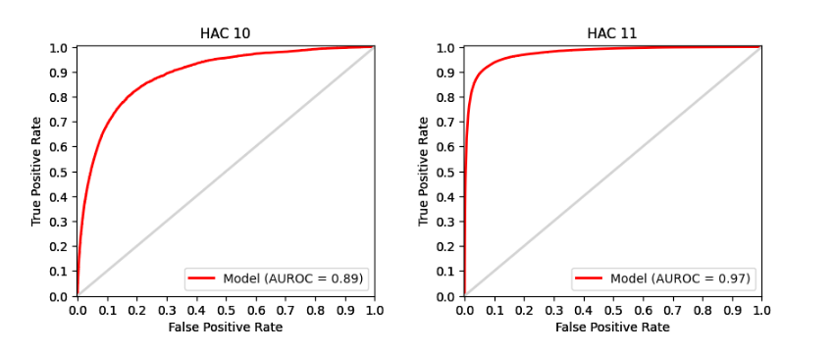
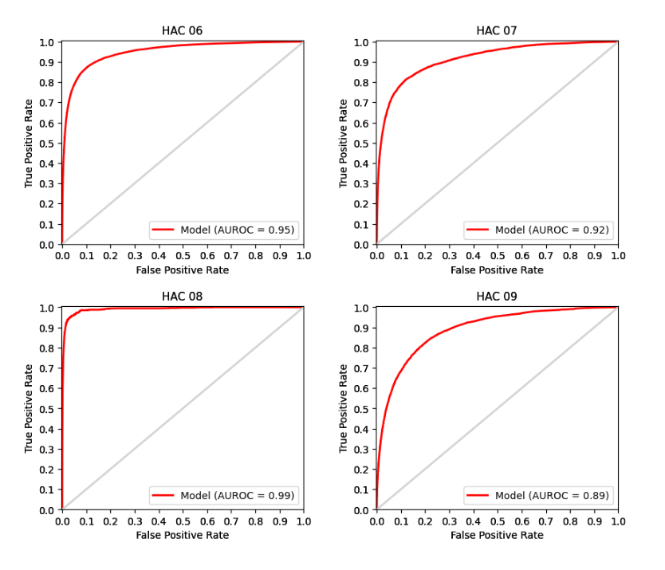

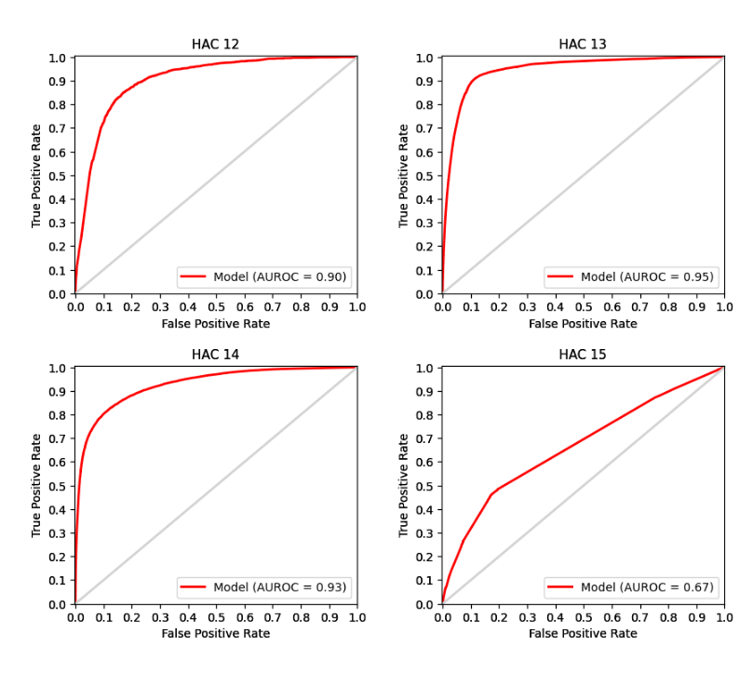

PRC curves
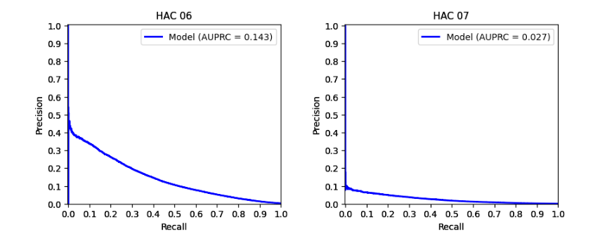
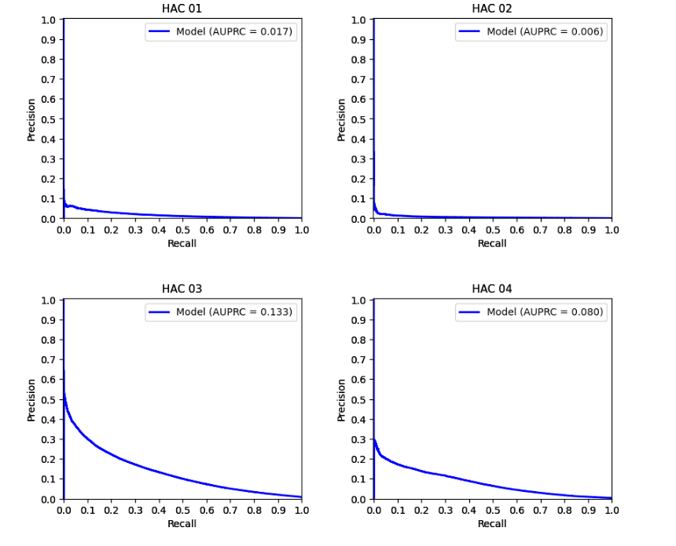

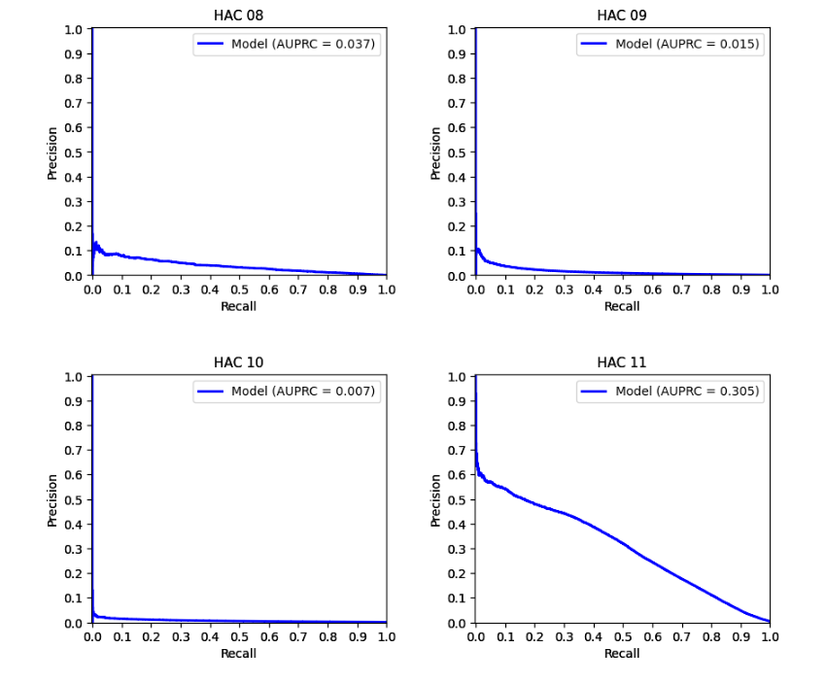

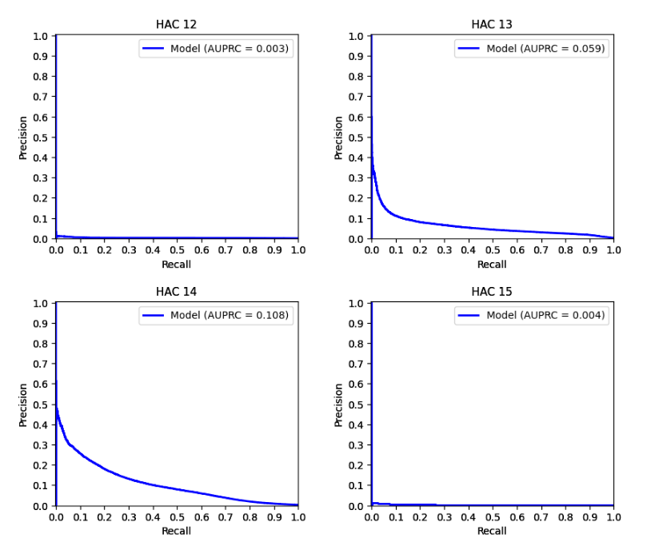

Appendix E – Complexity points

Table 19: Complexity points for HAC01 to HAC14.
Groups | 1. Pressure injury | 2. Falls resulting in fracture or intracranial injury | 3. Healthcare-associated infection | 4. Surgical complications requiring unplanned return to theatre | 6. Respiratory complications | 7. Venous thromboembolism | 8. Renal failure | 9. Gastrointestinal bleeding | 10. Medication complications | 11. Delirium | 12. Incontinence | 13. Endocrine complications | 14. Cardiac complications
Baseline | 38.8636 | 27.4572 | 52.5901 | 46.9451 | 50.6233 | 37.3362 | 33.3318 | 41.4471 | 36.1010 | 38.7098 | 50.3872 | 46.8835 | 46.1931
Emergency admission | 4.9510 | 5.3373 | 3.2572 | 0.5310 | 2.2858 | 3.3751 | 0.0000 | 2.1270 | 3.3511 | 0.0000 | 5.8275 | 3.4756 | -0.2567
ICU Hours | 7.4606 | 2.3473 | 9.3173 | 10.7022 | 13.2278 | 10.7398 | 21.1671 | 5.7008 | 7.3316 | 7.5356 | 11.9595 | 5.3357 | 11.4820
Admission Transfer Status | 2.1922 | 2.0900 | 2.0355 | 1.2721 | 0.5263 | 2.2477 | 0.0000 | 1.7031 | 1.1571 | 0.7549 | 2.1133 | 1.5810 | 0.0000
AR-DRG 12 Type
Medical | 0.0000 | 0.0000 | 0.0000 | 0.0000 | 0.0000 | 0.0000 | 0.0000 | 0.0000 | 0.0000 | 0.0000 | 0.0000 | 0.0000 | 0.0000
Intervention | 5.9612 | 3.0896 | 5.8680 | 11.7391 | 6.0855 | 8.0088 | 7.5852 | 3.9453 | 3.5773 | 7.5526 | 2.5603 | 3.6171 | 5.6875
Sex
Male | 0.0000 | 0.0000 | 0.0000 | 0.0000 | 0.0000 | 0.0000 | 0.0000 | 0.0000 | 0.0000 | 0.0000 | 0.0000 | 0.0000 | 0.0000
Female | -1.1740 | 0.0000 | 0.2896 | 0.0000 | -1.5101 | 0.0000 | -1.4315 | 0.0000 | 0.0000 | -0.9657 | 0.0000 | 0.0000 | 0.0000

Groups | 1. Pressure injury | 2. Falls resulting in fracture or intracranial injury | 3. Healthcare-associated infection | 4. Surgical complications requiring unplanned return to theatre | 6. Respiratory complications | 7. Venous thromboembolism | 8. Renal failure | 9. Gastrointestinal bleeding | 10. Medication complications | 11. Delirium | 12. Incontinence | 13. Endocrine complications | 14. Cardiac complications
Pre MDC | 0.0000 | 0.0000 | 0.0000 | 0.0000 | 0.0000 | 0.0000 | 0.0000 | 0.0000 | 0.0000 | 0.0000 | 0.0000 | 0.0000 | 0.0000
Diseases & Disorders of the Nervous System | -7.7789 | 1.5774 | -4.1378 | -6.4548 | -7.8585 | -4.9854 | -13.7197 | -4.3215 | 0.3927 | -6.9261 | -5.4643 | -4.0887 | -4.3371
Diseases & Disorders of the Eye | -13.7785 | -3.0898 | -17.1899 | -17.1244 | -20.6137 | -21.0757 | -13.7197 | -17.3392 | -13.9127 | -12.4772 | -21.4216 | -5.9393 | -13.7795
Diseases & Disorders of the Ear, Nose, Mouth & Throat | -14.3887 | -3.3129 | -9.4309 | -8.4040 | -10.7019 | -11.6306 | -13.7197 | -6.9663 | -5.6353 | -6.2979 | -21.4216 | -7.0487 | -6.2787
Diseases & Disorders of the Respiratory System | -7.8579 | -1.4765 | -6.7602 | -4.2014 | -10.3384 | -6.7411 | -13.7197 | -3.5011 | -0.8509 | -6.2040 | -9.6052 | -4.5638 | -3.5357
Diseases & Disorders of the Circulatory System | -9.2715 | -0.8810 | -4.7579 | -1.6803 | -9.6346 | -7.7959 | -6.3836 | -4.2584 | -1.2561 | -4.0687 | -10.6918 | -5.1335 | -2.7913
Diseases & Disorders of the Digestive System | -10.0671 | -3.0960 | -4.0838 | -3.9841 | -7.6165 | -6.7462 | -13.5757 | -3.5411 | -4.4745 | -4.6491 | -6.4142 | -3.8031 | -3.6734
Diseases & Disorders of the Hepatobiliary System & Pancreas | -8.1579 | -1.0780 | -2.4500 | -2.6796 | -7.1109 | -5.3216 | -6.5372 | 0.0131 | -2.6995 | -2.2890 | -5.9957 | -2.0231 | -1.1108
Diseases & Disorders of the Musculoskeletal System & Connective Tissue | -3.7181 | -0.4896 | -2.2746 | -0.1207 | -7.5983 | -0.3281 | -9.5775 | -2.7685 | -0.6739 | -0.4103 | -0.8256 | -3.9172 | -1.8810
Diseases & Disorders of the Skin, Subcutaneous Tissue & Breast | -7.3802 | -1.4699 | -5.6071 | -5.0124 | -12.2638 | -7.9937 | -13.7197 | -6.2767 | -3.3018 | -6.3652 | -12.6285 | -5.5222 | -5.4987
Endocrine, Nutritional & Metabolic Diseases & Disorders | -6.8541 | 0.6358 | -4.8532 | -5.1025 | -9.9503 | -7.0514 | -13.7197 | -4.1000 | -3.2290 | -5.8952 | -9.7713 | -2.3315 | -3.8982
Diseases & Disorders of the Kidney & Urinary Tract | -7.8642 | -1.3932 | -4.8686 | -3.9912 | -10.3381 | -6.9902 | -9.5775 | -4.4196 | -3.3780 | -6.3032 | -6.7393 | -4.6348 | -3.4254
Diseases & Disorders of the Male Reproductive System | -13.7785 | -3.0898 | -7.1962 | -4.9190 | -12.8950 | -8.7748 | -13.7197 | -6.4582 | -5.7176 | -4.7616 | -3.6348 | -8.1005 | -4.8162
Diseases & Disorders of the Female Reproductive System | -13.7785 | -3.0898 | -7.0874 | -4.5073 | -12.8950 | -8.7748 | -13.7197 | -8.7114 | -7.4752 | -5.6983 | 2.9917 | -8.1005 | -6.0046
Pregnancy, Childbirth & the Puerperium | -15.3904 | -1.6045 | -2.6490 | -3.7940 | -15.0112 | -8.4212 | -13.7197 | -12.4576 | -9.8574 | -9.6696 | 26.3668 | -5.9393 | -3.6382
Newborns & Other Neonates | 2.8479 | -1.6045 | 0.5133 | 0.9227 | -7.6048 | -3.3801 | -13.7197 | -1.0807 | -11.5246 | -15.5576 | -32.7325 | -5.9393 | -1.0486
Diseases & Disorders of Blood, Blood Forming Organs, Immunological Disorders | -10.0771 | -3.0898 | -5.0801 | -3.4815 | -9.9987 | -5.8947 | -13.7197 | -4.2048 | -6.8163 | -4.4417 | -13.8122 | -4.9306 | -4.2890
Neoplastic Disorders (Haematological & Solid Neoplasms) | -4.8131 | -0.8810 | 2.0739 | -3.3326 | -5.4348 | -1.7514 | -6.3836 | -0.5026 | -0.6591 | -1.4928 | -0.4922 | 0.4146 | -0.1846
Infectious & Parasitic Diseases | -5.1611 | -0.0805 | -4.9734 | -2.5362 | -8.6968 | -3.1092 | -9.6224 | -1.2149 | -0.3326 | -5.8135 | -5.0964 | -3.4483 | -1.2924
Mental Diseases & Disorders | -10.5832 | 0.2850 | -6.7526 | -11.0632 | -11.4513 | -7.9330 | -28.1499 | -8.1672 | -0.2132 | -18.4760 | -7.5345 | -3.5863 | -8.9808
Alcohol/Drug Use & Alcohol/Drug Induced Organic Mental Disorders | -17.2872 | 0.5308 | -6.9635 | -9.9406 | -11.8102 | -9.1776 | -24.4697 | -6.9599 | -1.7894 | -9.3088 | -13.7591 | -7.7041 | -7.2012
Injuries, Poisonings & Toxic Effects of Drugs | -4.1947 | 1.5774 | -3.6185 | -3.2664 | -5.9788 | -0.3281 | -10.7482 | -4.9292 | -3.7863 | -3.4610 | -7.5026 | -4.1633 | -3.8521
Burns | -0.7374 | 5.2696 | 1.4416 | -1.3698 | -3.0032 | -0.4796 | -9.6224 | -1.9946 | -1.7439 | 0.6195 | -6.4142 | -4.5638 | -1.5838
Factors Influencing Health Status & Other Contacts with Health Services | -8.2020 | 5.2696 | -6.3103 | -7.7801 | -11.0856 | -8.0558 | -13.7197 | -5.5395 | -3.2800 | -7.5967 | -12.5757 | -5.6467 | -5.6579

Age Group | 1. Pressure injury | 2. Falls resulting in fracture or intracranial injury | 3. Healthcare-associated infection | 4. Surgical complications requiring unplanned return to theatre | 6. Respiratory complications | 7. Venous thromboembolism | 8. Renal failure | 9. Gastrointestinal bleeding | 10. Medication complications | 11. Delirium | 12. Incontinence | 13. Endocrine complications | 14. Cardiac complications
000 to 004 | 0.0000 | 0.0000 | 0.0000 | 0.0000 | 0.0000 | 0.0000 | 0.0000 | 0.0000 | 0.0000 | 0.0000 | 0.0000 | 0.0000 | 0.0000
005 to 009 | 0.0000 | 0.0000 | -1.8797 | -2.8240 | -2.4566 | -2.8328 | 0.0000 | 0.0000 | 0.0000 | -3.2921 | 0.0000 | 0.0000 | -3.5180
010 to 014 | -0.4200 | 0.0000 | -1.5365 | -1.6991 | -2.2540 | -2.8328 | 0.0000 | 0.0000 | 0.0000 | -5.2595 | 0.0000 | 0.0000 | -3.6464
015 to 019 | 0.6209 | 0.0000 | -0.7899 | -0.8916 | 0.0477 | 1.6587 | 0.0000 | 0.0000 | 2.1970 | -5.2617 | 1.0947 | 0.8544 | -1.9473
020 to 024 | -0.8229 | 0.0000 | -1.1381 | -1.3295 | 0.2857 | 2.7319 | 0.0000 | 0.0000 | 1.8152 | -3.6891 | 1.0947 | 0.8544 | -0.7187
025 to 029 | 0.5033 | 0.0000 | -0.6887 | -0.8955 | -0.1697 | 3.4580 | 0.0000 | -0.0734 | 2.5635 | -4.4020 | 1.0947 | 0.8544 | -0.9218
030 to 034 | 0.0081 | 0.0000 | -0.4117 | -0.5114 | 0.2144 | 3.6076 | 0.0000 | 0.4767 | 2.5239 | -3.4121 | 5.1338 | 0.8544 | -0.0711
035 to 039 | 0.0081 | 0.0000 | 0.1137 | 0.0591 | 0.0582 | 4.1802 | 0.0000 | 0.4149 | 2.6380 | -2.9409 | 5.2607 | 0.1730 | 0.7397
040 to 044 | -0.6644 | 3.8847 | 0.5246 | 0.2882 | 0.4521 | 5.3211 | 0.0000 | 1.3633 | 2.9990 | -1.5860 | 4.8796 | -0.0569 | 1.0301
045 to 049 | 1.2394 | 3.8847 | 1.0197 | 0.6726 | 0.9478 | 5.1194 | 0.0000 | 1.5531 | 3.3266 | -0.9692 | 7.2716 | -0.4541 | 2.2425
050 to 054 | 0.7860 | 5.4279 | 1.4978 | 1.0912 | 1.2757 | 5.7911 | 0.0000 | 2.0570 | 3.9674 | 0.3721 | 7.0112 | -0.6211 | 3.2841
055 to 059 | 1.4337 | 6.5096 | 1.8841 | 1.0621 | 1.4624 | 6.2192 | 0.0000 | 2.3966 | 4.2172 | 1.2814 | 9.1808 | -0.5808 | 4.1401
060 to 064 | 1.4337 | 7.8252 | 2.3136 | 1.4997 | 1.8486 | 6.1652 | 0.0000 | 3.1807 | 4.9739 | 2.8164 | 10.2283 | -0.3984 | 5.1365
065 to 069 | 2.2982 | 8.5970 | 2.8318 | 1.9663 | 2.5907 | 6.4445 | 0.0000 | 3.8398 | 5.3794 | 4.4299 | 11.6918 | -0.2636 | 5.9195
070 to 074 | 2.7947 | 9.4478 | 3.1883 | 2.1053 | 3.2821 | 7.0475 | 0.0000 | 4.7783 | 5.8398 | 6.1688 | 12.2843 | -0.6031 | 6.5542
075 to 079 | 3.9362 | 10.9127 | 3.8102 | 2.4011 | 3.6624 | 7.1312 | 0.0000 | 5.4021 | 6.6116 | 7.5538 | 12.2273 | -0.6273 | 7.0569
080 to 084 | 4.6627 | 12.2307 | 4.5408 | 2.6134 | 4.7211 | 7.7693 | 0.0000 | 6.3122 | 7.0311 | 8.3662 | 13.4321 | -0.6878 | 7.5262
085 to 089 | 6.0521 | 13.1355 | 5.2750 | 2.9668 | 6.1289 | 8.0035 | 0.0000 | 7.0505 | 7.0188 | 8.7669 | 12.6789 | -0.8323 | 8.0397
090 to 094 | 7.4876 | 13.7086 | 6.0267 | 3.8245 | 7.5076 | 7.4489 | 0.0000 | 7.9788 | 7.3846 | 8.9848 | 12.6481 | -0.9572 | 8.6436
095 to 099 | 7.4876 | 13.7086 | 6.0267 | 3.8245 | 7.5076 | 7.4489 | 0.0000 | 7.9788 | 7.3846 | 8.9848 | 12.6481 | -0.9572 | 8.6436

Charlson comorbidity condition | 1. Pressure injury | 2. Falls resulting in fracture or intracranial injury | 3. Healthcare-associated infection | 4. Surgical complications requiring unplanned return to theatre | 6. Respiratory complications | 7. Venous thromboembolism | 8. Renal failure | 9. Gastrointestinal bleeding | 10. Medication complications | 11. Delirium | 12. Incontinence | 13. Endocrine complications | 14. Cardiac complications
Acute myocardial function | 0.0000 | 0.0000 | 1.3143 | 0.0000 | 1.5359 | 0.0000 | 0.0000 | 3.9853 | 4.3249 | 0.4626 | 0.0000 | 0.0000 | 10.9264
Congestive heart failure | 3.2632 | 1.8392 | 2.9923 | 0.2685 | 2.9801 | 1.5564 | 4.0844 | 2.7824 | 2.9345 | 0.8770 | 2.9483 | 1.6393 | 5.3789
Peripheral vascular disease | 5.5282 | 2.0288 | 3.7333 | 5.1294 | 2.1452 | 1.9041 | 4.4093 | 4.1845 | 4.2706 | 3.1581 | 4.9863 | 2.8801 | 3.7131
Cerebral vascular accident | 0.0000 | 2.8855 | 2.9434 | 1.2107 | 3.6227 | 2.3628 | 0.0000 | 3.4267 | 2.2180 | 3.5087 | 3.8313 | 2.2204 | 2.4758
Dementia | -0.6869 | 0.0000 | -1.8342 | -1.0747 | 0.0000 | -2.5561 | -5.2635 | -0.9516 | 0.0000 | -9.5793 | -6.6231 | 0.0000 | -1.3936
Pulmonary disease | 0.0000 | 0.4668 | 1.1487 | 0.0000 | 2.0790 | 0.0000 | 0.0000 | 0.2812 | 0.4448 | 0.0000 | 0.0000 | 0.0000 | 0.0000
Connective tissue disorder | 1.7201 | 0.0000 | 1.5711 | 1.3337 | 0.9984 | 0.8151 | 0.0000 | 1.7683 | 1.2650 | 0.8802 | 3.3462 | 2.1422 | 1.2161
Peptic ulcer | 1.2391 | 0.0000 | 1.7422 | 0.0000 | 0.0000 | 3.8148 | 0.0000 | 9.5522 | 4.9767 | 0.0000 | 0.0000 | 1.7102 | 1.5473
Liver disease | 1.4389 | 2.9751 | 2.1004 | 1.8146 | 0.6141 | 0.7839 | 3.3837 | 2.6563 | 2.1912 | 1.1633 | 1.9433 | 0.9914 | 1.1258
Diabetes | -1.1437 | 0.0000 | -0.7798 | -0.8353 | -1.2883 | -1.7350 | -23.8811 | -1.5429 | -1.4774 | -0.7042 | 0.0000 | -5.9801 | -0.7207
Diabetes complications | 3.8503 | 1.8932 | 1.8078 | 0.8416 | 1.0319 | 0.6272 | 1.5197 | 1.4127 | 1.1717 | 0.8215 | 3.6159 | 13.7786 | 0.7465
Paraplegia | 4.1339 | 1.0076 | 2.9511 | 1.1243 | 3.9890 | 2.3680 | 0.0000 | 2.6939 | 2.0610 | 1.4713 | 4.4592 | 1.6111 | 1.1729
Renal disease | 1.8056 | 1.7115 | 1.9245 | 2.0524 | 0.8761 | 0.0000 | 2.0108 | 2.7743 | 2.6741 | 1.0929 | 0.0000 | 1.6337 | 0.7285
Cancer | 2.3845 | 3.8836 | 4.3839 | 5.1094 | 1.7323 | 3.9508 | 3.1065 | 3.9396 | 2.1204 | 2.6303 | 7.9579 | 2.0081 | 2.3696
Metastatic cancer | 1.5815 | 0.0000 | 1.0579 | 0.3933 | 1.4091 | 2.5901 | -2.5006 | 0.7771 | 2.1005 | 1.0610 | 0.0000 | 0.0000 | 0.8097
Severe liver disease | 1.8785 | 2.5591 | 1.8384 | 1.4865 | 2.1330 | 0.0000 | 3.8820 | 2.8568 | 1.1497 | 2.5860 | 0.0000 | 0.0000 | 1.1403
HIV | 0.0000 | 0.0000 | 0.0000 | 0.0000 | 0.0000 | 0.0000 | 0.0000 | 0.0000 | 0.0000 | 0.0000 | 0.0000 | 0.0000 | 0.0000
Additional Risk Factors | 1. Pressure injury | 2. Falls resulting in fracture or intracranial injury | 3. Healthcare-associated infection | 4. Surgical complications requiring unplanned return to theatre | 6. Respiratory complications | 7. Venous thromboembolism | 8. Renal failure | 9. Gastrointestinal bleeding | 10. Medication complications | 11. Delirium | 12. Incontinence | 13. Endocrine complications | 14. Cardiac complications
COVID-19 Status | 2.7782 | 4.0221 | 4.7887 | 0.0000 | 2.6038 | 3.4256 | 0.0000 | 2.4990 | 0.0000 | 1.1916 | 0.0000 | 2.7172 | 0.0000
Obesity | 1.4578 | 0.0000 | 1.6045 | 1.2002 | 1.2238 | 1.7983 | 1.1305 | 1.6335 | 1.8419 | 0.3362 | 0.0000 | -1.0319 | 0.9492
Cystic fibrosis | 0.0000 | 0.0000 | 0.0000 | 0.0000 | 0.0000 | 0.0000 | 0.0000 | 0.0000 | 0.0000 | 0.0000 | 0.0000 | 0.0000 | 0.0000
Schizophrenia | 0.0000 | 0.0000 | -1.7369 | -1.9208 | 0.0000 | 0.0000 | -6.2445 | 0.0000 | 0.0000 | 0.0000 | 0.0000 | -1.3764 | -1.4305
Depression | -3.1032 | 0.0000 | -2.7636 | -1.9080 | -2.6541 | -2.4053 | 0.0000 | -1.6948 | -2.0909 | -10.4376 | -3.6310 | -1.0593 | -1.8659
Disorder of intellectual development | 0.0000 | 0.0000 | 0.0000 | 0.0000 | 0.0000 | 0.0000 | -4.5803 | 0.0000 | 0.0000 | -10.8844 | 0.0000 | 0.0000 | 0.0000
Parkinson’s disease | 2.3864 | 1.7341 | 2.1998 | 0.0000 | 3.8757 | 0.0000 | 0.0000 | 1.7478 | 2.9497 | 1.8466 | 0.0000 | 1.7701 | 0.0000
Multiple sclerosis | 4.8074 | 0.0000 | 1.6377 | 0.0000 | 2.3507 | 0.0000 | 0.0000 | 0.0000 | 0.0000 | 2.0166 | 0.0000 | 0.0000 | 0.0000
Epilepsy | 1.2196 | 3.4760 | 1.1474 | 0.0000 | 1.9310 | 0.0000 | 0.0000 | 0.0000 | 2.7816 | 0.9890 | 0.0000 | 1.5800 | 0.0000
Cerebral palsy | 6.2215 | 0.0000 | 2.9096 | 1.6217 | 5.2565 | 0.0000 | 0.0000 | 4.0866 | 3.9873 | 0.0000 | 0.0000 | 2.6870 | 0.0000
Ischaemic heart disease | -1.2846 | 0.0000 | 0.0000 | 1.3541 | -0.1248 | -1.3086 | 0.0000 | 0.0000 | 0.0000 | 0.6643 | 0.0000 | 1.0564 | 0.0000
Chronic heart failure | 0.0000 | 0.0000 | 0.0000 | 0.0000 | 0.0000 | 0.0000 | 0.0000 | 0.0000 | 0.0000 | 0.0000 | 0.0000 | 0.0000 | 0.0000
Hypertension | 0.0000 | 0.0000 | 0.0000 | 0.0000 | 0.0000 | 0.0000 | 0.0000 | 0.0000 | 0.0000 | 0.0000 | 0.0000 | 0.0000 | 0.0000
Emphysema without mention of COPD | 0.0000 | 0.0000 | 0.0000 | 0.0000 | 0.0000 | 0.0000 | 0.0000 | 0.0000 | 0.0000 | 0.0000 | 0.0000 | 0.0000 | 0.0000
COPD | 0.0000 | 0.0000 | 0.0000 | 0.0000 | 0.0000 | 0.0000 | 0.0000 | 0.0000 | 0.0000 | 0.0000 | 0.0000 | 0.0000 | 0.0000
Asthma without mention of COPD | 0.0000 | 0.0000 | 0.0000 | 0.0000 | 0.0000 | 0.0000 | 0.0000 | 0.0000 | 0.0000 | 0.0000 | 0.0000 | 0.0000 | 0.0000

Additional Risk Factors | 1. Pressure injury | 2. Falls resulting in fracture or intracranial injury | 3. Healthcare-associated infection | 4. Surgical complications requiring unplanned return to theatre | 6. Respiratory complications | 7. Venous thromboembolism | 8. Renal failure | 9. Gastrointestinal bleeding | 10. Medication complications | 11. Delirium | 12. Incontinence | 13. Endocrine complications | 14. Cardiac complications
Bronchiectasis without CF | 0.0000 | 0.0000 | 0.0000 | 0.0000 | 0.0000 | 0.0000 | 0.0000 | 0.0000 | 0.0000 | 0.0000 | 0.0000 | 0.0000 | 0.0000
Chronic respiratory failure | 0.0000 | 0.0000 | 0.0000 | 0.0000 | 0.0000 | 0.0000 | 0.0000 | 0.0000 | 0.0000 | 0.0000 | 0.0000 | 0.0000 | 0.0000
Crohn's disease | 0.0000 | 2.2051 | 1.2113 | 1.5422 | -1.1531 | 0.0000 | 0.0000 | 2.0779 | 0.0000 | 0.0000 | 0.0000 | 0.0000 | -1.7424
Ulcerative colitis | 0.0000 | 0.0000 | 1.5285 | 0.0000 | 0.0000 | 2.1010 | 0.0000 | 2.9064 | 0.0000 | 0.0000 | 0.0000 | 0.0000 | 0.0000
Chronic liver failure | 0.0000 | 0.0000 | 0.0000 | 0.0000 | 0.0000 | 0.0000 | 0.0000 | 0.0000 | 0.0000 | 0.0000 | 0.0000 | 0.0000 | 0.0000
Rheumatoid arthritis | 0.0000 | 0.0000 | 0.0000 | 0.0000 | 0.0000 | 0.0000 | 0.0000 | 0.0000 | 0.0000 | 0.0000 | 0.0000 | 0.0000 | 0.0000
Arthritis and osteoarthritis | 0.0000 | 0.0000 | 0.7218 | 0.7357 | 0.0000 | 2.0150 | 0.0000 | 0.6668 | 0.9537 | 0.4860 | 3.4137 | 0.4156 | 0.6344
Systemic lupus erythematosus | 0.0000 | 0.0000 | 0.0000 | 0.0000 | 0.0000 | 0.0000 | 0.0000 | 0.0000 | 0.0000 | 0.0000 | 0.0000 | 0.0000 | 0.0000
Osteoporosis | 1.0515 | 2.7896 | 1.7166 | 1.4586 | 0.8765 | 0.8784 | 0.0000 | 0.9684 | 0.5770 | 1.0183 | 0.0000 | 1.5621 | 1.0161
Chronic kidney disease | 0.0000 | 0.0000 | 0.0000 | 0.0000 | 0.0000 | 0.0000 | 0.0000 | 0.0000 | 0.0000 | 0.0000 | 0.0000 | 0.0000 | 0.0000
Spina bifida | 6.6112 | 0.0000 | 4.9232 | 4.7196 | 0.0000 | 0.0000 | 0.0000 | 0.0000 | 0.0000 | 0.0000 | 11.0269 | 0.0000 | 3.4397
Down's syndrome | 0.0000 | 0.0000 | 4.5117 | 0.0000 | 6.8530 | 6.1608 | 0.0000 | 0.0000 | 6.1248 | 3.2442 | 0.0000 | 5.1002 | 3.8202
Mental health | 5.7657 | 6.4950 | 5.9803 | 3.6358 | 6.0254 | 4.0944 | 3.9542 | 3.9697 | 5.0465 | 26.8591 | 10.3528 | 3.5666 | 3.4798
Homelessness | 0.0000 | 0.0000 | 0.7247 | 0.0000 | 0.0000 | 0.0000 | 0.0000 | 0.0000 | 0.0000 | 0.0000 | 0.0000 | 0.0000 | 0.0000
Post transplant status | 0.0000 | 2.8943 | 2.1874 | 1.6884 | 0.0000 | 1.4992 | 0.0000 | 3.0533 | 2.9544 | 2.6301 | 0.0000 | 1.5133 | 2.3041
Pacemaker status | 2.1371 | 0.0000 | 1.3218 | 1.3467 | 0.0000 | 0.0000 | 2.9548 | 1.3639 | 2.6101 | 0.7118 | 0.0000 | 0.0000 | -1.3607
Ventilator | 0.0000 | 0.0000 | 0.0000 | 0.0000 | 0.0000 | 0.0000 | 0.0000 | 0.0000 | 0.0000 | 0.0000 | 0.0000 | 0.0000 | 0.0000
Asthma | -1.0263 | 0.0000 | -0.4108 | 0.0000 | -1.6095 | 0.0000 | 0.0000 | 0.0000 | 0.0000 | 0.0000 | 0.0000 | 0.4548 | 0.0000
Malnutrition | 6.8904 | 5.6342 | 5.7990 | 3.5551 | 4.8453 | 4.0447 | 2.8574 | 5.7127 | 3.4132 | 2.5540 | 9.5207 | 9.9987 | 3.4706
Drug use | -1.7931 | -0.3283 | -2.2639 | -0.9782 | -1.5408 | -2.1149 | -4.5115 | 0.0000 | 0.0000 | -8.8258 | -4.4473 | -2.1484 | -1.5008
Dystocia | 0.0000 | 0.0000 | 4.5450 | 3.1472 | 0.0000 | 0.0000 | 0.0000 | 0.0000 | 0.0000 | 0.0000 | 15.7477 | 4.2216 | 0.0000
Low length of stay | -3.4674 | 0.0000 | -4.7876 | 2.1982 | -2.3103 | -3.3565 | -4.5808 | -2.4055 | -2.1544 | -3.4220 | -6.4989 | -2.9913 | 0.9255

Table 20: Complexity points for HAC15.02.
Groups | 15.02 Fourth degree perineal tears
Baseline | 50.1285
Emergency admission | 0.7932
Fetal distress | -1.4323
Instrument use | 5.9783
PPOP | 1.7
Primigravida | -6.7711
Dystocia | 7.2469
Age group
000 to 015 | 3.6129
016 to 034 | 0
035 to 099 | -1.8623

Appendix F – Complexity bounds, dampening factors, risk adjustments and complexity profile distributions

Table 21: Complexity bounds, dampening factors and HAC risk adjustments.
Complexity groups | 1. Pressure injury | 2. Falls resulting in fracture or intracranial injury | 3. Healthcare-associated infection | 4. Surgical complications requiring unplanned return to theatre | 6. Respiratory complications | 7. Venous thromboembolism | 8. Renal failure | 9. Gastrointestinal bleeding | 10. Medication complications | 11. Delirium | 12. Incontinence | 13. Endocrine complications | 14. Cardiac complications | 15.02 Fourth degree perineal tears
Complexity bounds
Low | 1 | 1 | 1 | 1 | 1 | 1 | 1 | 1 | 1 | 1 | 1 | 1 | 1 | 1
Moderate | 67 | 58 | 76 | 73 | 78 | 68 | 68 | 66 | 60 | 80 | 87 | 72 | 76 | N/A
High | 74 | 64 | 83 | 78 | 83 | 73 | 72 | 74 | 67 | 85 | 89 | 79 | 83 | 56
Dampening factors
Low | 1.0000 | 1.0000 | 1.0000 | 1.0000 | 1.0000 | 1.0000 | 1.0000 | 1.0000 | 1.0000 | 1.0000 | 1.0000 | 1.0000 | 1.0000 | 1.0000
Moderate | 0.7377 | 0.4890 | 0.7818 | 0.5897 | 0.5365 | 0.6138 | 0.9477 | 0.8584 | 0.3937 | 0.7508 | 0.7720 | 0.1867 | 0.8297 | N/A
High | 0.6669 | 0.3106 | 0.6656 | 0.4666 | 0.2567 | 0.4797 | 0.9268 | 0.8330 | 0.1009 | 0.5292 | 0.4362 | 0.1743 | 0.7616 | 0.6561

Complexity groups | 1. Pressure injury | 2. Falls resulting in fracture or intracranial injury | 3. Healthcare-associated infection | 4. Surgical complications requiring unplanned return to theatre | 6. Respiratory complications | 7. Venous thromboembolism | 8. Renal failure | 9. Gastrointestinal bleeding | 10. Medication complications | 11. Delirium | 12. Incontinence | 13. Endocrine complications | 14. Cardiac complications | 15.02 Fourth degree perineal tears
Risk Adjustments
Low | 13.7% | 3.2% | 8.4% | 11.8% | 13.7% | 12.1% | 20.8% | 9.6% | 9.5% | 10.9% | 8.6% | 8.9% | 12.5% | 34.1%
Moderate | 10.1% | 1.6% | 6.6% | 7.0% | 7.4% | 7.5% | 19.7% | 8.3% | 3.7% | 8.2% | 6.6% | 1.7% | 10.3% | N/A
High | 9.1% | 1.0% | 5.6% | 5.5% | 3.5% | 5.8% | 19.3% | 8.0% | 1.0% | 5.8% | 3.7% | 1.6% | 9.5% | 22.4%

Complexity profile distributions
This section provides the complexity profiles of non-HAC and HAC episodes for each HAC:
- x-axis: complexity score values
- left y-axis: percentage of episodes with a specific complexity score value (relevant for the non-HAC and HAC distributions)
- right y-axis: probability values with reference to the red probability line
- red probability line: shows the probability of the HAC at each complexity score value
- weighted probabilities: the probability of the HAC averaged over the entire complexity group.

Figure 6: HAC01 Pressure Injury – Complexity bounds.
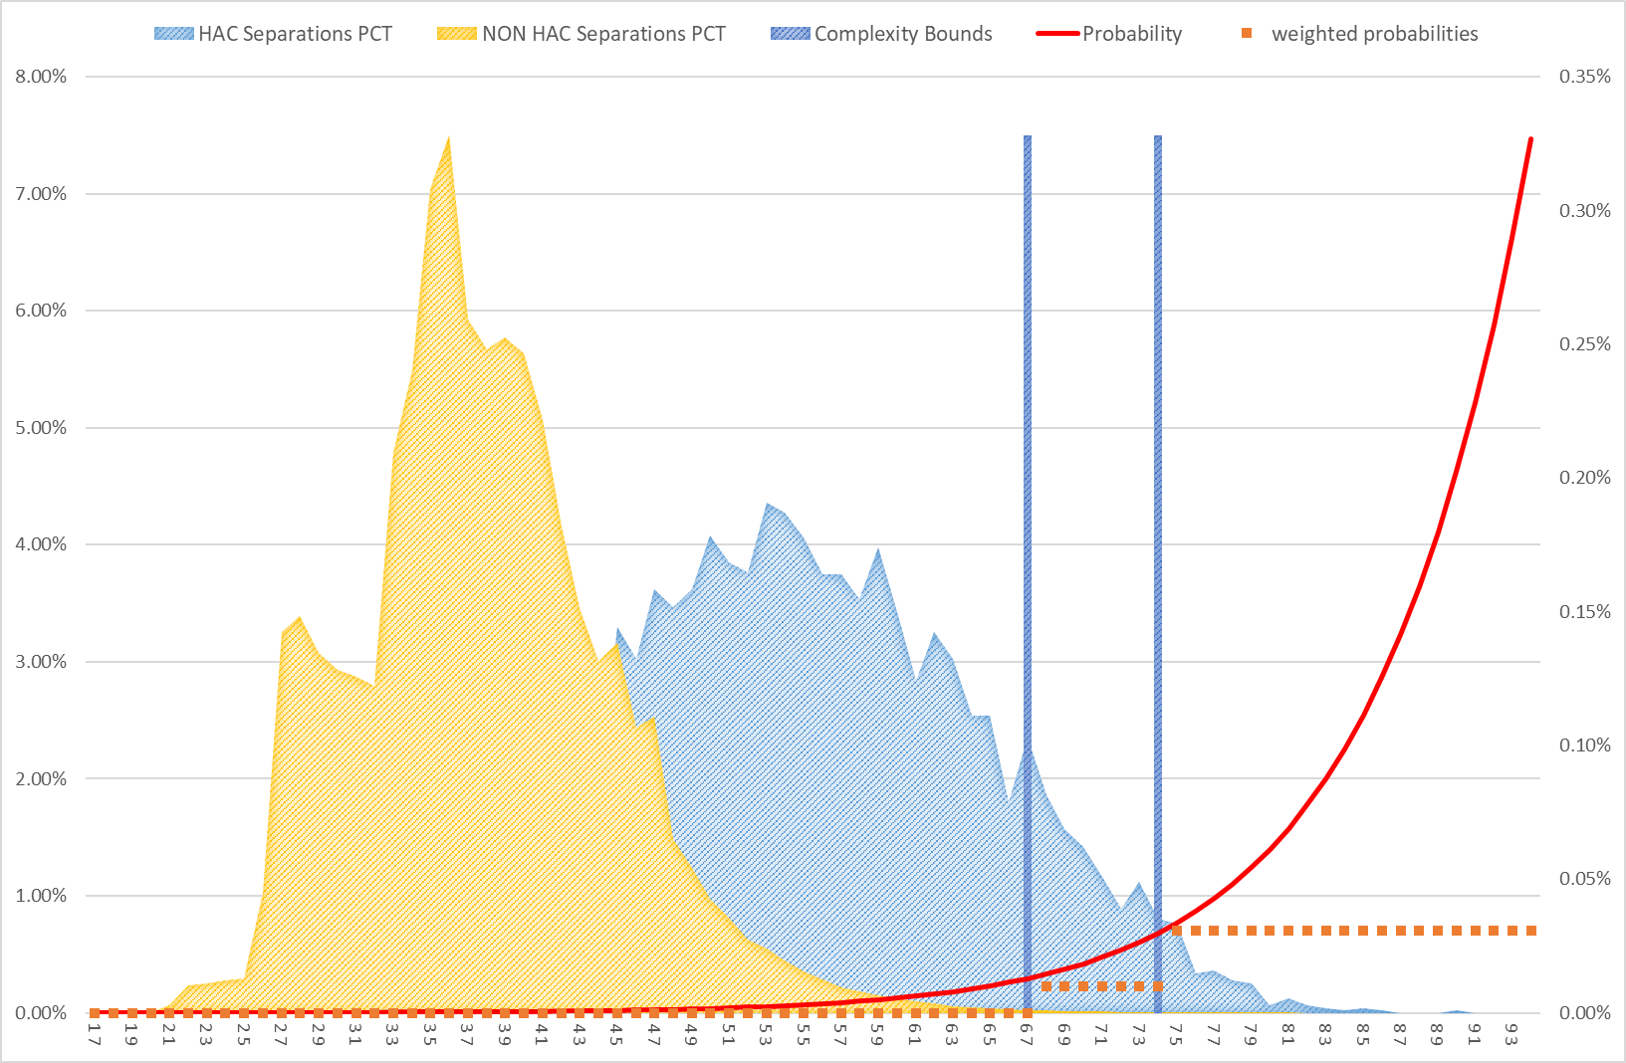

Figure 7: HAC02 Falls resulting in fracture or intracranial injury – Complexity bounds.
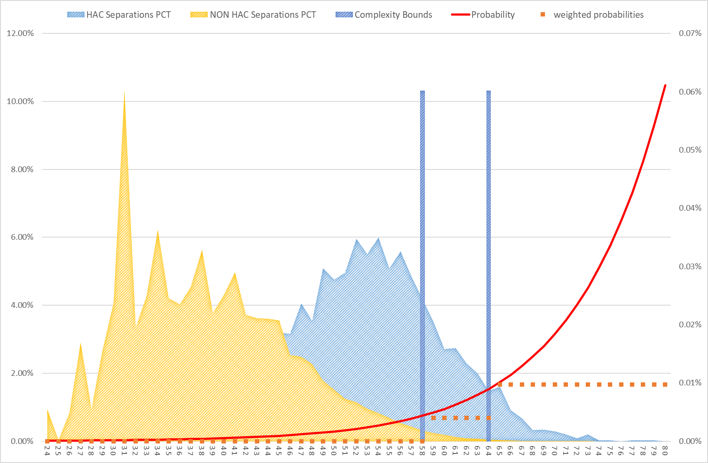

Figure 8: HAC03 Healthcare-associated infections – Complexity bounds.
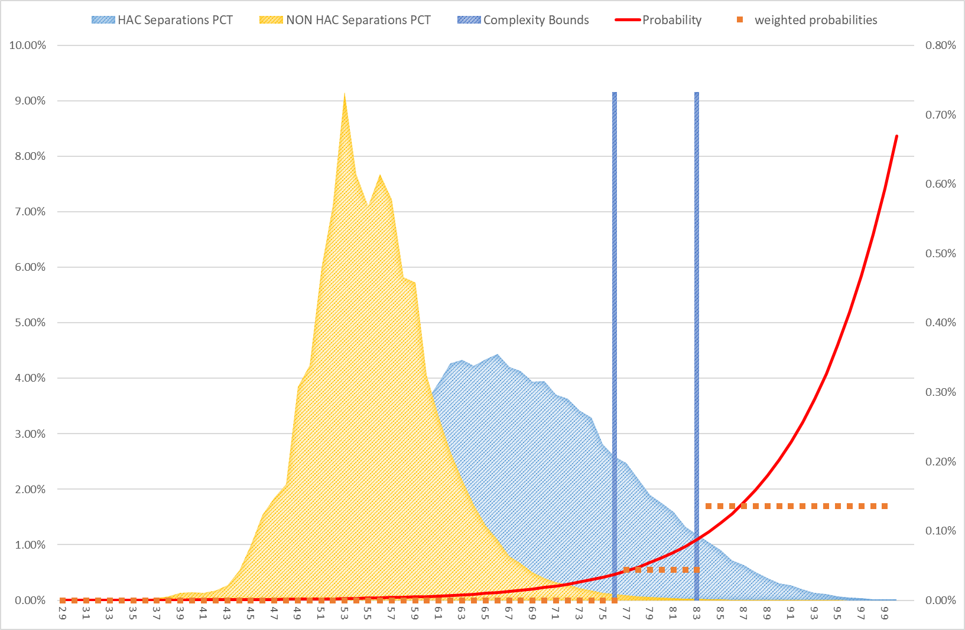

Figure 9: HAC04 Surgical complications requiring unplanned return to theatre – Complexity bounds.
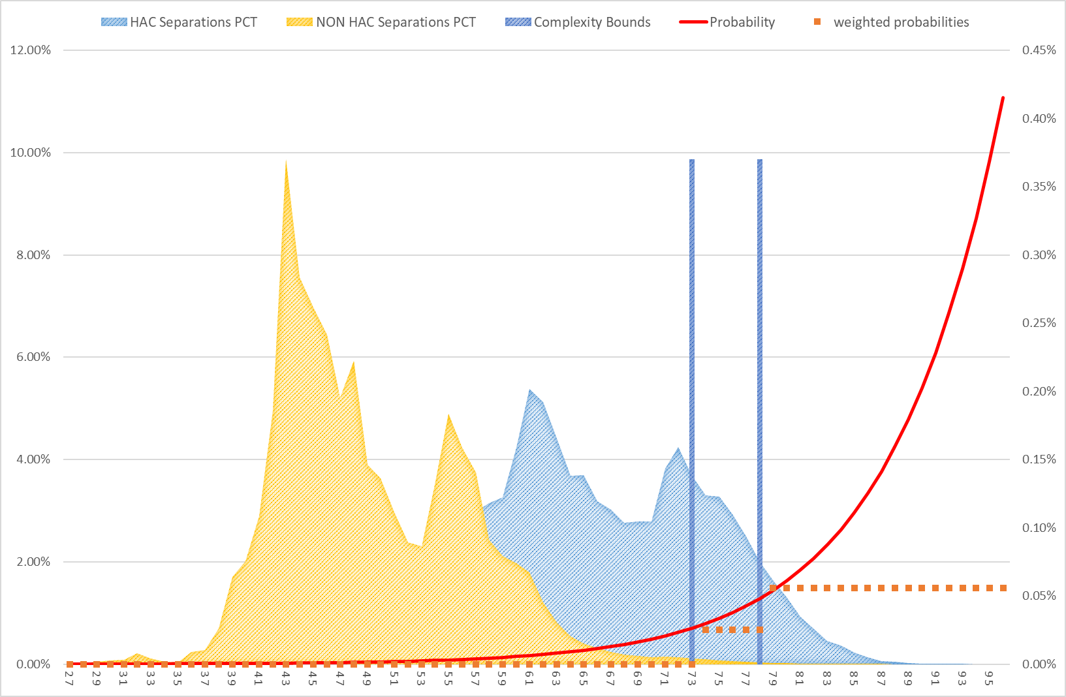

Figure 10: HAC06 Respiratory complications – Complexity bounds.
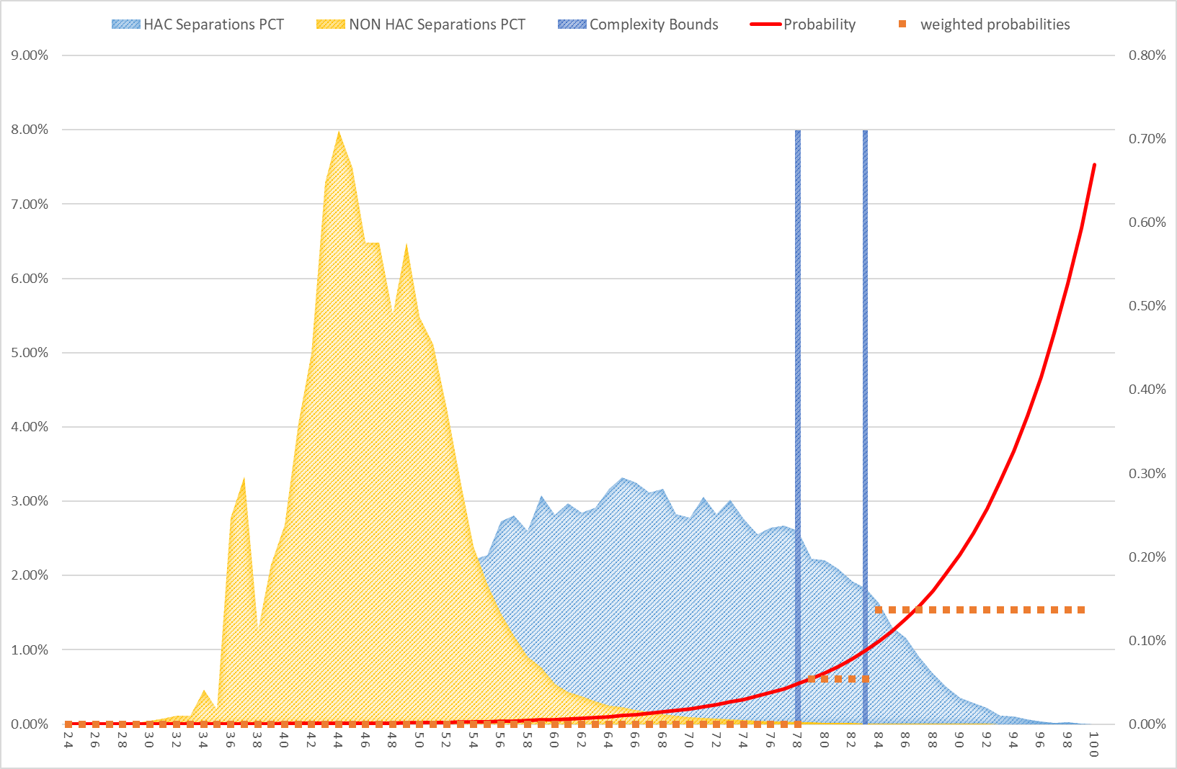

Figure 11: HAC07 Venous thromboembolism – Complexity bounds.
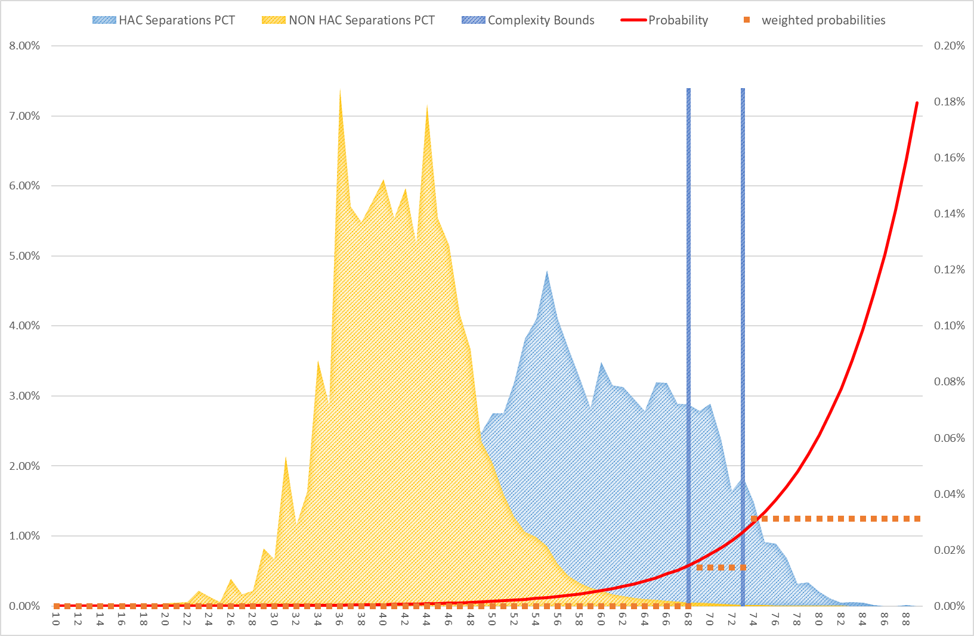

Figure 12: HAC08 Renal failure – Complexity bounds.
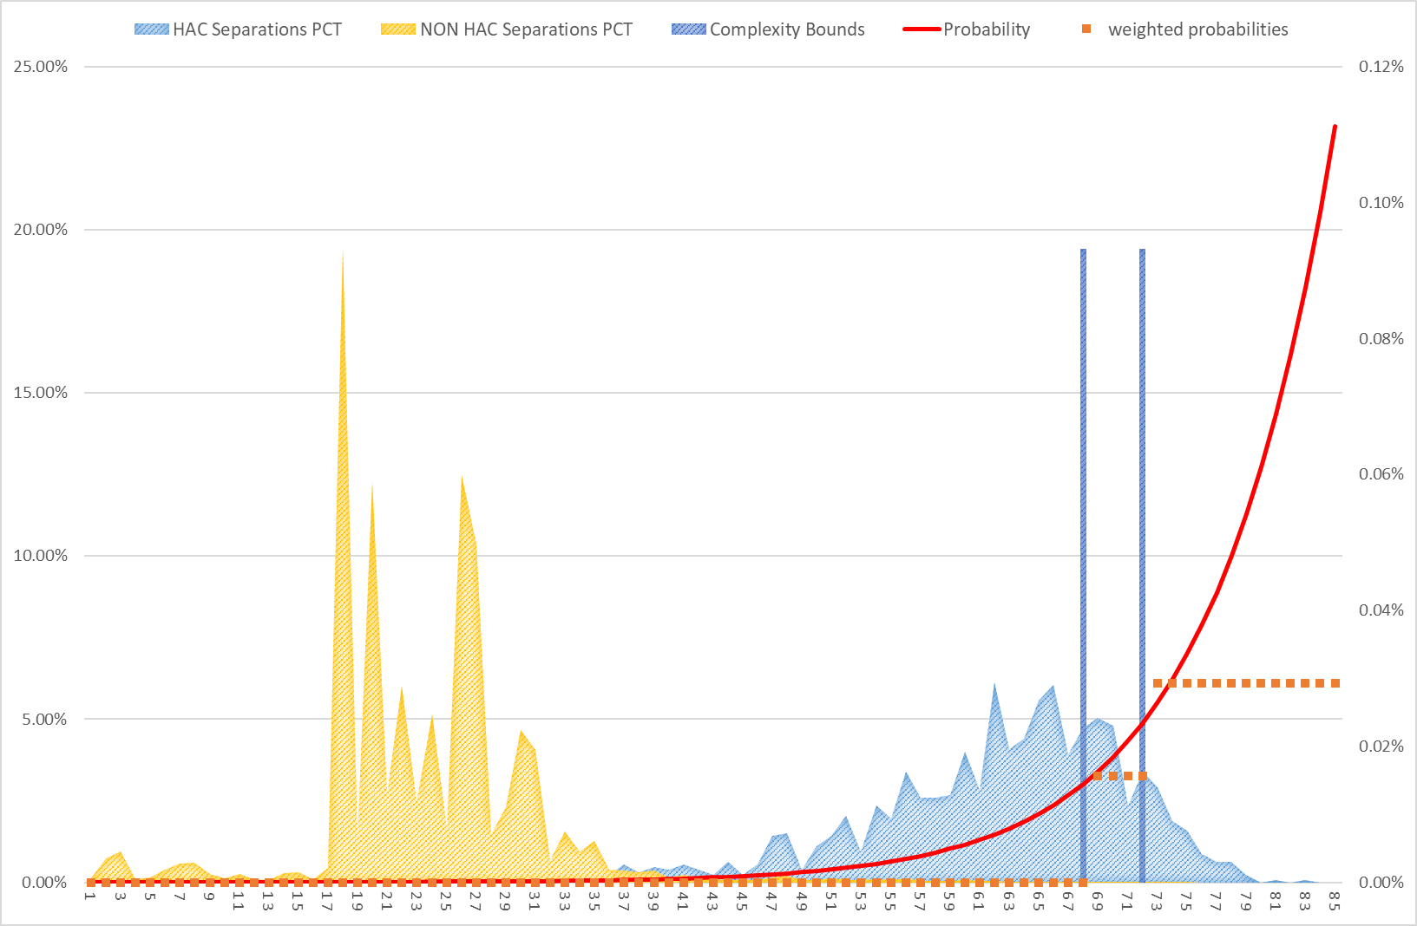

Figure 13: HAC09 Gastrointestinal bleeding – Complexity bounds.
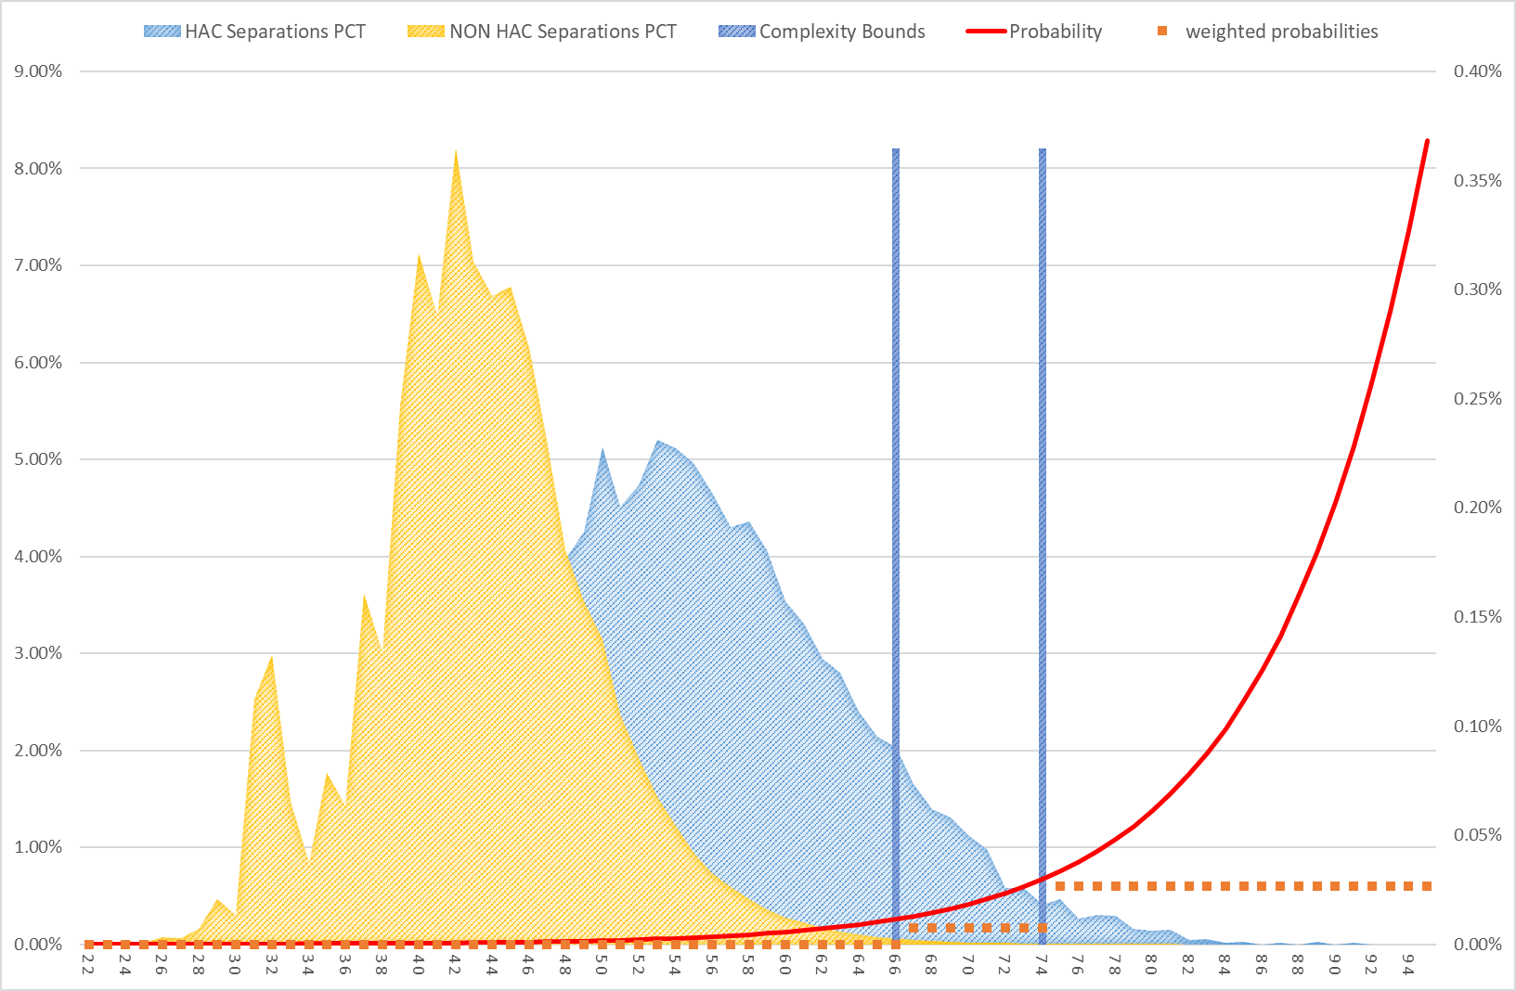

Figure 14: HAC10 Medication complications – Complexity bounds.

Figure 15: HAC11 Delirium – Complexity bounds.
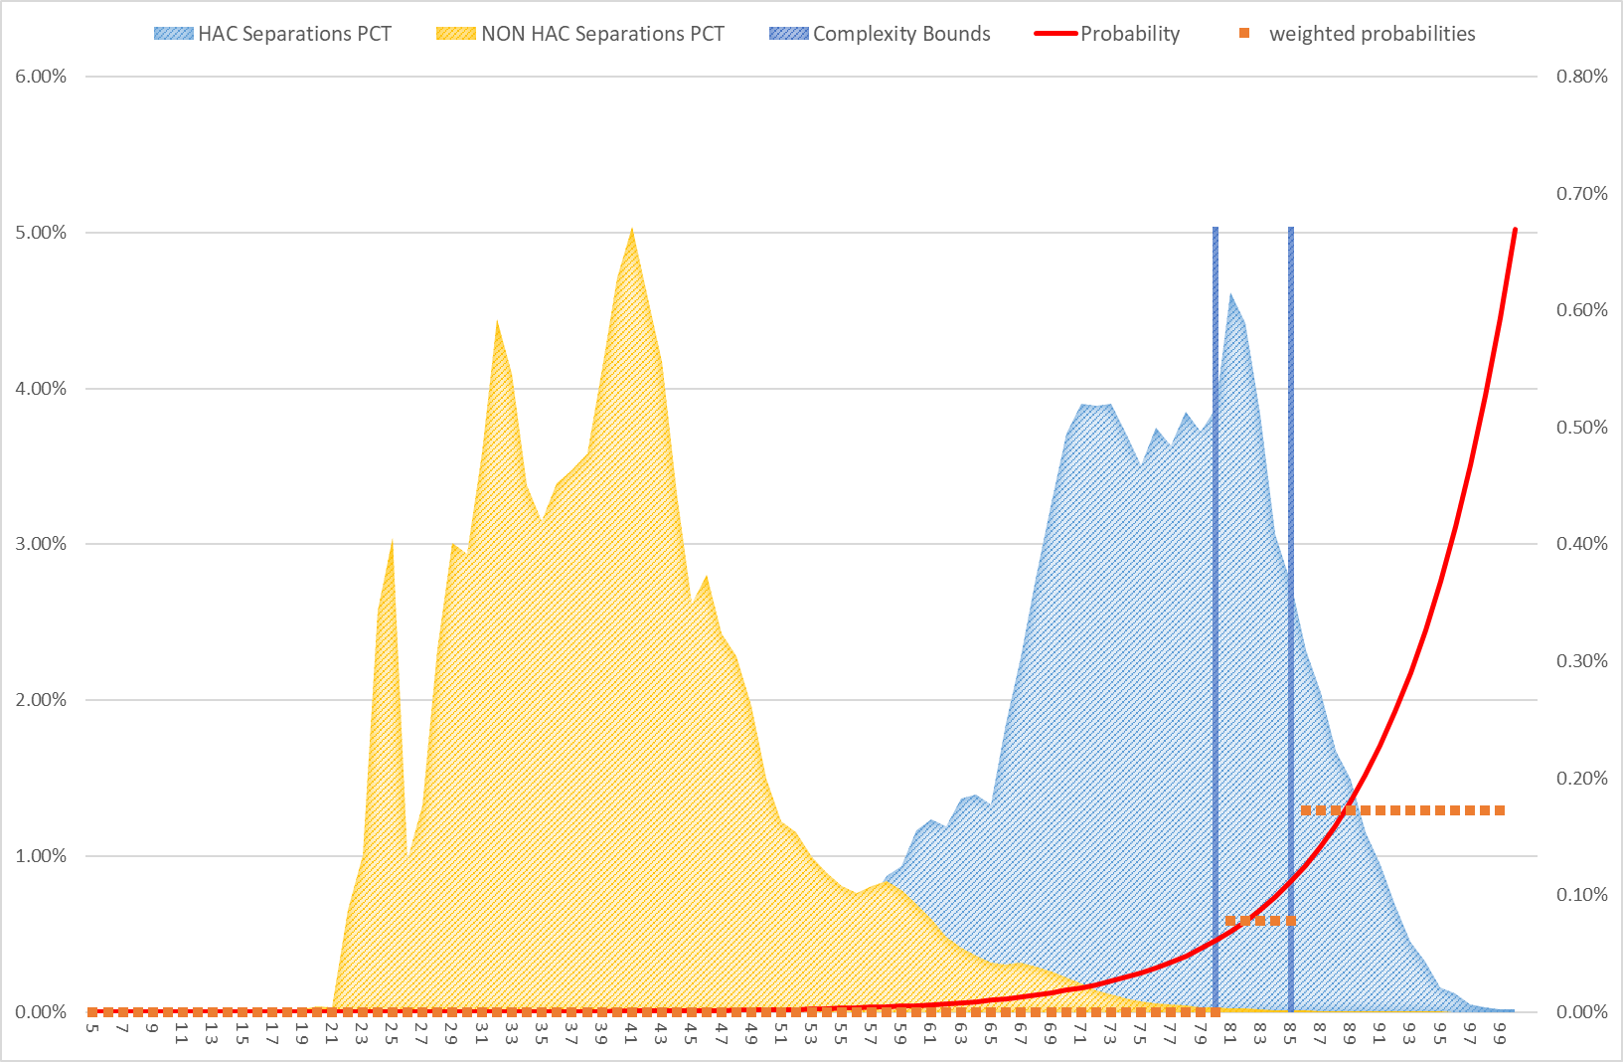

Figure 16: HAC12 Incontinence – Complexity bounds.
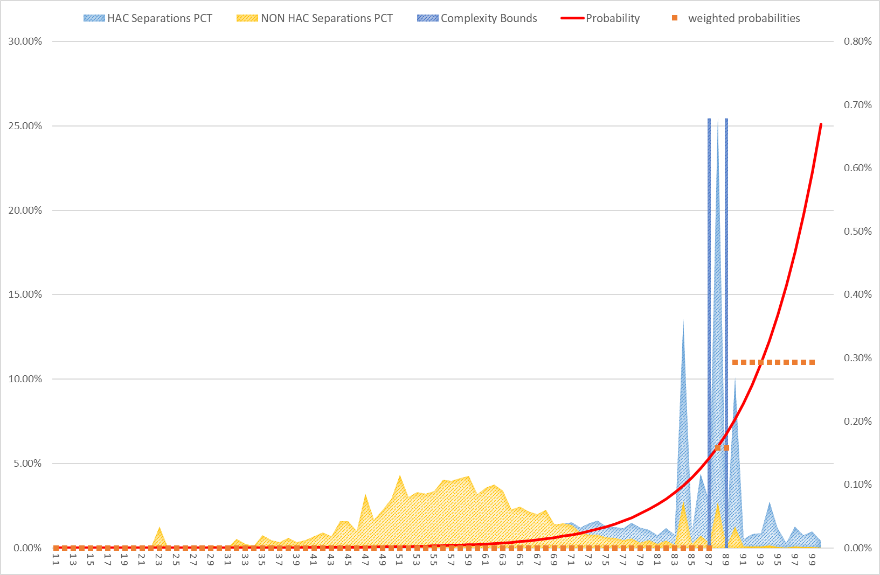

Figure 17: HAC13 Endocrine complications – Complexity bounds.
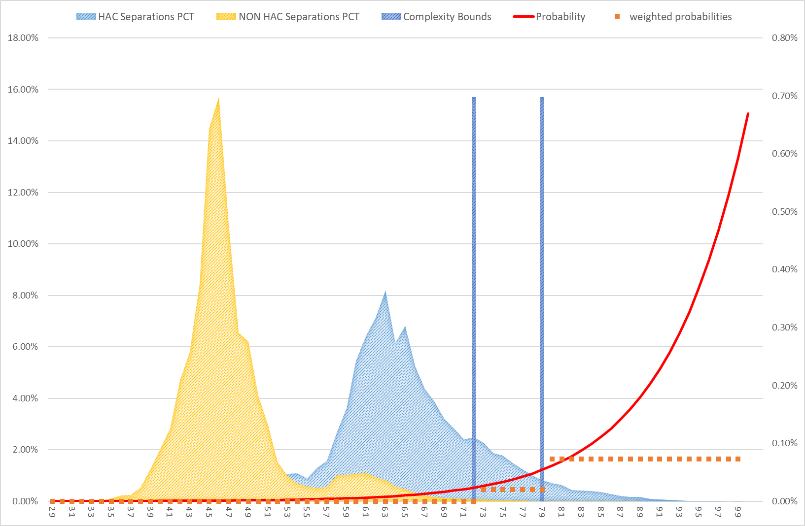

Figure 18: HAC14 Cardiac complications – Complexity bounds.
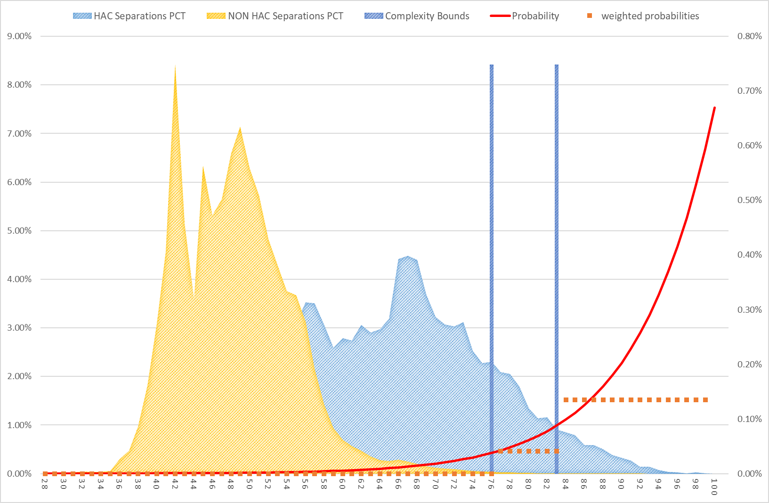

Figure 19: HAC15.02 Fourth degree perineal laceration during delivery – Complexity bounds.
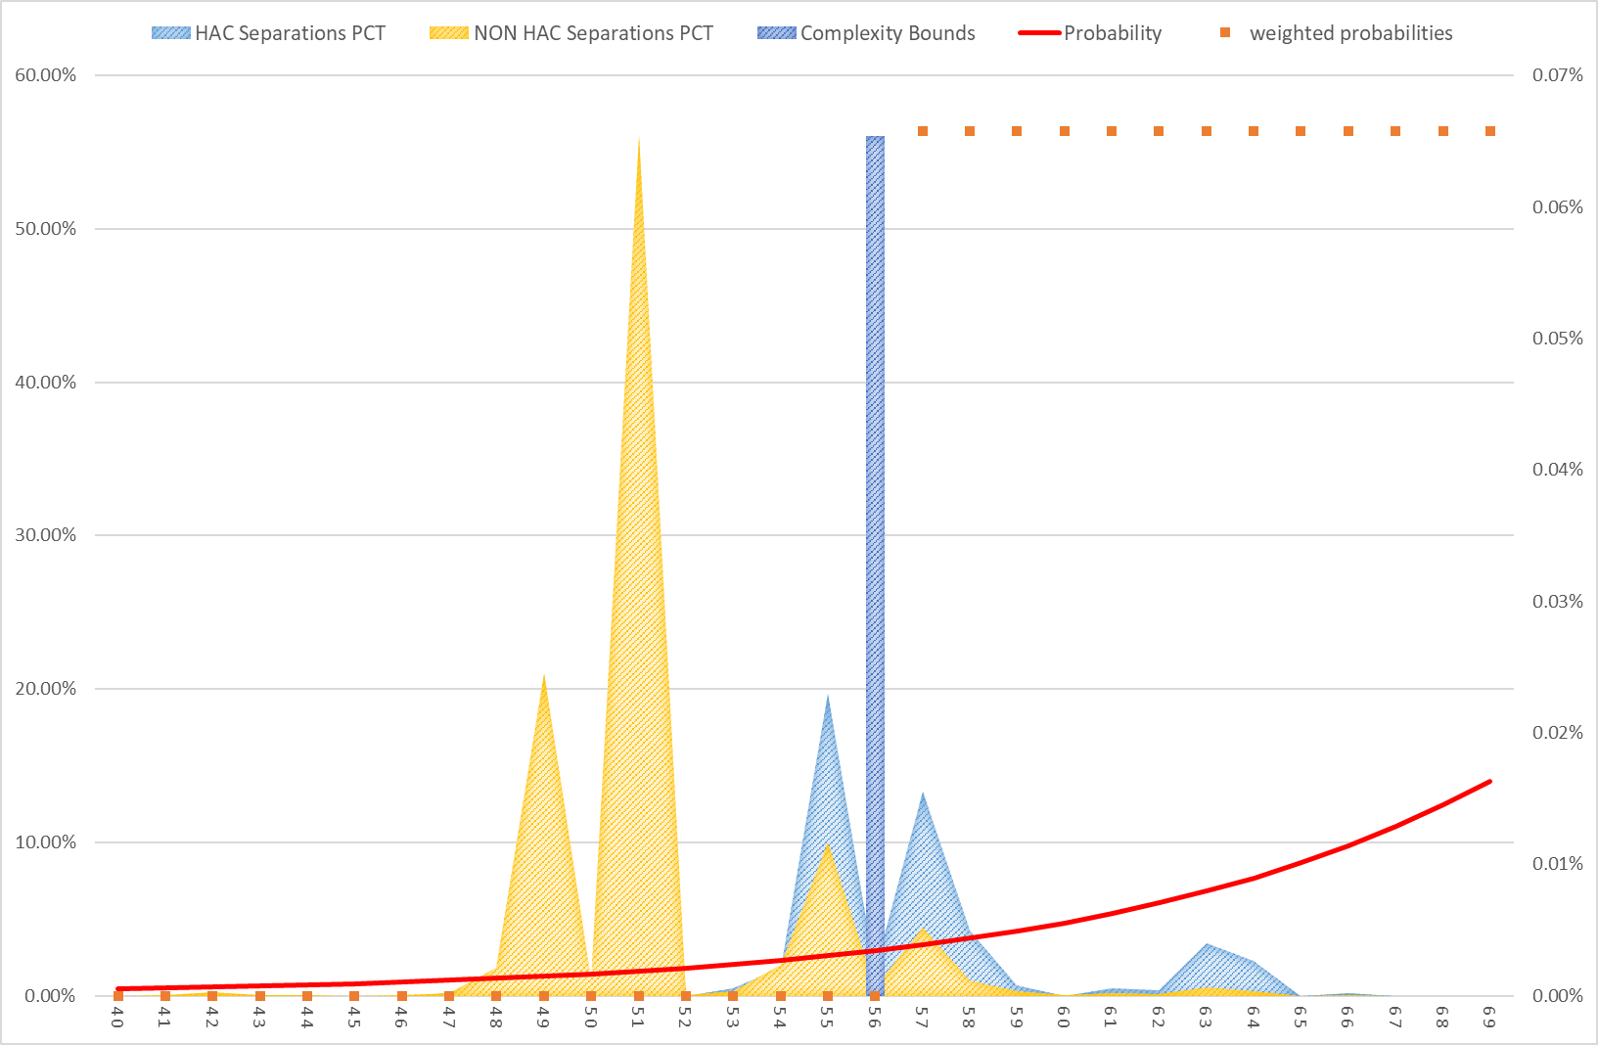

Appendix G – Change tracker

Table 22: Change tracker for HAC risk adjustment model and shadow period HAC risk adjustment model.
NEP year | HAC list version | Description of key changes
NEP18 | 1.0 | Introduction of safety and quality adjustment for HACs into the national pricing model (HAC01-HAC04, HAC06-HAC14).
NEP19 | 1.1 | N/A
NEP20 | 2.0 | Introduction of safety and quality adjustment for HAC15.02 Fourth degree perineal laceration during delivery into the national pricing model.
NEP21 | 3.0 | N/A
NEP22 | 3.1 | N/A
NEP23 | 3.1 | N/A
NEP24 | 3.1 | Replaced Charlson Score with its individual comorbidity conditions as risk factors for HAC01-HAC04 and HAC06-HAC14 logistic regression models.  Commenced the process of annually updating the ICD-10-AM codes to the latest edition; these codes underpin the identification of Charlson comorbidity conditions.
NEP25 | 3.1 | Minor updates to the ICD-10-AM diagnosis codes used to identify Charlson comorbidity conditions.
NEP26 | 3.2 | Updated risk factor revaluation for existing and additional risk factors based on statistical significance and clinical feedback (HAC15.02), to bring in line with the AHR model. This includes the suspension of COVID-19 blanket adjustment, which is instead included as an additional risk factor where appropriate.

Appendix H: HAC trajectory over time
The HAC risk adjustment model forms part of a program of work aimed at improving Australians’ health outcomes and decreasing avoidable demand for public hospital services through the implementation of funding and pricing approaches for safety and quality.
To measure the performance of the HAC model in reducing hospital acquired complications within public hospitals, the percentage of HACs identified in admitted acute episodes for each data year is provided in Figure 20. These values use datasets with trimming rules applied. These HAC counts also exclude multi-HAC episodes, that is episodes which are flagged for more than one HAC group. The results in Figure 20 illustrate trends based on the modelling data; refer to HAC dashboard on IHACPA’s National Benchmarking Portal for an indication of ‘real world’ HAC trends.

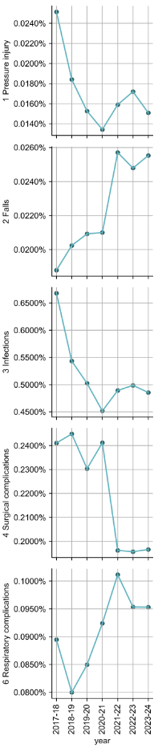
Figure 20: Summary of annual HAC counts by HAC group since 2017-18.
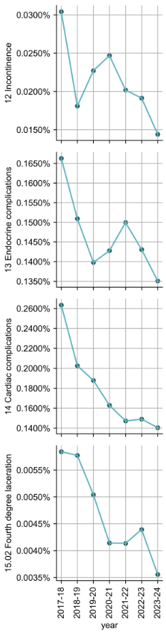
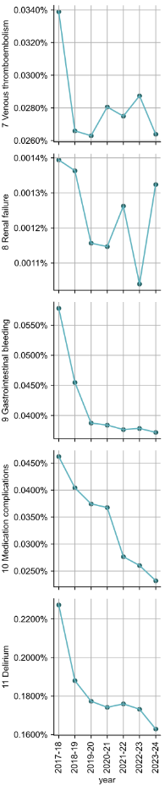


Independent Health and Aged Care Pricing Authority
Eora Nation, Level 12, 1 Oxford Street
Sydney NSW 2000
Phone 02 8215 1100
Email enquiries.ihacpa@ihacpa.gov.au
www.ihacpa.gov.au

Due to difficulty in constructing robust risk adjustment models, HAC15.01 Third degree perineal laceration during delivery and HAC16 Neonatal birth trauma were not considered for the funding adjustments. There are no funding adjustments for HAC05 Unplanned intensive care unit admission because current dataset specifications do not collect information which can identify an unplanned ICU admission.
https://www.safetyandquality.gov.au/our-work/indicators/hospital-acquired-complications/
Details on these datasets can be found at: https://www.ihacpa.gov.au/health-care/data/data-specifications/
The presence of HAC05 in an admitted episode cannot be determined because the current dataset specifications do not collect information which can identify an unplanned intensive care unit (ICU) admission.
This risk factor flags the ‘expectedness’ of a hospital admission based on its admission urgency status. All episodes except those with “urgency status assigned – elective”, are flagged as having an emergency admission status = 1.
In previous NEP technical specifications, this category was referred as ‘gender.’ It has been updated in this technical specification to distinguish it from the reporting of ‘gender’ in APC datasets from 2022-23 onwards. For the purposes of the HAC risk adjustment model, the ‘male’ sex category includes all patients who are not reported as ‘female.’ This treatment has not changed since the implementation of the HAC risk adjustment in NEP18.
Due to difficulty in constructing robust risk adjustment models, HAC15.01 Third degree perineal laceration during delivery and HAC16 Neonatal birth trauma were not considered for the funding adjustments. There are no funding adjustments for HAC05 Unplanned intensive care unit admission because current dataset specifications do not collect information which can identify an unplanned ICU admission.
Paraplegia includes Charlson’s comorbidity risk factor used prior to NEP26, the updated risk factor now includes this in addition to Chronic Condition Codes related to Tetraplegia, diplegia, monoplegia and hemiplegia, due to any cause.
Socio-Economic Indexes for Areas is a product developed by the Australian Bureau of Statistics that ranks areas in Australia according to relative socio-economic advantage and disadvantage.
The Charlson index is a score that predicts the one-year mortality for a patient with a range of specific comorbidities.
In addition to the risk factors listed in the table 6b presents all additional risk factors assessed for statistical significance for HAC15.02.
Backwards selection was adopted because it starts with all variables in the model, allowing their combined effects to be assessed from the beginning. This prevents important variables from being excluded early, which can happen in stepwise methods. It also produces more stable and consistent models across cycles, whereas stepwise can fluctuate due to its repeated add/remove process.
This risk factor flags the ‘expectedness’ of a hospital admission based on its admission urgency status. All episodes except those with “urgency status assigned – elective”, are flagged as having an emergency admission status = 1.
In previous NEP technical specifications, this category was referred as ‘gender.’ It has been updated in this technical specification to distinguish it from the reporting of ‘gender’ in APC datasets from 2022-23 onwards. For the purposes of the HAC risk adjustment model, the ‘male’ sex category includes all patients who are not reported as ‘female.’ This treatment has not changed since the implementation of the HAC risk adjustment in NEP18.
Dystocia was the only additional risk factor which tested statistically significant for HAC15.02 based on three cycles of NEP testing (NEP24, NEP25, NEP26).

