
National Pricing Model 2026–27

Shadow risk adjustments for avoidable hospital readmissions

Technical Specifications
March 2026
National Pricing Model 2026–27 – Shadow risk adjustments for avoidable hospital readmissions –Technical Specifications – March 2026
© Independent Health and Aged Care Pricing Authority 2026
This publication is available for your use under a Creative Commons Attribution 4.0 International licence, with the exception of the Independent Health and Aged Care Pricing Authority logo, photographs, images, signatures and where otherwise stated. The full licence terms are available from the Creative Commons website.

Use of Independent Health and Aged Care Pricing Authority material under a Creative Commons Attribution 4.0 International licence requires you to attribute the work (but not in any way that suggests that the Independent Health and Aged Care Pricing Authority endorses you or your use of the work).
Independent Health and Aged Care Pricing Authority material used 'as supplied'.
Provided you have not modified or transformed Independent Health and Aged Care Pricing Authority material in any way including, for example, by changing Independent Health and Aged Care Pricing Authority text – then the Independent Health and Aged Care Pricing Authority prefers the following attribution:
Source: The Independent Health and Aged Care Pricing Authority

Contents
Contents 3
Table of acronyms and abbreviations 5
Glossary of terms 6
1. Introduction 7
1.1 Purpose 7
1.2 Background 7
1.3 Risk adjustment for avoidable hospital readmissions 8
1.4 Treatment of transfer episodes 10
1.5 Risk factors 10
2. Avoidable Hospital Readmissions (AHRs) 11
2.1 Definition of an AHR 11
2.2 List of AHRs 11
2.3 Identification of AHRs 13
3. Data preparation 16
3.1 Datasets 16
3.2 Data trimming 16
4. Distribution of AHRs 19
4.1 AHR counts by admission year 19
5. AHR Risk adjustment model 21
5.1 Overview 21
5.2 Model description 21
5.3 Risk factors 23
5.4 Assessment of model performance 26
6. Episode complexity and AHR dampening 31
6.1 Complexity groups 31
6.2 Complexity scores 32
6.3 Complexity bounds 32
6.4 Dampening factors 33
7. The scope of AHR adjustment 36
7.1 Overview 36
7.2 Scope option for implementation 36
8. Funding adjustment in practice 38
8.1 Example: General Example 38
8.2 Example: Comprehensive case study 39
Appendix A: AHR trajectory over time 40
Appendix B: A brief context of AHR adjustment model development 42
Appendix C: Preliminary AHR risk adjustment modelling 44
Appendix D: Selection of and reassessment of risk factors 48
Appendix E: Shadow period risk factors, Charlson diagnosis codes and chronic condition diagnosis codes 54
Appendix F: Risk factor definitions 58
Appendix G: Key risk factor breakdowns 62
Appendix H: AHR Model Risk Factors prior to NEP26 64
Appendix I: Model testing dataset fit curves 66
Appendix J: Model complexity distributions 70
Appendix K: Change tracker 72

Table of acronyms and abbreviations
Acronym/abbreviation | Description
ACSQHC | Australian Commission on Safety and Quality in Health Care
AHR | Avoidable hospital readmission
APC NMDS | Admitted patient care national minimum data set
AR-DRG | Australian refined diagnosis related group
GBDT | Gradient boosting decision tree
COAG | Council of Australian Governments
COF | Condition onset flag
GWAU | Gross weighted activity unit
HAC | Hospital acquired complication
ICD-10-AM | International Statistical Classification of Diseases and Related Health Problems, Tenth Revision, Australian Modification
ICU | Intensive care unit
IHACPA | Independent Health and Aged Care Pricing Authority
IHI | Individual Healthcare Identifier
LHN | Local hospital network
MDC | Major diagnostic category
NEC | National efficient cost
NEP | National efficient price
NHCDC | National hospital cost data collection
NHRA | National Health Reform Agreement
NMDS | National minimum data set
NWAU | National weighted activity unit
PRC | Precision recall curves
ROC | Receiver operating characteristic
SEIFA | Socio-economic indexes for areas

Glossary of terms
Term | Description
AHR risk adjustment model | This predicts the probability of a specific AHR occurring within an episode of care. It consists of a series of logistic regression models, one for each AHR.
AHR risk adjusted NWAU | The NWAU of the index episode of care minus the dampening NWAU from the readmission episode.
AHR risk adjustment | The cost adjustment applied to the index admission for a readmission. This is measured in NWAU and is equal to the readmission episode base price weight multiplied by the dampening factor.
Complexity group | This refers to the grouping of episodes within a single AHR into low, moderate, and high complexities.
Complexity bounds/Complexity group cutoff thresholds | The threshold value of complexity score which separates episodes within a single AHR into low, moderate, and high complexity groups.
Complexity points | The numeric output of the AHR level models, prior to any manipulation.
Complexity score | The transformed logarithm of outputs from the AHR model gradient boosted decision tree (the complexity points), at the AHR level.
Condition onset flag | This flag is used to identify whether a diagnosis occurred during an episode of admitted care.
Dampening factor | The percentage total of the readmission NWAU removed from the index episode. This is based on the relative frequency of different episodes with complexities in the 1 to 100 range used in AHR modelling.
Gradient Boosting Decision Tree | A combined sequence of decision trees iteratively modelled on the residuals of previous decision trees.
Logistic regression | A model of the log-odds of an event as a linear combination of independent variables
Readmission category/condition | The avoidable hospital readmission category that a readmission episode is identified as. Categories AHR1 to AHR12 are currently identified.
Risk factor | A variable which is associated with the probability of a specific AHR occurring within an episode of care.
The Commission | The Australian Commission on Safety and Quality in Health Care
Unique Patient Identifier | A composite variable consisting of either Medicare PIN or Person Identifier used to track patient journey including readmission within the admitted acute stream.

Introduction

Purpose
This document has been produced as an accompaniment to the National Efficient Price 2026-27 (NEP26) Determination. It provides the technical specifications for how the Independent Health and Aged Care Pricing Authority (IHACPA) developed the avoidable hospital readmissions (AHRs) funding approach and risk adjustment methodology, which has been in effect since 1 July 2021. It also provides guidance to hospitals, local hospital networks (LHNs) and state and territory health authorities on how to apply these to hospital activity.
IHACPA develops the AHR funding approach based on the parameters specified under the Addendum to the National Health Reform Agreement (NHRA) 2020-26 and clause A63 of the Addendum to the NHRA 2026-31. According to clause A90 of the Addendum to the NHRA 2026–31, absolute pricing penalties for avoidable hospital readmissions will not be applied to states and territories, and will instead be shadow priced, while the Australian Commission on Safety and Quality in Health Care (ACSQHC) undertakes a review of the safety and quality measures as outlined in clauses D51–D55. As such, IHACPA is shadow pricing the AHRs funding approach and risk adjustment methodology for the National Efficient Price 2026-27 (NEP26) Determination.

Background
In April 2016, all Australian governments signed a Heads of Agreement that committed to improving the health outcomes of all Australians and ensuring the sustainability of the Australian health system. The Heads of Agreement required governments, in conjunction with IHACPA and the Commission, to develop ‘a comprehensive and risk-adjusted model to integrate safety and quality into hospital pricing and funding’ for ‘a set of agreed hospital acquired conditions’ to improve health outcomes and decrease avoidable demand for public hospital services.
In May 2020, all Australian governments signed the new Addendum to the National Health Reform Agreement (the Addendum), under which IHACPA is required to develop a pricing model for AHRs, for implementation from 1 July 2021, following approval from the Council of Australian Governments (COAG) Health Council.
The implementation of pricing and funding for safety and quality has been introduced on a staged basis. Funding adjustments related to sentinel events were introduced in July 2017, followed by funding adjustments for HACs in July 2018. In July 2019, IHACPA commenced a shadow period to analyse funding options for reducing avoidable hospital readmissions.
The Commission was tasked with developing and maintaining a nationally consistent definition of avoidable hospital readmissions. The list of clinical conditions considered as avoidable hospital readmissions was approved by the Australian Health Ministers’ Advisory Council (AHMAC) in June 2017.
In January 2026 the Addendum to the NHRA 2026-31 was agreed to by the National Cabinet. According to clause A90 of this Addendum, absolute pricing penalties for avoidable hospital readmissions will not be applied to states and territories, and will instead be shadow priced, while the Commission is undertaking a review of the safety and quality measures as outlined in clauses D51–D55. As such, the AHR risk models are shadow priced for NEP26.

AHR adjustment scope
The AHR shadow period investigated the following funding options across hospital, LHN and jurisdiction levels:
- Option one: Deduct the price of the readmission episode from the index episode (funding impact during the shadow period: 0.64%)
- Option two: Combine the index and readmission episodes and recalculate the price of the combined episode (funding impact during the shadow period: 0.63%)¹
- Option three: Adjust funding at the hospital level where actual rates of avoidable readmissions exceed expected rates of avoidable readmissions (funding impact during the shadow period: 0.15%).¹
These options are discussed in the ‘Consultation paper for the pricing framework for Australian public hospital services 2021-22’. IHACPA provided detailed reports to its Jurisdictional Advisory Committee (JAC), Technical Advisory Committee (TAC) and Clinical Advisory Committee (CAC) on the activity and funding impacts of the funding options. Following analysis and stakeholder feedback, option one, the deduction of the cost of the readmission episode from the index episode, was selected and has been continued to date.
Following reporting and consultation, the decision was made to apply AHR deductions at the jurisdiction level using the available Medicare PIN as a unique patient identifier until a nationally consistent Individual Healthcare Identifier (IHI) is available. During NEP26, this decision was extended through the use of Person Identifier as a fallback unique identifier where Medicare PIN data was missing or invalid. This decision reflects the reporting and consultation outcomes which note that identifying readmissions at a jurisdictional level allow for the best coverage of readmission episodes and a more robust validation of available data. This option was the preference for the majority of advisory sources, except for CAC, which supported option three, that is, adjustment at the hospital level. The decision to use option one was taken in light of the lower bias it showed against regional and remote hospitals compared to other options.

Risk adjustment for avoidable hospital readmissions
The initial risk adjustment model used in development of the AHRs pricing model was a logistic regression model. This was similar to the hospital acquired complications (HACs) risk adjustment model. This model showed poor fit to the readmission data. To improve the model, IHACPA tested a new risk adjustment model based on gradient boosting decision trees. This model showed substantial improvements in performance and better fit to data than the previous logistic regression model.
Based on this, AHRs uses a gradient boosting decision tree (GBDT) model. This model has been endorsed by the University of Melbourne and IHACPA has implemented this model since the start of AHR risk adjustment. Each NEP year, a risk adjustment model is created for each readmission category, which assigns the risk of being readmitted for each episode of care, based on ‘feature importance’ (these features being the most clinically significant and best performing risk factors).

Changes to the AHR risk adjustment model for the Shadow NEP26
 | According to clause A90 of the Addendum to the NHRA 2026–31, absolute pricing penalties for avoidable hospital readmissions will not be applied to states and territories, and will instead be shadow priced, while the Commission is undertaking a review of the safety and quality measures as outlined in clauses D51–D55. As such, IHACPA is shadow pricing the AHRs funding approach and risk adjustment methodology for the National Efficient Price 2026-27 (NEP26) Determination.
A NEP25 shift to the use of strictly separate model training and testing datasets for AHR modelling was carried forwards in NEP26. This is a standard approach to combat overfitting.
Changes were made to the way in which concurrent episodes were treated at the patient level, to improve the reliability of trimming in the rare case that multiple staggered episodes are reported during the stay of a larger parent episode.
In keeping with the goal of maximising the number of good quality data episodes used in training the AHR models for shadow NEP26, person identifier was introduced as a fallback for Medicare PIN in the case that Medicare PIN was found to be missing or invalid. Person identifier is an establishment level variable identifying an individual patient. The introduction of person identifier leads to a large decrease in the number of records trimmed from modelling due to an inability to track a patient journey for the purposes of identifying potential readmissions.
As part of the evolving treatment of COVID-19 episodes in the complex health environment, the suspension of safety and quality adjustments for episodes flagged with COVID-19 was discontinued for the shadow NEP26 and existing risk factors underlying the AHR models were revised based on a combination of statistical considerations and stakeholder feedback. This revision included the investigation of COVID-19 as an AHR risk factor and resulted in broad changes to the risk factors used in modelling each of the 12 AHR groups.
The reporting of sex and gender are changing in a number of jurisdictions and may take years to settle nationally. IHACPA will review the continued utility of these variables in respect of the modelling during future cycles. To maintain model stability for NEP25 it was necessary to backfill missing values for the sex variable using gender as a proxy for one jurisdiction. This backfilling continued for the shadow NEP26 cycle.

Treatment of transfer episodes
The Commission initially developed the specification for a hospital level approach using facility-specific identifiers, leading to transfers not being flagged as readmissions. However, during IHACPA’s assessment of funding impacts with an expanded scope, episodes where patients were transferred elsewhere after the index admission were being flagged as a readmission.
Due to this, IHACPA will continue utilising the definition and specifications developed by the Commission, but will trim transfer episodes from the readmissions. IHACPA will also provide data to the jurisdictions indicating how many episodes are affected and the specific episodes trimmed from the readmission counts.

Risk factors
A set of risk factors has been developed for each individual readmission category in the risk adjustment model. This means each readmission category has a tailored risk adjustment model based on risk factors that are highly relevant to the readmission condition. The risk factors for each readmission category were selected based on clinical relevance and statistical performance, using the feature importance breakdowns. During NEP26, the existing risk factors underlying the AHR models (with the sole addition of COVID-19 as a new risk factor) were revised based on statistical and clinical considerations. The risk factors are discussed further in Section 5.3.

Avoidable Hospital Readmissions (AHRs)

Definition of an AHR
The Commission convened a working group in late June 2019 to develop a nationally consistent definition for avoidable hospital readmissions. The Commission adopted the following working definition:
An avoidable hospital readmission occurs when a patient who has been discharged from hospital (index admission) is admitted again within a certain time interval, and the readmission:
- is clinically related to the index admission, and;
- has the potential to be avoided through improved clinical management and/or appropriate discharge planning and follow-up in the index admission, and;
- is measurable through coded data generated from the patient medical record.

The above definition has been presented to AHMAC and, pending endorsement, will be used by IHACPA to define avoidable hospital readmissions.

List of AHRs
Unplanned hospital readmissions are a measure of potential issues with the quality, continuity and integration of care provided to patients during or subsequent to their original hospital admission (the index admission).
In June 2017, AHMAC approved the list of avoidable hospital readmissions developed by the Commission. The Commission released Version 2.0 of the list in May 2022. This was followed by the release of Version 3.0 in May of 2025. Table 1 presents the AHMAC approved list of avoidable hospital readmissions and readmission diagnoses, together with the condition-specific readmissions intervals.
The condition-specific readmission intervals have been developed by the Commission, with input from a panel of clinical and consumer experts.
If a patient with a readmission condition presents at hospital in a timeframe that exceeds the condition-specific readmission interval, this episode is not considered to be an avoidable hospital readmission.

Table 1: List of avoidable hospital readmissions and readmission intervals
Readmission condition | Readmission diagnosis | Readmission interval
1. Pressure injury | Stage III ulcer | 14 days
1. Pressure injury | Stage IV ulcer | 7 days
1. Pressure injury | Unspecified decubitus and pressure area | 14 days
1. Pressure injury | Unstageable pressure injury | 14 days
1. Pressure injury | Suspected deep tissue injury, depth unknown | 14 days
2. Infections | Urinary tract infection | 7 days
2. Infections | Surgical site infection | 30 days
2. Infections | Pneumonia | 7 days
2. Infections | Blood stream infection | 2 days
2. Infections | Central line and peripheral line associated blood stream infection | 2 days
2. Infections | Multi-resistant organism | 2 days
2. Infections | Infection associated with devices, implants and grafts | 90 days
2. Infections | Infection associated with devices, implants and grafts in genital tract or urinary system | 30 days
2. Infections | Infection associated with peritoneal dialysis catheter | 2 days
2. Infections | Gastrointestinal infections | 28 days
2. Infections | Other high impact infections | 2 days
3. Surgical complications | Postoperative haemorrhage/haematoma | 28 days
3. Surgical complications | Surgical wound dehiscence | 28 days
3. Surgical complications | Anastomotic leak | 28 days
3. Surgical complications | Cardiac vascular graft failure | 28 days
3. Surgical complications | Pain following surgery | 14 days
3. Surgical complications | Other surgical complications | 28 days
4. Respiratory complications | Respiratory failure including acute respiratory distress syndromes | 21 days
4. Respiratory complications | Aspiration pneumonia | 14 days
4. Respiratory complications | Pulmonary oedema | 30 days
5. Venous thromboembolism | Venous thromboembolism | 90 days
6. Renal failure | Renal failure | 21 days
7. Gastrointestinal bleeding | Gastrointestinal bleeding | 2 days
8. Medication complications | Drug related respiratory complications/depression | 2 days
8. Medication complications | Hypoglycaemia | 4 days
8. Medication complications | Movement disorders due to psychotropic medications | 14 days
8. Medication complications | Serious alteration to conscious state due to psychotropic medication | 14 days
9. Delirium | Delirium | 10 days
10. Cardiac complications | Heart failure | 30 days
10. Cardiac complications | Ventricular arrhythmias and cardiac arrest | 30 days
10. Cardiac complications | Atrial tachycardia | 14 days
10. Cardiac complications | Acute coronary syndrome including unstable angina, STEMI and NSTEMI | 30 days
Other | 11. Constipation | 14 days
Other | 12. Nausea and vomiting | 7 days

Identification of AHRs
An AHR is identified using a combination of International Statistical Classification of Diseases and Related Health Problems, Tenth Revision, Australian Modification (ICD-10-AM) codes, allowable readmission periods, and exclusion criteria. Exclusion criteria are based on the AHR specification released by the Commission. The latest AHR specification is available on the Commission’s website.
For modelling AHRs during the shadow NEP26, AHRs were identified using ICD-10-AM 12th edition. Since data sets that include earlier ICD-10-AM edition codes are still in use for AHR modelling during NEP26, the ICD-10-AM 11th edition codes used in these data sets were forward cast to ICD-10-AM 12th edition for AHR identification in NEP26.

AHR inclusion and exclusion criteria
A readmission is deemed to be an avoidable hospital readmission if:
- the index and readmission separations meet their respective service (Table 2) or index/readmission (Table 3) exclusion criteria;
- the readmission has a principal diagnosis on the 'readmission codes' list (and/or an additional diagnosis where specified);
- the readmission meets any additional criteria (where specified); and
- the interval between the index admission and readmission (in days) is less than or equal to the interval specified, i.e.;
The date of readmission for an AHR must be within an allowed, AHR-level, interval of the index episode:

date of admission (of readmission) – date of separation (of index admission) ≤ AHR interval
.
Table 2 summarises the services that are included and excluded for AHRs based on the Commission’s advice.
⚠ | In response to stakeholder feedback, IHACPA made the decision to exclude transfer episodes from AHR adjustment. The Commission’s exclusion criteria in relation to transfer episodes was developed based on hospital-level readmissions.

Table 2: Scope of included and excluded services for avoidable hospital readmissions.
 | Service scope for avoidable hospital readmissions
Included services | All relevant acute admitted episodes in activity based funded (ABF) hospitals comprising:  - Episodes with an urgency status of emergency.
Excluded services | Exclusions comprise of:  - Any readmissions where the index admission had a separation mode of discharged against medical advice.  - Index admissions and readmissions for oncology, haematology, chemotherapy, dialysis, neonatal care and palliative care.  - Readmissions for child birth.  - Transfer episodes where previously classed as a readmission (i.e. a transfer from the index admission facility to a secondary facility within the same course of care).

Table 3 outlines the complete list of exclusion criteria, based on the Commission’s advice, for the list of conditions that are considered avoidable hospital readmissions.

Table 3: Complete list of exclusion criteria for avoidable hospital readmissions.
Index admission | Readmission
Exclude separations with ANY of the following:  - Multi-purpose services and Mothercraft facilities  - Admitted for same day and overnight chemotherapy and dialysis (AR-DRG equal to R63Z, L61Z, L68Z, with admission date equal to separation date)  - Admitted for oncology or haematology (any diagnosis: C00 to D89)  - Admitted for neonatal care (Care type: 7)  - Admitted for palliative care (Care type: 3)  - Hospital boarder, organ procurement, unqualified newborns (Care types 9, 10, or 7.3)  - Not discharged alive (mode of separation starts with 8)  - Discharged against medical advice (mode of separation starts with 6) | Exclude separations with ANY of the following:  - Multi-purpose services and Mothercraft facilities  - Admitted for same day and overnight chemotherapy and dialysis (AR-DRG equal to R63Z, L61Z, L68Z, with admission date equal to separation date)  - Admitted for oncology and haematology (any diagnosis: C00 to D89)  - Admitted for neonatal care (Care type: 7)  - Admitted for child birth (Adjacent AR-DRG equal to O01, O02, or O60)  - Admitted as a transfer from a different facility within the same course of care  - Non-acute care type (Care type not 1)  - Non-emergency admission (Urgency status not equal to 1)

Data preparation

Datasets
The development of the risk adjustment model and funding adjustments for AHRs used the following data:
- Twelve months activity data for 2020–21
- Twelve months activity data for 2021–22
- Twelve months activity data for 2022–23
- Nine months activity data for 2023–24.
The sample of data used to fit the risk model includes only nine months of activity data for 2023-24 to avoid any potential bias in the training sample, as the longest readmission interval is 90 days. For the purposes of the funding calculations, the hospital list from the most recent NEP Determination was used to define ABF hospitals and their characteristics.

Data trimming
The following rules were implemented to clean the data and identify whether an episode was to be trimmed:
- Episodes with no associated Unique Patient Identifier were trimmed as it is not possible to identify readmission episodes.
- Episodes with a missing separation date were trimmed as non-discharged episodes do not have complete ICD-10-AM/ACHI code arrays.
- Episodes with a shared Unique Patient Identifier but inconsistent birth date or sex were trimmed to ensure that only episodes with consistent patient identifiers were considered when flagging readmissions.
- Concurrent episodes were trimmed where the same patient had multiple concurrent admitted episodes, with only the episode with the earliest admission date and the readmission episode being kept. This was to prevent inconsistent flagging of potential readmission episodes. The trimming of concurrent episodes was added to in NEP26 to more consistently trim multiple staggered concurrent episodes occurring during the stay of a larger parent episode.
- Episodes that did not meet both the index episode denominator criteria and the readmission episode denominator criteria shown in Table 3 were trimmed as they were deemed irrelevant to the model.
A summary of the episodes trimmed for the 2020-21 to 2023-24 data years is presented in Table 4.

Table 4: Summary of trimmed episodes for the 2020-21, 2021-22, 2022-23 and 2023-24 activity data.
 | Activity Data Year
Trim type | 2020-21 | 2021-22 | 2022-23 | 2023-24
Total Episodes | 7,245,126 | 6,972,918 | 7,239,588 | 7,579,693
Trimming due to:
Missing Unique Patient Identifier | 41,535 | 143,675 | 42,337 | 47,127
Missing separation date | - | - | - | -
Not unique Unique Patient Identifier⁷ | 266,043 | 242,866 | 256,684 | 245,379
Concurrent episodes:
Reasonable concurrent episodes | 293 | 507 | 426 | 335
Same establishment | 1,674 | 1,866 | 2,474 | 1,900
Overlapping episodes | 651 | 1,025 | 997 | 723
Engulfed episode | 9,253 | 8,253 | 8,527 | 5,967
Cannot be index or readmission episode | 2,812,523 | 2,636,276 | 2,792,894 | 2,897,841
Total episodes remaining (untrimmed) | 4,113,154 | 3,938,450 | 4,135,249 | 4,380,421
% of episodes trimmed from consideration | 43.23% | 43.52% | 42.88% | 42.21%

Unique Patient Identifier Quality
Table 5 shows the quality of the Unique Patient Identifier reporting for 2020–21, 2021–22, 2022–23 and 2023–24 for admitted episodes of care. The percentage of good quality Unique Patient Identifier data for each year is measured based on the percentage of episodes with consistency in the birth date or sex of the episodes of care to which it has been attached and is measured as a step in trimming the AHR modelling datasets. Inconsistency in birth date or sex refers to differences in the birth date or sex of any episodes with a shared Unique Patient Identifier across the data years used for modelling AHRs. In the case that there is an inconsistency, all episodes with the identified Unique Patient Identifier are trimmed to ensure modelling is performed on the best possible quality data.
During NEP26, due to changes brought about by introduction of the gender variable, it was necessary to backfill missing values for the sex variable using gender as a proxy for one jurisdiction to maintain model stability. For all jurisdictions in all years assessed, the figures do not appear to indicate systemic reporting errors.

Table 5. Quality of Unique Patient Identifier reporting.
 | Percentage of good quality Unique Patient Identifier
State/Territory | 2020-21 | 2021-22 | 2022-23 | 2023-24
NSW | 96.2% | 96.1% | 96.5% | 97.4%
Vic | 94.0% | 94.2% | 94.4% | 94.7%
Qld | 98.1% | 98.1% | 98.0% | 98.0%
SA | 97.9% | 97.8% | 98.0% | 98.1%
WA | 97.0% | 98.5% | 97.0% | 96.9%
Tas | 99.7% | 99.7% | 99.7% | 99.7%
NT | 96.8% | 96.6% | 96.4% | 96.7%
ACT | 93.3% | 94.0% | 92.7% | 93.7%
National | 96.3% | 96.4% | 96.4% | 96.7%

Distribution of AHRs

AHR counts by admission year
Analysis of the highest presenting clinical conditions responsible for readmissions provides valuable insight to why readmission episodes are occurring.
Table 6 outlines the AHMAC approved list of avoidable hospital readmissions and corresponding number of readmissions for the years 2020–21, 2021–22, 2022–23 and the first nine months of 2023–24.

Table 6: List of avoidable hospital readmissions and number of readmissions over a four year period.
 | Number of readmissions
Readmission Condition | 2020-21 | 2021-22 | 2022-23 | 2023-24 | Total
1. Pressure injury | 113 | 93 | 105 | 78 | 389
2. Infections | 16,040 | 16,003 | 16,891 | 13,549 | 62,483
3. Surgical complications | 9,988 | 7,806 | 8,388 | 7,038 | 33,220
4. Respiratory complications | 2,276 | 2,285 | 2,413 | 2,094 | 9,068
5. Venous thromboembolism | 3,221 | 2,864 | 2,937 | 2,423 | 11,445
6. Renal failure | 1,671 | 1,557 | 1,623 | 1,420 | 6,271
7. Gastrointestinal bleeding | 381 | 325 | 380 | 307 | 1,393
8. Medication complications | 1,011 | 1,004 | 1,016 | 831 | 3,862
9. Delirium | 1,659 | 1,975 | 2,020 | 1,622 | 7,276
10. Cardiac complications | 14,848 | 13,323 | 13,598 | 10,518 | 52,287
11. Constipation | 2,985 | 2,414 | 2,551 | 2,182 | 10,132
12. Nausea and vomiting | 1,726 | 1,465 | 1,462 | 1,326 | 5,979
% of untrimmed episodes | 1.5% | 1.4% | 1.4% | 1.4% | 1.4%

Infections is the leading readmission condition, with 62,483 readmissions over the observation period, followed closely by cardiac complications with 52,287 readmission episodes. These figures are useful in assisting clinicians with the development of strategies to reduce or prevent avoidable hospital readmissions relating to specific conditions, and can be used to direct focus onto those conditions with disproportionately high rates of readmissions. The trajectory of AHRs as a percentage of total modelling records over time is shown in Appendix A.

AHR Risk adjustment model

Overview
IHACPA notes the need to balance the perspectives of both hospitals and patients when incorporating safety and quality into pricing. Hospitals that treat high-risk patients should not be disadvantaged compared to hospitals that treat fewer such patients. Likewise, high risk patients should have confidence that hospitals take all necessary actions to manage their risks and mitigate the occurrence of adverse events.
The equitable risk adjustment criterion used by IHACPA states that:
Pricing and funding approaches should balance the likelihood that some patients will be at higher risk of experiencing an adverse event while recognising that all hospitals have scope to improve safety and quality.
The history of developments and considerations during the shadow period for the AHR risk adjustment model that led to the adoption of the current model is discussed in Appendix B. The risk adjustment model is constructed on the premise that a patient’s likelihood of experiencing a potentially avoidable hospital readmission is the same regardless of the funding option considered. Therefore, a risk adjustment model is derived for each readmission condition, which assigns the readmission complexity for each episode of care, based on selected risk factors identifiable in the National Minimum Data Set (NMDS).
The readmission complexity output of the AHR risk adjustment model is different from the probability of being readmitted. The AHR model minimizes the cross-entropy loss of the aggregated residuals of a sequence of decision trees, which leads to the model output being the minimized cross-entropy of a complex system. This should not be interpreted as the chance of an episode being a readmission (a deterministic event based on definitions from the Commission), or the chance of an index episode resulting in a readmission, as these interpretations will lead to many false positives (non-readmission episodes identified as readmissions).
In the AHR model, episodes are assigned to a ‘Low’, ‘Moderate’ or ‘High’ complexity group representing the complexity of an episode, based on identified risk factors. The model assigns adjustments as percentages of the total readmission episode NWAU based on these complexity groups, which are removed from the NWAU assigned to the index episode for the readmission.

Model description
The original modelling approach investigated for AHRs was based on the HACs logistic regression model. Further information on the performance and limitations that led to moving away from this model are available in Appendix C. The AHR adjustment model applied uses gradient boosting decision trees (GBDTs). This is a shift away from the logistic regression model used for the HACs risk model. The shift to the GBDT model has seen a reasonable improvement in model performance due to its ability to model more complex interactions between risk factors, while reducing the possibility of ‘overfitting’. Under the GBDT model, the marginal risk of each risk factor is not a constant, but depends on the combination of risk factors present in a particular episode. For example, for a given readmission category, being admitted to ICU will have a different marginal impact depending if the patient is admitted to a surgical or medical AR-DRG, and similarly for all other risk factors.
Modelling interactions between risk factors in a complex manner like this will often result in ‘over-fitting’ the model to the data on which it is trained, picking up natural variance present in the data and measuring it as a real effect. In AHRs, over-fitting has been reduced using the GBDT machine learning technique, which involves fitting hundreds of thousands of similar models to subsets of the same data. This allows natural variance in the modelled data to be accounted for, therefore reducing over-fitting while retaining the benefits of decision tree classification algorithms. Overfitting is still very possible in gradient boosting methods, so in NEP25 tuned model parameters were implemented to minimize this effect. These tuned model parameters were used in NEP26.
The GBDT risk adjustment model automatically determines the best aggregation for risk factors that have multiple levels. As an example, this differs from some of the five-year age brackets in the HACs risk adjustment model, which are combined for some HACs depending on manual analysis and interpretation of sample size and statistical significance testing. The GBDT model is able to filter out factors automatically and determine how to achieve the most optimal grouping for risk factors as part of constructing individual decision trees that make up the model.

Ensemble Learning
During the development of the AHR model, IHACPA investigated using decision trees as an alternative to logistic regression. The original decision tree model is discussed in Appendix C. Using a small decision tree by itself may not consider all the risk factors, due to the limited tree depth. On the other hand, fitting a much deeper or wider decision tree is undesirable because it can overfit the data, meaning that the resulting model could perfectly describe the data it is trained on, but not generalise well to the broader population. A technique that captures the benefits of decision trees while producing a more general model is called ensemble learning.
Ensemble learning models make predictions based on the combined findings of several constituent models, each of which is individually known as a “weak learner” due to its low prediction accuracy. The combination of several weak learners tends to result in a model that overtrains less, is less biased and shows less variance than the individual models making it up, while performing well on unseen data. The GBDT model implemented is one such technique and has been used in other studies to predict readmissions, with sound results. This approach fits multiple decision trees in a sequential manner (a type of ensemble learning called boosting). The first decision tree is fit to the input data using the usual decision tree method (see Appendix C), and then the subsequent trees are fit to the residuals, or errors, from the preceding model. This way, as more decision trees are fit to the errors made by the preceding tree, the model gradually gets better.
As the model adds new decision trees, it tests its performance on a validation data set which was not used to train the model (comprising 10 per cent of the training data). When the model performance stops improving with respect to this validation set, the model stops adding new decision trees and the training process is complete. This is done to prevent overfitting by adding too many decision trees to the model.

Risk factors
The AHR model assigns AHR complexity based on episode level risk factors. Note that risk factors for readmissions are identified for the readmission index episode, rather than the readmission episode itself. The methods of risk factor selection and the evaluation for the addition or removal of risk factors is discussed in Appendix D.
IHACPA notes that risk factors for avoidable hospital readmissions were historically examined independently of risk factors included in the funding model for HACs, as there are additional elements of long-term patient characteristics that must be considered. In NEP26, existing risk factors, with the addition of COVID-19, were investigated across both the HACs and AHRs models. This largely standardized the risk factors being considered in both streams, with the exception of risk factors dependent on previous patient episodes, such as number of patient admissions in the previous year. Since statistical considerations with support from clinical feedback drove decisions around risk factor updates, not all examined risk factors appear in each AHR model.

Shadow period risk factors
Throughout the AHR shadow period, IHACPA assessed many risk factors. During this assessment, Charlson comorbidity diagnostic categories and chronic condition flags (which were identified based on the presence of chronic disease category ICD-10-AM codes) were examined for inclusion in the risk factor set for AHRs. The risk factors proposed throughout the shadow period and the shadow period definitions of Charlson comorbidity and chronic disease categories are presented in Appendix E.

Considerations during risk factor selection
During the shadow period, stakeholders expressed concern about using risk factors that were overly statistically driven and requested clinical evaluation of the final list. IHACPA has endeavored to achieve a balance of statistical significance and clinical relevance through a literature review of other readmissions studies,, and through the use of feature importance breakdowns for key risk factors associated with each readmission condition. Feature importance breakdowns are an output of the AHR risk adjustment model, where the relative statistical importance and model contribution of each risk factor can be assessed relative to that of other risk factors.
During the shadow period, IHACPA refined the list of risk factors based on stakeholder feedback, consultation with the University of Melbourne and assessment of clinical relevance using the top feature importance breakdowns to remove risk factors that did not significantly contribute to model performance and prediction of readmissions. During the NEP 2024-25 period (NEP24), IHACPA revised the original ICD-10-AM codes used in identifying the presence of risk factors, to make sure the most relevant advice was taken into account for ICD-10-AM 11th and 12th editions. This review was carried out in consultation with clinical, technical, and jurisdictional committees and resulted in significant changes to the codes used in identifying risk factors. The current set of ICD-10-AM codes used in identifying standalone and Charlson risk categories in avoidable hospital readmissions are presented in Appendix F. Note that, due to considerations below, not all of the potential risk factors are implemented in the modelling process for every AHR model. In the NEP 2025-26 period (NEP25), IHACPA further reviewed the risk factors contained within the Charlson comorbidity flags and chronic condition flags to identify clinically insignificant flags, leading to a small number of changes to capture intended ICD-10-AM codes for 12th and 13th editions. In the current NEP 2026-27 (NEP26) cycle, the statistical significance of existing model-level risk factors was reviewed, leading to updates in the risk factors underlying the AHR models.

NEP26 risk factors

Risk factor determination
Percentage contribution scores from relative feature importance plots, which rank variables by their relative discriminatory power with respect to model objectives, were examined for each risk factor, at the AHR level. This provided insight into the statistical significance and impact of the modelled risk factors. IHACPA created top feature importance breakdowns for each readmission category to finalise the risk factors.
Figure 1 below shows the top feature importance breakdown for infections (AHR2; the highest presenting readmission condition over the four year period assessed). The top feature importance breakdowns of all readmission categories are provided in Appendix G.

Figure 1: Top features relating to infections (AHR02) vs relative feature importance.

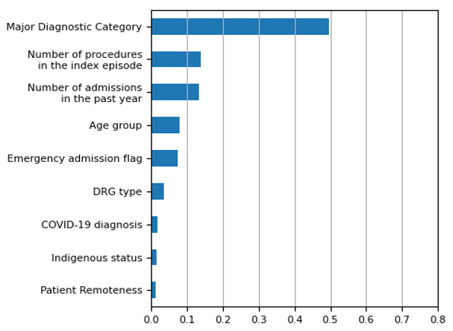
The detailed method used to select and the process for re-assessing the risk factors for each AHR is outlined in Appendix D.

Finalised risk factors
IHACPA revised the risk factors underlying each AHR model in NEP26. For this, all existing risk factors were considered, with the addition of patient COVID-19 flag as a new risk factor. The set of historical risk factors used up until NEP25 is presented in Appendix H.
Table 7 lists the final risk factors used in each AHR GBDT model, as used for NEP26. This table presents only risk factors that were selected for use in at least one AHR model. Based on historical sources, major diagnostic category, age group, emergency admission, patient remoteness, Indigenous status, procedure count and past year admissions were included as a clinically based risk factor regardless of statistical significance. This decision did not affect the inclusion of age group, major diagnostic category or past year admission risk factors, which were statistically significant to every AHR model. For an overview of the relative feature importance for each risk factor, see Appendix G.

Table 7: Risk factors for each readmission category
Risk Factor | 01. Pressure injury | 02. Infections | 03. Surgical complications | 04. Respiratory complications | 05. Venous thromboembolism | 06. Renal failure | 07. Gastrointestinal bleeding | 08. Medication complications | 09. Delirium | 10. Cardiac complications | 11. Constipation | 12. Nausea and vomiting
Standalone risk flags
Past year admissions | ✓ | ✓ | ✓ | ✓ | ✓ | ✓ | ✓ | ✓ | ✓ | ✓ | ✓ | ✓
Age group | ✓ | ✓ | ✓ | ✓ | ✓ | ✓ | ✓ | ✓ | ✓ | ✓ | ✓ | ✓
Major Diagnostic Category | ✓ | ✓ | ✓ | ✓ | ✓ | ✓ | ✓ | ✓ | ✓ | ✓ | ✓ | ✓
Procedure count | ✓ | ✓ | ✓ | ✓ | ✓ | ✓ | ✓ | ✓ | ✓ | ✓ | ✓ | ✓
AR-DRG type |  | ✓ | ✓ |  |  |  |  | ✓ |  | ✓ |  | ✓
Drug use |  |  |  |  |  |  |  |  |  |  |  | ✓
Emergency admission | ✓ | ✓ | ✓ | ✓ | ✓ | ✓ | ✓ | ✓ | ✓ | ✓ | ✓ | ✓
Sex/Gender |  |  |  |  |  |  |  |  |  |  |  | ✓
Indigenous | ✓ | ✓ | ✓ | ✓ | ✓ | ✓ | ✓ | ✓ | ✓ | ✓ | ✓ | ✓
Mental health |  |  |  | ✓ |  |  |  |  | ✓ |  |  | ✓
Patient remoteness | ✓ | ✓ | ✓ | ✓ | ✓ | ✓ | ✓ | ✓ | ✓ | ✓ | ✓ | ✓
COVID-19 diagnosis |  | ✓
Charlson comorbidity flags
Acute myocardial infarction |  |  |  |  |  |  |  |  |  | ✓
Cerebral vascular accident | ✓
Congestive heart failure |  |  |  | ✓ |  | ✓ |  |  |  | ✓
Diabetes |  |  |  |  |  |  |  | ✓
Diabetes complications | ✓ |  |  |  |  | ✓ |  | ✓
Dementia |  |  |  | ✓
Pulmonary disease |  |  |  | ✓ | ✓
Renal disease |  |  |  |  |  | ✓ |  |  |  | ✓
Chronic condition flags
Cerebral palsy |  |  |  | ✓
Chronic respiratory failure |  |  |  | ✓
Crohns disease |  |  |  |  |  |  |  |  |  |  |  | ✓
Depression |  |  |  |  |  |  |  |  | ✓
Epilepsy |  |  |  | ✓
Paraplegia | ✓
Total number of risk factors: | 10 | 9 | 8 | 14 | 8 | 10 | 7 | 10 | 9 | 11 | 7 | 12

Assessment of model performance
IHACPA has generally used receiver operating characteristic (ROC) curves to measure the performance of the HAC and early iterations of the AHR risk adjustment model.
However, ROC curve metrics do not present the whole picture about the performance of models, due to imbalance in the data. That is, the ROC curve metrics alone may not clearly reflect significant changes in model performance where the number of episodes with no subsequent avoidable hospital readmissions is far greater than the number of episodes with an avoidable hospital readmission. To account for this, IHACPA has used precision recall curves (PRC), which are more informative than ROC curves on highly unbalanced data, alongside ROC curves in evaluating readmissions risk modelling.

Receiver operating characteristic curve
The ROC curve is an analytical method that can be used to evaluate a model’s ability to predict a binary outcome. In the context of the AHR risk adjustment model, we seek to evaluate the ability of this model to predict the occurrence of an AHR.
The ROC curve is a parametric plot of the true positive rate (TPR) versus the false positive rate (FPR) of the model where:
  - the TPR is the proportion of observations that are correctly predicted to be positive out of all positive observations; that is, how well the model correctly predicts the occurrence of an AHR in an episode.
  - the FPR is the proportion of observations that are incorrectly predicted to be positive out of all negative observations; that is, how often does the model incorrectly predict the occurrence of an AHR for episodes which don’t have an AHR.
The ROC graph plots both parameters against a theoretical threshold varied between 0 and 1 to illustrate the tradeoff between TPR and FPR at different threshold values. An example ROC plot is provided in Figure 2.

Figure 2: Example of ROC curves
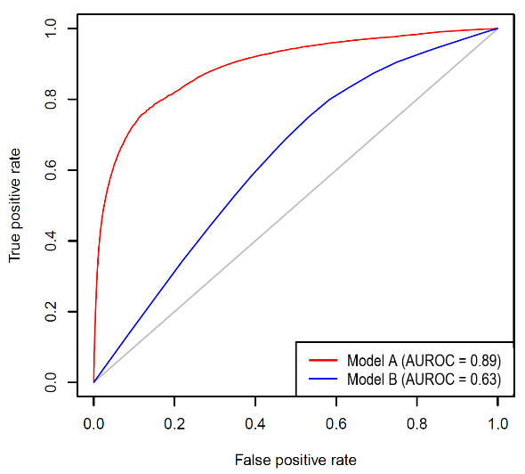
This example plot is for a general system, rather than the AHR model itself, and is purely explanatory. A ROC curve lying on the diagonal line (grey line) is reflective of a model that performs no better than chance level (random guessing). The closer the ROC curve is to the upper lefthand corner, the better the model can discriminate between two outcomes (by maximising the TPR and minimising the FPR). With reference to Figure 2, it shows that Model A (red line) performs better than Model B (blue line). In the context of the AHR risk adjustment model, this would mean that Model A is better at predicting the occurrence of a true positive AHR, with lower change of predicting a false positive AHR, in an admitted episode of care than Model B.
The area under the ROC curve (AUROC) provides an aggregate measure of the performance of the model across all the thresholds, and its value ranges between 0 and 1. A model that will predict 100% of categories wrong has an AUROC of 0.0 and a model which predicts all positive classes with 100% accuracy has an AUROC of 1.0. A model with an AUROC of 0.5, which will predict 50% of categories correctly (also referred to as the baseline) is represented by the grey diagonal line in the graph. In Figure 2, Model A has a higher AUROC than Model B which indicates that the former model performs better than the latter model.
The issue with using the ROC curve to assess model performance on imbalanced data is that the rates being compared have different denominators, that is;
$$\text{TPR = }\frac{\text{true positives}}{\text{all positives}}$$

$$\text{FPR =} \frac{\text{false positives}}{\text{all negatives}}$$

In each of the AHR models, the number of negatives (episodes with no subsequent avoidable hospital readmission) used in modelling AHRs are close to 14,000,000. While the number of positives vary from around 390 for readmission category 1 (pressure injury) to over 62,000 for readmission category 2 (infections) in the four years of activity data used for training during NEP26. Taking these figures into consideration and with reference to Figure 2, this effectively means that each incremental increase in the true positive rate (i.e. correctly identified AHR episodes) for a well performing model comes with a logarithmic increase in the false positive rate (i.e. number of incorrectly identified AHR episodes is initially small, but increases rapidly past a limit). Note that these figures are used for comparison of risk models only. In practice, risk models assign a probability based on the modelled objective (which is always low for a readmission), and do not use thresholds to assign definite positive/negative outcomes.

Precision recall curve
The precision recall curve (PRC) is a complement to the ROC curve. It may give additional insight compared to the ROC curve when evaluating model performance on imbalanced data.
The PRC curve is parametric plot of the precision and recall of the model where:
  - Precision is the number of true positives out of all the predicted positives, meaning the number of episodes which actually had an AHR out of those predicted to have had an AHR.
  - Recall is another name of the true positive rate and represents how successful the model is in identifying an episode with an AHR. That is, the number of AHR episodes that the model can successfully identify out of all the AHR episodes in the data set.
The PRC graph plots both parameters against a theoretical threshold varied between 0 and 1 to illustrate the tradeoff between precision and recall at different threshold values. An example PRC curve generated on the full modelling dataset is provided for AHR10 (cardiac complications) in Figure 3.

Figure 3: Example of PRC curve for AHR10 on the full modelling dataset
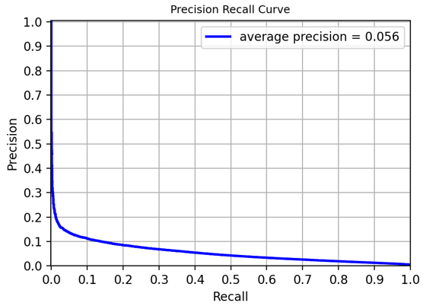
The closer the PRC curve is to the upper righthand corner, the better the model can discriminate between two outcomes (by maximising the precision and recall and thereby maximising the area under the curve).
The area under the PRC curve (AUPRC) provides an aggregate measure of the performance of the model across all thresholds. A higher AUPRC represents both high recall and high precision which is indicative of a better performing model. Generally, the AUPRC is considerably smaller in magnitude than the AUROC for the same model as the baseline is calculated as the proportion of positive observations over total observations, which is very small.
In the above case, picking a threshold which correctly identifies 20.0% of AHRs in the dataset (equivalent to 20.0% recall) gives a precision of 8.5%. In NEP26 there are approximately 52,000 AHR10 records. This means the model is predicted to return about 10,500 episodes correctly classified as leading to an avoidable hospital readmission, and around 112,000 false positives.

Training and testing data sets
Unlike the HAC risk model, which uses the same set of data for training and testing model performance, the AHR risk model has used a separate set for model testing from NEP25 onwards. This is to minimize model overfitting. Overfitting is not a significant issue for linear models like logistic regression, however, the decision tree based model implemented for readmissions is non-linear and risks overfitting to training data, such that model performance is good on the training dataset but generalizes poorly to unseen data. To mitigate this, ROC and PRC metrics are generated on a testing dataset, comprising of 20% of the total AHR model input set, which is not used during modelling to prevent cross-contamination. Here we report performance metrics calculated on this testing dataset. This is a standard method used in the literature for testing the performance of a machine learning model.
Figure 3, above, presents the PRC plot for the best performing model, as measured by the largest PRC-AUC. In terms of area under ROC and PRC, the GBDT models perform better across all readmission categories than logistic regression models. ROC curves and PRCs for the NEP26 readmission model testing dataset are presented in Appendix I.

Episode complexity and AHR dampening

Complexity groups
The risk adjustment methodology of AHRs creates complexity groups for each AHR, with differing risk adjustments applied based on the complexity. This is based on the concept that “pricing and funding approaches should balance the likelihood that some patients will be at higher risk of experiencing an adverse event while recognising that all hospitals have scope to improve safety and quality”. Each AHR is split into three complexity groups (low, moderate and high) representing the risk each patient has of experiencing an AHR. These risk categories are assigned at an AHR level and patients classified as ‘high complexity’ in an AHR attract a lower funding adjustment. Conversely, patients with a low risk of experiencing an AHR are classified as ‘low complexity’ and attract a higher funding adjustment.
The assignment of complexity group is undertaken separately for each AHR flagged in the episode, since there are separate risk adjustment models for each AHR:
- Episode level complexity points are calculated for each AHR using that AHRs individual model and the combination of different episode level risk factors present.
- A complexity score is calculated for each AHR in the episode through a re-scaling and bounding process that limits scores to the 1-100 range.
- AHR level complexity scores are then compared to complexity bounds for that AHR to determine the complexity group for that AHR.
This effectively means that an episode can have up to 12 different complexity scores and 12 different complexity groups assigned, one for each AHR.

To enable the assignment of complexity group for each AHR in the episode, IHACPA undertakes the following key steps on the complexity point outputs of the AHR models:
- Converts the AHR GBDT model outputs (the complexity points) into complexity scores through a logarithmic transformation method and;
- Determines complexity bounds for each AHR based on the distribution of complexity points for all modelling episodes. This enables assignment of a low, moderate or high complexity group for each AHR in the episode.
Due to the poor predictive nature of the AHR models at every threshold, as illustrated through the ROC and PRC false positive considerations noted above, the complexity points for an episode should not be used for the prediction of AHRs, instead being used to create the complexity measures here.

Complexity scores
For comparability to the HAC model, IHACPA converted the outputs of the AHR models (denoted complexity points) into complexity scores, which were then used to assign an episode into a ‘Low’, ‘Moderate’ or ‘High’ complexity through comparison to complexity bounds.
To calculate the complexity scores, IHACPA took the logarithm of the complexity points and calculated relative minimum and maximum scaling parameters from the 1st and 99th percentiles of log(points). This was done for each set of AHR complexity points in the modelled dataset, to produce minimum and maximum parameters for each AHR group. These minimum and maximums were then used during rescaling the model outputs to between 1 and 100, constraining results below the minimum and above the maximum (from below the 1st and above the 99th percentile) to 1 and 100, respectively. This scaled output for each AHR was the episode level complexity score.
Figure 4 shows the distribution of complexity scores for all episodes with readmissions due to cardiac complications (AHR10).

Figure 4: Readmission complexity due to cardiac complications (AHR10)
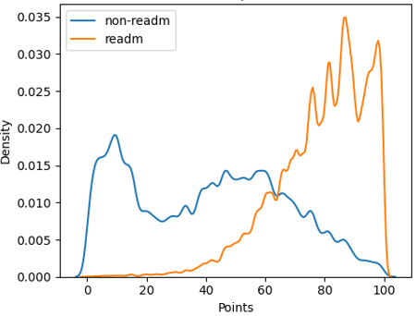
This shows the episodes resulting in readmission tend to have greater complexity than those which do not. Similar complexity distributions across all episodes are provided for all readmissions in Appendix J.

Complexity bounds
The AHR funding adjustment (AHR dampening) is applied at an episode level by reducing the efficient price of an episode based on an incremental cost associated with the potentially avoidable hospital readmission. This is similar to the incremental cost of a HAC used for the HACs funding adjustment.
To calculate the AHR-level complexity bounds for each AHR group, the distribution of complexity points for index episodes is split into terciles. The first tercile (rounded to the nearest integer value) is then the threshold between the low and moderate risk categories, and the second tercile is the threshold between the moderate and high risk categories.

Dampening factors

Overview
Dampening factors adjust the funding reduction for the index episode prior to an episode containing a readmission based on the risk of a patient having an AHR. Without dampening, episodes with higher complexity scores would be penalised the same amount for the same AHR as those with a lower complexity score. This goes against the policy intent of the pricing for safety and quality. Dampening factors have been developed to adjust for these differences in risk among patient profiles for different hospitals.

How do dampening factors work?
AHR adjustments reduce the NWAU assigned to an index episode based on the NWAU of a flagged readmission. Without dampening factors, this reduction would be static for each AHR, or 100% of the readmission NWAU (allowing for the caveat that the NWAU of the index admission cannot be negative, so the maximum allowable adjustment is the NWAU of the index episode). This fails to recognize the different complexity of patients that exists due to risk factors beyond the control of hospitals, and so goes against the intent of pricing for safety and quality. Dampening factors have been developed to adjust for these differences in risk among patient profiles for different hospitals.
Dampening factors take the form of a percentage score for each complexity group, at the AHR level. Low complexity patients do not receive a dampening effect on NWAU removed from the index episode, so always have a dampening factor of 1. For illustrative purposes Table 8 provides an example of how these dampening factors work in practice.

Table 8: Example – Dampening factor application
Complexity group | Index episode NWAU (a) | Readmission episode NWAU (b) | Dampening Factor (c) | Index episode NWAU received  (d) = (a) - (b) x (c)
Low | 1.0000 | 0.5000 | 100% | 0.5000
Moderate | 1.0000 | 0.5000 | 50% | 0.7500
High | 1.0000 | 0.5000 | 20% | 0.9000

Table 8 shows that, in the explanatory case where the index episode would be assigned an NWAU of 1.0000 and the readmission episode and NWAU of 0.5000 prior to adjustment for AHRs:
- Low complexity readmissions have a dampening factor of 100% and remove the total readmission NWAU (0.5000) from the index admission. The readmission episode is still funded in full.
- Moderate complexity readmissions have a dampening factor of 50% and remove 50% of total readmission NWAU (0.2500) from the index admission. The readmission episode is still funded in full.
- High complexity readmissions have a dampening factor of 20% and remove 20% of total readmission NWAU (0.1000) from the index admission. The readmission episode is still funded in full.
From this, it can be seen how the dampening factor allows the funding approach for AHRs to be risk-adjusted depending on the complexity of the episode.
One dampening factor applies per AHR that an episode has. An episode can have multiple AHR flags that apply based on its individual casemix of ICD-10-AM and procedure codes. In that case, the highest dampening factor is applied (leading to the maximum reduction of the index admission NWAU).

Calculating the AHR dampening factors
The ‘incremental cost of readmission’ (i.e. NWAU of the readmission episode) is used in conjunction with a dampening factor calculated based on average complexity points for each AHR category to determine the NWAU to be subtracted from the total NWAU of the index episode. The dampening factor for each risk category is calculated as the average complexity score for the low risk category, divided by the mean complexity score for that risk category, so that:
$${\text{d}}_{\text{lo}\text{w_risk}}\text{=}\frac{\text{ a}{\text{v}}_{\text{score(low)}}}{\text{a}{\text{v}}_{\text{score(low)}}}$$
$${\text{d}}_{\text{moderate}\text{_risk}}\text{=}\frac{\text{ a}{\text{v}}_{\text{score(low)}}}{\text{a}{\text{v}}_{\text{score(moderate)}}}$$
$${\text{d}}_{\text{high}\text{_risk}}\text{=}\frac{\text{ a}{\text{v}}_{\text{score(low)}}}{\text{a}{\text{v}}_{\text{score(high)}}}$$
Where d_{{category}} represents the dampening factor for a category of risk, and av_{score(category)} represents the mean complexity points of all episodes with an identified readmission in that category of risk. This calculation is carried out for every readmission category, so that 12 of each type of dampening factor is created.
Table 9 shows the AHR-level complexity bounds for each complexity group and the associated dampening factors applied to AHR01 to AHR12, for NEP26. These adjustments are only applied to episodes identified within the same jurisdiction. The dampening factors vary depending on the readmission category and the complexity group of the episode. For low complexity episodes, the full NWAU of the readmission episode is deducted from the index admission, where that would not exceed the NWAU of the index admission. Otherwise the NWAU of the index admission is deducted. For high complexity episodes, only a portion of the readmission NWAU is removed (e.g. 35.8% of the NWAU of the readmission episode is deducted from the NWAU of the index episode in the case of a high complexity medication complications readmission). As noted above, this is so that consideration is given to patient complexity.

Table 9: Adjustment factors for AHR01 to AHR12
 | 01. Pressure injury | 02. Infections | 03. Surgical complications | 04. Respiratory complications | 05. Venous thromboembolism | 06. Renal failure | 07. Gastrointestinal bleeding | 08. Medication complications | 09. Delirium | 10. Cardiac complications | 11. Constipation | 12. Nausea and vomiting
Complexity group point thresholds
Low | 0 | 0 | 0 | 0 | 0 | 0 | 0 | 0 | 0 | 0 | 0 | 0
Moderate | 64 | 63 | 89 | 68 | 69 | 70 | 50 | 71 | 64 | 75 | 55 | 49
High | 83 | 78 | 94 | 84 | 79 | 86 | 77 | 89 | 83 | 88 | 74 | 73
Complexity group dampening factors
Low | 1.0000 | 1.0000 | 1.0000 | 1.0000 | 1.0000 | 1.0000 | 1.0000 | 1.0000 | 1.0000 | 1.0000 | 1.0000 | 1.0000
Moderate | 0.3470 | 0.5140 | 0.2310 | 0.4270 | 0.5480 | 0.4490 | 0.4000 | 0.4300 | 0.2360 | 0.4440 | 0.3970 | 0.4830
High | 0.2720 | 0.4140 | 0.2160 | 0.3440 | 0.4490 | 0.3760 | 0.2700 | 0.3580 | 0.1830 | 0.3790 | 0.2910 | 0.3220

The scope of AHR adjustment

Overview
During the shadow period, IHACPA analysed a range of scope options for stakeholder consideration.
AHR adjustment scope options considered during the shadow period were adjustments being limited to episodes where the index and readmission occurred:
- In the same establishment,
- In the same LHN or
- In the same jurisdiction
The option to apply adjustment at the jurisdictional level was supported both by IHACPA and stakeholders, so was ultimately selected.

AHR distribution by hospital, LHN and jurisdiction
In NEP26, IHACPA has undertaken analysis of 2020-21, 2021-22, 2022-23 and 2023-24 data of all avoidable hospital readmissions identified on the trimmed readmission dataset by the location of the readmission. The analysis indicates that:
- 47.6 per cent of readmissions occurred when patients presented to the same hospital.
- 16.9 per cent of readmissions occurred in a different hospital in the same LHN.
- 35.5 per cent of readmissions occurred in a different LHN in the same state or territory.
This analysis supports continued application of the adjustment at the jurisdiction level to attain the widest coverage.

AHR distribution across financial years
In NEP26, IHACPA has undertaken analysis of 2020–21, 2021–22, 2022–23 and 2023–24 data of all avoidable hospital readmissions within or across financial years. The analysis indicates that:
- 97.3 per cent of readmissions occurred within the same financial year.
- 2.7 per cent of readmissions occurred across financial years.

Scope option for implementation
Throughout the shadow period, stakeholders were supportive of IHACPA’s preference for using the widest scope possible to maximise coverage of readmission episodes. Modelling the readmissions adjustment at a jurisdictional level was found to unequivocally be the best option as it provided the most robust data validation.
Applying funding adjustments at a jurisdictional level was also found to have a less disproportionate impact on smaller states and territories with fewer LHNs, as a large percentage of readmissions occur within the same jurisdiction. The wider scope meant a fuller coverage of readmissions.
During the shadow period, IHACPA planned to implement the AHR funding adjustment using patient Medicare PIN data to identify unique patients in the short term, with a view to shift to using an IHI available to the jurisdictions in the medium term. Medicare PIN is still to be used as a unique patient identifier for the AHR adjustment during NEP26, however, in aid of increased ability to link patient level episodes together, Person Identifier is used as a fallback unique patient identifier where Medicare PIN is missing or invalid during NEP26.

Funding adjustment in practice

Example: General Example
IHACPA developed the following general example to assist stakeholders in applying and calculating the funding adjustment. This example has multiple AHR flags for the readmission episode to illustrate how readmission dampening works in such a case:
Index admission characteristics
The index admission occurred at Hospital A:
- The index admission had AR-DRG D12B (Other Ear, Nose, Mouth and Throat Interventions, Minor Complexity)
- The index admission was assigned 0.9003 NWAU prior to AHR adjustment
Readmission episode characteristics
The readmission episode occurred at Hospital B:
- The readmission episode fit criteria for both AHR03 (Surgical complications) and AHR10 (Cardiac complications)
- The readmission episode had AR-DRG G66A (Abdominal Pain and Mesenteric Adenitis, Major Complexity)
- The readmission episode was assigned 0.7222 NWAU prior to AHR adjustment. This will not change since the readmission episode is not adjusted
- The complexity score for AHR03 is 93 (moderate complexity) and the complexity score for AHR10 is 98 (high complexity)
Identifying calculation parameters
- The incremental cost of the readmission is the NWAU of the readmission episode (0.7222)
- The hospitals A and B are in the same jurisdiction
- The dampening factor for AHR03 with moderate complexity is 0.2310
- The dampening factor for AHR10 with high complexity is 0.3790
- Despite having lower patient complexity for AHR03, the dampening factor for AHR10 is larger than that for AHR03
- The higher dampening factor (AHR10; 0.3790) is therefore used
The AHR adjustment calculation
$\text{NWAU reduction = incremental cost × dampening factor}$ = $\text{0.7222 × 0.3790 = 0.2737 NWAU}$
Noting that no dampening is applied to the readmission episode itself:
$$\text{Readmission Funding} \text{= 0.}\text{7222 }\text{NWAU}$$
However the index episode has the lower of either (a) the NWAU reduction amount or, if that exceeds the index admission NWAU then (b) the NWAU of the index admission; removed from it:

$$\text{index episode funding} \text{=} \text{preAHR}\text{ index episode NWAU} \text{-} \text{readmission funding} \\ \text{=} \text{0.9003 - 0.2737} \\ \text{=} \text{0.6266}$$
So, after dampening and funding deduction for AHRs, the index episode is assigned 0.6266 NWAU

Example: Comprehensive case study
The following clinical example demonstrates the application of the avoidable hospital readmissions risk adjustment model and funding adjustment in a more comprehensive form.
- Index admission and avoidable hospital readmission
A patient underwent an emergency appendicectomy following a diagnosis of appendicitis. At the index admission, they were assigned AR-DRG G07B (Appendicectomy, Minor Complexity) and the hospital received 1.3337 NWAU. Seven days after this patient was discharged, they were readmitted to the same hospital as they were experiencing acute pain in their lower right abdomen (AR-DRG G66B; Abdominal Pain and Mesenteric Adenitis, Minor Complexity). The price weight for the readmission was 0.2016 NWAU.
- Application of the risk adjustment model
Pain following surgery within a readmission interval of 14 days is a readmission condition (AHR03; Surgical complications). As such, there is a funding impact to the hospital for the index admission episode, based on the risk adjusted total NWAU of the readmission episode. The funding impact from this readmission depends on the complexity group. The below complexity groups are intended as scenarios that may lead to readmission of a certain complexity, and do not necessarily reflect a blend of risk factors that lead to an episode being assigned a certain complexity group in practice.
Low complexity group | Moderate complexity group | High complexity group
At the time of admission, the patient was otherwise fit and healthy, with no comorbidities. | At the time of admission, the patient’s medical history included hypertension and type 2 diabetes managed with oral medication. | At the time of admission, the patient’s medical history included cirrhosis of the liver, chronic renal failure, chronic obstructive pulmonary disease and type 2 diabetes managed with insulin.

- Calculation of the funding adjustment
Once the complexity group has been assigned, the final adjusted NWAU for the index admission can be calculated. This is determined by multiplying the NWAU of the readmission by the AHR and complexity dependent funding reduction, then subtracting the total from NWAU of the index admission.
Low complexity group | Moderate complexity group | High complexity group
As this patient was assigned to a low complexity group, funding for the index admission is reduced by 100% of the readmission episode NWAU.  Funding for the index admission (1.3337 NWAU) was therefore reduced by 100.0% of 0.2016 to a total of 1.1321 NWAU for the episode of care. | As this patient was assigned to a moderate complexity group, funding for the index admission is reduced by 23.1% of the readmission episode NWAU.  Funding for the index admission (1.3337 NWAU) was therefore reduced by 23.1% of 0.2016 to a total of 1.2871 NWAU for the episode of care. | As this patient was assigned to a high complexity group, funding for the index admission is reduced by 21.6% of the readmission episode NWAU.  Funding for the index admission (1.3337 NWAU) was therefore reduced by 21.6% of 0.2016 to a total of 1.2902 NWAU for the episode of care.

Appendix A: AHR trajectory over time
The development of the AHR model is based on an agreement to develop, with consultation and having regards to advice from the Commission and signing parties, a pricing model for implementation from 1 July 2021. This pricing model is intended to suit the ‘shared intention of the Commonwealth, State and Territory governments (the States) to work in partnership to improve health outcomes for all Australians and ensure the sustainability of the Australian health system’. To measure the performance of the AHR model in reducing avoidable demand for public hospital services, the percentage of total records resulting in an AHR have been tracked since its introduction in NEP21 (Figure A1). These percentages are taken as the percentage of records with only one readmission flag, relative to the total number of modelling records for a year. This is done to avoid effects from interactions between different AHR groups. Where a data year has been used across multiple NEP cycles, the most recent one is used.
It should be noted that relative percentages for the most recent data year is not a reliable measure for trends due to containing only 9 months of data. It should additionally be noted that sudden peaks and decays outside the apparent trend of AHR frequency in the AHR1, AHR2, AHR3, AHR5, AHR8, AHR12 2020-21 and/or 2021-22 data years may be due in part to effects from the COVID-19 pandemic. Beyond these considerations, Figure A1Error! Reference source not found. shows that, after initial increases or decays across the first three data years as the data quality and model matured, there is a weak trend of decreasing AHR percentages across AHR2, AHR3, AHR5, AHR10 and AHR11, with only AHR1, AHR4 and AHR9 showing an increasing trend.
IHACPA will continue to monitor the prevalence of AHRs in the general hospital episode data. For further insights based on ‘real world’ trends rather than modelling data, refer to the AHR section of the IHACPA National Benchmarking Portal.

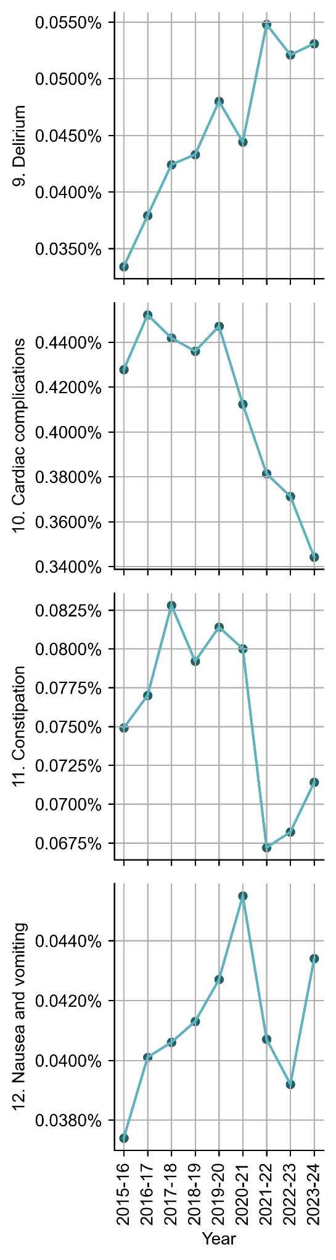
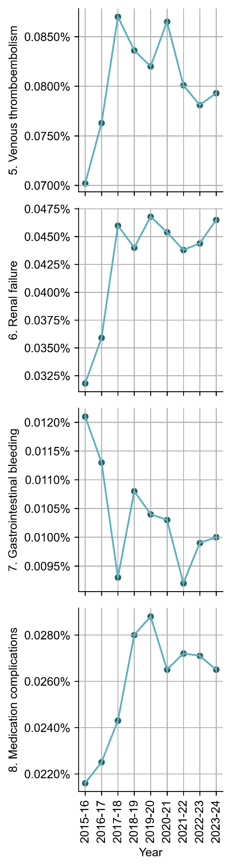
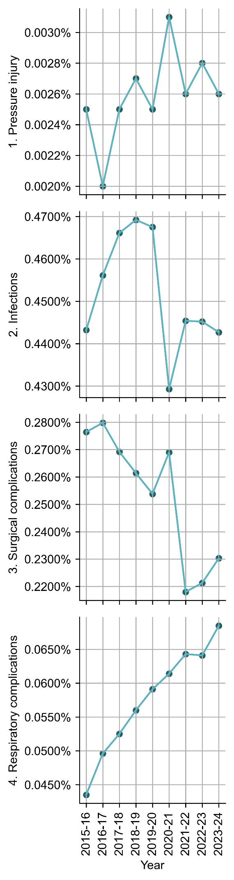

Figure A1. Yearly readmission percentage of total records as a fraction of total national records since the creation of the AHR model.

Appendix B: A brief context of AHR adjustment model development
Overview
From 1 July 2019, IHACPA commenced a 24-month shadow period encompassing three funding options for avoidable hospital readmissions:
- Option one: Deduct the cost of the readmission episode from the index episode;
- Option two: Combine the index and readmission episodes and recalculate the funding of the combined episode;
- Option three: Adjust funding at the hospital level where actual rates of avoidable readmissions exceed expected rates of avoidable readmissions.
Throughout the shadow period IHACPA worked closely with jurisdictional stakeholders in analysing and evaluating the three scope options for potential implementation.
The majority of stakeholders expressed a preference for funding option one throughout the shadow period. Funding option one is the simplest to apply as it follows the same methodology as the HACs adjustment, where the funding adjustment is applied to the index admission. Of the funding options investigated, option one impacted the jurisdictions more proportionately when compared to funding options two and three, which showed adjustment bias against smaller regional and remote hospitals when the scope is expanded beyond the hospital level.
Stakeholders initially had reservations about the potentially punitive effect of funding option one for episodes involving a transfer within hospital networks. IHACPA has made the decision to trim transfer episodes from the readmissions data to consolidate this risk and provide a more accurate picture of the readmissions landscape.
Stakeholders also expressed concerns about funding option one being a disincentive for hospitals to discharge patients to avoid penalisation for a potential readmission. However, this could be viewed as a positive change in clinical behaviour to reduce avoidable readmissions and improve patient safety if discharges were previously occurring too early.
Funding option for implementation
Following a development and consultation period, IHACPA implemented the funding adjustment for avoidable hospital readmissions using funding option one, i.e. deducting the cost of the readmission episode from the index episode.
Under this episode-level approach, an avoidable hospital readmission nominally receives no funding adjustment, with a funding adjustment applied to impact on where the index admission occurred (even when the readmission occurred in a different hospital/LHN to the index admission).
To accomplish this, an NWAU adjustment is applied to the index episode, based on the total NWAU of the associated readmission. For episodes considered low risk under the risk adjustment methodology, the full NWAU of the readmission episode is deducted from the index episode (up to the value of the index episode). This is similar to the full incremental cost deduction in the context of HACs.
This option is risk adjusted by the adjustment factors discussed above, for example, if the risk of a readmission is high, only a small percentage of the readmitted episode NWAU is deducted from the index episode.

Appendix C: Preliminary AHR risk adjustment modelling
Logistic regression – The original AHR model
The original modelling approach investigated for avoidable readmissions was based on the HACs logistic regression model. This modelling approach had limitations due to the large number of false positive outputs (where readmissions were identified for episodes where it had not occurred) from a much larger data set of non-readmission episodes. The logistic regression approach showed poor performance on episodes that were not readmissions and provided a less than optimal fit to the given data.
Receiver operating characteristic curves (ROC curves) were originally used to measure AHR model performance, however these presented an incomplete picture of model performance trained on imbalanced data. IHACPA has since updated the metrics used to describe the performance of the readmissions risk adjustment model to include areas under precision recall curves (PRC) as well, which gives a more complete idea of the performance of the model on highly unbalanced data.
The original logistic regression risk model estimated the effect of each risk factor independently. For example, for a given readmission category, being admitted to an intensive care unit (ICU) might indicate an increased risk of readmission of 3 per cent. Each risk factor had an associated marginal risk like this which, when added together, gave a total risk score. Due to poor performance, this method was replaced with one based on decision trees.
Figure C1 demonstrates an example of the historic PRC for readmission 10 when using the logistic regression model. Picking a threshold which identifies 20% of unplanned readmissions (recall) in the data set, the model has a precision of around 8%, meaning that it will return about 28,000 episodes correctly classified as leading to an avoidable hospital readmission but also around 130,000 false positives.

Figure C1: Precision Recall curve for readmission 10 with logistic regression model

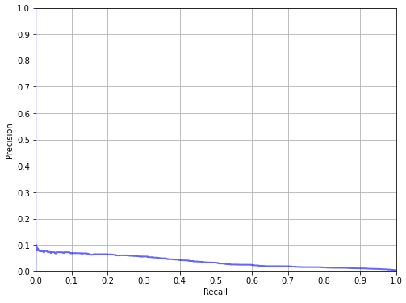

Decision trees – The first AHR model improvement
IHACPA investigated the performance of regression-based decision tree models as an alternative to the logistic regression model used for HACs. The model built a decision tree to classify the target variable by selecting features that give the highest information gain and splitting the data set on that feature. Figure C2 shows an example of a regression-based decision tree model for the Cardiac complications readmission category. Decision trees are easily visualised and understood, but have a large risk of overfitting or failing to generalize beyond training data with large, complex models.

Figure C2: Example regression based decision tree classifier for Readmission 10 – Cardiac complications
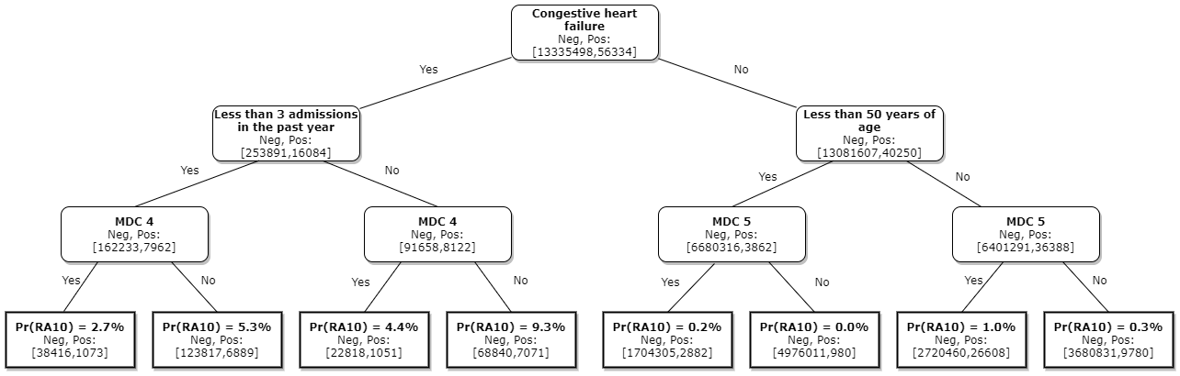
In Figure C2, the numbers in square brackets show how many non-readmissions (Neg) and readmissions (Pos) are considered at each stage. These episodes are then split on the risk factor (stated in bold) and shown on the next level of the decision tree.
For example, the node at the top of the tree shows that 13,335,498 non-readmissions and 56,334 cardiac complication readmissions are considered in this model. These are then split, based on whether the episode has the congestive heart failure risk factor, into 253,891 non-readmissions and 16,084 cardiac complication readmissions with congestive heart failure, and 13,081,607 non-readmissions and 40,250 cardiac complication readmissions without congestive heart failure.
Splitting on the congestive heart failure risk factor produces two nodes where less than 2 per cent of non-readmissions are on the left-hand side, though it contains over 28 per cent of cardiac complication readmissions. We therefore say that splitting on this feature produces a high information gain. This process is repeated, splitting on episodes with less than 3 admissions in the past year, then again on the major diagnostic category (MDC) risk factor, specifically if the episode is in MDC 4. At each level of the decision tree, the model identifies the risk factor that produces the highest information gain and splits the data set on this.
Leaf nodes are produced at the bottom of the chart. If the model was allowed to continue splitting the data set until each leaf node was either purely non-readmissions or purely readmissions, it would produce a much deeper model than is shown in Figure C2, with many more layers of nodes. To avoid overfitting, however, the model was limited to a “depth” of five layers of nodes (three in the example tree shown). The leaf nodes at the bottom of Figure C2, therefore; output the probability of whether an episode with the corresponding risk factors will lead to an avoidable readmission for cardiac complications.
Tracing a single example through the model in Figure C2, if an episode: has the congestive heart failure risk factor; more than three admissions in the previous year; and is not in MDC 4, the model says that this episode has a 9.3% chance of leading to an avoidable readmission for a cardiac complication.
To combat the overfitting and general poor fit of decision trees on the AHR datasets, GBDT methods were adopted for the AHR model. Refer to Section 5.2 for more details.

Appendix D: Selection of and reassessment of risk factors
The AHR risk adjustment model consists of a series of GBDT models, one for each AHR. Each model assigns episodes a complexity value, based on their unique risk flags. Due to the machine learning nature of the model, risk factors interact in complex, interrelated manners to form the final complexity output.
Risk factors are numerical or categorical variables that identify episode characteristics. These characteristics are identified in Section 5.3. Many of these characteristics are identified through flagging the presence of the ICD-10-AM codes identified in Appendix F. Risk factors for readmission episodes are identified on the index episode for the avoidable hospital readmission, rather than on the readmission episode itself.

IHACPA has established a general process for assessing risk factors included in the risk adjustment model. The process involves:
  - (For new risk factors) A preliminary assessment to determine whether there is adequate volume of information to allow for their use.
  - Assessing the relative feature performance of the risk factor in predicting the occurrence of a AHR across 3 years and
  - Seeking clinical advice on the appropriateness of the proposed risk factor.

Testing risk factor significance
Feature importance plots provide information on the risk factors used in the AHR model. During the shadow period, the top performing risk factors with the largest contribution to predicting the readmission category were used in the AHR-level risk adjustment models, based on a minimum relative feature importance threshold of 0.01. This approach was selected as it does not trim potentially important risk factors in some readmission categories, as would be the case if limited to an arbitrary number of risk factors (for example, top 10 risk factors), and as it removes risk factors that are not statistically significant for other readmission categories from consideration in those models.
This process allows for re-evaluation of risk factors in AHRs, with the additional criteria that a risk factor must be considered significant for three consecutive years before it is considered for implementation. Risk factor reevaluation is carried out through creating GBDT models for each AHR group, using every risk factor. This allows for the identification of risk factors for addition or removal, when considered across three NEP years.
Overall, this approach reflects the best risk factors (of those considered) for the best performing risk adjustment model for each readmission category. However, this method does have some shortcomings in that the models for certain readmission categories may perform less optimally than other categories due to low episode sample sizes. This is particularly true for the pressure injury and gastrointestinal bleeding categories, where the extremely low sample sizes means that both risk factor selection and the risk model in general are less robust compared to the other readmission categories.
Another consideration is the use of chronic condition flags as risk factors, due to concerns that if the presence of a chronic condition impacts the course of care, it would be coded differently. The primary purpose of using Charlson comorbidity flags and chronic condition flags is to capture whether a patient has these types of conditions, and their related risk of readmission. For example, if a patient was readmitted for renal failure, their risk profile would be affected by having one or more of the chronic condition flags and they are therefore more likely to be readmitted due to their chronic condition.
Seeking clinical advice
IHACPA will seek the advice of the CAC on the selection, addition and removal of risk factors in the AHR risk adjustment model. This will generally be undertaken in two stages, firstly to propose risk factors for broad consideration and exploration and then subsequently, after statistical analysis, seek advice on any finalised updates to the risk model.
IHACPA has previously received advice querying the use of length of stay in the risk adjustment model, as it is a factor under the control of the hospital and influenced by processes of care. There was concern that it could potentially capture patients who were discharged too early or be indicative of a less complex patient. While length of stay is not used as a risk factor in the AHR model, low length of stay flag is used as a risk factor. Additionally, based on feedback during development of the AHR model, readmissions where the index admission has a separation mode of discharged against medical advice are excluded from adjustment.
Historical advice
Historical advice was obtained through consultation with clinical and jurisdictional committees during the shadow period, and through consultation with the University of Melbourne. Advice is separated into general feedback, summarised below at the document or committee level, and advice on specific treatment of AHR risk factors (Table D1).
Feedback from the University of Melbourne
IHACPA consulted with the University of Melbourne on the creation of the AHR model. During this time, the University of Melbourne provided advice at both a general and risk factor level. General advice included to:
- Retain a core set of risk factors for all models regardless of statistical significance, based on consultation and clinical feedback
- Use statistical methods to determine the validity of AHR level risk factors for inclusion outside this core set and supplement this statistical criteria with clinical and policy considerations
- Consider the removal of AHRs that do not show enough records for the development of a stable model from the modelling process
- Not use risk factors that are more granular or which flag less than 5% of the total modelling dataset
- Use individual Charlson score components as flags, rather than as an aggregate Charlson score to allow for greater granularity.
Feedback to the Consultation paper on the pricing framework for Australian public hospital services 2021-22
General feedback to this consultation paper included:
- Queensland Health raised concerns that the inclusion of Indigenous status as a risk adjustment variable, in spite of being significant to readmissions, may give the perception of acceptance that nothing can/should be done to work with Indigenous groups to prevent readmissions. They also raised concern that the inclusion of number of readmissions in the previous years, while a potential indicator of how sick a patient is, may also reflect establishment admission policies and practices.
- Children’s Health Queensland Hospital and Health Service supported the inclusion of young age specific flagging. This was resolved with the decision to exclude neonatal episodes from AHR adjustment based on the specification from the Commission. It also advised that episodes with an index episode having a discharge mode that indicated discharge against medical advice should be excluded from risk adjustment. This was eventually incorporated into the Commission Technical Specification.
- The WA department of Health and Women’s and Children’s Healthcare Australia both supported the inclusion of paediatric specific risk factors in AHR modelling. This was resolved with the decision to exclude neonatal episodes from AHR adjustment based on the specification from the Commission.
- Women’s and Children’s Healthcare Australia recommended the exclusion of episodes with discharge modes that indicated discharge against medical advice. This is now part of the Commission Technical Specification. Similarly, there was a recommendation of paediatric specific risk factors, which are no longer relevant to the adopted model due to exclusion of neonatal episodes from risk adjustment.
CAC Feedback
Feedback from IHACPA’s CAC during development of the AHR model indicated that:
- Paediatric risk factors were not planned for inclusion due to the exclusion of neonatal episodes from AHR modelling.
- CAC advice raised no concerns on the clinical relevance of the final risk factors chosen by IHACPA for AHR modelling, which were based on the top performing risk factors from relative feature importance and reached consensus to support IHACPA’s proposed risk adjustment model based on funding option 1.
AHR Reports
There were four AHR Reports produced during the development of the AHR model. These reports built on the information presented in each other, taking a similar form to the AHR Technical Specifications by the final report. The AHR Reports provided updates on action on the advice received throughout the AHR model development period, and indicated that:
- Feature importance tables were chosen and reported as a method of validating the significance of proposed risk factors, and demonstrated that admissions in the previous year were a significant risk factor for all reasonably large sample size risk factors. This is in keeping with advice from the University of Melbourne included in Table D1.
Further advice was largely based on feedback from the University of Melbourne.

Table D1: Historical advice relating to the use of specific risk factors
Source | Risk Factor Advice
The University of Melbourne | - Use annual volume and rurality as potential risk factors instead of peer group.  - Use long stay and short stay outlier flags for testing instead of length of stay, which is a contentious variable in the literature  - It is recommended to include the number of procedures in the index admission  - It is recommended to include number of admissions in the previous year  - Use individual Charlson score component flags instead of an aggregate Charlson score  - It is highly recommended to include socioeconomic status as a risk factor  The University of Melbourne additionally recommended setting a set of core risk factors that are clinically important, so included regardless of statistical importance, and excluding or changing the bagging of risk factors that are granular enough to flag less than 5% of the sample.
Queensland Health | - Cautions against inclusion of Indigenous status as, while significant, it may represent a decision to risk adjust away, not highlight, the decreased health outcomes of Indigenous people  - Cautions against the use of number of readmissions in the past year
NSW Health | - Advises the use of an expanded set of risk factors in AHRs compared to HACs, including a range of diabetes and malignant conditions
Children’s Health Queensland Hospital and Health Services | - Charlson comorbidity flags should be used as risk factors to identify high risk patients  - Age and weight should be included as a risk factor. This was provided in the context of neonatal patients, which are currently excluded from risk adjustment, but age group is considered.  - Use chronic conditions flags to identify malignancy, cystic fibrosis, inflammatory bowel disease, immunocompromised patients and haemophilia patients, and use these flags as risk factors
Victorian Department of Health and Human Services | - Use socio-economic factors as risk factors  - Recommends the inclusion of non-English speaking background as a risk factor
Western Australia Department of Health | - Use remoteness and rurality as potential risk factors  - Use socio-demographic factors, including accommodation status, cultural status and refugee status as risk factors  - Consider separating advanced neoplastic disease and oesophageal cancers from other similar conditions, since they may behave differently  - Paediatric risk factors, including Rhee score, should be considered. This is not considered in the existing model, since neonatal episodes are excluded.
Women’s and Children’s Healthcare Australia | - Recommends the inclusion of paediatric specific risk factors. This is not considered in the existing model since neonatal episodes are excluded.
CAC paper inclusions | Selection was based largely on relative feature importance during the shadow period:  - IHACPA sought advice on if the following risk factors should be included for all AHRs regardless of statistical performance:  - Age  - Major diagnostic category (MDC)  - Emergency status and  - DRG type  - No feedback was noted to support or contradict this selection  - IHACPA sought any information of further suggested risk factors to include regardless of statistical significance, with no further suggestions noted  - IHACPA suggested the trimming of ICU hours, mental health flag, presence of a pacemaker, dependence on ventilation, post transplant status, asthma status and presence of a HAC from the AHR risk factors based on relative feature importance
AHR reports (Report One to Four) | - Number of admissions in the past year proved significant for the majority of risk factors, and is strongly recommended for inclusion in each AHR group  - Length of stay in the index admission, which was used in report 1-3, should be revised to short stay outlier flag based on balancing a need to capture patients who were discharged too early against stakeholder influence on care  - Long stay outlier flag was not considered  - Socio-economic Indexes for Areas (SEIFA) is a capturable proxy for socioeconomic status. The AHR Second Report noted it to not be a strong predictor, so removed it from subsequent testing.

Other general considerations
Advice on risk flagging should be followed when possible using the available activity datasets. Any changes to the risk factors in the AHR risk adjustment model should seek to optimise the statistical model performance and reflect model clinical considerations.
According to clause A90 of the Addendum to the NHRA 2026–31, absolute pricing penalties for avoidable hospital readmissions will not be applied to states and territories, and will instead be shadow priced, while the Commission is undertaking a review of the safety and quality measures as outlined in clauses D51–D55. As such, IHACPA is shadow pricing the AHRs funding approach and risk adjustment methodology for the National Efficient Price 2026-27 (NEP26) Determination.

Appendix E: Shadow period risk factors, Charlson diagnosis codes and chronic condition diagnosis codes

Table E1: Risk factors assessed throughout the shadow period
First Report | Second Report | Third Report
- Patient age  - Gender  - Indigenous status  - Treatment remoteness  - Diagnosis related group type (medical, surgical, other)  - MDC  - Charlson score  - Socio-Economic Indexes for Areas (SEIFA)  - ICU status  - Admission status  - Transfer status | - Patient age  - Charlson score  - MDC  - Emergency status  - ICU hours  - AR-DRG type  - Gender  - Transfer status  - Patient remoteness  - Indigenous status  - Mental health condition present  - Presence of a pacemaker  - Dependence on ventilation  - Post transplant  - Asthma  - Obesity/malnutrition  - Presence of a HAC | - Patient age  - MDC  - Emergency status  - ICU hours  - AR-DRG type  - Gender  - Transfer status  - Patient remoteness  - Indigenous status  - Mental health condition present  - Presence of a pacemaker  - Dependence on ventilation  - Post transplant  - Asthma  - Obesity  - Malnutrition  - Presence of a HAC  - Length of stay in the index admission  - Number of procedures undergone in the index admission  - Number of hospital admissions in the year prior to the index admission  - Charlson comorbidity diagnostic categories  - Chronic condition flags

Table E2: Previous Charlson diagnostic category definitions – Used up to NEP23
Diagnostic category | Diagnosis Codes
Acute myocardial infarction |  | I21-prefix I22-prefix I25.2-prefix
Congestive heart failure |  | I50-prefix
Peripheral vascular disease |  | I71-prefix I79.0-prefix I73.9-prefix R02-prefix Z95.8-prefix Z95.9-prefix
Cerebral vascular accident |  | I60-prefix I61-prefix I62-prefix I63-prefix I65-prefix I66-prefix G45.0-prefix G45.1-prefix G45.2-prefix G45.8-prefix G45.9-prefix G46-prefix I64-prefix G45.4-prefix I67.0-prefix I67.1-prefix I67.2-prefix I67.4-prefix I67.5-prefix I67.6-prefix I67.7-prefix I67.8-prefix I67.9-prefix I68.1-prefix I68.2-prefix I68.8 I-prefix 69-prefix
Dementia |  | F00-prefix F01-prefix F02-prefix F05.1-prefix
Pulmonary disease |  | J40-prefix J41-prefix J42-prefix J44-prefix J43-prefix J45-prefix J46-prefix J47-prefix J67-prefix J60-prefix J61-prefix J62-prefix J63-prefix J66-prefix J64-prefix J65-prefix
Connective tissue disorder |  | M32-prefix M34-prefix M33.2-prefix M05.3-prefix M05.8-prefix M05.9-prefix M06.0-prefix M06.3-prefix M06.9-prefix M05.0-prefix M05.2-prefix M05.1-prefix M35.3-prefix
Peptic ulcer |  | K25-prefix K26-prefix K27-prefix K28-prefix
Liver disease |  | K70.2-prefix K70.3-prefix K73-prefix K71.7-prefix K74.0-prefix K74.2-prefix K74.6-prefix K74.3-prefix K74.4-prefix K74.5-prefix
Diabetes |  | E10.9-prefix E11.9-prefix E13.9-prefix E14.9-prefix E10.1-prefix E11.1-prefix E13.1-prefix E14.1-prefix E10.5-prefix E11.5-prefix E13.5-prefix E14.5-prefix
Diabetes complications |  | E10.2-prefix E11.2-prefix E13.2-prefix E14.2-prefix E10.3-prefix E11.3-prefix E13.3-prefix E14.3-prefix E10.4-prefix E11.4-prefix E13.4-prefix E14.4-prefix
Paraplegia |  | G81-prefix G04.1-prefix G82.0-prefix G82.1-prefix G82.2-prefix
Renal disease |  | N03-prefix N05.2-prefix N05.3-prefix N05.4-prefix N05.5-prefix N05.6-prefix N07.2-prefix N07.3-prefix N07.4-prefix N01-prefix N18-prefix N19-prefix N25-prefix
Cancer |  | C0-prefix C1-prefix C2-prefix C3-prefix C40-prefix C41-prefix C43-prefix C45-prefix C46-prefix C47-prefix C48-prefix C49-prefix C5-prefix C6-prefix C70-prefix C71-prefix C72-prefix C73-prefix C74-prefix C75-prefix C76-prefix C80-prefix C81-prefix C82-prefix C83-prefix C84-prefix C85-prefix C88.3-prefix C88.7-prefix C88.9-prefix C90.0-prefix C90.1-prefix C91-prefix C92-prefix C93-prefix C94.0-prefix C94.1-prefix C94.2-prefix C94.3-prefix C94.5-prefix C94.7-prefix C95-prefix C96-prefix
Metastatic cancer |  | C77-prefix C78-prefix C79-prefix
Severe liver disease |  | K72.9-prefix K76.6-prefix K76.7-prefix K72.1-prefix
HIV |  | B20-prefix B21-prefix B22-prefix B23-prefix B24-prefix

Table E3: Chronic disease code categories
Chronic category | U code | Chronic condition codes
Obesity | U78.1 | E66.9 (ICD-10-AM 10th edition only) E66.90 E66.91 E66.92 E66.93 (ICD-10-AM 11th and 12th edition only)
Cystic fibrosis | U78.2 | E84
Dementia | U79.1 | F03 F00.0 F00.1 F00.2 F00.9 F01.0 F01.1 F01.2 F01.3 F01.8 F01.9 F02.0 F02.1 F02.2 F02.3 F02.4 F02.8 (ICD-10-AM 10th and 11th edition only) F00.00 F00.01 F00.10 F00.11 F00.20 F00.21 F00.90 F00.91 F01.00 F01.01 F01.10 F01.11 F01.20 F01.21 F01.30 F01.31 F01.80 F01.81 F01.90 F01.91 F02.00 F02.01 F02.10 F02.11 F02.20 F02.21 F02.30 F02.31 F02.40 F02.41 F02.80 F02.81 F03.00 F03.01 (ICD-10-AM 12th edition only)
Schizophrenia | U79.2 | F20.0 F20.1 F20.2 F20.3 F20.4 F20.5 F20.6 F20.8 F20.9
Depression | U79.3 | F33.4 F33.8 F33.9 F32.00 F32.01 F32.10 F32.11 F32.20 F32.21 F32.30 F32.31 F32.80 F32.81 F32.90 F32.91
Disorder of intellectual development | U79.4 | F70.0 F70.1 F70.8 F70.9 F71.0 F71.1 F71.8 F71.9 F72.0 F72.1 F72.8 F72.9 F73.0 F73.1 F73.8 F73.9 F78.0 F78.1 F78.8 F78.9 F79.0 F79.1 F79.8 F79.9
Parkinson's disease | U80.1 | G20
Multiple sclerosis | U80.2 | G35
Epilepsy | U80.3 | G40.00 G40.01 G40.10 G40.11 G40.20 G40.21 G40.30 G40.31 G40.40 G40.41 G40.50 G40.51 G40.60 G40.61 G40.70 G40.71 G40.80 G40.81 G40.90 G40.91
Cerebral palsy | U80.4 | G80.9 G80.00 G80.01 G80.02 G80.03 G80.09
Tetraplegia, paraplegia, diplegia, monoplegia and hemiplegia, due to any cause | U80.5 | G81.0 G81.1 G81.9 G83.0 G83.1 G83.2 G83.3 G82.00 G82.02 G82.04 G82.06 G82.10 G82.12 G82.14 G82.16 G82.20 G82.22 G82.24 G82.26 G82.30 G82.32 G82.34 G82.36 G82.40 G82.42 G82.44 G82.46 G82.50 G82.52 G82.54 G82.56
Ischaemic heart disease | U82.1 | I25.9 I25.10 I25.11 I25.12 I25.13
Chronic heart failure | U82.2 | I50.0 I50.9
Hypertension | U82.3 | I10
Emphysema without mention of COPD | U83.1 | J43.9
Chronic obstructive pulmonary disease | U83.2 | J44.9
Asthma, without mention of COPD | U83.3 | J45.0 J45.1 J45.8 J45.9
Bronchiectasis without mention of CF | U83.4 | J47
Chronic respiratory failure | U83.5 | J96.10 J96.11 J96.19
Crohn's disease | U84.1 | K50.9 K50.8 K50.1 K50.0
Ulcerative colitis | U84.2 | K51.0 K51.2 K51.3 K51.8 K51.9
Chronic liver failure | U84.3 | K72.1
Rheumatoid arthritis | U86.1 | M06.90 M06.91 M06.92 M06.93 M06.94 M06.95 M06.96 M06.97 M06.98 M06.99
Arthritis and osteoarthritis | U86.2 | M15.0 M16.0 M16.1 M17.0 M17.1 M18.0 M18.1 M13.90 M13.91 M13.92 M13.93 M13.94 M13.95 M13.96 M13.97 M13.98 M13.99 M19.01 M19.02 M19.03 M19.04 M19.07 M19.08 M19.09 M47.90 M47.91 M47.92 M47.93 M47.94 M47.95 M47.96 M47.97 M47.98 M47.99
Systemic lupus erythematosus | U86.3 | M32.0 M32.1 M32.8 M32.9
Osteoporosis | U86.4 | M81.90 M81.91 M81.92 M81.93 M81.94 M81.95 M81.96 M81.97 M81.98 M81.99
Chronic kidney disease stage 3 to 5 | U87.1 | N18.3 N18.4 N18.5
Spina bifida | U88.1 | Q05.00 Q05.01 Q05.02 Q05.10 Q05.11 Q05.12 Q05.20 Q05.21 Q05.22 Q05.30 Q05.31 Q05.32 Q05.40 Q05.41 Q05.42 Q05.50 Q05.51 Q05.52 Q05.60 Q05.61 Q05.62 Q05.70 Q05.71 Q05.72 Q05.80 Q05.81 Q05.82 Q05.90 Q05.91 Q05.92
Down's syndrome | U88.2 | Q90.0 Q90.1 Q90.2 Q90.9

Appendix F: Risk factor definitions

Table F1. ICD-10-AM 12th edition codes used for flagging risk categories for AHR modelling
Risk factor group | Diagnostic category | Diagnosis Codes
Standalone categories | Mental health |  | F-prefix R45.81 U79-prefix
Standalone categories | Drug use |  | F10-prefix to F19-prefix Z64.2-prefix Z72.2-prefix
Standalone categories | Homelessness |  | Z59.0-prefix
Standalone categories | Post transplant status |  | Z94-prefix
Standalone categories | Pacemaker status |  | Z95.0
Standalone categories | Ventilator |  | Z99.1
Standalone categories | Asthma |  | J45-prefix J46-prefix U83.3
Standalone categories | Obesity |  | E66.90 E66.91 E66.92 E66.93 E66.1-prefix E66.2-prefix
Standalone categories | Malnutrition |  | E40 E41 E42 E43 E44.0 E44.1 E45 E46
Standalone categories | Parkinson disease |  | G21-prefix G22-prefix
Standalone categories | Dystocia |  | P03.1 O66.0
Standalone categories | COVID-19 Status |  | U07.11 U07.2 U07.12
Charlson Categories | Acute myocardial infarction |  | I21-prefix I22-prefix
Charlson Categories | Congestive heart failure |  | I50-prefix I11.0-prefix I13.0-prefix I13.2-prefix U82.2
Charlson Categories | Peripheral vascular disease |  | I70-prefix I71-prefix I73-prefix
Charlson Categories | Cerebral vascular accident |  | I60-prefix to I66-prefix I67.0-prefix to I67.9-prefix I68.0-prefix to I68.2-prefix I68.8-prefix I69-prefix
Charlson Categories | Dementia |  | F00-prefix F01-prefix F03-prefix U79.1-prefix
Charlson Categories | Pulmonary disease |  | J40-prefix to J47-prefix J60-prefix to J67-prefix U83.1 U83.2 U83.3 U83.4
Charlson Categories | Connective tissue disorder |  | M30-prefix to M36-prefix M05-prefix M06-prefix U86.1 U86.3
Charlson Categories | Peptic ulcer |  | K25-prefix to K28-prefix
Charlson Categories | Liver disease |  | K70.0-prefix to K70.3-prefix K70.9-prefix K71.0-prefix K71.2-prefix to K71.9-prefix K72.0-prefix K73-prefix to K75-prefix K76.0-prefix to K76.4-prefix K76.8-prefix K76.9-prefix B18-prefix
Charlson Categories | Diabetes |  | E10.8 E10.9 E11.8 E11.9 E13.8 E13.9 E14.8 E14.9-prefix
Charlson Categories | Diabetes complications |  | E10.0-prefix to E10.7-prefix E11.0-prefix to E11.7-prefix E13.0-prefix to E13.7-prefix E14.0-prefix to E14.7-prefix
Charlson Categories | Paraplegia |  | G81-prefix G82.0-prefix to G82.2-prefix
Charlson Categories | Renal disease |  | N03-prefix N05.2-prefix to N05.6-prefix N07.2-prefix to N07.4-prefix N01-prefix N18.3-prefix to N18.5-prefix N18.9-prefix N19-prefix N25-prefix I12.0-prefix I13.1-prefix Z49.0-prefix to Z49.2-prefix U87.1
Charlson Categories | Cancer |  | C0-prefix to C3-prefix C40-prefix C41-prefix C43-prefix C45-prefix to C49-prefix C5-prefix C6-prefix C70-prefix to C76-prefix C80-prefix to C86-prefix C88.0-prefix C88.2-prefix to C88.4-prefix C88.7-prefix C88.9-prefix C90.0-prefix to C90.3-prefix C91.1-prefix C91.3-prefix to C91.9-prefix C92-prefix C93.0-prefix C93.1-prefix C93.3-prefix C93.7-prefix C93.9-prefix C94.0-prefix C94.2-prefix to C94.4-prefix C94.6-prefix C94.7-prefix C95.0-prefix C95.1-prefix C95.7-prefix C95.9-prefix D46-prefix D45
Charlson Categories | Metastatic cancer |  | C77-prefix to C79-prefix
Charlson Categories | Severe liver disease |  | K70.4-prefix K71.1-prefix K72.1-prefix K72.9-prefix K76.5-prefix to K76.7-prefix Z94.4-prefix U84.3
Charlson Categories | HIV |  | B20-prefix to B24-prefix R75-prefix Z21-prefix

Table F2. ICD-10-AM 12th edition codes used for flagging chronic conditions for AHR modelling
Chronic category | U code | Chronic condition codes
Obesity | U78.1 | E66.9 (ICD-10-AM 10th edition only) E66.90 E66.91 E66.92 E66.93 (ICD-10-AM 11th and 12th edition only)
Cystic fibrosis | U78.2 | E84
Dementia | U79.1 | F03 F00.0 F00.1 F00.2 F00.9 F01.0 F01.1 F01.2 F01.3 F01.8 F01.9 F02.0 F02.1 F02.2 F02.3 F02.4 F02.8 (ICD-10-AM 10th and 11th edition only) F00.00 F00.01 F00.10 F00.11 F00.20 F00.21 F00.90 F00.91 F01.00 F01.01 F01.10 F01.11 F01.20 F01.21 F01.30 F01.31 F01.80 F01.81 F01.90 F01.91 F02.00 F02.01 F02.10 F02.11 F02.20 F02.21 F02.30 F02.31 F02.40 F02.41 F02.80 F02.81 F03.00 F03.01 (ICD-10-AM 12th edition only)
Schizophrenia | U79.2 | F20.0 F20.1 F20.2 F20.3 F20.4 F20.5 F20.6 F20.8 F20.9
Depression | U79.3 | F33.4 F33.8 F33.9 F32.00 F32.01 F32.10 F32.11 F32.20 F32.21 F32.30 F32.31 F32.80 F32.81 F32.90 F32.91
Disorder of intellectual development | U79.4 | F70.0 F70.1 F70.8 F70.9 F71.0 F71.1 F71.8 F71.9 F72.0 F72.1 F72.8 F72.9 F73.0 F73.1 F73.8 F73.9 F78.0 F78.1 F78.8 F78.9 F79.0 F79.1 F79.8 F79.9
Parkinson's disease | U80.1 | G20
Multiple sclerosis | U80.2 | G35
Epilepsy | U80.3 | G40.00 G40.01 G40.10 G40.11 G40.20 G40.21 G40.30 G40.31 G40.40 G40.41 G40.50 G40.51 G40.60 G40.61 G40.70 G40.71 G40.80 G40.81 G40.90 G40.91
Cerebral palsy | U80.4 | G80.9 G80.00 G80.01 G80.02 G80.03 G80.09
Tetraplegia, paraplegia, diplegia, monoplegia and hemiplegia, due to any cause | U80.5 | G81.0 G81.1 G81.9 G83.0 G83.1 G83.2 G83.3 G82.00 G82.02 G82.04 G82.06 G82.10 G82.12 G82.14 G82.16 G82.20 G82.22 G82.24 G82.26 G82.30 G82.32 G82.34 G82.36 G82.40 G82.42 G82.44 G82.46 G82.50 G82.52 G82.54 G82.56
Ischaemic heart disease | U82.1 | I25.9 I25.10 I25.11 I25.12 I25.13
Chronic heart failure | U82.2 | I50.0 I50.9
Hypertension | U82.3 | I10
Emphysema without mention of COPD | U83.1 | J43.9
Chronic obstructive pulmonary disease | U83.2 | J44.9
Asthma, without mention of COPD | U83.3 | J45.0 J45.1 J45.8 J45.9
Bronchiectasis without mention of CF | U83.4 | J47
Chronic respiratory failure | U83.5 | J96.10 J96.11 J96.19
Crohn's disease | U84.1 | K50.9 K50.8 K50.1 K50.0
Ulcerative colitis | U84.2 | K51.0 K51.2 K51.3 K51.8 K51.9
Chronic liver failure | U84.3 | K72.1
Rheumatoid arthritis | U86.1 | M06.90 M06.91 M06.92 M06.93 M06.94 M06.95 M06.96 M06.97 M06.98 M06.99
Arthritis and osteoarthritis | U86.2 | M15.0 M16.0 M16.1 M17.0 M17.1 M18.0 M18.1 M13.90 M13.91 M13.92 M13.93 M13.94 M13.95 M13.96 M13.97 M13.98 M13.99 M19.01 M19.02 M19.03 M19.04 M19.07 M19.08 M19.09 M47.90 M47.91 M47.92 M47.93 M47.94 M47.95 M47.96 M47.97 M47.98 M47.99
Systemic lupus erythematosus | U86.3 | M32.0 M32.1 M32.8 M32.9
Osteoporosis | U86.4 | M81.90 M81.91 M81.92 M81.93 M81.94 M81.95 M81.96 M81.97 M81.98 M81.99
Chronic kidney disease stage 3 to 5 | U87.1 | N18.3 N18.4 N18.5
Spina bifida | U88.1 | Q05.00 Q05.01 Q05.02 Q05.10 Q05.11 Q05.12 Q05.20 Q05.21 Q05.22 Q05.30 Q05.31 Q05.32 Q05.40 Q05.41 Q05.42 Q05.50 Q05.51 Q05.52 Q05.60 Q05.61 Q05.62 Q05.70 Q05.71 Q05.72 Q05.80 Q05.81 Q05.82 Q05.90 Q05.91 Q05.92
Down's syndrome | U88.2 | Q90.0 Q90.1 Q90.2 Q90.9

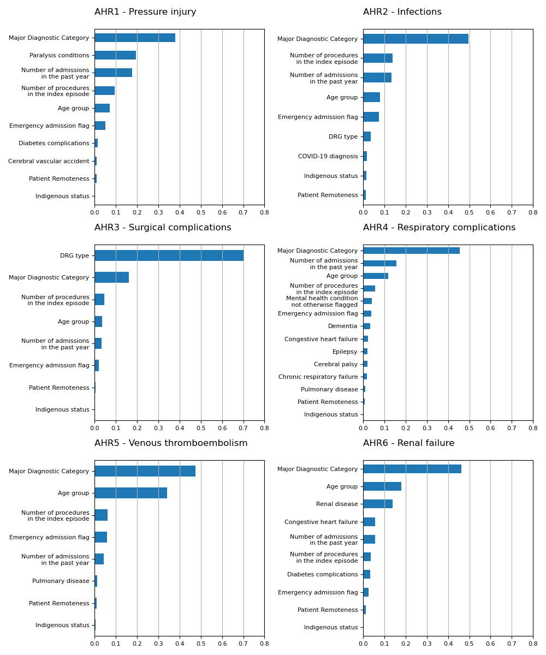
Appendix G: Key risk factor breakdowns

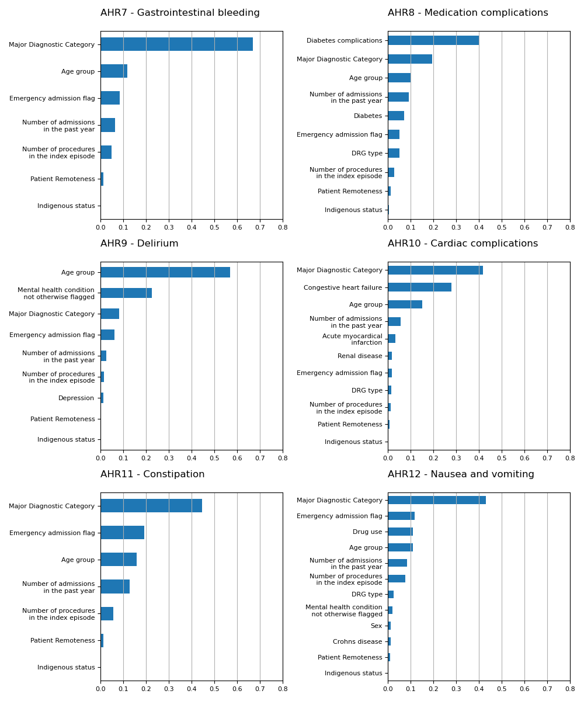

Appendix H: AHR Model Risk Factors prior to NEP26

Table H1: Risk factors for each readmission category prior to risk factor re-evaluation for NEP25 and earlier.
Risk Factor | 01. Pressure injury | 02. Infections | 03. Surgical complications | 04. Respiratory complications | 05. Venous thromboembolism | 06. Renal failure | 07. Gastrointestinal bleeding | 08. Medication complications | 09. Delirium | 10. Cardiac complications | 11. Constipation | 12. Nausea and vomiting
Standalone risk flags
Past year admissions | ✓ | ✓ | ✓ | ✓ | ✓ | ✓ | ✓ | ✓ | ✓ | ✓ | ✓ | ✓
Age group | ✓ | ✓ | ✓ | ✓ | ✓ | ✓ | ✓ | ✓ | ✓ | ✓ | ✓ | ✓
Major Diagnostic Category | ✓ | ✓ | ✓ | ✓ | ✓ | ✓ | ✓ | ✓ | ✓ | ✓ | ✓ | ✓
Procedure count | ✓ | ✓ | ✓ | ✓ | ✓ | ✓ | ✓ | ✓ | ✓ | ✓ | ✓ | ✓
AR-DRG type |  | ✓ | ✓ |  |  | ✓ | ✓ | ✓ | ✓ | ✓ | ✓ | ✓
Drug use |  |  |  |  |  |  |  |  | ✓
Transfer admission |  |  |  |  |  |  |  | ✓
Emergency admission | ✓ | ✓ | ✓ | ✓ | ✓ | ✓ | ✓ | ✓ | ✓ | ✓ | ✓ | ✓
ICU |  |  |  |  | ✓ |  |  |  | ✓
Gender |  | ✓ |  | ✓ | ✓ | ✓ | ✓ |  | ✓ |  | ✓ | ✓
Indigenous | ✓ | ✓ | ✓ | ✓ | ✓ | ✓ | ✓ | ✓ | ✓ | ✓ | ✓ | ✓
Low length of stay |  | ✓ |  |  | ✓
Malnutrition |  |  |  |  |  |  |  |  |  |  |  | ✓
Pacemaker | ✓
Patient remoteness | ✓ | ✓ | ✓ | ✓ | ✓ | ✓ | ✓ | ✓ | ✓ | ✓ | ✓ | ✓
Post transplant |  |  |  |  |  | ✓
Charlson comorbidity flags
Acute myocardial function |  |  |  |  |  |  |  |  |  | ✓
Congestive heart failure |  |  |  |  |  | ✓ |  |  |  | ✓
Diabetes |  |  |  |  | ✓ |  |  | ✓
Diabetes complications |  | ✓ |  |  |  | ✓ |  | ✓ |  | ✓
Dementia |  |  |  | ✓ |  |  |  |  | ✓
Pulmonary disease |  | ✓ |  |  | ✓
Renal disease |  |  |  |  |  | ✓ |  | ✓ |  | ✓
Chronic condition flags
Arthritis and osteoarthritis |  |  |  |  |  |  |  |  |  |  |  | ✓
Cerebral palsy |  |  |  | ✓ |  |  |  |  |  |  | ✓ | ✓
Chronic heart failure |  |  |  |  |  |  |  |  |  | ✓
Chronic kidney disease |  |  |  |  |  | ✓
Chronic respiratory failure |  |  |  | ✓
Chronic obstructive  pulmonary disease | ✓ |  |  | ✓
Crohns disease |  |  |  |  |  |  |  |  |  |  | ✓ | ✓
Depression |  |  |  |  | ✓ |  |  |  | ✓
Disorder of intellectual |  |  |  |  |  |  |  |  |  |  | ✓
Downs syndrome |  |  | ✓
Hypertension |  |  |  |  | ✓ | ✓ | ✓
Ischaemic heart disease |  |  |  |  | ✓ |  |  |  |  | ✓
Obesity |  | ✓ |  |  | ✓
Osteoporosis |  |  |  |  |  |  | ✓
Severe liver disease |  |  |  |  |  | ✓
Spina bifida | ✓
Paraplegia | ✓ | ✓ |  | ✓
Total number of risk factors: | 11 | 14 | 9 | 13 | 16 | 16 | 11 | 12 | 13 | 14 | 12 | 13

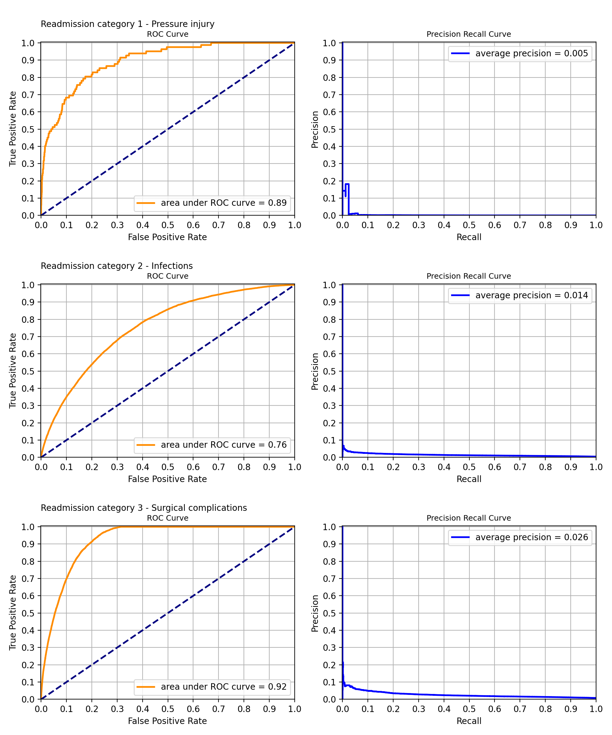
Appendix I: Model testing dataset fit curves
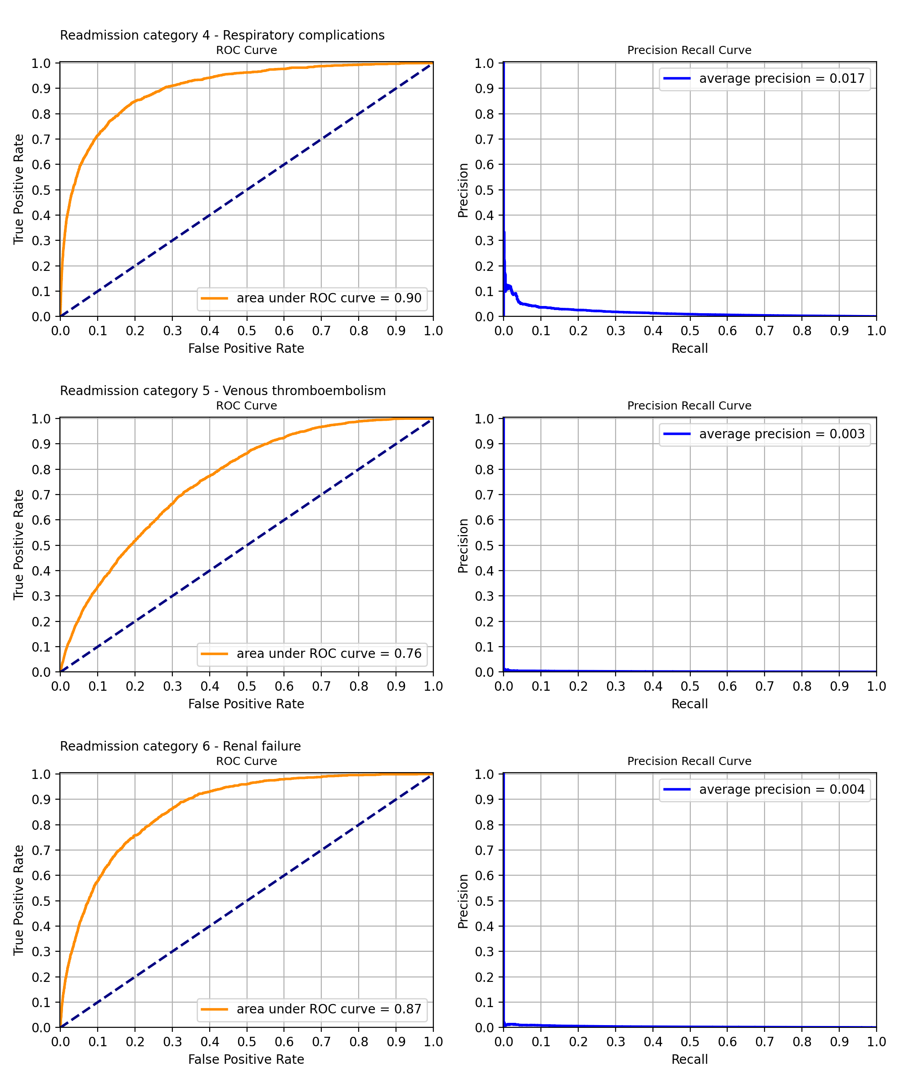

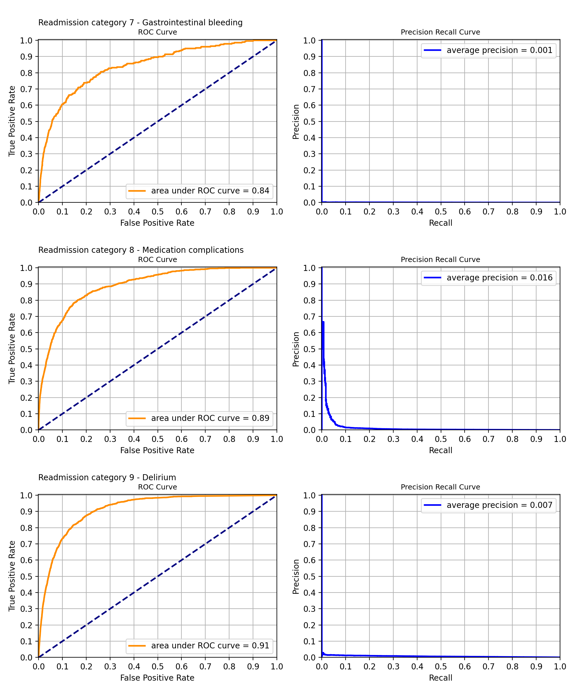

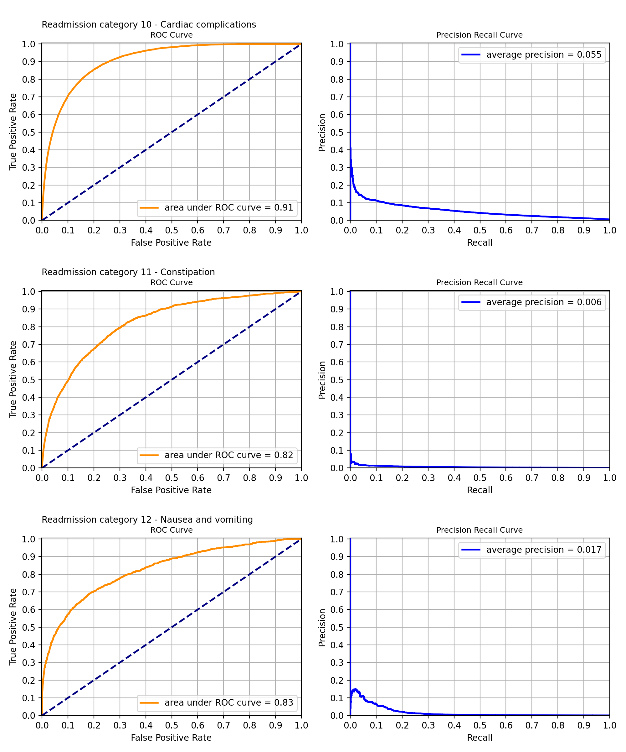

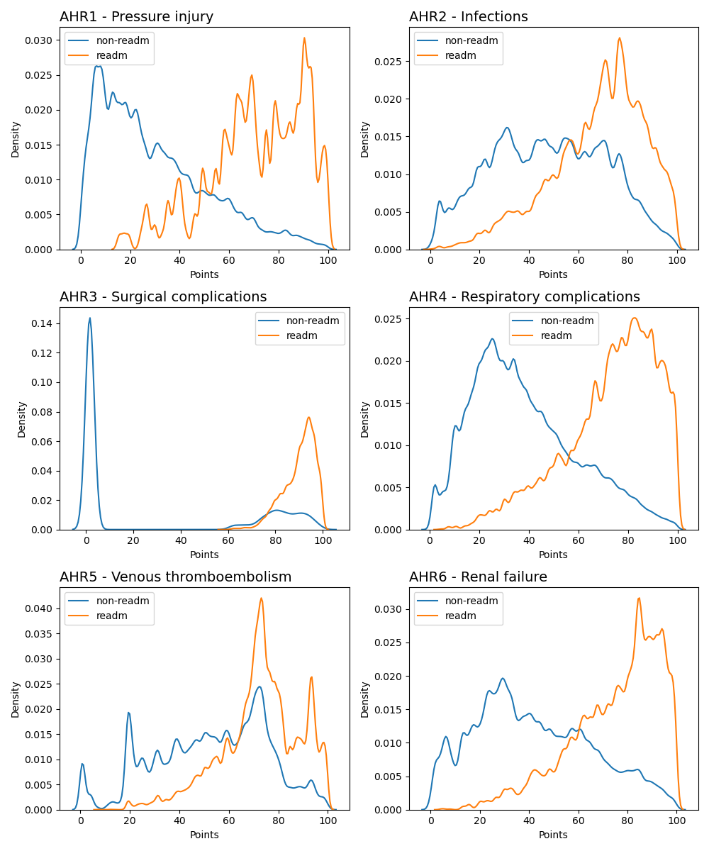
Appendix J: Model complexity distributions

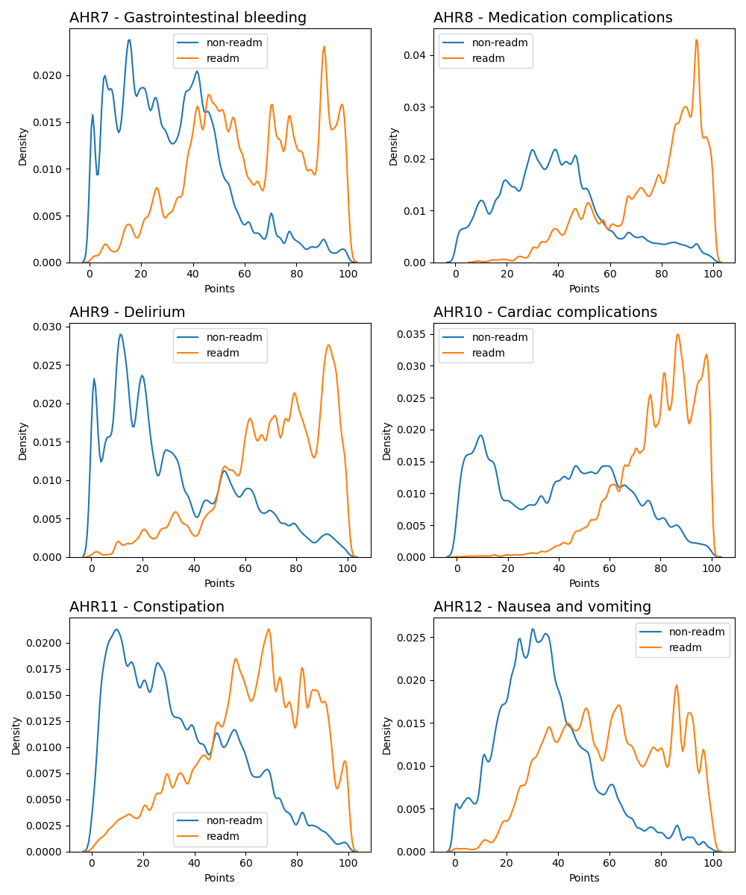
Complexity distribution characteristics
Based on the above figures, in general, the distribution of readmissions overlaps with that of non-readmissions, but the major episode-density of non-readmissions tends to be at lower complexities than those of readmission episodes. This is consistent with AHRs tending to occur in episodes with higher complexities.

Appendix K: Change tracker

Table J1: The description of key changes to the AHR model during NEP cycles
NEP year | AHR list version | Description of key changes
NEP21 | 1.0 | Introduction of AHR risk adjustment.
NEP22 | 1.0 | N/A
NEP23 | 2.0 | N/A
NEP24 | 2.0 | Commenced the process of updating the ICD-10-AM codes to 12th edition; these codes underpin the identification of Charlson comorbidity conditions and standalone risk factors.
NEP25 | 2.0 | Updates to risk flagging ICD-10-AM codes to prepare for ICD-10-AM 13th Edition and to remove outdated or otherwise unnecessary codes.  Updates were made to AHR modelling to use a strictly separated testing dataset for model performance evaluation. This is a standard modelling approach
NEP26 | 3.0 | Updates to concurrent episode treatment to trim rare cases of multiple staggered patient episodes during a larger parent episode.  Updates to introduce a fallback to person identifier for a Unique Patient Identifier when Medicare PIN was missing or invalid.  Updates to the risk factors, based on the statistical significance and clinical feedback around all existing risk factors in the system and COVID-19, a new risk factor.  Shadowing of the AHR risk model under clause A90 of the Addendum to the NHRA 2026–31, which states that absolute pricing penalties for avoidable hospital readmissions will not be applied to states and territories, and will instead be shadow priced, while the Commission is undertaking a review of the safety and quality measures as outlined in clauses D51–D55.


Independent Health and Aged Care Pricing Authority
Eora Nation, Level 12, 1 Oxford Street
Sydney NSW 2000
Phone 02 8215 1100
Email enquiries.ihacpa@ihacpa.gov.au
www.ihacpa.gov.au

Consultation Paper on the Pricing Framework for Australian Public Hospital Services 2021–22 | Resources | IHACPA
https://meteor.aihw.gov.au/content/290046
https://meteor.aihw.gov.au/content/601562
https://www.safetyandquality.gov.au/publications-and-resources/resource-library/avoidable-hospital-readmissions-ahrs-specifications
Relevant acute admitted episodes comprise episodes with one or more of the readmission conditions in the list of Avoidable Hospital Readmissions and the readmission interval is less than or equal to the condition specific timeframes specified in this list.
Note that the exclusion of transfer episodes from being a readmission Is the result of stakeholder feedback and does not appear as an AHR criteria in The Commission Avoidable Hospital Readmission Technical Specification.
During NEP25 and prior, this was referred to as missing or not unique Medicare PIN. This title has been changed to Unique Patient Identifier due to the introduction of Person Identifier as a fallback for where Medicare PIN is missing.
Note that the 2023-24 readmission counts may, in part, be lower due to the fact that only the first nine months of data were considered. The observation period in 2023-24 is restricted because the longest readmission interval is 90 days.
Min, X., Yu, B. & Wang, F. Predictive Modeling of the Hospital Readmission Risk from Patients’ Claims Data Using Machine Learning: A Case Study on COPD. Sci Rep 9, 2362 (2019). https://doi.org/10.1038/s41598-019-39071-y
Donzé J, Aujesky D, Williams D, Schnipper JL. Potentially Avoidable 30-Day Hospital Readmissions in Medical Patients: Derivation and Validation of a Prediction Model. JAMA Intern Med. 2013;173(8):632–638. doi:10.1001/jamainternmed.2013.3023
2020–25 National Health Reform Agreement (NHRA)
National Benchmarking Portal
In NEP25 and prior, the criteria of significance for any two of the last 3 years was instead used, however, during the NEP26 risk factor re-evaluation process, a stricter requirement of significance for all 3 of the last 3 NEP cycles was adopted.
Note that the x-axis is unlabelled due to being relative feature importance, a ranked arbitrary unit describing risk factor discriminatory power which depends on the specific model it is referring to.

