

c
2023-24
Independent Financial Review of the National Hospital Cost Data Collection
Subtext



Disclaimer

This report is not intended to be read or used by anyone other than The Independent Health and Aged Care Pricing Authority (IHACPA).
We prepared this report solely for IHACPA’s use and benefit in accordance with and for the purpose set out in our order for services with IHACPA dated May 2025. In doing so, we acted exclusively for IHACPA and considered no-one else’s interests.
We accept no responsibility, duty or liability:
- to anyone other than IHACPA in connection with this report
- to IHACPA for the consequences of using or relying on it for a purpose other than that referred to above.
We make no representation concerning the appropriateness of this report for anyone other than IHACPA. If anyone other than IHACPA chooses to use or rely on it, they do so at their own risk.
This disclaimer applies:
- to the maximum extent permitted by law and, without limitation, to liability arising in negligence or under statute; and
- even if we consent to anyone other than IHACPA receiving or using this report.
Liability limited by a scheme approved under Professional Standards legislation

Table of Contents
Disclaimer 2
Table of Contents 3
Glossary 5
1 Executive Summary 8
2 Introduction 14
3 Cost Driver analysis of the National Hospital Cost Data Collection (NHCDC) 2023-24 18
4 Key findings & recommendations 25
5 Jurisdiction chapters 41
6 Independent Health and Aged Care Pricing Authority (IHACPA) Review 153

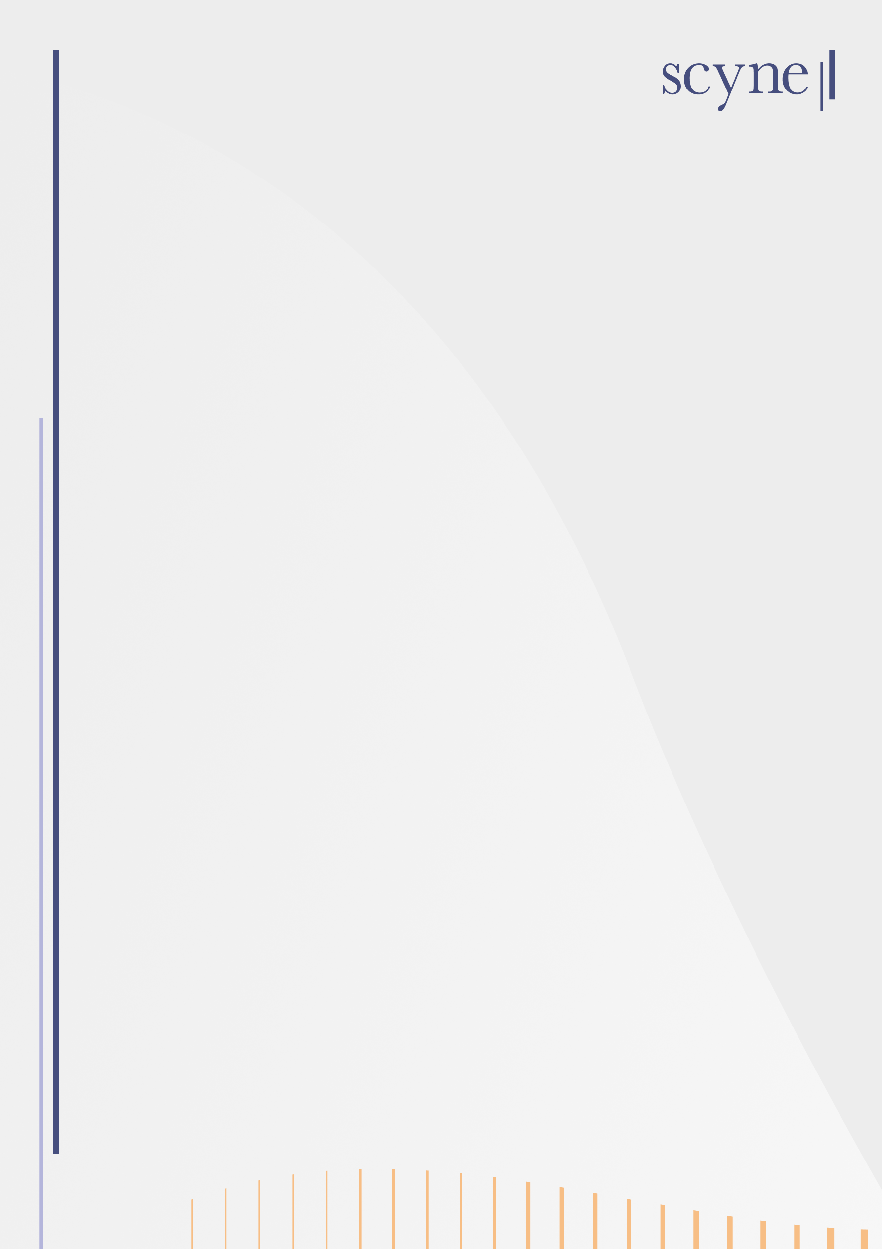
2023-24
Independent Financial Review of the National Hospital Cost Data Collection

Glossary

Term | Definition
ABF | Activity Based Funded
ACT | Australian Capital Territory
AHPCS | Australian Hospital Patient Costing Standards
AICU | Adult Intensive Care Unit (NHCDC Cost Centre)
AIN | Assistant in Nursing
AMHCC | Australian Mental Health Care Classification
CCU | Coronary Care Unit (NHCDC Cost Centre)
CNC / CNE | Clinical Nurse Consultant / Educator
CPAP | Continuous positive airway pressure
Cticu | Cardiothoracic Intensive Care Unit (NHCDC Cost Centre)
DHR | Digital Health Record
DNA | Do Not Attend
DoH | Department of Health
DQS | Data Quality Statement
DRG | Diagnostic related group
DRS | Data Request Specification
EBA | Enterprise bargaining agreement
ECMO | Extracorporeal Membrane Oxygenation
ED | Emergency department
EDW | Enterprise Data Warehouse
eMR | Electronic medical record
EN | Enrolled nurse
ETL | Extract, Transform, Load
FTE | Full-time equivalent
Gencritcare | General Critical Care Unit (NHCDC Cost Centre)
GL | General Ledger
GWAU | Gross weighted average unit
Hdicu | High Dependency Unit (NHCDC Cost Centre)
HEN | Home Enteral Nutrition
HHS | Hospital & Health Service
HS | Health Service
HSP | Health Service Provider
ICCU | Intensive and Critical Care Unit
ICU | Intensive Care Unit
ICT | Information and Communications Technology
IHACPA | Independent Health and Aged Care Pricing Authority
IFR | Independent Financial Review
IT | Information technology
JMO | Junior medical officer
LHD | Local Health District
LHN | Local Health Network
LHSN | Local Health Service Network
LOS | Length of stay
MET | Medical Emergency Team
METEOR | Metadata Online Registry
MBS | Medicare Benefits Schedule
NAC | NHCDC Advisory Committee
NAP | Non-admitted patient
NEP | National efficient price
NETS | Newborn and Paediatric Emergency Transport Service
NHCDC | National Hospital Cost Data Collection
NHRA | National Health Reform Agreement
NICU | Neonatal Intensive Care Unit (NHCDC Cost Centre)
NSW | New South Wales
NT | Northern Territory
NUM | Nurse Unit Manager
NWAU | National Weighted Activity Unit
OBD | Occupied bed day
OtherCritCare | Other Critical Care Unit (NHCDC Cost Centre)
Paedicu | Paediatric Intensive Care Unit (NHCDC Cost Centre)
PAS | Patient Administration System
PBS | Pharmaceutical Benefits Scheme
PICC | Peripherally Inserted Central Catheter
PPM2 / 3 | Power Performance Manager 2 / 3
PPP | Public-Private Partnership
Psychicu | Psychiatric Intensive Care Unit (NHCDC Cost Centre)
QA | Quality assurance
Qld | Queensland
RN | Registered nurse
RQ | Reasonableness and Quality
RVU | Relative value unit
S&W | Salaries & Wages
SA | South Australia
SCN | Special Care Nursery
Scnicu | Special Care Nursery Intensive Care Unit (NHCDC Cost Centre)
SRMO | Senior Resident Medical Officer
Tas | Tasmania
TAVI | Transcatheter Aortic Valve Implantation
TPN | Total parenteral nutrition
TTR | Teaching, Training and Research
UQB | Unqualified baby
URN | Unique Record Number
Vic | Victoria
VMO | Visiting Medical Officer
WA | Western Australia
WAU | Weighted Activity Unit
WIP | Work in progress

Executive Summary

Overview of the Independent Financial Review
The National Hospital Cost Data Collection (NHCDC) is compiled annually by the Independent Health and Aged Care Pricing Authority (IHACPA) from submissions by states and territories (jurisdictions) and serves as the primary input for determining the national efficient price (NEP). The NEP reflects the efficient cost of delivering public hospital services and underpins the activity-based funding (ABF) model used across Australia. A sample of NHCDC submitting hospitals from every jurisdiction undergoes an Independent Financial Review (IFR) to ensure the data is robust and fit-for-purpose. Although the IFR is intended to be conducted annually, it has not been carried out in full since 2020–210F due to operational constraints faced by jurisdictions and hospitals as health systems focused on recovery from the COVID-19 pandemic.
Through a review of costing data submissions and consultation with costing practitioners at the participating sites and jurisdictions, the IFR covers a review of costing processes and the reconciliation between financial and costing systems and assessment of the consistency between jurisdictions in the application of version 4.2 of the Australian Hospital Patient Costing Standards (AHPCS v4.2).
For the 2023–24 financial year, the IFR included a focused review into the costing methodologies and processes within Intensive Care Units (ICUs) / Critical Care Services. The aim was to understand the allocation methods used nationally and identify variations in costs to inform IHACPA’s ongoing work into the suitability of ICU pricing adjustments in the NEP.
The IFR 2023-24 also included a Cost Driver analysis, analysing trends in cost and activity data sourced from the NHCDC submissions of participating Local Health Networks (LHNs). This was aimed at understanding key movements by care stream between the 2022-23 and 2023-24 years and was supported by engagement with jurisdictions to develop narratives around movements to provide additional context to changes in the reported data.
All jurisdictions except Tasmania agreed to participate in the IFR, nominating one to 3 hospitals and up to 2 LHNs for the review. The Australian Capital Territory (ACT) completed a partial IFR review due to a delay in their NHCDC 2023-24 submission and Northern Territory (NT) was not included in the review as their NHCDC 2023-24 data was not yet submitted at the time the IFR was conducted.
IHACPA engaged Scyne Advisory to conduct the IFR 2023-24.

Cost Driver analysis for ABF funded hospitals
The Cost Driver analysis was performed to better understand trends and drivers of change in the NHCDC submissions for participating IFR jurisdictions between 2022-23 and 2023-24. The analysis was performed across all care streams and identified the following:
- Total episodes1F submitted in 2023-24 for the 5 fully participating IFR jurisdictions were 42.54 million, which represented an +8.8% increase compared to total episodes submitted in 2022-23. The increase varied by jurisdiction, ranging between 5.1% and 13.1%, reflecting an increase in delivered hospital activity as well as improvements in data reporting for streams such as non-admitted where multiple jurisdictions highlighted better reporting of patient level data.
- The total volume of Gross Weighted Activity Units (GWAU)2F, a casemix standardised unit of activity, was 10.15 million in 2023-24. This represented a +5.8% increase compared to the total GWAU calculated in 2022-23. This increase of 5.8% was lower than the increase in total episodes, indicating a change in the reported casemix between 2022-23 and 2023-24, primarily driven by GWAU growth in the admitted mental health stream being lower than the growth in number of submitted phases and episodes.
- Total cost submitted in 2023-24 for the participating IFR jurisdictions was $68.08 billion, which was a +8.8% increase compared to total costs submitted in 2022-23, with the growth rate ranging between 7.0% and 11.8% by jurisdiction.
- Total submitted costs increased by more than the increase in GWAU. This meant that the casemix adjusted average cost per unit, as measured by the average cost per GWAU increased by +2.9% to $6,707 in 2023-24. South Australia had the highest increase in average cost per GWAU with 5.1%, followed by Victoria with 3.9%, and the other jurisdictions increased by approximately 2.0% to 2.2%.
Variation was also observed in the growth for average cost per GWAU by NHCDC activity stream, with higher growth rates in admitted mental health (10.8%) and emergency department (6.0%) compared to admitted acute (2.2%) and non-admitted (0.6%).
Results from the Cost Driver analysis were discussed with jurisdictions’ representatives as part of the IFR to try to understand factors driving the observed activity and cost changes. Some insights around the analysis were obtained will be provided to IHACPA to consider as they use the dataset in the NEP determination. However a detailed understanding of the trends and movements in submitted data was limited by the time lag between the NHCDC submission and the financial year in question (2 years), and the fact that an understanding of a LHN / hospital’s performance is considered for the facility or entity as a whole rather than just the in-scope elements of the National Hospital Reform Agreement.

Findings and recommendations
Findings throughout this review have been grouped into 5 areas: the overall robustness of the NHCDC, the critical care focused review, scope of exclusions from NHCDC 2023-24, findings relating to costing processes, and comparability across jurisdictions.

Overall robustness of the NHCDC
One of the key objectives of the IFR is to assess the robustness of the NHCDC and its suitability to inform the NEP. The development of the NEP determination utilises submitted activity and cost data across all NHCDC activity streams.
The admitted acute stream is the most mature stream and accounts for the largest proportion of submitted costs. In the context of the development of the NEP determination, it is also the most important stream as it is used for the development of the Reference Cost (the average cost per weighted activity unit underpinning the NEP), against which all other streams are compared to for developing price weights.
Other streams such as non-admitted and mental health (especially community mental health) are still maturing and jurisdictions continue to make refinements to data collection and costing processes.
Five jurisdictions participated in a full IFR process this year, nominating one to 3 hospitals across one to 2 LHNs each. For these participants, the review consisted of workshops to discuss their costing processes, compliance with AHPCS v4.2, reconciliations from the general ledger (GL) to the costed submission and a focused review of costing critical care areas. The IFR is not an audit, and so the approach relies upon the information provided by fully participating jurisdictions to identify findings. While the IFR did identify some reporting inconsistencies and some opportunities for improvement in cost allocation processes, none of these were considered material or impacted on the suitability of the NHCDC 2023-24 to be used for the development of the NEP.

Critical Care focused review findings
The focused review of critical care costing practices across jurisdictions has highlighted variation in how critical care costs and activity are reported within the NHCDC 2023-24. These inconsistencies affect the comparability of cost data within the Critical NHCDC Cost Centre Group across jurisdictions for benchmarking purposes. It also impacts on IHACPA’s ability to accurately determine the ICU adjustment applied in the NEP calculation, as that relies on the reporting of hours and costs within specific NHCDC Cost Centre Groups and activity reporting.
While ICU departments cater to patients requiring both ICU and a step down level of care, most jurisdictions report the majority of critical care costs under the Adult ICU (Aicu) NHCDC Cost Centre due to challenges in distinguishing between care needs for ICU patients. Nationally, Aicu represented 65.4% of Critical NHCDC Cost Centre Group costs in 2023-24. Six of the 10 Critical NHCDC Cost Centres are underutilised nationally. New South Wales (NSW) is a notable exception, having implemented detailed mapping of local bed types to Critical NHCDC Cost Centres. While this varied practice did not materially affect total reported costs within Critical, they reduced the granularity and comparability of data at the individual cost centre level.
In terms of ICU hours reporting, only NSW and Victoria currently utilises the Other ICU Hours field, with other jurisdictions only using Level 3 ICU Hours. Despite this alignment, the type of hours and type of facilities included in the reporting of the Level 3 ICU Hours and Other ICU Hours differs between all jurisdictions. NSW uses local bed-type mapping to determine whether hours should be reported as Level 3 ICU Hours or Other ICU Hours, while Victoria bases its reporting on facility designation. Two other jurisdictions rely solely on ICU accreditation status and only report Aicu and Paediatric ICU (Paedicu) hours and the fifth participating jurisdiction reports all critical care hours regardless of the facilities ICU accreditation status. These differences between cost and activity make it difficult to accurately compare ICU costs per hour across jurisdictions.
The review also found ambiguity in the treatment of Coronary Care Unit (CCU) costs. CCUs are often operationally integrated with broader cardiology services, sharing resources and cost centres. This makes it difficult to isolate CCU specific costs. Costing practices vary, with some sites allocating a portion of CCU costs to the Ccu NHCDC Cost Centre within the Critical NHCDC Cost Centre Group and others reporting them under the Clinical NHCDC Cost Centre Group. Medical costs are consistently allocated to cardiology clinician cost centres and mapped to the Clinical Cost Centre Group. There is no clear guidance from IHACPA on whether CCU should be reported under Critical or Clinical, and CCU hours are excluded from Level 3 ICU Hours reporting definitions, further complicating alignment between cost and activity data.
Pathology, imaging, allied health, and most pharmacy costs consumed within critical care departments are not reported under the Critical NHCDC Cost Centre Group. While this practice is consistent across jurisdictions, it limits visibility into the full cost of delivering critical care services. Although IHACPA calculates the ICU NEP adjustment without these costs currently, visibility of these elements would be beneficial for future plans to refine the loading adjustment methodology.
In most jurisdictions, critical care costs are allocated using uniform methods based on a patient’s duration of stay in an ICU ward. In some jurisdictions (NSW, Queensland, Victoria) sites are utilising feeder systems that allow for more granular allocation based on patient need such as:
- NSW uses differing relative value units (RVUs) to account for higher care needs and staffing ratios for ICU patients versus step down care;
- Queensland uses feeder data from their nursing acuity system to allocate nursing costs;
- The Alfred (Victoria) utilises feeder data for extracorporeal membrane oxygenation (ECMO) and specialised burns patients to allocate specific costs to these high-cost cohorts of patients.
Finally, local admission practices determined whether the patient was admitted under the medical intensivist or a different admitting clinician, with this driving the allocation of Medical Salary & Wages (S&W) that were allocated to the episode and driving variability in these costs.
The following recommendations have been made from these findings:
- Recommendation 1: IHACPA should provide clear definitions and guidance on the cost centres within the Critical NHCDC Cost Centre Group and the ICU hours within the activity reporting.
- Recommendation 2: IHACPA should provide clarity on the Cost Bucket Matrix in relation to imaging, pharmacy, pathology and allied health in the critical care setting, in consultation with jurisdictions and in alignment with other ongoing work in this area.
- Recommendation 3: Costing teams should review the materiality and accuracy of key cost drivers within critical care specifically nursing RVUs, medical RVUs, consumables and, where feasible, refine allocation methodologies to better reflect actual resource consumption at the individual patient level.

Scope of exclusions from NHCDC 2023-24
The review identified 2 primary reasons for cost excluded from the NHCDC submissions: out-of-scope exclusions, appropriately removes costs for out-of-scope services such as population health programs; and in-scope linking exclusions, where costs were incurred for in-scope services but could not be matched to activity records. Across participating LHNs, between 58% and 90% of GL costs were submitted, though the granularity and structure of reconciliations varied, making it difficult to distinguish the breakdown of these excluded amounts.
Jurisdictions reported challenges identifying the appropriate treatment for unlinked costs — some excluded them via the costing process and creation of ‘dummy’ encounters, others redistributed the costs across linked records, and some used hybrid methods depending on the cost type. This lack of clarity may impact pricing, as in-scope linking-related exclusions could artificially reduce reported costs which are used for the purpose of calculating the NEP.
The following recommendations have been made from these findings:
- Recommendation 4: IHACPA should provide clear and consistent guidance on the treatment of unlinked costs in NHCDC submissions, including whether such costs should be excluded or proportionally allocated across all patient episodes.

Findings on costing processes and comparability of NHCDC outputs
As part of the review, details on the costing process, systems and quality assurance checks undertaken were discussed with all participating LHNs. The review identified several jurisdiction-specific practices that impact the comparability and consistency of NHCDC costing outputs.
- Two jurisdictions excluded costs related to certain Public-Private Partnerships (PPPs), citing commercial-in-confidence concerns or lack of patient-level data.
- Negative cost records were identified across 3 jurisdictions, stemming from mismatches in debit and corresponding credit journals being allocated to different GL accounts in error. While these negative records were at the NHCDC line item level, not the episode level, IHACPA requested further information from jurisdictions to understand the reason for the negative costs and to ensure they were appropriately treated in a consistent way nationally.
- Variation was observed in the allocation of expense types included within the Oncost line item, highlighting the need for clearer definitions to support consistent workforce cost reporting.
These inconsistencies highlight the need for clearer national guidance to support a more comparable costing practices nationally.
The following recommendations have been made from these findings:
- Recommendation 5: IHACPA should consider whether additional information is required from jurisdictions to support the development of the NEP where significant hospital costs associated with PPPs are not currently submitted.
- Recommendation 6: IHACPA should consider implementing a warning flag in the NHCDC submission process to detect negative line items (above a materiality threshold), even when the total episode cost remains positive. Jurisdictions should also consider implementing internal quality assurance (QA) checks to identify negative line item values prior to submission, to be reviewed with finance / business partners to understand the appropriate treatment of whether any additional reclasses of costs should be made.
- Recommendation 7: IHACPA should consult with jurisdictions to provide clarity on which costs should appear in the Oncost line item versus S&W.

Introduction

National Hospital Cost Data Collection (NHCDC)
The NHCDC Public Sector is an annual collection of Australian public hospital cost data that is the primary source of information about the cost of treating patients in Australian public hospitals. The NHCDC is a unique collection and valuable evidence base that is used across the Australian health system, linking patient level activity with the cost incurred by hospitals for this activity. The collection covers the following care streams: admitted acute, admitted subacute and non-acute, non-admitted, emergency department, admitted mental health, and community mental health. It is the primary data collection that the Independent Health and Aged Care Pricing Authority (IHACPA) relies on to calculate the national efficient price (NEP) used for the funding of public hospital services.
IHACPA commissioned an Independent Financial Review (IFR) of the NHCDC to ensure that the quality of the dataset is robust and fit-for-purpose for the development of the NEP.
IHACPA opened the NHCDC data portal to begin receiving NHCDC 2023-24 submissions from jurisdictions in January 2025. Costed datasets were submitted, reviewed by IHACPA and where required, revised and resubmitted by jurisdictions between March 2025 and November 2025. The draft NEP determination made using the NHCDC 2023-24 costed data will be finalised in November 2025.
As a result, this IFR commenced in June 2025, once the majority of the datasets had been submitted, and ran until October 2025. For future years, it is worth considering the benefits of splitting the IFR into 2 separate reviews. The first being the focused review conducted when the jurisdictions are undertaking costing to enable real time adjustments if identified, and the second being the reconciliation process, undertaken after submission have been completed.

Scope of the IFR
The primary purpose of the IFR is to understand the costing methodology applied by participating jurisdictions in generating their NHCDC submissions; and to assess whether the NHCDC dataset is fit-for-purpose as the primary input into the NEP calculation.
The design of the IFR was mainly focused around achieving this primary purpose, but also covering several other objectives, including:
- Assess the level of compliance with Australian Hospital Patient Costing Standards version 4.2 (AHPCS v4.2) for all data submitted to the NHCDC;
- Assess that the NHCDC data is robust and fit-for-purpose for users of the data, including for pricing purposes;
- Describe the level of alignment in the cost allocation process across jurisdictions and between Local Health Networks (LHNs) and make recommendations on how further alignment could be achieved;
- Deliver a focused review of critical care cost areas, focusing on Intensive Care Units (ICUs), as nominated by the NHCDC Advisory Committee and to support IHACPA’s ongoing work on ICU pricing adjustments;
- Facilitate a peer review process designed to promote cross-jurisdictional collaboration and shared learning among costing practitioners. These outputs aim to strengthen costing methodologies nationally and support continuous improvement across the costing community; and
- Conduct a Cost Driver analysis that examines trends in NHCDC cost and activity data for the 2023–24 financial year. This analysis includes a detailed exploration of the factors influencing changes in cost and activity levels across streams compared to the prior year, supported by engagement with jurisdictions to develop a meaningful narrative around these movements. This represents a new component of the IFR introduced in this year’s process.
The IFR is not an audit and as a result, no assurance on the completeness or accuracy of the costing has been provided. The outcomes and results rely heavily on the representations and data submissions made by hospital costing teams and jurisdiction representatives. Procedures performed were limited to analysing and reviewing costing submissions, discussing reconciliations from finance system general ledgers (GLs) to costing submissions and discussions with costing teams around their costing and quality assurance (QA) processes.

Costing
Hospital costing is the process of determining and allocating all the resources that are used to provide patient care in a hospital. IHACPA provide guidance to follow in the costing process through the AHPCS and Data Request Specifications for the NHCDC submissions.
In Australia, there are 2 main costing systems in use: PowerPerformance Manager (PPM), and CostPro. Both systems are used to allocate GL costs to patient episodes through the use of feeder system data and allocation methodologies. Further details about the systems used for each of the participating IFR sites is included in the respective jurisdiction chapters.

Methodology of the IFR
Throughout the IFR, the team gathered information from a range of sources to support the review. These included:
Jurisdictions’ Data Quality Statement (DQS): Completed by jurisdictions, these templates provided summaries of costing processes and assessments of compliance against the AHPCS v4.2. The DQS also included GL totals and costs submitted to the NHCDC 2023–24, which were further explored during site visits.
IHACPA’s QA reports: IHACPA provides jurisdictions with QA reports containing prior year comparisons of activity, cost and linking percentages and breakdowns of costs submitted. These reports served as a source of information for estimating the cost per episode in community mental health. Where questions were identified in these QA reports, email correspondence between IHACPA and jurisdictions responding to these questions were provided, from which additional insights were drawn.
Supplementary Reconciliation Data: Jurisdictions were asked to provide additional information to support reconciliations from the GL to the NHCDC 2023–24 submissions. This included detailed breakdowns of adjustments and exclusions for each participating LHN. The approach to this year’s IFR was aimed at minimising burden on participating jurisdictions, and so reconciliation data was obtained in their existing format rather than using a pre-prepared IFR template.
Cost Driver Analysis: Analysis of NHCDC 2022-23 and 2023-24 submissions was undertaken to review cost and activity changes between the 2 years, across streams for all participating jurisdictions. The methodology for performing this analysis, and key insights is discussed further in Section 3.
Site Visits: Each site visit involved 2 elements:
- A jurisdiction-level meeting involving hospital costing teams and jurisdictional representatives. These sessions explored costing processes, reconciliation to GL to submitted NHCDC costs, governance structures, and QA mechanisms focusing on the results for the nominated LHNs.
- Additionally, each participating site took part in a Critical Care Focused Review meeting, involving operational, finance and costing stakeholders. These workshops examined departmental structures, resource consumption, cost flows from the GL to the Costing Ledger, cost allocation methodologies, as well as how costs and activity were ultimately reported to IHACPA.
Peer Review Process: A key component of the IFR was the peer review initiative, enabling costing practitioners to attend site visits in other jurisdictions. This facilitated the exchange of information, insights, and methodologies, and helped build a deeper understanding of costing practices across the sector. Following the site visits, participants attended a dedicated workshop to discuss the IFR key learnings and proposed recommendations.
IHACPA Process Review: The IFR team engaged with IHACPA staff to understand the processes in place for collecting, adjusting, and performing QA over jurisdictions’ NHCDC submissions. These consultations also covered the methodology used to produce the final NHCDC dataset.

Participating sites
Six jurisdictions participated in the IFR for the NHCDC 2023-24 submissions, with 5 of them nominating one to 2 participating LHNs. The 6th jurisdiction was Australian Capital Territory (ACT), who completed a partial review due to a delay in their NHCDC submission.
Tasmania (Tas) elected not to participate in the IFR and Northern Territory (NT) was not included in the review as their NHCDC 2023-24 data was not yet submitted by the time the IFR was conducted.
A sampling framework was developed by the project team, considering the desired characteristics of participating sites including size, remoteness of location and whether they held a Level 3 ICU facility designation, to align with the scope of the Critical Care Focused Review. Each jurisdiction was provided with a list of hospitals and LHNs that met the required criteria, and the nomination of participating sites was undertaken by each jurisdiction.
Figure 1: Map of participating sites in IFR 2023-24
Queensland:
- Wide Bay HHS: Bundaberg Hospital
- Metro North HHS: Caboolture Hospital and Royal Brisbane & Women's Hospital
New South Wales:
- Hunter New England LHD: John Hunter Hospital
- Murrumbidgee LHD: Wagga Wagga Base Hospital
Victoria:
- Alfred Health HS: Alfred Hospital
- Barwon Health HS: University Hospital Geelong
Western Australia:
- North Metropolitan HSP:
Sir Charles Gairdner Hospital
Australian Capital Territory:
- Canberra Health Services
South Australia:
- Southern Adelaide LHN: Flinders Medical Centre

Peer review
A peer review process formed part of the IFR, with all participating jurisdictions invited to nominate peers to join site visits for other jurisdictions. Approximately 9 peers from 3 jurisdictions participated in the peer review process, attending up to 3 other jurisdiction level and / or Critical Care site visits for other jurisdictions.
At the end of the site visits, a virtual peer workshop was held to:
- Share key findings from across all site visits
- Discuss proposed recommendations and seek input from costing and jurisdiction representatives
- Seek feedback on proposed focus areas for future IFRs, and
- Obtain feedback on the IFR process for NHCDC 2023-24 submission.

Cost Driver analysis of the National Hospital Cost Data Collection (NHCDC) 2023-24

Purpose
A Cost Driver analysis was performed as part of this year’s Independent Financial Review (IFR) to better understand trends and drivers of change in the NHCDC submissions between 2022-23 and 2023-24. The aim of this analysis was to identify key material movements at a macro level for each jurisdiction to facilitate discussions with jurisdictions as part of the IFR, to supplement information provided in the Data Quality Statements (DQSs).
The analysis examined trends in:
- the volume of activity across care streams (raw and weighted), costs and average cost per unit by care stream3F
- changes in the average costs per unit by cost bucket (considering NHCDC Cost Centres and line items)
This section of the report focuses on movements in submitted activity and costs for 2023-24 at a national level. Further details on jurisdictional level movements are presented in jurisdiction chapters within Section 5.

Methodology
The findings presented in this section focus on a subset of the main NHCDC activity streams submitted in 2022-23 and 2023-24, reflecting data submissions (and any resubmissions) up to 7 August 2025.
In addition to examining changes in total activity volumes and cost submitted to the NHCDC for 2023-24, analysis was also undertaken using a weighted activity unit to standardise activity for changing casemix between the 2 years.4F Gross Weighted Activity Unit (GWAU) were used for this analysis. These were calculated and provided by IHACPA from the 2023-24 National Weighted Activity Unit (NWAU) calculator and applied to both the 2022-23 and the 2023-24 financial years. This also enabled analysis on the change in average cost per GWAU between years.
The scope of the Cost Driver analysis was also subject to the following:
- The Cost Driver analysis was restricted to only full participants of the IFR – that is, the results presented below do not include Northern Territory (NT), Australian Capital Territory (ACT) or Tasmania.
- The Cost Driver analysis focused on hospitals that were Activity Based Funded (ABF) in both 2022-23 and 2023-24 according to the IHACPA’s provided hospital lists. This allowed the analysis to be targeted to the largest hospitals and limited changes due to changes in reporting scope (e.g. newly reported hospitals).
- The Cost Driver analysis examined growth in GWAU and average cost per GWAU, and hence analysis excluded the following activity streams:
  - block-fund, not priced, missing, unknown, outreach or an out-of-scope Tier 2 non-admitted clinic;
  - hospital border, missing, unknown, organ procurement or other admitted Australian National Subacute and Non-Acute Patient Classification (AN-SNAP) version 5.0 episodes; and
  - activity with unknown or errors in their classification (e.g., unknown AN-SNAP version 5.0 phases).
- Community mental health was not priced as ABF in 2023-24. Therefore, price weights and GWAU calculations were not available and hence community mental health was excluded from the analysis.
- Analysis for admitted mental health included only phase level data submissions. Data submitted at an episodic level (based upon episode setting and care flag) could not have a GWAU calculated and hence were excluded from the analysis.
- The analysis considered total submitted costs. This is different to the definition of ‘in-scope’ costs considered for the development of the national efficient price (NEP), which removes certain costs categories such as depreciation, blood products and Pharmaceutical Benefits Scheme (PBS) costs.
Results from the Cost Driver analysis were discussed with jurisdictions’ representatives as part of the IFR in order to try to understand factors driving the observed activity and cost changes. These conversations were valuable in trying to understand the drivers of movements, though sometimes difficult to gather detailed information.
Contributing to this is the time lag between the NHCDC submission and the financial year in question, the separate teams responsible for activity and cost data submission, and the fact that jurisdictions and costing practitioners look at the performance of the hospital as a whole rather than just the in-scope elements for the National Hospital Reform Agreement relevant for the NHCDC.

Overall findings

National summary
The section below presents the results of the analysis for the jurisdictions that participated fully in the IFR (excluding ACT). For the scope of the NHCDC activity streams above:
- Total episodes submitted in 2023-24 was 42.54 million5F, which represented an +8.8% increase compared to total episodes submitted in 2022-23. The increased varied by jurisdiction, ranging between 5.1% and 13.1%, reflecting an increase in delivered hospital activity as well as improvements in data reporting for streams such as non-admitted where multiple jurisdictions highlighted better reporting of patient level data.
In terms of the proportion of submitted activity New South Wales (NSW) was the largest jurisdiction, contributing 35.6% of submitted records for jurisdictions involved in this IFR. This was followed by Queensland (24.7%), Victoria (22.2%), Western Australia (9.9%), and South Australia (7.6%).
- Total GWAU calculated in 2023-24 was 10.15 million, which was a +5.8% increase compared to total GWAU calculated in 2022-23. This increase of 5.8% was slightly lower than the increase in total episodes, indicating a change in the reported casemix between 2023-23 and 2023-24, primarily driven by GWAU growth in the admitted mental health stream being lower than growth in submitted episodes and phases.
- Total cost submitted in 2023-24 for the participating jurisdictions was $68.08 billion, which was a +8.8% increase compared to 2022-23, ranging between 7.0% and 11.8% by jurisdiction. As with submitted activity, NSW contributed the highest proportion of total submitted costs (30.2%), followed by Victoria (27.2%), Queensland (23.5%), Western Australia (10.4%), and South Australia (8.8%).
- Total submitted costs increased by more than the increase in GWAU. This meant that the casemix adjusted average cost per unit, as measured by the average cost per GWAU increased by +2.9% to $6,707 in 2023-24. As shown in Figure 2, across the jurisdictions, South Australia had the highest increase in average cost per GWAU with 5.1%, followed by Victoria with 3.9%, with other jurisdictions increasing by approximately 2.0% to 2.2%.
Figure 2: Average cost per GWAU in 2023-24 (and growth rate from 2022-23) – all participating jurisdictions
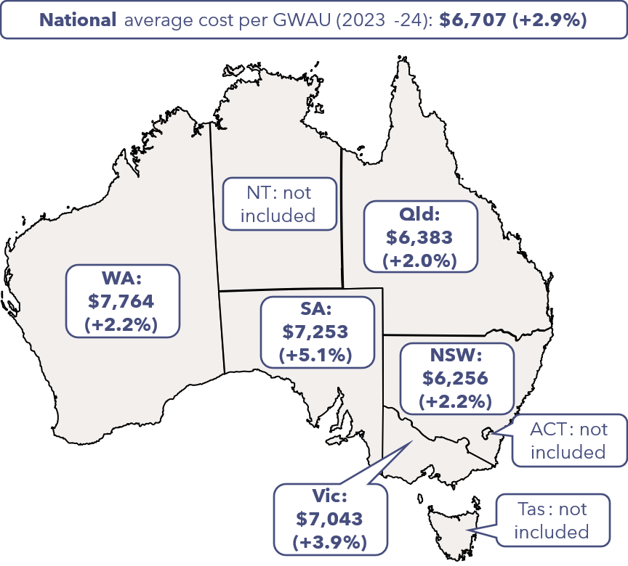

Table 1: Growth in episodes, GWAU and cost for 2023-23 and 2023-24 – all participating jurisdictions
 | 2022-23 | 2023-24 | Growth (%)
Episodes6F (m) | 39.09m | 42.54m | +8.8%
GWAU (m) | 9.60m | 10.15m | +5.8%
Cost ($bn) | $62.56bn | $68.07bn | +8.8%
Average cost per GWAU ($) | $6,518 | $6,707 | +2.9%

Results by NHCDC activity stream
The following section presents the changes in episodes, GWAU, total cost and average cost per GWAU across the different NHCDC activity streams, summarised in Table 2.
Table 2: Growth in episodes, GWAU and cost for 2023-23 and 2023-24 by stream – all participating jurisdictions
 | 2022-23 | 2023-24 | Growth (%)
Admitted acute
Episodes (m) | 6.10m | 6.41m | +5.1%
GWAU (m) | 5.90m | 6.20m | +5.1%
Cost ($bn) | $38.17bn | $40.98bn | +7.4%
Average cost per GWAU ($) | $6,469 | $6,610 | +2.2%
Subacute
Episodes7F (m) | 0.23m | 0.24m | +5.0%
GWAU (m) | 0.66m | 0.70m | +6.5%
Cost ($bn) | $4.13bn | $4.58bn | +10.8%
Average cost per GWAU ($) | $6,298 | $6,551 | +4.0%
Non-admitted
Service events (m) | 24.79m | 27.75m | +11.9%
GWAU (m) | 1.43m | 1.60m | +12.1%
Cost ($bn) | $10.12bn | $11.41bn | +12.7%
Average cost per GWAU ($) | $7,100 | $7,139 | +0.6%
Emergency department (ED)
Presentations (m) | 7.89m | 8.04m | +1.9%
GWAU (m) | 1.21m | 1.25m | +3.0%
Cost ($bn) | $7.75bn | $8.45bn | +9.1%
Average cost per GWAU ($) | $6,408 | $6,790 | +6.0%
Admitted mental health
Phases (m) | 0.09m | 0.10m | +11.2%
GWAU (m) | 0.41m | 0.41m | +0.5%
Cost ($bn) | $2.39bn | $2.66bn | +11.4%
Average cost per GWAU ($) | $5,858 | $6,492 | +10.8%
Key observations on the submitted activity and costs for 2023-24 at a stream level include:
- Admitted acute contributed 60.2% to total costs in 2023-24 (15.1% of total episodes) and it had the lowest increase in total cost (+7.4%) compared to other streams. The increase in total costs was primarily driven by an increase in activity volumes, with the average cost per GWAU increasing by 2.2%.
- Non-admitted contributed 16.8% to total costs in 2023-24 (65.2% of total episodes) and it had the highest increase in total costs compared to 2022-23 (+12.7%). The cost growth in non-admitted was mainly driven by an increase in total GWAU (+12.1%). Prior to 2023-24, some Local Hospital Networks provided non-admitted data in an aggregated form. These service events would not have been captured in the 2022-23 service event level data, and their inclusion in the 2023-24 submission increased service event growth (subsequently the GWAU growth) for this stream. Average cost per GWAU increased slightly by +0.6%, the lowest across the activity streams examined.
- ED contributed 12.4% to total costs in 2023-24 (18.9% of total episodes). Although the increase in the total costs of 9.1% was the second lowest across the streams, this far exceeded the growth in GWAU volumes, resulting in a relatively large increase in average cost per GWAU of 6.0%, being the second highest increase behind admitted mental health.
- The volume of submitted phases for admitted mental health increased significantly by 11.2% between 2022-23 and 2023-24, with several jurisdictions reported efforts to improve phase level data reporting in 2023-24. Correspondingly, total costs submitted for admitted mental health also increase by 11.4%. However, despite the increase in activity, the corresponding GWAU volumes only increased by 0.5%, which may have been impacted by a change in the casemix and reporting quality of admitted mental health phase data. As a result, there was a significant increase in the average cost per GWAU of 10.8%.

Results by NHCDC Cost Bucket
Direct costs and overhead costs contribute approximately 75% and 25% respectively towards the average cost per GWAU. As previously shown, the increase in average cost per GWAU was 2.9% in total, though this was higher when considering the increase in overhead costs (+4.6%) compared to direct costs (+2.4%).
Table 3 breaks down the changes in average cost per GWAU at an NHCDC Cost Bucket level to understand potential drivers in the cost increases for 2023-24.
Table 3: Average cost per GWAU in 2023-24 and growth from 2022-23 to 2023-24 by cost bucket – all participating jurisdictions
Cost Bucket | Average cost per GWAU (2023-24) |  |  | Growth (%)
Cost Bucket | Direct | Overhead | Total | Direct | Overhead | Total
Allied Health | $256 | $70 | $326 | +5.4% | +3.6% | +5.0%
Critical | $254 | $66 | $321 | -0.5% | +6.7% | +0.9%
Medical | $930 | $36 | $966 | +2.3% | -12.5% | +1.6%
Non-Clinical | $175 | $314 | $489 | -1.0% | +0.5% | -0.1%
Nursing | $1,182 | $94 | $1,276 | +0.4% | -2.1% | +0.2%
Oncosts | $472 | $178 | $649 | +13.6% | +24.5% | +16.4%
All other | $1,856 | $824 | $2,680 | +1.5% | +4.3% | +2.3%
Total8F | $5,126 | $1,581 | $6,707 | +2.4% | +4.6% | +2.9%

- Nursing was the largest cost bucket, contributing approximately 19% to 2023-24 average cost per GWAU. The cost increased by a relatively small growth rate of 0.2%, driven by a 0.4% increase in direct costs. The increase in the average nursing cost per GWAU varied by NHCDC activity stream, with larger increases in both ED (+4.0%) and non-admitted (+2.6%), offset by a reduction in admitted acute (-1.7%).
- Medical was the second largest cost bucket, contributing approximately 14% to 2023-24 average cost per GWAU. The cost increased by 1.6%, driven by a 2.3% increase in direct costs, offset by a reduction in the average overhead cost per GWAU of 12.5%. Similar to nursing, there was variation in the average medical cost per GWAU by NHCDC activity stream, with increases in ED (+6.7%), and offset by a reduction in admitted acute (-0.3%), and non-admitted (-2.2%).
- Oncost was the third largest cost bucket, contributing approximately 10% to 2023-24 average cost per GWAU. The cost increased significantly by 16.4%, driven by both an increase in direct costs (13.6%) and overhead costs (24.5%). Increases in the average Oncost per GWAU were observed across all activity streams.
Through the IFR consultations, it was observed that there was variation in what costs were included in the Oncost category. As a result, changes in reporting by jurisdictions will have impacted this growth rate. Further discussion on this finding is presented in Section 4.4.

Key findings & recommendations

Overall robustness of the National Hospital Cost Data Collection (NHCDC) 2023-24
Finding 1.1: NHCDC is suitable for the purpose of developing the national efficient price (NEP)
One of the key objectives of the Independent Financial Review (IFR) is to assess the robustness of the NHCDC and its suitability to inform the NEP. The development of the NEP utilises submitted activity and cost data across all NHCDC activity streams.
The admitted acute stream is the most mature stream and accounts for the largest proportion of submitted costs. In the context of the NEP development, it is also the most important stream as it is used for the development of the Reference Cost (the average cost per weighted activity unit underpinning the NEP), against which all other streams are compared to for developing price weights.
Other streams such as non-admitted and mental health (especially community mental health) are still maturing and jurisdictions continue to make refinements to data collection and costing processes.
It is also important to note that only 5 jurisdictions participated in a full IFR process this year, nominating one to 3 hospitals across one to 2 Local Health Networks (LHNs). From the review of the participating jurisdictions, the IFR did identify some reporting inconsistencies and some opportunities for improvement in cost allocation processes.
When considering the quantum of NHCDC submitted costs ($70.67 billion in 2022-239F), none of the findings from the IFR were considered material enough to impact on the suitability of the NHCDC 2023-24 to be used for the development of the NEP. Some of the findings and considerations include:
- Some critical care costs or Intensive Care Unit (ICU) hours that were erroneously reported in the wrong NHCDC Cost Centre. This did not impact the episode cost, but the NHCDC Cost Centre Group that these costs were reported in.
- Some jurisdictions report agency nursing in the line item of Goods & Services or Hotel. This did not impact the episode cost but the NHCDC Cost Centre Group these costs were allocated to.
- Two LHNs in a jurisdiction who were unable to allocate high-cost drugs to patients and excluded these costs. This is not considered material, and we note that IHACPA makes an adjustment for pharmaceutical benefits scheme (PBS) costs as part of the NEP development.
- Two jurisdictions excluded costs and activity for Public-Private Partnership arrangements, consistent with the treatment in prior years. Whilst the costs and activity from these arrangements are something IHACPA should consider collecting for future submissions, they would need a significantly different casemix and cost of delivery to the rest of the NHCDC to have a material impact on the NEP determination.
As part of the review from general ledger (GL) reconciliation to submitted costs, we identified some costs that were excluded from the NHCDC submission due to the availability of data to link costs to patient records. Whilst this could not be quantified and is an area to consider in future IFRs and NHCDC submissions, it is not expected that these unlinked exclusions would have a material impact on the submitted costs. This conclusion considers:
- The quality assurance checks performed at both the LHN and jurisdiction level before submitting costs.
- The reconciliations performed by the LHN and jurisdictions between the GL and submitted costs, identifying excluded costs and reconciling these to prior years and other LHNs within that jurisdiction.
- The process of obtaining sign-off from LHN chief executives on the costed outputs where jurisdictions have this process in place.
- The provision of the Data Quality Statements (DQS) from jurisdictions confirming the accuracy of their submissions.

Critical Care Focused Review
Critical care was selected as the focus area for this year’s IFR. The purpose of this review was to identify variation in the costs that were included in the Critical NHCDC Cost Centre Group, understand the allocation methods being used to understand the steps that can be taken to drive consistency in costing practices and maximise utility of the data. The selection of critical care aligns to IHACPA’s ongoing work on the ICU pricing adjustment.
IHACPA provides definitions in its Data Request Specifications (DRS) for the reporting of critical care costs and activity. These include:
- The NHCDC Public Sector DRS Cost Centre Groups contain 10 codes to capture the types of critical care costs:
  - Coronary Care Units (Ccu)
  - High Dependency Units (Hdicu)
  - Adult Intensive Care Units (Aicu)
  - Cardiothoracic Intensive Care Units (Cticu)
  - General Critical Care Units (Gencritcare)
  - Neonatal Intensive Care Units (Nicu)
  - Other Critical Care Units (OtherCritCare)
  - Paediatric Intensive Care Units (Paedicu)
  - Psychiatric Intensive Care Units (Psychicu)
  - Special Care Nursery Units (Scnicu)

- The Activity Based Funding (ABF) Admitted Patient Care DRS contains 2 data items for ICU hours. These are:
  - ‘Length of stay in ICU’ defined as the number of hours reported by a hospital with approved Adult ICU Level 3 or Paediatric ICU, and
  - ‘Length of stay in ICU – Other’ defined as hours reported by hospitals with approved ICUs other than Level 3 or Paediatric ICU.
Nationally, across the jurisdictions fully participating in the IFR, submitted costs in the Critical NHCDC Cost Centre Group totalled $3.26 billion, representing 4.7% of NHCDC 2023-24 costs. Costs in Critical increased by 7% from the prior year.
The focused review involved consultation with operational, finance, and costing stakeholders across 9 hospitals delivering various critical care services. The scope of the review included areas of the hospital that provide higher acuity ward-based care and is described in one of the 10 cost centres in the Critical NHCDC Cost Centre Group (listed above).
A summary of the sites and their respective reported critical care costs included in the scope of this review (as reported in the NHCDC 2023-24) is shown below.
Figure 3: Critical services at participating sites
Of the 9 sites participating in the Critical Care Focused Review, $7.91 million of costs were reported within the Critical NHCDC Cost Centre Group. Six of IHACPA’s 10 Critical NHCDC Cost Centres were used materially. No costs were reported under Othercritcare, Cticu and Hdicu. (Psychicu was only used by one site, Flinders Medical Centre, and comprised only 0.04% of their submitted Critical costs).
Our findings from conducting the focused review are set out below.
Finding 2.1: Variation in cost reporting with the Critical NHCDC Cost Centre Group
There is variation across jurisdictions in how costs are reported within the 10 Critical NHCDC Centre Groups. Analysis of NHCDC data shows that 6 of IHACPA’s 10 designated Critical Cost Centres (OtherCritCare, Gencritcare, Hdicu, Cticu, Psychicu, and Scnicu) are not widely utilised.
From our discussions with participating sites, we heard that ICU units are often structured to support patient needs at both an ICU level and an intermediate level of care between ICU and general, medical or surgical wards, with the latter described as High Dependency / Step Down care. These different levels attract different nurse to patient ratios, and as a result may have a different consumption of costs. While a high proportion of the patients admitted into ICUs required ICU level of care, most jurisdictions report all ICU costs under Aicu due to challenges in distinguishing between ICU and High Dependency (HDU) / Step Down care. However, New South Wales (NSW) has implemented detailed mapping of local bed types to NHCDC Cost Centres and reports HDU / Step Down care under Gencritcare.
For the 2023-24 year for Level 3 ICU facilities in NSW, utilising this approach NSW reported 83.5% of their critical care costs as Aicu and 16.5% as Gencritcare.
The focused review also identified several inconsistencies in ICU cost reporting in the 2023-24 year, including:
- A NSW site mapping NICU costs to Scnicu in error.
- A Western Australian site mapping Paedicu costs to the Hdicu NHCDC Cost Centre.
- A Queensland site that mapped nursing costs to Gencritcare and other ward-based costs to Aicu.
While these issues did not materially affect total costs reported under the Critical NHCDC Cost Centre Group, they did impact the granularity and comparability of data at the individual NHCDC Cost Centre level. In addition, they would impact the calculation of the ICU adjustment applied by IHACPA in the NEP calculation, which uses the Aicu costs and Length of stay in ICU hours (see Finding 2.2).
The table below sets out the proportion of costs with the Critical NHCDC Cost Centre Group at the cost centre level, for each of the participating sites.
Figure 4: Critical Costs by Cost Centre across participating sites – all participating jurisdictions
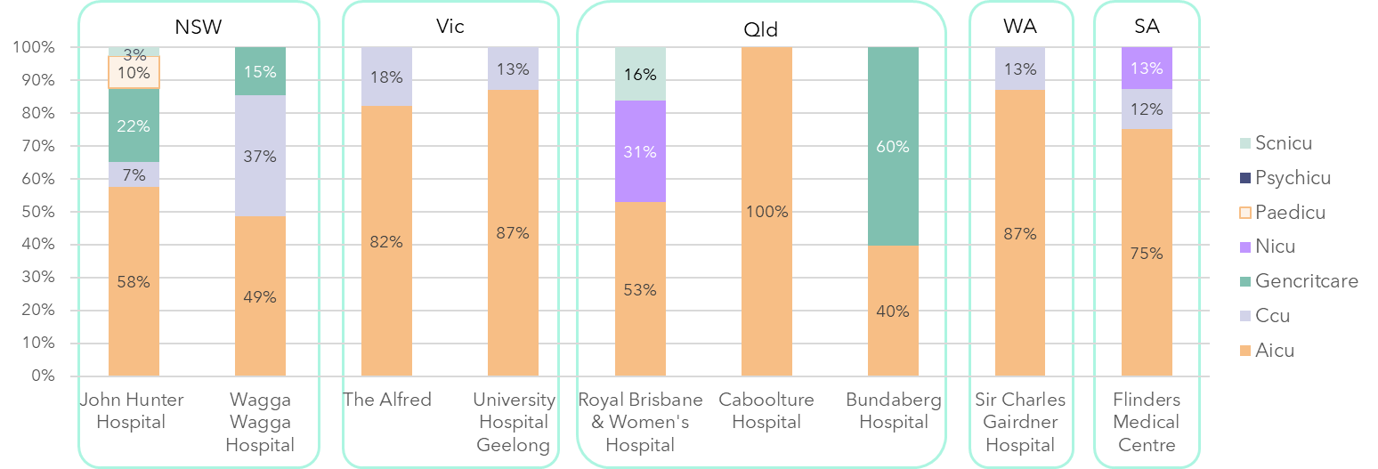
SA

Finding 2.2: Variation in ICU hours reported in the ICU activity dataset and inconsistency between treatment of critical care costs and hours
There is significant variation across jurisdictions in both which hours are reported and which category the ICU hours are reported under between the 2 ICU activity fields, ‘Length of stay in ICU’ (referred to hereafter as Level 3 ICU Hours) and ‘Length of stay in ICU – Other’ (Other ICU Hours).
The table below sets out the current treatment in each jurisdiction and demonstrates the inconsistent approach to capturing and reporting ICU hours.
Table 4: Comparison of reporting approaches for ICU Hours across all participating jurisdictions
Jurisdiction | Level 3 ICU hours are reported for: |  | Other ICU hours are reported for:
Jurisdiction | Hours | Facilities | Hours | Facilities
NSW | Adult ICU (AICU) and Paediatric ICU (PICU) hours for all patients in a bed type 91 (ICU level of care need). | All facilities regardless of designation | AICU and PICU hours for all patients in a bed type 92 (HDU/Step down) | All facilities regardless of designation
Victoria | AICU hours,  PICU hours,  Gencritcare hours,  NICU hours,  CCU hours. | Level 3 ICU facilities only | AICU hours,  PICU hours,  Gencritcare hours,  NICU hours,  CCU hours. | Non-level 3 ICU facilities
Queensland | AICU hours,  PICU hours,  Gencritcare hours,  NICU hours,  Special Care Nursery (SCN) hours,  CCU hours,  Othercritcare hours. | All facilities regardless of designation | None | None
South Australia | AICU hours,  PICU hours. | Level 3 ICU facilities only | None | None
Western Australia | AICU hours,  PICU hours. | Level 3 ICU facilities only | None | None

In summary, only NSW and Victoria (Vic) are using the Other ICU Hours field to capture ICU activity. Within the Level 3 ICU Hours field, the type of hours reported and inclusion of facilities differ significantly.
Figure 5: Proportion of ICU hours by Level 3 and Other ICU hours by participating site
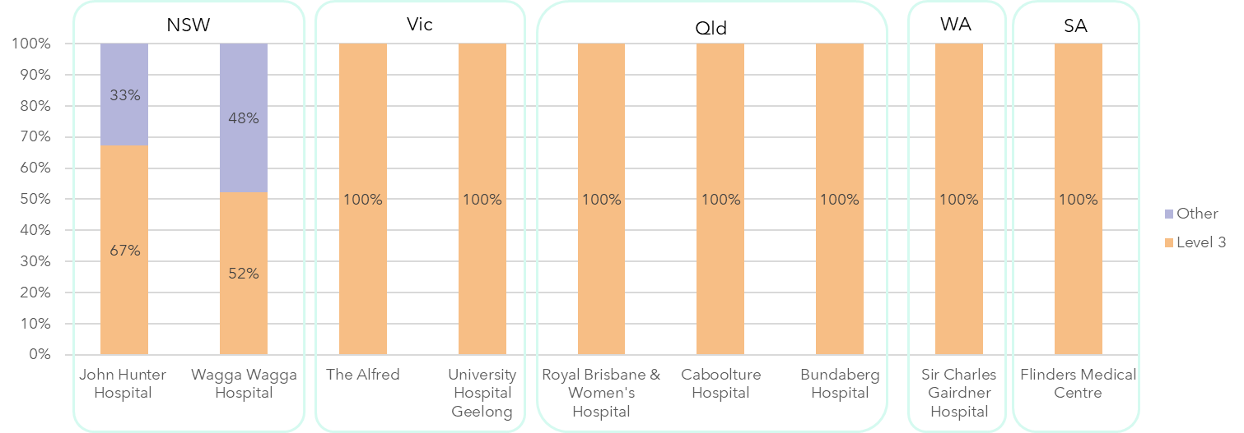

Note that while Victoria utilises the Other ICU Hours category, both of the sites participating in the IFR are Level 3 ICU designated facilities.
The review also identified the inconsistency between the reporting of critical care costs and hours, with some jurisdictions reporting critical care costs in the Critical NHCDC Cost Centre Group but no ICU hours, or reporting the relevant ICU hours in a different activity field to what IHACPA has specified in their DRS. This would make it difficult to accurately compare average ICU costs per hour across jurisdictions, and impact on the IHACPA’s ability to utilise the hours in their ICU adjustment in the NEP calculation.
Finding 2.3: Consistency of costing within CCUs
CCUs are often combined with broader cardiology / cardiothoracic services. Operationally, resources are frequently shared across these areas (e.g., shared rosters, ward areas, cardiac monitoring equipment, pharmacy storerooms) and GL costs sit within the same cost centre(s). As a result, it is challenging to accurately identify the CCU portion of these costs.
In terms of costing practices, there is inconsistency in how CCU-related costs are reported. Some sites estimated and fractioned a portion of the nursing / ward expenses and report this within the Critical NHCDC Cost Centre Group, and others report all CCU-related costs under the Clinical Cost Centre Group.
All sites reviewed included CCU medical costs in a separate cardiology clinicians GL cost centre, and in the costing process, these costs were allocated to Clinical NHCDC Cost Centre Group and Medical Salary & Wages (S&W) line item.
Jurisdictions were unclear on the appropriate treatment of the CCU portion of costs. While Ccu is listed as a cost centre within the Critical NHCDC Cost Centre Group, there is no clear guidance on whether it should be reported under Critical or Clinical. This ambiguity is further complicated by the exclusion of CCU hours from Level 3 ICU Hours reporting definitions, creating inconsistency between activity and cost reporting.
Finding 2.4: Pathology, imaging, allied health and majority of pharmacy costs consumed in critical care departments are not reported in Critical NHCDC Cost Centre Group
Pathology, imaging, allied health and pharmacy costs (dispensed) consumed in critical care departments were not reported in the Critical NHCDC Cost Centre Group in any of the sites participating in the focused review. Typically, only staffing costs (nursing, medical and other), some consumables, imprest drugs, and some overhead allocations are captured in this area.
The AHPCS v4.2 allows for judgement by costing practitioners on how costs are assigned to NHCDC Cost Centres and line items, stating that “the final NCHDC Cost Centre will build on the organisations existing cost centre and management reporting structure… Where possible, costs will also share a physical location, space or service area within an organisation.” However there is no definitive guidance on how NHCDC Cost Centres and line items are reported and rolled up within IHACPA’s Cost Bucket Matrix. As a result, the visual representation of the matrix does not clearly define which costs should ultimately be included within the Critical bucket.
In calculating the appropriate ICU NEP adjustment, IHACPA advised that it would be helpful to have visibility of all costs consumed within critical care setting, but it currently calculates the loading without this information. Some jurisdictions also noted that under their local funding models, visibility of the true total costs of a critical care bed (including pathology, pharmacy, allied health, and imaging elements) could be useful for accurate funding and resource planning.
While the Critical NHCDC Cost Centre Group is not currently used for benchmarking purposes, the existing approach does result in a consistent treatment of costs across jurisdictions. We also acknowledge the significant effort required to change costing and reporting processes.
Finding 2.5: Most critical care costs are applied using uniform cost allocation methods, based on ICU hours
Through the review process, we identified that approximately 80% of costs reported under the Critical NHCDC Cost Centre Group are attributed to S&W line items, with the largest portion being Nursing S&W, followed by Medical S&W, and then Other S&W. The remaining 20% of costs typically consist of medical supplies, maintenance, imprest pharmacy, medical gases, and hotel services such as food, linen, and cleaning.
Across jurisdictions, staffing nurse-to-patient ratios in critical care units were found to be generally prescriptive and consistent:
- ICU: 1:1 (2:1 for patients on extracorporeal membrane oxygenation (ECMO))
- PICU: 1:1
- Step-down care: 1:2
- CCU: typically 1:3
- NICU: 1:1
Some sites have feeder systems to allocate these costs more precisely to cohorts of ICU patients. The ability to do this depended in part on the availability of feeder system data that captured the patient’s care needs or bed type within the patient record. Jurisdictional differences in cost allocation methodologies were observed:
- NSW uses the bed type assigned to the patient, this determines the nursing ratio (e.g., 1:1 or 1:2).
- Queensland employs a nursing acuity system, capturing the actual nurses rostered to the ward on the day of patient admission.
- Other sites and jurisdictions applied uniform cost allocation for nursing costs (driven by ICU hours) across all patients with no differentiation for patient acuity.
Outside of nursing costs, we heard that high-cost drivers in critical care included ECMO, specialist burns care, and additional organ support, requiring specific consumables and / or may utilise higher cost ward drugs (imprest). However, in most cases, these costs could not be allocated to the individual patient and were spread to all ICU patients based on ICU hours.
The costing approach of only using ICU hours to allocate most critical care costs across patients results in a uniform allocation across all patients, with limited consideration of individual care needs or resource consumption outside of the number of hours they spent in ICU. This approach limits the ability to identify variation in care delivery or drivers in resource consumption within an ICU. This is especially useful, as these are often high acuity patients who consume a high volume of resources.
Incorporating additional information in the cost allocation process depends on the availability of additional feeder system data and should be considered with consideration to the effort involved in changing feeder system inputs and costing processes.
Finding 2.6: ICU teams perform activities which do not relate to direct ICU care which are typically not reallocated for costing purposes and may inflate costs within the Critical NHCDC Cost Centre Group
Critical care teams at participating sites were found to undertake a range of activities beyond direct ICU patient care, including Medical Emergency Team (MET) calls, anaesthetic cover for theatres, outpatient clinics, retrieval services, and participation in clinical committees.
Some sites have developed methodologies in consultation with critical care teams to estimate and fraction out these costs to appropriate cost centres. Where estimates were available, sites reported that 10–20% of medical and nursing resources were spent on activities outside of direct critical care.
Sites that successfully fractioned these costs typically had feeder data systems to support allocation to alternative areas (e.g., MET activity feeders). In contrast, other sites lacked the necessary data infrastructure and were either unable to fraction costs or planned to review this area in future costing cycles. In these cases, these costs remained within the Critical NHCDC Cost Centre Group.
This practice may result in inflated Medical and Nursing S&W allocations at the patient level for the ICU patient, reducing the accuracy of patient-level costing and potentially distorting comparisons across sites. This issue may also have implications for the pricing of the ICU NEP adjustment.
Finding 2.7: Local admission rules within hospitals drives differences in costing outputs between sites
Participating sites operate under 2 distinct models of care for ICU admissions:
- Patients were admitted under the care of an intensivist (within the ICU), and
- Patients were admitted under a specialty admitting clinician, with intensivist support.
The latter model results in the allocation of both intensivist and specialty clinician costs to the episode, that may contribute to higher cost allocations in the Medical S&W line item, with the intensivist portion sitting in the Critical NHCDC Cost Centre Group and the other medical staff costs sitting in the Clinical NHCDC Cost Centre group, relating to the duration of a patient’s critical care stay.

In some cases, this variation was observed across sites rather than jurisdictions, indicating that the model of care is determined at the local facility level. While this difference may influence costing outputs, no changes to costing processes are recommended at this time. The finding is presented to highlight that admission rules may drive variation in cost allocation and should be considered when interpreting cost data across sites.

Scope of exclusions from NHCDC 2023-24
Finding 3.1: Understanding the quantum of linking-related exclusions could be helpful to IHACPA for future consideration for pricing
We observed that in preparing the NHCDC submissions, costs were excluded from the LHN GL primarily for 2 reasons:
- Out-of-scope exclusions - removal of programs/costs that are outside of NHCDC submission scope e.g. population health programs performed by health services. These costs are appropriately excluded from submitted costs.
- In-scope linking exclusions - removal of in-scope costs relating to records unable to be linked to in-scope activity. These would only relate to costs incurred for services under the scope of the National Health Reform Agreement (NHRA).
The reason for in-scope linking exclusions could typically involve unavailability of data to link the cost to an episode. An example of this is where a diagnostic test or drug was provided to a patient after they were discharged, and so the date of the incurred cost could not be linked to that episode.
Jurisdictions had differing practices between LHNs and between types of costs with how they treated these in-scope linking exclusions. In some circumstances, the costs were excluded from the submitted records and in other circumstances, the costs were allocated evenly across all other patients (thereby not being an unlinked exclusion.)
From the sites identified, between 58% and 90% of costs included in the LHN’s GL were submitted to the NHCDC 2023-24. However, there was variation in the level of granularity and structure of jurisdictions’ reconciliations, and we were not always able to differentiate the proportion of exclusions that related to out-of-scope services versus inability to link costs to records.
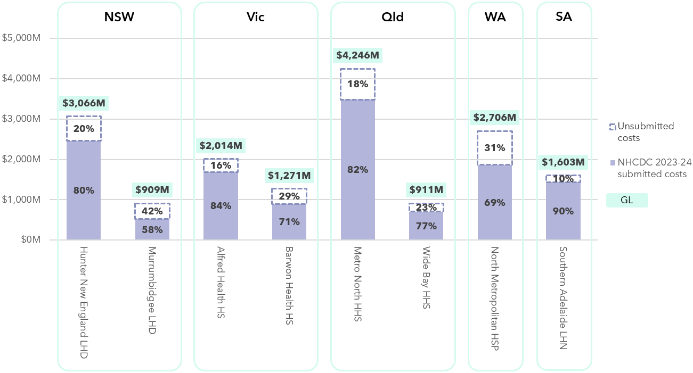
Figure 5: Percentage of GL costs submitted to NHCDC 2023-24 for participating LHNs10F
Understanding the quantum of in-scope linking exclusions is useful, as their removal could artificially reduce the NHCDC costs being used for pricing and benchmarking purposes. This information could be helpful to IHACPA for future consideration for pricing.

Costing process
As part of the site meetings, participating LHNs provided information on their costing processes, compliance with AHPCS v4.2, costing team structures, costing systems, feeder system inputs and quality assurance (QA) processes. A summary of the costing process for each jurisdiction has been included in the relevant jurisdiction chapter. As part of this discussion, a number of specific findings were identified for the NHCDC 2023-24 submissions.
Finding 4.1: Some Public-private Partnership (PPP) costs are excluded from costing submissions
Two jurisdictions did not include the costs or contracted activity relating to PPPs from their NHCDC submissions. Reasons for exclusions varied by jurisdiction, due to either commercial-in-confidence reasons, or lack of availability of patient level information to support costing. Costs and activity from other contracted care arrangements were included in the NHCDC submissions for these 2 jurisdictions, as well as the remaining participants. In the case of contracted care arrangements, the costs charged to the LHN are recorded as Goods & Services
Finding 4.2: Jurisdictions identified patient level records with negative costs during the submissions process
During the NHCDC 2023-24 review, many jurisdictions identified patient level records with negative costs during the submissions process. IHACPA’s submissions portal returns a critical error if the total cost at the episode level is negative. This has led to inconsistencies in how jurisdictions manage these records:
- Some jurisdictions adjusted the records to remove or correct the negative line items.
- Others excluded the affected records entirely from submission.

During the QA process further instances were identified by IHACPA where records with a negative line item were submitted. Where these instances were identified, jurisdictions investigated the root cause of the negative costs. It is possible that further records with negative costs were not picked up through the process.
The AHPCS v4.2 Business Rule 6.0A indicates that negative costs are seen as an error in the costing process. While there may be legitimate reasons for negative values to arise in the GL as inputs into the costing process, practitioners should try to identify and address negative components in costing ledgers as it is generally accepted that there cannot be negative costs in the cost of production. The AHPCS provide guidance to costing practitioners to address negative costs through cost allocation processes wherever possible.
Negative cost issues at the line item level, were identified across 3 jurisdictions at a total cost of $28.47 million. While this amount is negligible in aggregate, representing 0.04% of submitted costs, it has the potential to distort patient-level costing and impact comparability across sites.
This variation in handling may impact data completeness, comparability, and transparency across jurisdictions, and highlights the need for clear guidance or system enhancements to support consistent treatment of negative cost records in future submissions.

Finding 4.3: There is variation in the costs included in the Oncost line item
The current AHPCS v4.2 does not explicitly define which costs should be mapped to the Oncost category. While IHACPA has advised jurisdictions that Oncost is defined as long service leave, superannuation, payroll tax, fringe benefits tax, workers compensation payments (excluding premiums classified as Goods & Services), and redundancy payments, its preference is for these costs to be allocated to the relevant S&W line item wherever feasible.
In 2023–24, Oncost has emerged as a high-growth line item, increasing by 23.8% nationally from the prior year. Its proportion relative to total submitted costs varies significantly across jurisdictions, ranging from 7.1% (Queensland) to 14.4% (Vic), and averages 9.7% across the 5 fully participating jurisdictions. This variability highlights the need for clearer guidance and consistent application, particularly to support accurate workforce cost comparisons.

Future IFRs
The costing landscape across Australia has undergone significant change since the last time the IFR was delivered in its full format in 2021-22, including the introduction of new classifications such as community mental health, disruptions to frontline hospital services due to COVID-19, shifts in the costing workforce, and the rollout of new costing and activity systems across multiple jurisdictions.
Participants consistently highlighted the value of the IFR, particularly the benefits of peer collaboration, remaining a key strength of the process, and the insights from the focused review area. There was also recognition of opportunities to optimise the timing of the NHCDC, and several areas have been identified for improvement in future rounds to further enhance the process and outcomes.
Jurisdictions reported significant value and insight from the focused review into critical care, and therefore it is recommended that future focused reviews into costing methodologies are conducted in following IFRs to continue to evolve costing practices. Potential topics for consideration that were proposed by participants include: community mental health costing, virtual care, Teaching, Training and Research (TTR), contracted care, corporate costs and direct versus overhead costs.

Comparability between jurisdictions
Different interpretations of costing guidance and local operational decision-making can affect comparability of cost outputs across jurisdictions. Some of the differences identified through the course of the IFR are shown below:
Table 6: Factors impacting comparability of NHCDC 2023-24 outputs across jurisdictions
Jurisdiction | Factors impacting comparability of costing outputs across jurisdictions.
NSW | - Two NSW Local Health District (LHDs) – Southern LHD and Murrumbidgee LHD, do not have patient level feeder systems for pharmacy and exclude these costs from submission as they are unable to link to patient level activity.  - NSW reports community mental health under a separate LHD identified and transfers these costs from all other LHDs for reporting purposes.  - NSW refined local Oncost definitions to include long service leave, tax, and incentive payments, resulting in a shift from S&W to Oncost in 2023-24.  - NSW does not submit costs for Northen Beaches Hospital (PPP).  - NSW is one of 2 jurisdictions that are not signatories to Pharmaceutical Reform Agreement and do not have the same arrangements relating to Pharmaceutical Benefits Scheme (PBS) subsidised drugs.
Victoria | - Depreciation costs are excluded from Vic’s submission.  - TTR are excluded from patient level cost allocations unless directly relating to patient care. An example of TTR costs included is training expenses for the rollout of the Electronic Medical Record (eMR).  - Posthumous organ donation expenses are excluded.  - Special purpose trust fund expenses are excluded.
Queensland | - Queensland includes redundancy, Workcover, superannuation in the Oncost line item. Leave is recorded in the respective S&W line items.  - Queensland excludes TTR costs from their NHCDC submission.  - The payroll and account payable functions are provided to HSSs under a shared service arrangement with the cost of these services reported under the ‘exclude’ line item, hence not included in the costed output.
Western Australia | - Western Australia (WA) excludes blood products.  - WA excludes costs relating to PPP at Joondalup, Midland, and Peel hospitals.  - WA records Assistant in Nursing (AIN) agency costs under the Hotel line item.  - WA reports mental health at the episode level.  - WA does not submit Royal Flying Doctor retrieval costs to the NHCDC.
South Australia | - South Australia (SA) includes Nursing agency costs under Goods & Services.  - SA’s critical care units participating in the focused review, Flinders Medical Centre, has contracted care arrangements for ICU beds. The costs for these are arrangements are costed to the Goods & Services line item. This may impact the make-up of costs within the Critical NHCDC Cost Centre Group.
Australian Capital Territory | - Australian Capital Territory (ACT) is one of 2 jurisdictions that are not signatories to Pharmaceutical Reform Agreement and do not have the same arrangements relating to PBS subsidised drugs.

Recommendations
In light of the findings in this report, the following recommendations are provided to support improvements in NHCDC outputs and consistency across jurisdictions. We acknowledge that other work is currently underway to review cost allocation methodologies, and it is important that these recommendations are considered in alignment with broader work before progressing to implementation.
Recommendation 1: IHACPA should provide clear definitions and guidance on the cost centres within the Critical NHCDC Cost Centre Group and the ICU hours within the activity reporting.
Links to Findings:
- Finding 2.1: Variation in cost reporting with the Critical NHCDC Cost Centre Group
- Finding 2.2: Variation in ICU hours reported in the ICU activity dataset and inconsistency between treatment of critical care costs and hours
- Finding 2.3: Consistency of costing within CCUs
Owner: IHACPA
This will support more accurate and consistent reporting across jurisdictions and improve the utility of the data for benchmarking and funding purposes.
IHACPA is currently undertaking work which is expected to result in findings and recommendations regarding cost allocation and reporting within the Cost Bucket Matrix. This IFR has provided a deeper analysis into the Critical NHCDC Cost Centre Group specifically. The recommendations from broader work programs will need to be considered in conjunction with the findings from this report to assess whether the current cost centre structure is fit-for-purpose and to determine the critical care costs that should be reported.
It is noted that NSW has undertaken detailed mapping to all 10 Critical NHCDC Cost Centres and considers the current structure appropriate, provided there are clear definitions of the types of costs to be included.
Additional consideration should be given to whether ICU hours should be split based on the type of ICU care delivered instead of the facility designation as a Level 3 ICU provider, as this information is already available to IHACPA through other datasets. Grouping by ICU type (e.g., Adult ICU and Paediatric ICU, with other types mapped separately) would allow IHACPA to align costs with reported hours. However, activity datasets are used for other purposes and rely on the existing Metadata Online Registry (METEOR) definitions so cannot easily be changed without extensive consultation. It is understood that IHACPA is currently undertaking work on the definitions of ICU hours. It is recommended that any proposed changes take into account both the cost and activity components, as well as all intended uses of the data
Recommendation 2: IHACPA should provide clarity on the Cost Bucket Matrix in relation to imaging, pharmacy, pathology and allied health in the critical care setting, in consultation with jurisdictions and in alignment with other ongoing work in this area.
Link to Finding: Finding 2.4: Pathology, imaging, allied health and majority of pharmacy costs consumed in critical care departments are not reported in Critical NHCDC Cost Centre Group
Owner: IHACPA
A change to the mapping of these costs should consider the utility of the Critical NHCDC Cost Centre Groups in benchmarking, NEP development and the ICU adjustment.
We understand that for benchmarking and the NEP development, only the total episode cost is considered, not the breakdown by NHCDC Cost Centre Group however the review and calculation of the ICU adjustment does consider the costs included in the Critical NHCDC Cost Centre Group.
Securing commitment to this change may be challenging given jurisdictions’ competing priorities, particularly as the current practice does deliver consistent outputs across jurisdictions. If IHACPA determines that it is important for accurately capturing critical care costs for the ICU adjustment review, they could consider conducting a separate costing study to capture data on pharmacy, allied health, imaging and pathology costs within the critical care setting.
Recommendation 3: Costing teams should review the materiality and accuracy of key cost drivers within critical care specifically nursing relative value units (RVUs), medical RVUs and consumable allocation methods.
Links to Findings:
- Finding 2.5: Most critical care costs are applied using uniform cost allocation methods, based on ICU hours
- Finding 2.6: ICU teams perform activities which do not relate to direct ICU care which are typically not reallocated for costing purposes and may inflate costs within the Critical NHCDC Cost Centre Group
Owner: Jurisdictions and LHN costing teams
Where feasible, jurisdictions should refine allocation methodologies to better reflect actual resource consumption at the individual patient level.
Critical care patients are among the highest-cost cohorts in the hospital, and the current costing approaches and available data often lacks the granularity needed to accurately capture patient-level variation. While availability of feeder data to allocate these costs will inform the ability to do this, we have identified some data items that are already captured and could be used. Examples of this include the level of care needs, bed type, use of ECMO, and ventilation support which are documented on systems and could be utilised in costing with potential to inform a more nuanced and accurate cost attribution. We observed that a small number of jurisdictions and sites are already leveraging these feeder data sources to inform their costing processes.
While we acknowledge that introducing new feeder systems or refining costing processes requires additional effort, jurisdictions should weigh the benefits of improved data accuracy and decision-making against the resource investment required. Enhanced costing granularity would support better benchmarking and service planning for high-acuity care.
Recommendation 4: IHACPA should provide clear and consistent guidance on the treatment of unlinked costs in NHCDC submissions, including whether such costs should be proportionally allocated across all patient episodes.
Link to Finding: Finding 3.1: Understanding the quantum of linking-related exclusions could be helpful to IHACPA for future consideration for pricing
Owner: IHACPA
To better understand the scale and nature of unlinked costs, IHACPA should request jurisdictions to report this information in future NHCDC rounds, ideally through the DQS. This reporting should differentiate between:
- Unlinked costs that were subsequently allocated, and
- Unlinked costs that remained unallocated.
The overarching principle should be to ensure accuracy at the patient level, while also maintaining visibility of total costs for funding purposes. This dual focus will support both robust patient-level costing and transparent system-level financial oversight.
Recommendation 5: IHACPA should consider whether additional information is required from jurisdictions to support the development of the NEP where significant hospital costs associated with PPPs are not currently submitted.
Link to Finding: Finding 4.1: Some Public-private Partnership (PPP) costs are excluded from costing submissions
Owner: IHACPA
Given the commercial-in-confidence nature of PPP arrangements, IHACPA should:
- Consult with jurisdictions on the feasibility of sharing further information, considering data sensitivity and contractual limitations.
- Assess the materiality of PPP costs to determine whether enhanced data collection would improve pricing accuracy.
- Consider whether any additional information received should be published through the NHCDC or remain confidential.
Recommendation 6: IHACPA should consider implementing a warning flag in the NHCDC submission process to detect negative line items, even when the total episode cost remains positive.
Link to Finding: Finding 4.2: Jurisdictions identified patient level records with negative costs during the submissions process
Owner: IHACPA, Jurisdictions and LHN costing teams
This flag should include a defined materiality threshold (e.g., $1) to support early identification of potential negative cost anomalies within patient level records and promote consistency across jurisdictions.
We recognise that the root cause of these issues generally occurs in the GL prior to ingestion into the costing ledger. Jurisdictions should also consider implementing internal QA checks to identify negative line item values prior to submission, to be reviewed with finance / business partners to understand the appropriate treatment of whether any additional reclasses of costs should be made. Examples of checks that could be built in are:
- Check for negative totals following cost pool mapping to identify and investigate cost pools with negative dollars;
- Establishing this as a standard QA step to check for records with negative line items.
IHACPA should provide clearer guidance on the treatment for these records, either in the Data Request Specifications or NHCDC data portal.
Recommendation 7: IHACPA should consult with jurisdictions to provide clarity on which costs should appear in the Oncost line item versus S&W.
Link to Finding: Finding 4.3: There is variation in the costs included in the Oncost line item
Owner: IHACPA
IHACPA should consult with jurisdictions to provide clarity on which costs should appear in the Oncost line item versus S&W.
It is recognised that there may be challenges or long lead times for jurisdictions in implementing any changes given competing pressures; however, IHACPA should develop a best practice or best endeavours approach in consultation with jurisdictions, with jurisdictions reporting any areas where their implementation may vary.

Jurisdiction chapters

New South Wales

State-wide costed NHCDC 2023-24 submission
17
Health Services
$21.55bn
Total costs submitted to NHCDC
145
Facilities submitting data to the NHCDC in 2023-24
$6,256
Average cost per GWAU (excl. Community MH)
At a glance: NSW
New South Wales (NSW) submits costed activity for 15 local health districts (LHDs) and 2 Specialty Health Networks (SHNs) as part of the National Hospital Cost Data Collection (NHCDC).
Total costs submitted by NSW in 2023-24 were $21.55 billion and 15.80 million episodes.11F
The same scope of activity that was applied in the Cost Driver analysis has also been applied in this section. Costs for activity-based funded (ABF) hospitals and selected activity streams in NSW in 2023-24 were $20.58 billion. NSW is the largest contributor to the NHCDC nationally.
The total number of costed ABF hospital episodes in 2023-24 was 15.16 million, representing a growth of 11.5% since 2022-23. NSW ABF hospital episodes make up 34.9% of national ABF episodes for 2023-24.
NSW delivered 3.29 million gross weighted activity unit (GWAU) in 2023-2412F, representing 31.7% of weighted activity nationally, with a growth of 4.8% since 2022-23.
The average cost per GWAU in NSW was $6,256 in 2023-24, representing growth of 2.2% since 2022-23.
Overall, NSW has had considerable growth in episodes (11.5%), with a lower average casemix acuity per patient as reflected in the GWAU growth of 4.8%. Cost growth per GWAU is expected in the context of an inflationary environment and year-on-year enterprise bargaining agreement (EBA) wage rises for healthcare workers. NSW’s average cost per GWAU growth of 2.2% may indicate a level of cost containment in 2023-24.

Cost Driver analysis by activity stream
Analysis was undertaken on the NHCDC 2023-24 submission to understand how submitted activity and cost have changed since 2022-23 and whether any drivers of change could be identified. This analysis considered a subset of the submitted cost data, focusing on 5 key activity streams:
- Admitted acute,
- Non-admitted care,
- Subacute and non-acute care,
- Emergency Department (ED) care and,
- Mental health care (with mental health split by admitted and community).
A summary of the analysis is presented in the sections below. In this analysis, GWAU was used as a standardised activity unit, accounting for the relative complexity and resource intensity associated with treating patients. Furthermore, the results below are related to activity and cost submitted for ABF hospitals only unless stated otherwise.



Figure 6: Growth in activity, GWAU and total cost for NSW 2023-24
2023-24 costs
(and growth)
2023-24 GWAU
(and growth)
2023-24 Episodes (and growth)

Figure 7: Average cost per GWAU – NSW



0.4%
3.5%
19.3%
5.8%
1.3%
Average cost per GWAU
Average costs / GWAU
* Mental health analysis includes admitted only. Community mental health GWAU was not available as it was not priced in 2023-24.
Key findings by stream include:
Table 7: Key findings by stream in NSW
Admitted acute | - The admitted acute stream is the most resource intensive stream in a hospital. In 2023-24, admitted acute there were 1.7 million costed episodes, an increase of 3.9% from the prior year. The growth in GWAU was similar (3.6%), indicating that the average patient complexity was similar (or slightly lower) between the 2 years.  - Although admitted acute episodes made up 11.4% of total episodes for 2023-24, it accounted for over 57% of total costs with $11.8 billion submitted. This was an increase of 4.0% in total costs compared to 2022-23 and meant that the average cost to deliver services to the same casemix of patients (as measured by average cost per GWAU) was relatively stable between 2022-23 and 2023-24, only increasing by 0.4%.
Emergency Department | - The ED stream represented 18.5% of total encounters, with 2.81 million costed episodes submitted for 2023-24, an increase of 3.2% compared to 2022-23. Growth in GWAU was slightly higher at 4.3%, indicating a slightly more complex casemix of patients for the year.  - The average cost per GWAU for ED increased by 3.5%, meaning that total cost growth of 7.9% in 2023-24 was over and above the increase in activity volumes.
Non-admitted | - The non-admitted stream makes up the largest proportion of submitted episodes, with 10.5 million service events in 2023-24. This stream also had the largest growth in costed episodes, increasing 15.5% from the previous year. Over the same period, the volume of GWAU also increased significantly by 13.7%.  - The increases in non-admitted activity were observed across a range of LHDs across the state, this could be a result of improved data capture and submission at a patient level.  - Total submitted costs increased by 15.1%, meaning that when considering the growth in average cost per GWAU, this was relatively contained, increasing by 1.3% in 2023-24.  - Some of this cost change was attributed to the upgrade to Power Performance Manager 3 (PPM3) with the introduction of new functionality that resulted in Medical S&W costs being allocated to non-admitted from acute. This was only done for 3 LHDs in 2023-24, with the plan to expand this change to all LHDs in 2024-25. This is discussed in more detail in the NSW Costing Summary below.
Subacute | - The subacute stream is a relatively small stream, making up only 0.6% of episodes. Costed subacute episodes increased by 5.1% in 2023-24, with a similar increase in GWAU (4.6%) reflecting a relatively consistent level of patient complexity.  - The average cost per GWAU grew by 5.8% between years, resulting in a high growth in total cost for this stream over and above the increase in episodes, with the $1.27 billion in submitted costs representing a 10.7% increase compared to 2022-23.
Admitted mental health | - The majority of NSW’s submission for admitted mental health was for phases of care, growing by 1.0% in 2023-24. However, there was a 6.3% reduction in GWAU despite an increase in the number of phases. NSW reported that penalties are applied for poor data quality such as unknown phases of care. Improvements in local data quality and changes in phase assignment may have contributed to the difference between phase growth and GWAU growth.  - Total admitted mental health costs increased by 11.8%, meaning that the average cost to deliver admitted mental health services (average cost per GWAU) increased significantly by 19.3%, driven in part by the reduction in GWAU.
Community mental health | - Submissions for community mental health continue to mature for NSW and hence there has been volatility in submitted costs and activity for 2023-24 as data quality continues to improve.  - Community mental health activity is not restricted to ABF hospitals (unlike the rest of the Cost Driver analysis), and the number of phases submitted 2023-24 for all facilities increased by 50% compared to 2022-23. Community mental health was not ABF priced in 2023-24 and hence GWAU was not considered in this analysis.  - Submitted costs also increased significantly by 21% compared to 2022-23. Despite this, growth in costs was lower than the increase in the number of phases and hence the average cost per phase decreased by 19% compared to the prior year.

The transition to PPM3 introduced structural changes in the cost output framework, leading to shifts in cost allocations across buckets, streams, and direct/overhead splits when compared to 2022-23. These changes should be considered when conducting year-on-year analyses.

NSW Costing Summary

NSW costing process
Costing is undertaken by 18 LHDs/SHNs. The output of the costing process is referred to as the District Network Return (DNR) submission. The DNR is a requirement mandated by NSW Ministry of Health (MoH), that is prepared by all NSW LHDs and includes patient level clinical costing data based on the allocation of expense to service and activity data. The NSW MoH uses the information from the DNR to help inform their submission to the Independent Hospital and Aged Care Pricing Authority (IHACPA) for the NHCDC.
LHDs/SHNs perform the costing function with the jurisdiction providing activity and service data from several statewide data warehouses and systems of varying maturities covering areas including but not limited to patient administration systems (PAS), imaging, pharmacy, pathology, blood, organ retrieval, oral health, mental health and non-emergency patient transport. Activity data for admitted, emergency, subacute was sourced from a statewide data warehouse. LHDs/SHNs review feeder data, attempt to link to patient episodes, and investigate any differences identified to maximise cost and activity matching rates.
All NSW LHDs/SHNs use the statewide costing system, PPM3, introduced in 2023-24 (PPM2 in the prior years).
LHDs and NSW MoH perform quality assurance (QA) on their cost data, relying on a range of applications and tools to support the DNR and costing processes including the Reasonableness and Quality (RQ) App, and Weighted Activity Unit (WAU) app. The NSW Clinical Cost Data Collections and Standards (CCDCS) team perform further QA and liaise with LHDs/SHNs to resolve queries prior to their final submission to NSW MoH. The CCDCS uses LHD/SHNs’ DNR data to create the Cost C files for submission to IHACPA for the NHCDC.
NSW has implemented several changes for the 2023-24 year:
- NSW MoH transitioned the processing and storage of patient level activity data from the Health Information Exchange (HIE) to the Enterprise Data Warehouse (EDW). New scripts were written to extract activity information from EDW to use in the costing process.
- There was a statewide upgrade from the PPM2 costing system to PPM3 (see further details below).
- Two QA packages were added into the DNR applications that are used across the state. These QA checks flagged critical errors that needed to be resolved before the DNRs could be submitted. For future submissions, there are plans to build a dashboard to visualise the output of the QA checks.
- Through discussion with IHACPA, NSW changed the costs that were allocated to the Oncost line item with long service leave being included in oncosts in 2023-24 for the first time, and one-off incentive payments. Previously these costs were in Salary & Wages (S&W) for relevant professional groups.
The introduction of new costing software, enabled the following changes to the NSW process:
- NSW undertook a review of cost outputs which resulted in a larger number of cost outputs to accommodate a greater level of granularity and improved allocation of costs e.g., S&W were separated into productive and non-productive cost outputs.
- New functionality in PPM3 allowed for improved allocation of costs between care streams and reduced the need for reclass rules. This functionality was implemented by 3 LHDs (Northern NSW, Murrumbidgee and Southern LHDs) who observed an increase in non-admitted medical costs as a result of this inclusion. There are plans to roll this functionality out further from 2024-25.
NSW has reported variance from Australian Hospital Patient Costing Standards (AHPCS) v4.2 in the following areas:
- Pathology services for private and compensable patients are excluded from feeder files. Pathology services are shown at zero cost for these patients.
- Costs associated with the Newborn and Paediatric Emergency Transport Service (NETS) that do not relate to transport activities (including pre- and post-transfer clinical consultation and assessment, stabilisation, and handover) and are excluded from NSW’s submission. NSW is working towards including these costs in future costing rounds.
NSW Costing Insights:
The transition to PPM3 and some cost allocation changes to the Oncost line item have resulted in a number of cost movements between 2022-23 and 2023-24 which should be noted for any year-on-year analysis, including:
- Shift of costs from S&W to Oncost line items for certain pay categories such as superannuation, long service leave (LSL) and one-off incentives.
- Increases in overhead amounts as a result of the more granular cost output structure driven by the functionality in PPM3.
- New activity driven functionality for allocating Medical S&W across streams has led to a shift of medical costs from admitted to non-admitted streams. This has particularly been noted in 3 LHDs to date (Northern NSW, Murrumbidgee and Southern NSW) with additional LHDs in NSW intending to use this approach from 2024-25.
As part of the costing submission, a number of records with negative costs in nursing, medical and pharmacy line items across all LHDs were identified by IHACPA. NSW identified that these related to salary packaging arrangements that were incorrectly allocated to the wrong line item. NSW will be modifying the treatment of these arrangements for 2024-25’s costing process.

NSW structural arrangements and inclusion in costing outputs
NSW has shared services arrangements for several clinical and corporate expenses:
- Healthshare NSW provides linen, food, transport, procurement, cleaning, finance, payroll, and operational support services.
- eHealth provides information and communications technology (ICT) services.
- NSW Pathology provides statewide pathology services.
These organisations charge LHDs monthly via an intra-health invoice for services provided using an agreed rate card for the services delivered. The costs allocated to LHDs capture the operational costs of the relevant services and a share of the corporate or administrative costs incurred by the shared service function to manage and oversee the department. For NSW Pathology, a block charge to cover research and administrative costs is included in the monthly charge to LHDs/SHNs.
Additionally, for Healthshare NSW and eHealth, some special project-related expenses that relate to specific LHDs are not invoiced monthly and are instead reconciled at year-end. These costs will not be included in LHDs’ general ledger (GL) but instead get added through the costing process and can be seen as a reconciliation item below.
In addition to the list above, the NSW MoH pass on some costs to LHDs, including:
- The management and cost of medical indemnity insurance is managed centrally by NSW MoH and allocated to LHDs/SHNs in the DNR by transferring the cost from NSW MoH costing ledger to LHDs/SHNs costing ledgers. The charges only cover the insurance premiums, not the administrative costs of the team providing the service.
There are some other services provided by the NSW MoH where no costs are passed onto LHDs or allocated to patients in the costing process. These include:
- The services provided by the CCDCS team (including updating costing standards, receiving DNR costed submissions and collating these for the NHCDC submissions etc.).
- Services relating to the collation and reporting of activity records.
- Costs of the Financial and Corporate Services team around the GL management.

Contracted care costs included in costed records
There are a number of contracted care arrangements within NSW, with 39,670 episodes (across all streams) reported costs of $236.30 million in NSW in 2023-24. These arrangements were used extensively post-COVID to reduce the surgical wait lists. This was costed at a service encounter level at the agreed price with individual private hospitals, with the costs reported under the Goods & Services line item. The average cost per GWAU for contracted activity in NSW was $5,467, 12.8% lower than non-contracted care.
NSW does not include Northern Beach Hospital, a Public-Private Partnership (PPP), in costing submissions due to patient level data being unavailable.

Corporate costs included in costed records
Comparability of NSW’s costing outputs to other jurisdictions:
- NSW does not submit costs within the ‘Exclude’ cost bucket.
- NSW removes $808 million for Community Mental Health submission from LHDs and submits them under a different LHN ID “LHN199” – this will impact comparability when benchmarking to peers at LHN level.
- All NSW LHDs except Southern and Murrumbidgee LHDs have pharmacy feeder systems. These LHDs remove s100 high-cost drug costs and spread other drugs costs across all episodes.
- NSW is one of 2 states and territories that are not signatories to the Pharmaceutical Reform Agreements and therefore does not have the same arrangements relating to PBS subsidised drugs. This may explain higher costs in the Pharmacy NHCDC Cost Centre as they do not receive the rebate.
The AHPCS v4.2 provide guidance on the inclusion of corporate overhead expenses. Business Rule 3.1C.3.2 states that ‘corporate overhead expenses should not be included for more than one level above the management of the hospital. Expenses related to the direct management of the LHN or corporate management are within scope.’ The table below shows how NSW LHDs, the NSW equivalent of an LHN, are treating corporate costs and allocating them to patients in the costing process.
Table 8: NSW LHD treatment of corporate costs and patient allocation costing process
Type of corporate cost | Details of whether these are passed onto LHDs | Included in patient level costing | In line with the guidance in the AHPCS
Corporate costs at the facility | Included in LHD GL | ✔ | ✔
Corporate costs at the LHD | Included in LHD GL | ✔ | ✔
Corporate costs at share service functions | Only corporate costs for the function delivering the direct services (i.e., the laboratory performing tests, not the whole shared function) | ✔ | ✔
Corporate costs at NSW MoH | Not allocated to LHD | ✖ | ✔
A project is underway in NSW to identify whether any of NSW Health’s corporate costs should be included in LHD’s costing submissions (in line with AHPCS v4.2).

Reconciliation from GL to submitted costs
Two NSW LHDs participated in the Independent Financial Review (IFR): Hunter New England LHD and Murrumbidgee LHD. This section discusses major variances, reconciling items and adjustments from the GL of the participating sites from NSW, through to the costed products ($) submitted to IHACPA in the NHCDC submission.

Reconciliation from GL to NHCDC – HNELHD
NSW’s total reported costs were $21.6 billion (representing 29.2% of national costs).
- HNELHD’s GL was $3.07 billion.
  - Their submitted costs to the NHCDC were $2.46 billion (representing 11.4% of NSW costs).
  - Overall, HNELHD submitted 80% of their GL to the NHCDC.
  - $609 million costs (20% of GL) were not included in NHCDC submissions for a variety of reasons including being out-of-scope, or an inability to link costs and activity due to data quality issues.
Figure 8: Waterfall from GL to NHCDC submitted costs – HNELHD, NSW

This section discusses adjustments from the GL of HNELHD, through to the costed products ($) submitted to IHACPA in the NHCDC submission.
- Inclusions – HNELHD added costs that are held centrally within the MoH GL:
  - $50 million relating to medical indemnity;
  - $12 million in residual costs from shared service providers, Healthshare and eHealth, relating to special projects that are reconciled after an end-of-year process and sit in the MoH GL at year end;
  - $207 million relating to Calvary Mater Hospital, reported in HNELHD’s GL on an aggregate basis. The facility’s expenses are brought in at a detailed level to allow for costing. However, these are then offset in the exclusions below (so the reported costs are not affected).
- Exclusions – $208 million relating to the Calvary Mater third schedule arrangement described above and $1 million relating to an adjustment for S100 drugs;
- Jurisdiction adjustment – $14 million of 2022-23 costs that were recorded in the GL in the 2023-24 year relating to parental leave liabilities and were excluded from the NHCDC 2023-24.
- Inclusions (escalations) – HNELHD included costs of $60 million of costs relating to patients who had been admitted in previous financial years and were discharged during 2023-24.
- Out-of-Scope – HNELHD excluded items that do not map to a NHCDC Cost Centre totalling $12 million. HNELHD also removed a portion of medical costs relating to privately referred non-inpatient clinics ($9 million).
- Inter Jurisdiction Transfer – NSW removed costs of $102 million relating to Community Mental Health. These are reported separately to IHACPA via a statewide Identifier “LHN199”.
- Other exclusions – totalled $337 million including:
  - $199 million of costs relating to program level expenditure without patient level activity, termed “Z” encounters. This included Teaching, Training and Research (TTR) and population health.
  - Unlinked costs of $117 million where cost records could not be matched to activity records.
  - Other non-patient-level exclusions totalling $20 million, of which $12 million related to pathology, imaging, pharmacy and prostheses costs that could not be matched to a patient encounter.
- Work in progress (WIP) - $121 million of costs relating to patients who had not been discharged at 30 June 2024 were excluded.
- Non-ABF – $139 million of HNELHD costs relating to services which were not activity based funded were excluded.

Reconciliation from GL to NHCDC – Murrumbidgee LHD
- Murrumbidgee LHD’s GL was $909 million.
  - Their submitted costs to the NHCDC were $549 million (representing 2.5% of NSW costs).
  - Overall, Murrumbidgee LHD submitted 60% of their GL to the NHCDC.
  - $360 million costs (40% of GL) were not included in NHCDC submissions for a variety of reasons, as set out in the waterfall below.
Figure 9: Waterfall from GL to NHCDC submitted costs – Murrumbidgee LHD

This section discusses adjustments from the GL of Murrumbidgee LHD, through to the costed products ($) submitted to IHACPA in the NHCDC submission.
- Inclusions – Murrumbidgee LHD added $17 million for medical indemnity and $7 million for eHealth special project expenditure.
- Jurisdiction Adjustment - $3 million was excluded due to being a prior year cost for parental leave liabilities.
- Inclusions (Escalations) - $26 million included for patients admitted in prior years, discharged in 2023-24.
- Out-of-Scope costs - $2 million were excluded, primarily comprising items not mapped to an NHCDC Cost Centre.
- Inter-Jurisdiction Transfer - $30 million relating to Community Mental Health reported separately via LHN199.
- Other Exclusions - totalled $126 million relating to unlinked costs ($68 million); program-level ‘Z’ encounters ($52 million) and $7 million other non-patient level exclusions including unmatched pathology, imaging, pharmacy and prostheses costs.
- WIP costs - $126 million for patients not discharged by 30 June 2024 were excluded.
- Non-ABF - $123 million of costs were excluded.

ICU and Critical Care Focused Review
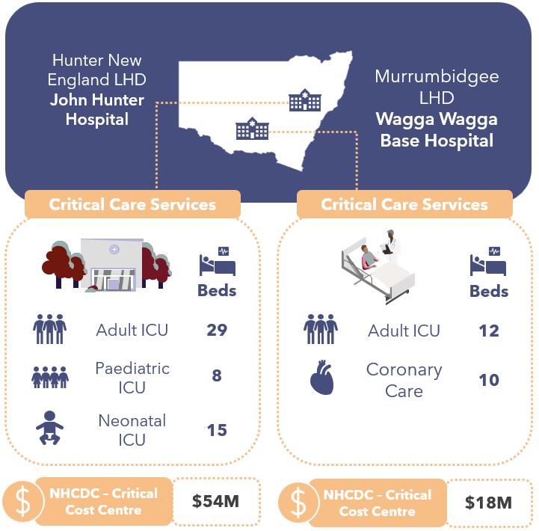
John Hunter Hospital is a metropolitan facility in Newcastle. Its critical care services include:
Figure 10 : Critical care services at NSW participating sites
- Neonatal Intensive Care Unit (NICU) is part of John Hunter Children’s Hospital. The NICU ward consists of 44 beds,15 Intensive Care Unit (ICU) beds, 5 Step Down or High Dependency Unit (HDU) beds, and 24 special care nursery beds. They also provide neonatal hospital in the home care services.
- Adult ICU services (29 beds). It is designated as a Level 3 ICU and is the tertiary referral centre for Central Coast, Hunter New England regions and Mid North Coast. It is co-located with an 8 bed Paediatric ICU (PICU) unit. ICU and PICU have shared staffing but separate care teams on a day-to-day basis, and costs are managed in the same cost centre.
- The ICU clinicians provide some other services in addition to treating the patients in their ward. These include retrieval services (consults across a broad geographic area), medical emergency team (MET) calls and rapid responses within the hospital and some emergency services.
Wagga Wagga Base Hospital (Wagga Wagga Hospital) is a regional NSW hospital. Its critical care services include:
- A 12-bed ICU, and
- A 10-bed coronary care unit (CCU), co-located with 4 respiratory beds (out-of-scope for the purposes of this review).
- The ICU director and intensivists are also part of the rapid response team across the hospital and run Total Parenteral Nutrition (TPN) clinics.
Both John Hunter Hospital and Wagga Wagga Hospital are Level 3 ICU facilities and meet the criteria13F for IHACPA’s ICU adjustment for the national efficient price (NEP). NSW considers ICUs on IHACPA’s list of Level 3 ICU facilities as ‘designated’.

Critical Care Cost and Activity Reporting
IHACPA provides definitions in its Data Request Specification (DRS) for the reporting of critical care costs and activity. These include:
- The NHCDC Public Sector DRS Critical NHCDC Cost Centre Group contains 10 codes to capture the types of critical care costs: Ccu, Hdicu, Aicu, Cticu, Gencritcare, Nicu, OtherCritCare, Paedicu, Psychicu, Scnicu.
- The ABF Admitted Patient Care DRS contains 2 data items for ICU hours. These are:
  - Length of stay in ICU, defined as the number of hours reported by a hospital with approved Adult ICU Level 3 or Paediatric ICU, and
  - Length of stay in ICU – Other, defined as hours reported by hospitals with approved ICUs other than Level 3 or Paediatric ICU.
One of the findings of this IFR was that the definitions and guidance for both Critical NHCDC Cost Centres and ICU hours require clarity and alignment to each other, as they are treated differently by every jurisdiction. This section of the IFR report seeks to provide information on how NSW is reporting this information, noting there is ambiguity in the current definitions.
All NSW LHDs uses the ‘bed type’ for costing purposes: NSW has 10 bed types relating to critical care, shown in the table below.
Bed types are allocated to the patient at the start of an episode. Where care needs increase or decrease, bed types will be changed to reflect the change in level of care.
NSW reports ICU hours in line with IHACPA’s DRS for activity. Across the state, NSW has standard definitions for how ICU activity is reported under IHACPA’s 2 ICU activity fields:
- Bed Type of 91 is used to report Level 3 ICU Hours for Adult and Paediatric within designated and non-designated ICUs;
- Bed Type of 92 is used to report Other ICU Hours
- NICU hours (i.e., those with a Bed Type of 37) are not reported under either Level 3 ICU Hours or Other ICU Hours.
NSW use the bed type to derive (map) the costed output to the NHCDC final cost centres (Ccu, Hdicu, Aicu, Cticu, Gencritcare, Nicu, OtherCritCare, Paedicu, Psychicu, Scnicu). The table below shows how NSW map ICU costs and activity to IHACPA’s cost and activity types.
Table 9: NSW ICU costs and activity mapped to IHACPA cost and activity types
NSW Bed Type | Description of Bed Type | NHCDC Cost Centre | Reported as L3 ICU Hours | Reported as Other ICU Hours
BT91ICU1 | Adult ICU care, at designated Level 3 facilities | Aicu | ✔ | ✖
BT91ICU1P | Paediatric ICU care at designated Level 3 facilities | Paedicu | ✔ | ✖
BT91ICU1Other | ICU care, at non-designated ICU facilities  (the cost associated with non-designated ICUs is not included in Aicu and Paedicu cost centres, but the ICU hours are reported to IHACPA as per the Activity DRS) | GenCritCare | ✔ | ✖
BT92ICU2 | HDU care, within designated and non-designated ICUs | GenCritCare | ✖ | ✔
BT92ICU2P | Paediatric HDU care, regardless of facility status | GenCritCare | ✖ | ✔
BT37NICU | NICU care | Nicu | ✖ | ✖
BT16SCN | Neonatal Special Care Nursery (SCN) | Speccn | ✖ | ✖
BT33CoronaryCare | Coronary Care | Ccu | ✖ | ✖
BT93COU | Close Observation Unit | GenCritCare | ✖ | ✖
BT12PsychIC | Psychiatric ICU care | Psychicu | ✖ | ✖

NSW does not report NICU, SCN, CCU, Close Observation Unit, or Psychiatric ICU in their ICU hours reporting to IHACPA.
The chart below shows the total volume of Level 3 ICU Hours and Other ICU Hours reported hours across all NSW LHDs and at the 2 participating sites.
Figure 11: Volume and percentage of ICU hours, reported by Level 3 ICU Hours and Other ICU Hours, at Wagga Wagga Hospital, John Hunter Hospital and all NSW hospitals
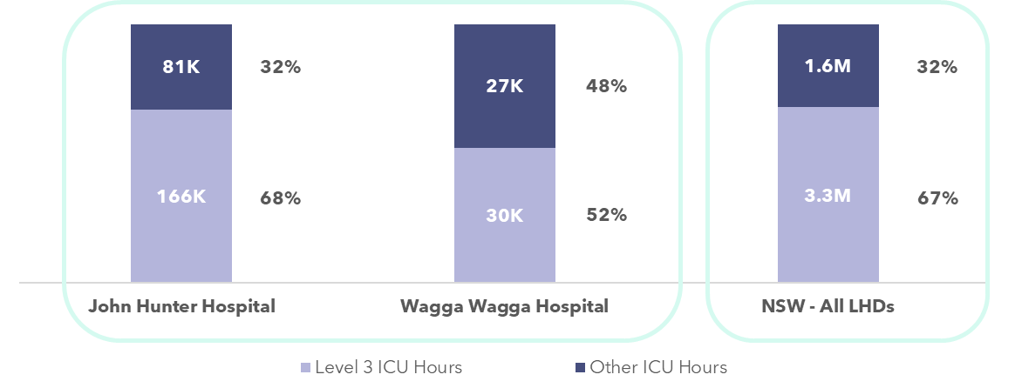
John Hunter’s activity profile is similar to the statewide average with 68% of its ICU hours comprising Level 3 ICU Hours, and 32% comprising Other ICU Hours (HDU or Step Down hours). In line with NSW guidance, NICU hours were not reported.
Wagga Wagga Hospital has a lower proportion of Level 3 ICU Hours than the statewide average (52%) and a higher proportion of Other ICU Hours (48%), reflecting the patient cohort that were treated in the 12 bed ICU ward and the NSW guidance on reporting ICU hours based on the bed type category. In line with NSW guidance, Wagga Wagga Hospital’s CCU hours were not reported.

Costs included in the Critical NHCDC Cost Centre Group
The Critical Care Focused Review aimed at understanding the resources consumed by patients admitted into the different critical care departments, and identifying how these were allocated to individual patients, and which costs were reported against the Critical NHCDC Cost Centre Group within NHCDC reporting.
In general, NSW includes the following costs in the Critical NHCDC Cost Centre Group:
- the staffing costs for nurses, medical (only for intensivists operating in ICUs), admin staff allocated to the wards,
- imprest drugs, medical consumables, hotel costs (food, cleaning and linen) and overheads.
The resources consumed by patients whilst in the ICU/critical care departments that are allocated to the patient but reported under a different NHCDC Cost Centre Group (e.g. not Critical) include pathology, imaging, drugs, allied health and other medical costs.
The analysis of NHCDC critical care costs has focused on the Adult ICU and Paediatric ICU reported costs, as corresponding ICU hours were reported for these episodes. Other critical care costs (such as CCU, NICU, etc.) cannot meaningfully be compared as no critical care hours for these episodes are reported.
An analysis into the Level 3 (L3) ICU Costs Per Hour – defined as Aicu + Paedicu costs, divided by Level 3 ICU Hours, shows the following:
- The NSW average L3 ICU Cost Per Hour is $202.59.
- John Hunter Hospital’s average L3 ICU Cost Per Hour is $218.89 (8% higher than the state average).
- Wagga Wagga Hospital’s average L3 ICU Cost Per Hour is $245.73 (21% higher than the state average).
- One NSW LHD, Mid North Coast, is a clear outlier on this measure at >$600 per hour, that warrants further investigation to understand their higher cost per ICU hour.
Note that Level 3 ICU Hours include ICU hours at non-Level 3 ICU facilities across the state.
Figure 12: Average Cost per Level 3 ICU Hour in Adult and Paediatric ICU - NSW
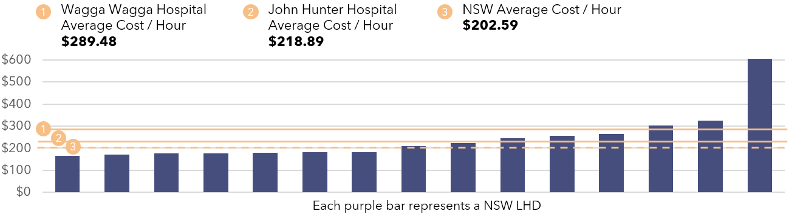
Critical Care - Average Cost Per Hour Insights:
- There is a mismatch between the costs and activity reported to IHACPA in NSW. NSW does not report NICU, SCN, CCU, Close Observation Unit and Psychiatric ICU care hours, but does report these critical care costs.
- ICU hours at non-Level 3 ICU facilities are reported as Level 3 ICU Hours, but costs are reported under Gencritcare cost centre.
- Some costs incurred during an ICU stay (allied health, drugs, imaging and pathology) do not flow through to the Critical NHCDC Cost Centre Group. This is in line with other states and territories.

ICU Cost Allocation Methodologies
The tables below show details of the types of expenditure incurred by each ICU site, John Hunter Hospital and Wagga Wagga Hospital, the allocation methodologies used, and the ultimate Critical NHCDC Cost Centre Group that these expenditure types map.
Table 10: John Hunter Hospital Cost Allocation Methodologies
● | Via patient level feeder system | ◕ | Via weighted RVU, to ICU patients
◑ | Using a standard RVU, to ICU patients | ◔ | Across ICU / non-ICU patients

Resources Consumed | Description of Costs | Allocation Methodology & Category | NHCDC Critical Cost Centre Group
Nursing S&W | Approximately 250 full-time equivalent (FTE) nursing staff shared across Adult ICU (AICU) and PICU, mix of substantive and casual staff (no agency).  ICU and PICU patients at John Hunter Hospital are typically cared for with a 1:1 or 1:2 nursing ratio. NICU patients had a ratio of 1:1 or 1:2; 1:3 or 1:4 for SCN.  Nursing team includes Clinical Nurse Unit Managers (NUMs) and educators. | Allocation of nursing costs that are based on their duration in ICU ward with an relative value unit (RVU) for each bed type. This enables a higher nursing costing for Bed Type 91 (ICU Care) versus Bed Type 92 (Step Down Care) reflecting different nursing ratios ranging from 1:1 to 1:2 or 1:4 for non-ICU patients. | ◕ | Critical
Allied Health S&W | ICU, PICU and NICU have shared dedicated allied health input from physiotherapists, social work, occupational therapist, dietician, but these costs do not sit in critical care cost entries in the GL. | Allied health interventions recorded on IPM. Australian Classification of Health Interventions (ACHI) codes are used to identify where a patient received allied health services. These are then allocated to the patient using a weight/RVU based on the diagnostic related groups (DRGs) and type of intervention. | ◕ | Allied
Other S&W | Technical assistant, Clinical Support Officers, Ward clerk, Administration. | Allocated using duration of patient in ICU ward. | ◑ | Critical
Medical S&W (& VMO) | Intensivists (Adult, Paediatric); Senior Resident Medical Officer (SRMOs); Junior Medical Officer (JMO) positions are supernumerary. There is occasional Visiting Medical Officers (VMO) usage to cover staffing shortages.  Consultant Neonatologists and JMOs are in NICU. | No adjustment is made for the retrieval services or MET calls.  Adult and Paediatric ICU medical cost is kept in the critical care area. Encounters will receive an allocation of medical costs that are based on their duration in ICU ward.  NICU Neonatologists are moved to a specialty Neonatology area, cost allocated based on medical hours duration. JMOs are in the NICU ward area and allocated on duration in NICU ward. | ◑ | Critical
Consumables | Includes medical supplies, Goods & Services expenses including lines, neuromonitoring and cardiac support devices | Allocated using duration of patient in ICU ward. | ◑ | Critical
Imaging | Imaging services provided by John Hunter Hospital. | Allocated using feeder data of actual tests per patient. | ● | Imaging
Pathology | Provided by NSW Pathology. | Allocated using feeder data of actual tests per patient. | ● | Pathology
Pharmacy | Prescribed drugs to patients using iPharmacy.  Some commonly used drugs are also held in imprest. Pharmacist costs sit in Pharmacy cost centre. | Allocated using feeder data of actual drug charge per patient. Imprest is spread to all ICU patients based on length of stay (LOS). | ● / ◑ | Pharmacy  (dispensed)  Critical (imprest)
Hotel | Includes cleaning, food and linen. Provided via Healthshare under Goods & Services. | Allocated using general allocation statistics, appropriate for each expense type (e.g., occupied bed days). | ◔ | Critical
Overheads | Facility and corporate overheads, inclusive of LHD biomedical engineering costs relating to medical equipment repairs and maintenance. | Allocated using general allocation statistics for each expense type (e.g., occupied bed days), S&W expense. | ◔ | Critical

Table 11: Wagga Wagga Hospital Cost Allocation Methodologies
● | Via patient level feeder system | ◕ | Via weighted RVU, to ICU patients
◑ | Using a standard RVU, to ICU patients | ◔ | Across ICU / non-ICU patients

Resources Consumed | Description of Costs | Allocation Methodology & Category | NHCDC Critical Cost Centre Group
Nursing S&W | ICU has 38 FTE nursing and a Clinical Nurse Educator (CNE), ICU Liaison Nurse, Clinical Nurse Consultant (CNC). There was significant agency nurse usage in 2023-24. Agency costs are allocated to the critical care GL cost centre.  CCU has 37 FTE nursing. | Allocation of nursing costs that are based on the patient’s duration in ICU ward with an RVU for each bed type. This enables variable nursing reflecting different nursing ratios ranging from 1:1 to 1:4 (general patients). | ◕ | Critical
Allied Health S&W | Dedicated physiotherapy and pharmacist rounds and dietician support, other allied health input on a referral basis. | Allied health professionals document their time spent with a patient in the electronic medical record (eMR), Powerchart, which is extracted and used as a feeder input to determine minutes per patient as a proportion of all minutes documented and used as a cost per minute to allocate to that patient. | ● | Allied
Other S&W | 2 FTE – Ward Clerk and Clinical Support Officer. | Spread across all ICU patients based on a patient’s duration in ICU ward. | ◑ | Critical
Medical S&W (& VMO) | Includes ICU Director, 6 sessional VMOs, SRMOs and JMOs.  CCU includes dedicated CCU JMO within the CCU Cost Centre. | ICU patient encounters will receive an allocation of medical costs (intensivists/JMOs) that are based a patient’s duration in ICU ward.  Medical costs for CCU all held in ‘physician specialty cost centre’, these costs are spread to all patients admitted under each clinician so ICU patients will have Medical S&W costs allocated under the Clinical NHCDC Cost Centre Group. | ◑ | Critical / Clinical
Consumables | Includes medical supplies, Goods & Services expenses including lines, neuromonitoring and cardiac support devices. | Spread across all patients in ICU based on a patient’s duration in ICU ward. | ◑ | Critical
Imaging | Provided by Wagga Wagga Hospital. | Allocated using feeder data of actual tests per patient. | ● | Imaging
Pathology | Provided by NSW Pathology. | Allocated using feeder data of actual tests per patient, based on price per test, administration charge, and point of care charge. | ● | Pathology
Pharmacy | Pharmacy includes drugs dispensed to ICU patients and imprest held on wards. | S100 drugs are costed to a dummy patient ‘D encounter’ and not allocated to patients. This is due to not having feeder data available (total value $7 million).  Pharmacist and non-s100 are allocated to all patients in the hospital based on occupied bed days.  Imprest drug costs are spread to ICU patients, based on duration of patient in ICU ward. | ◔ / ◑ | Pharmacy  (dispensed)  Critical (imprest), missing s100
Hotel | Includes cleaning, food and linen. Provided via Healthshare under Goods & Services line item. | Cleaning is treated as an overhead and is allocated to ICU cost centre in the costing system based on an allocation statistic based on S&W costs. | ◔ | Critical
Overheads | Corporate costs, biomedical engineering costs relating to maintenance, repairs (materials and labour costs). These are held centrally. | Allocated using general allocation statistics for each expense type (e.g. occupied bed days), S&W expense). | ◔ | Critical

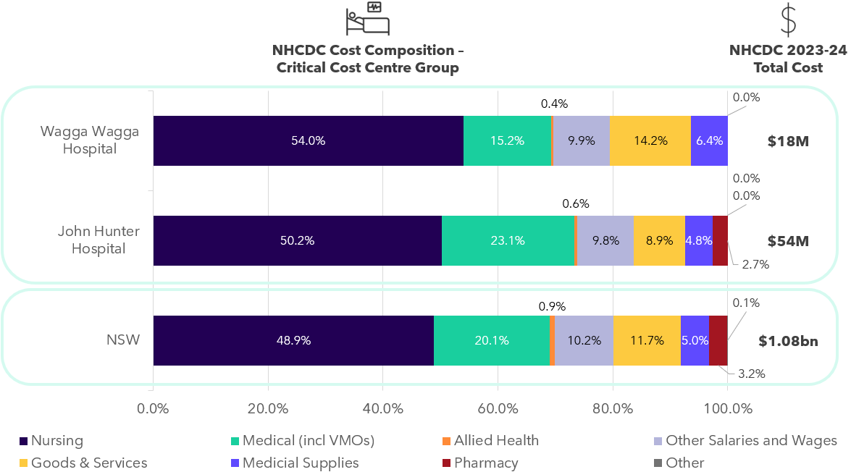
Figure 13: Total Critical costs at NHCDC line item level - NSW

Critical Care Comparability cost insights:
- Both NSW sites rely on RVUs to allocate ICU costs. The RVU for nursing costs is weighted based on bed type to reflect higher care needs / nursing ratios.
- Both sites had dedicated allied health support but these costs were allocated to the Allied NHCDC Cost Centre Group, not Critical. This is consistent with treatment of allied health costs in other jurisdictions.
- Pharmacy, pathology, and imaging costs are sitting in the Pharmacy, Pathology, and Imaging NHCDC Cost Centre Groups respectively, not Critical. This is consistent with other jurisdictions.
- ICU staff perform activities outside of the ICU unit or not delivering care to ICU patients. These costs are spread to ICU patients, potentially overstating their Medical / Nursing S&W costs. Activities include:
  - John Hunter Hospital provides inter-LHD retrieval services, MET calls, triage and tertiary support.
  - Wagga Wagga Hospital provide MET calls, outpatient services, TPN clinics.
  - Wagga Wagga Hospital experienced general ward admissions to ICU, due to lack of available ward beds (approximately 5-10 admissions per month in 2023-24). These patients were cared for by ICU nurses but remained under the care of the admitting doctor.

Victoria

State-wide costed NHCDC 2023-24 submission
38
Health Services
$19.62bn
Total costs submitted to NHCDC
91
Facilities submitting data to the NHCDC in 2023-24
$7,043
Average cost per GWAU (excl. Community MH)
At a glance: Victoria
Victoria submits costed activity for 38 Health Services (HS) as part of the NHCDC.
Total costs submitted by Victoria in 2023-24 were $19.62 billion for 10.29 million episodes.14F
The same scope of activity that was applied in the Cost Driver analysis has also been applied in this section. Costs for ABF hospitals and selected activity streams in Victoria in 2023-24 were $18.5 billion. Victoria is the second largest contributor to the NHCDC nationally.
The total number of costed ABF hospital episodes in 2023-24 was 9.43 million, representing a growth of 8.5% since 2022-23. Victorian ABF hospital episodes made up 21.7% of national ABF episodes for 2023-24.
Victoria delivered 2.63 million GWAU in 2023-2415F, representing 25.3% of weighted activity nationally, with a growth of 7.6% since 2022-23.
The average cost per GWAU in Victoria was $7,043 in 2023-24, representing growth of 3.9% since 2022-23.
Overall, Victoria has experienced high growth in episodes (8.5%) and a slightly lower for GWAU growth (7.6%), indicating a slightly lower patient complexity during 2023-24 compared to the prior year.
Cost growth per GWAU in the range of 3-4% is expected in the context of an inflationary environment and year-on-year EBA wage rises for healthcare workers and Victoria’s average cost per GWAU growth of 3.9% was at the upper end of this range.
From 1 July 2025, Victoria is moving towards amalgamating their HSs into 12 Local Health Service Networks (LHSN), aimed at driving efficiencies in both cost of delivery and improved access to the healthcare workforce.

Cost Driver analysis by activity stream
Analysis was undertaken on the NHCDC 2023-24 submission to understand how submitted activity and cost have changed since 2022-23 and whether any drivers of change could be identified. This analysis considered a subset of the submitted cost data, focusing on 5 key activity streams:
- Admitted acute
- Non-admitted care,
- Subacute and non-acute care,
- ED care and,
- Mental health care (with mental health split by admitted and community).
A summary of the analysis is presented in the sections below. In this analysis, GWAU was used as a standardised activity unit, accounting for the relative complexity and resource intensity associated with treating patients. Furthermore, the results below are related to activity and cost submitted for ABF hospitals only unless stated otherwise.
Figure 14: Growth in activity, GWAU and total cost for Victoria 2023-24
2023-24 Episodes
(and growth)
2023-24 costs
(and growth)
2023-24 GWAU
(and growth)

Figure 15: Average cost per GWAU - Victoria
Average cost per GWAU
Average costs / GWAU

3.6%
-2.1%
5.5%
4.9%
4.5%
*Mental health analysis includes admitted only. Community mental health GWAU was not available as it was not priced in 2023-24.
Key findings by stream include:
Table 12: Key findings by stream in Victoria
Admitted acute | - The admitted acute stream is the most resource intensive stream in a hospital. In 2023-24, there were 1.9 million costed admitted acute episodes, increasing 8.4% from the prior year. The growth in GWAU was similar (8.0%), indicating that the average patient complexity was similar between the 2 years.  - Although admitted acute episodes made up 20.6% of total episodes for 2023-24, it accounted for over 65% of total costs with approximately $12.2 billion submitted. This was an increase of 12.9% compared to 2022-23 and meant that the average cost to deliver services to the same casemix of patients (as measured by average cost per GWAU) was higher for 2023-24, increasing by 4.5%.  - Victoria highlighted that one of the increased costs was the transfer of Sandringham Hospital to Monash Hospital in February 2023, with some ‘doubling up’ of workforce costs during the transitional period.
Emergency Department | - The ED stream represented 20.3% of total episodes, with 1.9 million costed presentations submitted for 2023-24, an increase of 2.2% compared to 2022-23. Growth in GWAU was slightly higher at 3.5%, indicating a slightly more complex casemix of patients for the year.  - The average cost per GWAU for ED increased by 4.9%, meaning that total costs grew by over and above the increase in activity volumes, increasing by 8.6% in 2023-24.
Non-admitted | - The non-admitted stream makes up the largest proportion of submitted episodes, with 5.5 million service events in 2023-24. This stream also had the largest growth in costed episodes, increasing 10.8% from the previous year. As a result, the volume of GWAU also increased significantly by 11.5%.  - The increases in non-admitted activity were observed across a range of HSs across the state. This could be a result of improved data capture and submission at a patient level. Victoria explained that significant focus was placed on improving non-admitted reporting, with HSs formally notified by Victoria that funding is dependent on patient level activity capture resulting in more patient level activity being submitted.  - Total submitted costs increased by 9.2%, meaning that average cost per GWAU reduced by 2.1%.  - There was an exceptional circumstance noted in Victoria’s DQS relating to non-admitted, Western Health HS having implemented a new eMR system and were unable to submit costs and activity for 2 campuses.
Subacute | - The subacute stream is a relatively small stream, making up only 0.5% of episodes. Costed subacute episodes increased by 5.5% in 2023-24, with an increase in GWAU (0.9%) suggesting a slight reduction in average patient complexity.  - The average cost per GWAU grew by 5.5% over the year, resulting in a high growth in total cost for this stream over and above the increase in episodes, with the $1.2 billion in total submitted costs representing an 6.5% increase compared to 2022-23.
Admitted mental health | - The majority of Victoria’s submission for admitted mental health was for phases of care, growing by 25.9% in 2023-24. There was a corresponding 14.8% increase in GWAU. Costs submitted for admitted mental health phases increased by 19.0%. Victoria reported that a 2022 Royal Commission into Mental Health made a series of recommendations, implemented in 2023-24 including additional workforce and a layer in the mental health care model which will become the referral point into admitted mental health services.  - The net effect of these changes meant that the average cost to deliver admitted mental health phase services (average cost per GWAU) increased by 3.6%.
Community mental health | - Submissions for community mental health continue to mature for Victoria and hence there has been volatility in submitted costs and activity for 2023-24 as data quality continues to improve.  - Community mental health activity is not restricted to ABF hospitals (unlike the rest of the Cost Driver analysis), and the number of phases (number of episodes is negligible) submitted 2023-24 for all facilities decreased by 25.6% compared to 2022-23. Community mental health was not ABF priced in 2023-24 and hence GWAU was not considered in this analysis.  - Submitted phase costs increased significantly by 23.7% compared to 2022-23.  - Overall, the average cost per phase increased by 66.3% compared to the prior year.

Victoria Costing Summary

Victoria costing process
In Victoria, the Department of Health (DoH) coordinates the Victorian Cost Data Collection (VCDC), an annual submission of patient-level costing data across all hospital settings. This data supports the development and refinement of Victoria’s funding models and covers a broader scope than the NHCDC. The DoH maps the VCDC to the NHCDC to form Victoria’s national submission. Each year, the VCDC team at DoH releases updated guidance, data definitions, and specifications for the collection. While tailored to VCDC requirements, these are aligned with the AHPCS v4.2 and NHCDC specifications to ensure national consistency. Victoria is looking into aligning the VCDC to the NHCDC in the coming years.
Individual HSs prepare their costing returns using internal costing systems, although a small number of regional services outsource this function to third-party providers. Once prepared, costing files are submitted via a secure data exchange platform and undergo validation to identify critical errors. These are resolved through an iterative process. Validated data then enters a linking and matching phase, where the DoH team reviews and removes duplicate records. Reports are generated to highlight unmatched episodes, which are investigated further in another iterative cycle.
Following successful linking, QA checks are performed, and QA reports are produced. Queries are raised with commentary for each unlinked episode, and HSs submit a DQS and reconciliation documentation. Each submission is formally signed off by the Executive Director of Finance at the respective HS. The DoH then maps VCDC cost centres, line items, and activity data to meet NHCDC reporting requirements.
Across Victoria, costing data is used to inform and refine funding models at a jurisdiction level and, to varying degrees, support business case development and identify opportunities for service improvement within individual HSs.
Victoria has implemented several changes for the 2023-24 year:
- Data for Home Dialysis and Home Enteral Nutrition (HEN) are identified from the Victorian Integrated Non-Admitted Health (VINAH) Dataset with the extract modified in 2023-24 to address data issues identified in 2022-23.
- The higher weightings for COVID-19 patients on general wards are no longer applied. Victoria has identified that changed clinical practices to managing this cohort meaning that an uplift is no longer appropriate.
Victoria has reported variance from AHPCS v4.2 in the following areas:
- Capital and Depreciation are not included as it is a non-cash expenditure and does not impact operational costs.
- There is no consistent method for Teaching and Training expenses. It is included as an overhead when the sole purpose of the activity is teaching and training and as a S&W cost when teaching and training cannot be separated from routine work and is embedded in patient care.
- Research costs are excluded as the ABF work stream continues to be developed.

Victoria structural arrangements and inclusion in costing outputs
Other corporate functions including finance and payroll, cleaning, linen and food (support services), pathology, pharmacy, and radiology (clinical services) are generally provided at a HS level. There is a move towards consolidation of these services under regional alliances to benefit from economies of scale. Where these alliances are in place, costs are recharged between providers and receivers of services under local arrangements.
Comparability of Victoria’s costing outputs to other states
- Victoria excludes capital and depreciation costs.
- TTR are excluded from patient level cost allocations unless directly relating to patient care. An example of TTR costs included is training expenses for the rollout of the eMR.
- Posthumous organ donation expenses are excluded.
- Special purpose trust fund expenses are excluded.

Contracted care costs included in costed records
There are a number of contracted care arrangements within Victoria, with 47,783 episodes (across all streams) reported costs of $308 million in Victoria in 2023-24. These arrangements were used extensively post-COVID to reduce the surgical wait lists. This was costed at an episodic level at the agreed price with individual private hospitals, with the costs reported under the Goods & Services line item. The average cost per GWAU for contracted activity in Victoria was $6,143, 14.4% lower than non-contracted care.

Corporate costs included in costed records
The AHPCS v4.2 provide guidance on the inclusion of corporate overhead expenses. Business Rule 3.1C.3.2 states that ‘corporate overhead expenses should not be included for more than one level above the management of the hospital. Expenses related to the direct management of the LHN (Local Health Network) or corporate management are within scope.’ The table below shows how Victorian HSs, the Victoria equivalent of an LHN, are treating corporate costs and allocating them to patients in the costing process.
Table 13: Victorian HS treatment of corporate costs and patient allocation costing process
Type of corporate cost | Details of whether these are passed onto HSs | Included in patient level costing | In line with the guidance in the AHPCS
Corporate costs at the facility | Included in HS GL | ✔ | ✔
Corporate costs at the HS | Included in HS GL | ✔ | ✔
Corporate costs at shared service functions | Corporate costs for Health Purchasing Victoria (HPV) are passed to HSs | ✔ | ✔
Corporate costs at DoH | Not allocated to HS | ✖ | ✔

Reconciliation from GL to submitted costs
Two Victorian HSs participated in the IFR: Alfred Health HS and Barwon Health HS. This section discusses major variances, reconciling items and adjustments from the GL of the participating sites, through to the costed products submitted to IHACPA in the NHCDC submission.

Reconciliation from GL to NHCDC – Alfred Health HS
Victoria’s total reported costs were $19.92 billion (representing 26.0% of national costs).
- Alfred Health HS’s GL was $2.01 billion.
  - Their submitted costs to the NHCDC were $1.69 billion (representing 8.4% of Victoria’s costs).
  - Overall, Alfred Health HS submitted 84% of their GL to the NHCDC.
  - $327 million costs (16% of GL) were not included in NHCDC submissions for a variety of reasons including being out-of-scope, or an inability to link costs and activity due to data quality issues.
Figure 16: Waterfall from GL to NHCDC submitted costs – Alfred Health HS
This section discusses adjustments from the GL of Alfred Health HS, through to the costed products ($) submitted to IHACPA in the NHCDC submission.
Alfred Health HS GL
Inclusions
Restated GL
Out-of-scope
Jurisdiction exclusions
Other exclusions
Submitted to IHACPA
- Inclusions – $65 million of inclusions relating to national blood allocation ($51 million), HPV (procurement) costs ($7 million), and $7 million internal transfers were added to Alfreds Health HS’s GL.
- Out-of-scope – Alfred Health HS removed costs related to non-ABF service delivery or costs that were not in-scope for the costing year, relating to:
  - Special Purpose funds not relating to patient care, predominantly relating to research activities ($60 million), and
  - Movement in WIP ($9 million).
- Jurisdiction exclusions – Alfred Health HS removed capital related expenditure of $117 million and $5 million of non-operating costs relating to car parking expenses.
- Other exclusions – totalled $201 million. These are made up of both out-of-scope costs and excluded costs that are within the scope of the NHCDC and could not be matched to a record based on data quality. The exclusions are made up of:
  - Unlinked or unmatched activity that cannot be matched to cost records ($80 million), noting that some of this amount relates to non-ABF services. A portion relates to virtual dummy encounters where patient level data is not available.
  - Other non-patient products including $52 million sexual health services. The remainder could not be determined.
  - $90 million of costs were removed that related to VCDC products and were not submitted to NHCDC.

Reconciliation from GL to NHCDC – Barwon Health HS
- Barwon Health HS’s GL was $1.27 billion.
  - Their submitted costs to the NHCDC were $899 million (representing 2.5% of Victoria’s costs).
  - Overall, Barwon Health HS submitted 70% of their GL to the NHCDC.
  - $372 million costs (30% of GL) were not included in NHCDC submissions for a variety of reasons, as set out in the waterfall below.
Figure 17: Waterfall from GL to NHCDC submitted costs – Barwon Health HS
Barwon Health HS GL
Inclusions
Restated GL
Out-of-scope
Jurisdiction exclusions
Other exclusions
Submitted to IHACPA
Transfers / costed elsewhere
- Inclusions – $5 million of inclusions relating to national blood allocation ($3 million), HPV (procurement) costs ($2 million).
- Out-of-scope - totalled $43 million. These comprised services that were non-ABF funded including:
  - $15 million relating to community dental clinics,
  - $2 million relating to immunisation community clinics,
  - $6 million relating to COVID-19 management costs,
  - $4 million costs relating to Alcohol and Drug management costs,
  - Movement in WIP patients ($14 million), and
  - Other small out-of-scope costs totalling $3 million.
- Jurisdiction exclusions – $71 million of depreciation was removed from costing submissions in line with VCDC guidelines.
- Transferred costs – $43 million of costs under the South West Alliance of Rural Health were recharged to other HSs relating to information technology (IT) infrastructure and services, enabling smaller rural hospitals to benefit from economies of scale and improved digital capabilities that would be difficult to achieve independently. The costs for these services sit in Barwon Health HS’s GL.
- Other exclusions – These total $219 million are made up of non-ABF services, WIP, unlinked or unmatched activity that cannot be matched to cost records, (including virtual dummy encounters where patient level data is not available) and program expenditure.
  - This included $74 million of costs removed that related to VCDC products and were not submitted to NHCDC.

ICU and Critical Care Focused Review
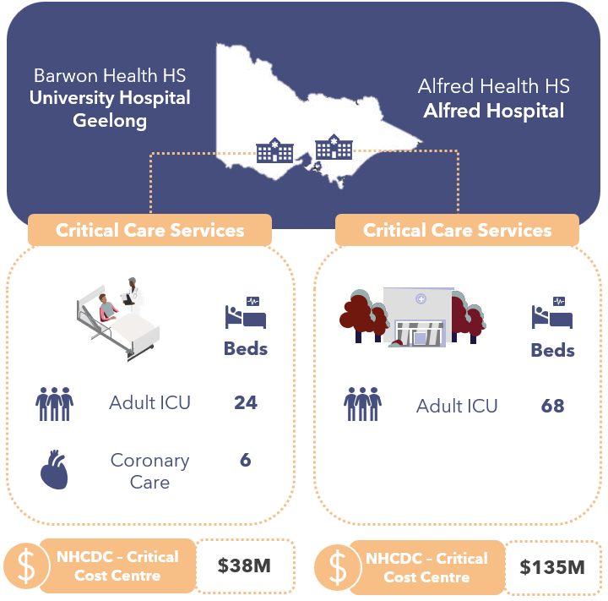
Victoria nominated 2 facilities to participate in the Critical Care Focused Review: Alfred Hospital (Alfred) and University Hospital Geelong.
Figure 18: Critical care services at Victorian participating sites
Alfred is a metropolitan facility in Melbourne which forms part of Alfred Health HS. Its critical care services include:
- The Alfred’s ICU is one of the largest in Australia, comprising 68 beds. It provides specialist care for over 3,000 critically ill patients annually, including statewide services such as trauma, burns, heart and lung transplantation, and hyperbaric treatments.
- The ICU clinicians provide some other services in addition to treating the patients in their ward. These include:
  - ECMO retrieval services (with Alfred clinical teams travelling to other facilities to retrieve patients to the Alfred’s ICU),
  - Organ retrieval services, and
  - MET calls.
  - Under highly specialised circumstances, ICU staff would be required to work outside the ICU, in the delivery of hyperbaric chamber services.
- The Alfred also includes a CCU that is co-located with a cardiac catheterisation laboratory (Cath lab). The hours and costs are reported as Cardiology.
University Hospital Geelong is a metropolitan facility in Geelong which forms part of Barwon HS. Its critical care services include:
- A 24-bed ICU providing mixed Adult and Paediatric ICU care and providing telehealth services to the Children’s Hospital, and
- A 6-bed CCU, co-located within a Cardiology/cardiothoracic ward (34 beds in total). The cardiology, cardiothoracic care services and Cath lab are deemed out-of-scope for the purposes of this review.
The ICU staff additionally provide outreach services to the wider hospital including:
- MET calls,
- Peripherally Inserted Central Catheter (PICC) Lines services 3 times a week, and
- TPN services for inpatients.
The staff working within the CCU deliver interventional and diagnostic services, bypass and valve surgery and complex thoracic surgeries. It is challenging to allocate costs across Cardiothoracic, Cardiology and CCU.
Both the Alfred and University Hospital Geelong are Level 3 ICU facilities and meet the criteria16F for IHACPA’s ICU adjustment for the NEP.

Critical Care Cost and Activity Reporting
IHACPA provides definitions in its DRS for the reporting of critical care costs and activity. These include:
- The NHCDC Public Sector DRS Critical NHCDC Cost Centre Group contains 10 codes to capture the types of critical care costs: Ccu, Hdicu, Aicu, Cticu, Gencritcare, Nicu, OtherCritCare, Paedicu, Psychicu, Scnicu.
- The ABF Admitted Patient Care DRS contains 2 data items for ICU hours. These are:
  - Length of stay in ICU, defined as the number of hours reported by a hospital with approved Adult ICU Level 3 or Paediatric ICU, and
  - Length of stay in ICU – Other, defined as hours reported by hospitals with approved ICUs other than Level 3 or Paediatric ICU.
One of the findings of this IFR was that the definitions and guidance for both Critical NHCDC Cost Centres and ICU hours require clarity and alignment to each other, as they are treated differently by every jurisdiction. This section of the report seeks to provide information on how Victoria is reporting this information, noting there is ambiguity in the current definitions.
Victoria has standard definitions for how ICU activity is reported under IHACPA’s 2 ICU activity fields in the Victorian Admitted Episodes Dataset (VAED) manual. ICU activity reporting is managed by the DoH using data within the PAS with the following application:
- If the campus is a Level 3 ICU, then the hours are reported as Level 3 ICU Hours.
- If the campus is not a Level 3 facility, then the hours are reported as Other ICU Hours.
The table below shows how Victoria maps ICU costs and activity to IHACPA’s cost and activity types.
Table 14: Victoria ICU costs and activity mapped to IHACPA cost and activity types
ICU Description | NHCDC Critical Cost Centre | Reported as Level 3 ICU Hours | Reported as Other ICU Hours
Adult ICU | Aicu | ✔ (if L3 facility) | ✔ (if not a L3 facility)
Paediatric ICU | Aicu (Paedicu cost centre not used) | ✔ (if L3 facility) | ✔ (if not a L3 facility)
HDU / Step Down Care | Hdicu | ✖ | ✖
Coronary Care Unit | Ccu | ✔ (if L3 facility) | ✔ (if not a L3 facility)
General Critical Care | GenCritCare | ✔ (if L3 facility) | ✔ (if not a L3 facility)
Other Critical Care | OtherCritCare | ✖ | ✖
Neonatal ICU | Nicu | ✔ (if L3 facility) | ✔ (if not a L3 facility)
Special Care Nursery | Scnicu | ✖ | ✖
Cardiothoracic ICU | Cticu | ✖ | ✖
Psychiatric ICU | Psychicu | ✖ | ✖

Victoria is reviewing how they are reporting ICU hours pending further guidance from IHACPA, including revised treatment of NICU hours.
The chart below shows the total volume of Level 3 ICU Hours and Other ICU Hours recorded hours across all Victorian HSs and at the 2 participating sites.
Figure 19: Volume and percentage of ICU hours, reported by Level 3 ICU Hours and Other ICU Hours, at Alfred, University Hospital Geelong and all Victorian hospitals
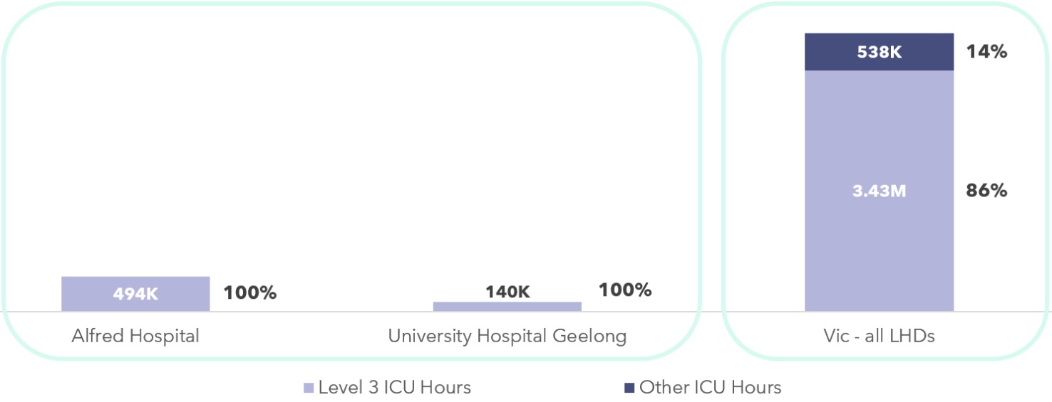
At both the Alfred and University Hospital Geelong, 100% of ICU hours are reported as Level 3 ICU Hours in line with their status as Level 3 ICU facilities. The hours reported include ICU and CCU hours (University Hospital Geelong) and AICU (Alfred).

Costs included in the Critical NHCDC Cost Centre Group
The Critical Care Focused Review aimed at understanding the resources consumed by patients admitted into the different critical care departments, and identifying how these were allocated to individual patients, and which costs were reported against the Critical NHCDC Cost Centre Group within NHCDC reporting.
In general, Victoria includes the following costs in the Critical NHCDC Cost Centre Group:
- the staffing costs for nurses, medical (only for intensivists operating in ICUs), admin staff allocated to the wards,
- imprest drugs, medical consumables, hotel costs and overheads.
The resources consumed by patients whilst in critical care departments that are allocated to the patient but reported under a different NHCDC Cost Centre Group (e.g. not Critical) include pathology, imaging, drugs, allied health and other medical costs.
An analysis into the ICU Costs Per Hour – defined as Total costs within the Critical NHCDC Cost Centre Group costs, divided by reported hours (Level 3 ICU Hours and Other ICU Hours), shows the following:
- Victoria’s average ICU Cost Per Hour is $225.37.
- The Alfred’s average ICU Cost Per Hour is $272.82 (21% higher than the state average).
- University Hospital Geelong’s average ICU Cost Per Hour is $268.05 (19% higher than the state average).
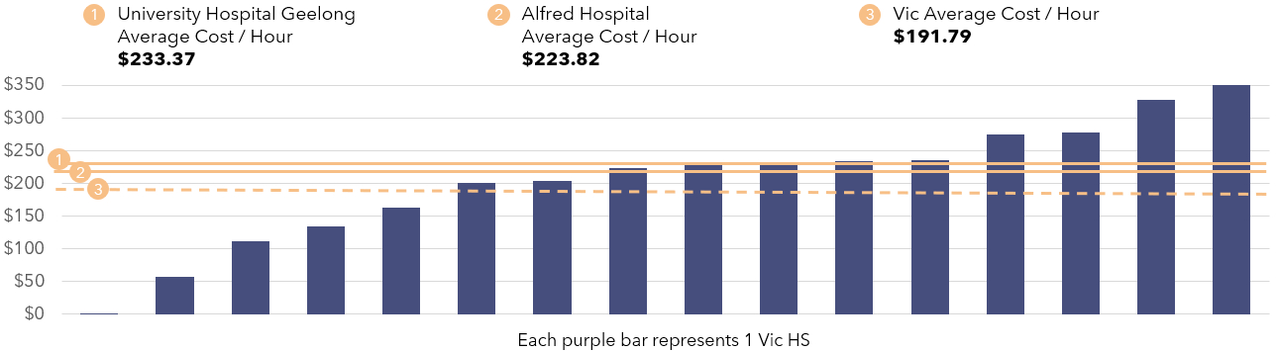
Figure 20: Average Cost Per ICU hour - Victoria
Critical Care – Average Cost Per Hour Insights
- Victoria reports Paediatric ICU costs under the Aicu NHCDC Cost Centre.
- Victoria reports NICU hours as Level 3 ICU Hours in Level 3 ICU facilities. This is inconsistent with other states.
- Alfred has a CCU, but does not report hours or costs as CCU.
- University Hospital Geelong has a CCU reporting Level 3 ICU Hours, inconsistent with Victoria reporting.
- Some costs incurred during an ICU stay (allied health, drugs, imaging, and pathology) are not reported within the Critical NHCDC Cost Centre Group. Victoria’s approach is in line with other jurisdictions.

ICU Cost Allocation Methodologies
At the Alfred, ICU cost centres in the GL are mapped to 6 areas in the costing ledger:
- ICU nursing – these costs are allocated to all ICU patients
- ICU medical and support – these costs are allocated to all ICU patients.
- ICU consumables, including linen, gases, consumables and mattress hire – these costs are allocated to all ICU patients.
- ECMO support, ECMO retrieval – these costs relate to staffing costs for workforce undertaking transport of ECMO patients to the Alfred from other sites, and consumables associated with receiving ECMO care. These costs are allocated only to patients receiving ECMO care, based on a feeder data of ECMO minutes.
- ICU burns dressing – these costs are allocated only to patients who are receiving specialist burns care, using feeder data from theatre with a flag for patients receiving burns procedures.
- ICU haemofiltration – these costs are allocated only to ICU patients who are receiving hemofiltration based on clinical coding which flags certain DRGs as patients receiving haemodialysis.
Generally, all costs in these GL areas are allocated to the Critical NHCDC Cost Centre Group.
At University Hospital Geelong ICU cost centres are
- ICU nursing – these costs are allocated to all ICU patients
- ICU medical – these costs are allocated to all ICU patients.
For CCU, there is one shared cost centre between 3 areas (CCU, cardiology, and cardiothoracic), and the CCU portion is fractioned out for costing purposes based on the number of beds and staffing rosters. This cost centre contains nursing cost and ward-based expenses. Cardiology clinicians work across these 3 areas and sit in a separate cost centre and are not mapped into critical care areas for costing.
The tables below show details of the types of expenditure incurred by each ICU site, the allocation methodologies used, and the ultimate Critical NHCDC Centre Groups to which these expenditure types map.
Table 15: Alfred Cost Allocation Methodologies
● | Via patient level feeder system | ◕ | Via weighted RVU, to ICU patients
◑ | Using a standard RVU, to ICU patients | ◔ | Across ICU / non-ICU patients

Resources Consumed | Description of Costs | Allocation Methodology & Category | NHCDC Critical Cost Centre Group
Nursing S&W | The Alfred ICU department has approximately 400 nursing and 25 nursing support and management roles. The majority of patients are cared for on a 1:1 or 1:2 basis. | Allocated based on ICU hours with no differentiation for acuity. | ◑ | Critical
Allied Health S&W | ICU have shared dedicated allied health input from physiotherapists, social work, occupational therapists, dietician, but these costs do not sit in critical care cost centres in the GL. | Allied Health document interventions minutes in the PAS system that is used to allocate to patients. | ◕ | Allied
Other S&W | Technical assistant, Clinical Support Officers, Ward clerk, secretaries. | Allocation based on ICU hours. | ◑ | Critical
Medical S&W (& VMO) | 37 FTE intensivists and 100 JMOs of various grades. JMOs are costed to the ICU cost centre for the duration of the time they are working in ICU. | Based on ICU hours (intensivists).  Specialty clinical costs (non-ICU) are allocated based on inpatient days.  ECMO costs are allocated at the patient level based on ECMO minutes, using data from the ECMO feeder data.  ECMO retrieval costs are allocated equally to all ECMO patients. | ◑ | Critical (intensivists only)
Medical Supplies, Goods & Services | Includes ECMO circuits, lines, neuromonitoring and cardiac support devices and mattress hire.  The main medical gas contract is not allocated to programs/ICU.  Biomedical engineering services for equipment repairs and maintenance is recharged to ICU. | General ICU consumables are allocated based on ICU hours.  ECMO consumables are allocated to ECMO patients based on feeder data.  Burns dressing are allocated using a theatre feed with flag for burns procedures.  Haemodialysis costs are allocated to the patients that received this care based on the DRG. | ◑ | Critical
Imaging | The Alfred’s imaging service is run in-house, and feeder level data is available. | Allocated at a patient level using RVU of the Medicare Benefit Schedule (MBS) price. | ● | Imaging
Pathology | The Alfred’s pathology service is run in house and feeder level data is available. | Pathology feeder system and allocated to patient at the using RVU of the MBS price. | ● | Pathology
Pharmacy | The Alfred has an electronic pharmacy system and dispensed drugs are held in a pharmacy cost centre in the GL. Pharmacist costs sit in pharmacy cost centre.  Some commonly used drugs are also held in imprest and sit within critical care cost centre in the GL. | Allocate to patients based on patient level feeder using RVU of the PBS price. Any unlinked costs go to dummy patients.  Imprest costs are allocated to all ICU patients using an RVU based on ICU hours. | ◑ / ● | Critical (imprest) Pharmacy (dispensed)
Hotel | Linen is allocated to ICU in the GL.  Food and cleaning sit in a non-clinical support program and are charged to | Linen is allocated to ICU patients based on ICU hours.  Food and cleaning charged to Critical as an overhead. | ◔ | Critical (linen as direct cost; food and cleaning as overhead)
Overheads | Corporate costs. | Allocated based on various allocation statistics (workforce, patient driven). | ◔ | Critical

Table 16: University Hospital Geelong Cost Allocation Methodologies
● | Via patient level feeder system | ◕ | Via weighted RVU, to ICU patients
◑ | Using a standard RVU, to ICU patients | ◔ | Across ICU / non-ICU patients

Resources Consumed | Description of Costs | Allocation Methodology & Category | NHCDC Critical Cost Centre Group
Nursing S&W | ICU has a nursing FTE of 138 at registered nurse (RN) level, along with 20 postgraduate student positions.  The ICU department also uses casuals and agency. Specialling is used for mental health patients, often with health care worker roles.  CCU has a nursing FTE of 70 shared across the cardiology, cardiothoracic and CCU areas. | ICU Nursing costs are allocated based on ICU hours, from the PAS.  CCU nursing costs are split 50% to cardiology and 50% to CCU and cardiothoracic. These costs are then allocated to patients based on their admission designation using their ward LOS. | ◕ | Critical
Allied Health S&W | ICU has dedicated social work (1 FTE), pharmacy (2 FTE), physiotherapist (1 FTE) and dietician (1 FTE).  CCU has a dedicated pharmacist, but this is shared with cardiology. | Recorded in the PAS as contact minutes and allocated to patients. | ● | Allied Health
Other S&W | Ward clerk, Patient Support Assistants, Equipment Nurse in ICU, and Ward Clerk in CCU. | Allocated based on ICU hours or ward LOS. | ◑ | Critical
Medical S&W (& VMO) | ICU’s medical staffing includes 11 consultants, 3 junior consultants, 15 registrars, 15 residents.  CCU’s medical staffing includes 12 cardiologists delivering interventional and diagnostic services, 4 surgeons, 4 registrars and 4 trainee registrars. | ICU medical staff time is allocated based on ICU minutes (extracted from the PAS iPM).  Due to the shared nature of resources across Cardiology, Cardiothoracic and CCU, it is hard to allocate costs across these areas, and these are allocated across patients based on ward LOS. | ◑ | Critical (ICU)  Clinical (CCU)
Consumables | Includes medical supplies, Goods & Services expenses including lines, neuromonitoring and cardiac support devices. | ICU consumables are allocated based on ICU hours. ECMO patients will get specific consumable allocations based on the data recorded in the PAS.  CCU, Cardiology and Cardiothoracic consumables are allocated to all patients using ward LOS. | ◑ | Critical
Imaging | Provided by University Hospital Geelong. | Feeder information is available - allocated based on price rate in the Agfa Healthcare system (medical imaging) and allocated at the patient level. | ● | Imaging
Pathology | Provided by third party providers, Australian Clinical Labs (ACL). | Pathology feeder system and allocated to patient at the using RVU of the MBS price. | ● | Pathology
Pharmacy | In ICU an electronic pharmacy system is in place (Merlin) and dispensed drugs are held in a pharmacy cost centre. In CCU, there is no electronic dispensing.  Some commonly used drugs are also held in imprest and sit within critical care. Pharmacist costs sit in pharmacy cost centre. | Allocated at the patient level from a feeder system (Merlin).  Unallocated costs are charged to a dummy episode.  Maximum linking rules up to 30 days (forwards and backwards). | ● / ◑ | Pharmacy (dispensed)  Critical (imprest)
Overheads | Corporate costs, biomedical engineering costs relating to maintenance, repairs (materials and labour costs). These are held centrally. | Allocated as an overhead based on hospital wide allocation statistics. | ◔ | Critical
Hotel | Includes food, linen, cleaning. | Allocated based on ICU hours or CCU/Cardiology ward LOS. | ◔ | Critical

The chart below shows the composition of costs within the Critical NHCDC Cost Centre Group:
- The Alfred and University Hospital Geelong’s Critical costs totalled $135 million and $38 million respectively of Victoria’s $894 million costs in the Critical NHCDC Cost Centre Group.
- The make-up of expense types was broadly consistent across both sites, and in line with the state average composition. S&W (Medical, Nursing, Allied Health and Other) comprises approximately 85% of the cost centre.
- The Alfred had a slightly lower proportion of nursing costs (49.9% versus 52.4%) and slightly higher proportion of medical costs (21.5% versus 20.7%) within Critical NHCDC Cost Centre Group than the state average.
- University Hospital Geelong had a slightly higher proportion of nursing costs (55.3% versus 52.4%) and medical costs (26.8% versus 20.7%) than the state average.
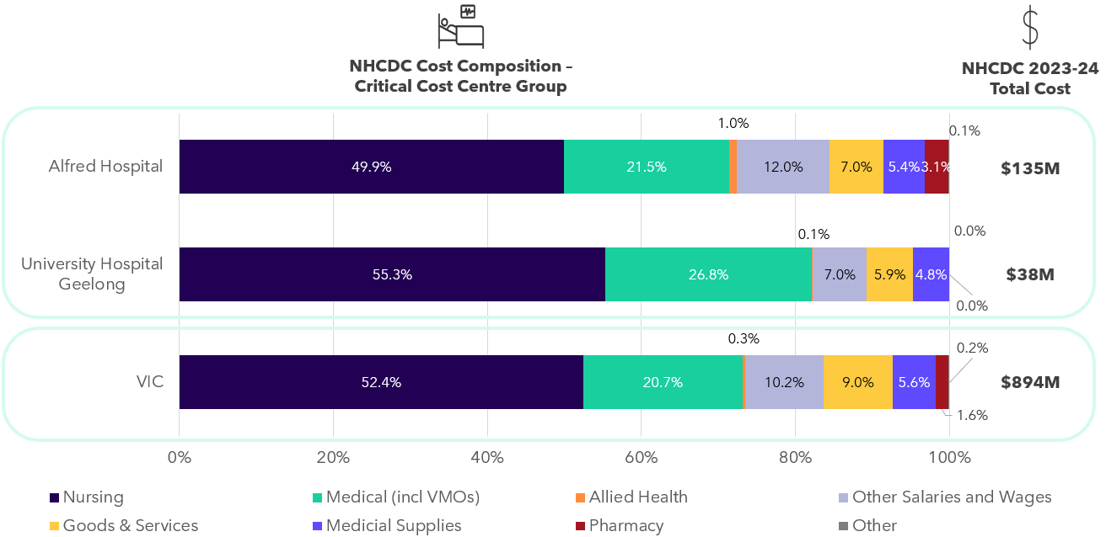
Figure 21: Total Critical Costs at NHCDC line item level - Victoria

Critical Care Comparability cost insights
- Both Victorian sites rely on RVUs to allocate ICU costs. The RVU for nursing costs is a standard weighting for all patients based on ICU hours. Both sites were able to allocate specific costs for ECMO services and retrieval, specialised burns (Alfred only) to only patients receiving these services.
- Both sites had dedicated allied health support but these costs were allocated to the Allied NHCDC Cost Centre Group, not Critical. Victoria’s approach is consistent with other jurisdictions.
- At both sites, patients remain under the care of their admitted specialty doctor and may have higher Medical S&W expenses as a result of this, due to receiving both allocations of intensivist and admitting specialty doctor costs for the duration of their ICU stay.
- CCU costs at University Hospital Geelong are in a shared GL cost centre with Cardiology and Cardiothoracic and the portion that ends up the Critical NHCDC Cost Centre Group may be understated, as medical costs are mapped to the Clinical NHCDC Cost Centre Group instead.
- Pharmacy, pathology, and imaging costs are sitting in the Pharmacy, Pathology, and Imaging NHCDC Cost Centre Groups respectively, not Critical. This approach is consistent with other jurisdictions.
- ICU staff perform activities outside of the ICU unit or not delivering care to ICU patients. These costs are spread to ICU patients, potentially overstating their Medical / Nursing S&W costs. Activities include:
  - ECMO retrieval services, organ retrieval services, hyperbaric chamber services, MET calls at the Alfred.
  - MET calls, PICC Lines services, TPN inpatient services at University Hospital Geelong.

Queensland

State-wide costed NHCDC 2023-24 submission
17
Hospital & Health Services and The Mater Public Hospitals
$17.88bn
Total costs submitted to NHCDC
383
Facilities submitting data to the NHCDC in 2023-24
$6,383
Average cost per GWAU (excl. Community MH)
At a glance: Queensland
Queensland submits costed activity for 16 Hospital & Health Services (HHS), in addition to the Mater Public Hospitals (Brisbane), as part of the NHCDC.
Total costs submitted by Queensland in 2023-24 were $17.88 billion and 11.72 million episodes.17F
The same scope of activity that was applied in the Cost Driver analysis has also been applied in this section. Costs for ABF hospitals and selected activity streams in Queensland in 2023-24 were $15.98 billion. Queensland is the third largest contributor to the NHCDC nationally.
The total number of costed ABF hospital episodes in 2023-24 was 10.51 million, representing a growth of 5.1% since 2022-23. Queensland ABF hospital episodes made up 24.2% of national ABF episodes for 2023-24.
Queensland delivered 2.50 million GWAU in 2023-2418F, with a growth of 4.9% since 2022-23. Queensland GWAU represents 24.1% of weighted activity nationally.
The average cost per GWAU in Queensland was $6,383 in 2023-24, representing growth of 2.0% since 2022-23.
Overall, Queensland has had moderate growth in episodes (5.1%) matched by similar growth in GWAU (4.9%). Cost growth per GWAU in the range of 3-4% is expected in the context of an inflationary environment and year-on-year EBA wage rises for healthcare workers. Queensland’s average cost per GWAU growth of 2.0% is lower than expected.

Cost Driver analysis by activity stream
Analysis was undertaken on the NHCDC 2023-24 submission to understand how submitted activity and cost have changed since 2022-23 and whether any drivers of change could be identified. This analysis considered a subset of the submitted cost data, focusing on 5 key activity streams:
- Admitted acute,
- Non-admitted care,
- Subacute and non-acute care,
- ED care and,
- Mental health care (with mental health split by admitted and community).
A summary of the analysis is presented in the sections below. In this analysis, GWAU was used as a standardised activity unit, accounting for the relative complexity and resource intensity associated with treating patients. Furthermore, the results below are related to activity and cost submitted for ABF hospitals only unless stated otherwise.
Figure 22: Growth in activity, GWAU and total cost for Queensland 2023-24
2023-24 Episodes
(and growth)
2023-24 GWAU
(and growth)
2023-24 costs
(and growth)

Figure 23: Average cost per GWAU - Queensland
7.4%
-0.6%
4.4%
11.4%
0.1%
Average costs / GWAU
Average cost per GWAU
*Mental health analysis includes admitted only. Community mental health GWAU was not available as it was not priced in 2023-24.
Key findings by stream include:
Table 17: Key findings by stream in Queensland
Admitted acute | - The admitted acute stream is the most resource intensive stream in a hospital. In 2023-24, there were 1.7 million admitted acute costed episodes which was an increase of 2.9% from the prior year. The growth in GWAU was 4.6%, indicating that the average patient complexity was slightly higher in 2023-24.  - Although admitted acute episodes made up 15.8% of total episodes for 2023-24, it accounted for 57.1% of total costs with $9.1 billion submitted. This was an increase of 4.7% compared to 2022-23 and meant that the average cost to deliver services to the same casemix of patients (as measured by average cost per GWAU) was relatively stable between 2022-23 and 2023-24, only increasing by 0.1%.  - Children’s Health Queensland was an outlier with significant reduction in episodes (-7.1%), GWAU (-20.4%) and average cost per GWAU (-12.1%). Queensland is investigating whether there is an underlying issue affecting matching of costs and activity in 2023-24, driving the reduction in activity.
Emergency Department | - The ED stream represented 18.4% of total episodes, with 1.9 million costed presentations submitted for 2023-24, a slight decrease of 0.4% compared to 2022-23. Growth in GWAU increased slightly by 0.6% over the same period, indicating a slightly more complex casemix of patients for the year.  - Despite small changes in activity volumes, the average cost per GWAU for ED increased significantly by 11.4% for 2023-24. This resulted in an increase to total costs of 12.1% in 2023-24.  - Queensland reported that there were investments in 2023-24 in ED to reduce ramping challenges, including $54 million to enhance transition and discharge lounges, extended hours of allied health clinicians in EDs, and senior doctors as Flow Commanders. Wide Bay, Mackay, and Cairns & Hinterland HHSs saw significant investments and largest corresponding cost increases.
Non-admitted | - The non-admitted stream makes up the largest proportion of submitted episodes, with 6.8 million service events in 2023-24. This stream also had highest growth in the number of costed service event records, increasing 7.3% from the previous year. Over the same period, the volume of GWAU also increased significantly by 10.1%.  - The increases in non-admitted activity were observed across a range of HSSs across the state, which could be a result of improved data capture and submission at a patient level. Queensland explained that there was a lot of focus by HSSs on improving patient activity capture in non-admitted collections.  - Total submitted costs grew in line with the increases in GWAU, with $3.1 billion submitted for the non-admitted stream in 2023-24, an increase of 9.4%. This resulted in a small decrease in the average cost per GWAU of 0.6%. The non-admitted stream was the only stream with a reduction in average cost per GWAU.
Subacute | - The subacute stream is a relatively small stream, making up only 0.6% of episodes. Costed subacute records increased by 1.9% in 2023-24, with a higher increase in GWAU (6.8%) reflecting an increasing level of patient complexity.  - The average cost per GWAU grew by 4.4% over the year, resulting in a high growth in total cost for this stream over and above the increase in episodes. The $1.2 billion in submitted costs represented an 11.5% increase compared to 2022-23.
Admitted mental health | - The majority of Queensland’s data for admitted mental health was submitted as phases of care, growing by 10.9% in 2023-24. However, despite the increases in phases of care, the volume of GWAU remained relatively stable, decreasing by only -0.1%. Queensland reported that initiatives were introduced to improve phase of care assignment and improve data quality, contributing to the difference between phase growth and GWAU growth.  - Total admitted mental health phase costs increased by 7.3%, with a corresponding change in the average cost to deliver admitted mental health services (average cost per GWAU) of 7.4%.
Community mental health | - Queensland submits community mental health activity and costs through both episodes and phases of care. Submissions for community mental health continue to mature and hence there has been volatility in submitted costs and activity for 2023-24 as data quality continues to improve.  - Community mental health activity is not restricted to ABF hospitals (unlike the rest of the Cost Driver analysis), and the records (episodes and phases) submitted in 2023-24 for all facilities increased by 6.3% compared to 2022-23. Community mental health was not ABF priced in 2023-24 and hence GWAU was not considered in this analysis.  - Submitted costs (episodes and phases) also increased significantly by 31.9% compared to 2022-23. The majority of community mental health costs were submitted as phases of care, with phase level costs increasing by 53.3% since 2022-23.  - This also led to a significant increase in the average cost per phase, increasing by 40.8% compared to the prior year.

Queensland Costing Summary

Queensland costing process
Hospital costing in Queensland is conducted by 12 HHSs and the Mater Public Hospitals, supported by the Queensland DoH Clinical Costing Team, providing technical expertise, guidance, and clinical costing resources. For the remaining 4 HHSs (North West HHS, South West HHS, Central West HHS, and Torres and Cape HHS) the DoH Clinical Costing Team directly performs the costing processing function.
The costing process is conducted for the purpose of submitting the NHCDC to IHACPA and supporting business case and benchmarking activities across the HHSs. HHSs perform the costing process monthly and try to focus on ‘audit areas’ (those flagged in the system as requiring follow up) during the year. However, due to the limited specialist clinical costing resources, the main focus and review is on the annual costed outputs.
HHSs perform clinical costing using data sourced from multiple statewide feeder systems of varying maturity. These systems cover key service areas such as medical imaging, pharmacy, pathology, blood products, organ retrieval, mental health, and non-emergency patient transport. Costing teams review feeder data, attempt to link to patient activity, and investigate discrepancies to improve the accuracy of cost and activity matching.
In 2023–24, 2 costing systems were used across Queensland:
- CostPro – used by 14 HHSs
- PPM – used by 3 HHSs
The DoH team requests HHS to provide their final costing submission in September each year, together with a survey that contains information around WIP, summary of costs, and compliance with the AHPCS. The costed output is accessed by the DoH team via a statewide data warehouse or via secure file transfer.
The DoH Clinical Costing Team performs QA checks on the output, comparing the total dollars costed to the GL amounts and the final cost centres and line items produced to what they expected. As part of this QA, they match the dataset to patient demographic data from the activity files, to enable a better understanding of the cost outputs (e.g., age, co-morbidities, etc.). This ‘longitudinal dataset’ is held by the DoH to support HHS in queries on the costed output or to inform business cases for investment.
Queensland has implemented several changes for the 2023-24 year:
- Reporting of ABF related statewide services in activity submissions allowing for clinical costing to be undertaken in future submissions.
- New feeds have been implemented that include emergency service and outpatient data from satellite hospitals and a new allied health feeder system.
As part of the costing submission, a number of records with negative costs across various line items were identified by Queensland. Queensland excluded the impacted records ($19 million) from their NHCDC 2023-24 submission, noting that the records represent only 0.1% of submitted costs.
As requested by IHACPA, Queensland has now submitted these negative records, and the records were reinstated in the costed submission. Queensland has committed to including negative costs in future submissions.
Queensland Costing Insights:
- Queensland HHS are their own statutory entities with a singular Chart of Accounts. HHSs not using CostPro need to map the GL accounts manually, resulting in minor reporting variations between HSSs.

Queensland structural arrangements and inclusion in costing outputs
Queensland has shared services arrangements for several clinical and corporate expenses:
- Shared services provided for accounts payable and payroll, with charge back to HHSs. These costs were recorded in the ‘exclude’ line item of their submission.
- eHealth provides IT services which are charged onto HHSs.
- Statewide Blood Service, for which HHSs receive a monthly charge.
There are some other services provided by Queensland Health where no costs are passed onto HHSs or allocated to patients in the clinical costing process – e.g., clinical costing services to 4 Rural and Remote HSSs.

Contracted care costs included in costed records
There are several contracted care arrangements within Queensland, with 761 episodes (across all streams) reported costs of $26.88 million in Queensland in 2023-24. These arrangements are used extensively post-COVID to reduce the surgical wait lists. This was costed at a service encounter level at an agreed price with individual private hospitals, with the costs reported under the Goods & Services line item. The average cost per GWAU for contracted activity in Queensland was $5,868, 8.2% lower than non-contracted care.

Corporate costs included in costed records
The AHPCS v4.2 provide guidance on the inclusion of corporate overhead expenses. Business Rule 3.1C.3.2 states that ‘corporate overhead expenses should not be included for more than one level above the management of the hospital. Expenses related to the direct management of the LHN or corporate management are within scope.’ The table below shows how Queensland HSSs, the Queensland equivalent of an LHN, are treating corporate costs and allocating them to patients in the costing process.
Table 18: Queensland HSS treatment of corporate costs and patient allocation costing process
Type of corporate cost | Details of whether these are passed onto HSSs | Included in patient level costing | In line with the guidance in the AHPCS
Corporate costs at the facility | Included in HHS GL | ✔ | ✔
Corporate costs at the HSS | Included in HHS GL | ✔ | ✔
Corporate costs at shared service functions | Accounts payable and payroll services are not passed on | ✖ | ✔
Corporate costs at Queensland Health | Not allocated to HHS (this includes the services from DoH Clinical Costing Team who perform costing services to the 4 Rural and Remote HHS, which should be passed onto HHS per the AHPCS). | ✖ | ✖  (for the costing services)

Comparability of Queensland’s costing outputs to other states
- Queensland includes redundancy, Workcover, superannuation in the Oncost line item. Leave is recorded in the respective S&W line items.
- Queensland excludes TTR costs from their NHCDC submission. These costs are obtained from the GL.
- The payroll and account payable functions are provided to HSSs under a shared service arrangement; the cost of these services reported under the ‘exclude’ line item.

Reconciliation from GL to submitted costs
On request from IHACPA, 2 Queensland HSSs participated in the IFR: Metro North HSS and Wide Bay HHS. This section discusses major variances, reconciling items and adjustments from the GL of the participating HHSs from Queensland, through to the costed products submitted to IHACPA in the NHCDC submission.

Reconciliation from GL to NHCDC – Metro North HHS
Queensland’s total reported costs were $17.9 billion (representing 23.4% of national costs).
- Metro North HHS’s GL was $4.25 billion.
  - Their submitted costs to the NHCDC were $3.48 billion (representing 19.4% of Queensland’s costs).
  - Overall, Metro North HHS submitted 72% of their GL to the NHCDC.
  - $767 million costs (28% of GL) were not included in NHCDC submissions for a variety of reasons including being out-of-scope, or an inability to link costs and activity due to data matching issues.
Figure 24: Waterfall from GL to NHCDC submitted costs – Metro North HHS

This section discusses adjustments from the GL of Metro North HHS, through to the costed products submitted to IHACPA in the NHCDC submission.
- Inclusions – Metro North HHS added $44 million relating to prior year WIP. These were for patients who were admitted in the prior year but discharged in 2023-24.
- Out-of-Scope – Metro North HHS excluded $93 million of out-of-scope costs, compromising of $67 million costs relating to Oral Health which is block funded, and $26 million relating to current WIP patients who were still admitted at 30 June 2024.
- Other exclusions – Metro North excluded $717 million, made up of costs for clinical services that are not in scope of the National Health Reform Agreement (NHRA) or costs incurred by the HHS that could not be matched to patient activity. The $717 million was made up of:
  - $606 million that included costs for non-NHRA programs such as population health services and TTR; and
  - $111 million of costs that could not be matched to activity either due to the activity being out-of-scope for NHRA, or an inability to link the costs to activity ($63 million for outpatients, $10 million for mental health, $2 million for emergency services and $1 million for acute services). $35 million represents costs which could not be linked to feeder systems and matched to a patient episode of care.

Reconciliation from GL to NHCDC – Wide Bay HHS
- Wide Bay HHS’s GL was $911 million.
  - Their submitted costs to the NHCDC were $704 million (representing 3.9% of Queensland’s costs).
  - Overall, Wide Bay HHS submitted 77% of their GL to the NHCDC.
  - $207 million costs (23% of GL) were not included in NHCDC submissions for a variety of reasons, as set out in the waterfall below:
Figure 25: Waterfall from GL to NHCDC submitted costs – Wide Bay HHS

- Inclusions – Wide Bay HHS added $22 million of prior year WIP.
- Out-of-scope – Wide Bay HHS excluded $23 million of out-of-scope costs, compromising of $23 million costs relating to Oral Health which is block funded, as well as $0.2 million current WIP patients.
- Other exclusions – Wide Bay HHS excluded a further $206 million, made up of costs for clinical services that are not in scope of the NHRA or costs incurred by the HHS that could not be matched to patient activity.

ICU and Critical Care Focused Review
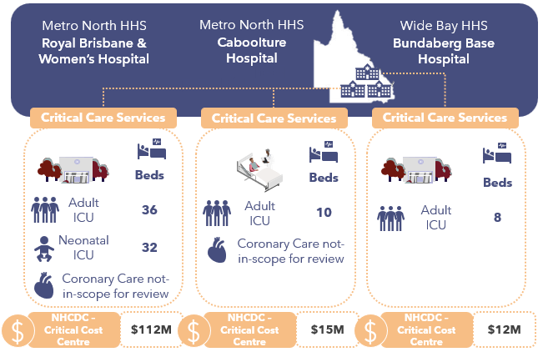
Royal Brisbane and Women’s Hospital (RBWH) is a metropolitan facility in Brisbane. It forms part of Metro North HHS. It is a tertiary service that offers a significant number of statewide highly specialised therapies, including to major trauma and burns patients. Its critical care services include:
Figure 26: Critical care services at Queensland’s participating sites
- A 36-bed Adult ICU staffed with a nursing ratio based on 33 of the beds designated for ICU patients (requiring a 1:1 ratio) and 3 for HDU (2:1 ratio).
- A 32-bed NICU and a separate SCN.
- There is also a dedicated Coronary Care Unit (CCU), but this is reported under Cardiology and information was not captured on the scope of these services.
Caboolture Hospital is a metropolitan facility in Brisbane, situated 44 kilometres north of Brisbane is also part of Metro North HHS. Its critical care services include:
- A 10-bed Adult ICU which offers ICU and HDU services.
- There is also a CCU but this is reported under Cardiology and information was not captured on the scope of these services.
Bundaberg Base Hospital is a regional Queensland hospital and is part of the Wide Bay HHS. Its critical care services include:
- 6-bed Adult ICU
RBWH, Caboolture Hospital and Bundaberg Base Hospital are Level 3 ICU facilities and meet the criteria19F for IHACPA’s ICU adjustment for the NEP.

Critical Care Cost and Activity Reporting
IHACPA provides definitions in its DRS for the reporting of critical care costs and activity. These include:
- The NHCDC Public Sector DRS Critical NHCDC Cost Centre Group contains 10 codes to capture the types of critical care costs: Ccu, Hdicu, Aicu, Cticu, Gencritcare, Nicu, OtherCritCare, Paedicu, Psychicu, Scnicu.
- The ABF Admitted Patient Care DRS contains 2 data items for ICU hours. These are:
  - Length of stay in ICU, defined as the number of hours reported by a hospital with approved Adult ICU Level 3 or Paediatric ICU, and
  - Length of stay in ICU – Other, defined as hours reported by hospitals with approved ICUs other than Level 3 or Paediatric ICU.
Queensland reports critical care hours for facilities that are certified as Level 3 ICU facilities, combining all critical care hours in the Level 3 ICU Hours field. The Other ICU Hours field has not been used for reporting any critical care hours.
In Queensland, levels of ICU are derived from the Clinical Services Capability Framework (CSCF) which is determined by each Hospital and Health Service and may not be contemporary. Queensland is currently reviewing each facility against the ICU criteria, noting that significant hospital capacity and service expansions are planned for many facilities. It is expected that some amendments to reporting may be made to the 2024-25 activity and cost submission, but most changes wouldn’t be implemented until 2025-26.
Facilities/HHS use local mappings from their GL, mapped to cost pools in their local instance of their costing ledger, to map to IHACPA’s Critical NHCDC Cost Centre Groups. They also determine which ICU hours are included in the Level 3 ICU Hours reporting.
The table below shows how the nominated sites map ICU costs and activity to IHACPA’s cost and activity types.
Table 19: Queensland ICU costs and activity mapped to IHACPA cost and activity types
ICU Description | NHCDC Critical Cost Centre | RBHW Hospital |  | Caboolture Hospital |  | Bundaberg Hospital
ICU Description | NHCDC Critical Cost Centre | Costs | Hours | Costs | Hours | Costs | Hours
Adult ICU | Aicu | ✔ | ✔ | ✔ | ✔ | ✔ | ✔
Paediatric ICU | Paedicu | ✖ | ✖ | ✖ | ✖ | ✖ | ✖
Neonatal ICU | Nicu | ✔ | ✔ | ✖ | ✖ | ✖ | ✖
Special Care Nursery | Scnicu | ✔ | ✔ | ✖ | ✔ | ✖ | ✖
Coronary Care Unit | Ccu | ✖ | ✖ | ✖ | ✖ | ✖ | ✖
General Critical Care | Gencritcare | ✖ | ✖ | ✖ | ✖ | ✔ | ✖
Other Critical Care | OtherCritCare | ✖ | ✖ | ✖ | ✖ | ✖ | ✖
HDU / Step Down Care | Hdicu | ✖ | ✖ | ✖ | ✖ | ✖ | ✖
Cardiothoracic ICU | Cticu | ✖ | ✖ | ✖ | ✖ | ✖ | ✖
Psychiatric ICU | Psychicu | ✖ | ✖ | ✖ | ✖ | ✖ | ✖

Queensland does not report any costs under Psychicu, Cticu and Hdicu. Participating sites did not report any hours in OtherCritCare. Neither RBWH or Caboolture recorded CCU costs or activity under the Critical NHCDC Cost Centre Group or captured hours relating to these services. This has been rectified for 2024-25.
The chart below shows the total volume of Level 3 ICU Hours across all Queensland HHSs and at the 3 participating sites.
Figure 27: Volume and percentage of ICU hours, reported by Level 3 ICU Hours, at RBWH, Bundaberg Base Hospital, Caboolture Hospital and all Queensland hospitals
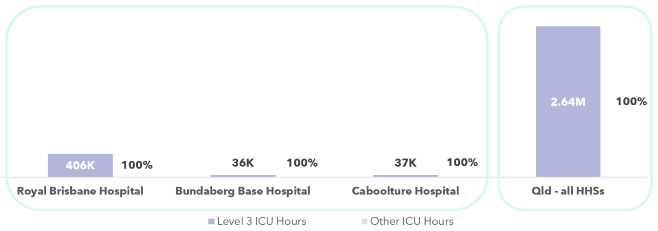

Costs included in the Critical NHCDC Cost Centre Group
The critical care focused review aimed at understanding the resources consumed by patients admitted into the different critical care departments, and identifying how these were allocated to individual patients, and which costs were reported against the Critical NHCDC Cost Centre Group within NHCDC reporting.
In general, Queensland includes the following costs in the Critical NHCDC Cost Centre Group:
- the staffing costs for nurses, medical (only for intensivists operating in ICUs), admin staff allocated to the wards,
- imprest drugs, medical consumables, hotel costs, and overheads.
The resources consumed by patients whilst in critical care departments that are allocated to the patient but reported under a different NHCDC Cost Centre Group (e.g. not Critical) include pathology, imaging, drugs, allied health and other medical costs.
The analysis of NHCDC critical care costs has focused on the AICU and PICU reported costs, as corresponding ICU hours were reported for these episodes. Other critical care costs (such as CCU, NICU, etc.) cannot meaningfully be compared as there is a mismatch in the way that critical care hours and costs for these episodes are reported.
An analysis into the Level 3 ICU Costs Per Hour – defined as Aicu + Paedicu costs, divided by Level 3 ICU Hours, shows the following:
- The Queensland average Level 3 ICU Cost Per Hour is $205.42.
- RBWH average Level 3 ICU Cost Per Hour is $145.07 (30% lower than the state average).
- Caboolture Hospital’s average Level 3 ICU Cost Per Hour is $416.68 (103% higher than the state average)
- Bundaberg Base Hospital’s Level 3 ICU Cost Per Hour is $134.39 (35% lower than the state average). However, it should be noted that under this measure, the hospital’s nursing costs were costed to the Gencritcare cost centre and these costs would not have been included in this measure. Adjusting for this, the average (total cost per ICU hour) would be $337.41, 64% higher than the state average.
Level 3 ICU Hours include ICU hours at non-Level 3 ICU facilities across the state.
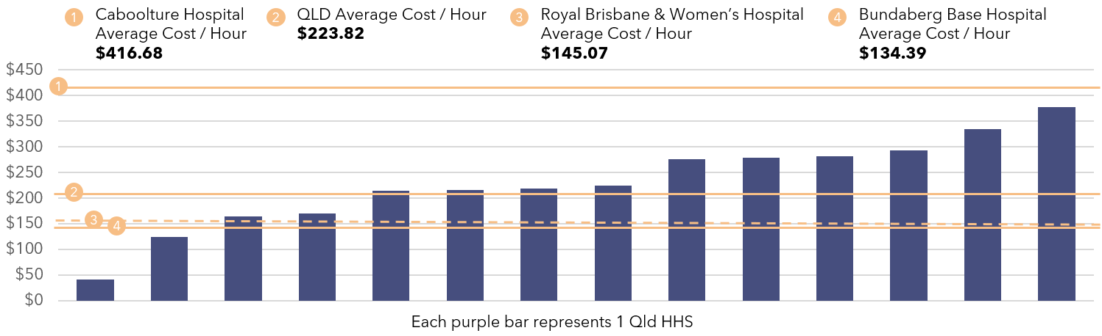
Figure 28: Average Cost per Level 3 ICU Hour in Adult and Paediatric ICU - Queensland
Critical Care – Average Cost Per Hour Insights
- RBWH reported SCN costs under the Scnicu NHCDC Cost Centre.
- More widely, Queensland reported NICU hours in Level 3 ICU Hours, but not SCN Hours.
- CCU is reported under Clinical (Cardiology), not Critical NHCDC Cost Centre Group.

ICU Cost Allocation Methodologies
The tables below show details of the types of expenditure incurred by each ICU site, the allocation methodologies used, and the ultimate Critical NHCDC Cost Centre Group to which these expenditure types map.
Table 20: RBWH Cost Allocation Methodologies
● | Via patient level feeder system | ◕ | Via weighted RVU, to ICU patients
◑ | Using a standard RVU, to ICU patients | ◔ | Across ICU / non-ICU patients

Resources Consumed | Description of Costs | Allocation Methodology & Category | NHCDC Critical Cost Centre Group
Nursing S&W | ICU comprises 163 FTEs (121 of which are RNs). There is no agency, casual usage or behavioural specialling requirements.  NICU includes approximately 94 nursing FTE and small components of agency staff. | Allocation of nursing costs are based on their ICU / hours with a RVU for each bed type, and also whether patients have received specialised services (ventilation hours, ECMO, dialysis). Homer Queensland Interface (HQI) is the feeder system used. This enables variable nursing reflecting different nursing ratios ranging from 1:1 (ICU) to 2:1.  Patients who receive specialised services receive an additional uplift that has been derived through consultation with the ICU team. This information is derived from Metavision system which is entered at point of care.  NICU patients receive a standard RVU based on their NICU hours. Patients in SCN also receive a standard daily RVU with a lower weighting than NICU. | ◕ | Critical
Allied Health S&W | One FTE pharmacist across NICU and ICU, additional assistance provided on a referral basis, with associated costs allocation to Allied Health cost centres. | Ward/profession specific RVUs are allocated to all patients discharged from wards. | ◔ | Allied
Other S&W | Ward Clerk expense. | Allocated based on beddays and ward movements – e.g., admission, discharge, transfer. | ◑ | Critical
Medical S&W (& VMO) | ICU: 12 specialists, 34 registrars, 0.66 FTE locums  NICU: 7.62 specialists, 9.19 fellows, 8.49 registrars, 2 senior house officers. | Allocation of medical costs with RVU weighted for ward code, patients will also receive a share of their medical costs under admitted doctor. | ◑ | Critical (intensivist / neonatologist costs)  Clinical (admitting doctor costs)
Consumables | Specific gases (e.g., Nitric Oxide), and medical supplies, Goods & Services expenses including lines, neuromonitoring and cardiac support devices. | Allocated based on ICU hours. | ◑ | Critical
Imaging | Imaging provided by Queensland DoH. HQI is the system used to capture for inpatient imaging. | Allocated to the patient based on time based RVUs for each imaging service. | ● | Imaging
Pathology | AusLabs for Pathology run by Queensland DoH. | Costs that come through are the unit charges that apply from the pathology department, based on the unit price per test, specific to location/facility. | ● | Pathology
Pharmacy | In ICU an electronic pharmacy system is in place and dispensed drugs are held in a pharmacy cost centre, with imprest drugs costs sitting in ICU cost centre. | Dispensed drugs are allocated at the patient level from a feeder system, with unlinked costs unable to be submitted in the NHCDC as there is no corresponding submitted ABF activity record with which to match.  Imprest drugs are spread to all ICU patients with a higher imprest loading for invasive ventilation, dialysis, and burns. | ◑ / ● | Critical (imprest)  Pharmacy (dispensed)
Hotel | Food services, cleaning and linen sit in ICU cost centre. | Allocated based on Occupied bed days (or part thereof for food). | ◔ | Critical
Overheads | RBWH has centralised patient services including Ward Clerks, Biomedical Technicians. | These are treated as an overhead. Allocated based on total expenditure. Biomedical costs are allocated to the facility but not the cost centre, so there is no specific allocation to ICU for ICU-specific equipment maintenance (e.g., ventilators). | ◔ | Critical

Table 21: Bundaberg Base Hospital Cost Allocation Methodologies
● | Via patient level feeder system | ◕ | Via weighted RVU, to ICU patients
◑ | Using a standard RVU, to ICU patients | ◔ | Across ICU / non-ICU patients

Resources Consumed | Description of Costs | Allocation Methodology & Category | NHCDC Critical Cost Centre Group
Nursing S&W | ICU includes approximately 31 nursing FTE across a range of grades: AIN equipment officer, RNs, CNs plus one Nurse Unit Manager and Clinical Nurse Consultant. | Data from the Trendcare nursing acuity system is used to derive RVUs with following assumptions applied: 2 hours for admission, 90 minutes for discharge, 2 hours for a transfer, plus ratio-based care.  Uplifts are applied for penalty loading – e.g., 1 for day shift, 1.125 for evening, 1.2 for night.  RVUs are updated every year following clinical consultation. | ◕ | Critical
Allied Health S&W | There is a dedicated part of an FTE for pharmacy and other Allied Health specialties are on a referral basis. | Allied health practitioners log activities on PI5 system, based on profession. Where they have an allocation to each ward, this is allocated to a bed day product for ICU and these costs will go to ICU patients in the Allied NHCDC Cost Centre. | ◔ | Allied
Other S&W | 1 ward clerk. | These costs are allocated to a specific Department and applied to the patient based on a weighting derived from the nursing RVU. | ◑ | Critical
Medical S&W (& VMO) | The medical establishment comprises approximately 13 FTE: 3.7 FTE senior medical staff (including locums), 1.79 RMO (shared with anaesthetics), and 7 FTE Registrars. | The following assumptions are applied to allocate medical S&W across ICU: 60 mins to each patient for admission / transfer out; 60 mins for discharge plus  4 hrs per ICU bed day. | ◑ | Critical / Clinical
Consumables | Includes medical supplies, goods & services expenses including lines, neuromonitoring and cardiac support devices. | These costs are allocated to a specific Department and applied to the patient based on a weighting derived from the nursing RVU. | ◑ | Critical
Imaging | Provided by Bundaberg Hospital. | Based on time based RVUs for each imaging test, and each imaging test is linked back to the patient using patient level feeder data. | ● | Imaging
Pathology | AusLabs for Pathology run by Queensland Health. | Reclassed to Pathology cost area.  Costs that come through are the unit charges that apply from the pathology department, based on the unit price per test, specific to location / facility. Cost recovery model. | ● | Pathology
Pharmacy | In ICU an electronic pharmacy system is in place (iPharmacy) and dispensed drugs are held in a pharmacy cost centre. | Dispensed drugs are allocated at the patient level from a feeder system, with unlinked costs costed to unable to be submitted in the NHCDC as there is no corresponding submitted ABF activity record to match to. Imprest drugs are spread to all ICU patients. | ● / ◑ | Pharmacy  (dispensed)  Critical (imprest)
Hotel | Includes linen, cleaning. The majority of food costs remain centrally. | Catering, cleaning are classified as direct costs.  Catering – have a service builder in PPM based on a daily charge per day for cleaning, food and security. If they were admitted at night this charge is modified to account for lower catering costs. | ◔ | Critical
Overheads | Corporate overheads at Bundaberg Base Hospital. | Use a variety of overhead allocation statistics to allocate these costs (e.g., LOS). | ◔ | Critical
Table 22: Caboolture Hospital Cost Allocation Methodologies
● | Via patient level feeder system | ◕ | Via weighted RVU, to ICU patients
◑ | Using a standard RVU, to ICU patients | ◔ | Across ICU / non-ICU patients

Resources Consumed | Description of Costs | Allocation Methodology & Category | NHCDC Critical Cost Centre Group
Nursing S&W | Nursing FTE totalled approximately 35 FTE and included NUM, CNC, Outreach Nurse, Stores Nurse, Clinical Nurse, and RNs. | As per RBWH allocation methodology | ◕ | Critical
Allied Health S&W | There is a dedicated 0.5 FTE for pharmacy and other Allied Health specialties are on a referral basis. | As per RBWH allocation methodology | ◔ | Allied
Other S&W | Ward clerk position. | As per RBWH allocation methodology | ◑ | Critical
Medical S&W (& VMO) | Includes 12 FTE, of which 6 staff were intensivists. | As per RBWH allocation methodology | ◑ | Critical / Clinical
Consumables | Medical supplies, Goods & Services expenses including lines, neuromonitoring and cardiac support devices. | As per RBWH allocation methodology | ◑ | Critical
Imaging | Radiology provided by iMed. Patient level feeder files are provided. | As per RBWH allocation methodology | ● | Imaging
Pathology | Pharmacy services delivered by hospital. | As per RBWH allocation methodology | ● | Pathology
Pharmacy | Pharmacy services delivered by hospital. | As per RBWH allocation methodology | ● / ◑ | Pharmacy  (dispensed)  Critical (imprest)
Hotel | Cleaning, linen and food services delivered by Caboolture Hospital. | As per RBWH allocation methodology | ◔ | Critical
Overheads | Caboolture Hospital has centralised patient services including Ward Clerks, Biomedical Technicians. | As per RBWH allocation methodology | ◔ | Critical

The chart below shows the composition of costs within the Critical NHCDC Cost Centre Group:
- RBWH, Caboolture Hospital and Bundaberg Hospital Critical costs totalled $112 million, $15 million and $12 million respectively of Queensland’s $756 million costs in the Critical NHCDC Cost Centre Group
- S&W (Medical, Nursing, Allied Health and Other) comprises approximately 85% of the cost centre (statewide). Staffing is the dominant cost driver.
- RBWH’s nursing costs were in line with the statewide average for nursing costs with a slightly lower proportion of medical costs (20.3% versus 21.7%) within Critical than the state average.
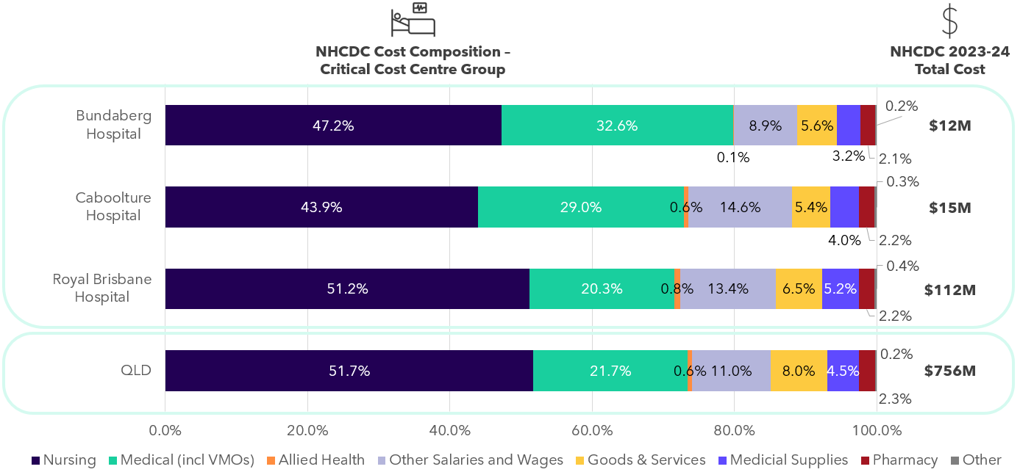
Both Bundaberg and Caboolture Hospital had a significantly higher proportion of medical staff (32.6% and 29% versus statewide average of 21.7%) offset by a lower proportion of nursing staff (47.2% and 43.7% versus statewide average of 51.7%). This suggests these hospitals with smaller ICU departments may rely more heavily on medical staff, possibly due to service models or staffing structures.
Figure 29: Total Critical Costs at NHCDC line item level - Queensland
Critical Care Comparability cost insights
- All 3 of Queensland’s sites use a combination of ICU hours and feeder data from the nursing roster system to allocate costs to patients admitted in critical care departments. This enables a more accurate cost allocation methodology as it reflects the nursing costs for patients with higher care needs.
- All 3 sites had dedicated allied health support but these costs were allocated to the Allied NHCDC Cost Centre Group, not Critical. Queensland’s treatment is in line with other jurisdictions.
- Pharmacy, pathology and imaging costs are sitting in the Pharmacy, Pathology and Imaging NHCDC Cost Centre Groups respectively, not Critical. Queensland’s treatment is in line with other jurisdictions.
- Queensland has specific feeder data for ECMO, highly specialised burns patients, so there is a differentiation in how these patients are costed to account for higher level nursing care and consumables.
- At Royal Brisbane Hospital and Caboolture Hospital, patients are admitted to ICU under the admitting clinical care team, not the intensivist. As a result, they receive double allocations of medical costs. This may driver higher Medical S&W costs than a patient under a hospital where the care model is to admit to ICU under the intensivist (as is the case in Bundaberg Base Hospital).
- All sites reported that ICU staff perform activities outside of the ICU unit or not delivering care to ICU patients, including MET calls, anaesthetics cover, outreach to other wards. These costs are spread to ICU patients, potentially overstating their Medical / Nursing S&W costs. Further work is ongoing to capture clinician time on these activities.

Western Australia

State-wide costed NHCDC 2023-24 submission
6
Health Services incl. PathWest
$8.17bn
Total costs submitted to NHCDC
37
Facilities submitting data to the NHCDC in 2023-24
$7,764
Average cost per GWAU (excl. Community MH)
At a glance: WA
Western Australia (WA) submits costed activity for 6 Health Service Providers (HSPs) including PathWest as part of the NHCDC.
Total costs submitted by WA in 2023-24 were $8.17 billion and 4.50 million episodes.20F
The same scope of activity that was applied in the Cost Driver analysis has also been applied in this section. Costs for ABF hospitals and selected activity streams in WA in 2023-24 were $7.05 billion. WA is the fourth largest contributor to the NHCDC nationally.
The total number of costed ABF hospital episodes in 2023-24 was 4.21 million, representing a growth of 6.6% since 2022-23. WA ABF hospital episodes make up 9.7% of national ABF episodes for 2023-24.
WA delivered 0.91 million GWAU in 2023-2421F, representing 8.8% of weighted activity nationally, with a growth of 5.7% since 2022-23.
The average cost per GWAU in WA was $7,764 in 2023-24, representing growth of 2.2% since 2022-23.
Overall, WA has had notable growth in episodes (6.6%) and a slightly lower GWAU growth (5.7%) indicating a slightly lower patient complexity.
In addition to the above changes, cost growth per GWAU in the range of 3-4% is expected in the context of an inflationary environment and year-on-year EBA wage rises for healthcare workers. WA’s average cost per GWAU growth of 2.2% is lower than this, which may indicate a level of cost containment in 2023-24. As a result of an inquiry into patient safety during 2021-22, WA committed to adopting statewide nursing ratios and an increase to other frontline workforce roles. This commenced in the Perth Children’s Hospital in early 2023-24 and has continued to be rolled out statewide during 2023-24 and 2024-25. This is expected to result in increased workforce FTE and costs.22F

Cost Driver analysis by activity stream
Analysis was undertaken on the NHCDC 2023-24 submission to understand how submitted activity and cost have changed since 2022-23 and whether any drivers of change could be identified. This analysis considered a subset of the submitted cost data, focusing on 5 key activity streams:
- Admitted acute,
- Non-admitted care,
- Subacute and non-acute care,
- ED care and,
- Mental health care (with mental health split by admitted and community).
A summary of the activity and costs across all streams except community mental health is presented in the sections below. In this analysis, GWAU was used as a standardised activity unit, accounting for the relative complexity and resource intensity associated with treating patients. Furthermore, the results below are related to activity and cost submitted for ABF hospitals only unless stated otherwise.

Figure 30: Growth in activity, GWAU and total cost for WA 2023-24
2023-24 GWAU
(and growth)
2023-24 costs
(and growth)
2023-24 Episodes
(and growth)

Figure 31: Average cost per GWAU - WA
Average cost per GWAU
Average costs / GWAU
3.6%
-11.1%
5.2%
2.5%
^Community mental health GWAU was not available as it was not priced in 2023-24. WA submitted admitted mental health at episode, not phase level and therefore cost per GWAU could not be calculated.
No Mental Health average cost per GWAU available.†‡
Key findings by stream include:
Table 23: Key findings by stream in WA
Admitted acute | - The admitted acute stream is the most resource intensive stream in a hospital. In 2023-24, there were over 642,000 costed acute episodes increasing 5.5% from the prior year. The growth in GWAU of 4.3% was slightly lower, reflecting a slight reduction in the average casemix complexity between 2022-23 and 2023-24.  - Admitted acute episodes made up 15.3% of total episodes across the streams analysed for 2023-24, but account for 63.5% of total costs with approximately $4.5 billion submitted. This was an increase of 6.9% compared to 2022-23.  - This resulted in an increase to the average cost per GWAU of 2.5% in 2023-24, meaning that cost growth was relatively contained given expected inflationary increases from year-to-year. It was noted during the jurisdictional review meeting that increases in average cost per GWAU varied across WA HSPs due to several reasons:  - Lower growth in the average cost per GWAU was observed in WA Country Health Service (-0.3% reduction in average cost per GWAU) reflecting a reduction in agency staffing usage as they managed nursing ratios with available staff.  - Higher growth in the average cost per GWAU was observed for Child and Adolescent Health Service (CAHS) which had an 8.4% increase. This was understood to be driven by an increase in the workforce (and hence workforce costs) resulting from an inquiry into patient safety during 2023-24.
Emergency Department | - The ED stream represented 18.7% of total episodes, with approximately 786,000 costed separations submitted for 2023-24, representing an increase of 3.3% compared to 2022-23. Growth in GWAU was slightly higher, increasing 4.4% compared to the previous year.  - The cost to deliver ED services increased in 2023-24, with the average cost per GWAU for ED increasing by 5.2%. Correspondingly, this meant that total submitted costs increased over and above the increase in activity volumes, growing by 9.8% in 2023-24.  - As with admitted acute, a significant increase in the average cost per GWAU was observed for CAHS (17.7%). This was understood to be driven by an increase in the workforce (and hence workforce costs) resulting from an inquiry into patient safety during 2023-24. In addition to the increasing workforce costs, the increase in the average cost per GWAU was also partially due to reduced ED presentation. The reduced ED presentations were thought to be due to activity being delivered in the other HSPs rather than through the specialised children’s health service.
Non-admitted | - The non-admitted stream makes up the largest proportion of submitted episodes, with 2.8 million service events in 2023-24. This was an increase of 7.8%. The volume of GWAU also increased over the same period, with a growth rate of 6.3%.  - Total submitted costs increased by 10.1% in 2023-24, corresponding to an increase in the average cost per GWAU of 3.6%. This was within an expected range given inflationary pressures year-on-year.  - It was also indicated in the WA jurisdictional meeting that refinements were made to the costing of non-admitted activity in 2023-24 to include costs for ‘Did Not Attend’ (DNA) patients, following guidance from IHACPA. WA had previously allocated these costs to dummy records based on DNA service events and excluded them from reporting. After discussion with IHACPA, these costs were instead spread across all attended non-admitted patients which have contributed to the increase in average costs for the non-admitted stream.
Subacute | - The subacute stream is relatively small, with 13,300 episodes submitted for 2023-24, making up only 0.3% of episodes. However, this represented an increase of 9.8% compared to the prior year, with an even more significant increase in GWAU of 23.4% in 2023-24. This reflects a higher average casemix complexity, which was thought to relate to an increase in maintenance care for patients awaiting placement in nursing homes.  - Total costs in subacute grew by 9.6%, meaning that despite the significant increase in GWAU, the average cost per GWAU decreased by 11.1%.
Admitted mental health  (episode-level only, not phase-level) | - WA only submitted episode level data for admitted mental health, with approximately 12,200 episodes submitted in 2023-24 across all facilities (including non-ABF hospitals), representing a slight reduction of 1.9%. GWAU was not available for this stream as part of this analysis.  - The total submitted costs (all facilities including non-ABF) were approximately $472 million, growing by approximately 9.1% compared to 2022-23, which meant the average cost to deliver admitted mental health services (measured as an average cost per episode) increased by 11.2%.
Community mental health  (episode-level only, not phase-level) | - Similarly to admitted mental health, community mental health was only submitted at an episodic level.  - Community mental health activity is not restricted to ABF hospitals (unlike the rest of the Cost Driver analysis), and the number of episodes submitted 2023-24 for all facilities increased only marginally by 0.9% compared to 2022-23. Community mental health was not ABF priced in 2023-24 and hence GWAU was not considered in this analysis.  - Submitted costs increased significantly by 18.6% compared to 2022-23 resulting in a similarly large increase in the average cost per episode of 17.5% compared to 2022-23.

WA Costing Summary

WA costing process
The WA Department of Health (WA Health) co-ordinates clinical costing for the state’s 5 HSPs and is responsible for the preparation of WA’s NHCDC submission. The costing system used in WA for 2023-24 was PPM2, with a plan to move to PPM3 in 2025-26 costing cycle.
Patient level costing is undertaken by costing teams at a HSP level, using a statewide instance of PPM2.
WA have their own costing guidelines providing HSPs with local application to comply with the AHPCS v4.2. There is a statewide, centralised Unique Record Number (URN) database and a PAS covering all hospital care, supporting linking in the costing process. There is also a standard chart of accounts in use across WA.
Health Support Services (HSS) is the shared service centre for WA’s health system and is responsible for providing activity extracts for WA’s HSPs. HSS performs validity checks on activity data monthly against agreed data standards such as ensuring completeness and logic checks. On a monthly basis, HSS also informs the HSPs of new cost centres to include in their reference files. HSS manages the statewide feeder system data for allied health, theatre, pathology, pharmacy, and imaging. HSS collate and provides all source information and feeder system data to each HSP costing team, for them to validate and import into PPM2.
Local costing teams at each HSP perform the costing process and conduct their own QA on the outputs. Costing is performed quarterly for some sites to meet their local needs and annually for others (and for the purposes of NHCDC). Each HSP is required to submit a formal sign off on the costed outputs at the Chief Executive level. WA Health coordinates the process, performs QA checks using a year-on-year analysis of cost outputs and reconciliations to central data sources, and ultimately submits the final output to IHACPA.
WA has implemented the following change for the 2023-24 year:
- Refinement to costing of non-admitted activity to include costs for DNA patients, following guidance from IHACPA. WA had previously allocated these costs to dummy records based on DNA service events and excluded them from reporting. After discussion with IHACPA, these costs in 2023-24 were spread across all attended non-admitted patients.
WA has reported variance from AHPCS v4.2 in the following areas:
- WA is not fully compliant with costing guidelines for TTR as these costs are currently calculated using a methodology from a 2010-11 survey to all staff to capture estimated research activity and teaching time. This survey is used to derive a TTR percentage of Medical S&W costs for each facility which are excluded from the annual submission to IHACPA.
- WA currently excludes the cost of blood products from submissions.
WA identified unexpected negative prosthetics costs for rehabilitation patients at Fiona Stanley Hospital. Investigation revealed these costs were incorrectly journalled from a rehabilitation cost centre (in-scope for ABF) instead of the correct block-funded cost centre within the GL. The misposting created a negative expense without a matching positive cost entry in the costing ledger. IHACPA excluded negative cost amounts in affected records. WA is reviewing appropriate treatment of these costs in 2024-25.

WA structural arrangements and inclusion in costing outputs
WA has shared services arrangements for several clinical and corporate expenses:
- HSS provide statewide services for human resources (HR), payroll, finance, procurement and IT. They also provide support for the costing software in place in WA and provide data extracts for costing. The costs of these services are charged onto the HSPs.
- PathWest is the state provider of pathology services to HSPs, and they also provide pathology services in non-ABF settings, including to prisons and forensic facilities. Only activity and costs related to hospital activity is allocated in the costing process.
PathWest operates as a standalone HSP. It charges HSPs monthly via an intra-health invoice for services provided using an agreed rate card based on the PBS price per test. The costs allocated to HSPs capture the operational costs of the relevant services.
There are some other services provided by WA Health where no costs are passed onto HSPs or allocated to patients in the costing process. These include:
- Blood Products
- Royal Flying Doctors retrieval (ambulance) services
Food, cleaning and linen, pharmacy, and imaging are mostly provided in-house by HSPs.

Contacted care costs included in costed records
- There are several contracted care arrangements within WA, with 119,878 episodes (across all streams) and reported costs of $104.75 million in 2023-24. These were costed at a service encounter level at the agreed price with individual private hospitals, with the costs reported under the Goods & Services line item. The average cost per GWAU for contracted activity in WA was $5,410, 31% lower than non-contracted care. This contracted activity is mainly WA’s outsourced model for dialysis which is used for lower acuity patients that are expected to require less monitoring after the treatment. More complex, older patients are treated in the admitted hospital setting and not contracted. As a result, the services are delivered at a discount to the NEP.
- In addition, WA also had substantial contracted care arrangements at Public-Private Partnerships (Joondalup, Midland, and Peel hospitals) for delivery of a range of hospital services. The costs of these services are not reported and have historically been excluded from the NHCDC including the 2023-24 period.
Comparability of WA’s costing outputs to other states
- WA does not submit PPP contracted care delivery at Joondalup, Midland or Peel hospitals.
- Royal Flying Doctors Retrieval Services and Patient Transport are not included in costing, differing to other states and territories.
- Not all hospitals operate under shared service arrangements for food, linen, and cleaning. Some hospitals deliver these services by salaried staff and recorded under the Other S&W line item within the Hotel NHCDC Cost Centre Group. This may result in a different cost structure compared to other jurisdictions, where such expenses are typically classified under Goods & Services.
- WA only submitted admitted mental health data at the episode level, not the phase level.

Corporate costs included in costed records
The AHPCS v4.2 provide guidance on the inclusion of corporate overhead expenses. Business Rule 3.1C.3.2 states that ‘corporate overhead expenses should not be included for more than one level above the management of the hospital. Expenses related to the direct management of the LHN (Local Health Network) or corporate management are within scope.’ The table below shows how WA HSPs, the WA equivalent of an LHN, are treating corporate costs and allocating them to patients in the costing process. Some costs are appropriately not allocated where they do not meet the definition above.
Table 24: WA HSP treatment of corporate costs and patient allocation costing process
Type of corporate cost | Details of whether these are passed onto HSPs | Included in patient level costing | In line with the guidance in the AHPCS
Corporate costs at the facility | Included in HSP GL | ✔ | ✔
Corporate costs at the HSP | Included in HSP GL | ✔ | ✔
Corporate costs at share service functions | HSS do not on-charge corporate overheads to HSPs. | ✖ | ✔
Corporate costs at share service functions | PathWest on-charges operational overhead costs (i.e., to run the laboratory). | ✔ | ✔
Corporate costs at WA Health | Not allocated to HSP | ✖ | ✔

Reconciliation from GL to submitted costs
One WA HSP participated in the IFR: North Metropolitan Health Service (North Metropolitan HS). This section discusses major variances, reconciling items and adjustments from the GL of the participating site from WA, through to the costed products submitted to IHACPA in the NHCDC submission.

Reconciliation from GL to NHCDC – North Metropolitan Health Service
WA’s total reported costs were $8.17 billion (representing 10.7% of national costs).
- North Metropolitan HS’s GL was $2.71 billion.
  - Their submitted costs to the NHCDC were $1.87 billion (representing 22.8% of WA costs).
  - Overall, North Metropolitan HS submitted 69% of their GL to the NHCDC.
  - $838 million (31% of GL) were not included in NHCDC submissions for a variety of reasons including being out-of-scope, or an inability to link costs and activity due to unmatched data.
Figure 32: Waterfall from GL to NHCDC submitted costs – North Metropolitan Health Service

This section discusses adjustments from the GL of North Metropolitan HS, through to the costed products ($) submitted to IHACPA in the NHCDC submission.
- Non-ABF – North Metropolitan HS removed costs related to non-ABF service delivery or costs that were not in-scope for the costing year. These totalled $285 million, comprising:
  - $63 million for out-of-scope services including public health ($31 million), domiciliary care services ($8 million), and funds held in special purpose accounts for research ($12 million).
  - WIP movements totalling $151 million.
- Jurisdiction exclusions – North Metropolitan HS has excluded $495 million of costs relating to the Joondalup Health Campus, who they have a PPP arrangement with. WA does not submit costs relating to these public patients for this site. There was an additional $5 million TTR costs that were not submitted to the NHCDC.
- Other exclusions – totalled $53 million. These are made up of both out-of-scope costs and excluded costs that are within the scope of the NHCDC and could not be matched to a record. The exclusions are made up of:
  - $12 million aggregate level outpatient services,
  - $0.57 million for boarders, and
  - $34 million in unlinked cost records that could not be matched to activity.

ICU and Critical Care Focused Review
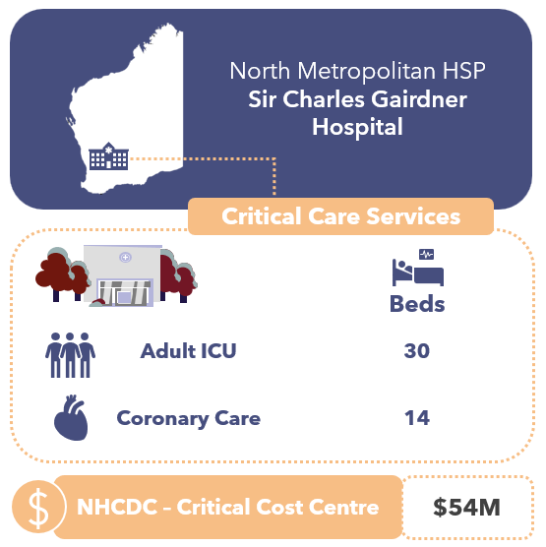
Sir Charles Gairdner Hospital (SCGH) is a metropolitan facility in Perth. Its critical care services include:
Figure 33: Critical care services at Western Australia’s participating site
- A 30-bed ICU providing specialised care for patients requiring life support and advanced therapies, including those recovering from cardiac surgery, neurosurgery, and liver transplants.
- A 14-bed CCU.
Staff reported that approximately 10-20% of medical staff time and 10% of nursing resource is consumed doing activities outside of ICU admitted patient care, including:
- MET calls;
- Non-admitted follow up clinic appointments post ICU discharge;
- A TPN non-admitted service;
- Tracheostomy round to inpatients across all wards;
- Retrieval phone/video assessments;
- Organ tissue service;
- Participation in research and clinical committees
The CCU nurse unit manager and medical staff covers both the CCU and cardiology ward, with the nurses rostered separately between the 2 areas. Approximately half their patients are estimated to require continuous observation or specialling services, provided by AIN, security staff or mental health trained nurses.
SCGH is a Level 3 ICU facility and meets the criteria23F for IHACPA’s ICU adjustment for the NEP. The hospital does not have an eMR system and uses a paper-based system.

Critical Care Cost and Activity Reporting
IHACPA provides definitions in its DRS for the reporting of critical care costs and activity. These include:
- The NHCDC Public Sector DRS Critical NHCDC Cost Centre Group contains 10 codes to capture the types of critical care costs: Ccu, Hdicu, Aicu, Cticu, Gencritcare, Nicu, OtherCritCare, Paedicu, Psychicu, Scnicu.
- The ABF Admitted Patient Care DRS contains 2 data items for ICU hours. These are:
  - Length of stay in ICU, defined as the number of hours reported by a hospital with approved Adult ICU Level 3 or Paediatric ICU, and
  - Length of stay in ICU – Other, defined as hours reported by hospitals with approved ICUs other than Level 3 or Paediatric ICU.
One of the findings of this IFR was that the definitions and guidance for both Critical NHCDC Cost Centres and ICU hours require clarity and alignment to each other, as they are treated differently by every jurisdiction. This section of the report seeks to provide information on how WA is reporting this information, noting there is ambiguity in the current definitions.
WA reports all ICU and PICU hours as Level 3 ICU Hours if a facility is a designated Level 3 facility. CCU hours and NICU hours are excluded from ICU hours reporting, but costs are reported against these Critical NHCDC Cost Centres.
Table 25: WA ICU costs and activity mapped to IHACPA cost and activity types
ICU Description | Critical NHCDC Cost Centre | Reported as ICU Hours (type determined by facility Level 3 status)
Adult ICU | Aicu | ✔
Paediatric ICU | Hdicu | ✔
HDU / Step Down Care | No services meeting this description delivered in WA | ✖
Coronary Care Unit | Ccu | ✖
General Critical Care | WA does not report costs under Gencritcare - no services meeting this description delivered in WA | ✖
Other Critical Care | WA does not report costs under OtherCritCare - no services meeting this description delivered in WA | ✖
Neonatal ICU | Nicu | ✖
Special Care Nursery | WA does not report costs under Scnicu - no services meeting this description delivered in WA | ✖
Cardiothoracic ICU | WA does not report costs under Cticu - no services meeting this description delivered in WA | ✖
Psychiatric ICU | WA does not report costs under Psychicu - no services meeting this description delivered in WA | ✖

WA only reports costs under 4 of the 10 Critical NHCDC Cost Centres (Aicu, Ccu and Nicu) and does not report any costs under Hdicu, Cticu, Gencritcare, OtherCritCare, Paedicu, Psychicu, Scnicu.
WA does not include NICU, SCN, CCU hours, Close Observation Unit hours or Psychiatric ICU hours in their ICU hours reporting to IHACPA.
The chart below shows the total volume of ICU and PICU reported hours across all WA HSPs and at the participating site, SCGH, represents 15% of all ICU hours in WA. All WA HSPs report all ICU hours under Level 3 ICU Hours.
Figure 34: Volume and percentage of ICU hours, reported by Level 3 ICU Hours and Other ICU Hours, at SCGH and all WA hospitals
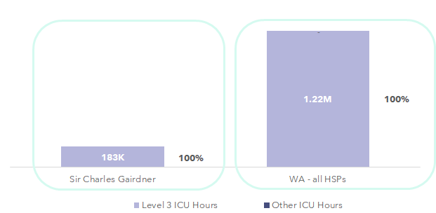

Costs included in the Critical NHCDC Cost Centre Group
The Critical Care Focused Review aimed at understanding the resources consumed by patients admitted into the different critical care departments, and identifying how these were allocated to individual patients, and which costs were reported against the Critical NHCDC Cost Centre Group within NHCDC reporting.
In general, WA includes the following costs in the Critical NHCDC Cost Centre Group:
- The staffing costs for nurses, medical (only for intensivists operating in ICUs), admin staff allocated to the wards,
- Imprest drugs, medical consumables, hotel costs and overheads.
The resources consumed by patients whilst in the ICU / critical care departments that are allocated to the patient but reported under a different NHCDC Cost Centre Group (e.g. not Critical) include pathology, imaging, drugs, allied health and other medical costs.
The analysis of NHCDC critical care costs has focused on the Adult ICU and Paediatric ICU reported costs, as corresponding ICU hours were reported for these episodes. Other critical care costs (such as CCU, NICU, etc.) cannot meaningfully be compared as no critical care hours for these episodes are reported. WA reports NICU hours as ‘ICU Hours’ and for Perth Children’s Hospital they report both Paediatric and Neonate under ICU hours. Splitting out the Paediatric information has not been possible for 2023-24 and the below represents Adult ICU only (i.e. exclusive of data from Perth Children’s Hospital. For 2024-25 WA assures this mapping will be better aligned with the national standards.
An analysis into the Level 3 ICU Costs Per Hour – defined as Aicu + Paedicu costs, divided by Level 3 ICU Hours, shows the following:
- Overall, there is significant variation in average Adult ICU Costs Per Hours across WA, ranging from $230.55 to $575.82. This is indicative of either significant differences in clinical practice in each ICU, or differences in how costs or hours are reported by each HSP.
- The WA average Level 3 ICU Cost Per Hour is $275.07
- SCGH’s average Level 3 ICU Cost Per Hour is $255.43 (7% higher than the state average).
- WA Country’s average Level 3 ICU Cost Per Hour is $575.82 (109% higher than the state average).
Figure 35: Average Cost per L3 ICU Hour (for HSPs reporting ICU costs and hours) – WA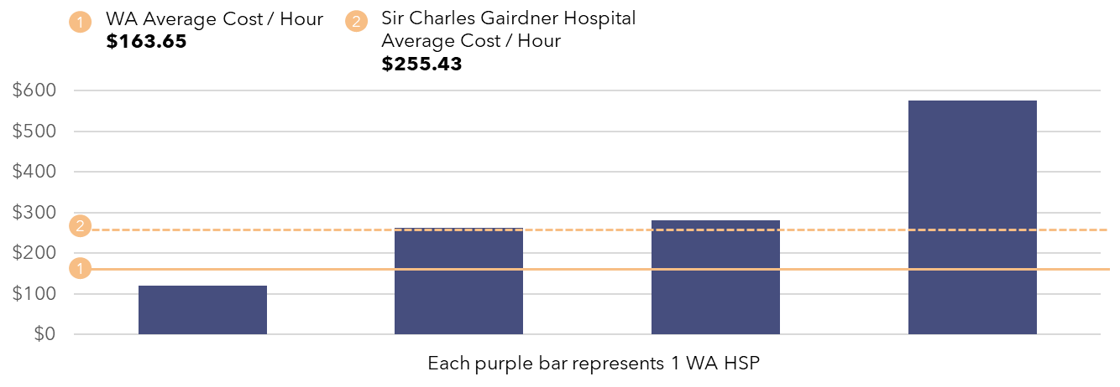
Critical Care – Average Cost Per Hour Insights:
- There is a mismatch between the critical care costs and activity reported to IHACPA in WA.
- WA reports NICU costs and CCU costs under the Critical NHCDC Cost Centre Group but does not report these hours under Other ICU Hours.
- Paediatric ICU costs were reported under Hdicu NHCDC Cost Centre not Paedicu Cost Centre in 2023-24. Future submissions will be mapped to Paedicu.
- Some costs incurred during an ICU stay (allied health, drugs, imaging and pathology) do not flow through to the Critical NHCDC Cost Centre Group. This is in line with other states and territories.
- In SCGH’s ICU patients remain admitted under the care of their specialty doctor, not the intensivist. As a result, they may have higher Medical S&W costs due to receiving allocations of both intensivist and admitting specialty doctor costs for the duration of their ICU stay.

ICU Cost Allocation Methodologies
The tables below show details of the types of expenditure incurred at SCGH, the allocation methodologies used, and the ultimate Critical NHCDC Cost Centre Groups to which these expenditure types map.
Table 26: SCGH Cost Allocation Methodologies
● | Via patient level feeder system | ◕ | Via weighted RVU, to ICU patients
◑ | Using a standard RVU, to ICU patients | ◔ | Across ICU / non-ICU patients

Resources Consumed | Description of Costs | Allocation Methodology & Category | NHCDC Critical Cost Centre Group
S&W Nursing | Approximately 175 FTE nursing staff in ICU and 41 FTE in CCU.  Where patients require specialling (more frequently in CCU than ICU), these are sourced via agency. | Spread to all patients within ICU cost centre based on ICU hours. | ◑ | Critical
S&W Allied Health | 4 pharmacists, 0.5 FTE social work and physiotherapy dedicated resources to ICU. | Allied Health practitioners document interventions minutes in the PAS system that is used to allocate to patients. | ◕ | Allied
S&W Other | Ward clerk (1 FTE) and receptionist (1 FTE). | Spread to all patients within ICU cost centre based on ICU hours. | ◑ | Critical
S&W Medical (& VMO) | ICU staffing includes 3.5 consultant intensivists and 20 registrars, as well as resident support.  CCU staffing sit within specialty medical cost centre in GL. | Spread to all patients within ICU cost centre based on ICU hours. | ◑ | Critical (ICU)  Clinical (CCU)
Consumables | Includes medical supplies, goods & services expenses including lines, neuromonitoring and cardiac support devices. | Spread to all patients within ICU cost centre based on ICU hours. | ◑ | Critical
Imaging | Imaging services provided by SCGH. | Allocated using feeder data of actual tests per patient. | ● | Imaging
Pathology | Provided by PathWest | Allocated using feeder data of actual tests per patient. | ● | Pathology
Pharmacy | Prescribed drugs to patients using electronic prescribing system.  Some commonly used drugs are also held in imprest within ICU and CCU areas. Pharmacist costs sit in pharmacy cost centre. | Imprest component is spread to all ICU patients based on ICU hours.  For dispensed drugs, ICU patients receive RVU based on PBS price schedule and actual drugs dispensed at a patient level. Residual amounts spread as pharmacy overhead. | ● / ◑ | Pharmacy  (dispensed)  Critical  (imprest)
Hotel | Includes cleaning, food, and linen, as well as agency nursing staff at AIN grade. | Allocated using general allocation statistics, appropriate for each expense type (e.g. occupied bed days). | ◔ | Critical
Overheads | Corporate costs, biomedical engineering costs relating to maintenance, repairs (materials and labour costs). | Allocated using general allocation statistics for each expense type (e.g. occupied bed days), S&W expense. | ◔ | Critical

The chart below shows the composition of costs within the Critical NHCDC Cost Centre Group:
- SCGH’s Critical costs totalled $54 million of WA’s $237 million costs in the Critical NHCDC Cost Centre Group
- SCGH had a slightly higher proportion of nursing costs (48.8% versus 44.3%) and medical costs (22.2% versus 19.5%) within Critical than the state average. It is possible that this reflects a higher acuity casemix at SCGH compared to the rest of the state.
Figure 36: Total Critical Costs at NHCDC line item level - WA
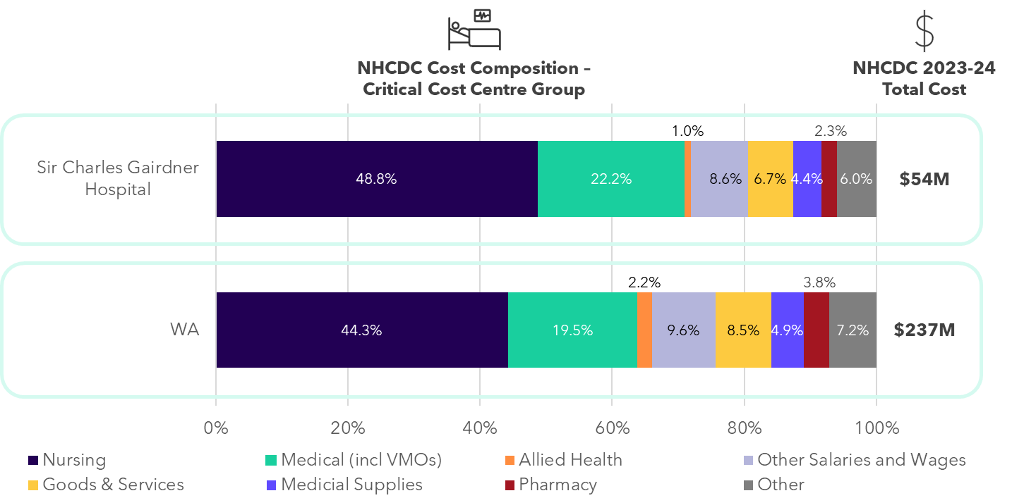
Critical Care Comparability cost insights:
- SCGH allocates ICU costs based on a patient’s ICU hours, with no differentiation in cost allocation for patient acuity levels.
- SCGH has dedicated allied health support in the ICU ward and these costs were allocated to the Allied NHCDC Cost Centre Group, not Critical. Western Australia’s treatment is in line with other jurisdictions.
- Pharmacy, pathology, and imaging costs are sitting in the Pharmacy, Pathology, and Imaging NHCDC Cost Centre Groups respectively, not Critical. Western Australia’s treatment is in line with other jurisdictions.
- ICU staff perform activities outside of the ICU unit or not delivering care to ICU patients. These costs are spread to ICU patients, potentially overstating their Medical and Nursing S&W costs.
- In WA, nursing agency at the AIN grade is costed to the Hotel line item instead of Nursing S&W or Goods & Services. Whilst not a significant cost for ICU and CCU, this would be different to other jurisdictions’ costing practice for these costs.

South Australia

State-wide costed NHCDC 2023-24 submission
5
Local Health Networks
$6.23bn
Total costs submitted to NHCDC
45
Facilities submitting data to the NHCDC in 2023-24
$7,253
Average cost per GWAU (excl. Community MH)
At a glance: SA
South Australia (SA) submits costed activity for 5 LHNs as part of the NHCDC.
Total costs submitted by SA in 2023-24 were $6.23 billion for 3.33 million episodes.24F
The same scope of activity that was applied in the Cost Driver analysis has also been applied in this section. Costs for ABF hospitals and selected activity streams in SA in 2023-24 were $5.96 billion. SA is the fifth largest contributor to the NHCDC nationally.
The total number of costed ABF hospital episodes in 2023-24 was 3.23 million, representing a growth of 13.1% since 2022-23. SA ABF hospital episodes make up 7.4% of national ABF episodes for 2023-24.
SA delivered 0.82 million GWAU in 2023-2425F, with a growth of 6.3% since 2022-23. SA ABF hospital GWAU represents 7.9% of national weighted activity for 2023-24.
The average cost per GWAU in SA was $7,253 in 2023-24, representing growth of 5.1% since 2022-23.
Overall, SA has had considerable growth in episodes (13.1%) matched by lower growth in GWAU (6.3%). The growth in episodes is both an increase in the reporting of activity (non-admitted and mental health) and an increase in the volume of activity that has been delivered. A shift towards lower patient complexity in mental health and improved reporting in mental health & non-admitted care type have contributed to the lower growth rate in GWAU.
Cost growth per GWAU in the range of 3-4% is expected in the context of an inflationary environment and year-on-year EBA wage rises for healthcare workers. SA’s growth of 5.1% is slightly higher which could be due to factors including higher EBA rises or one-off incentive payments; higher costs associated with a different workforce mix or increased use of agency/casuals; or other operational drivers of higher costs.

Cost Driver analysis by activity stream
Analysis was undertaken on the NHCDC 2023-24 submission to understand how submitted activity and cost have changed since 2022-23 and whether any drivers of change could be identified. This analysis considered a subset of the submitted cost data, focusing on 5 key activity streams:
- Admitted acute,
- Non-admitted care,
- Subacute and non-acute care,
- ED care and,
- Mental health care (with mental health split by admitted and community).
A summary of the activity and costs across all streams except community mental health is presented in the sections below. In this analysis, GWAU was used as a standardised activity unit, accounting for the relative complexity and resource intensity associated with treating patients. Furthermore, the results below are related to activity and cost submitted for ABF hospitals only unless stated otherwise.
Figure 37: Growth in activity, GWAU and total cost for SA 2023-24
2023-24 costs
(and growth)
2023-24 Episodes
(and growth)
2023-24 GWAU
(and growth)

Figure 38: Average cost per GWAU - SA
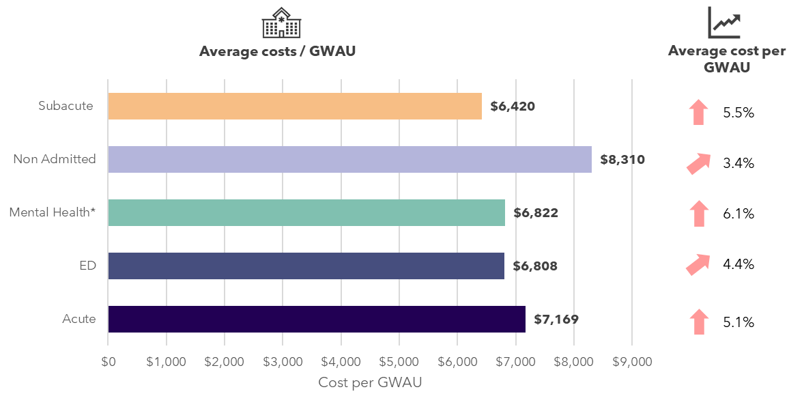
*Mental health analysis includes admitted only. Community mental health GWAU was not available as it was not priced in 2023-24
Key findings by stream include:
Table 27: Key findings by stream in SA
Admitted acute | - The admitted acute stream is the most resource intensive stream in a hospital. In 2023-24, there were approximately 436,000 costed episodes with almost 80% of episodes delivered across the 4 metropolitan LHNs. Episodes increased 4.1% from the prior year, while growth in GWAU was slightly lower (3.4%), which could indicate a slightly lower patient complexity between the 2 years.  - Although admitted acute episodes made up 14% of total episodes for 2023-24, it accounted for 57% of total costs with $3.39 billion submitted. This was an increase of 8.6% compared to 2022-23.  - As a result, average cost to deliver services to the same casemix of patients (as measured by average cost per GWAU) increased by 5.1% between 2022-23 and 2023-24.
Emergency Department | - The ED stream represented 18.7% of total costed activity, with approximately 603,000 costed separations submitted for 2023-24, an increase of 1.0% compared to 2022-23. Growth in GWAU was slightly higher at 2.3%, indicating a slightly more complex casemix of patients presenting to ED for the year.  - The average cost per GWAU for ED increased by 4.4%. Total costs grew by over and above the increase in activity volumes, increasing by 6.8% in 2023-24.
Non-admitted | - The non-admitted stream makes up the largest proportion of submitted service events, with 2.15 million service events in 2023-24.  - This stream also had the largest growth in costed activity (service events) of any stream, increasing 19.1% from the previous year, with significant increases in all the metropolitan LHNs. Over the same period, the volume of GWAU also increased significantly by 19.6%. Prior to 2023-24, non-admitted data was submitted by some LHNs in aggregated form and would not have been captured in the 2022-23 service event level data. Hence, some of the growth in activity for non-admitted is a result of better patient level costing and reporting.  - The increase in activity led to a significant increase in total submitted costs, growing by 23.8% to $1.23 billion in 2023-24. The non-admitted stream represented approximately 20.7% of submitted costs for this analysis, the largest increase across all streams.  - There was an increase of 3.4% in the average cost per GWAU for 2023-24 due to the corresponding growth in costs and activity. This suggests that the majority of the cost growth was volume driven.
Subacute | - Costed subacute episodes increased by 11.1% in 2023-24, with approximately 22,000 subacute episodes. GWAU volumes increased by 16.9% to 72,000, reflecting a higher patient complexity.  - There was a high growth in total cost for this stream over and above the increase in episodes. There was $462 million of submitted costs in 2023-24, representing a 23.3% increase in total costs compared to 2022-23. The average cost per GWAU grew by 5.5% over the year.
Admitted mental health | - The majority of admitted mental health activity in SA was submitted as phases of care, growing by 13.7% in 2023-24. Despite the increase in phases of care, there was an 8.3% reduction in GWAU over the same period, with shifts in the reporting Australian Mental Health Care Classification (AMHCC) end-classes potentially contributing to the changing GWAU casemix.  - The average cost per GWAU increased by 6.1%, contributing to the overall increase in admitted mental health costs of 23.3%.
Community mental health26F | - The data for community mental health was sourced from IHACPA’s QA reports.  - SA submitted community mental health data for the first time in the NHCDC 2023-24 submission.  - Community mental health activity is not restricted to ABF hospitals (unlike the rest of the Cost Driver analysis), and considering submitted activity across all facilities, there was approximately $182 million in costed activity (split between episodic and phase level mental health data).  - The average cost per phase was $3,374. The majority of costs were submitted at the phase level.

SA Costing Summary

SA costing process
The SA Department of Health (the department) Commissioning and Performance Division – Activity Based Management and Funding, Patient Costing team collects data for ABF costing purposes on behalf of 4 metropolitan LHNs and Country Health. Costing is performed centrally by the department on a quarterly basis (for the year-to-date) and the costing system in use is PPM2. The department is also responsible for the generation of inpatient, emergency, outpatient and community mental health data centrally from statewide data warehouses that are used in the costing process. There are statewide systems used for pharmacy, imaging, blood products, and pathology with feeder files generated from these systems for costing.
LHNs are responsible for providing service files that map costs from the GL to cost areas in PPM2 and allows the creation of intermediate products which are matched to patient activity for costing. Once information has been provided, the department sets up the costing files in PPM2. The LHN costing teams then review the costing outputs and have read-only access in PPM2 to run QA reports and conduct a series of checks. LHNs will attempt to link costs to patient episodes, and investigate any differences identified to maximise cost and activity matching rates. The types of QA performed by the LHN utilise the standard reports set up within PPM2 and includes a review for records with nil cost, loading and linking reports, year-on-year analysis into clinic costs, theatre costs per hour, ward costs per occupied bed day (OBD), allied health costs per hour, etc.
The department team perform further QA and liaise with LHNs to resolve queries. As part of this, the costed datasets are uploaded onto Power BI dashboards as part of a move towards statewide central data reporting. The dashboards include several metrics such as cost per service, cost per day, cost per National Weighted Activity Unit (NWAU) that are used for QA and benchmarking. The department then submit the dataset to IHACPA.
SA has implemented several changes for the 2023-24 year:
- A statewide dashboard has been developed by the department that provides comparison and benchmarking of costs per service, costs per NWAU against state or NEPs. This dashboard is used to conduct a state level review of costs around November as an annual QA exercise.
SA has reported variance from AHPCS v4.2 in the following areas:
- Pathology services for private and compensable patients are held centrally and do not flow into costing ledgers.
SA excluded contracted outpatient community care services (200,000 activity records totalling $35 million) due to insufficient data quality.

SA structural arrangements and inclusion in costing outputs
SA has shared services arrangements for several clinical and corporate expenses:
- Imaging, pharmacy, and pathology are provided as a statewide service. These are hosted by Central Adelaide LHN (CALHN) under a separate GL titled Business 55. These services are recharged to LHNs via a monthly recharge.
- The department provides IT, library services (doctor subscription services), and procurement. This is recharged to LHNs.
- Payroll and Accounts Receivable are provided by Shared Services South Australia, with a recharge allocated to the LHNs’ GL.
Each LHN has outsourced to a third-party food, linen and cleaning services.

Contracted care costs included in costed records
- There are a number of contracted care arrangements within SA, with reported activity of 21,737 episodes (across all streams) and reported costs of $155.43 million in SA in 2023-24. These arrangements covered dialysis services, subacute capacity, surgery, ED diversion, preadmission and post-surgical clinics. The department also oversees some contracted arrangements for admitted and non-admitted services. Generally, this was costed at an episodic level at the agreed price with individual private hospitals, with the costs reported under the Goods & Services line item. The average cost per GWAU for contracted activity in SA was $8,280, 14.5% higher than non-contracted care.
- Some contracted services were not costed and reported as mentioned in the Costing Process section above. These include emergency virtual care services at Southern Adelaide LHN (SALHN) and outpatient community care services commissioned by the department.
Comparability of SA’s costing outputs to other states
- Food, linen and cleaning are managed at the LHN level and costed as overheads. These costs may be higher for SA than other jurisdictions where these are managed as statewide contracts with benefits of economies of scale.
- $35 million of contracted care relating to outpatient community care services was excluded in 2023-24 due to insufficient data quality.
- Agency nursing contracts are recorded as Goods & Services in the GL and costing process in SA, so where agency staff were used, the Nursing S&W line item will be lower and the Goods & Services line item higher than other jurisdictions.
- SA include superannuation, workers compensation, long service leave, incentive payments and annual leave in the Oncost line item. This is an area of variation to other jurisdictions which include annual leave in S&W line item.
- For imaging and pathology unlinked costs, these are pooled and spread to linked patients rather than excluded. This is an area of variation to other jurisdictions.

Corporate costs included in costed records
The AHPCS v4.2 provide guidance on the inclusion of corporate overhead expenses. Business Rule 3.1C.3.2 states that ‘corporate overhead expenses should not be included for more than one level above the management of the hospital. Expenses related to the direct management of the LHN or corporate management are within scope.’ The table below shows how SA LHNs, are treating corporate costs and allocating them to patients in the costing process.
Table 28: SALHN treatment of corporate costs and patient allocation costing process
Type of corporate cost | Details of whether these are passed onto LHNs | Included in patient level costing | In line with the guidance in the AHPCS
Corporate costs at the facility | Included in HSP GL | ✔ | ✔
Corporate costs at the facility | Included in LHN GL | ✔ | ✔
Corporate costs at the LHN | Included in LHN GL, with exception of special projects and research | ✔ | ✔
Corporate costs at share service functions | Only corporate costs for the function delivering the direct services (i.e. the laboratory performing tests, not the whole shared function) | ✖ | ✔

Further work is being undertaken at the department to understand whether any of the department’s corporate costs should be recharged to LHN’s and be included in costing submissions (in line with AHPCS v4.2).

Reconciliation from GL to submitted costs
One SA LHN participated in the IFR: SALHN. This section discusses major variances, reconciling items and adjustments from the GL of the participating LHN from SA, through to the costed products submitted to IHACPA in the NHCDC submission.

Reconciliation from GL to NHCDC – Southern Adelaide LHN
SA’s total reported costs were $6.23 billion (representing 8.4% of national costs).
- SALHN’s GL was $1.60 billion.
  - Their submitted costs to the NHCDC were $1.44 billion (representing 23.1% of SA costs).
  - Overall, SALHN submitted 90% of their GL to the NHCDC.
  - $160 million costs (10% of GL) were not included in NHCDC submissions for a variety of reasons including being out-of-scope, or an inability to link costs and activity due to data quality issues.
Figure 39: Waterfall from GL to NHCDC submitted costs – Southern Adelaide LHN
This section discusses adjustments from SALHN’s GL, through to the costed products ($) submitted to IHACPA in the NHCDC submission.
SAHLN GL
Inclusions
Restated GL
Non-ABF
Jurisdiction exclusions
Other exclusions
Submitted to IHACPA
Transfers / costed elsewhere
- Inclusions – $71 million of costs were added to the SALHN GL amount. This was made up of:
  - Blood Products ($9 million) that are held in the department’s GL,
  - Costs relating to the Rights of Private Practice ($10 million), which are held in a separate administrative ledger,
  - Pharmacy services relating to SALHN ($41 million), that sit within the CALHN GL,
  - The remaining $11 million related to costs that are held in the GL of other LHNs but relate to SALHN activities including the Glenside facility that sits in CALHN’s GL with activity delivered by SALHN.
- Non-ABF – SALHN removed out-of-scope costs totalling $26 million. $19 million related to non-ABF service delivery (including primary care, Aged Care Assessment Team (ACAT), Drug and Alcohol Service South Australia, Flinders University, Transition services, Aboriginal health care). $7 million relates to the WIP adjustment, representing costs relating to patients who were not discharged in this financial year.
- Jurisdiction exclusions – SALHN removed $45 million in line with the department’s costing practices, including:
  - $8 million of operating expenses that were associated with research and own source revenue generation,
  - $33 million relating to research and teaching costs,
  - $4 million relating to residential mental health activity, and
  - $0.31 million relating to revaluations, impairments and bad debt write offs were excluded.
- Transferred costs – SALHN transferred costs of $25 million to other LHNs relating to SALHN staff providing services to other LHNs.
- Other exclusions – totalled $137 million. These are made up of both out-of-scope costs and excluded costs that are within the scope of the NHCDC and could not be matched to a record based on data quality. The exclusions are made up of:
  - Drug and alcohol services ($55 million) which was out-of-scope for ABF,
  - Dummy encounters that are intermediate products that cannot be linked to a patient encounter ($7 million, of which unmatched pharmacy costs represented $4 million),
  - The remaining $75 million could not be broken down further. The department reported that this figure included a mix of Program level expenditure, termed as “Z” encounters and other non-patient products, including costs that could not be matched due to lack of patient level datasets.

ICU and Critical Care Focused Review
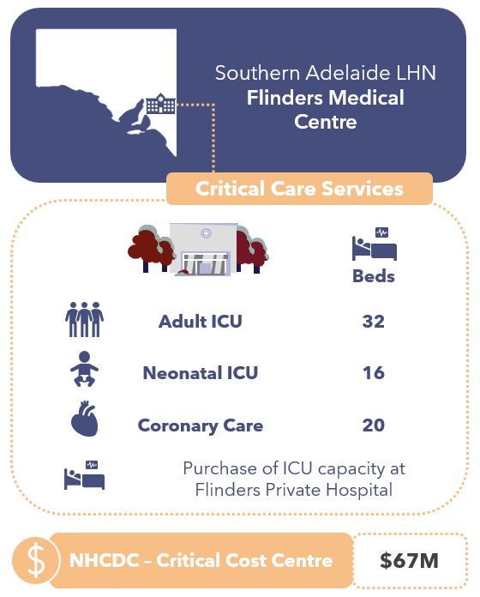
The Intensive and Critical Care Unit (ICCU) at Flinders Medical Centre (FMC) in Bedford Park, SA serves as a general medical and surgical ICU. It also serves as the state referral centre for critically ill pregnant women, liver and post-liver transplant patients, trauma cases and complex cardiac surgical patients. The unit handles approximately 2,200 admissions annually. Its Critical Care services include:
Figure 40: Critical care services at South Australia’s participating site
- A 32-bed ICU, that can be utilised as full ICU or Step Down beds. The unit will occasionally provide services to paediatric patients. There is an arrangement to purchase ICU bed capacity from Flinders Private Hospital.
- A 20-bed CCU. Additionally, FMC has arrangements with Flinders Private Hospital to purchase additional CCU capacity under a full package of care (including nursing).
- A 16-bed NICU beds and a 34-bed SCN.
The ICU and CCU clinicians provide some other services in addition to treating the patients in their ward. These include MET calls within the hospital, and surgical nursing support to Flinders Private Hospital for Transcatheter Aortic Valve Implantation (TAVI) theatre list, and provision of an outpatient Tier 2 service for home TPN. Within CCU, one consultant is seconded to Darwin for 6 months.
There are 6 different ‘level of care needs’ which are recorded in the eMR for each patient in the ICU. There are different nursing ratios required for patients based on their level of care need. This eMR data is not utilised for either cost allocation purposes or ICU activity reporting.
There is a high volume of ‘continuous observation’ or patients requiring ‘specialling’ in the CCU, where additional resources are required for the patients care over and above the standard nursing levels. Specialling use in ICU is limited. Where the requirement is behavioural, an enrolled nurse (EN), AIN or security guard is used. When the requirement is clinical in nature, a RN is utilised. While there is a nursing roster system that identifies the wards that require specialling and the type of additional workforce, this information is not at a patient level and so is not used to allocate the additional specialling costs to individual patients, with costs instead being spread to patients in the ward where the nursing specialling costs were incurred. This differs from where security personnel provide specialling, where this is captured and allocated at a patient level.
SALHN purchase ICU and CCU bed capacity from Flinders Private Hospital (692 hours in 2023-24) and receive information from the private hospital after the end of the financial year. The only information provided are the total costs paid for the arrangement and the total number of patients who utilised the contracted services. As such, the costs are spread across all patients admitted under this arrangement, based on stay (captured in 15-minute increments), and are costed to the Goods & Services line item.

Critical Care Cost and Activity Reporting
IHACPA provides definitions in its DRS for the reporting of critical care costs and activity. These include:
- The NHCDC Public Sector DRS Critical Cost Centre Group contains 10 codes to capture the types of critical care costs: Ccu, Hdicu, Aicu, Cticu, Gencritcare, Nicu, OtherCritCare, Paedicu, Psychicu, Scnicu.
- The ABF Admitted Patient Care DRS contains 2 data items for ICU hours. These are:
  - Length of stay in ICU, defined as the number of hours reported by a hospital with approved Adult ICU Level 3 or Paediatric ICU, and
  - Length of stay in ICU – Other, defined as hours reported by hospitals with approved ICUs other than Level 3 or Paediatric ICU.
One of the findings of this IFR was that the definitions and guidance for both Critical NHCDC Cost Centres and ICU hours require clarity and alignment to each other, as they are treated differently by every jurisdiction. This section of the report seeks to provide information on how SA is reporting this information, noting there is ambiguity in the current definitions.
FMC is a Level 3 ICU facilities and meet the criteria27F for IHACPA’s ICU adjustment for the NEP. ICU hours within FMC were reported to IHACPA as Level 3 ICU Hours based on the existence of a FMC ICU ward code in the PAS / eMR system.
In 2023-24, SALHN entered into a bed-buy arrangement with Flinders Private Hospital (FPH) to contract additional ICU capacity. While FPH is a Level 3 ICU facility, the ICU hours for patients under this bed-buy arrangement were not reported as ICU activity, as they did not have the FMC ICU ward code in the PAS / eMR system. The costs incurred for this arrangement were reported as in the Aicu cost centre (as shown in the table below) and totalled $0.94 million in 2023-24.
The table below shows how SA maps ICU costs and activity to IHACPA’s cost and activity types.
Table 29: SA ICU costs and activity mapped to IHACPA cost and activity types
South Australia Critical Care Type (Ward Type) | NHCDC Critical Cost Centre | Reported as L3 ICU Hours | Reported as Other ICU Hours
ICU | Aicu | ✔ | ✖
Paediatric patients in ICU | Aicu | ✔ | ✖
Step Down Care | Aicu | ✔ | ✖
ICU provided at Flinders Private Hospital | Aicu | ✖ | ✖
Level 6 NICU | Nicu | ✖ | ✖
Level 5, 4, 3 (Special Care - NISCU) | Nicu | ✖ | ✖
Coronary Care Unit | Ccu | ✖ | ✖
CCU provided at Flinders Private Hospital | Ccu | ✖ | ✖

FMC only reports costs against 3 of IHACPA’s 10 Critical NHCDC Cost Centres (Aicu, Ccu and Nicu) and does not report any costs under Hdicu, Cticu, Gencritcare, OtherCritCare, Paedicu, Psychicu, Scnicu.
There are mismatches between SA’s ICU costs and activity. The following critical care services have costs reported under Critical NHCDC Cost Centre Group, with no ICU hours reported:
- ICU services contracted at FPH
- NICU / Special Care
- CCU
All of SA’s ICU hours are reported as Level 3 ICU Hours, with no hours reported as Other ICU Hours. The chart below shows the total volume of ICU Hours at FMC, and total for all SA facilities.
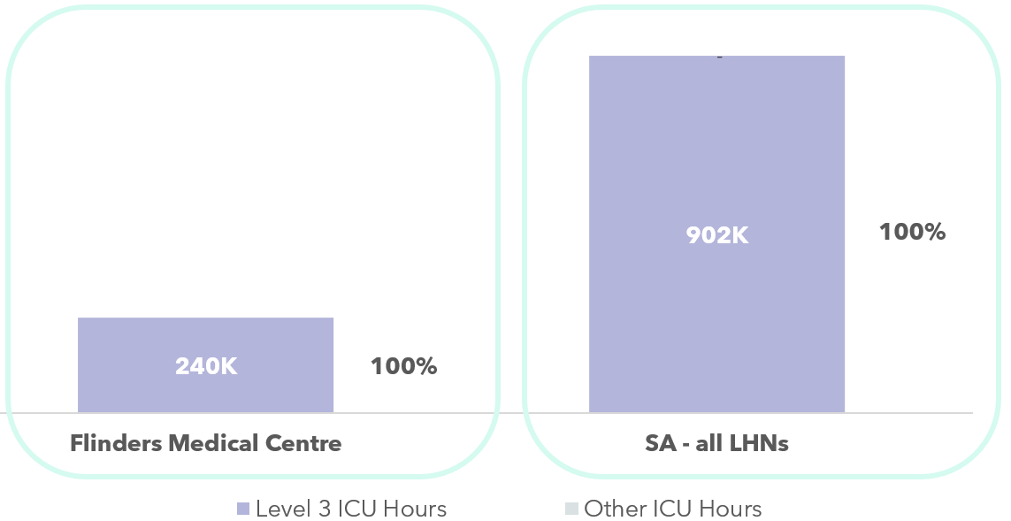
Figure 41: Volume and percentage of ICU hours, reported by Level 3 ICU Hours and Other ICU Hours, at Flinders Medical Centre and all SA Hospitals

Costs included in the Critical NHCDC Cost Centre Group
The Critical Care Focused Review aimed at understanding the resources consumed by patients admitted into the different critical care departments, and identifying how these were allocated to individual patients, and which costs were reported against the Critical NHCDC Cost Centre Group within NHCDC reporting.
In general, SA includes the following costs in the Critical NHCDC Cost Centre Group:
- the staffing costs for nurses, medical (only for intensivists and JMOs working in ICUs), and admin staff allocated to the wards,
- imprest drugs, medical consumables, hotel costs and overheads.
The resources consumed by patients whilst in the ICU/critical care departments that are allocated to the patient but reported under a different NHCDC Cost Centre Group (e.g. not Critical) include pathology, imaging, drugs, allied health, nursing specialling costs and Medical S&W for CCU and NICU that are reported under Clinical NHCDC Cost Centre Group for their respective areas (Cardiology / Perinatal Medicine).
The analysis below of critical care costs has focused on the Adult ICU and Paediatric ICU reported costs, as corresponding ICU hours were reported for these episodes. Other critical care costs (such as CCU, NICU etc) cannot meaningfully be compared as no critical care hours for these episodes are reported.
An analysis into ICU Costs Per Hour – defined as Aicu + Paedicu in the Critical NHCDC Cost Centre Group costs, divided by Level 3 ICU Hours, shows the following:
- The SA Average Level 3 ICU Cost Per Hour is $216.21
- FMC’s average Level 3 ICU Costs Per Hour is $209.56, 3.1% lower than the SA average.
It should be noted that in this calculation there are mismatches between the costs and activity:
- Contracted ICU at FPH activity is excluded from hours but included in costs (Aicu/Ccu).
- NICU costs are included, but hours are excluded.
Figure 42: Average Cost per ICU Hour - SA
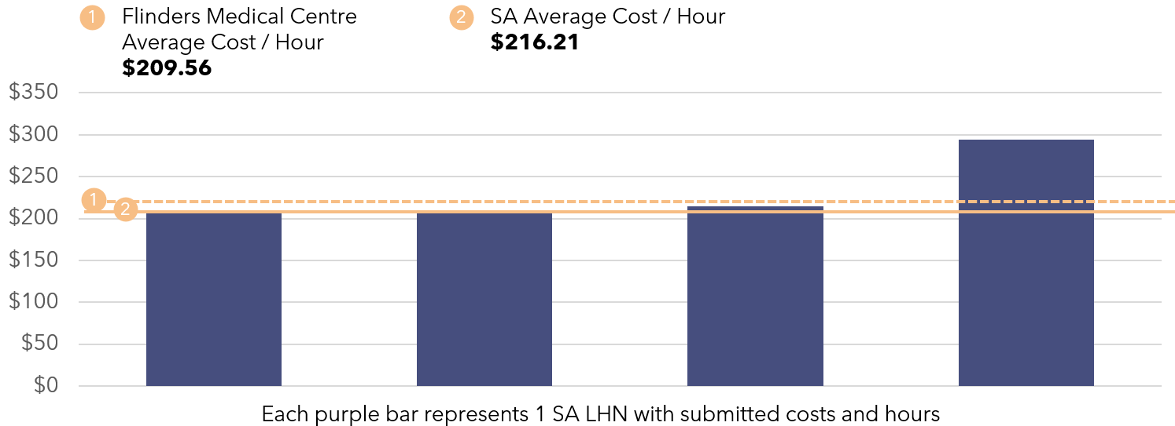
Critical Care – Average Cost Per Hour Insights:
- There is a mismatch between the costs and activity reported to IHACPA in SA. SA does not report contracted ICU hours at FPH and does not report NICU hours but does report these costs.
- Some costs incurred during an ICU stay (allied health, drugs, imaging and pathology) are not reported within the Critical NHCDC Cost Centre Group. South Australia’s treatment of these costs is in line with other states and territories.

ICU Cost Allocation Methodologies
ICU and critical care costs sit across many different RIs (SA’s local terminology for Cost Centres within their GL):
- There are 7 RIs containing expenditure within critical care services. Of these, 3 RIs (ICU, ECMO, Cardiovascular and Cath Lab Nursing) are into the critical care cost area for NHCDC purposes. The remaining RIs are mapped to other cost areas during the costing process as they relate to other services (e.g. TPN, Home TPN, and organ and tissue retrieval). The 3 in-scope RIs include the costs of:
  - ICU nursing (including casual),
  - medical costs,
  - ad hoc food supplies,
  - drug supplies (for all drugs dispensed to ICU patients, as well as imprest),
  - medical and laboratory patient consumables (includes nitric oxide gases),
  - pathology and imaging for ICU patients, and
  - corporate recharges for housekeeping (based on an allocation methodology).
- There are 4 RIs for NICU – for medical doctors, ward expenses (including nursing, consumables, pathology recharges), home oxygen (supplies and staffing) and Allied Health (negligible expenses), and RI costs transferred out of this due to a change in reporting structure in future periods. All of these are mapped to critical care cost areas.
- There is an RI for CCU, which is mapped to critical care cost area, but this does not include CCU medical staff salaries (these are held in the Cardiology RI).
- Flinders Private Hospital ICU costs are held into a separate RI, until a year end reconciliation of actual costs is performed. Then the elements relating to ICU and CCU are allocated to the critical care cost areas.
- Generally, overhead costs relating to all clinical areas (including ICU) are held centrally, and a portion is allocated.
Once costs have been mapped to critical cost areas, patient fractions (PFRACs) are made to allocate costs to other cost areas for services outside of ICU (e.g., portion of nursing time for MET calls).
The tables below show details of the types of expenditure incurred by each ICU site, the allocation methodologies used, and the ultimate Critical NHCDC Cost Centre Groups to which these expenditure types map.
Table 30: Flinders Medical Centre Cost Allocation Methodologies
● | Via patient level feeder system | ◕ | Via weighted RVU, to ICU patients
◑ | Using a standard RVU, to ICU patients | ◔ | Across ICU / non-ICU patients

Resources Consumed | Description of Costs | Allocation Methodology & Category | NHCDC Critical Cost Centre Group
S&W Nursing | Approximately 210 FTE nursing staff (ICU) and 36 (CCU), and ICU patients are typically cared for with a 1:1 or 1:2 nursing ratio. NICU patients had a ratio of 1:1 (ventilated) or 1:2 (for Continuous positive airway pressure (CPAP) / high flow ventilation); 1:3 or 1:4 for SCN. Casuals are used every shift, sourced from the casual pool.  Nursing team includes Clinical NUMs and educators. | Allocation of nursing costs via a standard RVU for all ICU patients based on ward hours.  If nursing staff are used for specialling, this follows the same approach (i.e., not allocated to specific patients). | ◑ | Critical
S&W Allied Health | ICU / PICU have shared dedicated allied health input from physiotherapists, social work, occupational therapists, dietician, but these costs do not sit in Critical Cost Centres in the GL.  There are no dedicated allied health in NICU. | Costing team collate all allied health into one cost area in PPM2. Allied health notes are documented on eMR’s Allied Health module and SALHN uses this to allocate care minutes at a patient level. However, there are gaps in data quality and a large proportion of residual amounts spread across all patients. | ◑ | Allied
S&W Other | Technical assistant, Clinical Support Officers, ward clerk, secretaries, security services. | Allocated using ward hours as an allocation statistic. | ◑ | Critical
S&W Medical (& VMO) | Intensivists (Adult, Paediatric); SRMOs; JMO positions are supernumerary. There is occasional VMO usage to cover staffing shortages.  Medical Staffing profile includes: 12 consultants and 30 JMOs (ICU); 16 JMOs and 5.6 consultants (NICU), and 3 consultants and 6 registrars (CCU, who also work across Cath Lab / cardiology). | All intensivist time is kept in the critical care cost area, with an adjustment via PFRAC for MET calls and Tier 2 clinic activity. ICU patients’ encounters will receive an allocation of medical costs that are based on their ward hours.  Medical S&W for CCU and NICU do not sit in Critical and are mapped to Clinical NHCDC Cost Centre Group for respective areas (Cardiology / Perinatal Medicine). The allocation for medical costs is based on their ward hours. | ◑ | Critical (ICU)  Clinical (NICU / CCU)
Goods & Services / Medical Supplies | Includes medical supplies and consumables expenses including lines, neuromonitoring and cardiac support devices and nitric oxide gas, minor equipment maintenance, as well as agency nursing costs and contracted care costs from FPH.  Agency costs for nursing are reported under Goods & Services. | Allocated based on ward hours.  For patients who have spent time at FPH, there may be inconsistencies between costs and hours allocated, where patients are transferred across multiple wards, because FMC cannot differentiate between ICU hours and other ward hours for the duration of the stay at FPH.  Where agency nursing is used for specialling, this is allocated to all ICU patients based on ward hours. However, where security staff are used, these are allocated at the patient level due to the availability of patient level information by the security provider (MSS) and costed to Goods & Services line item. | ◑ / ● | Critical
Imaging | Provided as a statewide service under Business 55 (hosted by CALHN) and recharged to FMC. | Allocated using feeder data of actual tests per patient. Where costs are unable to be linked to a specific patient from the feeder file, they are spread across all patient activity within ICU. | ● | Imaging
Pathology | Provided as a statewide service under Business 55 (hosted by CALHN) and recharged to FMC. | Allocated using feeder data of actual tests per patient. Where costs are unable to be linked to a specific patient from the feeder file, they are spread across all patient activity within ICU. | ● | Pathology
Pharmacy | Pharmacy is a statewide service provided by Business 55, hosted by CALHN. Prescribed drugs to patients using iPharmacy.  Some commonly used drugs are also held in imprest. Pharmacist costs sit in pharmacy cost centre. | Allocated using feeder data of actual tests per patient. Where costs are unable to be linked to a specific patient from the feeder file, they are spread across all patient activity within ICU.  Imprest costs are spread to all ICU patients based on ICU ward hours. | ● / ◑ | Pharmacy  (dispensed)  Critical (imprest)
Hotel | Includes cleaning, food and linen. These costs are captured in a central RI. | Allocated using general allocation statistics, appropriate for each expense type (e.g., occupied bed days). These are allocated as overheads.  Ad hoc food orders are costed to the ordering location (e.g., ICU and allocated based on ward hours). This represents a small portion of food costs. | ◔ | Critical
Overheads | Corporate costs. | Allocated using general allocation statistics for each expense type (e.g., occupied bed days, S&W expense). | ◔ | Critical

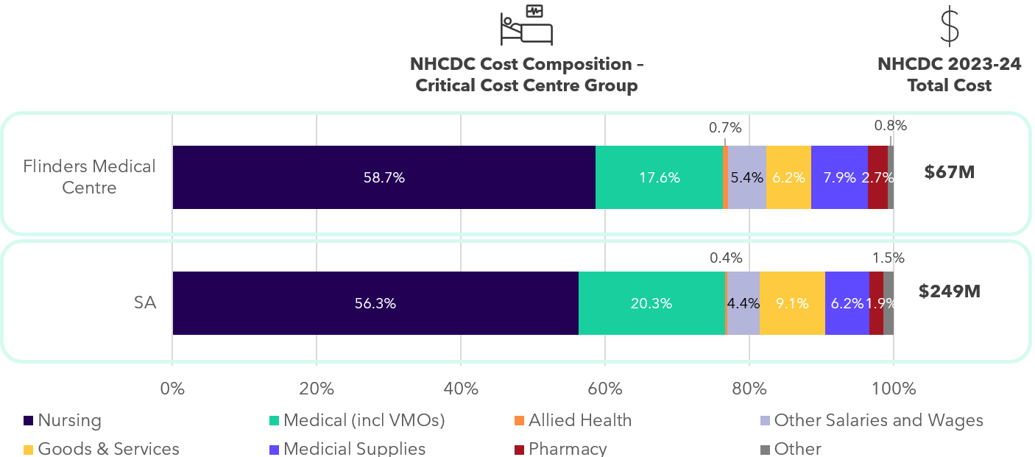
Figure 43: Total Critical Cost Centre Group Costs at NHCDC line item level - SA

Critical Care Comparability cost insights:
- ICU patients receive a standard RVU for ICU hours for nursing and medical costs, regardless of their acuity.
- Allied Health support to ICU patients, pharmacy (excluding imprest), pathology, and imaging costs incurred during an ICU stay is allocated to the Allied, Pharmacy, Pathology and Imaging NHCDC Cost Centre Groups, not Critical. South Australia’s treatment of these costs is consistent across jurisdictions.
- Medical S&W for NICU and CCU are shown in the Clinical NHCDC Cost Centre Group, not Critical.
- FMC is the only site identified through the IFR that has contracted ICU arrangements. These are costed to the Critical NHCDC Cost Centre Group under the Goods & Services line item, not S&W. This is an area of variation across jurisdictions.
- Agency costs are shown in the Goods & Services line item across all NHCDC Cost Centre Groups. This is an area of variation across jurisdictions.
- SA reported high specialling costs across all ward areas including CCU (less frequently in ICU) and specialling can be provided by nursing staff (RN, EN or AIN grade) or security staff. Where specialling is fulfilled by nurses these are not allocated to individual patients and are instead spread to all ward patients, resulting in potential overstatement of nursing costs.

Australian Capital Territory

State-wide costed NHCDC 2023-24 submission
$2.00bn
Total costs submitted to NHCDC
3
Facilities submitting data to the NHCDC in 2023-24
At a glance: ACT
Australian Capital Territory (ACT) submits costed activity for 3 public hospital sites as part of the NHCDC.
Total NHCDC costs submitted by ACT in 2023-24 were $2.00 billion.

ACT Costing Summary

Background to costing in ACT
In the 2023–24 cycle, ACT resumed its participation in the NHCDC following a hiatus during the 2022–23 cycle. The ACT was unable to submit data for the NHCDC 2022–23 due to challenges associated with the implementation of its new Digital Health Record (DHR) system. The DHR, that went live in November 2022, replaced ACT’s legacy patient administration system (ACTPAS) and other legacy systems across ACT’s public hospitals.
The transition to the DHR impacted ACT’s ability to extract data for hospital costing for the 2022-23 costing cycle. These included ward transfer records, clinician service data, and other activity-based inputs. As a result, ACT advised IHACPA that it could not provide a submission for the NHCDC 2022–23.
The 2023–24 period represents the first full year of DHR operation, and ACT has made a submission to the NHCDC on a ‘best endeavours’ basis. The ACT’s Health and Community Services Directorate (HCSD) continues to work on refining data quality to align to the DHR environment.
In February 2025, ACT formally notified IHACPA that they would not be able to meet the NHCDC timelines for 2023-24 due to the ongoing data and business impacts associated with the DHR transition. ACT’s data was fully submitted in late August 2025, which was too late to support ACT’s participation in the full IFR process. Consequently, ACT participated in the IFR via a modified approach, focusing on qualitative discussions with key personnel involved in the costing process to explore challenges, insights, and areas for improvement.

ACT structural arrangements and inclusion in costing outputs
The ACT has a single LHN, known as the ACT Local Hospital Network. It operates under a unique governance model compared to other jurisdictions. HCSD administers the LHN funds and specific programs and is responsible for submitting hospital costing.
Canberra Health Services (CHS) is the primary provider responsible for delivering public health services across ACT including 3 ABF funded hospitals (The Canberra Hospital (TCH), North Canberra Hospital (NCH, previously Calvary Public Hospital Bruce) and University of Canberra Hospital (UCH)), walk-in centres and community health centres. As of July 2023, NCH transferred to ACT Government control, consolidating public hospital facilities in ACT under CHS.
Unlike other jurisdictions, ACT HCSD and CHS are both directly accountable to the Minister for Health and do not hold a purchaser–provider or system manager relationship to each other.

ACT costing process
ACT utilised PPM3 costing system in 2023-24. Costing for CHS’s facilities was performed by ACT HCSD with input and QA from CHS, reflecting resource constraints during a complex transition period.
CHS staff provided advice on reclass rules and activity splits across care streams, which HCSD applied in the costing ledger. CHS also provided feeder files extracted from DHR including pathology (from statewide pathology provider ACT Pathology for inpatients), imaging, pharmacy, along with separate extract for s100 drugs, theatre, blood, MET calls, and prostheses. HCSD staff sourced the encounter files from the submitted ABF activity data and the ward transfer file from Badger (ACT’s intermediate data warehouse solution – see below).
ACT highlighted several data quality challenges during the costing cycle:
- ACT is still validating DHR outputs into the Enterprise Data Platform. In 2023-24, ACT used an intermediate system with manual inputs to cleanse and transform activity data inputs. ACT particularly highlighted data quality issues with duplicate records in ward transfer extracts, newborn qualification status and hours, and community mental health datasets (defaulting to unknown phase of care).
- 2023-24 is the first year of NCH’s operation under CHS management, following the ACT Government’s acquisition of the former Calvary Public Hospital Bruce on 3 July 2023. Prior to this, NCH used a separate chart of accounts to TCH and UCH. Mapping and alignment of two separate GLs to cost areas and NHCDC Cost Centres presented significant challenges and effort.
Overhead costs such as food, cleaning, and linen were allocated using appropriate allocation statistics (e.g., FTEs for CEO costs, area-based measures for cleaning).
ACT HCSD and CHS performed QA on the data through:
- Reconciliation against GL totals.
- Validation through IHACPA portal with submitted datasets passing IHACPA’s structural validation checks.
- NHCDC submission received sign offs by CHS’ Chief Finance Officer. CHS also verified inter-entity transaction amounts relating to the acquisition of NCH site.
ACT has reported compliance with AHPCS v4.2 to the best of their ability. However, limitations of the 2023-24 dataset were identified that are being addressed through ACT’s data governance forums for remediation in future rounds:
- Phase of care level data for mental health was not available for 2023-24.
- Non-admitted services were costed at a rolled-up level, meaning that when multiple service events occurred on the same day, only the initial activity received a cost allocation. Subsequent encounters, such as Allied Health services, were not reported in the ABF activity data and assigned costs.
- The approach for estimating the TTR costs will be examined.

Contracted care costs included in costed records
There are contracted care arrangements with 3 private hospitals within the ACT. These arrangements were used to deliver elective surgery joint replacements; ear, nose, and throat procedures, and surgery overflow. These activities were costed to the Goods & Services NHCDC line item.
Comparability of ACT’s costing outputs to other states
- ACT is one of 2 states and territories that are not signatories to the Pharmaceutical Reform Agreements and therefore does not have the same arrangements relating to PBS subsidised drugs. This may explain higher costs in the Pharmacy NHCDC Cost Centre Group as they do not receive the rebate.
- Due to the transition to the new DHR environment, significant data quality challenges have impacted activity capture in 2023-24. Data remediation is ongoing which may lead to shifts in reported activity volumes in future costing cycles.

Corporate costs in costed records
AHPCS v4.2 provide guidance on the inclusion of corporate overhead expenses. Business Rule 3.1C.3.2 states that ‘corporate overhead expenses should not be included for more than one level above the management of the hospital. Expenses related to the direct management of the LHN (Local Health Network) or corporate management are within scope.’ The table below shows how CHS are treating corporate costs and allocating them to patients in the costing process.
Table 31: ACT treatment of corporate costs and patient allocation costing process
Type of corporate cost | Details of whether these are passed onto facilities | Included in patient level costing | In line with the guidance in the AHPCS
Corporate costs at the facility | Included in GL | ✔ | ✔
Corporate costs at the LHN | Included in GL | ✔ | ✔
Corporate costs at shared service functions | Shared services provided by ACT government include payroll, accounts payable, HR, reinsurance model, IT, Hospital led ICU systems. the costs are journalled into facility GLs and included in the costing process | ✔ | ✔
Corporate costs at ACT HCSD | Not allocated to facilities | ✖ | ✔

ACT intends to review whether any of HCSD’s corporate costs should be included in the LHN’s costing submissions in future rounds.

Independent Health and Aged Care Pricing Authority (IHACPA) Review

As part of the Independent Financial Review (IFR), a review of IHACPA’s processes to collect and prepare the National Hospital Cost Data Collection (NHCDC) 2023-24 was also undertaken. The sections below summarise the findings from this component of the review.

IHACPA process for the NHCDC
This section sets out the role that IHACPA takes in overseeing the NHCDC process, and the activities undertaken across various teams from receipt of NHCDC to publication of the final NHCDC national dataset. This includes transformation, validation and performing quality assurance (QA).
Four of IHACPA’s teams play a critical role in the annual NHCDC process:
- The Hospital Costing team are the overall owners of the NHCDC process and data collection. They hold relationships with jurisdiction costing teams and are the day-to-day points of contact for the NHCDC, including coordination of the NHCDC Advisory Committee (NAC). They are responsible for the creation and updating of the Australian Hospital Patient Costing Standards (AHPCS), development of the Data Request Specifications (DRS) on an annual basis, management of the NHCDC dashboard, and own projects that deliver improvements to the NHCDC.
- The Data Acquisition team are responsible for maintaining the NHCDC data portal and for performing the Extract, Transform, Load (ETL) process. They perform data cleansing and summarise NHCDC outputs and artefacts (e.g., data reconciliation reports), providing them to other teams within IHACPA and to jurisdictions. They are responsible for several processes after jurisdictions submit within the data warehouse. They do not amend source data.
- The Analytics team perform QA on the NHCDC dataset after submission, once IHACPA’s transformations are complete. They conduct a variety of checks and high-level analyses on NHCDC movements year-to-year.
- IHACPA’s Pricing team is a key user of the NHCDC data and perform a further level of analysis downstream, looking at in-scope costs and performing analysis specific to pricing purposes.
The key processes performed by these teams are set out below.

NHCDC timeframes
The timeframes for the NHCDC 2023-24 costing are published in IHACPA’s Three Year Data Plan, and are set out below:
Table 32: Key dates in the NHCDC 2023-24
Data Request Sent | Data Portal Opened | Submission Date | IHACPA Review Date / ETL process
31 Jul 2024 | 3 Jan 2025 | 28 Feb 2025 | 14 Mar 2025
In 2023-24 there were several delays and extensions to published timeframes due to
- material errors identified through the QA process (identified either at the jurisdiction, IHACPA or ad hoc analysis) requiring resubmission of data;
- competing priorities within jurisdictional costing teams and the broader health service ecosystem including electronic medical record (eMR) implementations, data warehouse changes and costing system implementations) that impacted the availability and timeliness of costing data being submitted to IHACPA.
As a result, IHACPA did not receive a full NHCDC national submission until November 2025.

Detailed IHACPA NHCDC process
Stage 0: Providing DRS and preparing the Data Portal
IHACPA maintains a NHCDC Data Portal which is a secure environment for the transfer of cost and activity data.
Prior to accessing the NHCDC Data Portal, jurisdictions are provided with a DRS that is published on IHACPA’s website. These specifications provide guidance to the jurisdictions on the required structure of NHCDC submissions and the validation, logic rules and linking rules. The DRS document is refreshed every year to account for classification changes, and any changes to the cost bucket and line item matrix structure or AHPCS. Once the portal is prepared, IHACPA notifies data submitters within jurisdictions that the NHCDC Data Portal is ready for upload of their cost data files.
- The most significant change in the DRS for NHCDC 2023-24 was the removal the emergency department (ED) Cost Bucket to facilitate more meaningful analysis into cost drivers of the ED stream.
- The NHCDC 2023-24 submission also saw the introduction of the Emergency Virtual Care stream as part of the collection.
Stage 1: Data validation on the NHCDC Data Portal
Stage 1.1: Virus scan to check for malware
Once jurisdictions have gathered the relevant data for the NHCDC submission, this can be validated through the NHCDC Data Portal. In the first stage of the validation process the jurisdiction’s data submission is checked for malware and viruses before it is loaded into IHACPA’s data warehouse.
Stage 1.2: Structural validation
Once jurisdictions cost files are uploaded to the NHCDC Data Portal, they can be processed through IHACPA’s data validation program. This step ensures the structure of the data submission is compliant with IHACPA’s requirements and logic checks, providing an additional layer of validation for the DRS. At this stage of the process, no validation is undertaken on the accuracy of the contents of the data itself as this is performed in the next step.
If the data fails validation, jurisdictions receive a warning or critical error message indicating the issue. A critical error means the data hasn’t passed validation and must be corrected. This process helps reduce formatting issues and can be run once the portal opens. Many jurisdictions upload dummy files to perform early sample testing on data quality prior to their full submission.
All critical errors must be resolved before final costing data was submitted to IHACPA.
Stage 1.3: Content validation against requirement
IHACPA’s NHCDC Data Portal features several checks to validate the content of costing records, including checking that hospital’s submitted data was uploaded against the right jurisdiction. This ensured uploads were valid against jurisdiction hospital lists, establishment identifiers and the business rules within the DRS. These requirements ensure:
- Total costs are not less than $5 in the non-admitted stream,
- Total costs are not less than $200 in the admitted stream,
- Ensuring there are no episodes with negative total costs, and
- Flagging of any other warning and critical errors detected within submitted data.
New checks are added each year and any changes in future NHCDC content validation checks are discussed and adopted through the NAC consultation process.
Stage 1.4: Linking report checks
Finally, a linking report check is conducted to determine how many costed records can be linked to activity-based funding (ABF) activity data (submitted to IHACPA quarterly via ABF submissions) and what proportion of activity records can be linked to costs.
Linking rates vary by activity care stream, reflecting the differing maturity of the collection and jurisdictions’ processes. Linking rates for admitted acute were in excess of 95% for all 5 fully participating jurisdictions, whereas linking rates were lower for non-admitted and the mental health streams, ranging between 70-90% by jurisdiction, reflecting the lower maturity of these streams.
Stage 2: Upload, Extract, Transform and Load process
Once data is uploaded, IHACPA’s Data Acquisition team commence the ETL process. Jurisdictions’ data is amalgamated into one single file and transformations are made.
Stage 2.1: Unqualified Babies (UQBs)
UQBs are infants less than 10 days old, who do not meet set criteria for admission. IHACPA’s process for these records is to transfer the costs to the delivery episode at the NHCDC Cost Centre level (not moved at the line item level). The process for linking UQBs to the delivery episode was as follows:
- A linking key was used to match delivery episodes and babies with any UQB expected cost to be associated with the delivery episode.
- If no linking key existed, dates of birth, admission, and separation are used to assign UQB costs to specific delivery episodes.
- In the case of UQBs with no match, their costs were distributed to any remaining delivery episode that were not already associated with a UQB.
Some jurisdictions already transfer UQB costs to the delivery episode prior to submitting NHCDC data to IHACPA, in which case no further reallocations of cost are made during this step.
Stage 2.2: Duplication checks against phase and episodes of care
Checks are run across all service contacts, mental health and subacute streams to ensure reporting is occurring at the phase level, if phase level information is available. If duplicates exist a critical error is returned, and jurisdictions are not permitted to submit these records.
Once the above transformations are completed and a jurisdiction submits, the data is transferred into IHACPA’s data warehouse and data is released to the Hospital Costing and Analytics teams. Reconciliation reports are then produced for review.
Stage 3: Reconciliation
The Data Acquisition team prepare reconciliation reports that are provided back to jurisdictions and to Hospital Costing and Analytics teams. These reports include:
- high level summary of cost, by stream and establishment (facility) and linking of cost to activity,
- summary of UQB adjustments.
At this stage, should errors be identified, in limited circumstances IHACPA’s Data Acquisition Team are able to go into data warehouse and make small changes to small numbers of records at jurisdiction’s request, rather than requiring jurisdictions to recomplete the full submission process which is considerably more time consuming. If changes are more significant, jurisdictions will be required to complete the resubmission process.
If any changes are made to submissions, reconciliation steps are repeated to provide new reconciliation summaries.
Quality Assurance reporting
Once a jurisdiction has submitted for all facilities / local health networks (LHNs) and a jurisdiction level dataset is available, IHACPA’s Analytics Team produce QA reports. These provide jurisdictions with:
- Prior year comparisons of activity, costs and linking percentages,
- Breakdown of costs submitted by ABF source, average costs by cost bucket, hospital and stream level comparisons, and contracted care summaries (records and costs).
These were previously only available as Excel based product and stream level summaries, but IHACPA have developed an NHCDC Dashboard available for the first time for the NHCDC 2023-24 submission, with the Excel based reports alongside the dashboard for the transition year. Analysis is undertaken using a data focused approach (i.e., without consultation with jurisdictions) at this stage, and frequently when a Data Quality Statement (DQS) is not yet available. Key checks include:
- Comparison to prior year only, with material changes followed up with jurisdictions.
- Checks for negative values in one or more line items are internally flagged. Significant volumes of cost records with negative line items are followed up with jurisdictions.
Any insights are discussed in internal weekly costing meetings taking place throughout the annual NHCDC cycle between Analytics, Data Acquisition and Hospital Costing teams. Once analyses are complete, findings are documented in a written report produced by the Hospital Costing team for consultation with jurisdictions.
The Data Analytics team also produce cost per national weighted average unit (NWAU) and gross weighted average unit (GWAU) summaries. Although these measures are not fully aligned to the definition of “in-scope costs” as adopted by the Pricing team in developing the national efficient price (NEP) Determination, these are still a useful measure of movements from year-on-year.
All jurisdictions are given a comparison of the stream, cost bucket, line item, product type and classification levels (e.g., Australian Refined – Diagnosis Related Group (AR-DRG)) compared to the previous year. The QA report was able to indicate areas for investigation for individual jurisdictions.
Within the QA process, errors are also detected and relayed back to the Hospital Costing team who follow up with jurisdictions.
Hospital Costing team use the QA reports along with summary information on issues identified during the QA process to produce a consultation report that outlines the key findings relative to previous years and includes additional questions to the jurisdiction for further exploration, such as notable movements or trends in costs by stream.
Stage 5: Finalisation of the costing output
Once each jurisdiction’s queries are resolved, each jurisdiction finalises a DQS detailing their alignment with AHPCS v4.2, a jurisdictional reconciliation, and any reasons for material cost movements.

IHACPA published Review Reports for 2021-22 and 2022-23 along with reconciliations.
Overall activity units are labelled as “episodes”, but this includes both acute and subacute episodes, non-admitted service events, mental health phases and ED presentations.
GWAU was selected as the casemix standardised unit of activity for this analysis to measure and compare activities across care streams and financial years. These were calculated and provided by IHACPA from the 2023-24 National Weighted Activity Unit (NWAU) calculator and applied to both the 2022-23 and the 2023-24 financial years
Units of activity were defined for each care stream as follows: episodes for admitted acute, presentations for emergency department (ED) e, service events for non-admitted care, phases of care for community mental health, and a combination of phases and episodes for subacute and admitted mental health care
The volume of activity (as represented by a submitted record) depends on the NHCDC activity stream for example admitted acute episodes, ED presentations, non-admitted service events, episode and phases of care.
For consistency, all activity units across care streams are labelled as “episodes”.
Overall activity units are labelled as “episodes”, but this includes both acute and subacute episodes, non-admitted service events, mental health phases and ED presentations.
Activity volumes for subacute includes a small component of palliative care data which was submitted at a phase level.
Total by both column and row, may not sum due to rounding.
National NHCDC 2023-24 dataset was not finalised at the time of writing; 2022-23 total submitted costs used for reference value for materiality
Only ABF facilities are submitted to NHCDC, the “unsubmitted costs” category may include costs for non-ABF facilities.
For this analysis, a hospital episode refers to a submitted record in the NHCDC, which acts as a raw count of activity without any casemix adjustment (e.g., a separation of admitted acute care, an ED presentation, a non-admitted service event or an admitted mental health episode or phase of care).
GWAU represents a casemix adjusted measure of activity and has been determined using IHACPA’s NEP24 pricing model parameters. GWAU excludes community mental health, which was not priced in 2023-24, hence price weights were not available.
An ICU facility reporting 24,000 hours of ICU activity annually, and at least 20% of all hours involve mechanical ventilation.
For this analysis, a hospital episode refers to a submitted record in the NHCDC, which acts as a raw count of activity without any casemix adjustment (e.g., a separation of admitted acute care, an ED presentation, a non-admitted service event or an admitted mental health episode or phase of care).
GWAU represents a casemix adjusted measure of activity and has been determined using IHACPA’s NEP24 pricing model parameters. GWAU excludes community mental health, as it was not priced in 2023-24, hence price weights were not available.
An ICU facility reporting 24,000 hours of ICU activity annually, and at least 20% of all hours involve mechanical ventilation.
For this analysis, a hospital episode refers to a submitted record in the NHCDC, which acts as a raw count of activity without any casemix adjustment (e.g., a separation of admitted acute care, an ED presentation, a non-admitted service event or an admitted mental health episode or phase of care).
GWAU represents a casemix adjusted measure of activity and has been determined using IHACPA’s NEP24 pricing model parameters. GWAU excludes community mental health, which was not priced in 2023-24, hence price weights were not available.
An ICU facility reporting 24,000 hours of ICU activity annually, and at least 20% of all hours involve mechanical ventilation.
For this analysis, a hospital episode refers to a submitted record in the NHCDC, which acts as a raw count of activity without any casemix adjustment (e.g., a separation of admitted acute care, an ED presentation, a non-admitted service event or an admitted mental health episode or phase of care).
GWAU represents a casemix adjusted measure of activity and has been determined using IHACPA’s NEP24 pricing model parameters. GWAU excludes community mental health, which was not priced in 2023-24, hence price weights were not available.
For further information surrounding WA changes to workforce FTE and costs see Independent Inquiry into Perth Children’s Hospital (PCH).
An ICU facility reporting 24,000 hours of ICU activity annually, and at least 20% of all hours involve mechanical ventilation.
For this analysis, a hospital episode refers to a submitted record in the NHCDC, which acts as a raw count of activity without any casemix adjustment (e.g., a separation of admitted acute care, an ED presentation, a non-admitted service event or an admitted mental health episode or phase of care).
GWAU represents a casemix adjusted measure of activity and has been determined using IHACPA’s NEP24 pricing model parameters. GWAU excludes community mental health, which was not priced in 2023-24, hence price weights were not available.
Community mental health data is not presented in Figure 37 and Figure 38
An ICU facility reporting 24,000 hours of ICU activity annually, and at least 20% of all hours involve mechanical ventilation.

