Activity Based Funding Mental Health Care National Best Endeavours Data Set 2025–26

Technical Specifications for Reporting

**Version history**

| Version | Effective Dates | Change Summary |
| --- | --- | --- |
| 1.0 | 1 July 2018 | ABF MHC NBEDS 2018–19 Technical Specifications for Reporting, published October 2018 |
| 2.0 | May 2019 | Technical Specifications for reporting updated to ABF MHC NBEDS 2019–20 |
| 3.0 | May 2020 | Technical Specifications for reporting updated to ABF MHC NBEDS 2020–21 |
| 4.0 | May 2021 | Technical Specifications for reporting updated to ABF MHC NBEDS 2021–22 |
| 5.0 | May 2022 | Technical Specifications for reporting updated to ABF MHC NBEDS 2022–23 |
| 6.0 | May 2023 | Technical Specifications for reporting updated to ABF MHC NBEDS 2023–24 |
| 7.0 | May 2024 | Technical Specifications for reporting updated to ABF MHC NBEDS 2024–25 |
| 8.0 | May 2025 | Technical Specifications for reporting updated to ABF MHC NBEDS 2025–26 |

Activity Based Funding Mental Health Care National Best Endeavours Data Set 2025–26 – Technical Specifications for Reporting

© Independent Health and Aged Care Pricing Authority 2025

This publication is available for your use under a [Creative Commons Attribution 4.0 International licence](https://creativecommons.org/licenses/by/4.0/deed.en), with the exception of the Independent Health and Aged Care Pricing Authority logo, photographs, images, signatures and where otherwise stated. The full licence terms are available from the Creative Commons website.



Use of Independent Health and Aged Care Pricing Authority material under a Creative Commons Attribution 4.0 International licence requires you to attribute the work (but not in any way that suggests that the Independent Health and Aged Care Pricing Authority endorses you or your use of the work).

Independent Health and Aged Care Pricing Authority material used 'as supplied'.

Provided you have not modified or transformed Independent Health and Aged Care Pricing Authority material in any way including, for example, by changing Independent Health and Aged Care Pricing Authority text – then the Independent Health and Aged Care Pricing Authority prefers the following attribution:

Source: The Independent Health and Aged Care Pricing Authority

# Contents

Contents 3

Acronyms 5

1. Background 6

1.1 Development of the AMHCC Version 1.0 6

1.2 Development of the AMHCC Version 1.1 7

1.3 Development of the ABF MHC NBEDS 7

2. Australian Mental Health Care Classification 8

2.1 AMHCC related documentation 10

3. Purpose and scope 12

4. Activity Based Funding Mental Health Care National Best Endeavours Data Set 2025–26 structure 13

5. Scope of the Activity Based Funding Mental Health Care National Best Endeavours Data Set 2025–26 15

5.1 In-scope public hospital services 15

5.2 Specialised mental health services 16

5.3 Non-specialised mental health services 16

5.4 Non-governmental organisations 16

6. Key concepts of the Activity Based Funding Mental Health Care National Best Endeavours Data Set 2025–26 17

6.1 Mental health care establishments 17

6.2 Service setting 17

6.3 Age group 18

6.4 Mental Health Phase of Care 18

6.5 Service contact 21

6.6 Reporting unit of count 21

6.7 Unique identification of consumers 32

6.8 Linkage of mental health episodes within and across settings 32

7. Data items 34

7.1 Establishment and service unit identifiers 35

7.2 Episode level data items 36

7.3 Phase level data items 37

7.4 Ambulatory service contact level data items 39

8. Collection Protocol 41

8.1 Reporting occasions 41

9. Frequently Asked Questions 48

9.1 Episode of mental health care 48

9.2 Setting 49

9.3 Clinical assessments 50

9.4 Service contacts 50

Appendix A – Relationship between ABF MHC NBEDS 2025–26 and other related data set specifications 51

# 

# Acronyms

**ABF** Activity based funding

**ABF MHC DRS** Activity based funding mental health care data request specifications

**ABF MHC DSS** Activity based funding mental health care data set specifications

**ABF MHC NBEDS** Activity based funding: Mental health care national best endeavours data set

**AMHCC** Australian Mental Health Care Classification

**APC NMDS** Admitted patient care national minimum data set

**CGAS** Children’s Global Assessment Scale

**CMHC NMDS** Community mental health care national minimum data set

**FIHS** Factors Influencing Health Status

**HoNOS** Health of the Nation Outcome Scale

**HoNOS 65+** Health of the Nation Outcome Scale 65+

**HoNOSCA** Health of the Nation Outcome Scale Child and Adolescent

**IHACPA** Independent Health and Aged Care Pricing Authority

**LSP-16** Abbreviated Life Skills Profile

**METEOR** Metadata Online Registry

**MHPoC** Mental Health Phase of Care

**NBEDS** National Best Endeavours Data Sets

**NGO** Non-governmental organisations

**NHDISC** National Health Data and Information Standards

**NHISSC** National Health Information Standards and Statistics Committee

**NHRA** National Health Reform Agreement

**NMDS** National Minimum Data Set

**NOCC** National Outcomes and Casemix Collection

**NAP NBEDS** Non-admitted patient national best endeavours data set

**RMHC NMDS** Residential mental health care national minimum data set

**RUG-ADL** Resource Utilisation Groups – Activities of Daily Living

# Background

The Independent Health and Aged Care Pricing Authority (IHACPA) developed the Australian Mental Health Care Classification (AMHCC) to support the national implementation of activity based funding (ABF) for mental health care. The classification improves the clinical meaningfulness of classifying mental health care and is used to price public mental health care services nationally.

National data collections are essential to the development of the ABF classifications. They are required for several purposes, including:

* ensuring that activity is categorised into meaningful groups
* analysing activity between local hospital networks and jurisdictions
* monitoring trends over time.

IHACPA created the Activity based funding: Mental health care national best endeavours data set (ABF MHC NBEDS) to support the use of the AMHCC through the collection of data. The ABF MHC NBEDS contains a set of data items to be collected alongside instructions, definitions and output values.

The National Minimum Data Sets (NMDS) and National Best Endeavours Data Sets (NBEDS) for 2025–26 activity data reporting were endorsed by the National Health Data and Information Standards Committee (NHDISC) in December 2024. All NMDS and NBEDS have consequently been published on the Australian Institute of Health and Welfare’s (AIHW) Metadata Online Registry (METEOR).

## 1.1 Development of the AMHCC Version 1.0

In 2012, IHACPA commenced the development of a classification for mental health services in Australia for the purposes of ABF. To support classification development, IHACPA commenced the Definition and Cost Drivers for Mental Health Services Project. The output of the project was the creation of a separate care type for mental health services in the Admitted patient care national minimum data set (APC NMDS), a definition of mental health care for classification purposes and the identification of possible cost drivers.

The mental health care definition sets the scope of the AMHCC. The definition of mental health care was implemented as a [Health Standard](http://meteor.aihw.gov.au/content/index.phtml/itemId/575321) effective from 1 July 2014.

The mental health care definition[1] is:

Care in which the primary clinical purpose or treatment goal is improvement in the symptoms and/or psychosocial, environmental and physical functioning related to a patient’s mental disorder.

Mental health care:

* is delivered under the management of, or regularly informed by, a clinician with specialised expertise in mental health;
* is evidenced by an individualised formal mental health assessment and the implementation of a documented mental health plan; and
* may include significant psychosocial components including family and carer support.

This includes services provided as assessment only activities*.*

In 2014, IHACPA initiated a mental health costing study to generate data on mental health services and costs to inform the development of AMHCC Version 1.0 (V1.0). The study resulted in the creation of a robust consumer level dataset representative of mental health services provided in Australia.

The AMHCC V1.0 was implemented on a ‘best endeavours’ basis from 1 July 2016.

## 1.2 Development of the AMHCC Version 1.1

In 2021, IHACPA commenced exploratory analysis to inform potential refinements to the AMHCC due to improvements in data volume, quality and coverage since the 2014 costing study. The development of AMHCC Version 1.1 (V1.1) involved detailed statistical analysis and broad stakeholder consultation resulting in a minor update to the complexity model and allowance of phases with up to 2 missing HoNOS item scores to attract a valid complexity score. The AMHCC V1.1 represents a modest refinement of the classification and does not contain any structural changes or new data elements.

The AMHCC V1.1 was approved by the Pricing Authority in September 2023 and released in December 2023. IHACPA intends to use the AMHCC V1.1 to price admitted and community mental health services in the National Efficient Price Determination 2025–26 (NEP25).

## 1.3 Development of the ABF MHC NBEDS

To support the development and ongoing use of the AMHCC, IHACPA developed the ABF mental health care data set specification (ABF MHC DSS) in 2014 for data collection in 2015–16. The intention of the ABF MHC DSS was to utilise existing data collections and definitions where feasible, with a principle of ‘single provision, multiple use’.

Further development of the ABF MHC DSS occurred in 2014 with extensive consultation through IHACPA’s working and advisory groups, including the Mental Health Working Group, NHDISC and the Mental Health Information Strategy Standing Committee. As a result of stakeholder input a significantly revised version of the ABF MHC DSS 2016–17 was developed in 2015.

In 2016, IHACPA revised the name of the DSS to the ABF MHC NBEDS. The ABF MHC NBEDS describe metadata sets that are not mandated for national collection, but where there is a commitment to provide data nationally on a best endeavours basis.

IHACPA develops the ABF MHC NBEDS annually in accordance with national standards. The ABF MHC NBEDS is also published in the AIHW’s national metadata repository, METEOR.

# Australian Mental Health Care Classification

The Australian Mental Health Care Classification (AMHCC) is a consumer level classification, comprised of 6 variables that are utilised to determine an end class including:

* + setting
  + Mental Health Phase of Care (MHPoC)
  + age group
  + Health of the Nation Outcome Scales (HoNOS)/Health of the Nation Outcome Scales for Children and Adolescents (HoNOSCA)/Health of the Nation Outcome Scale 65+ (HoNOS65+)
  + Abbreviated Life Skills Profile (LSP-16)
  + mental health legal status (MHLS).

The classification structure for the AMHCC admitted and community settings is illustrated in Figures 1 and 2.

For the purposes of AMHCC, ambulatory care services are referred to as community mental health in the AMHCC structure and documentation. For the purposes of the ABF MHC NBEDS 2025–26, ambulatory setting is used when referring to activity reported under ambulatory mental health care services[2].

Figure 1. AMHCC– Admitted structure

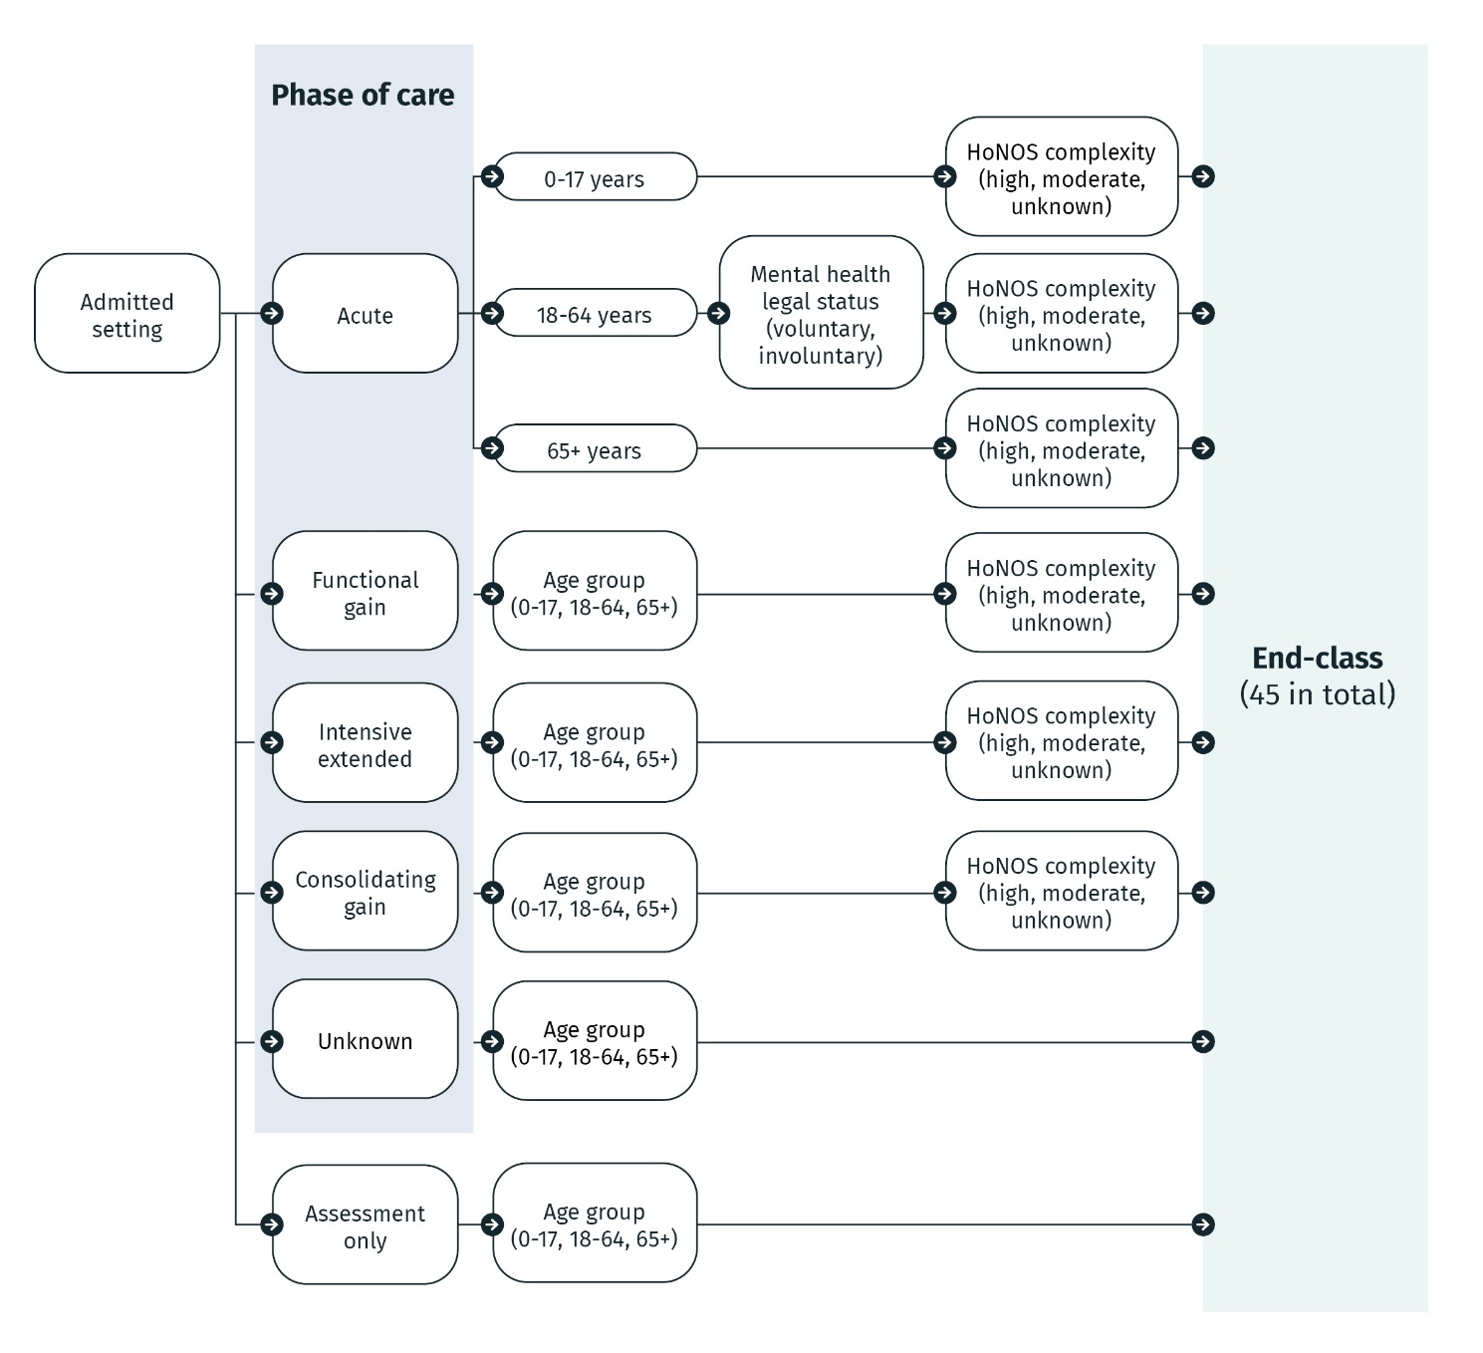

Figure 2. AMHCC – Community structure

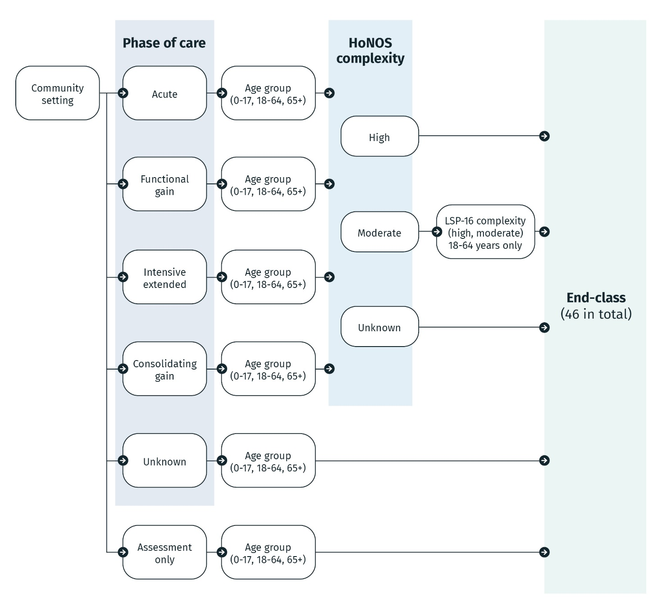

## 2.1 AMHCC related documentation

The Activity Based Funding: Mental health care national best endeavours data set (ABF MHC NBEDS) Technical Specifications 2025–26 should be read in conjunction with the following resource material that support the understanding and application of the AMHCC and associated data collection and reporting requirements.

### AMHCC User Manual

The AMHCC User Manual provides detailed information for users on the classification data elements, collection protocols, reporting requirements and how data are grouped, in addition to providing foundational information regarding the AMHCC structure, variables, and background of development.

### MHPoC Guide

The MHPoC Guide provides information for clinicians to assist with assessing phases accurately when applying the MHPoC concept and provides the definitions, guide for use and guiding principles for application.

### ABF MHC data request specifications

The ABF MHC data request specifications are used for the quarterly submission of activity data. The ABF MHC DRS contains overall specifications associated with episode, phase and service contact level data reporting.

### AMHCC grouper user guides

The AMHCC grouper user guides provide details of the AMHCC grouper application, including the input and output data specifications, and a step-by-step guide to how data are grouped to an end class.

### National Pricing Model Technical Specifications

The National Pricing Model Technical Specifications are produced as an accompaniment to the annual national efficient price and national efficient cost determinations. It provides the technical specifications for how the Independent Health and Aged Care Pricing Authority develops the activity based funding models and provides guidance to hospitals, local health networks and state and territory health authorities on how to apply these to hospital activity.

# Purpose and scope

The purpose of this document is to outline the reporting requirements for the provision of data against the Activity based funding: Mental health care national best endeavours data set (ABF MHC NBEDS) 2025–26 by state and territory governments. This document provides details about the:

* content and key concepts included in the ABF MHC NBEDS 2025–26
* business rules relating to the reporting of the data items
* frequently asked questions relating to the ABF MHC NBEDS 2025–26.

The purpose of the ABF MHC NBEDS 2025–26 is to capture information about consumers receiving mental health care, funded by states and territories, that is associated with Australian public hospital services.

This document is based on information in existing technical specifications, handbooks, manuals and the Metadata online registry (METEOR).

The scope of this document is limited to the above and does not cover information relating to the provision of data that is a result of, or can be resolved through, system management and design at a state and territory level.

Similarly, this document does not address the analysis and interpretation of the data gathered through the ABF MHC NBEDS 2025–26.

The reporting requirements outlined in this document represent a minimum requirement for activity based funding reporting purposes and are not intended to limit the scope of data collections maintained by individual service agencies or state and territory governments.

# Activity Based Funding Mental Health Care National Best Endeavours Data Set 2025–26 structure

The Activity based funding: Mental health care national best endeavours data set (ABF MHC NBEDS) 2025–26 consists of a single data collection, with the reporting of mental health care activity regardless of the setting. The ABF MHC NBEDS 2025–26 is intended to be used in conjunction with data collected via existing activity data collections and the National minimum data sets (NMDS). For example, mental health legal status is drawn from the Admitted patient care NMDS (APC NMDS) via a linking process.

The ABF MHC NBEDS 2025–26 contains data items that are required to be reported across all age groups and settings. The ABF MHC NBEDS requires the reporting of mental health care activity for consumer episodes, phases and ambulatory service contacts

The high-level structure of the ABF MHC NBEDS 2025–26 is illustrated at Figure 3.

Specific data is collected in relation to the level of reporting (episode, MHPoC, and service contact) and is dependent on the setting type and age of the consumer.

Key concepts and data items contained within the ABF MHC NBEDS 2025–26 are discussed in the following chapters.

Figure 3. ABF MHC NBEDS 2025–26 high level structure

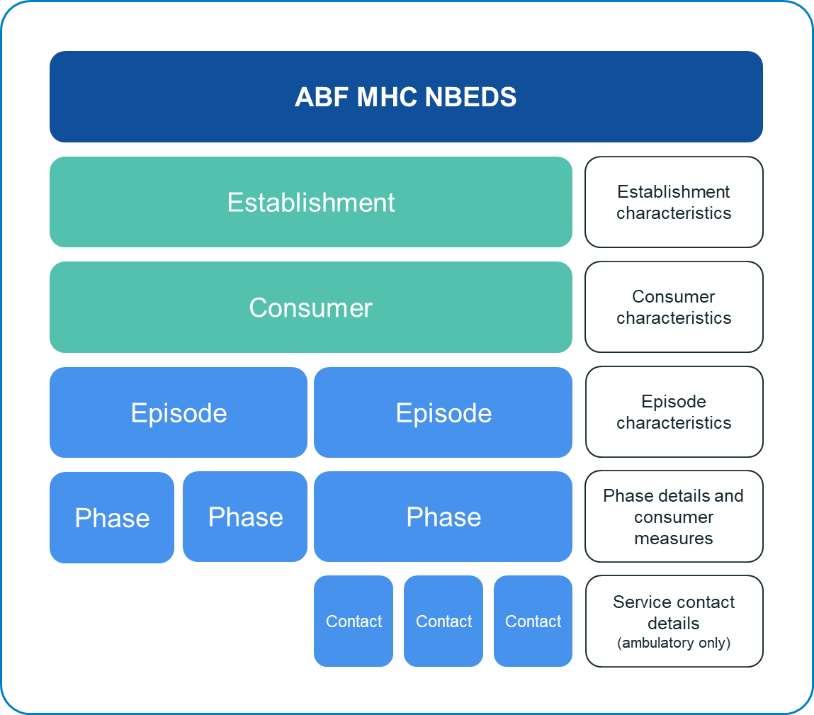

# Scope of the Activity Based Funding Mental Health Care National Best Endeavours Data Set 2025–26

The Activity based funding: Mental health care national best endeavours data set (ABF MHC NBEDS) 2025–26 was created for ABF purposes. The primary scope in mental health care is defined as care in which the primary clinical purpose or treatment goal is improvement in the symptoms and/or psychosocial, environmental and physical functioning related to a patient's mental disorder[3], provided by in‑scope public hospital services under the National Health Reform Agreement Addendum 2020–25 (the Addendum). This includes care delivered by specialised mental health services, public hospitals, Local Hospital Networks and non-government organisations (NGOs) managed or funded by state or territory health authorities.

The total scope of the ABF MHC NBEDS includes consumers receiving mental health care in specialised and non-specialised services, across admitted, ambulatory and residential care. The intention of the ABF MHC NBEDS is to capture instances of service provision from the consumer viewpoint.

## 5.1 In-scope public hospital services

Each year, the Independent Health and Aged Care Pricing Authority (IHACPA) publishes the General List of In-Scope Public Hospital Services (the General List) as part of the national efficient price determination. The General List defines the public hospital services eligible for Commonwealth funding, except where funding is otherwise agreed between the Commonwealth and a state or territory. The [General List of In-Scope Public Hospital Services Eligibility Policy](https://www.ihacpa.gov.au/resources/general-list-scope-public-hospital-services-eligibility-policy) outlines the scope of public hospital services that form the General List.

In accordance with section 131(1)(f) of the *National Health Reform Act 2011* and clauses A16–A24 of the Addendum to the scope of public hospital services eligible for Commonwealth funding are:

* all admitted services, including hospital-in-the-home programs and forensic mental health inpatient services;
* all emergency department services provided by a recognised emergency department service; and
* non-admitted patient services and non-admitted mental health care services, including community and residential mental health care services, that could reasonably be considered a public hospital service in accordance with clauses A18-24 of the Addendum.

Both ABF and block-funded mental health care services that are in-scope for Commonwealth funding under the NHRA should be reported through the ABF MHC NBEDS 2025–26. IHACPA has the expectation that block-funded NHRA mental health care services are also reported under the ABF MHC NBEDS 2025–26 for any future transition to ABF.

Further detail on the scope of mental health care services eligible for Commonwealth funding is available in the national efficient price determination for the relevant year.

## 5.2 Specialised mental health services

Specialised mental health services[4] are those with a primary function to provide treatment, rehabilitation or community health support targeted towards people with a mental disorder or psychiatric disability. These activities are delivered from a service or facility that is readily identifiable as both specialised and serving a mental health care function.

The concept of a specialised mental health service is not dependent on the inclusion of the service within the state or territory mental health budget.

A service is not defined as a specialised mental health service solely because its clients include people affected by a mental disorder or psychiatric disability. The definition excludes specialist drug and alcohol services and services for people with intellectual disabilities, except where they are established to assist people affected by a mental disorder who also have drug and alcohol related disorders or intellectual disability.

Specialised mental health services include admitted, residential and ambulatory mental health care services. In admitted consumer services, these can be a sub-unit of a hospital even where the hospital is not a specialised mental health establishment itself (for example, designated psychiatric units and wards or outpatient clinics).

## 5.3 Non-specialised mental health services

Non-specialised mental health services are those services that:

* + do not identify as both specialised and serving a mental health function
  + may provide services to people other than mental health consumers
  + may be recognised as a service that has a speciality other than mental health care.

A non-specialised mental health service may provide adjunct care and services to a specialised mental health service, or their services may encompass a consumer’s entire mental health plan. However, they are not recognised as providing specialised mental health care and may provide services to clients without a mental health disorder or disability.

## 5.4 Non-governmental organisations

A mental health NGO[5] is a private organisation that receives funding from the Australian or a state or territory government (or from both), specifically for the provision of services, where the principal intent is improving mental health and well-being and is delivered to people affected by mental illness, their families and carers, or the broader community. IHACPA refers to circumstances where a state or territory government contracts an NGO to deliver in-scope mental health care services in this definition for ABF purposes. IHACPA notes this definition refers to the nature of the services being in-scope under the General List, rather than the NGO as an organisation being determined to be in-scope. Contracted in-scope services should be reported in the ABF MHC NBEDS 2025–26.

# Key concepts of the Activity Based Funding Mental Health Care National Best Endeavours Data Set 2025–26

The type and number of data items reported for the Activity based funding: Mental health care national best endeavours data set (ABF MHC NBEDS) 2025–26 is dependent on the service setting, consumer age group and the consumer’s episode of mental health care.

The key concepts contained within the ABF MHC NBEDS 2025–26 are defined and discussed below.

## 6.1 Mental health care establishments

The term ‘establishment’ is consistently used across activity based funding data collections to identify entities in which an episode or event occurred for the purposes of activity based funding reporting, as represented by a combination of numeric and/or alphabetic characters. The establishment identifier should be able to distinguish between all health care establishments nationally and incorporates *Establishment—organisation identifier (state/territory)* or *Specialised mental health service organisation – organisation identifier* data items in the concatenation.[6]

## 6.2 Service setting

In the ABF MHC NBEDS, there are 3 different service provider settings: admitted, ambulatory and residential. The service setting is primarily defined by the service setting in which the consumer’s episode of mental health care takes place.

### 6.2.1 Admitted setting

The admitted setting includes consumers that are admitted for mental health care. The consumer may be admitted to a psychiatric hospital or a specialised mental health unit in an acute hospital[7]. All activity reported will have a mental health care type for the admitted episode, regardless of the mental health specialisation status of the provider.

Admitted consumer care includes mental health activity, both specialised and non-specialised, which is currently reported through the Admitted patient care national minimum data set (APC NMDS) as identified through the data item *Hospital Service – care type,* value *11* *Mental health care*.

### 6.2.2 Ambulatory setting

The ambulatory setting includes specialised and non-specialised mental health care services delivered to consumers who are generally not admitted to an inpatient facility or reside in a residential mental health care facility, including hospital outpatient clinics and non-hospital based community mental health services.

It is recognised that a mental health team from the ambulatory setting can provide mental health care to consumers in an admitted, emergency department or residential setting and this activity is considered to be part of a separate and concurrent episode. The ABF MHC NBEDS allows reporting of in-reach service contacts from specialised mental health community units into specialised mental health care admitted consumer units, which are out of scope for the Community mental health care national minimum data set (CMHC NMDS).

### 6.2.3 Residential setting

The residential setting[8] includes care provided in a residential mental health care service that employs mental health trained staff on-site 24 hours per day and other services with less intensive staffing (the trained staff must be on site for a minimum of 6 hours a day and at least 50 hours per week). Services provide specialised treatment, rehabilitation or care for people affected by a mental illness or psychiatric disability.

Residential care includes mental health activity that is currently reported through the Residential mental health care national minimum data set (RMHC NMDS).

## 6.3 Age group

The clinical measures reported in the ABF MHC NBEDS are dependent on the age group of the consumer, including children and adolescents defined as persons under the age of 18 years, adults defined as persons between the age of 18 and 64 years, and older persons defined as persons aged 65 years and older.

For the Australian Mental Health Care Classification (AMHCC), a consumer’s age is calculated based on the consumer’s birth date and record start date, giving preference to phase start date, otherwise episode start date. Further details on the calculation of age can be found in the corresponding National Pricing Model Technical Specifications for that year.

It is important to note that the decision to use a particular clinical measure may be influenced by a consumer’s age as well as the clinician’s decision on which clinical measure is the most appropriate. For example, there may be circumstances where the adult clinical instrument is considered most applicable to a 17-year-old consumer. Where the clinical measure does not align with the consumers age, the AMHCC Version 1.1 (V1.1) grouper will group the episode to an ‘unknown’ Health of the Nation Outcome Scales (HoNOS). As current data collection requirements would be unable to differentiate between a clinician assigned age group and an error in data entry, the Independent Health and Aged Care Pricing Authority (IHACPA) has included this area in future refinements of the AMHCC.

## 6.4 Mental Health Phase of Care

In addition to reporting episodes of mental health care, activity must also be reported according to the [Mental Health Phase of Care (MHPoC) Guide](https://www.ihacpa.gov.au/resources/mental-health-phase-care-guide). MHPoC is a prospective description of the primary goal of care that is reflected in the consumer's mental health treatment plan. The MHPoC reflects a prospective assessment at the time of collection, rather than a retrospective assessment. MHPoC should be considered a subset of episode of mental health care, meaning that for each episode there can be multiple phases.

MHPoC is independent of both the treatment setting and the designation of the treating service and does not reflect service unit type. For example, in an admitted episode of mental health care, the consumer may not have an Acute MHPoC for the entire period. Similarly, MHPoC should not be determined based on consumer presentation but rather the primary goal of care. For instance, two consumers with the same diagnosis may have different goals of care due to other factors such as socialisation or age. Where a consumer is receiving care from multiple service units or clinical teams in a community setting, a single coordinated MHPoC for the consumer should be reported.

The 4 MHPoC and related definitions from the metadata online registry (METEOR)[9] are described in Table 1.

**Table 1.** MHPoC and related METEOR definitions

| **Code descriptive term** | **Code definition** |
| --- | --- |
| Acute | The primary goals of care are intended to reduce high levels of distress, manage complex symptoms, contain and reduce immediate risk. |
| Functional gain | The primary goal of care is to improve personal, social or occupational functioning or promote psychosocial adaptation in a patient with impairment arising from a psychiatric disorder. |
| Intensive extended | The primary goal of care is prevention or minimisation of further deterioration, and reduction of risk of harm in a patient who has a stable pattern of severe symptoms, frequent relapses or severe inability to function independently and is judged to require care over an indefinite period. |
| Consolidating gain | The primary goal of care is to maintain the level of functioning, or improving functioning during a period of recovery, minimise deterioration or prevent relapse where the patient has stabilised and functions relatively independently. Consolidating gain may also be known as maintenance. |

It is recognised that there may be aspects of each MHPoC represented in the consumer’s mental health plan, the MHPoC is intended to reflect the main goal or aim of care that will underpin the next period of care. For example, a consumer in Consolidating gain phase may also have a goal to prevent relapse but the primary goal is to maintain their level of functioning, therefore Consolidating gain rather than the Intensive extended phase should be reported.

The MHPoC should be assessed on admission/registration to a service, where there has been a transfer of care between service settings or when there has been a change to the mental health care plan due to change to the consumer’s symptoms.

If the primary goal of care changes as a result of the assessment, a new MHPoC may begin. Similarly, a review of the consumer’s MHPoC may be undertaken part way through an episode within the assigned MHPoC but does not lead to a change in the MHPoC if the primary goal of care remains the same.

### 6.4.1 Assessment only data item

The [2017 Clinical Refinement Project](https://www.ihacpa.gov.au/resources/mental-health-phase-care-clinical-refinement-project-final-report) recommended that ‘assessment only’[10] be redefined from a MHPoC to an administrative data item to allow for greater flexibility in capturing triage and assessment activity without encumbering this activity with business rules commonly associated with MHPoC. The assessment only data item is not intended to capture regular reviews that are part of standard clinical practice. This data item was developed to capture the significant amount of work undertaken by mental health services in assessing consumers who do not go on to receive treatment at that particular mental health service.

To be assigned an assessment only data item, the care needs to first meet the definition of mental health care (as outlined in chapter 1 of this document). This can include triage and phone triage services as long as the mental health care and assessment only data item definitions are met.

#### Example 1

A help line received a call from a consumer. The consumer was having a stressful period at work but did not exhibit symptoms relating to a mental illness. General advice was given to the consumer. No further intervention was required. No consumer information was recorded, nor was a formal assessment completed, or care plan developed.

This activity is not in scope of the mental health care definition as no mental health assessment was undertaken and no mental health plan was implemented.

#### Example 2

A consumer was assessed by a psychiatrist following a GP referral to the psychiatrist. The consumer had a 3-year history of anxiety which had recently become more severe and had been seeing a psychologist following a referral by the GP. The consumer had a strong, supportive family network and was attending an anxiety management support group offered by a local church. The consumer information and mental health assessment was recorded along with a documented mental health plan which included commencement of medication and management advice to the consumer and GP. A follow up appointment was not required and the consumer continued to be managed by their GP.

This activity is in scope of the mental health care definition as a mental health assessment was undertaken and mental health plan was implemented. This activity meets the definition of assessment only because the primary goal of care was to obtain information in order to determine the treatment needs.

The assessment only data item should only be reported if the review outcome does not lead to the consumer being placed in one of the 4 MHPoC immediately after. If the assessment outcome leads to Acute, Functional gain, Intensive extended or Consolidating gain phase being selected, then the assessment is included as part of the phase chosen.

#### Example 3

A consumer presented at the emergency department following an attempt to take their own life, with their history of psychosis becoming unmanageable. The consumer was assessed by the mental health team in the emergency department who agreed the high levels of behavioural disturbance meant the consumer required admission to hospital with the primary goal of care being the short term reduction in severity of symptoms/risks. The consumer began their Acute MHPoC immediately and was discharged 10 days later.

Although an assessment was completed, this was not assessment only as the assessment led to the immediate start of the Acute MHPoC.

## 6.5 Service contact

### 6.5.1 Service contact definition

For ambulatory episodes of mental health care, individual service contacts must also be reported. The CMHC NMDS defines a mental health service contact[11] as:

‘The provision of a clinically significant service by a specialised mental health service provider(s) for consumer/clients…where the nature of the service would normally warrant a dated entry in the clinical record of the patient/client in question.’

### 6.5.2 Reporting difference between ABF MHC NBEDS and CMHC NMDS

The CMHC NMDS excludes the reporting of mental health service contacts for consumers in the admitted and residential settings. This exclusion covers consumers admitted to psychiatric hospitals or designated psychiatric units in acute care hospitals and residents in 24-hour staffed specialised residential mental health services.

In contrast, the ABF MHC NBEDS allows service contacts to be reported in these settings in the context of an in-reach, concurrent episode of care (refer to section 6.6.2 Concurrent episodes of care).

## 6.6 Reporting unit of count

The overarching unit of activity within the ABF MHC NBEDS is episode of mental health care. Within an episode of mental health care, activity is reported according to MHPoC.

### 6.6.1 Episode of mental health care

For the purposes of the ABF MHC NBEDS, an episode of mental health care is defined as the period of mental health care between the formal or statistical commencement of care (such as an admission) and a formal or statistical completion of care (such as a separation). The episode of mental health care is characterised by the mental health care type within a setting. An episode of mental health care reported through the ABF MHC NBEDS may differ from the clinical concept of an episode of mental health care.

Depending on the service setting and health service establishment, there may be variation regarding what constitutes or equates to the period of mental health care. For example, an episode of care may vary in definition between an admitted episode of care, an ambulatory episode of care and a residential episode of care.

For the purposes of the ABF MHC NBEDS, the episode of mental health care may be derived for admitted or residential consumers from existing reported episodes of care in the APC NMDS and the RMHC NMDS. Therefore, an admitted or residential episode of mental health care may commence with an admission to a facility or in the case of the residential setting it may be signalled by the start of a new reference period (refer to section 6.6.3 Reference period). Likewise, the end of the episode for a residential episode of mental health care occurs when a consumer is discharged from the facility, at the end of a reference period, or for any other reason as stated in associated activity data set specifications[12]. The reference period has no impact on an admitted episode of care.

The concept of an ambulatory episode of mental health care is specific to the ABF MHC NBEDS and AMHCC V1.1 and may not be able to be derived from existing data collections.

#### 6.6.1.1 Admitted episodes

Admitted episodesrefer to the period of care provided to a consumer who is admitted to a specialised psychiatric inpatient service or to a general public hospital for the purposes of receiving mental health care (that is, the consumer has a mental health care type). The period of care commences when the consumer has a formal or statistical admission and ceases with a discharge or other statistical separation such change of care type.

#### 6.6.1.2 Ambulatory episodes

Ambulatory episodesrefer to the care provided to consumers in a non-admitted setting that can be defined by exclusion – that is, the provider of the service is not of the admitted consumer, emergency department or residential care setting. However, it is recognised that a mental health team from the ambulatory setting can provide mental health care to consumers in any of those settings as an ambulatory in-reach service. This activity is considered an ambulatory episode and may be reported through the ABF MHC NBEDS.

The commencement of an ambulatory episode may be signalled by a new registration to ambulatory care or, if the consumer has previously been treated by the ambulatory team, the start of an episode may be the recommencement of care for a specified goal, such as when moving from mental health care in the admitted setting back to the community. Note that the rule for concurrent episodes allows an ambulatory episode to continue in parallel with an episode in another setting, such as admitted (refer to section 6.6.2 Concurrent episodes of care).

For ambulatory episodes that start and end within the same reference period, the episode start and end date should be the first and last service contact dates. It is recognised that client registration may occur prior to the first service contact, however for the purpose of consistent reporting practice the ambulatory episode start date must align with a service contact date.

The cessation of an ambulatory episode of mental health care may occur when the consumer’s case has been closed by the mental health care team, such as when the consumer moves to mental health care in another setting (for example, admitted or residential). *Episode of mental health care–episode end mode*[13] should be populated to identify the reason the episode ended.

An ambulatory mental health episode needs to be closed when there has been a period of inactivity greater than 120 days. For the purposes of ABF MHC NBEDS, the date of the last service contact in the episode of mental health care will be the episode end date.

#### Example 4

On 1 July 2025, a consumer commenced their episode of ambulatory mental health care under the Functional gain MHPoC. They received ambulatory service contacts on the following dates: 1 July, 1 August and 2 September 2025.

Since the last service contact on 2 September 2025, the ambulatory team has been unable to get in touch with the consumer who has not attended any further scheduled appointments nor responded to any phone call. On 31 December 2025 (120 days after the last service contact), the episode was closed following the business rule of closing off ambulatory episodes after 120 days of inactivity. The episode end date was backdated to the last service contact date being 2 September 2025, following the ABF MHC NBEDS reporting rule.

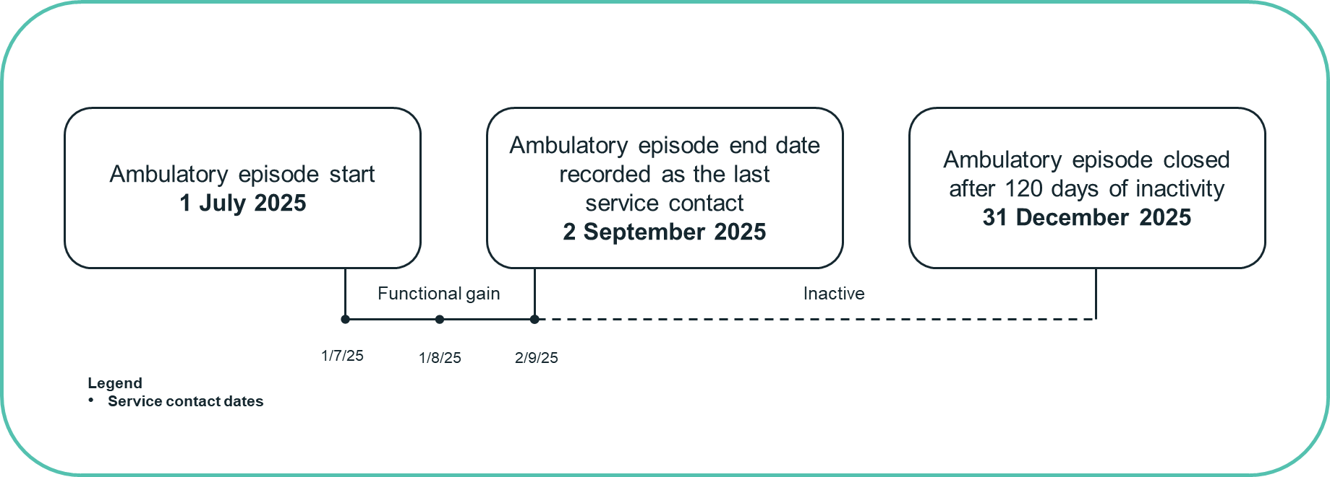

This should be reported as follows:

|  |  |  |
| --- | --- | --- |
| **Record** | **Start date** | **End date** |
| Ambulatory episode | 1 July 2025 | 2 September 2025 |
| Functional gain MHPoC | 1 July 2025 | 2 September 2025 |
| Service contacts | 1 July, 1 August and 2 September 2025 | |

#### 6.6.1.3 Residential episodes

Residential episodesrefer to the period of care between the start of residential care and the end of the residential care (either through the formal end of residential care or the end of the reference period). The period of care commences with an admission and ceases with a discharge. The admission and/or discharge may be formal or statistical.

For the purposes of reporting residential episodes of mental health care:

* formal episode start date or end date – the formal start date or end date of a residential episode of care must occur on the same date as an admission or discharge.
* statistical episode start date or end date (occurring at a change of reference period) – the statistical start date or end date of a residential episode of care must contain the first or last date of the reference period, which may or may not correspond with an admission or discharge date.

### 6.6.2 Concurrent episodes and phases of mental health care

Concurrent episodes of mental health care for a consumer can be reported, provided the episodes of mental health care are reported for different settings. The AMHCC allows for ambulatory mental health episodes to occur concurrently with episodes in other settings, such as an admitted episode or residential episode. For admitted episodes, this may take the form of a mental health admitted episode or a non-mental health admitted episode. Concurrent episodes should not be reported within one setting.

This aligns with the intent that consumers have one active phase and episode in the community setting at any given time, reflective of the primary goal of care. This is specified in the business rules and guiding principles for application of the AMHCC and MHPoC concept.

#### 6.6.2.1 Concurrent episodes and phases within an ambulatory service setting

A consumer receiving an ambulatory episode of mental health care who is admitted to hospital can have both the ambulatory episode and the admitted episode reported. However, a consumer receiving ambulatory mental health care from different ambulatory teams within or across establishments cannot have more than one ambulatory episode reported. If more than one service unit in the same setting provided services in one episode, only report the service unit that is *primarily responsible* for the care. At any one time, a consumer may only have one ambulatory episode and phase, and all service contacts should be reported in a way that links to that episode.

For concurrent episodes, the ambulatory service contact should be reported through the ABF MHC NBEDS with the appropriate ‘service contact episode of care setting’. The ‘service contact episode of care setting’ data item identifies the consumer location when they were seen by the community service provider. The location includes admitted or residential setting as well as emergency department.

#### Example 5

On 1 July 2025, a consumer started their episode of ambulatory mental health care with a Functional gain MHPoC. They received ambulatory service contacts on the following dates: 1 July, 15 July, 20 July, 25 July and 28 July 2025.

On 1 August 2025, they were admitted to hospital with an Acute MHPoC whilst continuing to be visited by the ambulatory care team on the following dates: 2 August and 15 August 2025.

On 1 September 2025, they were discharged from hospital but received further ambulatory service contacts under Functional gain MHPoC on the following dates 2 September, 12 September and 30 September 2025.

On 30 September 2025, their ambulatory care formally ended.

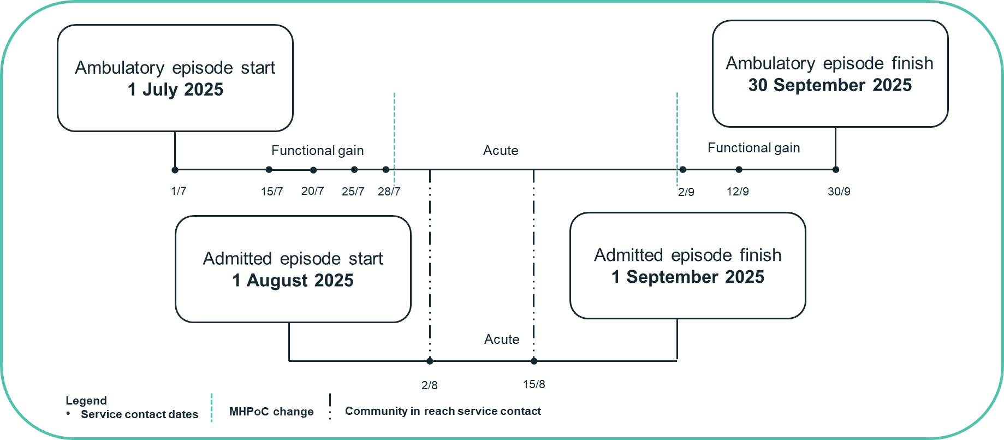

This should be reported as follows:

|  |  |  |
| --- | --- | --- |
| Record | Start date | End date |
| Admitted episode | 1 August 2025 | 1 September 2025 |
| Acute MHPoC | 1 August 2025 | 1 September 2025 |
| Ambulatory episode | 1 July 2025 | 30 September 2025 |
| Functional gain MHPoC | 1 July 2025 | 1 August 2025 |
| Acute MHPoC | 1 August 2025 | 1 September 2025 |
| Functional gain MHPoC | 1 September 2025 | 30 September 2025 |
| Service contacts | 1, 15, 20, 25 and 28 July; 2 and 15 August; 2, 12 and 30 September 2025 | |

As demonstrated in the example, the ABF MHC NBEDS does not require a concurrently occurring ambulatory episode to have an artificial separation date to coincide with the date of admission. The ABF MHC NBEDS supports the continuation of an ongoing ambulatory episode in parallel with an episode in another setting.

**Example 6**

If a consumer is receiving ambulatory mental health care from more than one mental health care team in ambulatory setting there will only be one episode and phase at any one time (refer to section 6.4 Mental Health Phase of Care). This would be reported as follows.

A consumer discharged from hospital receives care on 22 July 2025 in a Functional gain MHPoC with a community eating disorders support team (Establishment A, District-Wide). They received ambulatory service contacts on the following dates: 22 July, 25 July and 29 July 2025.

During a stressful exam period, the consumer experiences depressive episodes and suicidal ideation.

On 30 July 2025, the Acute Care Team (Establishment B, Regional) assesses, commences medication and provides after hours support and changes the consumer to an Acute MHPoC with the goal of care focused on reducing symptoms. They received ambulatory service contacts from the Acute Care Team on the following dates: 30 July, 1 August, 3 August, 15 August, 21 August and 30 August 2025.

The Eating Disorders team continues to review the consumer during this acute MHPoC with the goal of focusing on maintaining eating strategies and supporting activities of daily living. They received ambulatory service contacts from the Eating Disorders team on the following dates: 10 August and 29 August 2025.

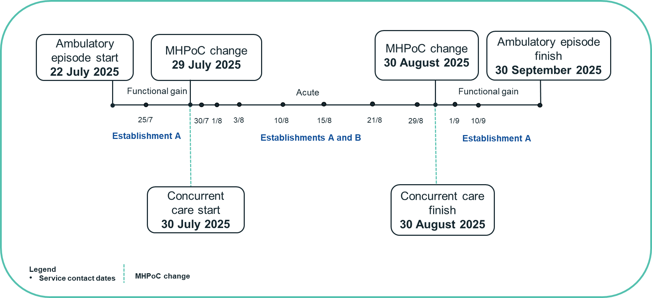

This should be reported as a single community episode with one active phase at any given point in time as represented below:

|  |  |  |
| --- | --- | --- |
| Record | Start date | End date |
| Ambulatory episode 1 | 22 July 2025 | 30 September 2025 |
| Functional gain MHPoC | 22 July 2025 | 29 July 2025 |
| Service contacts | 22, 25 and 29 July 2025 | |
| Acute MHPoC | 30 July 2025 | 30 August 2025 |
| Service contacts | 30 July; 1, 3, 10, 15, 21, 29 and 30 August 2025 | |
| Functional gain MHPoC | 1 September 2025 | 30 September 2025 |
| Service contacts | 1, 10 and 30 September 2025 | |

In this example the consumer’s characteristics become complex symptoms with high levels of behavioural disturbance during a stressful period. This indicates a change in the consumer’s care needs and primary goal of care including changes to their care plan and clinical interventions, therefore a change in the MHPoC from Functional gain to Acute.

When the focus of clinical intervention moves from symptoms, distress or risk to improvements in psychosocial functioning after the stressful period, the consumer’s care needs change requiring less intensive observation or intervention. The consumer is reassessed and assigned a Functional gain MHPoC.

As per the AMHCC business rules, a consumer receiving ambulatory mental health care from different ambulatory teams within or across establishments cannot have more than one ambulatory episode reported. If more than one service unit in the same setting provided services in one episode, only report the service unit that is *primarily responsible* for the care. At any one time, a consumer may only have one ambulatory episode and phase, and all service contacts should be reported in a way that links to that episode.

#### 6.6.2.2 Concurrent episodes within a residential service setting

In the circumstance of residential mental health care, while the RMHC NMDS allows concurrent episodes within the residential setting, the ABF MHC NBEDS does not allow concurrent episodes to be reported within the same setting.

#### 6.6.2.3 Concurrent episodes across different service settings

Examples of concurrent episodes across different service settings and applicable data set specifications are provided in Table 2.

**Table 2**. Concurrent episodes across different service settings and applicable data set specification

| Concurrent episodes across different service settings and applicable data set specification | | |
| --- | --- | --- |
|  | Episode A | Episode B |
| Example 1 – concurrent episodes across admitted and ambulatory settings with mental health care type. | Admitted setting – APC NMDS and ABF MHC NBEDS | Ambulatory setting – ABF MHC NBEDS |
| Example 2 – concurrent episodes across admitted and ambulatory settings with an acute care type and mental health in-reach services. | Admitted setting – APC NMDS | Ambulatory setting – ABF MHC NBEDS |
| Example 3 – concurrent episodes across emergency department and ambulatory setting | Emergency setting – Non‑admitted patient emergency department care NMDS | Ambulatory setting – ABF MHC NBEDS |

### 

### 6.6.3 Reference period

A reference period is defined as the period of time for which activity is collected or reported.

The start or end of a mental health episode will be either formal or statistical:

* a formal start, or end, of an episode is used to indicate the actual commencement of an episode of care, and the subsequent discharge or completion of the episode of care.
* a statistical start, or end, of an episode is used when the episode remains open between two or more reference periods and is used for reporting activity associated with an episode during the specified reference period.

For mental health activity, IHACPA requires quarterly year to date reporting. Therefore, the reference periods for mental health activity align with the reporting periods as outlined for 2024–25 data. For each quarter, the reporting period is financial year to date, that is:

Quarter 1: 1 July 2025 to 30 September 2025

Quarter 2: 1 July 2025 to 31 December 2025

Quarter 3: 1 July 2025 to 31 March 2026

Quarter 4: 1 July 2025 to 30 June 2026

#### 6.6.3.1 Reporting admitted mental health phase of care across different reference periods

The concept of reference periods does not apply to admitted mental health episodes. Admitted mental health episodes should only be reported once the consumer is discharged regardless of the timeframe and all MHPoC including those that ended in prior reporting periods should be reported once the episode concludes. The concept of reference periods also does not apply to MHPoC. When a MHPoC carries over from the previous reference period, the start date for the MHPoC should be reported, even though it is before the reference period. This is demonstrated in the example 7.

#### Example 7

On 1 June 2025, a consumer was admitted to hospital for mental health services, under the Acute MHPoC. On 6 July 2025, the consumer was discharged from the hospital.

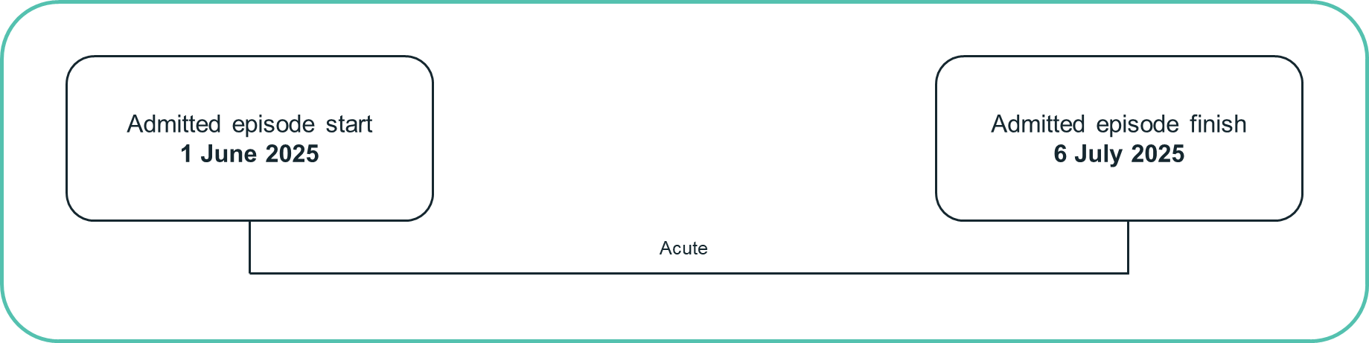

This should be reported as follows:

|  |  |  |
| --- | --- | --- |
| **Record** | **Start date** | **End date** |
| Admitted episode | 1 June 2025 | 6 July 2025 |
| Acute MHPoC | 1 June 2025 | 6 July 2025 |

**Example 8**

For admitted mental health, the term ‘work in progress’ is used to refer to phases that span more than one financial year. These are admitted mental health care phases that began before the beginning of the reporting financial year. In the 2025–26 reporting period, an admitted work in progress record would be a phase that began before 1 July 2025.

On 1 June 2025, a consumer was admitted to hospital for mental health services, under the Acute MHPoC.

On 6 November 2025, the consumer was discharged from hospital.

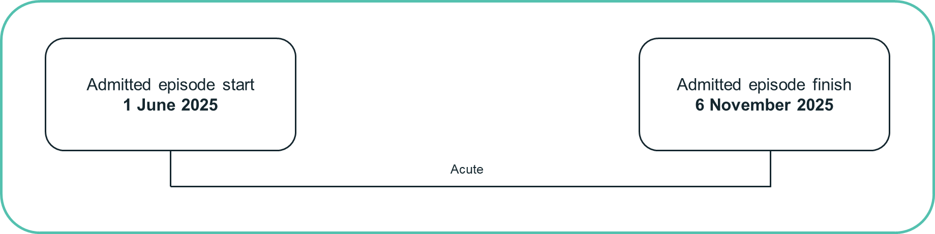

This should be reported as follows:

|  |  |  |
| --- | --- | --- |
| **Record** | **Start date** | **End date** |
| Admitted episode | 1 June 2025 | 6 November 2025 |
| Acute MHPoC | 1 June 2025 | 6 November 2025 |

#### 6.6.3.2 Reporting ambulatory mental health phase of care across different reference periods

In ambulatory mental health, the term ‘work in progress’ is used to describe records that are reported in reference periods prior to the end of service. Work in progress ambulatory episodes and phases are required to be reported while the service is ongoing and therefore may be reported over multiple financial quarters and years.

The start date of an ambulatory episode of care is:

* the first service contact of the episode if the episode began in the reference period being reported
* the first date of the reference period otherwise, indicating the episode began in a previous financial year, the episode start mode should be value 2 (start of a new reference period).

The end date of an ambulatory episode of care is:

* the date of the last service contact if the episode is complete at the end of the reference period.
* the episode end mode should be value 9 to indicate the end of the reference period.
* the last date of the reference period otherwise.

The start date of an ambulatory phase is always the date of the first service contact of that phase.

The end date of an ambulatory MHPoC is the date of the last service contact in that phase if the phase is complete by the end of the reference period. The end date is missing otherwise.

Service contacts are only reported in the data submission for the reference period in which they took place. Note that all reference periods begin on 1 July.

#### Example 9

On 1 June 2025, a consumer commenced their ambulatory mental health care episode under the Functional gain MHPoC. They received ambulatory service contacts on the following dates: 1 June, 15 June and 6 July 2025.

On 6 July 2025, their ambulatory care episode formally ended.

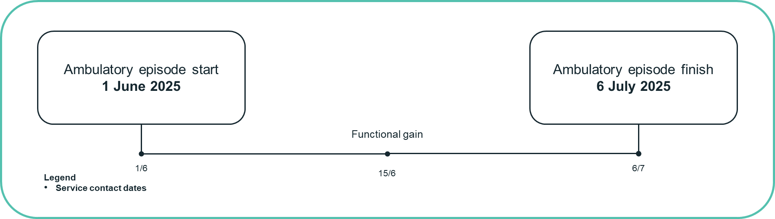

When reporting in Q4 2024–25, the reference period is 1 July 2024 to 30 June 2025 and should be reported as follows:

|  |  |  |
| --- | --- | --- |
| **Record** | **Start date** | **End date** |
| Reference period | 1 July 2024 | 30 June 2025 |
| Ambulatory episode | 1 June 2025 | 30 June 2025 |
| Functional gain MHPoC | 1 June 2025 | blank |
| Service contacts | 1 June and 15 June 2025 | |

When reporting in Q1 2025–26, the reference period is 1 July 2025 to 30 September 2025 and should be reported as follows:

|  |  |  |
| --- | --- | --- |
| **Record** | **Start date** | **End date** |
| Reference period | 1 July 2025 | 30 September 2025 |
| Ambulatory episode | 1 July 2025 | 6 July 2025 |
| Functional gain MHPoC | 1 June 2025 | 6 July 2025 |
| Service contact | 6 July 2025 | |

**Example 10**

On 15 July 2025, a consumer commenced their ambulatory mental health care episode under Functional gain MHPoC. They received ambulatory service contacts on the following dates: 15 July, 20 September, 1 October, 14 November, 15 December 2025.

On 15 December 2025, their ambulatory care episode formally ended.

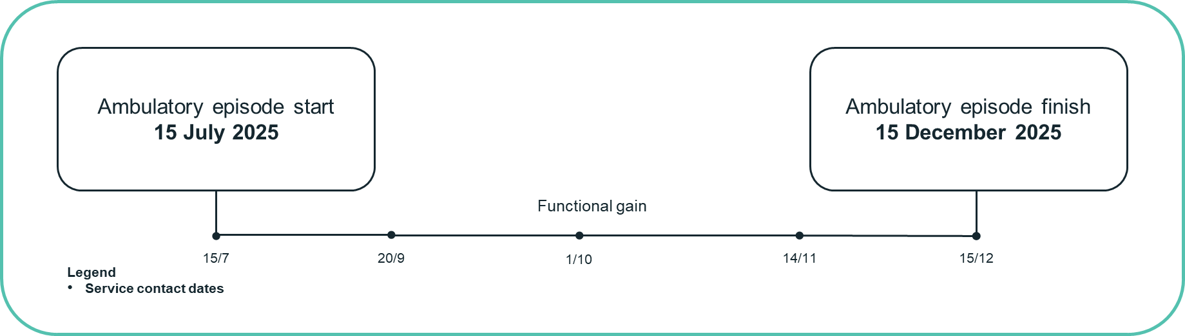

When reporting in Q1 2025–26 it should be as follows

|  |  |  |
| --- | --- | --- |
| **Record** | **Start date** | **End date** |
| Reference period | 1 July 2025 | 30 September 2025 |
| Ambulatory episode | 15 July 2025 | 30 September 2025 |
| Functional gain MHPoC | 15 July 2025 | blank |
| Service contacts | 15 July, 20 September 2025 | |

When reporting in Q2 2025–26 it should be as follows:

|  |  |  |
| --- | --- | --- |
| **Record** | **Start date** | **End date** |
| Reference period | 1 July 2025 | 31 December 2025 |
| Ambulatory episode | 15 July 2025 | 15 December 2025 |
| Functional gain MHPoC | 15 July 2025 | 15 December 2025 |
| Service contacts | 15 July; 20 September; 1 October; 14 November; 15 December 2025 | |

When reporting the ‘work in progress’ phase that spans across multiple quarters within the same financial year. In the above example, in quarter 2 reference period, the episode would be updated to reflect the year-to-date reference period, the phase end date would be updated to reflect the end of the phase and additional service contacts reported are linked to the same episode.

## 6.7 Unique identification of consumers

Unique identification of the consumer is an essential requirement in clinical information systems, both for ensuring that local information collections support continuity of care, as well as analysis at a state or territory and national level.

State and territory governments vary in the extent to which different mental health service units share a unique identifier for consumers under care. However, where these are not in place, state and territory governments are taking steps to establish such arrangements.

The unique patient identifier reported to the ABF MHC NBEDS 2025–26 should be in encrypted form and meet two fundamental requirements:

* the identifier should be identical to the identifier used in supplying unit record data in respect of the individual consumer in the corresponding data collections dataset
* the encrypted identifier used to supply data should be stable over time – that is, it should allow the consumer’s data to be linked across reporting years.

The ABF MHC NBEDS 2025–26 contains the *Person – unit identifier type, mental health organisation type* data item that identifies the highest level of organisation (administrative or geographical) to which the patient identifier is unique and allows all health care activity specific to the individual to be captured.

In addition to the above, the Individual Healthcare Identifier (IHI) NBEDS is for episodes of care for consumers reported against health metadata sets (NMDS and NBEDS) provided by states and territories, each consumer’s IHI is unique with the Australian healthcare system is automatically assigned to all individuals registered with Medicare Australia or enrolled in the Department of Veterans' Affairs programs. State and territory health authorities may report IHI data on a best-efforts basis to IHACPA. Any IHI data submission should occur as part of the related national minimum data set or national best endeavours data set data submissions.[14]

## 6.8 Linkage of mental health episodes within and across settings

The allocation of unique identifiers (for consumers, episodes and settings) plays an important role in the ability to link consumers episodes across and within settings.

IHACPA currently uses a combination of episode, establishment and service unit identifiers (refer to section 7.1 Establishment and service unit identifiers) to link data from the multiple data sets shown in Table 3.

**Table 3**. Data set specification sources of mental health care patient level data

| **Patient data type** | **Specialised /  non-specialised mental health care** | **Data set specification source** |
| --- | --- | --- |
| Admitted patient | Both | APC NMDS |
| Community patient | Specialised | ABF MHC NBEDS – values can be derived from CMHC NMDS |
| Residential patient | Specialised | ABF MHC NBEDS – values can be derived from RMHC NMDS |

These links also facilitate access to additional data items such as mental health legal status from the APC NMDS.

In the case of activity that has taken place in the emergency department, it should only be reported through the ABF MHC NBEDS if ambulatory mental health in-reach service was involved. All other activity that takes place in the emergency department does not form part of the ABF MHC NBEDS and should be reported through the Non‑Admitted Patient Emergency Department Care NMDS.

The use of *Person—unit identifier type, mental health organisation type* identifies the highest level of organisation to which the patient identifier is unique. Together with the *Episode of mental health care – identifier* within the setting, these enable person-level matching between records within the ABF MHC NBEDS, and also between ABF MHC NBEDS and related data sets, for example APC NMDS, depending on the episode service setting.

In selecting permissible values for *Person—unit identifier type, mental health organisation type*, where all ABF MHC NBEDS person identifiers are unique internally but do not match to a related non-mental health data set (for example the APC NMDS and NAP NBEDS) then Code 02 *state or territory Health Authority (specialised mental health)* should be applied.

# Data items

The Activity based funding mental health care data request specifications (ABF MHC DRS) incorporates unique linking keys that enable separately reported data to be linked together, providing more information without the need for lengthy data files. The ABF MHC DRS consists of three data files that can be linked, including:

* mental health care episode level data (MHCE)
* mental health care phase level data (MHCP)
* ambulatory service contact data (ASC).

Additional data specific to a particular setting, such as data reported through the Admitted patient care data request specifications (APC DRS), are linked with the MHCE via a linking key.

Table 4 provides an overview of the data files that are linked to the mental health care episode data file.

**Table 4**. Data files in the ABF MHC DRS linked to mental health episode data

| **Episode Setting** | **Episode Data** | **Phase data** | **Additional episode data** |
| --- | --- | --- | --- |
| Admitted | MHCE | MHCP | APC NMDS |
| Ambulatory | MHCE | MHCP | ASC |
| Residential | MHCE | MHCP | N/A |

The following lists the requirements for the linking keys between the data files:

* MHCE and APC has a one-to-one episode to episode relationship. *Episode of mental health care – episode identifier[15]* (APC DRS item 47 and MHCE DRS item 1) links together the 2 data files on an episode level. The keys need to be unique at the jurisdictional level in both MHCE file and APC file
* MHCE and MHCP has a one-to-many episode to phase relationship. The *phase linking key* (MHCE DRS item 28 and MHCP DRS item 14) links together the 2 data files. The keys need be unique at the jurisdictional level in the MHCE file or blank if no linking is required
* MHCE and ASC has a one to many episode to service event relationship. The *service contact linking key* (MHCE DRS item 29 and ASC DRS item 12) links together the 2 data files. The keys need be unique at the jurisdictional level in the MHCE file or blank if no linking is required.
* MHCP and ASC has a one to many phase to service event relationship. The *service contact phase linking key* (MHCP DRS item 15 and ASC DRS item 13) links together the 2 data files. The keys need be unique at the jurisdictional level in the MHCP file or blank if no linking is required.

In line with the principle of ‘single provision, multiple use’, several data items contained in the Activity based funding: Mental health care national best endeavours data set (ABF MHC NBEDS) can be derived from other linked data set specifications (DSS).

This section outlines the ABF MHC NBEDS data items, divided into each reporting level: episode, phase, and service contact. Appendix A contains lists of all data items and possible related DSS that could be sources for the provision of this content.

## 7.1 Establishment and service unit identifiers

Establishment and service unit identifiers are used in the ABF MHC NBEDS 2025–26 to enable identification of the different levels of service units and establishments that provide mental health care services in the public system. As the ABF MHC NBEDS 2025–26 specifies activity from both specialised and non-specialised services, the identifiers included may not be applicable for all settings.

Table 5 provides a guide as to when an identifier may be applicable, noting that this table is a guide only and local business rules may impact on when an identifier should be used.

**Table 5**. Establishment and service unit identifiers

| **Identifier data item** | **METEOR ID** | **Episode Setting** | |
| --- | --- | --- | --- |
| **Specialised** | **Non-specialised** |
| Episode of mental health care—identifier | 751899 | All settings | All settings |
| Establishment—activity based funding organisation identifier | 751912 | All settings | All settings |
| Establishment—Local Hospital Network identifier | 790673 | All settings | All settings |
| Person – person identifier | 799014 | All settings | All settings |
| Person—unit identifier type, mental health organisation type | 745668 | All settings | All settings |
| Specialised mental health service – admitted patient service unit identifier | 795850 | Admitted | None |
| Specialised mental health service – admitted patient service unit name | 721830 | Admitted | None |
| Specialised mental health service—ambulatory service unit identifier | 795855 | Ambulatory | None |
| Specialised mental health service—ambulatory service unit name | 750374 | Ambulatory | None |
| Specialised mental health service – residential service unit identifier | 795859 | Residential | None |
| Specialised mental health service – residential service unit name | 722715 | Residential | None |

## 7.2 Episode level data items

### 7.2.1 Principal and additional diagnosis

The principal diagnosis is the diagnosis established after study to be chiefly responsible for occasioning the consumer’s episode of care or presentation at a health service. A principal diagnosis is reported for an episode of mental health care that occurs in the admitted, residential and, where possible, the ambulatory settings.

In the APC NMDS, principal diagnosis is determined in accordance with the Australian Coding Standards.

Additional diagnoses identify secondary or other diagnoses that affected the person’s care during the period in terms of requiring therapeutic intervention, clinical evaluation, extended management or increased care or monitoring.

Additional diagnoses are reported for an episode of mental health care that occurs in the admitted or residential setting and where possible the ambulatory setting.

In the admitted and residential settings, the principal and additional diagnoses are coded at the end of the episode in accordance with the Australian Coding Standards.

Following the Australian Coding Standards, in situations when a principal diagnosis from the ICD-10-AM Chapter 5 Mental and Behavioural Disorders is not able to be established, as in the case of ambulatory consumers who have been assessed but not activated, a symptom diagnosis (such as R45.89 *Other symptoms and signs involving emotional state*) may be provided.

### 7.2.2 Service provider setting origin

In order to identify the setting from which a service provider for a mental health care episode originates, IHACPA included the data item *Episode of mental health care - Service provider setting origin* in the ABF MHC NBEDS. This data item contains three values: admitted, ambulatory or residential care.

Where there are multiple service providers for an episode of care, the service setting of the primary service provider should be reported.

For example, if the primary service provider is ambulatory mental health in-reach team for an admitted consumer (even if the consumer is not in a mental health care type for the admitted episode), the service provider setting origin will be ‘ambulatory care’ to reflect the origin of the primary service provider.

Alternatively, if the admitted team provides a post discharge follow-up service contact to a consumer previously under their care but their primary care provider is ambulatory mental health, the service provider setting origin will be ‘ambulatory care’.

### 7.2.3 Assessment only data item

An assessment only episode occurs when the consumer does not go on to receive further care from the mental health service which completed the initial review. This means the consumer does not go on to a MHPoC (Acute, Consolidating gain, Intensive extended, or Functional gain). If the consumer does go to a MHPoC the assessment forms part of the phase.

Episodes recorded as assessment only will be valid as part of the MHCE level data set and should have no phase level data associated in the MHCP level data set.

## 7.3 Phase level data items

### 7.3.1 Mental Health Phase of Care

As discussed in section 6.4, MHPoC is a key phase level data item being collected for all mental health episodes for the purpose of ABF reporting. For further information, please refer to the MHPoC documentation available on the IHACPA website.

### 7.3.2 Clinical assessments

#### 7.3.2.1 Health of the Nation Outcome Scales

The Health of the Nation Outcome Scales (HoNOS) and Health of the Nation Outcome Scales 65+ (HoNOS 65+) are 12 item clinician-rated measures designed by the Royal College of Psychiatrists specifically for use in the assessment of consumer outcomes in mental health services. The Health of the Nation Outcome Scales Child and Adolescent (HoNOSCA) is a 15 item clinician-rated measure modelled on the HoNOS and designed specifically for use in the assessment of child and adolescent consumers. HoNOS/CA/65+ should be reported at the beginning of each MHPoC regardless of the length of stay.

The supplementary value *9–Unable to rate* should be used for values that are missing or unknown in the HoNOSCA tool.

#### Key references

* Gowers S, Harrington R, Whitton A, Lelliott P, Beevor A, Wing J, Jezzard R (1999a) Brief scale for measuring the outcomes of emotional and behavioural disorders in children: Health of the Nation Outcome Scales for Children and Adolescents (HoNOSCA). *British Journal of Psychiatry*, 174, 413‑416.
* Gowers S, Harrington R, Whitton A, Beevor A, Lelliott P, Jezzard R, Wing J (1999b) Health of the Nation Outcome Scales for Children and Adolescents (HoNOSCA): Glossary for HoNOSCA score sheet. *British Journal of Psychiatry*, 174, 428-433.
* Wing J, Beevor A, Curtis R, Park S, Hadden S, Burns A (1998) Health of the Nation Outcome Scales (HoNOS). Research and development. *British Journal of Psychiatry*, 172, 11-18.
* Wing J, Curtis R, Beevor A (1999) Health of the Nation Outcome Scales (HoNOS): Glossary for HoNOS score sheet. *British Journal of Psychiatry*, 174, 432–434.
* Burns A, Beevor A, Lelliott P, Wing J, Blakey A, Orrell M, Mulinga J, Hadden S (1999) Health of the Nation Outcome Scales for Elderly People (HoNOS 65+). *British Journal of Psychiatry*, 174, 424-427.
* Burns A, Beevor A, Lelliott P, Wing J, Blakey A, Orrell M, Mulinga J, Hadden S (1999) Health of the Nation Outcome Scales for Elderly People (HoNOS 65+): Glossary for HoNOS 65+ score sheet. *British Journal of Psychiatry*, 174, 435-438.

#### 7.3.2.2 Children’s Global Assessment Scale

The Children’s Global Assessment Scale (CGAS) was developed by Schaffer and colleagues at the Department of Psychiatry, Columbia University to provide a global measure of severity of disturbance in children and adolescents. Similar to the HoNOSCA, it is designed to reflect the lowest level of functioning for a child or adolescent during a specified period. The measure provides a single global rating only, on a scale of 1–100.

#### Key reference

* Schaffer D, Gould MS, Brasic J, et al (1983) A children’s global assessment scale (CGAS). *Archives of General Psychiatry*, 40, 1228-1231.

#### 7.3.2.3 Factors Influencing Heath Status

The Factors Influencing Heath Status (FIHS) measure is a checklist of seven ‘psychosocial complications’ for child and adolescent consumers. The FIHS is based on the problems and issues identified in the Factors Influencing Health Status chapter in International Statistical Classification of Diseases and Health Related Problems, Tenth Revision, Australian Modification (ICD-10-AM). It is a simple checklist of the ICD factors originally developed for the Mental Health Classification and Service Costs (MH-CASC) project.

#### Key reference

* Buckingham W, Burgess P, Solomon S, Pirkis J, Eagar K (1998) *Developing a Casemix Classification for Mental Health Services. Volume 2: Resource Materials.* Canberra: Commonwealth Department of Health and Family Services.

#### 7.3.2.4 Abbreviated Life Skills Profile

The Life Skills Profile (LSP) was developed by a team of clinical researchers in Sydney (Rosen et al 1989, Parker et al 1991) to assess a consumer’s abilities with respect to basic life skills. It is applicable for adult and older consumers and is capable of being completed by family members and community housing members as well as professional staff.

The original form of the LSP consisted of 39 items. Work undertaken as part of the Australian MH‑CASC study saw the 39 items reduced to 16 items by the original designers. This reduction in item number aimed to minimise the rating burden on clinicians when the measure is used in conjunction with the HoNOS. The Abbreviated LSP-16 instrument is the version to be reported for the ABF MHC NBEDS 2025–26.

#### Key references

Original 39 item version of the LSP:

* Rosen A, Hadzi-Pavlovic D, Parker G (1989) The Life Skills Profile: A measure assessing function and disability in schizophrenia. *Schizophrenia Bulletin*, 1989, 325-337.
* Parker G, Rosen A, Emdur N, Hadzi-Pavlov D (1991) The Life Skills Profile: Psychometric properties of a measure assessing function and disability in schizophrenia. *Acta Psychiatrica Scandinavica*, 83 145-152.
* Trauer T, Duckmanton RA, Chiu E (1995) The Life Skills Profile: A study of its psychometric properties. *Australian and New Zealand Journal of Psychiatry*, 29, 492-499.

Abbreviated 16 item version of the LSP:

* Buckingham W, Burgess P, Solomon S, Pirkis J, Eagar K (1998) *Developing a Casemix Classification for Mental Health Services. Volume 2: Resource Materials*. Canberra: Commonwealth Department of Health and Family Services.

#### 7.3.2.5 Resources Utilisation Groups – Activities of Daily Living

Developed for the measurement of nursing dependency in skilled nursing facilities in the United States of America, the Resources Utilisation Groups – Activities of Daily Living (RUG-ADL) measures the ability of those activities that are likely to be lost last in life – ‘late loss’ activities (eating, bed mobility, transferring and toileting). ‘Early loss’ activities (managing finances, social relationships, grooming) are also included in the LSP. The RUG-ADL is specific for older persons and is widely used in Australian nursing homes and other aged care residential settings. The RUG-ADL comprises four items only and is usually completed by nursing staff.

The supplementary value *9–Unable to rate* should be used for values that are missing or unknown in the RUG ADL tool.

#### Key reference

* Fries BE, Schneider DP, et al (1994) Refining a casemix measure for nursing homes. Resource Utilisation Groups (RUG-III). *Medical Care*, 32, 668-685.

## 7.4 Ambulatory service contact level data items

### 7.4.1 Episode of care setting

The location of the consumer receiving the ambulatory activity is identified through the use of the *Service contact – episode of care setting* data item for each contact and may vary within the episode. As ambulatory mental health services can be provided to consumers in a variety of settings, this data item identifies the consumer setting during that service contact.

The service providing the care may be a specialised community-based ambulatory mental health service or a non‑specialised non-admitted public hospital service (for example, outpatient clinic). For example, if the ambulatory mental health team provide a service contact to an admitted consumer (in a non-specialised mental health care setting), the consumer episode setting for the ambulatory service contact will be ‘admitted patient – other’ to reflect the consumer setting.

Alternatively, if the ambulatory mental health team provide a service contact to a consumer in the emergency department, the patient episode setting for the ambulatory service contact will be ‘emergency department patient’.

### 7.4.2 Service duration

This data item, *Service contact – service duration, total minutes*, is intended to collect the total time in minutes from start to finish of a service contact. Although this has already been possible in specialised mental health services, inclusion of this data item in the ABF MHC NBEDS enables collection of data in non‑specialised mental health services too. For specialised mental health services this data element can be derived from the existing data element *Mental health service contact—service duration, total minutes*.

### 7.4.3 Source of funding

The source of funding for consumers receiving mental health care in an ambulatory setting is collected using the *Service contact—source of funding, patient funding source code* for each service contact*.* This data item is collected at the service contact level given episodes of mental health care can last for extended periods, and to ensure that potential changes to the source of funding over the course of a consumer episode are captured. The data element has been included specifically to enable the identification of the source of funding for ambulatory mental health care, as the source of funds for admitted mental health care is already captured in *Episode of care—source of funding, patient funding source code* in the APC NMDS.

# Collection Protocol

This section outlines the minimum requirements for the activity based funding: Mental health care national best endeavours data set (ABF MHC NBEDS) 2025–26 and should not confine state and territory governments.

Activity for the ABF MHC NBEDS is reported in conjunction with the Activity based funding mental health care data request specifications (ABF MHC DRS). The ABF MHC DRS 2025–26 consists of three data files, the mental health care episode level data (MHCE), the mental health care phase level data (MHCP) and ambulatory service contact data (ASC) which are linked with unique linking keys.

## 8.1 Reporting occasions

### 8.1.1 Episode level items

The ABF MHC NBEDS 2025–26 requires reporting of clinical and other data items at an episode level. Table 6 shows the items required to be reported at an episode level for each setting. The reporting of these data items is consistent for all age groups.

**Table 6**. ABF MHC NBEDS 2025–26 reporting occasions for episode level items

| **Data item** | **Admitted  Episode** | **Ambulatory Episode** | **Residential Episode** |
| --- | --- | --- | --- |
| **Demographics** |  |  |  |
| Person – date of birth | ✓ | ✓ | ✓ |
| Person – sex | ✓ | ✓ | ✓ |
| Person – marital status | ✓ | ✓ | ✓ |
| Person – Indigenous status | ✓ | ✓ | ✓ |
| Person – country of birth | ✓ | ✓ | ✓ |
| Person – area of usual residence, statistical area level 2 (SA2) code | ✓ | ✓ | ✓ |
| **Episode details** |  |  |  |
| Episode of mental health care – episode start date | ✓ | ✓ | ✓ |
| Episode of mental health care – episode end date | ✓ | ✓ | ✓ |
| Episode of mental health care – episode start mode | ✓ | ✓ | ✓ |
| Episode of mental health care – episode end mode | ✓ | ✓ | ✓ |
| Episode of care – principal diagnosis | ✓ | ✓ | ✓ |
| Episode of care – additional diagnoses | ✓ | ✓ | ✓ |
| Episode of mental health care - service provider setting origin | ✓ | ✓ | ✓ |
| Specialised mental health service - target population group | - | ✓ | - |
| Episode of care—clinical assessment only indicator | ✓ | ✓ | ✓ |
| **Identifiers** |  |  |  |
| Establishment – Activity based funding organisation identifier | ✓ | ✓ | ✓ |
| Specialised mental health service – admitted patient service unit identifier | ✓ | - | - |
| Specialised mental health service – admitted patient service unit name | ✓ | - | - |
| Specialised mental health service – ambulatory service unit identifier, | - | ✓ | - |
| Specialised mental health service – ambulatory service unit name | - | ✓ | - |
| Specialised mental health service – residential service unit identifier, | - | - | ✓ |
| Specialised mental health service – residential service unit name | - | - | ✓ |
| Episode of mental health care – identifier | ✓ | ✓ | ✓ |
| Establishment - LocalHospital Network identifier | ✓ | ✓ | ✓ |
| Person – person identifier | ✓ | ✓ | ✓ |
| Person – unit identifier type, mental health organisation type | ✓ | ✓ | ✓ |

### 8.1.2 Phase level items

The ABF MHC NBEDS 2025–26 requires reporting of clinical and other data items at phase level. Table 7 displays the items required to be reported at phase level for each setting. The reporting of these data items is consistent for all age groups.

**Table 7**. ABF MHC NBEDS 2025–26 reporting occasions for phase level items

| **Data item** | **Admitted  Episode** | **Ambulatory Episode** | **Residential Episode** |
| --- | --- | --- | --- |
| **Phase details** |  |  |  |
| Episode of care – mental health phase of care | ✓ | ✓ | ✓ |
| Episode of care – mental health phase of care start date | ✓ | ✓ | ✓ |
| Episode of care – mental health phase of care end date | ✓ | ✓ | ✓ |
| mental health phase of care – number of leave days | ✓ | - | ✓ |
| **Clinical assessments – *Refer section 8.1.2.1*** | | | |
| **Identifiers** |  |  |  |
| Establishment – Activity based funding organisation identifier | ✓ | ✓ | ✓ |
| Mental health care phase record identifier | ✓ | ✓ | ✓ |

#### 8.1.2.1 Clinical measures

The ABF MHC NBEDS 2025–26 requires clinical measures to be reported in relation to the Mental Health Phase of Care (MHPoC). A new MHPoC may be considered when undertaking a review. All clinical assessments should be completed as soon as practical following the commencement of MHPoC, with the exception of the Factors Influencing Health Status (FIHS). If an episode of mental health care only contains one MHPoC, the FIHS is reported at the end of the MHPoC (on discharge).

For the purposes of the ABF MHC NBEDS 2025–26, if a consumer is discharged from an episode of mental health care and commences an episode of mental health care in a different setting, then where applicable the clinical assessment score from the last MHPoC in the previous episode of mental health care may be recorded if:

* the assessment had been completed within the last two weeks
* the MHPoC is the same for the new episode of mental health care as it was for the discharge episode of mental health care.

Table 8 shows when the clinical measures are collected and reported in the ABF MHC NBEDS 2025–26.

**Table 8**. ABF MHC NBEDS 2025–26 reporting occasions for the clinical measures

| **Data item** | **Admitted Episode** | | **Ambulatory Episode** | | **Residential Episode** | |
| --- | --- | --- | --- | --- | --- | --- |
| **Children/ Young Adults** | **Phase 1** | **Phase 2 +** | **Phase 1** | **Phase 2 +** | **Phase 1** | **Phase 2 +** |
| Person – level of psychiatric symptom severity, Health of the Nation Outcome Scale for Children and Adolescents score (HoNOSCA) | ✓ | ✓ | ✓ | ✓ | ✓ | ✓ |
| Person – level of psychiatric symptom severity, Children’s Global Assessment Scale score (CGAS) | ✓ | ✓ | ✓ | ✓ | ✓ | ✓ |
| Episode of care – FIHS psychosocial complications indicator (FIHS) | *x*\* | ✓ | *x*\* | ✓ | *x*\* | ✓ |
| **Adults** |  |  |  |  |  |  |
| Person – level of psychiatric symptom severity, Health of the Nation Outcome Scale score (HoNOS) | ✓ | ✓ | ✓ | ✓ | ✓ | ✓ |
| Person – level of difficulty with activities in a life area, Abbreviated Life Skills Profile score (LSP-16) | *x* | *x* | ✓* | ✓* | ✓* | ✓* |
| **Older Adults** |  |  |  |  |  |  |
| Person – level of psychiatric symptom severity, Health of the Nation Outcome Scale 65+ score (HoNOS 65+) | ✓ | ✓ | ✓ | ✓ | ✓ | ✓ |
| Person – level of difficulty with activities in a life area, Abbreviated Life Skills Profile score (LSP-16) | *x* | *x* | ✓* | ✓* | ✓* | ✓* |
| Person – level of functional independence, Resource Utilisation Groups – Activities of Daily Living score (RUG‑ADL) | ✓ | ✓ | *x* | *x* | ✓ | ✓ |
| û* The FIHS is reported at the start of the second and subsequent phases within an episode. If an episode only has one phase, then the FIHS is reported at the end of the phase. | | | | | | |
| ü*The LSP-16 is assessed and reported at the start of the first phase. If an episode is longer than 3 months, then the LSP-16 score from the initial assessment is reported at the start of each new phase, however, will not need to be re-assessed until the next new phase that falls after the 3 month period. | | | | | | |

#### 8.1.2.2 Clinical measures rating periods

Table 9 contains a summary of the rating periods for the clinical measures.

**Table 9**. ABF MHC NBEDS 2025–26 rating periods for the clinical measures

| **Outcome measure** | **Rating period** |
| --- | --- |
| HoNOS/ HoNOS 65+/ HoNOSCA | Previous two weeks or preceding MHPoC (the shorter time period) |
| CGAS | Previous two weeks |
| FIHS | Period of care bound by preceding MHPoC |
| LSP-16 | Previous three months |
| RUG-ADL | Current status |

The clinician may draw on direct observation and information from other individuals that have been in contact with the consumer during the rating period. This may include family, friends, carers and health professionals. There are no exceptions to any of the rating periods.

### 8.1.3 Service contact level items

For ambulatory episodes, the ABF MHC NBEDS 2025–26 requires reporting of data items at an individual service contact level. Table 10 shows the items required to be reported at a service contact level. The reporting of these data items is consistent for all age groups.

**Table 10**. ABF MHC NBEDS 2025–26 reporting occasions for service contact level items

| **Data item** | **Ambulatory Episode** |
| --- | --- |
| **Service contact items** |  |
| Service contact – service date | ✓ |
| Service contact – service duration, total minutes | ✓ |
| Service contact – patient/client participation indicator | ✓ |
| Service contact – group session indicator | ✓ |
| Service contact – episode of care setting | ✓ |
| Service contact – source of funding | ✓ |
| Specialised mental health service - target population group | ✓ |
| **Identifiers** |  |
| Establishment – Activity based funding organisation identifier | ✓ |
| Specialised mental health service – ambulatory service unit identifier | ✓ |
| Specialised mental health service – ambulatory service unit name | ✓ |
| Mental health care service contact identifier | ✓ |

# Frequently Asked Questions

## 9.1 Episode of mental health care

**a) Can episodes overlap between settings?**

Two episodes that occur at the same time may be reported to the Activity based funding: Mental health care national best endeavours data set (ABF MHC NBEDS) 2025–26, provided the episodes are reported for different settings and one of them is an ambulatory episode. This may occur as a result of a consumer being admitted for mental health care, whilst in an episode of mental health care in the ambulatory. Multiple episodes that occur at the same time within the same setting cannot be reported to the ABF MHC NBEDS 2025–26. Refer to section 6.6.2 Concurrent episodes of mental health care.

**b) How and when is consumer episode setting reported?**

The *Service contact – episode of care setting* (consumer episode setting) data item is intended for use within the ambulatory setting only. When consumer activity is reported on the ambulatory patient administration system (PAS), the setting of the consumer’s service must be reported. For example, very often the ambulatory service will see consumers in the ambulatory setting, and the value reported will reflect that the care has been provided in the ambulatory setting. However, if the ambulatory service sees a consumer in another setting, such as the admitted patient setting (that is, in a concurrent episode) or the emergency care setting, the value reported will reflect the alternate setting. The patient episode setting data item is not reported by the alternate setting (for example, the admitted patient setting). Refer to section 6.6.2 Concurrent episodes of mental health care.

Example: A consumer is currently active in an ambulatory mental health service unit. The consumer is admitted into a hospital’s mental health ward with a mental health care type. The case manager from the ambulatory service wants to retain a pre-existing appointment with the consumer and visits them in the mental health ward. In this example, the episode reported in the community PAS has a patient episode setting value reported as *1 Admitted patient – specialised mental health care unit*. The patient episode setting data item is not reportable for the hospital’s episode of care.

**c) Ambulatory** **episodes of care may occasionally be opened prior to a service contact - how are these reported?**

There may be occurrences where an episode of care is opened administratively in the local system, allowing preparatory work to occur prior to the first service contact. Whilst the Independent Health and Aged Care Pricing Authority acknowledges the importance of this work, for the purposes of reporting to the ABF MHC NBEDS 2025–26 the episode must commence on the date of a service contact. Refer to section 6.6.1.2 Ambulatory episodes.

**d) There are occasions where an episode of care is formally closed, but work is still undertaken through family counselling or queries with service contacts - how are these reported?**

The episode of care should not be closed until care for the consumer and family has been completed. Single service contacts that occur outside of an episode of care should not be reported through the ABF MHC NBEDS 2025–26. If there are a significant number of service contacts occurring, a new episode of care may be required to be opened.

**e) How are episodes of care provided by non-governmental organisations (NGO) reported?**

Episodes of care delivered by an NGO should be reported under a private Establishment ID for that NGO or a public identifier for that contracting entity, either a public hospital, local health network or jurisdiction.

## 9.2 Setting

**a) What is the difference between a specialised ambulatory service and a non‑specialised ambulatory service?**

The specialised ambulatory services are those services that identify as specialised mental health services. Their primary function to provide treatment, rehabilitation or community health support targeted towards people with a mental illness. These activities are delivered from a service or facility that is readily identifiable as both specialised and serving a mental health care function[16].

Non-specialised mental health services are those mental health services that do not meet the definition of a specialised mental health service but provide mental health services to those consumers that meet the definition of mental health care type.

**b) How are ambulatory in-reach consultation liaison services reported in the ABF MHC NBEDS 2025–26?**

Consultation liaison in the community can be reported but it must be part of an episode. Associated service contacts should indicate that the consumer location is different from that of the health service provider.

For example, in the situation of consultation liaison to an admitted consumer episode in a non‑mental health care type, the consultation liaison will be reported as part of ambulatory episode and there will be an admitted episode in the Admitted patient care national minimum data set (APC NMDS). This may or may not be able to be linked (dependent on the use of a unique consumer identifier).

## 9.3 Clinical assessments

**a) Are clinical assessment tools required for assessment only**[17]**?**

Clinical assessment tools are not required for those episodes of care which are reported as assessment only and not linked to any phase-level data however local clinical practice may encourage the use of clinical assessments tools.

**b) Does the LSP-16 need to be re-assessed if the consumer has a mental health phase of care change within three months of completing the tool for a previous mental health phase of care change?**

No, as the Abbreviated Life Skills Profile (LSP-16) is based on the previous 3 months it does not need to be reassessed any more frequently than 3 months. Refer to section 8.1.2 Phase level items.

## 9.4 Service contacts

**a) Are all service contacts within an episode of care reported?**

Only the service contacts that occurred within the reference period are reported, rather than all the service contacts within an episode of care. Refer to section 6.6.3 Reference period.

Example: If an episode of care commenced in July 2025, and is still ongoing, the service contacts that occurred during the July to December reference period would be reported as part of the 2025–26 Quarter 2 activity data submission.

# Appendix A – Relationship between ABF MHC NBEDS 2025–26 and other related data set specifications

This appendix lists data items required for the Activity based funding: Mental health care national best endeavours data set (ABF MHC NBEDS) 2025–26 at each reporting level of the data collection: episode level, phase level and ambulatory service contact level. While all items are required to be reported for the ABF MHC NBEDS, some are able to be derived from other data set specifications (DSS) sources. This appendix provides the Metadata Online Registry (METEOR) identifier and identifies any related DSS source(s).

It also includes additional items required by the Activity based funding mental health care data request specifications (ABF MHC DRS).

#### Episode level data items

Table 11 lists all ABF MHC NBEDS 2025–26 data items required to be reported at the episode level.

**Table 11**. Episode level data items within the ABF MHC NBEDS

| **ABF MHC NBEDS data items  at episode level** | **METEOR ID** | **DSS Source** | | |
| --- | --- | --- | --- | --- |
| **Specialised** | **Non-specialised** | |
| **Demographics** | | | | |
| Person – date of birth | 287007 | Derived – APC NMDS, CMHC NMDS, RMHC NMDS | | Derived – APC NMDS |
| Person – sex | 741686 | Derived – APC NMDS, CMHC NMDS, RMHC NMDS | | Derived – APC NMDS |
| Person – marital status | 766507 | Derived – APC NMDS, CMHC NMDS, RMHC NMDS | | Derived – APC NMDS |
| Person – Indigenous status | 602543 | Derived – APC NMDS, CMHC NMDS, RMHC NMDS | | Derived – APC NMDS |
| Person – country of birth | 659454 | Derived – APC NMDS, CMHC NMDS, RMHC NMDS | | Derived – APC NMDS |
| Person – gender | 741842 | Derived – APC NMDS, CMHC NMDS, RMHC NMDS | | Derived – APC NMD |
| Person—area of usual residence, statistical area level 2 (SA2) | 747315 | Derived – APC NMDS, CMHC NMDS, RMHC NMDS | | Derived – APC NMDS |
| **Episode details** | | | | |
| Episode of mental health care – episode start date | 730809 | ABF MHC NBEDS  Derived – APC NMDS, RMHC NMDS | ABF MHC NBEDS  Derived – APC NMDS | |
| Episode of mental health care –episode end date | 730859 | ABF MHC NBEDS  Derived – APC NMDS, RMHC NMDS | ABF MHC NBEDS  Derived – APC NMDS | |
| Episode of mental health care – episode start mode | 730813 | ABF MHC NBEDS  Derived – APC NMDS, RMHC NMDS | ABF MHC NBEDS  Derived – APC NMDS | |
| Episode of mental health care—episode end mode | 745660 | ABF MHC NBEDS  Derived – APC NMDS, RMHC NMDS | ABF MHC NBEDS  Derived – APC NMDS | |
| Episode of care—principal diagnosis | 793125 | Derived – APC NMDS, CMHC NMDS, RMHC NMDS | Derived – APC NMDS | |
| Episode of care—additional diagnosis | 793130 | Derived – APC NMDS, RMHC NMDS | Derived – APC NMDS | |
| Episode of mental health care – service provider setting origin | 747301 | ABF MHC NBEDS | ABF MHC NBEDS | |
| Episode of care—clinical assessment only indicator | 745689 | ABF MHC NBEDS | | ABF MHC NBEDS |
| **Identifiers** | | | | |
| Establishment – Activity based funding organisation identifier | 751912 | Derived – concatenation | | Derived – concatenation |
| Episode of mental health care – identifier | 751899 | ABF MHC NBEDS | | ABF MHC NBEDS |
| Episode of mental health care – service provider setting origin | 747301 | ABF MHC NBEDS | | ABF MHC NBEDS |
| Establishment—Local Hospital Network identifier | 790673 | ABF MHC NBEDS | | ABF MHC NBEDS |
| Person – person identifier | 799014 | Derived - APC NMDS, CMHC NMDS, RMHC NMDS | | Derived - APC NMDS |
| Person—unit identifier type, mental health organisation type | 745668 | ABF MHC NBEDS  Derived – CMHC NMDS | | ABF MHC NBEDS |
| Specialised mental health service – target population group | 682403 | Derived – CMHC NMDS | - | |
| Specialised mental health service – admitted patient service unit identifier | 795850 | Derived - APC NMDS | | - |
| Specialised mental health service – admitted patient service unit name | 721830 | Derived – APC NMDS | | - |
| Specialised mental health service—ambulatory service unit identifier | 795855 | Derived – CMHC NMDS | | - |
| Specialised mental health service—ambulatory service unit name | 750374 | Derived – CMHC NMDS | | - |
| Specialised mental health service – residential service unit identifier | 795859 | Derived – RMHC NMDS | | - |
| Specialised mental health service – residential service unit name | 722715 | Derived – RMHC NMDS | | - |
| Person—Individual Healthcare Identifier | 743458 | Derived – IHI  NBEDS | | Derived – IHI NBEDS |
| **Additional DRS items** | | | | |
| Phase linking key | DRS | - | | - |
| Service contact linking key | DRS | - | | - |
| Quarter indicator | DRS | - | | - |

#### Phase level data items

Table 12 lists all ABF MHC NBEDS 2025–26 data items required to be reported at the phase level.

**Table 12**. Phase level data items within the ABF MHC NBEDS

| **ABF MHC NBEDS data items at phase level** | **METEOR ID** | **DSS Source** | | |
| --- | --- | --- | --- | --- |
| **Specialised** | **Non-specialised** | |
| **Phase details** | | | | |
| Episode of care—mental health phase of care | 744325 | ABF MHC NBEDS | ABF MHC NBEDS | |
| Episode of care – mental health phase of care start date | 575257 | ABF MHC NBEDS | ABF MHC NBEDS | |
| Episode of care – mental health phase of care end date | 575251 | ABF MHC NBEDS | ABF MHC NBEDS | |
| Mental health phase of care – number of leave days | 730862 | ABF MHC NBEDS | ABF MHC NBEDS | |
| **Clinical assessments** | | | | |
| Person – level of psychiatric symptom severity, Health of the Nation Outcome Scale (HoNOS)  Person – level of psychiatric symptom severity, Health of the Nation Outcome scale for Children and Adolescents (HoNOSCA)  Person – level of psychiatric symptom severity, Health of the Nation Outcome Scale 65+ (HoNOS65+) | 748290  748288  748292 | ABF MHC NBEDS | ABF MHC NBEDS | |
| Person—level of psychiatric symptom severity, Children's Global Assessment Scale score (CGAS) | 654407 | ABF MHC NBEDS | ABF MHC NBEDS | |
| Episode of care – FIHS psychosocial complications indicator (FIHS) | 758487 | ABF MHC NBEDS | ABF MHC NBEDS | |
| Person – level of difficulty with activities in a life area, Abbreviated Life Skills Profile score (LSP-16) | 751910 | ABF MHC NBEDS | ABF MHC NBEDS | |
| Person – level of functional independent, Resource Utilisation Groups – Activities of Daily Living score (RUG-ADL) | 748505 | ABF MHC NBEDS | ABF MHC NBEDS | |
| **Identifiers** | | | | |
| Establishment – Activity based funding organisation identifier | 751912 | Derived – concatenation | Derived – concatenation | |
| Person—Individual Healthcare Identifier | 743458 | Derived – IHI NBEDS | Derived – IHI NBEDS | |
| Identifier—record status, Individual Healthcare Identifier record status | 743464 | Derived – IHI NBEDS | Derived – IHI NBEDS | |
| Identifier—identifier status, Individual Healthcare Identifier number status | 743466 | Derived – IHI NBEDS | Derived – IHI NBEDS | |
| **Additional DRS items** | | | | |
| Mental health care phase record identifier | DRS | - | - | |
| Phase linking key | DRS | - | - | |
| Service contact to phase linking key | DRS | - | - |

**Ambulatory service contact level data items**

Table 13 lists all ABF MHC NBEDS 2025–26 data items required to be reported at the ambulatory service contact level.

**Table 13**. Ambulatory service contact data items within the ABF MHC NBEDS

| **ABF MHC NBEDS data item  at service contact level** | **METEOR ID** | **DSS Source** | |
| --- | --- | --- | --- |
| **Specialised** | **Non-specialised** |
| **Service contact items** | | | |
| Service contact—episode of care setting | 744363 | ABF MHC NBEDS | ABF MHC NBEDS |
| Service contact—group session indicator | 744359 | Derived – CMHC NMDS | - |
| Service contact—patient/client participation indicator | 744355 | Derived – CMHC NMDS | - |
| Service contact—service date | 744351 | Derived – CMHC NMDS | - |
| Service contact—service duration, total minutes | 744347 | Derived – CMHC NMDS | ABF MHC NBEDS |
| Service contact—source of funding | 744332 | ABF MHC NBEDS | ABF MHC NBEDS |
| Specialised mental health service—target population group | 682403 | ABF MHC NBEDS | ABF MHC NBEDS |
| **Identifiers** | | | |
| Establishment – Activity based funding organisation identifier | 751912 | Derived – concatenation | Derived – concatenation |
| Specialised mental health service—ambulatory service unit identifier | 795855 | Derived – CMHC NMDS | - |
| Specialised mental health service—ambulatory service unit name | 750374 | Derived – CMHC NMDS | - |
| **Additional DRS items** | | | |
| Mental health care service contact identifier | DRS | - | - |
| Service contact linking key | DRS | - | - |
| Service contact to phase linking key | DRS |  |  |



Independent Health and Aged Care Pricing Authority

Eora Nation, Level 12, 1 Oxford Street  
Sydney NSW 2000

Phone 02 8215 1100  
Email [enquiries.ihacpa@ihacpa.gov.au](mailto:enquiries.ihacpa@ihacpa.gov.au)

[www.ihacpa.gov.au](http://www.ihacpa.gov.au/)

1. Australian Institute of Health and Welfare. (2015). *Mental health care*. Retrieved 22 February 2025 from <https://meteor.aihw.gov.au/content/575321>
2. Australian Institute of Health and Welfare. (2018). *Ambulatory mental health care service*. Retrieved 22 February 2025 from <https://meteor.aihw.gov.au/content/699980>
3. Australian Institute of Health and Welfare. (2014). *Mental health care* (Glossary Item). Retrieved 22 February 2025 from <https://meteor.aihw.gov.au/content/575321>
4. Australian Institute of Health and Welfare. (2016). *Specialised mental health service* (Object class). Retrieved 22 February 2025 from <http://meteor.aihw.gov.au/content/index.phtml/itemId/268984>
5. Australian Institute of Health and Welfare. (2014). *Mental health non-government organisation* (Object class). Retrieved 22 February 2025 from <http://meteor.aihw.gov.au/content/index.phtml/itemId/432937>
6. Australian Institute of Health and Welfare. (2025). *Establishment—activity based funding organisation identifier* (Data element). Retrieved 22 February 2025 from <https://meteor.aihw.gov.au/content/782126>.
7. Australian Institute of Health and Welfare. (2015). *Admitted patient mental health care service*

   (Glossary item). Retrieved 22 February 2025 from <https://meteor.aihw.gov.au/content/409067>.
8. Australian Institute of Health and Welfare. (2015). *Residential mental health care service* (Glossary item). Retrieved 22 February 2025 from <https://meteor.aihw.gov.au/content/373049>
9. Australian Institute of Health and Welfare. (2021). *Episode of care—mental health care phase,* (Data element). Retrieved 22 February 2025 from <https://meteor.aihw.gov.au/content/744325>
10. Australian Institute of Health and Welfare. (2021). *Episode of Care – clinical assessment only indicator, yes/no/not stated/ inadequately described,* (Data element). Retrieved 22 February 2025 from <https://meteor.aihw.gov.au/content/745689>
11. Australian Institute of Health and Welfare. (2021). *Mental health service contact* (Object class). Retrieved 22 February 2025 from <https://meteor.aihw.gov.au/content/727358>
12. Refer to the [Admitted patient care national minimum data set](https://meteor.aihw.gov.au/content/790266) or the [Residential mental health care national minimum data set](https://meteor.aihw.gov.au/content/790479) for further information on episode of care specific to an admitted or residential consumer.
13. Australian Institute of Health and Welfare. (2021). *Episode of mental health care—episode end mode* (Data element). Retrieved 22 February 2025 from <https://meteor.aihw.gov.au/content/745660>
14. Australian Institute of Health and Welfare. (2024). *Individual Healthcare Identifier NBEDS 2025*–*26* Retrieved 22 February 2025 from <https://meteor.aihw.gov.au/content/790269>
15. Australian Institute of Health and Welfare. (2025). *Episode of mental health care—identifier, X[X(127)]* (data element)Retrieved 22 February 2025 from <https://meteor.aihw.gov.au/content/803691>
16. Australian Institute of Health and Welfare. (2016). *Specialised mental health service* (Object class). Retrieved 22 February 2025 from <https://meteor.aihw.gov.au/content/268984>
17. Australian Institute of Health and Welfare. (2021). *Episode of Care – clinical assessment only indicator, yes/no/not stated/ inadequately described,* (Data element). Retrieved 22 February 2025 from <https://meteor.aihw.gov.au/content/745689>