
Annual
Report
2021–22

Independent Hospital Pricing Authority

Acknowledgement of Country
We, the Independent Health and Aged Care Pricing Authority, acknowledge the Traditional Owners and Custodians of Country throughout Australia. We acknowledge and respect the Traditional Custodians, the Gadigal people, whose ancestral lands are where our offices are located in the Eora Nation. We recognise their continuing connection to land, water and culture and pay our respect to elders today and those who walk in spirit.
Introduction
During the drafting of this report, the Independent Hospital Pricing Authority commenced a formal transition as its functions were expanded to include the provision of costing and pricing advice on aged care services to the Commonwealth Government.
Amendments to the National Health Reform Act 2011 that saw the agency’s name change to the Independent Health and Aged Care Pricing Authority came into effect outside the reporting period of this annual report, on 12 August 2022.
Contact
If you have any queries about this annual report please contact us.
Independent Health and Aged Care Pricing Authority
Communication and Media Section
Eora Nation, PO Box 483
Darlinghurst NSW 1300
Email communications.ihacpa@ihacpa.gov.au
Phone 02 8215 1100
ABN 27 598 959 960
Website www.ihacpa.gov.au
Connect
 LinkedIn Independent Health and Aged Care Pricing Authority
 Twitter |  YouTube |  SoundCloud | @IHACPA

About this report
This annual report describes the operations and performance of the Independent Hospital Pricing Authority (IHPA) during 2021–22. The report was prepared in accordance with legislated reporting requirements under the Public Governance, Performance and Accountability Act 2013.
Online version
An online version of this annual report can be accessed at:
www.ihacpa.gov.au/ihpa-annual-report-2021-22
Attribution
We request that use of all or part of this report include the following attribution: Independent Hospital Pricing Authority Annual Report 2021–22
Cover design
The design of the front cover reflects IHPA’s visual identity with the use of its corporate logo and branded elements. These elements appear on the cover design and throughout the report. The concept of the front cover of this annual report presented 10 stacked hexagons to represent a key milestone celebrated by the agency in 2021–22, IHPA’s 10-year anniversary.
Copyright
Online ISSN: 2201–1862
Print ISSN: 2201–0718
© Independent Hospital Pricing Authority 2022

With the exception of the IHPA logo, photos and signatures and where otherwise noted, all material presented in this document is provided under a Creative Commons Attribution 3.0 Australia licence.
The details of the relevant licence conditions are available on the Creative Commons website, (www.creativecommons.org/licenses/by/3.0/au) as is the full legal code for the CC BY 3 AU licence.
Document control
This document is maintained in electronic form and is uncontrolled in printed form. It is the responsibility of the user to verify that this copy is the latest revision.




- Introduction
01



1.1 Chair’s welcome
Chair, Mr David Tune AO PSM
I am pleased to present the Independent Hospital Pricing Authority’s (IHPA) Annual Report for 2021–22.
As the first annual report I present as the Chair of IHPA, it was a pleasure to lead the agency as it marked a key milestone in its history and delivered yet another substantial work program.
Foundations for the future of funding
In December 2021, the Authority celebrated its 10th year designing pricing systems that support a sustainable, locally controlled network of public hospital services.
IHPA has been a key part of the national health reforms since 2011. It has made significant contributions to the healthcare sector through its robust national pricing model, clinically meaningful classifications, extensive cost and activity data collection, and transparent policy framework.
IHPA’s contribution has only been made possible through the support of its stakeholders across the public health sector.
I acknowledge the ongoing engagement of the health sector as we have continued to implement, refine and enhance activity based funding. Your joint efforts have played a large part in each of IHPA’s achievements.
Responding to evolving needs of the health system
While coronavirus disease 2019 (COVID-19) continues to have significant impacts within the health system, IHPA is monitoring the influence on healthcare costs and delivery nationally.
Released in March 2022, the National Efficient Price Determination 2022–23 was the first Determination that reflected the impact of COVID-19 on the pricing of public hospital services. While the full impact of COVID-19 on public hospital cost and activity data may not be understood for some time, IHPA prioritised assessing and accounting for the impact of COVID-19 on public hospital activity, costs and models of care for 2022–23.

IHPA continues to progress work on the development of innovative funding models and pricing methodologies. With this, IHPA continues to take the lead in the development and implementation of funding models that will support health care into the future.
It is our hope, collectively as the Pricing Authority, that in partnership with jurisdictions and other national bodies, this work will forge continuous pathways for patient-centred care and help shape strategies that prioritise value-based care, ultimately improving health outcomes for all Australians.
The first measure contributed to reforms to modernise and improve the private health insurance Prostheses List, with IHPA preparing a report that established the benchmark price that is paid for prostheses in the public sector. The report was delivered in March 2022 and has already influenced purchasing practices across the sector.
The second measure, with broader impacts on the agency, is the expansion of the agency’s functions to support the provision of pricing advice on aged care, commencing with advice on residential aged care to take effect from 1 July 2023. The expansion reflects the contribution made by IHPA to the implementation of activity based funding nationally over the past decade and the high degree of confidence stakeholders have in the transparent delivery of its work.

Valuable stakeholder partnerships
The National Partnership on COVID-19 Response has been an important part of IHPA’s engagement across the past year. I thank all of our stakeholders involved in data collection and analysis processes as we have navigated a challenging time for the sector.
IHPA continues to build many trusted partnerships with all Australian governments, peak bodies and associations and values the contribution of all stakeholders who have supported the agency’s work program. Engaging with, and listening to, our key stakeholders is a critical part of our ability to fulfil our statutory functions, and we look forward to building these strategic partnerships across the aged care sector in the coming years.
I would like to highlight the contributions made by our Clinical Advisory Committee, led by A/Prof Alasdair MacDonald. The expert advice of each member on the committee is essential to the decisions we make.

Commendation
This year the Pricing Authority said farewell to two long standing members, A/Prof Bruce Chater and Mr Shane Solomon. Bruce was appointed as a member of the Pricing Authority in February 2012 and provided invaluable contributions across his time with the Pricing Authority.
On behalf of the Pricing Authority, I commend Mr Shane Solomon. As inaugural Chair of the Pricing Authority, Shane has skilfully guided the agency from its inception and continued to make substantial contributions to the safe and efficient delivery of healthcare nationally throughout his term as Chair.
Following over 10 years with IHPA, six of which were as Chief Executive Officer, Mr James Downie resigned in June of this year. I speak for the Pricing Authority, staff and stakeholders in thanking James for his outstanding performance and leadership across his time with the organisation.
I congratulate Dr Adam Coltzau for his appointment to the Pricing Authority. Adam brings many years of healthcare delivery and leadership experience across rural and remote Australia to the Pricing Authority.
I also acknowledge IHPA staff for their continued commitment to the delivery of a successful program of work this year.
Looking ahead
In an evolving environment, I am confident that we will continue to build upon our solid foundation. We remain committed to the highest standards of transparency and accountability, grounded in an open and consultative approach in working with Australian governments and other stakeholders.
In the year ahead, the Pricing Authority looks forward to contributing further to the delivery of sustainable, efficient and quality public hospital and residential aged care services for all Australians.
I look forward to working with the Board, IHPA staff, and our network of stakeholders as we continue to drive positive impacts in both health and aged care.
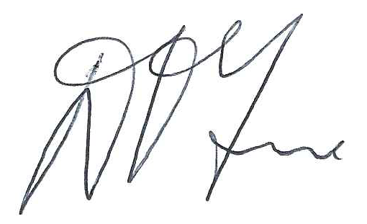
Mr David Tune AO PSM
Chair
Independent Hospital Pricing Authority
7 September 2022



1.2 Clinical Advisory Committee Chair’s letter
Chair, Clinical Advisory Committee, A/Prof Alasdair MacDonald
It is a privilege to work alongside my fellow advisory committee members, Independent Hospital Pricing Authority (IHPA) staff, and the Board as the Chair of the Clinical Advisory Committee once again.
As a multidisciplinary group whose members have extensive clinical knowledge and skills across a wide range of areas in the health sector, the Clinical Advisory Committee brought together the expertise of 21 members to provide advice on IHPA’s activity based funding work program.
Each year, IHPA has made significant progress on the development of the health classifications that underpin pricing and funding on an activity basis. Despite the unprecedented challenges facing the health sector in recent years, the agency has achieved important milestones that have ensured the classification systems reflect contemporary clinical practice and terminology to account for the costs of care.
During 2021–22, this included releasing new versions of the admitted care and subacute and non-acute care classifications and implementing pricing of admitted mental health care using the Australian Mental Health Care Classification.
In December 2021, IHPA released Version 5.0 of the Australian National Subacute and Non-Acute Patient Classification. Since commencing work to develop the classification in 2018, the committee worked closely with IHPA to refine the classification through broad consultation and detailed statistical analysis.
The committee was pleased to guide the implementation of pricing admitted mental health care using the Australian Mental Health Care Classification Version 1.0 and pricing of admitted care using ICD-10-AM/ACHI/ACS Twelfth Edition, which will both be used for pricing from 1 July 2022.
For the first time, the committee extended its advice to inform the development of education for new editions of classifications. IHPA launched a dedicated platform for self-paced learning in May 2022. With 1,900 registrations within the first month of its launch, I am looking forward to continuing work with IHPA and the committee to build upon the learning opportunities that broadening education will provide to health professionals in the coming years.
The committee provides ongoing input to the policies outlined in the annual Pricing Framework for Australian Public Hospital Services to ensure they reflect contemporary clinical practice and terminology.
IHPA commenced implementing the new clauses of the 2020–25 Addendum to the National Health Reform Agreement from 1 July 2020, which included clauses that support jurisdictions to trial innovative models of care. The committee worked with IHPA to achieve a significant milestone in supporting innovative models of care that have the potential to create better incentives for improved continuity of care, through the development of a discussion paper on future funding models and development of a proof of concept for a capitation payment model for chronic conditions.
The committee is working closely with IHPA and the healthcare sector more broadly to consider clinical engagement, change management and evaluation to support the development of contemporary funding models.
Under the National Partnership on COVID-19 Response, committee members provided feedback on the national activity based funding classifications and the updates to the coding and classification systems for reporting COVID-19 in Australian public hospitals, including admitted, emergency and non-admitted care.
I would like to express my sincere thanks to my fellow committee members for their meaningful contribution and thoughtful consideration of the complex, and at times highly technical, issues over the past year. I deeply appreciate their commitment to improving efficiency, accountability and transparency across the public healthcare system.
There were a few changes to the membership of the committee over this past year. We welcomed A/Prof Nicole Phillips, Dr Tracy Smith, Ms Monica Taylor, Dr Elaine Pretorius and Ms Elizabeth Prowse as new appointees to the committee.
I would like to thank Mr Anthony Graham Fish, Prof Leon Flicker, A/Prof Paul Varghese, A/Prof Bernard Whitfield, Dr Amod Karnik, Dr Phil Sargent and A/Prof Joanna Sutherland for their many years of greatly valued expertise and contributions.
On behalf of the Clinical Advisory Committee, I acknowledge and commend the Pricing Authority, the Chief Executive Officer and IHPA staff for delivering a successful program of work in 2021–22. In particular, I would like to personally thank Mr Shane Solomon (former Chair of the Pricing Authority) and Mr James Downie (former Chief Executive Officer) for their immense contribution and leadership.
I look forward to continuing to lead the work of the Clinical Advisory Committee in the coming year and welcome the opportunity to support the agency to drive its strategic agenda in the year ahead.
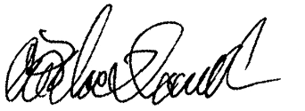
Associate Professor
Alasdair MacDonald
Chair, Clinical Advisory Committee
17 August 2022

1.3 Letter of transmittal
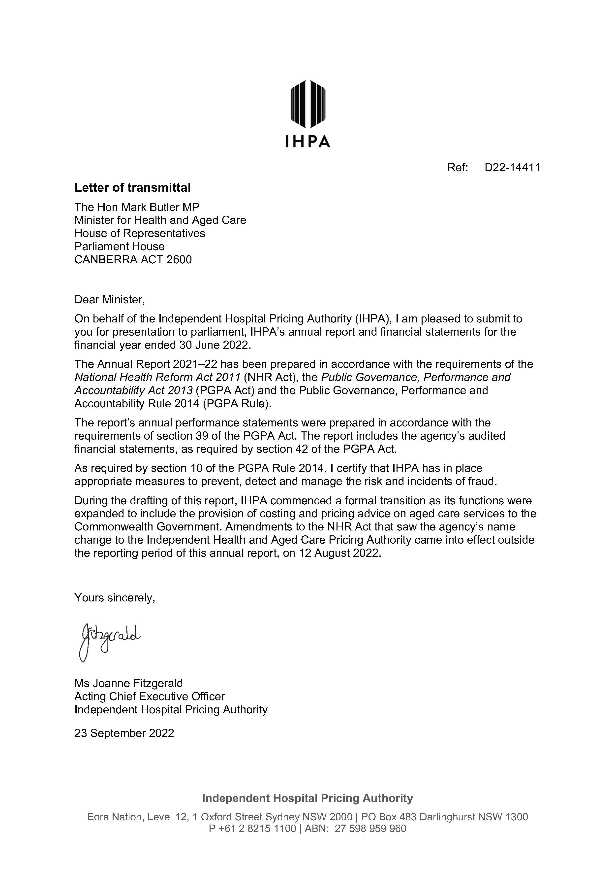




- Contents
02

Contents
About this report i
- Introduction 1
1.1 Chair’s welcome 2
1.2 Clinical Advisory Committee Chair’s letter 5
1.3 Letter of transmittal 7
- Contents 9
Contents 10
- Overview 13
3.1 CEO letter 14
3.2 Vision 17
3.3 Who we are 18
3.4 What we do 27
- Performance statements 33
4.1 Introductory statement 34
4.2 Reporting sources 35
4.3 Activities 37
- Management and accountability 61
5.1 Responsible Minister 62
5.2 Legislation 62
5.3 Corporate governance 65
5.4 Committees and working groups 69
5.5 Key corporate governance practices 76
5.6 Management of human resources 78

- Financial management 85
Financial statements 86
- Appendices 113
Appendix A: Figures and tables 114
Appendix B: Acronyms and abbreviations 115
Appendix C: Glossary 116
Appendix D: Compliance index 119
Appendix E: Index 123




- Overview
03



3.1 CEO letter
Acting Chief Executive Officer, Ms Joanne Fitzgerald
2021–22 was a year of significant change for the Independent Hospital Pricing Authority (IHPA).
In addition to our regular program of work, this year we celebrated a key milestone in the life of the agency, welcomed reforms in the aged care sector that would expand the agency, and continued to respond to ongoing challenges presented by coronavirus disease 2019 (COVID-19).
10 years
Wednesday 15 December 2021 marked the 10-year anniversary of the Authority’s establishment. Reflecting on the significance and ongoing relevance of our growing work program, I am certain this will prove to be an important cornerstone for IHPA for many years to come.

Our achievements over the past decade have been possible only as a result of the skill, dedication and commitment of a diverse team and of our many stakeholders. I would like to commend the Pricing Authority for their dedicated and informed leadership, all of our staff both past and present for their commitment to their roles and to our stakeholders who have provided their guidance to support IHPA through this past decade.
Key highlights
The recent year has been marked by a number of firsts for IHPA.
The ICD-10-AM/ACHI/ACS Twelfth Edition was released in March 2022 for implementation from 1 July 2022. For the first time, IHPA delivered education to support the implementation of the new admitted care classifications.
Following early consultation with jurisdictions on the emerging issues associated with COVID-19 during 2020–21, the 2022–23 pricing model is the first to reflect the early impacts of COVID-19 on the delivery of public hospital services. Released in March 2022, the National Efficient Price and National Efficient Cost Determinations 2022–23 are based on public hospital cost and activity data from the 2019–20 financial year.
IHPA is now preparing for the release of the 2023–24 Determinations, which will be calculated based on the first full financial year of data impacted by the response to the pandemic.

As I highlight our achievements, I would like to acknowledge the jurisdictions and healthcare professionals, who, through their collaboration and reporting, have enabled IHPA to ensure a swift response to updating classifications, data collection and costing standards, supporting pricing models to adapt.
Despite the impacts to resources and reporting capacity as a result of COVID-19, 553 Australian public hospitals submitted cost and activity data as part of IHPA’s National Hospital Cost Data Collection, which was published in March 2022.
Consistent with the requirements of the new clauses of the 2020–25 Addendum to the National Health Reform Agreement, IHPA contributed to the development of joint advice with the Administrator of the National Health Funding Pool and the Australian Commission on Safety and Quality in Health Care on options to reduce avoidable and preventable hospitalisations.
The advice was provided to the Health Ministers’ Meeting in October 2021. IHPA’s approach for 2022–23, aimed at supporting initiatives that place the patient at the centre of care, is set out in the Pricing Framework for Australian Public Hospital Services 2022–23.
Over the course of the past 10 years, we have seen a significant reduction in the rate of growth in public hospital costs since 2011–12, which is shown in the sustained growth rate of 2.2 per cent for the cost per national weighted activity unit (highlighted later in this report at page 29).

Expansion
The Federal Budget 2021–22 included measures that expand IHPA’s remit. Under these measures an expanded IHPA will provide advice to inform Commonwealth Government decisions on the costing and pricing of aged care services from 1 July 2023 and support the reforms to the Prostheses List.
The expansion of IHPA’s functions has in turn seen an expansion of the agency to support the delivery of the broadening work program. In the past year, IHPA has welcomed an additional two Executive Directors and 33 staff members as the agency prepares for this important contribution to the health and aged care sector reforms.
Long-lasting partnerships
IHPA’s achievements throughout 2021–22 would not have been possible without the valued input and collaboration of our many stakeholders. Engaging with a broad range of stakeholders continues to drive improvements in every area of our work. In 2021–22, this involved undertaking four public consultations, one virtual conference and launching an inaugural seven-part webinar series.
In May 2022, IHPA hosted its ninth Activity Based Funding Conference virtually. Over the two-day scientific program, we welcomed 47 local and international speakers and over 2,370 delegates from around the world to explore and debate the application of activity based funding under the theme ‘Innovation and collaboration: Activity based funding for sustainability in health care’.

Thank you
There have been several changes to the Pricing Authority team this year. I would like to thank A/Prof Bruce Chater whose appointment with the Pricing Authority ended in March this year. Bruce has been a member of the Pricing Authority since 2012 and we have benefitted greatly from his expertise during his tenure, particularly relating to rural healthcare delivery.
I am also very pleased to welcome to the Pricing Authority Mr David Tune AO PSM as Chair and member, Dr Adam Coltzau.
I would like to take this opportunity to thank two important individuals that have contributed significantly to this formative decade of IHPA and the national health reform agenda.
The inaugural Chair, Mr Shane Solomon, ended his tenure with IHPA in January 2022. Shane has been a key figure in the development and implementation of activity based funding across the country. His wealth of expertise has been instrumental in establishing a strong foundation for the safe and efficient delivery of public hospital services as Australia faced significant funding reforms.
Mr James Downie resigned as Chief Executive Officer, leaving IHPA on 22 June 2022. James was highly regarded throughout his 10 years with the agency, with six years as Chief Executive Officer. As one of the founding staff members, James has contributed beyond measure to the design and implementation of hospital pricing systems nationally and building IHPA into the trusted organisation it is today. The unwavering trust and confidence of governments, the health sector and Australian public in IHPA is in large part due to the efforts of these two individuals.
I take this opportunity to acknowledge the contributions of the Pricing Authority. I also wish to thank the Clinical Advisory Committee for their expert guidance to deliver a clinically relevant annual program of work.
And finally, I extend my thanks to all IHPA staff — for their support, commitment and dedication to the agency’s vision once again.
I am delighted to be leading an organisation that strives for excellence in delivering its purpose.
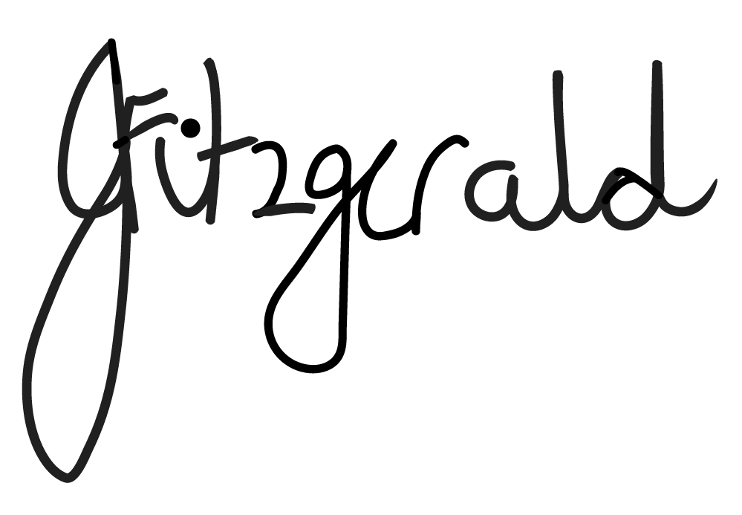
Ms Joanne Fitzgerald
Acting Chief Executive Officer
Independent Hospital Pricing Authority
9 September 2022

3.2 Vision
To design pricing systems that promote safe, efficient public hospital care for all Australians.
Figure 1: The Pricing Authority and Executive team

From the left: Ms Genevieve Donnelly, Executive Director, Aged Care Policy and Communications, Mr Glenn Appleyard, Member, Pricing Authority, Ms Joanne Fitzgerald, Acting Chief Executive Officer, Ms Prudence Ford, Member, Pricing Authority, Dr Adam Coltzau, Member, Pricing Authority, Mr David Tune AO PSM, Chair, Pricing Authority, Prof Kees van Gool, Executive Director, Pricing and Analytics, Distinguished Prof Jane Hall, Member, Pricing Authority, Ms Julia Hume, Executive Director, Costing and Data Infrastructure, Ms Chereta Daylight, Acting Executive Director, Hospital Policy and Classification.
Missing from the Pricing Authority: Ms Jennifer Williams AM, Deputy Chair, Ms Jenny Richter AM, Member, Dr Kate Taylor, Member.

3.3 Who we are

The Independent Hospital Pricing Authority (IHPA) is an independent government agency established by the Commonwealth as part of the National Health Reform Act 2011 to contribute to significant reforms to improve Australian public hospitals.
IHPA is a corporate Commonwealth entity consisting of a Chair, Deputy Chair and up to seven other members.
The Chief Executive Officer is responsible for the day‑to‑day management of IHPA and its staff. Under section163(4) of the National Health Reform Act 2011, the Chief Executive Officer is the accountable authority of IHPA for the purposes of the Public Governance, Performance and Accountability Act 2013 and therefore for the purposes of this annual report.
Based in Sydney, IHPA achieves its annual program of work, through consultation and collaboration with Commonwealth, state and territory governments, advisory committees, key stakeholders and the public.
Values
IHPA’s organisational values shape the culture of the agency and form the basis for stakeholder engagement to achieve our vision. Our core values are as follows:
- We act with independence, transparency, fairness, respect, accuracy and accountability.
- We value collaboration and demonstrate our values in the way we interact internally, with our stakeholders and the broader community.
- We value the work, talent and contribution of our staff, and create organisation‑wide development strategies to maintain and grow expertise and intellectual capital.
- Our staff act ethically, support a collaborative culture and take pride in their work.

Figure 2: IHPA’s organisational structure as at 30 June 2022
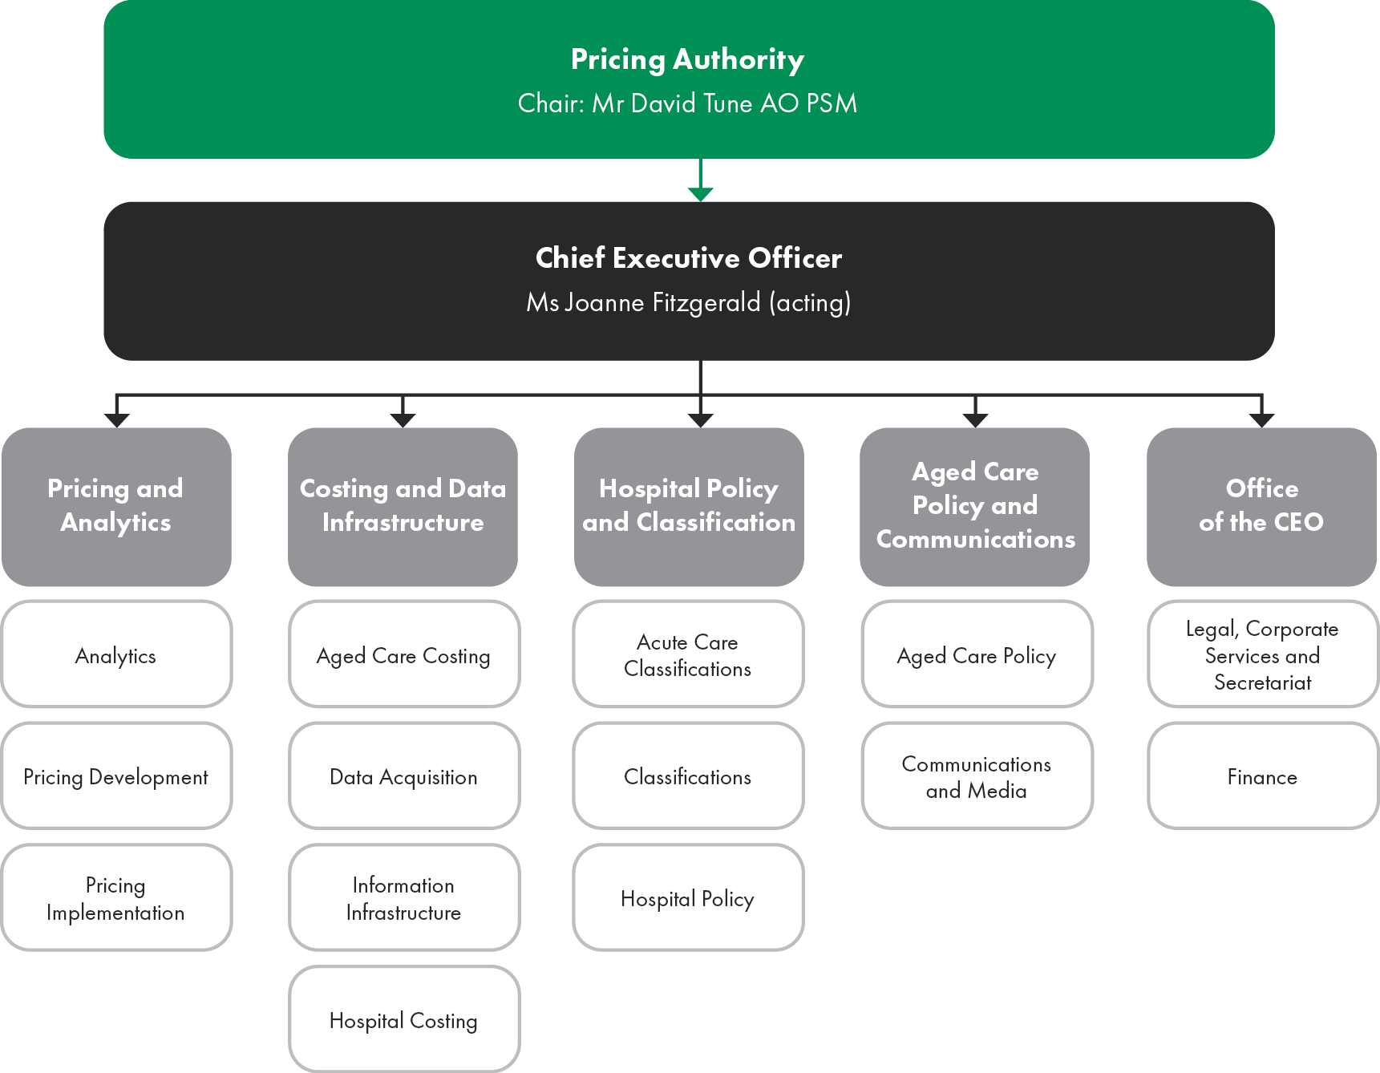

The Pricing Authority
The Pricing Authority is responsible for promoting improved efficiency in, and access to, public hospital services. This is achieved by providing independent advice to Australian governments in relation to the efficient costs of services, developing and implementing robust systems to promote activity based funding for these services and determining the national efficient price and the national efficient cost for public hospital services.
Pricing Authority members are appointed for a period of up to five years. The Chair is appointed by the Commonwealth Minister for Health and Aged Care, the Deputy Chair is appointed with the agreement of First Ministers of all states and territories and the remaining Pricing Authority members are appointed with the agreement of the Prime Minister and First Ministers of the states and territories.
Members of the Pricing Authority bring significant and varied expertise to their role, including substantial experience and knowledge of the health industry, healthcare needs and the provision of health care in regional and rural areas.
The Pricing Authority is supported by a Chief Executive Officer, who is responsible for the day to day running of IHPA. All Pricing Authority members are non-executive.


Mr David Tune AO PSM, Chair
Mr David Tune AO PSM was appointed Chair of the Pricing Authority with effect from 1 February 2022.
He was formerly the Chair of the Aged Care Sector Committee that provided advice to the Commonwealth Government on aged care from early 2015 to July 2021.
He has undertaken many reviews for the Commonwealth and state governments, including the Legislative Review of Aged Care in 2016.
Mr Tune was Secretary of the Commonwealth Department of Finance from 2009 until 2014.

Ms Jennifer Williams AM, Deputy Chair
Ms Jennifer Williams AM is a non-executive director and holds a number of Board positions including Chair of Northern Health and Chair of Yooralla.
Her other Board appointments are with Barwon Health and the Victorian Health Building Authority Advisory Board. She has previously held the positions of Chief Executive of the Australian Red Cross Blood Service, Chief Executive of Alfred Health and Chief Executive of Austin Health.
She has considerable experience in the health sector over several decades working across the hospital, aged care and community sectors.


Mr Glenn Appleyard
Mr Glenn Appleyard was a member of the Australian Accounting Standards Board from 1 January 2003 to 31 December 2011.
Glenn has held several senior positions within the public service including Deputy Secretary in the Tasmanian and Victorian Departments of Treasury and Finance and Regional Director for the Australian Bureau of Statistics in Tasmania.
He was a member of the Commonwealth Grants Commission for 11 years and was the Chair of the Tasmanian Economic Regulator.

Associate Professor Bruce Chater
Associate Professor Bruce Chater is head of the Mayne Academy of Rural and Remote Medicine at the University of Queensland. He undertakes this work from his rural base of Theodore, Queensland, where he continues as a practising rural doctor.
Bruce has been involved in ensuring that rural health services provide high-quality and professional services to rural communities. He was the founding convener of the Rural Doctors Association of Queensland and Australia, founding Chair of the National Rural Health Alliance, Chair of the Rural Working Party of the World Organization of Family Doctors and served as President of the Australian College of Rural and Remote Medicine.
Bruce’s appointment with the Pricing Authority ended on 23 March 2022.


Ms Prudence Ford
Ms Prudence Ford is a member of the Health Consumers’ Council of Western Australia. She was an inaugural member of the Medical Board of Australia, and was previously a member of the National Blood Authority, the National Health and Medical Research Council, the Brightwater Care Group Board (a provider of Aged and Disability Care Services) and the Western Australian Medical Board.
Prudence has had 30 years’ experience in the public service at Commonwealth and state levels. She has held senior executive positions in the (then) Commonwealth Departments of Community Services and Health, Finance, and the Attorney General and in the Western Australian Departments of Health and the Premier and Cabinet.

Dr Adam Coltzau
Dr Adam Coltzau is the director of medical services at St George Hospital in rural Queensland.
He is a rural generalist with advanced skills in obstetrics and anaesthetics and is a Fellow of both the Royal Australian College of General Practitioners and Australian College of Rural and Remote Medicine, with extensive experience in hospital management and aged care.
He is a senior clinical lecturer at the University of Queensland Rural Clinical School and General practitioner training supervisor.
As the 2017 Queensland General Practitioner of the year, Adam is a former president and served on the boards of the Rural Doctors Association of Queensland and the Rural Doctors Association of Australia.
Adam has served as the inaugural chair of the Board of the Rural Doctors Foundation, a charity he helped set up to improve health services in rural Australia.


Distinguished Professor Jane Hall
Professor Jane Hall is Distinguished Professor of Health Economics in the Business School at the University of Technology Sydney.
She is a Fellow of the Academy of Social Sciences in Australia and of the Australian Academy of Health and Medical Sciences.
Jane has worked across many areas of health economics, including funding and financing issues.
She has experience across a range of health policy issues in Australia and internationally.

Ms Jenny Richter AM
Ms Jenny Richter AM is a non-executive director and holds board positions with the South Australian Health and Medical Research Institute, Cancer Council SA (Deputy Chair), Cancer Council Australia (Deputy Chair) and the Southern Adelaide Local Health Network (Deputy Chair), where she also chairs the Clinical Governance Board Sub-Committee.
Jenny has previously held a number of executive roles including five years as Deputy Chief Executive for SA Health and as Chief Executive Officer of Central Adelaide Local Health Network. She is also a past board member of ECH a South Australian aged care provider.


Dr Kate Taylor
Dr Kate Taylor is the Vice President of Eye Care Solutions for Revenio Group Oyj, the global leader in ophthalmic equipment and solutions that acquired Oculo, where Kate was the Founder and Chief Executive Officer. Oculo is a cloud-based clinical platform connecting eye care professionals and their patients. Before Oculo, Kate built the Global Health Initiative at the World Economic Forum and worked with McKinsey & Co. Her initial training was in medicine and public health.
Kate also serves as a member of the Australian Digital Health Agency’s Clinical and Technical Advisory Committee. She was previously involved with the Board of the Mental Health Cooperative Research Centre in Australia, which researches early detection and treatment for dementias, and internationally with the Boards of Roll Back Malaria, Stop TB, and the GAVI Alliance.

Our Executive team
Figure 3: IHPA Executive team

From the left: Prof Kees van Gool, Executive Director, Pricing and Analytics, Ms Chereta Daylight, Acting Executive Director, Hospital Policy and Classification, Ms Julia Hume, Executive Director, Costing and Data Infrastructure, Ms Joanne Fitzgerald, Acting Chief Executive Officer, Ms Olga Liavas, Executive Officer, Ms Genevieve Donnelly, Executive Director, Aged Care Policy and Communications, Mr Chris Miljak, Chief Financial Officer.

3.4 What we do

IHPA undertakes several major areas of work to inform the annual determination of the national efficient price and national efficient cost (collectively referred to as the Determinations) and implement activity based funding. This includes developing national health classifications, the collection of cost and activity data, and resolving disputes on cost-shifting and cross-border issues, as required.
This is informed by ongoing consultation with all Australian health departments, expert advisory committees and key stakeholders to ensure IHPA’s pricing model responds to the needs of the health system.
The Determinations, in conjunction with data regarding the actual volume and type of hospital services provided by states and territories, are used by the Administrator of the National Health Funding Pool to calculate the Commonwealth funding contribution to public hospitals.
Functions
Pursuant to the National Health Reform Act 2011, the primary functions of IHPA are as follows:
- to determine the national efficient price for healthcare services provided by public hospitals where the services are funded on an activity basis
- to determine the national efficient cost for healthcare services provided by public hospitals where the services are block funded
to publish the national efficient price, national efficient cost and other information each year for the purpose of informing decision makers in relation to the funding of public hospitals.

Designing pricing systems
IHPA develops and implements robust systems to support the implementation of activity based funding.
Activity based funding supports the delivery of safe, efficient healthcare for all Australians.
Figure 4: Key agency functions
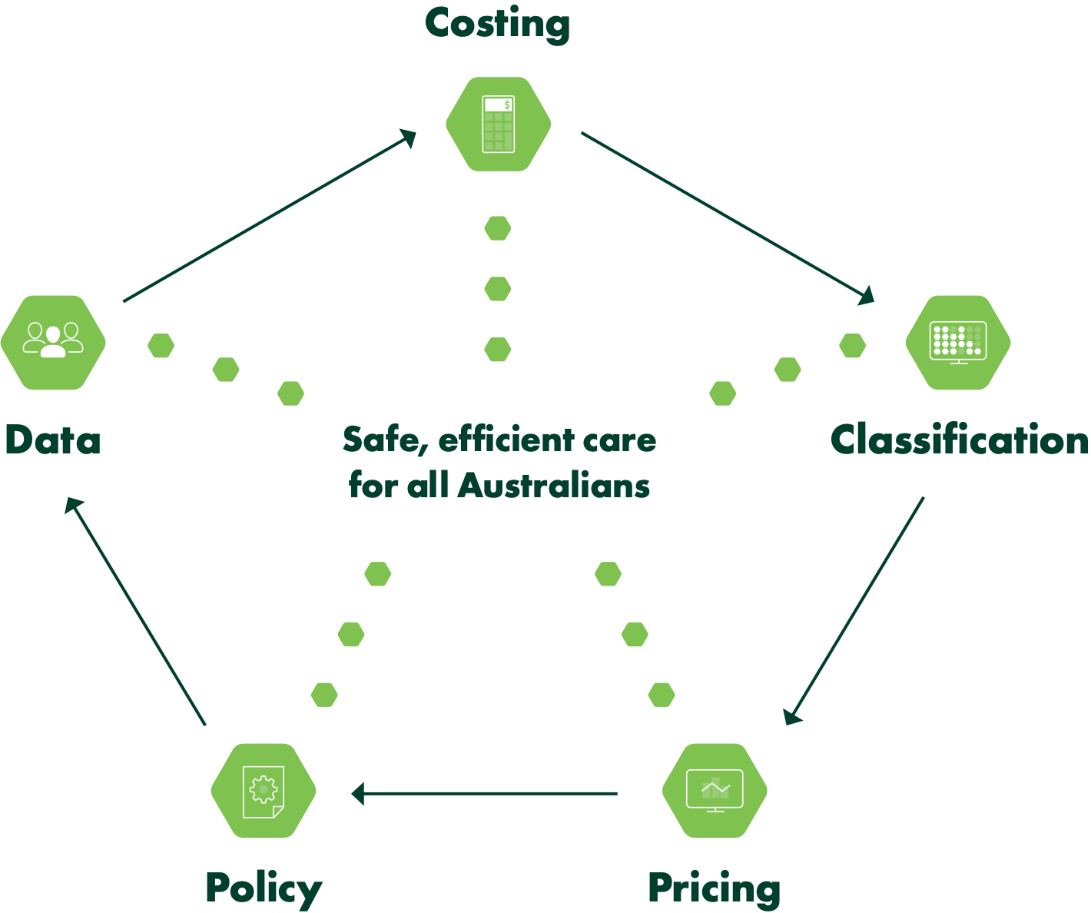

National efficient price
The national efficient price represents the average cost of a hospital admission across Australia and is a determinant (along with the volume of services delivered) of the Commonwealth’s funding contribution to public hospitals.
As required under the National Health Reform Agreement (clause A40), IHPA back-casts the national efficient price whenever significant changes to the methodology or underlying data occur, to enable the fair calculation of the Commonwealth’s growth funding.
National efficient cost
The national efficient cost represents the average cost of Commonwealth funding contribution on a block grant basis for small rural hospitals. This model underpins funding for services that are not suitable for activity based funding, such as small rural and regional hospitals, teaching, training and research in public hospitals, and non-admitted mental health care.
The fixed-plus-variable structure enables the changes in activity delivered in small rural hospitals to be reflected in funding and it ensures there is no disincentive for states to provide services in rural areas.

Sustainable growth in hospital costs
The national weighted activity unit is a measure of health service activity expressed as a common unit, against which the national efficient price is determined. Figure 5 indicates a significant reduction in the rate of growth in costs since 2011–12, to a sustained growth rate of 2.2 per cent.
Figure 5: Change in cost per national weighted activity unit

Safety and quality reforms
The program of work for pricing and funding for safety and quality originated from the April 2016 Council of Australian Governments Health Council Heads of Agreement on Public Hospital Funding.
In 2017, all Australian governments signed an Addendum to the National Health Reform Agreement (NHRA). Through this Addendum, parties committed to develop and implement reforms to improve health outcomes of Australians through funding and pricing approaches to safety and quality. These reforms are designed to improve patient outcomes in the public health system and decrease avoidable demand for public hospital services.
These pricing and funding approaches intend to complement existing strategies to improve safety and quality in public health care.
The Independent Hospital Pricing Authority (IHPA) works together with the Australian Commission on Safety and Quality in Health Care to incorporate safety and quality measures into the determination of the national efficient price.
Under the 2017–20 Addendum to the NHRA, IHPA is required to advise on options for a comprehensive and risk‑adjusted model to determine how funding and pricing is used to improve patient outcomes across three key areas: sentinel events, hospital acquired complications and avoidable hospital readmissions.
Under the 2020–25 Addendum to the NHRA, IHPA is required to continue reforms to integrate safety and quality into the pricing and funding approaches for public hospital services to further improve the health outcomes of patients and decrease avoidable demand for public hospital services.

The implementation of pricing and funding for safety and quality has been rolled out in stages as follows.
 | - Sentinel events are a subset of adverse patient safety events that are wholly preventable and result in serious harm to, or death of, a patient.  - Since 1 July 2017, no Commonwealth funding has been provided for any public hospital episode that includes a sentinel event. This approach applies to both activity based and block-funded hospitals.
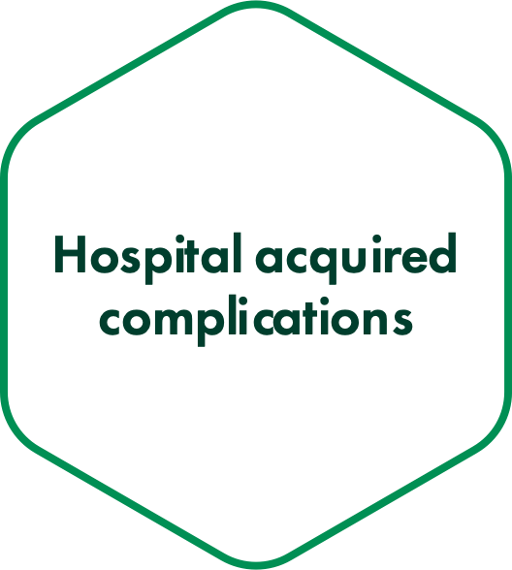 | - A hospital acquired complication refers to a complication for which clinical risk mitigation strategies may reduce (but not necessarily eliminate) the risk of that complication occurring. IHPA has worked with the Australian Commission on Safety and Quality in Health Care and other stakeholders to develop an agreed list of hospital acquired complications.  - From 1 July 2018, funding has been reduced for any episode of admitted acute care where hospital acquired complications such as falls, infections or pressure injuries occur during a hospital stay.
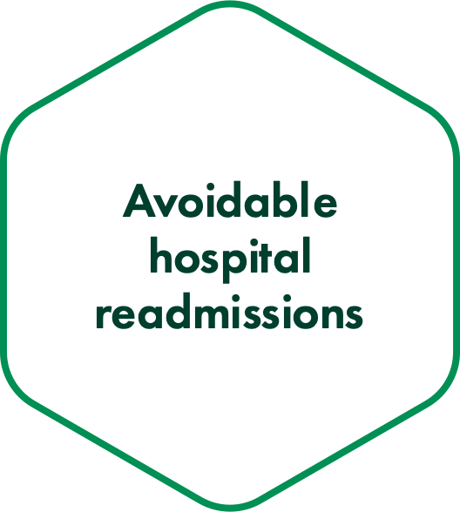 | - An avoidable hospital readmission occurs when a patient has been discharged from hospital (index admission) and has a subsequent unplanned admission that is related to the index admission and was potentially preventable.  - From 1 July 2021, a risk-adjusted reduction has been applied to the funding for the index admission, based on the total price of the associated readmission. This approach was implemented following a 24-month shadow period to trial three funding options to assist in reducing avoidable hospital readmissions.
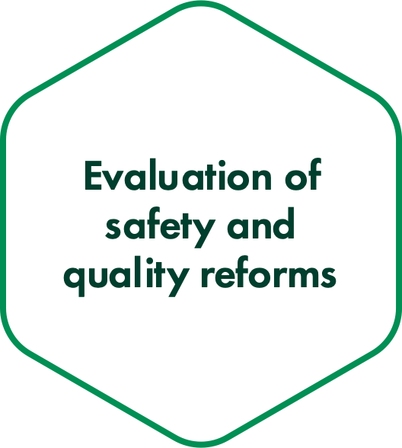 | - The 2020–25 Addendum to the NHRA stipulates that IHPA will work with the Administrator of the National Health Funding Pool and the Australian Commission on Safety and Quality in Health Care (the national bodies) to develop an evaluation framework to evaluate the implemented reforms for sentinel events, hospital acquired complications and avoidable hospital readmissions.  - IHPA led the development of a proposed approach to evaluate the implemented safety and quality reforms, which was provided to the Health Ministers’ Meeting for consideration in October 2021 as part of the joint advice from the national bodies.
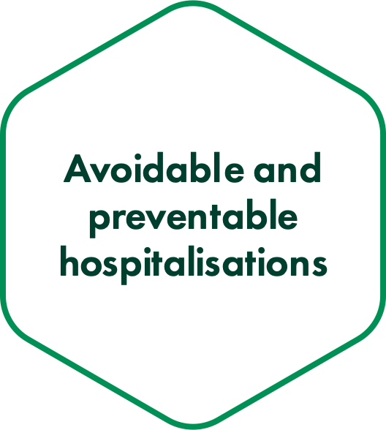 | - Under the 2020–25 Addendum to the NHRA, IHPA is required to provide joint advice with the national bodies on options for the further development of safety and quality-related reforms, including examining ways that avoidable and preventable hospitalisations can be reduced.  - IHPA contributed to the development of advice on options for further safety and quality-related reforms and will consider feedback and directives from the Health Ministers’ Meeting prior to progressing this program of work.




4. Performance statements
04

4.1 Introductory statement

I, Ms Joanne Fitzgerald, as the accountable authority of the Independent Hospital Pricing Authority, present the 2021–22 annual performance statements of the Independent Hospital Pricing Authority, as required under paragraph 39(1)(a) of the Public Governance, Performance and Accountability Act 2013 (PGPA Act).
In my opinion, these annual performance statements are based on properly maintained records, accurately reflect the performance of the entity, and comply with sub-section 39(2) of the PGPA Act.

4.2 Reporting sources

This year the Independent Hospital Pricing Authority (IHPA) made significant steps in driving improvements of the efficiency of public hospital services and deliverables outlined in its work program.
IHPA’s annual Work Program and Corporate Plan provides a detailed account of the performance criteria by which the agency’s objectives are reported against as part of the Portfolio Budget Statements, Program 1.1 Public Hospital Price Determinations.
The IHPA Work Program and Corporate Plan 2021–22 has been prepared in accordance with the requirements of section 225 of the National Health Reform Act 2011 (the Act) and section 35(1)(b) of the Public Governance, Performance and Accountability Act 2013 for the reporting periods 2021–22 to 2023–24.
Clause 16EA of the PGPA Act stipulates the requirements around performance measures for Commonwealth entities, including that they must relate directly to one or more of the entity’s purposes or key activities, use sources of information and methodologies that are reliable and verifiable, and provide an unbiased basis for the measurement and assessment of the entity’s performance.
The Work Program and Corporate Plan for 2021–22 defines IHPA’s strategic objectives and the associated key deliverables for the 2021–22 reporting period. In evaluating IHPA’s performance against the strategic objectives outlined in the Work Program and Corporate Plan, IHPA has ensured that the performance measures used relate directly to the delivery of its key deliverables as per its legislated functions.
IHPA utilises qualitative and quantitative data-based methodologies to assess its performance over the reporting period and deliverance on the strategic objectives, including undertaking independent quality assurance processes for deliverables such as the National Efficient Price Determination and National Efficient Cost Determination.
IHPA reviews the efficiency and effectiveness in its approach to delivering the strategic objectives outlined in the Work Program and Corporate Plan annually to ensure that the performance measures have been met and validated.
The agency’s planned activities for each year are set out in a draft program for public comment prior to 30 June of the respective financial year.
IHPA undertakes extensive consultation with jurisdictions, key stakeholder advisory committees, government and health sector stakeholders and the broader public to inform the deliverables outlined in its work program.
IHPA considers that the delivery and evaluation of its performance against the outcomes outlined in the Work Program and Corporate Plan for 2021–22 align with the requirements for performance measures under clause 16EA of the PGPA Act.

Portfolio Budget Statements 2021–22
Figure 6: Relationship between the sources of reporting for the Annual Report 2021–22 Performance Statement
Portfolio Budget Statements |  | IHPA Work Program and Corporate Plan
Outcome  Promote improved efficiency in, and access to, public hospital services primarily through setting efficient national prices and levels of block funding for hospital activities. |  | Strategic Objective 1  Perform IHPA pricing functions
Strategic Objective 2
Refine and develop hospital activity classification systems
Strategic Objective 3
Refine and improve hospital costing
Program 1.1 Public Hospital Price Determinations  IHPA promotes improved efficiency in, and access to, public hospital services by providing independent advice to the Australian Government and state and territory governments regarding the efficient price of healthcare services, and by developing and implementing robust systems to support activity based funding for those services. |  | Strategic Objective 4  Develop data requirements and collect hospital data
Strategic Objective 5
Resolve disputes on cost-shifting and cross-border issues
Strategic Objective 6
Conduct independent and transparent decision-making and engage with stakeholders

4.3 Activities
Activity 1: Perform IHPA pricing functions
IHPA’s primary function is to produce the National Efficient Price Determination and the National Efficient Cost Determination each year. The Pricing Framework for Australian Public Hospital Services (Pricing Framework) forms the policy basis for the Determinations. The Pricing Framework outlines the principles, scope and methodology to be adopted by IHPA in determining the national efficient price and national efficient cost for public hospital services in the next financial year.
During 2021–22, IHPA undertook significant technical developments to improve the price setting process and continued to refine the models used to determine the national efficient price and national efficient cost. These refinements were driven by the significant and potentially long-lasting changes to models of care and service delivery in Australian public hospitals as a result of coronavirus disease 2019 (COVID-19).
IHPA worked closely with the Administrator of the National Health Funding Pool to provide assistance in the implementation of the National Partnership for COVID-19 Response, and monitored the changes reported by jurisdictions as a result of the response to COVID-19 to ensure its price setting responds accordingly.
Results
The reporting of Activity 1 in this annual report refers to the deliverables of Strategic Objective 1 in the IHPA Work Program and Corporate Plan 2021–22, as part of Program 1.1 of the Portfolio Budget Statements.
Table 1: Summary of Performance for Activity 1 in 2021–22
Activity | Deadline | Outcome
Completion of public submission process for the Pricing Framework for Australian Public Hospital Services 2022–23. | Jul 2021 | Delivered
Provision of the draft Pricing Framework for Australian Public Hospital Services 2022–23 to health ministers for a 45-day comment period. | Sep 2021 | Delivered
Publish the Pricing Framework for Australian Public Hospital Services 2022–23. | Dec 2021 | Delivered
Finalise decisions on the General List of In-Scope Public Hospital Services for additional or altered in-scope services for 2022–23. | Dec 2021 | Delivered
Finalise decisions on the legitimate and unavoidable cost variations to assess changes or adjustments to the National Efficient Price Determination 2022−23. | Dec 2021 | Delivered
Provide the draft National Efficient Price Determination and National Efficient Cost Determination 2022–23 to health ministers for a 45-day comment period. | Dec 2021 | Delivered
Publish the National Efficient Price Determination and National Efficient Cost Determination 2022–23. | Mar 2022 | Delivered

Activity | Deadline | Outcome
Continue to assess the recommendations provided in the Fundamental Review. | Ongoing | Ongoing
Implementation of a risk-adjusted pricing approach to reduce the rates of avoidable hospital readmissions in public hospitals. | Jul 2021 | Delivered
Development of a framework to evaluate the implemented safety and quality reforms. | Apr 2021 | Delivered Oct 2021
Investigation and provision of advice on options to reduce preventable hospitalisations. | Apr 2021 | Delivered Oct 2021
Development of a software tool to track avoidable hospital readmissions. | Apr 2021 | Delivered
Inclusion of avoidable hospital readmissions rates in the National Benchmarking Portal. | Dec 2021 | Ongoing
Provide confidential national efficient price forecast for future years to jurisdictions. | Dec 2021 | Delivered Mar 2022
Publish the National Efficient Cost Supplementary Determination 2021–22. | Dec 2021 | Delivered
Investigate opportunities to harmonise prices across similar same-day services. | Ongoing | Ongoing

Performance criteria |  | Results against performance criteria
- Completion of public submission process for the Pricing Framework for Australian Public Hospital Services 2022–23 by July 2021. |  | The Consultation Paper on the Pricing Framework for Australian Public Hospital Services 2022–23 was published on 9 June and concluded on 9 July 2021.
- Provision of the draft Pricing Framework for Australian Public Hospital Services 2022–23 to health ministers for a 45-day comment period by September 2021. |  | The draft Pricing Framework for Australian Public Hospital Services 2022–23 was released to health ministers on 6 September 2021.
- Publish the Pricing Framework for Australian Public Hospital Services 2022–23 by December 2021. |  | The Pricing Framework for Australian Public Hospital Services 2022–23 was published on 1 December 2021.
- Finalise decisions on the General List of In-Scope Public Hospital Services for additional or altered in-scope services for 2022–23 by December 2021. |  | IHPA assessed requests for in-scope public hospital services as per its annual assessment of General List of In-Scope Public Hospital Services process. The outcome was published in the draft National Efficient Price Determination 2022−23 and released to health ministers on 1 December 2021.

Performance criteria |  | Results against performance criteria
- Finalise decisions on the legitimate and unavoidable cost variations to assess changes or adjustments to the National Efficient Price Determination 2022−23 by December 2021. |  | IHPA assessed changes and requests for adjustments to the national pricing model as per its annual assessment of legitimate and unavoidable cost variations process. The outcome was published in the draft National Efficient Price Determination 2022−23 and released to health ministers on 1 December 2021.
- Provide the draft National Efficient Price Determination and National Efficient Cost Determination 2022–23 to health ministers for a 45-day comment period by December 2021. |  | The draft National Efficient Price Determination 2022–23 and National Efficient Cost Determination 2022–23 was provided to health ministers on 1 December 2021.
- Publish the National Efficient Price Determination and National Efficient Cost Determination 2022–23 by March 2022. |  | The National Efficient Price Determination 2022–23 and National Efficient Cost Determination 2022–23 was published on 23 March 2022.
- Continue to assess the recommendations provided in the Fundamental Review. |  | Assessment of fundamental review recommendations has been put on hold due to COVID-19 pandemic potentially affecting input data used for analysis.
- Implementation of a risk adjusted pricing approach to reduce the rates of avoidable hospital readmissions in public hospitals by July 2021. |  | A risk adjusted pricing approach for avoidable hospital readmissions was published for the first time in the National Efficient Price Determination 2021–22 on 2 March 2021 for implementation from 1 July 2021.
- Development of a framework to evaluate the safety and quality reforms by April 2021. |  | IHPA led the development of an evaluation framework and proposed an approach to evaluate the implemented safety and quality reforms for sentinel events, hospital acquired complications and avoidable hospital readmissions. This was provided to the Health Ministers’ Meeting for consideration in October 2021 as part of the joint advice from the national bodies.
- Investigation and provision of advice on options to reduce avoidable and preventable hospitalisations by April 2021. |  | IHPA contributed to the development of joint advice from the national bodies on options to reduce avoidable and preventable hospitalisations. The advice was provided to the Health Ministers’ Meeting for consideration in October 2021.

Performance criteria |  | Results against performance criteria
- Development of a software tool to track avoidable hospital readmissions by April 2021. |  | In March 2020, IHPA engaged a vendor to develop a readmissions software tool, to inform opportunities for refinements to the avoidable hospital readmissions funding approach and the current list of readmission conditions. This project was finalised by April 2021.
- Inclusion of avoidable hospital readmissions rates in the National Benchmarking Portal. |  | Following the first phase of the National Benchmarking Portal launch in July 2022, IHPA will launch dashboards that focus on hospital acquired complication and avoidable hospital readmission rates in March 2023.
- Provide confidential national efficient price forecast for future years to jurisdictions by December 2021. |  | The confidential national efficient price forecast was provided to First Ministers on 21 March 2022.
- Publish the Supplementary National Efficient Cost Determination 2021–22 by December 2021. |  | The National Efficient Cost Supplementary Determination 2021–22 was published on 1 December 2021.
- Investigate opportunities to harmonise prices across similar same-day services. |  | The aim of price harmonisation is to ensure that similar services are priced consistently across settings. In 2020–21, IHPA investigated additional opportunities for the harmonisation of price weights for haemodialysis and chemotherapy in the admitted and non-admitted care settings. Due to the impacts of COVID-19 on public hospital cost and activity, further investigations to harmonise prices across similar same-day services have been put on hold.
- Provide a further increase in the proportion of funding for public services using activity based funding as reported by the Administrator of the National Health Funding Pool. |  | As at June 2021, 82.18 per cent of funding for public services paid by the Administrator of the National Health Funding Pool was based on activity based funding. This is a decrease of 0.45 per cent compared to the 2019–20 financial year.

Analysis
In March 2022, IHPA released the first National Efficient Price Determination (2022–23) that reflected the impact of COVID-19 on public hospital service pricing. Ahead of its release, IHPA conducted extensive consultation with the healthcare community and the general public to ensure that the national pricing model accurately reflected variations in costs, activity, and how patients access public hospital services.
Following on from those consultations, IHPA prioritised the assessment and accounting for the impact of COVID-19 on public hospital activity in 2021–22. Changes reported by jurisdictions included significant growth in the use of telehealth, a reduction in hospital admissions nationally and longer term changes to service delivery required to implement COVID-19 safety measures.
Following early analysis conducted in the preceding year and a public consultation process, IHPA’s policy approach was published in the Pricing Framework for Australian Public Hospital Services 2022–23 in December 2021.
Published in March 2022, the National Efficient Price Determination and National Efficient Cost Determination 2022–23 continue to demonstrate the benefits of activity based funding in reducing costs. This is demonstrated in both the reduction in the rate of growth in costs per national weighted activity unit since 2011–12, to a sustained growth rate of 2.2 per cent, and the reduction in costs at local hospital networks in the 50th and 90th percentile range of costs per national weighted activity unit.
Following extensive development of a new, publicly available, National Benchmarking Portal throughout 2021–22, IHPA launched its first phase of dashboards with nationally weighted public hospital costed activity data in July 2022. Phase two of the launch, which includes dashboards that focus on hospital acquired complication and avoidable hospital readmission rates, will be released in March 2023.
IHPA continued to progress its work towards pricing and funding for safety and quality in 2021–22. Following the completion of a 24-month analysis of three funding options for reducing avoidable hospital readmissions, a risk-adjusted reduction was applied to the funding for the index admission, based on the total price of the associated readmission, from 1 July 2021.

Activity 2: Refine and develop hospital activity classification systems
Activity based funding requires a robust classification system on which pricing can be based. Classifications aim to provide the healthcare sector with a nationally consistent method of classifying all types of patients, their treatment and associated costs. IHPA has determined the national classification systems for public hospital services, including admitted acute, non‑admitted, emergency, admitted subacute and non-acute, mental health care and teaching and training.
Classifications are reviewed regularly and updated periodically to ensure that they remain clinically relevant and resource homogeneous within a service category. Such modifications are based on robust statistical analysis and are overlaid by expert clinical advice.
During 2021–22, IHPA continued its work program to review and refine the classifications.
Results
The reporting of Activity 2 in this annual report refers to the deliverables of Strategic Objective 2 in the IHPA Work Program and Corporate Plan 2021–22, as part of Program 1.1 of the Portfolio Budget Statements.
Table 2: Summary of Performance for Activity 2 in 2021–22
Activity | Deadline | Outcome
Finalise the refinement of ICD-10-AM/ACHI/ACS Twelfth Edition. | Jul 2022 | Delivered
Finalise the development of Australian Refined Diagnosis Related Groups Version 11.0. | Jul 2022 | Delivered
Refine the Mental Health Phase of Care as part of the Australian Mental Health Care Classification development. | Ongoing | Ongoing
Continue to shadow price admitted mental health care services using the Australian Mental Health Care Classification Version 1.0 for the National Efficient Price Determination 2021–22. | Mar 2021 | Delivered
Shadow price community mental health care services using the Australian Mental Health Care Classification Version 1.0 for the National Efficient Price Determination 2021–22. | Mar 2021 | Delivered
Consult on the draft Australian National Subacute and Non-Acute Patient Classification Version 5.0. | Nov 2021 | Delivered
Continue to maintain the Tier 2 Non-Admitted Services Classification while undertaking development work for the Australian Non-Admitted Care Classification. | Ongoing | Ongoing

Activity | Deadline | Outcome
Complete the non-admitted care costing study, including the collection of activity and cost data for the Australian Non-Admitted Care Classification. | Ongoing | On hold
Refine the Australian Emergency Care Classification Version 1.0. | Ongoing | Ongoing
Continue to work with jurisdictions to implement the Australian Teaching and Training Classification. | Jun 2022 | Ongoing
Management of the international sales of the Australian Refined Diagnosis Related Groups Version 11.0 system. | Ongoing | Ongoing
Update the Impact of New Health Technology Framework to review the process for assessing the impact of new health technologies on patient classification systems and include process for incorporating new high-cost, highly specialised treatments. | Jun 2022 | Delivered
Finalise the review of new health technologies based on reports received from government agencies and advisory bodies. | Jun 2022 | Delivered

Performance criteria |  | Results against performance criteria
- Finalise the refinement of International Statistical Classification of Diseases and Related Health Problems, Tenth Revision, Australian Modification, Australian Classification of Health Interventions, Australian Coding Standards (collectively known as ICD-10-AM/ACHI/ACS) Twelfth Edition by July 2022. |  | IHPA released ICD-10-AM/ACHI/ACS Twelfth Edition in March 2022 for implementation on 1 July 2022. IHPA sought input from clinicians, other health sector stakeholders represented on its technical and advisory committees and through a public consultation in May 2021 and throughout the development cycle. IHPA also released a self-paced online educational program in May 2022 in order to assist health professionals involved in the clinical coding process to understand the key changes to be implemented in ICD-10-AM/ACHI/ACS Twelfth Edition.
- Finalise the development of Australian Refined Diagnosis Related Groups (AR-DRG) Version 11.0 by July 2022. |  | IHPA released AR-DRG Version 11.0 in July 2022. IHPA sought input from clinicians, other health sector stakeholders represented on its technical and advisory committees and through a public consultation in May 2021 and throughout the development cycle. IHPA also released self-paced online educational program in July 2022 in order to assist health professionals involved in the clinical coding process to understand AR-DRG fundamentals and the key changes in AR-DRG Version 11.0.
- Refine the Mental Health Phase of Care as part of the Australian Mental Health Care Classification (AMHCC) development. |  | In 2021–22, IHPA implemented minor refinements to the AMHCC recommended from the Mental Health Phase of Care (MHPoC) Clinical Refinement Testing Project. IHPA will continue to review and refine the AMHCC.
- Continue to shadow price admitted mental health care services using the AMHCC Version 1.0 for the National Efficient Price Determination 2021–22 by March 2021. |  | IHPA continued shadow pricing admitted mental health care services using AMHCC Version 1.0 for the National Efficient Price Determination 2021–22 released on 2 March 2021.

Performance criteria |  | Results against performance criteria
- Shadow price community mental health care services using the AMHCC Version 1.0 for the National Efficient Price Determination 2021–22 by March 2021. |  | IHPA commenced shadow pricing community mental health care as part of the National Efficient Price Determination 2021–22 released on 2 March 2021.
- Consult on the draft Australian National Subacute and Non-Acute Patient Classification (AN-SNAP) Version 5.0 by November 2021. |  | IHPA undertook a public consultation process to seek stakeholder feedback on the draft AN-SNAP Version 5.0 in April 2021. Subsequently, AN-SNAP Version 5.0 was released in December 2021.
- Continue to maintain the Tier 2 Non Admitted Services Classification (Tier 2), while undertaking development work for the Australian Non-Admitted Care Classificiation. |  | IHPA continues to maintain and update Tier 2 based on stakeholder feedback while work on a new non-admitted care classification is developed.
- Complete the non-admitted care costing study, including the collection of activity and cost data for the Australian Non-Admitted Care Classification. |  | In March 2020, the non-admitted care costing study was put on hold and then formally suspended due to the COVID-19 pandemic. In the meantime, IHPA will continue to classify non-admitted services using the Tier 2. IHPA is currently investigating the feasibility of recommencing the costing study.
- Price emergency department activity using the Australian Emergency Care Classification (AECC) Version 1.0 for the National Efficient Price Determination 2021–22 by March 2021. |  | IHPA commenced pricing emergency department care using the AECC Version 1.0 for the first time as part of the National Efficient Price Determination 2021–22 released on 2 March 2021.
- Refine the AECC Version 1.0. |  | In 2021, IHPA commenced work to update the AECC complexity model based on recent national data and to consider the inclusion of new variables such as diagnosis modifiers, procedures and investigations. IHPA will continue this work with an aim to release a refined version of the AECC in the future.

Performance criteria |  | Results against performance criteria
- Continue to work with jurisdictions to implement the Australian Teaching and Training Classification (ATTC) by June 2022. |  | ATTC Version 1.0 was released in July 2018. IHPA continues to work with jurisdictions to implement ATTC to address the variation and barriers to reporting teaching and training activity and cost data.
- Management of the international sales of the AR-DRG system. |  | IHPA continues to effectively administer the international sales of the AR-DRG classification system.
- Update the Impact of New Health Technology Framework to review the process for assessing the impact of new health technologies on patient classification systems and include process for incorporating new high-cost, highly specialised treatments by June 2022. |  | IHPA undertook a comprehensive review of the New Health Technology Policy (previously named the Impact of New Health Technology Framework) in 2021–22 to incorporate a more streamlined and timely process for assessing new health technologies for inclusion into the activity based funding system.
- Finalise the review of New Health Technologies based on reports received from government agencies and advisory bodies by June 2022. |  | IHPA undertook a consultation of the assessment of new health technology in August 2021 to ensure pricing of public hospital services responds to the introduction of evidence-based, effective new technology and innovations in the models of care that improve patient outcomes in a timely way. Final decisions on new health technologies prioritised for classification development occurred in May 2022.

Analysis
IHPA continued its work to develop and refine classification systems that accurately capture the resources required to treat different types of patients during 2021–22.
A key part of this process has been the development of classification, costing and pricing guidelines relating to COVID-19 and ensuring stakeholders are directly informed on any new advice in order to respond to the evolving nature of the COVID-19 pandemic.
IHPA continued to implement emergency use codes for COVID-19 in ICD-10-AM and in the Emergency Department Short List, which were used to classify admitted and emergency care respectively.
IHPA used the AMHCC Version 1.0 to continue to shadow price admitted mental health care in the National Efficient Price Determination 2021–22 and for the first time introduced shadow pricing of community mental health care using the AMHCC Version 1.0 in 2021–22. The AMHCC represents a more clinically meaningful classification system for the pricing of mental health care services and will result in more accurate pricing of these services.
On 15 June 2022, IHPA released the new edition of ICD-10-AM/ACHI/ACS, Twelfth Edition, which was the first time the admitted care classification was developed in-house. IHPA also released its first interactive online educational program in order to support health professionals involved in clinical coding and health information management process with understanding the key changes in the new edition of the classification. IHPA will price admitted acute care using the new Twelfth Edition of the ICD-10-AM/ACHI/ACS from 1 July 2022.
While Version 4.0 of AN-SNAP continues to be used for pricing, IHPA commenced shadow pricing a new version of the classification, Version 5.0 for the National Efficient Price Determination 2022–23. Released in December 2021, AN-SNAP Version 5.0 introduces a new variable to recognise frailty as a cost driver for geriatric evaluation and management, and non-acute episodes of care.
The non-admitted care costing study was suspended in 2020 due to the impact of COVID-19. The development of a new non-admitted care classification to replace Tier 2 has therefore been delayed. IHPA sought feedback on the readiness of jurisdictions to recommence the non-admitted care costing study as part of the Consultation Paper on the Pricing Framework for Australian Public Hospital Services 2023–24, which was released in June 2022.

Activity 3: Refine and improve hospital costing
Hospital costing focuses on the cost and mix of resources used to deliver patient care and plays a vital role in activity based funding. Costing informs the development of activity based funding classification systems and provides valuable information for pricing purposes.
A key output for IHPA is to coordinate the annual National Hospital Cost Data Collection, which is the primary input into the determination of the national efficient price. This includes the development of national costing standards, collection, validation, quality assurance, analysis, reporting, and benchmarking. The cost collection is undertaken in conjunction with states and territories.
Results
The reporting of Activity 3 in this annual report refers to the deliverables of Strategic Objective 3 in the IHPA Work Program and Corporate Plan 2021–22, as part of Program 1.1 of the Portfolio Budget Statements.
Table 3: Summary of Performance for Activity 3 in 2021–22
Summary of Performance | Deadline | Outcome
Review and update the Australian Hospital Patient Costing Standards Version 4.0 in consultation with the National Hospital Cost Data Collection Advisory Committee and jurisdictions. | Jun 2021 | Delivered Aug 2021
Release Round 24 National Hospital Cost Data Collection public sector report. | Dec 2021 | Delivered Mar 2022
Release Round 24 National Hospital Cost Data Collection cost weight tables for private hospitals. | Dec 2021 | Delayed
Release Round 24 National Hospital Cost Data Collection Independent Financial Review. | Dec 2021 | Delivered Mar 2022
IHPA will continue to work towards phasing out the private patient correction factor for the National Efficient Price Determination 2022−23. | Nov 2021 | Delayed

Performance criteria |  | Results against performance criteria
- Review and update Australian Hospital Patient Costing Standards Version 4.0 in consultation with the National Hospital Cost Data Collection (NHCDC) Advisory Committee and jurisdictions by June 2021. |  | Following consultation with IHPA’s advisory committees and jurisdictions, a new version of the Australian Hospital Patient Costing Standards, Version 4.1, was published in August 2021. The three-part standards include Standards, Business Rules and Costing Guidelines.
- Release Round 24 of the NHCDC public sector report by December 2021. |  | The Round 24 NHCDC report for the public sector was published on the IHPA website in March 2022 following the statutory 45-day consultation period with health ministers.
- Release Round 24 of the NHCDC private sector report by December 2021. |  | The delivery of the Round 24 NHCDC report for the private sector was delayed due to project establishment processes and challenges associated with data submissions. The Round 24 NHCDC private sector report will be published by December 2022.
- Release Round 24 NHCDC Independent Financial Review by December 2021. |  | The Round 24 NHCDC Independent Financial Review was completed and the report published in March 2022.
- IHPA will continue to work towards phasing out the private patient correction factor for National Efficient Price Determination 2022–23. |  | IHPA progressed phasing out the private patient correction factor for the National Efficient Price Determination 2022–23. IHPA will continue to work towards phasing out the private patient correction factor in future Determinations.

Analysis
In 2021–22, IHPA maintained its annual NHCDC and delivered the report for the public sector in March 2022. The release of Round 24 (financial year 2019–20) included the collection and analysis of submitted cost data from 553 unique Australian public hospitals—an increase of 46 hospitals from the previous year.
Through this process, IHPA ensures the effective collection and reporting of costing information to support activity based funding outcomes. Alongside the release of Round 24 of the NHCDC, IHPA reviewed and enhanced the report and the associated infographics, which combine and streamline content for the ease of stakeholders’ reference.
To ensure the quality of NHCDC data is robust and fit-for-purpose, IHPA commissions an independent financial review to assess whether all participating hospitals have included appropriate costs and patient activity.
While IHPA cancelled the Independent Financial Review of the NHCDC Round 23 (financial year 2018–19) in consideration of jurisdictions’ capacity to participate due to the COVID-19 pandemic, the Round 24 Independent Financial Review was published on 11 March 2022.
The report provides an overall summary and findings of the cost data collection by jurisdiction and for each participating site. It also outlines recommendations for IHPA and the jurisdictions to consider in future rounds of the NHCDC, with the aim of improving the consistency and transparency of national cost data submissions.
In 2020, the Australian Accounting Standards Board accounting standard 16 (AASB16) was implemented. The Australian Hospital Patient Costing Standards was subsequently reviewed to ensure that the standards were in line with the standards published by AASB.
Following consultation with IHPA’s advisory committees and jurisdictions, a new version of the Australian Hospital Patient Costing Standards, Version 4.1, was published in August 2021.

Activity 4: Develop data requirements and collect hospital data
Timely, accurate and reliable public hospital data is vital to both the development of activity based funding classifications for hospital services and the determination of the national efficient price for those services.
IHPA has developed a rolling Three Year Data Plan to communicate the data requirements, data standards and timelines that IHPA will use to collect data over the coming three years to the Australian Government and states and territories.
IHPA publishes data compliance reports on a quarterly basis, which indicate jurisdictional compliance with the specifications in the Three Year Data Plan.
Results
The reporting of Activity 4 in this annual report refers to the deliverables of Strategic Objective 4 in the IHPA Work Program and Corporate Plan 2021–22, as part of Program 1.1 of the Portfolio Budget Statements.
Table 4: Summary of Performance for Activity 4 in 2021–22
Summary of Performance | Deadline | Outcome
Publish the Three Year Data Plan 2022–23 to 2024–25. | Jun 2022 | Delivered
Complete the annual review of Activity Based Funding National Best Endeavours Data Sets and National Minimum Data Sets. | Dec 2021 | Delivered
Develop the process for the collection of Individual Healthcare Identifiers as part of national data sets. | Jun 2022 | Delivered
Further develop the secure data management system functionality. | Ongoing | Ongoing
Collect jurisdictional submissions for 2021 activity based funding activity data on a quarterly basis. | Ongoing | Delivered
Publish data compliance report for each quarter in 2021–22. | Ongoing | Delivered
Continue to expand access to the National Benchmarking Portal. | Ongoing | Ongoing

Performance criteria |  | Results against performance criteria
- Publish the Three Year Data Plan 2022–23 to 2024–25 by June 2022. |  | The Three Year Data Plan 2022–23 to 2024–25 was published on 22 June 2022.
- Complete the annual review of Activity Based Funding National Best Endeavours Data Sets and National Minimum Data Sets by December 2021. |  | IHPA continues to develop activity based funding data specifications on an annual basis. Both the National Best Endeavours Data Sets and National Minimum Data Sets were published in December 2021.
- Develop the process for the collection of the Individual Healthcare Identifiers as part of national data sets by June 2022. |  | IHPA worked with jurisdictions and embedded the Individual Healthcare Identifier in the national data submission to IHPA from June 2022.
- Further develop the secure data management system functionality. |  | IHPA will continue to develop the secure data management system to support its core technical functions, while ensuring the current high standards of data security are followed and maintained.
- Collect jurisdictional submissions for March quarter 2021 activity based funding (ABF) activity data by June 2021. |  | The March quarter 2021 ABF activity data was collected on 30 June 2021.
- Collect jurisdictional submissions for June quarter 2021 ABF activity data by September 2021. |  | The June quarter 2021 ABF activity data was collected on 30 September 2021.
- Collect jurisdictional submissions for September quarter 2021 ABF activity data by December 2021. |  | The September quarter 2021 ABF activity data was collected on 21 December 2021.
- Collect jurisdictional submissions for December quarter 2021 ABF activity data by March 2022. |  | The December quarter 2021 ABF activity data was collected on 31 March 2022.
- Publish data compliance report for March quarter 2021 by September 2021. |  | The data compliance report for March quarter 2021 was published on 22 December 2021.
- Publish data compliance report for June quarter 2021 by December 2021. |  | The data compliance report for June quarter 2021 was published on 8 April 2022.

Performance criteria |  | Results against performance criteria
- Publish data compliance report for September quarter 2021 by March 2022. |  | The data compliance report for September quarter 2021 was published on 11 May 2022.
- Publish data compliance report for December quarter 2021 by June 2022. |  | The data compliance report for December quarter 2021 will be published on IHPA’s website in September 2022.
- Continue to expand access to National Benchmarking Portal. |  | IHPA consulted with stakeholders to develop a pathway for the expansion of access to the National Benchmarking Portal to the general public, while ensuring sufficient context and privacy protections are in place. The portal was released on 26 July 2022.

Analysis
Throughout 2021–22, IHPA continued to work with national health bodies to ensure cost and expenditure data from jurisdictions was received in a timely basis and adhered to the existing data development standards to ensure it was able to perform its core determinative functions. This was done through the publication of the rolling Three Year Data Plan, which was published in June 2022 for the period of 2022–23 to 2024–25.
Now in its tenth year, the plan specifies the data requirements and timelines that IHPA will use to collect data over the next three years along, with commitments from the Commonwealth and state and territory governments.
Through the Pricing Framework for Australian Public Hospital Services, IHPA continues to advocate for the routine collection of the Individual Healthcare Identifier to provide greater transparency of the patient journey and to support implementation of new funding models.
IHPA commenced a pilot collection of the Individual Healthcare Identifier in 2021 to support jurisdictions in addressing implementation issues, and to consider data specifications and data submission processes. The Individual Healthcare Identifier Pilot Data Submission Final Report was finalised in April 2022 and the Individual Healthcare Identifier implemented on a best endeavors basis into ABF data sets from July 2022.
Following consultation with jurisdictions, stakeholders and the broader public, in mid-2021, IHPA began the development of a new National Benchmarking Portal (NBP) that would be made publicly available for the first time. This included work to ensure appropriate privacy protections are in place for release to the public. It is anticipated that increased access to the NBP will enhance policy decisions and improve patient outcomes.
The release of the NBP is in two phases. The first phase of the launch, which included dashboards that focus on cost and activity data based on the cost per national weighted activity unit, comprised of costed activity data that is in-scope for activity based funding within each activity stream was released in July 2022.
Phase two of the NBP launch will expand the data accessible to the public whereby safety and quality rates will be included in the NBP. This is set to be released in March 2023.
Both iterations of data releases will be supported by informative resources to help users in navigating the new platform. This includes the release of a user guide, technical specifications and an instructional video.
IHPA collected jurisdictional activity data submissions for 2021–22 on a quarterly basis as outlined in its work program and published the associated data compliance reports for each quarter on its website in accordance with the IHPA Data Compliance Policy.

Activity 5: Resolve disputes on cost‑shifting and cross‑border issues
IHPA has a role to investigate and make recommendations concerning cross-border disputes between states and territories and to make assessments of cost‑shifting disputes.
Results
The reporting of Activity 5 in this annual report refers to the deliverables of Strategic Objective 5 in the IHPA Work Program and Corporate Plan 2021–22, as part of Program 1.1 of the Portfolio Budget Statements.
Table 5: Summary of Performance for Activity 5 in 2021–22
Summary of Performance | Deadline | Outcome
Publish an updated Cost-Shifting and Cross-Border Dispute Resolution Policy. | Jun 2022 | Delivered

Performance criteria |  | Results against performance criteria
- Conduct an annual review of the Cost-Shifting and Cross-Border Dispute Resolution Policy. |  | An updated Cost-Shifting and Cross-Border Dispute Resolution Policy (Version 5.0) was published in June 2022.
- Investigation of cost-shifting or cross border disputes and provision of recommendations or assessment within six months of receipt of the request. |  | IHPA received a submission from South Australia in March 2022 under section 138 and 140 of the National Health Reform Act 2011. The assessment and investigation of this cross-border dispute is ongoing.
Analysis
IHPA follows the process outlined in the Cost-Shifting and Cross-Border Dispute Resolution Policy (previously known as the Cost-Shifting and Cross-Border Dispute Resolution Framework) to investigate cross-border disputes and to ensure they are managed in a timely, equitable and transparent manner.
Following a review of the Cost-Shifting and Cross-Border Dispute Resolution Policy in April 2021 by the Pricing Authority and Chief Executive Officer of IHPA, an updated version of the policy (Version 5.0) was published in June 2022.
IHPA received a submission from South Australia in March 2022 under section 138 and 140 of the National Health Reform Act 2011. The assessment and investigation of this cross-border dispute is ongoing.

Activity 6: Conduct independent and transparent decision‑making and engage with stakeholders
IHPA works in partnership with the Australian Government, state and territory governments and other stakeholders. IHPA conducts its work independently from governments, which allows the agency to deliver impartial, evidence‑based decisions. IHPA is transparent in its decision‑making processes and consults extensively across the health industry.
Extensive consultation with governments and stakeholders informs the methodology that underpins IHPA’s decisions and work program. IHPA has a formal consultation framework in place to ensure that it draws on an extensive range of expertise in undertaking its functions. Input from stakeholders, through IHPA’s multiple committees and working groups, ensures that IHPA’s work is informed by expert clinical advice, which helps to maintain IHPA’s credibility throughout the industry.
Results
The reporting of Activity 6 in this annual report refers to the deliverables of Strategic Objective 6 in the IHPA Work Program and Corporate Plan 2021–22, as part of Program 1.1 of the Portfolio Budget Statements.
Table 6: Summary of Performance for Activity 6 in 2021–22
Summary of Performance | Deadline | Outcome
Provide quarterly activity based funding activity data reports to the Pricing Authority and Jurisdictional Advisory Committee. | Ongoing | Ongoing
Publish evidence-based activity based funding related research and analysis. | Ongoing | Ongoing
Development of a funding methodology for innovative funding models. | Apr 2021 | Delivered Oct 2021
Implementation of strategies, tools and working papers to ensure that IHPA is providing information that will inform its stakeholders. | Ongoing | Ongoing
Deliver the Activity Based Funding Conference 2022. | May 2022 | Delivered

Performance criteria |  | Results against performance criteria
- Provide quarterly activity based funding activity data reports to the Pricing Authority and Jurisdictional Advisory Committee. |  | IHPA provides quarterly activity based funding activity data reports to the Pricing Authority, Jurisdictional Advisory Committee and Technical Advisory Committee.
- Publish evidence-based activity based funding related research and analysis. |  | IHPA continued to develop evidence-based activity based funding related research and analysis in 2021–22. This included the delivery of presentations delivered as part of the Activity Based Funding Conference 2022 scientific program. IHPA recognises that access to high-quality, nationally consistent health data is essential for conducting research and analysis, and to inform the development of policies for improving health outcomes for all Australians. IHPA’s Data Access and Release Policy governs the process regarding release of IHPA data to researchers.  In 2021–22, IHPA received six requests for data, which were processed according to the Data Access and Release Policy.  The release of the new National Benchmarking Portal is a significant new research asset to enable activity based funding analysis. Its release will play a major role in Australia’s capacity to produce activity based funding research.
- Development of a funding methodology for innovative funding models. |  | IHPA undertook analysis to develop a methodology that identified different patient cohorts amenable to activity based funding and innovative funding models. IHPA provided these findings as part of the joint advice from the national bodies to the Health Ministers’ Meeting for consideration in October 2021.
- Appropriate committees and working groups maintained to support IHPA’s functions. |  | In 2021–22 IHPA maintained up to 16 committees and working groups, to provide expert advice and to ensure the transparency and integrity of the organisation. During the reporting period, IHPA held 60 meetings with the various committees and working groups.

Performance criteria |  | Results against performance criteria
- Public consultation processes conducted in accordance with the National Health Reform Act 2011. |  | IHPA conducted four public consultation processes in 2021–22, each in accordance with the National Health Reform Act 2011. This included:  - Pricing Framework for Australian Public Hospital Services 2022–23 (July 2021)  - Assessment of New Health Technologies 2021–22 (August 2021)  - Consultation Paper on a Methodology for Determining the Benchmark Price for Prostheses in Australian Public Hospitals (September 2021)  - IHPA Work Program and Corporate Plan 2022–23 (April 2022).
- All stakeholder input is appropriately considered. |  | All submissions received by IHPA, as part of consultation processes, are presented to the Pricing Authority for consideration and published on the IHPA website.
- Inbox enquiries responded to within a two‑week timeframe. |  | IHPA received 272 inbox enquiries during the reporting period. IHPA responded to 94 per cent within two weeks, and to 36 per cent of those on the day of receipt.
- Deliver the biennial Activity Based Funding Conference hosted for a broad audience in the health industry. |  | IHPA hosted its Activity Based Funding Conference 2022 from 5 to 6 May 2022. The conference was held as a virtual event and provided education to 2,371 delegates from across Australia and around the world. The two-day scientific program featured 47 speakers who shared their technical expertise, insights and personal experiences in the healthcare sector under the conference theme: ‘Innovation and collaboration: Activity based funding for sustainability in health care’.

Analysis
IHPA continued to provide a transparent account of its decision-making through its committees and working groups, public consultations and the release of the detailed policies outlining the processes IHPA employs to undertake its key functions throughout 2021–22. During the reporting period, this included four public consultations that garnered 60 responses from stakeholders.
IHPA publishes public submissions to its completed consultations on its website. In addition, IHPA releases a ‘Consultation Report’ alongside the release of its key strategic policy document, the Pricing Framework for Australian Public Hospital Services, which details the feedback received during the public consultation and IHPA’s rationale behind its policy decisions.
From July 2020, IHPA commenced implementing the new clauses of the 2020–25 Addendum to the National Health Reform Agreement (NHRA), which continued to progress in the 2021–22 financial year.
One of the requirements under the Addendum to the NHRA included the development of a funding methodology that supports states and territories in undertaking trials of innovative models of care.
Following initial investigations into innovative funding models in 2020–21, IHPA has undertaken analysis to categorise patient cohorts that may be amenable to activity based funding, bundling or capitation payments. This analysis shows that around 30 per cent of patients analysed in the cohort that are currently funded under activity based funding could potentially benefit from alternate funding approaches.
As outlined in the Pricing Framework for Australian Public Hospital Services 2022–23 published in December 2021, IHPA is in the process of developing project parameters and business rules to facilitate piloting state and territory nominated innovative models of care and services for 2022–23 and will continue to work with jurisdictions and stakeholders to investigate options for further developing, trialling and implementing alternate funding models.
In May 2022, IHPA held its ninth Activity Based Funding Conference virtually from 5 to 6 May 2022 under the theme ‘Innovation and collaboration: Activity based funding for sustainability in health care’.
IHPA was pleased to host 47 local and international speakers who shared their research and insights, while welcoming 2,371 delegates who explored the applications of public hospital pricing and funding across a diverse range of discussion topics including value-based care, sustainability in health care, classification development, costing, coding and documentation, and data analytics and benchmarking.
In addition, IHPA introduced an inaugural digital webinar series to complement the agency’s educational offering and provide continuing development opportunities for health professionals. Throughout this seven-part webinar series, a total of 2,686 attendees registered to engage directly with IHPA’s senior leaders, technical advisors and industry experts on the practical application of the core themes relating to activity based funding processes to support their understanding of how their roles and the underlying processes and systems support pricing and funding of public hospital services.




5. Management and accountability
05

5.1 Responsible Minister

The Independent Hospital Pricing Authority sits within the Department of Health and Aged Care portfolio.
The Minister responsible for this reporting period was the Hon Greg Hunt MP, Minister for Health and Aged Care.

5.2 Legislation

The Independent Hospital Pricing Authority (IHPA) is a corporate Commonwealth entity under the Public Governance, Performance and Accountability Act 2013.
National Health Reform Agreement
IHPA was established under the National Health Reform Act 2011, giving effect to the National Health Reform Agreement signed by the Commonwealth Government and all states and territories in August 2011.
The National Health Reform Agreement sets out the intention of all Australian governments to work together to improve health outcomes for every Australian.

2020–25 Addendum to the National Health Reform Agreement
On 29 May 2020, all Australian governments signed a new Addendum, which amended the National Health Reform Agreement for the period from 1 July 2020 to 30 June 2025.
The Addendum to the National Health Reform Agreement:
- maintains a commitment to activity based funding
- reaffirms the independence and functions of the national agencies such as the Independent Hospital Pricing Authority, the National Health Funding Body and the Australian Commission on Safety and Quality in Health Care
- retains the 45 per cent Commonwealth funding contribution and the 6.5 per cent national growth cap
continues to integrate safety and quality reforms into the pricing and funding of public hospital services, including the current arrangements for sentinel events and hospital acquired complications.

Key changes to current arrangements introduced in the Addendum include:
- IHPA is required to develop an updated methodology for pricing private patients in public hospitals that accounts for all hospital revenues. This is to ensure funding models are financially neutral with respect to all patients, regardless of whether patients elect to be private or public.
- IHPA is required to develop a pricing model for avoidable hospital readmissions for implementation from 1 July 2021, following approval from the Council of Australian Governments (COAG) Health Council.
- IHPA is required to shadow price for a period of two years, or a shorter period if agreed by the Commonwealth and the majority of states and territories, prior to the implementation of new classifications or costing rules to mitigate the need for retrospective adjustments to the national funding model.
- High-cost, highly specialised therapies will attract 50 per cent Commonwealth funding under the new nationally cohesive health technology assessment process. These will be considered outside of the 6.5 per cent national growth cap for a period of two years.
- IHPA is required to develop a funding methodology that does not penalise states undertaking trials of innovative models of care for the COAG Health Council to approve by April 2021.
National Partnership on COVID-19 Response
On 13 March 2020, the Commonwealth and all state and territory governments signed the National Partnership on COVID-19 Response, to provide financial assistance for the additional costs incurred by health services in responding to the COVID-‍19 pandemic.
IHPA has worked closely with the Administrator of the National Health Funding Pool to provide assistance for the implementation of the National Partnership on the COVID-19 Response.
In order to implement the measures under this agreement, IHPA developed the national classification systems for reporting COVID-19 in Australian hospitals within admitted care, emergency care and non-admitted care settings.
Comprehensive guidelines were published and updated regularly to support hospitals in classifying and reporting COVID-19 related episodes of care.
The activity based funding classifications have been updated regularly to ensure that COVID-19 testing, treatment and vaccination can be accurately reported and tracked.
The associated national costing and pricing guidelines that were published ensure that the costs of responding to the pandemic, and in turn the evolving needs of the health system, are appropriately and consistently captured across the country.
On 20 March 2021, the Australian Government announced it would extend the National Partnership on COVID-19 Response with the states and territories until 30 September 2022 to support the health system’s capacity to respond to the ongoing COVID-19 challenges.

Ministerial directions and government policy orders
IHPA did not receive any Ministerial Directions in 2021–22.
Federal Budget measures
In response to the Royal Commission into Aged Care Quality and Safety (the Royal Commission), the Federal Budget 2021–22 included measures that expand the Independent Hospital Pricing Authority’s (IHPA) remit. Under these measures an expanded IHPA will provide advice to inform Commonwealth Government decisions on the costing and pricing of aged care services from 1 July 2023.
On 12 August 2022, the Aged Care and Other Legislation Amendment (Royal Commission Response) Act 2022 came into force amending the National Health Reform Act 2011 and increasing IHPA’s remit.
Under these amendments, IHPA will be renamed the Independent Health and Aged Care Pricing Authority and be required to inform Australian Government decisions on annual funding increases in residential aged care from 1 July 2023. IHPA will also have a role in providing pricing advice for home-based aged care.
The establishment of an independent aged care pricing function will support transparent and evidence-based assessment of the costs involved in delivering care to senior Australians who use aged care services.
IHPA will also be required to work with the Commonwealth Department of Health and Aged Care and key stakeholders to support reform to the Prostheses List, to reduce the cost of medical devices used in the private health sector and to streamline access to new medical devices.

5.3 Corporate governance

Pricing Authority
The Pricing Authority is responsible for promoting improved efficiency in, and access to, public hospital services. This is achieved by providing independent advice to Australian governments in relation to the efficient costs of services and developing and implementing robust systems to promote activity based funding for these services.
The composition of the Pricing Authority as at 30 June 2022 was a Chair, a Deputy Chair and six other members.
As at 30 June 2022, the Pricing Authority members were appointed for no greater than five years. The Chair was appointed by the Australian Government Minister for Health and Aged Care, the Deputy Chair was appointed with the agreement of First Ministers of all states and territories and the remaining Pricing Authority members were appointed with the agreement of the Prime Minister and First Ministers of the states and territories.
Members of the Pricing Authority bring significant and varied expertise to their role, including substantial experience and knowledge of the health industry, healthcare needs and the provision of health care in regional and rural areas. The Pricing Authority is supported by a Chief Executive Officer, who is responsible for the day-to-day running of IHPA. All Pricing Authority members are non-executive.
Amendments to the National Health Reform Act 2011, which come into effect on 12 August 2022, will alter the composition of the Pricing Authority.

Table 7: Meetings of the Pricing Authority 2021–22
The Pricing Authority met on 10 occasions between 1 July 2021 and 30 June 2022. The (former) Chief Executive Officer, Mr James Downie, as the accountable authority as at 22 June 2022, attended all 10 meetings.
Member | Meetings eligible | Meetings attended
Mr Shane Solomon (former Chair) | 6 | 6
Mr David Tune AO PSM (Chair) | 4 | 4
Ms Jennifer Williams AM (Deputy Chair) | 10 | 9
Mr Glenn Appleyard | 4 | 4
A/Prof Bruce Chater | 2 | 2
Dr Adam Coltzau | 2 | 1
Ms Prudence Ford | 10 | 10
Distinguished Prof Jane Hall | 10 | 10
Dr Kate Taylor | 10 | 10
Ms Jenny Richter AM | 10 | 10

The accountable authority
The Independent Hospital Pricing Authority is a corporate Commonwealth entity. This report has been prepared in accordance with the requirements of sections 17BA to 17BF of the Public Governance, Performance and Accountability Rule 2014. This report also contains information required under other applicable legislation, including the Work Health and Safety Act 2011.
As the accountable authority for the purposes of the Public Governance, Performance and Accountability Act 2013, I am responsible for preparing this annual report and providing a copy to the responsible minister.
Ms Joanne Fitzgerald
Acting Chief Executive Officer
Independent Hospital Pricing Authority
9 September 2022

Table 8: Details of accountable authority during the reporting period current report period (2021–22)
 |  | Period as the accountable authority or member
Mr James Downie
Position title  Chief Executive Officer (former)  Qualifications of the accountable authority  Masters of Business Administration; Bachelor of Engineering, Metallurgical Engineering  Experience of the accountable authority  Mr James Downie was appointed as Chief Executive Officer of IHPA on 1 September 2016. Prior to this, James was Executive Director, Activity Based Funding, leading the teams responsible for delivering the classification, costing and pricing functions of IHPA as well as the data acquisition activities.  He previously held roles with the Victorian Department of Health and the Royal Children’s Hospital Melbourne, and various technical and operational roles in the resources industry.  James resigned as IHPA Chief Executive Officer effective 22 June 2022. |  | Date of commencement  1 September 2016  Date of cessation  22 June 2022  Number of meetings of the board of the company  N/A
Ms Joanne Fitzgerald
Position title  Acting Chief Executive Officer  Qualifications of the accountable authority  Degree in Bachelor of Applied Science (Health Information Management)  Experience of the accountable authority  Ms Joanne Fitzgerald has worked at IHPA since 2012, and currently holds the position of Acting Chief Executive Officer. Prior to this, she was Executive Director, Policy and Classification, and earlier Director, AR-DRG Development and was responsible for developing and managing the Australian Refined Diagnosis Related Groups classification system.  Joanne has more than 15 years’ experience as a health information manager working with health classifications in both the public and private health sector. Joanne has worked as a clinical coder, manager of medical record departments and at the NSW Ministry of Health. |  | Date of commencement  23 June 2022  Date of cessation  20 October 2022  Number of meetings of the board of the company  N/A

5.4 Committees and working groups

The Independent Hospital Pricing Authority (IHPA) has developed a comprehensive committee framework to assist in providing IHPA with expert advice and to ensure transparency in the delivery of its work program.
IHPA’s statutory committees comprise of the Clinical Advisory Committee and the Jurisdictional Advisory Committee, established under Parts 4.10 and 4.11 of the National Health Reform Act 2011 (NHR Act) respectively.
Other advisory committees and working groups have been established to assist IHPA in the delivery of its work program, pursuant to Part 4.12 of the NHR Act. These include:
- Activity Based Funding Technical Advisory Committee
- Audit, Risk and Compliance Committee (internal)
- Classifications Clinical Advisory Group
- Data Governance Steering Committee (internal)
- Diagnosis Related Groups Technical Group
- Emergency Care Advisory Working Group
- International Classification of Diseases Technical Group
- Mental Health Working Group
- National Hospital Cost Data Collection Advisory Committee
- Non-Admitted Care Advisory Working Group
- Private Sector National Hospital Cost Data Collection Working Group
- Small Rural Hospitals Working Group
- Stakeholder Advisory Committee
- Subacute Care Working Group
- Teaching, Training and Research Working Group
- Work Health and Safety Committee (internal).
Committees and working groups are structured in a way that enhances IHPA’s statutory functions. Some committees and working groups may also have sub-committees to assist in the delivery of IHPA’s work program. All committees and working groups have Terms of Reference setting out their role, function, membership and reporting relationship, which are regularly updated.

Figure 7: IHPA’s management, committees and working groups
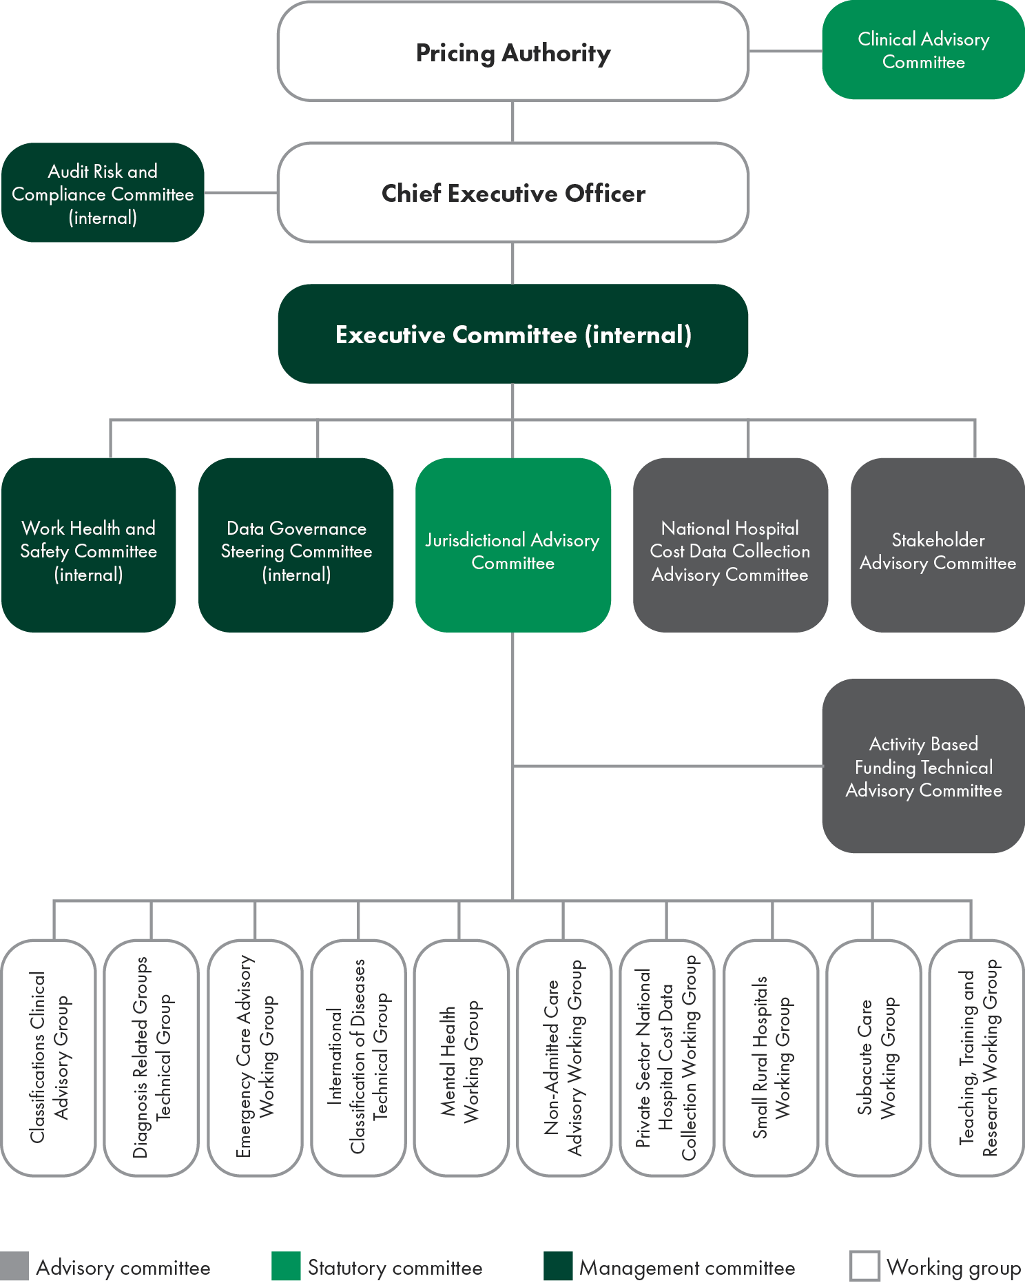

Clinical Advisory Committee
The Clinical Advisory Committee was established under section 176 of the NHR Act.
Clinical Advisory Committee members provide high-level technical and clinical advice to the Pricing Authority on a range of issues, such as activity based funding, classification development and policy development to inform the annual determination of the national efficient price and national efficient cost.
As at 30 June 2022, the Clinical Advisory Committee consisted of 19 members.
The Clinical Advisory Committee is a statutory committee established under Part 4.10 of the NHR Act.
The functions of the committee are described in section177:
- to advise the Pricing Authority in relation to developing and specifying classification systems for health care and other services provided by public hospitals
- to advise the Pricing Authority in relation to matters that:
  - relate to the functions of the Pricing Authority
  - are referred to the Clinical Advisory Committee by the Pricing Authority
- to do anything incidental to, or conducive to, the performance of the above functions.
The Clinical Advisory Committee is required to report on its work annually. The details of the committee’s membership and meetings sits within this annual report.
Membership
The members of the committee are appointed by the Australian Government Minister for Health and Aged Care and are drawn from a range of clinical specialties and backgrounds to ensure the committee represents a wide range of clinical expertise.
Appointments are based on individual expertise rather than as a representation of any organisation, peak body or jurisdiction. The Remuneration Tribunal determines remuneration.
The Chair of the committee, Associate Professor Alasdair MacDonald, reports to the Australian Government Minister for Health and Aged Care and is supported by IHPA staff.

Table 9: Membership and meetings of the Clinical Advisory Committee in 2021–‍22
Name | Position | Specialty | Meetings eligible | Meetings attended
A/Prof Alasdair MacDonald | Chair | Internal medicine | 4 | 4
Prof Gerard Carroll | Member | Cardiology/rural | 4 | 2
Mr Anthony Graham Fish | Member | Allied health | 3 | 2
Prof Leon Flicker | Member | Geriatrics/Indigenous health | 4 | 4
Ms Nicole Harwood | Member | Nursing | 4 | 2
Dr Amod Karnik | Member | Intensive care medicine | 4 | 3
Mr Christopher O’Donnell | Member | Nursing | 4 | 2
A/Prof Nicole Phillips | Member | Administration/anaesthesia and pain management | 4 | 4
A/Prof Virginia Plummer | Member | Nursing | 4 | 4
Ms Amber Polles | Member | Pharmacy | 4 | 3
Dr Elaine Pretorius | Member | Administration | 4 | 3
Ms Elizabeth Prowse | Member | Mental health | 4 | 3
Dr Phil Sargent | Member | Paediatrics | 3 | 2
Dr Tracy Smith | Member | Respiratory and palliative care | 4 | 2
A/Prof Joanna Sutherland | Member | Anaesthesia and pain management/rural | 4 | 2
Ms Monica Taylor | Member | Mental health | 4 | 4
A/Prof Melinda Truesdale | Member | Emergency medicine | 4 | 3
A/Prof Paul Varghese | Member | Geriatrics/rehabilitation | 4 | 4
A/Prof Andrew Wei | Member | Haematology | 4 | 1
A/Prof Bernard Whitfield | Member | Ear nose and throat surgery/ injuries/trauma | 4 | 1
Dr Jo Wright | Member | Rural medical practice | 4 | 4
Dr Kathryn Zeitz | Member | Nursing | 4 | 3

Clinical Advisory Committee meetings 2021–22
18 August 2021
21 October 2021
2 February 2022
18 May 2022

Jurisdictional Advisory Committee
The Jurisdictional Advisory Committee was established under section 195 of the NHR Act. It consists of a Chair, appointed by the Pricing Authority and nine other members (one to represent each state and territory, and one representing the Commonwealth Government).
Committee members are appointed by the head of the health department of the jurisdiction they represent.
The Jurisdictional Advisory Committee met on 10 occasions between 1 July 2021 and 30 June 2022.
Jurisdictional Advisory Committee members as of 30 June 2021:
- Ms Joanne Fitzgerald (Chair)
- Mr Rob Anderson (Western Australia)
- Ms Lynne Cowan (South Australia)
- Mr Michael Culhane (Australian Capital Territory)
- Ms Toni Cunningham (Queensland)
- Ms Denise Ferrier (Victoria)
- Ms Bronwyn Field (Commonwealth Government)
- Dr Nigel Lyons (New South Wales)
- Mr Damien Smith (Proxy for Tasmania)
- Mr Stathi Tsangaris (Northern Territory).
During the reporting period, there were changes to the Chair, Australian Capital Territory and Tasmania memberships.
Audit, Risk and Compliance Committee
The IHPA Audit, Risk and Compliance Committee provides independent advice to the Chief Executive Officer on managing IHPA’s financial and business risk.
The Audit, Risk and Compliance Committee Charter is available at: ihacpa.gov.au/audit-risk-and-compliance-committee.
During the reporting period, members of the Audit, Risk and Compliance Committee comprised:
- Ms Angela Diamond, Chair and independent member
- Mr Glenn Appleyard, member, Pricing Authority
- Mr John Lenarduzzi, independent member
- Ms Joanna Stone, independent member.

Table 10: Details of Audit, Risk and Compliance Committee during the reporting period (2021–22)
The IHPA Audit, Risk and Compliance Committee met on four occasions between 1 July 2021 and 30 June 2022. The (former) Chief Executive Officer, Mr James Downie, attended all meetings during the reporting period.
Member name | Qualifications, knowledge, skills and experience | Number of meetings attended/  total number of meetings eligible | Total annual remuneration | Additional information
Ms Angela Diamond | Ms Angela Diamond has held several senior finance positions within the public service and is currently the Chief Financial Officer at Services Australia.  Angela has a Bachelor of Commerce from the Australian National University and is a Certified Practicing Accountant. | 4/4 | Nil — employed by a Cwlth entity | Chair and independent member
Mr Glenn Appleyard | Mr Glenn Appleyard was a member of the Australian Accounting Standards Board from 1 January 2003 to 31 December 2011.  Glenn has held several senior positions within the public service including Deputy Secretary in the Tasmanian and Victorian Departments of Treasury and Finance and Regional Director for the Australian Bureau of Statistics in Tasmania.  He was a member of the Commonwealth Grants Commission for 11 years and was the Chair of the Tasmanian Economic Regulator.  Glenn has been a member of the Independent Hospital Pricing Authority since his appointment in 2012.  Glenn has a Bachelor of Economics from the University of Tasmania. | 4/4 | $9,232 | Pricing Authority member

Member name | Qualifications, knowledge, skills and experience | Number of meetings attended/  total number of meetings eligible | Total annual remuneration | Additional information
Mr John Lenarduzzi | Mr John Lenarduzzi has over 20 years’ experience working in technology and security environments and spent seven years as a senior executive in Australia’s National Intelligence Community. Having started his career as an electronic engineer in Adelaide, he moved to Canberra in 2001 where he worked in a range of roles to deliver transformational change nationally and internationally through strategic planning, organisational change, capability development and operations. John took a role in the private sector in 2020 and is currently the Director of Managed Security Operations (Global and Commercial) at CyberCX with leadership responsibilities across Australia, New Zealand, the United Kingdom and the United States.  John has a Bachelor of Electrical and Electronic Engineering (Flinders University) and a Masters of Business Administration (Deakin). He completed the Senior Executives in National Security Program at Harvard Kennedy School in 2017 and sits as an independent member on two audit and risk committee boards. | 4/4 | $8,800 | Independent member
Ms Joanna Stone | Ms Joanna Stone has substantial public and private sector management experience and extensive experience across several audit committees as a member and previously as a Chair. Joanna holds formal qualifications in finance. | 4/4 | Nil — employed by a Cwlth entity | Independent member

5.5 Key corporate governance practices

Risk management
IHPA’s enterprise-wide approach to risk management remains at the forefront of all of its activities. It administers its risks using tools that address the strategic and tactical risks of all significant decisions. IHPA’s risk management framework including its risk appetite statement and risk register is reviewed annually.
Strategic risks are identified with reference to current business and environmental issues facing IHPA. These risks fall into three major risk categories:
- reputational risks
- data and information governance risks
- corporate risks.
IHPA’s strategic risks are actively managed through audits, assurance and internal control processes. Where new risks emerge, resources are assigned to understand and manage those risks. Potential risks are reviewed biannually or more frequently, as required.
Tactical risks are managed through a decision-based risk management tool, which requires recording of the risk and a formal decision on the managed likelihood and consequence of the risk. The assessment tool forms part of any major decision, ensuring that the final decision maker is fully informed and cognisant of managed risk outcomes during the decision‑making process.
IHPA’s Privacy Threshold Assessment tool, allows IHPA to determine whether there is a risk to personal information, and therefore a need to undertake a Privacy Impact Assessment. As with the Tactical Risk Tool the Privacy Threshold Assessment tool forms part of any decision which may impact privacy.
IHPA has a mature enterprise risk management framework in place and risk management is considered a business‑as‑usual activity for all IHPA staff.
During the period of this annual report, IHPA closely monitored and managed the operational and technical risks associated with the coronavirus disease 2019 (COVID-19) pandemic.
Additionally, IHPA continues to maintain a shared Strategic Risk Register with the National Health Funding Body, which has identified joint risks that the agencies manage together. Currently those risks are:
- incorrect calculation of Commonwealth funding entitlements
- changes to models that have not been effectively modelled or implemented.
IHPA’s business continuity plan ensured an effective and seamless transition to working from home during the entire lockdown period required by the COVID-19 pandemic.

Compliance
IHPA has a broad range of compliance obligations including key statutory obligations set out in the National Health Reform Act 2011, the National Health Reform Agreement, the Public Governance Performance and Accountability Act 2013 and the Public Governance Performance and Accountability Rule 2014.
Other legal and compliance obligations include work health and safety, privacy, freedom of information, intellectual property, the Protective Security Policy Framework, website accessibility and records management.
The Chief Executive Officer, as the accountable authority, receives management assurances on IHPA’s compliance obligations through an organised system of controls and special exercises, including substantive testing, monthly reports, exception notifications and compliance audits undertaken by an independent internal auditor.
Compliance achievements
IHPA’s internal compliance audits during the year show that:
- information and communication technology systems continued to appropriately address the top risks defined by the Australian Signals Directorate
- no compliance issues arising from IHPA’s administration of relevant sections of the National Health Reform Act 2011.
Financial authorisation
As a corporate Commonwealth Agency, IHPA is not required to adhere to the Commonwealth Procurement Rules, however, it chooses to do so as a matter of best practice. All of IHPA’s procurement decisions are made in accordance with the Commonwealth Procurement Rules. Line managers have value and purchase class limits, in accordance with the delegation of financial authorities that are approved and reviewed regularly by the Chief Executive Officer, as the accountable authority.
Fraud control plan
IHPA’s fraud control plan is recognised as a critical internal tool used to mitigate the act and consequences of authorised use of IHPA data and financial resources. The plan encourages ethical behaviour through the use of business processes designed to prevent deceptive activities, supported by monitoring controls to detect fraud and deter offending behaviour and is reviewed annually or as required.
Inter-agency financial activity
During the 2021–22 financial year, IHPA received shared services resourcing from the Commonwealth Department of Health and Aged Care. The Commonwealth Department of Health and Aged Care charged IHPA $433,000 to provide these services covering treasury, processing of financial transactions, information and communication desktop services and parliamentary support.
Ecologically sustainable development and environmental performance
IHPA does not undertake any substantive work that is covered by section 516A of the Environment Protection Act 1999.

5.6 Management of human resources

The Chief Executive Officer is the Independent Hospital Pricing Authority’s (IHPA) only employee and is based in Sydney, New South Wales. All other staff are seconded from the Commonwealth Department of Health and Aged Care to IHPA and report to the Chief Executive Officer.
IHPA continues to place great value in creating a more productive and inclusive workplace—primarily by attracting and retaining high calibre, talented and engaged staff. The agency supports a flexible work environment and will continue to support all staff to optimise their work-life balance, as well as providing technological support critical to achieving their required work performance.
IHPA is committed to the recruitment and retention of a diverse workforce (for example, in gender, age, cultural and linguistic background, disability, Indigenous, and LGBTI+) and actively promotes an inclusive workplace culture.
Ongoing and non-ongoing employees
Although the Commonwealth Department of Health and Aged Care reports on seconded IHPA staff as part of its mandatory reporting requirements, to ensure transparency, IHPA has provided the following staffing tables.

Table 11: Ongoing seconded employees 2022
 | Male |  |  | Female
Classification | Full-time | Part-time | Total | Full-time | Part-time | Total | Total
Senior Executive Service | 0 | 1 | 1 | 2 | 0 | 2 | 3
Executive Level 2 | 6 | 0 | 6 | 8 | 0 | 8 | 14
Executive Level 1 | 6 | 1 | 7 | 18 | 2 | 20 | 27
APS Level 6 | 5 | 0 | 5 | 6 | 3 | 9 | 14
APS Level 5 | 0 | 0 | 0 | 0 | 0 | 0 | 0
Total | 17 | 2 | 19 | 34 | 5 | 39 | 58

Table 12: Ongoing seconded employees 2021
 | Male |  |  | Female
Classification | Full-time | Part-time | Total | Full-time | Part-time | Total | Total
Senior Executive Service | 0 | 0 | 0 | 2 | 0 | 2 | 2
Executive Level 2 | 5 | 0 | 5 | 7 | 0 | 7 | 12
Executive Level 1 | 10 | 0 | 10 | 9 | 2 | 11 | 21
APS Level 6 | 2 | 0 | 2 | 3 | 2 | 5 | 7
APS Level 5 | 0 | 0 | 0 | 1 | 0 | 1 | 1
Total | 17 | 0 | 17 | 22 | 4 | 26 | 43

Table 13: Non-ongoing seconded employees 2022
 | Male |  |  | Female
Classification | Full-time | Part-time | Total | Full-time | Part-time | Total | Total
Senior Executive Service | 0 | 0 | 0 | 0 | 0 | 0 | 0
Executive Level 2 | 1 | 0 | 1 | 0 | 0 | 0 | 1
Executive Level 1 | 1 | 0 | 1 | 3 | 0 | 3 | 4
APS Level 6 | 0 | 0 | 0 | 0 | 0 | 0 | 0
APS Level 5 | 0 | 0 | 0 | 0 | 0 | 0 | 0
Total | 2 | 0 | 2 | 3 | 0 | 3 | 5

Table 14: Non-ongoing seconded employees 2021
 | Male |  |  | Female
Classification | Full-time | Part-time | Total | Full-time | Part-time | Total | Total
Senior Executive Service | 0 | 0 | 0 | 0 | 0 | 0 | 0
Executive Level 2 | 0 | 0 | 0 | 0 | 1 | 1 | 1
Executive Level 1 | 1 | 0 | 1 | 2 | 0 | 2 | 3
APS Level 6 | 0 | 0 | 0 | 0 | 0 | 0 | 0
APS Level 5 | 0 | 0 | 0 | 0 | 0 | 0 | 0
Total | 1 | 0 | 1 | 2 | 1 | 3 | 4

Key management personnel
Table 15: Information about remuneration for key management personnel
IHPA Annual Report 2021–22 81

 |  | Short term benefits |  |  | Post-employment | Other long-term benefits
Name | Position title | Base salary | Bonuses | Other benefits and allowances | Superannuation contributions | Long service leave | Other long-term benefits | Termination benefits |  | Total remuneration
 |  | $ | $ | $ | $ | $ | $ | $ |  | $
Mr Glenn Appleyard | Pricing Authority member | 15,222 | - | - | 2,344 | - | - | - |  | 17,566
A/Prof Bruce Chater | Pricing Authority member (former) | 8,002 | - | - | 800 | - | - | - |  | 8,802
Dr Adam Coltzau | Pricing Authority member | 6,542 | - | - | 654 | - | - | - |  | 7,196
Mr James Downie | Chief Executive Officer (former) | 438,702 | - | - | 22,430 | 72,397 | - | - |  | 533,529
Ms Joanne Fitzgerald | Chief Executive Officer (acting) | 9,454 | - | 575 | 1,445 | 211 | - | - |  | 11,685
Ms Prudence Ford | Pricing Authority member | 31,748 | - | - | 3,175 | - | - | - |  | 34,923
Distinguished Prof Jane Hall | Pricing Authority member | 31,748 | - | - | 3,175 | - | - | - |  | 34,923
Ms Jenny Richter AM | Pricing Authority member | 31,748 | - | - | 3,175 | - | - | - |  | 34,923
Mr Shane Solomon | Pricing Authority Chair (former) | 52,234 | - | - | 5,224 | - | - | - |  | 57,458
Dr Kate Taylor | Pricing Authority member | 31,748 | - | - | 3,175 | - | - | - |  | 34,923
Mr David Tune AO PSM | Pricing Authority Chair | 33,411 | - | - | 3,341 | - | - | - |  | 36,752
Ms Jennifer Williams AM | Pricing Authority Deputy Chair | 31,748 | - | - | 3,175 | - | - | - |  | 34,923
Total |  | 722,307 | - | 575 | 52,113 | 72,608 | - | - |  | 847,603
Key management personnel are those persons having authority and responsibility for planning, directing and controlling the activities of the entity, directly or indirectly. IHPA has determined the key management personnel to be the Chief Executive Officer and the Pricing Authority members. The disaggregated key management personnel remuneration information in the table above is in accordance with the Public Governance, Performance and Accountability Rule 2014.
Staff development
IHPA cultivates, values and supports staff by developing their skills and capabilities to meet their work requirements, as well as to achieve their full potential. IHPA promotes a culture where people work within and across teams to broaden their expertise.
Training was provided on a programmed basis to management and a needs basis to individual staff. Additionally, mid-level and senior management staff undertook a program of leadership capability training. IHPA supported individuals to attend conferences and training events that assisted them to acquire and develop skills used in their work. In 2021–22, IHPA’s training investment averaged $1,701 per staff member.
Education and review processes
During the reporting period, the Chief Executive Officer enhanced his skills through attendance at domestic and international activity based funding events and attended specialised leadership training that was also made available to IHPA mid-level and senior management staff. He receives regular performance feedback via the Pricing Authority meetings.
Work health and safety
In 2021–22, IHPA’s Work Health and Safety Committee continued to manage work health and safety matters in accordance with the Work Health and Safety Act 2011.
The committee met six times during the year and dealt with a range of work health and safety matters.
IHPA maintained its ongoing practice of providing workplace assessments for new staff, as required, and provided additional support to staff working from home during the COVID-19 pandemic.
In 2021–22, no notifiable incidents were identified with regards to work health and safety.
One worker reported an injury.
There were no investigations conducted during the year relating to businesses or undertakings conducted by the entity.
Advertising and market research
In 2021–22, IHPA commissioned no advertising that must be reported under section 311A of the Commonwealth Electoral Act 1918.




6. Financial
management
06

Financial statements
Independent auditor’s report 87
Statement by the Chief Executive Officer and Chief Financial Officer 89
Primary financial statements 90
Statement of comprehensive income 90
Statement of financial position 91
Statement of changes in equity 92
Cash flow statement 93
Overview 94
Notes to the financial statements 96
Financial performance 96
Note 1.1 Expenses 96
Note 1.2 Own-source revenue and gains 98
Financial position 100
Note 2.1 Financial assets 100
Note 2.2 Non-financial assets 101
Note 2.3 Payables 104
Note 2.4 Interest bearing liabilities 104
People and Relationships 105
Note 3.1 Employee provisions 105
Note 3.2 Key management personnel remuneration 106
Note 3.3 Related party disclosures 106
Managing uncertainties 107
Note 4.1 Contingent assets and liabilities 107
Note 4.2 Financial instruments 108
Note 4.3 Fair value measurement 109
Other information 110
Note 5.1 Current/non-current distinction for assets and liabilities 110

Independent auditor’s report
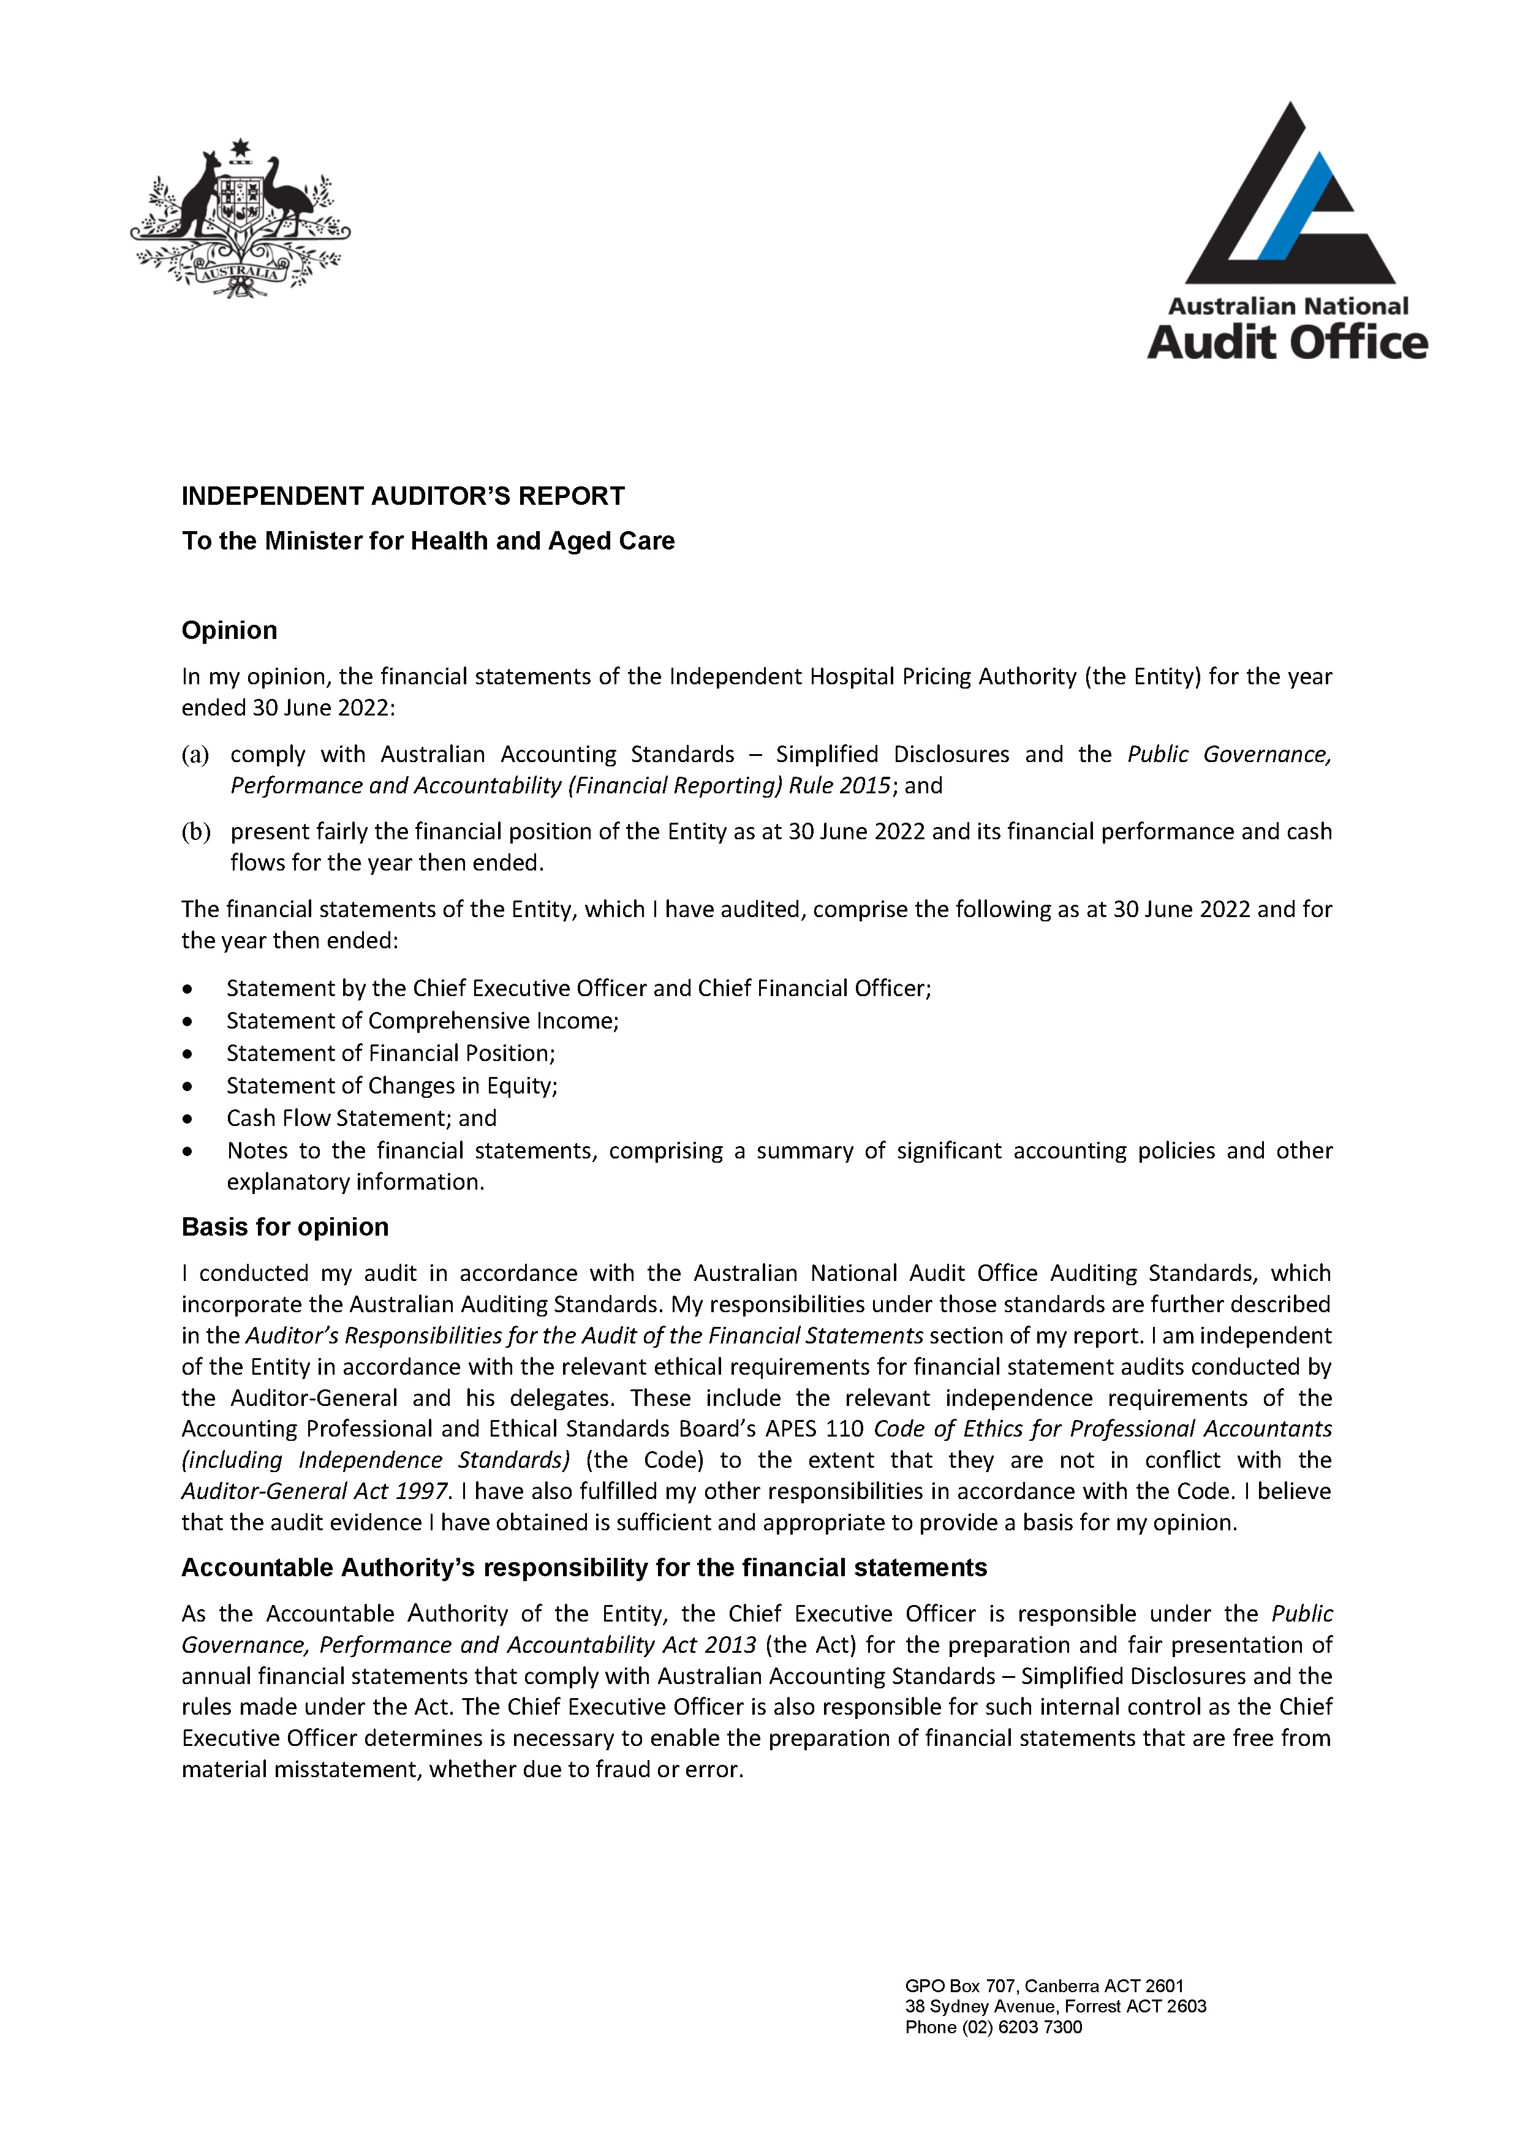

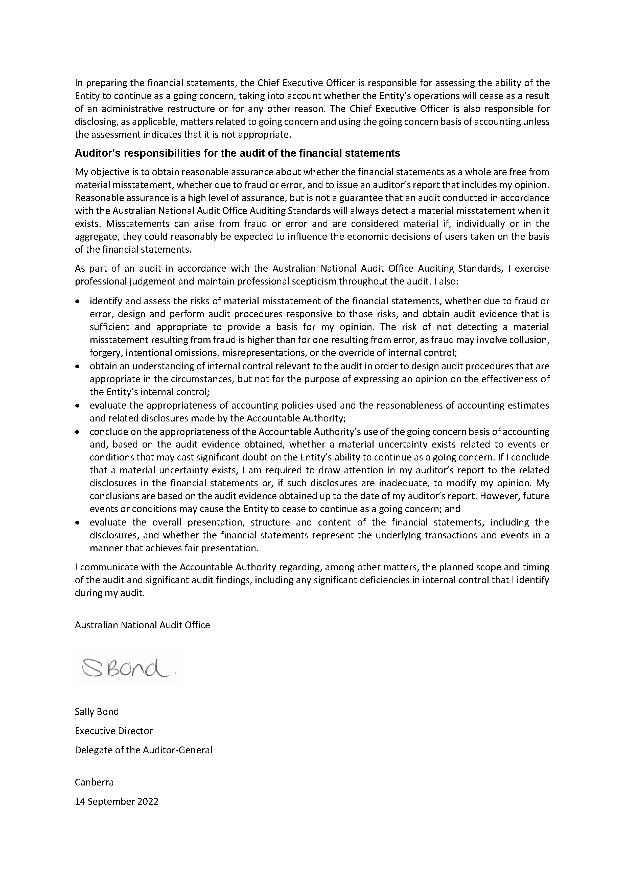

Independent Hospital Pricing Authority Financial Statements 2021–22
For the year ended 30 June 2022
Statement by the Chief Executive Officer and Chief Financial Officer
In our opinion, the attached financial statements for the year ended 30 June 2022 comply with subsection 42(2) of the Public Governance, Performance and Accountability Act 2013 (PGPA Act), and are based on properly maintained financial records as per subsection 41(2) of the PGPA Act.
In our opinion, at the date of this statement, there are reasonable grounds to believe that the Independent Hospital Pricing Authority¹ will be able to pay its debts as and when they fall due.
Ms Joanne Fitzgerald
Acting Chief Executive Officer
14 September 2022

Mr Chris Miljak
Chief Financial Officer
14 September 2022

________________
¹ On 12 August 2022, the Independent Hospital Pricing Authority was renamed to the Independent Health and Aged Care Pricing Authority.

Primary financial statements
Statement of comprehensive income
for the period ended 30 June 2022
 | Notes | 2022  $’000 | 2021  $’000 | Original Budget  $’000
NET COST OF SERVICES
EXPENSES
Employee benefits | 1.1A | 8,864 | 7,764 | 12,641
Suppliers | 1.1B | 16,695 | 9,800 | 18,702
Depreciation and amortisation | 2.2A | 1,301 | 1,437 | 1,165
Finance costs | 1.1C | 61 | 63 | 60
Losses from the disposal of assets | 2.2A | 738 | - | -
Total expenses |  | 27,659 | 19,064 | 32,568
OWN-SOURCE INCOME
Own-source revenue
Revenue from contracts with customers | 1.2A | 1,034 | 217 | 1,000
Resources received free of charge | 1.2B | 8,514 | 7,440 | 12,260
Interest |  | 6 | 5 | 5
Total own-source revenue |  | 9,554 | 7,662 | 13,265
Other gains | 1.2C | 270 | - | -
Total gains |  | 270 | - | -
Total own-source income |  | 9,824 | 7,662 | 13,265
Net cost of services |  | 17,835 | 11,402 | 19,303
Revenue from Government | 1.2D | 18,359 | 13,744 | 19,249
Surplus / (Deficit) |  | 524 | 2,342 | (54)
Total comprehensive surplus / (deficit) |  | 524 | 2,342 | (54)
The above statement should be read in conjunction with the accompanying notes.
Budget Variances Commentary
Statement of Comprehensive Income
Total expenses of $27.659m were $4.909m lower than budget primarily due to lower employee benefits expenses of $3.777m and supplier expenses of $2.007m.
Employee benefits expenses were below budget due to lower staff levels, and supplier expenses were lower due to deferred program activity arising from state and territory hospital resources managing the COVID-19 priorities.
Total own source income of $9.824m was $3.441m less than budget primarily due to lower resources received free of charge due to lower employee benefits expenses.

Statement of financial position
as at 30 June 2022
 | Notes | 2022  $’000 | 2021  $’000 | Original Budget  $’000
ASSETS
Financial assets
Cash and cash equivalents | 2.1A | 16,079 | 16,251 | 13,476
Trade and other receivables | 2.1B | 529 | 273 | 199
Total financial assets |  | 16,608 | 16,524 | 13,675
Non-financial assets
Buildings | 2.2A | 12,375 | 1,124 | 4,569
Leasehold improvement | 2.2A | 2,398 | 1,107 | 1,323
Computer software | 2.2A | 61 | 92 | 833
Plant and equipment | 2.2A | - | 1 | 12
Other - prepayments |  | 308 | 368 | 60
Total non-financial assets |  | 15,142 | 2,692 | 6,797
Total assets |  | 31,750 | 19,216 | 20,472
LIABILITIES
Payables
Suppliers | 2.3A | 2,623 | 1,737 | 1,977
Other payables | 2.3B | 235 | 18 | 12
Total payables |  | 2,858 | 1,755 | 1,989
Interest bearing liabilities
Lease liabilities | 2.4A | 12,532 | 1,519 | 5,038
Total interest bearing liabilities |  | 12,532 | 1,519 | 5,038
Provisions
Employee provisions | 3.1A | - | 106 | 100
Total provisions |  | - | 106 | 100
Total liabilities |  | 15,390 | 3,380 | 7,127
Net assets |  | 16,360 | 15,836 | 13,345
EQUITY
Contributed equity |  | 400 | 400 | 400
Retained surplus |  | 15,960 | 15,436 | 12,945
Total equity |  | 16,360 | 15,836 | 13,345
The above statement should be read in conjunction with the accompanying notes.
Budget Variances Commentary
Statement of Financial Position
Total assets of $31.750m were $11.278m higher than budget primarily due to the increase in property accommodation (i.e, right-of-use assets) of $7.806m and leasehold improvements of $1.075m.
Total liabilities of $15.390m were $8.263m higher than budget primarily due to higher lease liabilities of $7.494m, increased supplier payables of $0.646m for expenses accrued and increased other payables of $0.223m primarily driven by leave entitlements.
Total equity of $16.360m was $3.015m higher than the budget amount of $13.345m primarily due to the prior and current period surplus.

Statement of changes in equity
for the period ended 30 June 2022
 | Notes | 2022  $’000 | 2021  $’000 | Original Budget  $’000
CONTRIBUTED EQUITY
Opening balance
Balance carried forward from previous period |  | 400 | 400 | 400
Closing balance as at 30 June |  | 400 | 400 | 400
RETAINED EARNINGS
Opening balance
Balance carried forward from previous period |  | 15,436 | 13,094 | 12,999
Comprehensive income
Surplus / (deficit) for the period |  | 524 | 2,342 | (54)
Closing balance as at 30 June |  | 15,960 | 15,436 | 12,945
TOTAL EQUITY
Opening balance
Balance carried forward from previous period |  | 15,836 | 13,494 | 13,399
Equity movements during the period
Surplus for the period |  | 524 | 2,342 | (54)
Closing balance as at 30 June |  | 16,360 | 15,836 | 13,345
The above statement should be read in conjunction with the accompanying notes.
Budget Variances Commentary
Statement of Changes in Equity
Total equity of $16.360m was $3.015m higher than the budget amount of $13.345m primarily due to the prior and current period surplus.

Cash flow statement
for the period ended 30 June 2022
 | Notes | 2022  $’000 | 2021  $’000 | Original Budget  $’000
OPERATING ACTIVITIES
Cash received
Receipts from government |  | 18,359 | 13,744 | 19,249
Sale of goods and rendering of services |  | 954 | 215 | 1,075
Interest |  | - | 5 | 5
Net GST received |  | 1,689 | 1,021 | 1,533
Total cash received |  | 21,022 | 14,985 | 21,862
Cash used
Employees |  | (833) | (823) | (860)
Suppliers |  | (17,014) | (11,284) | (20,120)
Interest payments on lease liabilities |  | (61) | (63) | (60)
Total cash used |  | (17,908) | (12,170) | (21,040)
Net cash from / (used by) operating activities |  | 3,094 | 2,815 | 822
INVESTING ACTIVITIES
Cash used
Purchase of leasehold improvements |  | (2,481) | - | (30)
Total cash used |  | (2,481) | - | (35)
Net cash from /(used by) investing activities |  | (2,481) | - | (35)
FINANCING ACTIVITIES
Cash used
Principal payments of lease liabilities |  | (785) | (683) | (718)
Total cash used |  | (785) | (683) | (718)
Net cash from / (used by) financing activities |  | (785) | (683) | (718)
Net increase / (decrease) in cash held |  | (172) | 2,132 | 69
Cash and cash equivalents at the beginning of the reporting period |  | 16,251 | 14,119 | 13,407
Cash and cash equivalents at the end of the reporting period | 2.1A | 16,079 | 16,251 | 13,476
The above statement should be read in conjunction with the accompanying notes.
Budget Variances Commentary
Statement of Changes in Cash Flow
The closing cash balance of $16.079m was $2.603m higher than the budget due to opening balance difference of $2.844m.

Overview

Objectives of the Independent Hospital Pricing Authority
The Independent Hospital Pricing Authority (IHPA) is a corporate Commonwealth entity under the Public Governance, Performance and Accountability Act 2013 (PGPA Act).
IHPA's role and functions are set out in the National Health Reform Act 2011.
IHPA’s functions include to:
- determine the national efficient price and national efficient cost for public hospital services
- develop national classifications for activity based funding
resolve disputes on cost-shifting and cross-border issues.
IHPA is structured to meet the following outcome: promote improved efficiency in, and access to, public hospital services primarily through setting the national efficient price and levels of block funding for hospital activities.
The continued existence of the entity in its present form, and with its present programs, is dependent on government policy and on continuing funding by parliament for the entity's administration and programs.
The basis of preparation
The financial statements are general purpose financial statements and are required by section 42 of the PGPA Act.
The financial statements have been prepared in accordance with the:
- Public Governance, Performance and Accountability (Financial Reporting) Rule 2015 (FRR)
- Australian Accounting Standards and Interpretations — including simplified disclosures for Tier 2 Entities under AASB 1060 issued by the Australian Accounting Standards Board (AASB) that apply for the reporting period.
The financial statements have been prepared on an accrual basis and in accordance with the historical cost convention, except for certain assets and liabilities at fair value. Except where stated, no allowance is made for the effect of changing prices on the results or the financial position. The financial statements are presented in Australian dollars and values are rounded to the nearest thousand dollars, unless otherwise specified.
Significant changes affecting IHPA during 2021–22
No significant changes affecting IHPA have occurred in this reporting period.
COVID-19 pandemic impacts
Due to state and territory hospital resources being reassigned to manage the COVID-19 pandemic, some forecast expenditure relating to the non-admitted costing study has been deferred until such time resources become available.
There were no other financial impacts from the pandemic.

New Accounting Standards
IHPA has adopted all new, revised and amending standards and interpretations that were issued by the Australian Accounting Standards Board (AASB) prior to the sign-off date and which are applicable to the current reporting period.
The following new, revised and amending standards and interpretations were issued by the AASB prior to the signing of the statement by the Chief Executive Officer and Chief Financial Officer:
New standard | Expected impact
AASB 1060 General Purpose Financial Statements – Simplified Disclosures for For-Profit and Not-for-Profit Tier 2 Entities | No impact

All other new, revised and amending standards or interpretations that have been issued by the AASB prior to sign-off date that are applicable to future reporting period(s) are not expected to have a future material financial impact on IHPA's financial statements.
Significant accounting judgements and estimates
Except where specifically identified and disclosed, IHPA has determined that no accounting assumptions and estimates have a significant risk of causing a material adjustment to carrying amounts of assets and liabilities within the next accounting period.
Comparative figures
Comparative figures have been adjusted, where required, to conform to changes in presentation of the financial statements.
Taxation
IHPA is exempt from all forms of taxation, except Fringe Benefits Tax (FBT) and the Goods and Services Tax (GST). Revenues and expenses are recognised net of GST, except where the amount of GST incurred is not recoverable from the Australian Taxation Office.
Events after the reporting period
The Aged Care and Other Legislation Amendment (Royal Commission Response) Act 2022 (Cwlth) includes amendments that expanded the remit of the existing IHPA and renamed it to become the Independent Health and Aged Care Pricing Authority (IHACPA).
Commencing 12 August 2022, Schedule 8 amended the National Health Reform Act 2011, the Aged Care Act 1997 and the Quality and Safety Commission Act 2018 to expand the functions of a renamed IHACPA to include the:
- provision of advice on healthcare pricing and costing matters
- provision of advice on aged care pricing and costing matters
- performance of certain functions conferred by the Aged Care Act.
IHACPA will provide advice to inform Commonwealth Government decisions on the costing and pricing of aged care services from 1 July 2023.
No events have occurred since the reporting date which have had a material impact on the financial statements.

Notes to the financial statements
Financial performance
This section analyses the financial performance of IHPA for the year ended 30 June 2022.
Note 1.1 Expenses
 | 2022  $’000 | 2021  $’000
Note 1.1A: Employee Benefits
Wages and salaries | 528 | 524
Superannuation — Defined contribution plans | 63 | 56
Leave and other entitlements | 353 | 256
Wages and salaries for staff provided by Department of Health | 7,920 | 6,928
Total employee benefits | 8,864 | 7,764

Accounting Policy
Employee benefits
Accounting policies for employee benefits is contained in the People and Relationships section.

 | 2022  $’000 | 2021  $’000
Note 1.1B: Suppliers
Goods and services supplied or rendered
Consultants | 3,842 | 2,793
Contractors | 5,986 | 1,999
IT services | 5,081 | 3,908
Travel | 100 | 53
Training | 89 | 132
Publishing materials | 464 | 202
Legal and audit expenses | 279 | 179
Conferences and seminars | 234 | 132
Other | 618 | 400
Total goods and services supplied or rendered | 16,693 | 9,798
Goods supplied | 649 | 277
Services rendered | 16,044 | 9,521
Total goods and services supplied or rendered | 16,693 | 9,798
Other suppliers
Workers’ compensation expenses | 2 | 2
Total other suppliers | 2 | 2
Total suppliers | 16,695 | 9,800

 | 2022  $’000 | 2021  $’000
Note 1.1C: Finance Costs
Interest on lease liabilities (office space lease) | 61 | 63
Total finance costs | 61 | 63
The above lease disclosures should be read in conjunction with the accompanying notes 2.4A.

Note 1.2 Own-source revenue and gains
 | 2022  $’000 | 2021  $’000
OWN-SOURCE REVENUE
Note 1.2A: Revenue from contracts with customers
Sale of goods | 1,034 | 217
Total revenue from contracts with customers | 1,034 | 217

Accounting Policy
Revenue from contracts with customers
Revenue from the sale of goods is recognised when control has been transferred to the buyer.
In relation to AASB 15, IHPA has considered each revenue stream to identify the existence of an enforceable contract that requires the completion of sufficiently specific performance obligations in exchange for relevant consideration. Revenue is recognised either over time or at a point in time as performance obligations are completed and IHPA has an enforceable right to payment for the performance completed to date.
Receivables for goods and services, which have 30-day terms, are recognised at the nominal amounts due less any impairment allowance account. Collectability of debts is reviewed at the end of the reporting period. Allowances are made when collectability of the debt is no longer probable.

 | 2022  $’000 | 2021  $’000
Note 1.2B: Resources received free of charge
Departmental contribution received free of charge | 8,449 | 7,375
Other resources received free of charge | 65 | 65
Total other revenue | 8,514 | 7,440

Accounting Policy
Resources received free of charge
Resources received free of charge are recognised as revenue when, and only when, a fair value can be reliably determined and the services would have been purchased if they had not been donated. Use of those resources is recognised as an expense. Resources received free of charge are recorded as revenue.

 | 2022  $’000 | 2021  $’000
Note 1.2C: Other gains
Gain on lease modification | 270 | -
Total other gains | 270 | -
Note 1.2D: Revenue from Government
Amounts from Department of Health | 18,359 | 13,744
Total revenue from Government | 18,359 | 13,744

Accounting Policy
Revenue from Government
Funding received or receivable from non-corporate Commonwealth entities is recognised as Revenue from Government by IHPA unless the funding is in the nature of an equity injection or a loan.

Financial position
This section analyses the IHPA's assets used to conduct its operations and the operating liabilities incurred as a result. Employee-related information is disclosed in the People and Relationships section.
Note 2.1 Financial assets
 | 2022  $’000 | 2021  $’000
Note 2.1A: Cash and cash equivalents
Cash on deposit | 16,079 | 16,251
Total cash and cash equivalents | 16,079 | 16,251

Accounting Policy
Cash and cash equivalents
Cash is recognised at its nominal amount. Cash and cash equivalents includes:
- cash on hand, and
- demand deposits in bank accounts with an original maturity of three months or less that are readily convertible to known amounts of cash and subject to insignificant risk of changes in value.

 | 2022  $’000 | 2021  $’000
Note 2.1B: Trade and other receivables
Other receivables
GST receivable from the Australian Taxation Office | 382 | 242
Other amounts receivable | 147 | 31
Total other receivables | 529 | 273
Total trade and other receivables (gross) | 529 | 273
Less impairment allowance | - | -
Total trade and other receivables (net) | 529 | 273
No amounts receivable are overdue.

Accounting Policy
Trade and other receivables
IHPA's financial assets are comprised of trade receivables and other receivables that are held for the purpose of collecting the contractual cash flows. All of IHPA's financial assets are measured, and carried, at amortised cost.
Impairment
All assets were assessed for impairment as at 30 June 2022. Where indications of impairment exist, the asset's recoverable amount is estimated and an impairment adjustment made if the asset's recoverable amount is less than its carrying amount.

Note 2.2 Non-financial assets
Note 2.2A: Reconciliation of the Opening and Closing Balances of Property, Plant and Equipment, and Intangibles
 | Buildings  $’000 | Leasehold improvement  $’000 | Plant and equipment  $’000 | Computer software  $’000 | Total  $’000
As at 1 July 2021
Gross book value | 2,653 | 1,846 | 5 | 803 | 5,307
Accumulated depreciation, amortisation and impairment | (1,529) | (739) | (4) | (712) | (2,984)
Total as at 1 July 2021 | 1,124 | 1,107 | 1 | 91 | 2,323
Additions
Right-of-use assets | 12,801 | - | - | - | 12,801
Purchase | - | 2,481 | - | - | 2,481
Depreciation and amortisation | - | (467) | (1) | (15) | (483)
Depreciation on right-of-use assets | (818) | - | - | - | (818)
Disposals
Non-cash consideration | (1,920) | (1,846) | (5) | (25) | (3,796)
Adjustment to right-of-use assets from lease modification | (733) | - | - | - | (733)
Writeback of depreciation and other adjustments | 1,920 | 1,124 | 5 | 10 | 3,059
Total as at 30 June 2022 | 12,375 | 2,398 | - | 61 | 14,834
Total as at 30 June 2022 represented by
Gross book value | 12,801 | 2,480 | - | 778 | 16,059
Accumulated depreciation, amortisation and impairment | (427) | (82) | - | (717) | (1,225)
Total as at 30 June 2022 represented by | 12,375 | 2,398 | - | 61 | 14,834
Carrying amount of right-‍of-‍use assets | 12,375 | - | - | - | 12,375
No indicators of impairment were found for property, plant and equipment or intangibles.
Summary of asset transactions
During the period, IHPA signed a new lease for larger office space at Level 12 at 1 Oxford Street, Sydney and a Deed of Surrender and Release for the existing Level 6 lease. The Level 6 lease modification (the shortening of the lease term) resulted in the reduction of the right-of-use asset by $0.733m. The Level 12 office lease commenced on 1 March 2022 for a term of 5 years (with a 5-year extension option), with a right-of-use asset of $12.801m and office fit-out costs of $2.481m recognised. Losses from the disposal of assets were $0.738m and comprised of the written down value of Level 6 leasehold improvements assets at the end of the lease of $0.722m and redundant computer software of $0.016m.

Accounting Policy
Property, plant and equipment, and intangibles
Assets are recorded at cost on acquisition except as stated below. The cost on acquisition includes the fair value of assets transferred in exchange and liabilities undertaken. Financial assets are initially measured at their fair value plus transaction costs where appropriate.
Assets acquired at no cost, or for nominal consideration, are initially recognised as assets and income at their fair value at the date of acquisition, unless acquired as a consequence of restructuring of administrative arrangements. In the latter case, assets are initially recognised as contributions by owners at the amounts at which they were recognised in the transferor’s accounts immediately prior to the restructuring.
Asset recognition threshold
Purchases of property, plant and equipment are recognised initially at cost in the statement of financial position, except for purchases costing less than $5,000, which are expensed in the year of acquisition (other than where they form part of a group of similar items which are significant in total).
Lease right-of-use (ROU) assets
Leased ROU assets are capitalised at the commencement date of the lease and comprise of the initial lease liability amount, initial direct costs incurred when entering into the lease less any lease incentives received. These assets are accounted for by Commonwealth lessees as separate asset classes to corresponding assets owned outright, but included in the same column as where the corresponding underlying assets would be presented if they were owned. Lease ROU assets continue to be measured at cost after initial recognition.
Revaluations
Following initial recognition at cost, property, plant and equipment (excluding ROU assets) are carried at fair value less subsequent accumulated depreciation and accumulated impairment losses. Valuations are conducted with sufficient frequency to ensure that the carrying amounts of assets did not differ materially from the assets’ fair values as at the reporting date. The regularity of independent valuations depended upon the volatility of movements in market values for the relevant assets.
Revaluation adjustments are made on a class basis. Any revaluation increment is credited to equity under the heading of asset revaluation reserve except to the extent that it reversed a previous revaluation decrement of the same asset class that was previously recognised in the surplus/deficit. Revaluation decrements for a class of assets are recognised directly in the surplus/deficit except to the extent that they reversed a previous revaluation increment for that class.
Any accumulated depreciation as at the revaluation date is eliminated against the gross carrying amount of the asset and the asset restated to the revalued amount.
Depreciation
Depreciable property, plant and equipment assets are written-off to their estimated residual values over their estimated useful lives to the entity using, in all cases, the straight-line method of depreciation. Depreciation rates (useful lives), residual values and methods are reviewed at each reporting date and necessary adjustments are recognised in the current, or current and future reporting periods, as appropriate.
Depreciation rates applying to each class of depreciable asset are based on the following useful lives:
 | 2022 | 2021
Leasehold improvements | Lease terms | Lease terms
Plant and equipment | 3 to 6 years | 3 to 6 years

Impairment
All assets were assessed for impairment at 30 June 2022. Where indications of impairment exist, the assets recoverable amount is estimated and an impairment adjustment made if the asset’s recoverable amount is less than its carrying amount.
The recoverable amount of an asset is the higher of its fair value less costs of disposal and its value in use. Value in use is the present value of the future cash flows expected to be derived from the asset. Where the future economic benefit of an asset is not primarily dependent on the asset’s ability to generate future cash flows, and the asset would be replaced if the entity were deprived of the asset, its value in use is taken to be its depreciated replacement cost.
Derecognition
An item of property, plant and equipment is derecognised upon disposal or when no further future economic benefits are expected from its use or disposal.
Intangibles
The entity's intangibles comprise internally developed software for internal use. These assets are carried at cost less accumulated amortisation and accumulated impairment losses.
Software is amortised on a straight-line basis over its anticipated useful life. The useful lives of the entity's software are 1 to 6 years (2021: 1 to 6 years). All software assets were assessed for indications of impairment as at 30 June 2022.

Note 2.3 Payables
 | 2022  $’000 | 2021  $’000
Note 2.3A: Suppliers
Trade creditors and accruals | 2,623 | 1,737
Total suppliers | 2,623 | 1,737
Settlement terms are 30 days.
Note 2.3B: Other Payables
Salaries and wages | 35 | 18
Leave provisions payable | 200 | -
Total other payables | 235 | 18

Note 2.4 Interest bearing liabilities
 | 2022  $’000 | 2021  $’000
Note 2.4A: Lease liabilities
Lease liability (office space) | 12,532 | 1,519
Total lease liabilities | 12,532 | 1,519
Total cash outflow for leases for the year ended 30 June 2022 was $0.848m (2021: $0.746m).
Maturity analysis – contractual undiscounted cash flows
Within 1 year | 834 | 777
Between 1 to 5 years | 4,076 | 742
More than 5 years | 7,622 | -
Total leases | 12,532 | 1,519

During the period, IHPA signed a new lease for larger office space at Level 12 at 1 Oxford Street, Sydney and a Deed of Surrender and Release for the existing Level 6 lease. The Level 12 office lease commenced on 1 March 2022 for a term of five years (with a five-year extension option), with a right-of-use-asset and lease liability recognised of $12.801m.

People and Relationships
This section describes a range of employment and post-employment benefits provided to our people and our relationships with other key people.
Note 3.1 Employee provisions
 | 2022  $’000 | 2021  $’000
Note 3.1A: Employee provisions
Leave | - | 106
Total employee provisions | - | 106

Accounting Policy
Employee provisions
Liabilities for short-term employee benefits and termination benefits expected within 12 months of the end of reporting period are measured at their nominal amounts.
Other long-term employee benefits are measured as net total of the present value of the defined benefit obligation at the end of the reporting period, minus the fair value at the end of the reporting period of plan assets (if any), out of which the obligations are to be settled directly.
Leave
The liability for employee benefits includes provision for annual leave and long service leave.
The leave liabilities are calculated on the basis of employees’ remuneration at the estimated salary rates that will be applied at the time the leave is taken, including the entity’s employer superannuation contribution rates to the extent that the leave is likely to be taken during service rather than paid out on termination. The estimate of the present value of the liability takes into account attrition rates, and pay increases through promotion and inflation.
Superannuation
The entity's staff are members of the Commonwealth Superannuation Scheme (CSS), the Public Sector Superannuation Scheme (PSS), or the PSS accumulation plan (PSSap), or other superannuation funds held outside the Australian Government. The CSS and PSS are defined benefit schemes for the Australian Government. The PSSap is a defined contribution scheme.
The liability for defined benefits is recognised in the financial statements of the Australian Government and is settled by the Australian Government in due course. This liability is reported in the Department of Finance’s administered schedules and notes.
The entity makes employer contributions to the employees' defined benefit superannuation scheme at rates determined by an actuary to be sufficient to meet the current cost to the Australian Government. The entity accounts for the contributions as if they were contributions to defined contribution plans.
The liability for superannuation recognised as at 30 June represents outstanding contributions.

Note 3.2 Key management personnel remuneration
Key management personnel are those persons having authority and responsibility for planning, directing and controlling the activities of the entity, directly or indirectly, including any Pricing Authority member. The entity has determined the key management personnel to be the Chief Executive Officer and the Pricing Authority members.
Key management personnel remuneration is reported in the table below
 | 2022  $’000 | 2021  $’000
Short-term employee benefits | 723 | 758
Post-employment benefits | 52 | 53
Other long-term benefits | 73 | 7
Termination benefits | - | -
Total key management personnel remuneration expenses² | 848 | 818
The total number of key management personnel that are included in the above table is 12 (2021: 9).
Note 3.3 Related party disclosures
Related party relationships
IHPA is an Australian Government controlled entity. Related parties to this entity are the key management personnel (as per Note 3.2) and other Australian Government entities.
Transactions with related parties
Given the breadth of government activities, related parties may transact with the government sector in the same capacity as ordinary citizens. Such transactions include the payment or refund of taxes, receipt of a Medicare rebate or higher education loans. These transactions have not been separately disclosed in this note.
The following transactions with related parties occurred during the financial year
Mr Glenn Appleyard and A/Prof Bruce Chater provided advice to IHPA during periods where they were not Pricing Authority members or key management personnel. Mr Glenn Appleyard was paid $19,245 (2021: $6,123) and A/Prof Bruce Chater was paid $13,969 (2021: $5,810). These amounts include superannuation.

________________
²The above key management personnel remuneration excludes the remuneration and other benefits of the Portfolio Ministers whose remuneration and other benefits are set by the Remuneration Tribunal and are not paid by the entity.
Managing uncertainties
This section analyses how IHPA manages financial risks within its operating environment.
Note 4.1 Contingent assets and liabilities
Quantifiable contingencies
There were no quantifiable contingent assets or liabilities in this reporting period (2021: nil).
Unquantifiable contingencies
There were no unquantifiable contingent assets or liabilities in this reporting period (2021: nil).
Significant remote contingencies
There were no significant remote contingent assets or liabilities in this reporting period (2021: nil).
Accounting Policy
Contingent asset and liabilities
Contingent liabilities and contingent assets are not recognised in the statement of financial position but are reported in the notes. They may arise from uncertainty as to the existence of a liability or asset, or represent an asset or liability in respect of which the amount cannot be reliably measured. Contingent assets are disclosed when settlement is probable but not virtually certain, and contingent liabilities are disclosed when settlement is greater than remote.

Note 4.2 Financial instruments
 | 2022  $’000 | 2021  $’000
Note 4.2A: Financial instruments (assets)
Financial assets at amortised cost
Cash and cash equivalents | 16,079 | 16,251
Trade and other receivables | 147 | 31
Less: Impairment allowance | - | -
Total financial assets at amortised cost | 16,226 | 16,282
Note 4.2B: Financial instruments (liabilities)
Financial liabilities measured at amortised cost
Trade creditors and accruals | 2,623 | 1,737
Total financial liabilities measured at amortised cost | 2,623 | 1,737

Accounting Policy
Cash and cash equivalents
Cash is recognised at its nominal amount. Cash and cash equivalents includes:
- cash on hand, and
- demand deposits in bank accounts with an original maturity of three months or less that are readily convertible to known amounts of cash and subject to insignificant risk of changes in value.
Classification and measurement
The classification and measurement of IHPA's financial assets under AASB 9 is determined by its business model for managing its financial assets and the contractual cash flow characteristics of those assets.
Financial assets
IHPA's financial assets are comprised of trade receivables and other receivables that are held for the purpose of collecting the contractual cash flows. All of IHPA's financial assets are measured, and carried, at amortised cost.
Financial liabilities
IHPA's financial liabilities are measured, and carried, at amortised cost. Supplier and other payables are recognised to the extent that the goods or services have been received, irrespective of having been invoiced. Lease liabilities are measured using the effective interest method.
Impairment
AASB 9 requires IHPA to impair its financial assets by applying the 'expected credit losses' (ECL) model. IHPA has taken advantage of the practical expedient which allows the use of a Provision Matrix to calculate expected credit losses on trade receivables. IHPA has assessed the loss allowance for its financial assets at an amount equal to lifetime expected credit losses.
Due to the nature of IHPA's receivables, a nil loss allowance has been calculated. There is no impairment of IHPA's financial assets for 2021–22.

Note 4.3 Fair value measurement
Accounting Policy
As allowed for by AASB 13 Fair Value Measurement, quantitative information on significant unobservable inputs used in determining fair value is not disclosed.
Assets held at fair value include leasehold improvements and property, plant and equipment. Assets not held at fair value include computer software and right-of-use (ROU) assets.
IHPA tests the procedures of the valuation model as an internal management review at least once every 12 months (with a formal revaluation undertaken once every three years). If a particular asset class experiences significant and volatile changes in fair value (that is, where indicators suggest that the value of the class has changed materially since the previous reporting period), that class is subject to specific valuation in the reporting period, where practicable, regardless of the timing of the last specific valuation.
The categories of fair value measurement are:
- Level 1: Quoted prices (unadjusted) in active markets for identical assets that the entity can access at measurement date.
- Level 2: Inputs other than quoted prices included within Level 1 that are observable for the asset, either directly or indirectly.
- Level 3: Unobservable inputs.
IHPA's assets are held at fair value and are measured at category Levels 2 or 3 with no fair values measured at category Level 1.
Leasehold improvements are measured at category Level 3 and the valuation methodology used is Depreciated Replacement Cost (DRC). Under DRC the estimated cost to replace the asset is calculated, with reference to new replacement price per square metre, and then adjusted to take into account its consumed economic benefit (accumulated depreciation). The consumed economic benefit has been determined based on the professional judgement with regard to physical, economic and external obsolescence factors.
Property, plant and equipment is measured at either category Level 2 or 3. The valuation methodology is either market approach or DRC, based on replacement cost for a new equivalent asset. The significant unobservable inputs used in the fair value measurement of property, plant and equipment assets are the market demand and professional judgement.

Other information
Note 5.1 Current/non-current distinction for assets and liabilities
 | 2022  $’000 | 2021  $’000
Note 5.1A Current/non-current distinction for assets and liabilities
Assets expected to be recovered in:
No more than 12 months
Cash and cash equivalents | 16,079 | 16,251
Trade and other receivables | 529 | 273
Prepayments | 292 | 368
Total no more than 12 months | 16,900 | 16,892
More than 12 months
Buildings | 12,375 | 1,124
Leasehold improvements | 2,398 | 1,107
Computer software | 61 | 92
Plant and equipment | - | 1
Prepayments | 16 | -
Total more than 12 months | 14,850 | 2,324
Total assets | 31,750 | 19,216
Liabilities expected to be settled in:
No more than 12 months
Suppliers | 2,623 | 1,737
Leases | 834 | 777
Other payables | 235 | 18
Employee provisions | - | 18
Total no more than 12 months | 3,692 | 2,550
More than 12 months
Leases | 11,698 | 742
Employee provisions | - | 88
Total more than 12 months | 11,698 | 830
Total liabilities | 15,390 | 3,380

Appendices
07

Appendix A: Figures and tables
Figure 1: The Pricing Authority and Executive team 17
Figure 2: IHPA’s organisational structure as at 30 June 2022 19
Figure 3: IHPA Executive team 26
Figure 4: Key agency functions 28
Figure 5: Change in cost per national weighted activity unit 29
Figure 6: Relationship between the sources of reporting for the Annual Report 2021–22 Performance Statement 36
Table 1: Summary of Performance for Activity 1 in 2021–22 37
Table 2: Summary of Performance for Activity 2 in 2021–22 42
Table 3: Summary of Performance for Activity 3 in 2021–22 48
Table 4: Summary of Performance for Activity 4 in 2021–22 51
Table 5: Summary of Performance for Activity 5 in 2021–22 55
Table 6: Summary of Performance for Activity 6 in 2021–22 56
Table 7: Meetings of the Pricing Authority 2021–22 66
Table 8: Details of accountable authority during the reporting period current report period (2021–22) 68
Figure 7: IHPA’s management, committees and working groups 70
Table 9: Membership and meetings of the Clinical Advisory Committee in 2021–‍22 72
Table 10: Details of Audit, Risk and Compliance Committee during the reporting period (2021–22) 74
Table 11: Ongoing seconded employees 2022 79
Table 12: Ongoing seconded employees 2021 79
Table 13: Non-ongoing seconded employees 2022 80
Table 14: Non-ongoing seconded employees 2021 80
Table 15: Information about remuneration for key management personnel 81

Appendix B: Acronyms and abbreviations
ANAO – Australian National Audit Office
COAG – Council of Australian Governments
IHPA – Independent Hospital Pricing Authority
NHCDC – National Hospital Cost Data Collection
NWAU – National weighted activity unit
PGPA – Public Governance, Performance and Accountability Act 2013

Appendix C: Glossary

Activity based funding
A system for funding public hospital services based on the actual number of services provided to patients and the efficient cost of delivering those services. Activity based funding uses national classifications, cost weights and the national efficient price to determine the amount of funding for each activity or service.
Australian Refined Diagnosis Related Groups
Australian Refined Diagnosis Related Groups are an Australian admitted patient classification system, which provides a clinically meaningful way of relating a hospital’s casemix to the resources required by the hospital. Each Australian Refined Diagnosis Related Group represents a class of patients with similar clinical conditions requiring similar hospital services. The classification categorises acute admitted patient episodes of care into groups with similar conditions and similar usage of hospital resources, using information in the hospital morbidity record such as the diagnoses, procedures and demographic characteristics of the patient.
Avoidable hospital readmissions
An avoidable hospital readmission occurs when a patient who has been discharged from hospital (index admission) is admitted again within a certain time interval, and the readmission:
- is clinically related to the index admission, and
has the potential to be avoided through improved clinical management and/or appropriate discharge planning in the index admission.
The Australian Commission on Safety and Quality in Health Care is tasked with developing and maintaining a list of clinical conditions considered to be avoidable hospital readmissions.
Back-casting
The process by which the effect of significant changes to the activity based funding classification systems or costing methodologies are reflected in the pricing model the year prior to implementation, for the calculation of Commonwealth Government funding for each activity based funding service category.
Block funding
A system of funding public hospital functions and services as a fixed amount based on population and previous funding.

Corporate Plan
The primary strategic planning document of a Commonwealth Government entity. It sets out the objectives, capabilities and intended results over a four‑year period, in accordance with the entity’s stated purposes. The Corporate Plan should provide a clear line of sight with the relevant annual performance statement, Portfolio Budget Statement and Annual Report.
Council of Australian Governments
The Council of Australian Governments (COAG) was the peak intergovernmental forum in Australia.
The members included the Prime Minister, state and territory Premiers and Chief Ministers, and the President of the Australian Local Government Association. The role of COAG was to promote policy reforms that were of national significance, or which needed coordinated action by all Australian governments.
COAG has been dissolved as of 29 May 2020. The Health Ministers’ Meeting has been established to consider matters previously brought to the COAG Health Council.
Health Ministers’ Meeting
Following the dissolution of COAG and its supporting mechanisms, matters previously considered by COAG Health Council will now be considered by health ministers through the Health Ministers' Meeting.
Hospital acquired complication
A complication which occurs during a hospital stay such as falls, infections or pressure injuries. Clinical risk mitigation strategies may reduce (but not necessarily eliminate) the risk of that complication occurring. The Australian Commission on Safety and Quality in Health Care maintains the list of hospital acquired complications.
National efficient cost
IHPA determines a national efficient cost for services that are not suitable for activity based funding, such as small rural hospitals. The national efficient cost determines the Commonwealth Government contribution to block-funded hospitals.
National efficient price
A base price calculated by IHPA as a benchmark to guide governments about the level of funding that would meet the average cost of providing acute care (admitted, emergency and outpatient) services in public hospitals across Australia. The national efficient price is based on the projected average cost of a national weighted activity unit after the deduction of specified Commonwealth Government funded programs.
National Health Reform Act 2011
IHPA was established under the National Health Reform Act 2011. The National Health Reform Act 2011 gave effect to the National Health Reform Agreement signed by the Commonwealth Government and all states and territories in August 2011.
National Health Reform Agreement
The National Health Reform Agreement outlines the funding, governance and performance arrangements for the delivery of public hospital services in Australia.
The Agreement was entered into by the Australian Government and all states and territories in August 2011.
On 29 May 2020 all Australian governments signed a new Addendum, which amended the National Health Reform Agreement for the period from 1 July 2020 to 30 June 2025.
National weighted activity unit
A national weighted activity unit (NWAU) is a measure of health service activity expressed as a common unit, against which the national efficient price is paid. It provides a way of comparing and valuing each public hospital service (whether it is an admission, emergency department presentation or outpatient episode), by weighting it for its clinical complexity.
The average hospital service is worth one NWAU. The most intensive and expensive activities are worth multiple NWAUs, and the simplest and least expensive are worth fractions of an NWAU.
Protective Security Policy Framework
The Protective Security Policy Framework provides policy, guidance and better practice advice for governance, personnel, physical and information security. The 36 mandatory requirements assist agency heads to identify their responsibilities to manage security risks to their people, information and assets.
Public Governance, Performance and Accountability Act 2013
The Public Governance, Performance and Accountability Act 2013 (PGPA Act) establishes a coherent system of governance and accountability for public resources, with an emphasis on planning, performance and reporting. The PGPA Act applies to all Commonwealth entities and Commonwealth companies.
Sentinel event
A sentinel event is a subset of adverse events that result in death or serious harm to the patient, such as surgical procedures involving the wrong body part or medication errors leading to death.
Shadow pricing
Shadow pricing is the indicative or likely cost of services.
Clause A40 of the National Health Reform Agreement requires IHPA to consider transitional arrangements when developing new activity based funding classification systems or costing methodologies.
This includes shadowing the pricing of new classifications, costing methodologies or adjustments, when appropriate. Shadow pricing enables states and territories to understand and assess the impact of a new approach on the level and distribution of funding to local hospital networks.
Work Program
Each year, IHPA consults on and publishes a work program for the year ahead. As prescribed in section 225 of the National Health Reform Act 2011, the objectives of the IHPA Work Program set out IHPA’s program of work for the coming year and invite interested persons (including states and territories) to make submissions to the Pricing Authority about the work program up to 30 days after publication. IHPA work programs are available at ihacpa.gov.au/work-program.

Appendix D: Compliance index
The Independent Hospital Pricing Authority, as a corporate Commonwealth entity, has prepared this annual report under section 17BA of the Public Governance, Performance and Accountability Rule 2014, and section 46 of the Public Governance, Performance and Accountability Act 2013 (the Act).
PGPA Rule Reference | Part of Report | Page | Description | Requirement
17BE | Contents of annual report
17BE(a) | Legislation | 62 | Details of the legislation establishing the body. | Mandatory
17BE(b)(i) | Who we are | 18 | A summary of the objects and functions of the entity as set out in legislation. | Mandatory
17BE(b)(ii) | Who we are | 18 | The purposes of the entity as included in the entity’s corporate plan for the reporting period. | Mandatory
17BE(c) | Responsible Minister | 62 | The names of the persons holding the position of responsible Minister or responsible ministers during the reporting period, and the titles of those responsible ministers. | Mandatory
17BE(d) | Ministerial Directions and government policy orders | 64 | Directions given to the entity by the Minister under an Act or instrument during the reporting period. | If applicable, mandatory
17BE(e) | Ministerial Directions and government policy orders | 64 | Any government policy order that applied in relation to the entity during the reporting period under section 22 of the Act. | If applicable, mandatory
17BE(f) | N/A |  | Particulars of non‑compliance with:  (a) a direction given to the entity by the Minister under an Act or instrument during the reporting period, or  (b) a government policy order that applied in relation to the entity during the reporting period under section 22 of the Act. | If applicable, mandatory
17BE(g) | Annual performance statements | 34-59 | Annual performance statements in accordance with paragraph 39(1)(b) of the Act and section 16F of the rule. | Mandatory

PGPA Rule Reference | Part of Report | Page | Description | Requirement
17BE(h), 17BE(i) | N/A |  | A statement of significant issues reported to the minister under paragraph 19(1)(e) of the Act that relates to non‑compliance with finance law and action taken to remedy non‑compliance. | If applicable, mandatory
17BE(j) | The accountable authority | 68 | Information on the accountable authority, or each member of the accountable authority, of the entity during the reporting period. | Mandatory
17BE(k) | Organisational structure | 19 | Outline of the organisational structure of the entity (including any subsidiaries of the entity). | Mandatory
17BE(ka) | Ongoing and non-ongoing employees | 79-81 | Statistics on the entity’s employees on an ongoing and non‑ongoing basis, including the following:  (a) statistics on full‑time employees  (b) statistics on part‑time employees  (c) statistics on gender  (d) statistics on staff location. | Mandatory
17BE(l) | Organisational structure | 18 | Outline of the location (whether or not in Australia) of major activities or facilities of the entity. | Mandatory
17BE(m) | Key corporate governance practices | 76-77 | Information relating to the main corporate governance practices used by the entity during the reporting period. | Mandatory
17BE(n), 17BE(o) | N/A |  | For transactions with a related Commonwealth entity or related company where the value of the transaction, or if there is more than one transaction, the aggregate of those transactions, is more than $10,000 (inclusive of GST):  (a) the decision‑making process undertaken by the accountable authority to approve the entity paying for a good or service from, or providing a grant to, the related Commonwealth entity or related company, and  (b) the value of the transaction, or if there is more than one transaction, the number of transactions and the aggregate of value of the transactions. | If applicable, mandatory

PGPA Rule Reference | Part of Report | Page | Description | Requirement
17BE(p) | N/A |  | Any significant activities and changes that affected the operation or structure of the entity during the reporting period. | If applicable, mandatory
17BE(q) | N/A |  | Particulars of judicial decisions or decisions of administrative tribunals that may have a significant effect on the operations of the entity. | If applicable, mandatory
17BE(r) | N/A |  | Particulars of any reports on the entity given by:  (a) the Auditor‑General (other than a report under section 43 of the Act), or  (b) a Parliamentary Committee, or  (c) the Commonwealth Ombudsman, or  (d) the Office of the Australian Information Commissioner. | If applicable, mandatory
17BE(s) | N/A |  | An explanation of information not obtained from a subsidiary of the entity and the effect of not having the information on the annual report. | If applicable, mandatory
17BE(t) | Organisational structure |  | Details of any indemnity that applied during the reporting period to the accountable authority, any member of the accountable authority or officer of the entity against a liability (including premiums paid, or agreed to be paid, for insurance against the authority, member or officer’s liability for legal costs). | If applicable, mandatory
17BE(ta) | Key management personnel | 72 | Information about executive remuneration. | Mandatory
17BE(taa) | Audit, Risk and Compliance Committee | 73-75 | The following information about the audit committee for the entity:  (a) a direct electronic address of the charter determining the functions of the audit committee;  (b) the name of each member of the audit committee;  (c) the qualifications, knowledge, skills or experience of each member of the audit committee;  (d) information about each member’s attendance at meetings of the audit committee;  (e) the remuneration of each member of the audit committee. | Mandatory

PGPA Rule Reference | Part of Report | Page | Description | Requirement
17BF | Disclosure requirements for government business enterprises
17BF(1)(a)  (‍i) | N/A |  | An assessment of significant changes in the entity’s overall financial structure and financial conditions. | If applicable, mandatory
17BF(1)(a)  (ii) | N/A |  | An assessment of any events or risks that could cause financial information that is reported not to be indicative of future operations or financial conditions. | If applicable, mandatory
17BF(1)(b) | N/A |  | Information on dividends paid or recommended. | If applicable, mandatory
17BF(1)(c) | N/A |  | Details of any community service obligations the government business enterprise has including:  (a) an outline of actions taken to fulfil those obligations, and  (b) an assessment of the cost of fulfilling those obligations. | If applicable, mandatory
17BF(2) | N/A |  | A statement regarding the exclusion of information on the grounds that the information is commercially sensitive and would be likely to result in unreasonable commercial prejudice to the government business enterprise. | If applicable, mandatory

Appendix E: Index

A
accountability and management, 62–82
accountable authority, 18, 34, 67, 68, 77
annual performance statements, 34–59
acknowledgement of country, inside front cover
acronyms and abbreviations, 115
Acting Chief Executive Officer. See Fitzgerald, Joanne
activity based funding (ABF), 28, 41
classifications for, 42–47, 63
data collection, 52
defined, 116
for public services, 40
Activity Based Funding Conference 2022, 15, 57, 58, 59
Addendum to the National Health Reform Agreement 2020–25, 6, 30, 59, 62
Administrator of the National Health Funding Pool, 15, 27, 63
admitted care classifications, 5, 14, 47, 63
advertising and market research, 82
advisory committees, 69–74
See also Clinical Advisory Committee
Aged Care and Other Legislation Amendment (Royal Commission Response) Act 2022, 64, 95
aged care service pricing, inside front cover, 3, 14, 15, 64, 95
ANAO report, 87–88

annual performance statements, 34–59
Activity 1, 37–41
Activity 2, 42–47
Activity 3, 48–50
Activity 4, 51–54
Activity 5, 55
Activity 6, 56–59
analysis, 41, 47, 50, 54, 55, 59
Appleyard, Glenn, 22, 74, 81
Audit, Risk and Compliance Committee, 73–75
audits, 76, 77
independent auditor’s report, 77
Australian Accounting Standards, 50
Australian Classification of Health Interventions (ACHI), 44
Australian Coding Standards (ACS), 5, 14, 44, 47
Australian Commission on Safety and Quality in Health Care, 15, 30, 31, 116
Australian Emergency Care Classification (AECC), 45
Australian Hospital Patient Costing Standards, 48–50
Australian Mental Health Care Classification (AMHCC), 5, 44, 45, 47
Australian National Audit Office (ANAO), 87–88
Australian National Subacute and Non-Acute Patient Classification (AN-SNAP), 5, 45, 47
Australian Non-Admitted Care Classification, 45, 47
Australian Refined Diagnosis Related Groups (AR-DRGs), 44, 46
defined, 116
Australian Teaching and Training Classification, 46
avoidable hospital readmissions, 15, 31, 40, 41, 63
defined, 116

B
back-casting, 29
defined, 116
benchmarking portal. See National Benchmarking Portal
block funding, 29
defined, 116
business continuity plan, 76
C
capitation funding models, 6
Chair’s welcome, 2–4
Chater, Bruce, 4, 22
Chief Executive Officer, 18, 20, 65, 68, 77, 89
remuneration, 81
review of year, 14–16
training, 82
Chief Financial Officer, 89
classification levels of staff, 79–80
classification systems, 42–47, 63
online education, 5
Clinical Advisory Committee, 5–6, 16, 69–72
functions, 71
meetings, 72
membership, 71, 72
remuneration, 71
COAG Health Council, 30
Coltzou, Adam, 4, 23
committees and working groups, 57, 69–75
Commonwealth Electoral Act 1918, 82
Commonwealth funding contribution, 62
Commonwealth Procurement Rules, 77
compliance index, 119–122
compliance reports, 77
conferences, 15, 57, 58, 59
consultation framework, 56–59
contact details, inside front cover
corporate Commonwealth entity status, 18, 67
corporate governance, 65–68
Corporate Plan, 35–36
defined, 117
See also annual performance statements
cost-shifting, 55
costing standards, 48–50
Council of Australian Governments (COAG), 30 defined, 117
COVID-19, 2, 63
impacts of, 40, 41, 50, 76, 94
national classification system, 63
response to, 37
cross-border disputes, 55

D
Data Access and Release Policy, 57
data collection and analysis, 45, 51–54
Data Compliance Policy and reports, 51–54
data management systems, 52
data release, 54
deliverables, 35
Department of Health and Aged Care (Cwlth), 64, 77, 78
Determinations (NEP and NEC), 14
Diamond, Angela, 74
digital webinar series, 59
disputes on cost-shifting and cross-border issues, 55
diversity of staff, 78
Downie, James, 4, 6, 16, 68, 81
See also Chief Executive Officer
E
ecologically sustainable development and environmental performance, 77
emergency care pricing, 45
employees. See staff
enquiries, inbox, 58
Environmental Protection Act 1999, 77
ethical standards, 18, 77
evaluation of safety and quality reforms, 31
external scrutiny, 77
F
Federal Budget 2021–22, 15, 64
female staff, 79–80
financial authorisation, 77
financial management, 86–110
ANAO report, 87–88
Fitzgerald, Joanne (Acting CEO), 7, 34, 67, 68, 89
CEO’s letter, 14–16
Ford, Prudence, 23
fraud control plan, 77
full-time staff, 79–80
functions and roles, 27–31, 94
funding for innovative models of care, 6, 59, 63
funding models, 57
future. See outlook

G
General List of In-Scope Public Hospital Services, 37–38
glossary, 116–118
goals, 20
governance, 76–77
government policy orders (none received), 64
growth funding, 29
H
Hall, Jane, 24
Health Ministers’ Meeting, 15, 31, 39, 57
defined, 117
high-cost specialised therapies, 63
hospital acquired complications, 31, 41
defined, 117
hospital activity classification systems, 42–47
hospital activity data, 41
human resources. See staff
I
ICD-10-AM/ACHI/ACS Twelfth Edition, 5, 14, 44, 47
IHPA overview, 27–31
2021–22 highlights, 14–15
business continuity plan, 76
CEO’s letter, 14–16
Chair’s welcome, 2–4
enabling legislation, 62–64
executive team, 26
financial statements, 87–110
functions, 27–28
governance, 76–77
meetings, 57, 66
new roles, inside front cover, 15
organisational structure, 19
organisational values, 18
performance statements, 34–59
purpose, 18, 94
roles and functions, 27–31, 94
stakeholders, 3
work program, 35–36
inbox enquiries, 58
independent auditor’s report, 87–88
Independent Health and Aged Care Pricing Authority (IHACPA), inside front cover, 15, 64
Individual Healthcare Identifiers (IHI), 52, 54
innovative models of care, 6, 59, 63
inter-agency financial activity, 77
internal audits, 76
International Statistical Classification of Diseases and Related Health Problems, Tenth Revision, Australian Modification (ICD-10-AM), 5, 14, 44, 47
internet home page, inside front cover

J
Jurisdictional Advisory Committee, 69–70, 73
jurisdictional compliance, 51
K
key management personnel, 17, 79, 81
remuneration, 81, 106
L
legislation, 62–64
Lenarduzzi, John, 75
letter of transmittal, 7
M
MacDonald, Alasdair, 3, 5–6, 71
management and accountability, 62–82
management committees, 69–75
medical devices. See Prosthesis List reform
meetings, 57, 66
Audit, Risk and Compliance Committee, 74–75
Clinical Advisory Committee, 72
Jurisdictional Advisory Committee, 73
Mental Health Phase of Care (MHPoC) Clinical Refinement Testing Project, 44
Miljak, Chris, 89
Minister responsible, 7, 20, 62, 65, 71
Ministerial directions (none received), 64
N
National Benchmarking Portal, 40, 41, 53, 54, 57
National Best Endeavours Data Sets, 52
national efficient cost, 29
defined, 117
National Efficient Cost Determination 2022–23, 14, 37–41
national efficient price, 29
defined, 117
National Efficient Price Determination 2022–23, 2, 14, 37–41, 49
National Health Funding Body, 76
National Health Funding Pool, 15, 27, 63
National Health Reform Act 2011, inside front cover, 27, 35, 55, 58, 62, 64, 65, 69
defined, 117
National Health Reform Agreement (NHRA), 29, 62
defined, 117
National Hospital Cost Data Collection (NHCDC), 15, 48–50
National Minimum Data Sets, 52
National Partnership on COVID-19 Response, 3, 6, 37, 63
National Weighted Activity Units (NWAU), 29
defined, 118
New Health Technology Policy, 46
NHCDC Independent Financial Review, 49
non-admitted care classification, 45, 47
non-admitted care costing study (suspended), 45
non-admitted mental health care, 29
non-ongoing seconded employees, 78, 80
notifiable incidents, 82

O
objectives, 18, 35, 94
occupational health and safety. See work health and safety
office location, 18
ongoing seconded employees, 78–79
online training for classifications, 5, 44
organisational structure, 19
organisational values, 18
outlook, 2–3, 4, 6, 14, 45, 50, 65, 78
transition to the Independent Health and Aged Care Pricing Authority (IHACPA), inside front cover, 15, 64
overview, 14–31
P
pandemic response. See COVID-19
part-time staff, 79–80
performance statements. See annual performance statements
personnel. See staff
Portfolio Budget Statements, performance against objectives, 36
price harmonisation, 40
Pricing Authority (board), 17, 20, 65
Pricing Framework for Australian Public Hospital Services, 5, 37–38, 54, 59
pricing models, 14, 39, 41, 63
Privacy Threshold Assessment, 76
private patients, 63
procurement, 77
Prosthesis List reform, 3, 15, 58, 64
Protective Security Policy Framework, 77
defined, 118
public consultations, 15, 35, 59
Public Governance, Performance and Accountability Act 2013, 18, 34, 35, 67
defined, 118
Public Governance Performance and Accountability Rule 2014, 67
public hospital pricing and funding, 15, 20, 41
purpose statement, 18
R
remuneration of key management personnel, 81, 106
reporting
data compliance, 51–54
National Hospital Cost Data Collection, 15, 48–50
response rate to enquiries, 58
responsible Minister, 7, 20, 62, 65, 71
Richter, Jenny, 24
risk management, 76
roles and functions, 27–31, 94
Royal Commission into Aged Care Quality and Safety, 64
rural and regional hospitals, 29

S
safety and quality, 15, 30, 31, 41, 54
senior executive service staff. See key management personnel
sentinel events, 31
defined, 118
shadow period, 31
shadow pricing, 45, 63
defined, 118
social media, inside front cover
Solomon, Shane, 4, 6, 16
staff, 78–82
benefits, 105–106
commendations, 4
diversity, 78
employee benefits, 96
key management personnel, 17, 79, 81
numbers and workforce composition, 16, 79–80
training, 82
work health and safety, 82
working from home, 76, 82
workplace assessments, 82
stakeholders, 3, 15, 35, 56–59
statutory committees, 69–75
statutory obligations, 77
Stone, Joanna, 75
Strategic Risk Register, 76
T
Tactical Risk Tool, 76
taxation, 95
Taylor, Kate, 25
teaching and training classification, 42, 46
telehealth, 41
10th anniversary, 2, 14
Three Year Data Plan, 51, 54
training, staff, 82
transition to the Independent Health and Aged Care Pricing Authority (IHACPA), inside front cover, 15, 64
Tune, David (Chair), 2–4, 21
W
webinar series, 15, 59
website, inside front cover
Williams, Jennifer (Deputy Chair), 21
Work Health and Safety Act 2011, 67
Work, Health and Safety Committee, 82
Work Program, 35–36
defined, 118
workers’ compensation claims, 97
working from home, 76, 82
working groups and committees, 57, 69–75

Eora Nation, Level 12, 1 Oxford Street
Sydney NSW 2000
T 02 8215 1100
E enquiries.ihacpa@ihacpa.gov.au
@IHACPA

One meeting was informal due to a quorum not being reached. No formal decisions were made at this meeting.
The appointment of Mr Shane Solomon ended on 31 January 2022 and Mr David Tune was appointed with effect from 1 February 2022.
A/Prof Bruce Chater and Mr Glenn Appleyard were reappointed from 24 November 2021 to 23 February 2022. At other times during the year, A/Prof Bruce Chater and Mr Glenn Appleyard attended Pricing Authority meetings as advisors.
Dr Adam Coltzau was appointed on 9 April 2022 and Mr Appleyard was reappointed on 9 April 2022.
Mr Glenn Appleyard: appointed as Pricing Authority member from 24 November 2021 to 23 February 2022 and from 9 April 2022. In addition to the amounts reported in the table above, Mr Glenn Appleyard also received $19,245 for providing advice to IHPA during the periods where he was not a Pricing Authority member or key management personnel and $9,232 for Audit, Risk and Compliance Committee sitting fees. These amounts include superannuation.
A/Prof Bruce Chater: appointed as Pricing Authority member from 24 November 2021 to 23 February 2022. In addition to the amounts reported in the table above, A/Prof Bruce Chater received $13,969 for providing advice to IHPA during periods where he was not a Pricing Authority member or key management personnel. These amounts include superannuation.
Dr Adam Coltzau: appointed as Pricing Authority member from 9 April 2022.
Mr James Downie: resigned as Chief Executive Officer on 22 June 2022.
Ms Joanne Fitzgerald: appointed as Acting Chief Executive Officer from 23 June 2022.
Mr Shane Solomon: appointment as Pricing Authority Chair expired on 31 January 2022.
Mr David Tune AO PSM: appointed as Pricing Authority Chair from 1 February 2022.
IHPA notes that the Council of Australian Governments has been dissolved and the Health Ministers’ Meetings has been established to consider matters previously brought to the Council of Australian Governments Health Council.

