Independent Hospital Pricing Authority

Activity Based Funding Mental Health Care National Best Endeavours Data Set 2020-21

Overview

May 2020



Activity Based Funding Mental Health Care National Best Endeavours Data Set 2020-21 – Overview – May 2020

© Independent Hospital Pricing Authority 2020

This publication is available for your use under a [Creative Commons BY Attribution 3.0 Australia](http://creativecommons.org/licenses/by/3.0/au/deed.en) licence, with the exception of the Independent Hospital Pricing Authority logo, photographs, images, signatures and where otherwise stated. The full licence terms are available from [the Creative Commons website](http://creativecommons.org/licenses/by/3.0/au/legalcode).

Logo representing Creative Commons by Attribution 3.0 Australia licence.

Use of Independent Hospital Pricing Authority material under a [Creative Commons BY Attribution 3.0 Australia](http://creativecommons.org/licenses/by/3.0/au/deed.en) licence requires you to attribute the work (but not in any way that suggests that the Independent Hospital Pricing Authority endorses you or your use of the work).

*Independent Hospital Pricing Authority material used 'as supplied'.*

Provided you have not modified or transformed Independent Hospital Pricing Authority material in any way including, for example, by changing Independent Hospital Pricing Authority text – then the Independent Hospital Pricing Authority prefers the following attribution:

*Source: The Independent Hospital Pricing Authority*

# Data set specifications

National data collections are essential to the development of classifications and activity based funding (ABF). They are required for a number of purposes, including:

* ensuring that activity is categorised into meaningful groups
* analysing activity volumes between local health networks and jurisdictions
* monitoring trends over time.

National data collections are described in the format of data set specifications (DSS). National Best Endeavours Data Sets (NBEDS) describe DSS where there is a commitment to provide data nationally on a best endeavours basis. They contain a set of data items to be collected in combination with an agreed set of instructions, definitions and output values.

The Independent Hospital Pricing Authority (IHPA) develops NBEDS in accordance with national standards and NBEDS are published in the Australian Institute of Health and Welfare’s national metadata repository, the Metadata Online Registry (METeOR).

## Activity Based Funding: Mental Health Care National Best Endeavours Data Set

The Activity Based Funding: Mental Health Care Data Set Specification (ABF MHC DSS) 2015‑16 was first endorsed as an IHPA standard DSS in December 2014. The specification was subsequently reclassified to the ABF MHC NBEDS in 2016-17 and has been updated annually to meet the ongoing requirements of the Australian Mental Health Care Classification.

## Scope

The ABF MHC NBEDS 2020-21 defines information about patients receiving mental health care, funded by states and territories, that is associated with Australian public hospital services. Mental health care is care in which the primary clinical purpose or treatment goal is improvement in the symptoms and/or psychosocial, environmental and physical functioning related to a patient’s mental disorder. Mental health care as defined in METeOR:

* is delivered under the management of, or regularly informed by, a clinician with specialised expertise in mental health;
* is evidenced by an individualised formal mental health assessment and the implementation of a documented mental health plan; and
* may include significant psychosocial components, including family and carer support.

The ABF MHC NBEDS 2020-21 includes consumers receiving mental health care in the admitted hospital, ambulatory (community) and residential settings. It encompasses mental health care provided to all age groups, including children and adolescents, adults and older persons.

Whilst not specifically stated, ‘assessment only’ activities are considered in scope for the classification provided they are provided as part of an episode of care. ‘Assessment only’ is a type of activity where the primary goal is to obtain information, including collateral information where possible, in order to determine the intervention/treatment needs and to arrange for this to occur (includes brief history, risk assessment, referral to treating team or other service).

## Structure

The ABF MHC NBEDS 2020-21 contains data elements that are required to be reported for all settings of mental health care and all age groups. The NBEDS requires reporting of activity according to patient episodes of mental health care and mental health phases of care. For ambulatory (community) care, individual service events or contacts are also reported.

The high-level structure of the ABF MHC NBEDS 2020-21 is illustrated in Figure 1.

**Figure 1:** ABF MHC NBEDS 2020-21 high-level structure

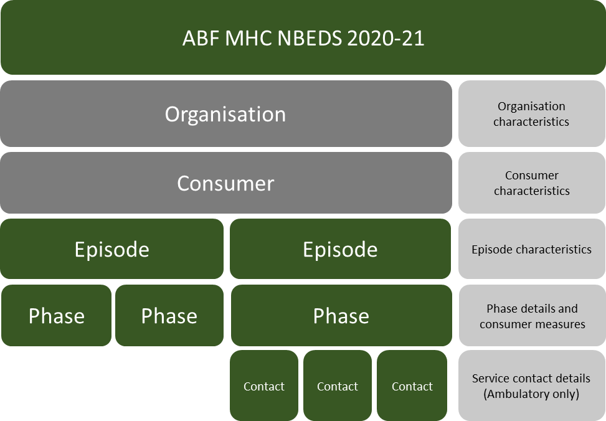

## Data elements

The ABF MHC NBEDS 2020-21 includes data elements required to describe organisation, consumer and episode characteristics, mental health phase of care details and clinical measures which describe consumer diagnoses, functioning and symptoms. The NBEDS contains all the data elements required to assign a mental health phase of care to an end class in the Australian Mental Health Care Classification (AMHCC) version 1.0.

Some data elements are mandatory for all settings of mental health care, age groups, and episodes. There are also data elements which are only required for specific settings, age groups, mental health phases or service contacts. For example, the data element ‘group session status’ is only collected if the consumer has an ambulatory service event, as this information is only pertinent within that setting. ‘Date of birth’ is an example of a data element which is collected across all settings.

The data elements which describe organisation, episode and consumer characteristics are required to be reported for all settings and for all age groups, and require collection at each patient episode of mental health care. These data elements include:

* organisation/service identifiers
* person identifiers
* date of birth
* sex
* marital status
* Indigenous status
* country of birth
* area of usual residence
* episode start and end date
* episode start and end mode
* mental health phase of care start and end date
* mental health phase of care
* mental health phase of care leave days
* service provider setting origin
* principal diagnosis
* additional diagnoses.

The data elements which describe consumer functioning and symptom severity require collection at the commencement or change of a mental health phase of care. These data elements include:

* Health of the Nation Outcome Scales for Children and Adolescents (HoNOSCA)
* Health of the Nation Outcome Scales (HoNOS)
* Health of the Nation Outcome Scales for Older Persons (HoNOS 65+)
* Children’s Global Assessment Score (CGAS)
* Factors Influencing Health Status (FIHS)
* Abbreviated Life Skills Profile (LSP-16)
* Resource Utilisation Groups - Activities of Daily Living (RUG-ADL)

Collection protocols for these consumer measures vary depending on the setting of care and the age of the consumer. A summary of the collection protocols is outlined in Table 1.

**Table 1**: Collection protocols for phase level consumer functioning and symptom severity measures

|  | Admitted Episode | | Ambulatory Episode | | Residential Episode | |
| --- | --- | --- | --- | --- | --- | --- |
| Children/Young Adults | Phase 1 | Phase 2 + | Phase 1 | Phase 2 + | Phase 1 | Phase 2 + |
| HoNOSCA | ✓ | ✓ | ✓ | ✓ | ✓ | ✓ |
| CGAS | ✓ | ✓ | ✓ | ✓ | ✓ | ✓ |
| FIHS | 🗶* | ✓ | 🗶* | ✓ | 🗶* | ✓ |
| Adults |  |  |  |  |  |  |
| HoNOS | ✓ | ✓ | ✓ | ✓ | ✓ | ✓ |
| LSP-16 | 🗶 | 🗶 | ✓* | ✓* | ✓* | ✓* |
| Older Adults |  |  |  |  |  |  |
| HoNOS 65+ | ✓ | ✓ | ✓ | ✓ | ✓ | ✓ |
| LSP-16 | 🗶 | 🗶 | ✓* | ✓* | ✓* | ✓* |
| RUG-ADL | ✓ | ✓ | 🗶 | 🗶 | ✓ | ✓ |
| 🗶* The FIHS is reported at the start of the second and subsequent phases within an episode. If an episode only has one phase, then the FIHS is reported at the end of the phase. | | | | | | |
| ✓* The LSP-16 is assessed and reported at the start of the first phase. If an episode is longer than 3 months, then the LSP-16 score from the initial assessment is reported at the start of each new phase, however will not need to be re‑assessed until the next new phase that falls after the 3 month period. | | | | | | |

In the ambulatory setting, specific data elements are required for collection for each service event. These data elements include:

* service contact date
* patient/client participation indicator
* group session status
* patient episode setting
* service duration, total minutes.

## Further information

### ABF MHC NBEDS 2020-21

The complete NBEDS and associated metadata is available on METeOR via the following link: [http://meteor.aihw.gov.au/content/index.phtml/itemId/](http://meteor.aihw.gov.au/content/index.phtml/itemId/715671)715671

### ABF MHC NBEDS 2020-21 Technical Specifications for Reporting

The Technical Specifications for Reporting are a companion document to the NBEDS which outlines the reporting requirements for the provision of data against the ABF MHC NBEDS 2020-21 by state and territory governments. This document provides details about the:

1. content and key concepts included in the ABF MHC NBEDS 2020-21
2. business rules relating to the reporting of the data items
3. frequently asked questions relating to the ABF MHC NBEDS 2020-21.

The [Technical Specifications](https://www.ihpa.gov.au/what-we-do/mental-health-care) for Reporting are available on IHPA’s website.

### ABF MHC NBEDS 2020-21 data request specifications

The data request specifications (DRS) outline the technical requirements for data submission, including:

* the format of the data submission file
* acceptable data values
* data submission file structures and linking relationships
* edit checks to be applied to the data.

The DRS for ABF MHC NBEDS 2020-21 is available on IHPA’s website.

<https://www.ihpa.gov.au/what-we-do/data-specifications>



Independent Hospital Pricing Authority

Level 6, 1 Oxford Street

Sydney NSW 2000

Phone 02 8215 1100

Email enquiries.ihpa@ihpa.gov.au

Twitter @IHPAnews

www.ihpa.gov.au