Independent Hospital Pricing Authority

Understanding the NEP and NEC Determinations 2022–23

March 2022

Understanding the NEP and NEC Determinations 2022–23 – March 2022

© Independent Hospital Pricing Authority 2022

This publication is available for your use under a [Creative Commons BY Attribution 3.0 Australia](http://creativecommons.org/licenses/by/3.0/au/deed.en) licence, with the exception of the Independent Hospital Pricing Authority logo, photographs, images, signatures and where otherwise stated. The full licence terms are available from [the Creative Commons website](http://creativecommons.org/licenses/by/3.0/au/legalcode).

Creative Commons BY Attribution 3.0 brand mark

Use of Independent Hospital Pricing Authority material under a [Creative Commons BY Attribution 3.0 Australia](http://creativecommons.org/licenses/by/3.0/au/deed.en) licence requires you to attribute the work (but not in any way that suggests that the Independent Hospital Pricing Authority endorses you or your use of the work).

*Independent Hospital Pricing Authority material used 'as supplied'.*

Provided you have not modified or transformed Independent Hospital Pricing Authority material in any way including, for example, by changing Independent Hospital Pricing Authority text – then the Independent Hospital Pricing Authority prefers the following attribution:

Source: The Independent Hospital Pricing Authority

# Table of contents

1. Introduction 3

1.1 About the national efficient price 3

1.2 About the national efficient cost 4

2. Summary of key changes 5

2.1 Impact of COVID-19 5

2.2 National Efficient Price Determination 2022–23 6

2.3 National Efficient Cost Determination 2022–23 7

3. More information 9

# Introduction

The Independent Hospital Pricing Authority’s (IHPA) key role is to determine the annual [national efficient price (NEP)](https://www.ihpa.gov.au/what-we-do/national-efficient-price-determination) and [national efficient cost (NEC)](https://www.ihpa.gov.au/what-we-do/national-efficient-cost-determination) for Australian public hospital services. IHPA publishes the NEP and NEC Determinations each year.

The NEP underpins activity based funding (ABF) across Australia for public hospital services. ABF is a way of funding hospitals whereby they are paid for the number and mix of patients they treat. ABF is intended to improve the value of the public investment in hospital care and ensure a sustainable and efficient network of public hospital services.

The NEC determines the Commonwealth Government’s funding contribution to local hospital networks for public hospital services that are not suitable for ABF, such as small rural hospitals.

In order to make the NEP and NEC Determinations, IHPA develops and publishes the annual [*Pricing Framework for Australian Public Hospital Services*](https://www.ihpa.gov.au/what-we-do/pricing-framework) (the Pricing Framework), which outlines the principles and policies adopted by IHPA to determine the NEP and the NEC for that financial year.

IHPA consults with all stakeholders, including state and territory governments, the Commonwealth Government and the general public, prior to finalising the Pricing Framework each year.

The Pricing Framework is released prior to the NEP and NEC Determinations to provide transparency and accountability by making available the key principles and policies adopted by IHPA to inform the NEP and NEC Determinations.

## 1.1 About the national efficient price

The NEP is based on the average cost of an admitted acute episode of care provided in public hospitals during a financial year. Each episode of patient care is allocated a national weighted activity unit (NWAU).

The NWAU is a measure of hospital activity expressed as a common unit, against which the NEP is paid. It is a point of relativity for the pricing of hospital services which are weighted for clinical complexity. The ‘average’ hospital service is worth one NWAU. More complex and expensive activities are worth multiple NWAUs, and simpler and less expensive activities are worth fractions of an NWAU.

The price of each public hospital service is calculated by multiplying the NWAU allocated to that service by the NEP.

For example:

* A tonsillectomy has a weight of 0.7400 NWAU which equates to $4,290.
* A coronary bypass (minor complexity) has a weight of 5.3925 NWAU which equates to $31,260.
* A hip replacement (minor complexity) has a weight of 3.4152 NWAU which equates to $19,798.

The NEP has two key purposes:

1. To determine the amount of Commonwealth Government funding for public hospital services.
2. To provide a price signal or benchmark about the efficient cost of providing public hospital services.

Each NEP Determination includes the scope of public hospital services eligible for Commonwealth Government funding on an activity basis as per the General List of In-Scope Public Hospital Services. It also includes loadings (‘adjustments’) to the price to reflect legitimate and unavoidable variations in the cost of delivering health care services, including patient factors such as patient complexity, residence and treatment location, and hospital factors such as hospital type, size, and location.

Approximately 478 public hospitals nationwide, including all of the large metropolitan hospitals, receive funding based on their activity levels.

The NEP is used by jurisdictions as an independent benchmarking tool to measure the efficiency of public hospital services in their state or territories. For instance, it is possible to compare the cost of a hip replacement in two different hospitals, which may assist jurisdictions to identify best practice and make funding decisions.

## 1.2 About the national efficient cost

The NEC is used when activity levels are not suitable for funding based on activity, such as for small rural hospitals. In these cases, hospitals are funded by a block allocation based on size, location and the type of services they provide. This type of funding applies to approximately 370 small rural hospitals. Some of these hospitals and services may operate with a mix of block funding and ABF.

The NEC also applies to public hospital services or functions that are not yet able to be described in terms of ‘activity’ such as teaching, training and research.

The NEC Determination outlines the efficient cost of a small rural hospital, which is the sum of the fixed component and a variable cost component.

IHPA works closely with its Small Rural Hospitals Working Group, which includes representatives from states and territories, small rural hospitals, and peak healthcare bodies and associations. The working group provides vital guidance and advice to IHPA about setting the efficient cost of a small rural hospital.

# Summary of key changes

Based on the principles in the *Pricing Framework for Australian Public Hospital Services   
2022–23* (the Pricing Framework), the Independent Hospital Pricing Authority (IHPA) has determined the national efficient price (NEP) and national efficient cost (NEC) for 2022–23. Some of the key changes and policy considerations for the NEP and NEC Determinations for 2022–23 are outlined below.

## 2.1 Impact of COVID-19

Coronavirus disease 2019 (COVID‑19) has resulted in significant and potentially long lasting changes to models of care and service delivery in Australian public hospitals. IHPA notes the importance of ensuring that the impact of COVID-19 is adequately accounted for in the national pricing model.

In developing the NEP and NEC Determinations for 2022–23, IHPA has considered the impact of COVID‑19 on the 2019–20 financial year. To do this, IHPA has analysed the cost and activity data from the COVID-19 impacted period in consultation with the jurisdictions.

Analysis of hospital activity between 1 January 2020 and 30 June 2020 showed a substantial reduction in the number of daily separations in March 2020, relative to the prior year daily average (**Figure 1**). This fall in activity coincided with the onset of national lockdowns and cancellation of some elective surgery in the initial response to the COVID-19 pandemic in Australia. Hospital activity subsequently recovered to normal levels by the end of June 2020. This pattern was fairly consistent across all jurisdictions during this period.

1. Ratio of separations in Australian public hospitals between 1 January 2020 and 30 June 2020, relative to the 2018–19 daily average

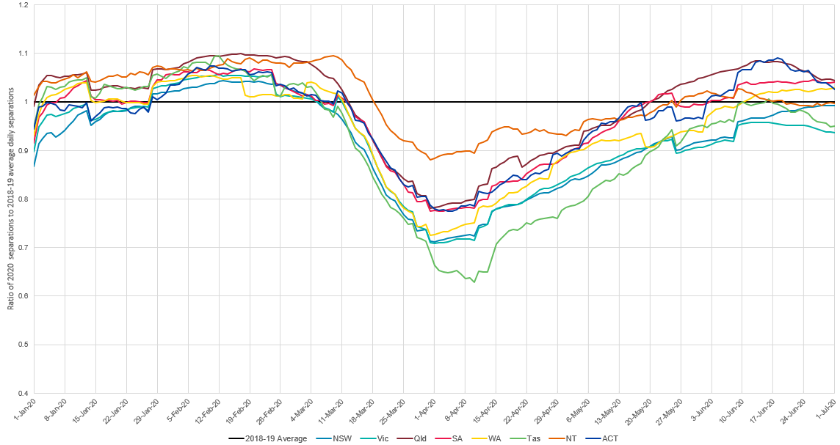

Analysis of cost data showed that hospital expenditure remained relatively stable despite the significant reduction in activity. Advice from states and territories indicated this was due to a combination of inflexible costs that did not reduce in line with activity and additional costs associated with COVID-19, such as the costs of increased infection control measures. As part of the *National Partnership on COVID-19 Response*, the Commonwealth also provided a minimum funding guarantee to address the temporary reduction in activity.

IHPA acknowledges that it is not possible to definitively account for the ongoing impact that COVID-19 may have on hospital service delivery and costs in 2022–23. As such, IHPA has modelled the impact of COVID-19 on the development of the Determinations based on the following assumptions:

* The public hospital system will deliver a volume of national weighted activity unit 2022–23 (NWAU(22)) in line with historical trends in volume growth[1].
* The NWAU(22) price weight relativities within each stream will not vary significantly compared to 2019–20.
* The increase in costs measured in the National Hospital Cost Data Collection (NHCDC) of 0.2 per cent above the pre-COVID-19 efficient price in the final quarter of 2019–20 are assumed to persist into 2022–23.
* All funding distributed through the National Health Funding Pool for 2019–20 (including the minimum hospital funding guarantee) was expended and allocated to patients, and submitted within the NHCDC.
* Normalised activity, not covered by the Commonwealth’s minimum hospital funding guarantee (and corresponding state and territory contributions), requires a variable cost adjustment.

IHPA notes that if any of these assumptions do not eventuate in 2022–23, it may be necessary for IHPA to review the Determinations as actual cost and activity data becomes available.

## 2.2 National Efficient Price Determination 2022–23

The NEP for 2022–23 is $5,797 per national weighted activity unit (NWAU).

A number of methodological improvements have been made to the NEP for 2022–23 (NEP22).

### Classification system updates

NEP22 represents the first year of pricing admitted mental health care using the Australian Mental Health Care Classification (AMHCC), following the completion of a two-year shadow pricing period. The AMHCC represents a more clinically meaningful classification system for the pricing of admitted mental health care services and will result in more accurate pricing of these services, with adjustments in the pricing model to capture and account for legitimate and unavoidable variations in the costs of delivering these services.

Community mental health care will continue to be block funded for NEP22 while a second year of shadow pricing is undertaken using the AMHCC. IHPA will work with the states and territories to assess the feasibility of transitioning community mental health care to be priced using the AMHCC in 2023–24.

For NEP22, IHPA will price admitted acute care using the new International Statistical Classification of Diseases and Related Health Problems, Tenth Revision, Australian Modification (ICD-10-AM), Australian Classification of Health Interventions (ACHI), Australian Coding Standards (ACS) Twelfth Edition.

IHPA will price admitted subacute and non-acute care using the Australian National Subacute and Non-Acute Patient Classification (AN-SNAP) Version 4.0 for NEP22. In December 2021, IHPA finalised AN-SNAP Version 5.0. IHPA has developed AN-SNAP Version 5.0 through detailed statistical analysis and consultation with jurisdictions, clinical experts and other subacute care stakeholders. AN-SNAP Version 5.0 is being shadow priced for NEP22.

### Back-casting

As with previous years, the Pricing Authority has recalculated (‘back-cast’) the NEP Determination 2021–22 (NEP21) to incorporate the most up-to-date cost data and to take account of methodological changes introduced in NEP22 which impact on the ability to compare the NEP between years. IHPA is required to back‑cast the previous year’s NEP under clause A41 of the Addendum to the National Health Reform Agreement 2020–25 (the Addendum).

Back-casting is important to ensure the calculation of Commonwealth funding is not adversely impacted by changes in the calculation of the NEP over the years. Under the Addendum, the Commonwealth funds 45 per cent of the efficient growth in public hospital services which are funded on an activity basis with a growth cap of 6.5 per cent a year.

The Pricing Authority has recalculated NEP21 using more up-to-date cost data than was available when NEP21 was initially calculated.

The back-cast NEP21 shows an increase of 4.1 per cent between NEP21 to NEP22, which is the basis for Commonwealth growth funding for 2022–23.

| NEP21 | Back-cast NEP21 | NEP22 |
| --- | --- | --- |
| $5,597 | $5,567 | $5,797 |

## 2.3 National Efficient Cost Determination 2022–23

The efficient cost of a small rural hospital is the sum of the fixed cost component and the variable cost component.

For 2022–23, the total modelled cost for block-funded hospitals up to 194 NWAU comprises a fixed cost of $2.265 million and the variable cost of $5,850 per NWAU. An additional loading of 44.1 per cent is applied for ‘very remote’ hospitals.

In addition, the NEC Determination covers some services in public hospitals that do not meet the technical requirements for applying activity based funding. Usually this means that they cannot be counted and/or costed. For example, teaching, training and research and some non-admitted mental health services are instead provided a block-funding amount.

IHPA recognises that service delivery models are not static and innovative models of care offer the potential to provide more efficient health services. The Pricing Guidelines in the Pricing Framework outline the policy objectives to guide IHPA’s work and reference fostering clinical innovation whereby the pricing of public hospital services respond in a timely way to the introduction of evidence-based, effective new technology and innovations in the models of care that improve patient outcomes.

With this in mind IHPA will continue to block-fund programs that have been approved by the Pricing Authority for inclusion on the General List of In-Scope Public Hospital Services.

The Addendum contains provisions around specific arrangements for high cost, highly specialised therapies recommended for delivery in public hospitals by the Medical Services Advisory Committee. In 2022–23, the following high cost, highly specialised therapies are recommended for delivery in public hospitals, based on advice received from the Commonwealth:

* Kymriah® – for the treatment of acute lymphoblastic leukaemia in children and young adults.
* Kymriah® or Yescarta® – for the treatment of diffuse large B-cell lymphoma, primary mediastinal large B-cell lymphoma and transformed follicular lymphoma.
* Qarziba® – for the treatment of high risk neuroblastoma.
* Luxturna™ – for the treatment of inherited retinal dystrophies.
* Tecartus® – for the treatment of relapsed or refractory mantle cell lymphoma.

### Back-casting

The back-cast NEC Determination 2021–22 for the purpose of estimating Commonwealth growth funding between 2021–22 and 2022–23 is the sum of the fixed component and the variable component.

The fixed component is determined as:

* $2.193 million for hospitals with an annual NWAU 2021–22 (NWAU(21)) less than or equal to 194.
* $2.193 million less 0.029 per cent per NWAU(21) for hospitals with an annual NWAU(21) greater than 194, with an additional loading of 44.1 per cent for ‘very remote’ hospitals.

The variable component of the efficient cost is determined as $5,663 per NWAU(21) for hospitals with an annual NWAU(21) greater than 194.

# More information

For more information about the Independent Hospital Pricing Authority, activity based funding and the National Efficient Price and National Efficient Cost Determinations for 2022–23, please visit [www.ihpa.gov.au](http://www.ihpa.gov.au) or contact [enquiries.ihpa@ihpa.gov.au](mailto:enquiries.ihpa@ihpa.gov.au).



Independent Hospital Pricing Authority

Eora Nation, Level 12, 1 Oxford Street

Sydney NSW 2000

Phone 02 8215 1100

Email enquiries.ihpa@ihpa.gov.au

Twitter @IHPAnews

www.ihpa.gov.au

1. In doing so, IHPA has estimated an amount of ‘normalised’ hospital activity that approximates the volume of services that would have been delivered without the impact of COVID-19.