Independent Hospital Pricing Authority

National Hospital Cost Data Collection Report

**Public Sector, Round 22 (Financial Year 2017-18)**

February 2020



National Hospital Cost Data Collection Report: Public Sector, Round 22 Financial Year 2017-18

© Independent Hospital Pricing Authority 2020

This publication is available for your use under a [Creative Commons BY Attribution 3.0 Australia](http://creativecommons.org/licenses/by/3.0/au/deed.en) licence, with the exception of the Independent Hospital Pricing Authority logo, photographs, images, signatures and where otherwise stated. The full licence terms are available from [the Creative Commons website](http://creativecommons.org/licenses/by/3.0/au/legalcode).

Logo

Use of Independent Hospital Pricing Authority material under a [Creative Commons BY Attribution 3.0 Australia](http://creativecommons.org/licenses/by/3.0/au/deed.en) licence requires you to attribute the work (but not in any way that suggests that the Independent Hospital Pricing Authority endorses you or your use of the work).

*Independent Hospital Pricing Authority material used 'as supplied'.*

Provided you have not modified or transformed Independent Hospital Pricing Authority material in any way including, for example, by changing Independent Hospital Pricing Authority text – then the Independent Hospital Pricing Authority prefers the following attribution:

*Source: The Independent Hospital Pricing Authority*

Contents

1. Purpose of the NHCDC Report 5

2. What is the NHCDC? 7

3. What is Activity Based Funding? 7

4. Scope of Round 22 8

5. Key results in Round 22 11

5.1 Participation 11

5.2 Costed activity 12

5.3 Total expenditure 13

5.4 Average cost 14

5.5 Line items and cost buckets 15

6. Admitted acute care 17

6.1 Average cost per weighted separation 17

6.2 Patient length of stay 19

7. Supplementary material 21

8. Data Quality Statements 21

Appendix A. Data Quality Statements 22

Tables

Table 1 NHCDC Report Appendix Tables, Round 22 (Appendix B) 6

Table 2 IHPA classifications for key activity collections, Round 22 NHCDC 9

Table 3 Summary NHCDC results by activity stream, Round 22 11

Table 4 Number of hospitals, by jurisdiction, Round 20-22 12

Table 5 Percentage of submitted activity data with matching cost data, Round 20-22 13

Table 6 Total national expenditure, by activity stream, Round 21-22 13

Table 7 Total expenditure, by jurisdiction, Round 20-22 14

Table 8 Average cost per episode, by activity stream, Round 21-22 14

Table 9 National average cost per line item, by activity stream, Round 22 16

Table 10 National average cost per cost bucket, by activity stream, Round 22 17

Table 11 Average cost per weighted separation (admitted acute), by jurisdiction, Round 22 18

Table 12 Number of separations, haemodialysis and chemotherapy, by jurisdiction, Round 22 19

Figures

Figure 1 Admitted acute average length of stay of all separations and all overnight separations, by jurisdiction 20

# Purpose of the NHCDC Report

The purpose of this report is to provide an overview of the results from the Round 22 National Hospital Cost Data Collection (NHCDC). The report gives a clear picture of hospital cost data submitted by jurisdictions to the Independent Hospital Pricing Authority (IHPA) for the financial year 2017-18.

After each round of the NHCDC, IHPA publishes the NHCDC Report. The report allows benchmarking across hospitals and jurisdictions and, through reporting multiple years of cost data, identifies change over time.

Specifically, the NHCDC Round 22 Report answers the following questions:

* What is the NHCDC?
* How does IHPA use the NHCDC?
* How many hospitals participated?
* What was the level of hospital expenditure?
* How much cost data was provided (i.e. costed activity)?
* What was the average cost of hospital patient episodes?
* What was the average cost of patient episodes across the different hospital activity streams?

All data presented in the NHCDC Report are included in Appendix B. The complete list of tables included in this report is shown in Table 1.

**Note to readers**

The scope of the NHCDC Report includes costs related to public hospital activities. Due to differing methodologies and data sources used, the costs reported here may differ from cost data published by other organisations. Such differences apply to data presented in the following Australian Institute of Health and Welfare (AIHW) report series: *Health expenditure Australia; Costs of acute admitted patients in public hospitals;* and *Australian Hospital statistics*. The reader is advised to take care when comparing these data.

Table NHCDC Report Appendix Tables, Round 22 (Appendix B)

|  |  |
| --- | --- |
| **No** | **Table title** |
| 1 | NHCDC Round 20 to 22 summary, by jurisdiction and stream |
| 2 | NHCDC Round 20 to 22 Direct and Overhead Expenditure, by stream |
| 3 | Cost weights for AR-DRG Version 10.0, Round 22 (2017-18) national sample |
| 4 | NHCDC Round 20 to 22 admitted acute summary, by jurisdiction |
| 5 | NHCDC Round 20 to 22 admitted acute summary, by peer group |
| 6 | NHCDC Round 20 to 22 admitted acute cost bucket average cost per separation, by jurisdiction |
| 7 | NHCDC Round 20 to 22 admitted acute line item average cost per separation, by jurisdiction |
| 8 | NHCDC Round 20 to 22 admitted acute overnight and same day, by jurisdiction |
| 9 | NHCDC Round 20 to 22 admitted acute urgency of admission, by jurisdiction |
| 10 | NHCDC Round 20 to 22 admitted acute same day and overnight, Indigenous and non-Indigenous, by jurisdiction |
| 11 | NHCDC Round 20 to 22 admitted acute paediatric, by jurisdiction |
| 12 | NHCDC Round 20 to 22 admitted acute geographic location, by jurisdiction |
| 13 | NHCDC Round 20 to 22 Emergency Department by jurisdiction |
| 14 | Emergency care summary, Urgency Related Groups (URG) Version 1.45, Round 22 |
| 15 | NHCDC Round 20 to 22 emergency department cost bucket average cost per separation, by jurisdiction |
| 16 | NHCDC Round 20 to 22 admitted Emergency Department line item average cost per separation, by jurisdiction |
| 17 | Non-admitted summary table, Tier 2 Version 4.1, |
| 18 | NHCDC Round 20 to 22 Non-admitted summary by Tier 2 class |
| 19 | NHCDC Round 20 to 22 Non-admitted summary by jurisdiction |
| 20 | NHCDC Round 20 to 22 non-admitted cost bucket per service event by jurisdiction |
| 21 | NHCDC Round 20 to 22 non-admitted line item average cost per separation, by jurisdiction |
| 22 | NHCDC Round 20 to 22 sub-acute summary care type, by jurisdiction |
| 23 | Sub-acute summary table, ANSNAP Version 4, Round 22 |
| 24 | NHCDC Round 20 to 22 admitted subacute cost bucket average cost per separation, by jurisdiction |
| 25 | NHCDC Round 20 to 22 subacute line item average cost per separation, by jurisdiction |
| 26 | NHCDC Round 20 to 22 Other stream summary, by jurisdiction |
| 27 | NHCDC Round 20 to 22 Organ Procurement cost bucket average per separation by jurisdiction |
| 28 | NHCDC Round 22 Mental health summary table |
| 29 | NHCDC Round 20 to 22 mental health cost bucket average cost per separation, by jurisdiction |
| 30 | NHCDC Round 20 to 22 mental health line item average cost per separation, by jurisdiction |

# What is the NHCDC?

The National Hospital Cost Data Collection (NHCDC) is an annual collection of public hospital cost data. This remarkable evidence base is used across the Australian health system.

The collection matches patient level activity data with the costs incurred by the patient’s hospital. These data are submitted to IHPA by the health departments of Australia’s states and territories and represent the key source of information about the cost of treating patients in Australian hospitals.

The NHCDC was established in 1996 with the primary objective of providing Australian governments and the health care industry with a nationally consistent method of costing all types of hospital activity related to the care of patients.

Under the National Health Reform Act 2011, IHPA was established and assumed responsibility for the governance of the NHCDC. Through the national health reform process, a range of developments to the NHCDC have been implemented, including data quality controls, the introduction of a submission portal and developments in the Australian Hospital Patient Costing Standards (AHPCS) [1]. These improvements have all provided increased confidence in the collection for the purpose of national reporting.

Each year, IHPA aims to produce a NHCDC dataset comprised of data that has been submitted according to nationally consistent methods of costing hospital activity.

A robust NHCDC dataset is an essential requirement for the funding of public hospital services. Once IHPA finalises the NHCDC dataset, it uses it to develop the National Efficient Price (NEP).

The Round 22 NHCDC contains hospital cost data for the 2017-18 financial year and IHPA will use it to inform the NEP 2020-21.

# What is Activity Based Funding?

Activity Based Funding (ABF) is the process by which hospitals are paid for the number and complexity of patients they treat. ABF takes into account the fact that some patients are more complicated to treat than others. This type of funding model aims to improve the value of public investment in hospital care, improve transparency of funding, ensure a sustainable and efficient network of public hospital services, and provide a tool to benchmark the cost of public hospitals.

The annual National Efficient Price (NEP) and National Efficient Cost (NEC) determine the amount of funding the Commonwealth Government contributes to public hospitals. The funding is then distributed by the Administrator of the National Health Funding Pool.

The building blocks required for an ABF system are: classification systems, data collection, costing and pricing.

# Scope of Round 22

The data in scope for the NHCDC includes all patient level activity for all public hospital facilities across Australia, and the costs incurred by the hospital in relation to this activity in financial year 2017-18 (Round 22). Admitted activity is required to have an end date before the end of the financial year.

**Reporting requirements**

To ensure consistency in the approach to costing nationally, NHCDC data is costed in accordance with the Australian Hospital Patient Costing Standards Version 4.0 (the Standards), available on IHPA’s website.

Version 4.0 of the Standards was released in February 2018 and applied for the first time in Round 22 of the NHCDC.  The Standards documentation comprises three parts:

* Part 1: Standards – provides the underlying costing principles.
* Part 2: Business Rules – provides practical guidance on how the Standards are translated into action.
* Part 3: Costing Guidelines – provides step-by-step guidance on how to cost particular services.

The Standards also prescribe the set of line items and cost centres used for mapping hospital costs in the costing process, to ensure that there is a consistent treatment of costs between hospitals. These costs are allocated to, and reported under, the NHCDC-defined ‘cost buckets’[2]. Cost buckets represent different combinations of the NHCDC line items and costs centres and can be considered as cost pools within the hospital.

Please refer to the Standards for the reference tables of line items and cost centre groups. Costed results are produced at the episode level, per cost centre and per line item. These results are provided to IHPA and are collated and analysed to produce this report.

**Classifications**

IHPA uses classifications to categorise, cost and fund hospital activity.

Hospital activity refers to the resources used by the patient in relation to their treatment. Classification systems are used to describe activity related to the following types of patient care: Admitted acute care, sub-acute and non-acute care, non-admitted care, emergency care, mental health care.

Each classification system is comprised of codes that provide clinically meaningful ways of relating the types of patients treated by a hospital to the resources required.

Effective clinical classification systems ensure that hospital data is grouped into outputs reflective of their resource use. Table 2 describes the different types of activity streams (i.e. patient care types) and the associated classification applied by IHPA for funding purposes. The NHCDC Report uses these activity streams to present the cost data.

Table IHPA classifications for key activity collections, Round 22 NHCDC

|  |  |  |
| --- | --- | --- |
| **Activity Stream** | **Description** | **Classification** |
| *Admitted*  *acute care* | Admitted acute care is provided to patients who are formally admitted to hospital to receive active but short-term treatment with a goal to:   * cure, treat or relieve symptoms of illness or injury * reduce severity of an illness or injury * perform surgery * perform diagnostic or therapeutic procedures * manage childbirth | Australian Refined Diagnosis Related Groups (AR-DRG) Version 10 |
| *Subacute and non-acute care* | Specialised multidisciplinary care in which the primary need for care is optimisation of the patient’s functioning and quality of life. | Australian National Subacute and Non-Acute Patient (AN-SNAP) classification Version 4 |
| Sub-acute care includes the following care types:   * Rehabilitation care * Palliative care * Geriatric evaluation and management (GEM) care * Psychogeriatric care |
| Non-acute care relates to maintenance care in which the treatment goal is to support a patient with impairment, activity limitation or participation restriction due to a health condition. |
| *Non-admitted care* | Services provided to patients who do not undergo a formal admission process and do not occupy a hospital bed. | Non-admitted Tier 2 Classification Version 4 |
| Includes:   * Hospital outpatient clinics * Community based clinics * Patients’ homes |
| *Emergency care* | Services provided to patients in a hospital’s emergency department | Urgency Related Groups (URG)  Version 1.45 |
| *Mental Health care* | Mental Health services provided to patients. Includes services provided both in admitted and community settings. | Australian Mental Health Care Classification (AMHCC) v1.0 |
|
| *Teaching Training and Research* | Teaching and training activities which occur in public hospital services. | Australian Teaching and Training Classification (released 1 July 2018) |

**Admitted activity reporting scope**

***Work in Progress patients***

A Work in Progress (WIP) patient is defined as a patient that is not admitted and discharged within the reference financial year. For the Round 22 NHCDC, the only WIP patients that are in-scope are the ones admitted in the previous financial year (2016-17) and discharged in 2017-18. Patients who were not discharged in 2017-18 are ‘out-of-scope’.

***Admitted via emergency department patients***

In past NHCDC Reports, the total reported cost of an acute or sub-acute patient who was admitted to hospital via the emergency department included all costs associated with the patient’s emergency department (ED) treatment. This meant that an admitted acute patient’s ED costs were reported twice: in the admitted acute activity stream[3] and the emergency department activity stream.

The purpose was to a) reflect in the admitted cost record the full cost of treatment for patients admitted to hospital following a presentation at ED, and b) address challenges faced by some jurisdictions in separately identifying hospital costs between ED and admitted areas.

For Round 22, IHPA has adjusted the method it uses to calculate the total cost of admitted patients. In this report, the ED cost of a patient who was subsequently admitted to hospital is reported on solely in the ED activity stream. The change reflects improvements in the quality of costing data. Jurisdictions and hospitals have developed costing processes to enable both activities to be counted and costed separately.

As a result of this change, the total admitted costs presented in this report for past years (i.e. figures for Rounds 20 and 21) do not reconcile to the figures presented in past reports. For example, the Round 21 NHCDC Report reported that the average cost for admitted acute patients in 2016-17 was $5,171 (including $379 of EDPro costs). This is now reported as $4,792.

***Unqualified baby adjustment***

IHPA includes the costs associated with unqualified babies (UQBs) on an adjusted basis. Unqualified babies are those without care interventions following birth, and are less than ten days old when they are discharged. Unqualified babies with lengths of stay over ten days incur ‘qualified’ days which need to be recorded for the activity data submission within the NB care type.

IHPA links costs associated with UQBs to the mother’s separation. This results in UQB activity being removed from the newborn (NB) care type and the costs transferred from the newborn care to the mother’s admitted care separation.

**Independent Financial Review**

The Independent Financial Review is a data review, performed by an independent consultancy, based on a sample selection of hospitals within each jurisdiction. Activity and financial data is reviewed from source systems within hospitals and followed through the costing and submission process, leading to its inclusion in the national cost data set. The Independent Financial Review report is published on IHPA’s website each year alongside the NHCDC Report.

# Key results in Round 22

In Round 22:

* The NHCDC sample comprised 453 public hospitals, an increase of two from Round 21.
* In total, $47.15 billion of hospital expenditure was submitted for the financial year   
  1 July 2017 – 30 June 2018.
* This expenditure was linked to 35,857,766 patient-level encounters across all hospital activity streams.

Table 3 Summary NHCDC results by activity stream, Round 22 summarises the Round 22 results at the national level for each activity stream.

Table Summary NHCDC results by activity stream, Round 22

|  |  |  |  |  |  |
| --- | --- | --- | --- | --- | --- |
|  | **Number of Hospitals** | **Number of Episodes** | **Total Expenditure** | **Average Cost per Episode** | **Percent Change in Average Cost Since Round 21** |
|  |  |  | ($m) | ($) | (%) |
| Admitted Acute | 342 | 6,019,172 | 29,406 | 4,885 | 1.9 |
| Emergency Department | 274 | 7,877,053 | 5,554 | 705 | 5.9 |
| Non-Admitted | 315 | 21,529,952 | 6,820 | 317 | 2.6 |
| Sub-Acute | 333 | 218,482 | 2,927 | 13,397 | -4.2 |
| Mental Health |  |  |  |  |  |
| *Admitted Mental Health* | *169* | *134,613* | *2,050* | *15,229* | *-5.7* |
| *Community Mental Health* | *80* | *58,545* | *335* | *5,725* | *n/a[4]* |
| Other activity | 167 | 19,949 | 55 | 2,773 | 79.2 |

## 5.1 Participation

Between Round 21 and Round 22, the number of unique hospitals that submitted cost data to the NHCDC increased from 451 to 453. Despite the small overall increase, the group of submitting hospitals changed considerably– particularly from Queensland. Twenty-one of the 453 hospitals which participated in Round 22 did not participate in Round 21. Of these hospitals, 19 were located in Queensland. Similarly, Queensland’s Round 22 submission did not include 17 of the hospitals included in their Round 21 submission. Between the rounds, the number of Public Community Mental Health facilities submitted by Queensland decreased from 79 to 65, and the number of Primary Health Centres increased from 6 to 22.

Table Number of hospitals, by jurisdiction, Round 20-22

|  |  |  |  |
| --- | --- | --- | --- |
|  | **Number of participating hospitals** | | |
| **Jurisdiction** | Round 20 | Round 21 | Round 22 |
| NSW | 98 | 95 | 95 |
| Vic | 73 | 79 | 79 |
| Qld | 111 | 195 | 196 |
| SA | 16 | 20 | 20 |
| WA | 34 | 33 | 33 |
| Tas | 4 | 22 | 23 |
| NT | 5 | 5 | 5 |
| ACT | 2 | 2 | 2 |
| **National** | **343** | **451** | **453** |

## 5.2 Costed activity

To report on the NHCDC’s level of completeness, IHPA examines the linkage between the patient activity for which cost data were submitted via the NHCDC and records for which activity data were submitted to IHPA (using the Activity Based Funding Data Request Specifications[5]). IHPA receives the following types of episode level data:

1. Cost data, submitted annually via the NHCDC, which contains detailed information about the actual costs associated with a patient’s episode.
2. Activity data, which is submitted quarterly in line with data set specifications unique to each activity stream[6]. From these data, patient episodes are categorised according to IHPA’s classifications which represent each of the activity streams.

When both activity and cost data relating to a particular patient episode are submitted, IHPA links the data. ‘Costed Activity’ refers to this linkage. The ‘percent of Costed Activity’ represents the number of public sector episodes in the activity data with costs submitted via the NHCDC.

In Round 22, 96 percent of the admitted acute activity data had matching cost data. Table 5 shows the completeness of the NHCDC data for four activity streams. This is represented by the percentage of activity with costs over the past three rounds. The greater variation in the non-admitted stream reflects ongoing development of the definitions of the Tier 2 classes.

Table Percentage of submitted activity data with matching cost data, Round 20-22

|  |  |  |  |
| --- | --- | --- | --- |
| **Activity stream** | **Round 20** | **Round 21** | **Round 22** |
|  | (%) | (%) | (%) |
| Acute admitted | 93 | 96 | 96 |
| Sub-acute | 69 | 69 | 66 |
| Emergency Department | 90 | 92 | 90 |
| Non-admitted | 73 | 57 | 73 |

## 5.3 Total expenditure

In Round 22 of the NHCDC, $47.15 billion of hospital expenditure was submitted for the 2017-18 financial year. This represents a 7.7 percent increase over the total for Round 21 ($43.8 billion). Table 6 shows the change in expenditure by activity stream.

Table Total national expenditure, by activity stream, Round 21-22

|  |  |  |  |  |  |  |
| --- | --- | --- | --- | --- | --- | --- |
|  | | **Round 21** | | **Round 22** | | **Percent Change in Total Expenditure** |
|  | | Number of Hospitals | Total Expenditure | Number of Hospitals | Total Expenditure |
|  | |  | ($m) |  | ($m) | (%) |
| Admitted Acute | 344 | | 27,666 | 342 | 29,406 | 6.3 |
| Emergency Department | | 265 | 5,100 | 274 | 5,554 | 8.9 |
| Non-Admitted | | 273 | 5,742 | 315 | 6,820 | 18.8 |
| Sub-Acute | | 331 | 2,796 | 333 | 2,927 | 4.7 |
| Mental Health | | 242 | 2,436 | 234 | 2,385 | -2.1 |
| *Admitted Mental Health* | | *163* | *2,116* | *169* | *2050* | *-3.1* |
| *Community Mental Health* | | *99* | *320* | *80* | *335* | *4.7* |
| Other Expenditure | | 138 | 35 | 167 | 55 | 59.0 |
| **Total** | | **451** | **43,775** | **453** | **47,147** | **7.7** |

Table 7 presents the total hospital expenditure submitted by jurisdictions across the past three NHCDC rounds. While the national reported expenditure increased by 17 percent since Round 20, the share of this expenditure at the jurisdictional level has remained consistent. In each round, NSW, Queensland and Victoria have collectively submitted around 75 percent of the national hospital expenditure.

Table Total expenditure, by jurisdiction, Round 20-22

|  |  |  |  |  |  |  |
| --- | --- | --- | --- | --- | --- | --- |
|  | **Round 20** | | **Round 21** | | **Round 22** | |
| **Jurisdiction** | Total Expenditure | % of Total Expenditure | Total Expenditure | % of Total Expenditure | Total Expenditure | % of Total Expenditure |
|  | ($m) | (%) | ($m) | (%) | ($m) | (%) |
| NSW | 12,158 | 30 | 12,757 | 29 | 13,753 | 29 |
| Vic | 8,765 | 22 | 9,818 | 22 | 10,723 | 23 |
| Qld | 8,571 | 21 | 10,117 | 23 | 10,849 | 23 |
| SA | 3,255 | 8 | 3,345 | 8 | 3,752 | 8 |
| WA | 4,622 | 11 | 4,860 | 11 | 4,955 | 11 |
| Tas | 906 | 2 | 948 | 2 | 1,137 | 2 |
| NT | 834 | 2 | 919 | 2 | 965 | 2 |
| ACT | 1,182 | 3 | 1,011 | 2 | 1,013 | 2 |
| **Total** | **40,292** |  | **43,775** |  | **47,147** |  |

## 5.4 Average cost

This report provides the average cost information for all hospital activity captured by the different IHPA classifications. Table 8 summarises these results by presenting the average cost at the activity stream level. While each activity stream is broad and represents a wide variety of different hospital procedures and services provided, the categories enable the reporting of useful summary statistics.

Between Round 21 and 22, the average cost per episode increased for each of the activity streams except for sub-acute, which fell by 4.2 percent (from $13,987 to $13,397). While the total national expenditure grew significantly for admitted acute episodes (6 percent), emergency department episodes (9 percent) and non-admitted episodes (19 percent), the growth in average cost for these episode types was much lower (1.9 percent, 5.9 percent and 2.6 percent respectively).

Table Average cost per episode, by activity stream, Round 21-22

|  |  |  |  |  |  |  |
| --- | --- | --- | --- | --- | --- | --- |
|  | **Round 21** | | **Round 22** | | |  |
|  | Number of Episodes | Average Cost per Episode | Number of Episodes | Average Cost per Episode | Change in Average Cost Since Previous Round | | |
|  |  | ($) |  | ($) | (%) | | |
| Admitted acute | 5,773,102 | 4,792 | 6,019,172 | 4,885 | 1.9 | | |
| Emergency department | 7,662,322 | 666 | 7,877,053 | 705 | 5.9 | | |
| Non-admitted | 18,592,529 | 309 | 21,529,952 | 317 | 2.6 | | |
| Sub-acute | 199,911 | 13,987 | 218,482 | 13,397 | -4.2 | | |
| Mental health |  |  |  |  |  | | |
| *Admitted Mental Health* | *131,083* | *16,141* | *134.613* | *15,229* | *-5.7* | | |
| *Community Mental Health* | *106,743* | *3,000* | *58,545* | *5,725* | *n/a\** | | |

*See footnote for Table 3.

In determining the final funding amount per service, various adjustments are applied based on patient characteristics that influence the cost of service delivery (such as indigenous status, age and remoteness). The appendix to this report includes an analysis of the cost data used to inform these adjustments.

## 5.5 Line items and cost buckets

Cost data submitted to the NHCDC is reported by line items and cost centres. Line items represent types of costs (e.g. salaries and wages or goods and services) incurred by hospitals. Cost centres represent departmental cost objects within a hospital that relate to a particular function of the hospital – for example, the hospital operating room. Further information relating to the Round 22 NHCDC line items and cost centres are available in costing standards.

IHPA combines the line items and cost centres to create cost buckets. Cost buckets can be considered as cost pools within the hospital.

Table 9 presents the total average cost (in dollars) for each line item by each activity stream.

In all streams, the line items linked to salaries and wages accounted for approximately two-thirds of all costs. Within the salary and wages categories, however, there is considerable variation in the costs assigned. For example, the nursing wages line item accounts for 32 percent of sub-acute patient costs but only 15 percent of non-admitted patient costs.

Similarly, the share of costs attributed to allied health salaries is higher for non-admitted patients (12 percent) and sub-acute patients (10 percent) compared with acute and Emergency Department patients (four percent and three percent respectively). This reflects the type of care provided.

Table National average cost per line item, by activity stream, Round 22

|  |  |  |  |  |  |
| --- | --- | --- | --- | --- | --- |
| Line Item | Acute | Sub-acute | Emergency Department | Non-admitted | Mental Health |
|
|  | ($) | ($) | ($) | ($) | ($) |
| Salary & Wages Nursing | 1,340 | 4,338 | 156 | 47 | 4,479 |
| Salary & Wages Medical (nonVMO) | 719 | 1,412 | 168 | 52 | 1,619 |
| Salary & Wages Medical (VMO) | 201 | 224 | 24 | 11 | 256 |
| Salary & Wages Allied Health | 189 | 1,345 | 21 | 38 | 955 |
| Salary & Wages Other | 509 | 1,746 | 77 | 40 | 1,476 |
| On-costs | 372 | 1,287 | 56 | 24 | 1,119 |
| Pathology | 98 | 100 | 34 | 6 | 70 |
| Imaging | 26 | 32 | 21 | 2 | 11 |
| Prostheses | 156 | 8 | 0 | 1 | 2 |
| Medical supplies | 250 | 229 | 17 | 9 | 70 |
| Goods and services | 442 | 1,285 | 69 | 33 | 1,230 |
| Pharmaceuticals PBS | 54 | 34 | 3 | 25 | 14 |
| Pharmaceuticals nonPBS | 133 | 179 | 6 | 6 | 127 |
| Blood | 36 | 11 | 2 | 2 | 2 |
| Depreciation building | 102 | 288 | 16 | 7 | 309 |
| Depreciation equipment | 43 | 70 | 6 | 4 | 47 |
| Hotel | 150 | 619 | 15 | 4 | 449 |
| Corporate | 22 | 67 | 5 | 2 | 58 |
| Lease | 14 | 41 | 2 | 1 | 23 |
| Patient Travel | 32 | 82 | 9 | 1 | 32 |
| **Total ($)** | **4,885** | **13,397** | **705** | **317** | **12,348** |

At the cost bucket level, the Ward Nursing cost bucket accounted for the biggest share of the costs for the admitted acute (18 percent of costs), sub-acute (32 percent) and mental health (35 percent) activity streams. Similarly, the Ward Medical cost bucket accounted for a high share of costs in all activity streams except the emergency department.

Table 10 presents the total average cost (in dollars) for each cost bucket by each activity stream.

Table National average cost per cost bucket, by activity stream, Round 22

|  |  |  |  |  |
| --- | --- | --- | --- | --- |
| Cost Bucket | Acute | Sub-acute | Emergency Department | Non-admitted |
|
|  | ($) | ($) | ($) | ($) |
| Ward Medical | 560 | 1,598 | 8 | 56 |
| Ward Nursing | 903 | 4,296 | 7 | 43 |
| Allied Health | 153 | 1,577 | 3 | 37 |
| Non Clinical | 320 | 1,511 | 7 | 31 |
| On-costs | 372 | 1,287 | 56 | 24 |
| Pathology | 176 | 148 | 45 | 14 |
| Imaging | 117 | 105 | 67 | 16 |
| Prosthesis | 156 | 8 | 0 | 1 |
| Ward Supplies | 362 | 1,382 | 9 | 32 |
| Pharmacy | 192 | 344 | 4 | 33 |
| Critical Care | 398 | 10 | 0 | 0 |
| Operating Room | 748 | 23 | 1 | 5 |
| Patient Travel | 32 | 82 | 9 | 1 |
| Special Procedure Suite | 59 | 6 | 0 | 5 |
| Emergency Department | 28 | 2 | 449 | 0 |
| Hotel | 150 | 619 | 15 | 4 |
| Depreciation | 159 | 400 | 24 | 13 |
| **Total ($)** | **4,885** | **13,397** | **705** | **317** |

# Admitted acute care

Of the six activity streams, the admitted acute care stream accounts for the major share of all hospital costs: in Round 22, $29.4 billion of hospital costs were associated with admitted acute care separations. Admitted acute care has the most developed classification system[7], which in turn generates the most robust cost data results.

## 6.1 Average cost per weighted separation

The average cost per acute separation in Round 22 is $4,885. The average cost at the jurisdiction level varied from $3,697 (Northern Territory) to $6,032 (South Australia). The variation in average cost is caused by the admission policies of the jurisdictions and the complexity of the treatment required and other factors such as location and age.

To compare the average cost of admitted acute care separations between jurisdictions, the complexity of each jurisdiction’s work profile should be considered.

To do this, IHPA creates *weighted separations*. A weighted separation considers the complexity of the acute activity each type of separation relative to the average of all activity for the year. The level of complexity is based on the resources required to treat that patient.

Admitted acute cost weight tables are included in the appendix of this report. These tables include the cost weights for all Diagnosis Related Groups (DRGs) in Round 22, which are used to compare resource utilisation based on the national level.

The average cost per separation is $4,885 has a weight of 1. In Round 22, a single heart transplant patient separation[8], for example, corresponds to 38.74 weighted separations[9]. In contrast, a single colonoscopy patient separation[10] corresponds to 0.45 of a weighted separation. The difference reflects the significantly greater complexity associated with a heart transplant operation.

By summing the weighted separations for each jurisdiction, we can compare the volume of jurisdictions’ acute admitted activity.

Table 11 compares the average cost and average cost per weighted separation by jurisdiction. The *‘average cost p*er *weighted separation’* accounts for the relative complexity of each jurisdiction’s work profile. If a jurisdiction’s *average cost per weighted separation* is lower than its average cost, the jurisdiction’s hospital activity comprised a higher proportion of complex Diagnosis Related Groups.

The Northern Territory has the biggest variance, with a low average cost ($3,697) and a high average cost per weighted separation ($6,231). This reflects that the complexity of separations is quite low relative to the national case-mix.

Table Average cost per weighted separation (admitted acute), by jurisdiction, Round 22

|  |  |  |  |  |  |
| --- | --- | --- | --- | --- | --- |
| **Jurisdiction** | Number of separations | Number of weighted separations | Complexity factor (1) | Average cost per separation | Average cost per weighted separation |
|  |  |  |  | ($) | ($) |
| NSW | 1,635,575 | 1,818,488 | 1.11 | 5,267 | 4,737 |
| Vic | 1,675,397 | 1,572,290 | 0.94 | 4,282 | 4,563 |
| Qld | 1,400,536 | 1,342,059 | 0.96 | 4,523 | 4,720 |
| SA | 379,772 | 405,894 | 1.07 | 6,032 | 5,644 |
| WA | 531,540 | 532,146 | 1.00 | 5,827 | 5,821 |
| Tas | 121,513 | 135,195 | 1.11 | 5,772 | 5,188 |
| NT | 165,704 | 98,297 | 0.59 | 3,697 | 6,231 |
| ACT | 109,135 | 114,802 | 1.05 | 5,319 | 5,057 |
| **National** | **6,019,172** | **6,019,172** | **1.00** | **4,885** | **4,885** |

*(1) Determined by dividing the jurisdiction’s number of weighted separations by number of separations.*

Table 12 further highlights the varied case-mix complexity between the jurisdictions by showing the count of haemodialysis and chemotherapy separations. In Round 22, these were the two most common admitted acute separations and each had a relatively low complexity: haemodialysis had a cost weight of 0.12 and chemotherapy 0.36. The low complexity factor in the Northern Territory is driven largely by the high share of separations which were haemodialysis (50%).

Table Number of separations, haemodialysis and chemotherapy, by jurisdiction, Round 22

|  |  |  |  |  |  |
| --- | --- | --- | --- | --- | --- |
|  | Haemodialysis | |  | Chemotherapy | |
|  | Number of separations | Percentage of jurisdiction's total separations |  | Number of separations | Percentage of jurisdiction's total separations |
| NSW | 353,945 | 22% |  | 3,240 | 0% |
| Vic | 289,605 | 17% |  | 114,202 | 7% |
| Qld | 196,334 | 14% |  | 90,738 | 6% |
| SA | 83,711 | 22% |  | 11 | 0% |
| WA | 125,083 | 24% |  | 32,560 | 6% |
| Tas | 17,648 | 15% |  | 3,257 | 3% |
| NT | 82,718 | 50% |  | 3,091 | 2% |
| ACT | 20,432 | 19% |  | 643 | 1% |
| **National** | **1,169,476** | **19%** |  | **247,742** | **4%** |

## 6.2 Patient length of stay

In Round 22, the national average length of stay (ALOS) for admitted acute patients is 2.40 days, continuing a downward trend from Round 21 (2.43 days) and Round 20 (2.56 days).

Two factors are contributing to this trend: an increased share of same-day patients, and shorter average stays for overnight patients.

An increasing share of admitted acute separations represents patients admitted and separated from the hospital on the same day. In Round 22, 56.3 percent of patients (3.4 million) were same-day separations, an increase from Round 21 (55.7 percent) and Round 20 (54.6 percent).

For patients who stayed overnight in hospital, the national average length of stay was 4.19 days, down from Round 21 (4.24 days) and Round 20 (4.45 days).

Figure 1 compares the average length of stay of all patients and overnight patients between jurisdictions.

Figure Admitted acute average length of stay of all separations and all overnight separations, by jurisdiction, Round 22

Days

The Northern Territory, which had the highest share of same-day patients (72 percent), had the lowest average length of stay (1.93 days). Conversely, New South Wales, which had the lowest share of same-day patients (48 percent), had the highest average length of stay (2.86 days).

# Supplementary material

More information about the Round 22 NHCDC results is available in the following supplementary material:

* Round 22 NHCDC Report Appendix tables – Detailed multi-year NHCDC results by activity stream and jurisdiction.

# Data Quality Statements

Each jurisdiction provides IHPA with a Data Quality Statement (Appendix A) to highlight key aspects that may impact on a jurisdiction’s results. This may include variations with respect to costs, practices, participation and coverage of results that have occurred in the Round.

These Data Quality Statements should be considered when reading the NHCDC Report and when using data included in the report.

# Appendix A. Data Quality Statements

**ACT**

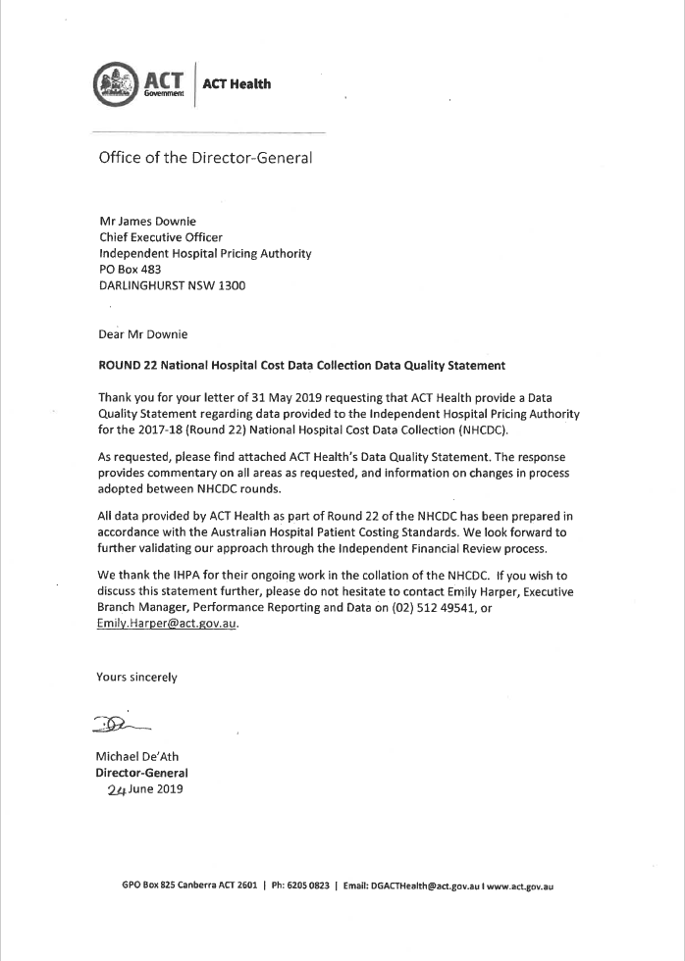

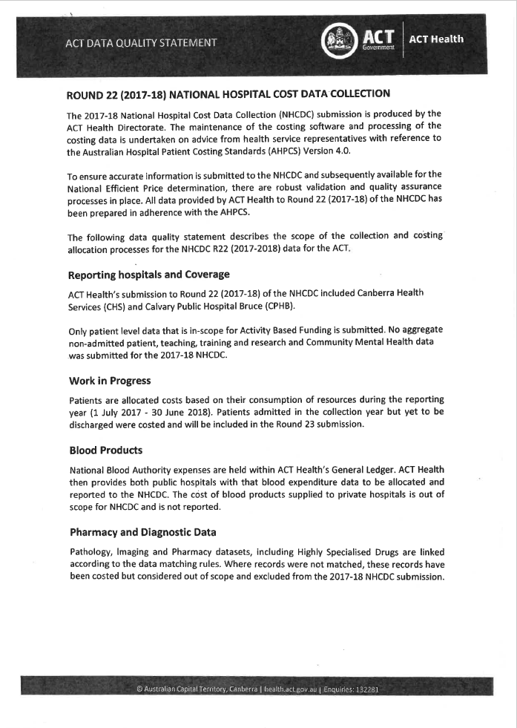

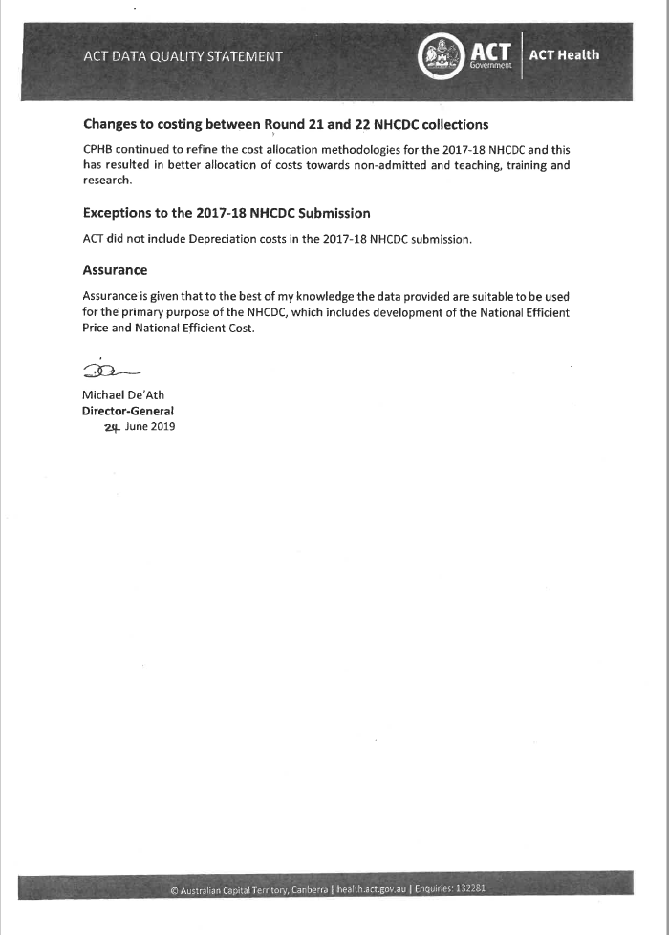

**New South Wales**

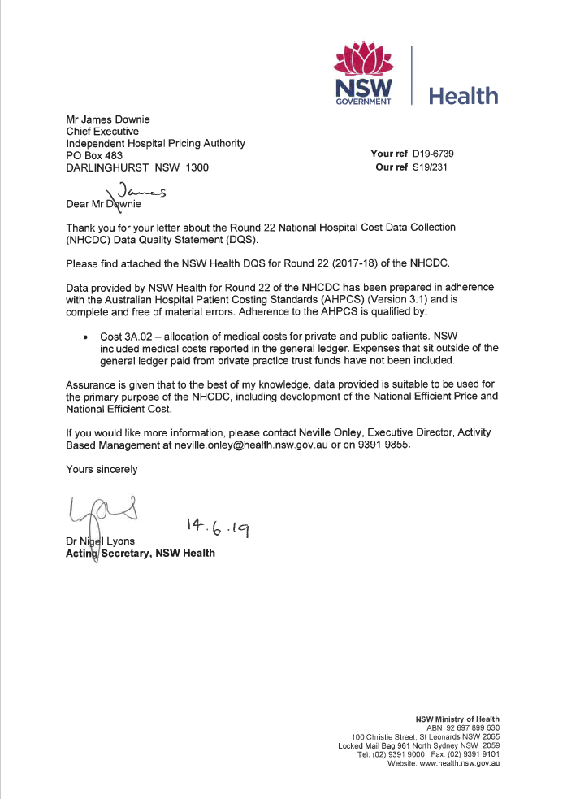

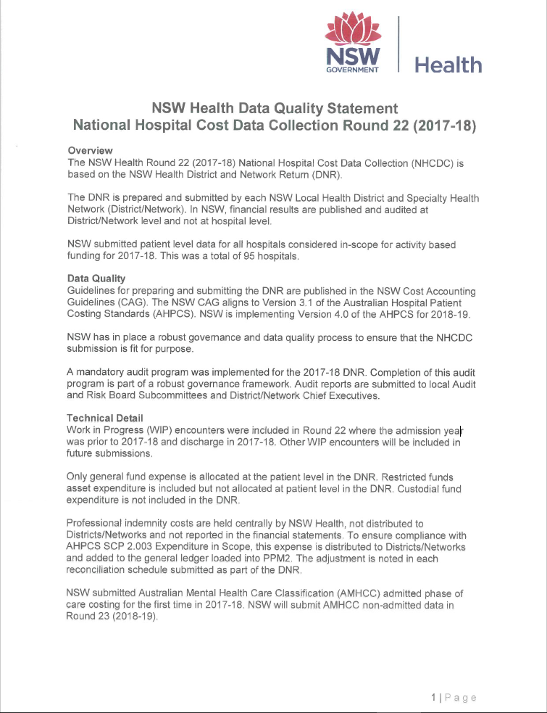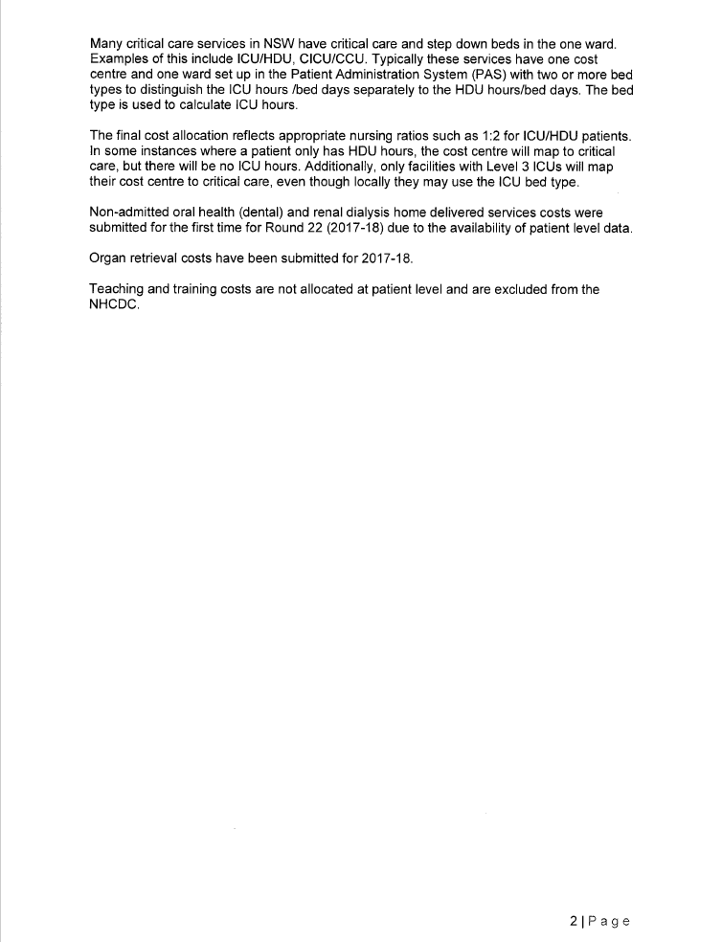

**Northern Territory**

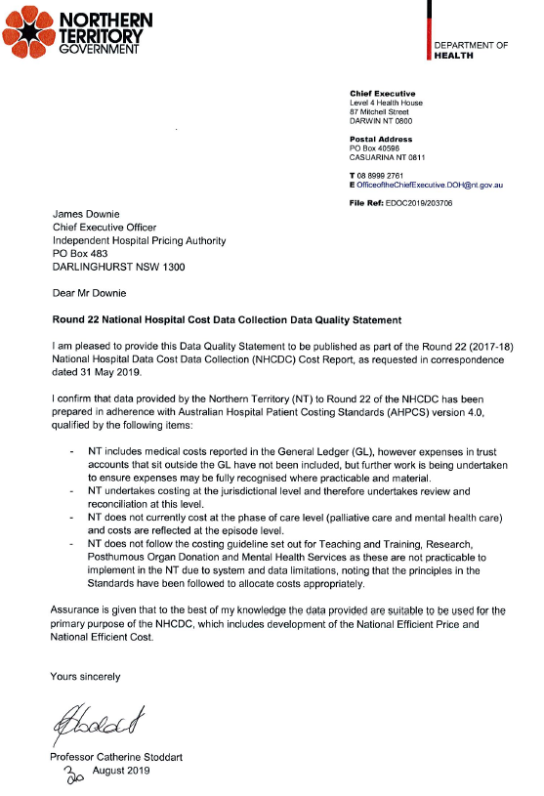

**Queensland**

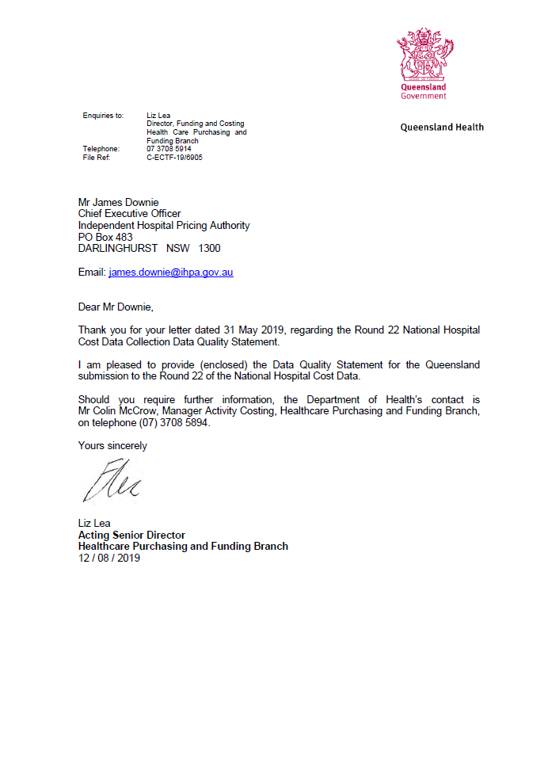

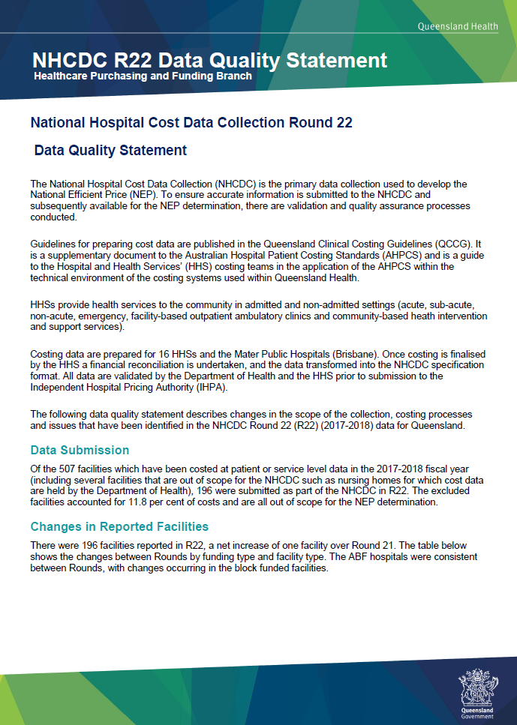 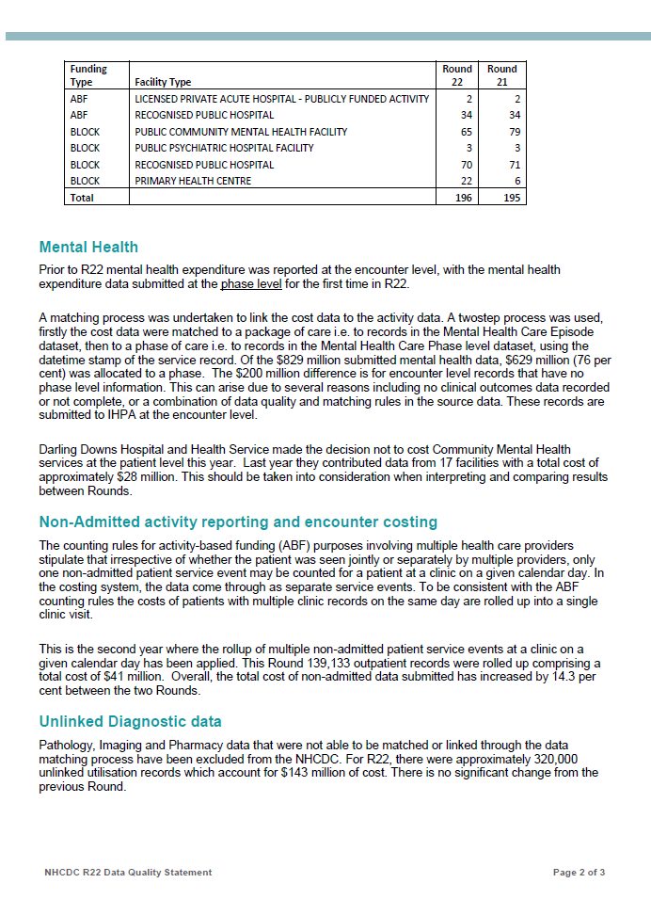 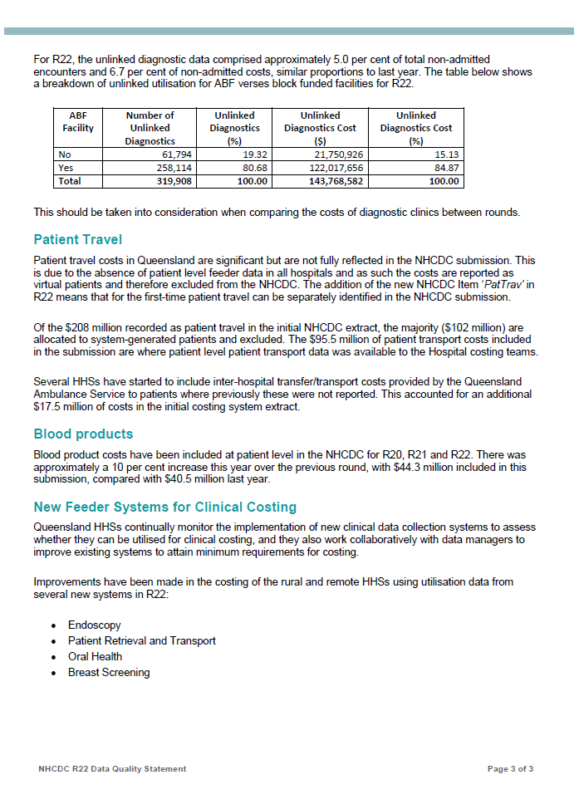

**South Australia**

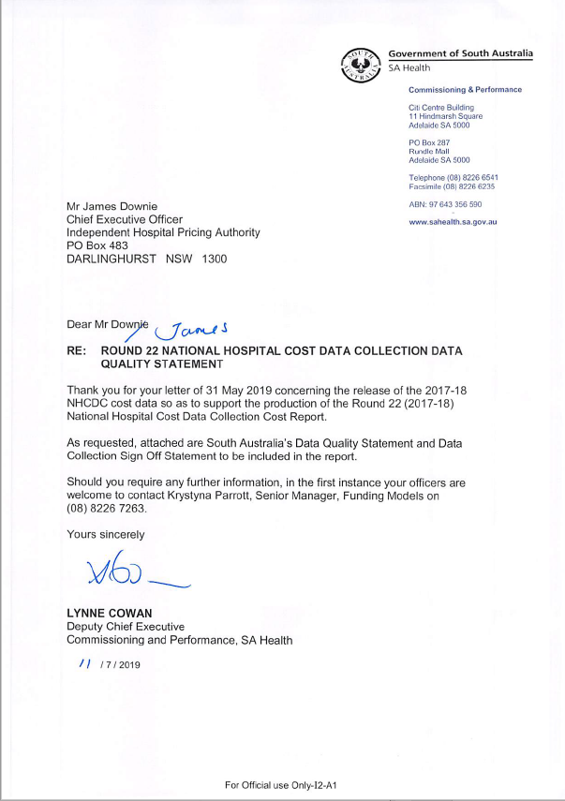

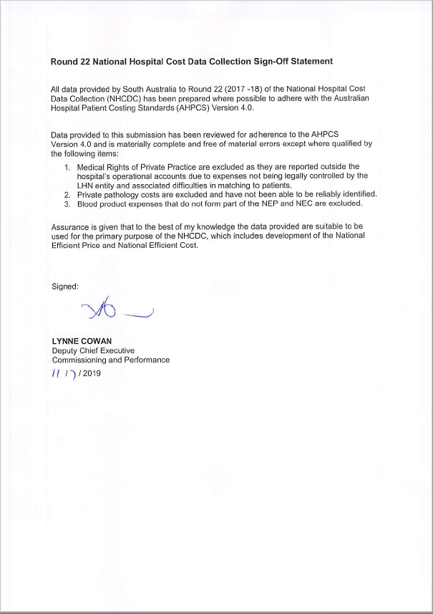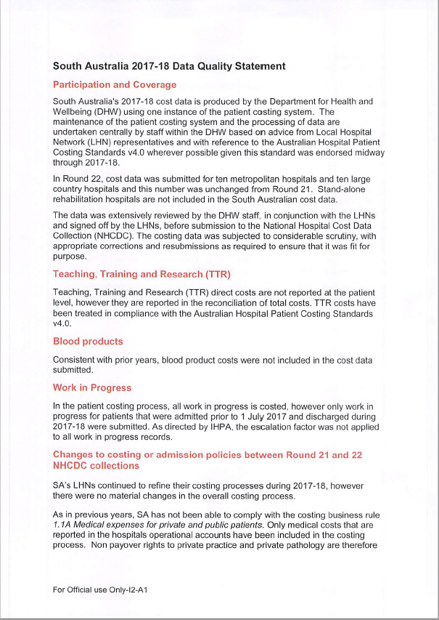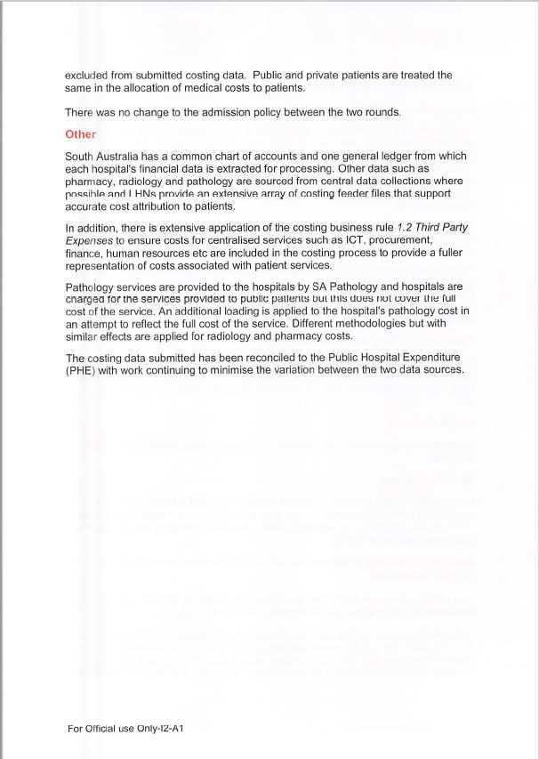

**Tasmania**

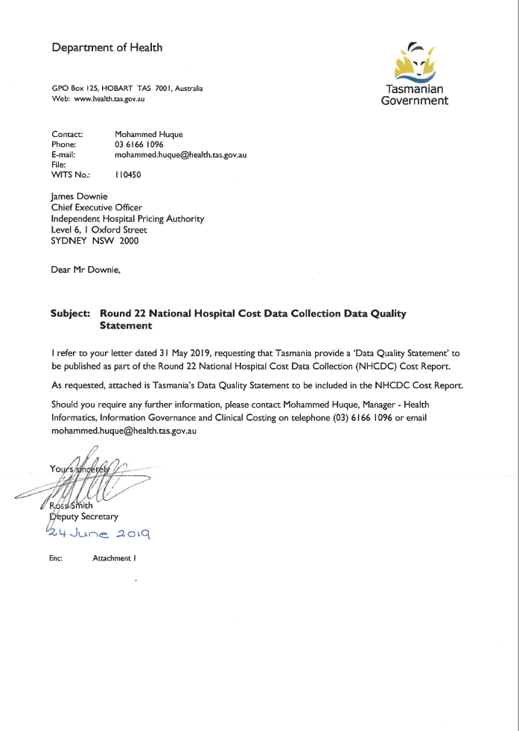



**Victoria**

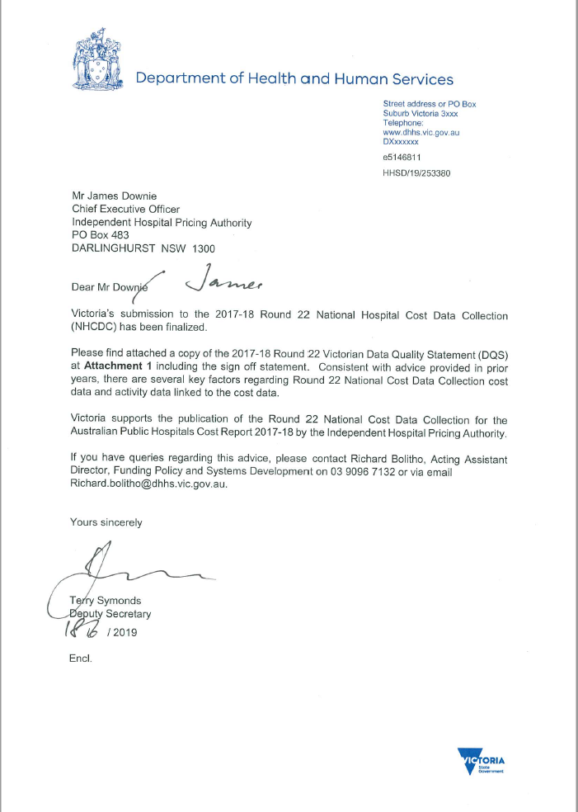

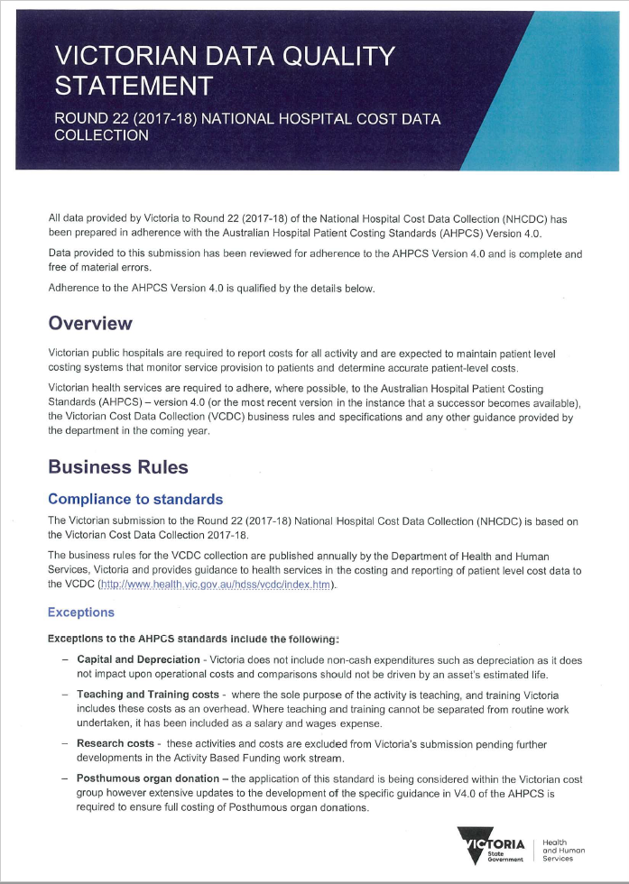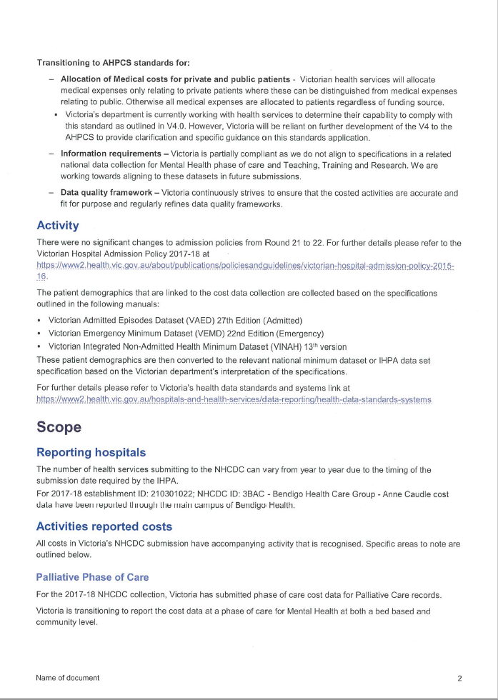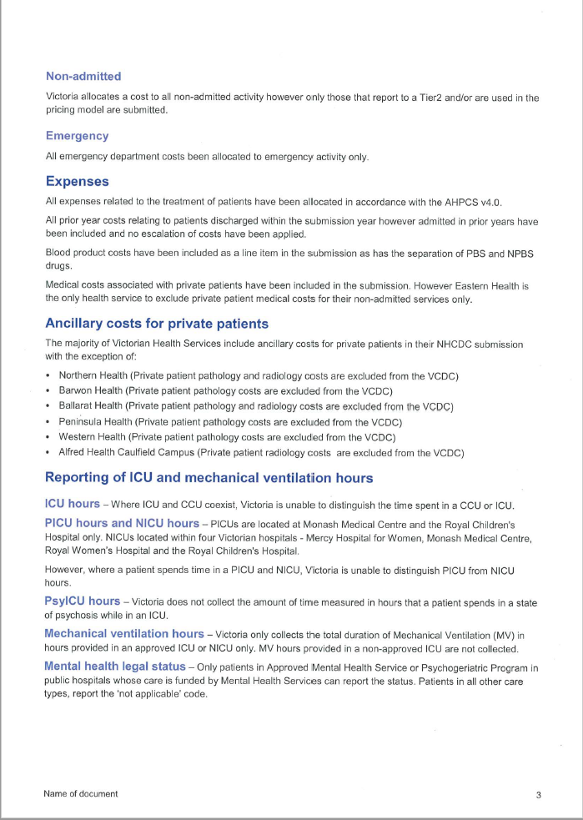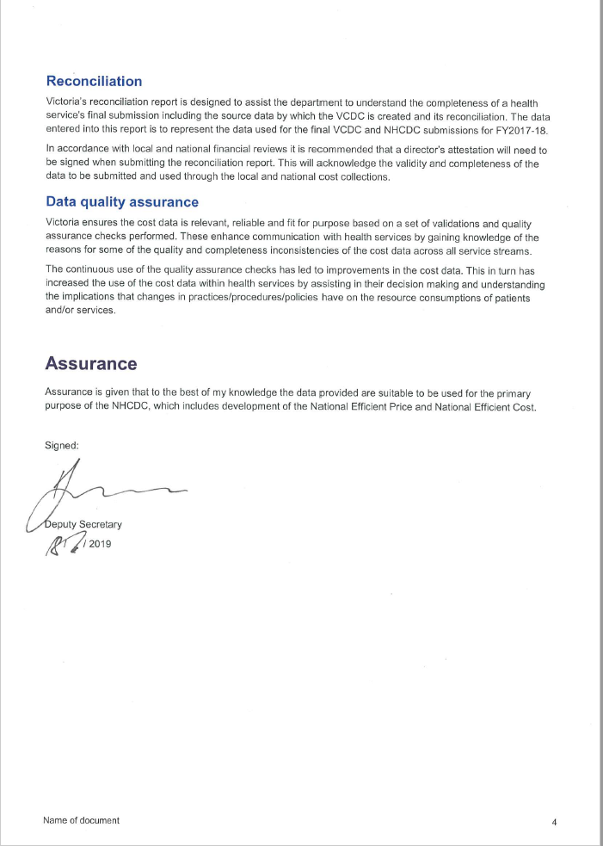

**Western Australia**

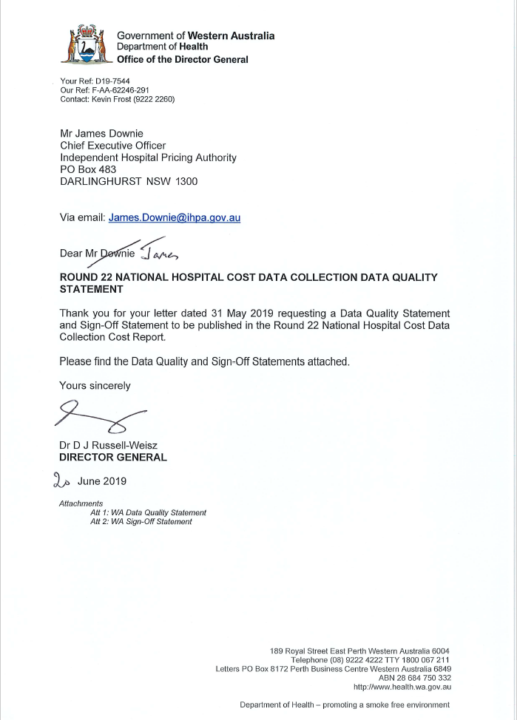

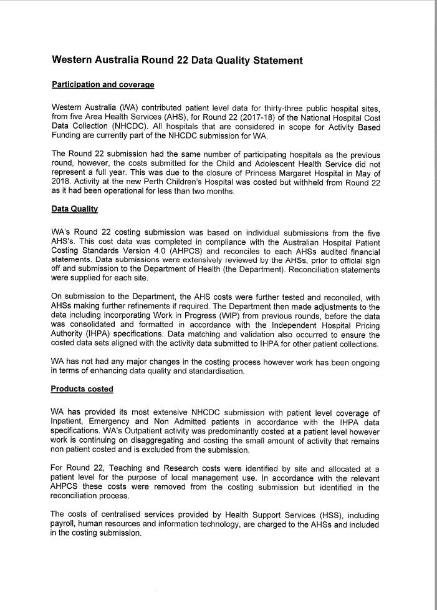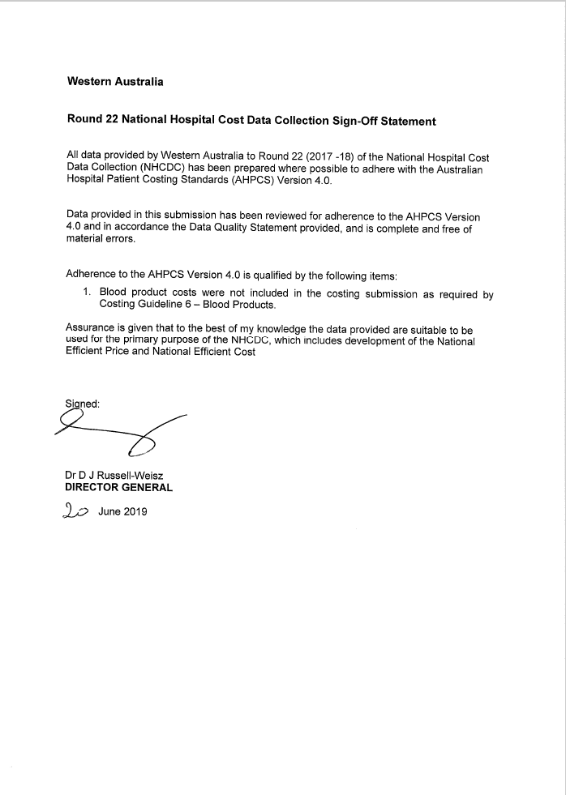



Independent Hospital Pricing Authority

Level 6, 1 Oxford Street

Sydney NSW 2000

Phone 02 8215 1100

Email enquiries.ihpa@ihpa.gov.au

Twitter @IHPAnews

www.ihpa.gov.au

1. <https://www.ihpa.gov.au/publications/australian-hospital-patient-costing-standards-version-40>
2. Tab 12 of the Round 23 Data Request Specifications includes the cost bucket matrix for Round 23: <https://www.ihpa.gov.au/sites/default/files/publications/national_hospital_cost_data_collection_-_data_request_specifications_round_23.xlsx>
3. Within the Emergency Department cost bucket
4. Note that different counting rules led to a change in the denominator for Community mental health activity between Round 21 and 22. Round 21 included phases and service contacts, while Round 22 included only phases. As such, the results for this category are not directly comparable.
5. <https://www.ihpa.gov.au/what-we-do/abf-data-request-specifications-2017-18>
6. For more information about IHPA’s hospital activity collection visit: <https://www.ihpa.gov.au/what-we-do/data-collection>
7. Australian Revised –Diagnosis Related Groups Version 10.0
8. DRG: F23Z
9. This figure is also referred to as the cost weight. Cost Weights are included for all acute admitted care separation types in the Appendix Tables.
10. DRG: G48B