Independent Hospital Pricing Authority

Pricing and funding for safety and quality

Risk adjusted model for hospital acquired complications

National Efficient Price Determination 2022–23

March 2022

Pricing and funding for safety and quality – Risk adjustment model for hospital acquired complications – March 2022

© Independent Hospital Pricing Authority 2022

This publication is available for your use under a [Creative Commons BY Attribution 3.0 Australia](http://creativecommons.org/licenses/by/3.0/au/deed.en) licence, with the exception of the Independent Hospital Pricing Authority logo, photographs, images, signatures and where otherwise stated. The full licence terms are available from [the Creative Commons website](http://creativecommons.org/licenses/by/3.0/au/legalcode).

CC by_grey

Use of Independent Hospital Pricing Authority material under a [Creative Commons BY Attribution 3.0 Australia](http://creativecommons.org/licenses/by/3.0/au/deed.en) licence requires you to attribute the work (but not in any way that suggests that the Independent Hospital Pricing Authority endorses you or your use of the work).

*Independent Hospital Pricing Authority material used 'as supplied'.*

Provided you have not modified or transformed Independent Hospital Pricing Authority material in any way including, for example, by changing Independent Hospital Pricing Authority text – then the Independent Hospital Pricing Authority prefers the following attribution:

*Source: The Independent Hospital Pricing Authority*

# Executive summary

## Purpose

This document has been produced as an accompaniment to the National Efficient Price 2022–23 (NEP22) and the National Efficient Cost 2022–23 (NEC22) Determinations. It provides the technical specifications for how the Independent Hospital Pricing Authority (IHPA) developed the hospital acquired complication (HAC) funding approach and risk adjustment methodology, which has been in effect since 1 July 2018. It also provides guidance to hospitals, local hospital networks (LHNs) and state and territory health authorities on how to apply these to hospital activity.

## Risk adjustment

On the 29 August 2016, IHPA received a ministerial direction which required IHPA to develop a risk adjustment methodology ‘to consider different patient complexity levels or specialisation across jurisdictions and hospitals’.

This approach is also relevant to risk adjustment for safety and quality where the objective is to provide funding signals so that hospitals can take action to reduce systemic risks related to the delivery of care. Some patients will be at higher risk of adverse events due to factors such as their age and the presence of other comorbidities. The design of risk adjustment for safety and quality has to balance two perspectives, namely that:

Hospitals that treat more high-risk patients should not be disadvantaged compared to hospitals that treat fewer such patients.

From the perspective of patients, high-risk patients want assurance that hospitals take all necessary action to manage their risks and mitigate the occurrence of any adverse events.

This means that risk adjustment should not discount away or fully adjust for the higher risks experienced by some patients.

The risk adjustment model is built on a logistic regression model for each HAC. To ensure each risk factor is assessed in an effective and timely manner, IHPA has established multiple stages for the development of the model and assessment of each of the risk factors. This assessment involved:

Seeking clinical advice on the appropriateness of the proposed risk factors.

Preliminary assessment to determine whether there was adequate volume of information to allow for their use.

Assessing the statistical performance of the risk factor in predicting the occurrence of a HAC.

Full details of the risk adjustment model are provided in Section 4.

Episodes were then classified into complexity groups for the purposes of dampening and funding adjustments. Three complexity groupings of ‘low’, ‘moderate’ and ‘high’ have been adopted to provide an optimal balance between complexities, risk homogeneity and sample size within each group, with the exception of HAC15 which has two complexity groupings, ‘low’ and ‘high’. Further details are provided in Section 5.

### Incremental cost of a HAC

The funding approach for HACs requires that the funding level for all HACs across every hospital be reduced to reflect the extra cost of a hospital admission with a complication.

This additional cost may be as a result of a more complex episode of stay, or due to an increase in the length of stay than would have otherwise occurred. It is necessary then to determine the value of only the *incremental* cost relating to the HAC and use this as the basis of the funding adjustment.

The methodology used to determine the incremental cost of a HAC uses similar principles to that adopted for the national cost models, in that it uses linear regression to predict the cost of an episode. The episode’s DRG and length of stay were adopted in the predictive model as these characteristics represent the most significant cost drivers.

Overall, HAC episodes had an 8.7 per cent higher cost compared to non-HAC episodes (or a cost ratio of 1.087). Table 1 shows the incremental costs for all HACs as well as by HAC group.

**Table 1**: Incremental cost adjustments by HAC group

|  |  |  |  |  |  |  |
| --- | --- | --- | --- | --- | --- | --- |
| **Complication** | |  | **Final incremental cost** | **Adopted adjustment** | | |
|  | All HACs | | 8.7% | 8.0% | | |
| 1 | Pressure injury | | 12.3% | 10.9% | | |
| 2 | Falls resulting in fracture or other intracranial injury | | 3.0% | 2.9% | | |
| 3 | Healthcare associated infection | | 8.6% | 7.9% | | |
| 4 | Surgical complications requiring unplanned return to theatre | | 12.1% | 10.8% | | |
| 5 | Unplanned intensive care unit admission | | n/a | n/a | | |
| 6 | Respiratory complications | | 14.4% | 12.6% | | |
| 7 | Venous thromboembolism | | 10.1% | 9.2% | | |
| 8 | Renal failure | | 21.8% | 17.9% | | |
| 9 | Gastrointestinal bleeding | | 9.0% | 8.2% | | |
| 10 | Medication complications | | 10.6% | 9.6% | | |
| 11 | Delirium | | 10.1% | 9.2% | | |
| 12 | Persistent incontinence | | 7.2% | 6.7% | | |
| 13 | Malnutrition | | 8.1% | 7.5% | | |
| 14 | Cardiac complications | | 11.8% | 10.5% | | |
| 15.01 | Third degree perineal laceration during delivery | | n/a | n/a | | |
| 15.02 | Fourth degree perineal laceration during delivery | | 47.7% | 32.3% | | |
| 16 | Neonatal birth trauma | | n/a | n/a | | |
| Note: figures have been rounded to 1 decimal place | | | | |  |  | |

The final incremental costs for each HAC are then converted into adjustments which will be applied to the national weighted activity unit (NWAU) through the use of the formula:

$$\text{Adjustment} \text{=} \text{1} \text{-} \frac{\text{1}}{\text{1} \text{+} \text{incremental} \text{cost}}$$

### Dampening factors

The 29 August 2016 direction to IHPA stated that pricing and funding approaches should balance the likelihood that some patients will be at higher risk of experiencing an adverse event. This has been addressed by the construction of dampening factors that vary depending on the episode’s complexity, or risk, of a particular HAC occurring. Section 7 provides further details on the quantile cut off points, dampening factors and adjustment factors for each of the HAC groups.

### Funding adjustment

The following steps are used to determine the adjustment:

1. Calculate the overall complexity score for each HAC in an episode by summing the complexity scores derived from each risk factor variable relevant to each HAC.
2. Assign a complexity group for each HAC based on the complexity score using the quantile cut off points.
3. Apply the adjustment relevant to each HAC based on the assigned complexity group. If an episode contains more than one HAC, then the maximum adjustment is used for the funding adjustment (regardless of the complexity of the HAC).
4. Calculate the final safety and quality adjusted NWAU, calculated as:

$$\text{Adjusted} \text{NWAU} \text{=} \text{NWAU} \text{-} \text{base} \text{price} \text{weight} \text{×} \text{adjustment} \text{factor}$$

The adjustments have been designed and calculated at an episode level allowing for aggregation to a jurisdiction, LHN or hospital level to determine the aggregate impact.

Contents

[1. Executive summary 3](#_Toc57274221)

[1.1 Purpose 3](#_Toc57274222)

[1.2 Risk adjustment 3](#_Toc57274223)

[Acronyms and abbreviations 8](#_Toc57274224)

[2. Introduction 9](#_Toc57274225)

[2.1 Purpose 9](#_Toc57274226)

[2.2 Background 9](#_Toc57274227)

[2.3 Risk adjustment for hospital acquired complications 10](#_Toc57274228)

[3. Data preparation 11](#_Toc57274229)

[3.1 Overview 11](#_Toc57274230)

[3.2 Identification of HACs 11](#_Toc57274231)

[3.3 Hospital level trimming 13](#_Toc57274232)

[3.4 Episode trimming 13](#_Toc57274233)

[3.5 Distribution of HACs 16](#_Toc57274234)

[4. Risk adjustment model 17](#_Toc57274235)

[4.1 Overview 17](#_Toc57274236)

[4.2 Risk factors 17](#_Toc57274237)

[4.3 Model construction 18](#_Toc57274238)

[4.4 Assessment of model fit 20](#_Toc57274239)

[4.5 Third degree perineal laceration and neonatal birth trauma 21](#_Toc57274240)

[4.6 Results 22](#_Toc57274241)

[5. Complexity scores 23](#_Toc57274242)

[5.1 Overview 23](#_Toc57274243)

[5.2 Complexity score conversion 23](#_Toc57274244)

[5.3 Grouping of complexity scores 24](#_Toc57274245)

[6. Incremental cost of a HAC 26](#_Toc57274246)

[6.1 Overview 26](#_Toc57274247)

[6.2 Methodology 26](#_Toc57274248)

[6.3 Further adjustments 27](#_Toc57274249)

[6.4 Results 28](#_Toc57274250)

[7. Dampening factors 30](#_Toc57274251)

[7.1 Overview 30](#_Toc57274252)

[7.2 Methodology 31](#_Toc57274253)

[7.3 Results 32](#_Toc57274254)

[8. Funding adjustment 34](#_Toc57274255)

[8.1 Overview 34](#_Toc57274256)

[8.2 Methodology 34](#_Toc57274257)

[8.3 Vignettes 35](#_Toc57274258)

[9. Issues and other considerations 39](#_Toc57274259)

[9.1 Treatment of episodes with multiple HACs 39](#_Toc57274260)

[Appendix A: ROC curves 40](#_Toc57274261)

[Appendix B: Complexity scores 43](#_Toc57274262)

[Appendix C: Complexity bounds 49](#_Toc57274263)

# Acronyms and abbreviations

|  |  |
| --- | --- |
| APC NMDS | Admitted patient care national minimum data set |
| CAC | Clinical Advisory Committee |
| COAG | Council of Australian Governments |
| COF | Condition onset flag |
| Commission | Australian Commission on Safety and Quality in Health Care |
| DRG | Diagnosis related groups |
| GWAU | Gross weighted activity unit |
| HACs | Hospital acquired complications |
| ICD-10-AM | International Statistical Classification of Diseases and Related Health Problems, Tenth Revision, Australian Modification |
| ICU | Intensive care unit |
| IHPA | Independent Hospital Pricing Authority |
| MDC | Major diagnostic category |
| NEP | National efficient price |
| NHCDC | National hospital cost data collection |
| NWAU | National weighted activity unit |
| ROC | Receiver operating characteristic |
| SEIFA | Socio-economic indexes for areas |

# Introduction

## Purpose

This document has been produced as an accompaniment to the National Efficient Price 2022–23 (NEP22) and the National Efficient Cost 2022–23 (NEC22) Determinations. It provides the technical specifications for how the Independent Hospital Pricing Authority (IHPA) developed the hospital acquired complications (HAC) funding approach and risk adjustment methodology, which has been in effect since 1 July 2018. It also provides guidance to hospitals, local hospital networks (LHN) and state and territory health authorities on how to apply these to hospital activity.

## Background

In April 2016, all Australian governments signed a Heads of Agreement that committed to improve Australians’ health outcomes and decrease avoidable demand for public hospital services through a series of reforms including the development and implementation of funding and pricing approaches for safety and quality.

The commitment by governments to pricing for safety and quality follows a four-year work program jointly undertaken by IHPA and the Australian Commission on Safety and Quality in Health Care (the Commission) to undertake research and develop options for incorporating safety and quality into IHPA’s annual Pricing Framework for Australian Public Hospital Services (the Pricing Framework). One of the outcomes of this collaboration was the development, through a clinician-led process, of an agreed Australian list of HACs.

In August 2016, IHPA was given a direction by the then Commonwealth Minister for Health and Aged Care, acting under subsection 226(1) of the *National Health Reform Act 2011* (the Act). IHPA was directed to advise the Council of Australian Governments (COAG) Health Council on an option or options for a comprehensive and risk adjusted model to determine how funding and pricing could be used to improve patient outcomes across three key areas: sentinel events, HACs and avoidable hospital readmissions.

Informed by feedback from the Consultation Paper on the Pricing Framework for Australian Public Hospital Services 2017–18, on 30 November 2016, IHPA provided advice to the COAG Health Council on options for the integration of safety and quality into public hospital pricing and funding models.

In February 2017, the Commonwealth Minister for Health directed IHPA to undertake implementation of three recommendations of the COAG Health Council relating to sentinel events, HACs and avoidable readmissions. IHPA’s decisions in relation to this were set out in the Pricing Framework for Australian Public Hospital Services 2017–18.

For HACs, this included that, consistent with the ministerial direction, IHPA will reduce the funding level for all HACs across every hospital to reflect the extra cost of a hospital admission with a complication by 1 July 2018, subject to the results of a shadow year from 1 July 2017.

In implementing this approach, IHPA was directed to:

Further refine the risk adjustment methodology prior to 1 July 2018.

Shadow the implementation of the HACs model to assess the impact on funding, data reporting, clinical information systems, and specific population and peer hospital groups.

Conduct public consultation on the findings of the shadow implementation and report to the COAG Health Council by 30 November 2017.

## Risk adjustment for hospital acquired complications

Furthermore, the August 2016 ministerial direction required IHPA to develop a risk adjustment methodology ‘to consider different patient complexity levels or specialisation across jurisdictions and hospitals’.

The Pricing Framework includes adjustments to the NEP that are intended ‘to reflect legitimate and unavoidable variations in the costs of delivering health care services’ (Clause A131(d) of the Act). This is intended to ensure that hospitals are not unfairly penalised if they experience higher costs due to factors that are largely outside their control. IHPA’s Pricing Guidelines stipulate that adjustments to the price should, as far as practicable, be based on patient-related rather than provider-related characteristics.

This approach is also relevant to risk adjustment for safety and quality where the objective is to provide funding signals so that hospitals can take action to reduce systemic risks related to the delivery of care. Some patients will be at higher risk of adverse events due to factors such as their age and the presence of other comorbidities. The design of risk adjustment for safety and quality has to balance two perspectives, namely that:

Hospitals that treat more high-risk patients should not be disadvantaged compared to hospitals that treat fewer such patients.

However, from the perspective of patients, high-risk patients want assurance that hospitals take all necessary action to manage their risks and mitigate the occurrence of any adverse events.

This means that risk adjustment should not discount away or fully adjust for the higher risks experienced by some patients. The most suitable approach to risk adjustment for safety and quality may vary according to the measure being used (for example, sentinel events, HACs and avoidable hospital readmissions).

Pricing and funding approaches should balance the likelihood that some patients will be at higher risk of experiencing an adverse event while ensuring that all hospitals have ongoing responsibility to mitigate risks, to reduce and manage any negative impacts for all patients, and to improve safety and quality systemically.

IHPA’s initial advice to COAG Health Council in November 2016 included a preliminary risk adjustment approach for HACs based on a patient’s age, as this is the single biggest predictor of the likelihood of someone incurring a HAC.

Since February 2017, IHPA has worked with a range of stakeholders including jurisdictions, clinicians and technical experts to refine the risk adjustment methodology. This has included consideration of a broad range of patient factors in the model, as well as the technical approach to funding adjustments and testing of the model to ensure that it balances the two perspectives described above. Additionally, from NEP20, HAC15.02 Fourth degree perineal lacerations from delivery is included in the risk adjusted models with risk factors specific to this HAC category.

# Data preparation

## Overview

The development of the risk adjustment model and funding adjustments for HACs utilised hospital activity and cost data related to acute admitted separations.

Three years of hospital activity data were used to develop the risk adjustment model, using the admitted patient care (APC) datasets for the 2017–18, 2018–19 and 2019–20 years. These datasets contain episode-level information about the hospital, patient and importantly, diagnoses information which allowed for HAC identification.

Hospital cost data was also utilised to develop the modelling which determines the incremental cost of a HAC. This data was sourced from the 2017–18, 2018–19 and 2019–20 National Hospital Cost Data Collection (NHCDC).

These data sources are summarised in Table 2.

**Table 2**: Data used for the development of pricing for hospital acquired complications[[1]](#footnote-2)

| Data source | Risk adjustment model | Incremental cost model |
| --- | --- | --- |
| APC1718 | Yes | Yes |
| APC1819 | Yes | Yes |
| APC1920 | Yes | Yes |
| NHCDC1718 | No | Yes |
| NHCDC1819 | No | Yes |
| NHCDC1920 | No | Yes |

## Identification of HACs

Fundamental to the development of the risk adjustment model and funding adjustments was the list of the HACs which were considered in the modelling. In 2012, the Commission and IHPA established a joint working group and over the years have refined and developed the current list of HACs (the HAC list).

All the work undertaken for the development of pricing for HACs in NEP22 has utilised the HAC list Version 3.1 as at March 2021. This list contains 16 HACs summarised in Table 3. A full list of all HACs and identifying diagnoses is available on the Commission’s website[[2]](#footnote-3).

The only change in moving from Version 3.0 to Version 3.1 is the inclusion of mental health cohorts which do not impact HAC counts.

There are two key pieces of information required to determine the presence of a HAC in a hospital separation, the diagnosis code and the condition onset flag (COF). The diagnosis code is recorded using the International Statistical Classification of Diseases and Related Health Problems, Tenth Revision, Australian Modification (ICD-10-AM) under the edition which is relevant to the year’s data collection.

Each associated diagnosis code in the diagnosis array will also have an associated COF, which identifies whether the condition was present on admission or not. This information is critical in determining whether the complication was acquired in the hospital episode for the purposes of correctly identifying a HAC.

**Table 3**: List of hospital acquired complications

| Number | Complication |
| --- | --- |
| 1 | Pressure injury |
| 2 | Falls resulting in fracture or intracranial injury |
| 3 | Healthcare associated infection |
| 4 | Surgical complications requiring unplanned return to theatre |
| 5 | Unplanned intensive care unit admission |
| 6 | Respiratory complications |
| 7 | Venous thromboembolism |
| 8 | Renal failure |
| 9 | Gastrointestinal bleeding |
| 10 | Medication complications |
| 11 | Delirium |
| 12 | Incontinence |
| 13 | Endocrine complications |
| 14 | Cardiac complications |
| 15 | Third and fourth degree perineal laceration during delivery |
| 16 | Neonatal birth trauma |

Although the HAC list from the Commission includes HAC05: unplanned intensive care unit admission, this currently cannot be measured. This is because the information that is required to identify an unplanned intensive care (ICU) unit admission is not collected in the current dataset specification and thus cannot be identified.

## Hospital level trimming

In order to develop a robust risk adjustment model, the APC data was trimmed such that only records which were of a certain quality and reflective of hospital experience would be included in the modelling dataset. It was particularly important to understand and only retain records from hospitals which had a high quality of COF reporting. This process was carried out at a hospital level.

Three rules were developed to identify whether a hospital would be trimmed:

Hospitals with fewer than 100 episodes were trimmed. This removed low-volume hospitals where it is not possible to determine the quality of COF reporting.

Hospitals where less than one per cent of episodes contained conditions arising in the hospital (that is, where less than one per cent of records had a COF = ‘1’ for any diagnosis). This removed hospitals deemed to have unusually few episodes with any condition arising during episode.

Hospitals where more than 10 per cent of episodes had no reported COF (that is, where more than 10 per cent of episodes only reported COF = ‘9’ for all diagnoses). This removed hospitals deemed to have poor quality COF reporting due to the high proportion of unknown onset statuses.

This process resulted in:

* 231 hospitals out of 730 public hospitals being trimmed for 2017-18, accounting for 119,120 episodes (or 1.8 per cent).
* 247 hospitals out of 744 public hospitals being trimmed for 2018-19, accounting for 145,242 episodes (or 2.1 per cent).
* 262 hospitals out of 767 public hospitals being trimmed for 2019-20, accounting for 144,034 episodes (or 2.1 per cent).

## Episode trimming

In addition to hospital level quality trimming, a number of records were trimmed based on characteristics related to the episode of care. These records were trimmed to ensure that their inclusion did not reduce the robustness of the risk adjustment model as some types of admissions would not be expected to receive a HAC. These trimmed records generally fell into three categories.

The first category included episodes which were considered to be outliers after discussions with risk adjustment experts Professors Scott and Yong, who advised that their inclusion would disproportionately skew the risk adjustment model and included:

Long-stay patients (patients with a length of stay greater than 200 days).

Patients over 95 years old.

Episodes where the patient died.

The second category included episodes which were trimmed as it was advised by the Commission that the admission characteristics could not lead to a HAC or that they were generally not representative for the purpose of determining the probability of a HAC occurring. This category included:

Episodes classified as same-day dialysis, chemotherapy or radiotherapy, on the basis that these are high-volume, same-day episodes with very low HAC counts and have the potential to ‘wash’ out the analysis.

Episodes from rehabilitation, mothercraft, psychiatric, other non-acute and unpeered hospitals. These hospitals had a very low prevalence of HAC and were selected for trimming.

The final category related to decisions around which episodes were considered in-scope for the purpose of developing the risk adjustment model and calculating the funding adjustments. These episodes were trimmed if they were:

Episodes not from activity based funding (ABF) public hospitals (that is, private or block-funded hospitals).

Episodes with error or ungroupable Diagnosis related groups (DRGs).

Additionally, episodes with input errors were removed from the in-scope datasets. These include:

* Episodes where the separation date is before the admission date.
* Episodes where the admission date is before the birthdate.
* Episodes where the separation date is before the birthdate.
* Episodes with the default birthdate of 1 January 1900.

The number of episodes trimmed for the 2017–18, 2018–19 and 2019–20 activity data as a result of each step is summarised in Table 4.

**Table 4**: Summary of trimmed episodes for the 2017–18, 2018–19 and 2019–20 activity data

|  |  |  |  |
| --- | --- | --- | --- |
|  | **Number of records 2017-18** | **Number of records 2018-19** | **Number of records 2019-20** |
| **Total episodes** | 6,554,277 | 6,768,193 | 6,734,253 |
| **Trimming due to:** |  |  |  |
| **Non-public hospitals** | 205,391 | 202,563 | 250,296 |
| **Hospital quality trimming:** |  |  |  |
| ***Stage 1: low volume*** | 4,408 | 4,613 | 5,528 |
| ***Stage 2: COF = 1 less than 1%*** | 113,013 | 140,629 | 138,506 |
| ***Stage 3: COF = 9 greater than 10%*** | 1,699 | 0 | 0 |
| **Error DRGs** | 368 | 872 | 149 |
| **Peer group trimming** | 6,986 | 3,130 | 7,448 |
| **Non-ABF hospital trimming** | 235,435 | 207,189 | 197,014 |
| **Same-day dialysis trimming** | 1,136,095 | 1,166,968 | 1,239,656 |
| **Same-day chemotherapy trimming** | 253,001 | 274,583 | 280,494 |
| **Patient over 95 trimming** | 17,164 | 18,299 | 18,481 |
| **Death trimming** | 33,506 | 32,187 | 30,578 |
| **Long stay patient trimming** | 117 | 149 | 173 |
| **Same-day radiotherapy trimming** | 3867 | 3784 | 4591 |
| **Input error trimming** | 0 | 0 | 1 |
| **Total episodes remaining (untrimmed)** | 4,543,227 | 4,713,227 | 4,561,338 |
| **% of episodes trimmed from public hospitals** | 28.44% | 28.21% | 29.65% |

## Distribution of HACs

The number of HACs identified after trimming is presented in Table 5. The total number of episodes identified with a HAC was 114,436, 99,929 and 91,507 for 2017-18, 2018-19 and 2019-20 respectively. This equates to approximately 2.5 per cent, 2.1 per cent and 2.0 per cent for each year respectively of untrimmed episodes.

The number of episodes identified for each HAC group is also shown in Table 5. It is worth noting that as an episode may have multiple HACs, these episodes have been counted more than once (in their respective HAC groups) and thus the total will be less than the sum of the individual HACs.

**Table 5**: Number of HACs for 2017–18, 2018–19 and 2019–20

|  |  |  |  |  |
| --- | --- | --- | --- | --- |
| **No.** | **Complication** | **2017-18** | **2018-19** | **2019-20** |
|  | Total episodes with a HAC | 114,436 | 99,929 | 91,507 |
|  | *Number of episodes with:* |  |  |  |
| **1** | Pressure Injury | 2,413 | 1,662 | 1,410 |
| **2** | Falls resulting in fracture or other intracranial injury | 1,229 | 1,320 | 1,279 |
| **3** | Healthcare associated infection | 46,088 | 38,631 | 34,918 |
| **4** | Surgical complications requiring unplanned return to theatre | 17,440 | 17,637 | 16,192 |
| **5** | Unplanned intensive care unit admission | n/a | n/a | n/a |
| **6** | Respiratory complications | 9,982 | 9,094 | 8,968 |
| **7** | Venous thromboembolism | 3,492 | 2,886 | 2,764 |
| **8** | Renal failure | 580 | 555 | 453 |
| **9** | Gastrointestinal bleeding | 4,503 | 3,690 | 3,053 |
| **10** | Medication complications | 3,824 | 3,192 | 2,863 |
| **11** | Delirium | 19,263 | 15,940 | 14,718 |
| **12** | Persistent incontinence | 2,257 | 1,320 | 1,274 |
| **13** | Malnutrition | 11,225 | 9,944 | 8,863 |
| **14** | Cardiac complications | 19,880 | 15,546 | 14,064 |
| **15** | Third and fourth degree perineal laceration during delivery | 5,370 | 5,288 | 4,870 |
| **16** | Neonatal birth trauma | 990 | 1,041 | 1,088 |

# Risk adjustment model

## Overview

This section outlines the methodology used to develop the risk adjustment model introduced in Section 2.3 and the risk factors adopted. Overall, the risk adjustment model predicts the probability of a specific HAC occurring within an episode of care. A patient with a higher probability of receiving a HAC is expected to be at a ‘higher risk’.

For NEP22, the same factors were used as the original model developed for consultation and presented in the Risk Adjustment Model for Hospital Acquired Complications – Technical Specifications (HAC Technical Specifications) in July 2017. That is, the model was not completely re-fit using the stepwise regression and contains the same number of risk factors, with checks carried out to ensure the risk factors were still significant.

The key change for the risk adjustment model is the use of DRG Version 10.0 to be consistent with the acute admitted national cost model (compared to the risk adjustment model presented in the HAC Technical Specifications in July 2017, which used DRG Version 8.0). A shift to the new DRG Version 10.0 has impacted the major diagnosis category and DRG type model parameters, which have been updated to reflect the new DRG version.

## Risk factors

IHPA has undertaken an extensive consultation process with the Australian Commission on Safety and Quality in Health Care (the Commission), IHPA’s Clinical Advisory Committee (CAC) and jurisdictions to assist in investigating potential risk factors for HACs.

Empirical evidence suggested that patient age was a strong predictor for the probability of the presence of a HAC. Thus, preliminary risk adjustment modelling utilised the patient age as the only risk factor in the risk adjustment model (the age only model). This model was conceptually simple and easy to explain, however, it was believed that other risk factors existed which may significantly impact the chance of a particular patient acquiring a HAC which should be considered in the model.

Furthermore, a risk adjustment model that only considered age did not appear to adequately adjust for specialist paediatric and tertiary hospitals. IHPA sought consultation from the Commission and the CAC regarding risk factors that should be considered in a refined model. Table 6 outlines the various risk factors investigated in the model presented for consultation in the HAC Technical Specifications in July 2017.

Based on advice from the Commission, fourth degree perineal laceration during delivery (HAC15.02) risk has been modelled using a unique set of risk factors compared to HACs one to 14, as shown in Table 7. This includes the use of young and mature aged primigravida instead of primiparity due to the lack of consistent documentation in the latter category. The panel has recommended advocating for routine coding of parity. Another risk factor that was noted by the panel, but not included in the model due to lack of documentation, was mothers of Asian ethnicity.

**Table 6**: List of potential risk factors for investigation

| **HAC01-HAC14 risk factors** | **HAC-specific factors** |
| --- | --- |
| Patient age | Liver disease (HAC04) |
| Gender | Heart failure (HAC07) |
| MDC | Myocardial infarction (HAC07) |
| DRG type (medical, intervention) | Stroke with immobility (HAC07) |
| Intensive care unit status | Cardiovascular disease (HAC08) |
| Presence of another HAC | Malignancy (HAC08) |
| Patient Indigenous status | Mechanical ventilation (HAC09) |
| Patient remoteness | Parkinson’s disease (HAC13) |
| Patient SEIFA[[3]](#footnote-4) | Dementia (HAC13) |
| Admission transfer status |  |
| Chronic disease count |  |
| Highly specialised procedures |  |
| Emergency admission status |  |
| Length of stay |  |
| Charlson score[[4]](#footnote-5) |  |

Additionally, age and emergency admission status are also used as risk factors in the model.

**Table 7**: HAC15.02 risk factor definitions

| HAC15 specific risk factors | Diagnosis (surgical) codes |
| --- | --- |
| Foetal distress | O680, 0682, O683, O688, O689 |
| Use of instruments | (9047002), (9047004), (9046800), (9046801), (9046802), (9046803), (9046804), (9046805), (9046900), (9046901) and (9046806) for ICD10AM v.10 and above. |
| Young and mature aged primigravida | Z3551, Z356 |
| Persistent posterior occiput presentation | O328, O640 |

## Model construction

The risk adjustment model is built on a logistic regression model for each HAC. To ensure each risk factor is assessed in an effective and timely manner, IHPA has established multiple stages for the development of the model and assessment of each of the risk factors. This assessment involves:

* Seeking clinical advice on the appropriateness of the proposed risk factors.
* A preliminary assessment to determine whether there was adequate volume of information to allow for their use.
* Assessing the statistical performance of the risk factor in predicting the occurrence of a HAC.

### Clinical advice

Clinical advice was essential during the development of the HAC risk adjustment model as it provided a practical perspective on the stepwise logistic regression model.

IHPA sought the advice of the CAC at various points during the development of the model on the choice of risk factors, first for broad consideration and exploration, and then following statistical analysis, for finalisation of the model.

This included advice in relation to the potential use of length of stay and presence of another HAC as risk factors within the model. Advice from the CAC was that the lines of causation and correlation between these risk factors and HACs were blurred, and that it was not appropriate to include them within the model. For example, an episode with a higher length of stay has a higher exposure to risk receiving a HAC (correlation). However, conversely, the episode may have a longer length of stay due to a HAC occurring (causation). Risk factors deemed unviable due to clinical advice were removed before the subsequent stages.

### Overall risk factor significance

A stepwise selection methodology was adopted in the final proposed model at July 2017 to test and select the risk factors included in the logistic regression model. The stepwise selection methodology involves starting with a model with no variables and then iteratively adding each risk factor that provides the highest statistically significant improvement to the model. Variables are added to the model in an iterative approach:

Independent assessment: chi-squared statistics are calculated and used to test the hypothesis that ‘a specific risk factor that is not already in the model has no effect’ given the other variables already included in the model. For the first iteration there are no variables other than the intercept term. For subsequent iterations the variables included are those that were selected in previous steps.

Stepwise selection: the risk factor that is statistically significant with the highest chi‑squared statistic is added to the model. Variables cease being added once there are no other risk factors that meet the significance criteria for inclusion in the model.

As the risk factors for HAC15.02 are limited and based on clinical advice, a stepwise selection was not adopted the final model.

### Individual parameter assessment HAC01 to HAC14

The individual parameter assessment investigates if there are any further potential refinements to each logistic regression model through examining the statistical performance of each class within the risk factors. The classes within each risk factor were assessed under a number of criteria including:

The statistical significance of each parameter (0.05 threshold was adopted).

The statistical estimates of a class compared with subsequent classes (that is, if there are overlaps between confidence intervals indicating potential groupings of parameters).

Analysing trends in overall estimates within the risk factors and comparing them to clinical expectations.

Impact on model performance.

This is an iterative assessment where various scenarios of different groupings of parameters are investigated.

The groupings adopted for the risk adjustment model are consistent with those adopted for the final proposed model for consultation. Checks were carried out to ensure the model parameters remained statistically significant.

### Parameter impacts

The prior sections in the model construction provide a methodology to assess the various risk factors for each HAC in an autonomous fashion. This section provides a period for reassessment of the impacts for each risk factor with the objective to optimise the statistical performance and reduce the overall complexity of each logistic regression model. Risk factors are assessed against a number of criteria including:

Complexity of identification (for example, if there are any interaction effects between patient age and ICU status).

The consistency of the risk factor across each HAC model (that is, how prominent each risk factor is across the HAC logistic regression models).

The odds ratio for each of the parameters.

The impact on model performance if specific risk factors are removed.

## Assessment of model fit

### Receiver operating characteristic curve

A receiver operating characteristic (ROC) curve is a statistical method that evaluates a model’s ability to predict a binary outcome. In this context, it is the occurrence of a HAC during an episode of care. The ROC curve graphically compares the true positive rate to the false positive rate, where:

A true positive rate is the rate at which the model *correctly* predicts a positive outcome.

A False positive rate is the rate at which the model *incorrectly* predicts a positive outcome.

An optimal model would aspire to maximise its true positive rate and minimise its false positive rate (that is, maximising the area under the curve).

Figure 1 illustrates the ROC curve for the final complexity model relative to an age only model for HAC03 (health care associated infections).

**Figure 1**: HAC03 – Health care associated infections – ROC curve

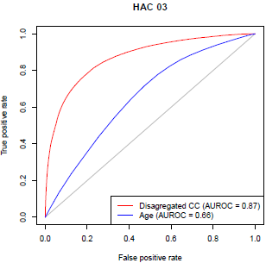

As illustrated in figure 1, the complexity model (0.87) outperforms the age only model (0.66) indicating it contains higher predictive capabilities and performance. **Appendix A** provides the ROC curve for each HAC complexity model.

## Third degree perineal laceration and neonatal birth trauma

In early 2019, the Commission convened condition-specific HAC curation clinical advisory panels for delirium, pressure injuries, renal failure, cardiac complications, respiratory complications, third and fourth degree perineal lacerations and neonatal birth trauma.

The panels considered the pricing of perineal lacerations and neonatal birth trauma, neither of which were included for a funding adjustment in NEP18 or NEP19. This was due to difficulty in identifying suitable risk factors to construct a robust risk adjustment model.

The clinical review supported further investigation into a risk adjustment model for fourth degree perineal lacerations. They did not support a HAC funding adjustment for third degree perineal laceration or neonatal birth trauma.

## Results

| Risk factors | 1. Pressure injury | 2. Falls resulting in fracture or intracranial injury | 3. Healthcare associated infection | 4. Surgical complications requiring unplanned return to theatre | 6. Respiratory complications | 7. Venous thromboembolism | 8. Renal failure | 9. Gastrointestinal bleeding | 10. Medication complications | 11. Delirium | 12. Persistent incontinence | 13. Malnutrition | 14. Cardiac complications | 15.2 Fourth degree perineal laceration during delivery |
| --- | --- | --- | --- | --- | --- | --- | --- | --- | --- | --- | --- | --- | --- | --- |
| Emergency admission status | ✓ | ✓ | ✓ | ✓ | ✓ | ✓ | ✓ | ✓ | ✓ | ✓ | ✓ | ✓ | ✓ | ✓ |
| Patient age | ✓ | ✓ | ✓ | ✓ | ✓ | ✓ | ✓ | ✓ | ✓ | ✓ | ✓ | ✓ | ✓ | ✓ |
| Major diagnosis category 10 | ✓ | ✓ | ✓ | ✓ | ✓ | ✓ | ✓ | ✓ | ✓ | ✓ | ✓ | ✓ | ✓ |  |
| Intensive care unit status | ✓ | ✓ | ✓ | ✓ | ✓ | ✓ | ✓ | ✓ | ✓ | ✓ | ✓ | ✓ | ✓ |  |
| DRG10 type | ✓ | ✓ | ✓ | ✓ | ✓ | ✓ | ✓ | ✓ | ✓ | ✓ | ✓ | ✓ | ✓ |  |
| Charlson Score | ✓ | ✓ | ✓ | ✓ | ✓ | ✓ | ✓ | ✓ | ✓ | ✓ | ✓ | ✓ | ✓ |  |
| Gender |  | ✓ | ✓ |  | ✓ | ✓ | ✓ | ✓ | ✓ | ✓ | ✓ |  |  |  |
| Admission transfer status | ✓ | ✓ | ✓ | ✓ | ✓ | ✓ |  | ✓ | ✓ | ✓ | ✓ | ✓ | ✓ |  |
| Foetal distress |  |  |  |  |  |  |  |  |  |  |  |  |  | ✓ |
| Instrument use |  |  |  |  |  |  |  |  |  |  |  |  |  | ✓ |
| Persistent posterior occiput presentation |  |  |  |  |  |  |  |  |  |  |  |  |  | ✓ |
| Young and mature aged primigravida |  |  |  |  |  |  |  |  |  |  |  |  |  | ✓ |

Table 8 outlines the individual risk factors utilised for each HAC logistic regression model.

**Table 8**: Final risk factors adopted for each HAC group

| Risk factors | 1. Pressure injury | 2. Falls resulting in fracture or intracranial injury | 3. Healthcare associated infection | 4. Surgical complications requiring unplanned return to theatre | 6. Respiratory complications | 7. Venous thromboembolism | 8. Renal failure | 9. Gastrointestinal bleeding | 10. Medication complications | 11. Delirium | 12. Persistent incontinence | 13. Malnutrition | 14. Cardiac complications | 15.2 Fourth degree perineal laceration during delivery |
| --- | --- | --- | --- | --- | --- | --- | --- | --- | --- | --- | --- | --- | --- | --- |
| **Emergency admission status** | ✓ | ✓ | ✓ | ✓ | ✓ | ✓ | ✓ | ✓ | ✓ | ✓ | ✓ | ✓ | ✓ | ✓ |
| **Patient age** | ✓ | ✓ | ✓ | ✓ | ✓ | ✓ | ✓ | ✓ | ✓ | ✓ | ✓ | ✓ | ✓ | ✓ |
| **Major diagnosis category 10** | ✓ | ✓ | ✓ | ✓ | ✓ | ✓ | ✓ | ✓ | ✓ | ✓ | ✓ | ✓ | ✓ |  |
| **Intensive care unit status** | ✓ | ✓ | ✓ | ✓ | ✓ | ✓ | ✓ | ✓ | ✓ | ✓ | ✓ | ✓ | ✓ |  |
| **DRG10 type** | ✓ | ✓ | ✓ | ✓ | ✓ | ✓ | ✓ | ✓ | ✓ | ✓ | ✓ | ✓ | ✓ |  |
| **Charlson Score** | ✓ | ✓ | ✓ | ✓ | ✓ | ✓ | ✓ | ✓ | ✓ | ✓ | ✓ | ✓ | ✓ |  |
| **Gender** |  | ✓ | ✓ |  | ✓ | ✓ | ✓ | ✓ | ✓ | ✓ | ✓ |  |  |  |
| **Admission transfer status** | ✓ | ✓ | ✓ | ✓ | ✓ | ✓ |  | ✓ | ✓ | ✓ | ✓ | ✓ | ✓ |  |
| **Foetal distress** |  |  |  |  |  |  |  |  |  |  |  |  |  | ✓ |
| **Instrument use** |  |  |  |  |  |  |  |  |  |  |  |  |  | ✓ |
| **Persistent posterior occiput presentation** |  |  |  |  |  |  |  |  |  |  |  |  |  | ✓ |
| **Young and mature aged primigravida** |  |  |  |  |  |  |  |  |  |  |  |  |  | ✓ |

# Complexity scores

## Overview

This section outlines the methodology to transform the risk adjustment model into a set of complexity scores and assign a complexity group to each episode of care. As separate risk adjustment models have been developed for each HAC, an episode is assigned different complexity scores for each HAC. That is, each episode can have a set of 14 complexity scores calculated using the various risk factor variables (corresponding to the 14 risk adjusted HAC groups).

## Complexity score conversion

The complexity score parameters are derived from the logistic regression estimates and transformed to a score for each risk factor variable. Table 9 provides an illustrative example for the derivation of the age group complexity score for HAC02 (falls resulting in facture or intracranial injury).

**Table 9**: HAC02 – Falls resulting in fracture or intracranial injury – Patient age complexity scores

|  |  |  |  |
| --- | --- | --- | --- |
| **Parameters** | **Group** | **Estimate** | **Complexity Score** |
| **Age group** | 000 to 039 | 0 | 0 |
|  | 040 to 049 | 0.8324 | 4.162 |
|  | 050 to 054 | 0.9775 | 4.8874 |
|  | 055 to 059 | 1.3666 | 6.833 |
|  | 060 to 064 | 1.5287 | 7.6434 |
|  | 065 to 069 | 1.5749 | 7.8745 |
|  | 070 to 074 | 1.7761 | 8.8804 |
|  | 075 to 079 | 2.0752 | 10.3758 |
|  | 080 to 084 | 2.4338 | 12.1691 |
|  | 085 to 089 | 2.6972 | 13.486 |
|  | 090 to 099 | 2.8871 | 14.4354 |

Table 9 shows that older patients are assigned a higher complexity score. These calculations are repeated for each risk factor. The complexity scores are additive, therefore, an episode complexity score for a specific HAC is the aggregation of scores across all risk factors.

To enable comparison across HACs, the complexity scores are derived such that they range from zero to 100, where zero represents the lowest chance of acquiring that HAC.

Zero is set with reference to an extremely low risk profile in the model, and 100 is set with reference to an extremely high risk profile in the model. Figure 2 illustrates the non-HAC and HAC complexity profiles for HAC10 (medication complications). Separations with a HAC, are in general, assigned a higher complexity score.

**Figure 2**: HAC10 – Medication complications – Complexity profile

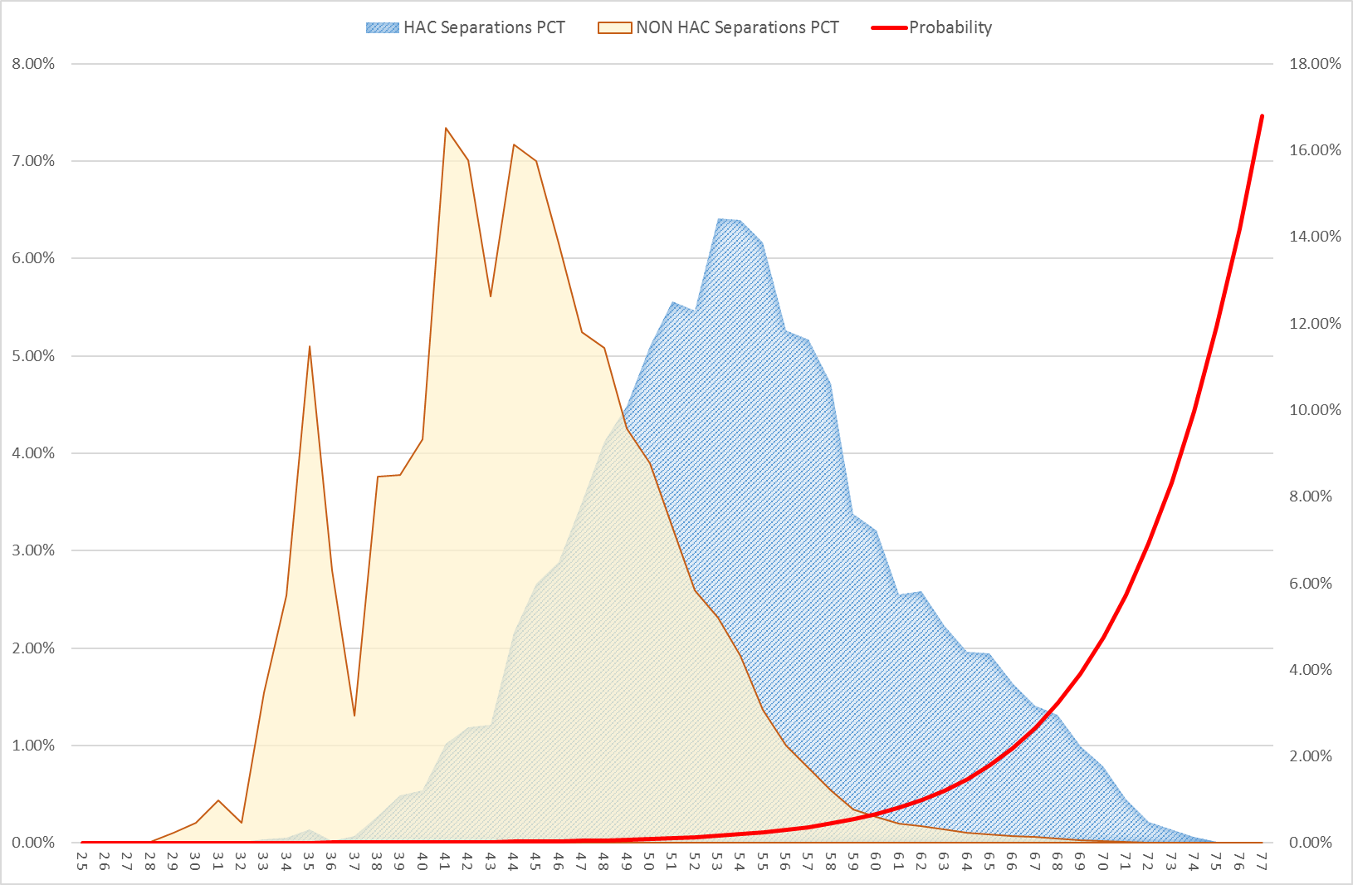

## Grouping of complexity scores

A range of complexity groups were investigated in order to provide balance between having enough volume of data for each grouping, the separation between the cut-off points for each group and the distribution of complexity scores for HAC separations. A range of options were tested, including two, three, five, eight and ten complexity groups. Three complexity groupings of ‘low’, ‘moderate’ and ‘high’ have been adopted to provide an optimal balance between complexities, risk homogeneity and sample size within each group. Due to the small cohort for HAC15.02, only two complexity groupings of ‘low’ and ‘high’ have been adopted.

The complexity bounds for each group were determined by first calculating the cumulative distribution of probability-weighted episodes for episodes with a HAC. The cut off points are calculated as the complexity score that divides the cumulative distribution into three quantiles with the following additional criteria:

* A minimum of 100 episodes must be contained within each complexity group.
* The ratio between probabilities between each group must be at least 1.2.

Figure 3 overlays the complexity bounds selected for HAC10 (medication complications) and the corresponding probabilities for each complexity group in the final selected groupings.

**Figure 3**: HAC10 – Medication complications – Complexity bounds

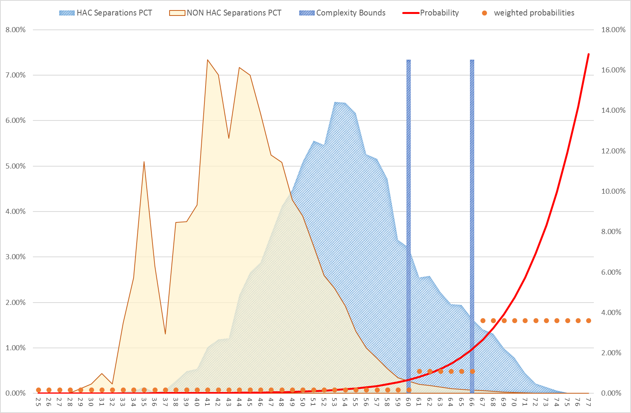

See **Appendix B** for the complete breakdown of complexity scores for each HAC complexity model.

# Incremental cost of a HAC

## Overview

The funding approach for HACs requires that the funding level for all HACs across every hospital be reduced to reflect the extra cost of a hospital admission with a complication. This additional cost may be as a result of a more complex episode of stay or due to an increase in the length of stay than would have otherwise occurred.

It is necessary then to determine the value of only the *incremental* cost relating to the HAC and use this as the basis of the funding adjustment. There are a number of challenges to this:

In episodes that contain a HAC, it is impossible to identify from the NHCDC data what components of the cost directly result from the HAC.

The presence of a HAC may increase the length of stay, but it is impossible to determine the additional length of stay directly attributable to the HAC in the current data collections as there is no record of the date that the HAC occurred.

The presence of a HAC may increase the complexity of an episode (resulting in a more complex DRG) and this may confound analysis to determine the incremental cost and how an episode should be classified.

The following sections describe the methodology used to determine the incremental cost of a HAC and present the resulting factors for use in the funding adjustment.

## Methodology

The methodology used to determine the incremental cost of a HAC uses similar principles to that adopted for the national cost models, in that it uses linear regression to predict the cost of an episode. The episode’s DRG and length of stay were adopted in the predictive model as these characteristics represented the most significant cost drivers. Other drivers of avoidable costs included in the national cost models, for example, remoteness and Indigenous status were not included to retain simplicity. These cost drivers may be considered in future refinements of the model.

Three years of activity and cost data were used for the incremental cost model and they were fit using untrimmed episodes only (Section 2.3). The approach taken to determining the incremental cost can be summarised in the following steps:

1. A ‘best fit’ model was developed using a length of stay by DRG linear regression to predict the cost of *non-HAC episodes* only. This model provides the best estimate for a cost of an episode with no HAC occurrence.
2. The modelled parameters were then applied to HAC episodes (by DRG and length of stay) to calculate a predicted cost for HAC episodes based on the non-HAC information. This is the cost predicted for the HAC episode with the same DRG and length of stay, but assuming the HAC was not present.
3. A cost ratio was then calculated to compare actual in-scope cost to the predicted cost for the HAC episodes.

$$\text{Cost} \text{ratio} \text{=} \frac{\text{Actual} \text{in}\text{-}\text{scope} \text{cost}}{\text{Predicted} \text{cost}}$$

Under the hypothesis that a HAC leads to greater cost, it would be expected that the actual in‑scope cost of a HAC episode would be greater than one predicted for a non-HAC episode with the same DRG and length of stay. This would result in a cost ratio which is greater than 1.0 for HAC episodes.

This cost ratio formed the basis of the incremental cost calculation and was carried out for all HAC episodes in aggregate, as well as each HAC group separately to determine whether the incremental cost varied between HAC groups.

This approach was considered appropriate because of its relative simplicity, using a ‘best fit’ model that takes into account the main drivers of cost. Before finalising the incremental cost adjustments, some further adjustments were required to improve the overall all results of the model.

## Further adjustments

Developing the cost ratios for each HAC group, a number of further challenges were discovered, which required adjustments to the modelled incremental costs.

### Low volume DRGs and cost ratios less than 1

The overall HAC rates observed in the activity data were low, and therefore, using a model fit by DRG meant that HAC rates were very volatile by DRG. Furthermore, some DRGs also had a low volume of non-HAC episodes, resulting in greater uncertainty in the modelled parameters.

This resulted in some DRGs where the cost ratio of HAC episodes was less than 1.0, even though at an aggregate and HAC group level the cost ratio indicated that HAC separations cost more than non-HAC episodes. In addition to this, some DRGs had many more HAC episodes compared to non-HAC episodes (for example some of the obstetrics DRGs) which skewed the results for the HAC group related to perineal laceration during delivery.

As a result, the decision was made to trim DRGs where the cost ratio was below 1.0 and calculate the cost ratio for the HAC group on the remaining DRGs.

### Treatment of HAC02: Falls resulting in fracture or intracranial injury and HAC12: Persistent incontinence

These HACs had a very low number of HAC episodes and the resulting incremental cost calculations were therefore less robust than the other HAC groups. In particular, the incremental cost for HAC episodes, running the model above, was very close to 1.0. The decision was made to consider an alternative approach for these HAC groups which involved regrouping the DRG as if the HAC had not occurred. As described above, the presence of a HAC has the potential to increase the complexity of the episode, increasing the complexity of the DRG. This could result in that episode being compared to significantly more costly episodes which were in that DRG for reasons other than the HAC.

Therefore, rather than applying the parameters from the ‘best fit’ model according to the recorded DRG, the parameters for the regrouped (and potentially less complex) DRG model were applied. This resulted in a lower predicted cost, and all else being equal, a potentially higher cost ratio.

The argument could be made that the ‘best fit’ model should be parameterised using regrouped DRGs for all HAC groups. However, current price weights for the DRGs are developed using a mix of HAC and non-HAC episodes for that DRG and accordingly, the funding adjustment should be calibrated using the same DRG assignments.

### Treatment of HAC15.02: Fourth degree perineal lacerations during delivery

When a HAC15.02 occurs, the DRG is usually changed to account for the new diagnosis. As a result, the cost of an episode with and without a HAC15.02 cannot be easily compared, as such the incremental cost of the HAC cannot be measured without regrouping the DRG as if the HAC had not occurred.

Therefore, rather than applying the parameters from the ‘best fit’ model according to the recorded DRG, the parameters for the regrouped DRG model were applied. This resulted in a more accurate predicted cost and a more fitting cost ratio.

## Results

Table 10 shows the incremental costs for all HACs, as well as by HAC group, using the trimmed DRG and other adjustments as described in Section 6.3.

**Table 10**: Incremental cost adjustments by HAC group

|  |  |  |  |
| --- | --- | --- | --- |
| **Complication** | | **Final incremental cost** | **Adopted adjustment** |
|  | All HACs | 8.7% | 8.0% |
| 1 | Pressure injury | 12.3% | 10.9% |
| 2 | Falls resulting in fracture or other intracranial injury | 3.0% | 2.9% |
| 3 | Healthcare associated infection | 8.6% | 7.9% |
| 4 | Surgical complications requiring unplanned return to theatre | 12.1% | 10.8% |
| 5 | Unplanned intensive care unit admission | n/a | n/a |
| 6 | Respiratory complications | 14.4% | 12.6% |
| 7 | Venous thromboembolism | 10.1% | 9.2% |
| 8 | Renal failure | 21.8% | 17.9% |
| 9 | Gastrointestinal bleeding | 9.0% | 8.2% |
| 10 | Medication complications | 10.6% | 9.6% |
| 11 | Delirium | 10.1% | 9.2% |
| 12 | Persistent incontinence | 7.2% | 6.7% |
| 13 | Malnutrition | 8.1% | 7.5% |
| 14 | Cardiac complications | 11.8% | 10.5% |
| 15.01 | Third degree perineal laceration during delivery | n/a | n/a |
| 15.02 | Fourth degree perineal laceration during delivery | 47.7% | 32.3% |
| 16 | Neonatal birth trauma | n/a | n/a |
| Note: figures have been rounded to 1 decimal place | | |

Due to difficulty in constructing robust risk adjustment models, HAC16 Neonatal birth trauma and HAC15.1 Third degree perineal laceration during delivery were not considered for the funding adjustments.

The final incremental costs for each HAC are then converted into adjustments which will be applied to the NWAU through the use of the formula:

$$\text{Adjustment} \text{=} \text{1} \text{-} \frac{\text{1}}{\text{1} \text{+} \text{Incremental} \text{cost}}$$

The application of the funding calculation is explained in detail in [**Section 8**](#_Funding_adjustment).

# Dampening factors

## Overview

The 29 August 2016 Direction to IHPA stated that pricing and funding approaches should balance the likelihood that some patients will be at higher risk of experiencing an adverse event. This has been addressed by the construction of dampening factors that vary depending on the episode’s complexity, or risk, of a particular HAC occurring.

The episode’s complexity group (low moderate or high, as defined in Section 5.3) is used to risk adjust the reduction. For example, an older patient admitted through emergency, and hence a higher probability of having a HAC, would not have as great a price reduction as a younger patient with a planned admission, and hence a lower probability of having the same HAC.

This section outlines the methodology adopted by IHPA to derive the dampening factors for each HAC. Dampening factors adjust the funding reduction for an episode containing a HAC on the basis of the risk of that patient acquiring a HAC. Without dampening, episodes with higher complexity scores would be penalised the same amount for the same HAC as those with a lower complexity score (by the incremental cost adjustment for the corresponding HAC as discussed in Section 6.4). This goes against the intent of the pricing for safety and quality and therefore, dampening factors have been developed to adjust for the differences in risk of the patient profiles for different hospitals.

In preliminary modelling, dampening factors were determined through age alone. As a more refined risk model was developed, this also necessitated the refinement of the methodology used to calculate the dampening factors.

Dampening factors are represented as a set of percentage scores for each complexity group which is applied multiplicatively to the percentage reduction in NWAU (i.e. the lower dampening factor applied the smaller the reduction in NWAU). Table 11 provides an illustrative example.

**Table 11**: Example - Dampening factor calculations

| Complexity Group | Reduction in NWAU  (a) | Dampening Factor  (b) | Funding Impact’  (c) = (a) x (b) |
| --- | --- | --- | --- |
| Low | -10% | 100% | -10% |
| Moderate | -10% | 50% | -5% |
| High | -10% | 20% | -2% |

Table 11 shows that all episodes receive the same percentage reduction in NWAU, which would be the case if the episodes had the same HAC. However, by varying the dampening factor, episodes within each group vary as follows:

* Low complexity group receives a 10 per cent reduction in NWAU.
* Moderate complexity group receives a 5 per cent reduction in NWAU.
* High complexity group receives a 2 per cent reduction in NWAU.

A number of different dampening factor methodologies were tested, considering variations on the number of complexity groupings and methods to determine the relative probability of a HAC derived from the risk adjustment model.

## Methodology

The dampening factors were derived by assessing the differences between the cost profiles between HAC and non-HAC cohorts in each complexity group. Figure 4 illustrates the cost profile for HAC10: Medical Complications.

**Figure 4**: HAC10 Medical Complications - Cost profile analysis

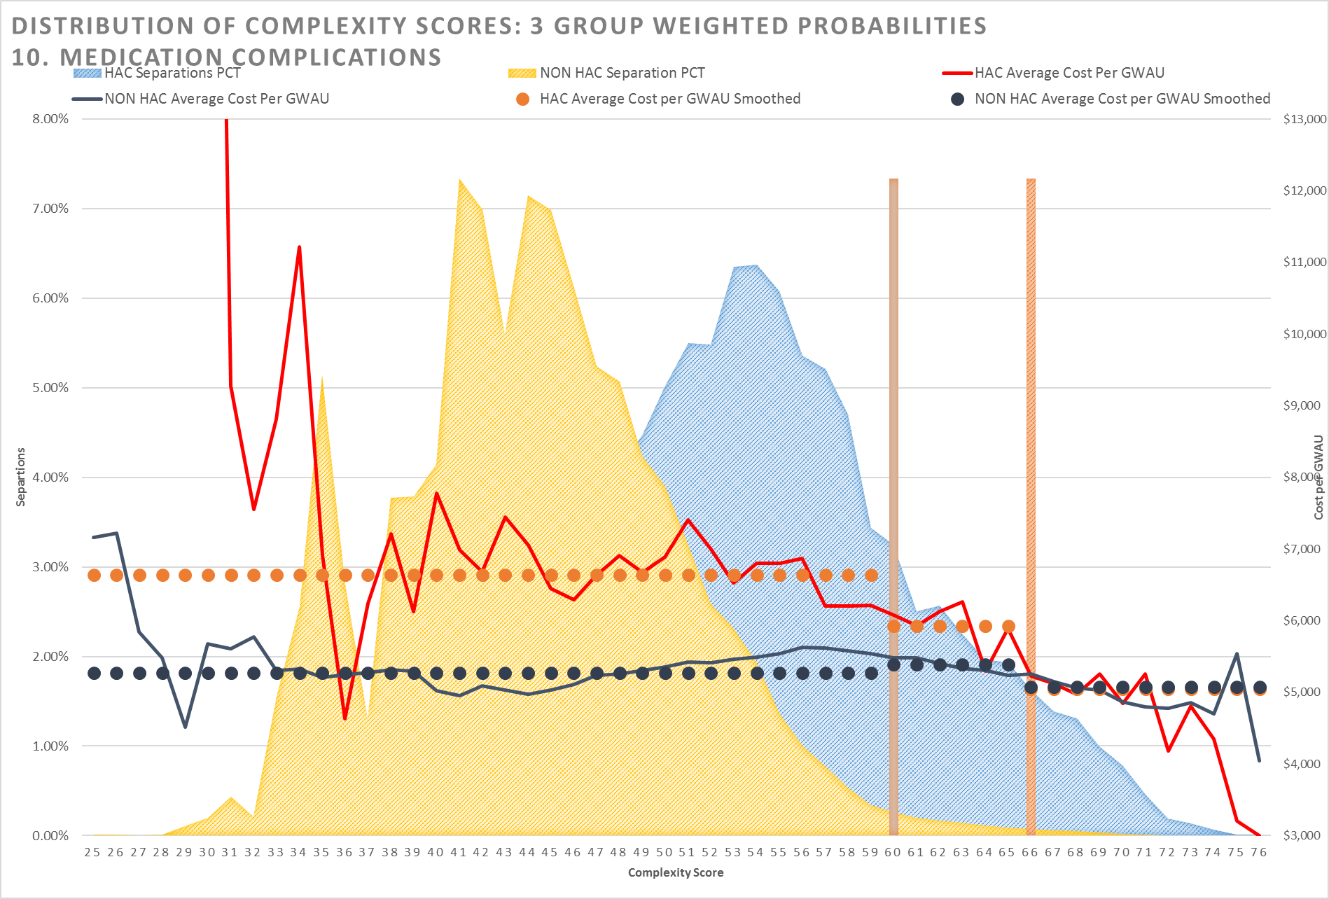

Figure 4 shows the cost differential between HAC and non-HAC cohorts. The red lines show the average cost per Gross Weighted Activity Unit (GWAU) for the HAC cohorts (the dotted line representing a smoothed average cost within the complexity group). The blue lines show the equivalent average cost per GWAU for the non-HAC cohorts. The NEP21 Determination was used to calculate the GWAU.

It was observed that the differential between the HAC and non-HAC cohorts differed depending on the complexity group, and that this differential reduced as the complexity increased (as demonstrated by the converging lines).

The differentials in the average cost per GWAU form the basis for determining the dampening factors in the following way:

Episodes belonging to the lowest complexity group receive no dampening, that is, these episodes receive the full funding adjustment for that HAC.

The dampening factors for episodes that are in moderate or high complexity group are calculated by dividing the cost differential in that group by the cost differential in the lowest complexity group. That is, the cost differential in the lowest complexity group are used as a benchmark against which the moderate and high complexity groups are compared.

Table 12 shows an example calculation of the dampening factors and final adjustment to be applied for HAC10 Medical Complications. The dampening factor is calculated by using the cost differential for the lowest complexity group as a benchmark. These are then multiplied by the incremental cost adjustment for this HAC (9.6 per cent) to derive the final adjustment.

**Table 12**: Dampening factor calculation for HAC10 Medical Complications

| Complexity Group | $$\text{\%}\frac{\text{HAC} \text{cost} \text{profile}}{\text{non-HAC} \text{cost} \text{profile}}-1$$ | Dampening factor | Adjustment after dampening |
| --- | --- | --- | --- |
| Low | $$\frac{\text{ LINK Excel.Sheet.12 "\backslash \backslash \backslash \backslash IHPAPORTAL\backslash \backslash SharedFolder\backslash \backslash Working\backslash \backslash 007 NEP22\backslash \backslash 10 Safety and Quality\backslash \backslash 05 Technical Specifications\backslash \backslash HAC Tech Specs input.xlsx" "Tables!R31C3" \backslash f 4 \backslash r \backslash * MERGEFORMAT }\text{\$6,629}}{\text{\$5.257}} \text{- 1 =} \text{26.1\%} \text{ LINK Excel.Sheet.12 "\backslash \backslash \backslash \backslash IHPAPORTAL\backslash \backslash SharedFolder\backslash \backslash Working\backslash \backslash 007 NEP22\backslash \backslash 10 Safety and Quality\backslash \backslash 05 Technical Specifications\backslash \backslash HAC Tech Specs input.xlsx" "Tables!R31C5" \backslash t }$$ | $$\frac{\text{26.1\%}}{\text{26.1\%}}\text{ = 1.0000}$$ | 1.0000 x 0.096 = 0.096 |
| Moderate | $$\frac{\text{\$5,926}}{\text{\$5,376}} \text{- 1 = 10.}\text{2}\text{\%}$$ | $$\frac{\text{10.}\text{2}\text{\%}}{\text{26.1\%}}\text{ = 0.392}\text{3}$$ | 0.3923 x 0.096 = 0.037 |
| High | $$\frac{\text{\$5,089}}{\text{\$5,071}} \text{- 1 = 0.4\%}$$ | $$\frac{\text{0.4\%}}{\text{26.1\%}}\text{ = 0.01}\text{37}$$ | 0.0137 x 0.096 = 0.001 |

## Results

Table 13 summarises the quantile cut off points, dampening factors and adjustment factors for each of the HAC groups.

The cut off points represent the lowest complexity score required to be assigned to a complexity group. For example, for medication complications, episodes with a complexity score:

* Greater than or equal to 66 are assigned to the high complexity group.
* Greater than or equal to 60, and less than 66, are assigned to the moderate complexity group.
* Less than 60 are assigned to the low complexity group.

The sizes of the dampening factors are derived from empirically observed cost differentials and as such, the dampening factors can vary between the different complexity and HAC groups.

**Table 13**: Final adopted quantile cut off points, dampening factors and adjustments after dampening

|  |  |  |  |  |  |  |  |  |  |  |  |  |  |  |
| --- | --- | --- | --- | --- | --- | --- | --- | --- | --- | --- | --- | --- | --- | --- |
| **Complexity Groups** | **1. Pressure injury** | **2. Falls resulting in fracture or other intracranial injury** | **3. Healthcare associated infection** | **4. Surgical complications requiring unplanned return to theatre** | **6. Respiratory complications** | **7. Venous thromboembolism** | **8. Renal failure** | **9. Gastrointestinal bleeding** | **10. Medication complications** | **11. Delirium** | **12. Persistent incontinence** | **13. Malnutrition** | **14. Cardiac complications** | **15.02 Fourth degree perineal tears** |
| **Quantile cut off points** | | | | | | | | | | | | | | |
| **Low** | 1 | 1 | 1 | 1 | 1 | 1 | 1 | 1 | 1 | 1 | 1 | 1 | 1 | 1 |
| **Moderate** | *65* | 55 | 74 | 73 | 76 | 65 | 84 | 62 | 60 | 73 | 54 | 66 | 74 |  |
| **High** | 73 | 62 | 82 | 76 | 81 | 70 | 85 | 68 | 66 | 79 | 63 | 72 | 78 | 56 |
| **Dampening Factors** | | | | | | | | | | | | | | |
| **Low** | 1.0000 | 1.0000 | 1.0000 | 1.0000 | 1.0000 | 1.0000 | 1.0000 | 1.0000 | 1.0000 | 1.0000 | 1.0000 | 1.0000 | 1.0000 | 1.0000 |
| **Moderate** | 0.6010 | 0.8249 | 0.7520 | 0.6120 | 0.5786 | 0.7593 | 0.3247 | 0.8343 | 0.3923 | 0.7160 | 0.8161 | 0.8784 | 0.7034 |  |
| **High** | 0.5277 | 0.7565 | 0.6063 | 0.4568 | 0.2530 | 0.5464 | 0.2830 | 0.6335 | 0.0137 | 0.5414 | 0.6404 | 0.6970 | 0.4949 | 0.7275 |
| **Adjustments** | | | | | | | | | | | | | | |
| **Low** | 10.9% | 2.9% | 7.9% | 10.8% | 12.6% | 9.2% | 17.9% | 8.2% | 9.6% | 9.2% | 6.7% | 7.5% | 10.5% | 32.3% |
| **Moderate** | 6.6% | 2.4% | 5.9% | 6.6% | 7.3% | 7.0% | 5.8% | 6.9% | 3.7% | 6.6% | 5.5% | 6.6% | 7.4% |  |
| **High** | 5.8% | 2.2% | 4.8% | 4.9% | 3.2% | 5.0% | 5.1% | 5.2% | 0.1% | 5.0% | 4.3% | 5.2% | 5.2% | 23.5% |

# Funding adjustment

## Overview

This section outlines the methodology that was adopted to combine the incremental cost of a HAC (Section 6) and dampening factors (Section 7) into a set of funding adjustments. The funding adjustments are ultimately applied as a percentage reduction to the NWAU for an episode where a HAC is present.

These adjustments also take into account the complexity profile of each episode as they are modified for each complexity group (low, moderate or high) to ensure an equitable adjustment to public hospitals relative to their patient risk profile.

## Methodology

The following steps are used to determine the adjustment:

1. Calculate the overall complexity score for each HAC in an episode by summing the complexity scores derived from each risk factor variable relevant to each HAC (Section 5.2).
2. Assign a complexity group for each HAC based on the complexity score using the quantile cut off points.
3. Apply the adjustment relevant to each HAC based on the assigned complexity group. If an episode contains more than one HAC, then the maximum adjustment is used for the funding adjustment (regardless of the complexity of the HAC).
4. Calculate the final safety and quality adjusted NWAU as:

$$\text{Adjusted} \text{NWAU} \text{=} \text{NWAU} \text{-} \text{base} \text{price} \text{weight} \text{×} \text{adjustment} \text{factor}$$

As discussed in Section 5, it is possible for an episode to have a different complexity score relating to each different HAC. Furthermore, since each HAC group has a different set of quantile cut off points it is possible for the same episode to be considered a low complexity group for one HAC and a moderate or high complexity for another HAC. Thus, in step c above, the final adjustment that is applied does not necessarily belong to the highest complexity, but rather the maximum adjustment.

Table 14 presents an example of how the adjustment factor is calculated for an episode with more than one HAC.

**Table 14**: Example calculation of adjustment factor for an episode with more than one HAC

|  |  |  |  |
| --- | --- | --- | --- |
| **HACs present** | **Complexity score** | **Complexity group** | **Adjustment after dampening** |
| HAC06: Respiratory complications | 75 | Low | 12.6% |
| HAC10: Medication complications | 76 | High | 0.1% |
| Selected adjustment |  |  | 12.6% |

Even though the episode was considered as high complexity for HAC10, the adjustment for HAC06 was greater and therefore selected for the adjustment. This assessment is performed on an episode level for all HAC episodes.

The adjustments have been designed and calculated at an episode level allowing for aggregation to a jurisdiction, LHN or hospital level to determine the aggregate impact. The issues and other considerations of developing a funding adjustment for safety and quality are discussed further in Section 9.1.

## Vignettes

The following clinical examples demonstrate the application of the risk adjustment model and funding adjustments to individual episodes.

### Case one: falls resulting in fracture or intracranial injury – low risk

A 27 year old female patient was a booked admission to day-surgery for a cholecystectomy. She had no comorbid conditions. Following the surgery, she fell off the bed in the ward, hitting her head on the floor. A computed tomography (CT) scan showed a subdural haematoma. The patient remained in hospital for further treatment and surgery.

Table 15 breaks down the complexity and adjustment calculations for case one.

**Table 15**: Case one breakdown: HAC02 Falls resulting in fracture or intracranial injury

|  |  |  |
| --- | --- | --- |
| **Complexity score calculations** | | |
| **Risk factor breakdown** | | **Complexity Score** |
|  | *Baseline* | 28.2947 |
|  | *Age Group: 025 to 029* | 0.0000 |
|  | *Charlson Score = 0* | 0.0000 |
|  | *DRG Type: Intervention* | 4.1479 |
|  | *Gender: Female* | 0.6804 |
|  | *MDC: Diseases & Disorders of the Hepatobiliary System & Pancreas* | -2.8607 |
|  | *Emergency admission: No* | 0.0000 |
|  | *ICU Hours: No* | 0.0000 |
|  | *Admission transfer status: No* | 0.0000 |
| **Total** | | **30** |
| **Adjustment calculations** | | |
|  | Complexity group | Low |
|  | Maximum adjustment | 2.9% |
|  | Dampening | 1.0000 |
| **Final adjustment** | | **2.9%** |

As illustrated from the above table, an episode in the ‘low risk’ category for this HAC is subject to a negative funding adjustment equivalent to 2.9 per cent of the funding for this episode of care.

### Case two: falls resulting in fracture or intracranial injury – moderate risk

The patient is a 73 year old male who was admitted through emergency for acute shortness of breath. The patient has a background of ischaemic heart disease, myocardial infarction, hypertension, peripheral vascular disease and type 2 diabetes managed with oral medication.

The patient was transferred to the ICU for non-invasive ventilation due to pneumonia before being transferred to the ward seven days later. While on the ward, the patient slipped and fell heavily while in the shower, resulting in a fracture of the lumbar vertebra L4-L5.

The fracture was managed conservatively and the patient was discharged home 12 days following admission. Table 16 breaks down the complexity and adjustment calculations for case two.

**Table 16**: Case two breakdown: HAC02 Falls resulting in fracture or intracranial injury

|  |  |  |
| --- | --- | --- |
| **Complexity score calculations** | | |
| **Risk factor breakdown** | | **Complexity Score** |
|  | *Baseline* | 28.2947 |
|  | *Age Group: 070 to 074* | 8.8804 |
|  | *Charlson Score = 3* | 7.2845 |
|  | *DRG Type: Intervention* | 4.1479 |
|  | *Gender: Male* | 0.0000 |
|  | *MDC: Diseases & Disorders of the Respiratory System* | -3.7964 |
|  | *Emergency admission: Yes* | 7.7604 |
|  | *ICU Hours: Yes* | 3.9863 |
|  | *Admission transfer status: No* | 0.0000 |
| **Total** | | **57** |
| **Adjustment calculations** | | |
|  | Complexity group | Moderate |
|  | Maximum adjustment | 2.9% |
|  | Dampening | 0.8249 |
| **Final adjustment** | | **2.4%** |

As illustrated from the above table, an episode in the ‘moderate risk’ category for this HAC is subject to a negative funding adjustment equivalent to 2.4 per cent of the funding for this episode of care.

### Case three: falls resulting in fracture or intracranial injury – high risk

The patient is an 87 year old female who was admitted to hospital via the emergency department with a principal diagnosis of stroke. The patient has a background of dementia, cirrhosis of the liver, chronic renal failure, chronic obstructive pulmonary disease and type 2 diabetes managed with insulin.

The patient was treated conservatively. On the second day of her admission she fell while trying to take herself to the bathroom unsupervised, which resulted in a fractured neck of femur. A total hip replacement was performed. The patient was discharged to her residential aged care accommodation 25 days following admission. Table 17 breaks down the complexity and adjustment calculations for case three.

**Table 17**: Case three breakdown: HAC02 Falls resulting in fracture or intracranial injury

|  |  |  |
| --- | --- | --- |
| **Complexity score calculations** | | |
| **Risk factor breakdown** | | **Complexity Score** |
|  | *Baseline* | 28.2947 |
|  | *Age Group: 085 to 089* | 13.4860 |
|  | *Charlson Score = 7* | 10.3298 |
|  | *DRG Type: Medical* | 0.0000 |
|  | *Gender: Female* | 0.6804 |
|  | *MDC: Diseases & Disorders of the Nervous System* | -0.5160 |
|  | *Emergency admission: Yes* | 7.7604 |
|  | *ICU Hours: Yes* | 3.9863 |
|  | *Admission transfer status: No* | 0.0000 |
| **Total** | | **64** |
| **Adjustment calculations** | | |
|  | Complexity group | High |
|  | Maximum adjustment | 2.9% |
|  | Dampening | 0.7565 |
| **Final adjustment** | | **2.2%** |

As illustrated from the above table, an episode in the ‘high risk’ category for this HAC is subject to a negative funding adjustment equivalent to 2.2 per cent of the funding for this episode of care.

# Issues and other considerations

## Treatment of episodes with multiple HACs

IHPA initially undertook investigations to determine whether the presence of a second HAC could be used as a variable in the risk adjustment model. However, this approach could not be progressed given that it is not possible to determine which HAC occurred first from the episode data, as well as the issues addressed in Section 4.3.1.

IHPA also considered whether the presence of multiple HACs could be addressed through a funding approach. An additive funding approach was evaluated, where the funding adjustment for each HAC that occurred is deducted from the NWAU of an episode. For example, if both a healthcare associated infection and a medication complication occurred within a moderate complexity episode of care, the NWAU would be reduced by 5.9 + 3.7 = 9.6 per cent. This approach assumes that HACs occur independently, which is not the case and therefore found to overly penalise episodes with more than one HAC.

IHPA then considered developing a model where the funding adjustment for episodes with multiple HACs would be scaled depending on the underlying correlation of one HAC to another. It was decided that the additional complexity of this approach was not warranted given the expected minimal funding impact.

Funding impacts have therefore been calculated using the HAC that results in the highest funding adjustment for an episode (see Section 8.2), with the additional costs of other HACs not considered in the funding adjustment.

Appendix A: ROC curves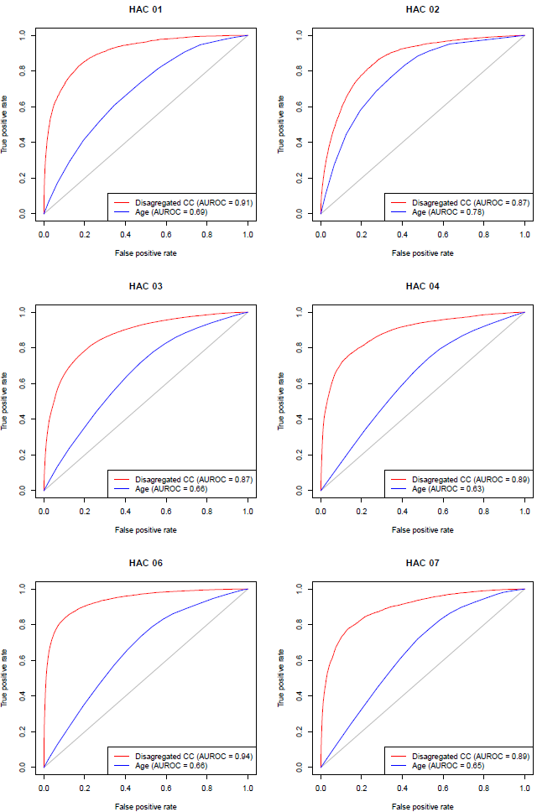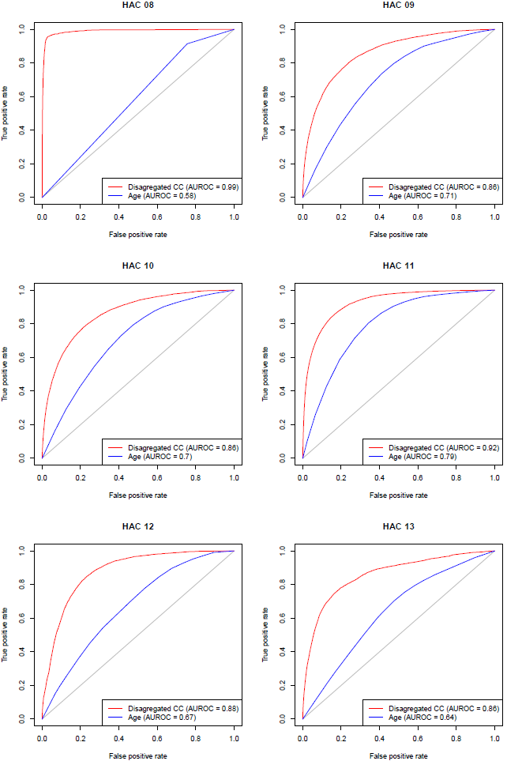

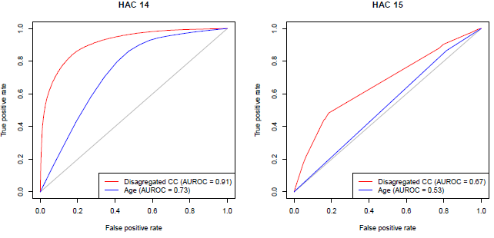

Appendix B: Complexity scores

**Table 18**: Complexity scores for HAC01 to HAC14 logistic regression model

|  |  |  |  |  |  |  |  |  |  |  |  |  |  |
| --- | --- | --- | --- | --- | --- | --- | --- | --- | --- | --- | --- | --- | --- |
| **Groups** | **1. Pressure injury** | **2. Falls resulting in fracture or intracranial injury** | **3. Healthcare associated infection** | **4. Surgical complications requiring unplanned return to theatre** | **6. Respiratory complications** | **7. Venous thromboembolism** | **8. Renal failure** | **9. Gastrointestinal bleeding** | **10. Medication complications** | **11. Delirium** | **12. Persistent incontinence** | **13. Malnutrition** | **14. Cardiac complications** |
| **Baseline** | **44.9032** | **28.2947** | **56.8520** | **50.2544** | **51.1954** | **37.9232** | **35.5166** | **44.1210** | **39.4162** | **44.5057** | **35.6105** | **48.7251** | **46.5584** |
|  |  |  |  |  |  |  |  |  |  |  |  |  |  |
| **Emergency admission** | 4.8376 | 7.7604 | 3.8284 | 0.4094 | 3.4379 | 3.5507 | 0.8331 | 3.2297 | 4.0616 | 3.8751 | 4.5452 | 4.5325 | 1.2260 |
| **ICU Hours** | 8.7305 | 3.9863 | 9.9714 | 11.0034 | 14.5293 | 10.6923 | 33.0186 | 7.4366 | 8.7516 | 10.0895 | 8.2095 | 6.3257 | 12.1794 |
| **Admission Transfer Status** | 2.2868 | 0.9602 | 1.5566 | 1.1905 | 0.5206 | 2.7572 | 0.0000 | 1.9830 | 1.2514 | 1.7493 | 1.7003 | 2.1417 | 1.1253 |
|  |  |  |  |  |  |  |  |  |  |  |  |  |  |
| **DRG 10 Type** |  |  |  |  |  |  |  |  |  |  |  |  |  |
| **Medical** | 0.0000 | 0.0000 | 0.0000 | 0.0000 | 0.0000 | 0.0000 | 0.0000 | 0.0000 | 0.0000 | 0.0000 | 0.0000 | 0.0000 | 0.0000 |
| **Intervention** | 6.4374 | 4.1479 | 6.1154 | 11.3413 | 6.4415 | 7.3065 | 9.6384 | 4.4523 | 4.0237 | 7.2585 | 2.6561 | 3.6480 | 6.1435 |
|  |  |  |  |  |  |  |  |  |  |  |  |  |  |
| **Gender** |  |  |  |  |  |  |  |  |  |  |  |  |  |
| **Male** | 0.0000 | 0.0000 | 0.0000 | 0.0000 | 0.0000 | 0.0000 | 0.0000 | 0.0000 | 0.0000 | 0.0000 | 0.0000 | 0.0000 | 0.0000 |
| **Female** | 0.0000 | 0.6804 | 0.5252 | 0.0000 | -1.1842 | 0.3215 | -1.1796 | -0.6342 | 0.3797 | -0.6965 | 0.8421 | 0.0000 | 0.0000 |

|  |  |  |  |  |  |  |  |  |  |  |  |  |  |
| --- | --- | --- | --- | --- | --- | --- | --- | --- | --- | --- | --- | --- | --- |
| **MDC** | **1. Pressure injury** | **2. Falls resulting in fracture or intracranial injury** | **3. Healthcare associated infection** | **4. Surgical complications requiring unplanned return to theatre** | **6. Respiratory complications** | **7. Venous thromboembolism** | **8. Renal failure** | **9. Gastrointestinal bleeding** | **10. Medication complications** | **11. Delirium** | **12. Persistent incontinence** | **13. Malnutrition** | **14. Cardiac complications** |
| **Pre MDC** | 0.0000 | 0.0000 | 0.0000 | 0.0000 | 0.0000 | 0.0000 | 0.0000 | 0.0000 | 0.0000 | 0.0000 | 0.0000 | 0.0000 | 0.0000 |
| **Diseases & Disorders of the Nervous System** | -9.2907 | -0.5160 | -6.7528 | -6.5715 | -7.8142 | -5.7922 | -17.9888 | -6.1008 | -2.1610 | -7.1010 | -5.6186 | -5.9963 | -6.0539 |
| **Diseases & Disorders of the Eye** | -17.6502 | -5.4583 | -21.5611 | -17.5084 | -24.1610 | -22.8754 | -17.9888 | -19.8861 | -14.1098 | -18.6237 | -15.6047 | -5.8167 | -14.6122 |
| **Diseases & Disorders of the Ear, Nose, Mouth & Throat** | -16.2152 | -5.8316 | -12.7960 | -9.1844 | -11.8930 | -11.5357 | -17.9888 | -8.1696 | -7.4463 | -10.2603 | -15.6047 | -8.2341 | -7.3961 |
| **Diseases & Disorders of the Respiratory System** | -9.8774 | -3.7964 | -10.0109 | -5.4160 | -10.4246 | -6.9974 | -17.9888 | -6.0882 | -3.2614 | -8.3175 | -9.7991 | -6.0203 | -3.9288 |
| **Diseases & Disorders of the Circulatory System** | -11.9720 | -5.0765 | -8.5071 | -2.7532 | -11.5506 | -9.3881 | -10.3379 | -6.1034 | -2.8110 | -8.7684 | -12.0867 | -5.6088 | -0.9193 |
| **Diseases & Disorders of the Digestive System** | -12.1388 | -5.6123 | -6.6887 | -4.7718 | -9.3040 | -6.6120 | -19.0547 | -3.4793 | -5.9002 | -9.0868 | -8.3959 | -4.6191 | -5.3319 |
| **Diseases & Disorders of the Hepatobiliary System & Pancreas** | -10.3708 | -2.8607 | -4.8430 | -3.0319 | -9.0412 | -6.4078 | -9.3638 | -1.5776 | -3.5141 | -6.2714 | -7.8356 | -2.5444 | -3.2643 |
| **Diseases & Disorders of the Musculoskeletal System & Connective Tissue** | -5.9302 | -2.2768 | -4.7286 | -0.8660 | -8.6617 | -1.0973 | -13.9665 | -4.2281 | -1.6659 | -2.4866 | -4.2065 | -4.6166 | -2.7692 |
| **Diseases & Disorders of the Skin, Subcutaneous Tissue & Breast** | -10.2372 | -3.7318 | -9.1490 | -5.9640 | -14.1071 | -8.7301 | -17.9888 | -8.7178 | -5.1931 | -10.4747 | -10.8088 | -6.3575 | -7.4808 |
| **Endocrine, Nutritional & Metabolic Diseases & Disorders** | -8.0561 | -1.5982 | -8.1472 | -5.1337 | -11.9328 | -8.0808 | -17.9888 | -5.9816 | -5.8550 | -7.9766 | -7.7971 | 0.2954 | -5.0693 |
| **Diseases & Disorders of the Kidney & Urinary Tract** | -10.4796 | -4.4327 | -7.6672 | -4.6237 | -12.3800 | -7.2275 | -13.9665 | -6.3966 | -5.4172 | -9.4266 | -8.2081 | -4.8611 | -5.1000 |
| **Diseases & Disorders of the Male Reproductive System** | -17.6502 | -5.4583 | -9.8642 | -5.5140 | -14.2704 | -8.9571 | -17.9888 | -8.9808 | -5.8773 | -9.6091 | -4.4883 | -9.3883 | -7.5164 |

|  |  |  |  |  |  |  |  |  |  |  |  |  |  |
| --- | --- | --- | --- | --- | --- | --- | --- | --- | --- | --- | --- | --- | --- |
| **MDC** | **1. Pressure injury** | **2. Falls resulting in fracture or intracranial injury** | **3. Healthcare associated infection** | **4. Surgical complications requiring unplanned return to theatre** | **6. Respiratory complications** | **7. Venous thromboembolism** | **8. Renal failure** | **9. Gastrointestinal bleeding** | **10. Medication complications** | **11. Delirium** | **12. Persistent incontinence** | **13. Malnutrition** | **14. Cardiac complications** |
| **Diseases & Disorders of the Female Reproductive System** | -17.6502 | -5.4583 | -8.7544 | -5.0971 | -14.2704 | -8.9571 | -17.9888 | -11.0616 | -6.1807 | -11.1143 | -6.2741 | -9.3883 | -6.2606 |
| **Pregnancy, Childbirth & the Puerperium** | -15.5057 | -5.4443 | -5.0726 | -3.4535 | -17.2866 | -9.2689 | -17.9888 | -14.5038 | -11.6722 | -16.3644 | 7.7424 | -5.8167 | -4.9722 |
| **Newborns & Other Neonates** | -2.8123 | -5.4443 | 5.9695 | 1.2728 | -9.8839 | -4.4215 | -17.9888 | -3.6265 | -10.3963 | -23.0220 | -17.7029 | -5.8167 | -2.6964 |
| **Diseases & Disorders of Blood, Blood Forming Organs, Immunological Disorders** | -13.0439 | -5.4583 | -7.7387 | -4.8271 | -11.0553 | -6.0176 | -17.9888 | -5.0830 | -8.3184 | -10.5655 | -10.9071 | -6.6710 | -4.5365 |
| **Neoplastic Disorders (Haematological & Solid Neoplasms)** | -8.9170 | -5.0765 | -1.1284 | -3.2100 | -7.4663 | -0.5410 | -10.3379 | -1.5820 | -4.5531 | -6.0040 | -4.5515 | -3.1070 | -2.3539 |
| **Infectious & Parasitic Diseases** | -5.3412 | -1.4627 | -6.6523 | -2.4826 | -9.3913 | -2.5259 | -13.4782 | -2.5061 | -2.4329 | -5.5321 | -6.0856 | -2.6521 | -0.9981 |
| **Mental Diseases & Disorders** | -9.5347 | 1.2243 | -6.7623 | -12.2311 | -10.6002 | -10.0037 | -13.9881 | -6.4593 | 2.3654 | -9.3036 | -6.6387 | -0.7780 | -7.0491 |
| **Alcohol/Drug Use & Alcohol/Drug Induced Organic Mental Disorders** | -17.3143 | 4.2683 | -8.3770 | -9.0909 | -8.3813 | -11.5943 | -14.2243 | -3.7685 | -0.0844 | -8.7774 | -6.6220 | -8.1666 | -6.9849 |
| **Injuries, Poisonings & Toxic Effects of Drugs** | -6.5632 | -0.5160 | -6.0130 | -3.8389 | -6.3743 | -1.0973 | -14.3555 | -6.6233 | -4.8746 | -5.5220 | -6.9609 | -5.1501 | -4.9685 |
| **Burns** | -4.0794 | 4.3321 | -0.9717 | -2.4522 | -4.7153 | -2.5839 | -13.4782 | -5.3371 | -1.5538 | -1.0165 | -8.3959 | -6.0203 | -2.8895 |
| **Factors Influencing Health Status & Other Contacts with Health Services** | -10.7025 | 4.3321 | -8.9494 | -8.6755 | -11.8687 | -8.2731 | -17.9888 | -6.7814 | -5.9542 | -11.2049 | -9.7861 | -6.4763 | -6.4467 |

|  |  |  |  |  |  |  |  |  |  |  |  |  |  |
| --- | --- | --- | --- | --- | --- | --- | --- | --- | --- | --- | --- | --- | --- |
| **Age Group** | **1. Pressure injury** | **2. Falls resulting in fracture or intracranial injury** | **3. Healthcare associated infection** | **4. Surgical complications requiring unplanned return to theatre** | **6. Respiratory complications** | **7. Venous thromboembolism** | **8. Renal failure** | **9. Gastrointestinal bleeding** | **10. Medication complications** | **11. Delirium** | **12. Persistent incontinence** | **13. Malnutrition** | **14. Cardiac complications** |
| **000 to 004** | 0.0000 | 0.0000 | 0.0000 | 0.0000 | 0.0000 | 0.0000 | 0.0000 | 0.0000 | 0.0000 | 0.0000 | 0.0000 | 0.0000 | 0.0000 |
| **005 to 009** | 0.0000 | 0.0000 | -2.1579 | -2.6557 | -2.9816 | -1.6583 | 0.0000 | 0.0000 | 0.0000 | 0.7114 | 0.0000 | 0.0000 | -2.2677 |
| **010 to 014** | 0.6367 | 0.0000 | -1.8098 | -2.0543 | -1.6597 | -1.6583 | 0.0000 | 0.0000 | 0.0000 | 1.3191 | 0.0000 | 0.0000 | -1.6886 |
| **015 to 019** | -0.6279 | 0.0000 | -1.3661 | -1.7851 | 0.3375 | 2.1222 | 0.0000 | 0.0000 | 2.3955 | 1.6261 | 1.9723 | 0.9129 | -1.2168 |
| **020 to 024** | -4.3381 | 0.0000 | -1.4048 | -1.6056 | 1.3229 | 4.0209 | 0.0000 | 0.0000 | 2.6823 | 1.6568 | 1.9723 | 0.9129 | -0.7997 |
| **025 to 029** | -5.0512 | 0.0000 | -1.5591 | -1.5735 | 0.3173 | 4.5060 | 0.0000 | -0.8755 | 1.8551 | 1.6344 | 1.9723 | 0.9129 | -0.4102 |
| **030 to 034** | -3.6456 | 0.0000 | -1.1443 | -1.4100 | 0.6362 | 4.9026 | 0.3620 | 0.2876 | 2.9678 | 2.9274 | 3.9321 | 0.9129 | 0.4163 |
| **035 to 039** | -3.6456 | 0.0000 | -0.6917 | -1.1193 | 0.6249 | 5.5739 | 0.3620 | 0.6142 | 3.1309 | 3.4052 | 4.2260 | 0.7308 | 0.8363 |
| **040 to 044** | -2.0866 | 4.1620 | -0.2958 | -0.4776 | 0.6004 | 5.8614 | 0.3620 | 1.8128 | 3.5332 | 4.5778 | 2.3933 | 0.2421 | 1.6986 |
| **045 to 049** | -1.6357 | 4.1620 | 0.3908 | 0.1748 | 0.7375 | 6.2045 | 0.3620 | 1.6614 | 4.0203 | 5.2361 | 4.4373 | 0.0049 | 2.8362 |
| **050 to 054** | -1.9981 | 4.8874 | 0.7143 | 0.3605 | 1.3198 | 6.0124 | 0.3620 | 1.9375 | 4.1889 | 6.0417 | 4.2193 | 0.3575 | 3.5256 |
| **055 to 059** | -1.2296 | 6.8330 | 1.1344 | 0.5136 | 1.4208 | 6.7657 | 0.3620 | 2.4081 | 4.8790 | 7.2715 | 5.7231 | 0.5812 | 4.9087 |
| **060 to 064** | -1.2296 | 7.6434 | 1.6063 | 0.8957 | 1.8578 | 7.1278 | 0.3620 | 3.0980 | 5.3869 | 8.6291 | 7.3768 | 1.0755 | 5.8649 |
| **065 to 069** | -0.3560 | 7.8745 | 2.0491 | 1.2736 | 2.3873 | 7.3815 | 0.3620 | 3.6615 | 5.9692 | 10.3888 | 8.0727 | 0.9963 | 6.6904 |
| **070 to 074** | 0.1571 | 8.8804 | 2.6122 | 1.4859 | 2.9437 | 7.7663 | 0.3620 | 4.3729 | 6.5845 | 11.9382 | 8.7207 | 0.9809 | 7.4729 |
| **075 to 079** | 1.5634 | 10.3758 | 3.3457 | 1.7178 | 3.8077 | 8.0344 | 0.3620 | 5.2441 | 7.1640 | 13.9677 | 9.8700 | 1.3302 | 8.3591 |
| **080 to 084** | 2.8559 | 12.1691 | 4.3507 | 2.0065 | 4.7582 | 8.1887 | 0.3620 | 6.3233 | 8.2043 | 15.6255 | 10.7589 | 1.5362 | 8.9709 |
| **085 to 089** | 4.2574 | 13.4860 | 5.4697 | 2.8666 | 6.1723 | 8.1131 | 0.3620 | 7.4591 | 8.8608 | 17.2834 | 11.2885 | 1.4144 | 10.1055 |
| **090 to 094** | 5.7562 | 14.4354 | 6.4300 | 3.6790 | 8.1823 | 8.3714 | 0.3620 | 8.0553 | 9.2569 | 18.7946 | 12.0216 | 0.7960 | 11.2789 |
| **095 to 099** | 5.7562 | 14.4354 | 6.4300 | 3.6790 | 8.1823 | 8.3714 | 0.3620 | 8.0553 | 9.2569 | 18.7946 | 12.0216 | 0.7960 | 11.2789 |

|  |  |  |  |  |  |  |  |  |  |  |  |  |  |
| --- | --- | --- | --- | --- | --- | --- | --- | --- | --- | --- | --- | --- | --- |
| **Charlson Score** | **01. Pressure injury** | **02. Falls resulting in fracture or other intracranial injury** | **03. Healthcare associated infection** | **04. Surgical complications requiring unplanned return to theatre** | **06. Respiratory complications** | **07. Venous thromboembolism** | **08. Renal failure** | **09. Gastrointestinal bleeding** | **10. Medication complications** | **11. Delirium** | **12. Persistent incontinence** | **13. Malnutrition** | **14. Cardiac complications** |
| **0** | 0.0000 | 0.0000 | 0.0000 | 0.0000 | 0.0000 | 0.0000 | 0.0000 | 0.0000 | 0.0000 | 0.0000 | 0.0000 | 0.0000 | 0.0000 |
| **1** | 3.3881 | 3.9891 | 3.7281 | 2.4182 | 3.6366 | 2.6534 | 4.4086 | 3.6701 | 3.3779 | 3.2116 | 3.0686 | 4.1889 | 4.7672 |
| **2** | 5.3942 | 5.6715 | 5.9427 | 4.5112 | 4.2449 | 4.6076 | 7.1353 | 5.7534 | 4.9298 | 4.3190 | 4.7095 | 8.7887 | 5.4837 |
| **3** | 7.0613 | 7.2845 | 7.4217 | 5.0329 | 6.5029 | 5.0106 | 8.2176 | 7.9529 | 6.7889 | 6.1446 | 7.3791 | 12.4133 | 7.3144 |
| **4** | 8.2185 | 7.8310 | 8.0167 | 5.5499 | 6.7846 | 5.0106 | 8.9242 | 7.9529 | 7.5568 | 6.1446 | 7.7647 | 12.4133 | 7.6673 |
| **5** | 8.4329 | 8.0226 | 8.1329 | 6.2323 | 5.4872 | 7.1497 | 8.9242 | 7.9529 | 7.2215 | 6.1446 | 7.7647 | 12.2466 | 6.4700 |
| **6** | 9.5176 | 9.9583 | 9.8297 | 6.5886 | 7.6456 | 7.7596 | 8.9242 | 10.1318 | 8.8709 | 7.5876 | 9.4111 | 13.4877 | 9.6909 |
| **7** | 10.6099 | 10.3298 | 10.4990 | 6.7147 | 8.5188 | 8.4734 | 11.9151 | 10.5834 | 8.8823 | 8.7314 | 10.9228 | 14.9338 | 10.6050 |
| **8** | 11.5581 | 10.3298 | 11.4705 | 7.8263 | 9.0061 | 8.0684 | 11.9151 | 12.0304 | 9.5369 | 9.2239 | 12.7097 | 15.6276 | 11.3242 |
| **9** | 11.5581 | 10.3298 | 11.4705 | 7.8263 | 9.0061 | 8.8545 | 11.9151 | 12.0304 | 10.4378 | 9.8717 | 12.1834 | 15.6276 | 11.3242 |
| **10** | 11.5581 | 10.3298 | 13.3333 | 8.1273 | 9.0061 | 8.8545 | 11.9151 | 12.0304 | 9.7218 | 9.9127 | 12.1834 | 15.6276 | 11.3242 |
| **11** | 11.5581 | 10.3298 | 12.5635 | 8.1273 | 10.5861 | 8.8545 | 11.9151 | 12.0304 | 12.6721 | 11.4785 | 12.1834 | 15.6276 | 13.9015 |
| **12** | 11.5581 | 10.3298 | 12.5635 | 8.1273 | 10.5861 | 8.8545 | 11.9151 | 12.0304 | 12.6721 | 11.4785 | 12.1834 | 15.6276 | 13.9015 |
| **13** | 11.5581 | 10.3298 | 12.5635 | 8.1273 | 10.5861 | 8.8545 | 11.9151 | 12.0304 | 12.6721 | 11.4785 | 12.1834 | 15.6276 | 13.9015 |
| **14** | 11.5581 | 10.3298 | 12.5635 | 8.1273 | 10.5861 | 8.8545 | 11.9151 | 12.0304 | 12.6721 | 11.4785 | 12.1834 | 15.6276 | 13.9015 |
| **15** | 11.5581 | 10.3298 | 12.5635 | 8.1273 | 10.5861 | 8.8545 | 11.9151 | 12.0304 | 12.6721 | 11.4785 | 12.1834 | 15.6276 | 13.9015 |
| **16+** | 11.5581 | 10.3298 | 12.5635 | 8.1273 | 10.5861 | 8.8545 | 11.9151 | 12.0304 | 12.6721 | 11.4785 | 12.1834 | 15.6276 | 13.9015 |

**Table 19**: Complexity scores for HAC15.02 logistic regression model

|  |  |
| --- | --- |
| **Groups** | **15.02 Fourth degree perineal tears** |
| **Baseline** | **51.1929** |
|  |  |
| **Emergency admission** | 0.12 |
| **Foetal distress** | -2.0635 |
| **Instrument use** | 8.0877 |
| **PPOP** | 1.2505 |
| **Primigravida** | 0.0346 |
|  |  |
| **Age Group** |  |
| **000 to 015** | 4.2841 |
| **016 to 035** | 0 |
| **035 to 099** | -1.664 |

Appendix C: Complexity bounds

**Figure 5**: HAC01 – Pressure Injury – Complexity bounds

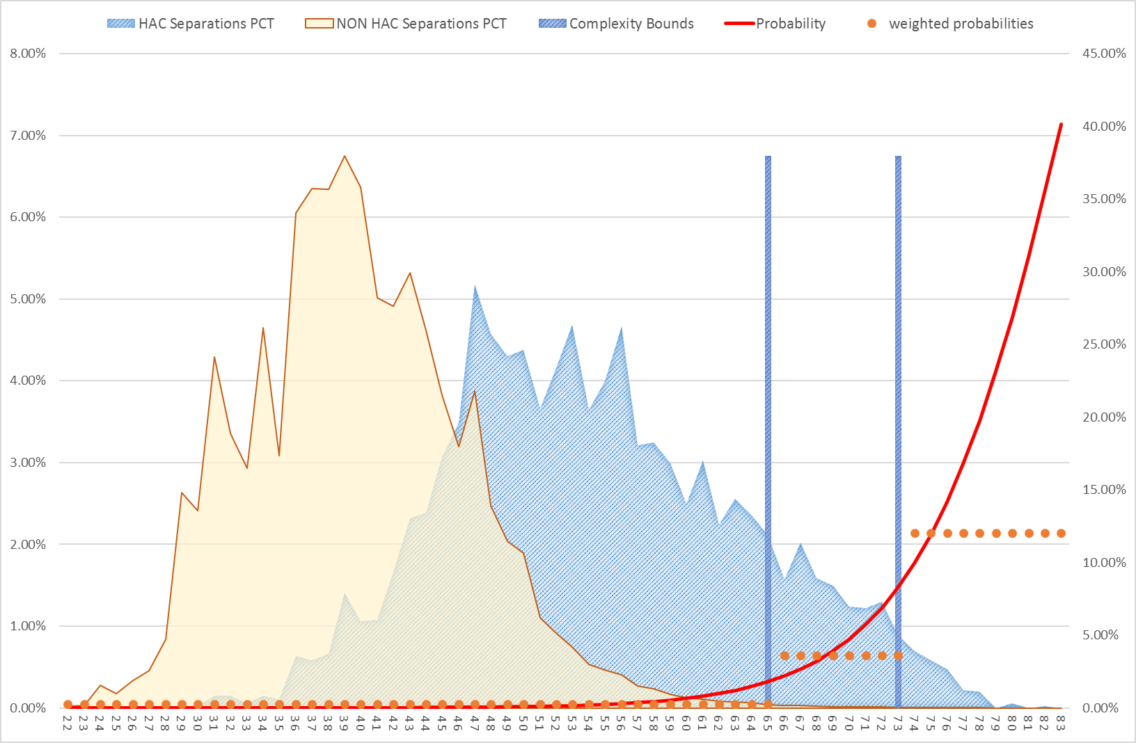

**Figure 6**: HAC02 – Falls resulting in fracture or intracranial injury – Complexity bounds

**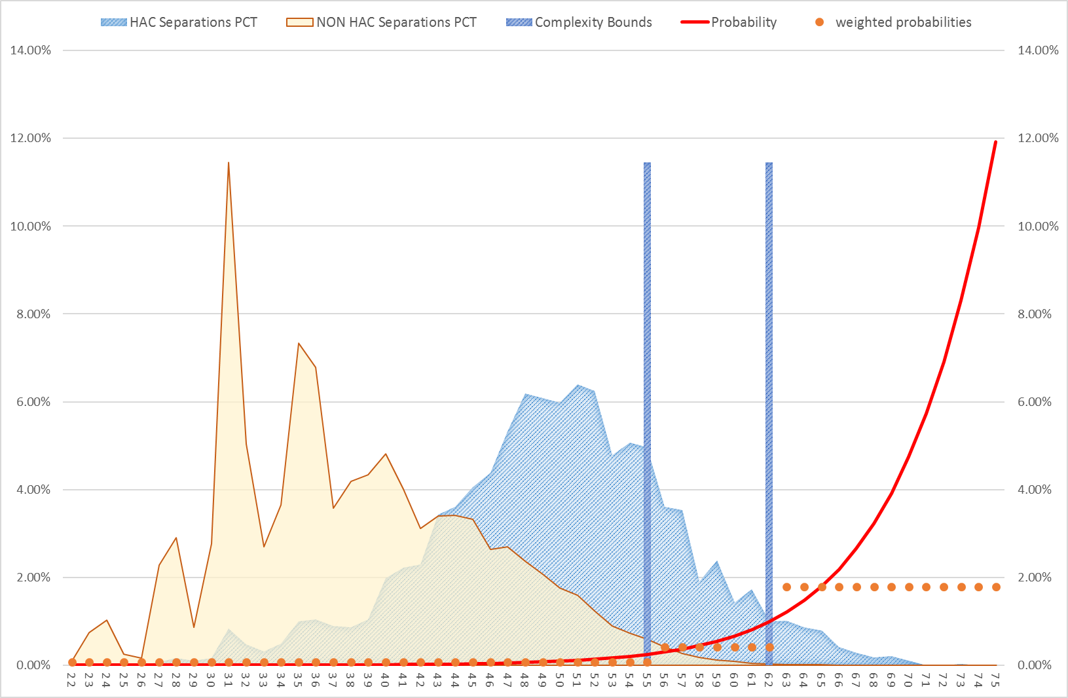**

**Figure 7**: HAC03 – Health care associated infections – Complexity bounds

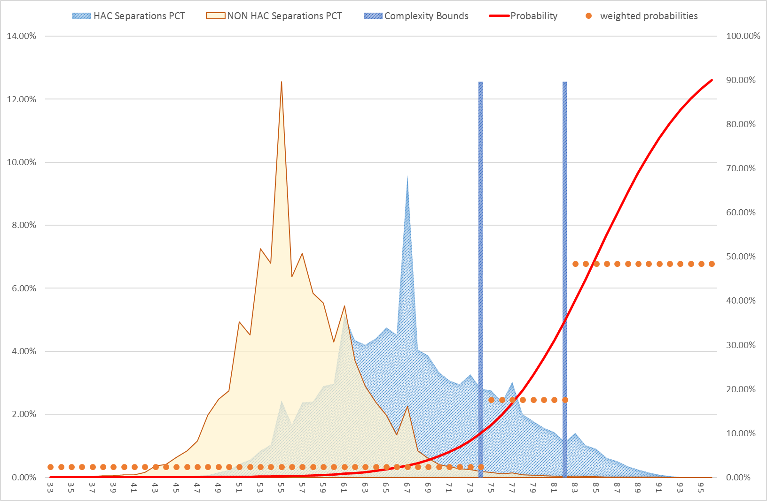

**Figure 8**: HAC04 – Surgical complications requiring unplanned return to theatre – Complexity bounds

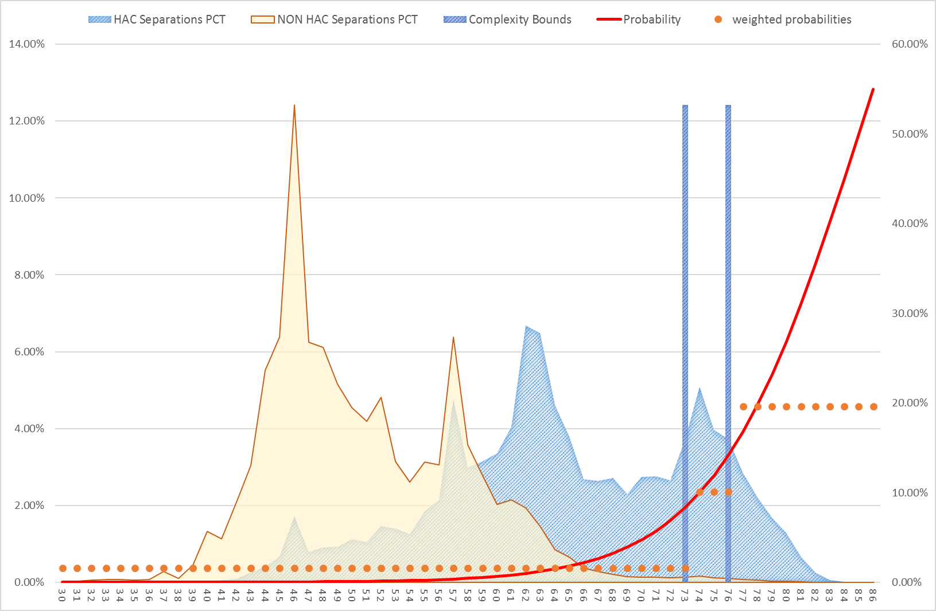

**Figure 9**: HAC06 – Respiratory complications – Complexity bounds

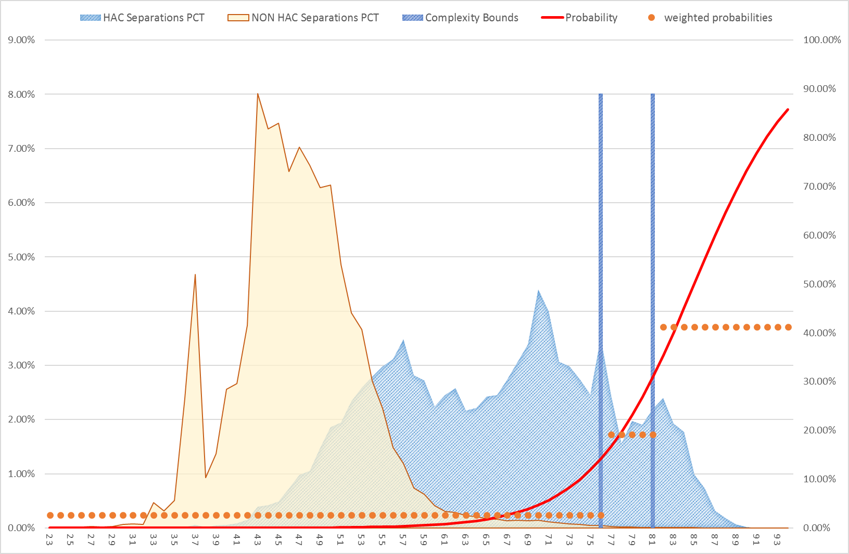

**Figure 10**: HAC07 – Venous thromboembolism – Complexity bounds

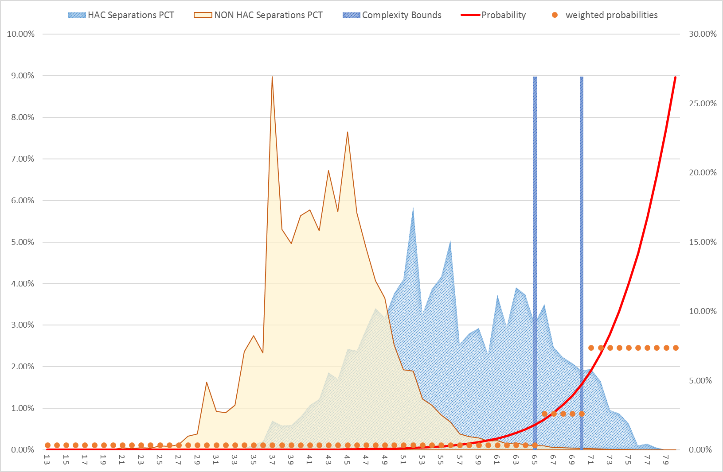

**Figure 11**: HAC08 – Renal failure – Complexity bounds

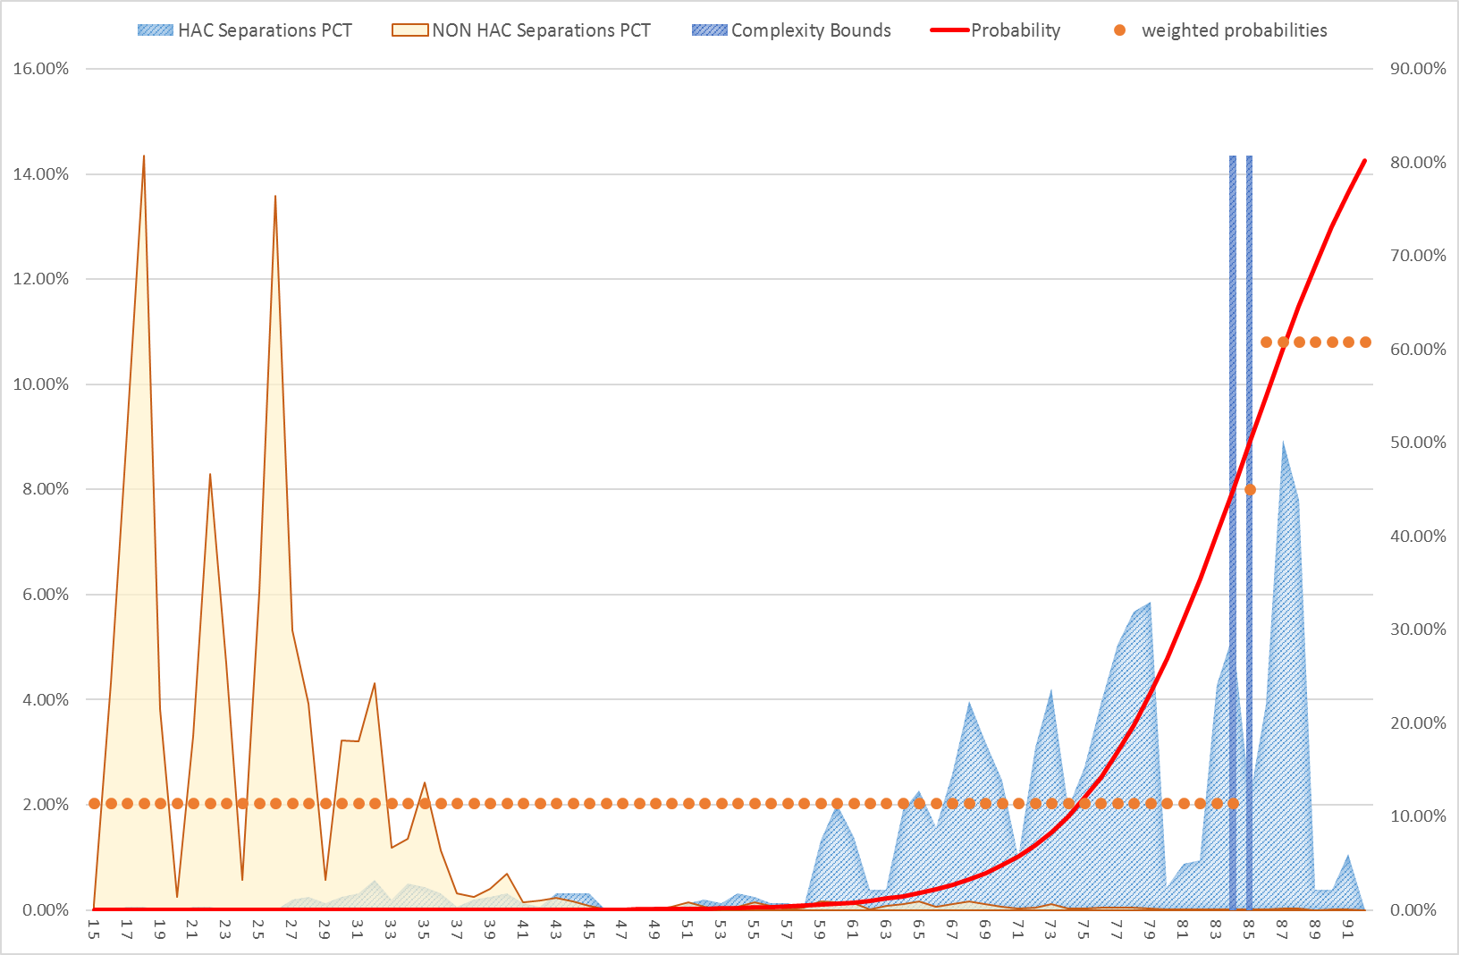

**Figure 12**: HAC09 – Gastrointestinal bleeding – Complexity bounds

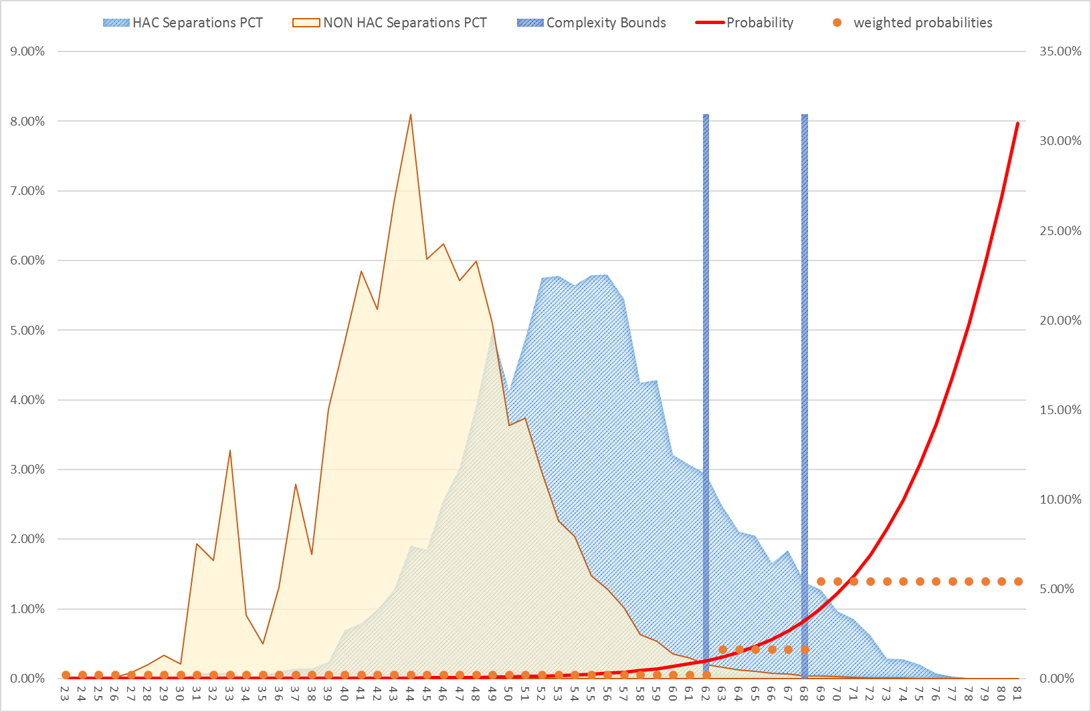

**Figure 13**: HAC10 – Medication complications – Complexity bounds

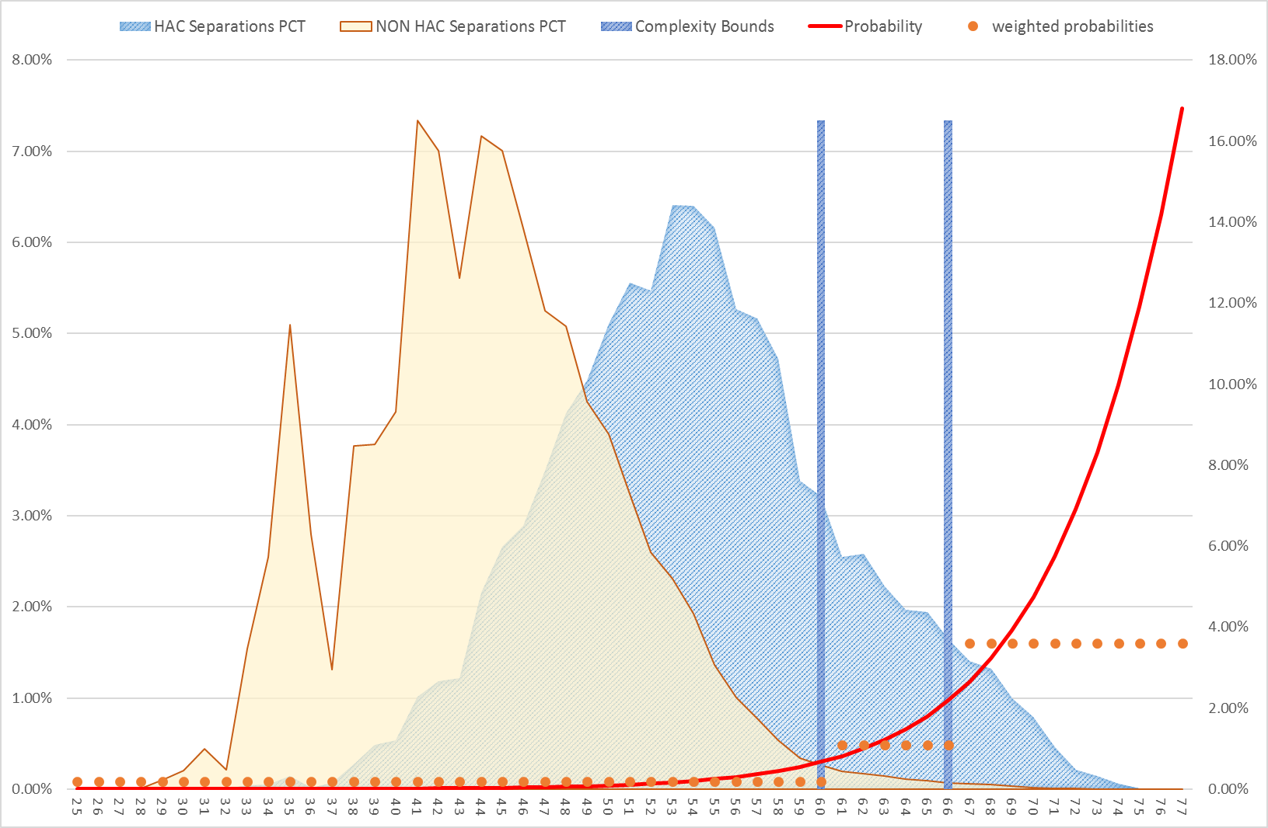

**Figure 14**: HAC11 – Delirium – Complexity bounds

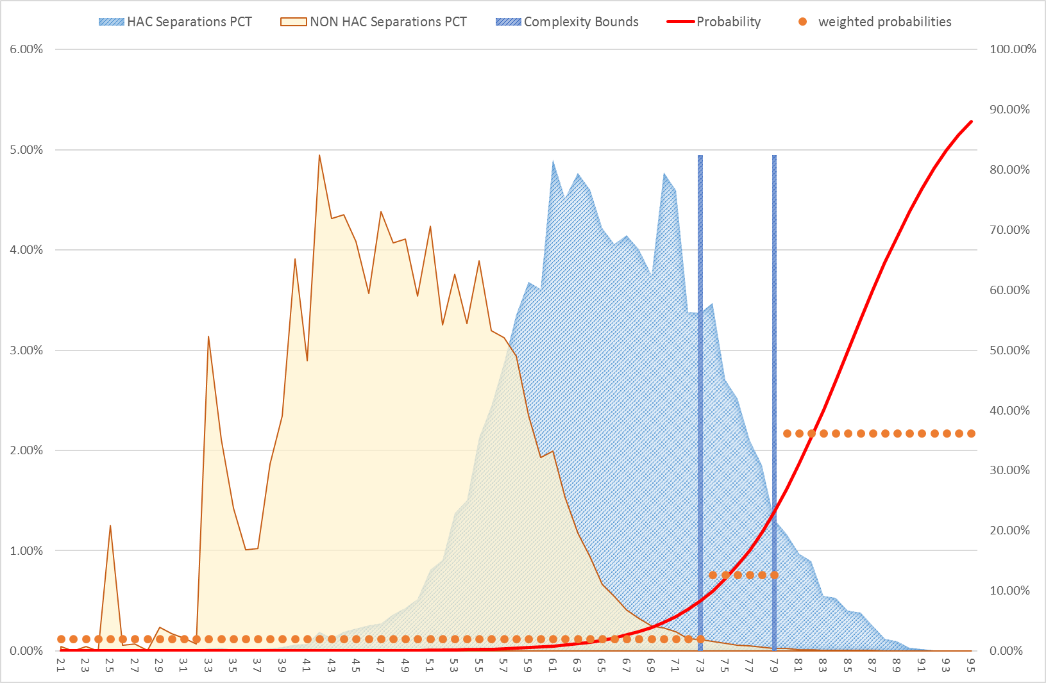

**Figure 15**: HAC12 – Incontinence – Complexity bounds

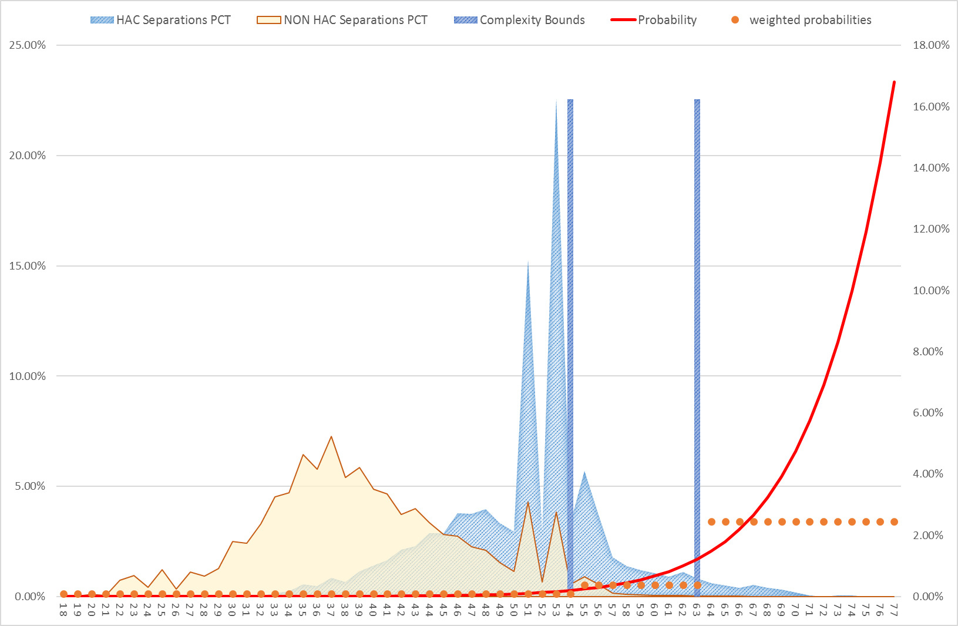

**Figure 16**: HAC13 – Endocrine complications – Complexity bounds

**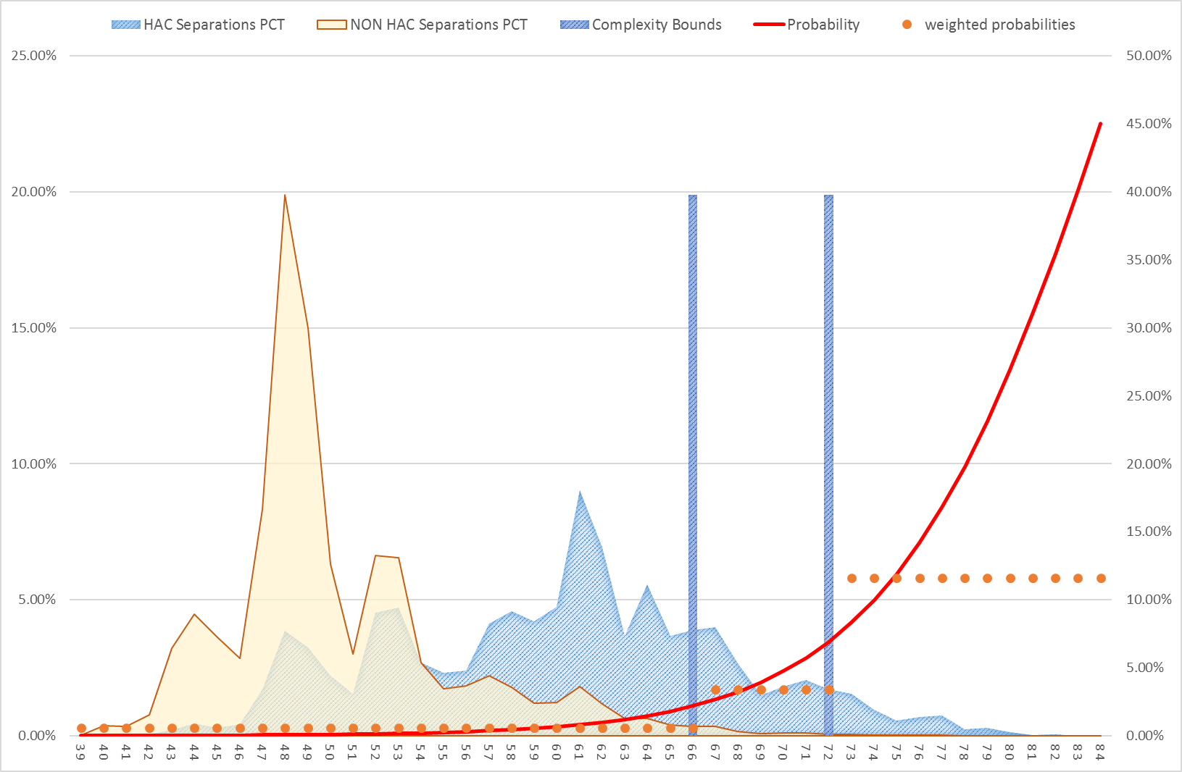**

**Figure 17**: HAC14 – Cardiac complications – Complexity bounds

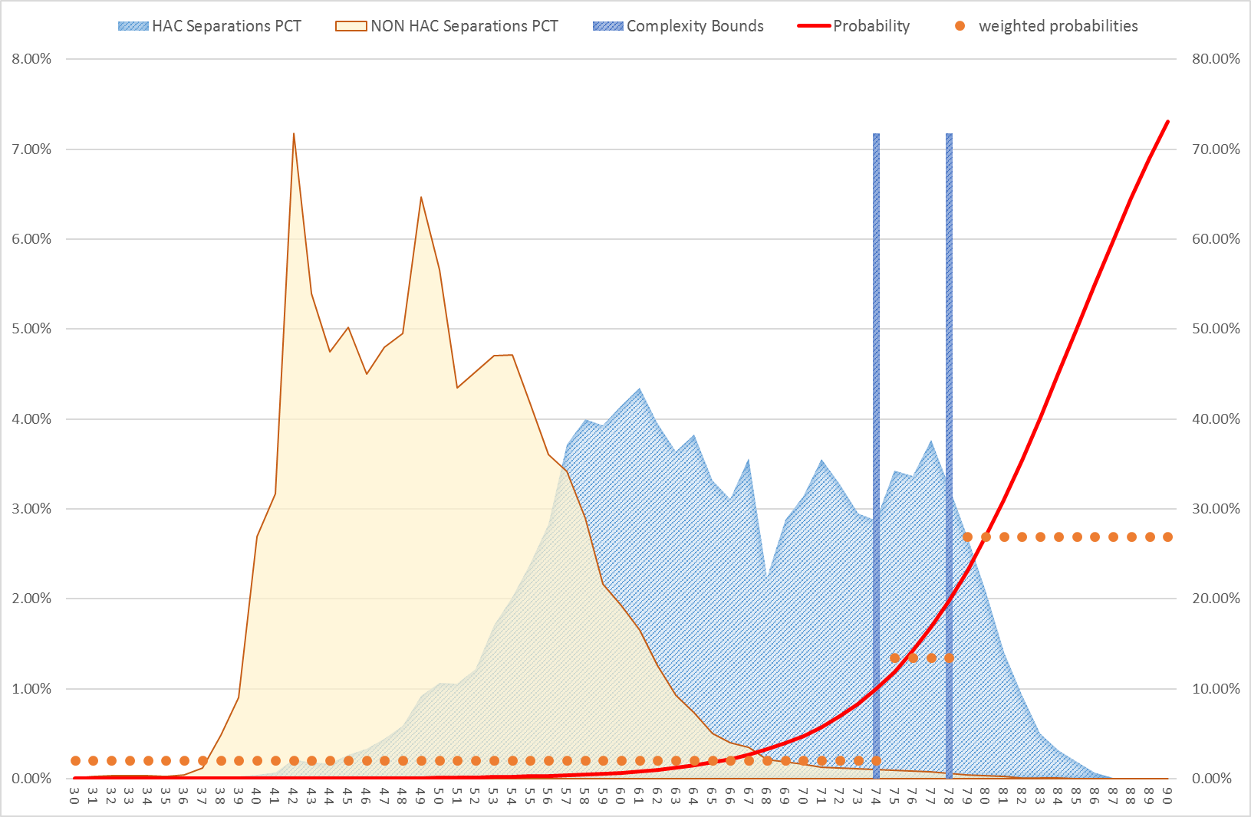

**Figure 18**: HAC15.02 – Fourth degree perineal laceration during delivery – Complexity bounds

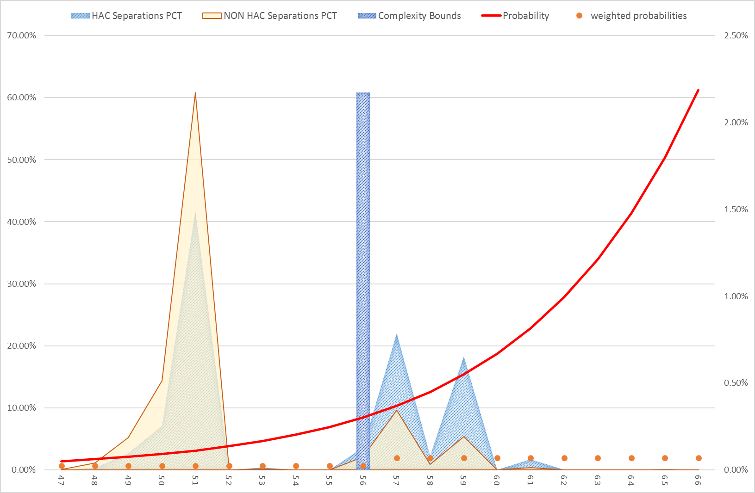



Independent Hospital Pricing Authority

Eora Nation, Level 12, 1 Oxford Street

Sydney NSW 2000

Phone 02 8215 1100

Email enquiries.ihpa@ihpa.gov.au

Twitter @IHPAnews

www.ihpa.gov.au

www.ihpa.gov.au

1. Details on these datasets can be found at: https://www.ihpa.gov.au/what-we-do/data-specifications [↑](#footnote-ref-2)
2. https://www.safetyandquality.gov.au/our-work/information-strategy/indicators/hospital-acquired-complications/ [↑](#footnote-ref-3)
3. Socio-Economic Indexes for Areas is a product developed by the Australian Bureau of Statistics that ranks areas in Australia according to relative socio-economic advantage and disadvantage.

   http://www.abs.gov.au/websitedbs/censushome.nsf/home/seifa [↑](#footnote-ref-4)
4. The Charlson index is a score that predicts the one-year mortality for a patient with a range of specific comorbidities. [↑](#footnote-ref-5)