Independent Hospital Pricing Authority

Pricing and funding for safety and quality

Risk adjusted model for avoidable hospital readmissions

National Efficient Price Determination 2022-23

March 2022



Avoidable hospital readmissions – Technical specifications – March 2022

© Independent Hospital Pricing Authority 2022

This publication is available for your use under a [Creative Commons BY Attribution 3.0 Australia](http://creativecommons.org/licenses/by/3.0/au/deed.en) licence, with the exception of the Independent Hospital Pricing Authority logo, photographs, images, signatures and where otherwise stated. The full licence terms are available from [the Creative Commons website](http://creativecommons.org/licenses/by/3.0/au/legalcode).



Use of Independent Hospital Pricing Authority material under a [Creative Commons BY Attribution 3.0 Australia](http://creativecommons.org/licenses/by/3.0/au/deed.en) licence requires you to attribute the work (but not in any way that suggests that the Independent Hospital Pricing Authority endorses you or your use of the work).

*Independent Hospital Pricing Authority material used 'as supplied'.*

Provided you have not modified or transformed Independent Hospital Pricing Authority material in any way including, for example, by changing Independent Hospital Pricing Authority text – then the Independent Hospital Pricing Authority prefers the following attribution:

Source: The Independent Hospital Pricing Authority

# Executive Summary

## Purpose

This document has been produced as an accompaniment to the National Efficient Price 2022-23 (NEP22). It provides the technical specifications for how the Independent Hospital Pricing Authority (IHPA) developed the avoidable hospital readmissions funding approach and risk adjustment methodology. It also provides guidance to hospitals, local hospital networks (LHNs) and state and territory health authorities on how to apply these to hospital activity.

## Risk adjustment

In accordance with the Addendum to the National Health Reform Agreement 2020–25 (the Addendum), IHPA was required to develop a pricing model for avoidable hospital readmissions for implementation from 1 July 2021, following approval from the Council of Australian Governments (COAG) Health Council.

The approach, development and implementation of the final pricing adjustment for avoidable hospital readmissions follows a 24-month shadow period that commenced on 1 July 2019. During this period, IHPA worked closely with jurisdictional stakeholders when trialling adjustment methodologies and in considering the activity and funding impacts of these options.

### Scope

Throughout the shadow period, IHPA analysed three scope options (readmissions that occur within the same hospital, LHN and jurisdiction), and investigated the funding impacts of each option. Following this analysis and consultation with jurisdictional stakeholders, IHPA has developed the risk model with the intention of it applying the funding adjustment to readmissions that have occurred within the same jurisdiction, using the available Medicare PIN until a nationally consistent Individual Healthcare Identifier (IHI) is available. Identifying readmissions occurring within a jurisdictional level will allow for the best coverage of readmission episodes and a more robust validation of available data.

### Funding option

IHPA undertook analysis of the funding impacts of several options presented in the ‘Consultation paper for the pricing framework for Australian public hospital services 2021-22’.Following the results of this analysis and informed by stakeholder feedback, IHPA has determined that the readmission funding adjustment will be to deduct the cost of the readmission episode from the index episode, discussed in further detail in this specification.

### Risk adjustment model

The initial risk adjustment model used in development of the readmissions pricing model was a logistic regression model, similar to the hospital acquired complications (HACs) risk adjustment model. To improve the model, IHPA has evaluated logistic regression modelling, and developed and trialled a new risk adjustment model based on gradient boosting decision trees. Using existing and refined performance metrics, this new model shows substantial improvement in performance and better fit to data.

The final gradient boosting decision tree model has been endorsed by the University of Melbourne and IHPA has implemented this model. A risk adjustment model has been derived for each readmission condition, which assigns the risk of being readmitted for each episode of care, based on ‘feature importance’, that is, the most clinically significant and best performing risk factors.

### Inclusions/exclusions

The Commission initially developed the specification for a hospital level approach using facility-specific identifiers, an outcome of this is that transfers would not be flagged as readmissions. However, during IHPA’s assessment of funding impacts with an expanded scope, episodes where patients are transferred elsewhere after the index admission were being flagged as a readmission.

Due to this, IHPA will continue utilising the definition and specifications developed by the Commission, but will trim transfer episodes from the readmissions. IHPA will also provide data to the jurisdictions indicating how many episodes are affected and the specific episodes trimmed from the readmission counts.

### Risk factors

A set of risk factors has been developed for each individual readmission category in the risk adjustment model. This means the readmission categories have tailored risk adjustment models based on risk factors that are highly relevant to the readmission condition. The risk factors for each readmission category were selected based on clinical relevance and statistical performance, using the feature importance breakdowns. The risk factors are discussed further in section 6.

Contents

1. Executive Summary 3

1.1. Purpose 3

1.2. Risk adjustment 3

Acronyms and abbreviations 6

2. Introduction 7

2.1. Purpose 7

2.2. Background 7

3. Model specifications 8

3.1. Avoidable hospital readmission conditions 8

3.2. Avoidable hospital readmission definition 10

4. Conditions responsible for readmissions 12

4.1. Highest presenting clinical conditions 12

5. Data specifications 14

5.1. Activity data 14

5.2. Data trimming 14

6. Risk adjustment model 16

6.1. Overview 16

6.2. Finalised risk adjustment model 16

7. Risk factors 23

7.1. Previous risk factors 23

7.2. Finalised risk factors 26

7.3. Results 29

8. Scope options 32

8.1. Overview 32

8.2. Scope option for implementation 32

9. Funding adjustment 33

9.1. Overview 33

9.2. Funding option for implementation 33

Appendix A – Model fit curves 35

Appendix B – Key risk factor breakdowns 39

Appendix C – Model complexity distributions 45

# Acronyms and abbreviations

|  |  |
| --- | --- |
| APC NMDS | Admitted patient care national minimum data set |
| AR-DRG | Australian refined diagnosis related group |
| COAG | Council of Australian Governments |
| COF | Condition onset flag |
| Commission | Australian Commission on Safety and Quality in Health Care |
| DRG | Diagnosis related group |
| GWAU | Gross weighted activity unit |
| HACs | Hospital acquired complication, as defined by the Commission |
| LHN | Local hospital network |
| ICD-10-AM | International Statistical Classification of Diseases and Related Health Problems, Tenth Revision, Australian Modification |
| ICU | Intensive care unit |
| IHI | Individual Healthcare Identifier |
| MDC | Major diagnostic category |
| NEC | National efficient cost |
| NEP | National efficient price |
| NHCDC | National hospital cost data collection |
| NMDS | National minimum data set |
| NWAU | National weighted activity unit |
| PRC | Precision recall curves |
| ROC | Receiver operating characteristic |
| SEIFA | Socio-economic indexes for areas |

# Introduction

## Purpose

This document has been produced as an accompaniment to the National Efficient Price 2022-23 (NEP22). It provides the technical specifications for how the Independent Hospital Pricing Authority (IHPA) developed the Avoidable hospital readmissions funding approach and risk adjustment methodology. It also provides guidance to hospitals, local hospital networks (LHNs) and state and territory health authorities on how to apply these to hospital activity.

## Background

In early 2016, the Commonwealth Government and state and territory governments signed a Heads of Agreement that committed to improving the health outcomes of all Australians and ensuring the sustainability of the Australian health system. The Heads of Agreement required governments, in conjunction with IHPA and the Commission, to develop ‘a comprehensive and risk-adjusted model to integrate safety and quality into hospital pricing and funding’ for ‘a set of agreed hospital acquired conditions’ in order to improve health outcomes and decrease avoidable demand for public hospital services.

In May 2020, all Australian governments signed the new Addendum to the National Health Reform Agreement (the Addendum), under which IHPA is required to develop a pricing model for avoidable hospital readmissions, for implementation from 1 July 2021, following approval from the Council of Australian Governments (COAG) Health Council.

The implementation of pricing and funding for safety and quality has been introduced on a staged basis. Funding adjustments related to sentinel events were introduced in July 2017, followed by funding adjustments for HACs in July 2018. In July 2019, IHPA commenced a shadow period to analyse funding options for reducing avoidable hospital readmissions.

The Commission was tasked with developing and maintaining a nationally consistent definition of avoidable hospital readmissions. The list of clinical conditions considered as avoidable hospital readmissions was approved by the Australian Health Ministers’ Advisory Council (AHMAC) in June 2017.

The shadow period incorporated the following funding options across hospital, LHN and jurisdiction levels:

* Option one: Deduct the price of the readmission episode from the index episode
* Option two: Combine the index and readmission episodes and recalculate the price of the combined episode
* Option three: Adjust funding at the hospital level where actual rates of avoidable readmissions exceed expected rates of avoidable readmissions.

IHPA has provided detailed reports to its Jurisdictional Advisory Committee (JAC), Technical Advisory Committee (TAC) and Clinical Advisory Committee on the activity and funding impacts of the funding options.

# Model specifications

## Avoidable hospital readmission conditions

Unplanned hospital readmissions are a measure of potential issues with the quality, continuity and integration of care provided to patients during or subsequent to their original hospital admission (the index admission).

The criteria used by the Commission states that clinical conditions have to be:

* Related to the index admission.
* Avoidable by improved clinical management in the index admission and/or suitable discharge planning and follow-up.
* Measurable through coded data generated from the patient medical record.

In June 2017, AHMAC approved the list of avoidable hospital readmissions developed by the Commission. Table 1 presents the AHMAC approved list of avoidable hospital readmissions and readmission diagnoses, together with the condition-specific readmissions intervals.

Table 1: List of avoidable hospital readmissions and readmission intervals

| **Readmission condition** | **Readmission diagnosis** | **Readmission interval** |
| --- | --- | --- |
| 1. Pressure injury | Stage III ulcer | 14 days |
| Stage IV ulcer | 7 days |
| Unspecified decubitus and pressure area | 14 days |
| 1. Infections | Urinary tract infection | 7 days |
| Surgical site infection | 30 days |
| Pneumonia | 7 days |
| Blood stream infection | 2 days |
| Central line and peripheral line associated bloodstream infection | 2 days |
| Multi-resistant organism | 2 days |
| Infection associated with devices, implants and grafts | 90 days |
| Infection associated with prosthetic devices, implants and grafts in genital tract or urinary system | 30 days |
| Infection associated with peritoneal dialysis catheter | 2 days |
| Gastrointestinal infections | 28 days |
| 1. Surgical complications | Postoperative haemorrhage/haematoma | 28 days |
| Surgical wound dehiscence | 28 days |
| Anastomotic leak | 28 days |
| Cardiac vascular graft failure | 28 days |
| Pain following surgery | 14 days |
| Other surgical complications | 28 days |
| 1. Respiratory complications | Respiratory failure including acute respiratory distress syndromes | 21 days |
| Aspiration pneumonia | 14 days |
| 1. Venous thromboembolism | Venous thromboembolism | 90 days |
| 1. Renal failure | Renal failure | 21 days |
| 1. Gastrointestinal bleeding | Gastrointestinal bleeding | 2 days |
| 1. Medication complications | Drug related respiratory complications/depression | 2 days |
| Hypoglycaemia | 4 days |
| 1. Delirium | Delirium | 10 days |
| 1. Cardiac complications | Heart failure and pulmonary oedema | 30 days |
| Ventricular arrhythmias and cardiac arrest | 30 days |
| Atrial tachycardia | 14 days |
| Acute coronary syndrome including unstable angina, STEMI and NSTEMI | 30 days |
| Other | 1. Constipation | 14 days |
| 1. Nausea and vomiting | 7 days |

### Readmission intervals

The use of the condition-specific readmission intervals has been developed by the Commission, with input from a panel of clinical and consumer experts.

If a patient with a readmission condition presents at hospital in a timeframe that exceeds the condition-specific readmission interval, these episodes are not considered to be avoidable hospital readmissions.

## Avoidable hospital readmission definition

When AHMAC approved the list of avoidable hospital readmissions conditions developed by the Commission, it also directed the Commission to determine ‘a nationally consistent definition for [avoidable hospital readmissions](https://www.safetyandquality.gov.au/our-work/indicators/avoidable-hospital-readmissions)’.

The Commission convened a working group in late June 2019 to develop a nationally consistent definition for avoidable hospital readmissions. The Commission adopted the following working definition:

An avoidable hospital readmission occurs when a patient who has been discharged from hospital (index admission) is admitted again within a certain time interval, and the readmission:

* is clinically related to the index admission, and
* has the potential to be avoided through improved clinical management and/or appropriate discharge planning in the index admission.

The above definition has been presented to AHMAC and, pending endorsement, will be used by IHPA to define avoidable hospital readmissions.

### Included and excluded services

A readmission is deemed as an avoidable hospital readmission if:

1. the index and readmission separations meet their respective exclusion’s criteria;
2. the readmission has a principal diagnosis on the 'codes' list (and/or an additional diagnosis where specified);
3. the readmission meets any additional criteria (where specified); and
4. the interval between the index admission and readmission (in days) is less than or equal to the interval specified, i.e. date of admission (of readmission) – date of separation (of index admission) ≤ interval.

Table 2 summarises the services that are included and excluded for avoidable hospital readmissions based on the Commission’s advice. In response to stakeholder feedback, IHPA has made the decision to exclude transfers, which are currently flagged as readmissions. The Commission’s exclusion criteria in relation to transfers was developed on the basis of hospital-level readmissions.

Table 2: Scope of included and excluded services for avoidable hospital readmissions

|  | Service scope for avoidable hospital readmissions |
| --- | --- |
| Included services | All relevant acute admitted episodes**[1]** in activity based funded (ABF) hospitals comprising:   * Episodes with an urgency status of emergency. |
| Excluded services | Exclusions comprise:   * Any readmissions where the index admission had a separation mode of discharged against medical advice. * Index admissions and readmissions for oncology, haematology, chemotherapy, dialysis, neonatal care and palliative care. * Readmissions for child birth. * Transfer episodes where previously classed as a readmission (i.e. a transfer from the index admission facility to a secondary facility within the same course of care). |

Table 3 outlines the complete list of exclusion criteria, based on the Commission’s advice for the list of conditions that are considered avoidable hospital readmissions.

Table 3: Complete list of exclusion criteria for avoidable hospital readmissions

|  |  |
| --- | --- |
| Index admission | Readmission |
| Exclude separations with ANY of the following:   * Multi-purpose services and Mothercraft facilities * Hospital boarder, organ procurement, unqualified newborns (Care types 9, 10, or 7.3) * Not discharged alive (mode of separation: 8) * Discharged against medical advice (mode of separation: 6) * Admitted for same day and overnight chemotherapy and dialysis (AR-DRG equal to R63Z, L61Z or L68Z, with admission date equal to separation date) * Admitted for palliative care (Care type: 3) * Admitted for oncology or haematology (any diagnosis: C00 to D89) * Admitted for neonatal care (Care type: 7) | Exclude separations with ANY of the following:   * Multi-purpose services and Mothercraft facilities * Non-acute care type (Care type not 1) * Non-emergency admission (Urgency status not equal to 1) * Admitted for same day and overnight chemotherapy and dialysis (AR-DRG = R63Z, L61Z or L68Z, with admission date equal to separation date) * Admitted for oncology or haematology (any diagnosis: C00 to D89) * Admitted for child birth (Adjacent AR-DRG equal to O01, O02, or O60) * Admitted for neonatal care (Care type: 7) * Admitted as a transfer from a different facility within the same course of care |

# Conditions responsible for readmissions

## Highest presenting clinical conditions

Analysis of the highest presenting clinical conditions responsible for readmissions provides valuable insight to why readmission episodes are occurring.

Table 4 outlines the AHMAC approved list of avoidable hospital readmissions and corresponding number of readmissions for the years 2016–17, 2017–18, 2018–19 and the first nine months of 2019–20.

Table 4: List of avoidable hospital readmissions and number of readmissions over a four year period

|  |  |  |  |  |  |
| --- | --- | --- | --- | --- | --- |
| **Readmission Condition** | **Number of readmissions (2016-17)** | **Number of readmissions (2017-18)** | **Number of readmissions (2018-19)** | **Number of readmissions (2019-20)[2]** | **Number of readmissions (total)** |
| 1. Pressure injury | 64 | 70 | 76 | 48 | 258 |
| 2. Infections | 14,931 | 16,388 | 17,027 | 13,210 | 61,556 |
| 3. Surgical complications | 9,152 | 9,464 | 9,514 | 7,092 | 35,222 |
| 4. Respiratory complications | 1,621 | 1,744 | 1,948 | 1,601 | 6,914 |
| 5. Venous thromboembolism | 2,497 | 3,078 | 3,048 | 2,182 | 10,805 |
| 6. Renal failure | 1,173 | 1,615 | 1,601 | 1,320 | 5,709 |
| 7. Gastrointestinal bleeding | 371 | 372 | 445 | 331 | 1,519 |
| 8. Medication complications | 749 | 877 | 1,031 | 816 | 3,473 |
| 9. Delirium | 1,240 | 1,483 | 1,579 | 1,311 | 5,613 |
| 10. Cardiac complications | 14,787 | 15,968 | 16,150 | 12,252 | 59,157 |
| 11. Constipation | 2,519 | 2,891 | 2,868 | 2,170 | 10,448 |
| 12. Nausea and vomiting | 1,310 | 1,417 | 1,484 | 1,132 | 5,343 |

Infections are shown to be the leading readmission condition, with 61,556 readmissions over the observation period, followed closely by cardiac complications with 59,157 readmission episodes. These figures are useful in assisting clinicians with the development of strategies to reduce or prevent avoidable hospital readmissions relating to specific conditions.

# Data specifications

## Activity data

The following data was used for the calculations of the funding adjustments for avoidable hospital readmissions:

* Twelve months activity data for 2015–16
* Twelve months activity data for 2016–17
* Twelve months activity data for 2017–18
* Nine months activity data for 2019–20.

The sample of data used to fit the risk model includes only nine months of activity data for 2019‑20 to avoid any potential bias in the training sample, as the longest readmission interval is 90 days.

For the purposes of the funding calculations, the hospital list from the most recent NEP Determination was used to define ABF hospitals and their characteristics.

## Data trimming

The following rules are implemented to clean the data, or identify whether an episode is trimmed:

* Episodes with no associated Medicare PIN were trimmed as it is not possible to identify readmission episodes.
* Episodes with a missing separation date are trimmed as non-discharged episodes do not have complete ICD-10-AM/ACHI code arrays.
* Episodes with a Medicare PIN that has inconsistent birth date or sex across episodes were trimmed to ensure that only episodes with consistent patient identifiers are considered when flagging readmissions. This is discussed further in section 5.2.1.
* Where the same patient has multiple concurrent admitted episodes, only the episode with the earliest admission date is kept. This is to prevent concurrent episodes resulting in inconsistent flagging of potential readmission episodes.
* Episodes that do not meet neither the index episode denominator criteria nor the readmission episode denominator criteria shown in Table 3 were removed as they were deemed irrelevant to the model.

**Table 5: Summary of trimmed episodes for the 2016–17, 2017–18, 2018–19 and 2019–20 activity data**

|  |  |  |  |  |
| --- | --- | --- | --- | --- |
| **Trim type** | **2016-17** | **2017-18** | **2018-19** | **2019-20** |
| **Total Episodes** | 6,494,755 | 6,747,156 | 6,960,457 | 6,923,469 |
| Trimming due to: |  |  |  |  |
| Missing Medicare PIN | 559,227 | 438,905 | 442,341 | 471,975 |
| Missing separation date | - | - | - | - |
| Not unique Medicare PIN | 247,923 | 267,020 | 278,818 | 266,054 |
| Concurrent episodes: |  |  |  |  |
| Reasonable concurrent episodes | 274 | 266 | 244 | 233 |
| Same establishment | 132 | 189 | 293 | 299 |
| Overlapping episodes | 506 | 548 | 475 | 431 |
| Engulfed episode | 6,042 | 5,939 | 6,776 | 6,179 |
| Cannot be index or readmission episode | 2,114,151 | 2,244,755 | 2,354,665 | 2,456,816 |
| **Total episodes remaining (untrimmed)** | 3,566,500 | 3,789,534 | 3,876,845 | 3,721,482 |
| % of episodes trimmed from public hospitals | 12.53% | 10.57% | 10.47% | 10.76% |

### Medicare Pin Quality

Table 6 shows the quality of the Medicare PIN reporting for 2016–17, 2017–18, 2018–19 and2019–20 for admitted episodes of care.

Analysis shows the percentage of good quality Medicare PIN data for each year. This is measured by identifying where there is inconsistency in the birth date or sex of the episodes of care to which it has been attached.

For all jurisdictions in all years assessed, the figures seem reasonable and indicate no systemic reporting errors. In cases where the Medicare PIN is considered poor quality, these episodes are removed for the purposes of modelling (i.e. those which have records with multiple different birth dates or sexes associated with it).

Table : Quality of Medicare PIN reporting

|  |  |  |  |  |
| --- | --- | --- | --- | --- |
| **Percentage of good quality Medicare PIN** | | | | |
| **State/Territory** | **2016-17** | **2017-18** | **2018-19** | **2019-20** |
| NSW | 95.6% | 95.5% | 95.3% | 95.4% |
| Vic | 93.6% | 93.2% | 93.3% | 93.4% |
| Qld | 97.9% | 97.9% | 98.0% | 98.1% |
| SA | 97.4% | 97.3% | 97.2% | 97.3% |
| WA | 96.3% | 96.4% | 96.2% | 96.5% |
| Tas | 99.7% | 99.7% | 99.6% | 99.6% |
| NT | 95.7% | 95.6% | 95.8% | 95.8% |
| ACT | 95.1% | 96.5% | 96.1% | 96.8% |
| **National** | **95.8%** | **95.8%** | **95.7%** | **95.9%** |

# Risk adjustment model

## Overview

IHPA notes the need to balance the perspectives of both hospitals and patients in incorporating safety and quality into pricing. Hospitals that treat high-risk patients should not be disadvantaged compared to hospitals that treat fewer such patients. Likewise, high‑risk patients should have confidence that hospitals take all necessary actions to manage their risks and mitigate the occurrence of adverse events.

The equitable risk adjustment criterion used by IHPA states that:

Pricing and funding approaches should balance the likelihood that some patients will be at higher risk of experiencing an adverse event while recognising that all hospitals have scope to improve safety and quality.

The risk adjustment model is constructed on the premise that a patient’s likelihood of experiencing a potentially avoidable hospital readmission is the same regardless of the funding option considered. Therefore, a risk adjustment model is derived for each readmission condition, which assigns the risk of being readmitted for each episode of care, based on the risk factors identifiable in the National Minimum Data Set (NMDS).

In this model, episodes are assigned to a ‘Low’, ‘Medium’ or ‘High’ complexity group representing the risk of a readmission occurring based on identified risk factors. This new risk modelling approach for assessing the impact of risk factors has a basis in assessing risks in top predictors for each risk adjustment variable, essentially changing how the scores are assigned for ‘Low’, ‘Medium’ and ‘High’ risk category patients.

### Previous risk adjustment model

The previous modelling approach for avoidable readmissions was based on the HACs logistic regression model. This modelling approach had limitations due to the large number of false positive outputs, where readmissions were identified as positives from a much larger data set of non-readmission episodes. The logistic regression approach showed poor performance on episodes that were not readmissions and provided a less than optimal fit to the given data.

Previous reports used receiver operating characteristic curves (ROC curves) to measure performance, however these presented an incomplete picture of model performance trained on imbalanced data. IHPA has since updated the metrics used to describe the performance of the readmissions risk adjustment model.

## Finalised risk adjustment model

### Final risk adjustment model

The avoidable readmission risk adjustment model represents a shift away from the more familiar logistic regression model used for the HACs risk model, to a predictive modelling approach based on gradient boosting decision trees. The shift to a new model has seen a substantial improvement in model performance due to its ability to model more complex interactions between risk factors, while reducing the possibility of ‘overfitting’ to characteristics specific to the available data.

The previous logistic regression risk model estimated the effect of each risk factor independently. For example, for a given readmission category, being admitted to an intensive care unit (ICU) might indicate an increased risk of readmission of 3 per cent. Each risk factor has an associated marginal risk like this which, when added together, gives a total risk score.

The revised modelling approach is based on gradient boosting decision trees. Under this model, the marginal risk of each risk factor is not a constant, but depends on the combination of risk factors present in a particular episode. For example, for a given readmission category, being admitted to ICU will have a different marginal impact depending if the patient is admitted to a surgical or medical DRG, and similarly for all other risk factors.

Modelling interactions between risk factors like this will often result in ‘over-fitting’ the model the data on which it is trained, picking up natural variance present in the data and measuring it as a real effect. This is overcome using a machine learning technique, fitting hundreds of thousands of similar models to subsets of the same data, which allows that natural variance to be accounted for, therefore reducing over-fitting while retaining the benefits of decision tree classification algorithms.

This risk adjustment model has the additional benefit of also determining the best aggregation for risk factors that have multiple levels. For example, in the HACs risk adjustment model, some of the five-year age brackets are combined for some HACs depending on manual analysis and interpretation of sample size and statistical significance testing. The gradient boosting decision tree model is able to filter out factors automatically, or determine how to achieve the most optimal grouping for the most accurate possible outcome.

### Gradient boosting decision trees

#### Decision trees

IHPA investigated the performance of decision tree-based models as an alternative to the logistic regression model used for HACs. The final model builds a decision tree to classify the target variable. It does this by selecting features that give the highest information gain and splitting the data set on that feature.

Example decision tree classifier for Readmission 10 - Cardiac complications

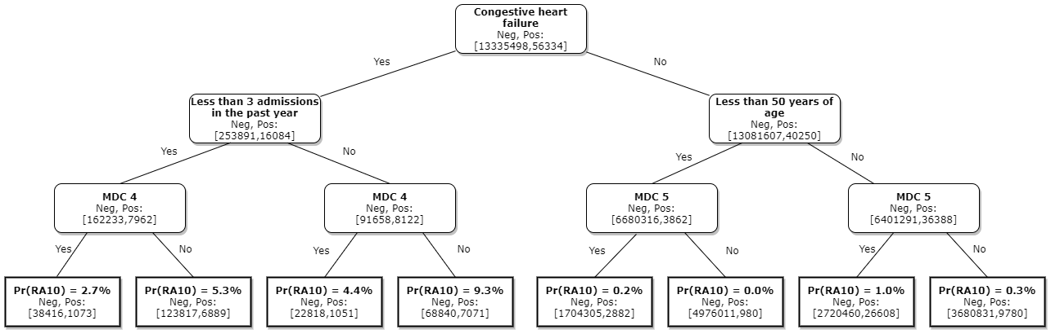

Figure 1 shows an example of a decision tree model for the Cardiac complications readmission category. The numbers in square brackets show how many non-readmissions (Neg) and readmissions (Pos) are considered at each stage. These episodes are then split on the risk factor (stated in bold) and shown on the next level down.

For example, the node at the top of the tree shows that 13,335,498 non-readmissions and 56,334 cardiac complication readmissions are considered in this model. These are then split based on whether the episode has the congestive heart failure risk factor. The result is that there are 253,891 non-readmissions and 16,084 cardiac complication readmissions with congestive heart failure, and 13,081,607 non-readmissions and 40,250 cardiac complication readmissions without congestive heart failure.

Splitting on the congestive heart failure risk factor produces two nodes where less than 2 per cent of non-readmissions are on the left-hand side, though it contains over 28 per cent of cardiac complication readmissions. We therefore say that splitting on this feature produces a high information gain. This process is repeated at the next level down on the major diagnostic category (MDC) risk factor, specifically if the episode is in MDC 4. At each stage, the decision tree model finds the risk factor that produces the highest information gain and splits the data set on this.

Leaf nodes are produced at the bottom of the chart. If the model was allowed to continue splitting the data set until each leaf node was either purely non-readmissions or purely readmissions, it would produce a much bigger model than is shown in Figure 1. To avoid overfitting, however, we limit the “depth” of the model to five (three in the example tree shown). The leaf nodes at the bottom of Figure 1, therefore output a probability of whether an episode with the corresponding risk factors will lead to an avoidable readmission for cardiac complications.

Tracing a single example through the model in Figure 1, if an episode: has the congestive heart failure risk factor; more than three admissions in the previous year; and is not in MDC 4, the model says that this episode has a 9.3 per cent chance of leading to an avoidable readmission for a cardiac complication.

#### Gradient boosting decision tree model

Using a decision tree by itself, as shown in Figure 1, does not produce the best model because it does not consider all of the risk factors. On the other hand, fitting a much larger decision tree is undesirable because it can overfit the data, meaning that you could create a model that perfectly describes the data you train it on, without generalising to the broader population. A technique that captures the benefits of decision trees while producing a more general model is called ensemble learning.

The gradient boosted model implemented is one such technique and has been used in other studies in attempting to predict readmissions with sound results. This approach fits multiple decision trees in a sequential manner (a type of ensemble learning called boosting). The first decision tree is fit as shown in the previous example, and then the subsequent trees are fit to the residuals, or errors, from the preceding model. This way, as more and more decision trees are fit to the errors made by the preceding tree, the model gradually gets better and better.

As the model adds new trees, it tests its performance on a validation data set which was not used to train the model (comprising 10 per cent of the data). When the model performance stops improving with respect to this validation set, the model stops adding new decision trees and the training process is complete. This is done to prevent overfitting by adding too many decision trees to the model.

### Performance metrics

IHPA has generally focussed on receiver operating characteristic curves (ROC curves) to measure the performance of the HAC and early iterations of the readmissions risk adjustment model.

However, these metrics do not present the whole picture about the performance of models, due to imbalance in the data. That is, the ROC curve metrics alone may not clearly reflect significant changes in model performance where the number of episodes with no subsequent avoidable hospital readmissions is far greater than the number of episodes with an avoidable hospital readmission. To account for this, IHPA has used precision recall curves (PRC) alongside ROC curves in evaluating readmissions risk modelling.

#### Receiver operating characteristic curve

The ROC curve is a parametric plot of the true positive rate versus the false positive rate of the model where the theoretical threshold is varied between 0 and 1 – so that the probability outcome of the model can be assigned as leading to a readmission or not, dependent on the threshold. The idea being that for anything short of a perfect model, a higher true positive rate will also yield a higher false positive rate.

The issue with using the ROC curve to assess model performance on imbalanced data is that the rates being compared have different denominators. The true positive rate is *True positives/All positives*, while the false positive rate is *False positives/All negatives*. In each of the risk adjustment models, the number of negatives (episodes with no subsequent avoidable hospital readmission) is close to 13,000,000. While the number of positives varies from around 300 for readmission category 1 (Pressure injury), and 58,000 for category 10 (cardiac complications) in the four years of activity data used for training.

The risk adjustment model for readmission category 10 (cardiac complications) has an area under ROC of 0.91. To illustrate the issue described above, a single point on the curve may be considered. Picking a threshold to correctly identify 20 per cent of the 58,000 avoidable hospital readmissions (i.e. 0.2 on the vertical axis in Figure 2) gives a false positive rate (i.e. the horizontal axis in Figure 2) of around 0.1 per cent, or 1,300,000 false positives. Note that these figures are used for comparison of risk models only. In practise, risk models assign a probability (which is always low for a readmission), and do not use thresholds to assign definite positive/negative outcomes.

ROC curve for readmission 10

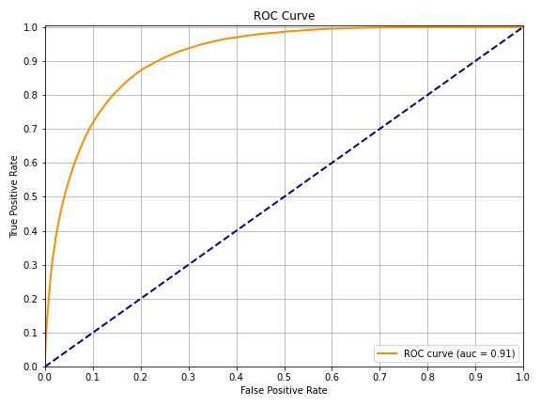

#### Precision recall curve

A complement to the ROC curve is the precision recall curve (PRC), which can give additional insight when comparing model performance on imbalanced data.

Precision is the number of true positives out of all the predicted positives. This means, out of all the episodes the model classifies as leading to an avoidable hospital readmission, how many actually lead to an avoidable hospital readmission.

Recall is another name of the true positive rate. Intuitively here it represents how well the model finds avoidable hospital readmissions. That is, out of all the avoidable hospital readmissions in the data set, how many the model has identified.

This curve also parametric, based on a threshold to declare each point as a readmission or not as a readmission. Similar to the ROC curve, PRC is a plot of precision versus recall as the threshold varies between 0 and 1.

The figure below demonstrates the PRC for readmission 10 when using a logistic regression model. Picking a threshold which identifies 20 per cent of unplanned readmissions (recall) in the data set, it will have a precision of around 8%. Meaning that it will return about 28,000 episodes correctly classified as leading to an avoidable hospital readmission, and around 130,000 false positives. The area under ROC for this logistic regression model is 0.87.

Precision Recall curve for readmission 10 with logistic regression model

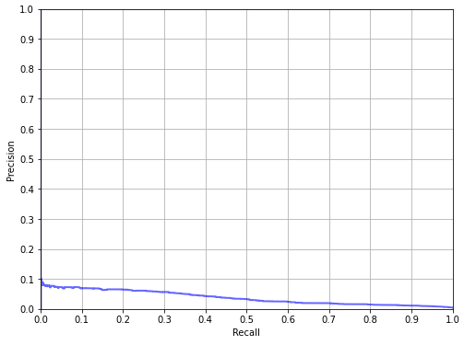

#### Training and testing data sets

The HAC risk models use the same set of data for training and testing model performance. This is not a significant issue for linear models like logistic regression, as overfitting is less likely. The decision tree‑based model implemented for readmissions is non-linear and in the extreme case can fit a model perfectly to the training data. So here we report performance metrics calculated on a hold-out "test" data set that was not used to fit the model.

When comparing the chart below with Figure 3 in the previous section, you can see a considerable improvement in the model precision at each level of recall. At 20 per cent recall, the model would have precision of around 13 per cent, a significant improvement compared with the 8 per cent of the logistic regression model.

Precision Recall curve for readmission 10 with gradient boosting decision tree model

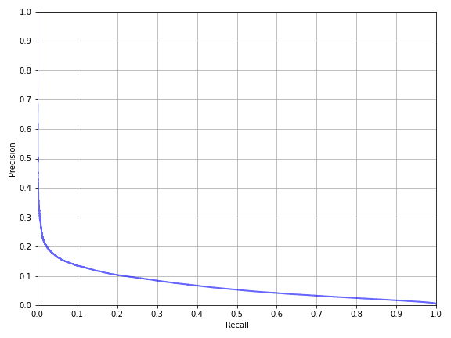

Note that this is the best performing model. In terms of ROC and PRC, the gradient boosting decision tree models with the additional risk factors (discussed further in Section 7) perform better across all readmission categories than the logistic regression models. ROC curves and PRC for the implemented readmission model are given in Appendix A.

# Risk factors

For the determination of patient-level funding options, episodes are assigned to a ‘Low’, ‘Medium’ or ‘High’ complexity group representing the risk of a readmission occurring based on any identified risk factors. IHPA notes that risk factors for avoidable hospital readmissions were examined independently of risk factors included in the funding model for HACs, as there are additional elements of long-term patient characteristics that must be taken into account.

## Previous risk factors

Throughout the shadow period, IHPA has assessed a number of risk factors, outlined in Table 7.

Table : Risk factors assessed throughout the shadow period

| First Report | Second Report | Third Report |
| --- | --- | --- |
| * Patient age * Gender * Indigenous status * Treatment remoteness * Diagnosis related group type (medical, surgical, other) * MDC * Charlson score * Socio-Economic Indexes for Areas (SEIFA) * ICU status * Admission status * Transfer status | * Patient age * Charlson score * MDC * Emergency status * ICU hours * DRG type * Gender * Transfer status * Patient remoteness * Indigenous status * Mental health condition present * Presence of a pacemaker * Dependence on ventilation * Post transplant * Asthma * Obesity/malnutrition * Presence of a HAC | * Patient age * MDC * Emergency status * ICU hours * DRG type * Gender * Transfer status * Patient remoteness * Indigenous status * Mental health condition present * Presence of a pacemaker * Dependence on ventilation * Post transplant * Asthma * Obesity * Malnutrition * Presence of a HAC * Length of stay in the index admission * Number of procedures undergone in the index admission * Number of hospital admissions in the year prior to the index admission * Charlson comorbidity diagnostic categories * Chronic condition flags |

Table : Charlson diagnostic category definitions

|  |  |
| --- | --- |
| Diagnostic category | Diagnosis codes |
| Acute myocardial infarction | I21 I22 I25.2 |
| Congestive heart failure | I50 |
| Peripheral vascular disease | I71 I79.0 I73.9 R02 Z95.8 Z95.9 |
| Cerebral vascular accident | I60 I61 I62 I63 I65 I66 G45.0 G45.1 G45.2 G45.8 G45.9 G46 I64 G45.4 I67.0 I67.1 I67.2 I67.4 I67.5 I67.6 I67.7 I67.8 I67.9 I68.1 I68.2 I68.8 I69 |
| Dementia | F00 F01 F02 F05.1 |
| Pulmonary disease | J40 J41 J42 J44 J43 J45 J46 J47 J67 J60 J61 J62 J63 J66 J64 J65 |
| Connective tissue disorder | M32 M34 M33.2 M05.3 M05.8 M05.9 M06.0 M06.3 M06.9 M05.0 M05.2 M05.1 M35.3 |
| Peptic ulcer | K25 K26 K27 K28 |
| Liver disease | K70.2 K70.3 K73 K71.7 K74.0 K74.2 K74.6 K74.3 K74.4 K74.5 |
| Diabetes | E10.9 E11.9 E13.9 E14.9 E10.1 E11.1 E13.1 E14.1 E10.5 E11.5 E13.5 E14.5 |
| Diabetes complications | E10.2 E11.2 E13.2 E14.2 E10.3 E11.3 E13.3 E14.3 E10.4 E11.4 E13.4 E14.4 |
| Paraplegia | G81 G04.1 G82.0 G82.1 G82.2 |
| Renal disease | N03 N05.2 N05.3 N05.4 N05.5 N05.6 N07.2 N07.3 N07.4 N01 N18 N19 N25 |
| Cancer | C0 C1 C2 C3 C40 C41 C43 C45 C46 C47 C48 C49 C5 C6 C70 C71 C72 C73 C74 C75 C76 C80 C81 C82 C83 C84 C85 C88.3 C88.7 C88.9 C90.0 C90.1 C91 C92 C93 C94.0 C94.1 C94.2 C94.3 C94.5 C94.7 C95 C96 |
| Metastatic cancer | C77 C78 C79 |
| Severe liver disease | K72.9 K76.6 K76.7 K72.1 |
| HIV | B20 B21 B22 B23 B24 |

Table : Chronic disease code categories

| Category | U code | Chronic condition codes |
| --- | --- | --- |
| Obesity | U78.1 | E66 |
| Cystic fibrosis | U78.2 | E84 |
| Dementia | U79.1 | F00 F01 F02 F03 |
| Schizophrenia | U79.2 | F20 |
| Depression | U79.3 | F32 F33 |
| Disorder of intellectual development | U79.4 | F70 F71 F72 F73 F74 F75 F76 F77 F78 F79 |
| Parkinson's disease | U80.1 | G20 |
| Multiple sclerosis | U80.2 | G35 |
| Epilepsy | U80.3 | G40 |
| Cerebral palsy | U80.4 | G80 |
| Tetraplegia, paraplegia, diplegia, monoplegia and hemiplegia, due to any cause | U80.5 | G81 G82 G83 |
| Ischaemic heart disease | U82.1 | I25 |
| Chronic heart failure | U82.2 | I50 |
| Hypertension | U82.3 | I10 |
| Emphysema without mention of COPD | U83.1 | J43.9 |
| Chronic obstructive pulmonary disease | U83.2 | J44.9 |
| Asthma, without mention of COPD | U83.3 | J45 |
| Bronchiectasis without mention of CF | U83.4 | J47 |
| Chronic respiratory failure | U83.5 | J96 |
| Crohn's disease | U84.1 | K50 |
| Ulcerative colitis | U84.2 | K51 |
| Chronic liver failure | U84.3 | K72.1 |
| Rheumatoid arthritis | U86.1 | M06 |
| Arthritis and osteoarthritis | U86.2 | M13 M15 M16 M17 M18 M19 M47 |
| Systemic lupus erythematosus | U86.3 | M32 |
| Osteoporosis | U86.4 | M81 |
| Chronic kidney disease stage 3 to 5 | U87.1 | N18 |
| Spina bifida | U88.1 | Q05 |
| Down's syndrome | U88.2 | Q90 |

### Feedback on risk factors development

Stakeholders expressed concern about using risk factors that were overly statistically driven and requested clinical evaluation of the final list. IHPA has endeavoured to achieve a balance of statistical significance and clinical relevance through a literature review of other readmissions studies[3],[4] and the use of feature importance breakdowns for key risk factors associated with each of the readmission conditions. Feature importance breakdowns is an attribute of the revised risk adjustment model, where the statistical importance and model contribution of each risk factor can be assessed and utilised in the readmission category models as required.

IHPA has refined the list of risk factors based on stakeholder feedback, consultation with the University of Melbourne and assessment of clinical relevance using the top feature importance breakdowns to remove risk factors that did not significantly contribute to model performance and prediction of readmissions.

IHPA also consolidated the risk factors contained within the Charlson comorbidity flags and chronic condition flags to eliminate overlapping risk factors and statistically and clinically insignificant factors.

## Finalised risk factors

### Key risk factors

With decision tree-based risk models it is possible to calculate the importance of each risk factor, giving it a percentage score for its contribution to the model. This provides insight into the statistical significance and impact of the proposed risk factors. IHPA has created top feature importance breakdowns for each readmission category to finalise the risk factors.

Figure 5 below shows the top feature importance breakdown for infections (category 2), which is the highest presenting readmission condition over the four year period assessed. The top feature importance breakdowns of all readmission categories are provided at Appendix B.

Top features relating to infections.

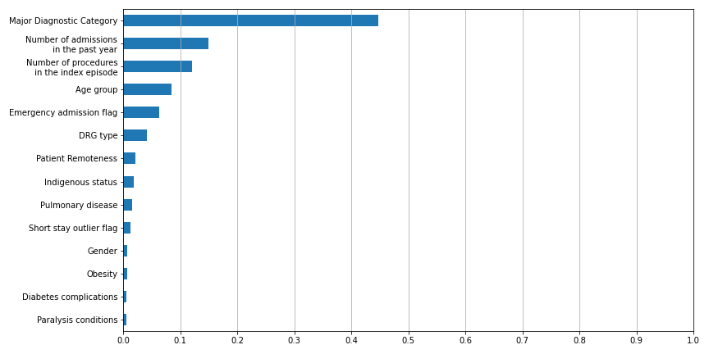

The feature importance tables have validated the significance of several new risk factors proposed in the previous report.

During the shadow reporting period, stakeholders queried using length of stay in the risk adjustment model, as it is a factor under the control of the hospital and influenced by processes of care. There was concern that it could potentially capture patients who were discharged too early or be indicative of a less complex patient. It should be noted that readmissions where the index admission had a separation mode of discharged against medical advice are excluded.

### Determination of finalised risk factors

IHPA developed a discrete set of risk factors for each readmission category for NEP22, instead of using a one-size-fits-all approach. The finalised risk factors were determined using feature importance breakdowns for each readmission category and underwent clinical consultation before being included in the final model.

The top performing risk factors with the largest contribution to predicting the readmission category were used in the risk adjustment models, based on a minimum relative feature importance threshold of 0.01. This approach was selected as it does not trim potentially important risk factors in some readmission categories, as would be the case if limited to an arbitrary number of risk factors (for example, top 10 risk factors). The same applies for risk factors that are not statistically significant for other readmission categories and can be subsequently eliminated from the lists.

In addition, a risk factor must be considered significant under these criteria for two of the past three years before it is considered for implementation. Lastly, the potential changes to the risk factor list is reviewed by IHPA’s Clinical Advisory Committee before being implemented.

Overall, this approach reflects the best risk factors (of those considered) for the best performing risk adjustment model for each readmission category. However, this method does have some shortcomings as the models for certain readmission categories may perform less optimally than other categories due to low episode sample sizes. This is particularly true for the pressure injury and gastrointestinal bleeding categories, where the extremely low sample sizes means that both risk factor selection and the risk model in general are less robust compared to the other readmission categories.

Another consideration is the use of chronic condition flags as risk factors, due to concerns that if the presence of a chronic condition impacts the course of care, it would be coded differently. The primary purpose of using Charlson comorbidity flags and chronic condition flags is to capture whether a patient has these types of conditions, and their related risk of readmission. For example, if a patient was readmitted for renal failure, their risk profile would be affected by having one or more of the chronic condition flags and they are therefore more likely to be readmitted due to their chronic condition.

Table 10 lists the final risk factors used in each readmission model.

Table : Risk factors for each readmission category

|  | **01. Pressure injury** | **02. Infections** | **03. Surgical complications** | **04. Respiratory complications** | **05. Venous thromboembolism** | **06. Renal failure** | **07. Gastrointestinal bleeding** | **08. Medication complications** | **09. Delirium** | **10. Cardiac complications** | **11. Constipation** | **12. Nausea and vomiting** |
| --- | --- | --- | --- | --- | --- | --- | --- | --- | --- | --- | --- | --- |
| **Past year admissions** | **✓** | **✓** | **✓** | **✓** | **✓** | **✓** | **✓** | **✓** | **✓** | **✓** | **✓** | **✓** |
| **Age group** | **✓** | **✓** | **✓** | **✓** | **✓** | **✓** | **✓** | **✓** | **✓** | **✓** | **✓** | **✓** |
| **Major Diagnostic Category** | **✓** | **✓** | **✓** | **✓** | **✓** | **✓** | **✓** | **✓** | **✓** | **✓** | **✓** | **✓** |
| **Procedure count** | **✓** | **✓** | **✓** | **✓** | **✓** | **✓** | **✓** | **✓** | **✓** | **✓** | **✓** | **✓** |
| **DRG type** |  | **✓** | **✓** |  |  | **✓** | **✓** | **✓** | **✓** | **✓** | **✓** | **✓** |
| **Drug use** |  |  |  |  |  |  |  |  | **✓** |  |  |  |
| **Transfer admission** |  |  |  |  |  |  |  | **✓** |  |  |  |  |
| **Emergency admission** | **✓** | **✓** | **✓** | **✓** | **✓** | **✓** | **✓** | **✓** | **✓** | **✓** | **✓** | **✓** |
| **ICU** |  |  |  |  | **✓** |  |  |  | **✓** |  |  |  |
| **Gender** |  | **✓** |  | **✓** | **✓** | **✓** | **✓** |  | **✓** |  | **✓** | **✓** |
| **Indigenous** | **✓** | **✓** | **✓** | **✓** | **✓** | **✓** | **✓** | **✓** | **✓** | **✓** | **✓** | **✓** |
| **Low length of stay** |  | **✓** |  |  | **✓** |  |  |  |  |  |  |  |
| **Malnutrition** |  |  |  |  |  |  |  |  |  |  |  | **✓** |
| **Pacemaker** | **✓** |  |  |  |  |  |  |  |  |  |  |  |
| **Patient remoteness** | **✓** | **✓** | **✓** | **✓** | **✓** | **✓** | **✓** | **✓** | **✓** | **✓** | **✓** | **✓** |
| **Post transplant** |  |  |  |  |  | **✓** |  |  |  |  |  |  |
| **Charlson comorbidity flags** |  |  |  |  |  |  |  |  |  |  |  |  |
| **Acute myocardial function** |  |  |  |  |  |  |  |  |  | **✓** |  |  |
| **Congestive heart failure** |  |  |  |  |  | **✓** |  |  |  | **✓** |  |  |
| **Diabetes** |  |  |  |  | **✓** |  |  | **✓** |  |  |  |  |
| **Diabetes complications** |  | **✓** |  |  |  | **✓** |  | **✓** |  | **✓** |  |  |
| **Dementia** |  |  |  | **✓** |  |  |  |  | **✓** |  |  |  |
| **Pulmonary disease** |  | **✓** |  |  | **✓** |  |  |  |  |  |  |  |
| **Renal disease** |  |  |  |  |  | **✓** |  | **✓** |  | **✓** |  |  |
| **Chronic condition flags** |  |  |  |  |  |  |  |  |  |  |  |  |
| **Arthritis and osteoarthritis** |  |  |  |  |  |  |  |  |  |  |  | **✓** |
| **Cerebral palsy** |  |  |  | **✓** |  |  |  |  |  |  | **✓** | **✓** |
| **Chronic heart failure** |  |  |  |  |  |  |  |  |  | **✓** |  |  |
| **Chronic kidney disease** |  |  |  |  |  | **✓** |  |  |  |  |  |  |
| **Chronic respiratory failure** |  |  |  | **✓** |  |  |  |  |  |  |  |  |
| **Chronic obstructive pulmonary disease** | **✓** |  |  | **✓** |  |  |  |  |  |  |  |  |
| **Crohns disease** |  |  |  |  |  |  |  |  |  |  | **✓** | **✓** |
| **Depression** |  |  |  |  | **✓** |  |  |  | **✓** |  |  |  |
| **Disorder of intellectual** |  |  |  |  |  |  |  |  |  |  | **✓** |  |
| **Downs syndrome** |  |  | **✓** |  |  |  |  |  |  |  |  |  |
| **Hypertension** |  |  |  |  | **✓** | **✓** | **✓** |  |  |  |  |  |
| **Ischaemic heart disease** |  |  |  |  | **✓** |  |  |  |  | **✓** |  |  |
| **Obesity** |  | **✓** |  |  | **✓** |  |  |  |  |  |  |  |
| **Osteoporosis** |  |  |  |  |  |  | **✓** |  |  |  |  |  |
| **Severe liver disease** |  |  |  |  |  | **✓** |  |  |  |  |  |  |
| **Spina bifida** | **✓** |  |  |  |  |  |  |  |  |  |  |  |
| **Paraplegia** | **✓** | **✓** |  | **✓** |  |  |  |  |  |  |  |  |
| **Total number of risk factors:** | 11 | 14 | 9 | 13 | 16 | 16 | 11 | 12 | 13 | 14 | 12 | 13 |

## Results

### Complexity points

For comparability to the HAC model, IHPA converted the resulting probability scores into complexity points, which are then used to assign an episode into a ‘Low’, ‘Moderate’ or ‘High’ complexity.

To calculate the points, IHPA calculated out min-max scaling parameters on model outputs to between the 1st and 99th percentiles. These are then used these to rescale the model outputs to between 1 and 100, clipping results below 1 and 100 (from the <1st and >99th percentile outliers) to 1 and 100 respectively.

Figure 6 shows the distribution of complexity scores for episodes with readmissions due to cardiac complications (category 10).

Figure 6: Readmission complexity due to cardiac complications

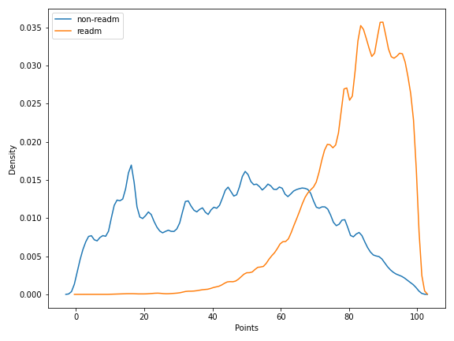

This shows the episodes resulting in readmission have far greater complexity than those which do not. Similar complexity distributions are provided for all readmissions in Appendix C.

### Dampening factors

The avoidable readmission funding adjustment is applied at an episode level by reducing the efficient price of an episode based on an incremental cost associated with the potentially avoidable hospital readmission, similar to the incremental cost of a HACs used for the HACs funding adjustment.

To calculate the risk categories the distribution of points scores for readmission index episodes is split into three equal sized groups. The first tercile (rounded to the nearest integer value) is then the threshold between the low and medium risk categories, and the second tercile is the threshold between the medium and high risk categories.

The ‘incremental cost’ (i.e. NWAU of the readmission episode) is then reduced by a dampening factor dependent on index episode risk of readmission, and subtracted from the total NWAU of the index episode. The dampening factor for each risk category is calculated as: the mean point score for the low risk category divided by the mean points score for each other risk category corresponding to the dampening factor. So the risk score for the low risk category is *mean_low / mean_low*, which will always be equal to one, the medium risk category is *mean_low / mean_medium*, and the high risk category is *mean_low / mean_high*.

Table 11 shows the adjustment applied to avoidable hospital readmissions identified within the same jurisdiction. The adjustment factors vary depending on the readmission category and the complexity group of the episode. For low complexity episodes, the full NWAU of the readmission episode is deducted from the index admission. For high complexity episodes, only a portion of it is removed (e.g. 36.3 per cent for Medication complications).

Table : Adjustment factors

|  |  |  |  |  |  |  |  |  |  |  |  |  |
| --- | --- | --- | --- | --- | --- | --- | --- | --- | --- | --- | --- | --- |
|  | **01. Pressure injury** | **02. Infections** | **03. Surgical complications** | **04. Respiratory complications** | **05. Venous thromboembolism** | **06. Renal failure** | **07. Gastrointestinal bleeding** | **08. Medication complications** | **09. Delirium** | **10. Cardiac complications** | **11. Constipation** | **12. Nausea and vomiting** |
| **Complexity group point thresholds** | | | | | | | | | | | | |
| **Low** | 0 | 0 | 0 | 0 | 0 | 0 | 0 | 0 | 0 | 0 | 0 | 0 |
| **Moderate** | 46 | 66 | 91 | 75 | 81 | 72 | 59 | 64 | 79 | 79 | 58 | 52 |
| **High** | 64 | 80 | 95 | 88 | 88 | 86 | 87 | 85 | 90 | 89 | 76 | 72 |
| **Complexity group dampening factors** | | | | | | | | | | | | |
| **Low** | 1.0000 | 1.0000 | 1.0000 | 1.0000 | 1.0000 | 1.0000 | 1.0000 | 1.0000 | 1.0000 | 1.0000 | 1.0000 | 1.0000 |
| **Moderate** | 0.4810 | 0.5620 | 0.2470 | 0.5750 | 0.7140 | 0.5260 | 0.5070 | 0.4460 | 0.4760 | 0.5180 | 0.4390 | 0.5570 |
| **High** | 0.3560 | 0.4710 | 0.2370 | 0.4950 | 0.6520 | 0.4510 | 0.3800 | 0.3630 | 0.4260 | 0.4620 | 0.3370 | 0.4150 |

# Scope options

## Overview

IHPA has analysed all scope options (readmissions that occur within the same hospital, Local Hospital Network (LHN) and jurisdiction) in the shadow reporting period for stakeholder consideration.

### Impact within the same hospital, LHN or jurisdiction

IHPA has undertaken analysis of 2016–17, 2017–18, 2018–19 and 2019–20 data of all avoidable hospital readmissions by the location of the readmission. The analysis indicates that:

53.7 per cent of readmissions occurred when patients presented to the same hospital.

16.7 per cent of readmissions occurred in a different hospital in the same LHN.

29.6 per cent of readmissions occurred in a different LHN in the same state or territory.

### Impact within or across financial years

IHPA has undertaken analysis of 2016–17, 2017–18, 2018–19 and 2019–20 data of all avoidable hospital readmissions within or across financial years. The analysis indicates that:

97.0 per cent of readmissions occurred within the same financial year.

3.0 per cent of readmissions occurred across financial years.

## Scope option for implementation

Throughout the shadow period, stakeholders were supportive of IHPA’s preference for using the widest scope possible to maximise coverage of readmission episodes. Modelling the readmissions adjustment at a jurisdictional level was found to unequivocally be the best option as it provided the most robust data validation.

Applying funding adjustments at a jurisdictional level was also found to have a less disproportionate impact on smaller states and territories with fewer LHNs, as a large percentage of readmissions occur within the same jurisdiction. The wider scope meant a fuller coverage of readmissions.

IHPA will implement the funding adjustment using the Medicare PIN in the short term, with a view to shift to using an IHI available to the jurisdictions in the medium term. In progressing the implementation of the funding adjustment, IHPA will consolidate the process with transparency in the pricing, data and reconciliation practices.

# Funding adjustment

## Overview

From 1 July 2019, IHPA commenced a 24-month shadow period encompassing three funding options for avoidable hospital readmissions:

Option one: Deduct the cost of the readmission episode from the index episode;

Option two: Combine the index and readmission episodes and recalculate the funding of the combined episode;

Option three: Adjust funding at the hospital level where actual rates of avoidable readmissions exceed expected rates of avoidable readmissions.

Throughout the shadow period IHPA worked closely with jurisdictional stakeholders in analysing and evaluating the three scope options for potential implementation.

A majority of stakeholders expressed a preference for funding option one throughout the shadow period. Funding option one is the simplest to apply as it follows the same methodology as the HACs adjustment, where the funding adjustment is applied at the place of the index admission. Of the funding options investigated, option one impacted the jurisdictions more proportionately when compared to funding options two and three, which showed adjustment bias against smaller regional and remote hospitals when the scope is expanded beyond the hospital level.

Stakeholders initially had reservations about the potentially punitive effect of funding option one for episodes involving a transfer within hospital networks. IHPA has made the decision to trim transfer episodes from the readmissions data to consolidate this risk and provide a more accurate picture of the readmissions landscape.

Stakeholders also expressed concerns about funding option one being a disincentive for hospitals to discharge patients to avoid penalisation for a potential readmission. However, this could be viewed as a positive change in clinical behaviour to reduce avoidable readmissions and improve patient safety if discharges were previously occurring too early.

## Funding option for implementation

IHPA has implemented the funding adjustment for avoidable hospital readmissions using funding option one: deduct the cost of the readmission episode from the index episode.

Under this episode-level approach, an avoidable hospital readmission would nominally receive no funding, with a funding adjustment applied to impact on where the index admission occurred (even when the readmission occurred in a different hospital/LHN to the index admission).

To accomplish this, an NWAU adjustment is applied to the index episode, based on the total NWAU of the associated readmission. For episodes considered low risk under the risk adjustment methodology, the full NWAU of the readmission episode is deducted from the index episode (up to the value of the index episode). This is similar to the full incremental cost deduction in the context of HACs.

This option is risk adjusted by the adjustment factors given in Table 11, for example, if the risk of a readmission is high, only a small percentage of the readmitted episode NWAU is deducted from the index episode.

### Application of funding adjustment

IHPA developed the following example to assist stakeholders in applying and calculating the funding adjustment:

The index episode occurred at Hospital A:

DRG D12B (Other Ear, Nose, Mouth and Throat Interventions, Minor Complexity)

NWAU 0.8362

The readmission episode occurred at Hospital B:

Readmission condition category 3 (Surgical complications)

DRG G66A (Abdominal Pain and Mesenteric Adenitis, Major Complexity)

NWAU 0.6526

Complexity score for readmission category 3 is 93, moderate complexity.

The calculation:

The incremental cost of the readmission is the NWAU of the readmission episode, i.e. 0.6526.

The dampening factor for readmission category 3 moderate complexity is 0.2470 therefore the NWAU reduction is 0.6526*0.2470 = 0.1612

The readmission episode is funded with the full NWAU, i.e. 0.6526.

The funding deduction applies to the index episode, so the index episode is assigned NWAU of 0.8362 - 0.1612 = 0.6750.

Appendix A – Model fit curves

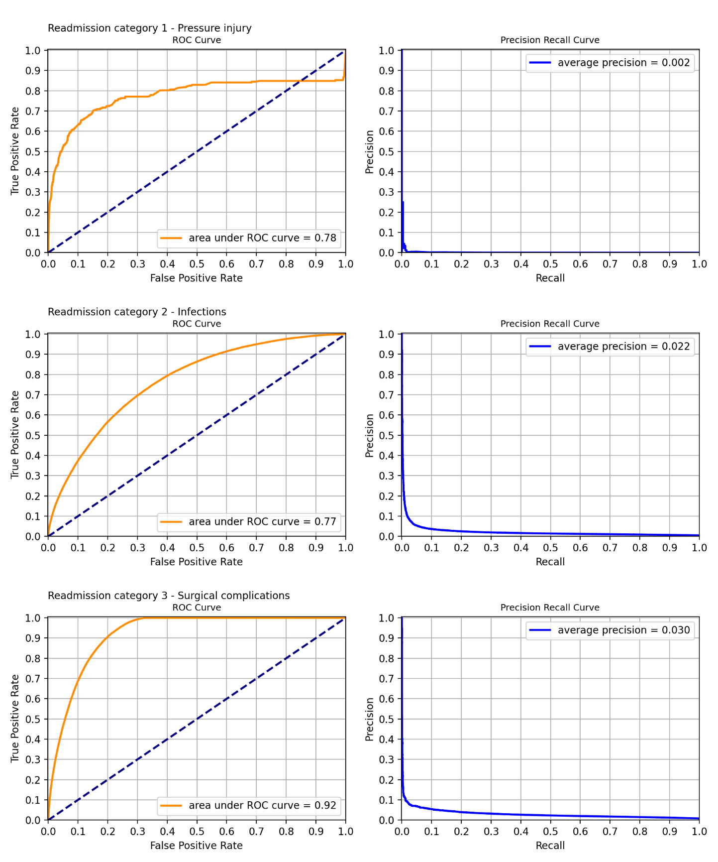

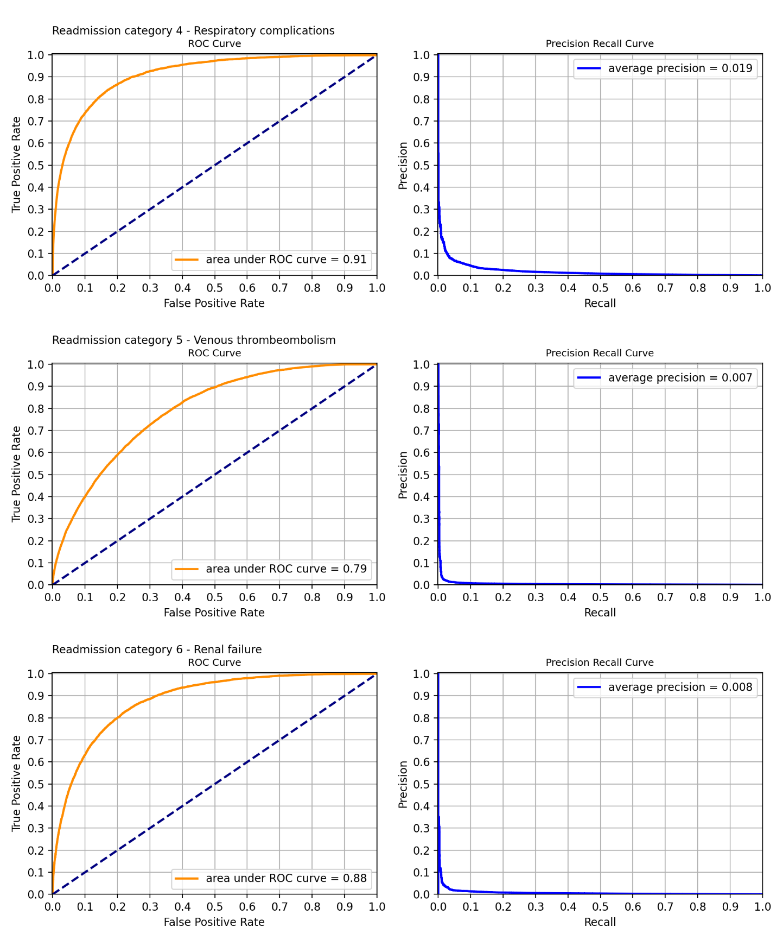

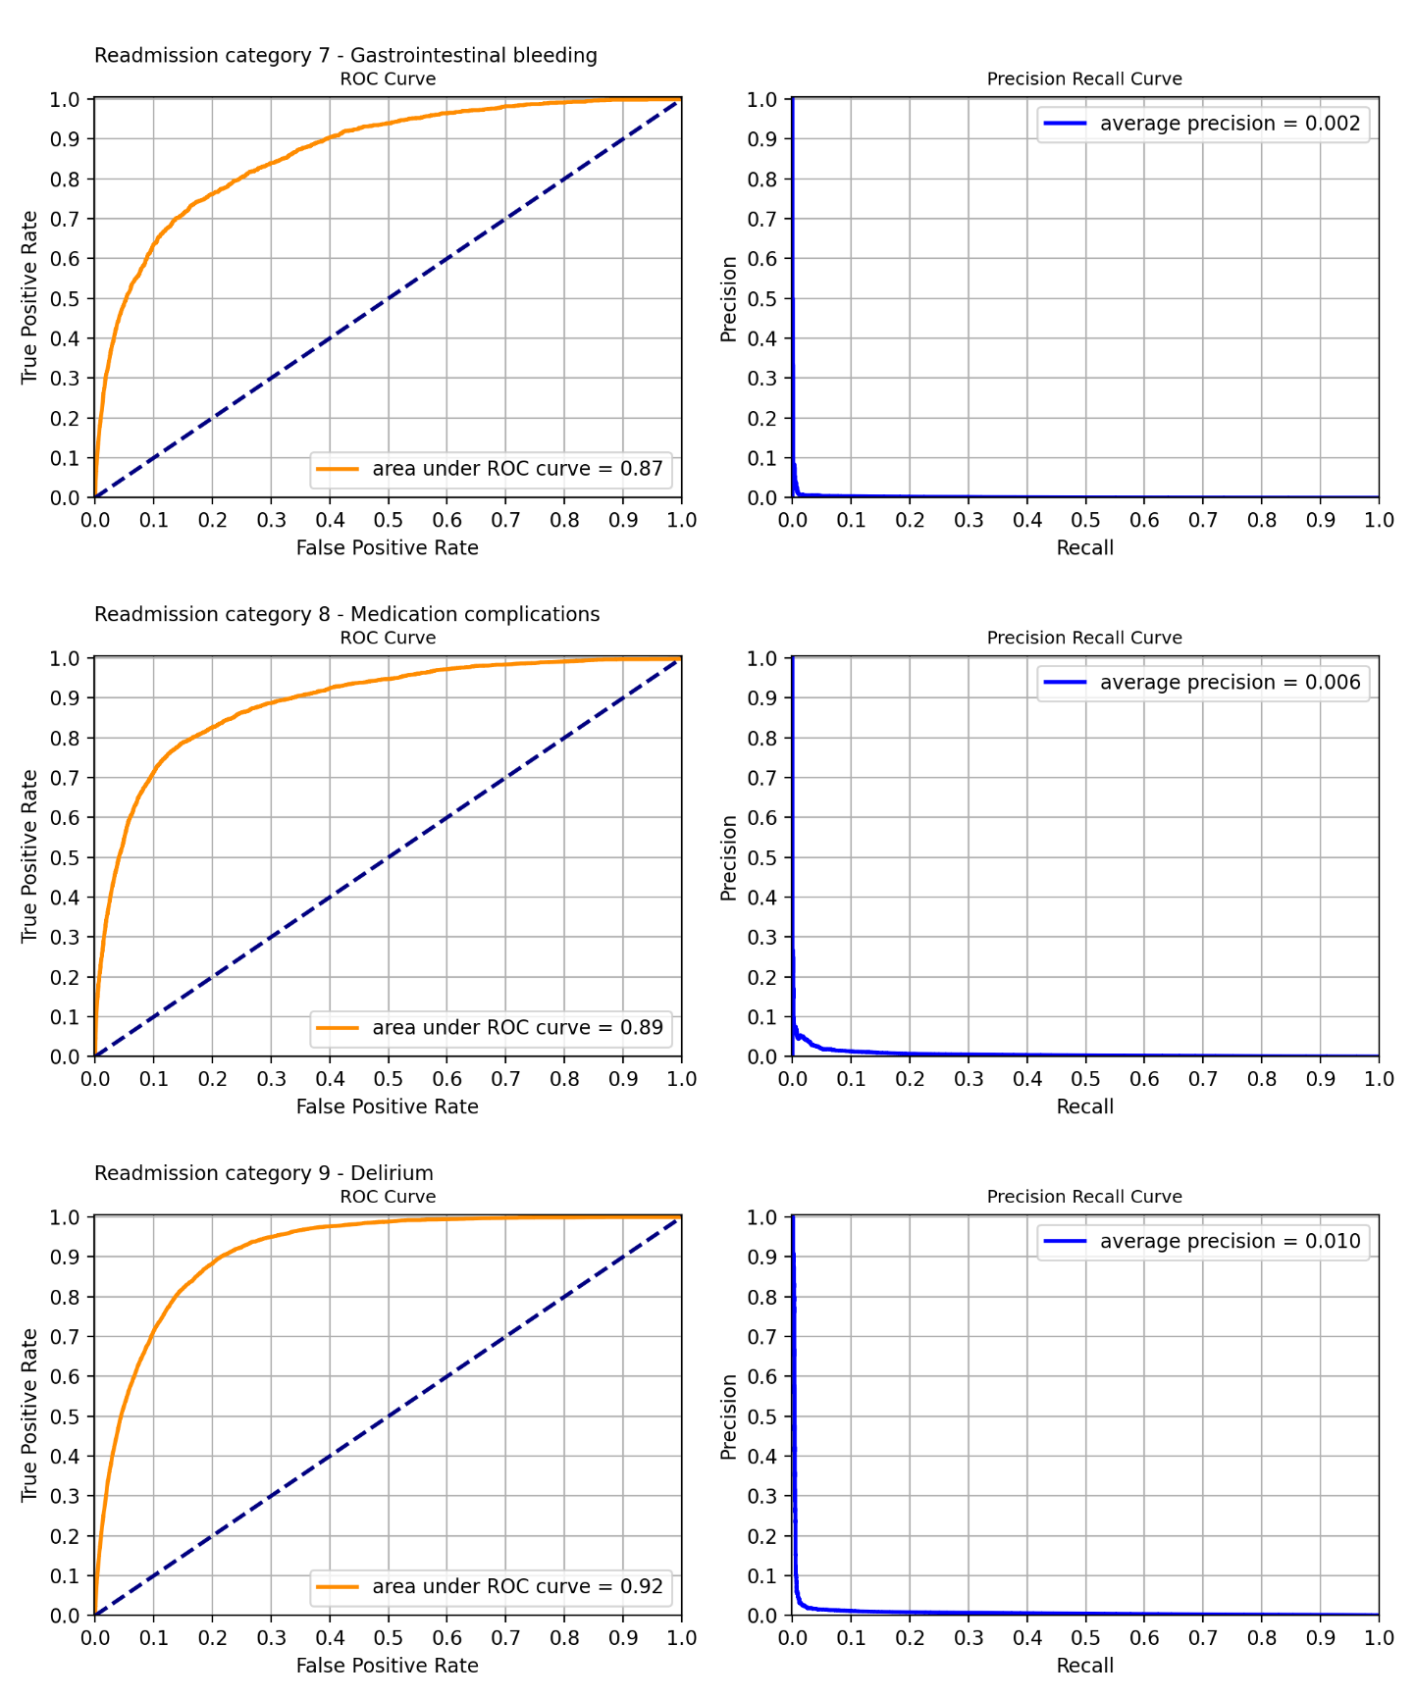

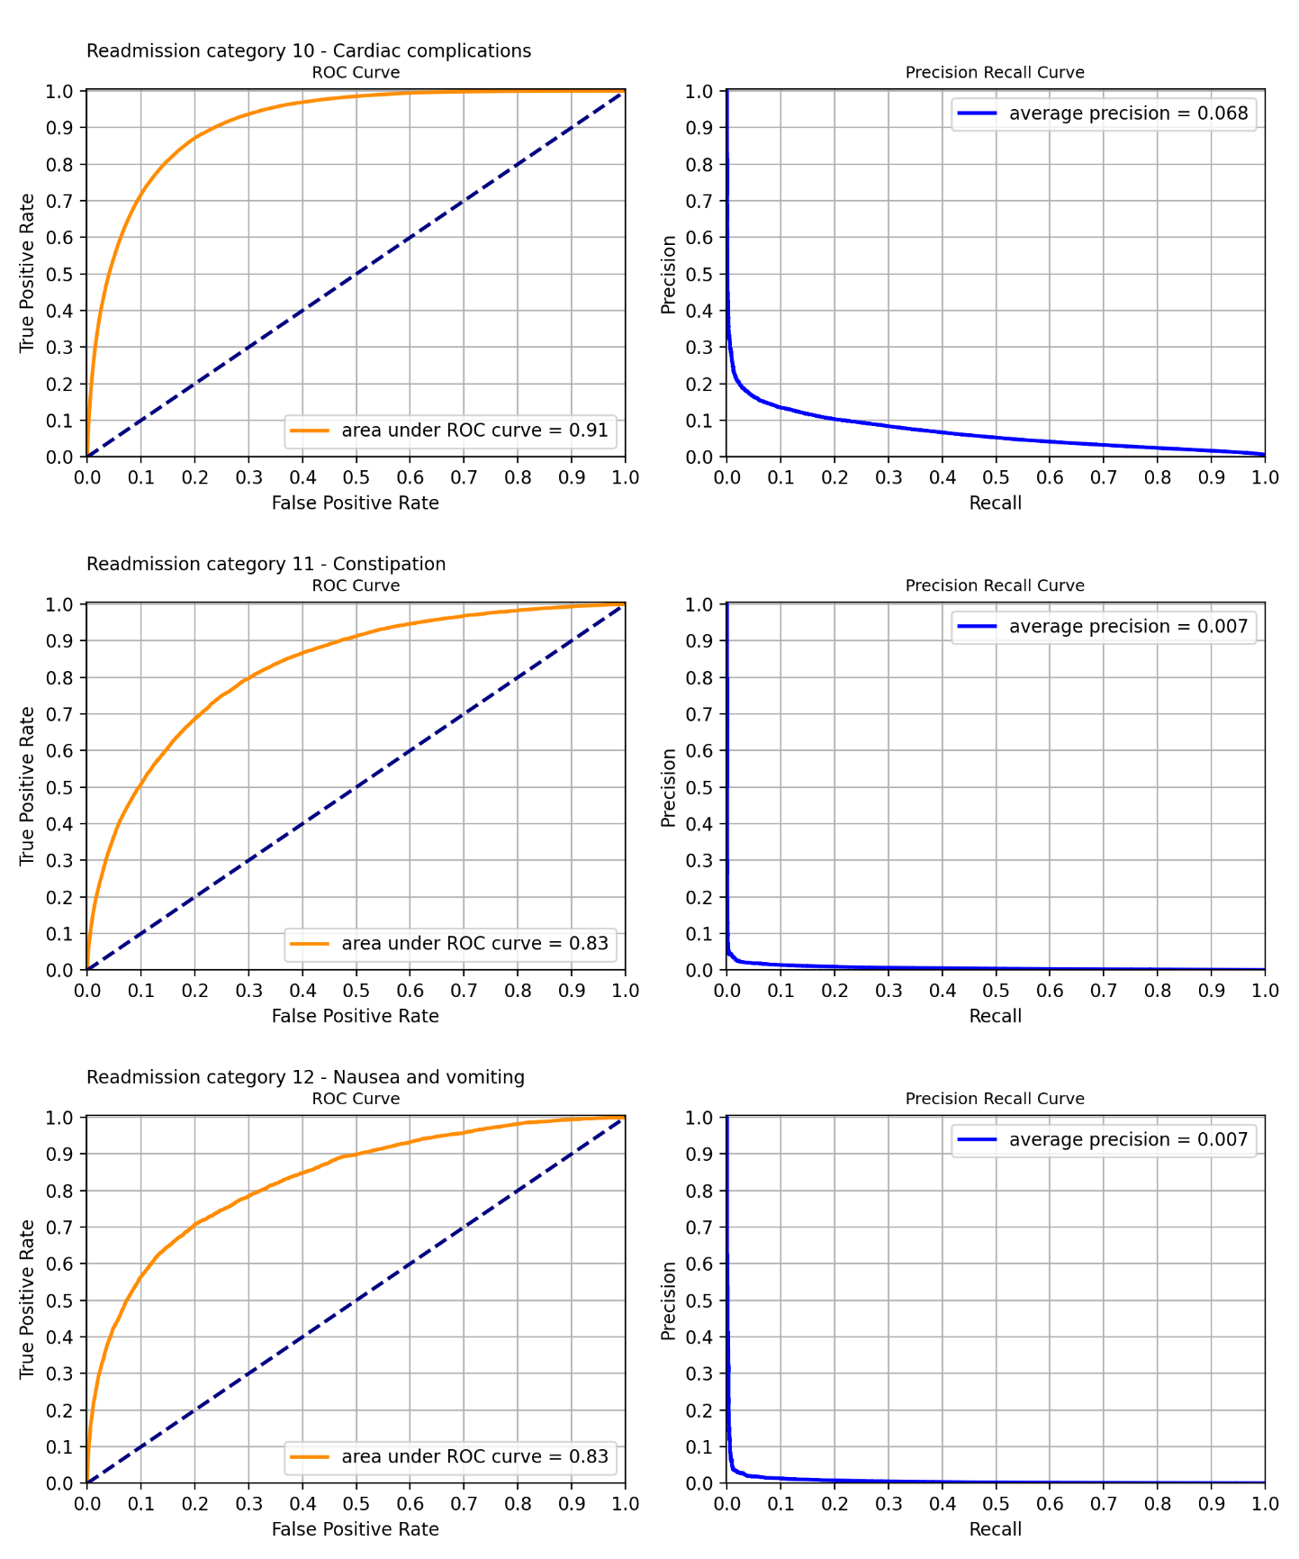

Appendix B – Key risk factor breakdowns

Readmission category 1 – Pressure injury.

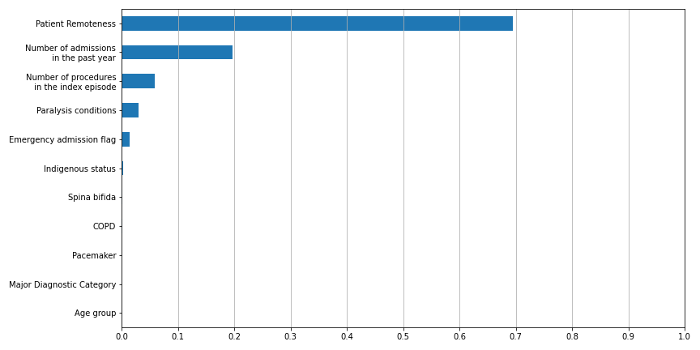

Readmission category 2 – Infections.



Readmission category 3 – Surgical complications.

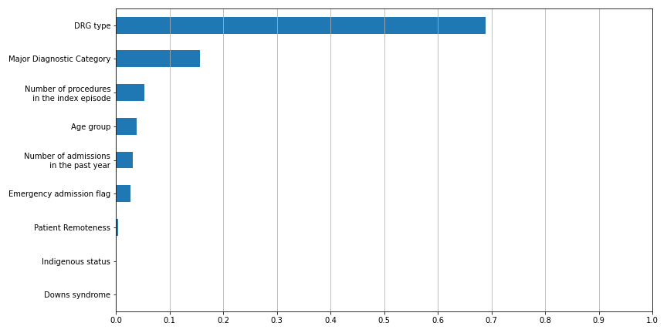

Readmission category 4 – Respiratory complications.

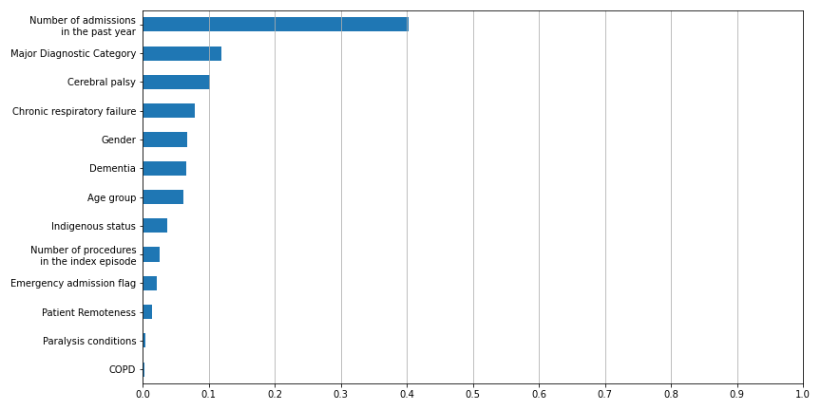

Readmission category 5 – Venous thromboembolism.

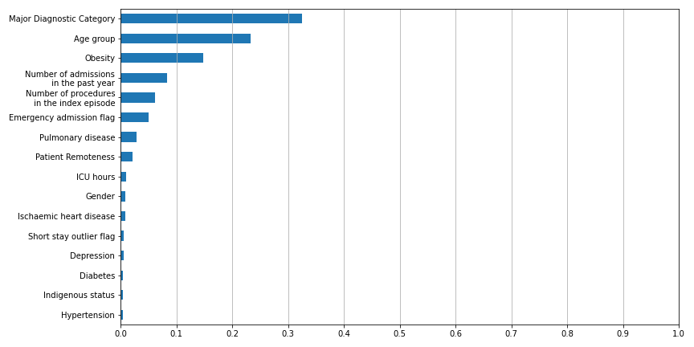

Readmission category 6 – Renal failure.

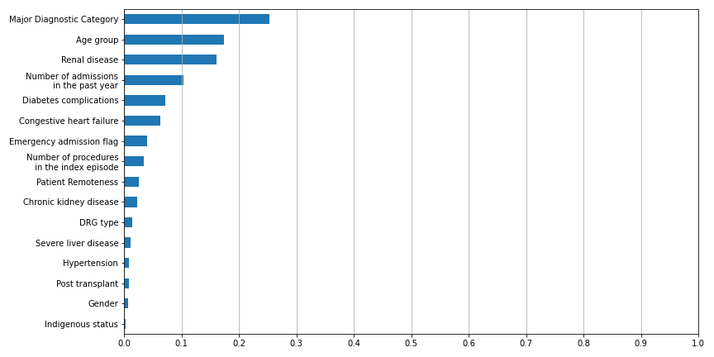

Readmission category 7 – Gastrointestinal bleeding.

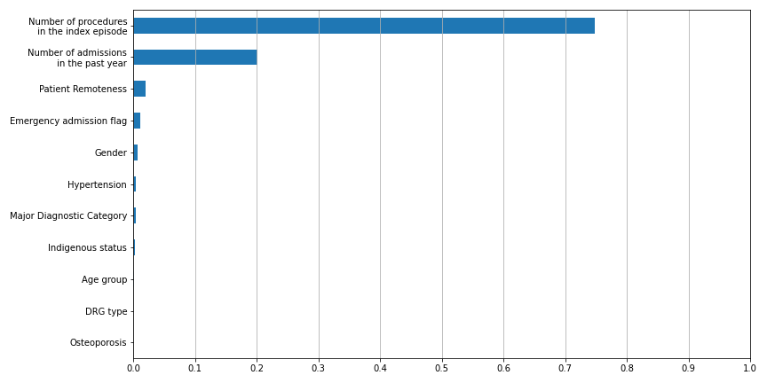

Readmission category 8 – Medication complications.

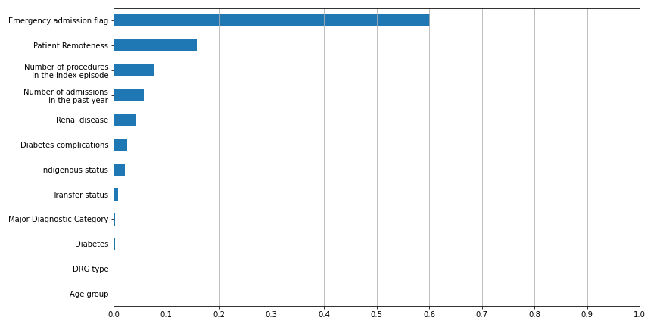

Readmission category 9 – Delirium.

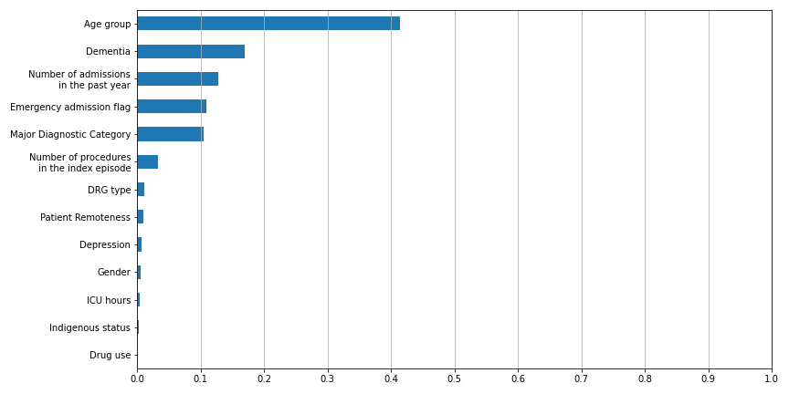

Readmission category 10 – Cardiac complications.

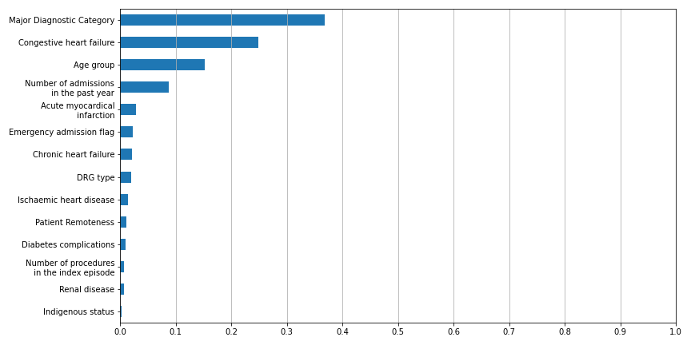

Readmission category 11 – Constipation.

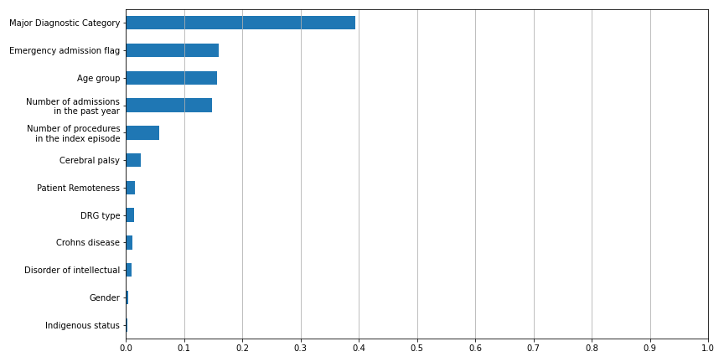

Readmission category 12 – Nausea and vomiting.

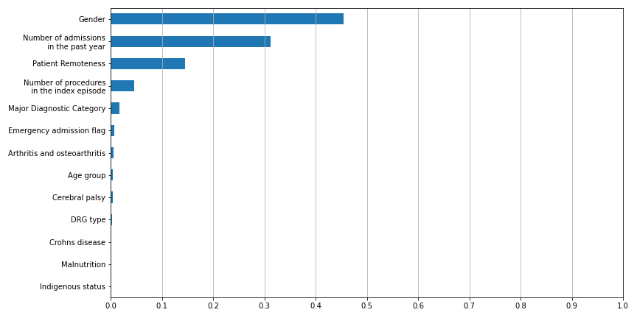

Appendix C – Model complexity distributions

Readmission category 1 – Pressure injury.

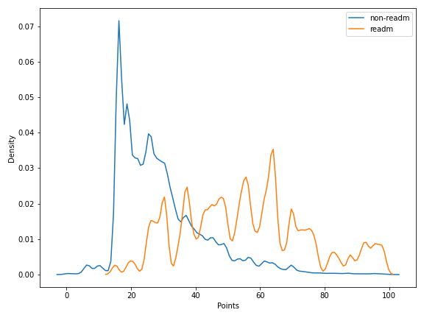

Readmission category 2 – Infections.

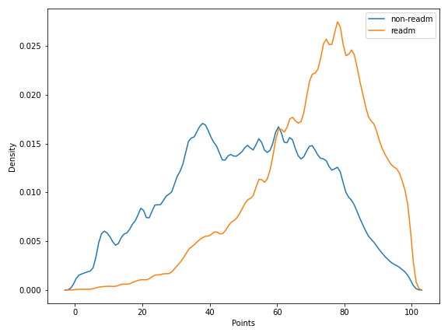

Readmission category 3 – Surgical complications.

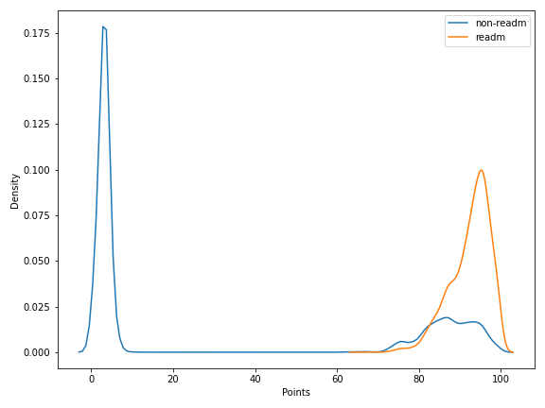

Readmission category 4 – Respiratory complications.

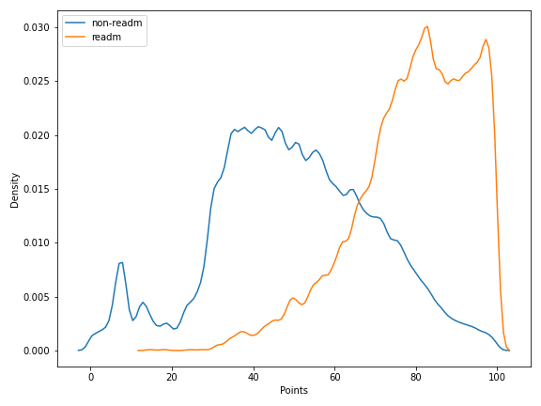

Readmission category 5 – Venous thromboembolism.

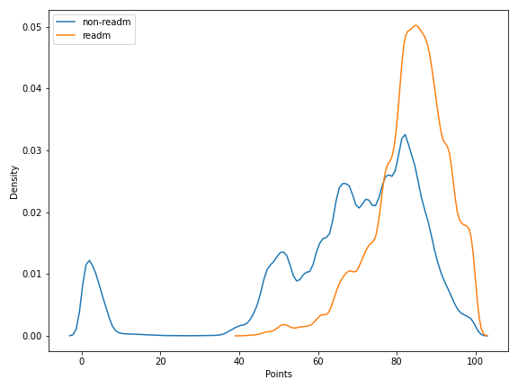

Readmission category 6 – Renal failure.

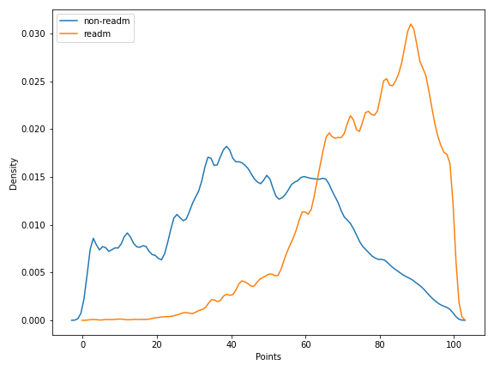

Readmission category 7 – Gastrointestinal bleeding.

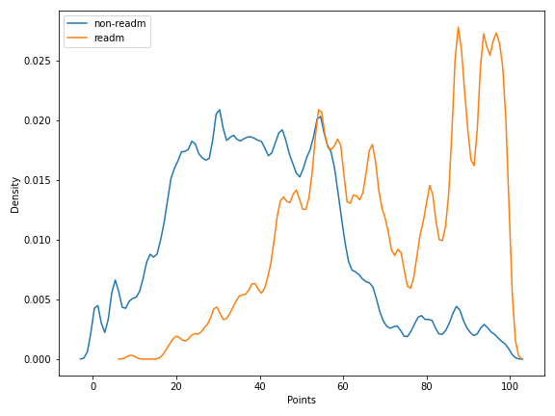

Readmission category 8 – Medication complications.

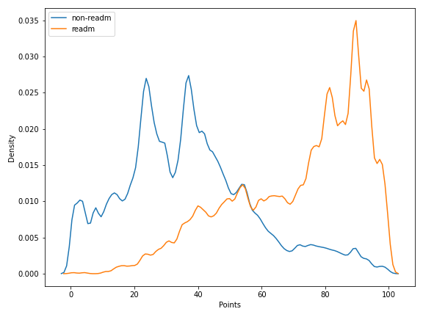

Readmission category 9 – Delirium.

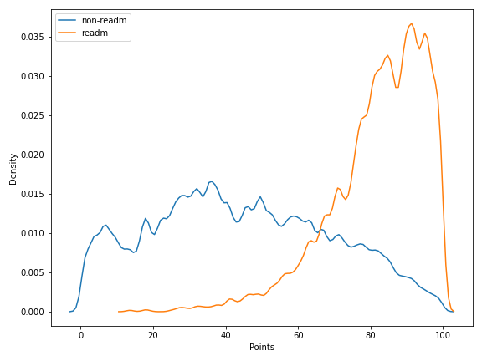

Readmission category 10 – Cardiac complications.



Readmission category 11 – Constipation.

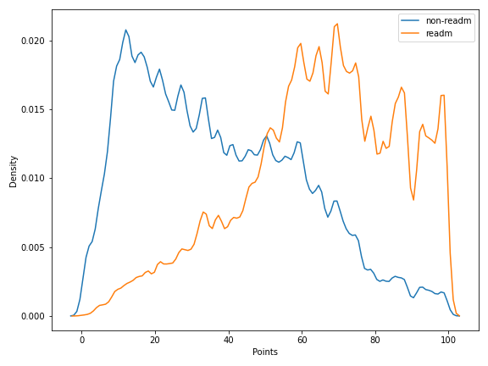

Readmission category 12 – Nausea and vomiting.





Independent Hospital Pricing Authority

Eora Nation, Level 12, 1 Oxford Street

Sydney NSW 2000

Phone 02 8215 1100

Email enquiries.ihpa@ihpa.gov.au

Twitter @IHPAnews

www.ihpa.gov.au

www.ihpa.gov.au

1. 1 Relevant acute admitted episodes comprise episodes with one or more of the readmission conditions in the list of Avoidable Hospital Readmissions and the readmission interval is less than or equal to the condition‑specific timeframes specified in this list.
2. Note that the 2019-20 readmission counts are lower as only the first nine months of data were considered due to the longest readmission interval being 90 days.
3. Min, X., Yu, B. & Wang, F. Predictive Modeling of the Hospital Readmission Risk from Patients’ Claims Data Using Machine Learning: A Case Study on COPD. Sci Rep 9, 2362 (2019). https://doi.org/10.1038/s41598-019-39071-y
4. Donzé J, Aujesky D, Williams D, Schnipper JL. Potentially Avoidable 30-Day Hospital Readmissions in Medical Patients: Derivation and Validation of a Prediction Model. JAMA Intern Med. 2013;173(8):632–638. doi:10.1001/jamainternmed.2013.3023