Independent Hospital Pricing Authority

National Pricing Model Stability Policy

May 2022



National Pricing Model Stability Policy – Version 5.0 May 2022

© Independent Hospital Pricing Authority 2022

This publication is available for your use under a [Creative Commons BY Attribution 3.0 Australia](http://creativecommons.org/licenses/by/3.0/au/deed.en) licence, with the exception of the Independent Hospital Pricing Authority logo, photographs, images, signatures and where otherwise stated. The full licence terms are available from [the Creative Commons website](http://creativecommons.org/licenses/by/3.0/au/legalcode).



Use of Independent Hospital Pricing Authority material under a [Creative Commons BY Attribution 3.0 Australia](http://creativecommons.org/licenses/by/3.0/au/deed.en) licence requires you to attribute the work (but not in any way that suggests that the Independent Hospital Pricing Authority endorses you or your use of the work).

*Independent Hospital Pricing Authority material used 'as supplied'.*

Provided you have not modified or transformed Independent Hospital Pricing Authority material in any way including, for example, by changing Independent Hospital Pricing Authority text – then the Independent Hospital Pricing Authority prefers the following attribution:

*Source: The Independent Hospital Pricing Authority*

# Table of contents

Acronyms and abbreviations 3

Definitions 4

1. Executive summary 5

1.1 Background 5

1.2 Purpose 5

1.3 Review 5

2. Context 6

2.1 Policy statement 6

3. Stabilisation process 7

4. Base data preparation 8

4.1 NEP data preparation 8

4.2 NEC data preparation 9

4.3 Movements in cost parameters 9

4.4 Movements in paediatric adjustments 10

4.5 Stability of adjustments 10

# Acronyms and abbreviations

|  |  |
| --- | --- |
| **ABF** | Activity based funding |
| **ALOS** | Average length of stay |
| **AR-DRG** | Australian Refined Diagnosis Related Group |
| **CAC** | Clinical Advisory Committee |
| **ICU** | Intensive care unit |
| **IHPA** | Independent Hospital Pricing Authority |
| **LHN** | Local hospital network |
| **NEC** | National efficient cost |
| **NEP** | National efficient price |
| **NHRA** | National Health Reform Agreement |
| **TAC** | Technical Advisory Committee |
| **The Addendum** | Addendum to the National Health Reform Agreement 2020–25 |
| **This Policy** | *National Pricing Model Stability Policy* |
|  |  |

# Definitions

|  |  |
| --- | --- |
| **Activity based funding** | Refers to a system for funding public hospital services provided to individual patients using national classifications, cost weights and nationally efficient prices developed by the Independent Hospital Pricing Authority (IHPA), as outlined in the Addendum to the National Health Reform Agreement 2020–25 (the Addendum).  An activity based funding activity may take the form of a separation, presentation or service event. |
| **National pricing model** | The national pricing model is produced annually by IHPA and defines the national efficient price, price weights and adjustments based on the cost and activity data from three years prior. For more detail, refer to the link below for the National Pricing Model Technical Specifications.  <https://www.ihpa.gov.au/what-we-do/pricing/national-pricing-model-technical-specifications> |
| **Public hospital services** | From 1 July 2013, the scope of public hospital services eligible for Commonwealth funding will be[1],[2]:   * all admitted programs, including hospital in the home programs; * all emergency department services; and * non-admitted services that meet the criteria for inclusion on the IHPA General List of In-Scope Public Hospital Services. |
| **Pricing Authority** | The governing body of IHPA established under the *National Health Reform Act 2011* (Cwlth). |

# Executive summary

## Background

The Independent Hospital Pricing Authority (IHPA) undertakes work to stabilise variation in the year-on-year national efficient price (NEP) and national efficient cost (NEC) price weights and adjustments, prior to determination of the NEP and NEC. Variation exists due to various reasons, including changes in the costing and activity data each year, changes in coding practices, technology changes and modifications to the classification systems used by IHPA.

As outlined in the [*Pricing Framework for Australian Public Hospital Services*](https://www.ihpa.gov.au/what-we-do/pricing-framework), IHPA will follow the Pricing Guidelines to guide its decision-making where it is required to exercise policy judgement in undertaking its legislated functions.

## Purpose

The purpose of the *National Pricing Model Stability Policy* (this Policy) is to outline the processes for adjusting for instability in the year-on-year price weights and adjustments. This Policy supports the ‘Stability’ Pricing Guideline, that is, ‘the payment relativities for activity based funding (ABF) are consistent over time’.

## Review

The Pricing Authority and Chief Executive Officer of IHPA will review this Policy, including associated documentation annually or as required.

This Policy was last reviewed in May 2022.

# Context

The Australian health care system is undergoing significant changes and there is inherent variability in the data sets that IHPA uses for the purposes of determining the NEP and NEC. Ensuring year-on-year stability in the price weights and adjustments is necessary to ensure funding stability and predictability for local hospital networks (LHNs) and hospital managers.

In determining the NEP and NEC each year, IHPA will adopt methods to stabilise the data from the previous year/s so that the impact of statistical variation or ‘noise’ on the national pricing model can be minimised, whilst ensuring that the model accurately reflects changes in practice in public hospitals.

## Policy statement

IHPA will promote funding stability and predictability for LHNs and hospital managers through satisfying two key principles within the national pricing model:

1. Being sensitive to changes in activity, cost or data lags

The stabilisation process is important to ensure that only observed changes related to activity and/or cost variations in Australian public hospitals are reflected in the national pricing model.

1. Minimising statistical variation

The national pricing model is empirically based. This can create unexplained statistical variation. In analysing data variance to calculate the NEP and NEC, IHPA will use a 95 per cent confidence interval to determine statistical significance.

# Stabilisation process

All proposed changes to the national pricing model will first undergo the assessment and jurisdictional consultation process as outlined in IHPA’s *National Pricing Model Consultation Policy*. Such proposed changes may include pricing changes and projected pricing impact on funding, costing methodology changes, new classifications and major structural changes to existing classifications and funding cycle impacts.

Once a proposed change progresses to implementation, following assessment against the *National Pricing Model Consultation Policy*, changes that require back-casting will follow the processes outlined in IHPA’s *Back-Casting Policy*.

The key stages in the NEP and NEC stabilisation process are outlined in **Figure 1**. IHPA’s Jurisdictional Advisory Committee and Clinical Advisory Committee (CAC) will be provided with the opportunity to review the stability interventions presented to IHPA’s Technical Advisory Committee (TAC) before these interventions are implemented.

1. Overview of the NEP and NEC stabilisation process

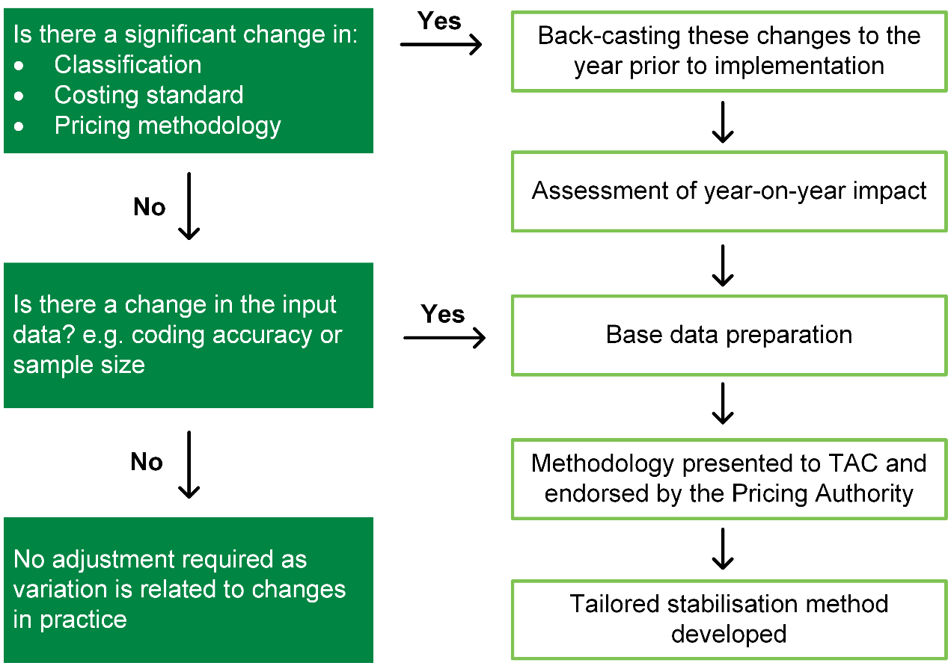

# Base data preparation

## NEP data preparation

The steps IHPA adopts to prepare the data for the NEP are detailed in the National Pricing Model Technical Specifications, released in conjunction with the NEP each year.

### 4.1.1 Identification and classification of outlier data

In preparing the data, IHPA identifies and removes extreme cost outliers. This process is detailed in the National Pricing Model Technical Specifications.

### 4.1.2 Low volume end-classes

Some end-classes, such as end-classes within the Australian Refined Diagnosis Related Groups Classification (AR-DRGs), have very low volumes of patients treated each year and as such are particularly vulnerable to volatility, as each patient cost record has a greater influence on the average cost and length of stay.

For end-classes with less than 100 separations in any given year, IHPA will combine data from the current year and preceding year in order to increase the volume in the sample and provide improved stability to the cost and length of stay parameters for that end-class. The preceding year’s data will be indexed to ensure comparability between the two years’ data.

### 4.1.3 Establishing inlier bounds

The inlier bounds are used to define the pool of separations within an admitted end‑class that are considered to be homogenous. Those separations with a length of stay that falls outside the bounds are classified as outliers, where costs are not representative of the average cost of treating patients within the end-classes.

Moving the inlier bounds leads to a recalculation of price weights and changes in the relativities between the price weights of different end-classes.

The impact of changing the bounds for any end-class is compounded if the National Hospital Cost Data Collection also reports changes in the average cost for that end‑class relative to other end-classes.

In developing a robust, stable system of price weights, it is important that the relative values of price weights do not fluctuate with random variations in activity and/or cost data from year-to-year.

Therefore, changes to the inlier bounds should only be made when there is either a clinical or methodological reason, or a sustained trend in behaviour that is observed over time.

The inlier bounds for each end-class are determined by IHPA based on the average length of stay (ALOS) profile.

The steps IHPA adopted to calculate the inlier bounds are outlined in further detail in the annual National Pricing Model Technical Specifications.

### 4.1.4 Movements in inlier bounds

The inlier bounds for length of stay based cost models are subject to fluctuation year‑to‑year as the ALOS moves.

Changes to the lower and upper bounds are considered legitimate if the end-class has had a change in its status on:

* the same-day pricing list; or
* the bundled list for intensive care unit (ICU) payments; or
* the list to move from L3H3[3] to L1.5H1.5[4] because of the distribution of long stay, high cost outliers.

Otherwise, inlier bounds will only be changed when there is:

* a statistically significant change in the bounds (at the 95 per cent confidence level); or
* if a change in a bound affects more than 1 per cent or more than 10 of the end-class episodes.

These two tests are applied in the first instance to the upper bounds and only when there is movement to the upper bound will the lower bounds be subjected to the same tests to see if there should be any movement in them as well.

In some rare instances, if inlier bounds are stabilised, the ALOS for an end-class may lay outside the inlier bounds. In those cases, the inlier bounds are not stabilised.

## NEC data preparation

The steps IHPA adopts to prepare the data for the NEC are detailed in the National Pricing Model Technical Specifications, released in conjunction with the NEC each year.

## Movements in cost parameters

Movements in cost parameters, which become price weights, may vary from year-to-year for many reasons including changes in cost data or inlier bound movements. The net impact of large fluctuations can be an undesired instability in the model.

In the admitted cost models (acute care, mental health care and subacute care) IHPA will restrict the year-to-year movement in price weights to +/- 20 per cent where:

* there are less than 1,000 inlier episodes; and
* there is no change to inlier bounds; and
* there is no change to the status on the same-day pricing list and bundled ICU list; and
* the change in the inlier cost parameter is outside +/- 20 per cent.

In the non-admitted care and emergency department cost models, IHPA will restrict the year-to-year movement to +/- 20 per cent for all price weights.

For services with high patient volumes and high aggregate expenditure (for example, chemotherapy and dialysis) IHPA may consider lower thresholds than the +/- 20 per cent movement, for applying stabilisation techniques.

Where price weights meet the above criteria, they may be exempt from stabilisation based on advice from IHPA’s TAC and CAC.

In some years where there are significant changes in price weights due to changes in the cost model arising from changes in IHPA’s *Pricing Framework for Australian Public Hospital Services* these rules will not be applied (for example, treatment of Commonwealth pharmaceutical program payments or subacute activity).

Where there are significant changes in price weights due to changes in the source data, IHPA will consider not stabilising the price weights (for example, the Pricing Authority approved the exemption of non-admitted cost models even though the movement was +/- 20 per cent, due to changes in source data).

## Movements in paediatric adjustments

Some movements in the paediatric adjustments[5] may be extreme. The instability in these adjustments is likely to be exacerbated by the significantly smaller pool of hospitals used in the calculation of these adjustments.

For end-classes with less than 500 episodes, movement between years will be stabilised by setting the adjustment to the average value across the two NEP models.

The adjustment will be set to 1.00 if:

* there are less than 30 paediatric episodes or less than 30 non-paediatric episodes; and
* the adjustment is between 0.96 and 1.04; or
* the adjustment moves from positive to negative (or vice versa) between years.

The paediatric adjustment in the admitted mental health care stream is uniform between end-classes, and so it is not dependent on end-class. Its stability is evaluated along with other adjustments as per Section 4.5.

## Stability of adjustments

For adjustments to the NEP, IHPA stabilises adjustments across years to minimise volatility in year-to-year changes.

Adjustments are determined on a rolling average where up to three years’ historical data was available in order to maximise stability of these adjustments.



Independent Hospital Pricing Authority

Eora Nation, Level 12, 1 Oxford Street

Sydney NSW 2000

Phone 02 8215 1100

Email enquiries.ihpa@ihpa.gov.au

Twitter @IHPAnews

www.ihpa.gov.au

1. In August 2011, Governments agreed to be jointly responsible for funding growth in ‘public hospital services’. As there is no standard definition or listing of public hospital services, Governments gave IHPA the task of deciding which services will be ruled ‘in-scope’ as public hospital services, and so eligible for Commonwealth funding under the Addendum.
2. With regards to IHPA’s role in defining the scope of public hospital services, refer to the Addendum clauses A16–A32.
3. The L3H3 form refers to the common trimming method used in Australia in which the low trim point is a third of the ALOS, and the high trim point is three times the ALOS.
4. The L1.5H1.5 form is applied for Major Diagnostic Categories 19 and 20, or if the AR-DRG has an unusual distribution of long stay, high cost outliers.
5. A paediatric adjustment is applied where an ABF activity is in respect of a person who is aged up to and including 17 years and is treated by a specialised children’s hospital as an admitted acute, admitted mental health care or non-admitted patient.