Independent Hospital Pricing Authority

National Hospital Cost Data Collection Cost Report: Round 20 Financial Year 2015-16

February 2018

National Hospital Cost Data Collection Cost Report: Round 20 Financial Year 2015-16 – February 2018

© Independent Hospital Pricing Authority 2018

This publication is available for your use under a [Creative Commons BY Attribution 3.0 Australia](http://creativecommons.org/licenses/by/3.0/au/deed.en) licence, with the exception of the Independent Hospital Pricing Authority logo, photographs, images, signatures and where otherwise stated. The full licence terms are available from [the Creative Commons website](http://creativecommons.org/licenses/by/3.0/au/legalcode).

CC by_grey

Use of Independent Hospital Pricing Authority material under a [Creative Commons BY Attribution 3.0 Australia](http://creativecommons.org/licenses/by/3.0/au/deed.en) licence requires you to attribute the work (but not in any way that suggests that the Independent Hospital Pricing Authority endorses you or your use of the work).

*Independent Hospital Pricing Authority material used 'as supplied'.*

Provided you have not modified or transformed Independent Hospital Pricing Authority material in any way including, for example, by changing Independent Hospital Pricing Authority text – then the Independent Hospital Pricing Authority prefers the following attribution:

*Source: The Independent Hospital Pricing Authority*

# Contents

[Tables and figures 3](#_Toc496536114)

[Acronyms/Abbreviations 5](#_Toc496536115)

[1. Executive Summary 6](#_Toc496536116)

[2. Introduction 9](#_Toc496536117)

[3. Scope and reporting requirements 10](#_Toc496536118)

[4. Admitted acute care 12](#_Toc496536119)

[5. Emergency department presentations 24](#_Toc496536120)

[6. Non-admitted service events 29](#_Toc496536121)

[7. Subacute and non-acute services 35](#_Toc496536122)

[8. Other costed products 41](#_Toc496536123)

# Tables and figures

Table 1. NHCDC Round 18 to Round 20, comparison of admitted acute summary, national 13

Table 2. NHCDC Round 20, admitted acute summary, by jurisdiction 13

Table 3. NHCDC Round 19 and Round 20, comparison of admitted acute average cost per separation 15

Table 4. NHCDC Round 20 Overnight and same say separations, by jurisdiction 17

Table 5. Round 20 Admitted acute average cost by line item, national 19

Table 6. Round 20 Admitted acute average cost per separation by cost bucket, national 20

Table 7. Round 20 Admitted acute separations admitted via emergency department, jurisdiction 21

Table 8. Round 20 Admitted acute Indigenous and non-Indigenous separations, jurisdiction 22

Table 9. Round 20 admitted acute paediatric and non-paediatric separations, jurisdiction 22

Table 10. Round 20 Admitted acute separations by remoteness, jurisdiction 23

Table 11. Round 18 to Round 20 Emergency department summary by product type, national 24

Table 12. Round 20 ED presentations summary, jurisdiction 25

Table 13. Round 19 and Round 20 average cost for admitted and non-admitted ED presentations, jurisdiction 26

Table 14. Round 19 and Round 20 ED average cost by line item, national 28

Table 15. Round 18 to Round 20 Non-admitted summary, national 29

Table 16. Round 19 and Round 20 Non-admitted summary, jurisdiction 30

Table 17. Round 20 Non-admitted average cost per non-admitted service event, jurisdiction 30

Table 18. Round 19 and Round 20 Non-admitted average cost per line item, national 32

Table 19. Round 19 and Round 20 Non-admitted average cost per cost bucket 33

Table 20. Round 19 and Round 20 Tier 2 classes (grouped) summary, national 33

Table 21. Top ten Tier 2 classes by expenditure, national 34

Table 22. Round 18 to Round 20 admitted subacute summary, national 35

Table 23. Round 19 and Round 20 admitted subacute comparison by jurisdiction 36

Table 24. Round 19 and Round 20 admitted subacute summary, by product type, national 37

Table 25. Round 19 and Round 20 admitted comparison, jurisdiction 38

Table 26. Round 20 Subacute average cost per line item 39

Table 27. Round 19 subacute average cost per cost bucket 40

Table 28. Other product types summary, national 41

Table 29. Organ procurement average cost per separation by cost bucket, national 42

Figure 1. Rounds 18 to 20, number of participating hospitals by jurisdiction 6

Figure 2. Total expenditure and percentage movement by stream, Round 18 to 20 7

Figure 3. Admitted acute average cost per separation actual and weighted, by jurisdiction 8

Figure 4. Hospital Costing Process 11

Figure 5. Admitted acute average length of stay of all separations and all overnight separations, jurisdiction 16

Figure 6. Admitted acute average cost per separation actual and weighted, by jurisdiction 18

Figure 7. Emergency department ratio of average cost admitted to non-admitted presentation 27

Figure 8. Round 20 Non-admitted average cost per service event, jurisdiction 31

Figure 9. Subacute care types change in expenditure from Round 19 to 20, jurisdiction 36

# Acronyms/Abbreviations

List of acronyms and abbreviations in a table

# Executive Summary

The National Health Reform Act 2011 established the Independent Hospital Pricing Authority (IHPA) as part of the National Health Reform agenda. The key purpose of IHPA is to promote improved efficiency in, and access to, public hospital services through the setting of the National Efficient Price (NEP) and National Efficient Cost (NEC) for public hospital services. The National Hospital Cost Data Collection (NHCDC) is the annual collection of public hospital cost data, and is the primary data collection used to inform the NEP and the NEC.

## Participation

The Round 20 NHCDC, for financial year 2015-16, includes costs from 343 hospitals, 15 less than in Round 19.

Figure 1. Rounds 18 to 20, number of participating hospitals by jurisdiction

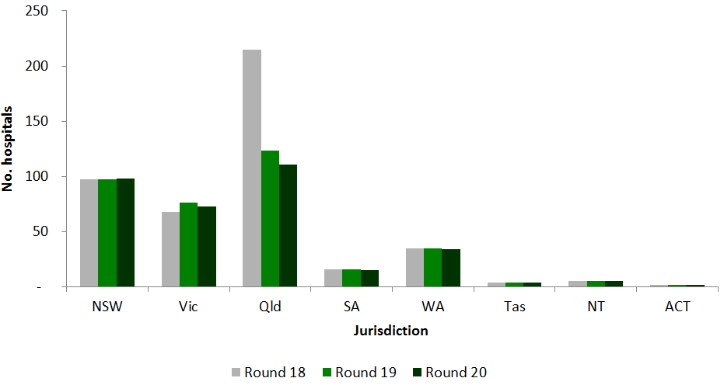

## Total expenditure

In the Round 20 NHCDC, total expenditure submitted was $38.8 billion, a 9.3 per cent increase over Round 19.

Expenditure is split between five streams:

* **Admitted acute** accounted for 73 per cent of total expenditure, reporting $28.3 billion from 334 hospitals. This represents a 7.5 per cent increase in expenditure from Round 19, with 11 fewer hospitals reporting data.
* **Emergency Department** expenditure accounted for $4.7 billion from 215 hospitals. This represents a 13.4 per cent increase in expenditure from Round 20, with 16 additional hospitals reporting data.
* **Non-admitted** expenditure accounted for $5.4 billion from 257 hospitals. This represents a 15.5 per cent increase in expenditure from Round 19, with 11 fewer hospitals reporting data.
* **Subacute and non-acute** expenditure accounted for $2.4 billion from 314 hospitals. This represents a 6.1 per cent increase in expenditure from Round 19, with 17 fewer hospitals reporting data.
* **Other** product expenditure accounted for $94.8 million from 165 hospitals. This represents a 83.9 per cent increase in expenditure over Round 19, with 28 fewer hospitals reporting data.

Figure 2. Total expenditure and percentage movement by stream, Round 18 to 20

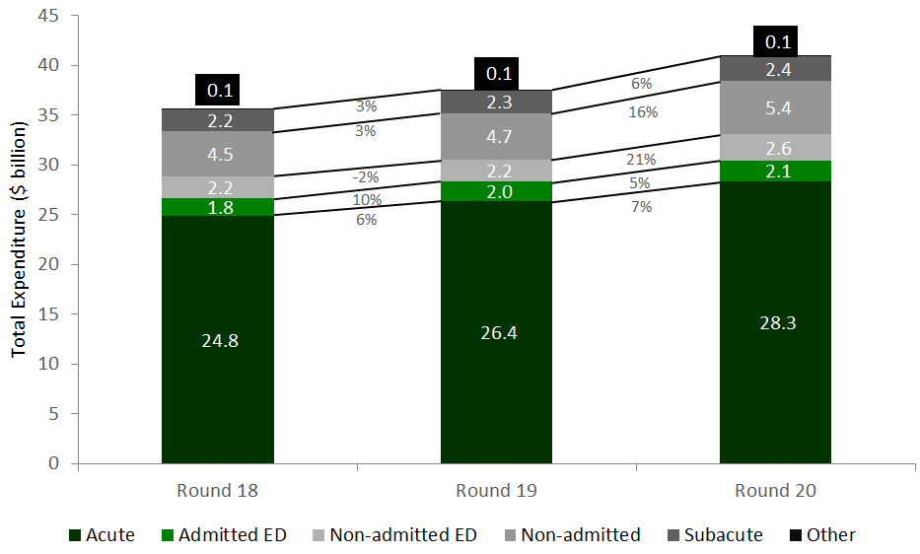

## Average costs

For the NHCDC, costs are reported at the patient level. This allows for the calculation of average costs per episode by product stream:

* 5.5 million admitted acute separations were reported in Round 20, an increase of 4.0 per cent over Round 19. The average cost per admitted acute separation was $5,194, a 3.3 per cent increase on Round 19;
* 7.2 million ED presentations were reported in Round 20, an increase of 5.1 per cent over Round 19. The average cost per presentation was $652, a 7.8 per cent increase on   
  Round 19;
* 17.8 million non-admitted service events were reported in Round 20, an increase of 3.6 per cent over Round 19. The average cost per non-admitted service event was $303, an 11.5 per cent increase on Round 19;
* 173,396 subacute and non-acute separations were reported in Round 20, an increase of 0.6 per cent over Round 19. The average cost per separation was $13,911, a 5.4 per cent increase on Round 19;
* 25,298 other product counts of activity were reported in Round 20, remaining consistent with activity reported in Round 19 despite the increase in total costs submitted.

## Average cost per weighted separation

Figure 3 (below) identifies the average cost and average weighted cost by jurisdiction. Victoria, Queensland and Northern Territory all have average costs per separation below the national average cost. NSW, Victoria, Queensland and Tasmania have an average cost per weighted separation below the national average. The average cost per weighted separation considers the complexity of separations of each jurisdiction.

Figure 3. Admitted acute average cost per separation actual and weighted, by jurisdiction

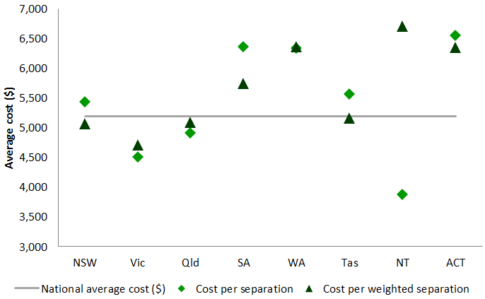

Readers of the report are reminded that the results published should not be compared to the NEP. The NEP includes a series of adjustments to the NHCDC results to account for variations in the cost of delivering services, based on factors such as location, indigenous status and paediatrics. Further information about the NEP adjustments can be found on [IHPA’s website](https://www.ihpa.gov.au). This report presents an analysis of the annual data submitted to the NHCDC for Round 20 (2015-16).

# Introduction

Hospital costing is the process of identifying the resources and inputs used during an episode and applying the costs of those inputs to the different types of clinical procedures and treatments provided to each patient in a hospital.

The NHCDC is the annual collection of public hospital cost data from a range of public hospital facilities nationally. The objective of the NHCDC is to provide all governments with a robust dataset developed using nationally consistent methods of costing hospital activity.

The dataset is used for benchmarking, funding and planning hospital services and is the primary dataset used to develop the National Efficient Price (NEP) and produce weights for the funding of public hospital services on an activity basis, as well as to develop the National Efficient Cost (NEC) for block funded hospitals. More information about the NEP, NEC and activity based funding is available on [IHPA’s website](https://www.ihpa.gov.au).

The annual NHCDC process includes publication of data request specifications, data collection and validation, application of quality assurance processes and an Independent Financial Review, prior to the development of the NHCDC dataset.

## Background

The NHCDC was established in the mid-1990s through the joint collaboration of the Commonwealth with state and territory governments. State and territory health ministers agreed to collect and provide cost data to the Commonwealth for the purposes of national reporting to support a range of funding and health care initiatives. The NHCDC was designed as a voluntary cost data collection. Collection of Round 1 commenced in 1997. The early Rounds of collection were predominantly focused on collating costs at a ‘product’ level for acute hospital services.

Under the National Health Reform Act 2011, IHPA was established and assumed responsibility for the governance of the NHCDC. Through the national health reform process, a range of developments to the NHCDC have been implemented, including data quality controls, the introduction of a submission portal and developments in costing standards. These improvements have all provided increased confidence in the collection for the purpose of national reporting.

## Purpose of this report

The purpose of this report is to provide an overview of costs as reported to Round 20 of the NHCDC (2015-16). The report is intended to provide cost data information for a range of users including hospital representatives, jurisdictional representatives, policy makers, clinicians, commercial entities, researchers, and students.

This report contains detailed analysis of the Round 20 NHCDC including:

* summary tables at the national and jurisdiction level by admitted acute, subacute, non-admitted, emergency department and other products.
* cost weight tables for actual and estimated admitted acute separations.

The report also contains data quality statements that are supplied by each jurisdiction to highlight key aspects that may impact on a jurisdiction’s results. This may include variations with respect to costs, practices, participation and coverage of results that have occurred in the Round.

# Scope and reporting requirements

## Scope

The data in scope for the NHCDC includes all patient level activity for all public hospital facilities across Australia, and the costs incurred by the hospital in relation to this activity in financial year 2015-16 (Round 20).

The classifications used for reporting the Round 20 NHCDC are:

* Australian Refined Diagnosis Related Groups (AR-DRG) Version 8;
* Urgency Related Groups (URG) Version 1.4;
* Non-admitted Tier 2 Classification Version 4; and
* Australian National Subacute and Non-Acute Patient (AN-SNAP) classification Version 4.

## Reporting requirements

To ensure consistency in the approach to costing nationally, NHCDC data is subject to the Australian Hospital Patient Costing Standards Version 3.1 (the Standards), available on [IHPA’s website](https://www.ihpa.gov.au/publications/australian-hospital-patient-costing-standards-version-31). The Standards prescribe the set of line items and cost centres that hospital costs are mapped to for the costing process, to ensure that there is a consistent treatment of costs between hospitals. These costs are allocated to, and reported under, the NHCDC defined ‘cost buckets’. Please refer to the Standards for the reference tables of line items, cost centre groups and cost buckets.

Costed results are produced at the episode level, per cost centre and per line item. These results are provided to IHPA and are collated and analysed to produce this report.

Figure 4 illustrates the process undertaken to prepare and submit NHCDC data.

## Work in progress patients

The Standards require that all patient activity during the year be costed according to its set of guidelines. For the purposes of the NHCDC, all patients are considered in scope where discharged within the submission year. A work in progress (WIP) patient is defined as a patient that is not admitted and discharged within the 2015-16 financial year. For the purposes of this report, data in all tables excludes WIP patients unless specifically noted.

## Independent Financial Review

The Independent Financial Review is a whole of data review from a sample selection of hospitals within each jurisdiction. The review provides transparency in the way data is reported from source to its use for development of the NEP and NEC. The Independent Financial Review report is published on IHPA’s website each year alongside this cost report.

Figure 4. Hospital Costing Process



## Release notes

Footnotes are available under each table within the report and appendices, as applicable, to guide readers on any missing data in the tables through asterisks (\*\*\*), dashes (----) and blanks. Issues relating to missing data are:

* Confidentiality: to ensure hospital and patient confidentiality is maintained information has been removed from some tables. The figures have been replaced asterisks (\*\*\*).
* Relevance: if a particular attribute is not relevant to a jurisdiction, then dashes (----) are used.
* Data availability: if a jurisdiction does not submit data, then blanks are used.

# Admitted acute care

The admitted acute episodes of care in scope for Round 20 include all public hospital admitted acute separations with an admission and discharge date in financial year 2015-16.

Admitted acute care is provided to patients who go through a formal admission process where the clinical intent or treatment goal is to do one or more of the following:

* manage labour (obstetric);
* cure illness or provide definitive treatment of injury;
* perform surgery;
* relieve symptoms of illness or injury (excluding palliative care);
* reduce severity of illness or injury;
* protect against exacerbation and/or complication of an illness and/or injury which could threaten life or normal functions; or
* perform diagnostic or therapeutic procedures.

These separations have been classified under AR-DRG Version 8 and have a care type[[1]](#footnote-1) of ‘1’ (acute) or ‘7’ (neonates).

## Overview

The admitted acute stream represents the primary function of hospitals in Australia, with the associated expenditure of $28.3 billion representing 72.9 per cent of total hospital expenditure submitted to the Round 20 NHCDC (Appendix 1).

Table 1 summarises the Round 20 NHCDC admitted acute results. In the Round 20 admitted acute stream of the NHCDC:

* 334 hospitals participated;
* expenditure increased by 7.5 per cent;
* costed activity increased by 4.0 per cent;
* the average cost of an admitted acute separation was $5,194; and
* the average length of stay was 2.59 days.

Table 1. NHCDC Round 18 to Round 20, comparison of admitted acute summary, national

This table displays national data on number of participating hospitals, separations, total expenditure, average length of stay, average cost per day and average cost per separation for Round 18, 19 and 20.

Cost weight tables are published in AR-DRG Version 8 for actual (Appendix 3) and estimated costed data (Appendix 4). The actual cost weights are based on costed activity in the NHCDC, where as the estimated cost weights are calculated to reflect the total population of activity.

These headline changes reflect a number of developments in the Round, including changes to the number of participating hospitals, admission practices and to a lesser extent costing methodology in selected jurisdictions. The Data Quality Statements, at Attachment B, provide detail about how changes implemented at the jurisdiction level have affected NHCDC results. Table 2 provides a summary of acute cost and activity data submitted to the Round 20 NHCDC by jurisdiction.

Table 2. NHCDC Round 20, admitted acute summary, by jurisdiction

This table displays total hospitals, separations and expenditure and the aveage length of stay, cost per day, cost per separations cost per weighted separations by jurisdiction.  

## Participation

The jurisdiction level data included in Appendix 1 identifies that costs from 334 hospitals were reported in Round 20, a decrease of 11 hospitals over Round 19. Three jurisdictions had changes in the number of hospitals with costed admitted acute separations. Queensland reported 11 fewer, NSW reported one more and WA reported one fewer. Lower participation by Queensland in Round 20 was driven by a decision to submit only hospitals for which patient level cost and activity could be matched, resulting in a decrease in the number of hospitals submitted by 11.

The hospitals that submitted data to the Round 20 NHCDC do not include all hospitals nationally within the scope of ABF. The hospitals submitted cost data account for 93.9 per cent of all admitted acute separations, similar to Round 19 where IHPA received cost data for 93.6 per cent of admitted acute separations.

## Expenditure

The admitted acute stream has the most robust costing results and developed classification system. This is reflected in consistent and stable movements in costs and the number of separations between Rounds. Both the expenditure and the number of costed separations have had consistent increases over the last three Rounds.

National expenditure in Round 20 increased by 7.5 per cent to $28.3 billion, with all jurisdictions contributing to this increase. The three most populous jurisdictions, NSW, Victoria, and Queensland, account for 77 per cent of the national population[[2]](#footnote-2) and contributed 74 per cent of national expenditure.

While national expenditure increased by 7.5 per cent, this increase was largely driven by WA and Queensland, who reported an increase in expenditure of 16.4 per cent and 11.2 per cent respectively. Western Australia’s increased costs are the result of the inclusion of a major tertiary site (Fiona Stanley Hospital) in the collection for the first time. The increase in Queensland expenditure is reported in the ward supplies cost bucket. NSW, SA and Tasmania increased expenditure between four and six per cent (Appendix 5).

There were 5.5 million admitted acute costed separations in the NHCDC in Round 20, an increase of 4.0 per cent compared to the prior Round. All jurisdictions contributed to this increase, with Queensland, WA and NT reporting the largest increases at 6.9 per cent, 9.5 per cent and 11.5 per cent respectively.

As with the number of hospitals and expenditure, the three most populous jurisdictions also contributed the bulk of activity, collectively accounting for 77 per cent of national separations. ACT has the smallest number of hospitals and the fewest separations with 102,825 in Round 20.

## Average cost

In Round 20, the average cost per admitted acute separation was $5,194, an increase of 3.3 per cent from $5,026 reported in Round 19. The growth in the national average cost per admitted acute separation between Round 18 and Round 19 was 1.1 per cent.

Across the nation, change in the average cost per acute separation varied with WA hospitals reporting the highest average increase of 6.3 per cent while hospitals in NT reported the largest decrease in average cost of 8.1 per cent when compared to Round 19 (Appendix 5).

The average costs per admitted acute separation varied across jurisdictions from a minimum of $3,870 reported by NT to $6,551 in ACT (Table 3). Victoria, Queensland and NT all reported average costs below the national average.

Table 3. NHCDC Round 19 and Round 20, comparison of admitted acute average cost per separation

This table displays average cost per separation, weighted separation and the year-on-year change between Round 19 and 20 by jurisdiciton. 

Two jurisdictions reported a decreased average cost in Round 20, with NT and ACT decreasing by 8.1 per cent and 4.4 per cent respectively. The large movement observed in the NT reflected improvements in cost allocation in the Round resulting in a shift in costs to the other products from admitted acute.

The movement in national average cost is composed of change in costs and activity contributed by each jurisdiction. Each jurisdiction’s change in expenditure and activity impact the national change depending on their level of overall contribution. A jurisdiction with a high percentage of the national separations or expenditure will affect the national percentage change differently to a jurisdiction which makes up a low percentage of the national total.

Although a less refined measure, comparison at a cost per day can give context to changes in average cost per separation. The national average cost per bed day, Table 2, in Round 20 is $2,003. All jurisdictions, except ACT, reported increased average costs per day in Round 20 (Appendix 5). Consistent with cost per separation, WA and Victoria reported the largest increases in average cost per day increasing by 12.5 per cent and 7.4 per cent respectively. The NT reported a 3 per cent increase in average cost per day, despite reporting a 8.1 per cent decrease in average cost per separation. The decrease in average cost per separation was driven by a 10.8 per cent decrease in average length of stay. One jurisdiction, the ACT, reported a decrease in average cost per day of 0.9 per cent.

Three jurisdictions, NSW and Victoria and the NT have an average cost per day less than the national average. WA and ACT have the highest average cost per day reporting $2,718 and $2,398 per day respectively.

Average cost per separation is typically highly dependent on length of stay, a shortened length of stay tends to result in a lower cost per separation. The NT and ACT reported decreases in average length of stay (ALOS) consistent with the decreases in average cost per separation. A number of jurisdictions, including NSW, Victoria, WA, SA and Tasmania, reported increases in average cost per separation despite reporting decreases in ALOS. The increase in the average cost was reported in the on-costs cost bucket for Victoria, South Australia and Tasmania. The average cost in Western Australia acute admissions is reported in the Operating room cost bucket and NSW had increase in the Pathology cost bucket.

## Average length of stay

The national average length of stay (ALOS) for admitted acute patients was 2.59 days (Table 2). Five jurisdictions had lower ALOS than the national average with NT having the shortest ALOS at 1.94 days. NSW, SA and ACT have ALOS longer than the national average with NSW and SA having ALOS longer than three days. For NSW and SA the long ALOS is driven by proportion of same day to overnight separations with only these two jurisdictions having more overnight than same day separations. Table 4 (below) identifies the number of same day and overnight separations for each jurisdiction. The ALOS for overnight separations is 4.50 days. Figure 5 shows the difference between the ALOS including and excluding same day separations.

Figure 5. Admitted acute average length of stay of all separations and all overnight separations, jurisdiction

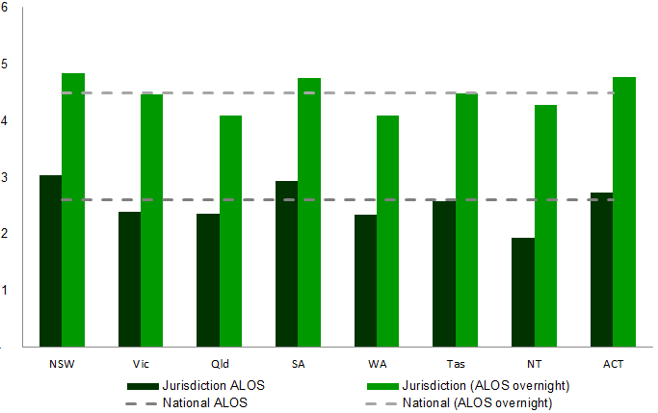

There were 3.0 million same day separations (54 per cent of all separations) and 2.5 million overnight separations reported nationally (Table 4). The ratio of same day to overnight separations varied greatly between jurisdictions with NSW having the lowest ratio with 0.89 same day separations for every overnight separation and NT with the highest ratio with 2.51 same day separations for every overnight separation. The NT had the largest change in same day separations with an increase of 14.6 per cent between Round 19 and Round 20 (Appendix 9), this was not attributable to a single DRG rather an increase in same day separations.

Table 4. NHCDC Round 20 Overnight and same say separations, by jurisdiction

Table shows the oevernight and same day separations, average length of stay and average cost per dey (for overnight), by jurisdiciton.

The high volume of dialysis patients admitted for care causes the high ratio of same day separations reported by NT. NSW and SA are the only jurisdictions with less than half of all separations being same day. This may be as a result of differing admission policies across jurisdictions and the sample of hospitals included in the NHCDC. Length of stay variation between jurisdictions is reflective of admission policies. Particularly in relation to activity which may be treated as a same day admission or as a non-admitted service event. Examples of these services include dialysis, chemotherapy and gastroscopy services.

Across the nation, the ALOS of overnight separations was 4.5 days, when excluding same day separations. The national ALOS decreased by 1.6 per cent between Round 19 and Round 20 and decreased in all jurisdictions with the exception of Qld, which increased 3.7 per cent. Queensland reported the shortest overnight ALOS at 4.09 days per separation.

## Average cost per weighted separation

Average cost per weighted separation is a casemix adjusted average cost, where the relative complexity of the activity is taken into account. It uses the national cost weights (See Appendix 3) to weight jurisdiction separations at the DRG level. If the jurisdiction weighted average is lower than the simple average the activity had a higher proportion of complex DRGs.

Figure 6 shows the variance between the average cost and average cost per weighted separation by jurisdiction. NT has the biggest variance with a low average cost and a high average cost per weighted separation. This reflects that the complexity of separations is quite low relative to the national casemix.

Figure 6. Admitted acute average cost per separation actual and weighted, by jurisdiction



The weighted average cost by jurisdiction for Round 20 is similar to that of previous Rounds. NSW, Victoria, Queensland and Tasmania have weighted average costs below the national average of $5,199. Victoria has the lowest average cost per weighted separation of $4,707. The remaining jurisdictions are above the national average with WA, NT and ACT over $6,300. Western Australia reported the largest increase in average cost per separation of 6.3 per cent while Victoria reported the largest increase in cost per weighted separation of 6.0 per cent. Northern Territory reported the largest decrease in average cost per separation of 8.1 per cent accompanied by a 0.5 per cent decrease in average cost per weighted separation. The ACT reported a decrease of 4.4 per cent in both average cost per separation and average cost per weighted separation.

Vic, Qld, WA and ACT have a weighted average cost per separation within 4 per cent of their unweighted cost per separation indicating that, on average, these jurisdictions provide services to a patient cohort similar to that of the national average. In contrast, the NT’s average cost per separation is almost twice the unweighted average cost per separation indicating that the NT has a patient cohort of generally lower complexity.

## Cost bucket and line item costs

Line items represent types of costs (e.g. salaries and wages or goods and services) incurred by hospitals. Cost buckets represent cost pools within a hospital, i.e. all the costs associated with a particular function of the hospital (e.g. the operating room). The cost buckets and line items are set out in the Standards.

At a line item level most costs comprise of salaries and wages. In Round 20, salaries and wages comprise 60 per cent of total costs nationally (Table 5). While the expenditure reported in the on-cost and blood line items increased in Round 20 there has been little movement in other line item. Appendix 8 provides jurisdiction level line item information, which identifies that there is variance across jurisdictions, and in some cases across Rounds, in reporting of some line item costs. Line item costs were not reported for:

* Imaging by Tasmania;
* Pharmaceutical PBS by NSW or Queensland;
* Blood costs by SA or WA;
* Corporate costs by NSW, Victoria, Queensland or ACT;
* Depreciation costs by Victoria; and
* Lease costs by NSW.

Jurisdiction data quality statements clarify if these costs have been reported under alternative line items or there are alternative jurisdiction level funding and reporting mechanisms in place. For example NSW is not a signatory to the Pharmaceutical Benefits Scheme so has no expense reported under the Pharmaceutical PBS line item.

Table 5. Round 20 Admitted acute average cost by line item, national

The table displays the national average cost by line item for round 19 and Round 20 and the annual change between the two


The line items of salaries and wages make up 60 per cent of national costs, with nursing salaries and wages alone contributing 28 per cent. The contribution of salaries and wages line items is seen across all jurisdictions with all reporting ward nursing as the cost bucket with the highest cost.

Table 6, below, contains costs by cost bucket and the component each bucket contributes to the total. Ward nursing and ward medical are two cost buckets which are comprised of salaries and wages and they account for over 29 per cent of acute costs. The cost bucket information reports that operating room costs account for 13.5 per cent of expenditure.

Table 6. Round 20 Admitted acute average cost per separation by cost bucket, national

The table displays the national average cost by cost bucket for round 19 and Round 20 and the annual change between the two


There was significant variation in the movement of costs reported under cost buckets in Round 20. On-costs, pathology and ward supplies contributed to the increase in the national average cost per separation between Rounds 19 and 20. Ward medical and ward nursing, which together contribute 29 per cent of total reported costs in the acute stream, decreased by 2.9 per cent in Round 20.

A 5.3 per cent decrease in the ward medical cost bucket was driven by decreased reported costs in Queensland, SA, NT and ACT. Queensland alone reported a 26.6 per cent decrease in ward nursing costs, resulting from changes to allocation of overhead costs. On-costs increased by 16.1 per cent increase in on-costs from Rounds 19 to 20, driven by Victoria, Qld and SA.

A 12.3 per cent increase in the ward supplies cost bucket was almost entirely driven by increased expenditure by Queensland, which increased 83.9 per cent in Round 20.

## Admitted via emergency department

The admission via ED field is used as a proxy for urgency of admission for the episode of care. If admission is via ED then it is considered that the episode is not planned or it is an emergency. Alternatively, for the purpose of cost analysis, if the patient is not admitted via the ED then they are considered a planned or elective admission. Acute separations admitted through the ED cost almost twice as much as planned admissions, with the average cost of a patient admitted via ED at $7,068 and planned admissions at $3,875 (Table 7).

There are two primary drivers of this cost disparity; length of stay and ED costs. Separations which were admitted via the ED have an ALOS almost twice as long as planned admissions.

Table 7. Round 20 Admitted acute separations admitted via emergency department, jurisdiction

Table shows admitted, non admitted and not assigned serapation , average length of stay and average cost by jurisdiciton. 

Across the jurisdictions, the NSW reported the biggest difference in cost and ALOS between emergency and elective separations with emergency separations costing 2.5 times more and being almost three times as long. The ALOS of emergency separations was more than twice that of elective separations for all jurisdictions with the exception of Queensland. Queensland reported the smallest difference between emergency and elective separations with a comparable average cost and ALOS for emergency separations only 1.5 times that of elective separations. Changes between Round 18 to 20 can be seen at Appendix 10.

## Price weight adjustments for ABF

Certain characteristics of patients are used to adjust the price weight applied to each separation for activity based payment purposes. Some of these characteristics that influence clinical complexity include Indigenous status, patient age and remoteness of a patient’s residence.

### Indigenous status

Each patient has an Indigenous status assigned. ‘Indigenous Status’ is defined in the Australian Institute of Health and Welfare (AIHW) Metadata Online Registry (METeOR) as determining whether a person identifies as being of Aboriginal or Torres Strait Islander origin.

The NT and Queensland together account for over half of the national Indigenous separations. Indigenous patients are over-represented in same day separations, reflecting an overall lower ALOS and lower average cost for Indigenous separations. Haemodialysis accounts for almost half of all Indigenous separations.

Given the relatively low average cost for haemodialysis, this casemix results in Indigenous same day separations costing 27.7 per cent less than non-Indigenous same day separations. On average Indigenous overnight separations cost 5.8 per cent more than non-Indigenous overnight separations (Appendix 11).

Table 8. Round 20 Admitted acute Indigenous and non-Indigenous separations, jurisdiction

Tabel shows separation, average length of stay and average cost for indigenous and non-indigenous separations by jurisdiction. 

### Paediatric hospitals

Five jurisdictions have qualified paediatric hospitals[[3]](#footnote-3): NSW, Victoria, Queensland, SA and WA. A paediatric separation is one which occurs at a qualified hospital and the patient is up to and including 17 years of age. The average cost for paediatric separations is 29 per cent higher than non-paediatric separations; however, the ALOS for these separations is lower, identifying the high resource utilisation of this cohort.

SA reported the lowest average cost for paediatric separations, at $5,760. SA and WA were the only jurisdictions where paediatric separations cost less than non-paediatric separations. Paediatric separations in Queensland cost 1.6 times more than non-paediatric separations, the highest ratio of all jurisdictions.

Table 9. Round 20 admitted acute paediatric and non-paediatric separations, jurisdiction

Table shows the separations, average length of stay and average cost for paediatric and non-paediatric separations by jurisdiciton. 

The number of reported paediatric separations increased 1.9 per cent between Rounds 19 and 20 (Appendix 12). The average cost per paediatric admitted acute separation increased by 3.4 per cent to $6,634, resulting in paediatric separations costing 29 per cent more than non-paediatric separations.

### Remoteness

The patient’s postcode is used to classify each separation in to a geographical locality. The average cost for patients from remote areas of Australia is 1.5 per cent higher than those from metropolitan areas (Table 10). The ALOS for remote separations is lower by 8.2 per cent than patients from metropolitan areas. NT and Queensland account for almost half of national remote separations. ACT has the biggest difference in cost between where the patient’s residence is metro versus remote, with remote separations costing more than double at $12,913. Comparisons with previous Rounds and across jurisdictions can be seen at Appendix 13.

Table 10. Round 20 Admitted acute separations by remoteness, jurisdiction

Table displays separations, average length of stay, average cost for metro and inner regional areas and outer regional, remote and very remote separations by jurisdiction. 

# Emergency department presentations

Emergency Department (ED) presentations in scope for Round 20 include all patients registered for care in an emergency care service within a public hospital during 2015-16. This includes patients who present to the ED who are treated and then leave (non-admitted emergency, NE), and presentations that are subsequently admitted to hospital (admitted emergency, AE).

In this report emergency care services are reported using Urgency Related Group (URG) Version 1.4.

## Overview

The ED stream, compared to other streams, has the smallest number of hospitals reporting costs with 215 hospitals providing costs for ED presentations in Round 20, an increase from 199 hospitals in Round 19.

Table 11 summarises the Round 20 NHCDC ED results which include:

* 215 hospitals participated;
* expenditure increased by 13.4 per cent to 4.7 billion dollars;
* costed presentations increase by 5.1 per cent;
* the average cost of an admitted ED presentation was $977; and
* the average cost of a non-admitted ED presentation was $517.

Table 11. Round 18 to Round 20 Emergency department summary by product type, national

Table displays data on hospital counts, presentation counts, expenditure and average cost per presentation for admitted and non-admitted emeregncy department for Round 18, 19 and 20. 

Expenditure submitted for ED presentations totalled $4.7 billion in Round 20; this is 12 per cent of the total Round 20 NHCDC reported expenditure. Expenditure increased by 13.4 per cent, from $4.2 billion in Round 19. Costed presentations increased by 5.1 per cent in Round 20 in contrast to Round 19, which reported a 0.5 per cent decrease in ED presentations from Round 18.

The respective changes in expenditure and total ED presentations in the Round translated to an increase in national average cost, which increased by 7.8 per cent. This increase was largely driven by an increase in reported expenditure for non-admitted ED presentations, which reported an increase in expenditure of 20.6 per cent, a comparatively lower increase in presentations of 4.8 per cent, resulting in a 15.1 per cent increase in average cost per presentation. This was reflective of the increase of non-admitted ED cost data submitted from NSW.

## Participation

Costs from 215 hospitals were reported in Round 20, an increase of 16 hospitals from Round 19. Queensland provided costs for ED presentations from 53 hospitals, an increase of 18 hospitals from that reported by Queensland in Round 19.

## Expenditure

National expenditure for ED services was $4.7 billion in Round 20, an increase of 13.4 per cent over Round 20. The three most populous jurisdictions, NSW, Victoria and Queensland, contribute 75 per cent of national expenditure, with NSW the largest at $1.6 billion (Table 12). All jurisdictions contributed positively to growth in total expenditure. New South Wales made the most notable contribution to national growth, reporting a 20 per cent increase in expenditure in Round 20.

Total non-admitted ED expenditure increased by 20.6 per cent, and increased as a proportion of total ED expenditure from 53 per cent in Round 19 to 56 per cent in Round 20. Admitted ED expenditure increased at a slower rate of 5.3 per cent. The large relative increase in non-admitted ED, as a proportion of the stream, was driven by NSW. In Round 20, NSW reported a 51.5 per cent increase in non-admitted ED expenditure accompanied by an 8.9 per cent decrease in admitted ED expenditure. IHPA understands this was due to an anomaly in reporting Round 19 ED costs which has been identified and addressed in Round 20.

Table 12. Round 20 ED presentations summary, jurisdiction

Table displays hospital count, presentation count, expenditure and average cost per presentation by jurisdiction.

There were 7.2 million costed presentations in Round 20, a 5.1 per cent increase on Round 19. All jurisdictions reported an increase in costed presentations with the exception of Vic and WA. Western Australia have previously submitted admitted ED costs with the corresponding admitted episode. Historically, IHPA has identified these costs in the ED cost buckets and created an admitted ED presentation record and counted the activity. Queensland reported the largest increase in costed presentations of 13.9 per cent, reflecting better linking to activity data. In Round 19 these presentations were costed however were not submitted as part of the NHCDC.

## Average cost

The average cost of an ED presentation is $652, an increase of 7.8 per cent from Round 19. The overall increase in the average cost of ED presentations is driven entirely by an increase in the average cost per non-admitted ED presentation of 15.1 per cent. The average cost per admitted ED presentation, on the other hand, decreased by 0.5 per cent in Round 20.

Table 13. Round 19 and Round 20 average cost for admitted and non-admitted ED presentations, jurisdiction

Table contains the average cost per ED presentation (admitted and non-admitted) by jurisdiciton. 

All jurisdictions reported an increase in average cost per ED presentation, with the exception of ACT who reported a decrease of 1.8 per cent. At a jurisdictional level, there were a number of movements in the average cost of both admitted and non-admitted ED presentations reflecting changes in reported expenditure and activity. NSW reported a 13.5 per cent decrease in the average cost per admitted ED presentation while the average cost per non-admitted ED presentation increased by 41.4 per cent.

WA reported the largest increase in average cost per ED presentation of 16.7 per cent. This increase was primarily driven by a 41.2 per cent increase in the average cost per admitted ED presentation.

The cost difference between admitted and non-admitted ED presentations is significant. At a national level, admitted presentations cost almost twice that of non-admitted presentations, although this varies across jurisdictions. In Tasmania, the average cost of an admitted ED presentation is more than three times that of a non-admitted presentation.

Figure 7. Emergency department ratio of average cost admitted to non-admitted presentation

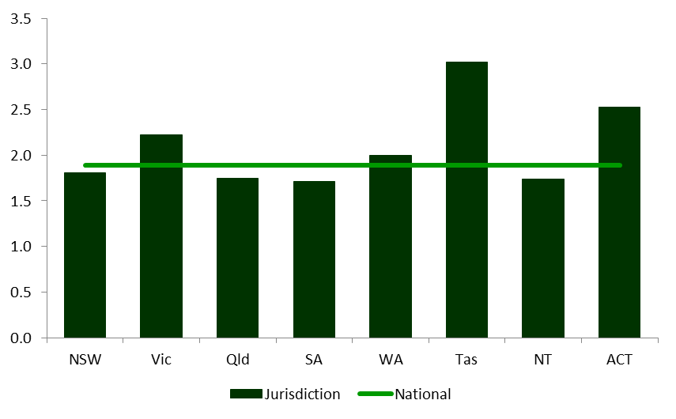

## Cost bucket and line item costs

The increase in average cost per presentation between Round 19 and 20 was largely driven by increases in the line items salary and wages for nursing and other, on-costs and goods and services (Appendix 18).

At a national level, the salaries and wages line items increased 5 per cent from Round 19 to Round 20, with all jurisdictions contributing to this increase except Vic and ACT. The goods and services line item increased 12.3 per cent in Round 20, driven by increased expenditure allocation in the three most populous jurisdictions of NSW, Vic and Qld. A similar trend is observed in the on-costs line item.

Similar to admitted acute, salaries and wages costs account for 64 per cent of total ED expenditure (Table 14). Salaries and wages for medical (non-VMO) and nursing in particular are significantly higher than the remaining line items, collectively accounting for 47 per cent of all costs.

Fifty seven per cent of ED costs fall in to the ED cost bucket (Appendix 17) with the remaining costs are in the imaging, on-costs and pathology cost buckets. While the average cost of an ED presentation in Queensland remained stable from Round 19 to Round 20, there was a 58.1 per cent decrease in the emergency department cost bucket, with costs shifted to the ward nursing, ward medical and ward supplies cost buckets.

Table 14. Round 19 and Round 20 ED average cost by line item, national

Table displays average cost by line item between Round 19 and Round 20 as well as the percentage change between the two. 

# Non-admitted service events

Non-admitted care in scope for Round 20 includes all patients who attended a non-admitted clinic at a public hospital during 2015-16. In this Report, community mental health service events are reported in the non-admitted chapter. With the introduction of the Australian Mental Health Care Classification, these service events will be reported under the mental health stream in future years.

Non-admitted activity accounts for the majority of unique patient encounters in public hospitals in Australia. In Round 20 non-admitted activity is reported using the Tier 2 classification Version 4. In previous rounds, Tier 2 classification Version 3 was used. The Tier 2 classification is assigned by the hospital and reflects the type of clinic the patient has visited. Unlike other classification systems, no diagnosis or procedure codes are used when assigning a class.

## Overview

Table 15 summarises the Round 20 non-admitted NHCDC results including that:

* 257 hospitals participated;
* expenditure increased by 15.5 per cent;
* there were 17.8 million service events;
* costed service events increased by 3.6 per cent; and
* the average cost of a service event was $303.

Table 15. Round 18 to Round 20 Non-admitted summary, national

Table shows the number of hospitals, service events, total expenditure and average cost per event at the national level for Round 18, 19 and 20 as well as the annual change between each year. 

## Participation

The number of hospitals submitting non-admitted cost data in Round 20 was 257, a reduction of 11 hospitals. Victoria decreased the number of hospitals submitting non-admitted cost data by seven, with the remaining reduction in reporting hospitals attributable to NSW, Qld and WA (Appendix 21).

## Expenditure

In Round 20, non-admitted expenditure captured in the NHCDC increased by 15.5 per cent to $5.39 billion and the number of service events costed increased by 3.6 per cent. The number of service events reported in Round 20 was 17.8 million, which is 0.6 million more than were reported in Round 19.

In Round 20, all jurisdictions increased their total reported service events, with the exception of Qld and SA who reduced their total reported service events by 8.5 per cent and 0.5 per cent respectively.

Tasmania reported the largest proportional increase in both service events and expenditure, reporting a 70.3 per cent increase in service events and a 126.8 per cent increase in expenditure in Round 20. In addition to increased PBS expenditure in Round 20, Tasmania implemented a new feeder system that monitors allied health service utilisation for non-admitted patients. In previous rounds these costs were reported through the acute stream.

Western Australia and Vic reported increases in total service events of 14.5 per cent and 13.4 per cent respectively (Table 16). NSW accounts for the largest share of non-admitted service events and expenditure nationally, reporting 38 per cent of all non-admitted service events and 28 per cent of all non-admitted expenditure.

Table 16. Round 19 and Round 20 Non-admitted summary, jurisdiction

The table contains data on hospital count, service event, and expenditure for Round 19 and Round 20 as well as the annual change between years. 

## Average cost

The average cost for non-admitted service events is the lowest of all streams, at $303 per service event in Round 20. The primary driver for this is the generally low levels of resource utilisation during non-admitted service events.

Table 17. Round 20 Non-admitted average cost per non-admitted service event, jurisdiction

Table contains the average cost per service event by jurisdiction for Round 19 and Round 20 and the annual change percentage change between the two. 

In Round 20, the average cost per service event increased by 11.5 percent to $303. All jurisdictions contributed to this increase to varying degrees. Of the most populous jurisdictions, Victoria reported the largest increase in average cost per service event from $273 in Round 19 to $332 in Round 20, primarily driven by an increase in Medical Consultation classes (20 series). In particular, the average cost of Gastroenterology (class 20.25) more than tripled and was the single largest contributor to the increase in Victoria’s average cost. Clinical measurement (class 20.08) also reported a marked increase in Round 20. The increase in average cost per service event in NSW was driven by the Chemotherapy and Radiation Therapy classes (10.11 and 10.12).

Of the less populous jurisdictions, the NT and Tas reported significant increases in average cost per service event of 40.9 per cent and 33.2 per cent respectively. In the NT, this was driven by increases in the Radiation Therapy and Infectious Disease classes (10.12 and 20.44 respectively). The increase in average cost per service event in Tas was driven by increases in Gastroenterology classes (40.41and 20.25) and the Paediatric Medicine class (20.11).

Figure 8. Round 20 Non-admitted average cost per service event, jurisdiction

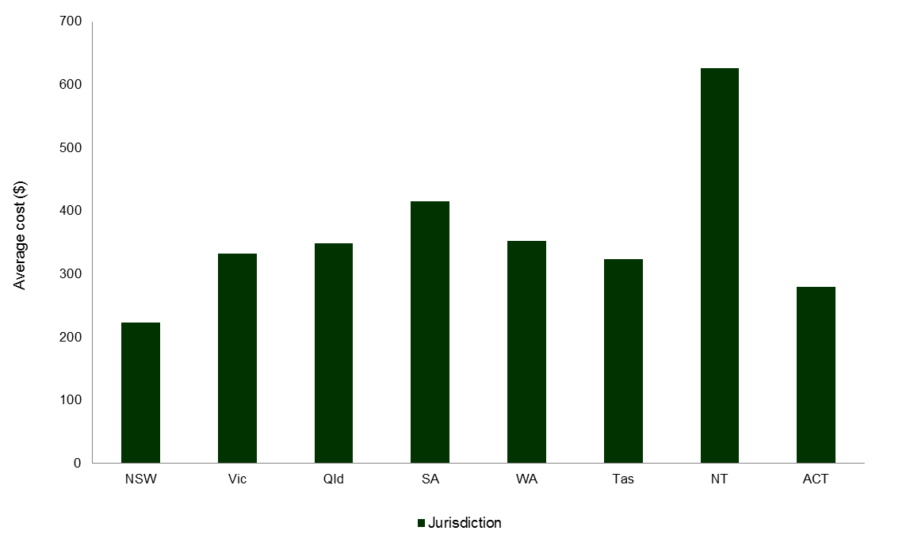

Figure 8 shows the variance across jurisdictions of the average cost of non-admitted service events. NSW and ACT had an average cost per service event below the national average while NT reported the highest average cost at $627, more than double the national average cost per service event.

## Cost bucket and line item costs

A review of the cost components that make up the total national average cost shows that the national increase in Round 20 of 11.5 per cent was driven primarily by an increase in reported pharmacy expenses and in particular, those relating to the Pharmaceutical Benefits Scheme (PBS).

Table 18. Round 19 and Round 20 Non-admitted average cost per line item, national

This table contains the national average cost per line item in Round 19 and Round 20. 

Salaries and wages line items make up a combined 58 per cent of all non-admitted costs. Salaries and wages for medical (non-VMO), nursing, allied and other increased on average by 5.7 per cent in Round 20. Costs reported under pharmaceuticals – PBS almost tripled, and now account for 9.7 per cent of non-admitted costs. This is the result of uptake of new high cost Hepatitis C drugs through the PBS in the last quarter of 2015-16.

Table 19. Round 19 and Round 20 Non-admitted average cost per cost bucket

This table contains the national average cost per cost bucket in Round 19 and Round 20. 

## Tier 2 class variation

Of the 17.8 million service events reported for non-admitted in Round 20, 159,513 did not have a valid Tier 2 class, as identified in the Tier 2 table at Appendix 20. The excluded records were submitted with an error or missing Tier 2 class.

Table 20. Round 19 and Round 20 Tier 2 classes (grouped) summary, national

This table contains service event and average expenditure aggregated at the series level at the national level.

The 140 Tier 2 classes are structured into four groups, procedures; medical consultation services, diagnostic services, and allied health and/or clinical nurse specialist intervention services. Consistent with results in Round 19, the bulk of service events (47 per cent) were classified as medical consultations (8.3 million) and 46 per cent were nurse/allied health led service events (8.1 million).

There was large variation across jurisdictions in both counting and costing of non-admitted service events. At the national level this resulted in changes in both the number of service events costed, an increase of 3.6 per cent and the average cost per service event which increased by 11.5 per cent. The number of service events in classes with less than a ten per cent change in average cost from Round 19 to Round 20 was 11 million, 62 per cent of all non-admitted service events.

The top ten Tier 2 classes by expenditure (Table 21) account for 34 per cent of non-admitted costs submitted and 37 per cent of service events costed.

Table 21. Top ten Tier 2 classes by expenditure, national

This table contains the top ten tier 2 classes by expenditure and displays their total cost and number of service events. 

At the national level there are notable changes in

* Classes 10.15-10.19 Home Delivered dialysis, nutrition and ventilation: counting of these classes was changed from daily to monthly.
* Class 10.04 Dental: there is a total reduction of service events of 88 per cent driven by NSW changing their reporting of this activity.

# Subacute and non-acute services

Subacute and non-acute care in scope for Round 20 includes all patients who received subacute or non-acute care at a public hospital during 2015-16.

This care is classified using Australian National Subacute and Non-acute Patient Classification Version 4 (AN-SNAP) and includes all separations with a care type of rehabilitation care (care type ‘2’), palliative care (care type ‘3’), geriatric evaluation and management (GEM) (care type ‘4’), psychogeriatric care (care type ‘5’) or maintenance care (care type ‘6’).

## Overview

Table 22 summarises costs submitted using the subacute care types in Round 20 including that:

* 314 hospitals participated;
* $2.4 billion of costs were submitted; and
* activity increased by 0.6 per cent and cost increased by 6.1 per cent.

Table 22. Round 18 to Round 20 admitted subacute summary, national

This table contains hospital counts,  serpataions, total expenditure, average length of stay, average cost per day and average cost per separaiton at the national level for Round 18, 19 and 20 and the percentage change between rounds.

## Participation

The subacute stream has 314 hospitals reporting costs in Round 20, this is a decrease of 17 hospitals from Round 19 and is a similar number of hospitals reporting admitted acute data. This decrease was driven by Queensland who reported subacute costs from 20 fewer hospitals in Round 20. This reflects a decision by Queensland to submit costed separations for which patient level cost and activity data could be matched, this is described in the Queensland Data Quality Statement.

The populous states of Vic, NSW and Qld together account for 81 per cent of all hospitals that reported subacute data in Round 20 (Table 23). Queensland reported the highest number of hospitals at 99, equivalent to 32 per cent of all hospitals. Queensland hospitals however, represented a proportionally smaller percentage of total activity and expenditure, reported as 24 per cent of activity and 23 per cent of expenditure.

Table 23. Round 19 and Round 20 admitted subacute comparison by jurisdiction

This table contains hospital, separation and expenditure data at the national level for Round 19, 20 and the annual percentage change between the two.

## Expenditure

National expenditure in Round 20 was $2.4 billion, an increase of 6.1 per cent, $139 million dollars, over Round 19. Between Rounds 19 and 20, subacute activity increased by 0.6 per cent.

The three most populous jurisdictions contribute the bulk of expenditure, collectively accounting for 78 per cent of national expenditure (Appendix 24). NSW reported 31 per cent of subacute expenditure, with $741 million. Rehabilitation is the product type with the largest expenditure, with $1.2 billion reported in Round 20, accounting for half of total subacute expenditure. Psychogeriatric reports the lowest expenditure with $46 million.

All jurisdictions reported an increase in subacute expenditure in Round 20. The most populous jurisdictions of NSW, Vic and Qld had relatively low growth in reported subacute expenditure of between one and six per cent (Table 23). The remaining jurisdictions reported larger increases in reported expenditure ranging from 18 per cent in SA to 35 per cent in NT.

WA reported the largest absolute increase in subacute expenditure of $38.6 million increase in Round 20. This was driven by increases in reported expenditure for maintenance and rehabilitation.

Figure 9. Subacute care types change in expenditure from Round 19 to 20, jurisdiction

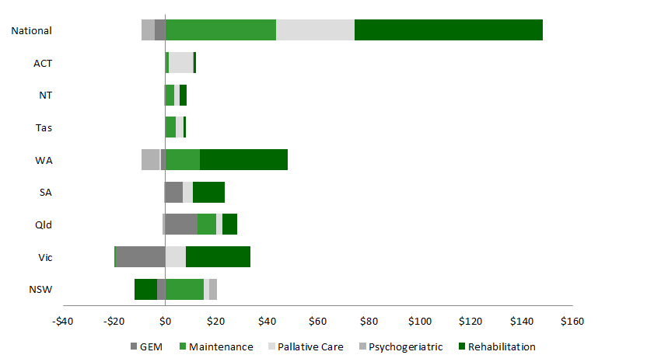

Nationally all products reported increases in expenditure with the exception of GEM and psychogeriatric, which reported minor decreases in between Round 19 and Round 20. Rehabilitation reported the largest increase in expenditure, contributing $74 million to the total increase in reported subacute expenditure.

There were 173,396 costed separations in Round 20, a 0.6 per cent increase from Round 19. Across the nation, NSW contributed the most separations, with 62,010. The three most populous jurisdictions of NSW, Victoria and Qld reported stable or marginally declining activity in Round 20 with Vic reported the largest decrease in separations, between Round 19 and Round 20, of 3.1 per cent. The least populous jurisdictions of Tas, NT and ACT reported high growth in reported activity however had a limited impact on national subacute activity.

Table 24. Round 19 and Round 20 admitted subacute summary, by product type, national

Table contains national data on hospital counts, separations, expenditure, average length of stay and average cost per separation by subacute care type for Round 19 and Round 20.

Consistent with the prior Round, rehabilitation was the product type with the most separations, with 90,689 reported in Round 20, accounting for 52 per cent of total activity. The second largest product is Palliative care which accounts for 18 per cent of activity followed by GEM which accounts for 16 per cent.

## Average cost

The average cost for subacute separations in Round 20 was $13,911. The primary driver for the cost per separation is the long length of stay for subacute separations, with the average being 13.0 days. Despite a reduction in ALOS of 0.3 per cent, the average cost increased by 5.4 per cent in Round 20. This continues a trend observed from Round 18 to Round 19 in which ALOS decreased by 2.4 per cent and average cost remained unchanged.

Table 25 summarises the ALOS and average cost by jurisdiction between Rounds 19 and 20.

Table 25. Round 19 and Round 20 admitted comparison, jurisdiction

Table contains the average length of stay and average cost by jurisdiction for Round 19, Round 20 and the annual percentage change between the two.  

Average cost per subacute episode increased by 5.4 per cent in Round 20. Across the jurisdictions the relatively low numbers of separations can lead to volatility in the average cost. However, the average cost for four of the five product types are within 19 per cent of the total average cost, ranging from palliative care at $11,216 to GEM at $16,155.

The average cost increased for all product types except psychogeriatric, ranging from a three per cent increase for GEM services to a seven per cent increase in the average cost of rehabilitation. Following a substantial increase in Round 19, the average cost of psychogeriatric services decreased eight per cent in Round 20.

Psychogeriatric is almost three times the total average cost at $33,862, primarily due to its long ALOS at 23.7 days, which is almost double the national ALOS.

In Round 20, as in previous Rounds, only NSW reported palliative care data costed at the phase level. In this report, the AN-SNAP table reports phase level information, whereas the remaining subacute tables aggregate the NSW data to the separation level.

Appendix 25 shows the number and average cost of subacute phases/episodes by AN‑SNAP class.

## Cost bucket and line item costs

The increase in average cost per episode was primarily driven by increased reported expenditure in on-costs, ward supplies, and depreciation. On-costs increased by 25.1 per cent or $265 per episode to $1,320 per episode. Ward supplies increased by 21.9 per cent or $263 per episode to $1,465. There were no significant or comparable reductions in costs in other line items.

Salaries and wages costs account for 67 per cent of subacute expenditure. The three largest line items are all salaries and wages being Nursing, Other and Medical. Nursing was significantly higher than the remaining line items, accounting for almost a third of all costs. On-costs is the highest cost non-salaries and wages line item, accounting for 9.5 per cent of total costs, followed by Goods & Services which account for 9.4 per cent of total(Appendix 27).

Table 26. Round 20 Subacute average cost per line item

This table contains the average cost per line item and percentage of total average cost for Round 19 and Round 20 and the annual percentage change between the two.

Table 27. Round 19 subacute average cost per cost bucket

This table contains the average cost per cost bucket and percentage of total average cost for Round 19 and Round 20 and the annual percentage change between the two.

The high line item cost of salaries and wages translates in to the Ward Nursing cost bucket holding 32.1 per cent of subacute costs (Table 27). The next three highest cost buckets consist predominantly of Ward Medical, Allied Health and Ward Supplies. This is consistent across all jurisdictions (Appendix 27).

# Other costed products

This chapter reports on a group of product types that are grouped together as ‘Other’, which includes hospital boarders, posthumous organ procurement, teaching, training and research and other.

## Overview

The number of hospitals reporting Other data in Round 20 was 165, a decrease of 28 from Round 19. Total expenditure submitted for other episodes increased 84 per cent in Round 20, totalling 94.8 million. The increase in total expenditure is driven by a 32.8 million increase in reported expenditure in research by the NT and ACT. Reported activity remained relatively unchanged in Round 20, at just over 25,000 separations.

Table 28. Other product types summary, national

This table contains the national level dat aon hospital counts, separations, expenditure and average cost per separation for product types in other costed products.

## Organ procurement

Organ procurement costs from 48 hospitals were reported in Round 20, an increase of three hospitals from Round 19. There were 295 costed episodes in Round 20, 99 more than in the prior Round. National expenditure in Round 20 was $8.1 million, more than double the $3.7 million reported in Round 19. NSW and Northern Territory reported a combined $3.2 million of the increase in expenditure. The NT and ACT reported activity and expenditure for organ procurement for the first time in Round 20.

The average cost for organ procurement episodes in Round 20 was $27,651, a 47 per cent increase on the average reported cost per separation in Round 19. Northern Territory contributed to this large increase in average cost per separation.

Table 29. Organ procurement average cost per separation by cost bucket, national

This table contains the average cost per line item and percentage of total average cost for Round 19 and Round 20 and the annual percentage change between the two.

A breakdown of the total average cost, by cost bucket, indicates that ward nursing and operating room account for almost half of the total average cost per separation.

Ward nursing and pathology contributed the most to the significant increase in average cost per separation, increasing 48 per cent and 350 per cent respectively.

The distribution of expenditure across cost buckets continues to vary significantly between Rounds, including a large increase in ward nursing and pathology expenditure. The largest change in Round 20 was an 8.6 percent decrease in operating room expenditure as a percentage of total average cost per separation, despite average expenditure on operating costs remaining relatively unchanged.

## Boarder costs

Boarder costs from 126 hospitals were reported in Round 20, a decrease of 28 hospitals from Round 19. There were 24,351 costed episodes in Round 20, comparable to the number costed in Round 19. Queensland and WA contribute the bulk of activity, collectively accounting for 93 per cent of episodes. Queensland reported 13,963 episodes, which represents 57 per cent of national activity.

National expenditure in Round 20 was $7.2 million, a 35 per cent decrease in expenditure reported in Round 19. Queensland was the primary driver of this decrease reporting a decrease in expenditure of 3.5 million in Round 20, roughly half of the expenditure reported in Round 19.

The average cost for Boarder episodes in Round 20 is $297, which is 34 per cent lower than Round 19. This decrease was driven by Queensland, which reported a 54 per cent decrease in average cost.



Independent Hospital Pricing Authority

Level 6, 1 Oxford Street

Sydney NSW 2000

Phone 02 8215 1100

Email enquiries.ihpa@ihpa.gov.au

Twitter @IHPAnews

www.ihpa.gov.au

1. The Care Types are defined in the Australian Institute of Health and Welfare (AIHW) Metadata Online Registry (METeOR). URL: <http://meteor.aihw.gov.au/content/index.phtml/itemId/584408> , accessed 15/01/2018. [↑](#footnote-ref-1)
2. Australian Bureau of Statistics, [3101.0 - Australian Demographic Statistics](http://www.abs.gov.au/AUSSTATS/abs@.nsf/allprimarymainfeatures/1BE1961A8F6C7D37CA25814700246614?opendocument), Sep 2016 abs.gov.au [↑](#footnote-ref-2)
3. Specialist paediatric hospitals that treat patients up to and including 17 years of age (IHPA National Efficient Price Determination 2017-18, <https://www.ihpa.gov.au/sites/g/files/net636/f/nep.pdf>, viewed 15/01/18) [↑](#footnote-ref-3)