Independent Hospital Pricing Authority

Governance framework for the development of the admitted care classifications

ICD-10-AM/ACHI/ACS Twelfth Edition   
and AR-DRG Version 11.0

December 2020



Version history

|  |  |  |
| --- | --- | --- |
| Version | Effective Dates | Description |
| 1.0 | December 2020 | This document replaces the *ICD‑10‑AM/ACHI/ACS Governance and Consultation* (September 2019) and *AR-DRG Governance and Consultation Process* (September 2017) documents.  Information has been incorporated in response to the *Consultation and review of the AR-DRG and  ICD-10-AM/ACHI/ACS Classification Systems* (February 2020).  Feedback received in October/November 2020 after review from IHPA’s technical and clinical advisory groups, and endorsed from IHPA’s Jurisdictional Advisory Committee in December 2020. |

Governance framework for the development of the admitted care classifications –   
ICD-10-AM/ACHI/ACS Twelfth Edition and AR-DRG Version 11.0

© Independent Hospital Pricing Authority 2020

This publication is available for your use under a [Creative Commons BY Attribution 3.0 Australia](http://creativecommons.org/licenses/by/3.0/au/deed.en) licence, with the exception of the Independent Hospital Pricing Authority logo, photographs, images, signatures and where otherwise stated. The full licence terms are available from [the Creative Commons website](http://creativecommons.org/licenses/by/3.0/au/legalcode).

Licence Mark

Use of Independent Hospital Pricing Authority material under a [Creative Commons BY Attribution 3.0 Australia](http://creativecommons.org/licenses/by/3.0/au/deed.en) licence requires you to attribute the work (but not in any way that suggests that the Independent Hospital Pricing Authority endorses you or your use of the work).

*Independent Hospital Pricing Authority material used 'as supplied'.*

Provided you have not modified or transformed Independent Hospital Pricing Authority material in any way including, for example, by changing Independent Hospital Pricing Authority text – then the Independent Hospital Pricing Authority prefers the following attribution:

*Source: The Independent Hospital Pricing Authority*

**Table of Contents**

Abbreviations 4

1. Purpose 5

2. Background 6

2.1 Admitted care classification systems 6

2.2 Processes related to classification development 7

3. Development principles 8

3.1 Process principles 8

3.1.1 Transparency 8

3.1.2 Respect of process 9

3.1.3 Decisions are evidence-based 9

3.2 ICD-10-AM/ACHI/ACS principles 9

3.2.1 Decision principles 9

3.2.2 Prioritisation principles 10

3.2.3 Development principles 11

3.3 AR-DRG principles 12

3.3.1 Decision principles 12

3.3.2 Prioritisation principles 12

3.3.3 Development principles 14

4. Classification development process 17

4.1 Development cycle timelines and milestones 17

4.2 Inputs 17

4.3 Advisory groups 18

4.4 Consultation and endorsement committees 18

4.5 Classification approval by the Pricing Authority 19

5. Development cycle outputs 21

5.1 New edition education 21

5.2 Classification products 21

5.2.1 ICD-10-AM/ACHI/ACS products 21

5.2.2 AR-DRG products 22

# Abbreviations

|  |  |
| --- | --- |
| **ABF** | Activity based funding |
| **ACE** | Australian Classification Exchange |
| **ADA** | Australian Schedule of Dental Services and Glossary |
| **ADRG** | Adjacent Diagnosis Related Groups |
| **APC NMDS** | Admitted Patient Care National Minimum Data Set |
| **AR-DRGs** | Australian Refined Diagnosis Related Groups |
| **CCAG** | Classifications Clinical Advisory Group |
| **CHADx** | Classification of Hospital Acquired Diagnoses |
| **ECC** | Episode Clinical Complexity |
| **ECCS** | Episode Clinical Complexity Score |
| **ECL** | Electronic code list |
| **DCL** | Diagnosis Complexity Levels |
| **DRG** | Diagnosis Related Group |
| **DTG** | Diagnosis Related Groups Technical Group |
| **HAC** | Hospital Acquired Complications |
| **ICD-10** | International Statistical Classification of Diseases and Related Health Problems, Tenth Revision |
| **ICD-10-AM/ACHI/ACS** | International Statistical Classification of Diseases and Related Health Problems, Tenth Revision, Australian Modification  (ICD-10-AM)/Australian Classification of Health Interventions (ACHI)/Australian Coding Standards (ACS) |
| **ICD-11** | International Classification of Diseases, Eleventh Revision |
| **ICD-O** | International Classification of Diseases for Oncology |
| **ICHI** | International Classification of Health Interventions |
| **IHPA** | Independent Hospital Pricing Authority |
| **ITG** | International Classification of Diseases Technical Group |
| **MBS** | Medicare Benefits Schedule |
| **MDC** | Major Diagnostic Category |
| **NHDISC** | National Health Data and Information Standards Committee |
| **NHRA** | National Health Reform Agreement |
| **WHO** | World Health Organization |

# Purpose

The Independent Hospital Pricing Authority (IHPA) undertakes the development of classifications for admitted patient care. In Australia, the classification and standards used for admitted patient care include:

* International Statistical Classification of Diseases and Related Health Problems, Tenth Revision, Australian Modification (ICD-10-AM)
* Australian Classification of Health Interventions (ACHI)
* Australian Coding Standards (ACS)
* Australian Refined Diagnosis Related Groups (AR-DRGs).

The *Governance framework for the development of the admitted care classifications* (the Framework) outlines the classification development and approval process, the guiding principles and classification products that are the result of the classification development cycle.

The Framework is to be updated with each new classification development cycle to ensure it, and the classifications that it governs, remain fit for purpose and relevant to the Australian healthcare system.

The governance arrangements outlined in this Framework are applicable for the development of:

* ICD-10-AM/ACHI/ACS Twelfth Edition
* AR-DRG Version 11.0

# Background

## 2.1 Admitted care classification systems

In Australia, the classifications and standards used for admitted patient care are:

* ICD-10-AM/ACHI/ACS that captures clinical activity in the admitted patient setting
* AR-DRGs that relate, or group, similar patient acute admitted episodes of care to the resources required in treatment.

These classifications are interrelated but have different use cases as illustrated in   
**Figure 1**.

**Figure 1. ICD-10-AM/ACHI/ACS, used for admitted patient care, underpins AR-DRGs.**

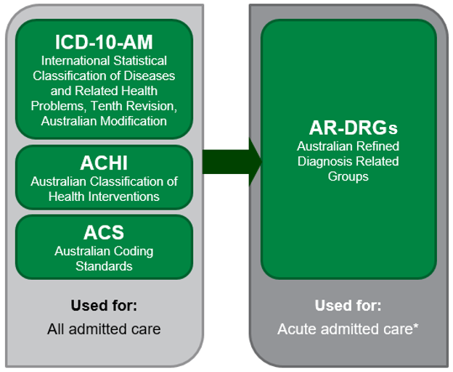

**\*AR-DRGs used for acute care, newborn care and mental health care**

The ICD-10-AM is based on the World Health Organization’s (WHO) International Statistical Classification of Diseases and Related Health Problems, Tenth Revision (ICD-10) and is utilised to classify diseases and other health related problems, while the ACHI classifies procedures and interventions and was originally based on the Medical Benefits Scheme (MBS).

The ACS are a set of instructions that are applied in assigning ICD-10-AM and ACHI codes to promote consistency in the classification of admitted episodes of care. Collectively known as the ICD-10-AM/ACHI/ACS classification system, it captures clinical activity for admitted patient care, and has a number of purposes, including:

* identifying patterns and disease trends
* clinical research and management
* research into the quality of healthcare and patient safety.

The AR-DRG classification uses data coded using the ICD-10-AM/ACHI/ACS classification system along with other routinely collected data to classify episodes of acute care in public and private hospitals across Australia. AR-DRGs provide a clinically meaningful way of relating the number and types of acute admitted patients to the resources required by the hospital.

AR-DRGs are used for a number of purposes, including:

* benchmarking
* epidemiology
* facilitation of payment of services in the private healthcare sector
* health service planning
* performance management.

AR-DRGs capture acute admitted activity and are utilised in calculating the National Efficient Price for public hospital activity based funding.

## 2.2 Processes related to classification development

Information on other processes related to classification development not covered by the Framework are found on the following websites:

* Submission of classification queries via the Australian Classification Exchange (ACE): ace.ihpa.gov.au/Submissions.aspx
* Product purchase and distribution: [ar-drg.laneprint.com.au](http://ar-drg.laneprint.com.au/)
* Licencing arrangements: [www.ihpa.gov.au/what-we-do/products/admitted-acute-care-products-and-licences](https://www.ihpa.gov.au/what-we-do/products/admitted-acute-care-products-and-licences)

For further information related to classification development please contact IHPA:

Email: [enquiries.ihpa@ihpa.gov.au](mailto:enquiries.ihpa@ihpa.gov.au)

Phone: (02) 8215 1100

# Development principles

The admitted care classifications are developed using a principles-based approach. Four types of principles are used across the development cycle and ensure that the classifications are fit for purpose. These principles are illustrated in **Figure 2**.

Figure 2. Four types of principles guiding the classification development cycle.

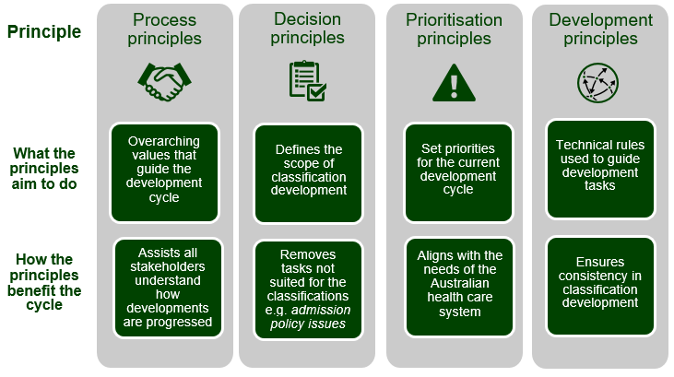

The process principles apply across all aspects of the classification development cycle.

The decision principles, prioritisation principles and development principles are specific to the development of each classification system.

## 3.1 Process principles

The process principles identify the overarching values strived for, and the steps taken to achieve these values, during the process of reviewing and developing refinements to the acute care classifications.

### 3.1.1 Transparency

* Consult on the development of the work program by following the decision and prioritisation principles, and making the final work program available on the IHPA website.
* Seek and document input on the direction and development of technical development work at scheduled meetings or other forums.
* Display the status, outcome, and other necessary attributes of a submission or coding query by enhancing the Australian Classification Exchange (ACE) portal.
* Ensure the admitted care classifications are fit for purpose for its many uses.

### 3.1.2 Respect of process

* Meeting papers are provided to relevant members in advance of an advisory group meeting.
* Advisory group members will have appropriate opportunity to provide feedback.
* IHPA will make a final decision, considering all factors informing the development process (i.e. development principles, technical group feedback and clinical feedback).
* IHPA will share the final decision with members, and notify them of any subsequent amendments before publication.
* Final decisions will remain independent and not favour a particular individual or single stakeholder group.

### 3.1.3 Decisions are evidence-based

* Development tasks will follow an evidence-based approach based on the decision, prioritisation and development principles.
* Clinical input will be sought from the Classifications Clinical Advisory Group (CCAG), or a more specialised clinical authority, where necessary.

## 3.2 ICD-10-AM/ACHI/ACS principles

### 3.2.1 Decision principles

The decision principles identify submissions that are in scope for classification development. IHPA will seek advice from the CCAG or the appropriate advisory group where required. Where CCAG determines that a public submission is clinically incoherent, it will not proceed for classification development.

**In scope:**

* Change requests submitted through the ACE portal with evidence of materiality and significant impact on health services or epidemiology
* Mandatory updates relating to the MBS and the Australian Schedule of Dental Services and Glossary (ADA)
* Advice or instructions from the WHO.

**Out of scope:**

* Change requests seeking clarification to a coding challenge (query)
* Changes to the Hospital Acquired Complications (HAC) list
* Changes to the Classification of Hospital Acquired Diagnoses (CHADx) list
* Change requests relating to data quality audits that are not directly about classification development
* Change requests relating to metadata specifications, definitions and standards
* Major reconstruction of ICD-10-AM
* Major reconstruction of ACHI
* Major changes to the classification that may lead to significant instability in collected health data
* Submissions where the underlying cause of concern lies within AR-DRGs alone
* Submissions where the underlying cause of concern is directly related to admission policy.

### 3.2.2 Prioritisation principles

All in scope development submissions will be assessed against the prioritisation principles, or criteria for priority level, and assigned to one of the following categories:

* **High priority**: essential to ensure the integrity and currency of the core components and attributes of the classification
* **Medium priority**: has merit but is not critical for integration in the current development cycle
* **Low priority**: has merit, but is low priority; but may be developed in the progression of other related development tasks.

A development submission will be assigned a priority level if it meets at least one of the criteria defined within that priority level (**Table 1**). Where a development submission meets criteria from more than one priority level it will be assigned to the higher level.

IHPA will seek advice from CCAG and/or the appropriate advisory group to determine if the priority level of a development task requires review.

Table 1. Priority criteria for ICD-10-AM/ACHI/ACS development tasks

| **Priority** | **Criteria for priority level** |
| --- | --- |
| **High priority** | * Maintain alignment with parent classifications * Address significant gaps in the classification that do not reflect contemporary clinical or classification practice * Support safety and quality initiatives * Referrals from significant AR-DRG development proposals that also add value to ICD-10-AM/ACHI/ACS * Incorporation of errata |
| **Medium priority** | * Support national or jurisdictional strategies, or high priority public interest issues * Changes to sex or age edits * Address conflicting or missing classification conventions that may restrict code assignment * Referrals from AR-DRG development that add value in a future edition |
| **Low priority** | * Incorporating advice provided within coding rules into the classification * Incorporating additional index entries, nonessential modifiers, or synonyms |

### 3.2.3 Development principles

The development principles identify the rules applied during the refinement and development process of the ICD-10-AM/ACHI/ACS classification system, as follows:

* Development must be evidence based with strong clinical support or proof of materiality
* Related items, irrespective of priority level, will be evaluated and incorporated where possible into a development task within a current development cycle
* ICD-10-AM codes will not exceed five characters, ACHI codes will not exceed seven characters.
* The ACHI must adopt MBS item numbers where possible
* The ACS and coding rules must be informative and written in plain English to avoid ambiguity
* Examples in the ACS must demonstrate application of the standard (i.e. if the examples were removed can it stand alone)
* Maintain alignment with the rubrics in the International Classification of Diseases, Eleventh Revision (ICD-11) and the International Classification of Health Interventions (ICHI) where possible
* Support logical classification of concepts by correctly applying conventions in ICD‑10‑AM or ACHI, without the need for explicit support from specialty standards in the ACS
* Inclusion terms must be indexed but Includes notes do not require indexing
* Essential modifiers and nonessential modifiers must not be indexed at the same level (i.e. subterms)
* Change requests for laterality or multiplicity for granularity must be supported by data or literature
* Scientific names must be used rather than eponyms for code titles, but may exist in the Alphabetic Index or listed as Inclusion terms for classification purposes
* Conventions and specifications outlined in the classification system (e.g. ACHI aims to be technique and provider neutral, and avoids the use of diagnostic concepts etc.) must be adhered to.

The ICD-10-AM/ACHI/ACS development principles support the established classification conventions that are found in the ICD-10-AM/ACHI/ACS manuals.

## 3.3 AR-DRG principles

### 3.3.1 Decision principles

The decision principles identify submissions that are in scope for classification development. IHPA will seek advice from the CCAG or other appropriate advisory group where required. Where CCAG determines that a public submission is clinically incoherent, it will not proceed for classification development.

**In scope:**

Development proposals should address issues of:

* Clinical coherency, or
* Cost homogeneity, and be
* Measureable – to facilitate an informed evidence based decision (i.e. there must be data available to IHPA to allow statistical assessment, such as hospital activity and cost data).

**Out of scope:**

* Issues that are not classifiable
* Coding issues in the underpinning disease and intervention classification
* Issues unique to an AR-DRG version no longer supported by IHPA.

### 3.3.2 Prioritisation principles

All in scope development submissions will be assessed against the prioritisation principles and assigned to one of the following categories:

* **High priority**: essential to ensure the integrity and currency of the core components and attributes of the classification
* **Medium priority**: has merit but is not critical for integration in the current development cycle
* **Low priority**: has merit but is low priority; but may be developed in the progression of other related development tasks.

A development submission will be assigned a priority level if it meets at least one of the criteria defined within that priority level (**Table 2**). Where a development submission meets criteria from more than one priority level it will be assigned to the higher level.

IHPA will seek advice from CCAG and/or the appropriate advisory group to determine if the priority level of a development task requires review.

Table 2. Priority criteria for AR-DRG development tasks

| **Priority** | **Criteria for priority level** |
| --- | --- |
| **High priority** | There are a number of standard refinements that are undertaken with every revision. These are assigned as high priority and include:   * Review and refinement of the Episodic Clinical Complexity (ECC) model to maintain clinical currency and cost homogeneity, including: * Recalibration and enhancement of the precision of the Diagnosis Complexity Levels (DCLs) using the most recent available cost and activity data * Review of splitting thresholds for end classes * Review of the intervention hierarchy using the most recent available cost and activity data * Integration of changes emanating from the underpinning  ICD-10-AM/ACHI/ACS classification system * Review of episodes that group to ADRG 801 *General Intervention Unrelated to Principal Diagnosis* for clinical currency   Development submissions may fall within refinement of the core components/attributes of the AR-DRG classification and consequently assigned as high priority. |
| Medium priority | Development proposals are assigned as medium priority if they demonstrate significant material impact as defined by the following criteria:  Volume  A development proposal meets the volume criteria if it meets either criteria 1 or 2 below:  1. Volume of episodes affected is large  2. Aggregated cost of episodes affected is large  Growth rate  A development proposal meets growth rate criteria if it meets criteria 1 and either criteria 2 or 3 below:  1. Growth rate of number of episodes affected is high  2. Volume of episodes affected is relatively small  3. Aggregated cost of episodes affected is relatively small  Resource homogeneity  A development proposal meets the resource homogeneity criteria if it meets criteria 1 and either criteria 2 or 3 below:  1. Episodes affected have significantly different levels of resource consumption from other episodes within the same class  2. Volume of episodes affected is relatively small  3. Aggregated cost of episodes affected is relatively small |
| Low priority | A development proposal is assigned as low priority if it does not meet any of the principles in high or medium priority. |

### 3.3.3 Development principles

The development principles identify the rules applied during the refinement and development process for the AR-DRG classification system, as follows:

Primary principles

* Clinical coherence: The AR-DRG classification must ensure that episodes within a class have similar characteristics with respect to diagnoses (both principal and additional diagnoses), interventions and treatment administered.
* Resource homogeneity: The AR-DRG classification must ensure episodes have a similar level of resource utilisation within a class, and a large variation in resource utilisation between classes.
* Classification soundness: The AR-DRG classification must have a manageable, balanced number of classes that are statistically robust and relatively stable over time.
* Statistical soundness: The statistical performance of the AR-DRG classes must be sound according to various statistical measures.
* Evidence based: Changes to the AR-DRG classification must be supported by hospital activity and cost data that can be accessed by IHPA.
* Integration with underpinning disease and intervention classification: The AR-DRG classification should be integrated with the underpinning ICD-10-AM/ACHI/ACS classification system, for example, there should be consistency between the admitted care classifications in relation to unacceptable principal diagnoses, sex and other demographic edits.

#### Pre Major Diagnostic Category (Pre MDC) principles

A Pre MDC class must meet both of the following criteria:

* Episodes are clinically considered to be more appropriately classified according to treatment provided than principal diagnosis
* There is an inherent high cost in the treatment provided.

#### Major Diagnostic Category (MDC) principles

* An MDC requires a balance of clinical coherence and resource homogeneity
* All episodes can be grouped into an MDC based on its principal diagnosis
* The majority of episodes within an MDC should be grouped to specific ADRGs rather than non-specific ADRGs (e.g. ADRG 801 *General Interventions (GIs) Unrelated to Principal Diagnosis* and residual, non-specific ADRGs).

#### Adjacent Diagnosis Related Group (ADRG) principles

* An ADRG requires a balance of clinical coherence and resource homogeneity
* An ADRG should contain at least 200 episodes per year, except for those designed to contain rare and high cost episodes
* For development proposals requesting new ADRGs, appropriate placement within a current ADRG must be considered in the first instance.

#### ADRG hierarchy principles

The intervention hierarchy is based on the following criteria:

* Intervention ADRGs must be sorted from high to low cost with decisions based on both mean and median cost
* Intervention ADRGs must be sorted from specific to non-specific ADRGs and before ADRG 801 *General Interventions (GIs) Unrelated to Principal Diagnosis*. This criterion may override the cost criterion[1]
* Intervention ADRGs must be sorted from the initial definitive intervention, to follow-up and supportive interventions and from major to minor or other interventions. This criterion may override the cost criterion
* Intervention ADRGs must be sorted from treatment to diagnostic interventions. This criterion may override the cost criterion.

#### Diagnosis Related Group (DRG) principles**[2]**

The following principles inform appropriate splitting into DRG end classes. In certain circumstances, the specific principles may be relaxed to cater for special case ADRGs. An example includes high volume ADRGs such as O60 *Vaginal delivery*.

1. A DRG must have at least 200 episodes per year, except for those within an ADRG with a limited number of episodes

2. A DRG must have a minimum total cost of $1 million per year

3. A DRG must have at least 10 per cent of episodes within the ADRG

4. The absolute change in mean cost between consecutive DRGs must be at least $3,700

5. The relative change in mean cost between consecutive DRGs should be at least 2 times

6. There should be an inverse trend between the number of episodes in a DRG and the complexity level of the DRG.

The AR-DRG development principles support the established classification conventions that are found in the AR-DRG definitions manuals.

#### Principles for diagnosis exclusions from the complexity model

Codes are out of scope within the complexity model and excluded if they:

* represent undefined or ill-specified conditions
* represent symptoms and findings or transient conditions
* provide additional or contextual information only
* most unacceptable principal diagnosis codes
* represent asymptomatic or sub-clinical conditions (e.g. latent conditions)
* represent markers of other diseases (e.g. hypercholesterolaemia)
* represent minor conditions that do not generally result in admitted acute episodes of care
* represent an underlying cause of disease (e.g. tobacco dependence/use).

# Classification development process

## 4.1 Development cycle timelines and milestones

Historically the ICD-10-AM/ACHI/ACS and AR-DRG classification systems have generally been updated in a two-year development cycle. From 1 July 2019 the development cycle of both classification systems changed to a three-year cycle. This approach balances currency and stability, and reduces the administrative burden in implementing new editions/versions. **Figure 3** provides an illustration of the three-year cycle.

Figure 3. Timelines and milestones for ICD-10-AM/ACHI/ACS Twelfth Edition and AR-DRG Version 11.0.

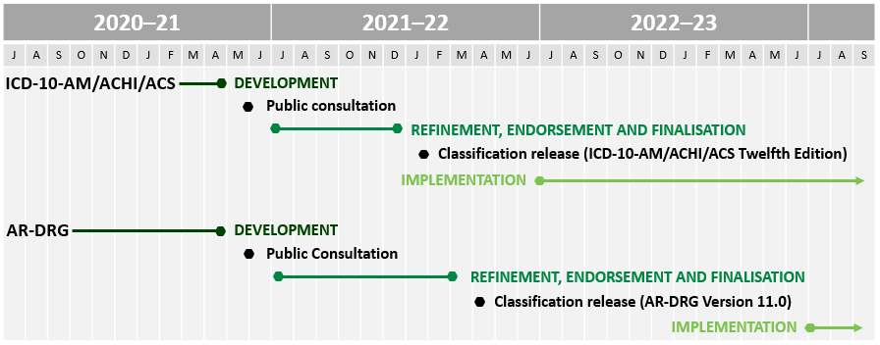

There are key dependencies between the ICD-10-AM/ACHI/ACS and AR-DRG classification systems and both are developed concurrently to ensure these dependencies are maintained. ICD-10-AM/ACHI/ACS is released several months prior to AR-DRGs and its implementation is staggered one year after ICD-10-AM/ACHI/ACS.

## 4.2 Inputs

All change requests and classification queries for the ICD-10-AM/ACHI/ACS and AR‑DRG classifications must be submitted on the ACE portal.

Guidelines ensure submissions provide adequate documentation to support the request or query. These guidelines are found on the ACE website: <https://ace.ihpa.gov.au/Submissions.aspx>

Other sources are used for classification changes such as the MBS, the ADA, the International Classification of Diseases for Oncology (ICD-O).

International health classifications are used in the development process to ensure consistency in approach. These include the WHO’s ICD-11 and ICHI.

## 4.3 Advisory groups

IHPA’s advisory groups listed in **Table 3** are responsible for providing expert technical and clinical advice throughout the development cycle. Advisory groups use their networks to ensure comprehensive input is received on changes to the classification in the development stage of the cycle.

Table 3. Advisory groups involved in the development stage

|  |  |  |
| --- | --- | --- |
| Group | Description | Role in development cycle |
| Classifications Clinical Advisory Group (CCAG) | Advisory group.  Membership includes representation from IHPA’s Clinical Advisory Committee (including the Chair) as well as medical, nursing and allied health professions with significant knowledge of the classification. | Provides expert clinical advice on development proposals across both admitted care classifications.  Assists IHPA in applying development principles (see Section 3). |
| ICD Technical Group (ITG) | Advisory group.  Membership includes representatives from all jurisdictions, public and private healthcare organisations, Australian health sector organisations and peak bodies. | Provides expert classification advice and technical input on  ICD-10-AM/ACHI/ACS development by providing feedback on technical development tasks.  Assists IHPA in applying development principles (see Section 3). |
| DRG Technical Group (DTG) | Advisory group.  Membership includes representatives from all jurisdictions, public and private healthcare organisations, Australian health sector organisations and peak bodies. | Provides technical input on  AR-DRG development by providing feedback on technical development tasks.  Assists IHPA in applying development principles (see Section 3). |

## 4.4 Consultation and endorsement committees

IHPA’s consultation and endorsement committees are listed in **Table 4** and provide strategic advice in the consultation stage of the development cycle.

The public consultation process is conducted prior to finalising the admitted care classifications to ensure the broadest possible consultation across the public and private health sector. A draft final report for both ICD-10-AM/ACHI/ACS and AR-DRGs outlines key areas of change proposed for interested stakeholders and members of the public to provide feedback on new editions/versions of the classifications.

IHPA uses feedback from the public consultation process to refine the classifications and, where necessary, seeks advice from the advisory groups before progressing the classifications through the endorsement committees and finally to the Pricing Authority for approval.

Table 4. Consultation and endorsement committees involved in the consultation stage

|  |  |  |
| --- | --- | --- |
| Group | Description | Role in development cycle |
| Technical Advisory Committee (TAC) | Endorsement committee.  Membership includes representatives from all jurisdictions with expertise in clinical costing, classification, data processing and modelling that underpins the development of ABF. | Provides technical input on classification and data standards that underpin classification development. |
| Jurisdictional Advisory Committee (JAC) | Endorsement committee.  Membership includes representatives from all jurisdictions | Reviews and endorses the classifications. |
| Clinical Advisory Committee (CAC) | Endorsement committee.  Membership consists of specialists that are appointed by the Australian Government Minister for Health, and are drawn from a range of clinical specialties and backgrounds to ensure a wide range of clinical expertise | Provides clinical input on classification and data standards that underpin the classifications development.  Reviews and endorses the classifications. |

The National Health Data and Information Standards Committee (NHDISC) is a national committee run by the Australian Institute of Health and Welfare with technical and working knowledge of health classification and data standards. They are an endorsement committee for the metadata and data standards that relate to data coded using ICD-10-AM/ACHI/ACS in the various health data collections, including the Admitted Patient Care NMDS (APC NMDS).

## 4.5 Classification approval by the Pricing Authority

Following the public consultation on major classification changes, IHPA seeks endorsement of the finalised classifications from its technical and advisory groups. The final step is to seek approval from the Pricing Authority. The Pricing Authority (IHPA’s Board) oversees IHPA’s function and work and has ultimate responsibility to finalise and implement classifications under the *National Health Reform Agreement*.

**Figure 4** illustrates the stages in the classification development cycle with key governance groups identified and the role of the Pricing Authority in the finalisation stage.

Figure 4. Overview of the stages in the classification development process.

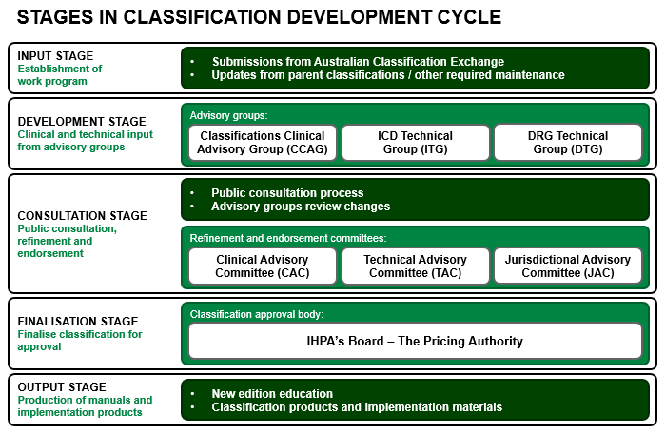

# Development cycle outputs

## 5.1 New edition education

Education is released with each new edition of ICD-10-AM/ACHI/ACS and AR-DRGs to familiarise users with the changes being implemented. The education is designed to highlight major changes in a comprehensive and accessible manner and may be provided in varying formats. Education is also supplemented by a number of accompanying documents that support implementation.

## 5.2 Classification products

The ICD-10-AM/ACHI/ACS and AR-DRG classification systems are licenced products. There are no restrictions for purchasing the books if you are located within Australia, however users from other countries require a licence agreement to purchase the relevant classification products.

Further information can be found on IHPA’s website: [www.ihpa.gov.au/what-we-do/products/admitted-acute-care-products-and-licences](http://www.ihpa.gov.au/what-we-do/products/admitted-acute-care-products-and-licences)

### 5.2.1 ICD-10-AM/ACHI/ACS products

The following classification products were produced for ICD-10-AM/ACHI/ACS Eleventh Edition:

* **ICD-10-AM Alphabetic Index** is used to locate diagnostic terms to be coded. The ICD‑10-AM Alphabetic Index contains diagnostic terms that do not appear in the   
  ICD-10-AM Tabular List. The ICD-10-AM Alphabetic Index contains three sections:

Section I: Alphabetic index of diseases and nature of injury

Section II: External causes of injury

Section III: Table of drugs and chemicals

* **ICD-10-AM Tabular List** contains the disease classification itself at the three, four and five character levels. A listing of the three character categories is included, as are four appendices:

Appendix A: Morphology of neoplasms

Appendix B: Special tabulation lists for mortality and morbidity

Appendix C: Unacceptable principal diagnosis codes

Appendix D: Classification of hospital acquired diagnoses.

The Alphabetic Index and Tabular List are used in conjunction with each other. After locating the appropriate code in the Alphabetic Index, the corresponding code must be identified in the Tabular List. The Tabular List provides further guidance on the use of additional codes, sequencing, inclusion and exclusion criteria.

* **ACHI Alphabetic Index** is used to locate procedural terms to be coded. The ACHI Alphabetic Index contains procedural terms which do not appear in the ACHI Tabular List.
* **ACHI Tabular List** contains the procedure classification itself and includes the following appendices:

Appendix A: Mapping table for MBS items not included in ACHI

Appendix B: ACHI codes listed in numerical order.

Similar to ICD-10-AM, the Alphabetic Index and Tabular List are used together for accurate coding.

* **ACS** contains the Australian standards that provide guidance in the application of the ICD-10-AM and the ACHI codes.
* **Mapping tables for ICD-10-AM and ACHI** demonstrate the relationship between the codes in two concurrent editions of the ICD-10-AM/ACHI. The mapping tables provide a means of interpreting data using codes from either of the two concurrent editions of the classification with:
* backward maps providing equivalent codes for new codes in the newer edition
* forward maps providing equivalent codes for deleted codes in the newer edition.

Both of these types of maps provide an equivalent code that best matches the concept from a clinical perspective in a tabulated form.

* **Electronic code lists (ECLs) for ICD-10-AM and ACHI** are electronic files that are used in the development of software or are integrated into existing patient software using the ICD-10-AM and ACHI codes for private or commercial purposes.
* The **Chronicle** is a reference tool to document changes between editions of   
  ICD-10-AM/ACHI/ACS and aims to improve the understanding about changes made to the ICD-10-AM/ACHI/ACS, and reasons for changes. The chronicle is updated with each edition of ICD-10-AM/ACHI/ACS.

### 5.2.2 AR-DRG products

The following classification products were produced for AR-DRG Version 10.0:

* **AR-DRG Definitions Manual** provides a high level understanding of DRG grouping logic and assists with the identification of likely DRG assignments for individual episodes of care. The Definitions Manual comprise three volumes:

Volume One: DRGs A13A–I180Z

Volume Two: DRGs J01A–Z66Z

Volume Three: Appendices.

Appendices found in volume three are also provided in excel format. As there is no DCL information within the Definitions Manual, users are unable to identify the resulting DRG that requires Episode Clinical Complexity Score splits, therefore, it is not intended to serve as a substitute for the grouper.

* **Code descriptions** provide a full listing of long and short descriptions for MDCs, ADRGs and DRGs and are displayed in an excel format.
* **Technical specifications** for grouper software are used to define theelectronicgrouping of episodes of care, based on both clinical (underpinned by ICD-10-AM and ACHI) and demographic information for admitted episodes of care into MDCs and DRGs for casemix purposes.



Independent Hospital Pricing Authority

Level 6, 1 Oxford Street

Sydney NSW 2000

Phone 02 8215 1100

Email enquiries.ihpa@ihpa.gov.au

Twitter @IHPAnews

www.ihpa.gov.au

1. Specific ADRGs are ADRGs designed for one or more specific interventions. Non-specific ADRGs are residual ADRGs designed to catch episodes not grouped to specific ADRGs but have interventions related to the principal diagnoses. Non-specific ADRGs normally start with the word ‘Other’. For example. ADRG C02 *Enucleations and Orbital Interventions* is a specific ADRG, while ADRG C14 *Other Eye Interventions* is a non-specific ADRG. Non-specific ADRGs are normally at the bottom of the intervention hierarchy but before ADRG 801 *General Interventions* (*GIs) Unrelated to Principal Diagnosis*.
2. The thresholds of DRG principles 1 to 5 were used in AR-DRG V8.0 and V9.0.