Mental Health

Phase of Care

Inter-rater Reliability Study

Final Report

April 2017

Tim Coombs

theawesomeprojectcompany

PO Box 5413 Wollongong

Ph 0429946667

ABN: 18 277 208 468

**Contents**

Acknowledgments 4

Executive Summary 5

1. Introduction 9

1.1 Study objectives 10

1.2 Study scope 10

1.3 Development of study design 10

1.3.1 Training 11

2. Method 13

2.1 Stages of the inter-rater reliability study 13

2.2 Clinical reference and technical advisory group 13

2.3 Site selection 15

2.4 Mental health phase of care training and data collection 15

2.4.1 Face-to-face training and data collection 15

2.4.2 Online training and data collection 17

2.5 Test-retest reliability 17

2.6 Demographic and evaluation questions 18

2.7 Evaluation of the face-to-face training 18

2.8 Ethics 18

3. Results 19

3.1 Profile of respondents 19

3.2 Test-retest population 21

3.3 Final data set for analysis 22

3.4 Raw agreement results 22

3.5 Kappa statistic calculation 24

3.6 Feedback received from the respondents on the mental health phase of care instrument 29

3.6.1 Clarity in defining mental health phase of care 29

3.6.2 Classification use and implementation 30

3.6.3 Service setting and additional vignettes 30

3.6.4 Feedback and training 31

3.7 Confidence in rating mental health phase of care 31

3.8 Additional observations on vignettes 32

3.9 Focus groups 34

4. Discussion 41

5. Study Limitations 43

5.1 Participant recruitment 43

5.2 Vignettes 43

5.3 Training 44

5.4 Environment 44

6. Conclusion 45

7. Recommendations 47

7.1 Option 1 - Minor changes to mental health phase of care definitions 49

7.2 Option 2 - Changes to mental health phase of care descriptors and definitions 51

7.3 Option 3a - Creation of new mental health phases of care 52

7.4 Option 3b - Creation of new phases of mental health care and removal of assessment only as a mental health phase of care 54

8. References 56

Appendix 1: Preliminary vignettes – raw agreement 58

Cross Sectional Vignettes 60

Longitudinal Vignettes 138

Appendix 2: Final Vignettes used in study 152

Appendix 3: Training Slides/ Mini vignettes/ Knowledge Quiz 215

Training Slides 215

Mini Vignettes 221

Knowledge Quiz 223

Appendix 4: Mental Health Focus of Care to Phase of Care Development 224

Appendix 5: Mental Health Phase of Care Development 229

Appendix 6: Mental Health Phase of Care Guide Development 232

Appendix 7: Inter-rater reliability study sites 242

Figure 1: Breakdown of comments from respondents 29

Figure 2: MindMap of focus groups 35

Table 1: Vignette sets used in the study 16

Table 2: Breakdown of respondents by location, mode of training and prior training 20

Table 3: Breakdown of respondents by experience 21

Table 4: Raw agreement rates across the study sample – correct assessment 22

Table 5: Raw agreement rates across the study sample – any agreement between respondents 23

Table 6: Calculated Kappa statistic for whole study sample 24

Table 7: Respondents’ estimated proportion of their consumers’ mental health phases of care 25

Table 8: Calculated Kappa statistic by true vignette phase of care 25

Table 9: Calculated Kappa statistic by respondents’ target population 26

Table 10: Calculated Kappa statistics by type and presence of training 26

Table 11: Calculated Kappa statistic for test-retest cohort 27

Table 12: Calculated Kappa statistic by location 28

Table 13: Calculated Kappa statistic by discipline 28

Table 14: Calculated Kappa statistic by setting 28

Table 15 Confidence rating mental health phase of care 31

Table 16: Vignettes ranked by rate of raw agreement to the true rating 32

Table 17: Vignettes ranked by rate of any agreement 33

Table 18: Highest rated vignettes by phase of care and target population – based on rate of any agreement 34

Table 19 Table of Frequently Asked Questions 38

# Acknowledgments

This inter-rater reliability study of mental health phase of care is the result of the work of a number of people.

IHPA was responsible for site engagement and coordination. Statistical Analysis was under taken by PricewaterhouseCoopers, in particular Chris Larkin, Roland Fan and Ruby Huang.

The initial vignettes were developed by Steve Maron and Tim Coombs. The study design, training material development, face-to-face and online training and data collection was conducted by Tim Coombs.

Vignette and study design review and development was undertaken by the Stage 1 Clinical Reference and Technical Advisory Group (see Appendix 1), supported by Tim Coombs.

Twelve (12) sites were engaged for Stage 2, involving 434 participants with 408 clinicians representing child and adolescent, adult, and older persons’ mental health services from six states (see Appendix 7).

**Suggested citation:**

Coombs, T. (2016) ‘Mental health phase of care - Inter-rater reliability study’, the Independent Hospital Pricing Authority. Available from <https://www.ihpa.gov.au/publications/mental-health-phase-care-inter-rater-reliability-irr-study-final-report>. Month Year.

# Executive Summary

**Background**

In 2013, the Definition and Cost Drivers for Mental Health Services project identified mental health phase of care as a new concept that could be a cost driver in mental health care, noting that an episode of mental health care could be made up of multiple phases of care. A mental health costing study completed in 2016 identified the mental health phase of care as an instrument suitable for inclusion in the Australian Mental Health Care Classification (AMHCC). Version 1.0 of the AMHCC was released for best endeavours collection from 1 July 2016. The Independent Hospital Pricing Authority (IHPA) is committed to the further development of this classification and agreed to undertake a mental health phase of care inter-rater reliability study (the inter-rater reliability study) to support this development process.

**Study Aim**

The primary aims of the study were to test the inter-rater reliability of the mental health phase of care instrument, gather information about clinicians' views of the mental health phase of care, identifying ways of increasing the clarity to reduce the ambiguity of the instrument, and to provide recommendations on how the instrument may be refined.

**Method**

The study occurred in two stages. Stage 1 involved developing written case vignettes that described the different mental health phases of care for all age groups and service settings. The case vignettes were then refined by a clinical reference and technical advisory group. This group also developed consensus or ‘true’ ratings for these vignettes. Stage 2 involved clinicians receiving training in the use of the mental health phase of care instrument, reviewing a series of case vignettes, assigning a mental health phase of care to the case vignettes, and collecting these ratings. The training and case vignettes were delivered through two modes: face-to-face, and through an online web portal. This data from the clinicians were used to explore both the accuracy (agreement with ‘true’ ratings) and the inter-rater reliability or the agreement between raters, using the Kappa statistic. Data collection took place between August and October 2016.

**Setting**

Stage 1 involved 40 clinicians from five jurisdictions, including admitted and ambulatory services for children and adolescents, adults, and older persons. Stage 2 involved 408 clinicians from six jurisdictions, and 10 different public mental health service organisations that included admitted (inpatient) and ambulatory (community) services for children, youth, adolescents, adults, and older persons.

**Results**

A total of 408 clinicians including psychiatrists, nurses, psychologists, social workers, occupational therapists and others participated. There were 331 clinicians who reviewed 40 vignettes through face-to-face session and 77 additional clinicians again reviewing the same vignettes through an online web portal. Overall, the agreement between the clinicians regarding the mental health phase of care instrument (and all five mental health phases of care) was found to be poor to fair   
(k = 0.4016 [95% CI, 0.3990 to 0.4042, p <.05]), where values greater than 0.75 are excellent, values between 0.40 and 0.75 are fair to good and values below 0.40 are poor. These results indicate that there is a 95 percent degree of confidence that in all probability the observed inter-rater reliability is between 0.399 and 0.404.

The results indicated that the mental health phase of care instrument, as currently defined, has poor to fair inter-rater reliability, with participants indicating that the greatest challenge was in discriminating between the three mental health phases of care: functional gain, intensive extended and consolidating gain. There was stronger level of agreement between clinicians regarding assessment only (k = 0.5289 [95%CI, 0.5238 to 0.5340, p<.05]) and acute (k = 0.5149 [95% CI, 0.5098 to 0.5199, p<.05]) mental health phases of care. The majority of participants were ‘somewhat confident’ in assigning a mental health phase of care. There was evidence to suggest that greater exposure to the instrument resulted in an increase in agreement.

Examination of the test-retest reliability of the instrument indicated stable but low levels of agreement. However, these results should be approached with caution given low levels of participation in the test-retest component of the study despite further attempts to manually match unique identifier codes. Participants indicated a desire for more training that included more substantive feedback on the accuracy of their ratings. Comments indicated that this type of training would improve the inter-rater reliability of the instrument. In line with previous work, participants commented that the mental health phase of care instrument would be useful in clinical practice and provide an opportunity to ensure consistency in service provision.

**Limitations**

There were a number of limitations to the inter-rater reliability study. Vignettes may not provide the detailed or nuanced material upon which clinicians make a determination of the mental health phase of care in clinical practice. The training provided was brief and did not provide enough practice or feedback to enable accurate rating. The instrument was also being tested in an environment within which the mental health focus of care has been collected for over 15 years and during a period of initial local implementation of the AMHCC and mental health phase of care. This complex and dynamic environment may have confounded ratings.

**Conclusion**

The current study provides a foundation for further development work on the mental health phase of care and the refinement of the AMHCC. The results of this study show that the mental health phase of care, as it stands, has poor to fair inter-rater reliability. However, as with previous studies there is broad support for the concept and participants identified that the instrument would be useful in clinical practice to support consistency in service delivery. Focus groups and evaluation comments indicated that this poor to fair inter-rater reliability was to be expected for such a new concept. Generally, the view was expressed that ongoing training to ensure the reliability of collected data during the implementation of the mental health phase of care would result in improvements in inter-rater reliability. As approximately three quarters of participants were from the ambulatory (community) setting, it would be feasible that future training could be targeted to this setting. The need for training materials that provide feedback on clinicians’ ratings was also seen as particularly important.

**Recommendations**

The results of the inter-rater reliability study of mental health phase of care have produced a number of recommendations:

**Recommendation 1** - The implementation of the mental health phase of care instrument should be supported by a comprehensive training program. Such a training program would include; the background and rationale for the AMHCC, the importance of identifying cost drivers in mental health, the role of mental health phase of care in the classification as well as practice rating the instrument with a number of case vignettes. This training should include feedback on performance in terms of the accuracy of the ratings.

In addition:

* The sub-set of vignettes with the best agreement from the inter-rater reliability study of mental health phase of care study should be seen as the gold standard and distributed to jurisdictions to support training activities (see Table 18 for vignettes).
* Additional vignettes that reflect specific service types and populations should be developed to support implementation.
* Future training could be targeted to the ambulatory (community) setting.

**Recommendation 2** - Periodic retraining in the instrument should be undertaken. This could involve regular retraining activities, vignettes or case studies that require the development of consensus ratings.

**Recommendation 3** - Modification of the mental health phase of care guidance material to reflect the input of clinicians who participated in the inter-rater reliability study of mental health phase of care (See Appendix 6).

**Recommendation 4** - Modifications to the instrument that increase the clarity and reduce the ambiguity of the instrument should be considered. These modifications can be separated into three options:

* + Option 1 – identifies modification to the definitions of individual categories. The changes to definitions aim to provide greater clarity, with a particular focus on discriminating between functional gain, intensive extended and consolidating gain. This would increase the clarity and reduce the ambiguity involved in discriminating between these three mental health phases of care.
  + Option 2 – in addition to the modification of the definitions, the names of each mental health phase of care could be changed. This would clarify the distinction between categories, making explicit the shorter term nature of functional gain and the longer term needs of individuals in an intensive extended mental health phase of care.
  + Option 3 – includes the modifications outlined for option 2 but includes the removal of the ‘assessment only’ mental health phase of care, because it could be considered service activity that could be better collected in another manner rather than as a ‘phase’ of mental health care.

**Recommendation 5** –The suitability of some of the suggested changes to the mental health phase of care for child and adolescent and older person’s mental health consumers and clinicians will require more detailed exploration and testing.

In addition to retraining to improve the inter-rater reliability of the mental health phase of care, the study points to a number of modifications that may improve the clarity and decrease the ambiguity of the instrument. These modifications range from simple alterations to the definitions of the mental health phases of care to more detailed renaming of the phases and an overall restructuring of the instrument.

# Introduction

The mental health phase of care concept was developed in 2012, through a project commissioned by the IHPA. This project identified possible cost drivers in mental health and suggested a number of concepts that should be considered for inclusion in the architecture of a mental health care classification. One proposal was the development of a mental health phase of care concept within a mental health care type (University of Queensland, 2013).

The mental health phase of care, while a new concept, is based on the notion that mental illness can be episodic in nature and that at different times during the consumer’s journey of recovery their need for mental health services, the types of services required, and the intensity of service provision can vary. These ideas were initially developed as part of a large mental health costing study undertaken in the 1990’s (Buckingham et al., 1998) (See Appendix 4 for developmental history).

This new concept of the mental health phase of care was subsequently developed and initially tested in the IHPA Mental Health Costing Study (MHCS), a national study that involved 26 hospital service sites across Australia (HealthConsult Pty Ltd, 2016). The mental health phase of care concept was also tested in the Australian Mental Health Care Classification (AMHCC) pilot undertaken in late 2015, at four hospital service sites across Australia.

The mental health phase of care is a prospective description of the primary goal of care for a consumer at a point in time. While many factors can impact on the consumer’s mental health care plan, the mental health phase of care is intended to identify the primary goal of care by the treating professional(s) through engagement with the consumer. The mental health phase of care is independent of both the treatment setting and the designation of the treating service, and does not reflect service unit type. The setting in which the consumer is treated depends upon the level of risk, the responsiveness of the consumer to engage with services, treatments and supports, and the type of care to be delivered.

Both the AMHCC and the mental health phase of care instrument have undergone considerable clinical and stakeholder consultation which have included two public consultation processes that were undertaken in January and December 2015.

The public consultation process identified the need to determine the inter-rater reliability or the consistency with which different clinicians identified a consumer’s mental health phase of care when provided with the same information.

IHPA is committed to the further refinement of the mental health phase of care. To achieve this refinement, IHPA undertook an inter-rater reliability study of the mental health phase of care.

## Study objectives

The inter-rater reliability study had four objectives:

* To test the inter-rater reliability of the mental health phase of care instrument
* To gather information of clinicians’ views of the mental health phase of care and consider ways of increasing the clarity and reducing the ambiguity of the instrument
* To determine the test-retest reliability of the mental health phase of care instrument, and
* To make recommendations on how the mental health phase of care maybe modified to support the development of the instrument and the refinement of the AMHCC.

## Study scope

The study was designed to capture information from mental health clinicians working with consumers across child and adolescent, adult, and older persons’ mental health services, in both admitted (inpatient) and ambulatory (community) service settings.

## Development of study design

To achieve the objectives of the inter-rater reliability study a number of approaches were considered. Initially, consideration was given to undertaking a naturalistic observational study of clinicians rating the mental health phase of care on current consumers of services.

However, a number of logistical and ethical challenges were identified with this approach. Firstly, identifying participants and gaining permission from clinicians and informed consent from consumers to participate in the study were seen as significant challenges. Second, there were concerns that this particular approach could potentially result in a selection bias, giving preference to consumers in a particular mental health phase of care over another (for example, enabling greater participation from consumers in a consolidating gain mental health phase over an acute mental health phase of care). Finally, concerns were raised about the burden that participating in the study would place on clinicians and consumers with both parties having to share their story on multiple occasions to researchers who may not have direct involvement in the consumers’ care.

While none of these challenges were insurmountable, they were seen as prohibitive in achieving the study objectives within the required timeframes. Given these logistical and ethical challenges, the decision was made to use case vignettes to test the inter-rater reliability of the instrument.

There was early discussion about creating video vignettes. Video vignettes are seen as providing a more realistic representation of the consumer (Stacey et al., 2014). However, the creation of these vignettes can be complex and time consuming with the challenge of recruiting actors or clinicians, scripting, selecting camera angles and editing vignettes (Hillen, 2013). These challenges were considered logistically prohibitive within the required timeframes.

The use of vignettes has a number of advantages. Firstly, vignettes enable the collection of information from a large under of subjects (Gould, 1996). Secondly, vignettes are generally short, and it is this brevity that increases the chance of holding participants’ attention during the study (Bradbury-Jones et al., 2014). Finally, vignettes have been found to be valid, reliable, inexpensive and a practical method of assessing clinical decision-making (Evans et al., 2015). Case vignettes have been used extensively to test the inter-rater reliability of the measures that make up the National Outcomes and Casemix Collection (NOCC) (Rock and Preston, 2001, Trauer, 2002, Webster et al., 2013).

As a result, case vignettes were chosen as the most appropriate approach to test the inter-rater reliability of the mental health phase of care. There is also evidence in the literature that there can be agreement between naturalistic data collection and paper-based case scenarios (Worster et al., 2007).

Case vignettes have the advantage of not requiring direct consumer involvement in data collection. They are also relatively inexpensive to create and may be easily altered based on feedback compared to video vignettes. The scope and variety of vignettes may, as far as possible, reflect the variety and scope of types of consumers and service types that could potentially be involved in the study. Appendix 1 outlines the vignette development process.

In order to ensure a robust study, it was agreed the case vignettes would need to be completed by as many clinicians across as many service settings and age groups as possible. Subsequently attention turned to the mode of administration. Initially, the study was conceived as an online study. However, there was some concern that an online study could not assure the response rate that would enable adequate testing of the inter-rater reliability of the instrument. As a result, a mixed approach to data collection was considered the most suitable. This was a combination of face-to-face and online data collection.

Given that the mental health phase of care is a new concept, introduced in July 2015, the study had to include some training to orientate people to the instrument before they could supply a rating of a vignette. As a result, both face-to-face and online data collection required a training component so that participants who had never been exposed to the mental health phase of care concept would have some understanding of the instrument.

### Training

Several instructional design models were considered in the development of the training for the study: the 10 step Dick, Carey, and Carey model (Identify Instructional Goal(s), Conduct Instructional Analysis, Analyze Learners and Contexts, Write Performance Objectives, Develop Assessment Instruments, Develop Instructional Strategy, Develop and Select Instructional Materials, Design and Conduct Formative Evaluation of Instruction, Revise Instruction, Design and Conduct Summative Evaluation) (Burggraff, 2015) or the model of Smith and Ragan (Introduction, body, conclusion, assessment) (Ragan and Smith, 1994). The current study utilised the Direct Instruction Model*,* developed by Joyce, Wells and Showers (Hirumi, 2014).

All of these models are based on behavioural educational theory. Behaviourism contends that any behaviour is the result of a specific stimuli and learning takes place when behaviour changes in response to specific stimuli. Programs that are based on skills development are often based on behavioural theories (te Pas et al., 2016).  Learning occurs through stimulus response conditioning and is generated and sustained through reinforcement.

The Direct Instruction Model moves through five broad phases. The orientation phase consists of an outline of the lesson content and its relationship to previous learning. It outlines the objectives of the lesson and establishes how the lesson will unfold. The participant is then presented with a demonstration or explanation of the new concept or skill. They are provided with a visual representation of the task and their understanding of the concept or skill is tested. The participant is then guided through structured practice with a practice example. Participants respond to questions and corrective feedback is provided along with positive reinforcement of correct responses. Participants are then exposed to guided practice where they practice semi-independently and provide with prompting and praise. Finally, participants undertake independent practice and feedback is delayed. On the context of the current study the independent practice is the completion of the vignettes.

# Method

## Stages of the inter-rater reliability study

The inter-rater reliability study of the mental health phase of care instrument consisted of two stages:

* Stage 1 involved developing written case vignettes that described the different mental health phases of care for all age groups and service settings. The case vignettes were then refined by a clinical reference and technical advisory group. This group also developed consensus or ‘true’ ratings for these vignettes.
* Stage 2 involved clinicians receiving training in the use of the mental health phase of care instrument, reviewing a series of case vignettes, assigning a mental health phase of care to the case vignettes, and collecting these ratings. The training and case vignettes were delivered through two modes: face-to-face, and through an online web portal. This data from the clinicians were used to explore both the accuracy (agreement with ‘true’ ratings) and the inter-rater reliability or the agreement between raters, using the Kappa statistic. Data collection took place between August and October 2016.

## Clinical reference and technical advisory group

A clinical reference and technical advisory group was formed to provide support for the inter-rater reliability study as part of Stage 1. This group was brought together to provide advice on the design of the study, review the vignettes that would be used in Stage 2 of the study and provide advice on the suitability of the vignettes for use in the study. This clinical reference and technical advisory group would also provide advice on the training materials developed for use during Stage 2 of the study.

Two types of vignettes were developed. One set involved a cross sectional view of the presentation of different consumers, while another set presented a longitudinal view outlining how the mental health phase of care changed over time.

The development of the vignettes was guided by four principles:

* each vignette should adequately cover each of the important considerations when rating the mental health phase of care
* the vignettes should describe consumers as close to their usual presentation as much as possible
* each vignette should provide a uniform amount of information in the different vignettes, and
* each vignette should have the optimum level of difficulty (Sriram, 1990).

The challenge was to write vignettes that provided information about the characteristics of the consumer, their symptoms and functioning as well as an indication of the types and intensity of interventions being offered. Vignettes were structured so that information regarding the behaviour of the consumer, their physical health, symptoms, social functioning and the types of interventions being offered was presented for each vignette. Considerations such as length, wording and the target audience mean that the scenarios described in vignettes are only partial representations of reality (Hughes and Huby, 2002). The vignettes were written to provide enough information at a realistically ambiguous level to mimic how consumers actually present (Veloski et al., 2005). The use of ambiguous material is also seen as important for engaging participants but the material should not be deliberate “red herrings” or so bizarre that it is distracting (Evans et al., 2015).

The Stage 1 clinical reference and technical advisory group was brought together via a series of face-to-face, teleconference and video conference meetings. Participants in the clinical reference and technical advisory group were nominated by jurisdictions and included staff who had participated in the MHCS and those who had not been involved.

During these meetings, a general overview of the study was provided, along with an outline of the training being provided and the training materials being used. This overview included the demographic and additional questions, including evaluation questions, being used in the study.

Participants in this stage were specifically asked to provide comments on the study design, the training materials and review the vignettes that would be used in the study in terms of their readability and the accuracy with which they reflected the types of consumers seen in clinical practice. Participants were also asked to provide a rating of the mental health phase of care for each vignette. In an effort to determine the response equivalency of the vignettes (Randhawa et al., 2015) or the consistency with which the members of the clinical reference and technical advisory group rated the vignettes, their ratings were collated. The vignettes that follow in Appendix 1 report the raw percentage agreement of this group's ratings. They do not reflect the inter-rater reliability of the instrument.

Forty-two (42) clinicians from across Australia participated in Stage 1 clinical reference and technical advisory group meetings. These meetings occurred over June and July 2016.

After the initial meeting, a follow up meeting was held where the participants’ comments were reviewed, along with the rating on the mental health phase of care provided. The comments and discussions held in the second clinical reference and technical advisory group meeting were used as a basis for the modification of the training materials as well as the vignettes that would be used in Stage 2 of the study.

A small number of responses to the longitudinal vignettes were received from the clinical reference and technical advisory group. There was significant variability in the supplied ratings which, combined with the challenge of producing vignettes that described all the mental health phases of care for a consumer in a brief vignette, meant that the development of the longitudinal case vignettes did not proceed.

The short and long form vignettes that were developed for review by the clinical reference and technical advisory group are found in Appendix 1.

## Site selection

In April 2016, IHPA sought nominations from each state and territory to provide clinicians and public hospital sites to participate in the two stages of the inter-rater reliability study.

Nominations were sought from admitted and ambulatory (community) public mental health services that could:

* Identify a site coordinator
* Make staff available from child and adolescent, adult, and older persons’ mental health services to participate in training in the mental health phase of care instrument
* Promote study participation in face-to-face training and data collection as well as the online training and data collection.

In May 2016, IHPA received nominations for both stages from New South Wales (NSW), Victoria (Vic), Queensland (Qld), Western Australia (WA), South Australia (SA), and Tasmania (Tas). IHPA conducted a site selection strategy that considered the setting, age cohorts and number of clinicians available. The requirements for participation included having:

* Admitted or ambulatory (community) services
* Services that covered at least one of the three age groups (child and adolescent, adult, older persons’)
* A large number of suitable mental health clinicians to enable appropriate statistical analysis and feedback from a diverse range of perspectives
* Previous participation in the MHCS/AMHCC pilot, and
* No participation in the MHCS/AMHCC pilot.

Using these criteria, a total of 12 sites were chosen to participate across six jurisdictions.

## Mental health phase of care training and data collection

There were two methods used to deliver training and collect data for the study:

* Face-to-face training and data collection
* An online web portal providing the training and enabling data collection.

### Face-to-face training and data collection

Initially, training and data collection was undertaken face-to-face to ensure stronger data collection rates than online data collection (Cunningham et al., 2015, Burke and Hodgins, 2015). Face-to-face sessions also provided an opportunity to receive queries or feedback directly from clinicians. Face-to-face data collection took place between early August and early October 2016 at twelve sites around Australia.

Each face-to-face session was allocated two hours. These sessions were held at specific organisations within each jurisdiction. However, one jurisdiction chose to provide a state panel and several organisation-based sessions.

Participation varied across sites. Some groups were from services for a particular age group or service setting, while the majority (greater than 60 percent) of groups were mixed, with participants coming from different service settings working and representing different age groups.

Sessions began with a brief introduction and an orientation to the study. As the training slides in Appendix 4 indicate, participants were informed that the focus of the training session was on the mental health phase of care and not the AMHCC or associated activity based funding.

Each group received a copy of the definitions of the mental health phase of care and the training guidelines.

Each training session reinforced the following:

* The mental health phase of care is independent of service setting/ discipline
* Mental health phase of care is a broad descriptor of the consumer’s phase of care
* Mental health phase of care is determined by:
  + The primary goal of care
  + Consumer characteristics
  + Clinician activity and expectation of change.

Each training session then systematically worked through each of the five mental health phases of care. Each session then practiced assigning a mental health phase of care to three mini vignettes (Appendix 3). These mini vignettes were used to support practice in the allocation of the mental health phase of care. Feedback was provided to participants at this time and correct responses were praised and discussed. Participants were then provided with an opportunity to complete a brief quiz to again reinforce their ratings.

Towards the end of the face-to-face session, participants were given instructions regarding completion of the demographic questions and how to complete the case vignette rating task. Participants were made aware of the online web portal that would be made available following the face-to-face session. They were encouraged to participate to support the test-retest study and also encouraged to pique the interest of their colleagues who were unable to participate in the face-to-face sessions to participate in the online approach to data collection.

Training and instruction on the task of rating vignettes took between 20 and 30 minutes, depending on the size of the group and the degree of interaction or questioning.

There were a total of 40 case vignettes available for distribution (see Appendix 3). Concerns were raised by the clinical reference and technical advisory group during Stage 1 that some vignettes were too similar in terms of background and that this may cause confusion for participants. As a result, groups of vignettes were developed which limited participants’ exposure to vignettes with similar backgrounds. This produced the potential for two vignette groups for each age group.

The two groups of vignettes per age group were randomly distributed to participants by organisation. As per Table 1, organisations received vignettes that were common for each age group (Group A) as well as unique vignettes for each age group (from Group B or C). All participants in the face-to-face training had access to the common vignettes of Group A.

Table 1: Vignette groups used in the study

|  | **Common vignettes used for each age group** | **Unique vignettes used for each age group** | |
| --- | --- | --- | --- |
|  | **Group A** | **Group B** | **Group C** |
| Child and Adolescent | Sophia  Aiden  Lachlan  Bryce  Ebony | Theo  Tameka  Marcus  Llubica  Jade | Jordan  Alinga  Jack  Nadeen  Chloe |
| Adult | Gary  Daniel  Faith  Ashley  Vivian  Jo Beth  Malcolm | Paul  Xi  Zlatko | Jason  Bo  Barry |
| Older | Agnes  Doris  Antonina  Edward | Eric  Jo  Mara  Peter | Donald  Rose  Angelina  William |

In this way, participants who worked primarily with child and adolescent consumers had the opportunity to complete 10 vignettes; those that worked with adults had the opportunity to complete 10 vignettes; and those that worked with older persons had the opportunity to complete eight vignettes.

All face-to-face sessions ended with a focus group, which asked participants:

* What were the challenges in rating the mental health phase of care?
* What information would help clarify the different mental health phases of care?
* Do you have any other comments?

### Online training and data collection

The online data collection component of the study aimed to collect information on the inter-rater reliability of the instrument using an online web portal to deliver the training and table the case vignettes. The content of the training and the case vignettes provided was identical to the material provided to the face-to-face participants. Online data collection took place between mid-August and mid-October 2016.

## Test-retest reliability

As a result of collecting data through both face-to-face and online, the study provided the opportunity to examine the test-retest reliability of the instrument. A participant could provide ratings as part of the face-to-face training and data collection and following these sessions also provide ratings on vignettes in the online environment.

## Demographic and evaluation questions

Given the aims of the study, additional information was sought to describe participants in the study in addition to the potential relationship between the types of consumer routinely seen by participants and subsequent allocations of mental health phase of care. These additional questions included:

* What is your **discipline**? (i.e. nurse, psychologist, social worker, occupational therapist, psychiatrist, psychiatric registrar, other)
* How many **years of experience** had you had working in mental health?
* What is the **main** target population you work with clinically? (i.e. child and adolescent, adult, older persons)
* What is the **main** service setting in which you work? (i.e. admitted (inpatient) unit or ambulatory (community) mental health service)
* In thinking about the people that you have seen in your clinical practice within the last 3 months, please estimate the proportion that fall within each mental health phase of care:

|  |  |
| --- | --- |
| Acute |  |
| Functional gain |  |
| Intensive extended |  |
| Consolidating gain |  |
| Assessment only |  |
| Total | 100 |

* Have you seen or completed mental health phase of care prior to this session? (Yes/No)

Participants were also asked to provide a unique code so that if they participated in the face-to-face sessions and then completed the online data collection their responses could be used to evaluate the test-retest reliability of the instrument.

## Evaluation of the face-to-face training

Face-to-face training and data collection included an evaluation of the training, open-ended questions that asked how the training could be improved and sought suggestions about any changes that could be made to the mental health phase of care instrument that could increase clarity or reduce ambiguity.

## Ethics

The inter-rater reliability study of mental health phase of care did not collect information from or about consumers and involved voluntary participation of non-identifiable clinicians. As such, the study was considered to be low risk research, as per the definition provided by the National Health and Medical Research Council (NHMRC) National Statement on Ethical Conduct in Human Research (2007) and sections 5.1.18 to 5.1.21 in particular. The expression ‘low risk research’ describes research ‘where the only foreseeable risk is one of discomfort’.

# Results

There were 20 face-to-face sessions across six states and 10 mental health service organisations across Australia. The average number of face-to-face participants in each session was approximately 16, ranging from five to 35 in number. There were a total of 331 people who participated in the face-to-face component of the study. Some of these were excluded from the analysis of inter-rater reliability because they were not clinicians. Similarly, there were 103 online responses and of these 103, 26 had also participated in the face-to-face sessions and were therefore excluded from the total count of respondents and total number of responses available for the analysis of the inter-rater reliability. This resulted in a total of 408 responses available for analysis (See section 3.3).

This is the largest inter-rater reliability study that has ever been undertaken in mental health in Australia.

## Profile of respondents

The study sample consisted of 434 respondents who provided the following information:

* Location
* Mode of training – face-to-face or online
* Discipline – for example nurse, occupational therapist, psychologist
* Years of experience
* Area of specialisation
* Main service setting – for example admitted (inpatient) or ambulatory (community) mental health service.

The data also contained the respondents’ estimate of the proportion of the consumers at their clinical practice which fell into each of the five mental health phases of care. Approximately eight percent of respondents did not complete these estimates with a further 11 percent of responses having responses being erroneous because they were not valid responses.

Importantly, the study required the respondents to assess the mental health phase of care for   
40 vignettes. For each of the vignettes, the respondent was asked to provide their rating of:

1. the mental health phase of care, and
2. how confident they were in their rating.

The 40 vignettes were spread across the three target populations (child and adolescent, adult, older persons).

Respondents did not always complete ratings on all the vignettes they were asked to review as there was some missing ratings. The majority of respondents reviewed vignettes that related to the age group they provided services to and generally completed 10 vignettes.

Table 2 shows the profile of the 434 respondents by the location of the study site and by the mode by which the training was delivered:

* The data shows a spread of respondents across a number of jurisdictions
* Three quarters of the responses were from respondents who attended a face-to-face training session, and
* 64 percent of the respondents indicated they were seeing or completing a mental health phase of care assessment for the first time.

Table 2: Profile of respondents by location, mode of training and prior training

|  |  | **Number of respondents** | % |
| --- | --- | --- | --- |
|  | **Total** | **434** | **100%** |
| Location | NSW | 112 | 26% |
|  | QLD | 46 | 11% |
|  | SA | 109 | 25% |
|  | TAS | 38 | 9% |
|  | VIC | 59 | 14% |
|  | WA | 70 | 16% |
| Mode of training | Face to face | 331 | 76% |
|  | Online | 103 | 24% |
| Seen or completed Mental | Yes | 148 | 34% |
| Health Phase of Care prior to | No | 279 | 64% |
| this session? | Not provided | 7 | 2% |

Table 3 shows the profile of respondents based on factors associated with their experience:

* 318 of the 434 respondents (73 percent) worked with the adult population.
* Approximately three quarters of the respondents (320 out of 434) worked in an ambulatory (community) mental health service setting. This is followed by approximately 21 percent who worked in an admitted (inpatient) setting. Of the remaining 18 percent, a large proportion worked in policy and administrative settings.
* Nurses made up about half of the respondents (212 out of 434), followed by social workers (18 percent) and psychologists (10 percent). The remaining respondents who nominated ‘Other’ were predominantly students (7 percent).

There was a wide range of practice experience among the respondents. Approximately 23 percent (100 out of 434) had five years or less experience, with slightly less (20 percent) having between six to 10 years of experience. Approximately a quarter of respondents had more than 20 years of experience.

Table 3: Profile of respondents by consumer age group, service setting, discipline and experience

|  |  | **Number of respondents** | % |
| --- | --- | --- | --- |
|  | **Total** | **434** | **100%** |
| Main target population | Child and Adolescent | 75 | 17% |
|  | Adult | 318 | 73% |
|  | Older Persons | 35 | 8% |
|  | Not provided | 6 | 1% |
| Main service setting | Ambulatory mental health service | 320 | 74% |
|  | Admitted mental health service | 92 | 21% |
|  | Other | 18 | 4% |
|  | Not provided | 4 | 1% |
| Discipline | Psychologist | 45 | 10% |
|  | Psychiatrist | 25 | 6% |
|  | Psychiatric Registrar | 8 | 2% |
|  | Social Worker | 79 | 18% |
|  | Occupational Therapist | 32 | 7% |
|  | Nurse | 212 | 49% |
|  | Other | 32 | 7% |
| Years of experience | 0-5 | 100 | 23% |
|  | 6-10 | 88 | 20% |
|  | 11-15 | 71 | 16% |
|  | 16-20 | 65 | 15% |
|  | 21-25 | 26 | 6% |
|  | 26-30 | 40 | 9% |
|  | 30+ | 38 | 9% |

## Test-retest population

Online respondents were also given the opportunity to carry out a retest. However, of the 103 entries relating to respondents who were involved in online sessions, only 39 had completed the required identifier code which could allow them to be identified if they had completed a retest. It was suggested that respondents use the month and year of birth as the identifier code, although any code of their own choosing was acceptable. Of those, only six records could be matched against a face-to-face record directly using the identifier code.

One reason for the low level of matching is due to the varying formats in which respondents entered their identifier code. Attempts were made to manually review the remaining identifier codes to ascertain whether there could be more matches based on the use of different formats, for example matching ‘Jan-1987’ to ‘0101987’. A ‘match’ was considered after also looking at the respondent’s location, discipline, target population and service setting for these records, with secondary consideration also given to years of experience. This yielded a further 20 possible matches although it should be noted that these cannot be considered matched with full certainty.

## Final data set for analysis

In total, there were 3,339 responses to the vignettes from the 434 respondents, as respondents could provide ratings for multiple vignettes. However, some responses were excluded for the following reasons:

* Respondents where the main discipline was missing or ‘other’ were excluded as many of these respondents were students or in managerial or administration roles.
* Respondents where the main service setting was missing or ‘other’ were excluded as these respondents were mainly in policy rather than in a clinical setting.
* Responses for vignettes number 1, 2 and 3 were related to cases for children aged between zero and five years, which is a specialised group and were deemed to be unrepresentative of the child and adolescent cohort for the purpose of analysis.
* The ‘online’ responses relating to the test-retest population were removed, to ensure only one response for each of these respondents was included.

The results shown in the following sections exclude the responses discussed above. There were   
909 (21 percent) responses excluded, leaving 3,339 responses from 408 respondents available for analysis.

The reasonable sample size enables the development of robust conclusions for the ongoing refinement of the mental health phase of care instrument.

## Raw agreement results

The first way that agreement was measured was to compare the respondents’ assessment against the ‘true’ mental health phase of care for each vignette[1], thereby providing a raw level of agreement. Table 4 shows the total number of responses, comparing the respondents’ assessment (horizontal categories) against the vignette’s true rating of the mental health phase of care (vertical categories). As a respondent provided ratings for more than one vignette, each response is captured separately in Table 4. This gives a total number of 3,339 responses after allowing for the exclusions described above.

Table 4: Raw agreement rates across the study sample – correct assessment

|  |  | **Responder mental health phase of care** | | | | |  |  |
| --- | --- | --- | --- | --- | --- | --- | --- | --- |
|  |  | Assessment only | Functional gain | Consolidating gain | Intensive extended | Acute | **Total** | **Raw Agreement** |
| **Vignette designed mental health phase of care** | Assessment only | 704 | 43 | 71 | 62 | 78 | 958 | **73%** |
| Functional gain | 57 | 326 | 123 | 56 | 52 | 614 | **53%** |
| Consolidating gain | 59 | 174 | 462 | 44 | 6 | 745 | **62%** |
| Intensive extended | 4 | 104 | 62 | 306 | 32 | 508 | **60%** |
| Acute | 44 | 30 | 6 | 35 | 399 | 514 | **78%** |
|  | Total | 868 | 677 | 724 | 503 | 567 | 3,339 | **66%** |

The baseline mental health phase of care for each vignette (i.e. the ‘true’ mental health phase of care) was established by the Stage 1 clinical reference and technical advisory group. Agreement in the assessment occurs when each respondent’s assessment of the mental health phase of care matches the ‘true’ mental health phase of care, and these are highlighted across the diagonal in red. The raw level of agreement across the responses is shown for each of the five mental health phases of care.

Vignettes for the ‘acute’ mental health phase of care had the highest level of raw agreement at   
78 percent (399 matched responses out of 514) followed closely by the ‘assessment only’ mental health phase of care which had 73 percent raw agreement. These two mental health phases of care had much higher levels of raw agreement compared to the other three mental health phases of care. This suggests it may be easier to identify the more distinct ‘acute’ or ‘assessment only’ phases of care compared to those potentially more influenced by differences in practice and expectation where the distinctions are less clear.

A second approach is to look at the level of agreement between pairs of respondents, regardless of whether they agreed on the ‘true’ mental health phase of care rating. This approach could be thought of as a way of identifying whether respondents were in agreement with each other even if they were not in agreement with the case vignette rating of the clinical reference and technical advisory group.

Table 5 presents the results for this approach which shows all combinations of responses by choosing two pairs of respondents for a given vignette.

Table 5: Raw agreement rates across the study sample – any agreement between respondents

|  |  | **Responder B mental health phase of care** | | | | |  |  |
| --- | --- | --- | --- | --- | --- | --- | --- | --- |
|  |  | Assessment only | Functional gain | Consolidating gain | Intensive extended | Acute | **Total** | **Agreement** |
| **Responder A mental health phase of care** | Assessment only | 51,494 | 6,744 | 9,670 | 4,026 | 8,819 | 80,752 | **64%** |
| Functional gain | 6,744 | 20,417 | 17,180 | 7,495 | 5,001 | 56,836 | **36%** |
| Consolidating gain | 9,670 | 17,180 | 29,452 | 7,215 | 2,411 | 65,927 | **45%** |
| Intensive extended | 4,026 | 7,495 | 7,215 | 18,606 | 3,107 | 40,448 | **46%** |
| Acute | 8,819 | 5,001 | 2,411 | 3,107 | 26,357 | 45,693 | **58%** |
|  | Total | 80,752 | 56,836 | 65,927 | 40,448 | 45,693 | 289,655 | **51%** |

Table 5describes the combined total number of possible pairs for each mental health phase of care. The total number of possible pairs is independent of the order of raters. To present the pairs in the table above, the full matrix is shown which resulted in an order being applied and as a result, the number of pairs was divided across combinations of raters. Where there were an odd number of pairs, this resulted in a non-integer value which was subsequently rounded in the above table.

This approach shows that overall there is a lower level of agreement compared to only looking at raw responses against the ‘true’ mental health phase of care rating. However, the pattern of agreement between the different mental health phases of care is similar, with the ‘acute’ and ‘assessment only’ mental health phases of care having a higher rate of agreement than the other three, among which ‘functional gain’ had the lowest rate of agreement.

## Kappa statistic calculation

The Kappa statistic (k) was used to measure the level of agreement amongst the study sample. It is a commonly used approach for inter-rater reliability studies (for example, to assess the inter-rater reliability of palliative care phases[2]). The Kappa statistic method takes into account agreement over and above what would be expected as ‘chance’ and is therefore more robust than simple raw agreement percentages[3].

The statistic is a single measure that ranges between -1 and +1, with +1 representing perfect agreement. Although the Kappa statistic is commonly used, it is not a perfect measure as there is a need to determine what a ‘chance’ level of agreement would be which is not a straightforward exercise. This also affects the interpretation of what a ‘good’ level of agreement is, and various studies provide differing ranges.

The Kappa statistic was calculated and used in addition to the raw agreement findings and comments from the respondents to explore the level of agreement for the mental health phases of care.

Table 6: Calculated Kappa statistic for complete study sample

|  |  |
| --- | --- |
| Number of responses | 3,339 |
| Raw agreement | 66% |
| **Calculated Kappa statistic** | **0.4016** |
| 95% confidence interval | (0.3990, 0.4042) |

The calculated Kappa statistic for the overall mental health phase of care instrument is 0.4016. Fleiss[4] suggests that “for most purposes, values greater than 0.75 or so may be taken to represent excellent agreement beyond chance, values below 0.40 or so may be taken to represent poor agreement beyond chance, and values between 0.40 and 0.75 may be taken to represent fair to good agreement beyond chance”. This suggests that the level of agreement amongst the respondents is borderline between poor and fair.

However, the statistic can be difficult to interpret and this is particularly so if the probability of observing each of the five mental health phases of care ratings are not the same in the underlying study sample. The proportions estimated by the study sample are reported in Table 7, although it should be noted that because these are reliant on the respondents’ interpretation of the mental health phases of care, the estimate itself is somewhat circular. Indeed, the estimated proportions may also be dependent on the respondent’s service setting and this was reflected in some of the comments.

Table 7: Respondents’ estimated proportion of their consumers’ mental health phases of care

| **Mental health phase of care** | **Estimated proportion** |
| --- | --- |
| Assessment only | 11% |
| Functional gain | 25% |
| Consolidating gain | 17% |
| Intensive extended | 23% |
| Acute | 25% |

As well as calculating the Kappa statistic for all responses in total, the Kappa statistic was also calculated for various subgroups of respondents/responses to assess whether there were any differences amongst certain groups of respondents where the volume of responses allowed for meaningful comparison. These results are presented below.

Table 8: Calculated Kappa statistic by true vignette phase of care

| **Mental health phase of care** | **Calculated Kappa statistic** | **95% confidence interval** |
| --- | --- | --- |
| Assessment only | 0.5289 | ( 0.5238, 0.5340) |
| Functional gain | 0.2266 | ( 0.2215, 0.2317) |
| Consolidating gain | 0.4027 | ( 0.3976, 0.4078) |
| Intensive extended | 0.3335 | ( 0.3284, 0.3386) |
| Acute | 0.5149 | ( 0.5098, 0.5199) |

The calculated Kappa statistic by the vignette’s true mental health phase of care shows a similar pattern to the raw agreement, with responses to ‘acute’ and ‘assessment only’ vignettes demonstrating higher Kappa scores compared to the other three mental health phases of care. For ‘acute’ and ‘assessment only’, the Kappa scores indicate a fair level of agreement. On the other hand the very low Kappa score for ‘functional gain’ indicates that the level of agreement is poor.

Table 9: Calculated Kappa statistic by respondents’ target population

|  | **Child and Adolescent** | **Adult** | **Older Person** |
| --- | --- | --- | --- |
| Number of responses | 465 | 2,622 | 252 |
| Raw agreement | 61% | 67% | 59% |
| **Calculated Kappa statistic** | **0.3364** | **0.4247** | **0.4161** |
| 95% confidence interval | (0.3222, 0.3505) | (0.4214, 0.4280) | (0.3956, 0.4366) |

Table 9 shows the calculated Kappa statistic according to the respondents’ target population. Notwithstanding the lower number of responses, there appears to be a lower level of agreement for respondents whose target population is children and adolescents. The lower response volume for this group also results in a wider confidence interval. This potentially means that greater training and clarity may be required when applying the mental health phase of care definitions to consumers in the child and adolescent category.

The Kappa statistic was also calculated based on the target population of the vignette. However, since most respondents only provided a rating for the vignettes related to the target population that they work with, the results are very similar.

Table 10: Calculated Kappa statistics by type and presence of training

|  |  |  | **Have you seen or completed mental health phase of care prior to this session?** | |
| --- | --- | --- | --- | --- |
|  | **Face-to-face training** | **Online training** | **No** | **Yes** |
| Number of responses | 2,745 | 594 | 2,196 | 1,083 |
| Raw agreement | 66% | 63% | 65% | 67% |
| **Calculated Kappa statistic** | **0.4127** | **0.3618** | **0.3892** | **0.4330** |
| 95% confidence interval | (0.4096, 0.4159) | (0.3469, 0.3766) | (0.3853, 0.3931) | (0.4249, 0.4410) |

Table 10 shows the calculated Kappa statistics based on the respondent’s mode of training and whether they had previously seen or completed a mental health phase of care prior to this training. The following observations can be made:

* The level of raw agreement and the resulting Kappa statistic appears higher for the   
  face-to-face training (k = 0.4127 [95% CI, 0.4096 to 0.4159, p <.05]) when compared to the online assessment group (k = 0.3618 [95% CI, 0.3469 to 0.3766, p <.05]) and those who had no previous exposure to the instrument (k = 0.3892 [95% CI, 0.3853 to 0.3931, p <.05]). Of note, the online training group excludes respondents who were identified as having completed a retest.
* There is evidence of a difference between those who answered ‘yes’ and ‘no’ when asked if they had seen or completed the mental health phase of care prior to the training session. Those who answered ‘yes’ had a Kappa statistic of 0.4330 compared to 0.3829 for those who answered ‘no’.

It is not clear (or indeed, possible to tell) what level of exposure the respondents had to the mental health phase of care instrument when answering the question. However, the last point suggests that there may be a higher level of agreement if it is not the respondent’s first time seeing or using the mental health phase of care instrument.

The level of agreement for the test-retest population was examined. However, due to the small sample size and the uncertainty around identifying the 26 individuals for the test-retest population, the results from these respondents will not be as robust as the larger population.

Table 11: Calculated Kappa statistic for test-retest cohort

|  | **Test** | **Retest** |
| --- | --- | --- |
| Number of responses | 235 | 218 |
| Raw agreement | 71% | 67% |
| **Calculated Kappa statistic** | **0.4764** | **0.4677** |
| 95% confidence interval | (0.4373 , 0.5155) | (0.4241 , 0.5112) |

Table 11 shows the calculated raw agreement rate and calculated Kappa statistic for the test and retest rounds for the 26 individuals. The individuals did not all complete the same questions in both rounds, but we have kept all the responses (as opposed to only common responses) between the two rounds to capture as much information as possible. The level of agreement for these individuals appears to be higher than for the rest of the population as whole. There does not appear to be a significant difference between the test and the retest results, with the retest results being slightly lower. However, these have been calculated using matches which are uncertain and more data would be required to achieve more robust results as to whether there is a difference between the level of agreement on the initial test compared to the retest. Table 12 shows the variations in Kappa scores across the different locations at a jurisdictional level (J). Table 13 shows the calculated Kappa scores across disciplines.

Table 12: Calculated Kappa statistic by location

|  | **J 1** | **J 2** | **J 3** | **J 4** | **J 5** | **J 6** |
| --- | --- | --- | --- | --- | --- | --- |
| Number of responses | 821 | 342 | 955 | 269 | 438 | 514 |
| Raw agreement | 69% | 64% | 66% | 53% | 70% | 66% |
| **Calculated Kappa statistic** | **0.4389** | **0.3690** | **0.4078** | **0.2414** | **0.4538** | **0.4413** |

Table 13: Calculated Kappa statistic by discipline

|  | **Nurse** | **Occupational Therapist** | **Psychiatric Registrar** | **Psychiatrist** | **Psychologist** | **Social Worker** |
| --- | --- | --- | --- | --- | --- | --- |
| Number of responses | 1,865 | 259 | 55 | 154 | 344 | 662 |
| Raw agreement | 63% | 70% | 80% | 64% | 68% | 69% |
| **Calculated Kappa statistic** | **0.3628** | **0.4743** | **0.6629** | **0.4122** | **0.4573** | **0.4720** |

Table 14: Calculated Kappa statistic by respondent’s main service setting

|  | **Ambulatory mental health service** | **Admitted mental health service** |
| --- | --- | --- |
| Number of responses | 2,625 | 714 |
| Raw agreement | 67% | 62% |
| **Calculated Kappa statistic** | **0.4143** | **0.3831** |

## Feedback received from the respondents on the mental health phase of care instrument

As part of the study, respondents had the opportunity to provide free-text comments relating to the mental health phase of care instrument. Some respondents were confident in their ability to be able to distinguish between the five mental health phases of care, although many were more concerned about their ability to provide the correct rating. Of the 434 respondents, 148 provided meaningful comments and these have been grouped into broad themes.

Figure 1: Breakdown of comments from respondents

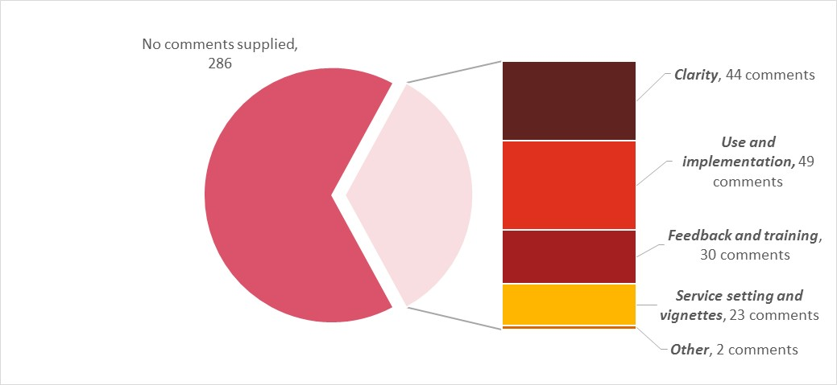

### Clarity in defining mental health phase of care

One key theme emerging from the comments was the about the clarity of the mental health phase of care definitions. A small number of respondents commented that they found the definitions clear and self-explanatory but most found it difficult to distinguish between the five mental health phases of care. In particular, some of the following points were mentioned:

* A number of respondents expressed confusion around the changes/transition in the consumer’s circumstances. Some said every consumer can always improve from where they are at, therefore they questioned if it meant every consumer can be ‘functional gain’ and at what stage dysfunction is accepted and ‘consolidating gain’ is allocated.
* Ambiguity between ‘intensive extended’ and ‘consolidating gain’ and some believe transfers of care or discharge should be included as a service outcome.
* A number of respondents thought that references to the intensity/frequency of intervention required by clinical staff, further information about the timeframes for care and previous instances of care would be helpful in defining the phase of care.
* Respondents who work across multiple target populations find that with the youth consumer, mental health phase of care change very quickly.
* There are times when it can be difficult to distinguish between two or three different phases of care for a consumer. It should be acknowledged that sometimes a consumer could reasonably fit within multiple phases of care at one time.
* There could be confusion between the phase of care and the focus of care.
* A number of respondents thought the assessment could be subjective, depending on the clinician and their experience or when considering the different viewpoints between management and clinicians.

### Classification use and implementation

Some respondents provided comments around the use of the mental health phase of care instrument, how it fits into their roles and its links to budgets and funding. Positive comments included:

* Some respondents were enthusiastic and were looking forward to discussing it within their workplaces.
* Some respondents thought that the phase of care could be seen as a tool to manage caseloads and treatment planning.

However, many respondents raised concerns about how the phase of care instrument would be implemented and its links to funding. Specifically:

* The introduction of phase of care will require additional training, documentation and validation. Respondents questioned who would be responsible for managing and reviewing the processes to assign phases of care
* Respondents questioned whether the phases of care would be used on their own or how it might interact with other assessment tools or service measures
* Some respondents thought it may be hard to determine a phase of care if there are multiple clinicians with differing points of view
* Some respondents wanted reassurance that service for everyone who needs it will be adequately funded and that the funding will be based on needs and not any other categories
* Potential system gaming – if funding is directly linked to the phase of care, there may be a tendency for people to put all consumer’s into ‘intensive extended’ in order to maximise the funding rewards
* Some respondents were unable to see how phase of care could be linked to activity based funding and saw it as having more of a clinical benefit rather than being utilised to determine funding allocation.

### Service setting and additional vignettes

Respondents identified potential gaps in the vignettes, particularly in relation to an admitted (inpatient) setting. There were also comments relating to what they observed in their service setting and how that influenced their ability to provide a rating. In particular, some of the following points were mentioned:

* Respondents who only see acute consumers find some of the other phases unfamiliar even after involvement in the training
* Respondents in a particular service setting find they are limited to seeing only some of the case studies and phases of care cannot be easily fitted to their consumers in admitted (inpatient) and in ambulatory (community) settings
* Some respondents employ the Choice and Partnership Approach (CAPA) system with most starting with ‘assessment only’. They have rated based on referral and exclusion criteria following the assessment rather than perhaps what the consumer needed
* Many respondents noted that it would be difficult to apply the phase of care to the child and adolescent mental health services (CAMHS) setting and that consideration could be given to rewording some of the descriptors to make it more appropriate
* Respondents also commented that for CAMHS, especially for children under five years, there should also be consideration of the families of consumers.

### Feedback and training

A number of respondents would like to have feedback on their results from this study and have identified that more practice is required. In particular, some of the following were mentioned:

* Feedback on the responses to vignettes with correct answers would be helpful, either during the training session or online
* Some find their understanding of the use of phase of care was enhanced after the session and more training was needed
* A lot more training should be offered to direct care clinicians e.g. additional handouts/fact sheets.

## Confidence in rating mental health phase of care

As part of the evaluation of the face-to-face sessions and on the online web portal, respondents were asked to score how confident they were at rating the mental health phase of care. Ranging from ‘not confident’ = 0, ‘A little confident’ = 1, ‘Somewhat confident’ = 2, ‘Very confident’ = 3 and ‘extremely confident’ = 4. A total of 434 responses were available for analysis. Almost 70 percent of respondents indicated that they were somewhat confident rating the mental health phase of care.

Table 15: Confidence rating mental health phase of care

| **Response** | **Proportion of responses** |
| --- | --- |
| Blank | 13.42% |
| Not confident | 1.315% |
| A little confident | 14.73% |
| Somewhat confident | 68.94% |
| Very confident | 14.73% |
| Extremely confident | 0.26% |

Table 15 shows the confidence respondents felt in rating the mental health phase of care. The majority of respondents indicated they were ‘somewhat confident’.

## Additional observations on vignettes

One of the outcomes of the preliminary analysis may be to carry out further refinements to the vignettes. It has already been observed that the Kappa results relating to the child and adolescents target group is significantly lower than for adults and these may need to be refined. Furthermore, the comments from respondents have identified potential gaps in the coverage of the vignettes and new vignettes may also be required.

Table 16: Vignettes ranked by rate of raw agreement to the true rating

|  |  |  |  |  |  |  |  | **Rated Phase** |  |  |
| --- | --- | --- | --- | --- | --- | --- | --- | --- | --- | --- |
| **Rank** | **Vignette no.** | **True mental health phase of care** | **Vignette target population** | **Total no. of responses** | **Raw agreement** | **Assessment only** | **Functional gain** | **Consolidating gain** | **Intensive extended** | **Acute** |
| 1 | 32 | Acute | Older Persons | 20 | 95% | 5% | 0% | 0% | 0% | **95%** |
| 2 | 35 | Intensive extended | Older Persons | 19 | 95% | 0% | 5% | 0% | **95%** | 0% |
| 3 | 6 | Consolidating gain | Child and Adolescent | 35 | 94% | 0% | 3% | **94%** | 3% | 0% |
| 4 | 23 | Assessment only | Adult | 149 | 89% | **89%** | 3% | 5% | 1% | 3% |
| 5 | 13 | Consolidating gain | Child and Adolescent | 32 | 88% | 0% | 3% | **88%** | 9% | 0% |
| 6 | 20 | Acute | Adult | 117 | 86% | 6% | 0% | 3% | 5% | **86%** |
| 7 | 33 | Acute | Older Persons | 20 | 85% | 5% | 10% | 0% | 0% | **85%** |
| 8 | 24 | Assessment only | Adult | 123 | 85% | **85%** | 1% | 3% | 2% | 9% |
| 9 | 28 | Assessment only | Adult | 252 | 84% | **84%** | 3% | 4% | 2% | 7% |
| 10 | 7 | Assessment only | Child and Adolescent | 36 | 78% | **78%** | 3% | 19% | 0% | 0% |
| 11 | 19 | Acute | Adult | 255 | 77% | 13% | 6% | 1% | 4% | **77%** |
| 12 | 16 | Intensive extended | Adult | 240 | 70% | 1% | 15% | 12% | **70%** | 2% |
| 13 | 10 | Intensive extended | Child and Adolescent | 36 | 69% | 0% | 25% | 3% | **69%** | 3% |
| 14 | 12 | Acute | Child and Adolescent | 35 | 69% | 6% | 9% | 0% | 17% | **69%** |
| 15 | 37 | Functional gain | Older Persons | 18 | 67% | 6% | **67%** | 6% | 17% | 6% |
| 16 | 22 | Consolidating gain | Adult | 117 | 66% | 6% | 22% | **66%** | 5% | 1% |
| 17 | 14 | Assessment only | Child and Adolescent | 61 | 64% | **64%** | 13% | 2% | 15% | 7% |
| 18 | 25 | Functional gain | Adult | 152 | 63% | 10% | **63%** | 8% | 3% | 16% |
| 19.5 | 30 | Consolidating gain | Older Persons | 35 | 63% | 9% | 26% | **63%** | 3% | 0% |
| 19.5 | 40 | Acute | Older Persons | 35 | 63% | 3% | 23% | 3% | 9% | **63%** |
| 21 | 5 | Acute | Child and Adolescent | 32 | 63% | 0% | 6% | 0% | 31% | **63%** |
| 22 | 17 | Consolidating gain | Adult | 251 | 62% | 0% | 29% | **62%** | 8% | 0% |
| 23 | 26 | Assessment only | Adult | 249 | 62% | **62%** | 3% | 16% | 10% | 9% |
| 24 | 39 | Functional gain | Older Persons | 33 | 61% | 0% | **61%** | 21% | 12% | 6% |
| 25 | 29 | Assessment only | Older Persons | 34 | 56% | **56%** | 0% | 0% | 0% | 44% |
| 26 | 27 | Consolidating gain | Adult | 255 | 54% | 18% | 22% | **54%** | 5% | 2% |
| 27 | 15 | Functional gain | Child and Adolescent | 63 | 51% | 8% | **51%** | 6% | 29% | 6% |
| 28 | 18 | Functional gain | Adult | 258 | 51% | 13% | **51%** | 25% | 4% | 8% |
| 29 | 21 | Intensive extended | Adult | 157 | 49% | 0% | 25% | 18% | **49%** | 8% |
| 30 | 31 | Consolidating gain | Older Persons | 20 | 45% | 15% | 35% | **45%** | 5% | 0% |
| 31 | 8 | Functional gain | Child and Adolescent | 34 | 41% | 3% | **41%** | 24% | 32% | 0% |
| 32.5 | 11 | Functional gain | Child and Adolescent | 35 | 40% | 6% | **40%** | 43% | 11% | 0% |
| 32.5 | 9 | Intensive extended | Child and Adolescent | 35 | 40% | 3% | 23% | 11% | **40%** | 23% |
| 34 | 4 | Assessment only | Child and Adolescent | 36 | 36% | **36%** | 33% | 3% | 19% | 8% |
| 35 | 34 | Functional gain | Older Persons | 21 | 33% | 0% | **33%** | 57% | 10% | 0% |
| 36 | 36 | Assessment only | Older Persons | 18 | 22% | **22%** | 6% | 6% | 61% | 6% |
| 37 | 38 | Intensive extended | Older Persons | 21 | 19% | 0% | 52% | 5% | **19%** | 24% |

Table 16 shows the list of vignettes ranked by their rate of raw agreement. The following observations can be made:

* Of the top 10 vignettes (ranked by rate of raw agreement), seven of the vignettes had a true phase of care of ‘acute’ or ‘assessment only’. This is aligned with the study findings where those two phases of care had higher kappa scores
* The bottom 10 vignettes all had a raw agreement of 51 percent or less and four of these related to vignettes with a true phase of care of ‘functional gain’
* The majority of the poorly rated vignettes were from those where the target population was either child and adolescent or older persons.

Table 17: Vignettes ranked by rate of any agreement

| **Rank** | **Vignette no.** | **True mental health phase of care** | **Vignette target population** | **Total no. of responses** | **Any agreement** |
| --- | --- | --- | --- | --- | --- |
| 1 | 32 | Acute | Older Persons | 20 | 90% |
| 2 | 35 | Intensive extended | Older Persons | 19 | 89% |
| 3 | 6 | Consolidating gain | Child and Adolescent | 35 | 89% |
| 4 | 23 | Assessment only | Adult | 149 | 79% |
| 5 | 13 | Consolidating gain | Child and Adolescent | 32 | 77% |
| 6 | 20 | Acute | Adult | 117 | 75% |
| 7 | 24 | Assessment only | Adult | 123 | 72% |
| 8 | 33 | Acute | Older Persons | 20 | 72% |
| 9 | 28 | Assessment only | Adult | 252 | 71% |
| 10 | 7 | Assessment only | Child and Adolescent | 36 | 63% |
| 11 | 19 | Acute | Adult | 255 | 61% |
| 12 | 10 | Intensive extended | Child and Adolescent | 36 | 53% |
| 13 | 16 | Intensive extended | Adult | 240 | 52% |
| 14 | 12 | Acute | Child and Adolescent | 35 | 50% |
| 15 | 29 | Assessment only | Older Persons | 34 | 49% |
| 16 | 22 | Consolidating gain | Adult | 117 | 48% |
| 17 | 5 | Acute | Child and Adolescent | 32 | 48% |
| 18 | 17 | Consolidating gain | Adult | 251 | 48% |
| 19 | 30 | Consolidating gain | Older Persons | 35 | 45% |
| 20 | 37 | Functional gain | Older Persons | 18 | 45% |
| 21 | 14 | Assessment only | Child and Adolescent | 61 | 44% |
| 22 | 40 | Acute | Older Persons | 35 | 44% |
| 23 | 25 | Functional gain | Adult | 152 | 44% |
| 24 | 26 | Assessment only | Adult | 249 | 43% |
| 25 | 34 | Functional gain | Older Persons | 21 | 42% |
| 26 | 39 | Functional gain | Older Persons | 33 | 41% |
| 27 | 36 | Assessment only | Older Persons | 18 | 40% |
| 28 | 27 | Consolidating gain | Adult | 255 | 37% |
| 29 | 15 | Functional gain | Child and Adolescent | 63 | 34% |
| 30 | 11 | Functional gain | Child and Adolescent | 35 | 34% |
| 31 | 18 | Functional gain | Adult | 258 | 34% |
| 32 | 38 | Intensive extended | Older Persons | 21 | 34% |
| 33 | 21 | Intensive extended | Adult | 157 | 34% |
| 34 | 31 | Consolidating gain | Older Persons | 20 | 32% |
| 35 | 8 | Functional gain | Child and Adolescent | 34 | 31% |
| 36 | 4 | Assessment only | Child and Adolescent | 36 | 27% |
| 37 | 9 | Intensive extended | Child and Adolescent | 35 | 26% |

Table 17 shows the rankings by the rate of whether there was any agreement between the respondents. It shows similar trends whereby the ‘acute’ and ‘assessment only’ vignettes overall had higher levels of agreement than the other phases of care. Similarly, the child and adolescent vignettes tended to have poor levels of agreement.

Although there were trends in the rate of agreement across phases of care more broadly, there were also disparities in agreement rates within the phases of care. We have identified the ‘best’ vignettes for each phase of care and target population, based on the highest rate ranked by any agreement and these are presented in Table 18.

Table 18: Highest rated vignettes by phase of care and target population – based on rate of any agreement

|  |  | **Vignette no.** | **Vignette name** | **Any agreement** |
| --- | --- | --- | --- | --- |
| Assessment only | Adult | 23 | Bo | 79% |
|  | Child and Adolescent | 7 | Aldinga | 63% |
|  | Older Persons | 29 | Agnes | 49% |
| Consolidating gain | Adult | 22 | Xi | 48% |
|  | Child and Adolescent | 6 | Tameka | 89% |
|  | Older Persons | 30 | Doris | 45% |
| Functional gain | Adult | 25 | Barry | 44% |
|  | Child and Adolescent | 15 | Ebony | 34% |
|  | Older Persons | 37 | Peter | 45% |
| Intensive extended | Adult | 16 | Gary | 52% |
|  | Child and Adolescent | 10 | Llubica | 53% |
|  | Older Persons | 35 | Mara | 89% |
| Acute | Adult | 20 | Paul | 75% |
|  | Child and Adolescent | 12 | Jade | 50% |
|  | Older Persons | 32 | Donald | 90% |

These different vignettes across the age groups represent a useful training resource that can provide consensus ratings that could be used to support training during implementation.

## Focus groups

As outlined, following every face-to-face session a focus group was undertaken. Notes were taken during these discussions and these notes are shown as a MindMap in Figure 2. Mind mapping has proven useful in organising complex areas to provide coherence (Heinrich, 2001). Mind mapping can help make the links between data, concepts and categories (Chen and Boore, 2009).

Similar to the written responses to the evaluation of the face-to-face training and data collection and the comments provided online, a number of issues were raised regarding the mental health phase of care, discrimination between the different phases along with implementation issues.

The discussions during these focus groups were used to develop the report recommendations. The recommendations are a synthesis of the issues raised during discussions and an attempt to resolve the confusion some participants expressed in relation to some mental health phases of care. Like the snowball approach, once an issue was raised in one group the proposed resolution was raised in the subsequent group.

Figure 2: MindMap of focus groups

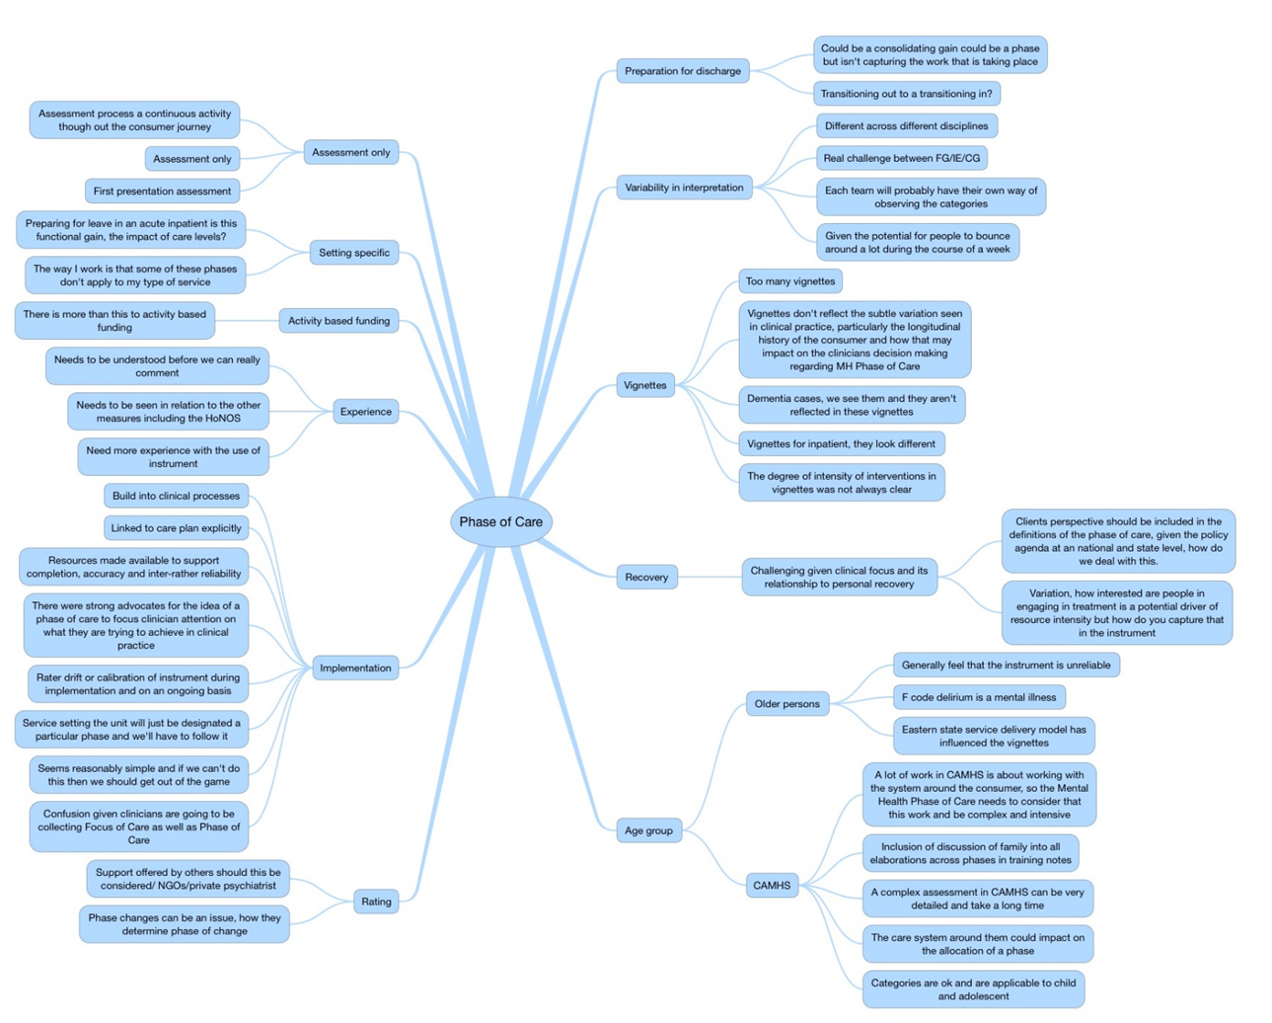

Each node and sub node of the MindMap is presented below. These nodes and sub nodes were created using a constant comparative methodology.

**Preparation for discharge**

* Could be a consolidating gain could be a phase but is not capturing the work that is taking place
* Transitioning out to or transitioning in?
* Variability in interpretation

**Different across different disciplines**

* Real challenge between functional gain/intensive extended / consolidating gain
* Each team will probably have their own way of observing the categories
* Given the potential for people to bounce around a lot during the course of a week

**Vignettes**

* Too many vignettes
* Vignettes do not reflect the subtle variation seen in clinical practice, particularly the longitudinal history of the consumer and how that may impact on the clinician’s decision making regarding mental health phase of care
* Dementia cases, we see them and they aren't reflected in these vignettes
* Vignettes for inpatients as they look different
* The degree of intensity of interventions in vignettes was not always clear

**Recovery**

* Challenging given clinical focus and its relationship to personal recovery
* Client’s perspective should be included in the definitions of the phase of care, given the policy agenda at a national and state level, how do we deal with this?
* Variation, how interested are people in engaging in treatment is a potential driver of resource intensity but how do you capture that in the instrument

**Age group**

***Older persons***

* Generally, feel that the instrument is unreliable
* F code delirium is a mental illness
* Eastern state service delivery model has influenced the vignettes

***Child and Adolescent Mental Health***

* A lot of work in CAMHS is about working with the system around the consumer, so the Mental Health Phase of Care needs to consider that this work and be complex and intensive
* Inclusion of discussion of family into all elaborations across phases in training notes
* A complex assessment in CAMHS can be very detailed and take a long time
* The care system around them could impact on the allocation of a phase
* Categories are ok and are applicable to child and adolescent

**Rating**

* Support offered by others should this be considered/ NGOs/private psychiatrist
* Phase changes can be an issue, how they determine phase of change

**Implementation**

* Build into clinical processes
* Linked to care plan explicitly
* Resources made available to support completion, accuracy and inter-rater reliability
* There were strong advocates for the idea of a phase of care instrument to focus clinician attention on what they are trying to achieve in clinical practice
* Rater drift or calibration of instrument during implementation and on an ongoing basis
* Service setting the unit will just be designated a particular phase and we'll have to follow it
* Seems reasonably simple and if we cannot do this then we should get out of the game
* Confusion given clinicians are going to be collecting Focus of Care as well as Phase of Care

**Experience**

* Needs to be understood before we can really comment
* Needs to be seen in relation to the other measures including the HoNOS
* Need more experience with the use of instrument

**Activity based funding**

* There is more than this to activity based funding

**Setting specific**

* Preparing for leave in an acute inpatient unit, is this functional gain? What is the impact of care levels?
* The way I work is that some of these phases do not apply to my type of service

**Assessment only**

* Assessment process a continuous activity though out the consumer journey
* Assessment only
* First presentation assessment

The issues identified during the focus groups have been grouped to identify Frequently Asked Questions (FAQs). These FAQs could be used to support training during implementation.

Table 19: Table of Frequently Asked Questions

| **Question** | **Answer** |
| --- | --- |
| 1. I am always looking towards improving a consumer level of functioning, why would I choose any other mental health phase of care? | The interplay between symptoms and functioning is complex. The overall goal of care would be to reduce the distress or risks associated with symptoms and improve individual functioning, regardless of the mental health phase of care. The instrument requires a decision regarding the primary goal of care given the consumers current presentation. |
| 1. I am the person making the rating of the mental health phase of care but other people are involved in providing intensive input. I only see them once a month. How should I rate intensive extended or consolidating gain? | You are rating the consumer’s primary goal of care. Although you may not be delivering the service, you have been responsible for mobilising a range of other service providers to support improvements in symptoms or functioning or prevent deterioration in an individual with an enduring presentation. The mental health phase of care should be rated as intensive extended. |
| 1. Someone is in a consolidating gain mental health phase of care and becomes unwell; do they go to an acute or an intensive extended? | People can move between the different mental health phases of care and there is no set or expected progression between the different mental health phases of care. |
| 1. How do I make the decision that a mental health phase of care has changed? | A mental health phase of care change is a clinical decision that you make following your assessment. You should consider if there is a need to provide more support for a consumers or are primarily focusing on symptoms or functioning. |
| 1. You say that people have reached a plateau when they are in a consolidating gain mental health phase of care, but what about hope? Are we just giving up? | Research indicates that recovery can include a moratorium phase during which consumers consolidate their experience. The identification of someone in a consolidating gain phase of care does not mean that clinicians have stopped actively engaging with the consumer in the work of change. This mental health phase of care acknowledges that some change can take an extended period of time, and that consumers may require the ongoing support of the clinicians. |
| 1. How long does a mental health phase of care last? What is the rating period? | There is no rating period for the mental health phase of care. Consumers stay in the phase that best describes their characteristics, the primary goal of care, and the activity of the clinician. The mental health phase of care lasts as long as it lasts. |
| 1. How do you deal with co-morbidities, what if for one disorder the consumer has no problems but for another they are very distressed? | There can only be one mental health phase of care at a time and while the consumer may have various comorbid conditions the clinician must choose the primary goal of care for the current mental health phase of care. |
| 1. Does the person have to be present for an ‘assessment only’ mental health phase of care to be identified; sometimes it is only the family or teachers that are part of the assessment process. | In some specialist primarily child and adolescent or consultation liaison services, the consumer is not present during the gathering of information for decisions regarding service suitability. On these occasions, even though the consumer is not present, the mental health phase of care would be best described as assessment only. |
| 1. What is the difference between focus of care and mental health phase of care? | There are a number of differences between the two instruments. The mental health phase of care is a prospective rating. There have also been changes in the definitions and the addition of an ‘assessment only’ category. |
| 1. How do you determine the mental health phase of care when clinicians have different points of view? | One of the advantages of working as part of a multidisciplinary team is the different perspectives that each discipline can bring to the process of clinical review. These different perspectives need to be considered when rating the mental health phase of care. During the process of clinical review, these different perspectives are discussed and a consensus as to the primary goal of care should be formed. Although each member of the team may be focused on a different aspect of the consumer’s care, the primary goal is the overarching goal of the combined team’s activities. |
| 1. How do the other assessment tools or service measures relate to the mental health phase of care? | The Mental Health Costing Study found that outcome measures such as the Health of the Nation Outcome Scales (HoNOS) and the new concept ‘mental health phase of care’ were significant variables for predicting cost across settings and ages.  At the commencement of, or a change in a mental health phase of care, an outcome measures collection is required in all mental health service settings as per clinical guidelines.  With the implementation of the AMHCC, there will be an opportunity to gather more data to better understand the impact of other assessment tools or service measures as the collection proceeds.  Work is also being undertaken to align the mental health phase of care and the National Outcomes and Casemix Collection (NOCC), via a national committee called the National Mental Health Information Strategy Standing Committee (MHISSC). This work is essential to the ongoing refinement of information collection in the mental health sector. |

# Discussion

The current study aimed to:

* Test the inter-rater reliability of the mental health phase of care
* Gather information of clinician’s views of the mental health phase of care and ways of increasing the clarity and reducing the ambiguity of the instrument
* Determine the test – retest reliability of the mental health phase of care
* Make recommendations on how the mental health phase of care may modified to support the development of the instrument and the AMHCC

Six jurisdictions took part in the study, with 331 individual participants in the face-to-face component and 103 in the online component. The majority of participants had no experience of the mental health phase of care, indicating that the concept was new to most participants. Three quarters of participants worked with adult consumers in ambulatory (community) services. Almost half of participants were nurses. Almost half of participants had been 0 and 10 years of experience.

Some participants were excluded from data analysis because they worked in an administrative capacity or were students who participated in the study during their practicums. With these exclusions 3,339 responses to vignettes were available for analysis.

Raw agreement across these responses indicated greater agreement for ‘assessment only’ and ‘acute’ mental health phases of care. There was less raw agreement for ‘functional gain’, ‘intensive extended’ and ‘consolidating gain’. This pattern was similar for agreement in comparison to ‘true assessment’[5] and ‘any agreement’[6].

The results indicate that overall the inter-rater reliability of the mental health phase of care is poor to fair (k = 0.4016 [95% CI, 0.3990 to 0.4042, p <.05]). Respondents to the Adult vignettes (k = 0.4247 [95% CI, 0.4214 to 0.4280, p <.05]) and for Older Persons vignettes (k = 0.4161 [95% CI, 0.3956 to 0.4366, p <.05]) had better results than respondents to the Child and Adolescent vignettes (k =0.3364 [95% CI, 0.3222 to 0.3505, p <.05]) which demonstrated poor agreement beyond chance.

Respondents that viewed the vignettes through the face-to-face training (k = 0.4127 [95% CI, 0.4096 to 0.4159, p <.05]) or respondents that had previous experience with the instrument (k = .336 [95% CI, .424 to .441, p <.05]) had slightly better results than respondents who received online training   
(k = 0.3618 [95% CI, 0.3469 to 0.3766, p <.05]) and respondents who had no previous experience with the instrument (k = 0.3892 [95% CI, 0.3853 to 0.3931, p <.05]).

Difficulties in identifying those participants who participated in the test-retest component of the study mean that the results should be approached with caution. However, there was little difference in test (k = 0.4764 [95% CI, 0.4373 to 0.5155, p <.05]) and retest (k = 0.4677 [95% CI, 0.4241 to 0.5112, p <.05]) inter-rater reliability.

Clinicians raised a number of concerns regarding the mental health phase of care, including:

* Clarity around the boundaries between different mental health phases of care
* Concerns regarding implementation
* Variability across clinicians in rating the instrument and the implications for funding
* The need for more specific vignettes to the respondent’s service setting (admitted) and age group (child and adolescent and older persons)
* The need for training and retraining to support inter-rater reliability.

A group of vignettes across mental health phases of care and across age groups could be identified that may be suitable for training purposes.

This variation in ratings is not unprecedented in these types of studies. Philips et al (2015) using vignettes found wide variation in the way that nurses in emergency departments made mental health triage decisions. There was only slight agreement between clinicians using vignettes to determine competence to provide informed consent (Kitamura and Kitamura, 2000). There was only low agreement between clinicians when using vignettes to rate the mini-mental state examination (Queally et al., 2010). Along with making decisions regarding triage in Emergency Departments (Creaton et al., 2008). Similarly, Store-Valen (Store-Valen et al., 2015) found significant variability between clinicians in rating the Global Assessment of Function (GAF), however this variability could be decreased using online training.

# Study Limitations

There are a number of limitations to the current study. These limitations may in part explain the poor to fair inter-rater reliability of the mental health phase of care.

## **Participant recruitment**

Recruitment of participants was problematic. Current arrangements did not enable the trainer who delivered the face-to-face training to communicate directly with the site coordinators or participants. This resulted in the number of participants, their service setting and target age group population being unknown prior to the delivery of training.

While the invitation to participate made clear that it would be best that clinicians active in service delivery should participate in the study, this was not always the case. Some groups had a significant proportion of service managers or team leaders, with some organisations using participation in the study as an opportunity to engage managers and give them a greater understanding of activity based funding and its implications, as well as the place of the mental health phase of care in the AMHCC.

While the sessions focused on the mental health phase of care, activity based funding, its implications, its suitability for funding mental health services, the impact on staffing, the potential for gaming and requests to “just tell us which category attracts the most money” were never far from discussion during the focus groups.

## **Vignettes**

Although vignettes have the ability to overcome the logistical and ethical issues of undertaking research into clinical decision-making by being efficient, inexpensive and reducing the burden of participation consumers and clinicians, they may not always accurately reflect the complexity of clinical practice and cannot always convey the rich historical and contextual information that may influence clinical decision-making. The relatively short vignettes developed for this study may not have been detailed enough to adequately reflect clinical complexity. The challenge in producing vignettes is striking the balance between short descriptions that resemble actual case histories and varying the factors that are the focus of the study (Heverly et al., 1984). The vignettes used in the current study may not have that balance correct.

Some services indicated that the vignettes did not reflect the types of consumers seen in their particular service model and that this reduced the relevance and potentially the engagement of participants in rating the vignettes.

Respondents indicated that there were no vignettes that provided detailed examples of the mental health phase of care in admitted (inpatient) units. For example, the distinction between acute and functional gain in admitted (inpatient) care may have been enhanced if the vignettes included description of the ‘care levels’ or frequency of observations being undertaken in an admitted (inpatient) unit. They may also have been enhanced by a description of ‘leave arrangements’ for the consumer. Similarly, there were no vignettes that specifically described consumers in community residential facilities and this may have had an impact on the ratings of some participants. These concerns regarding vignettes were particularly strong in those clinicians that worked in child and adolescent and older persons’ mental health services.

Although there is evidence in the literature that there can be agreement between naturalistic data collection and paper-based case scenarios (Worster et al., 2007), it is also important to consider that there may be a difference between what people believe they would rate in a given situation and how they may actually rate in a real-life scenario (Bradbury-Jones et al., 2014).

## **Training**

The training offered in the face-to-face sessions focused on the mental health phase of care instrument (not the broader AMHCC), and usually lasted from 15 to 20 minutes. While it did contain practice ratings, a number of comments, both during the focus groups and as part of the evaluation of the sessions, indicated the desire for greater feedback with correction of errors when rating the mental health phase of care. Each training session included practice ratings of “mini” vignettes and the opportunity to reflect on knowledge questions. However, there was no exhaustive testing of participant’s knowledge of the mental health phase of care prior to vignette completion. Variation in ratings may therefore reflect a lack of knowledge or understanding of the instrument rather than any inherent problem with the concept of definition of the mental health phase of care. Longer and more detailed training may have increased participants understanding of the mental health phase of care and the subsequently inter-rater reliability the instrument.

## **Environment**

Some sites had participated in IHPA’s MHCS and the AMHCC pilot, while other sites had not. This meant that some sites had participants who recalled collection of the mental health phase of care as it was collected as part of the MHCS. The collection protocol of the instrument in the MHCS varied from site to site and this introduced additional variability into the inter-rater reliability study environment.

The study was conducted while some sites had introduced, were preparing to introduce or were planning to introduce the mental health phase of care instrument. As a result, some services were already receiving various messages about the instrument. For example, one site had been instructed that all consumers in acute mental health admitted (inpatient) units should be categorised as ‘acute’.

Participants indicated that given the inclusion and exclusion criteria for their service they felt compelled to rate the vignette in a manner contrary to their individual view of the mental health phase of care of the consumer.

All sites had been exposed to the mental health Focus of Care. As a result, in discussions during focus groups it became clear that the pre-established mental health focus of care was often confused with the new concept of mental health phase of care.

# Conclusion

The findings from the inter-rater reliability study of mental health phase of care, the largest Australian study of its kind in mental health, confirms the need for the ongoing refinement of the mental health phase of care instrument.

Case vignettes were chosen to test the inter-rater reliability of the mental health phase of care instrument. Although vignettes have the ability to overcome the logistical and ethical issues of undertaking research into clinical decision-making by being efficient, inexpensive and reducing the burden of participation consumers and clinicians, they may not always accurately reflect the rich nuanced presentation of consumers that influences clinical decision-making.

Based on the data collected during the study, the analysis of the Kappa statistic indicated that currently the level of agreement between respondents is borderline between poor and fair. While the raw agreement rates and the Kappa statistic suggested a higher level of agreement for the ‘acute’ and ‘assessment only’ mental health phases of care, the results for the other three mental health phases of care were less robust. The comments received from the respondents also suggested that these three mental health phases of care may be more difficult to rate given the complexity of the presentation of consumers, the confounding nature of clinical expectation and resource availability and the current mental health phase of care definitions.

There was some evidence to suggest that those who had prior exposure to the mental health phase of care instrument had a marginally superior inter-rater agreement with the true vignette rating and higher agreement using the Kappa statistic. It can be deduced that the greater the exposure to the instrument the higher the rates of agreement.

It is important to note that overall inter-rater agreement was generally lower for respondents who received training and provided ratings online when compared those who received face-to-face training. This could indicate that for the purposes of improving inter-rater reliability face-to-face training is superior or that the type of online training provided requires modification to improve agreement. Further research in this area is required to draw stronger conclusions.

The study had a number of limitations, including gaining access to participants, the amount of training provided, the ability to provide more detailed feedback to participants on their performance when rating the mental health phase of care, and the environment in which the study occurred. The mental health phase of care was being tested in an environment where services had been collecting the mental health focus of care for over 12 years, some participating services had already undertaken preliminary work to introduce the mental health phase of care, while other had done extensive work using the mental health focus of care to better understand workload and service performance. All of these factors may have confounded the ratings provided by clinicians during the study.

It is important to note that while the mental health phase of care may be a new concept to the mental health sector, fundamentally the instrument is based on four categories developed by a clinical reference group in the mid 1990’s. These four categories have been used in subsequent studies and have also been routinely collected within the sector for the past 15 years (see Appendix four). It is not surprising that participants in the focus groups indicated that the mental health phase of care has utility for the sector. Written responses to the evaluation of the face-to-face sessions and the online collection support this response. This utility was identified as part of the consultation process for the review of mental health cost drivers study (University of Queensland, 2013) and the MHCS (HealthConsult Pty Ltd, 2016). However, participants in the inter-rater reliability study of mental health phase of care indicated that utility of the instrument would only be realised with an approach to implementation that involves vigorous training and retraining activities.

# Recommendations

The results of the inter-rater reliability study of mental health phase of care have produced a number of recommendations. Recommendations 1, 2 and 3 are related to the Mental Health Phase of Care as it is currently defined. These recommendations are aimed at improving the inter-rater reliability of the instrument that is currently being implemented across states and territories. Recommendations 4 and 5 outline potential ways that the instrument could be developed and are based on the comments of the participants in this study.

**Recommendation 1** - The implementation of the mental health phase of care instrument should be supported by a comprehensive training program. Such a training program would include; the background and rationale for the AMHCC, the importance of identifying cost drivers in mental health, the role of mental health phase of care in the classification as well as practice rating the instrument with a number of case vignettes. This training should include feedback on performance in terms of the accuracy of the ratings.

In addition:

* The sub-set of vignettes with the best agreement from the inter-rater reliability study of mental health phase of care study should be seen as the gold standard and distributed to jurisdictions to support training activities (see Table 18 for vignettes).
* Additional vignettes that reflect specific service types and populations should be developed to support implementation.
* Future training could be targeted to the ambulatory (community) setting.

**Recommendation 2** - Periodic retraining in the instrument should be undertaken. This could involve regular retraining activities, vignettes or case studies that require the development of consensus ratings.

**Recommendation 3** - Modification of the mental health phase of care guidance material to reflect the input of clinicians who participated in the inter-rater reliability study of mental health phase of care (See Appendix 6).

**Recommendation 4** - Modifications to the instrument that increase the clarity and reduce the ambiguity of the instrument should be considered. These modifications can be separated into three options:

* + Option 1 – identifies modification to the definitions of individual categories. The changes to definitions aim to provide greater clarity, with a particular focus on discriminating between functional gain, intensive extended and consolidating gain. This would increase the clarity and reduce the ambiguity involved in discriminating between these three mental health phases of care. Further detail is at Table 19.
  + Option 2 – in addition to the modification of the definitions, the names of each mental health phase of care could be changed. This would clarify the distinction between categories, making explicit the shorter term nature of functional gain and the longer term needs of individuals in an intensive extended mental health phase of care. Further detail is at Table 20.
  + Option 3 includes the modifications outlined for option 2 but includes the removal of the ‘assessment only’ mental health phase of care, because it could be considered service activity that could be better collected in another manner rather than as a ‘phase’ of mental health care. Further detail is at Table 21.

**Recommendation 5** –The suitability of some of the suggested changes to the mental health phase of care for child and adolescent and older person’s mental health consumers and clinicians will require more detailed exploration and testing.

## Option 1 - Minor changes to mental health phase of care definitions

This option involves minor changes to the definitions used in the mental health phase of care instrument and changes to the training notes/clarifications provided in supporting material for implementation by states and territories. This recommendation comes from the focus groups conducted following face-to-face data collection and comments provided in the evaluation of the face-to-face sessions and the online web portal. Participants viewed the current definitions as requiring review aimed at clarification; in particular, the inclusion of the expected rate of change in the consumer presentation.

Table 19: Option 1

| **Mental health phase of care** | **June 2016 definitions** | **Recommended modifications** |
| --- | --- | --- |
| Preamble | This instrument reflects the primary goal of care documented within a consumer’s mental health treatment plan at the time of collection (prospective assessment). | The mental health phase of care is a prospective instrument. There is a complex inter-relationship between symptoms and functioning during a consumer’s recovery. However, the mental health phase of care is the clinician’s view of the ***primary*** goal of care. As much as possible, the primary goal of care is reflective of collaborative mental health care planning following an assessment. |
| **Assessment only:** | The primary goal is to obtain information, including collateral information where possible; in order to determine the intervention/treatment needs and to arrange for this to occur (includes brief history, risk assessment, referral to treating team or other service). | The primary goal is the collection of information (i.e. brief history, risk assessment, collection of collateral information as able), decision-making regarding the consumer’s intervention or treatment needs and referral to the most appropriate service to meet those needs. |
| **Acute:** | The primary goal is the short term reduction in severity of symptoms and/or personal distress associated with the recent onset or exacerbation of a psychiatric disorder. | The primary goal is the reduction of distress and/or the severity of symptoms and/or the mitigation of risk associated with the onset or exacerbation of a psychiatric disorder. Change is expected in the short term. |
| **Functional gain:** | The primary goal is to improve personal, social or occupational functioning or promote psychosocial adaptation in a consumer with impairment arising from a psychiatric disorder. | The primary goal is improvement in the personal, social or occupational functioning of an individual with a psychiatric disorder. Change is expected in the short to medium term. |
| **Intensive extended:** | The primary goal is prevention or minimisation of further deterioration, and reduction of risk of harm in a consumer who has a stable pattern of severe symptoms, frequent relapses or severe inability to function independently and is judged to require care over an indefinite period. | The primary goal is to reduce the severity of symptoms and improve functioning for an individual who has an ongoing inability to function independently, relapses frequently and has an enduring psychiatric disorder. Change is expected in the longer term. |
| **Consolidating gain:** | The primary goal is to maintain the level of functioning, or improving functioning during a period of recovery, minimise deterioration or prevent relapse where the consumer has stabilised and functions relatively independently. Consolidating gain may also be known as maintenance. | The primary goal is to support an individual who has reached a stable pattern of symptoms and functioning, manages relatively independently but requires the ongoing support of mental health services. |

**Implications:** Modification of these definitions will require cognitive testing and review with mental health clinicians from a variety of disciplines.

## Option 2 - Changes to mental health phase of care descriptors and definitions

This option suggests changes to the definitions as well as changes to the item descriptors and accompanying training notes/clarifications. This recommendation again came from discussions during focus groups as well as responses to the face-to-face and online web portal evaluation. Changes to the mental health phase of care name are the result of a synthesis of these discussions. In particular the observation that participants were often challenged to discriminate short and long term presentations and were distracted by the use of the term ‘function’ in the title, with the often offered comment, “we focus on functioning all the time”. Changing titles, which are often the only aspect of the instrument that a busy clinician will review, was seen as one way of providing greater clarity and consistency in interpretation.

Table 20: Option 2

| **Mental health phase of care** | **Modified Definitions** |
| --- | --- |
| Preamble | The mental health phase of care is a prospective instrument. There is a complex inter-relationship between symptoms and functioning during a consumer’s recovery. However, the mental health phase of care is the clinician’s view of the ***primary*** goal of care. As much as possible, the primary goal of care is reflective of collaborative mental health care planning following an assessment. |
| **Assessment only:** | The primary goal is the collection of information (i.e. brief history, risk assessment, collection of collateral information as able), decision-making regarding the consumer’s intervention or treatment needs and referral to the most appropriate service to meet those needs. |
| **Acute:** | The primary goal is the reduction of distress and/or the severity of symptoms and/or the mitigation of risk associated with the onset or exacerbation of a psychiatric disorder. Change is expected in the short term. |
| **Short term rebuilding:** | The primary goal is improvement in the personal, social or occupational functioning of an individual with a psychiatric disorder. Change is expected in the short to medium term. |
| **Complex and enduring:** | The primary goal is to reduce the severity of symptoms and improve functioning for an individual who has an ongoing inability to function independently, relapses frequently and has an enduring psychiatric disorder. Change is expected in the longer term. |
| **Ongoing support:** | The primary goal is to support an individual who has reached a stable pattern of symptoms and functioning, manages relatively independently but requires the ongoing support of mental health services. |

**Implications:** Modification of these definitions will require cognitive testing and review with mental health clinicians from a variety of disciplines.A repeat of the inter-rater reliability testing of the instruments using vignettes may prove useful.

## Option 3a - Creation of new mental health phases of care

This option suggests more detailed changes, with changes to definitions, item descriptors and the different categories that make up the mental health phase of care.

This recommendation came from discussions during focus groups as well as responses to the face-to-face and online web portal evaluation. Changes to the mental health phase of care name are the result of a synthesis of these discussions. This option not only includes changes in definitions and mental health phase of care labels but involves splitting the mental health phase of care ‘consolidating gain’ into two. The ‘ongoing support’ phase acknowledges a reduced consumer need for resources based on the stable and ongoing nature of the consumers need. The ‘preparing for transfer/discharge’ phase recognises a decreased need for service provision as consumers are preparing to disengage or transfer to other service providers.

Table 21: Option 3

| **Mental health phase of care** | **June 2016 definitions** |
| --- | --- |
| Preamble | The mental health phase of care is a prospective instrument. There is a complex inter-relationship between symptoms and functioning during a consumer’s recovery. However, the mental health phase of care is the clinician’s view of the ***primary*** goal of care. As much as possible, the primary goal of care is reflective of collaborative mental health care planning following an assessment. |
| **Assessment only:** | The primary goal is the collection of information (i.e. brief history, risk assessment, collection of collateral information as able), decision-making regarding the consumer’s intervention or treatment needs and referral to the most appropriate service to meet those needs. |
| **Acute:** | The primary goal is the reduction of distress and/or the severity of symptoms and/or the mitigation of risk associated with the onset or exacerbation of a psychiatric disorder. Change is expected in the short term. |
| **Short term rebuilding:** | The primary goal is improvement in the personal, social or occupational functioning of an individual with a psychiatric disorder. Change is expected in the short to medium term. |
| **Complex and enduring:** | The primary goal is to reduce the severity of symptoms and improve functioning for an individual who has an ongoing inability to function independently, relapses frequently and has an enduring psychiatric disorder. Change is expected in the longer term. |
| **Ongoing support:** | The primary goal is to support an individual who has reached a stable pattern of symptoms and functioning, manages relatively independently but requires the ongoing support of mental health services. |
| **Preparing for transfer/discharge:** | The primary goal of care is to help support the individual who has achieved improvements in symptoms and functioning and there is an expectation that this improvement will continue in the short term. This improvement will enable their total care to be transferred from the mental health service to another type of care or they require no ongoing care from mental health services at all. |

**Implications:** Modification of these definitions will require cognitive testing and review with mental health clinicians from a variety of disciplines.A repeat of the inter-rater reliability testing of the instruments using vignettes may prove useful. This option could also be tested empirically using the MHCS data set to see if there is a distinction between resource utilisation between those people who were in ongoing care and those that were discharged.

## Option 3b - Creation of new phases of mental health care and removal of assessment only as a mental health phase of care

This option involves the removal of the assessment only mental health phase of care based on the view that it is not a ‘phase’ of care but an activity that is undertaken by services as part of the process of entry into the service. Like option 3b, this option includes changes in definitions and mental health phase of care labels and involves splitting the mental health phase of care ‘consolidating gain’ into two. The ‘ongoing support’ phase acknowledges a reduced consumer need for resources based on the stable and ongoing nature of the consumers need. The ‘preparing for transfer/discharge’ phase recognises a decreased need for service provision as consumers are preparing to disengage or transfer to other service providers.

Table 22: Option 3b

| **Mental health phase of care** | **June 2016 definitions** |
| --- | --- |
| Preamble | The mental health phase of care is a prospective instrument. There is a complex inter-relationship between symptoms and functioning during a consumer’s recovery. However, the mental health phase of care is the clinician’s view of the ***primary*** goal of care. As much as possible, the primary goal of care is reflective of collaborative mental health care planning following an assessment. |
| **Acute:** | The primary goal is the reduction of distress and/or the severity of symptoms and/or the mitigation of risk associated with the onset or exacerbation of a psychiatric disorder. Change is expected in the short term. |
| **Short term rebuilding:** | The primary goal is improvement in the personal, social or occupational functioning of an individual with a psychiatric disorder. Change is expected in the short to medium term. |
| **Complex and enduring:** | The primary goal is to reduce the severity of symptoms and improve functioning for an individual who has an ongoing inability to function independently, relapses frequently and has an enduring psychiatric disorder. Change is expected in the longer term. |
| **Ongoing support:** | The primary goal is to support an individual who has reached a stable pattern of symptoms and functioning, manages relatively independently but requires the ongoing support of mental health services. |
| **Preparing for transfer/discharge:** | The primary goal of care is to help support the individual who has achieved improvements in symptoms and functioning and there is an expectation that this improvement will continue in the short term. This improvement will enable their total care to be transferred from the mental health service to another type of care or they require no ongoing care from mental health services at all. |

**Implications:** Modification of these definitions will require cognitive testing and review with mental health clinicians from a variety of disciplines.A repeat of the inter-rater reliability testing of the instruments using vignettes may prove useful. This option could also be tested empirically using the MHCS data set to see if there is a distinction between resource utilisation between those people who were in ongoing care and those that were discharged.

# References

BRADBURY-JONES, C., TAYLOR, J. & HERBER, O. 2014. Vignette development and administration: a framework for protecting research participants. . *nternational Journal Of Social Research Methodology,,* 117**,** 427 - 440.

BUCKINGHAM, W., BURGESS, P., SOLOMON, S., PIRKIS, J. & EAGAR, K. 1998. *Developing a Casemix Classification for Mental Health Services. Volume 1: Main Report* [Online]. Canberra: Commonwealth Department of Health and Family Services. Available: <http://www.amhocn.org/publications/developing-casemix-classification-mental-health-services-volume-1-main-report> [Accessed 1/11/2016].

BURGGRAFF, A. 2015. Developing discipleship curriculum: Applying the systems approach model for designing instruction by Dick, Carey and Carey to the construction of church discipleship courses. *Christian Education Journal,* 12**,** 397-414.

BURKE, M. & HODGINS, M. 2015. Is 'Dear colleague' enough? Improving response rates in surveys of healthcare professionals. *Nurse Researcher,* 23**,** 8-15.

CHEN, H. & BOORE, J., P,R. 2009. Using a synthesised technique for grounded theory in nursing research. *Journal of Clinical Nursing,* 18**,** 2251-2260.

CREATON, A., LIEW, D., KNOTT, J. & WRIGHT, M. 2008. Interrater reliability of the Australasian Triage Scale for mental health patients. *Emergency Medicine Australasia,* 20**,** 468-474.

CUNNINGHAM, C. T., QUAN, H., HEMMELGARN, B., NOSEWORTHY, T., BECK, C. A., DIXON, E., SAMUEL, S., GHALI, W. A., SYKES, L. L. & JETTÉ, N. 2015. Exploring physician specialist response rates to web-based surveys. *BMC Medical Research Methodology,* 15**,** 1-8.

EVANS, S. C., ROBERTS, M. C., KEELEY, J. W., BLOSSOM, J. B., AMARO, C. M., GARCIA, A. M., STOUGH, C. O., CANTER, K. S., ROBLES, R. & REED, G. M. 2015. Vignette methodologies for studying clinicians' decision-making: Validity, utility, and application in ICD-11 field studies. *INTERNATIONAL JOURNAL OF CLINICAL AND HEALTH PSYCHOLOGY,* 15**,** 160-170.

GOULD, D. 1996. Using vignettes to collect data for nursing research studies: how valid are the findings? *Journal of Clinical Nursing,* 5**,** 207-212.

HEALTHCONSULT PTY LTD. 2016. *Mental Health Costing Study Final Report* [Online]. Sydney: Independent Hospital Pricing Authority. Available: [www.ihpa.gov.au/sites/g/files/net636/f/publications/mental_health_costing_study.pdf](http://www.ihpa.gov.au/sites/g/files/net636/f/publications/mental_health_costing_study.pdf) [Accessed 1/11/2016].

HEINRICH, K. 2001. Mind-Mapping: A successful technique for organising a literature review. *Nurse Author & Editor,* 11**,** 4-8.

HEVERLY, M. A., FITT, D. X. & NEWMAN, F. L. 1984. Constructing case vignettes for evaluating clinical judgment. *Evaluation and Program Planning,* 7**,** 45-55.

HILLEN, M. A. 2013. Developing and administering scripted video vignettes for experimental research of patient–provider communication. *Patient education and counseling,* 91**,** 295-309.

HIRUMI, A. 2014. Online and Hybrid Learning: Design Fundamentals (Grounded Designs for Online and Hybrid Learning). Washington DC:: ISTE.

HUGHES, R. & HUBY, M. 2002. The application of vignettes in social and nursing research. *Journal of Advanced Nursing,* 37**,** 382-386.

KITAMURA, T. & KITAMURA, F. 2000. Reliability of clinical judgment of patients' competency to give informed consent: A case vignette study. *PSYCHIATRY AND CLINICAL NEUROSCIENCES,* 54**,** 245-247.

PHILLIPS, G., GERDTZ, M. F., ELSOM, S. J., WEILAND, T. J. & CASTLE, D. 2015. Mental Health Nurses' Dispositional Decision-Making for People Presenting to the Emergency Department With Deliberate Self-Harm: An Exploratory Study. *Perspectives in Psychiatric Care,* 51**,** 148-153.

QUEALLY, V. R., EVANS, J. J. & MCMILLAN, T. M. 2010. Accuracy in Scoring Vignettes Using the Mini Mental State Examination and the Short Orientation Memory Concentration Test. *Journal of Geriatric Psychiatry and Neurology,* 23**,** 160-164.

RAGAN, T. J. & SMITH, P. L. 1994. *Opening the Black Box: Instructional Strategies Examined*.

RANDHAWA, H., JIWA, A. & OREMUS, M. 2015. Identifying the components of clinical vignettes describing Alzheimer's disease or other dementias: a scoping review. *BMC Medical Informatics & Decision Making,* 15**,** 1-9.

ROCK, D. & PRESTON, N. 2001. HoNOS: is there any point in training clinicians? *Journal of Psychiatric & Mental Health Nursing,* 8**,** 405-409.

SRIRAM, T. 1990. Development of case vignettes to assess the mental health training of primary care medical officers. *Acta psychiatrica Scandinavica,* 82**,** 174 - 177.

STACEY, D., BRIÈRE, N., ROBITAILLE, H., FRASER, K., DESROCHES, S. & LÉGAR, F. 2014. A systematic process for creating and appraising clinical vignettes to illustrate interprofessional shared decision making. *Journal of Interprofessional Care,* 28**,** 453-459.

STORE-VALEN, J., RYUM, T., PEDERSEN, G. A. F., PRIPP, A. H., JOSE, P. E. & KARTERUD, S. 2015. Does a Web-Based Feedback Training Program Result in Improved Reliability in Clinicians' Ratings of the Global Assessment of Functioning (GAF) Scale? *PSYCHOLOGICAL ASSESSMENT,* 27**,** 865-873.

TE PAS, E., WAARD, M. W.-D., BLOK, B. S., POUW, H. & VAN DIJK, N. 2016. Didactic and technical considerations when developing e-learning and CME. *Education and Information Technologies,* 21**,** 991-1005.

TRAUER, T. C., T. & EAGAR, K. 2002. Training in mental health outcome measurement: the Victorian experience. *Australian health review a publication of the Australian Hospital Association,* 25**,** 122-128.

UNIVERSITY OF QUEENSLAND. 2013. *STAGE A FINAL REPORT: Defining mental health services for classification purposes* [Online]. Sydney: Independent Hospital Pricing Authority. Available: [www.ihpa.gov.au/sites/g/files/net636/f/publications/uq_stage_a_final_report.pdf](http://www.ihpa.gov.au/sites/g/files/net636/f/publications/uq_stage_a_final_report.pdf) [Accessed 1/11/2016].

VELOSKI, J., TAI, S., EVANS, A. S. & NASH, D. B. 2005. Clinical Vignette-Based Surveys: A Tool for Assessing Physician Practice Variation. *American Journal of Medical Quality,* 20**,** 151-157.

WEBSTER, J., BRETHERTON, F., GOULTER, N. S. & FAWCETT, L. 2013. Does an educational intervention improve the usefulness of the Health of the Nation Outcome Scales in an acute mental health setting? *International Journal of Mental Health Nursing,* 22**,** 322-328.

WORSTER, A., SARDO, A., EVA, K., FERNANDES, C. M. B. & UPADHYE, S. 2007. Triage tool inter-rater reliability: a comparison of live versus paper case scenarios. *JEN: Journal of Emergency Nursing,* 33**,** 319-323.

# Appendix 1: Preliminary vignettes – raw agreement

**Overview of initial vignettes and raw agreement**

| **Case Vignette** | **Mental health phase of care 1** | | | **Mental health phase of care 2** | |
| --- | --- | --- | --- | --- | --- |
| ***Child and Adolescent*** | |  |  |  |  |
| *Theo Age 8* | | Assessment only |  | Acute |  |
| *Tameka 16* | | Consolidating gain |  | Assessment only |  |
| *Marcus 17* | | Functional gain |  | Intensive extended |  |
| *Llubica 15* | | Intensive extended |  | Functional gain |  |
| *Jade 16* | | Acute |  | Consolidating gain |  |
| *Bryce 13* | | Child and Adolescent: Assessment only | | |  |
| *Ebony 11* | | Child and Adolescent: Functional gain | | |  |
| ***Adult*** | |  |  |  |  |
| *Gary* | | Intensive extended |  | Consolidating gain |  |
| *Faith* | | Functional gain |  | Acute |  |
| *Paul* | | Acute |  | Intensive extended |  |
| *Xi* | | Consolidating gain |  | Assessment only |  |
| *Zlatko* | | Assessment only |  | Functional gain |  |
| *Vivian* | | Adult: Assessment only | | |  |
| *Jo Beth* | | Adult: Consolidating gain | | |  |
| *Malcolm* | | Adult: Assessment only | | |  |
| ***Older*** |  | |  |  |  |
| *Agnes* | Assessment only | |  | Consolidating gain |  |
| *Eric* | Consolidating gain | |  | Acute |  |
| *Jo* | Acute | |  | Functional gain |  |
| *Mara* | Intensive extended | |  | Assessment only |  |
| *Peter* | Functional gain | |  | Intensive extended |  |
| *Antonia* | Older: Functional gain | | | |  |
| *Edward* | Older: Acute | | | |  |

Key for use Raw Agreement:

|  |  |  |  |  |  |
| --- | --- | --- | --- | --- | --- |
| >60% agreement with vignette intent |  | Between 50% and 60% agreement with vignette intent |  | Agreement lower than 50% |  |

The pie charts for each case vignette display the ratings from the Stage 1 clinical reference and technical advisory group members of the case vignette as a proportion of all submitted ratings for that vignette. It should be noted that that not all group members completed all vignettes. The confidence rating of the clinical reference and technical advisory group members is also described using the mean, median and mode. These cut off points were arbitrary determined and simply a device to promote discussion during technical advisory group meetings during the review and development of the vignettes.

## Cross Sectional Vignettes

**Child and Adolescent**

Theo - ASSESSMENT ONLY

|  |  |  |  |
| --- | --- | --- | --- |
| Mental health phase of care | | **ASSESSMENT ONLY** | |
| **Name: Theo, 8**  Theo lives at home with his father and 3 year old sister, following the death of his mother 18 months ago from breast cancer. | | | |
| Behaviour | Theo has been referred to your service by the family GP. Six months ago, Theo’s father started to date a single mother who he met through Theo’s school. Over the past five months, Theo has been expressing the fear that ‘something bad might happen’ to his father and sister, particularly when he goes to bed at night. He has started to wet the bed and is refusing to go to school on some days as he worries that he will wet his pants in class. He appears fearful of letting his father out of his sight. | | |
| Physical | Theo is a healthy young boy, but recently he has lost interest in eating his favourite foods and has been reported to be visibly thinner. He is still within a normal weight range for his age and height. He has taken to chewing his nails when watching TV. | | |
| Symptoms | Theo says that he feels ‘funny’ when he is left alone at home and worries that if he can’t see his Dad and sister that they will ‘disappear’. He has experienced nightmares in the past two weeks with associated bed wetting. | | |
| Social | Theo has a good group of friends that he has had since preschool, but since his father started dating he is reluctant to go to his friends’ homes after school or on weekends. He has also stopped playing soccer with his local team, something he previously loved to do. | | |
| Interventions | Theo’s father is encouraged to reconnect with the psychologist that Theo saw after his mother’s death. A copy of Theo’s assessment and care plan is sent to his referring GP. They are also referred to the local CAMHS team for review. | | |
| Rationale for **assessment only**  mental health phase of care | The goal of Theo’s care is to gather information to determine the level of care required and to refer him to appropriate services if needed. | | |
| Possible indicators for mental health phase of care change | Theo refuses to attend school on a regular basis and his educational requirements are not being met. | | Functional gain |
| Theo’s anxiety significantly worsens and he finds it very difficult to leave his room, even for meals. He begins to misbehave at home and is aggressive towards his father and sister. | | Intensive extended |
| Theo returns to school on a regular basis and his anxiety abates through applying some simple relaxation techniques. | | Consolidating gain |
| Theo starts to self-harm by scratching his legs and arms with sharp objects and reports he hears a woman’s voice telling him that he is ‘no good’. | | Acute |

Acute 14%; Consolidating gain 0%; Functional gain 0%; Intensive extended 0%; Assessment only 86%.


**Confidence**

|  |  |
| --- | --- |
| Mean | 7.857143 |
| Median | 8 |
| Mode | 10 |

**Comments**

Nil

Theo – ACUTE

|  |  |  |  |
| --- | --- | --- | --- |
| Mental health phase of care | | **ACUTE** | |
| **Name: Theo, 8**  Theo lives at home with his father and 3 year old sister, following the death of his mother 18 months ago from breast cancer. | | | |
| Behaviour | Theo has been re-referred to your service by his treating psychologist after a recent contact. Theo has been refusing to sleep in his own bed at night for some days now and his father has noticed a number of scratches and bite marks on his left arm, which he tries to hide. Theo also told a teacher at school that he can hear his late mother talking to him when he is alone, particularly at night, and reported that he bites himself to make him feel better and for the ‘voice’ to stop. | | |
| Physical | Theo’s weight is at the lower end of what would be considered normal for his age and height. He has taken to only eating white or orange foods. Theo has also been noted to have soiled himself a few times after school and then hiding his underpants from his father, who found them in the backyard. | | |
| Symptoms | Theo is seen muttering to himself with a deep frown on his face when sitting in the waiting room. He is seen to be rocking himself backwards and forwards on the chair, clutching at his left arm. He is only sleeping 3 to 4 hours a night. | | |
| Social | Theo has refused to leave the house on the weekends and his father says he does not want his friends to come to his home. He has not played soccer for 6 weeks and says that one of the boys on the team hates him. | | |
| Interventions | Theo is reviewed by the CAMHS Team on a weekly basis. Consideration is given to referring him to the Children’s Hospital due to his weight loss. His father is contacted daily by the acute mental health team for support. | | |
| Rationale for **acute** mental health phase of care | The goal of Theo’s care is to keep Theo safe by reducing the self-harming behaviours, assist in discovering the meaning behind the behaviour and manage Theo’s and his father’s level of distress. | | |
| Possible indicators for mental health phase of care change | Theo refuses to attend school on a regular basis and his educational requirements are not being met. | | Functional gain |
| Theo’s anxiety significantly worsens and he finds it very difficult to leave his room, even for meals. He begins to misbehave at home and is aggressive towards his father and sister. | | Intensive extended |
| Theo returns to school on a regular basis and his anxiety abates through applying some simple relaxation techniques. | | Consolidating gain |
| Theo presents outside his normal review times with an itchy rash that developed in the past two days. | | Assessment only |

Acute 67%, Consolidating gain 0%, Functional gain 17%, Intensive extended 16%, Assessment only 0%.


**Confidence**

|  |  |
| --- | --- |
| Mean | 7.666667 |
| Median | 8.5 |
| Mode | 8 |

**Comments**

The fact that Theo doesn't find his mother's voice reassuring is suggestive of the possibility that he is beginning to experience the commencement of a psychotic phenomenon and is more than an extreme bereavement reaction.

Tameka - CONSOLIDATING GAIN

|  |  |  |  |
| --- | --- | --- | --- |
| Mental health phase of care | | **CONSOLIDATING GAIN** | |
| **Name:** **Tameka, 16**  Tameka is a 16 year old young woman of Maori heritage who lives with her parents, four older siblings and maternal grandmother. She is in Year 11 at the local Catholic High School. | | | |
| Behaviour | Tameka has been diagnosed with a Conduct Disorder when she was in Year 8 at her previous high school. She has also been diagnosed with ADHD by a Paediatrician when she was aged 8. Jade has been attending school regularly after a period of intensive intervention involving school, CAMHS and a local church based NGO that her parents are involved with. She is reported to be ‘much calmer’ at home after a medication change some months ago. Her behaviour at school has improved and she has been asked to join the local drama group which she is very pleased about. | | |
| Physical | Tameka has an athletic build and exercises regularly with her father by helping him train the rugby union team that her brother plays for. She is physically larger than the other girls in her class but She has lost 5 kg in the last 6 weeks by cutting back on junk food that she used to enjoy when she was ‘unhappy’ and now cooks regularly at home with her mother. | | |
| Symptoms | Tameka reports that she is sleeping well though sometimes struggles to get up for school in the mornings. She reports that she has been ‘counting to 10’ when she feels herself getting angry and has also been practicing her relaxation techniques with her aunty. She has been receiving regular pocket money when she completes chores around the house. | | |
| Social | Tameka has made a number of friends at school, though her mother says that she tends to spend time with the family on weekends. Her mother has encouraged her to invite her friends over. She has now been given her own room as one of her brothers has recently left home. | | |
| Interventions | Tameka attends the local CAMHS monthly with one or both of her parents for support and a ‘check in’. She is involved with the local youth service that runs acting classes. | | |
| Rationale for **consolidating gain**  mental health phase of care | The prospective goal of care is to promote recovery and to continue to assist Tameka in optimising her level of functioning in order to meet her personal goals of furthering her education and acting skills. | | |
| Possible indicators for mental health phase of care change | Tameka presents with anxiety after a recent sexual encounter with a boy she likes. This is viewed as a normal adolescent milestone | | Assessment only |
| Tameka’s school performance declines markedly after her father is involved in a work accident and hospitalised. She has been banned from further acting classes after a fight with a number of other girls there. | | Intensive extended |
| Tameka reports that her ability to concentrate on school work is declining, she is increasingly withdrawn, and describes being unable to go to rugby training because she believes she is fat. | | Functional gain |
| Tameka presents to the service with her brother after being expelled from school due to assaulting a teacher. | | Acute |

Acute 0%, Consolidating gain 71%, Functional gain 29%, Intensive extended 0%, Assessment only 0%.


**Confidence**

|  |  |
| --- | --- |
| Mean | 7.833333 |
| Median | 8.5 |
| Mode | 10 |

**Comments**

Jade has been attending school regularly after a period of intensive intervention? Why the name Jade

In Behaviour (line 3) consumer is referred to as Jade.

who's Jade

It’s not clear whether it should be functional gain or consolidating gain. The answer is different depending on whether the question you ask yourself is 'What have I done?' vs 'What am I doing next?'

There is a name error in first section Tameka/Jade

Tameka - ASSESSMENT ONLY

|  |  |  |  |
| --- | --- | --- | --- |
| Mental health phase of care | | **ASSESSMENT ONLY** | |
| **Name:** **Tameka, 16**  Tameka is a 16 year old young woman of Maori heritage who lives with her parents, four older siblings and maternal grandmother. She is in Year 11 at the local Catholic High School. | | | |
| Behaviour | Tameka has applied to join the Army Cadets at school. After a period of relative calm with an absence of behavioural outbursts at home and school, she has been advised by her father that this would be a positive step for her. Tameka rings the Health Centre and makes an appointment to discuss this application, as she needs to provide a report about her progress to the administrator of the Cadets program. | | |
| Physical | Tameka continues to assist her father with training his Rugby Union team and has maintained a healthy weight. She is consistently helping her mother at home with the cooking and only eats junk food on ‘special occasions.’ | | |
| Symptoms | Tameka reports that she is sleeping well and is finding getting up for school easier now that she is eating healthier. There has only been one angry outburst at school when one of the boys in her Biology Class tried to ‘take over’ the experiment they were working on. Tameka feels that if she could get into Army Cadets with two of her friends, she would feel much happier. | | |
| Social | Tameka has involved a couple of her friends in some of her family activities which has been welcomed by her mother and father. Her mother has encouraged her to invite her friends over. She has been using social media to tell people about her plans to join the Army Cadets and this has been positively encouraged. | | |
| Interventions | Tameka attends the local service to get assistance for her application to the Army Cadets that requires a mental health review and documentation of her past contact. | | |
| Rationale for **assessment only**  mental health phase of care | The prospective goal of care is to help Tameka to gather information in support of her referral to the Army Cadets program. | | |
| Possible indicators for mental health phase of care change | Tameka is doing well at school and has successfully joined the Army Cadets. There have been no further outbursts of anger at school in the past 6 months. | | Consolidating gain |
| Tameka’s school performance declines markedly after her father is involved in a work accident and hospitalised. She has been banned from further acting classes after a fight with a number of other girls there. | | Intensive extended |

|  |  |  |
| --- | --- | --- |
|  | Tameka reports that her ability to concentrate on school work is declining, she is increasing withdrawn, and describes being unable to go to rugby training because she believes she is fat. | Functional gain |
| Tameka presents to the service with her brother after being expelled from school due to assaulting a teacher. | Acute |

Acute 0%, Consolidating gain 57%, Functional gain 0%, Intensive extended 0%, Assessment only 43%.


**Confidence**

|  |  |
| --- | --- |
| Mean | 6.166667 |
| Median | 6 |
| Mode | 9 |

**Comments**

Nil

Marcus - FUNCTIONAL GAIN

|  |  |  |  |
| --- | --- | --- | --- |
| Mental health phase of care | | **FUNCTIONAL GAIN** | |
| **Name: Marcus, 17**  Marcus is a 17 year old boy who has been living in a local Youth Refuge for the past 6 months. | | | |
| Behaviour | Marcus has a history of drug induced psychosis and has come to your service after being discharged from an out of area mental health unit. He has reported to have been using cannabis for three years and developed psychotic symptoms which have now abated. He presents as somewhat withdrawn and lacking in confidence. He says that he would like to get a job like his brother in construction. He also says that he would like to be better able to interact with the other residents in the Youth Refuge but thinks he is ‘stupid and will probably say something dumb.’ | | |
| Physical | Marcus reports that since taking antipsychotic medication, he has trouble ‘getting things going down there’ and is very concerned about ‘not being a real man’. He has also put on a little weight and would like to get back to ‘how I was before I got sick’ when he was participating in mixed martial arts. | | |
| Symptoms | Marcus reports that he will sometimes eat his meals in his room rather than sit in the dining area with other residents because he feels ‘nervous’. He says that the medication he takes makes him very ‘weak’ and worries that he might not be able to work if he feels tired all the time. | | |
| Social | Marcus has lived in the Youth Refuge for six months after being evicted from his family home due to his aggressive behaviour towards his mother when under the influence of drugs. He has seen his mother only once since being back in the local area. He has one mate in the Youth Refuge that he has known from school. He is not working or studying currently. | | |
| Interventions | Marcus is reviewed by your team and his medications are adjusted so that he does not feel as tired. He is referred to an Employment Skills program and is also engaged with a nearby Youth Centre where they train people in mixed martial arts. He also sees the local Youth Drug and Alcohol Service for support. | | |
| Rationale for **functional gain** mental health phase of care | Marcus has developed a good understanding of the impact of cannabis on his mental health and expresses a strong desire to gain employment, improve his self-confidence and his physical fitness. | | |
| Possible indicators for mental health phase of care change | Marcus drops in and reports that he thinks he has a urinary tract infection after unprotected sex. | | Assessment only |
| Marcus has not been attending the Employment Skills program as he thinks everyone there hates him. He has started using cannabis again and is missing doses of his medication. | | Intensive extended |
| Marcus has gained part-time employment with his brother’s employer and has been assisting with martial arts training. | | Consolidating gain |
| Marcus presents with paranoid ideas about his fellow residents and worries that one of them is trying to tattoo him in his sleep. | | Acute |

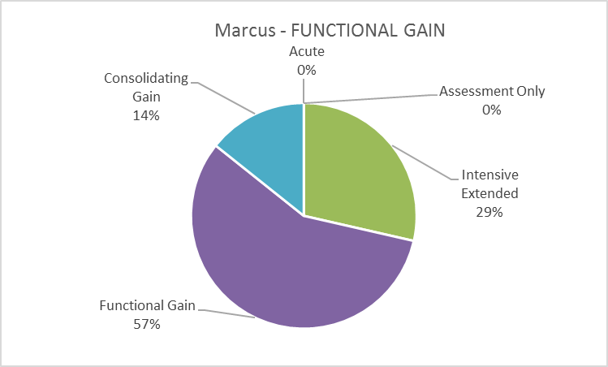

**Confidence**

|  |  |
| --- | --- |
| Mean | 7 |
| Median | 7.5 |
| Mode | 9 |

**Comments**

Nil

Marcus - INTENSIVE EXTENDED

|  |  |  |  |
| --- | --- | --- | --- |
| Mental health phase of care | | **INTENSIVE EXTENDED** | |
| **Name**: **Marcus, 17**  Marcus is a 17 year old boy who has been living in a local Youth Refuge for the past 6 months. | | | |
| Behaviour | Marcus has a history of drug induced psychosis and has been attending the service for some months. His case worker has reported that Marcus is using cannabis again and is forgetting to take his medication. He presents as irritable and more difficult to engage, dismissing the concerns of his case worker at the Youth Refuge. He reports that his Job Agency ‘sucks’ as most of the people there ‘hate him’. His brother has expressed a reluctance to take him on as a casual labourer as he seems angry and unpredictable when he is ‘stoned’. | | |
| Physical | Marcus reports that he doesn’t want to take medication as his girlfriend is ‘unhappy’ as he can’t maintain an erection. He has gained considerable weight and is unable to exercise regularly as he always feels tired. He has not been attending martial arts classes because of his weight. | | |
| Symptoms | Marcus reports that he has taken to eating most of his meals either outside on the veranda or going to get take away to avoid seeing the other residents. He appears to be irritable when he attends the centre and has missed several appointments because he feels tired all the time. He appears vigilant and guarded when he comes to the Centre. | | |
| Social | Marcus continues to live in the Youth Refuge but plans to move him into more independent accommodation have stalled due to Marcus’ recent reported substance use. His one friend at the Youth Refuge is due to leave in the next few weeks and Marcus fears he will not make other friends. His mother has told him that she will not see him while he continues to use cannabis. | | |
| Interventions | Marcus has his medications reviewed and is engaged with the Early Intervention Youth Service to help develop living skills. He has been assigned a Case Manager along with the local Drug and Alcohol service are engaged in his care. | | |
| Rationale for **intensive extended** mental health phase of care | Marcus requires more focused attention to minimise the possibility of acute deterioration and development of relapse prevention strategies that will assist him in achieving his goal to be more independent. | | |
| Possible indicators for mental health phase of care change | Marcus has been drug-free for a period of time after attending an outpatient Drug and Alcohol program. He is actively seeking employment. | | Functional gain |
| Marcus has gained part-time employment with his brother’s employer and has been assisting with martial arts training. | | Consolidating gain |
| Marcus presents with paranoid ideas about his fellow residents and worries that one of them is trying to tattoo him in his sleep. | | Acute |

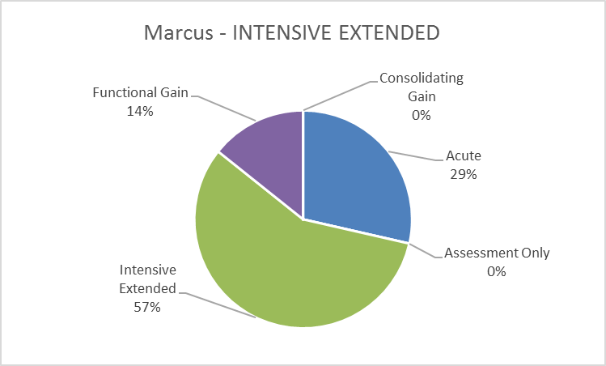

**Confidence**

|  |  |
| --- | --- |
| Mean | 7 |
| Median | 7.5 |
| Mode | 9 |

**Comments**

Nil

Llubica - INTENSIVE EXTENDED

|  |  |  |  |
| --- | --- | --- | --- |
| Mental health phase of care | | **INTENSIVE EXTENDED** | |
| **Name:** **Llubica, 15**  Llubica lives at home with her parents and two younger sisters, who are from Serbia. She has started to attend a Flexible Learning Centre and is in Year 9 at school. | | | |
| Behaviour | Llubica has enrolled at the Flexible Learning Centre two months ago after being expelled from her two previous high schools due to her disruptive and aggressive behaviour. She has found it difficult to engage with a number of counsellors and other mental health professionals. Her mother reports that she is oppositional at home and will stand over her ‘to get money for drugs’. She has frequently threatened self-harm when she does not ‘get her own way’ but this has decreased somewhat since starting at her new school. | | |
| Physical | Llubica is overweight and complains that the medication she takes is making her ‘fat’. She says her friends post mean things about her on Facebook. She has started to drink protein shakes instead of eating regular meals on week days in order to lose weight. | | |
| Symptoms | Llubica’s mood is highly changeable and she reports feeling ‘bored all the time' when she is not with her friends. She reports that she has trouble focusing on her school work and staying calm when people ‘say the wrong thing to me’. She reports that she thinks about cutting herself when she gets angry. | | |
| Social | Llubica’s parents have reluctantly brought her to your service. They appear to lack knowledge about the nature of Llubica’s concerns and do not appear to take their daughter’s self-harm and other behaviours seriously. They do not like Llubica’s choice of friends and think she is a ‘bad influence’ on her sisters. | | |
| Interventions | Llubica sees her Case Manager at CAMHS once a fortnight. She is enrolled in an Affect Regulation clinic with other young people to help her manage her mood and improve her distress tolerance. Her parents are involved with carer support services. | | |
| Rationale for **intensive extended** mental health phase of care | The goal of Llubica’s care is to minimise further deterioration and decrease her risk and severity of self-harming behaviours, whilst improving her ability to manage distress and emotional difficulties over time. | | |
| Possible indicators for mental health phase of care change | Llubica presents seeking information about safe sex and birth control options as she feels uncomfortable talking to her mother about this. | | Assessment only |
| Llubica is attending school regularly and has completed the Affect Regulation course. She has not self-harmed for several months. | | Consolidating gain |
| Llubica’s school performance deteriorates and she reports that she would like to gain some part-time employment but lacks confidence. | | Functional gain |
| Llubica is found intoxicated late one night in the local mall and has self-harmed. She is tearful and distressed. | | Acute |

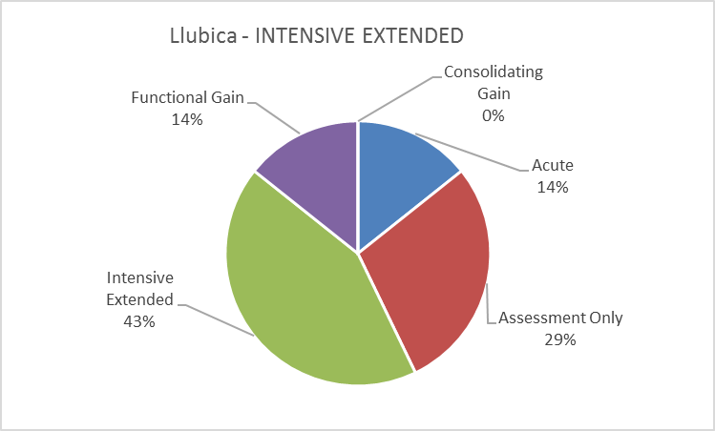

**Confidence**

|  |  |
| --- | --- |
| Mean | 6.142857 |
| Median | 7 |
| Mode | 8 |

**Comments**

Nil

Llubica - FUNCTIONAL GAIN

|  |  |  |  |
| --- | --- | --- | --- |
| Mental health phase of care | | **FUNCTIONAL GAIN** | |
| **Name: Llubica, 15**  Llubica lives at home with her parents and two younger sisters, who are from Serbia. She has started to attend a Flexible Learning Centre and is in Year 9 at school. | | | |
| Behaviour | Llubica has now been attending the Flexible Learning Centre for two terms now. She has developed a good relationship with the school counsellor. Her mother reports that though she no longer demanding money for drugs, she seems to lack confidence and feels excluded from some of her peer group as many of her friends are now working part-time. She has not harmed herself for some weeks and is now asking for assistance to find employment. | | |
| Physical | Llubica remains mildly overweight but she is pleased that she has lost some weight through a combination of exercise and dietary changes. She gave up on the protein shakes as they ‘tasted disgusting and made me constipated’. | | |
| Symptoms | Llubica’s mood is less changeable and has developed an interest in photography so feels less bored when she is alone. She says that her school performance has improved and has only been sent out of class once when she ‘made a fart noise with my mouth’. She reports that she sleeps better if she goes to bed later. | | |
| Social | Llubica’s parents have attended a couple of sessions with the local carer support service. Her parents still think she is attention seeking and that she needs to stop wasting everyone’s time. They feel her friends are a bad influence on her but this is less so now that she has changed schools. | | |
| Interventions | Llubica is enrolled in a vocational skills group through the local health service that focuses on building confidence and communication skills for young people. Llubica is assisted in completing job applications for local fast food restaurants. | | |
| Rationale for **functional gain** mental health phase of care | The goal of Llubica’s care is to improve Llubica’s confidence and work with her in developing skills that will assist her with gaining some independence and having some added responsibility and money of her own | | |
| Possible indicators for mental health phase of care change | Llubica is attending school regularly and has completed the Affect Regulation course. She has not self-harmed for several months. | | Consolidating gain |
| Llubica is refusing to go to school and has been sporadically adherent with her prescribed medication as it makes her feel sick. | | Intensive extended |
| Llubica is found intoxicated late one night in the local mall and has self-harmed. She is tearful and distressed. | | Acute |

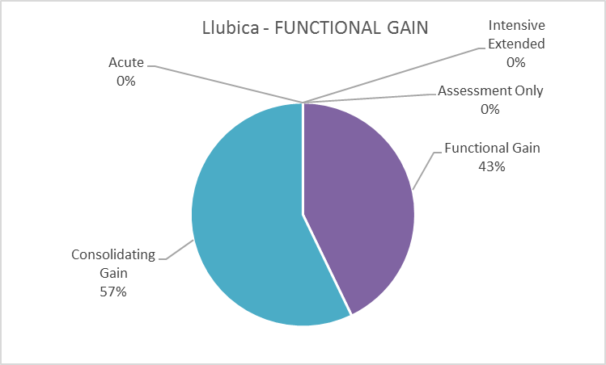

**Confidence**

|  |  |
| --- | --- |
| Mean | 6.571429 |
| Median | 7 |
| Mode | 7 |

**Comments**

Nil

Jade - ACUTE

|  |  |  |  |
| --- | --- | --- | --- |
| Mental health phase of care | | **ACUTE** | |
| **Name: Jade, 16**  Jade is a 16 year old girl that lives at home with her parents and is in Year10 at a local high school. | | | |
| Behaviour | Jade was diagnosed with Bipolar Affective Disorder during Year10 exams, eight months ago. She is in regular contact with the local CAMHS team and had a prolonged absence from school at the time and is repeating Year10 as a result. Jade presents to the Emergency Department one Saturday night after an argument with her boyfriend and has threatened self-harm while intoxicated. She appears elevated in mood and is dressed as a gothic vampire slayer with heavy make-up, fishnets, tall black boots, a cape and a short dress. She is pacing up and down in the waiting area, talking loudly into her phone, being trailed by her mother who is clearly distressed. | | |
| Physical | Jade has a number of superficial lacerations to her left forearm, one of which appears to be actively bleeding. She is a tall, slim young woman who looks otherwise well. She has visible psoriasis behind her knees. | | |
| Symptoms | Jade is elevated in her mood and very talkative; she is difficult to interrupt. She claims her boyfriend has been cheating on her and she knows this because of ‘his eyes’. Her mother reports that she has not slept for 48 hours. | | |
| Social | Jade has a small circle of friends at school. She reports being teased at school about her psoriasis. Her parents are divorced but custody of Jade and her 2 siblings is shared. She has lived with her dad following her diagnosis but says she gets on well with her mum. | | |
| Interventions | Jade requires oral sedation and accepts this with some negotiation and prompting. Blood tests reveal that her Valproate levels are sub-therapeutic. A safety plan is negotiated with Jade and her parents and she is discharged to her parents’ care. She is also referred to the Community Mental Health Team for close monitoring and support. | | |
| Rationale for **acute** mental health phase of care | The primary goal of care is the urgent reduction in Jade’s symptoms, along with the management of risk of harm and associated behavioural disturbance. | | |
| Possible indicators for mental health phase of care change | Jade presents concerned about a recent sexual encounter with a boy she likes at her school, following a comprehensive assessment, this is viewed as a normal adolescent milestone | | Assessment only |
| Jade’s mood has been low for over 6 months and she is not responding to treatment. She complains that the medication is making her drowsy at school, which she fails to attend on a regular basis, and she is withdrawn from social activities. | | Intensive extended |
| Jade reports that her ability to concentrate on school work is declining. She is increasingly withdrawn, and is anxious of her school performance. | | Functional gain |
| Jade is attending school regularly and doing well. Her sleep pattern is good and she has not experienced thoughts of self-harm for some months now. | | Consolidating gain |

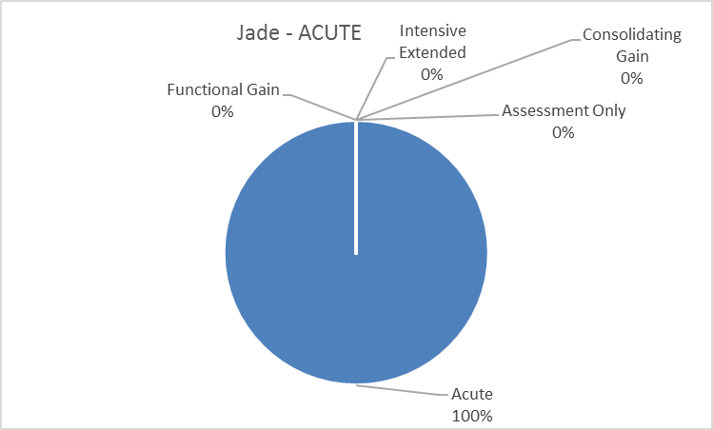

**Confidence**

|  |  |
| --- | --- |
| Mean | 6.571429 |
| Median | 7 |
| Mode | 5 |

**Comments**

Description Year10 needs a space Year 10

Who is doing the assessment? The hospital or the CMHT?

Jade - CONSOLIDATING GAIN

|  |  |  |  |
| --- | --- | --- | --- |
| Mental health phase of care | | **CONSOLIDATING GAIN** | |
| **Name: Jade, 16**  Jade is a 16 year old girl that lives at home with her parents and is in Year 10 at a local high school. She is in regular contact with the local CAMHS team. | | | |
| Behaviour | Jade has a diagnosis of Bipolar Affective Disorder and has almost completed Year 10 and her school attendance has improved dramatically. She has only missed a couple of days of school due to flu in the final term. Jade has been attending the CAMHS team for regular review and no longer requires reminders to do so. Her mood appears stable and she is now dressing in less revealing clothes and noticeably less make-up. Her parents report that she is getting on well with her siblings and is working part-time as a baby sitter for some family friends. | | |
| Physical | Jade has reported that though she sometimes has thoughts of self-harm, she has not acted on these thoughts for several months. She has been using mindfulness and distraction techniques that were suggested to her with some success. After attending a skin specialist her psoriasis has substantially cleared up. | | |
| Symptoms | Jade’s mood appears stable and she has identified a number of recovery goals. She has been actively engaged in identifying relapse prevention strategies. She is sleeping and eating well. She is getting on well with her boyfriend. Her year adviser at school no longer has to meet with Jade weekly and now sees her monthly. | | |
| Social | Jade has maintained her small group of friends at school and has joined a local drama group to help with costume design, which she enjoys. Jade spends every second weekend with her mother and is planning to spend a few weeks with her in the upcoming school holidays. | | |
| Interventions | Jade attends monthly reviews with CAMHS. Her Safety Plan is reviewed and updated to change the name of her current GP. Jade is keen to attend a small group activity with the local Headspace about maintaining a healthy lifestyle. | | |
| Rationale for **consolidating gain**  mental health phase of care | The primary goal of care is to maintain the improvement in functioning and to promote Jade’s sense of personal understanding and responsibility for her recovery. | | |
| Possible indicators for mental health phase of care change | Jade presents concerned about a recent sexual encounter with a boy she likes at her school, following a comprehensive assessment, this is viewed as a normal adolescent milestone | | Assessment only |
| Jade’s mood has been low for over 6 months and she is not responding to treatment. She complains that the medication is making her drowsy at school, which she fails to attend on a regular basis, and she is withdrawn from social activities. | | Intensive extended |
| Jade reports that her ability to concentrate on school work is declining. She is increasingly withdrawn, and is anxious of her school performance. | | Functional gain |
| Jade presents to the Emergency Department after hours, as she has overdosed on her prescribed medication. | | Acute |

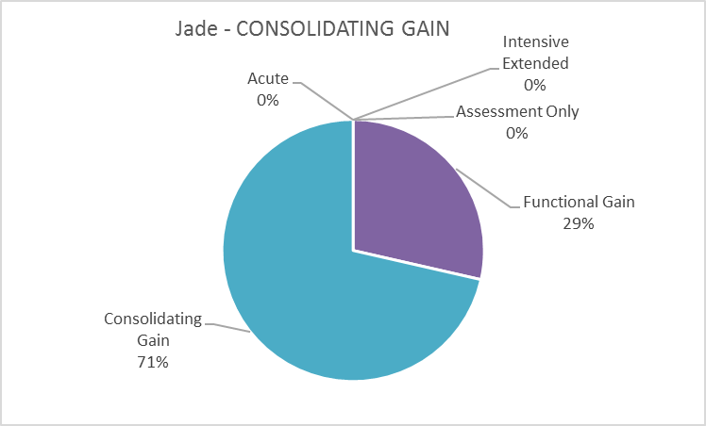

**Confidence**

|  |  |
| --- | --- |
| Mean | 7.428571 |
| Median | 7 |
| Mode | 7 |

**Comments**

Nil

**DISTRACTORS**

Bryce - Child ASSESSMENT ONLY

|  |  |  |  |
| --- | --- | --- | --- |
| Mental health phase of care | | **ASSESSMENT ONLY** | |
| **Name: Bryce, 13**  Bryce is a 13 year old boy who has recently moved into a group home with two other adolescent males, where he is supported 24 hours a day by workers from a local NGO. He has been in foster care since aged 7 and had lived with the same family until an aggressive incident and some contact with the police. He has had no previous contact with mental health services. | | | |
| Behaviour | Bryce is seen in your department after falling through the roof over the decking of his group home after he crawled out onto the roof with two other boys after curfew. When confronted about this behaviour, he became verbally aggressive and threatened self-harm. He is a young man who says that he gets ‘very angry easily’ and is especially upset when he hears loud noises. He has had some difficulties at his new school with anger outbursts in class. He is sitting in your department, watching a video on his phone and laughing at what he sees. | | |
| Physical | Bryce has a very large build for his age. He is a little overweight and is self-conscious about this as he says that people ‘stare at him’ when he tells them his age. He is dressed in a rugby league shirt and shorts. He appears clean and tidy in appearance. | | |
| Symptoms | Bryce reports that he feels angry a lot of the time and he is not sure why. He lacks self-confidence and expresses the wish that he could be ‘just normal like everyone else.’ He reports feeling anxious in large groups of strangers. He sleeps well at night if he can listen to music before bed. | | |
| Social | Bryce misses the contact with his two younger siblings who still live with their foster parents. He says he has made a couple of friends at school and has started to play football with a local rugby league team which he enjoys. | | |
| Interventions | Bryce is interviewed along with the support worker who has attended the appointment with him. Collateral history is gathered from his GP and a developmental profile is formulated with Bryce’s assistance. He is referred to the local Youth Service for support with his anger management issues. | | |
| Rationale for **assessment only**  mental health phase of care | The primary goal of care is to complete a comprehensive assessment in collaboration with Bryce and his carers and to document this assessment in such a way that the receiving referral service is able to assist Bryce in formulating his goals. | | |
| Possible indicators for mental health phase of care change | Bryce presents to your service again with persistent thoughts of self-harm and escalating aggression after ongoing conflict with his fellow housemates. | | Acute |
|  | Bryce has failed to attend a number of scheduled appointments with the NGO service and his behaviour and functioning are deteriorating. He has declined to attend school for three weeks now. | | Intensive extended |
| Bryce would like to make contact with his mother but she has indicated this would not be possible unless he is able to demonstrate some commitment to dealing with his anger in a more constructive manner. | | Functional gain |
| Bryce is attending school and is getting along with his two housemates. He has been voted best and fairest in his football team. | | Consolidating gain |

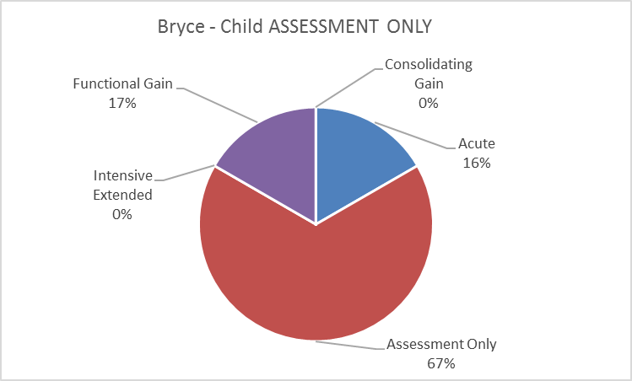

**Confidence**

|  |  |
| --- | --- |
| Mean | 6.333333 |
| Median | 7 |
| Mode | 9 |

**Comments**

It’s not clear re the setting. If it’s not CAHMS it could be assessment only.

Ebony - Child FUNCTIONAL GAIN

|  |  |  |  |
| --- | --- | --- | --- |
| Mental health phase of care | | **FUNCTIONAL GAIN** | |
| **Name**: **Ebony, 11**  Ebony is an 11 year old girl who lives at home with her mother and two older sisters in rental accommodation. They arrived in Australia as settled refugees from Somalia 18 months ago. Her father is deceased, killed in the war three years previously. She presents to the service in company of her mother and has been seeing you for some time. | | | |
| Behaviour | Ebony is somewhat withdrawn and hides her face in the side of her mother’s clothing. She appears shy and is hard to engage. She has had several episodes at home where she will refuse to leave her mother’s side when her mother tries to breastfeed Ebony’s younger sister and has also smacked her other sister when she refuses to go to school with her. | | |
| Physical | Ebony is a slim young girl who appears underweight. Her mother reports that she will only eat broccoli, cherry tomatoes, cheese and plain pasta and she is worried about her health. Since the beginning of the school year, Ebony has started to pull out strands of her hair when she is at the school gates. | | |
| Symptoms | Ebony is reported to seem very anxious when she has to go to school and expresses a fear that she is not ‘smart like the other girls’. She has developed a number of odd vocalisations when her mother tries to talk to her about her school work. Ebony sometime wakes in the middle of the night and goes to her mother’s bed to sleep. | | |
| Social | Ebony is a talented guitar player and enjoys playing with her two female friends after school. She is somewhat excluded from her larger peer group. Her mother has expressed the belief that Ebony may have been cursed by her grandmother when she left Somalia because she did not approve of her father. | | |
| Interventions | Ebony is enrolled in a day program at the local adolescent day unit with a focus on addressing her anxiety and confidence in the school setting. Ebony expresses the wish to be able to walk to school by herself, as it is only 5 minute walk from her home. Her mother is also engaged in some education and support around assisting Ebony with her anxiety. Ebony is also referred to a dietician to discuss her current food preferences. | | |
| Rationale for **functional gain** mental health phase of care | The focus of Ebony’s care is on improving her ability to function in the school setting; helping her with self-confidence while supporting her mother in helping Ebony feels more involved in her younger sister’s care. | | |
| Possible indicators for mental health phase of care change | Ebony is referred to your service by the school counsellor due to concerns that she may have learning difficulties. | | Assessment only |
| Ebony is missing a great deal of school due to her anxiety and her mother says she thinks she is making herself sick after meals so wants to take her to see a local female shaman from her community. | | Intensive extended |
| Ebony is attending school regularly and has attended a sleep -over at a friend’s house. She has been eating a normal diet and gaining some weight. | | Consolidating gain |
| Ebony presents to the service and refuses to speak. Her mother says she has not spoken to anyone for two days. She is heard crying in her room most nights. | | Acute |

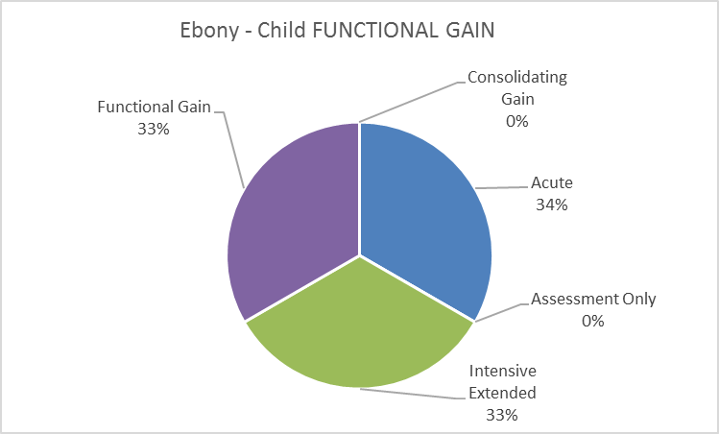

**Confidence**

|  |  |
| --- | --- |
| Mean | 6.666667 |
| Median | 6 |
| Mode | 5 |

**Comments**

I am confused by the she has been seeing you for some time. I would be wanting to re-assess her with a view to booking another psychiatrist review. I am unsure if this is assessment only or acute as a consequence.

Hard to identify the POC based on information provided. E.g. No severe mental health issues however attending a day program for anxiety.

There is a distinct lack of assessment details including confusion over the relationship with a male person in the mother’s life and how she coped with the death of hubby. A smattering of symptoms suggestive of Trichotillomania and obsessional dieting with possible intrusive worries about something happening to her family or mother expressed as separation anxiety and the need for reassurance at points of separation or perhaps the curse was successful. There is insufficient information to develop a working hypothesis means a phase of care other than acute clinical can't be assigned.

**Adult**

Gary - INTENSIVE EXTENDED

|  |  |  |  |
| --- | --- | --- | --- |
| Mental health phase of care | | **INTENSIVE EXTENDED** | |
| **Name:** **Gary, 38**  Gary is a single male who has lived with his mother his whole life. | | | |
| Behaviour | Gary has a diagnosis of Schizophrenia and has been on a Community Treatment Order in the past but not at present. He is very reluctant to speak with you and will only do so on the front veranda of his family home, as he says he does not want his mother ‘listening in’. Gary makes little eye contact and he seems guarded. He says that the medication is making him ‘slow’ and that people ‘look at me like I’m a zombie’. He reports that the only thing he likes to do is watch DVDs and smoke. He says he cannot listen to music because it makes him ‘sad’. | | |
| Physical | Gary is overweight and his GP has advised that he is in danger of developing Type 2 diabetes. Gary says that he feels hungry all the time. He also worries that he needs glasses as he has trouble seeing the TV unless he ‘sits on top of it’. He says that he feels like he has to burp all the time, so he drinks a lot of soft drinks which he says helps with this. | | |
| Symptoms | Gary appears to responding to non-evident stimuli and mumbles to himself frequently, though he does not appear distressed by this. He says his mood is ‘OK’ but he has felt better before. He sleeps during the day and is awake at night. He feels that his neighbours joke about him when he comes outside to smoke. | | |
| Social | Gary is not able to identify any friends and is socially isolated. He says that his sister sometimes comes to take him out for a meal if he asks. He is worried that his mother is getting old and what will happen to her if she gets sick. Gary has never worked and his siblings want him to move out as their mother is elderly; but they and are also worried what will happen to Gary if she doesn’t look after him. | | |
| Interventions | Gary is assigned a Case Manager who arranges for him to have a review with a psychiatrist. He is also engaged with the local community Rehab service for social skills development. An appointment is made for him to speak to a dietician about his weight. | | |
| Rationale for **intensive extended** mental health phase of care | The goal of Gary’s care is symptom mitigation and to focus on functional improvement and the developmental of living skills that will help assist Gary to transition towards more independent living. | | |
| Possible indicators for mental health phase of care change | Gary presents to the community centre complaining of a productive cough. He is referred to his GP. | | Assessment only |
| Gary has been attending the Community Rehab service and has made two friends with whom he regularly meets to go to the movies. | | Consolidating gain |
| Gary has been told that his mother needs to extended stay in hospital after a stroke and he worries he won’t be able to look after himself. | | Functional gain |
| Gary brings a copy of a letter he has written to the US president requesting a drone strike on the community centre. | | Acute |

**Clinical Reference Group Ratings and Feedback**

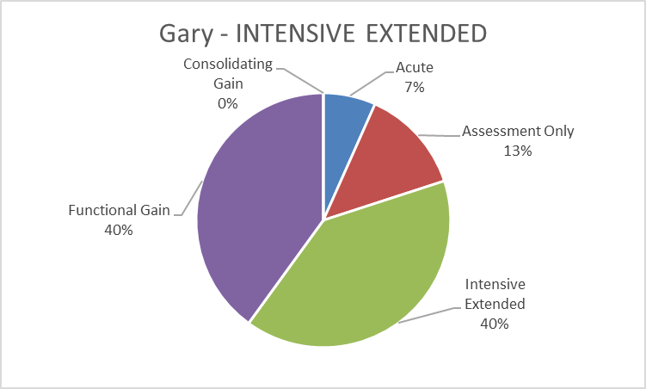

**Confidence**

|  |  |
| --- | --- |
| Mean | 7.266667 |
| Median | 8 |
| Mode | 9 |

**Comments**

It is unclear whether the patient is currently with the service, or whether he has been taking prescribed treatment. Depending on how unwell or urgent the need for treatment, he could called assessment, or intensive extended

The context for booking with a psychiatrist will vary from service to service; he may have already been assessed by triage. This may confuse some staff.

TYPO: Gary has never worked and his siblings want him to move out as their mother is elderly; but they and [REMOVE AND] are also worried what will happen to Gary

care plan would focus on symptom reduction (response to non evident stimuli, beliefs about neighbours) and improving psychosocial functioning (occupation and social isolation) and physical health care (inactivity and nutrition)

Noted as a person with “a stable pattern of severe symptoms”; history of “relapse”; “inability to function independently”, & to require care over an indefinite period. Currently moving towards relapse but with early intervention current symptoms may be minimised or prevented from further deterioration.

It seems to sit somewhere between the intensive extended and the functional gain phases of care. I think I chose the functional gain because of the lack of distress with symptoms.

Straight forward vignette, easily illustrates the point of PoC and very relatable to community setting.

Gary - CONSOLIDATING GAIN

|  |  |  |  |
| --- | --- | --- | --- |
| Mental health phase of care | | **CONSOLIDATING GAIN** | |
| **Name:** **Gary, 38**  Gary had lived with his mother until 6 months ago, when he moved into supported accommodation as his mother became ill. | | | |
| Behaviour | Gary has a diagnosis of Schizophrenia and continues to meet with you at his home and would prefer to speak with you inside. He says he gets angry sometimes with the two other males who live with him but he has learned to ‘count to ten’ and try to ignore them when he feels himself getting upset. He is very pleased to have found a part-time job as his father was a butcher and it reminds him of when he was a child. He only speaks when spoken to and otherwise does not initiate conversation. | | |
| Physical | Gary has been skipping rope the last 5 months as his favourite podcaster also skips rope. He feels like he has more energy when asked. He has also taken to wearing reading glasses after having his eyes tested. His GP says he still needs to lose more weight and he worries about the constant burping. | | |
| Symptoms | Gary says he is ‘OK’ and does not want to elaborate on this when pressed. He says he is trying to change his sleep pattern by not watching so many movies at night. He reports that he sometimes thinks one of his housemates can see him when he is in the shower. He feels positive about getting additional work to supplement his hours at the butcher shop. | | |
| Social | Gary has started working one half-day a week at a local butcher shop to help with cleaning on Friday afternoons. Gary has been home when visited for the past 5 months. He has lost 4 kg in weight as he has started to skip each afternoon. Gary reports that he has invited his sister to his new home for a meal and that went ‘OK’. He has met another man at the Living Skills Centre that likes super hero movies so he has been to two of them so far this year. He visits his mother every Saturday afternoon in the Nursing Home where she now lives. | | |
| Interventions | Gary is visited regularly by a Case Manager and in consultation with his Case Manager has been encouraged to work towards his identified goals such as getting more work and remaining in his supported accommodation. In addition, Gary’s medication is monitored and he is referred to his GP to investigate his complaints of continuous burping. | | |
| Rationale for **consolidating gain**  mental health phase of care | The goal of Gary’s care is to build on the positive changes that he has identified in his life and to further extend his social contacts and range of activities. | | |
| Possible indicators for mental health phase of care change | Gary presents to the community centre complaining of a productive cough. He is referred to his GP. | | Assessment only |
| Gary’s tenancy is placed at risk due to some persistent antisocial behaviour on weekends. He reports ongoing difficulties with side effects of his medication. | | Intensive extended |
| Gary has been told that his mother needs to stay in a nursing home after a stroke and he worries he won’t be able to look after himself. | | Functional gain |
| Gary brings a copy of a letter he has written to the US president requesting a drone strike on the community centre. | | Acute |

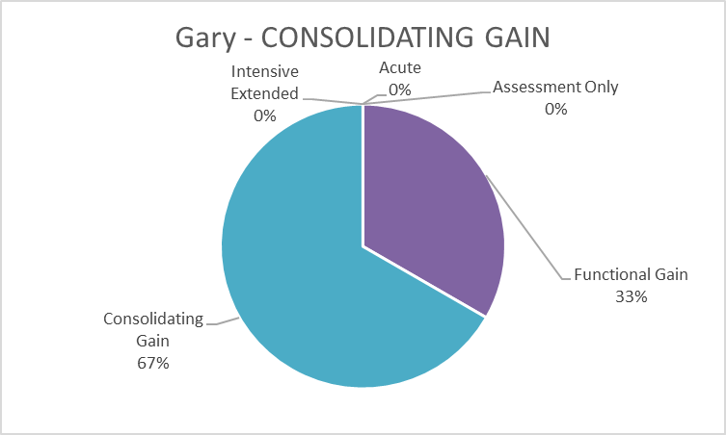

**Confidence**

|  |  |
| --- | --- |
| Mean | 7.5 |
| Median | 8 |
| Mode | 8 |

**Comments**

It is unclear how bad the symptoms of illness are which may put him in the intensive extended, or whether this is his stable level of functioning and so could be consolidating.

still working toward his skill development and functional ability

recovery is progressing, support from services to maintain and optimise functioning

Gary is moving towards the goal of “maintaining an improved level of functioning” where he seems to have stabilised from his previous move toward relapse.

Seems to be a clear case of maintenance from the point of view of mental health services.

Faith - FUNCTIONAL GAIN

|  |  |  |  |
| --- | --- | --- | --- |
| Mental health phase of care | | **FUNCTIONAL GAIN** | |
| **Name: Faith, 20**  Faith is new to the area after moving to commence study at University. She has never lived away from home before and is a new relationship. | | | |
| Behaviour | Faith is a friendly and polite young woman, though she does appear a little shy and blushes easily. Faith was diagnosed with a Borderline Personality Disorder when she was 18. She makes good eye contact and does not appear agitated or overtly distressed. She reports that she has presented to engage with the local service after moving from Tenterfield and was further advised to do so by her GP. She carries a number of letters with her from her previous contacts with her local service providers in Tenterfield and appears keen to show these to you. | | |
| Physical | Faith is a tall, slim young woman, dressed in stylish vintage clothing. She is very well groomed with immaculate yet subtle make up. She wrings her hands gently but constantly during your contact. She says she has recently started Implanon birth control. Faith reports that she binge drinks every second weekend. | | |
| Symptoms | Faith reports that she will not be able to cope once university starts, as she has a great deal of trouble being around groups of people in social situations where she feels ‘constantly judged’. She is determined to succeed in her new studies as she previously struggled at school. She demonstrates a good understanding of her challenges. | | |
| Social | Faith lives in shared student accommodation with her boyfriend of 4 months, Cody. She speaks with her father via Skype most days but has had little contact with her mother since a big fight before she left home. She says she has made two other friends in her student accommodation who are ‘like me’. | | |
| Interventions | Faith is engaged with a social worker who delivers a series of brief targeted interventions to assist her with mindfulness, problem solving and anxiety management. | | |
| Rationale for **functional gain** mental health phase of care | The goal of Faith’s care is to assist her in the development of confidence and mastery in self-management in order to promote success in her identified goal of engaging successfully in her studies. | | |
| Possible indicators for mental health phase of care change | Faith drops in to discuss her concern about urinary frequency following a sexual encounter with her boyfriend. | | Assessment only |
| Faith reduces her study load from full-time to part-time as she is struggling to be motivated and is sleeping excessively. There is also some minor self-harming behaviour evident. | | Intensive extended |
| Faith has successfully negotiated her first semester of University and has moved into private rental with her boyfriend. | | Consolidating gain |
| Faith attends the Emergency Department after a significant paracetamol overdose while intoxicated late one night. | | Acute |

Acute 0%, Consolidating gain 33%, Functional gain 0%, Intensive extended 0%, Assessment only 67%.


**Confidence**

|  |  |
| --- | --- |
| Mean | 7.466666667 |
| Median | 8 |
| Mode | 8 |

**Comments**

As she is new, there needs to be collaterals history obtained and determination of whether she needs ongoing care or referral. Could require more intensive input with functional gain.

Description “and is in a new relationship”.

...and is.... IN..... a new relationship

not necessary to comment on stylishness of clothing or use of makeup.

Presents to engage with services in area only, there is currently no referral & although there is a potential for symptoms to exacerbate due to an increase in current stressors, she seems to have supports in place & may require referral to a local area GP also.

Borderline personality disorder is an extremely complex disorder which can lead to a complex case rapidly, although this appears to be a classic consolidating gain scenario.

There is an omission of a word in the first sentence it should read 'and is in a new relationship'

Faith - ACUTE

|  |  |  |  |
| --- | --- | --- | --- |
| Mental health phase of care | | **ACUTE** | |
| **Name**: **Faith, 20**  Faith moved to the area five months ago to commence University. She is living in student accommodation and her family are 500 km away, living in a rural area. | | | |
| Behaviour | Faith has been previously diagnosed with a Borderline Personality Disorder when she was 18. She is pacing backwards and forwards, chewing vigorously on the nails of her left hand and her right arm is bandaged. She is talking loudly into her mobile phone while at the same time glaring at her boyfriend who has accompanied her. When she sees you however, she smiles and hangs up. She speaks in a high pitched voice and appears to be on the verge of tears. She hides her bandaged arm behind her back. | | |
| Physical | Faith is a tall, slim young woman, and appears somewhat dishevelled compared to when she was seen previously one month ago. Her makeup is smudged and she says that the Implanon she has had for four months is not working and is ‘poisoning’ her. She smells of alcohol. | | |
| Symptoms | Faith is agitated and distressed. She reports that she is thinking of hurting herself and she does not feel she can stop herself. She says she can’t cope with being a girlfriend to someone who does not respect her. She has not slept for 24 hours. She is angry and dismissive after initially appearing friendly and smiling. | | |
| Social | Faith says that she is breaking up with her boyfriend because he is a ‘lying pig’. She says she will instead go and live with a new female friend as she says she is ‘now a lesbian’. She has missed the last week of University, and so is in danger of failing this semester. | | |
| Interventions | Faith is assessed and placed in a safe place until she is sober; her distress is validated and she is encouraged to focus on her previously identified strengths. A safety plan is formulated with Faith and her family are contacted for further collateral support at Faith’s request. | | |
| Rationale for **functional gain** mental health phase of care | The goal of Faith’s care is to assist her in the development of confidence and mastery in self-management in order to promote success in her identified goal of engaging successfully in her studies. | | |
| Possible indicators for mental health phase of care change | Faith drops in to discuss her concern about urinary frequency following a sexual encounter with her boyfriend. | | Assessment only |
| Faith reduces her study load from full-time to part-time as she is struggling to be motivated and is sleeping excessively. There is also some minor self-harming behaviour evident. | | Intensive extended |
| Faith has successfully negotiated her first semester of University and has moved into private rental with her boyfriend. | | Consolidating gain |
| Faith is attending University but expresses great anxiety about having to present at seminars next semester. | | Functional gain |

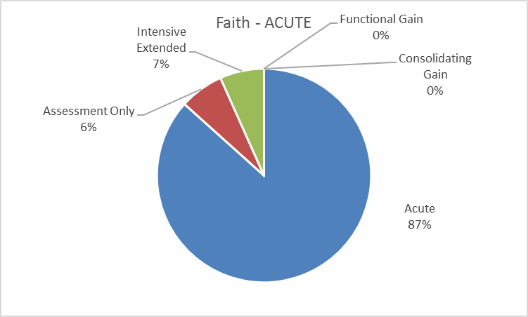

**Confidence**

|  |  |
| --- | --- |
| Mean | 7.533333 |
| Median | 8 |
| Mode | 9 |

**Comments**

It is not clear what her usual level of functioning is. May require acute intervention to alleviate distress, or intensive extended to put in place longer term management plan.

I have chosen this option due to the presence of intoxication. Depending on the APU she may be admitted as acute.

focus of planned care is on management of current risk of self harm

Faith is demonstrating high levels of “behavioural disturbance” with symptoms requiring monitoring, risk assessment & interventions to reduce “symptom intensity” she may require an admitted admission to Hospital or a HITH.

Again complex presentation with Borderline Personality Disorder. Always tricky to categorise anything with this consumer group.

Paul - ACUTE

|  |  |  |  |
| --- | --- | --- | --- |
| Mental health phase of care | | **ACUTE** | |
| **Name: Paul, 46**  Paul is an ex-Air Force air craft engineer who lives alone. | | | |
| Behaviour | Paul was diagnosed with Bipolar Affective Disorder in 2000. He presents in a highly agitated state after being picked up by the Police last night at a nearby beach, where he had been discovered swimming naked. When he was picked up he was noted to be talking rapidly and was unable to stand still. He attempted to hit one of the police officers and so had been hand cuffed. Paul reports that he is ‘from the future’ and declines to remove his sunglasses. Paul reports that he has been non- adherent with his prescribed medication for three months claiming he wants to stop being poisoned. | | |
| Physical | Paul is a solidly built man with visible tattoos and a number of raised red welts to his upper arms and torso. He reports that he has had a headache for the past two days. He is also complaining of having had his thigh ‘corked’ while being restrained by police and appears to have a slight limp. | | |
| Symptoms | Paul is agitated, with rapid speech that is difficult to interrupt. He is tangential, circumstantial and demonstrates flight of ideas. He reports that he can read the thoughts of the police officer and states that he ‘does not like what I see.’ He is over familiar and disinhibited. | | |
| Social | Paul lives alone in a public housing bed sitter and receives the Disability Support Pension. He has regular contact with his younger brother who lives nearby. His brother visits every few days and they regularly smoke cannabis together. Paul spends a lot of time playing online games and enjoys costume role paying activities with a number of like-minded friends. He is also very interested in online movie making. | | |
| Interventions | Paul is given oral sedation to help reduce his agitation and requires a period of close observation and containment. He has recommenced on his routine mood stabiliser. Paul is given a thorough physical examination. Paul’s brother is contacted for collateral information to support in his care planning. | | |
| Rationale for **acute** mental health phase of care | The goal of Paul’s care is to reduce the severity of his symptoms and minimise the risk of harm to himself and others. | | |
| Possible indicators for mental health phase of care change | Paul presents seeking referral to a community based drug and alcohol service to help address his cannabis use. | | Assessment only |
| On discharge from hospital, Paul becomes intermittently non- adherent with his medications and has a number of run- in’s with police and neighbours. | | Intensive extended |
| Paul is seeking help with anger management issues as he would like to reconnect with his elderly mother. | | Functional gain |
| Paul has begun teaching online video editing at the local youth centre after a period of stability and wellness. He is seeking advice on stress management. | | Consolidating gain |

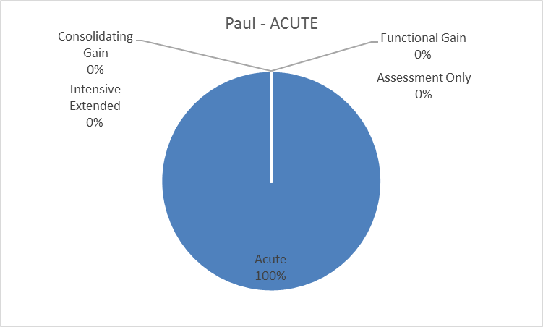

**Confidence**

|  |  |
| --- | --- |
| Mean | 8.285714 |
| Median | 9 |
| Mode | 9 |

**Comments**

Some of the vignette suggests that this is an assessment phase, but overall it looks like admission is warranted and that most information has been obtained.

primary current focus is reduction of intensity of symptoms

Paul requires an inpatient admission to hospital for close monitoring, reduction in intensity & stabilising of symptoms; he is currently a high risk to self & others.

Paul - INTENSIVE EXTENDED

|  |  |  |  |
| --- | --- | --- | --- |
| Mental health phase of care | | **INTENSIVE EXTENDED** | |
| **Name: Paul, 46**  Paul is an ex Air Force air craft engineer who lives alone. | | | |
| Behaviour | Paul was diagnosed with Bipolar Affective Disorder in 2000. He reports that he believes he is being bullied by his brother. He has had one incident the last 3 months where the police have been called to his house but left without further action. Paul attends your service reluctantly and often has to be reminded of appointment times. When he does attend, he is often distant and says that he feels that ‘you only talk to me because you have to.’ He makes very little eye contact and plays games on his phone whilst meeting with you. | | |
| Physical | Paul has gained 12 kg in the past three months and says he cannot afford to eat ‘healthy food’. He appears to have persistent open sores on the side of his neck which he repeatedly picks at. He says it itches all the time. Paul says he finds it hard to walk to the shops as he seems to get out of breath easily. | | |
| Symptoms | Paul appears at times to be responding to stimuli that are not evident to others, though he denies this when asked. He says his mood is ‘fine’ but his brother thinks that he is ‘as flat as a tack’. He sleeps irregular hours and thinks the neighbours have it in for him, though he does like one old lady who lives next door. | | |
| Social | Paul’s public housing tenancy is in danger due to the lack of cleanliness and complaints by some neighbours. His brother continues to visit regularly, but not as often as he once had, as Paul has reportedly stopped smoking cannabis. He hocked his computer for cash but goes to a friend’s place to play online role-play games with him, which he enjoys. | | |
| Interventions | Paul is engaged with a Case Manager and referred to a local NGO to assist with living skills and social contacts. His medication is regularly reviewed. He has been engaged with a local bulk-billing GP for metabolic screening and monitoring. Paul and his brother are introduced to a local online games club at Paul’s request as he identifies having more friends as one of his main treatment goals. | | |
| Rationale for **intensive extended mental health phase of care** | The goal of Paul’s care is to minimise his acute symptoms and reduce the likelihood of further relapse and to reduce the distress he feels in relation to his social isolation while assisting him to improve his physical health. | | |
| Possible indicators for mental health phase of care change | Paul presents seeking referral to a community based drug and alcohol service to help address his cannabis use. | | Assessment only |
| Paul is in a highly agitated state and presents to your service requesting help as he has run out of medication. | | Acute |
| Paul is seeking help with anger management issues as he would like to reconnect with his elderly mother. | | Functional gain |
| Paul has begun teaching online video editing at the local youth centre after a period of stability and wellness. He is seeking advice on stress management. | | Consolidating gain |

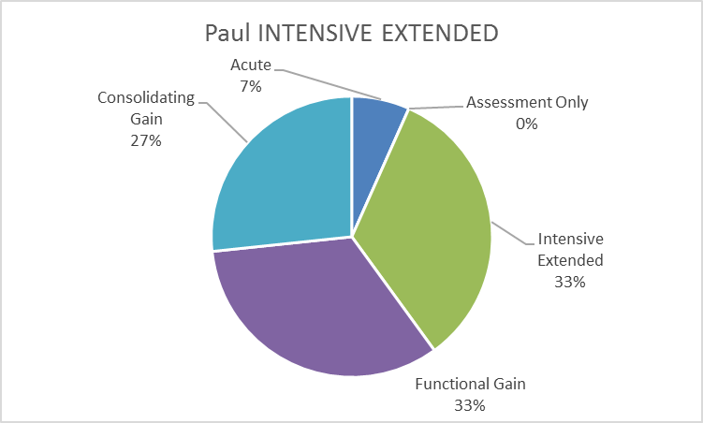

**Confidence**

|  |  |
| --- | --- |
| Mean | 7.266667 |
| Median | 8 |
| Mode | 8 |

**Comments**

While it appears that Paul has been engaged with the service and relatively stable, albeit with ongoing symptoms, there could be a place for more active engagement with intention for functional gain.

There is evidence of depressive symptoms with the potential for psycho social stressor r/t accommodation. There is a risk of “further deterioration” leading to potential relapse although there has been improvement in his social/familial engagement & health monitoring.

Intensive extended as requires the input of multiple service providers.

Xi - CONSOLIDATING GAIN

|  |  |  |  |
| --- | --- | --- | --- |
| Mental health phase of care | | **CONSOLIDATING GAIN** | |
| **Name: Xi, 28**  Xi is a Chinese woman who has lived in Australia for the past 7 years after arriving with her husband and his family. She is married and has one child. | | | |
| Behaviour | Xi developed postpartum depression after the birth of her first child, twelve months ago. Xi presents for a scheduled review appointment at your service. She is sitting quietly in the waiting room with her young baby with whom she is smiling and talking quietly. She is dressed fashionably in a designer outfit. She appears animated and chatty. When another young mother enters the room she introduces herself and her baby and the two mothers talk with great animation. | | |
| Physical | Xi has now returned to her prenatal weight. She attends boot camp with her sister-in-law two to three days a week after being encouraged to do so by the baby health nurse. She reports residual nausea from her antidepressant medication but manages this with a Chinese herbal remedy. She has now stopped breast feeding. | | |
| Symptoms | Xi’s mood has improved and she rates it at about ‘7 out of 10’, though she still finds it hard to wake up in the morning. She worries that she is ‘not as good a as her own mother’ in raising her child and constantly compares herself to her mother. | | |
| Social | Xi lives with her husband, Julian, who is a doctor at the local hospital. Her husband’s parents and younger brother live nearby. Xi reports that her husband is supportive but he works long hours. Her mother-in-law visits most days and helps her with cooking and home duties. Xi has expressed a desire to return to part-time work but says her mother-in-law and husband do not approve of this plan, as she ‘is a mother now’. Xi also expresses a strong desire to meet other young mothers. | | |
| Interventions | Xi’s medication regime is reviewed and she continues to attend for supportive psychotherapy once a month. She has also been referred to a mother and baby group for young mothers who are recovering from postpartum depression. | | |
| Rationale for **consolidating gain**  mental health phase of care | The focus of Xi’s care is to continue to support her recovery through self-management and help her to maintain her ability to function as a mother and partner in the family home. | | |
| Possible indicators for mental health phase of care change | Xi attends seeking advice about vaccinations for her child as she has been spooked by the anti‑vaccination information she has been exposed to on Facebook. | | Assessment only |
| Xi’s mood deteriorates after a period of prolonged sleep disturbance when her child became ill. She begins to lose weight and reports a loss of confidence in her mothering ability. | | Intensive extended |
| Xi has expressed a desire to return to work part- time as a Physiotherapy Assistant, but feels she has lost confidence in herself after a prolonged maternity leave. | | Functional gain |
| Xi presents to the service reporting that she has thoughts that her child has been possessed by the ghost of Chairman Mao which has made her face change. | | Acute |

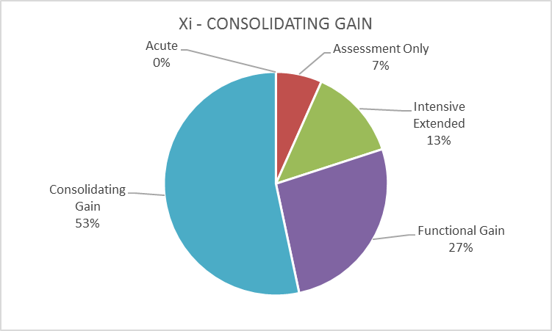

**Confidence**

|  |  |
| --- | --- |
| Mean | 7.266667 |
| Median | 8 |
| Mode | 8 |

**Comments**

This patient probably could be discharged to primary care or private follow up. Not sure what phase since she does not need intensive or functional.

Xi is “less distressed by symptoms”, “gaining confidence” & making good progress toward “self management”. She now requires more psycho social/interpersonal support.

It would appear that Xi has fully recovered, but is being monitored to prevent relapse and to maintain her mental health.

Xi - ASSESSMENT ONLY

|  |  |  |  |
| --- | --- | --- | --- |
| Mental health phase of care | | **ASSESSMENT ONLY** | |
| **Name: Xi, 28**  Xi is a Chinese woman who has lived in Australia for the past 7 years after arriving with her husband and his family. | | | |
| Behaviour | Xi is now 2 years post-partum after the birth of her first child. Xi was treated for post natal depression and has recovered well. She presents to your service expressing concern about the vaccinations that her child has had. She appears mildly anxious and is clutching a small handkerchief which she continually knots and unknots whilst she waits. She denies any significant deterioration in her mood and her husband reports that although she has been argumentative with him about the childhood vaccinations she has not appeared overtly agitated nor unreasonable. She appears confused about the information she is receiving about vaccinations from the media. | | |
| Physical | Xi reports that she has the occasional headache but feels otherwise well. She continues to exercise regularly and has started as an instructor with a local ‘Mummy Gym’ which enjoys. She takes several traditional Chinese herbal medicines that her great aunt sends to her from overseas to help with her vitality’. | | |
| Symptoms | Xi’s mood is stable and she feels ‘quite well’. She reports that she has been feeling anxious about the conflicting information she has been receiving about childhood vaccinations, as she has heard that they ‘cause Autism’. She is thinking about having another child. | | |
| Social | Xi’s husband Brian is a doctor at the local health service. Xi reports that she is not sure her husband is ‘telling me the whole truth’ about the safety of vaccinations. This has led to some conflict between them. Xi’s mother-in-law has also expressed strong views on this matter which has led to further distress for Xi. | | |
| Interventions | Xi is assessed by the community nurse and given a range of information about childhood vaccinations. A letter is sent to her GP advising him of Xi’s concerns with a suggestion for further contact if required. | | |
| Rationale for **assessment only**  mental health phase of care | The focus of Xi’s care is to gather information and provide additional referral information if required. | | |
| Possible indicators for mental health phase of care change | Xi’s mood is stable, and she is not experiencing any adverse effects from her medication. She has returned to part-time work. | | Consolidating gain |
| Xi’s mood deteriorates after a period of prolonged sleep disturbance when her child became ill. She begins to lose weight and reports a loss of confidence in her mothering ability. | | Intensive extended |
| Xi has expressed a desire to return to work part- time as a Physiotherapist Assistant, but feels she has lost confidence in herself after a prolonged maternity leave. | | Functional gain |
| Xi presents to the service reporting that she has thoughts that her child has been possessed by the ghost of Chairman Mao which has made her face change. | | Acute |

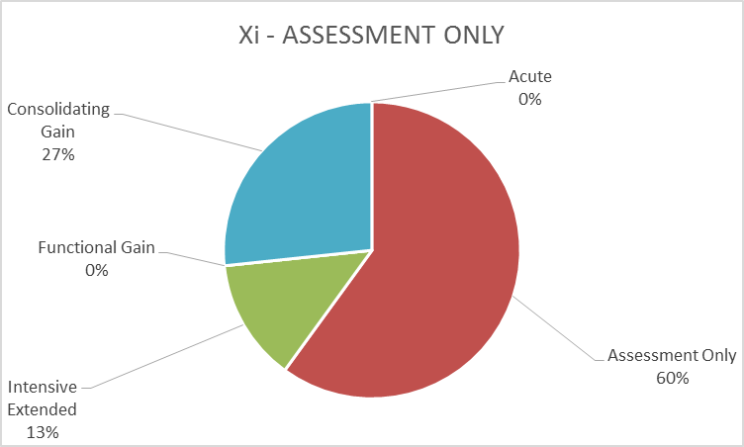

**Confidence**

|  |  |
| --- | --- |
| Mean | 7.428571 |
| Median | 7.5 |
| Mode | 9 |

**Comments**

The patient appears unwell but not severe enough to warrant acute intervention.

It is difficult to ascertain if she has been an ongoing consumer or if she recovered and was discharged then re-presented. I am assuming the latter

Social - states husband's name is Brian - however previous vignette states that his name is Julian. Having problems distinguishing if this consumer is still open (from previous scenario) or a new referral.

where's Julian her husband???? did he die, are they divorced? who's Brian???

Xi's husband was previously called Julian

At this time Xi has presented for an “assessment only” & although somewhat anxious, it appears her symptoms are able to be managed by the GP & may require some additional psychosocial support.

There doesn't appear to be a treatment role for the MH service until or if things deteriorate, but at present there appears to be no mental health issue.

Under the physical box there is a word omitted it should read 'with a local mummy gym which she enjoys'

Zlatko - ASSESSMENT ONLY

|  |  |  |  |
| --- | --- | --- | --- |
| Mental health phase of care | | **ASSESSMENT ONLY** | |
| **Name: Zlatko, 61**  Zlatko is a married man who lives with his wife in his own home. He is a successful builder and works with his two sons. He is four days post-operative after a laparoscopic cholecystectomy. He has no history of mental health concerns. | | | |
| Behaviour | Zlatko presents complaining of feeling anxious and unable to sleep for the past few nights. He is seen sitting quietly in the waiting area with his wife who is holding and stroking his hand. He appears to be taking slow deep breaths and is stretching his neck and shoulders. He is engaging and talking with the reception staff, appearing to be telling them jokes. | | |
| Physical | Zlatko looks well. He is well-groomed and dressed. He is a tall man with an upright bearing. He is clean shaven. The wound on his abdomen appears clean and dry and is healing well. He says it is a little tender but otherwise ‘OK’. He walks with a wide gait. He says he has had cardiac stents five years ago and has stopped smoking since that time. | | |
| Symptoms | Zlatko says that he has been having trouble getting to sleep the past few nights and his thoughts seem like they are ‘all jumbled up’. He has only slept for four hours a night, which is unusual for him. He seeks reassurance that ‘he will be all right as this has never happened before’. | | |
| Social | Zlatko lives with his wife in their own home for the past 40 years since arriving from Serbia in the 1970s. He works part-time with his two sons who own their own commercial construction company. He has many friends that he sees regularly to play cards and dominos. Zlatko regularly describes his love and affection for his wife, boasting that he is ‘the luckiest man on earth’. His wife appears nervous and avoids direct eye contact. | | |
| Interventions | Zlatko and his wife are interviewed. He is referred to his GP to review his wound and prescribed some PRN hypnotics in the short term.  He and his wife are reassured by this process and are happy to see their family GP who knows them well. | | |
| Rationale for **assessment only**  mental health phase of care | The goal of Zlatko’s care is information gathering and referral to the appropriate service provider | | |
| Possible indicators for mental health phase of care change | Zlatko’s anxiety has prevented him from returning to work with his sons and he has lost confidence in himself after a prolonged absence. | | Functional gain |
| Zlatko’s mood deteriorates after he develops post-operative complications and he is not able to leave the house without his wife. He no longer visits his friends. | | Intensive extended |
| Zlatko returns to work after a trial of antidepressant medication and he attends a CBT group. | | Consolidating gain |
| Zlatko reports that he has not been able to sleep for two weeks and his appetite has markedly declined. He expresses the wish to die and you notice his wife has bruising on her arms. | | Acute |

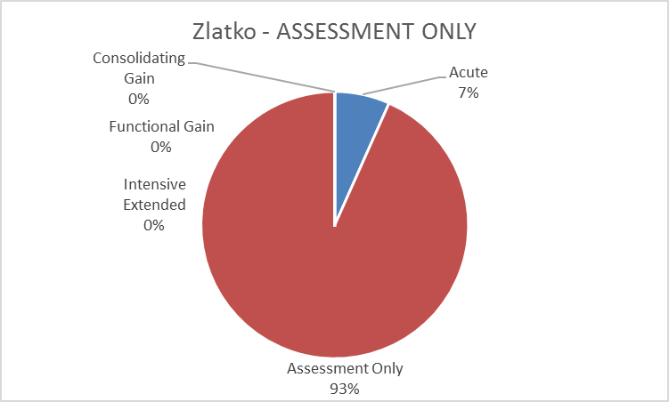

**Confidence**

|  |  |
| --- | --- |
| Mean | 7.428571 |
| Median | 7.5 |
| Mode | 9 |

**Comments**

Zlatko seems to have some anxiety related to his recent surgery requiring assessment only with GP follow up. His wife however appears to require information on carer support & may require follow up advice from the GP also.

There doesn't appear to be an ongoing or acute mental health issue in this vignette. Assessment only.

Zlatko - FUNCTIONAL GAIN

|  |  |  |  |
| --- | --- | --- | --- |
| Mental health phase of care | | **FUNCTIONAL GAIN** | |
| **Name: Zlatko, 61**  Zlatko is a married man who lives with his wife in his own home. He is a successful builder and works with his two sons. He has now recovered from his laparoscopic cholecystectomy, though this has taken longer than he might have hoped. He is looking to return to work. | | | |
| Behaviour | Zlatko had previously been seen by your service when he was suffering from anxiety and has been referred again as by his GP as says he is having difficulty returning to work as a builder. Zlatko presents with his younger son as his wife is unable to accompany him. He is seen to be wringing his hands while he waits to be seen. He has been reluctant to return to work as he feels that he has lost his ability ‘to be strong’ around his workmates. He has been lying awake at night worrying about being able to work and his son reports that he is ‘second guessing himself’ in lots of different ways, though Zlatko says his son ‘is making a big deal out of nothing’. | | |
| Physical | Zlatko looks well but has put on some weight since last seen; he says he has been eating ‘rubbish food’ as it makes him feel better. He has started exercising by going for brief walks with his neighbour each afternoon but says he has to hurry home as he feels too anxious to leave his wife for too long. | | |
| Symptoms | Zlatko reports that he has become more stressed as he is only able to get about four hours sleep a night, nearly every night. He says he is sure that he will ‘never be able to sleep properly again’, and if this is the case he does not know how he could return to work as planned. He says he gets ‘a funny feeling in his chest’ when he thinks about going back to work, but he has seen his GP and found no physical cause for concern. | | |
| Social | His son Zifko, with whom Zlatko works, says his father is ‘driving Mum crazy’ as he does not want to be left alone. In addition, he has had a falling out with two of his friend’s with whom he plays cards, accusing one of them of ‘making eyes’ at his wife. | | |
| Interventions | Zlatko is enrolled in a time limited brief CBT program and has a staged approach to return to work that was formulated with Zlatko. Zlatko’s exercise program is also modified so that he can do more independent activities that take him outside of his home. | | |
| Rationale for **functional gain** mental health phase of care | The goal of Zlatko’s care is to assist him in regaining his self-confidence, that he had previously demonstrated and to further help him to return to work, which is his main goal in seeking help and support. | | |
| Possible indicators for mental health phase of care change | Zlatko presents with his wife worried that he’s not able to ‘perform my duties as a husband’ due to his pain medication. | | Assessment only |
| Zlatko’s mood deteriorates after he develops post-operative complications, and he is not able to leave the house without his wife. He no longer visits his friends. | | Intensive extended |
| Zlatko returns to work after a trial of antidepressant medication and he attends a CBT group. | | Consolidating gain |
| Zlatko reports that he has not been able to sleep for two weeks and his appetite has markedly declined. He expresses the wish to die and you notice his wife has bruising on her arms. | | Acute |

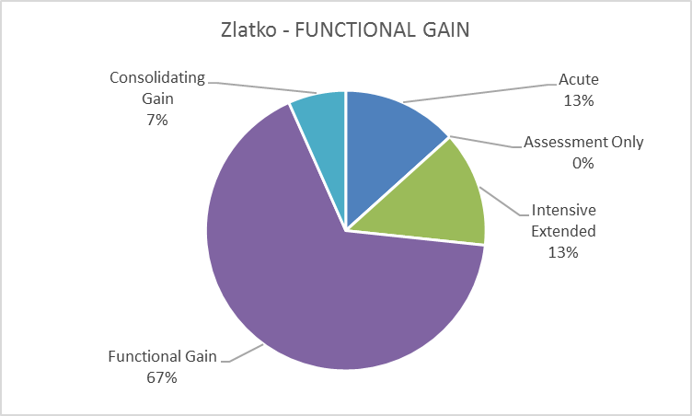

**Confidence**

|  |  |
| --- | --- |
| Mean | 7.4 |
| Median | 8 |
| Mode | 9 |

**Comments**

It appears some additional support is indicated in the presence of ongoing impairment. acute phase could be indicated depending on level of intervention required.

Zlatko seems to have developed some depressive symptoms along with his anxiety that appears to have been triggered by recent life events resulting in a somewhat “situational crisis”. He is actively engaging in therapies which should provide him with the means to recover & develop resistance resources. However, it seems his wife and son require support and together with Zlatko would benefit from relationship/family therapy interventions.

The disorder is ongoing, not acute onset; hence this is functional gain - reduction of anxiety and return to work rather than an acute care situation.

Vivian - ASSESSMENT ONLY (Site Requested)

|  |  |  |  |
| --- | --- | --- | --- |
| Mental health phase of care | | **ASSESSMENT ONLY** | |
| **Name: Vivian, 55**  Vivian is 55 and lives alone. She has a long history of anxiety and depression and although she has been treated by a psychiatrist in the past, her care is currently managed by her general practitioner. She is well known to the service and has been visited on multiple occasions, reviewed and follow-up arrangements made. | | | |
| Behaviour | Vivian retired early and currently from her role as a clerical assistant in a large manufacturer of cardboard products. She has great skills as a quilter and works for hours on extremely intricate embroidery on very large quilts that are auctioned for charity. Vivian has called the triage line of your service on a regular basis over the course of the last year. She usually calls when she is intoxicated, complaining of the ingratitude of her children, the fact that she is “not understood” and the futility of life. | | |
| Physical | Vivian is a small thin woman. She has been a smoker most of her life and suffers from chronic emphysema. As a result, she gets very little exercise and leads a fairly sedentary life. However this does not impact her ability to undertake activities or daily living such as domestic chores. | | |
| Symptoms | Vivian does feel depressed and is anxious but these are long term issues that are currently well controlled with (insert fancy pharmaceutical names here). | | |
| Social | Vivian’s husband died 4 years ago after a short battle with Leukaemia. She has a daughter and a son who live locally and are supportive but complain that “mum can be demanding sometimes”. Vivian attends a local quilter’s group meeting weekly and interacts well in these social settings and gets a gets a deal of enjoyment from this. | | |
| Interventions | You remind Vivian of the supports that are currently in place. Her general practitioner, the members of her quilters group. You talk to Vivian of the potential to talk though some of the issues she raises with a counsellor, which can be arranged by her general practitioner. Vivian insists that life still isn’t worth living but has no active intent or plans of self harm. | | |
| Rationale for **assessment only**  mental health phase of care | The goal of Vivian’s care is information gathering and encouragement to continue with service providers already in place. | | |
| Possible indicators for mental health phase of care change | If Vivian is unable to attend her quilters’ group meetings or undertake her activities of daily living, she is a significant risk of self-harm. | | Functional gain |
| Vivian’s symptoms and functioning are such that she requires intensive ongoing care from a specialist mental health service. | | Intensive extended |
| Vivian’s symptoms and functioning are such that she requires specialist mental health services. | | Consolidating gain |
| Vivian becomes acutely depressed and is unable to function; she cannot undertake activities of daily living or participate in social activities. | | Acute |

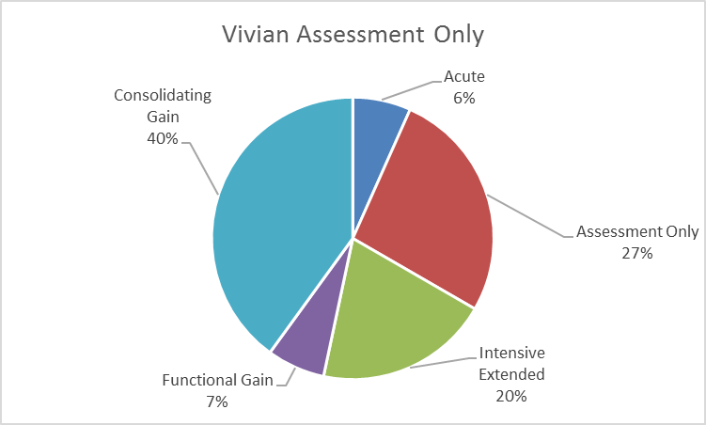

**Confidence**

|  |  |
| --- | --- |
| Mean | 6.866667 |
| Median | 7 |
| Mode | 5 |

**Comments**

This looks like another assessment is not indicated, and that intensive input is not required.

Description: “who has knonw (known) her for many years”.

SPELLING: has knonw [known] her for many extensively reviewed by thye multidisciplinary team [the]

Typos in first paragraph with 'knonw' and 'thye'

Vivien's longstanding history indicates a “plateau of symptoms” which currently requires “supportive care planning” to ensure ongoing maintenance & minimise risk of deterioration.

spelling errors in her description box

More of a maintenance picture than anything else - there doesn't appear to be an acute or other illness issues, more of a reiteration of her current supports and plans.

There are numerous spelling errors in the first paragraph that need to be fixed - knonw, thye & altering the word 'consort' to 'consultation'.

**DISTRACTOR**

Jo Beth - Adult CONSOLIDATING GAIN

|  |  |  |  |
| --- | --- | --- | --- |
| Mental health phase of care | | **CONSOLIDATING GAIN** | |
| **Name:** **Jo Beth, 29**  Jo Beth is a 29 year old single woman, works as a Librarian at the University and lives with her boyfriend of 8 months. | | | |
| Behaviour | Jo Beth has a diagnosis of Obsessive Compulsive Disorder after attending a review at Beyond Blue two years ago. She is seen after attending a review appointment with her primary physician. She is well presented and immaculately groomed. Jo Beth sits fidgeting in her chair with her boyfriend next to her. She makes good eye contact when spoken to. She reports that she has not had any major ‘blow ups’ at work with her junior colleagues for some months and is proud of her achievements in this respect as it had been a source of some distress to her previously. | | |
| Physical | Jo Beth looks well. She is normal weight for her height and has maintained this weight for some time after a period of some weight loss in the previous year. She says she sometimes gets ‘stress headaches’ but is trying to manage this with Rescue Remedy and some regular Pilates and Yoga. She is sleeping well, sometimes with the aid of a light hypnotic medication. She complains that her medication sometimes makes her nauseous in the mornings. | | |
| Symptoms | Jo Beth reports that she feels mildly anxious most mornings and this settles throughout the day. She is still performing a number of self-soothing rituals prior to leaving work each afternoon and has managed to reduce the frequency and number of these rituals. She continues to count her steps to and from work but is not distressed by this. | | |
| Social | Jo Beth lives with her boyfriend, after asking him to move in with her. She found this step quite remarkable as she had never previously felt comfortable living with anyone since leaving home. She has some contact with her mother but tries to limit this by being the one ‘who does the visiting’ so she can leave when she feels she has ‘had enough’. | | |
| Interventions | Jo Beth’s medication regime is reviewed in consultation with her treating psychiatrist and she is encouraged to identify further goals to build on her identified successes in her work setting. Jo Beth is provided with information about a number of smart phone apps to help with stress management and relaxation. | | |
| Rationale for **consolidating gain**  mental health phase of care | The focus of Jo Beth’s care is to continue to support her recovery and self-advocacy. A focus on building on her work placed successes, by helping her to develop a healthy and positive relationship with her mother is also identified as important by Jo Beth. | | |
| Possible indicators for mental health phase of care change | Jo Beth is thinking about having a baby and is seeking information about the potential adverse effects of her medication of the developing foetus. | | Assessment only |
| Jo Beth reports that after a viral illness she has felt unable to return to work as her compulsive behaviours have become very debilitating and her partner expresses a deep concern for her. | | Intensive extended |
| Jo Beth has been offered a promotion and a change of role into the research department and is feeling very anxious about this and does not feel she will be able to manage the change. | | Functional gain |
| Jo Beth has been unable to leave her home for three days as her compulsive rituals have become overwhelming. | | Acute |

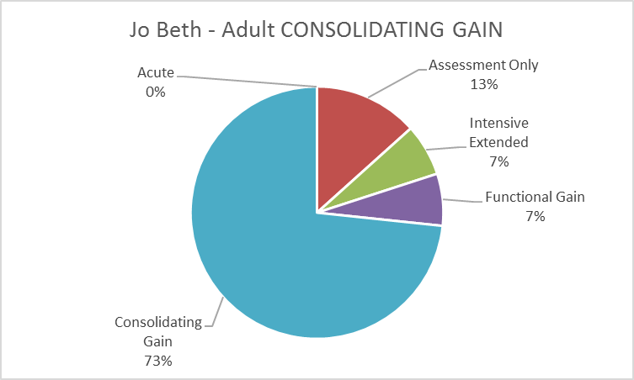

**Confidence**

|  |  |
| --- | --- |
| Mean | 7.666667 |
| Median | 8 |
| Mode | 9 |

**Comments**

If this consumer wasn't case managed we wouldn't accept the referral.

Jo Beth is currently “maintaining her function” with the clinical focus around the long term management of symptoms & function; her care is in support of psycho social & interpersonal functioning relating to personal relationships.

She has made a number of impressive steps to recovery. The Phase of Care is in maintaining these. Clearly Consolidation phase.

Malcolm - Adult ASSESSMENT ONLY

|  |  |  |  |
| --- | --- | --- | --- |
| Mental health phase of care | | **ASSESSMENT ONLY** | |
| **Name: Malcolm, 57**  Malcolm is a 57 year old married man with three adult daughters. He works as a Chief Financial Officer with a large multinational merchant bank. | | | |
| Behaviour | Malcolm has presented on the strong advice of his eldest daughter after a significant late night domestic dispute with his wife. He has a history of depression and sits in the waiting area texting on his phone. He is smiling to himself and dismissive of his daughter who is trying to talk to him. He looks at his watch repeatedly while you are talking to him and answers questions with an elaborate vocabulary full of psychological jargon. He sits very still in his chair with his legs crossed and reports that he is ‘only here under the greatest of duress’. His daughter rolls her eyes when he says this. He says he is ‘only hear to keep the princess happy’. | | |
| Physical | Malcolm is a powerfully built man with olive complexion and slight astigmatism to his left eye. He has hypertension but says ‘so does everyone I know’. He reports that he gets tension headaches ‘every Friday at about knock off time’. He drinks 1 bottle of wine every night. | | |
| Symptoms | Malcolm reports that ‘everything is fine’ and believes his wife and daughters ‘are over- reacting’. He reports that he ‘knows more about this stuff than you do’. He denies feeling depressed and that the medication he takes ‘keeps me on the up and up’. He denies any thoughts of self-harm or harm to others. He says he is irritable ‘most of the time, especially when I’m losing money’. | | |
| Social | Malcolm lives in his own home on the waterfront with his wife, Lucille. He says he has a large circle of ‘so called friends’, but professes that he can ‘barely tolerate most of them because they are imbeciles’. He has a strong relationship with his daughters though ‘is no fan of their husbands’. | | |
| Interventions | Malcolm is referred to his GP for review of his medications. A comprehensive documentation of his history and current circumstances are provided to his GP. | | |
| Rationale for **assessment only**  mental health phase of care | The focus of Malcolm’s care is information gathering and referral to the most appropriate care provider and giving feedback to Malcolm and his daughter about the reasons behind this. | | |
| Possible indicators for mental health phase of care change | Malcolm is laid off work after a series of financial scandals and is looking to change his career, but feels he has ‘lost my mojo’ which is unfamiliar to him. | | Functional gain |
| Malcolm develops a significant depressive illness and is separated from his wife after he is charged with insider trading by ASIC. | | Intensive extended |
| Malcolm moves in with his eldest daughter and is working part-time as an adviser to the local state MP. He would like to try to reconcile with his wife. | | Consolidating gain |
| Malcolm presents intoxicated and is found naked on the roof of the local Toyota dealer saying he is ‘the King of the World’ after the ASIC charges are dropped. | | Acute |

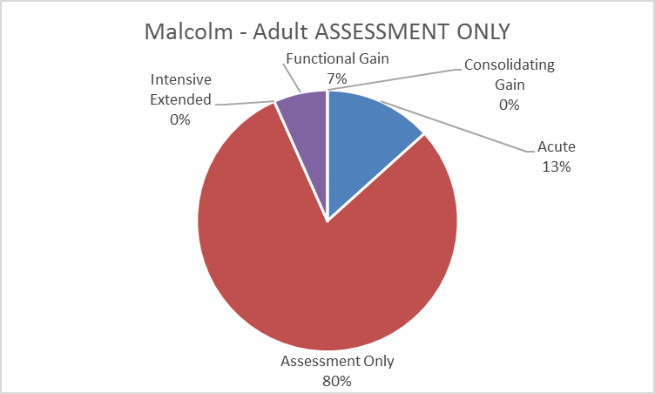

**Confidence**

|  |  |
| --- | --- |
| Mean | 7.666667 |
| Median | 8 |
| Mode | 8 |

**Comments**

Behaviour – “only hear (here) to keep the princess happy”. Physical - astigmatism - do you mean nystagmus?

*Typo under “Behaviour” last line “hear”. Malcolm exhibits signs & symptoms of Stress with difficulty coping & displays limited insight in that he is moving towards a depressive episode (also evidenced by alcohol use). He requires early intervention to prevent a major episode of relapse.

What medication does he take that keeps him on the “up and up”, D& A issues, mood issues, ? bipolar - at this time assessment, but may be acute later??

There doesn't appear to be an acute issue here - as he is referred back to the GP as a primary care giver it would appear this was an assessment only.

**Other Comments**

Some services have youth stream which is 15 to 24 year olds and will straddle two streams.

Nothing to add

These are good straightforward & Objective questions.

Main target population - ? add D&A

**Older**

Agnes - ASSESSMENT ONLY

|  |  |  |  |
| --- | --- | --- | --- |
| Mental health phase of care | | **ASSESSMENT ONLY** | |
| **Name: Agnes, 82**  Agnes is an 82 year-old woman, who has been married to John for 61 years. | | | |
| Behaviour | Agnes has no reported history of mental health concerns beyond post-natal depression that she had more than 50 years ago. She has presented to your service referred by her daughter who is concerned about a recent deterioration in her mental state. She is accompanied by her husband who appears somewhat frail. She appears to be picking at her clothing and examining what she sees closely. Agnes appears irritable and difficult to engage. She is having difficulty sitting still and appears to respond sharply to her husband when he tries to reassure her. She is speaking loudly at times and is seen to be calling out ‘Here Benji’ over and over again. | | |
| Physical | Agnes is a woman of medium build; her hair on one side of her head is pressed against her scalp and she appears to have dry mucous membranes; she is complaining of ‘having to pass water every ten minutes’ and has a flushed appearance. Her husband reports that she appears a little unsteady on her feet the past three days. | | |
| Symptoms | Agnes complains of feeling ’hot all over’ and she appears disorientated to time and place; she appears to be having difficulty with her concentration and says she feels ‘dreadful’. She is sleeping poorly and has been up all night, walking around looking for her dog, who died 7 years previously. | | |
| Social | Agnes lives with her husband in their own home. She has frequent contact with her children, grandchildren and great grandchildren and is usually busy in her garden most days. She has a large circle of friends, many of whom she used to work with. | | |
| Interventions | A mental state examination is conducted and collateral history gathered from her husband and her GP who saw her a week ago where she seemed ‘fine’. She was referred to the local Emergency Department for medical review as she appeared delirious. | | |
| Rationale for **assessment only**  mental health phase of care | The goal of Agnes’s care is information gathering and appropriate referral for physical health care. | | |
| Possible indicators for mental health phase of care change | Agnes presents after her husband dies and is seeking assistance with gaining more independence, as she has never managed her finances herself. | | Functional gain |
| Agnes develops a depressive illness which is resistant to medication treatment and her physical health is declining. | | Intensive extended |
| Agnes has settled into supported accommodation and her depression has lifted. She is seeking to engage with some outside social groups. | | Consolidating gain |
| Agnes presents with suicidal thoughts after her husband dies. | | Acute |

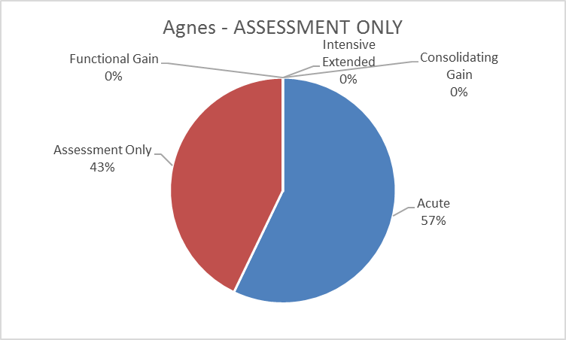

**Confidence**

|  |  |
| --- | --- |
| Mean | 8.666667 |
| Median | 9 |
| Mode | 9 |

**Comments**

I had thought we were looking at only in-patient phase of care. There is heterogeneity across the country as to who sees delirious patients. IN WA a patient with this history would not been seen by mental health either in community or in-patient but maybe in a C-L situation or if they developed delirium as an in-patient

Have made an assumption that the “acute change” is very recent. This would not be followed up by the team and would instead be referred on to appropriate medical service with advice to re-refer if needed post treatment

Comments: It is likely Agnes has an infection related Delirium related to a UTI, there may be other factors to consider also which require assessment related to the provision of support & information to the couple/family.

Agnes - CONSOLIDATING GAIN

|  |  |  |  |
| --- | --- | --- | --- |
| Mental health phase of care | | **CONSOLIDATING GAIN** | |
| **Name: Agnes, 82**  Agnes is an 82 year-old woman, who has been married to John for 61 years. | | | |
| Behaviour | Agnes has no reported history of mental health concerns, beyond post-natal depression that she had more than 50 years ago. She has been treated for delirium in hospital after referral from your service some months ago. She has subsequently been treated for a depressive illness after her husband was diagnosed with cancer of the oesophagus. Agnes is again accompanied by her husband who appears frailer than when seen previously. She sits quietly in the waiting room and holds her husband’s hand. She is talking quietly to him and he seems to be smiling at what she is saying. Agnes has reported that she feels quite well at present, though feels as if there is ‘something churning away inside of me’ which she puts down to worry about John’s health. John reports he can tell when she is stressed, as she ‘snaps’ at him which is unlike her. | | |
| Physical | Agnes looks well. She is well dressed and well groomed. She walks with the aid of an antique walking stick that once belonged to her father, though she insists that she does not need it ‘all the time’. She reports that a change in her blood pressure medication makes her feel flushed in the mornings. | | |
| Symptoms | Agnes reports that for the past few weeks she has been feeling ‘like my old self again’, though she is worried what would happen if John were to get sick again as he is due for two more doses of chemotherapy. She says she has been sleeping well at night with the aid of a relaxation CD. She denies any pervasive disturbance of her mood but says she sometimes feels anxious in the mornings. | | |
| Social | Agnes lives with her husband in their own home. She has frequent contact with her children, grandchildren and great grandchildren and is usually busy in her garden most days. She has a large circle of friends, many of whom she used to work with. | | |
| Interventions | Agnes’s medications are reviewed by the team and a care plan formulated that focuses on helping Agnes manage her anxiety effectively. She is encouraged to have contact with the social worker in the Cancer Care centre while John’s treatment is ongoing. | | |
| Rationale for **consolidating gain**  mental health phase of care | The goal of Agnes’s care is to monitor her mental health and continue to support her recovery and ability to provide support to John while he is undergoing chemotherapy. | | |
| Possible indicators for mental health phase of care change | Agnes presents after her husband dies and is seeking assistance with gaining more independence, as she has never managed her finances herself. | | Functional gain |
| Agnes develops a depressive illness which is resistant to medication treatment and her physical health is declining. | | Intensive extended |
| Agnes presents with complaints of deteriorating eye sight after a change of medication by her GP. | | Assessment only |
| Agnes presents with suicidal thoughts after her husband dies. | | Acute |

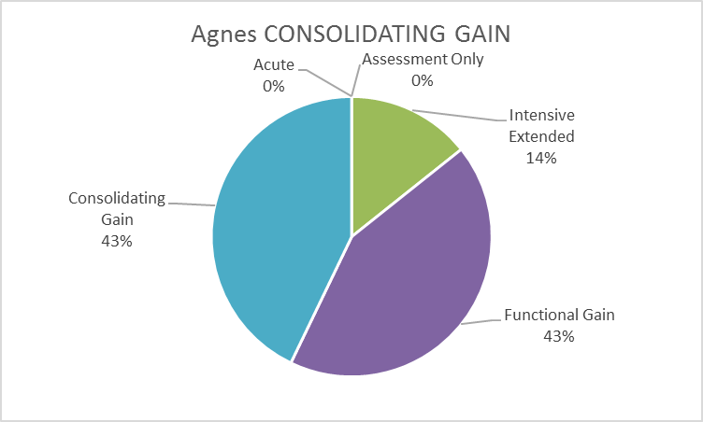

**Confidence**

|  |  |
| --- | --- |
| Mean | 6.285714 |
| Median | 7 |
| Mode | 7 |

**Comments**

It is not clear if Agnes is seeking to have additional help with symptoms (which are understandable given the stressors) or whether it is a perception by the referrer that she has the potential to relapse given the stressors which are ongoing and most likely to get worse, hence the choice of 'extended'

No mention of level of engagement by team. Does she have a case manager and seeing clin psych also? Does Ange's case manager visit weekly or fortnightly?

Comments: Goal of care is more directed toward “gaining confidence in self-management” related to life changes requiring psychosocial adaption. They are facing a series of situational crisis due to stressors related to her husband's Cancer dx & ongoing tx.

Eric - CONSOLIDATING GAIN

|  |  |  |  |
| --- | --- | --- | --- |
| Mental health phase of care | | **CONSOLIDATING GAIN** | |
| **Name:** **Eric, 71**  Eric is a 71 year old widowed man, who lives in a self-contained ‘granny flat’ in the backyard of his eldest daughter’s house. | | | |
| Behaviour | Eric has been living in the granny flat for two years after a prolonged hospitalisation due to post-operative complications that triggered a severe psychotic episode, which required several months to settle. He presents with his granddaughter, Melanie, for a scheduled review. He is well dressed and groomed and is chatting happily with Melanie. Eric makes good eye contact and does not appear agitated or distressed. Eric engages with other clients in the waiting room prior to his review and is polite and friendly, talking with great pride about Melanie and her siblings, much to Melanie’s embarrassment. There are no reports of aggression towards his family and he denies any thoughts of harming himself. | | |
| Physical | Eric is a moderately overweight man who has Type 2 diabetes, which is managed by diet and oral hypoglycaemic medication. He finds it hard to ‘stick to the diet’. He reports that he does not do much exercise other than ‘walk down to the shops every morning’, which he says makes him feel ‘fresh enough’. There are no further reported concerns post-surgery. | | |
| Symptoms | Eric reports that he feels ‘pretty good’ especially when he looks back to his period of being very unwell after his surgery. Melanie says that she sometimes looks like he is talking to himself, but Eric says that he just ‘thinks aloud’. He expresses some anxiety that he is a burden on his daughter as he gets older and worries what will happen if he gets sick again. | | |
| Social | Eric enjoys teaching his granddaughter the guitar, for which he was famous for in his home country of Holland. He previously worked as a professional musician and has been thinking about trying to meet up with some other musicians and playing as he misses it. He says that most of his friends have now died and he primarily relies on his family for support and company. Eric feels that his daughter is not too sure what would be helpful and she is very ‘protective of him’ and ‘sometimes treats me like a baby’, but he says, ‘I suppose that’s just part of getting older’. | | |
| Interventions | Eric’s medications are reviewed and a care plan is developed with a focus on wellness and improving his physical health with some regular exercise. His daughter is contacted and offered referral to a Carer Support group that meets at the community health centre. Eric is encouraged with his plans to meet up with fellow musicians, which he has indicated that this would give him great pleasure. | | |
| Rationale for **consolidating gain**  mental health phase of care | The focus of Eric’s care is to continue to support his recovery through medication use, social contacts and gentle physical exercise. His family are also supported to encourage this recovery. | | |
| Possible indicators for mental health phase of care change | Eric and his daughter attend seeking advice on the management of his Type 2 diabetes. | | Assessment only |
| Eric has a number of relapses that are thought to involve adverse drug reactions. His daughter is finding it difficult to cope with his behaviour and wonders if he can live with her anymore. | | Intensive extended |
| Eric has to have several toes amputated due to his diabetes and is now having trouble getting out of the home independently. | | Functional gain |
| Eric has gone missing for 48 hours and when found by a neighbour in the backyard, he is rambling incoherently. | | Acute |

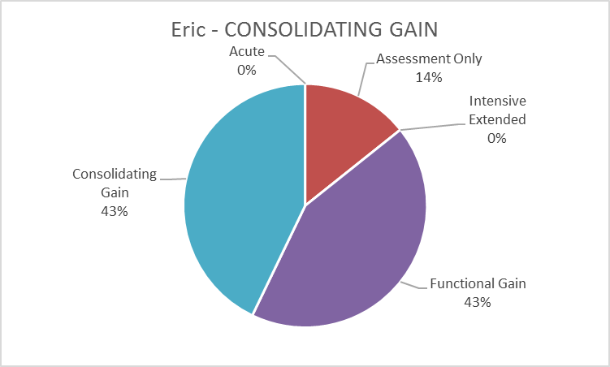

**Confidence**

|  |  |
| --- | --- |
| Mean | 6.285714 |
| Median | 8 |
| Mode | 9 |

**Comments**

There is a typo in symptoms section “she” should be “he”

Focus is on gaining function and re-engaging in previously enjoyed activities.

Comments: Symptoms Line 3 change she to “he” At this stage, is seems Eric & his daughter have been assessed, with advice given for a plan of care inclusive of appropriate referrals.

Eric - ACUTE

|  |  |  |  |
| --- | --- | --- | --- |
| Mental health phase of care | | **ACUTE** | |
| **Name:** **Eric, 71**  Eric is a 71 year old widowed man, who lives in a self-contained ‘granny flat’ in the backyard of his eldest daughter’s house. | | | |
| Behaviour | Eric has been living there for three years after a prolonged hospitalisation due to post-operative complications that triggered a severe psychotic episode which required some months to settle. Eric enjoys teaching his granddaughter the guitar, for which he was famous for in his home country of Holland, but he has recently upset her when he smashed her guitar over the bannister of their home after a lesson. Eric is agitated and pacing out the front of his granny flat when you see him. He is talking to himself and gesticulating wildly. Attempts by his daughter to calm him are met with outright hostility and verbal abuse. He has not slept for two days as he says he has to ‘work on my opus unimpeded’, which means nothing to his daughter. He has reverted to speaking Dutch to his daughter for the past three days which is out of character for him. | | |
| Physical | Eric is moderately overweight and has Type 2 diabetes that is managed by diet and oral hypoglycaemic medication. He finds it hard to ‘stick to the diet’ and has been drinking more alcohol lately. He is unshaven and has a mild coarse tremor. He is dressed in pyjama bottoms and a T-shirt that is covered with food stains. | | |
| Symptoms | Eric is agitated with incoherent speech with increased content; he appears somewhat disordered in his thoughts and his speech is littered with grandiose themes. He says his neighbours are trying to steal his ‘musical genius’. | | |
| Social | Eric had been playing with a local three piece jazz band where he gained a level of local notoriety for his playing style and stage manner. However, he has recently been ejected from his favourite bar after abusing a fellow musician calling them a ‘three chord hack’. His daughter remains his primary support though he says she is ‘a little tired of putting out the fires’. | | |
| Interventions | Eric requires hospitalisation under the Mental Health Act due to risk of harm to himself, his reputation and others; he requires a medication review as well as further care and observation in the least restrictive environment possible. | | |
| Rationale for **acute** mental health phase of care | The focus of Eric’s care is to mitigate the acute symptoms of mania to stabilise his mental state while management his moderate alcohol withdrawal. | | |
| Possible indicators for mental health phase of care change | Eric and his daughter attend seeking advice on the management of his Type 2 diabetes. | | Assessment only |
| Eric has a number of relapses that are thought to involve adverse drug reactions. His daughter is finding it difficult to cope with his behaviour and wonders if he can live with her anymore. | | Intensive extended |
| Eric has to have several toes amputated due to his diabetes and is now having trouble getting out of the home independently. | | Functional gain |
| Eric’s mental state has stabilised, he has reunited with his musician friends and has returned to live with his daughter. He is expressing concerns about his Type 2 Diabetes. | | Consolidating gain |

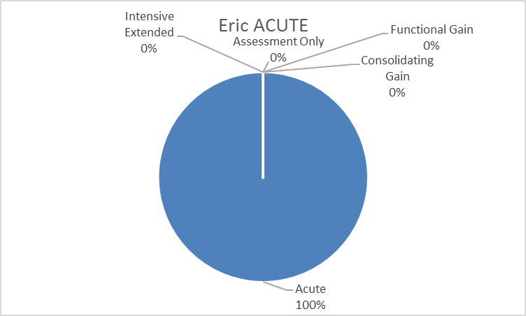

**Confidence**

|  |  |
| --- | --- |
| Mean | 7.857143 |
| Median | 9 |
| Mode | 10 |

**Comments**

Behaviour - wildly Attempts (wildly. Attempts or ,)

More information on the acuity of the presentation - is it only a couple of days?

Eric is acutely unwell requiring immediate tx to reduce the intensity of his symptoms to enable further assessment. It is likely that his type 2 diabetes has become unstable due to his increased alcohol use inducing a psychosis. There is likely to have been an underlying depression related to the psychosocial adaption to life changes that Eric has undergone following the loss of his wife.

Jo - ACUTE

|  |  |  |  |
| --- | --- | --- | --- |
| Mental health phase of care | | **ACUTE** | |
| **Name:** **Jo, 67**  Jo is a 67 year old woman who lives in rental accommodation with her long-term partner. | | | |
| Behaviour | Jo has an intellectual disability. She has been previously diagnosed with a Generalised Anxiety Disorder and has had long standing difficulties with benzodiazepine dependence. She is distressed and agitated after being brought in by police after being found in her bathroom by her partner holding scissors to her neck, threatening to ‘end it all’. She appears mildly intoxicated and smells of alcohol. Joe is having difficulty articulating her concerns beyond saying that the ‘medication does nothing’ and that she is ‘beyond help’. Her partner reports that she has struck him with a wet tea towel earlier in the day, when he made her tea without milk. | | |
| Physical | Jo is a tall slim woman who is neatly and stylishly dressed. She reports that her asthma has been ‘playing up with the change in the weather’. She continues to smoke roll-your- own cigarettes. Joe says she has to wear orthotics in her shoes due to chronic plantar fasciitis. | | |
| Symptoms | Jo is agitated and distressed; she reports that she has persistent thoughts of harming herself and she has a plan to save up all her medications and overdose on them ‘as soon as I get out of here’. Jo’s sleep is poor as she wakes at 0300 most days and cannot get back to sleep due to ‘worrying about everything’. | | |
| Social | Jo lives in a Department of Housing unit with her long term partner and receives the Disability Support Pension. She works part-time at a local hairdresser, which she enjoys. She reports that her sons do not come and visit her as often as she likes, because ‘they don’t like where I live and they’re snobs’. | | |
| Interventions | Jo is contained in a safe place until she is sober and then offered oral medication to help her settle as she remains agitated. She is admitted briefly to the PECC for further observation and care planning. | | |
| Rationale for **acute** mental health phase of care | The goal of Jo’s care is to reduce the severity of her symptoms and minimise the risk of harm to herself. A medication review is also required as she is on multiple medications from a number of prescribers. | | |
| Possible indicators for mental health phase of care change | Jo is seeking information and referral to Carer Support Services as her partner is becoming infirmed after recent surgery. | | Assessment only |
| Jo continues to ‘doctor shop’ and presents several times to the ED with unintentional overdoses of her medications. | | Intensive extended |
| Jo wishes to participate in the upcoming Masters Games and she would like to develop a fitness and healthy eating program to help with this goal. | | Functional gain |
| Jo has developed good self-management and monitoring skills around her anxiety and medication usage. | | Consolidating gain |

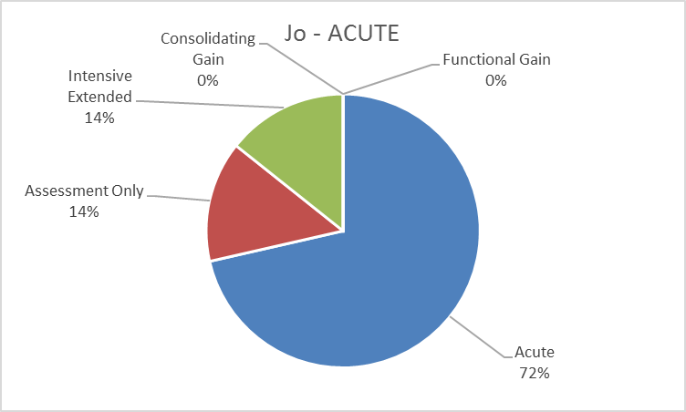

**Confidence**

|  |  |
| --- | --- |
| Mean | 6.28571429 |
| Median | 7 |
| Mode | #N/A |

**Comments**

In WA we don't have units called PECC so either use the full title so people can have an idea what their local equivalent might be. WE have MHOA (mental health observation and assessment) etc

Comments: Initially I would have put “acute” but as it seems Jo has already received an acute admission POC it seems she now requires care planning which addresses “relapse prevention” “Symptom management” & “substance use” with a strategy which offers supports for herself husband & children.

Jo - FUNCTIONAL GAIN

|  |  |  |  |
| --- | --- | --- | --- |
| Mental health phase of care | | **FUNCTIONAL GAIN** | |
| **Name:** **Jo, 67**  Jo is a 67 year old woman who lives in rental accommodation with her long-term partner. | | | |
| Behaviour | Jo has an intellectual disability. She has been previously diagnosed with a Generalised Anxiety Disorder and has had long standing difficulties with benzodiazepine dependence. Joe has been involved with the Drug and Alcohol Service and has completed a supported home detox. She is in regular contact with her two adult sons who live nearby. Jo reports that she is having some difficulty negotiating time to herself with her partner who has become more dependent on her since his brother died. She says she feels like she is ‘trapped’. Jo reports that she feels irritable a lot of the time and from time to time has thoughts of her own death. These are only in passing and she denies any plans or intent to harm herself. | | |
| Physical | Jo reports that she is trying to give up smoking and her asthma has improved; in addition, she has had a physical health check with her GP in preparation for her plans to compete in the Masters Games next year. She would like to improve her diet and level of fitness between now and then. She reports that the pain in her foot is of some concern and her orthotics ‘don’t work anymore since I have started to power walk’. | | |
| Symptoms | Jo remains mildly anxious with some difficulty sleeping at night. She denies thoughts of harming herself and describes her mood as ‘getting there’. There is no evidence of psychosis. She says that she feels tired in the mornings. | | |
| Social | Jo has increased her hours at the local hairdresser and thinks this is one of the things that have upset her partner. She has started to meet with her sons in local cafes and restaurants as they seem more comfortable with this. | | |
| Interventions | Jo is engaged with a local sports nutritionist and supported to enrol in a local boot camp for older women, near her home. Joe is also referred to a podiatrist to review her plantar fasciitis and her need for orthotics. She meets with her case worker monthly to review her progress. Her partner is enrolled in a local social group to give Jo some time out. | | |
| Rationale for **functional gain** mental health phase of care | The goal of Jo’s care is to assist her to move towards her stated goal of competing in the Masters Games, while helping her to maintain her independence. | | |
| Possible indicators for mental health phase of care change | Joe is seeking information and referral to Carer Support Services as her partner is becoming infirmed after recent surgery. | | Assessment only |
| Jo continues to ‘doctor shop’ and presents several times to the ED with unintentional overdoses from her medications. | | Intensive extended |
| Jo presents in a highly agitated state with thoughts of wanting to kill her partner after an argument about money. | | Acute |
| Jo has developed good self-management and monitoring skills around her anxiety and medication usage. | | Consolidating gain |

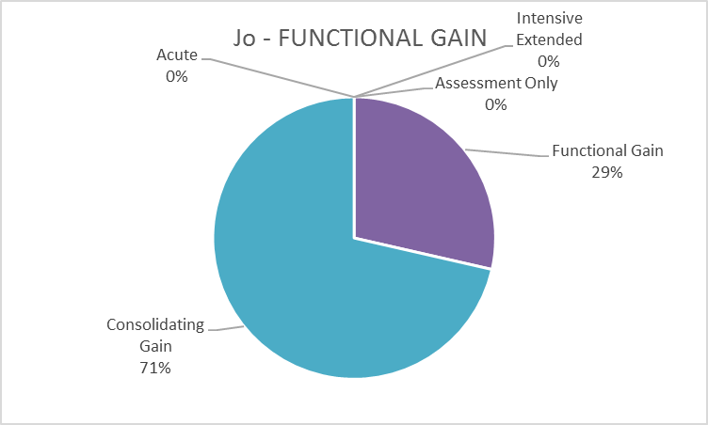

**Confidence**

|  |  |
| --- | --- |
| Mean | 6 |
| Median | 7 |
| Mode | 9 |

**Comments**

The case vignette provides conflicting information on the history - has stopped working and then has increased her work hours. Also information on where she is being assessed and by whom.

I considered functional gain, but opted for Consolidating gain based on the fact that Jo has a long history of signs & symptoms, & has moved more towards a recovery/maintenance phase.

Mara - INTENSIVE EXTENDED

|  |  |  |  |
| --- | --- | --- | --- |
| Mental health phase of care | | **INTENSIVE EXTENDED** | |
| **Name:** **Mara, 69**  Mara is a 69 year old, recently widowed woman of Italian heritage. Her husband of 48 years, Roberto, has died 8 months ago after battling a long illness. She lives alone, around the corner from her youngest daughter. | | | |
| Behaviour | Mara has a long history of Bipolar Affective Disorder, first diagnosed when she arrived in Australia from Sicily. During her husband’s illness, Mara, was hospitalised for mania three times and her treatment is now made more challenging as she has developed chronic renal failure. Mara is a friendly, somewhat overfamiliar woman who looks older than her stated age. She is dressed in black and smiles often when questioned. She claims that she cannot understand English very well (though her daughter disputes this). In recent weeks, she has been seen walking in the very early hours of the morning, muttering to herself and has also struck her youngest grandson as she claims he ‘disrespected’ her. She says she often ‘wishes for death’ so she could be with her beloved husband. | | |
| Physical | Mara is a small statured woman, slim build but has been putting on weight since she was diagnosed with ‘the kidney troubles’ about which she appears to have a poor understanding. She frequently feels nauseous in the mornings and blames this on her change of medications in the past few months. She has refused out right to alter her diet to control her kidney disease. She likes to drink wine with dinner every night. | | |
| Symptoms | Mara is slightly elevated in mood and is very talkative. Her daughter reports that since her husband died, she is not sure if she is taking her tablets or not. She dismisses the concerns of her daughter. She says three months ago she was ‘very depressed’ but now feels fine. She is sleeping with the aid of hypnotics at night. She denies suicidal thoughts as ‘it is a sin’ and she has strong religious beliefs. | | |
| Social | Mara’s daughter has also been diagnoses with BPAD. Mara lives about 500 metres from her daughter’s house, in her own home. She has a large circle of friends from the local Italian community and plays cards each Saturday afternoon at the local club. Mara and her daughter ‘clash’ often to the point where Mara will refuse to speak to her for weeks at a time over some perceived slight. | | |
| Interventions | Mara is allocated to a Case Manager with the Older Persons’ Community Team for close monitoring of her mental state and physical health status in consort with her family GP. Her medication regime requires close monitoring due to her renal disease. Her daughter is also engaged in planning her care as the stress of caring for her mother has the potential to adversely impact on her own mental health recovery. | | |
| Rationale for **intensive extended** mental health phase of care | The goal of Mara’s care is to assist her in maintaining her independence and social functioning while at the same time ensuring that her medication regime is appropriately managed with due consideration for her impaired renal function and her serious mental illness. | | |
| Possible indicators for mental health phase of care change | Mara presents with onset of anxiety around receiving notification from the Australian Taxation Office (ATO) about unpaid tax liability. | | Assessment only |
| Mara’s mood has been stabilised and she is getting on well with her daughter. Mara is attending appointments without reminder. | | Consolidating gain |
| Mara is planning to move to a retirement village after selling her home, but feels anxious about meeting new people and living in an unfamiliar environment. | | Functional gain |
| Mara presents highly agitated with pressured speech and has assaulted her daughter after she was refused entry to her home. | | Acute |

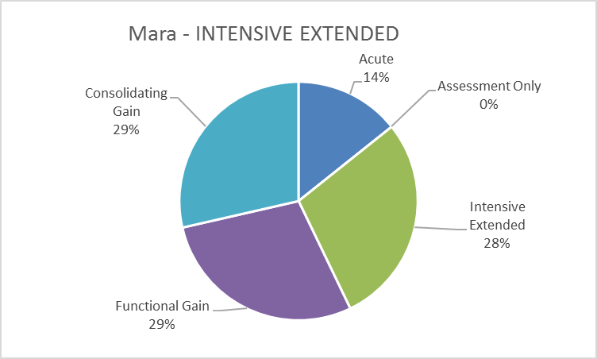

**Confidence**

|  |  |
| --- | --- |
| Mean | 7.333333 |
| Median | 7 |
| Mode | 7 |

**Comments**

Spelling “consort” with GP in interventions

This is a clearer scenario as the intervention directs the care to the community team. It is hard to gauge the phase of care when the outcome moves the work to an inpatient unit. Would be helpful to have specific, quantifiable interventions. i.e. weekly visits, fortnightly, monthly.

I considered Consolidating gain, but as Mara is developing symptoms which indicate deterioration & a move towards an acute POC, she requires a plan with interventions which focus on “symptom reduction” & psycho social support which addresses her family with carer support.

Mara - ASSESSMENT ONLY

|  |  |  |  |
| --- | --- | --- | --- |
| Mental health phase of care | | **ASSESSMENT ONLY** | |
| **Name:** **Mara, 69**  Mara is a 69 year old, widowed woman of Italian heritage. Her husband of 48 years, Roberto, has died 18 months ago after battling a long illness. She lives alone, around the corner from her youngest daughter, who also has a diagnosis of BPAD. | | | |
| Behaviour | Mara has a long history of Bipolar Affective Disorder, first diagnosed when she arrived in Australia from Sicily. During her husband’s illness, Mara, was hospitalised for mania three times and her treatment is now made more challenging as she has developed chronic renal failure. Mara is first seen sitting in her lounge room where she is wringing her hands and rocking gently in her chair. She is speaking to herself in Italian and looking at a document in front of her on the coffee table. She has called you because she has received a notification from the ATO about an unpaid tax liability from her late husband’s small business and cannot read English well enough to comprehend its meaning. | | |
| Physical | Mara has gained some weight in the past 8 months though she says she ‘eats like a bird’. It’s apparent that she has fluid retention due to her renal disease. She now wears a brace on her left wrist after a fall some weeks ago. | | |
| Symptoms | Mara appears moderately anxious and reports that she ‘is going to jail’ after reading the ATO assessment notice. Before receiving this notice two days ago, she had been feeling ‘very well, all things considered’. She has had some difficulty sleeping last night. She denies any thoughts of self-harm and there is no evidence of a pervasive change to her mood. | | |
| Social | Mara’s daughter has also been diagnosed with BPAD. Mara lives about 500 metres from her daughter’s house, in her own home. She has a large circle of friends from the local Italian community and plays cards each Saturday afternoon at the local club. Mara reports that she and her daughter are getting on better since Mara agreed to look after her granddaughter two afternoons a week, which she enjoys. | | |
| Interventions | An Italian interpreter is contacted to attend Mara’s home with you and the ATO assessment notice is explained in clear and simple language. Her GP is provided with a letter about her current concerns and her daughter contacted to make appointment with the family accountant. | | |
| Rationale for **assessment only**  mental health phase of care | The goal of Mara’s care is to gather information and provide appropriate advice and referral. | | |
| Possible indicators for mental health phase of care change | Mara’s mental health is seriously affected by the development of comorbidities affecting her physical health and compromising her mental health recovery. | | Intensive extended |
| Mara’s mood has been stabilised and she is getting on well with her daughter. Mara is attending appointments without reminder. | | Consolidating gain |
| Mara is planning to move to a retirement village after selling her home, but feels anxious about meeting new people and living in an unfamiliar environment. | | Functional gain |
| Mara presents highly agitated with pressured speech and has assaulted her daughter after she was refused entry to her home. | | Acute |

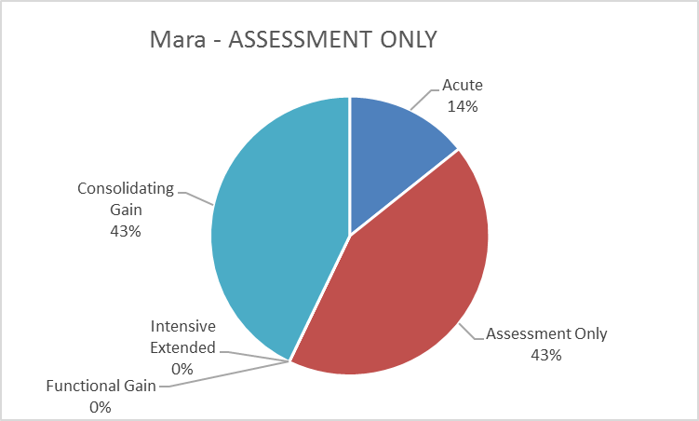

**Confidence**

|  |  |
| --- | --- |
| Mean | 6.6 |
| Median | 7 |
| Mode | 7 |

**Comments**

Based on this vignette alone it would be assessment only - however if she was still being case managed (previous scenario) then she would be in consolidating gain.

Although Maras symptoms seem quite stable & she has reached a period of recovery, to maintain this she will require ongoing support with psycho social planning to ensure she does not deteriorate.

Peter - FUNCTIONAL GAIN

|  |  |  |  |
| --- | --- | --- | --- |
| Mental health phase of care | | **FUNCTIONAL GAIN** | |
| **Name**: **Peter, 85**  Peter is an 85 year old man, married to his second wife, Minnie, for 11 years who is 23 years his junior. They live in their own second storey unit. He has two children from his previous marriage that live overseas. | | | |
| Behaviour | Peter has recently suffered a stroke and has subsequently developed a major depressive illness, for which he has been treated with a combination of medication and supportive psychotherapy. He was previously a very active man who ran the local ‘Men’s Shed’ in his area, which he misses a great deal. He presents in company of his wife. Peter appears irritable and dismissive with his wife, when you see them. He reports that he feels as if he is ‘trapped under her feet 24/7’ to which she nods vigorously. He has tended to try to avoid her for the past few weeks by keeping to himself in the spare room where he has been building model planes. Minnie appears anxious to placate him at all times. He is cooperative with the interview but keeps looking at his watch. | | |
| Physical | Peter is a tall, slim man who walks with the aid of a four prong stick and has a residual paresis of his left side which he says he is ‘working on like I’m told’. He has some problems with urinary frequency at night. He reports that his appetite is good and he enjoys cooking ‘when Minnie lets me’. He denies any other major physical concerns. | | |
| Symptoms | Peter reports that his mood is about ‘6/10’ and thinks he might not get much better than that. He has negative thoughts about his future and fears that Minnie will leave him. He has some trouble sleeping due to his urinary frequency. His speech is animated and articulate. | | |
| Social | Peter and Minnie report that they are having difficulty negotiating the stairs to their second storey unit. She says that Peter is very reluctant to let his friends from the Men’s Shed visit him at home as he feels ‘embarrassed’. Peter has also been avoiding speaking to his two children when they call, which upsets Minnie a great deal as she thinks they will blame her for this ‘as they have never really liked me’. | | |
| Interventions | Peter and his wife are engaged with a social worker who assists with getting Peter back into his preferred community activity – the Men’s Shed. His accommodation is assessed by an OT for modifications to help with mobility and he is enrolled in a swim class at the local leisure centre to help with his physical recovery. His children are also contacted with consent and advised on his progress. | | |
| Rationale for **functional gain** mental health phase of care | The goal of Peter’s care is to help him reengage with community activities that he previously enjoyed; support his independence and encourage improvements in his physical and mental health. | | |
| Possible indicators for mental health phase of care change | Peter presents with complaints of back and hip soreness secondary to his use of the walking stick. | | Assessment only |
| Peter declines to leave his unit for several weeks and his wife has been staying with her sister for two nights a week, due to his irritability and verbal aggression. | | Intensive extended |
| Peter has reengaged with Men’s Shed but expresses lack of confidence in his previous skills as a mentor to other men. | | Consolidating gain |
| Peter has taken an overdose of his medications that he has been hoarding for some weeks after Minnie says she wants a divorce. | | Acute |

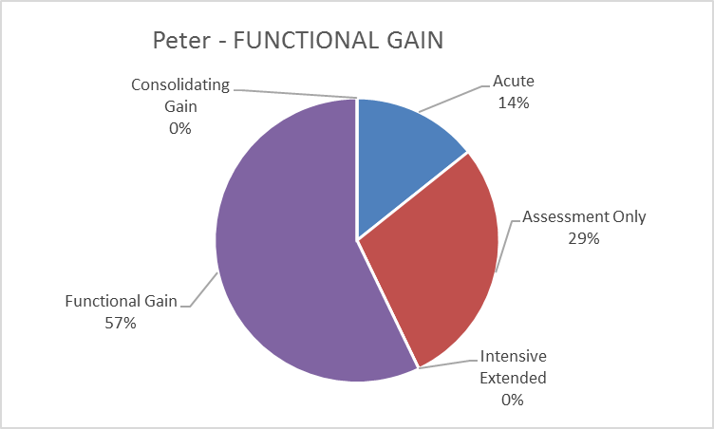

**Confidence**

|  |  |
| --- | --- |
| Mean | 6.285714 |
| Median | 7 |
| Mode | 7 |

**Comments**

In the introduction it should read “who live overseas”

At this stage, it seems as though Peter & his wife have adequate supports & resources in place. His family will require a referral to family/relationship therapy.

Peter - INTENSIVE EXTENDED

|  |  |  |  |
| --- | --- | --- | --- |
| Mental health phase of care | | **INTENSIVE EXTENDED** | |
| **Name**: **Peter, 85**  Peter is an 85 year old man, married to his second wife, Minnie, for 11 years who is 23 years his junior. They have recently moved to a ground floor unit. He has two children from his previous marriage that live overseas. | | | |
| Behaviour | Peter has recently suffered a stroke and subsequently developed a major depressive illness, for which he has been treated with a combination of medication and supportive psychotherapy. He was previously a very active man who ran the local ‘Men’s Shed’ in his area, which he misses a great deal. He is seen without his wife for the first time in six months. Peter appears upset and mildly agitated when he is seen at home. He is difficult to engage and reports that he has had been thinking about his mortality for some weeks. Peter and his wife, Minnie, have separated 4 weeks ago. She has gone to stay with his sister in Liverpool, after he waved his walking stick at her ‘one too many times’. He is spending a lot of time in bed now. | | |
| Physical | Peter is a tall, slim man who walks with the aid of a four prong stick and has a residual paresis of his left side. He has stopped attending outpatient rehab since Minnie left, and appears to have ‘stiffened up’ with lack of mobility compared to before. His personal appearance is not as sprightly as it had been previously. He has not shaved for several days as he says ‘no one is going to see me anyway.’ | | |
| Symptoms | Peter reports a loss of interest in the things he normally enjoys, such as the Men’s Shed. He says the other men there avoid him ‘because they don’t like to be told what’s what’. He reports feeling tired all the time and worries that Minnie will not come back to him and ‘where would I be without her.’ He reports that he has no appetite. | | |
| Social | Peter and Minnie have been separated for four weeks. His sons have been calling on Peter now that Minnie is not in the home and believe that their father ‘is under her spell’. Peter has not been attending the Men’s Shed for two weeks. | | |
| Interventions | The frequency of contact with Peter is increased to twice weekly and he is reviewed by the treating psychiatrist and his medications adjusted. Contact is made with Minnie and some relationship counselling is organised with her local church. Peter is taken to his Outpatient Rehabilitation appointments to ensure that he gets the physical health care he needs to aid recovery. He is assessed by the OT for his mobility concerns. | | |
| Rationale for **intensive extended** mental health phase of care | The goal of Peter’s care is to closely monitor his symptoms and focus on his physical and functional recovery goals, to maximise his independence and sense of mastery. | | |
| Possible indicators for mental health phase of care change | Peter presents with complaints of back and hip soreness secondary to his use of the walking stick | | Assessment only |
| Peter is seeking to return to his Men’s Shed activities after a prolonged absence. | | Functional gain |
| Peter has re-engaged with Men’s Shed, but expresses a lack of confidence in his previous skills as a mentor to other men. | | Consolidating gain |
| Peter has taken an overdose of his medications that he has been hoarding for some weeks after Minnie says she wants a divorce. | | Acute |

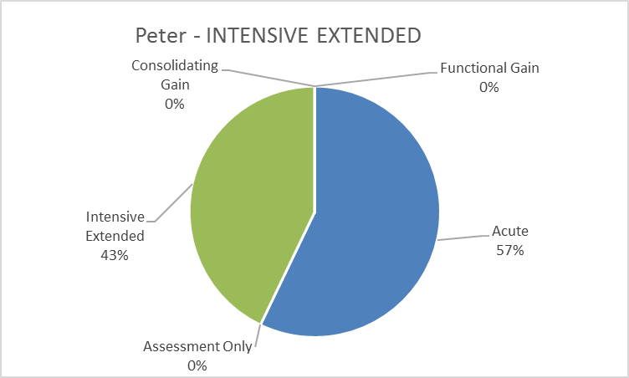

**Confidence**

|  |  |
| --- | --- |
| Mean | 6.666667 |
| Median | 7 |
| Mode | 7 |

**Comments**

Peter is deteriorating as a result of his ongoing psycho social stressors, as a result of difficulty with adapting to his physical limitations. He is experiencing a depressive episode which could rapidly move to acute without intervention.

**DISTRACTORS**

Antonina - Older FUNCTIONAL GAIN

|  |  |  |  |
| --- | --- | --- | --- |
| Mental health phase of care | | **FUNCTIONAL GAIN** | |
| **Name: Antonina, 66**  Antonina is a 66 year old Pilipino woman, who has worked as a foster carer for FACS for many years. She has recently separated from her second husband after reported domestic violence. Her husband has subsequently been diagnosed with an aggressive brain tumour which has accounted for his aggressive behaviour and Antonina reports feeling very guilty about leaving him. Antonina has been previously treated for depression throughout her life but feels that she manages this well. | | | |
| Behaviour | Antonina presents in company of her sister; they appear to be identical twins. She is polite and friendly though she appears ‘eager to please’ and will defer to her sister at times to answer any queries. When Antonina’s sister goes out of the room to answer her phone, Antonina reports that she feels irritated with her sister and has always found it difficult to ‘stick up for myself around her’. She reports that she has had fleeting thoughts of self-harm but with no intent or pre-made plans. | | |
| Physical | Antonina reports that she feels well. She is accustomed to regular exercise and yoga but has let this fall away since her sister arrived. She reports that she experiences mild tension headaches on some afternoons and takes analgesia for this. She is not on any routine medications. | | |
| Symptoms | Antonia describes a loss of confidence in herself and has been ‘second guessing’ herself in relation to reconciliation with her partner. She feels as if she is no longer a ‘good person’ and does not feel she would be able to take in any foster children at this time, which she misses a great deal. She has some trouble sleeping. | | |
| Social | Antonina has a wide circle of friends and has been involved in a voice choir singing group at her local church which she enjoys. Her sister, who has arrived from the Philippines to stay with her, is discouraging when Antonina expresses a wish to try and reconcile with her husband. Her sister feels that she should instead ‘look after herself’. Her sister is currently staying with her for an indefinite period of time. Antonina’s husband lives just around the corner, after having recovered from recent surgery. He frequently drops round and Antonina pretends she is not home. | | |
| Interventions | Antonina is referred to the social worker on your team for support to help he manage her anxiety and for some supportive counselling. With her consent, her sister is engaged with a Pilipino support worker to enable Antonina to comfortably express her strong desire to continue fostering children and resume having some close contact with her husband. | | |
| Rationale for **functional gain** mental health phase of care | The focus of Antonina’s care is to support her in reconciling with her husband and returning to her work as a foster carer, while at the same time providing education and support to her sister about Antonina’s identified goals. | | |
| Possible indicators for mental health phase of care change | Antonina walks in off the street asking question about her nephew’s recent drug use. | | Assessment only |
| Antonina husband has returned to live with her and she requires support to care for him under difficult circumstances when his health deteriorates. | | Intensive extended |
| Antonina has returned to work as a foster carer with her husband, but he is unsure if she can manage this stress. | | Consolidating gain |
| Antonina presents in a highly agitated state and is claiming she can hear the voice of her sister telling her that her husband is trying to kill her. | | Acute |

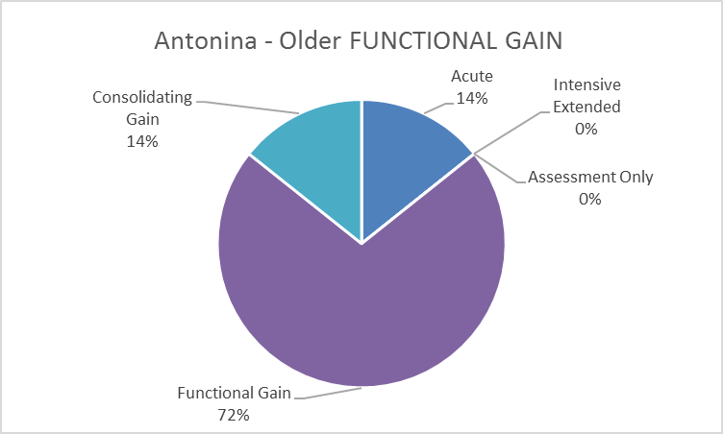

**Confidence**

|  |  |
| --- | --- |
| Mean | 6 |
| Median | 7 |
| Mode | 8 |

**Comments**

Filipina? Phillipina? ?what is FACS This case would not have got through triage, would have been referred by GP to Medicare funded psychology

Spelling “he” should be “her” in Interventions

Error Line 1, Pilipino to Philippine? & Interventions Line 2 & 3 Antonia's Goal of care requires support to “gain confidence” & self determination; she requires support with the psycho social aspects of her life & although she has a history of depression this seems more related to her social circumstances for which she exhibits good coping strategies for which she requires support to maintain in her current circumstance.

Edward - Older ACUTE

|  |  |  |  |
| --- | --- | --- | --- |
| Mental health phase of care | | **ACUTE** | |
| **Name:** **Edward, 73**  Edward is a 73 year old man who has been with his same sex partner for 41 years. They live in their own unit. Edward has no previous history of mental health concerns. His partner, Gerald, has recently been admitted to ICU, post-surgery, and he has been referred to your service by the ICU social worker due to concerns about his mental health and his ability to look after himself. | | | |
| Behaviour | Edward sits slumped in his chair, staring at the floor; he picks repeatedly at the cuticle on his left index finger, where he has a gold ring. He does not make eye contact when he is spoken to. He has acted with frustration towards the social worker who has referred him to your service and says he is only here ‘under sufferance’. He reports that if Gerald does not get better he ‘can’t really see any point in carrying on’. | | |
| Physical | Edward is a tall, solidly built man but his clothes appear to be hanging quite loosely on him. His shirt is not buttoned correctly. He has some hearing loss and usually wears hearing aids, but is not wearing them when you see him. He has a pale complexion and looks tired and worn out. He says he has not slept properly since Gerald was admitted to hospital and reports feeling weak and lethargic. | | |
| Symptoms | Edward reports a feeling of helplessness about his situation as he says he ‘relied on Gerald for everything: he was the boss’. He rates his mood as ‘the worst it has ever been’ and feels anxious when he leaves the hospital after visiting and this feeling persists until he returns. His appetite is poor. He usually loves to cook but has been relying on cheap take away when he can ‘be bothered’. He says he is being punished for not letting Gerald go to the hospital when he first got sick. | | |
| Social | Edward is a retired school teacher and sometimes runs some classes at the Workers Education Authority He has not done this for some weeks. He is visited by his younger sister from time to time and says that he and Gerald used to enjoy going to the local club for a Trivia competition on Sunday afternoons. | | |
| Interventions | Edward is assessed by the team and is commenced on antidepressants. Regular review appointments are scheduled to allow monitoring of his mental state and physical health as well as his response to medication. Edward’s sister is engaged and agrees to visit Edward at home every couple of days. | | |
| Rationale for **acute** mental health phase of care | The goal of Edwards care is to reduce the severity of his symptoms, develop a suitable safety plan in consort with Edward and his sister, as well as provide additional support to ensure the best chances of recovery. | | |
| Possible indicators for mental health phase of care change | Edward presents seeking advice on applying for a Carers Pension when Gerald is discharged home. | | Assessment only |
| Edward continues to lose weight and appears dishevelled and increasingly unkempt when visiting Gerald. He says he cannot live at home without him and will often refuse to leave the hospital. | | Intensive extended |
| Edward reports that he feels very anxious about returning to his part time adult teaching role after a prolonged absence due to Gerald’s rehabilitation. | | Functional gain |
| Edward reports that his mood has improved and he is enjoying helping Gerald with his rehabilitation exercises. | | Consolidating gain |

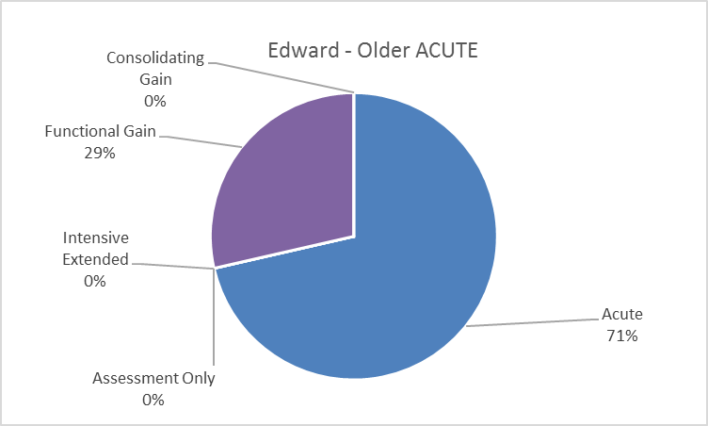

**Confidence**

|  |  |
| --- | --- |
| Mean | 6.714286 |
| Median | 7 |
| Mode | 9 |

**Comments**

Initially I considered intensive extended but as Edward has no clinical MH history, this seems to be a situational crisis for Edward. Although he is receiving input from a probable HITH or acute community team, his symptoms could rapidly deteriorate requiring an inpatient admission.

**Other Comments**

These are objective and relevant.

## Longitudinal Vignettes

The purpose is to identify the mental health phase of care or more particularly when the mental health phase of care changes.

Please review this vignette and indicate where the mental health phase of care changes.

**Child and Adolescent - Alexia**

| **Date** | **Consumer Presentation** | **MHPoC** | **Respondent 1** | **Respondent 2** |
| --- | --- | --- | --- | --- |
| Feb 2 | Alexia is 14 years old. Her mother brought her to “see someone” because she had stopped talking and “didn’t seem herself” She isolates herself in her room for long periods of time. Her teachers were concerned about her poor performance at school. She used to be vibrant and engaged in class but now is withdrawn and isolates herself at break time. She is neatly dressed in a school uniform when you first meet her. Initially, she does not make eye contact and gives very brief answers to your interview questions. Her mother seems to do most of the talking for her, so you ask to talk to Alexia alone. She slowly opens up and says that she has been having trouble getting on with other girls at school. They are mean one minute and then your best friends she reports. She denies thoughts of self-harm or harm to others. There is no evidence of thought disorder but she has some odd beliefs about the girls at school being able to “understand” her, but will not elaborate further. She says that she would like to be able to get on better with people and this would probably make her mother happy. You plan on seeing Alexia in about two weeks and working on her social skills development. | Functional gain | Functional gain | Assessment only |
| Feb 10 | Alexia was supposed to go to school but had stomach pains and didn’t want to get into trouble. She had a fight with another girl last week because “I know she has been watching me”. Other than this isolated incident, she is unchanged from the last time you saw her; she is slow to engage in conversation but when she does she reports that the other girls “understand” her. The session focuses on a discussion about being able to tell her mother how she feels. She sometime feels that her mother “bosses me around and I can’t think for myself”. You discuss boundaries and development and the fact that her mother would appreciate getting to know what Alexia is thinking. Alexia says she has noticed that she forgets things sometimes. She denies drug or alcohol use. | Functional gain | Functional gain | Assessment only |
| Feb 17 | Alexia presents as unkempt, and giggles inappropriately during your interview. She says that she knows why the other girls understand her, which is because they can hear what she is thinking. It is the reason that she has avoided being with them in social situations and part of the reason that she got into a fight. She hasn’t been able to sleep because she knows something will happen to her; “that girl will come around”. Her mother says that Alexia is refusing to go to school and has started acting strangely like cowering when there’s a knock at the door or when the phone rings. Her mother is concerned about her lack of sleep; “she stays up all night, I am sure”. Her mother seems increasingly frustrated by Alexia’s behaviour and she admits they argue frequently. You plan on seeing Alexia more frequently and also having her reviewed by a psychiatrist ASAP. | Acute | Acute | Acute |
| Feb 20 | Alexia was seen by a psychiatrist and prescribed medication to help her sleep. She feels no different and is sure that the other girls at school are making this happen. She doesn’t know how much she can take of them “being inside my head”. Sometimes she thinks she would be better off dead. She denies having plans but can’t guarantee that she will not harm herself. Following discussion with the multidisciplinary team, admission to the child and adolescent special care unit is organised. | Acute | Assessment only | Acute |
| Feb 21 | Alexia is very agitated on the unit, and is sure that the other consumers can read her mind. She sometimes accuses others of taking her thoughts. She has thoughts of self-harm but will not elaborate. She is prescribed antipsychotic medication and is willing to take these but with reluctance. She stays in her room most of the time and will not interact with other consumers. It is noted that she doesn’t eat very much while on the unit and appears suspicious. It emerges during this admission that Alexia had been smoking cannabis with a friend from school. This had become a regular occurrence. She started doing this in an effort to win more friends and it wasn’t as bad as she thought it was going to be but sometimes made her “freak out.” | Acute | Intensive extended | Acute |
| Feb 29 | Over the course of this admission, Alexia becomes less agitated and isolated. Her sleep is much better. She denies thoughts of self-harm. However, she continues to complain of trouble with her memory but denies girls are doing anything to her. She is still sure that people “understand” her but isn’t willing to elaborate. She denies that she will use cannabis again.  Alexia’s mother is much happier with the way that Alexia is behaving but continues to express concern that “this will scar her for life”, “how will she get over this”, and “it’s such a shame on the family”. When Alexia leaves hospital, Alexia’s mother plans on having her go to a different school to get her away from “bad influences”.  Review appointments with a psychiatrist and appointments are made with the community team during plans for Alexia’s transfer of care. | Acute | Assessment only | Functional gain |
| April 4 | Alexia failed to attend her initial appointment because she had changed school and “couldn’t make the appointment”. Alexia presents as well groomed. Alexia continues to take the antipsychotic medication as it has been prescribed, but isn’t sure if there is any need to take it anymore. Her sleep has returned to normal. Her appetite is good and she feels like she is “better” at her new school. She is not avoiding school and her grades are average for her age. Alexia denies that other girls can read her mind but is clearly suspicious of what motivates other people. She denies thoughts of self-harm. Alexia’s mother indicates that Alexia with never use cannabis again because “I am not letting her out of my sight”. Alexia would still like to talk about how she can get her mother not to “boss her around” and how to get on better with other girls at school. | Functional gain | Consolidating gain | Consolidating gain |

**Adult - Tom**

Please review this vignette and indicate where the mental health phase of care changes.

| **Date** | **Consumer Presentation** | **MHPoC** | **Acute** | **Assessment only** | **Intensive extended** | **Functional gain** | **Consolidating gain** |
| --- | --- | --- | --- | --- | --- | --- | --- |
| March 1 | It was Tom’s birthday a couple of days ago and he had just turned 35. He was brought to hospital by Police, as he was behaving inappropriately by abusing the neighbors and passersby to his house. His wife tells you that he has been on a binge since his birthday, drinking “beer and anything else we have in the house”. He hasn’t slept since his birthday and this type of behavior isn’t like him. Tom denies any problems and says everything would be alright if his wife just relaxed a little and started acting like a proper wife. Tom denies ideas of self-harm but becomes agitated if he thinks of harming others. He denies drug or alcohol use or auditory hallucination. At times, his speech is incoherent and he appears to be responding to auditory hallucinations. He is scheduled and admitted to the acute psychiatric unit. He is prescribed some Valium 10mgs and Olanzapine 10mgs. You tell Tom you will see him tomorrow. | Acute | 6 | 1 | 0 | 0 | 0 |
| March 2 | You visit Tom on the unit. Tom and his wife are together when you approach them for additional information. According to his wife, Tom is usually organised. He has just completed a Master’s degree in town planning and has a job in the town planning department of the local city council. He holds a responsible position and was seeking a promotion at work. During this conversation Tom is half-asleep; he has a blank affect and doesn’t really engage with you. You tell Tom you will see him tomorrow. | Acute | 7 | 0 | 0 | 0 | 0 |
| March 3 | Tom is irritable and initially hostile when you first approach him. He says he doesn’t know why he is here and wants to be discharged. He doesn’t need to take any medication and feels fine. Staff indicate that he has settled onto the ward but does tend to isolate himself. He interacts appropriately with others. During your conversation he admits to trying methamphetamine at his birthday party. He says he feels terrible and just wants to go home. He denies auditory hallucination, being a danger to himself or someone else. You plan on seeing Tom tomorrow. | Acute | 7 | 0 | 0 | 0 | 0 |
| March 4 | Tom is with his wife when you see him. He presents as calm and relaxed during your discussions, but does display some irritability with his wife. Tom denies any thoughts of self-harm or harm to others. He denies auditory hallucinations. He says he has learnt his lesson and just wants to go home and then get back to work. | Acute | 6 | 0 | 0 | 0 | 1 |
| March 6 | You visit Tom at his home, he tells you it is great to be home and finally be free of that “nut house”. He says he is just looking forward to getting back to work. His wife tells you that he irritable at times and although he denies auditory hallucinations he appears distracted. His wife says that despite taking the medication as prescribed, Tom has had little sleep. You discuss the need to take the additional PRN medication that he has been prescribed and indicate that you will see him. | Acute | 6 | 0 | 0 | 0 | 1 |
| March 7 | You talk to Tom on the telephone; he indicates that he slept better last night. He still sounds loud and some of his comments seem a little inappropriate. You talk to Tom’s wife and she indicates that Tom “still isn’t himself”. You plan to visit Tom as often as possible over the next couple of weeks and at minimum calling him on the telephone daily. | Acute | 5 | 0 | 1 | 0 | 1 |
| March 8 | When you arrive, Tom greets you and appears slightly unkempt and disorganized. He says he is fine but his thinking is somewhat tangential and he does not seem to be able to focus on your questions about his sleep, how he is feeling or getting along with his wife. He denies auditory hallucinations but does indicate his head feels “fuzzy”. He says he is taking his medication as prescribed but his wife says “he only takes the medication because I tell him”. She says he did get a good night’s sleep last night and he isn’t back to normal. She indicates that they have been fighting over the last couple of days because Tom starts “carrying on, but none of it makes any sense”. She says, he talks about return to work but he can’t even get organised to do the dishes. | Acute | 6 | 0 | 0 | 1 | 0 |
| March 10 | Tom is watching TV when you arrive and appears much more calm and relaxed. He says that he feels a “bit better” and is “not as stressed”. He talks about things getting to him at work and his birthday party was the last straw. He isn’t planning on going back to work just yet, “I am going to take some time off and get my head straight”. He indicates that he has thoughts of self-harm but “I wouldn’t do anything to hurt myself”. You plan on continuing to see Tom as often as you can. | Acute | 5 | 0 | 0 | 1 | 1 |
| March 12 | Tom feels depressed, and he says he “can’t muster the energy for anything”. He is sleeping better; in fact, he thinks he is sleeping too much. He says he is embarrassed by his recent behavior and can’t believe that his wife has “put up with me”. He denies auditory hallucinations but indicates that “I had some strange thoughts for a while”. He has an appointment to see his psychiatrist next week and plans on keeping the appointment. He only takes the PRN medication when he thinks he needs it. You plan on staying in touch with Tom as often as possible until he is reviewed by his psychiatrist. Tom’s wife indicates that he still isn’t himself, but he isn’t as disorganised or irritable as he has been since his birthday. | Acute | 5 | 0 | 0 | 1 | 1 |
| March 16 | Tom says he is feeling much better; “I don’t know what was wrong with me.” His speech is a normal rate and rhythm; he expresses himself clearly and denies any cognitive problems. He denies ideas of self-harm.  Tom has a Doctor’s certificate for another month off work. He isn’t looking forward to returning to work; “I am not sure how I am going to handle it”.  Tom’s wife says that he still isn’t his old self but is much better than he was. He has learnt his lesson and he’ll never try drugs again.  You plan on seeing Tom in a week or two to discuss his return to work. | Functional gain | 0 | 0 | 3 | 2 | 2 |

**Older Persons - Barnaby**

| **Date** | **Consumer Presentation** | **Mental health phase of care** | **Acute** | **Assessment only** | **Intensive extended** | **Functional gain** | **Consolidating gain** |
| --- | --- | --- | --- | --- | --- | --- | --- |
| July 2 | You are allocated as Case Manager of Barnaby at your regular team review meeting. He is a long-term client of the service and well- known and recognised in the community. When you first meet Barnaby, he is outside collecting his mail from the letter box. He is very difficult to understand with a tendency to mumble. He is 68 years old and lives alone in a small unit which his family bought for him many years ago. He is significantly overweight with a waist size of 130cms. He has Type 2 diabetes which is diet and insulin controlled. Barnaby tells you his “normal” doctor is happy with his “sugar”. He shows you his blood sugar record, where it looks like he has an average blood sugar of 8. You note that he is circumstantial in his thought form and his conversation is peppered with complaints about the Catholic Church and how Brother Ignatius was “terrible” putting things into the “eye of his penis”. He then proceeds to laugh about the information he has just shared. You have been told that this is his usual presentation and topic of conversation and that he can be a “cranky old man”. In fact, his outbursts at catholic mass are well-known and accepted in the congregation. You decide to continue to see Barnaby every two weeks and like his previous Case Manager negotiate to attend his regular psychiatrist appointment with him in 6 months’ time. Barnaby denies auditory hallucinations. He has few friends and only interacts occasionally with his brother and sister who are both older than him. | Consolidating gain | 1 | 0 | 1 | 1 | 2 |
| August 12 | You continue to visit every two weeks. During this visit, Barnaby talks about his experience at a Catholic Boarding School, where he reports that he was a very good student. He attended university, being one of the first members of his family to do so. He appears a little unkempt and clearly hasn’t had a shave in a couple of days.  He receives an injection of Risperdal Consta 50 mgs every two weeks. He readily accepts this medication, although he clearly indicates that he has no idea why he should take it, because it does “absolutely nothing”; but “bloody psychiatrists…” a thought that never gets completed. He indicates that he has plenty of medication for his physical health conditions which include hypertension and a thyroid condition. He shows you evidence of his medication supplies and that he has been taking it.  His unit, although a little cluttered, is clean with fresh food in his refrigerator. Barnaby indicates that he has been getting plenty of rest. Barnaby denies thoughts of self-harm and becomes agitated when you ask this question, “that is a sin”; “I don’t think I want to talk to you, you are an idiot”. He agrees to see you in two weeks. | Consolidating gain | 0 | 0 | 1 | 1 | 3 |
| September 6 | You continue to visit every two weeks. On this visit, he appears better groomed than last. You notice that there a dishes pilled in the sink, which is unusual. He continues to accept his medication. He continues to accept the Risperdal Consta 50 mgs. He tells you that the Catholic Church is something that has brought a lot of good to the world, where people and places are better for its existence and that people can only become educated because of the Church. Barnaby discusses his desire to lose weight and do more exercise because he wants to have good control of his diabetes, “I have to look after myself my Doctors says it’s important”. You encourage his 30 minute daily walks. He informs you that he is thinking of visiting his sister for her birthday, “I have a twin sister, she has been really good to me”. You talk to him about the relationship between his physical health and mental health, and how weight loss and increased exercise can help control his diabetes. You suggest a meeting with a dietician. | Consolidating gain | 0 | 0 | 1 | 2 | 2 |
| November 2 | You saw Barnaby two weeks ago where he appeared unchanged. You discussed his next review by a psychiatrist in a months’ time. Barnaby refuses to open the door when you visit. He calls out “go away, leave me alone, I am busy with a friend”. You decide visit tomorrow. | Consolidating gain | 0 | 1 | 1 | 1 | 2 |
| November 3 | Barnaby is not home. | Consolidating gain | 1 | 0 | 1 | 2 | 1 |
| November 18 | You have tried to see Barnaby twice last week but he wasn’t home. This visit, Barnaby opens the door and although superficially pleasant he appears agitated. You try to discuss his upcoming review by his psychiatrist, but he indicates he is capable of attending without your support. Although he continues to accept his Risperdal Consta 50 mgs he becomes quiet loud and aggressive when he explains that he doesn’t need it anymore. He clearly doesn’t want to engage in conversation. You discuss seeing Barnaby next week rather than in two weeks’ time to “see how he is going”. You also talk to him about scheduling an earlier appointment with his psychiatrist. | Acute | 3 | 0 | 0 | 1 | 1 |
| November 25 | Barnaby appears unkempt, and his unit is untidy. Although he lets you into his unit, he is reluctant to engage in conversation. He is determined to see his psychiatrist because he says he hasn’t been sleeping, “there are people out there carrying on at all hours of the night”. You talk about ways of helping with sleep and he indicates that he will try them, but you aren’t positive he will incorporate your advice. | Acute | 4 | 0 | 0 | 1 | 0 |
| Dec 3 | Initially, Barnaby refuses to come to the door when you visit, “I’m busy with a friend”. Reminding him of his psychiatrist appointment, he reluctantly agrees to come to the appointment with you. On review Barnaby has been increasingly distressed by obsessional thoughts about the Catholic Church. He is prescribed additional oral medication and a new appointment is made for two weeks’ time. | Acute | 3 | 0 | 1 | 0 | 1 |
| Dec 4 | Following the visit to the psychiatrist, you visit Barnaby every couple of days and he gradually becomes more engaged. He is very circumstantial in conversation and his focus is on the Catholic Church, his boarding school days and Brother Ignatius. He is very distressed by these thoughts and they have been affecting his sleep. You encourage his adherence to his increased medication to help with his sleep. You also encourage him to continue with his exercise and diet. He continues to attend Catholic Mass services on Sundays, where he is welcomed despite the occasional outburst. | Acute | 0 | 0 | 1 | 1 | 3 |
| Dec 18 | Over the course of several weeks Barnaby becomes less distressed by his thinking. His sleep improves and he continues his 30 minute daily walks. He is really looking forward to going to his sister place for Christmas. A GP near his sister is organised to administer his Risperdal Consta 50 mgs. You plan on seeing Barnaby when he returns. | Consolidating gain | 0 | 0 | 1 | 0 | 4 |

# Appendix 2: Final Vignettes used in study

The following vignettes were used during the inter-rater reliability study. They are the vignettes that were modified from those in Appendix 1 based on the comments and suggestions provided by the clinical advisory and technical reference group.

| Number | Name | Phase of care | Target Population |
| --- | --- | --- | --- |
| 1 | Sophia | Functional gain | Child and Adolescent |
| 2 | Aiden | Intensive extended | Child and Adolescent |
| 3 | Lachlan | Functional gain | Child and Adolescent |
| 4 | Theo | Assessment only | Child and Adolescent |
| 5 | Jordan | Acute | Child and Adolescent |
| 6 | Tameka | Consolidating gain | Child and Adolescent |
| 7 | Aldinga | Assessment only | Child and Adolescent |
| 8 | Marcus | Functional gain | Child and Adolescent |
| 9 | Jack | Intensive extended | Child and Adolescent |
| 10 | Llubica | Intensive extended | Child and Adolescent |
| 11 | Nadeen | Functional gain | Child and Adolescent |
| 12 | Jade | Acute | Child and Adolescent |
| 13 | Chloe | Consolidating gain | Child and Adolescent |
| 14 | Bryce | Assessment only | Child and Adolescent |
| 15 | Ebony | Functional gain | Child and Adolescent |
| 16 | Gary | Intensive extended | Adult |
| 17 | Daniel | Consolidating gain | Adult |
| 18 | Faith | Functional gain | Adult |
| 19 | Ashley | Acute | Adult |
| 20 | Paul | Acute | Adult |
| 21 | Jason | Intensive extended | Adult |
| 22 | Xi | Consolidating gain | Adult |
| 23 | Bo | Assessment only | Adult |
| 24 | Zlatko | Assessment only | Adult |
| 25 | Barry | Functional gain | Adult |
| 26 | Vivian | Assessment only | Adult |
| 27 | Jo Beth | Consolidating gain | Adult |
| 28 | Malcolm | Assessment only | Adult |
| 29 | Agnes | Assessment only | Older Persons |
| 30 | Doris | Consolidating gain | Older Persons |
| 31 | Eric | Consolidating gain | Older Persons |
| 32 | Donald | Acute | Older Persons |
| 33 | Jo | Acute | Older Persons |
| 34 | Rose | Functional gain | Older Persons |
| 35 | Mara | Intensive extended | Older Persons |
| 36 | Angelina | Assessment only | Older Persons |
| 37 | Peter | Functional gain | Older Persons |
| 38 | William | Intensive extended | Older Persons |
| 39 | Antonina | Functional gain | Older Persons |
| 40 | Edward | Acute | Older Persons |

*Note: Case vignettes 1, 2 and 3 were removed from the final analysis (See Section 3.1)*

**Child and Adolescent: Sophia**

|  |  |
| --- | --- |
| **Name: Sophia, 5**  Sophia is five years old and is being seen for problems with interpersonal relationships at home. She lives with her parents and three older siblings. | |
| Behaviour | Sophia is very active,agitated and impulsive. She is constantly running around, rarely sits still and cannot concentrate for more than a few minutes. |
| Physical | Sophia was operated on for a major heart defect during her first year of life and was in the hospital for a long time. She still uses oxygen. There is a question as to whether the operation has caused organic brain damage. |
| Symptoms | Sophia is not particularly anxious but turns more towards adults than other children. Her general IQ is within the normal range. However, Sophia has substantial language difficulties, which are evident through her vague speech and limited vocabulary.  Sophia needs more supervision with everyday activities than expected for her age. Sophia is defiant with her mother, but not so much her father. Consequently, her mother finds her difficult to handle, while her father finds her a bit easier. |
| Social | Sophia has no friends at day-care as she is unable to play with the other children. Children at Sophia’s day care withdraw from her because she hits and scratches them instead of talking. |
| Family/ Carer | Sophia’s parents think that her serious physical illness and the strain that has accompanied it is the main cause of her problems and the reason that she functions so poorly. Sophia has three older siblings that are healthy. Her siblings find Sophia difficult to relate to because she demands so much of them. Her parents say they are worn out, that they argue a lot, and that they sometimes take this out on the children. |
| Interventions | Sophia’s parents are seeking the best possible ways to deal with their daughter. They are seeking counselling and help with their interpersonal relationships. |

Please indicate the mental health phase of care described in the vignette (Circle only one)

|  |  |  |  |  |
| --- | --- | --- | --- | --- |
| Acute | Functional gain | Intensive extended | Consolidating gain | Assessment only |

How likely are you to have contact with a person demonstrating the characteristics described in the vignette? (Circle only one)

|  |  |  |  |  |
| --- | --- | --- | --- | --- |
| Very Unlikely | Unlikely | Neither Likely nor Unlikely | Likely | Very Likely |

**Child and Adolescent: Aiden**

|  |  |
| --- | --- |
| **Name: Aiden, 4**  Aiden is four years old and lives with his parents and his older sister who is six. | |
| Behaviour | Aiden is described as a boy who almost never sits still and his parents are concerned that Aiden is hyperactive. His parents believe that the only time they see him concentrate is when he plays with his iPad. During meals they can barely get him to sit at the table. Every day there are episodes where Aiden hits other children.He has, however, never hurt anyone. In situations with limit settinghe often hits or kicks his parents. This has not happened with the carers at day-care. |
| Physical | Aiden is physically healthy. |
| Symptoms | At home, Aiden’s mother dresses him each morning. At day-care the carers try to get Aiden to dress himself when he is going out, but he repeatedly forgets what he is doing and usually one of the adults ends up dressing him. Aiden wets his pants during the day at least once a week and he uses diapers at night. The staff at day-care say that in situations with a lot of staff and adult supervision, Aiden can play relatively quietly, but they see that he quickly becomes agitated in less structured situations.  Aiden’s parents think that his language development has been much slower than his sister’s. He said “Mummy”, “Daddy” and “Isbell” (sister) at about two years of age. When he was three he uttered short sentences such as “Aiden eat”, “Mummy come”. He now speaks in longer sentences, but has problems with the “R” and “K” sounds and he does not pronounce words beginning with the “S” sound before a consonant. |
| Social | At day-care, Aiden prefers to play with younger or older children. The children his age do not want to include him when they are playing because they think that he is mean. He is never invited home to visit the other children. Aiden’s parents have tried to invite other children from the day care to their house several times, but the other parents always politely decline. |
| Family/ Carer | His parents are very worried and his father describes Aiden as a ‘little psychopath’. At home he is frequently in conflict with his older sister, although she is now better at withdrawing from conflict situation. Aiden’s parents report that there are periods where they find it difficult to stay calm, particularly in situations with limit setting. They sometimes shake him or lock him in his room. |
| Interventions | Aiden’s parents are seeking an understanding of the causes of Aiden’s problems and the best way of managing his behaviour. |

Please indicate the mental health phase of care described in the vignette (Circle only one)

|  |  |  |  |  |
| --- | --- | --- | --- | --- |
| Acute | Functional gain | Intensive extended | Consolidating gain | Assessment only |

How likely are you to have contact with a person demonstrating the characteristics described in the vignette? (Circle only one)

|  |  |  |  |  |
| --- | --- | --- | --- | --- |
| Very Unlikely | Unlikely | Neither Likely nor Unlikely | Likely | Very Likely |

**Child and Adolescent: Lachlan**

|  |  |
| --- | --- |
| **Name: Lachlan, 20 months**  Lachlan is 20 months old and lives with his parents and 9 week old sister. He is being seen for problems with pulling out his hair, pica and aggressive behaviour at home. | |
| Behaviour | Lachlan is active and impulsive. Lachlan does not manage change easily and gets distressed when routines change. |
| Physical | Lachlan is physically healthy, however, he has presented to the Emergency Department of his local hospital on two occasions after having inserted objects up his nose. Lachlan has required medical intervention to remove the objects. |
| Symptoms | Lachlan frequently eats fluff, hair, sand and crayons. He has been observed to suck on furniture at home and will pull out his hair when distressed. Lachlan has recently started to bite and hit his parents when things do not go the way he wants.  Lachlan does not display any of these behaviours when in the care of either of his grandmothers.  Lachlan has reached his developmental milestones early and has good expressive and receptive language skills. |
| Social | Lachlan attends a weekly playgroup and interacts well with his peers.  He can be kind and appropriate with his younger sister at times, however, on other occasions he has scratched her face.  Lachlan’s parents attempted to start him at part-time day care however he became so distressed after repeated visits, that it was decided to withdraw him. |
| Family/ Carer | Lachlan’s parents do not know what to make of his behaviour and are very worried. His father is actively involved with parenting and Lachlan has a close relationship with both parents. Lachlan’s mother reports that she experiences anxiety and has seen her GP for help. |
| Interventions | Lachlan’s parents are seeking the best possible ways to deal with their son. They are seeking counselling and parental guidance regarding how to manage Lachlan’s behaviour. |

Please indicate the mental health phase of care described in the vignette (Circle only one)

|  |  |  |  |  |
| --- | --- | --- | --- | --- |
| Acute | Functional gain | Intensive extended | Consolidating gain | Assessment only |

How likely are you to have contact with a person demonstrating the characteristics described in the vignette? (Circle only one)

|  |  |  |  |  |
| --- | --- | --- | --- | --- |
| Very Unlikely | Unlikely | Neither Likely nor Unlikely | Likely | Very Likely |

**Child and Adolescent: Theo**

|  |  |
| --- | --- |
| **Name: Theo, 8**  Theo lives at home with his father and 3 year old sister, following the death of his mother 18 months ago from breast cancer. | |
| Behaviour | Theo has been referred to your service by the family GP. Six months ago, Theo’s father started to date a single mother who he met through Theo’s school. Over the past five months, Theo has been expressing the fear that ‘something bad might happen’ to his father and sister, particularly when he goes to bed at night. He has started to wet the bed and is refusing to go to school on some days as he worries that he will wet his pants in class. He appears fearful of letting his father out of his sight. |
| Physical | Theo is a healthy young boy, but recently he has lost interest in eating his favourite foods and has been reported to be visibly thinner. He is still within a normal weight range for his age and height. He has taken to chewing his nails when watching TV. |
| Symptoms | Theo says that he feels ‘funny’ when he is left alone at home and worries that if he can’t see his Dad and sister that they will ‘disappear’. He has experienced nightmares in the past two weeks with associated bed wetting. |
| Social | Theo has a good group of friends that he has had since preschool, but since his father started dating he is reluctant to go to his friends’ homes after school or on weekends. He has also stopped playing soccer with his local team, something he previously loved to do. |
| Family/ Carer | Theo’s father is very concerned that his new relationship is upsetting Theo. He tries to reassure Theo that everything will be all right. He is seeking advice on the best way of supporting Theo. Theo interacts appropriately with his sister and appears to have a good relationship with his father. |
| Interventions | Theo’s father is encouraged to reconnect with the psychologist that Theo saw after his mother’s death. A copy of Theo’s assessment and care plan is sent to his referring GP. |

Please indicate the mental health phase of care described in the vignette (Circle only one)

|  |  |  |  |  |
| --- | --- | --- | --- | --- |
| Acute | Functional gain | Intensive extended | Consolidating gain | Assessment only |

How likely are you to have contact with a person demonstrating the characteristics described in the vignette? (Circle only one)

|  |  |  |  |  |
| --- | --- | --- | --- | --- |
| Very Unlikely | Unlikely | Neither Likely nor Unlikely | Likely | Very Likely |

**Child and Adolescent: Jordan**

|  |  |
| --- | --- |
| **Name: Jordan, 8**  Jordan lives at home with his father and 3 year old sister, following the death of his mother 18 months ago from breast cancer. | |
| Behaviour | Jordan has been referred to your service by his treating psychologist after a recent contact. Jordan has been refusing to sleep in his own bed at night for some days now and his father has noticed a number of scratches and bite marks on his left arm, which he tries to hide. Jordan also told a teacher at school that he can hear his late mother talking to him when he is alone, particularly at night, and reported that he bites himself to make him feel better and for the ‘voice’ to stop. |
| Physical | Jordan’s weight is at the lower end of what would be considered normal for his age and height. He has taken to only eating white or orange foods. Jordan has also been noted to have soiled himself a few times after school and then hiding his underpants from his father, who found them in the backyard. |
| Symptoms | Jordan is seen muttering to himself with a deep frown on his face when sitting in the waiting room. He is seen to be rocking himself backwards and forwards on the chair, clutching at his left arm. He is only sleeping 3 to 4 hours a night. |
| Social | Jordan has refused to leave the house on the weekends and his father says he does not want his friends to come to his home. He has not played soccer for 6 weeks and says that one of the boys on the team hates him. |
| Family/ Carer | Jordan’s father is very distressed and he is thankful that he is getting support from his mother. Jordan and his sister do not interact at all and he is somewhat distant to his father. |
| Interventions | Jordan is reviewed by the CAMHS Team on a weekly basis. Consideration is given to referring him to the Children’s Hospital due to his weight loss. His father is contacted daily by the acute mental health team for support. |

Please indicate the mental health phase of care described in the vignette (Circle only one)

|  |  |  |  |  |
| --- | --- | --- | --- | --- |
| Acute | Functional gain | Intensive extended | Consolidating gain | Assessment only |

How likely are you to have contact with a person demonstrating the characteristics described in the vignette? (Circle only one)

|  |  |  |  |  |
| --- | --- | --- | --- | --- |
| Very Unlikely | Unlikely | Neither Likely nor Unlikely | Likely | Very Likely |

**Child and Adolescent: Tameka**

|  |  |
| --- | --- |
| **Name:** **Tameka, 16**  Tameka is a 16 year old young woman of Maori heritage who lives with her parents, four older siblings and maternal grandmother. She is in Year 11 at the local Catholic High School. | |
| Behaviour | Tameka has been diagnosed with a Conduct Disorder when she was in Year 8 at her previous high school. She has also been diagnosed with ADHD by a Paediatrician when she was aged 8. Tameka has been attending school regularly after a period of intensive intervention involving school, CAMHS and a local church based NGO that her parents are involved with. She is reported to be ‘much calmer’ at home after a medication change some months ago. Her behaviour at school has improved and she has been asked to join the local drama group which she is very pleased about. |
| Physical | Tameka has an athletic build and exercises regularly with her father by helping him train the rugby union team that her brother plays for. She is physically larger than the other girls in her class but she has lost 5 kg in the last 6 weeks by cutting back on junk food that she used to enjoy when she was ‘unhappy’ and now cooks regularly at home with her mother. |
| Symptoms | Tameka reports that she is sleeping well though sometimes struggles to get up for school in the mornings. She reports that she has been ‘counting to 10’ when she feels herself getting angry and has also been practicing her relaxation techniques with her aunty. She has been receiving regular pocket money when she completes chores around the house. |
| Social | Tameka has made a number of friends at school, though her mother says that she tends to spend time with the family on weekends. Her mother has encouraged her to invite her friends over. She has now been given her own room as one of her brothers has recently left home. |
| Family/ Carer | Tameka has a good relationship with her parents and siblings. |
| Interventions | Tameka attends the local CAMHS monthly with one or both of her parents for support and a ‘check in’. She is involved with the local youth service that runs acting classes. |

Please indicate the mental health phase of care described in the vignette (Circle only one)

|  |  |  |  |  |
| --- | --- | --- | --- | --- |
| Acute | Functional gain | Intensive extended | Consolidating gain | Assessment only |

How likely are you to have contact with a person demonstrating the characteristics described in the vignette? (Circle only one)

|  |  |  |  |  |
| --- | --- | --- | --- | --- |
| Very Unlikely | Unlikely | Neither Likely nor Unlikely | Likely | Very Likely |

**Child and Adolescent: Alinga**

|  |  |
| --- | --- |
| **Name:** **Alinga, 16**  Alinga is a 16 year old young woman of Aboriginal heritage who lives with her parents, four older siblings and maternal grandmother. She is in Year 11 at the local Catholic High School. Alinga has not had previous contact with mental health services. She is known to the school counsellors due to some behavioural issues at school, which are well managed by the school with her parent’s support. She has been advised by her year adviser to attend the local health centre in order to get a report completed that will assist her in applying for the Army Cadets. | |
| Behaviour | Alinga has applied to join the Army Cadets at school. After a period of relative calm with an absence of behavioural outbursts at home and school, she has been advised by her father that this would be a positive step for her. Alinga rings the Health Centre and makes an appointment to discuss this application, as she needs to provide a report about her progress to the administrator of the Cadets program. She is cooperative and friendly when you see her. |
| Physical | Alinga continues to assist her father with training his Rugby Union team and has maintained a healthy weight. Her mother reports that she is consistently helping her mother at home with the cooking and only eats junk food on ‘special occasions.’ |
| Symptoms | Alinga reports that she is sleeping well and is finding getting up for school easier now that she is eating healthier. There has only been one angry outburst at school when one of the boys in her Biology Class tried to ‘take over’ the experiment they were working on. Alinga feels that if she could get into Army Cadets with two of her friends, she would feel much happier. She does not report any other symptoms of concern. |
| Social | Alinga has involved a couple of her friends in some of her family activities which has been welcomed by her mother and father. Her mother has encouraged her to invite her friends over. She has been using social media to tell people about her plans to join the Army Cadets and this has been positively encouraged. |
| Family/ Carer | Alinga has a good relationship with her parents and siblings. |
| Interventions | Alinga attends the local service to get assistance for her application to the Army Cadets that requires a mental health report and documentation of any past history of contact with mental health services. The report is completed and returned to the school in the care of Alinga and her family. |

Please indicate the mental health phase of care described in the vignette (Circle only one)

|  |  |  |  |  |
| --- | --- | --- | --- | --- |
| Acute | Functional gain | Intensive extended | Consolidating gain | Assessment only |

How likely are you to have contact with a person demonstrating the characteristics described in the vignette? (Circle only one)

|  |  |  |  |  |
| --- | --- | --- | --- | --- |
| Very Unlikely | Unlikely | Neither Likely nor Unlikely | Likely | Very Likely |

**Child and Adolescent: Marcus**

|  |  |
| --- | --- |
| **Name: Marcus, 17**  Marcus is a 17 year old boy who has been living in a local Youth Refuge for the past 6 months. He attends your service with a Youth Support Worker who knows Marcus well. | |
| Behaviour | Marcus has a history of drug induced psychosis and has come to your service after being discharged from an out of area mental health service. His acute symptoms have stabilised. Marcus has reported to have been using cannabis for three years and developed psychotic symptoms which have now been in remission for some months. He presents as somewhat withdrawn and lacking in confidence but warms up after being engaged on neutral topics of interest to him. He says that he would like to get a job like his brother in construction. He also says that he would like to be better able to interact with the other residents in the Youth Refuge but thinks he is ‘stupid and will probably say something dumb’. |
| Physical | Marcus reports that since taking antipsychotic medication, he has trouble ‘getting things going down there’ and is very concerned about ‘not being a real man’. He has also put on a little weight and would like to get back to ‘how I was before I got sick’ when he was participating in mixed martial arts. He reports that he has enrolled in a gym. |
| Symptoms | Marcus reports that he will sometimes eat his meals in his room rather than sit in the dining area with other residents because he feels ‘nervous’. He says that the medication he takes makes him very ‘weak’ and worries that he might not be able to work if he feels tired all the time. He feels that with some exercise and minor changes to his medication he may be able to manage this issue better. Marcus does not display any evidence of acute psychotic symptoms. |
| Social | Marcus has lived in the Youth Refuge for six months after being evicted from his family home due to his aggressive behaviour towards his mother when under the influence of drugs. He has seen his mother only once since being back in the local area. He has one mate in the Youth Refuge that he has known from school. He is not working or studying currently. |
| Family/ Carer | He has a very poor relationship with his mother and little interaction with his siblings. His father separated from his mother a number of years ago and Marcus has had no contact with him since. |
| Interventions | Marcus is reviewed by your team and his medications are adjusted so that he does not feel as tired. He is referred to an Employment Skills program and is also engaged with a nearby Youth Centre where they train people in mixed martial arts. He also sees the local Youth Drug and Alcohol Service for support and engages in some family intervention work to restore his family relationships particularly with his mother. |

Please indicate the mental health phase of care described in the vignette (Circle only one)

|  |  |  |  |  |
| --- | --- | --- | --- | --- |
| Acute | Functional gain | Intensive extended | Consolidating gain | Assessment only |

How likely are you to have contact with a person demonstrating the characteristics described in the vignette? (Circle only one)

|  |  |  |  |  |
| --- | --- | --- | --- | --- |
| Very Unlikely | Unlikely | Neither Likely nor Unlikely | Likely | Very Likely |

**Child and Adolescent: Jack**

|  |  |
| --- | --- |
| **Name**: **Jack, 17**  Jack is a 17 year old boy who has been living in a local Youth Refuge for the past 6 months. | |
| Behaviour | Jack has a history of drug induced psychosis and has been attending the service for more than six months as his GP felt unable to satisfactorily monitor his progress. After a period of stability in relation to his acute symptoms he is having some difficulty initiating and maintaining healthy relationships in the Youth Refuge and is reported to be increasingly withdrawn. His case worker at the refuge has reported that Jack is using cannabis again and is forgetting to take his medication. He presents as irritable and more difficult to engage, dismissing the concerns of his case worker at the Youth Refuge. He reports that his Job Agency ‘sucks’ as most of the people there ‘hate him’. His brother has expressed a reluctance to take him on as a casual labourer as he seems angry and unpredictable when he is ‘stoned’. |
| Physical | Jack reports that he doesn’t want to take medication as his girlfriend is ‘unhappy’ as he can’t maintain an erection. He has gained considerable weight and is unable to exercise regularly as he always feels tired. He has not been attending martial arts classes because of his weight. |
| Symptoms | Jack reports that he has taken to eating most of his meals either outside on the veranda or going to get take away to avoid seeing the other residents. He appears to be irritable when he attends the centre and has missed several appointments because he feels tired all the time. He appears vigilant and guarded when he comes to the Centre. |
| Social | Jack continues to live in the Youth Refuge but plans to move him into more independent accommodation have stalled due to Jack’s recent reported substance use. His one friend at the Youth Refuge is due to leave in the next few weeks and Jack fears he will not make other friends. His mother has told him that she will not see him while he continues to use cannabis. |
| Family/ Carer | He has a very poor relationship with his mother and little interaction with his siblings. His father separated from his mother a number of years ago and Jack has had no contact with him. |
| Interventions | Jack has his medications reviewed regularly with no recent changes. He is engaged with the Early Intervention Youth Service to help develop his living skills. He has been assigned an assertive case manager who along with the local Drug and Alcohol service is actively engaged in his monitoring and care. |

Please indicate the mental health phase of care described in the vignette (Circle only one)

|  |  |  |  |  |
| --- | --- | --- | --- | --- |
| Acute | Functional gain | Intensive extended | Consolidating gain | Assessment only |

How likely are you to have contact with a person demonstrating the characteristics described in the vignette? (Circle only one)

|  |  |  |  |  |
| --- | --- | --- | --- | --- |
| Very Unlikely | Unlikely | Neither Likely nor Unlikely | Likely | Very Likely |

**Child and Adolescent: Llubica**

|  |  |
| --- | --- |
| **Name:** **Llubica, 15**  Llubica lives at home with her parents and two younger sisters, who are from Serbia. She has started to attend a Flexible Learning Centre and is in Year 9 at school. | |
| Behaviour | Llubica has enrolled at the Flexible Learning Centre two months ago after being expelled from her two previous high schools due to her disruptive and aggressive behaviour. She has a troubled history with school attendance and peer relationships and her parents find it very difficult to manage her at home. Llubica has found it difficult to engage with a number of counsellors and other mental health professionals. Her mother reports that she is oppositional at home and will stand over her ‘to get money for drugs’. She has frequently threatened self-harm when she does not ‘get her own way’ but this has decreased somewhat since starting at her new school. |
| Physical | Llubica is overweight and complains that the medication she takes is making her ‘fat’. She says her friends post mean things about her on Facebook. She has started to drink protein shakes instead of eating regular meals on week days in order to lose weight. |
| Symptoms | Llubica’s mood is highly changeable and she reports feeling ‘bored all the time' when she is not with her friends. She reports that she has trouble focusing on her school work and staying calm when people ‘say the wrong thing to me’. She reports that she thinks about cutting herself when she gets angry. She demonstrates poor frustration tolerance and affective ability. |
| Social | Llubica’s parents have reluctantly brought her to your service. They appear to lack knowledge about the nature of Llubica’s concerns and do not appear to take their daughter’s self-harm and other behaviours seriously. They do not like Llubica’s choice of friends and think she is a ‘bad influence’ on her sisters. |
| Family/ Carer | Llubica’s parents appear to have a limited understanding of the nature of her particular challenges and report being very frustrated with her lack of progress. |
| Interventions | Llubica sees her Case Manager at CAMHS once a fortnight. She is enrolled in an Affect Regulation clinic with other young people to help her manage her mood and improve her distress tolerance. Her parents are involved with carer support services and agree to attend psycho education sessions with Llubica’s Case Manager. The school counsellor from the Flexible Learning Centre is also engaged by the Case Manager so a treatment plan can be formulated in collaboration with Llubica and her parents as she transitions into her senior school years. |

Please indicate the mental health phase of care described in the vignette (Circle only one)

|  |  |  |  |  |
| --- | --- | --- | --- | --- |
| Acute | Functional gain | Intensive extended | Consolidating gain | Assessment only |

How likely are you to have contact with a person demonstrating the characteristics described in the vignette? (Circle only one)

|  |  |  |  |  |
| --- | --- | --- | --- | --- |
| Very Unlikely | Unlikely | Neither Likely nor Unlikely | Likely | Very Likely |

**Child and Adolescent: Nadeen**

|  |  |
| --- | --- |
| **Name: Nadeen , 15**  Nadeen lives at home with her parents and two younger sisters, who are from France. She has started to attend a Flexible Learning Centre and is in Year 9 at school. | |
| Behaviour | She has a troubled history with school attendance and peer relationships and her parents find it very difficult to manage her at home. Nadeen has a past history of self-harm. Nadeen has been attending the Flexible Learning Centre for the past two terms. She has developed a good relationship with the school counsellor. Her mother reports that Nadeen no longer demands money for drugs, something she used to do regularly. She has not harmed herself for some weeks and is now asking for assistance to find employment. |
| Physical | Nadeen is mildly overweight but she is pleased that she has lost some weight through a combination of exercise and dietary changes recently. She gave up on protein shakes as they ‘tasted disgusting and made me constipated’. |
| Symptoms | Nadeen’s mood remains changeable although increasingly less so. She has developed an interest in photography and feels less bored when she is alone. She says that her school performance has improved and has only been sent out of class once when she ‘made a fart noise with my mouth’. She reports that she sleeps better if she goes to bed later. |
| Social | Nadeen feels that getting some part time employment will help with her self-confidence and enable her to meet and interact with a broader range of people rather than just her family and friends at school. |
| Family/ Carer | Nadeen seems to lack confidence and feels excluded from some of her peer group as many of her friends are working part-time. Nadeen’s parents have attended a couple of sessions with the local carer support service. Her parents did not attend the family intervention sessions and think she is attention seeking and that she needs to stop wasting everyone’s time. They feel her friends are a bad influence on her. |
| Interventions | Nadeen is enrolled in a vocational skills group through the local health service that focuses on building confidence and communication skills for young people. Nadeen is assisted in completing job applications for local fast food restaurants. |

Please indicate the mental health phase of care described in the vignette (Circle only one)

|  |  |  |  |  |
| --- | --- | --- | --- | --- |
| Acute | Functional gain | Intensive extended | Consolidating gain | Assessment only |

How likely are you to have contact with a person demonstrating the characteristics described in the vignette? (Circle only one)

|  |  |  |  |  |
| --- | --- | --- | --- | --- |
| Very Unlikely | Unlikely | Neither Likely nor Unlikely | Likely | Very Likely |

**Child and Adolescent: Jade**

|  |  |
| --- | --- |
| **Name: Jade, 16**  Jade is a 16 year old girl that lives at home with her Dad and is in Year 10 at a local high school. Her parents are divorced but they share custody of Jade and her two siblings. | |
| Behaviour | Jade was diagnosed with Bipolar Affective Disorder during Year 10 exams, eight months ago. She is in regular contact with the local CAMHS team and had a prolonged absence from school at the time and is repeating Year 10 as a result. Jade presents to the Emergency Department one Saturday night after an argument with her boyfriend and has threatened self-harm while intoxicated. She appears elevated in mood and is dressed as a gothic vampire slayer with heavy make-up, fishnets, tall black boots, a cape and a short dress. She is pacing up and down in the waiting area, talking loudly into her phone, being trailed by her mother who is clearly distressed. |
| Physical | Jade has a number of superficial lacerations to her left forearm, one of which appears to be actively bleeding. She is a tall, slim young woman who looks otherwise well. She has visible psoriasis behind her knees. |
| Symptoms | Jade is elevated in her mood and very talkative; she is difficult to interrupt. She claims her boyfriend has been cheating on her and she knows this because of ‘his eyes’. Her mother reports that she has not slept for 48 hours. |
| Social | Jade has a small circle of friends at school. She reports being teased at school about her psoriasis. |
| Family/ Carer | She has lived with her dad following her diagnosis but says she gets on well with her mum. |
| Interventions | A safety plan is negotiated with Jade and her parents and she is discharged to her parents’ care. She is also referred to the Community Mental Health Team for close monitoring and support. Her parents are referred to carer support services. |

Please indicate the mental health phase of care described in the vignette (Circle only one)

|  |  |  |  |  |
| --- | --- | --- | --- | --- |
| Acute | Functional gain | Intensive extended | Consolidating gain | Assessment only |

How likely are you to have contact with a person demonstrating the characteristics described in the vignette? (Circle only one)

|  |  |  |  |  |
| --- | --- | --- | --- | --- |
| Very Unlikely | Unlikely | Neither Likely nor Unlikely | Likely | Very Likely |

**Child and Adolescent: Chloe**

|  |  |
| --- | --- |
| **Name: Chloe, 16**  Chloe is a 16 year old girl that lives at home with her Dad and is in Year 10 at a local high school. Her parents are divorced but they share custody of Chloe and her two siblings. She is in regular contact with the local CAMHS team. | |
| Behaviour | Chloe has a diagnosis of Bipolar Affective Disorder and has almost completed Year 10 and her school attendance has improved dramatically with active treatment. She has only missed a couple of days of school due to flu in the final term. Chloe has been attending the CAMHS team for regular review and no longer requires reminders to do so. Her mood appears stable and she is now dressing in less revealing clothes and noticeably less make-up. Her parents report that she is getting on well with her siblings and is working part-time as a baby sitter for some family friends. |
| Physical | Chloe has reported that she sometimes has thoughts of self-harm, but has not acted on these thoughts for several months. She has been using mindfulness and distraction techniques that were suggested to her with some success. After attending a skin specialist her psoriasis has substantially cleared. |
| Symptoms | Chloe’s mood appears stable and she has identified a number of recovery goals. She has been actively engaged in identifying relapse prevention strategies. She is sleeping and eating well. She is getting on well with her boyfriend. Her year adviser at school no longer has to meet with Chloe weekly and now sees her monthly. |
| Social | Chloe has maintained her small group of friends at school and has joined a local drama group to help with costume design, which she enjoys. |
| Family/ Carer | Her parents are divorced but custody of Chloe and her 2 siblings is shared. Chloe spends every second weekend with her mother and is planning to spend a few weeks with her in the upcoming school holidays. She has a good relationship with her siblings. |
| Interventions | Chloe attends monthly reviews with CAMHS. Her Safety Plan is reviewed and updated to change the name of her current GP. Chloe is attending a small group activity with the local Headspace about maintaining a healthy lifestyle. |

Please indicate the mental health phase of care described in the vignette (Circle only one)

|  |  |  |  |  |
| --- | --- | --- | --- | --- |
| Acute | Functional gain | Intensive extended | Consolidating gain | Assessment only |

How likely are you to have contact with a person demonstrating the characteristics described in the vignette? (Circle only one)

|  |  |  |  |  |
| --- | --- | --- | --- | --- |
| Very Unlikely | Unlikely | Neither Likely nor Unlikely | Likely | Very Likely |

**Child and Adolescent: Bryce**

|  |  |
| --- | --- |
| **Name: Bryce, 13**  Bryce is a 13 year old boy who has recently moved into a group home with two other adolescent males, where he is supported 24 hours a day by workers from a local NGO. He has been in foster care since aged 7 and had lived with the same family until an aggressive incident and some contact with the police. He has had no previous contact with mental health services. | |
| Behaviour | Bryce is seen in your department after falling through the roof over the decking of his group home after he crawled out onto the roof with two other boys after curfew. When confronted about this behaviour, he became verbally aggressive and threatened self-harm. He is a young man who says that he gets ‘very angry easily’ and is especially upset when he hears loud noises. He has had some difficulties at his new school with anger outbursts in class. He is sitting in your department, watching a video on his phone and laughing at what he sees. |
| Physical | Bryce has a very large build for his age. He is a little overweight and is self-conscious about this as he says that people ‘stare at him’ when he tells them his age. He is dressed in a rugby league shirt and shorts. He appears clean and tidy in appearance. |
| Symptoms | Bryce reports that he feels angry a lot of the time and he is not sure why. He lacks self-confidence and expresses the wish that he could be ‘just normal like everyone else.’ He reports feeling anxious in large groups of strangers. He sleeps well at night if he can listen to music before bed. |
| Social | He says he has made a couple of friends at school and has started to play football with a local rugby league team which he enjoys. |
| Family/ Carer | Bryce misses the contact with his two younger siblings who still live with their foster parents. |
| Interventions | Bryce is interviewed along with the support worker who has attended the appointment with him. Collateral history is gathered from his GP and a developmental profile is formulated with Bryce’s assistance. He is referred to the local Youth Service for support with his anger management issues. |

Please indicate the mental health phase of care described in the vignette (Circle only one)

|  |  |  |  |  |
| --- | --- | --- | --- | --- |
| Acute | Functional gain | Intensive extended | Consolidating gain | Assessment only |

How likely are you to have contact with a person demonstrating the characteristics described in the vignette? (Circle only one)

|  |  |  |  |  |
| --- | --- | --- | --- | --- |
| Very Unlikely | Unlikely | Neither Likely nor Unlikely | Likely | Very Likely |

**Child and Adolescent: Ebony**

|  |  |
| --- | --- |
| **Name**: **Ebony, 11**  Ebony is an 11 year old girl who lives at home with her mother and two older sisters in rental accommodation. They arrived in Australia as settled refugees from Somalia 18 months ago. Her father is deceased, killed in the war seven years previously. He is barely remembered by Ebony as he had been away fighting for 18 months before his death. She has been seeing you for some months after an initial referral from her primary school. You have a good rapport. | |
| Behaviour | Ebony is somewhat withdrawn and hides her face in the side of her mother’s clothing. She appears shy and is hard to engage. She has had several episodes at home where she will refuse to leave her mother’s side when her mother tries to breastfeed Ebony’s younger sister and has also smacked her other sister when she refuses to go to school with her. |
| Physical | Ebony is a slim young girl who appears underweight. Her mother reports that she will only eat broccoli, cherry tomatoes, cheese and plain pasta and she is worried about her health. For the past six months, Ebony has been pulling out strands of her hair when she is at the school gates. |
| Symptoms | Ebony is reported to seem anxious when she has to go to school in the morning and expresses a fear that she is not ‘smart like the other girls’. She has developed a number of odd vocalisations when her mother tries to talk to her about her school work. Ebony sometime wakes in the middle of the night and goes to her mother’s bed to sleep. |
| Social | Ebony is a talented guitar player and enjoys playing with her two female friends after school. She is somewhat excluded from her larger peer group. |
| Family/ Carer | Her mother has expressed the belief that Ebony may have been cursed by her grandmother when she left Somalia because she did not approve of her father when he was alive. |
| Interventions | Ebony is enrolled in a day program with a focus on addressing her anxiety and confidence in the school setting. Ebony expresses the wish to be able to walk to school by herself, as it is only 5-minute walk from her home, so a graduated program is planned. Her mother is also engaged in some education and support around assisting Ebony with her anxiety. Ebony is also referred to a dietician to discuss her current food preferences. |

Please indicate the mental health phase of care described in the vignette (Circle only one)

|  |  |  |  |  |
| --- | --- | --- | --- | --- |
| Acute | Functional gain | Intensive extended | Consolidating gain | Assessment only |

How likely are you to have contact with a person demonstrating the characteristics described in the vignette? (Circle only one)

|  |  |  |  |  |
| --- | --- | --- | --- | --- |
| Very Unlikely | Unlikely | Neither Likely nor Unlikely | Likely | Very Likely |

**Adult: Gary**

|  |  |
| --- | --- |
| **Name:** **Gary, 38**  Gary is a single male who has lived with his mother his whole life. He has been case managed across a range of service settings for some years. He has been managed almost exclusively by an acute care team for two years due to the treatment resistant nature of his symptoms. Gary is a challenge to engage. He is currently reporting that he is adherent with his medications but there is some doubt as to the veracity of this claim. | |
| Behaviour | Gary has a diagnosis of Schizophrenia and has been on a Community Treatment Order in the past but is not at present. He is very reluctant to speak with you and will only do so on the front veranda of his family home, as he says he does not want his mother ‘listening in’. Gary makes little eye contact and he seems guarded. He says that the medication is making him ‘slow’ and that people ‘look at me like I’m a zombie’. He reports that the only thing he likes to do is watch DVDs and smoke. He says he cannot listen to music because it makes him ‘sad’. |
| Physical | Gary is overweight and his GP has advised that he is in danger of developing Type 2 diabetes. Gary says that he feels hungry all the time. He also worries that he needs glasses as he has trouble seeing the TV unless he ‘sits on top of it’. He says that he feels like he has to burp all the time, so he drinks a lot of soft drinks which he says helps with this. |
| Symptoms | Gary appears, as is usual, to be responding to non-evident stimuli and mumbles to himself frequently, at times he appears distressed but denies that he is. He says his mood is ‘OK’ but he has felt better before. He sleeps during the day and is awake at night. He feels that his neighbours joke about him when he comes outside to smoke. |
| Social | Gary is not able to identify any friends and is socially isolated. He says that his sister sometimes comes to take him out for a meal if he asks. He is worried that his mother is getting old and what will happen to her if she gets sick. Gary has never worked and his siblings want him to move out as their mother is elderly; but they are also worried what will happen to Gary if she doesn’t look after him. |
| Interventions | Gary is engaged with the local community Rehab service for social skills development. An appointment is made for him to speak to a dietician about his weight. His mother is engaged with carer support services and encouraged to support Gary to live more independently with the view to gaining his own accommodation. |

Please indicate the mental health phase of care described in the vignette (Circle only one)

|  |  |  |  |  |
| --- | --- | --- | --- | --- |
| Acute | Functional gain | Intensive extended | Consolidating gain | Assessment only |

How likely are you to have contact with a person demonstrating the characteristics described in the vignette? (Circle only one)

|  |  |  |  |  |
| --- | --- | --- | --- | --- |
| Very Unlikely | Unlikely | Neither Likely nor Unlikely | Likely | Very Likely |

**Adult: Daniel**

|  |  |
| --- | --- |
| **Name:** **Daniel, 38**  Daniel had lived with his mother until 6 months ago, when he moved into supported accommodation as his mother became ill. | |
| Behaviour | Daniel has a diagnosis of Schizophrenia and continues to meet with you at his home and would prefer to speak with you inside. He says he gets angry sometimes with the two other males who live with him but he has learned to ‘count to ten’ and try to ignore them when he feels himself getting upset. He is very pleased to have found a part-time job at a local butcher as his father was a butcher and it reminds him of when he was a child. He only speaks when spoken to and otherwise does not initiate conversation. |
| Physical | Daniel has been skipping rope the last 5 months as his favourite podcaster also skips rope. He feels like he has more energy when asked. He has also taken to wearing reading glasses after having his eyes tested. His GP says he still needs to lose more weight and he worries about the constant burping. |
| Symptoms | Daniel says he is ‘OK’ and does not want to elaborate on this when pressed. He says he is trying to change his sleep pattern by not watching so many movies at night. He reports that he sometimes thinks one of his housemates can see him when he is in the shower. He feels positive about getting additional work to supplement his hours at the butcher shop. |
| Social | Daniel has started working one half-day a week at a local butcher shop to help with cleaning on Friday afternoons. For the past 5 months, Daniel has been home when visited. He has lost 4 kg in weight as he has started to skip each afternoon. Daniel reports that he has invited his sister to his new home for a meal and that went ‘OK’. He has met another man at the Living Skills Centre that likes super hero movies so he has been to two of them so far this year. He visits his mother every Saturday afternoon in the Nursing Home where she now lives. |
| Interventions | Daniel is visited regularly by a Case Manager and in consultation with his Case Manager has been encouraged to work towards his identified goals such as getting more work and remaining in his supported accommodation. In addition, Daniel’s medication is monitored and he is referred to his GP to investigate his complaints of continuous burping. |

Please indicate the mental health phase of care described in the vignette (Circle only one)

|  |  |  |  |  |
| --- | --- | --- | --- | --- |
| Acute | Functional gain | Intensive extended | Consolidating gain | Assessment only |

How likely are you to have contact with a person demonstrating the characteristics described in the vignette? (Circle only one)

|  |  |  |  |  |
| --- | --- | --- | --- | --- |
| Very Unlikely | Unlikely | Neither Likely nor Unlikely | Likely | Very Likely |

**Adult: Faith**

|  |  |
| --- | --- |
| **Name: Faith, 20**  Faith is new to the area after moving to commence study at University. She has never lived away from home before and is in a new relationship. She has been involved with the service for the last three months. | |
| Behaviour | Faith is a friendly and polite young woman, though she does appear a little shy and blushes easily. Faith was diagnosed with a Borderline Personality Disorder when she was 18. She makes good eye contact and does not appear agitated or overtly distressed. |
| Physical | Faith is a tall, slim young woman, dressed in vintage clothing. She is very well groomed and kempt. She wrings her hands gently but constantly during your contact. She says she is in a new relationship and has recently started Implanon birth control. Faith reports that she binge drinks every second weekend. |
| Symptoms | Faith reports that she will not be able to cope once university starts, as she has a great deal of trouble being around groups of people in social situations where she feels ‘constantly judged’. She is determined to succeed in her new studies as she previously struggled at school. She demonstrates a good understanding of her challenges and identifies a successful transition to her studies as the main goal at this time. |
| Social | Faith lives in shared student accommodation with her boyfriend of 4 months, Cody. She speaks with her father via Skype most days but has had little contact with her mother since a big fight before she left home. She says she has made two other friends in her student accommodation who are ‘like me’. |
| Interventions | Collateral history is gathered from Faith’s family with her consent. Faith has engaged with her Case Manager who delivers a series of brief targeted interventions to assist her with mindfulness, problem solving and anxiety management. |

Please indicate the mental health phase of care described in the vignette (Circle only one)

|  |  |  |  |  |
| --- | --- | --- | --- | --- |
| Acute | Functional gain | Intensive extended | Consolidating gain | Assessment only |

How likely are you to have contact with a person demonstrating the characteristics described in the vignette? (Circle only one)

|  |  |  |  |  |
| --- | --- | --- | --- | --- |
| Very Unlikely | Unlikely | Neither Likely nor Unlikely | Likely | Very Likely |

**Adult: Ashley**

|  |  |
| --- | --- |
| **Name**: **Ashley, 20**  Ashley moved to the area five months ago to commence University. She is living in student accommodation and her family are 500 km away, living in a rural area. | |
| Behaviour | Ashley has been previously diagnosed with a Borderline Personality Disorder when she was 18. She is pacing backwards and forwards, chewing vigorously on the nails of her left hand and her right arm is bandaged. She is talking loudly into her mobile phone while at the same time glaring at her boyfriend who has accompanied her. When she sees you however, she smiles and hangs up. She speaks in a high pitched voice and appears to be on the verge of tears. She hides her bandaged arm behind her back. |
| Physical | Ashley is a tall, slim young woman, and appears somewhat dishevelled compared to when she was seen previously one month ago. Her makeup is smudged and she says that the Implanon she has had for four months is not working and is ‘poisoning’ her. She smells of alcohol. |
| Symptoms | Ashley is agitated and distressed. She reports that she is thinking of hurting herself and she does not feel she can stop herself. She says she can’t cope with being a girlfriend to someone who does not respect her. She has not slept for 24 hours. She is angry and dismissive after initially appearing friendly and smiling. |
| Social | Ashley says that she is breaking up with her boyfriend because he is a ‘lying pig’. She says she will instead go and live with a new female friend as she says she is ‘now a lesbian’. She has missed the last week of University, and so is in danger of failing this semester. |
| Interventions | Ashley is assessed and placed in a safe place until she is sober; her distress is validated and she is encouraged to focus on her previously identified strengths. A safety plan is formulated with Ashley and her family are contacted for further collateral support at Ashley’s request. |

Please indicate the mental health phase of care described in the vignette (Circle only one)

|  |  |  |  |  |
| --- | --- | --- | --- | --- |
| Acute | Functional gain | Intensive extended | Consolidating gain | Assessment only |

How likely are you to have contact with a person demonstrating the characteristics described in the vignette? (Circle only one)

|  |  |  |  |  |
| --- | --- | --- | --- | --- |
| Very Unlikely | Unlikely | Neither Likely nor Unlikely | Likely | Very Likely |

**Adult: Paul**

|  |  |
| --- | --- |
| **Name: Paul, 46**  Paul is an ex-Air Force air-craft engineer who lives alone. | |
| Behaviour | Paul was diagnosed with Bipolar Affective Disorder in 2000. He presents in a highly agitated state after being picked up by the Police last night at a nearby beach, where he had been discovered swimming naked. When he was picked up he was noted to be talking rapidly and was unable to stand still. He attempted to hit one of the police officers and so had been hand-cuffed. Paul reports that he is ‘from the future’ and declines to remove his sunglasses. Paul reports that he has not been taking his prescribed medication for three months, claiming he wants to stop being poisoned. |
| Physical | Paul is a solidly built man with visible tattoos and a number of raised red welts to his upper arms and torso. He reports that he has had a headache for the past two days. He is also complaining of having had his thigh ‘corked’ while being restrained by police and appears to have a slight limp. |
| Symptoms | Paul is agitated, with rapid speech that is difficult to interrupt. He is tangential, circumstantial and demonstrates flight of ideas. He reports that he can read the thoughts of the police officer and states that he ‘does not like what I see’. He is over familiar and disinhibited. |
| Social | Paul lives alone in a public housing bed sitter and receives the Disability Support Pension. He has regular contact with his younger brother who lives nearby. His brother visits every few days and they regularly smoke cannabis together. Paul spends a lot of time playing online games. He also enjoys costume role paying activities with a number of like-minded friends. He is also very interested in online movie making. |
| Interventions | Paul is given oral sedation to help reduce his agitation and requires a period of close observation and containment. He has recommenced on his routine mood stabiliser. Paul is given a thorough physical examination. Paul’s brother is contacted for collateral information to support in his care planning and is offered carer support/education. |

Please indicate the mental health phase of care described in the vignette (Circle only one)

|  |  |  |  |  |
| --- | --- | --- | --- | --- |
| Acute | Functional gain | Intensive extended | Consolidating gain | Assessment only |

How likely are you to have contact with a person demonstrating the characteristics described in the vignette? (Circle only one)

|  |  |  |  |  |
| --- | --- | --- | --- | --- |
| Very Unlikely | Unlikely | Neither Likely nor Unlikely | Likely | Very Likely |

**Adult: Jason**

|  |  |
| --- | --- |
| **Name: Jason, 46**  Jason is an ex train conductor who lives alone. He has had contact with the mental health service for a number of years. | |
| Behaviour | Jason has had various diagnoses in the past including Bipolar Affective Disorder, Schizophrenia and Schizoaffective Disorder. He reports that he believes he is being bullied by his brother. He has had one incident in the last 3 months where the police have been called to his house but left without further action. Jason attends your service reluctantly and has done so for some months after referral to an acute care team on discharge from hospital. He is often distant and says that he feels that ‘you only talk to me because you have to’. He makes very little eye contact and plays games on his phone whilst meeting with you. |
| Physical | Jason has gained 12 kg in the past three months and says he cannot afford to eat ‘healthy food’. He appears to have persistent open sores on the side of his neck which he repeatedly picks at. He says it itches all the time. Jason says he finds it hard to walk to the shops as he seems to get out of breath easily. Jason reports that he believes the medication he is on is a ‘sort of poison’. |
| Symptoms | Jason appears at times to be responding to stimuli that are not evident to others, though he denies this when asked. He says his mood is ‘fine’ but his brother thinks that he is ‘as flat as a tack’. He sleeps irregular hours and poor sleep has resulted in relapses of his illness in the past. He thinks the neighbours have it in for him, though he does like one lady who lives next door because she bakes him cookies. |
| Social | Jason’s public housing tenancy is in danger due to the lack of cleanliness and complaints by some neighbours. His brother continues to visit regularly, but not as often as he once had, as Jason has reportedly stopped smoking cannabis. He hocked his computer for cash but goes to a friend’s place to play online games because he enjoys being part of the clan. |
| Interventions | Jason has a Case Manager who visits him once a fortnight and he has been referred to a local NGO to assist with living skills and social contacts. His medication is regularly reviewed. He has been engaged with a local bulk-billing GP for metabolic screening and monitoring. Jason and his brother are introduced to a local online gaming group at Jason’s request as he identifies having more friends as one of his main treatment goals. Jason’s brother is given information on drug use and mental illness and is encouraged to support his brother’s abstinence from cannabis. |

Please indicate the mental health phase of care described in the vignette (Circle only one)

|  |  |  |  |  |
| --- | --- | --- | --- | --- |
| Acute | Functional gain | Intensive extended | Consolidating gain | Assessment only |

How likely are you to have contact with a person demonstrating the characteristics described in the vignette? (Circle only one)

|  |  |  |  |  |
| --- | --- | --- | --- | --- |
| Very Unlikely | Unlikely | Neither Likely nor Unlikely | Likely | Very Likely |

**Adult: Xi**

|  |  |
| --- | --- |
| **Name: Xi, 28**  Xi is a Chinese woman who has lived in Australia for the past 7 years after arriving with her husband and his family. She is married and has one child. She has been attending your service for the past six months after referral from the community midwife one month post-partum. | |
| Behaviour | Xi developed postpartum depression after the birth of her child. Xi presents for a scheduled review appointment at your service. She is sitting quietly in the waiting room with her young baby with whom she is smiling and talking quietly. She is dressed fashionably in a designer outfit. She appears animated and chatty. When another young mother enters the room she introduces herself and her baby and the two mothers talk with great animation. |
| Physical | Xi has now returned to her prenatal weight. She attends boot camp with her sister-in-law two to three days a week after being encouraged to do so by the baby health nurse. She reports residual nausea from her antidepressant medication but manages this with a Chinese herbal remedy. She has now stopped breast feeding. |
| Symptoms | Xi’s mood has improved and she rates it at about ‘7 out of 10’, though she still finds it hard to wake up in the morning. She worries that she is ‘not as good as her own mother’ in raising her child and constantly compares herself to her mother. |
| Social | Xi lives with her husband, Julian, who is a doctor at the local hospital. Her husband’s parents and younger brother live nearby. Xi reports that her husband is supportive but he works long hours. Her mother-in-law visits most days and helps her with cooking and home duties. |
| Interventions | Xi’s medication regime has been reviewed and is unchanged. She is attending your service for supportive psychotherapy once a month. She has also been referred to a mother and baby group for young mothers who are recovering from postpartum depression. She enjoyed participating in the group and plans to continue participating. |

Please indicate the mental health phase of care described in the vignette (Circle only one)

|  |  |  |  |  |
| --- | --- | --- | --- | --- |
| Acute | Functional gain | Intensive extended | Consolidating gain | Assessment only |

How likely are you to have contact with a person demonstrating the characteristics described in the vignette? (Circle only one)

|  |  |  |  |  |
| --- | --- | --- | --- | --- |
| Very Unlikely | Unlikely | Neither Likely nor Unlikely | Likely | Very Likely |

**Adult: Bo**

|  |  |
| --- | --- |
| **Name: Bo, 28**  Bo is a Chinese woman who has lived in Australia for the past 7 years after arriving with her husband and his family. | |
| Behaviour | Bo is now 2 years’ post-partum after the birth of her first child. Bo was treated for post natal depression and has recovered well. She presents to your service expressing concern about the vaccinations that her child has had. She appears mildly anxious and is clutching a small handkerchief which she continually knots and unknots whilst she waits. She denies any significant deterioration in her mood and her husband reports that although she has been argumentative with him about the childhood vaccinations she has not appeared overtly agitated or unreasonable. She appears confused about the information she is receiving about vaccinations from the media. |
| Physical | Bo reports that she has the occasional headache but feels otherwise well. She continues to exercise regularly and has started as an instructor with a local ‘Mummy Gym’ which enjoys. She takes several traditional Chinese herbal medicines that her great aunt sends to her from overseas to help with her vitality’. |
| Symptoms | Bo’s mood is stable and she feels ‘quite well’. She reports that she has been feeling anxious about the conflicting information she has been receiving about childhood vaccinations, as she has heard that they ‘cause Autism’. She is thinking about having another child. |
| Social | Bo’s husband Brian is a doctor at the local health service. Bo reports that she is not sure her husband is ‘telling me the whole truth’ about the safety of vaccinations. This has led to some conflict between them. Bo’s mother-in-law has also expressed strong views on this matter which has led to further distress for Bo. |
| Interventions | Bo is assessed by the community nurse and given a range of information about childhood vaccinations. A letter is sent to her GP advising him of Bo’s concerns with a suggestion for further contact if required. |

Please indicate the mental health phase of care described in the vignette (Circle only one)

|  |  |  |  |  |
| --- | --- | --- | --- | --- |
| Acute | Functional gain | Intensive extended | Consolidating gain | Assessment only |

How likely are you to have contact with a person demonstrating the characteristics described in the vignette? (Circle only one)

|  |  |  |  |  |
| --- | --- | --- | --- | --- |
| Very Unlikely | Unlikely | Neither Likely nor Unlikely | Likely | Very Likely |

**Adult: Zlatko**

|  |  |
| --- | --- |
| **Name: Zlatko, 61**  Zlatko is a married man who lives with his wife in their own home. He is a successful builder and works with his two sons. He is four days’ post-operative after a laparoscopic cholecystectomy. He has no history of mental health concerns. | |
| Behaviour | Zlatko presents complaining of feeling anxious and unable to sleep for the past few nights. He is seen sitting quietly in the waiting area with his wife who is holding and stroking his hand. He appears to be taking slow deep breaths and is stretching his neck and shoulders. He is engaging and talking with the reception staff, appearing to be telling them jokes. |
| Physical | Zlatko looks well. He is well-groomed and dressed. He is a tall man with an upright bearing. He is clean shaven. The wound on his abdomen appears clean and dry and is healing well. He says it is a little tender but otherwise ‘OK’. He walks with a wide gait. He says he has had cardiac stents five years ago and has stopped smoking since that time. |
| Symptoms | Zlatko says that he has been having trouble getting to sleep the past few nights and his thoughts seem like they are ‘all jumbled up’. He has only slept for four hours a night, which is unusual for him. He seeks reassurance that ‘he will be all right as this has never happened before’. |
| Social | Zlatko lives with his wife in their own home for the past 40 years since arriving from Serbia in the 1970s. He works part-time with his two sons who own their own commercial construction company. He has many friends that he sees regularly to play cards and dominos. Zlatko regularly describes his love and affection for his wife, boasting that he is ‘the luckiest man on earth’. His wife appears nervous and avoids direct eye contact. |
| Interventions | Zlatko and his wife are interviewed. He is referred to his GP to review his wound and prescribed some PRN hypnotics in the short term.  He and his wife are reassured by this process and are happy to see their family GP who knows them well. |

Please indicate the mental health phase of care described in the vignette (Circle only one)

|  |  |  |  |  |
| --- | --- | --- | --- | --- |
| Acute | Functional gain | Intensive extended | Consolidating gain | Assessment only |

How likely are you to have contact with a person demonstrating the characteristics described in the vignette? (Circle only one)

|  |  |  |  |  |
| --- | --- | --- | --- | --- |
| Very Unlikely | Unlikely | Neither Likely nor Unlikely | Likely | Very Likely |

**Adult: Barry**

|  |  |
| --- | --- |
| **Name: Barry, 61**  Barry is a married man who lives with his wife in his own home. He is a successful builder and works with his two sons. He has now recovered from his laparoscopic cholecystectomy, though this has taken longer than he might have hoped. He is looking to return to work. | |
| Behaviour | Barry had previously been seen by your service when he was suffering from anxiety and has been referred again as by his GP as says he is having difficulty returning to work as a builder. Barry presents with his younger son as his wife is unable to accompany him. He is seen to be wringing his hands while he waits to be seen. He has been reluctant to return to work as he feels that he has lost his ability ‘to be strong’ around his workmates. He has been lying awake at night worrying about being able to work and his son reports that he is ‘second guessing himself’ in lots of different ways, though Barry says his son ‘is making a big deal out of nothing’. |
| Physical | Barry looks well but has put on some weight since last seen; he says he has been eating ‘rubbish food’ as it makes him feel better. He has started exercising by going for brief walks with his neighbour each afternoon but says he has to hurry home as he feels too anxious to leave his wife for too long. |
| Symptoms | Barry reports that he has become more stressed as he is only able to get about four hours sleep a night, nearly every night. He says he is sure that he will ‘never be able to sleep properly again’, and if this is the case he does not know how he could return to work as planned. He says he gets ‘a funny feeling in his chest’ when he thinks about going back to work, but he has seen his GP and found no physical cause for concern. |
| Social | His son Bruce, with whom Barry works, says his father is ‘driving Mum crazy’ as he does not want to be left alone. In addition, he has had a falling out with two of his friend’s with whom he plays cards, accusing one of them of ‘making eyes’ at his wife. |
| Interventions | Barry is enrolled in a time limited brief CBT program and has a staged approach to return to work that was formulated with Barry. Barry’s exercise program is also modified so that he can do more independent activities that take him outside of his home. |

Please indicate the mental health phase of care described in the vignette (Circle only one)

|  |  |  |  |  |
| --- | --- | --- | --- | --- |
| Acute | Functional gain | Intensive extended | Consolidating gain | Assessment only |

How likely are you to have contact with a person demonstrating the characteristics described in the vignette? (Circle only one)

|  |  |  |  |  |
| --- | --- | --- | --- | --- |
| Very Unlikely | Unlikely | Neither Likely nor Unlikely | Likely | Very Likely |

**Adult: Vivian**

|  |  |
| --- | --- |
| **Name: Vivian, 55**  Vivian is 55 and lives alone. | |
| Behaviour | Vivian has a long history of anxiety and depression and although she has been treated by a psychiatrist in the past, her care is currently managed by her General Practitioner. She is well known to the service and has been visited on multiple occasions. She has been reviewed and follow-up arrangements have been made. Vivian has called the triage line of your service on a regular basis over the course of the last year. She usually calls when she is intoxicated, complaining of the ingratitude of her children, the fact that she is “not understood” and the futility of life. |
| Physical | Vivian is a small thin woman. She has been a smoker most of her life and suffers from chronic emphysema. As a result, she gets very little exercise and leads a fairly sedentary life. This does not impact her ability to undertake activities or daily living such as domestic chores. |
| Symptoms | Vivian does feel depressed and is anxious, but these are long term issues that are currently well controlled with Duloxetine. |
| Social | Vivian’s husband died 4 years ago after a short battle with Leukaemia. She has a daughter and son who live locally and are supportive but complain that “mum can be demanding sometimes”. Vivian attends a local quilter’s group meeting weekly and interacts well in these social settings. She gets a great deal of enjoyment from her involvement. |
| Interventions | When Vivian calls the Mental Health Helpline after hours, you remind her of the supports that are currently in place such as her General Practitioner and members of her quilters group. You assess her mental state and document your contact with her. You discuss with Vivian the potential to talk though some of the issues she has raised with a Counsellor, which can be arranged by her General Practitioner. Vivian insists that life still isn’t worth living but has no active intent or plans of self-harm. The call is terminated after 30 minutes. |

Please indicate the mental health phase of care described in the vignette (Circle only one)

|  |  |  |  |  |
| --- | --- | --- | --- | --- |
| Acute | Functional gain | Intensive extended | Consolidating gain | Assessment only |

How likely are you to have contact with a person demonstrating the characteristics described in the vignette? (Circle only one)

|  |  |  |  |  |
| --- | --- | --- | --- | --- |
| Very Unlikely | Unlikely | Neither Likely nor Unlikely | Likely | Very Likely |

**Adult: Jo Beth**

|  |  |
| --- | --- |
| **Name:** **Jo Beth, 29**  Jo Beth is a 29 year old single woman, works as a Librarian at the University and lives with her boyfriend of 8 months. | |
| Behaviour | Jo Beth has a diagnosis of Obsessive Compulsive Disorder after attending a review at Beyond Blue two years ago. She is seen after attending a review appointment with her primary physician. She is well presented and immaculately groomed. Jo Beth sits fidgeting in her chair with her boyfriend next to her. She makes good eye contact when spoken to. She reports that she has not had any major ‘blow ups’ at work with her junior colleagues for some months and is proud of her achievements in this respect as it had been a source of some distress to her previously. |
| Physical | Jo Beth looks well. She is normal weight for her height and has maintained this weight for some time after a period of some weight loss in the previous year. She says she sometimes gets ‘stress headaches’ but is trying to manage this with Rescue Remedy and some regular Pilates and Yoga. She is sleeping well, sometimes with the aid of a light hypnotic medication. She complains that her medication sometimes makes her nauseous in the mornings. |
| Symptoms | Jo Beth reports that she feels mildly anxious most mornings and this settles throughout the day. She is still performing a number of self-soothing rituals prior to leaving work each afternoon and has managed to reduce the frequency and number of these rituals. She continues to count her steps to and from work but is not distressed by this. |
| Social | Jo Beth lives with her boyfriend, after asking him to move in with her. She found this step quite remarkable as she had never previously felt comfortable living with anyone since leaving home. She has some contact with her mother but tries to limit this by being the one ‘who does the visiting’ so she can leave when she feels she has ‘had enough’. |
| Interventions | Jo Beth’s medication regime is reviewed in consultation with her treating psychiatrist and she is encouraged to identify further goals to build on her identified successes in her work setting. Jo Beth is provided with information about a number of smart phone apps to help with stress management and relaxation. |

Please indicate the mental health phase of care described in the vignette (Circle only one)

|  |  |  |  |  |
| --- | --- | --- | --- | --- |
| Acute | Functional gain | Intensive extended | Consolidating gain | Assessment only |

How likely are you to have contact with a person demonstrating the characteristics described in the vignette? (Circle only one)

|  |  |  |  |  |
| --- | --- | --- | --- | --- |
| Very Unlikely | Unlikely | Neither Likely nor Unlikely | Likely | Very Likely |

**Adult: Malcolm**

|  |  |
| --- | --- |
| **Name: Malcolm, 57**  Malcolm is a 57 year old married man with three adult daughters. He works as a Chief Financial Officer with a large multinational merchant bank. | |
| Behaviour | Malcolm has presented on the strong advice of his eldest daughter after a significant late night domestic dispute with his wife. He has a history of depression and sits in the waiting area texting on his phone. He is smiling to himself and dismissive of his daughter who is trying to talk to him. He looks at his watch repeatedly while you are talking to him and answers questions with an elaborate vocabulary full of psychological jargon. He sits very still in his chair with his legs crossed and reports that he is ‘only here under the greatest of duress’. His daughter rolls her eyes when he says this. He says he is ‘only here to keep the princess happy.’ |
| Physical | Malcolm is a powerfully built man with olive complexion and slight astigmatism to his left eye. He has hypertension but says ‘so does everyone I know’. He reports that he gets tension headaches ‘every Friday at about knock off time’. He drinks 1 bottle of wine every night. |
| Symptoms | Malcolm reports that ‘everything is fine’ and believes his wife and daughters ‘are over- reacting’. He reports that he ‘knows more about this stuff than you do’. He denies feeling depressed and that the medication he takes ‘keeps me on the up and up’. He denies any thoughts of self-harm or harm to others. He says he is irritable ‘most of the time, especially when I’m losing money’. |
| Social | Malcolm lives in his own home on the waterfront with his wife, Lucille. He says he has a large circle of ‘so called friends’, but professes that he can ‘barely tolerate most of them because they are imbeciles’. He has a strong relationship with his daughters but ‘is no fan of their husbands’. |
| Interventions | Malcolm is referred to his GP for review of his medications. A comprehensive documentation of his history and current circumstances are provided to his GP. |

Please indicate the mental health phase of care described in the vignette (Circle only one)

|  |  |  |  |  |
| --- | --- | --- | --- | --- |
| Acute | Functional gain | Intensive extended | Consolidating gain | Assessment only |

How likely are you to have contact with a person demonstrating the characteristics described in the vignette? (Circle only one)

|  |  |  |  |  |
| --- | --- | --- | --- | --- |
| Very Unlikely | Unlikely | Neither Likely nor Unlikely | Likely | Very Likely |

**Older Persons: Agnes**

|  |  |
| --- | --- |
| **Name: Agnes, 82**  Agnes is an 82 year-old woman, who has been married to John for 61 years. She has presented to the accident and emergency department. | |
| Behaviour | Agnes has no reported history of mental health concerns beyond post-natal depression that she had more than 50 years ago. She has presented to accident and emergency because her daughter is concerned about a recent deterioration in her mental state. She is accompanied by her husband who appears somewhat frail. She appears to be picking at her clothing and examining what she sees closely. Agnes appears irritable and difficult to engage. She is having difficulty sitting still and appears to respond sharply to her husband when he tries to reassure her. She is speaking loudly at times and is seen to be calling out ‘Here Benji’ over and over again. |
| Physical | Agnes is a woman of medium build; her hair on one side of her head is pressed against her scalp and she appears to have dry mucous membranes; she is complaining of ‘having to pass water every ten minutes’ and has a flushed appearance. Her husband reports that she has appeared a little unsteady on her feet for the past three days. |
| Symptoms | Agnes complains of feeling ‘hot all over’ and she appears disorientated to time and place; she appears to be having difficulty with her concentration and says she feels ‘dreadful’. She is sleeping poorly and has been up all night, walking around looking for her dog, who died 7 years previously. |
| Social | Agnes lives with her husband in their own home. She has frequent contact with her children, grandchildren and great grandchildren and is usually busy in her garden most days. She has a large circle of friends, many of whom she used to work with. |
| Interventions | A mental state examination is conducted and collateral history gathered from her husband and her GP who saw her a week ago where she seemed ‘fine’. The initial impression is that Agnes has a delirium and there is no evidence of a mental illness. |

Please indicate the mental health phase of care described in the vignette (Circle only one)

|  |  |  |  |  |
| --- | --- | --- | --- | --- |
| Acute | Functional gain | Intensive extended | Consolidating gain | Assessment only |

How likely are you to have contact with a person demonstrating the characteristics described in the vignette? (Circle only one)

|  |  |  |  |  |
| --- | --- | --- | --- | --- |
| Very Unlikely | Unlikely | Neither Likely nor Unlikely | Likely | Very Likely |

**Older Persons: Doris**

|  |  |
| --- | --- |
| **Name: Doris, 71**  Doris is a 71 year-old woman, who has been married to John for 51 years. Doris was referred to your service by her GP. Some months ago she hospitalised for an acute delirium which has now abated. She was subsequently diagnosed with a depressive illness for which she has received appropriate treatment and care and her mood has lifted. She presents for a review appointment after you have not seen her for one month. | |
| Behaviour | Doris has no reported history of mental health concerns, beyond post- natal depression that she had more than 40 years ago. She has been treated for delirium in hospital after referral from your service some months ago. She has subsequently been treated for a depressive illness after her husband was diagnosed with oesophageal cancer. Doris is again accompanied by her husband who appears very frail. She sits quietly in the waiting room and holds her husband’s hand. She is talking quietly to him and he seems to be smiling at what she is saying. Doris has reported that she feels quite well at present, though feels as if there is ‘something churning away inside of me’ which she puts down to worry about John’s health. John reports he can tell when she is stressed, as she ‘snaps’ at him which is unlike her. |
| Physical | Doris looks well. She is well dressed and well groomed. She walks with the aid of an antique walking stick that once belonged to her father, though she insists that she does not need it ‘all the time’. She reports that a change in her blood pressure medication makes her feel flushed in the mornings. |
| Symptoms | Doris reports that for the past few weeks she has been feeling ‘like my old self again’. She is worried what would happen if John were to get sick again as he is due for two more doses of chemotherapy. She says she has been sleeping well at night with the aid of a relaxation CD. She denies any pervasive disturbance of her mood but says she sometimes feels anxious in the mornings. |
| Social | Doris lives with her husband in their own home. She has frequent contact with her children, grandchildren and great grandchildren and is usually busy in her garden most days. She has a large circle of friends, many of whom she used to work with. |
| Interventions | Doris’s medications have been reviewed and are unchanged. She is focused on managing her anxiety. She has been in contact with the social worker in the Cancer Care centre while John’s treatment is ongoing. |

Please indicate the mental health phase of care described in the vignette (Circle only one)

|  |  |  |  |  |
| --- | --- | --- | --- | --- |
| Acute | Functional gain | Intensive extended | Consolidating gain | Assessment only |

How likely are you to have contact with a person demonstrating the characteristics described in the vignette? (Circle only one)

|  |  |  |  |  |
| --- | --- | --- | --- | --- |
| Very Unlikely | Unlikely | Neither Likely nor Unlikely | Likely | Very Likely |

**Older Persons: Eric**

|  |  |
| --- | --- |
| **Name:** **Eric, 71**  Eric is a 71 year old widowed man, who lives in a self-contained ‘granny flat’ in the backyard of his eldest daughter’s house. | |
| Behaviour | Eric has been living in the granny flat for two years after a prolonged hospitalisation due to post-operative complications that triggered a severe psychotic episode, which required several months to settle. He presents with his granddaughter, Melanie, for a scheduled review. He is well dressed and groomed and is chatting happily with Melanie. Eric makes good eye contact and does not appear agitated or distressed. Eric engages with other clients in the waiting room prior to his review and is polite and friendly, talking with great pride about Melanie and her siblings, much to Melanie’s embarrassment. There are no reports of aggression towards his family and he denies any thoughts of harming himself. |
| Physical | Eric is a moderately overweight man who has Type 2 diabetes, which is managed by diet and oral hypoglycaemic medication. He finds it hard to ‘stick to the diet’. He reports that he does not do much exercise other than ‘walk down to the shops every morning’, which he says makes him feel ‘fresh enough’. There are no further reported concerns post-surgery. |
| Symptoms | Eric reports that he feels ‘pretty good’ especially when he looks back to his period of being very unwell after his surgery. Melanie says that she sometimes looks like he is talking to himself, but Eric says that he just ‘thinks aloud’. He expresses some anxiety that he is a burden on his daughter as he gets older and worries what will happen if he gets sick again. |
| Social | Eric enjoys teaching his granddaughter the guitar, for which he was famous for in his home country of Holland. He previously worked as a professional musician and has been thinking about trying to meet up with some other musicians and playing as he misses it. He says that most of his friends have now died and he primarily relies on his family for support and company. Eric feels that his daughter is not too sure what would be helpful and she is very ‘protective of him’ and ‘sometimes treats me like a baby’, but he says, ‘I suppose that’s just part of getting older’. |
| Interventions | Eric’s medications are reviewed and his care plan continues to focus on wellness and improving his physical health with some regular exercise. His daughter is contacted and offered referral to a Carer Support group that meets at the community health centre. Eric is encouraged with his plans to meet up with fellow musicians, which he has indicated that this would give him great pleasure. |

Please indicate the mental health phase of care described in the vignette (Circle only one)

|  |  |  |  |  |
| --- | --- | --- | --- | --- |
| Acute | Functional gain | Intensive extended | Consolidating gain | Assessment only |

How likely are you to have contact with a person demonstrating the characteristics described in the vignette? (Circle only one)

|  |  |  |  |  |
| --- | --- | --- | --- | --- |
| Very Unlikely | Unlikely | Neither Likely nor Unlikely | Likely | Very Likely |

**Older Persons: Donald**

|  |  |
| --- | --- |
| **Name:** **Donald, 71**  Donald is a 71 year old widowed man, who lives in a self-contained ‘granny flat’ in the backyard of his eldest daughter’s house. | |
| Behaviour | Donald has been living there for three years after a prolonged hospitalisation due to post-operative complications that triggered a severe psychotic episode which required some months to settle. Donald enjoys teaching his granddaughter the guitar, for which he was famous for in his home country of Holland, but he has recently upset her when he smashed her guitar over the bannister of their home after a lesson. Donald is agitated and pacing out the front of his granny flat when you see him. He is talking to himself and gesticulating wildly. Attempts by his daughter to calm him are met with outright hostility and verbal abuse. He has not slept for two days as he says he has to ‘work on my opus unimpeded’, which means nothing to his daughter. He has reverted to speaking Dutch to his daughter for the past three days which is out of character for him. |
| Physical | Donald is moderately overweight and has Type 2 diabetes that is managed by diet and oral hypoglycaemic medication. He finds it hard to ‘stick to the diet’ and has been drinking more alcohol lately. He is unshaven and has a mild coarse tremor. He is dressed in pyjama bottoms and a T-shirt that is covered with food stains. |
| Symptoms | Donald is agitated with incoherent speech with increased content; he appears somewhat disordered in his thoughts and his speech is littered with grandiose themes. He says his neighbours are trying to steal his ‘musical genius’. |
| Social | Donald had been playing with a local three-piece jazz band where he gained a level of local notoriety for his playing style and stage manner. However, he has recently been ejected from his favourite bar after abusing a fellow musician calling them a ‘three chord hack’. His daughter remains his primary support though he says she is ‘a little tired of putting out the fires’. |
| Interventions | Donald requires hospitalisation under the Mental Health Act due to risk of harm to himself, his reputation and others; he requires a medication review as well as further care and observation in the least restrictive environment possible. |

Please indicate the mental health phase of care described in the vignette (Circle only one)

|  |  |  |  |  |
| --- | --- | --- | --- | --- |
| Acute | Functional gain | Intensive extended | Consolidating gain | Assessment only |

How likely are you to have contact with a person demonstrating the characteristics described in the vignette? (Circle only one)

|  |  |  |  |  |
| --- | --- | --- | --- | --- |
| Very Unlikely | Unlikely | Neither Likely nor Unlikely | Likely | Very Likely |

**Older Persons: Jo**

|  |  |
| --- | --- |
| **Name:** **Jo, 67**  Jo is a 67 year old woman who lives in rental accommodation with her long-term partner. | |
| Behaviour | Jo has an intellectual disability. She has been previously diagnosed with a Generalised Anxiety Disorder and has had long standing difficulties with benzodiazepine dependence. She is distressed and agitated after being brought in by police after being found in her bathroom by her partner holding scissors to her neck, threatening to ‘end it all’. She appears mildly intoxicated and smells of alcohol. Jo is having difficulty articulating her concerns beyond saying that the ‘medication does nothing’ and that she is ‘beyond help’. Her partner reports that she has struck him with a wet tea towel earlier in the day, when he made her tea without milk. |
| Physical | Jo is a tall slim woman who is neatly and stylishly dressed. She reports that her asthma has been ‘playing up with the change in the weather’. She continues to smoke roll-your-own cigarettes. Jo says she has to wear orthotics in her shoes due to chronic plantar fasciitis. |
| Symptoms | Jo is agitated and distressed; she reports that she has persistent thoughts of harming herself and she has a plan to save up all her medications and overdose on them ‘as soon as I get out of here’. Jo’s sleep is poor as she wakes at 0300 most days and cannot get back to sleep due to ‘worrying about everything’. |
| Social | Jo lives in a Department of Housing unit with her long term partner and receives the Disability Support Pension. She works part-time at a local hairdresser, which she enjoys. She reports that her sons do not come and visit her as often as she likes, because ‘they don’t like where I live and they’re snobs’. |
| Interventions | Jo is contained in a safe place until she is sober and then offered oral medication to help her settle as she remains agitated. She is admitted briefly to the Psychiatric Emergency Care Centre (PECC) for further observation and care planning. |

Please indicate the mental health phase of care described in the vignette (Circle only one)

|  |  |  |  |  |
| --- | --- | --- | --- | --- |
| Acute | Functional gain | Intensive extended | Consolidating gain | Assessment only |

How likely are you to have contact with a person demonstrating the characteristics described in the vignette? (Circle only one)

|  |  |  |  |  |
| --- | --- | --- | --- | --- |
| Very Unlikely | Unlikely | Neither Likely nor Unlikely | Likely | Very Likely |

**Older Persons: Rose**

|  |  |
| --- | --- |
| **Name:** **Rose, 67**  Rose is a 67 year old woman who lives in rental accommodation with her long-term partner. | |
| Behaviour | Rose has an intellectual disability. She has been previously diagnosed with a Generalised Anxiety Disorder and has had long standing difficulties with benzodiazepine dependence. Rose has been involved with the Drug and Alcohol Service and has completed a supported home detox. She is in regular contact with her two adult sons who live nearby. Rose reports that she is having some difficulty negotiating time to herself with her partner who has become more dependent on her since his brother died. She says she feels like she is ‘trapped’. Rose reports that she feels irritable a lot of the time and from time to time has thoughts of her own death. These are only in passing and she denies any plans or intent to harm herself. |
| Physical | Rose reports that she is trying to give up smoking and her asthma has improved; in addition, she has had a physical health check with her GP in preparation for her plans to compete in the Masters Games next year. She would like to improve her diet and level of fitness between now and then. She reports that the pain in her foot is of some concern and her orthotics ‘don’t work anymore since I have started to power walk.’ |
| Symptoms | Rose remains mildly anxious with some difficulty sleeping at night. She denies thoughts of harming herself and describes her mood as ‘getting there’. There is no evidence of psychosis. She says that she feels tired in the mornings. |
| Social | Rose has increased her hours at the local hairdresser and thinks this is one of the things that have upset her partner. She has started to meet with her sons in local cafes and restaurants as they seem more comfortable with this. |
| Interventions | Rose is engaged with a local sports nutritionist and supported to enrol in a local boot camp for older women, near her home. Rose is also referred to a podiatrist to review her plantar fasciitis and her need for orthotics. She meets with her case worker regularly to review her progress. Her partner is enrolled in a local social group to give Rose some time out. |

Please indicate the mental health phase of care described in the vignette (Circle only one)

|  |  |  |  |  |
| --- | --- | --- | --- | --- |
| Acute | Functional gain | Intensive extended | Consolidating gain | Assessment only |

How likely are you to have contact with a person demonstrating the characteristics described in the vignette? (Circle only one)

|  |  |  |  |  |
| --- | --- | --- | --- | --- |
| Very Unlikely | Unlikely | Neither Likely nor Unlikely | Likely | Very Likely |

**Older Persons: Mara**

|  |  |
| --- | --- |
| **Name:** **Mara, 69**  Mara is a 69 year old, recently widowed woman of Italian heritage. Her husband of 48 years, Roberto, has died 8 months ago after battling a long illness. She lives alone, around the corner from her youngest daughter. | |
| Behaviour | Mara is a current client of the Older Persons Community MH team and is under active case management. Mara has a long history of Bipolar Affective Disorder (BPAD), first diagnosed when she arrived in Australia from Sicily. During her husband’s illness, Mara was hospitalised for mania three times and her treatment is now made more challenging as she has developed chronic renal failure. Mara is a friendly, somewhat overfamiliar woman who looks older than her stated age. She is dressed in black and smiles often when questioned. She claims that she cannot understand English very well (though her daughter disputes this). For over a month she has been seen walking in the very early hours of the morning, muttering to herself. More recently, she struck her youngest grandson as she claims he ‘disrespected’ her. She says she often ‘wishes for death’ so she could be with her beloved husband. |
| Physical | Mara is a small statured woman, slim build but has been putting on weight since she was diagnosed with ‘the kidney troubles’ about which she appears to have a poor understanding. She frequently feels nauseous in the mornings and blames this on her change of medications in the past few months. She has refused out-right to alter her diet to control her kidney disease. She likes to drink wine with dinner every night. |
| Symptoms | Mara is slightly elevated in mood and is very talkative. Her daughter reports that since her husband died, she is not sure if Mara is taking her tablets or not. Mara dismisses the concerns of her daughter. She says three months ago she was ‘very depressed’ but now feels fine. She is sleeping with the aid of hypnotics at night. She denies suicidal thoughts as ‘it is a sin’ and she has strong religious beliefs. |
| Social | Mara’s daughter has also been diagnosed with BPAD. Mara lives about 500 metres from her daughter’s house, in her own home. She has a large circle of friends from the local Italian community and plays cards each Saturday afternoon at the local club. Mara and her daughter ‘clash’ often to the point where Mara will refuse to speak to her for weeks at a time over some perceived slight. |
| Interventions | The Case Manager with the Older Persons’ Community Team has been closely monitoring of Mara’s mental state and physical health status. Her medication regime requires close monitoring due to her renal disease. Mara is visited at home weekly due to her high likelihood of relapse. |

Please indicate the mental health phase of care described in the vignette (Circle only one)

|  |  |  |  |  |
| --- | --- | --- | --- | --- |
| Acute | Functional gain | Intensive extended | Consolidating gain | Assessment only |

How likely are you to have contact with a person demonstrating the characteristics described in the vignette? (Circle only one)

|  |  |  |  |  |
| --- | --- | --- | --- | --- |
| Very Unlikely | Unlikely | Neither Likely nor Unlikely | Likely | Very Likely |

**Older Persons: Angelina**

|  |  |
| --- | --- |
| **Name:** **Angelina, 69**  Angelina is a 69 year old, widowed woman of Italian heritage. Her husband of 48 years, Greg, has died 18 months ago after battling a long illness. She lives alone, around the corner from her youngest daughter. Her care is coordinated by her General Practitioner. | |
| Behaviour | Angelina has a long history of Bipolar Affective Disorder, first diagnosed when she arrived in Australia from Sicily. During her husband’s illness, Angelina was hospitalised for mania three times and her treatment is now made more challenging as she has developed chronic renal failure. Angelina is first seen sitting in her lounge room where she is wringing her hands and rocking gently in her chair. She is speaking to herself in Italian and looking at a document in front of her on the coffee table. She has called you because she has received a notification from the Australian Taxation Office about an unpaid tax liability from her late husband’s small business and cannot read English well enough to comprehend its meaning. |
| Physical | Angelina has gained some weight in the past 8 months though she says she ‘eats like a bird’. It’s apparent that she has fluid retention due to her renal disease. She wears a brace on her left wrist after a fall some weeks ago. |
| Symptoms | Angelina appears moderately anxious and reports that she ‘is going to jail’ after reading the ATO assessment notice. Before receiving this notice two days ago, she had been feeling ‘very well, all things considered’. She has had some difficulty sleeping last night. She denies any thoughts of self-harm and there is no evidence of a pervasive change to her mood. |
| Social | Angelina’s daughter has also been diagnosed with Bipolar Affective Disorder. Angelina lives about 500 metres from her daughter’s house, in her own home. She has a large circle of friends from the local Italian community and plays cards each Saturday afternoon at the local club. Angelina reports that she and her daughter are getting on better since Angelina agreed to look after her granddaughter two afternoons a week, which she enjoys. |
| Interventions | An Italian interpreter is contacted to attend Angelina’s home with you and the Australian Taxation Office assessment notice is explained in clear and simple language. Her GP is provided with a letter about her current concerns and her daughter contacted to make appointment with the family accountant. |

Please indicate the mental health phase of care described in the vignette (Circle only one)

|  |  |  |  |  |
| --- | --- | --- | --- | --- |
| Acute | Functional gain | Intensive extended | Consolidating gain | Assessment only |

How likely are you to have contact with a person demonstrating the characteristics described in the vignette? (Circle only one)

|  |  |  |  |  |
| --- | --- | --- | --- | --- |
| Very Unlikely | Unlikely | Neither Likely nor Unlikely | Likely | Very Likely |

**Older Persons: Peter**

|  |  |
| --- | --- |
| **Name**: **Peter, 85**  Peter is an 85 year old man, married to his second wife, Minnie, for 11 years who is 23 years his junior. They live in their own second storey unit. He has two children from his previous marriage who live overseas. | |
| Behaviour | Peter suffered a stroke a few months ago has subsequently developed a major depressive illness, for which he has been treated with a combination of medication and supportive psychotherapy. He was previously a very active man who ran the local ‘Men’s Shed’ in his area, which he misses a great deal. He presents in company of his wife. Peter appears irritable and dismissive with his wife, when you see them. He reports that he feels as if he is ‘trapped under her feet 24/7’ to which she nods vigorously. He has tended to try to avoid her for the past few weeks by keeping to himself in the spare room where he has been building model planes. Minnie appears anxious to placate him at all times. He is cooperative with the interview but keeps looking at his watch. |
| Physical | Peter is a tall, slim man who walks with the aid of a four prong stick and has a residual paresis of his left side which he says he is ‘working on like I’m told’. He has some problems with urinary frequency at night. He reports that his appetite is good and he enjoys cooking ‘when Minnie lets me’. He denies any other major physical concerns. |
| Symptoms | Peter reports that his mood is about ‘6/10’ and thinks he might not get much better than that. He has negative thoughts about his future and fears that Minnie will leave him. He has some trouble sleeping due to his urinary frequency. His speech is animated and articulate. |
| Social | Peter and Minnie report that they are having difficulty negotiating the stairs to their second storey unit. She says that Peter is very reluctant to let his friends from the Men’s Shed visit him at home as he feels ‘embarrassed’. Peter has also been avoiding speaking to his two children when they call, which upsets Minnie a great deal as she thinks they will blame her for this ‘as they have never really liked me’. |
| Interventions | Peter and his wife are working with the mental health case manager to assist with Peter getting back into his preferred community activity – the Men’s Shed. His accommodation is assessed by an Occupational Therapist for modifications to help with mobility and he is enrolled in a swim class at the local leisure centre to help with his physical recovery. His children are also contacted with consent and advised on his progress. |

Please indicate the mental health phase of care described in the vignette (Circle only one)

|  |  |  |  |  |
| --- | --- | --- | --- | --- |
| Acute | Functional gain | Intensive extended | Consolidating gain | Assessment only |

How likely are you to have contact with a person demonstrating the characteristics described in the vignette? (Circle only one)

|  |  |  |  |  |
| --- | --- | --- | --- | --- |
| Very Unlikely | Unlikely | Neither Likely nor Unlikely | Likely | Very Likely |

**Older Persons: William**

|  |  |
| --- | --- |
| **Name**: **William, 85**  William is an 85 year old man, married to his second wife, June, for 11 years who is 23 years his junior. They have recently moved to a ground floor unit. He has two children from his previous marriage who live overseas. | |
| Behaviour | William has recently suffered a stroke and subsequently developed a major depressive illness, for which he has been treated with a combination of medication and supportive psychotherapy. He was previously a very active man who ran the local ‘Men’s Shed’ in his area, which he misses a great deal. William appears upset and mildly agitated when he is seen at home. He is difficult to engage and reports that he has had been thinking about his mortality for some weeks. William and his wife, June, separated 4 weeks ago. She has gone to stay with his sister in Liverpool, after he waved his walking stick at her ‘one too many times’. He is spending a lot of time in bed now. |
| Physical | William is a tall, slim man who walks with the aid of a four prong stick and has a residual paresis of his left side. He has stopped attending outpatient rehab since June left, and appears to have ‘stiffened up’ given a lack of activity. He has not shaved for several days as he says ‘no one is going to see me anyway’. |
| Symptoms | William reports a loss of interest in the things he normally enjoys, such as the Men’s Shed. He says the other men there avoid him ‘because they don’t like to be told what’s what.’ He reports feeling tired all the time and worries that June will not come back to him and ‘where would I be without her’. He reports that he has no appetite, although he does prepare food, “because you have to eat”. He denies thoughts of self-harm. |
| Social | William and June have been separated for four weeks. His sons have been calling on William now that June is not in the home and believe that their father ‘is under her spell’. William has not been attending the Men’s Shed for two weeks. |
| Interventions | William is seen regularly. His medication is being closely monitored. Contact is made with June and some relationship counselling is organised with her local church. An NGO is organised so that William is taken to his Outpatient Rehabilitation appointments to ensure that he gets the physical health care he needs. |

Please indicate the mental health phase of care described in the vignette (Circle only one)

|  |  |  |  |  |
| --- | --- | --- | --- | --- |
| Acute | Functional gain | Intensive extended | Consolidating gain | Assessment only |

How likely are you to have contact with a person demonstrating the characteristics described in the vignette? (Circle only one)

|  |  |  |  |  |
| --- | --- | --- | --- | --- |
| Very Unlikely | Unlikely | Neither Likely nor Unlikely | Likely | Very Likely |

**Older Persons: Antonina**

|  |  |
| --- | --- |
| **Name: Antonina, 66**  Antonina is a 66 year old Filipino woman, who has worked as a foster carer for FACS for many years. She has recently separated from her second husband after reported domestic violence. Her husband has subsequently been diagnosed with an aggressive brain tumour which has accounted for his aggressive behaviour and Antonina reports feeling very guilty about leaving him. Antonina has been previously treated for depression throughout her life but feels that she manages this well. | |
| Behaviour | Antonina presents in company of her sister; they appear to be identical twins. She is polite and friendly though she appears ‘eager to please’ and will defer to her sister at times to answer any queries. When Antonina’s sister goes out of the room to answer her phone, Antonina reports that she feels irritated with her sister and has always found it difficult to ‘stick up for myself around her’. She reports that she has had fleeting thoughts of self-harm but with no intent or pre-made plans. |
| Physical | Antonina reports that she feels well. She is accustomed to regular exercise and yoga but has let this fall away since her sister arrived. She reports that she experiences mild tension headaches on some afternoons and takes analgesia for this. She is not on any routine medications. |
| Symptoms | Antonia describes a loss of confidence in herself and has been ‘second guessing’ herself in relation to reconciliation with her partner. She feels as if she is no longer a ‘good person’ and does not feel she would be able to take in any foster children at this time, which she misses a great deal. She has some trouble sleeping. |
| Social | Antonina has a wide circle of friends and has been involved in a voice choir singing group at her local church which she enjoys. Her sister, who has arrived from the Philippines to stay with her, is discouraging when Antonina expresses a wish to try and reconcile with her husband. Her sister feels that she should instead ‘look after herself’. Her sister is currently staying with her for an indefinite period of time. Antonina’s husband lives just around the corner, after having recovered from recent surgery. He frequently drops round and Antonina pretends she is not home. |
| Interventions | Antonina is referred to the social worker on your team for support to help her manage her anxiety and for some supportive counselling. With Antonina’s help, her sister engages with a Filipino support worker to enable Antonina to comfortably express her strong desire to continue fostering children and resume having some close contact with her husband. |

Please indicate the mental health phase of care described in the vignette (Circle only one)

|  |  |  |  |  |
| --- | --- | --- | --- | --- |
| Acute | Functional gain | Intensive extended | Consolidating gain | Assessment only |

How likely are you to have contact with a person demonstrating the characteristics described in the vignette? (Circle only one)

|  |  |  |  |  |
| --- | --- | --- | --- | --- |
| Very Unlikely | Unlikely | Neither Likely nor Unlikely | Likely | Very Likely |

**Older Persons: Edward**

|  |  |
| --- | --- |
| **Name:** **Edward, 73**  Edward is a 73 year old man who has been with his same sex partner, Gerald, for 41 years. They live in their own unit. Edward has no previous history of mental health concerns. Gerald has recently been admitted to ICU, post-surgery, and Edward has been referred to your service by the ICU social worker due to concerns about his mental health and his ability to look after himself. | |
| Behaviour | Edward sits slumped in his chair, staring at the floor; he picks repeatedly at the cuticle on his left index finger, where he has a gold ring. He does not make eye contact when he is spoken to. He has acted with frustration towards the social worker who has referred him to your service and says he is only here ‘under sufferance’. He reports that if Gerald does not get better he ‘can’t really see any point in carrying on’. |
| Physical | Edward is a tall, solidly built man but his clothes appear to be hanging quite loosely on him. His shirt is not buttoned correctly. He has some hearing loss and usually wears hearing aids, but is not wearing them when you see him. He has a pale complexion and looks tired and worn out. He says he has not slept properly since Gerald was admitted to hospital and reports feeling weak and lethargic. |
| Symptoms | Edward reports a feeling of helplessness about his situation as he says he ‘relied on Gerald for everything; he was the boss’. He rates his mood as ‘the worst it has ever been’ and feels anxious when he leaves the hospital after visiting and this feeling persists until he returns. His appetite is poor. He usually loves to cook but has been relying on cheap take away when he ‘can’t be bothered’. He says he is being punished for not letting Gerald go to the hospital when he first got sick. |
| Social | Edward is a retired school teacher and sometimes runs some classes at the Workers Education Authority. He has not done this for some weeks now. He is visited by his younger sister from time to time and says that he and Gerald used to enjoy going to the local club for a Trivia competition on Sunday afternoons. |
| Interventions | Edward is assessed by the team and is commenced on antidepressants. Regular review appointments are scheduled to allow monitoring of his mental state and physical health as well as his response to medication. Edward’s sister is engaged and agrees to visit Edward at home every couple of days. |

Please indicate the mental health phase of care described in the vignette (Circle only one)

|  |  |  |  |  |
| --- | --- | --- | --- | --- |
| Acute | Functional gain | Intensive extended | Consolidating gain | Assessment only |

How likely are you to have contact with a person demonstrating the characteristics described in the vignette? (Circle only one)

|  |  |  |  |  |
| --- | --- | --- | --- | --- |
| Very Unlikely | Unlikely | Neither Likely nor Unlikely | Likely | Very Likely |

# Appendix 3: Training Slides/ Mini vignettes/ Knowledge Quiz

## Training Slides



































## Mini Vignettes













## Knowledge Quiz

1. The primary goal of an ‘acute’ mental health phase of care is:

❑ Improving medication adherence

* Focused on improving the consumer’s level of functioning
* The short term reduction of symptoms
* All of the above

1. The mental health phase of care ‘assessment only ‘ is:

❑ The active treatment of the consumer’s symptoms

❑ Collection of collateral information to support assessment and referral

* Focused on improving the consumer’s level of functioning
* All of the above

1. The mental health phase of care ‘consolidating gain’ is:

❑ The gathering of information and the referral of the consumer to another service

❑ The short term reduction of symptoms

❑ Focused on improving the consumer’s level of functioning

❑ None of the above

1. When identifying the ‘functional gain’ mental health phase of care you should consider:

❑ The primary goal of care

❑ Consumer characteristics

❑ Your expectations of the rate of change in the consumer’s presentation

❑ All of the above

1. The primary goal of an ‘intensive extended’ mental health phase of care is:

❑ The short term reduction of symptoms

❑ Focused on improving the consumer’s level of functioning

❑ The gathering of information and the referral of the consumer to another service

❑ None of the above

# Appendix 4: Mental Health Focus of Care to Phase of Care Development

The mental health phase of care has developed from the mental Health Focus of Care. The mental health phase of care Development and Definitions

| **Category** | **AMHCC 2015 pilot** | **Focus of Care New Zealand**  **2006** | **Focus of Care**  **Australia**  **2002** | **Focus of Care**  **MH-CASC**  **1998** |
| --- | --- | --- | --- | --- |
| **Acute** | An acute phase of care is the short term reduction in severity of symptoms and/or personal distress associated with the recent onset or exacerbation of a psychiatric disorder, crisis, risk, impaired functioning or personal distress. It would be reasonable to expect that consumers in an acute phase of care would have daily contact with the health care service over a short period of time. | Short-term reduction in severity of symptoms and/or personal distress associated with recent onset or exacerbation of psychiatric disorder. | where the primary goal is the short term reduction in severity of symptoms and/or personal distress associated with the recent onset or exacerbation of a psychiatric disorder. | Short-term reduction in severity of symptoms and/or personal distress associated with recent onset or exacerbation of psychiatric disorder[7]. |
| **Functional gain** | A functional gain phase of care is to improve personal, social or occupational functioning, or to promote psychosocial adaptation in a consumer with impairment arising from a psychiatric disorder. The functional gain phase of care aims to improve consumer functioning by gaining proficiency in self-management, psychosocial adaptation and vocational skills, through structured training and therapy. It would be reasonable to expect that consumers in a functional gain phase of care would have multiple contacts per week with the health care service for an extended period of time (approximately greater than two weeks) in a structured rehabilitation program. | Improve personal, social or occupational functioning or promote psychosocial adaptation in a client with impairment arising from a psychiatric disorder. | where the primary goal is to improve personal, social or occupational functioning or promote psychosocial adaptation in a patient with impairment arising from a psychiatric disorder. | Improve personal, social or occupational functioning or promote psychosocial adaptation in a patient with impairment arising from a psychiatric disorder. |
| **Intensive extended** | An intensive extended phase of care is to prevent or minimise further deterioration of the consumer, and reduce the risk of harm in a consumer who has a stable pattern of severe symptoms, frequent relapses or severe inability to function independently. The intensive extended phase of care aims to assist the consumer to return to functional capacity in order to reduce the risk and impairment that arises from ongoing illness by assertively managing a relapse of symptoms or an emotional disturbance. It would be reasonable to expect that consumers in an intensive extended phase of care would have a minimum of multiple contacts with the health care service at least weekly over an extended period of time (approximately greater than one month). Contacts with the health care service may vary in frequency as required, and can be delivered over an indefinite period of time. | Prevent or minimise further deterioration and reduce risk of harm in a client who has a stable pattern of severe symptoms/frequent relapses/severe inability to function independently, and is judged to require care over an indefinite period. | where the primary goal is prevention or minimisation of further deterioration, and reduction of risk of harm in a patient who has a stable pattern of severe symptoms, frequent relapses or severe inability to function independently and is judged to require care over an indefinite period. | Prevent or minimise further deterioration and reduce risk of harm in a patient who has a stable pattern of severe  symptoms/frequent relapses/severe inability to function independently, and is judged to require care over an indefinite period. |
| **Consolidating gain /**  **Maintenance** | A consolidating gain (also known as maintenance) phase of care is to maintain the level of consumer functioning or improve functioning during a period of recovery, and minimise deterioration or prevent relapse where the consumer has stabilised and functions relatively independently. The consolidating gain phase of care aims to promote recovery to assist in community integration and independence. It would be reasonable to expect that consumers in a consolidating gain phase of care would have weekly to monthly contact with the health care service. | Maintain level of functioning, minimise deterioration or prevent relapse where the client has stabilised and functions relatively independently. | where the primary goal is to maintain the level of functioning, minimise deterioration or prevent relapse where the patient has stabilised and functions relatively independently. | Maintain level of functioning, minimise deterioration or prevent relapse where the patient has stabilised and functions relatively independently. |
| **Assessment only** | An assessment only phase of care is where the primary goal is to obtain information, including collateral information where possible, in order to determine the consumer’s intervention or treatment requirements, and to arrange for this to occur. The assessment includes a brief history, risk assessment, and a referral to treating the team or other service. The assessment only phase of care aims to complete a mental health assessment to determine the level of intervention required (if necessary), to decrease or resolve crisis, and either refer the consumer on or admit the consumer into care. | The primary goal is only to assess the client. |  |  |

# Appendix 5: Mental Health Phase of Care Development

There have been modifications to the mental health phase of care during its development and its inclusion in Version 1 of the AMHCC. In particular these changes have included a move from what has been described as an ‘initial assessment’ phase of care to the concept of ‘assessment only’. The following table outlines the modifications in definitions that have been produced between 2015 and 2016.

**Phase of Care Definition Comparison**

| **Phase of Care** | **AMHCC Version 1.0 Draft User Manual for the AMHCC Pilot - November 2015** | **Mental health phase of care guidance - February 2016** |
| --- | --- | --- |
| Assessment only | An assessment only phase of care is where the primary goal is to obtain information, including collateral information where possible, in order to determine the consumer’s intervention or treatment requirements, and to arrange for this to occur. The assessment includes a brief history, risk assessment, and a referral to treating the team or other service. The assessment only phase of care aims to complete a mental health assessment to determine the level of intervention required (if necessary), to decrease or resolve crisis, and either refer the consumer on or admit the consumer into care. | The primary goal is to obtain information, including collateral information where possible, in order to determine the intervention/treatment needs and to arrange for this to occur (includes brief history, risk assessment, referral to treating team or other service). |
| Acute | An acute phase of care is the short term reduction in severity of symptoms and/or personal distress associated with the recent onset or exacerbation of a psychiatric disorder, crisis, risk, impaired functioning or personal distress. It would be reasonable to expect that consumers in an acute phase of care would have daily contact with the health care service over a short period of time. | The primary goal is the short term reduction in severity of symptoms and/or personal distress associated with the recent onset or exacerbation of a psychiatric disorder. |
| Functional gain | A functional gain phase of care is to improve personal, social or occupational functioning, or to promote psychosocial adaptation in a consumer with impairment arising from a psychiatric disorder. The functional gain phase of care aims to improve consumer functioning by gaining proficiency in self-management, psychosocial adaptation and vocational skills, through structured training and therapy. It would be reasonable to expect that consumers in a functional gain phase of care would have multiple contacts per week with the health care service for an extended period of time (approximately greater than two weeks) in a structured rehabilitation program. | The primary goal is to improve personal, social or occupational functioning or promote psychosocial adaptation in a consumer with impairment arising from a psychiatric disorder. |
| Intensive extended | An intensive extended phase of care is to prevent or minimise further deterioration of the consumer, and reduce the risk of harm in a consumer who has a stable pattern of severe symptoms, frequent relapses or severe inability to function independently. The intensive extended phase of care aims to assist the consumer to return to functional capacity in order to reduce the risk and impairment that arises from ongoing illness by assertively managing a relapse of symptoms or an emotional disturbance. It would be reasonable to expect that consumers in an intensive extended phase of care would have a minimum of multiple contacts with the health care service at least weekly over an extended period of time (approximately greater than one month). Contacts with the health care service may vary in frequency as required, and can be delivered over an indefinite period of time. | The primary goal is prevention or minimisation of further deterioration, and reduction of risk of harm in a consumer who has a stable pattern of severe symptoms, frequent relapses or severe inability to function independently and is judged to require care over an indefinite period. |
| Consolidating gain | A consolidating gain (also known as maintenance) phase of care is to maintain the level of consumer functioning or improve functioning during a period of recovery, and minimise deterioration or prevent relapse where the consumer has stabilised and functions relatively independently. The consolidating gain phase of care aims to promote recovery to assist in community integration and independence. It would be reasonable to expect that consumers in a consolidating gain phase of care would have weekly to monthly contact with the health care service. | The primary goal is to maintain the level of functioning, or improving functioning during a period of recovery, minimise deterioration or prevent relapse where the consumer has stabilised and functions relatively independently. |

# Appendix 6: Mental Health Phase of Care Guide Development

Here suggestions are made to modify the mental health phase of care guide distributed to states and territories in July 2016 based on feedback from participants in the face-to-face and online approaches to testing the inter-rater reliability of the instrument.

**Mental Health Phase of Care Guide Distributed July 2016**

These descriptions are simply to be used as a guide and are not meant to be an exhaustive list. Making a mental health phase of care rating requires clinical judgement and consideration given to meaningful consumer engagement. When in doubt, discuss the consumer’s mental health phase of care with a senior colleague or a wider multi-disciplinary team.

| **Phase of Care** | **Goal of Care** | **Consumer’s Unique Characteristics** | **Clinician Activity or Expectation** | | | **Indicators of Phase Start** | **Indicators of Phase End** |
| --- | --- | --- | --- | --- | --- | --- | --- |
| Assessment only | Information gathering to enable assessment of an consumer  Or potential referral for treatment services if required. | Consumer presents seeking assessment or has been referred from another agency. | Completion of a mental health assessment to determine if referral for treatment is required.  Collection of collateral information.  Initial management planning focused on the identification and referral to alternative services.  Phase expected to last hours.  This phase is not intended to capture regular review as part of a standard clinical workflow routine.  This phase was developed to capture the significant amount of work that occurs for people who do not necessarily go on to formal episodes of care. | | | Symptoms or distress experienced by the consumer or family member or friend result in help seeking behaviour.  Phase occurs on first contact with a service where a mental health assessment is needed, to determine if any further intervention is required. | Information collection, interview, observation, collateral history gathering, formulation, initial management plan and referral have been completed.  Further care needs have been identified. |
| Acute | Reduce intensity of symptoms and manage risk associated with mental illness. | Consumer has complex symptoms and/or high levels of behavioural disturbance. | Consumer may require an increase in intensity of visual observations or increased monitoring by clinician to maintain safety.  Need for urgent risk assessment and management.  Consumer may require a low stimulus environment.  The consumer’s family or support network may require additional assistance.  Activities undertaken in an acute phase of care are designed to reduce the intensity of symptoms.  Recovery/Treatment/ Care or Management plan is highly dynamic.  Phase expected to last days to weeks. | | | Increasing impact on behaviour, distress associated with psychiatric symptoms. Increased risk of harm to self or others.  Change in intensity requiring greater observation and contact with the clinician.  Care plan focuses on interventions associated with symptom reduction and/or risk management as well as comprehensive documentation and recovery focused care. | Reduction in symptoms and/or risk, requiring less intensive observation or intervention.  Focus moves from symptoms to functional improvement. |
| Functional gain | Improvement in functioning by gaining confidence and mastery in self-management, psychosocial adaptation and vocational performance through structured training and therapy. | Consumer is less distressed by symptoms and is further seeking or would benefit from greater psychosocial activity. | Assessment is concentrated on psychosocial functioning.  Recovery/Treatment/ Care or Management plan is focused on development of the consumer’s living and/or interpersonal skills.  Phase expected to last weeks to months. | | | Focus is less on symptom reduction and management, but more directed towards improvement in consumer functioning.  Care planning includes group or individual work that focuses on individual, occupational or social functioning. | Increasing need for interventions associated with symptoms or increasing distress  Functional improvement that requires longer term intervention.  Symptom mitigation requiring greater clinical input.  Primary goal of care shifts to self-managing psychosocial engagement in the absence of regular clinical input. |
| Intensive extended | Symptom mitigation /Functional Improvement/ relapse prevention strategy development. | Prevention/minimisation of further deterioration or risk of harm in circumstances where there are frequent relapses, a severe inability to function independently and/or minimal personal understanding and acceptance. | | Recovery/Treatment/ Care or Management plan is focused on reducing symptoms and improving psychosocial functioning.  Phase expected to last months to years. | Focus of clinical input includes management of symptoms and functioning.  Both symptoms and function require longer term clinical input.  Care plan focuses on supporting improvement or preventing deterioration.  Significant symptoms and poor psychosocial functioning are an ongoing issue requiring intensive clinical input. | | Management of symptomology and distress levels, become the primary focus of clinical concern.  Increasing risk of harm requires risk mitigation and management.  Improvement of symptomology and psychosocial functioning. |
| Consolidating gain | Plateau of symptoms and maintenance of functioning. | Psychiatric symptoms continue but are not distressing nor pose significant risk to consumer or carer. | | Monitoring of symptoms and functioning occurs on a regular basis.  Optimise level of functioning and promote recovery to assist community integration and independence.  Phase expected to last months to years. | Symptoms and functioning are stable but ongoing inputs from services are still required. | | Symptoms and consumer distress are the focus of clinical concern.  Increasing risk of harm, requiring additional risk mitigation.  Reduction in symptomology and improved ability to self-manage psychosocial engagement in the absence of regular clinical input. |

**Mental Health Phase of Care Guide Draft Suggested Modifications**

These descriptions are simply to be used as a guide and are not meant to be an exhaustive list. Making a mental health phase of care rating requires clinical judgement and consideration given to meaningful consumer engagement. Assigning a mental health phase of care does not stop the delivery of recovery oriented practice. Meaningful disagreements between clinicians and consumers are fundamental to personal ownership and responsibility. The mental health phase of care reflects the clinician’s judgement. When in doubt, discuss the consumer’s mental health phase of care with a senior colleague or the wider multi-disciplinary team.

| **Phase of Care** | **Goal of Care** | **Consumer’s Unique Characteristics** | **Clinician Activity or Expectation** | | | **Indicators of Phase Start** | **Indicators of Phase End** |
| --- | --- | --- | --- | --- | --- | --- | --- |
| Assessment only | Information gathering to enable assessment of a consumer  Or potential referral for treatment services if required. | Consumer presents seeking assessment or has been referred from another agency. | Completion of a mental health assessment to determine if referral for treatment is required.  There is collection of collateral information. The consumer’s family or support network is actively involved (as much as possible) in the collection of information.  Initial management planning focused on the identification and referral to alternative services.  Phase expected to last hours.  This phase is not intended to capture regular review as part of a standard clinical workflow routine.  This phase was developed to capture the significant amount of work that occurs for people who do not necessarily go on to formal episodes of care. | | | Symptoms or distress experienced by the consumer or family member or friend result in help seeking behaviour.  Phase begins with first contact with a service where a mental health assessment is needed, to determine if any further intervention is required. | Information collection, interview, observation, collateral history gathering, formulation, initial management plan and referral have been completed.  Further care needs have been identified. |
| Acute | Reduce intensity of symptoms and/or manage risk associated with mental illness. | Consumer has complex symptoms and/or high levels of behavioural disturbance. The consumer’s presentation indicates significant risk that requires mitigation. | Consumer may require an increase in intensity of visual observations or increased monitoring by clinician to maintain safety.  Need for urgent risk assessment and management.  Consumer may require a low stimulus environment.  The consumer’s family or support network is actively involved (as much as possible) in providing assistance.  Activities undertaken in an acute phase of care are designed to reduce the intensity of symptoms.  The Recovery/Treatment/ Care or Management plan is highly dynamic.  Phase expected to last days to weeks. | | | Increasing impact on behaviour, distress associated with psychiatric symptoms. Increased risk of harm to self or others, with associated risk migration activities.  Change in intensity requiring greater observation and contact with the clinician.  Care plan focuses on interventions associated with symptom reduction and/or risk management as well as comprehensive documentation and recovery focused care. | Reduction in symptoms and/or risk, requiring less intensive observation or intervention.  Focus moves from symptoms to functional improvement. |
| Functional gain | Improvement in functioning by gaining confidence and mastery in self-management, psychosocial adaptation and vocational performance through structured training and therapy. | Consumer is less distressed by symptoms and is further seeking or would benefit from greater psychosocial activity through skills development. | Assessment is concentrated on psychosocial functioning.  Recovery/Treatment/ Care or Management plan is focused on development of the consumer’s living and/or interpersonal skills.  The consumer’s family or support network is actively involved (as much as possible) in providing assistance.  Phase expected to last weeks to months. | | | Focus is less on symptom reduction and management and/or risk mitigation, but more directed towards improvement in consumer functioning.  Care planning includes group or individual work that focuses on individual, occupational or social functioning. | Need for interventions associated with symptoms or increasing distress that requires longer term interventions  Functional improvement that requires longer term intervention.  Symptom mitigation requiring greater clinical input, over the longer term. |
| Intensive extended | Symptom mitigation /Functional Improvement/ relapse prevention strategy development. | Prevention/minimisation of further deterioration or risk of harm in circumstances where there are frequent relapses, a severe inability to function independently and/or minimal personal understanding and acceptance. | | Recovery/Treatment/ Care or Management plan is focused on reducing symptoms and improving psychosocial functioning.  The consumer’s family or support network is actively involved (as much as possible) in providing assistance.  Phase expected to last months to years. | Focus of clinical input includes management of symptoms and functioning.  Both symptoms and function require longer term clinical input.  Care plan focuses on supporting improvement or preventing deterioration.  Significant symptoms and/or poor psychosocial functioning are an ongoing issue requiring intensive clinical input. | | Management of symptomology and distress levels, become the primary focus of clinical concern in the short term.  Increasing risk of harm requires risk mitigation and management.  Improvement in symptoms or distress or psychosocial functioning require more intensive input in the shorter term |
| Consolidating gain | Plateau of symptoms and maintenance of functioning. | Psychiatric symptoms continue but are not distressing nor pose significant risk to consumer or carer. | | Monitoring of symptoms and functioning occurs on a regular basis.  Optimise level of functioning and promote recovery to assist community integration and independence.  The consumer’s family or support network is actively involved (as much as possible) in providing assistance.  Phase expected to last months to years. | Symptoms and functioning are stable but ongoing inputs from mental health services are still required. | | Symptoms and consumer distress are the focus of clinical concern.  Increasing risk of harm, requiring additional risk mitigation.  Deterioration of symptomology and /or to maintain psychosocial functioning without more intensive input from mental health services. |

# Appendix 7: Inter-rater reliability study sites

| **Site No.** | **Site** | **State** | **Location** | **Target Population** |
| --- | --- | --- | --- | --- |
| 1 | Panel of NSW clinicians at one central location | NSW | Metropolitan | Adult  Child and Adolescent  Older Persons’ |
| 2 | Tasmanian Health Services - North | Tas | Metropolitan | Adult  Child and Adolescent  Older Persons’ |
| 3 | Austin Health – Austin & Repatriation Medical Centre | Vic | Metropolitan | Older  Child and Adolescent |
| 4 | Albury Wodonga Health- Northeast & Border Mental Health Service | Vic | Major Regional | Adult  Child and Adolescent |
| 5 | Armadale Health Service Mental Health | WA | Major Regional | Adult ambulatory (community) |
| 6 | Osborne Park Community Mental Health Service | WA | Metropolitan | Adult – admitted and ambulatory (community) |
|  | Osborne Park Older Adult Mental Health Service | WA | Metropolitan | Older Persons’ – admitted and ambulatory (community) |
|  | Child and Adolescent Mental Health Service | WA | Metropolitan | Child and Adolescent - ambulatory (community) |
| 7 | Tranmere Adult Community Mental Health | SA | Metropolitan | Adult ambulatory (community) |
| 8 | Marion Adult Community Mental Health | SA | Metropolitan | Adult ambulatory (community) |
|  | Northern Adelaide Adult Community Mental Health | SA | Metropolitan | Adult ambulatory (community) |
| 9 | Darling Downs Hospital and Health Service | Qld | Regional | Adult  Child and Adolescent  Older Persons’ |
| 10 | Sutherland Hospital | NSW | Metropolitan | Adult  Child and Adolescent  Older Persons’ |
| 11 | St George Hospital | NSW | Major Metropolitan | Adult  Child and Adolescent  Older Persons’ |
| 12 | Prince of Wales Hospital | NSW | Major Metropolitan | Adult  Child and Adolescent  Older Persons’ |

1. The ‘true’ phase of care is mental health phase of care that was determined by the Clinical Reference and Technical Advisory Group (See Appendix 1)
2. M. Masso, S. Frederic . Allingham, M. Banfield, C. Elizabeth. Johnson, T. Pidgeon, P.Yates & K. Eagar, “Palliative Care Phase: inter-rater reliability and acceptability in a national study”, Palliative Medicine 29 1 (2015) 22-30; <http://ro.uow.edu.au/cgi/viewcontent.cgi?article=1417&context=ahsri> accessed 22/09/2016
3. There were a number of approaches that could be used to test agreement between raters and the Kappa statistic was chosen as it was a commonly understood and interpretable calculation. It is acknowledged that there are varying viewpoints regarding the reliability of the Kappa calculation, in particular discussion in the literature of the impact of prevalence and bias. In the study sample, the mental health phases of care were reasonably equally distributed and further analysis indicated that the impact of prevalence and bias was negligible. This study’s findings confirm that there are other more practical ‘next steps’ required for the refinement of the mental health phase of care instrument before conducting additional work on a prevalence adjustment to the Kappa statistic. As a result, this additional analysis does not form part of the report.
4. Joseph L. Fleiss, Bruce Levin, and Myunghee Cho Paik, Statistical Methods for Rates and Proportions, Third Edition; <http://citeseerx.ist.psu.edu/viewdoc/download?doi=10.1.1.456.3830&rep=rep1&type=pdf> accessed 22/09/2016
5. ‘True assessment’ is comparison of respondent’s ratings with clinical reference and technical advisory group ratings.
6. ‘Any agreement’ is agreement between raters regardless of the ‘true’ or expected rating.
7. Mental Health Classification and Service Costs Project Vol 1 1998